Slide 1 - Annual Written Contact
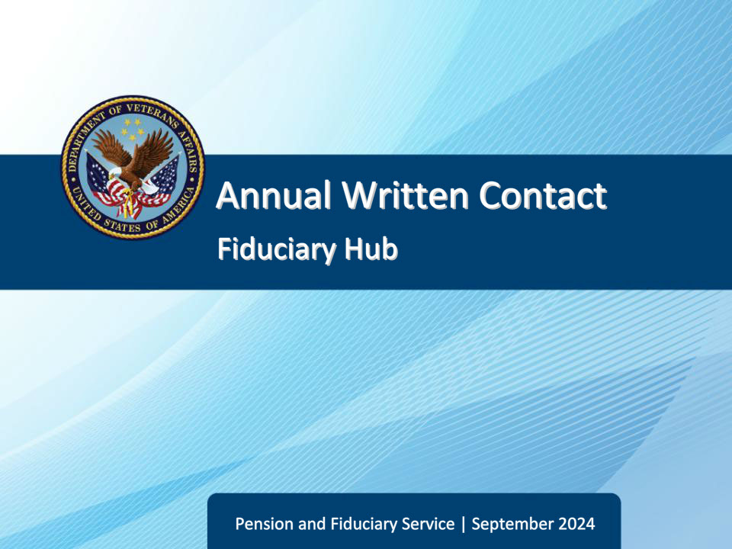
Slide notes

Course Description:

This course teaches learners an overview of annual written contact content, eligibility, and procedures.

Slide 2 - Objectives
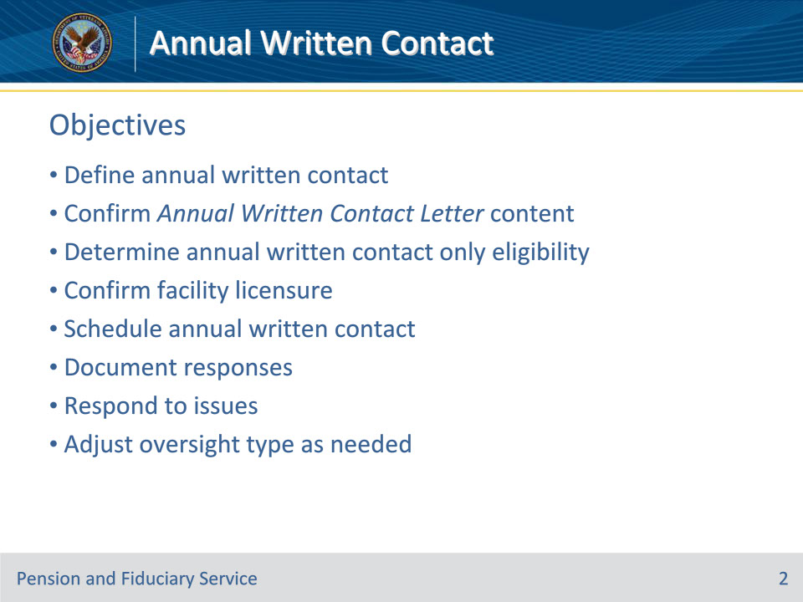
Slide notes

Instructor Notes:

At the end of this lesson, given the training and references, the learner will be able to do the following:

• Define annual written contact

• Confirm Annual Written Contact Letter content

• Determine annual written contact only eligibility

• Confirm facility licensure

• Schedule annual written contact

• Document responses

• Respond to issues

• Adjust oversight type as needed

Slide 3 - References
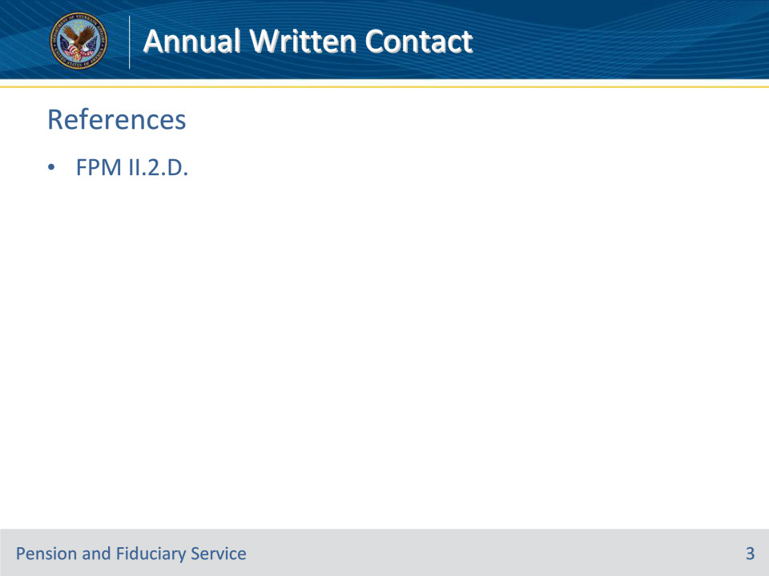
Slide notes

Instructor Notes:

These are the relevant references pertaining to this course:

• FPM II.2.D. - Annual Contact

Slide 4 - Overview
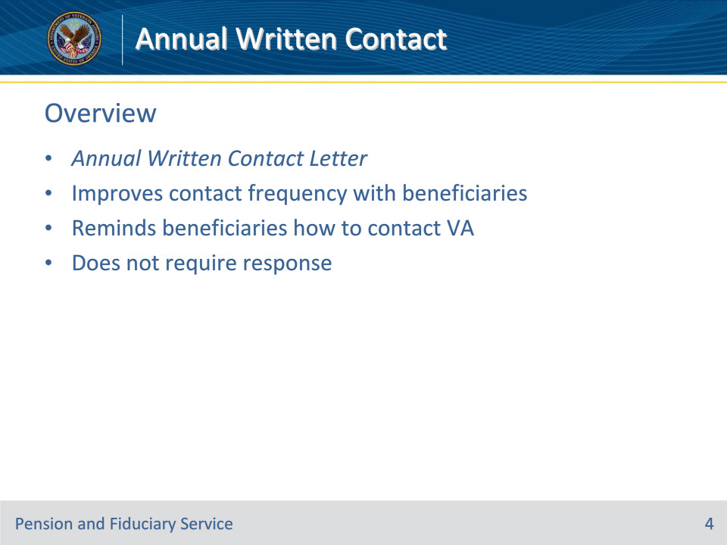
Slide notes

Policy Reference(s): FPM II.2.D.1.a.

Instructor Notes:

Hubs will initiate the use of the Annual Written Contact Letter to improve the frequency of contact with all beneficiaries in the Fiduciary Program. The letter helps to remind beneficiaries in the program how to contact the Department of Veterans Affairs (VA) if an issue or concern with their fiduciary exists.

The letter does not require the beneficiary to respond to VA.

Slide 5 - Letter Content
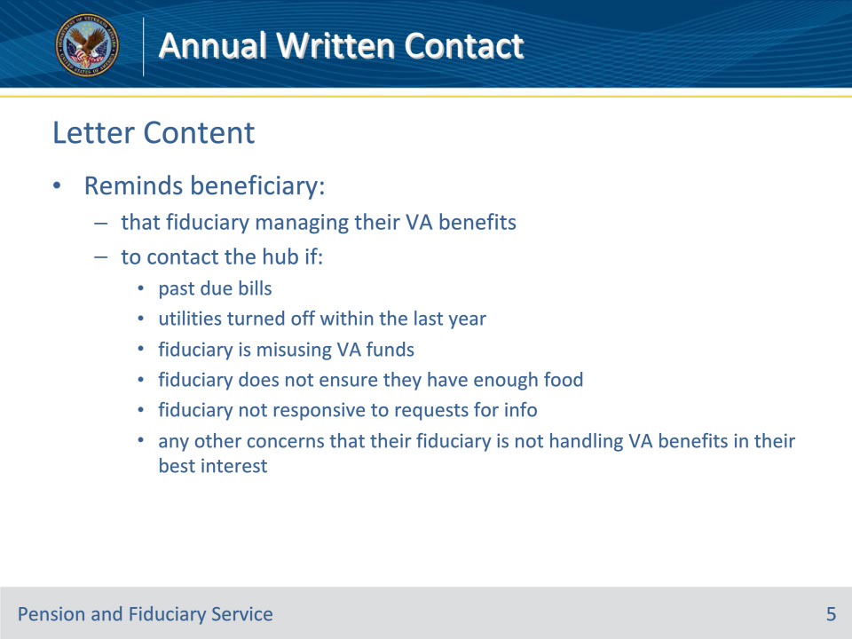
Slide notes

Policy Reference(s): FPM II.2.D.1.b.

Instructor Notes:

The Annual Written Contact Letter will remind the beneficiary that a fiduciary is managing their VA benefit payments and to contact the hub, if the beneficiary

• received notification of past due bills

• had their utilities turned off within the last year

• reports that their fiduciary

• is misusing VA funds

• does not ensure they have enough food, or

• is not responsive to requests for information about how VA benefit funds are spent or account balances, and

• has any other concerns that their fiduciary is not handling VA benefits in their best interest.

Slide 6 - Letter Content
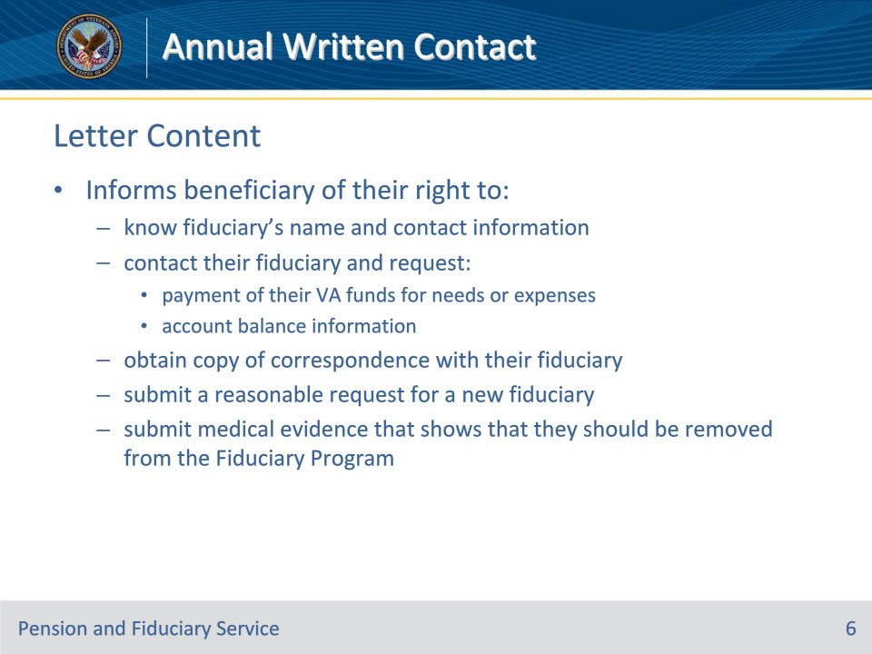
Slide notes

Policy Reference(s): FPM II.2.D.1.b.

Instructor Notes:

The Annual Written Contact Letter will also inform the beneficiary of their right to

• know their fiduciary’s name, telephone number, mailing address, and email address

• contact their fiduciary and request

• payment of their VA funds for current or foreseeable needs or expenses, and

• account balance information

• obtain a copy of their correspondence with their fiduciary

• submit to VA a reasonable request for appointment of a new fiduciary if

• their fiduciary receives a VA authorized fee, and they would like a volunteer to serve as fiduciary

• they believe their fiduciary is not acting in their best interest, or

• their fiduciary does not respond to their calls, emails, or letters, and

• submit medical evidence that shows that they should be removed from the Fiduciary Program.

Slide 7 - Annual Written Contact Only
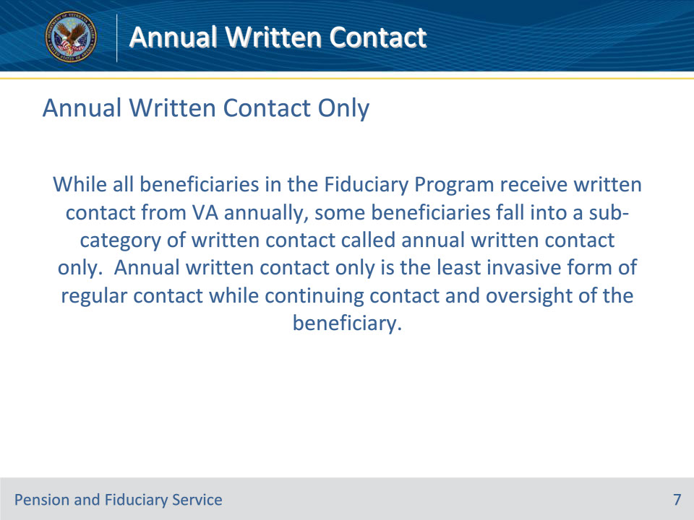
Slide notes

Policy Reference(s): FPM II.2.D.1.c.

Instructor Notes:

While all beneficiaries in the Fiduciary Program receive written contact from VA annually, some beneficiaries fall into a sub-category of written contact called annual written contact only. Annual written contact only is the least invasive form of regular contact while continuing contact and oversight of the beneficiary.

Slide 8 - Eligibility
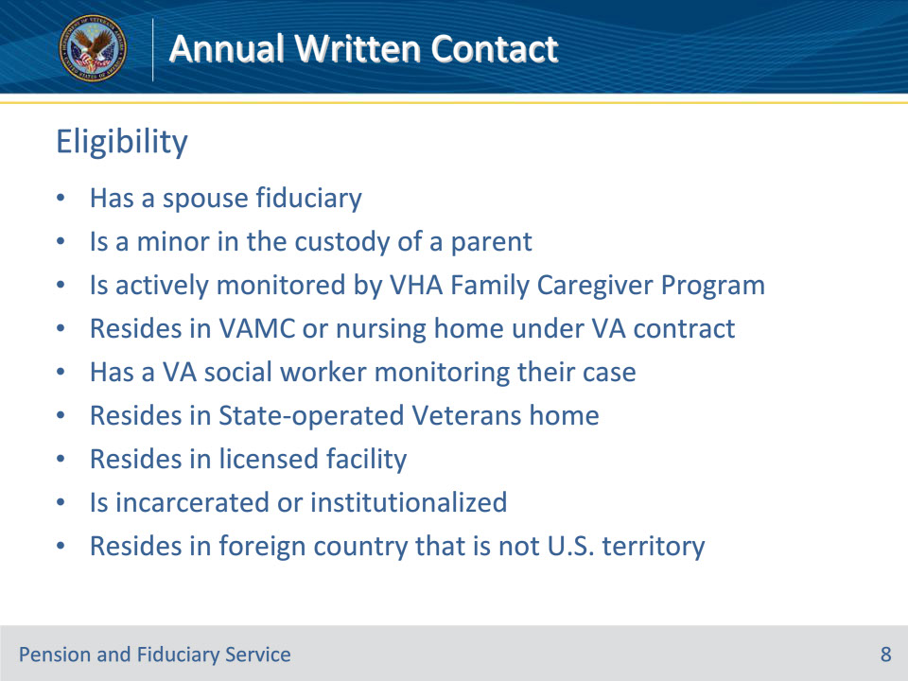
Slide notes

Policy Reference(s): FPM II.2.D.1.c.

Instructor Notes:

These are the eligibility criteria for annual written contact only:

• has a spouse appointed as their fiduciary, or

• is a minor in the custody of a parent (natural, adopted, or stepparent)

• is actively monitored by the Veterans Health Administration (VHA) Family Caregiver Program

• permanently resides in a VA medical center or in a nursing home under VA contract, or

• has a VA social worker monitoring their case (includes homeless)

• permanently resides in a State-operated Veterans home or facility regulated or licensed by State or local government, or

• is incarcerated or institutionalized

• resides in a foreign country that is not a U.S. territory

Slide 9 - Facility License
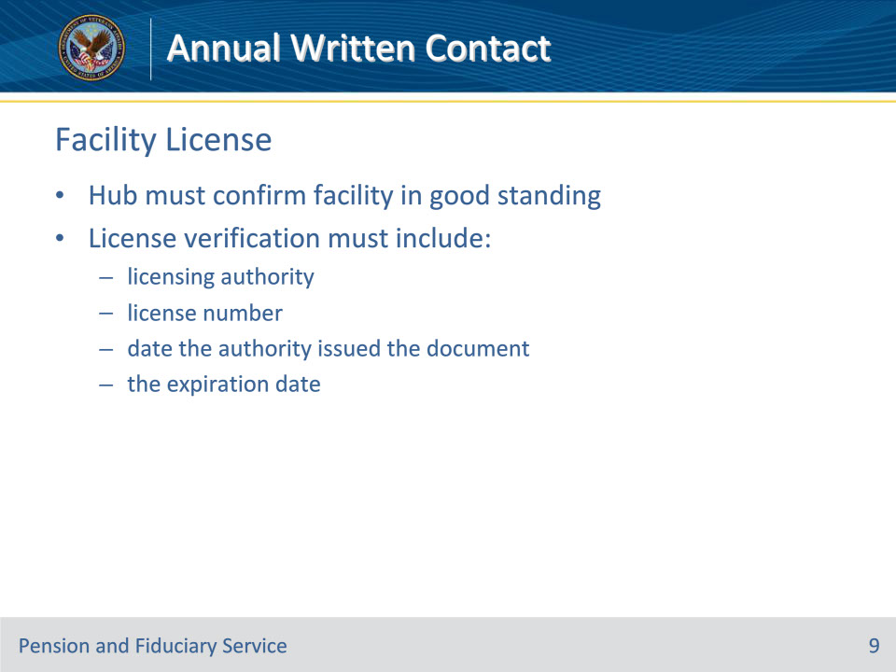
Slide notes

Policy Reference(s): FPM II.2.D.1.c.-e.

Instructor Notes:

If the hub personnel are unable to confirm the facility license status, the beneficiary does not qualify for annual written contact only oversight.

When a beneficiary resides in a facility regulated or licensed by a State or local government agency (excluding VA facilities, Medicaid-approved nursing homes, and State-owned or operated nursing homes and hospitals), the facility must be in good standing with the government regulator or licensing authority.

During each field examination, hubs must confirm the license of the facility and ensure there are no pending violations or complaints that would call into question the future standing of the facility.

When a facility is in good standing, the facility has authority to provide general care and supervision, group home, or assisted living services.

Licensing information may vary from place to place. Hubs must record sufficient license information to verify that the facility is in good standing based on the governmental regulatory agency’s most recent assessment.

Facility license verification must include

• licensing authority

• license number

• date the authority issued the document, and

• the expiration date.

Slide 10 - Expired License
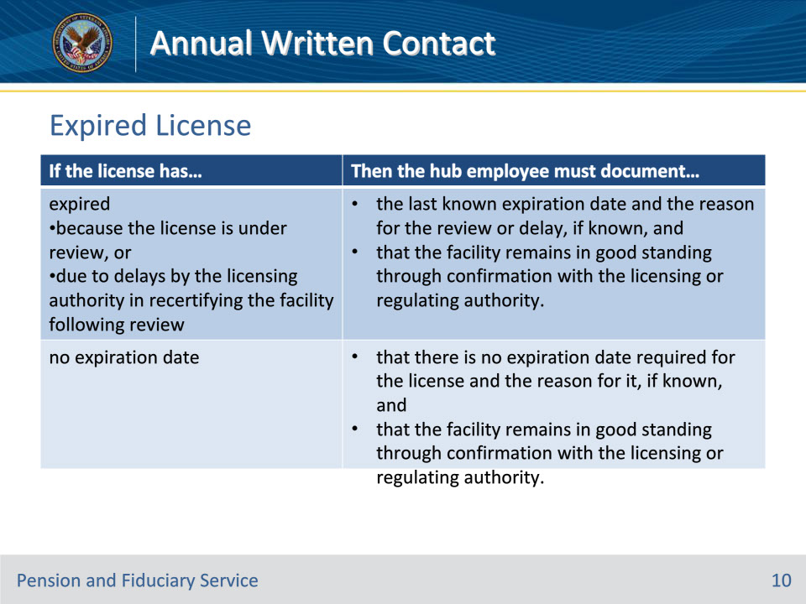
Slide notes

Policy Reference(s): FPM II.2.D.1.e.

Instructor Notes:

An expired facility license does not necessarily mean that the facility is not in good standing. Use this table to determine the information needed when attempting to resolve license expiration issues during verification.

Slide 11 - Confirming License
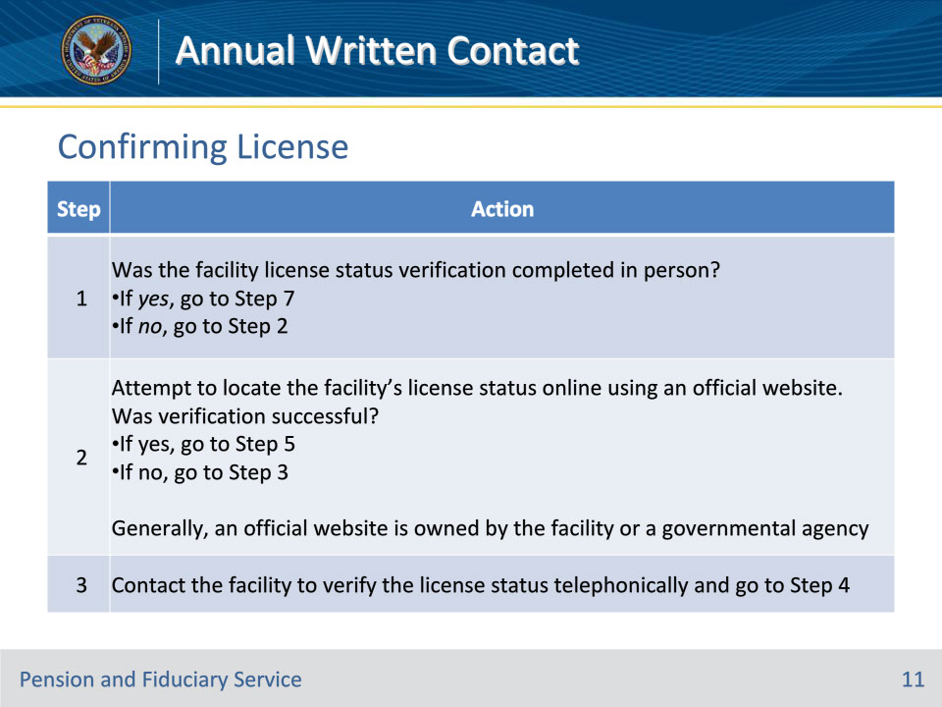
Slide notes

Policy Reference(s): FPM II.2.D.1.e.

Instructor Notes:

The method in which a facility license status verification may occur varies. Attempts to verify the facility’s status must begin with an online verification attempt unless the oversight activity is a field examination conducted in person.

Follow the steps in the table on this slide to document the facility license status in the eFolder.

Slide 12 - Confirming License
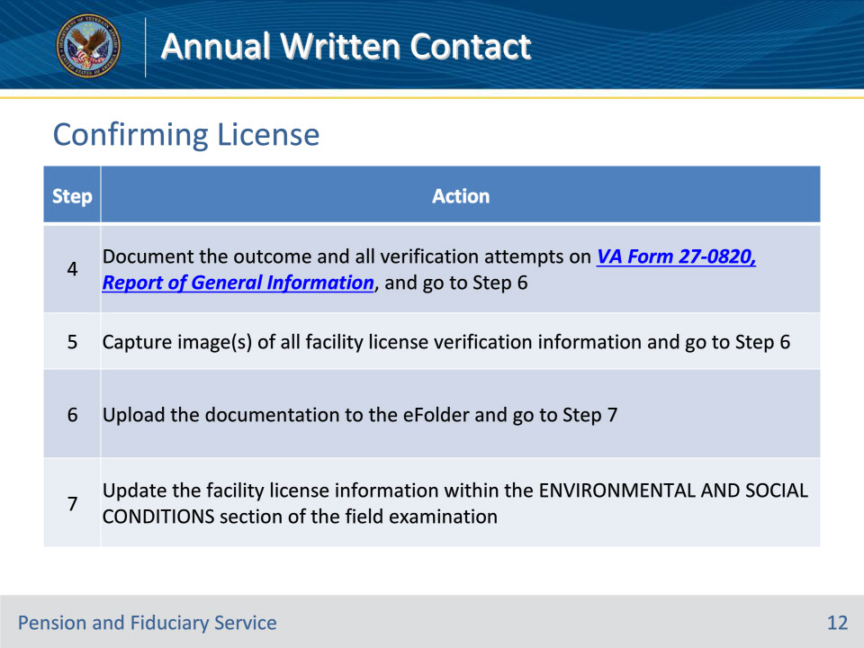
Slide notes

Policy Reference(s): FPM II.2.D.1.e.

Instructor Notes:

Follow the steps in the table on this slide to document the facility license status in the eFolder.

Note for Step 5: The digital image must also capture the date and time of the screenshot/screen print and website address from which the information was obtained.

Reference for Step 7: For more information on updating the field examination, ENVIRONMENTAL AND SOCIAL CONDITIONS section in Veterans Benefits Management System (VBMS), see the VBMS Core User Guide.

Slide 13 - Scheduling
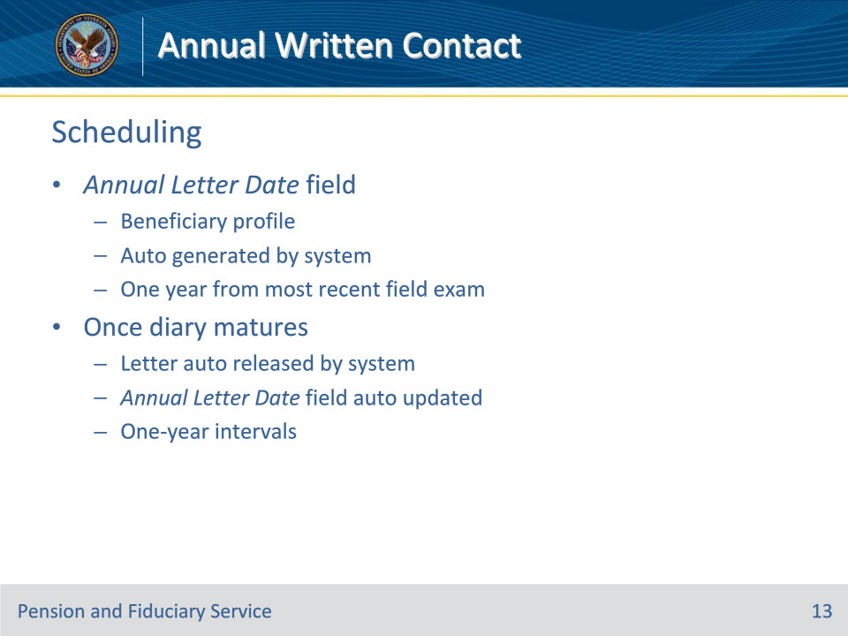
Slide notes

Policy Reference(s): FPM II.2.D.1.f.

Instructor Notes:

Each active beneficiary must have a date listed in the ANNUAL LETTER DATE field of the beneficiary profile.

Generally, the system automatically establishes a diary for the annual letter which is one year from the date of the most recently completed field examination (i.e., the date the end product (EP) 590 initial appointment (IA), expedited IA, or successor IA is cleared).

Once the diary matures, the system automatically

• releases the Annual Written Contact Letter through a batch mailing process, and

• updates to reflect a new date in the ANNUAL LETTER DATE field, which is one year from the notification date as described in the VBMS Core User Guide.

Slide 14 - Scheduling
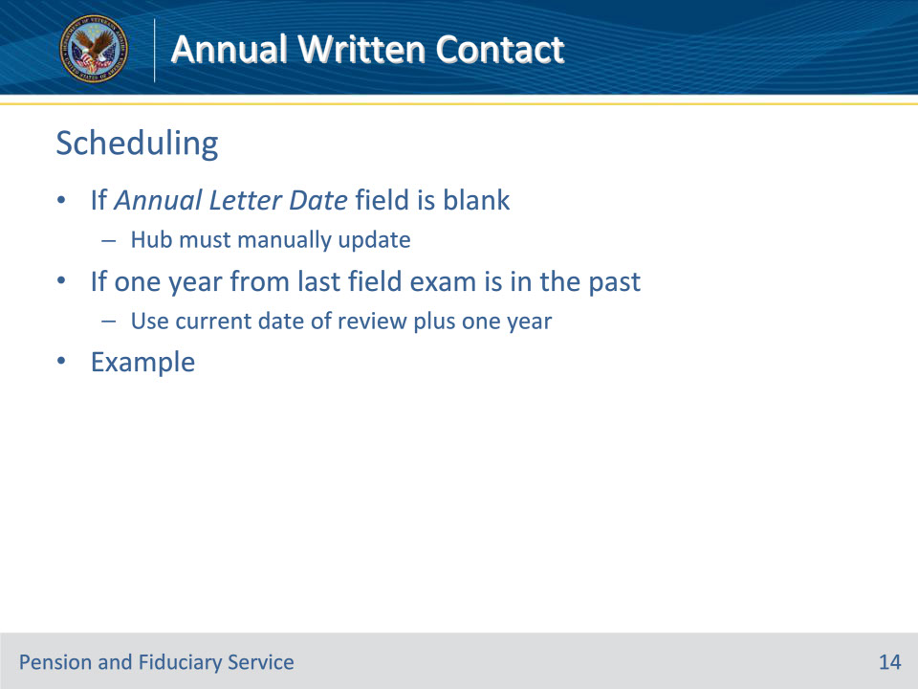
Slide notes

Policy Reference(s): FPM II.2.D.1.f.

Instructor Notes:

If the ANNUAL LETTER DATE field is blank the hub employee must manually update the DIARY INFORMATION section of the beneficiary profile to include an annual letter date that is either

• one year from the date of the most recently completed field examination, if the date is not in the past, or

• the current date of review plus one year, if the most recently completed field examination was more than a year ago.

Example: The hub identifies that the ANNUAL LETTER DATE field is not of record on the DIARY INFORMATION section of the beneficiary profile on November 23, 2020. The most recent field examination was completed on October 15, 2017. The hub employee updates the ANNUAL LETTER DATE field to reflect November 23, 2021.

Slide 15 - Scheduling
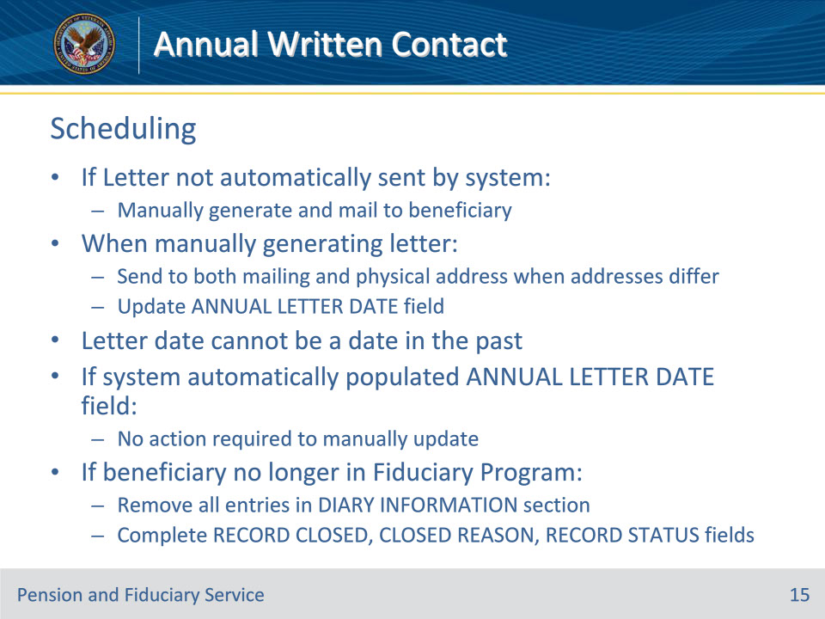
Slide notes

Policy Reference(s): FPM II.2.D.1.f.

Instructor Notes:

• If the Annual Written Contact Letter was not automatically sent by the system, the letter must be manually generated and mailed to the beneficiary. When manually generating the letter, the hub employee must ensure that the

• letter is sent to both the mailing and physical address of the beneficiary when the addresses differ, and

• ANNUAL LETTER DATE field is updated so that the letter is automatically sent the following year.

• The annual letter date cannot be a date in the past.

• No action is required to manually update or revise the ANNUAL LETTER DATE field if the system has automatically populated this date.

• The hub must remove the annual letter date when the beneficiary is no longer in the Fiduciary Program due to death or change in competency status. To ensure the system does not require a date in the ANNUAL LETTER DATE field, remove all entries in the DIARY INFORMATION section and then complete the RECORD CLOSED, CLOSED REASON, and RECORD STATUS fields.

Slide 16 - Documenting Responses
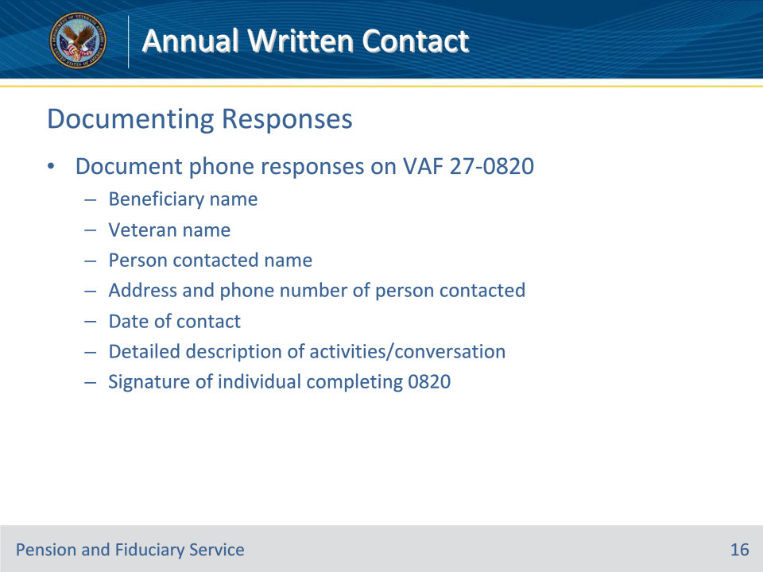
Slide notes

Policy Reference(s): FPM II.2.D.1.g.

Instructor Notes:

When beneficiaries receive the Annual Written Contact Letter, some may call or write VA to report information or to ask questions about the letter. Document all telephone contact relating to the Annual Written Contact Letter on VA Form 27-0820. A separate VA Form 27-0820 must be generated for each individual with whom the hub speaks.

Documentation must include

• the name of the

• beneficiary

• Veteran, and

• person

• contacting VA, or

• contacted by VA

• the address and telephone number of the person

• contacting VA, or

• contacted by VA

• the date of the contact

• a detailed description of the call activities and/or conversation to include the specific area of concern (as applicable), and

• the wet or electronic signature of the individual completing the VA Form 27-0820.

Slide 17 - Documenting Responses
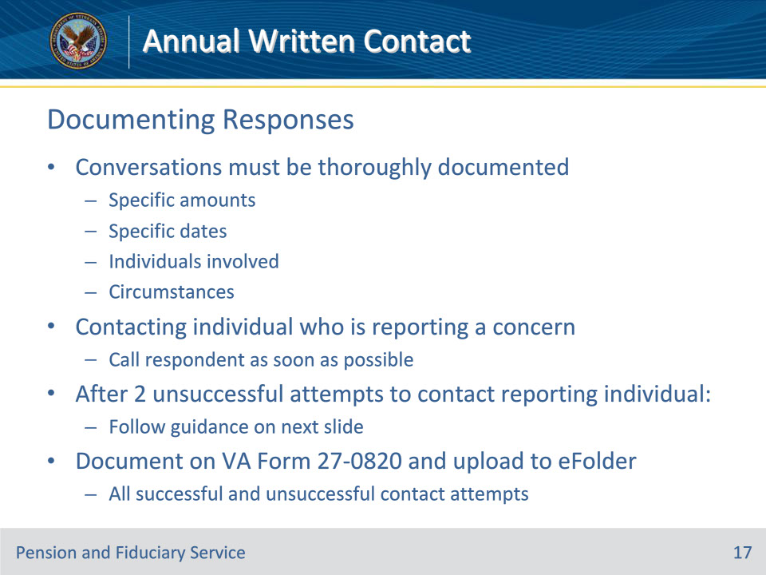
Slide notes

Policy Reference(s): FPM II.2.D.1.g.

Instructor Notes:

Conversations must be thoroughly documented including items such as specific amounts, dates, individuals involved, and circumstances as the information gathered during the call may be subject to appeal, if misuse is found. The information may also be used as grounds for removal of a fiduciary from service.

When it is necessary to contact the individual who is reporting a concern (e.g., VA received a written response to the Annual Written Contact Letter and an issue regarding a beneficiary’s well-being was not clear), hubs should call the respondent as soon as possible. Contact with the respondent must be prioritized to ensure that concerns relating to the beneficiary and/or fiduciary are addressed promptly.

Follow the guidance in FPM, Part II, 2.D.1.h after two unsuccessful attempts to contact the reporting individual for more information.

All successful and unsuccessful contact attempts, regardless of the mode of communication, must be documented on VA Form 27-0820 and uploaded to the eFolder.

Slide 18 - Responding to Issues
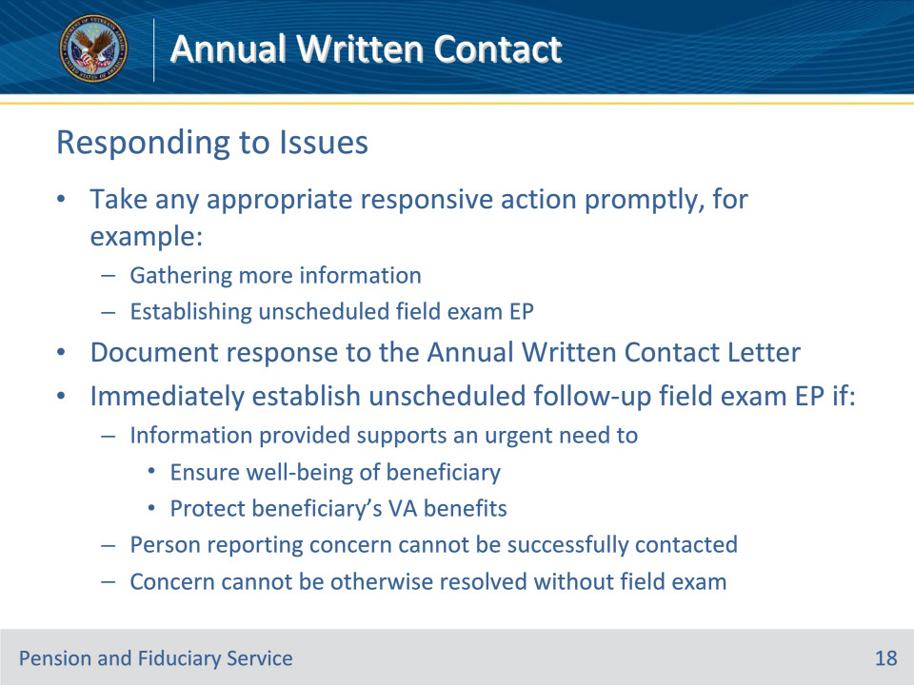
Slide notes

Policy Reference(s): FPM II.2.D.1.h.

Instructor Notes:

When VA receives information of a beneficiary concern in response to the Annual Written Contact Letter, the hub must take any appropriate responsive action promptly, to include gathering more information and/or establishing an unscheduled field examination EP, if necessary.

Follow the guidance in FPM, Part II, 2.D.1.g to document a response to the Annual Written Contact Letter. Immediately establish an unscheduled follow-up field examination EP if

• information and/or evidence provided in the response (or subsequent contact) supports an urgent need to

• ensure the well-being of the beneficiary, or

• protect a beneficiary’s VA benefits

• the person reporting the concern cannot be successfully contacted for additional information when needed (i.e., details of the concern are not clear, warranting the unscheduled field examination out of an abundance of caution), or

• the concern cannot be otherwise resolved without an unscheduled field examination.

Slide 19 - Removal
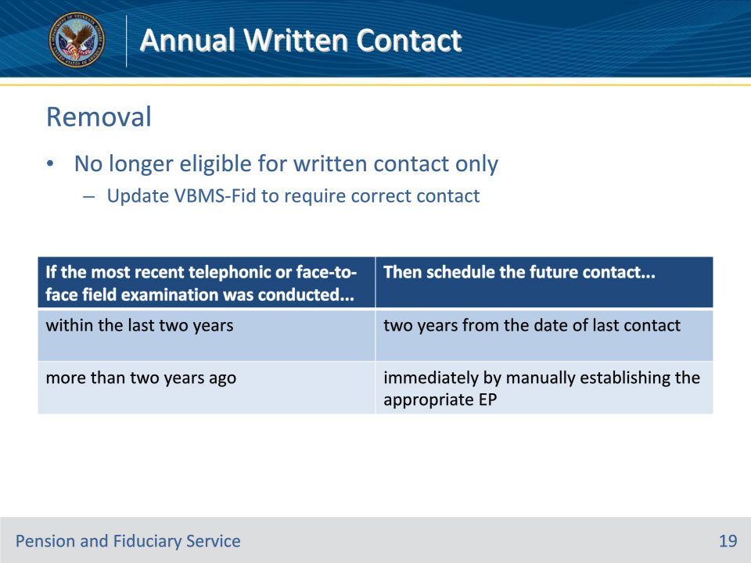
Slide notes

Policy Reference(s): FPM II.2.D.1.i.

Instructor Notes:

If VA receives information that a beneficiary’s circumstances have changed that make the beneficiary no longer eligible for annual written contact only based on the criteria, the hub must update the beneficiary record in VBMS to require telephonic contact, if eligible, or a follow-up field examination.

Use this table to determine when the contact must be scheduled.

If the beneficiary’s circumstances change but the beneficiary remains eligible for annual written contact only based on the criteria, a field examination is not required.

If VA receives information that there is an issue concerning the beneficiary’s well-being, immediately establish an unscheduled field examination EP.

Slide 20 - Questions?
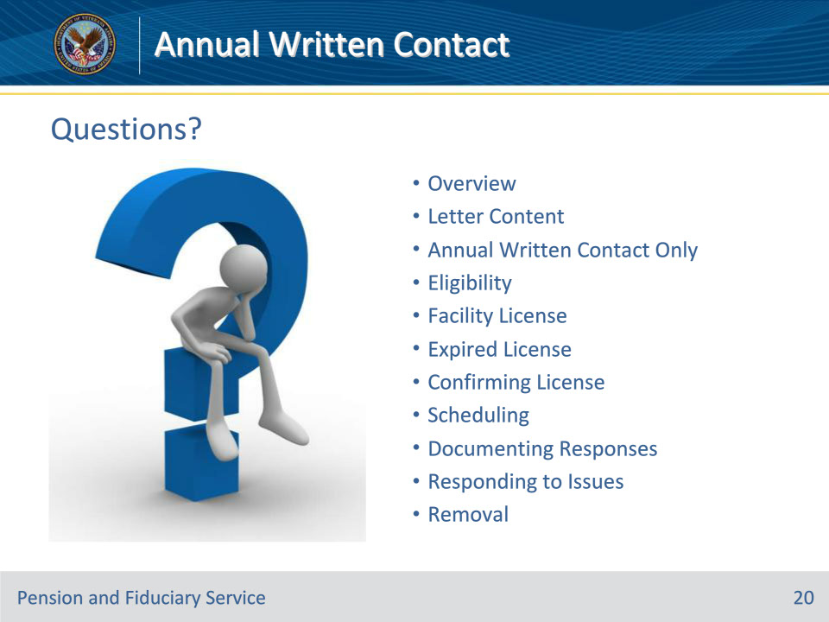
Slide notes

Instructor Notes:

(Recall) These are our learning objectives as stated from the beginning of the training:

• Define annual written contact

• Confirm Annual Written Contact Letter content

• Determine annual written contact only eligibility

• Confirm facility licensure

• Schedule annual written contact

• Document responses

• Respond to issues

• Adjust oversight type as needed

(Recap) We discussed each of these learning objectives through the following topics in each slide today:

• Overview

• Letter Content

• Annual Written Contact Only

• Eligibility

• Facility License

• Expired License

• Confirming License

• Scheduling

• Documenting Responses

• Responding to Issues

• Removal

Are there any additional questions?

Questions should be filtered through your QRT team. They will submit your questions to the Field Inquiry Tool (FIT) on your behalf.

Slide 21 - TMS Survey/Assessment
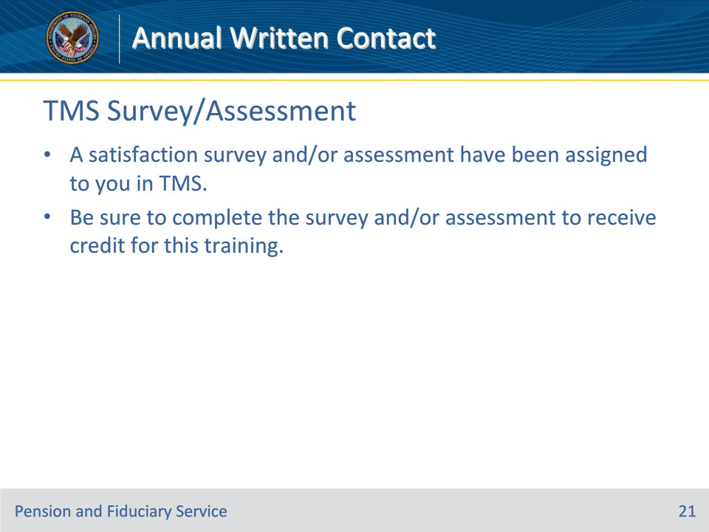
Slide notes

Instructor Notes:

A satisfaction survey and/or assessment have been assigned to you in TMS.

Be sure to complete the survey and/or assessment to receive credit for this training.

