Slide 1 - Competency Hearings

Slide notes

Course Description:

This course teaches learners about the changes to competency hearing request procedures and how to conduct hearings.

Slide 2 - Objectives
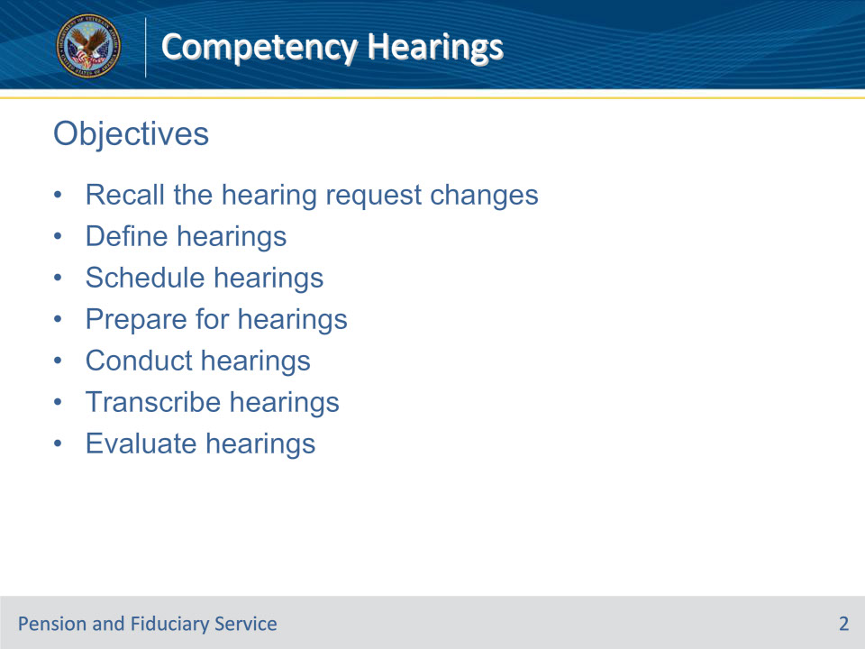
Slide notes

Instructor Notes:

At the end of this lesson, given the training and references, the learner will be able to do the following:

• Recall the hearing request changes

• Define hearings

• Schedule hearings

• Prepare for hearings

• Conduct hearings

• Transcribe hearings

• Evaluate hearings

Slide 3 - References
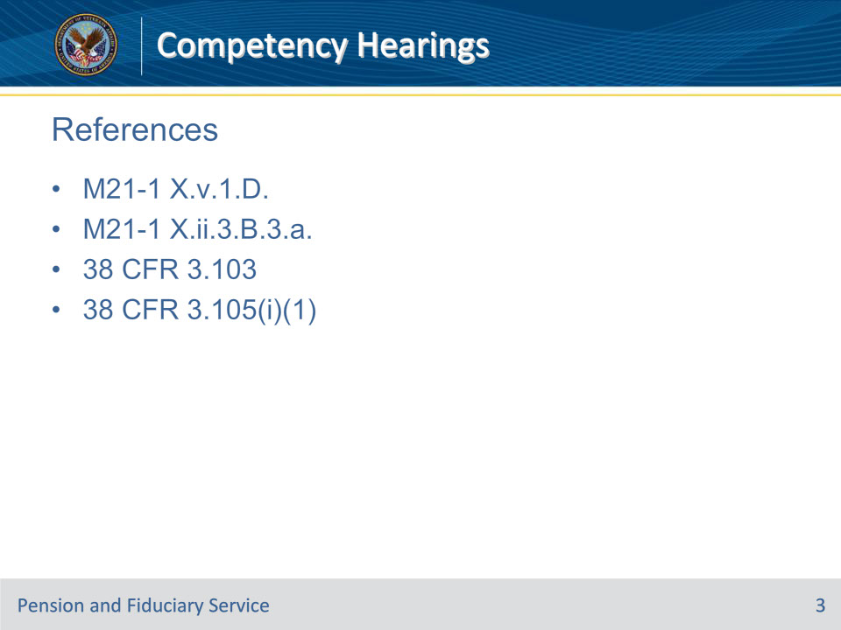
Slide notes

Instructor Notes:

These are the relevant references pertaining to this course. Please take the time to review these references after the conclusion of this course.

• M21-1 X.v.1.D.

• M21-1 X.ii.3.B.3.a.

• 38 CFR 3.103

• 38 CFR 3.105(i)(1)

Slide 4 - Definition
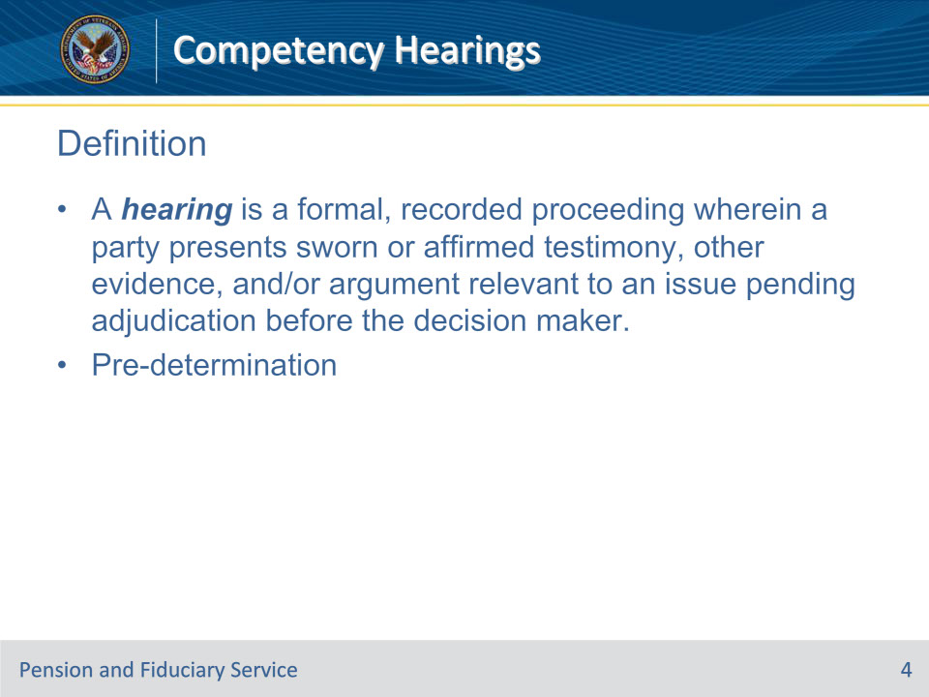
Slide notes

Policy Reference(s): M21-1 X.v.1.D.1.a.

Instructor Notes:

A hearing is a formal, recorded proceeding wherein a party presents sworn or affirmed testimony, other evidence, and/or argument relevant to an issue pending adjudication before the decision maker.

Hearing requests received related to incompetency proposal due process are pre-determination hearing requests. Pre-determination hearings are on matters related to an adjudicative issue that is pending an initial decision.

Slide 5 - Purpose
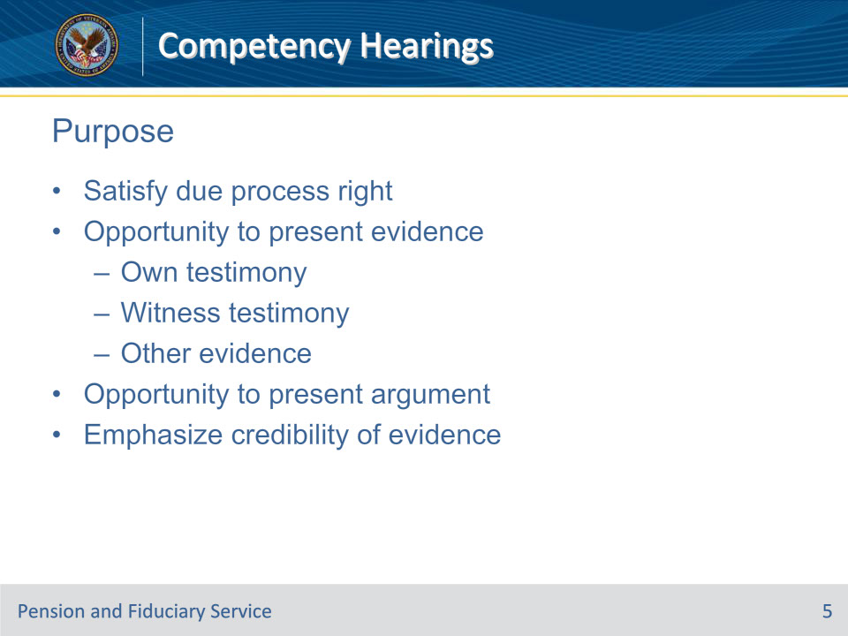
Slide notes

Policy Reference(s): M21-1 X.v.1.D.1.b.

Instructor Notes:

The purposes of an RO hearing include

• to satisfy the claimant or beneficiary’s due process right to a requested hearing

• to provide a claimant or beneficiary with the opportunity to present, in person, evidence material to the issue(s) including

• his/her own testimony

• testimony of witnesses, and/or

• other evidence (exhibits)

• to provide a claimant or beneficiary (and/or his or her representative) an opportunity to present argument on the hearing issue(s), or

• to emphasize the credibility of testimonial evidence through the personal presentation of testimony before the decision maker.

Do not schedule a hearing solely for a representative to offer arguments, absent a witness to offer testimony. Arguments can be presented in writing or in an informal conference.

Slide 6 - Requests
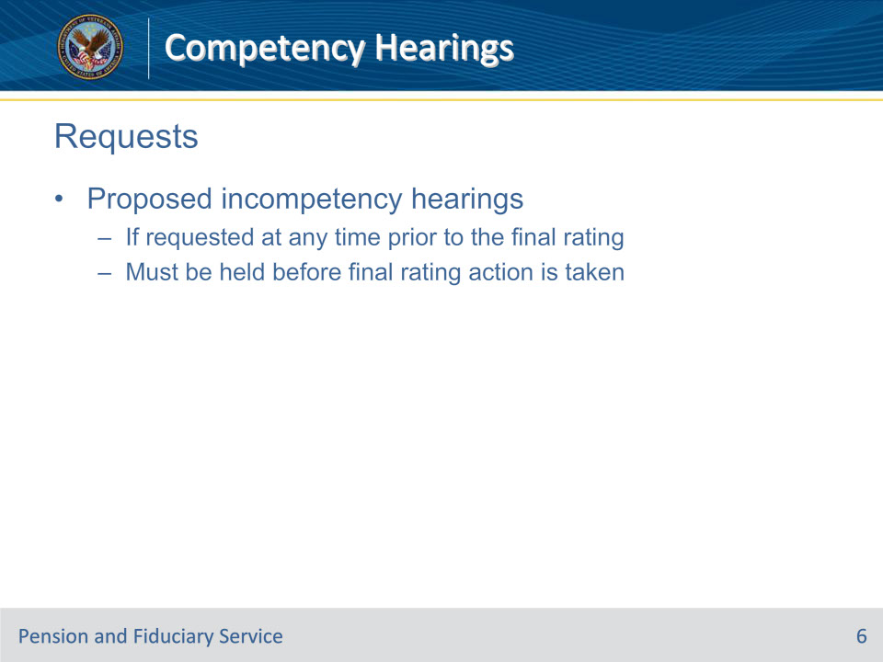
Slide notes

Policy Reference(s): M21-1 X.ii.3.B.3.a.

Instructor Notes:

For hearings requested in connection with proposed incompetency, a hearing requested at any time prior to the final rating must be held before final rating action is taken.

Slide 7 - Testimony
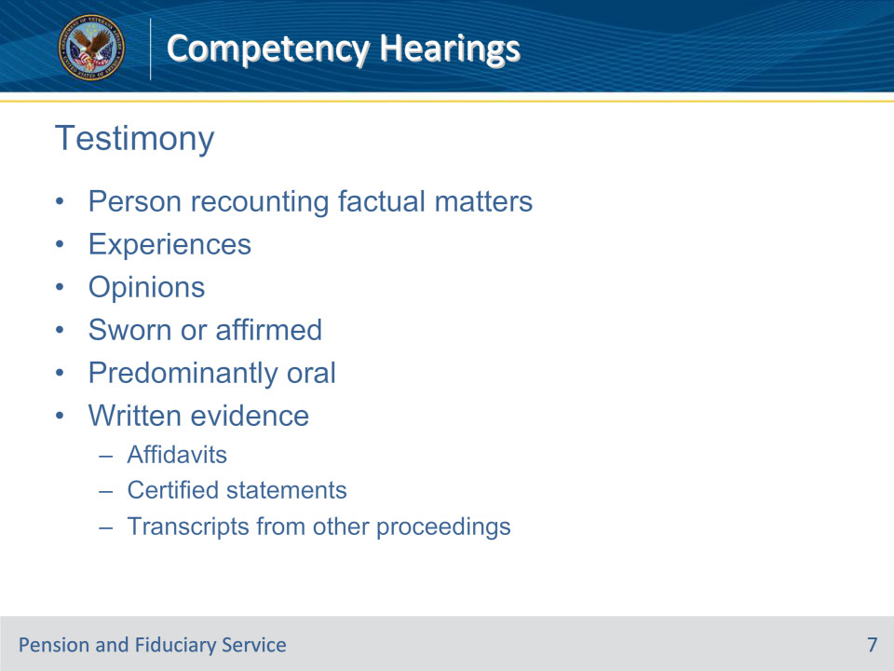
Slide notes

Policy Reference(s): M21-1 X.v.1.D.1.c.

Instructor Notes:

Testimony refers to a person recounting factual matters he or she experienced and/or offering opinions premised upon other facts. It usually denotes a sworn or affirmed evidentiary use in an adjudication context.

Hearing testimony is predominately oral. Written testimonial evidence includes affidavits or other certified statements, or transcripts from another proceeding.

Slide 8 - Argument
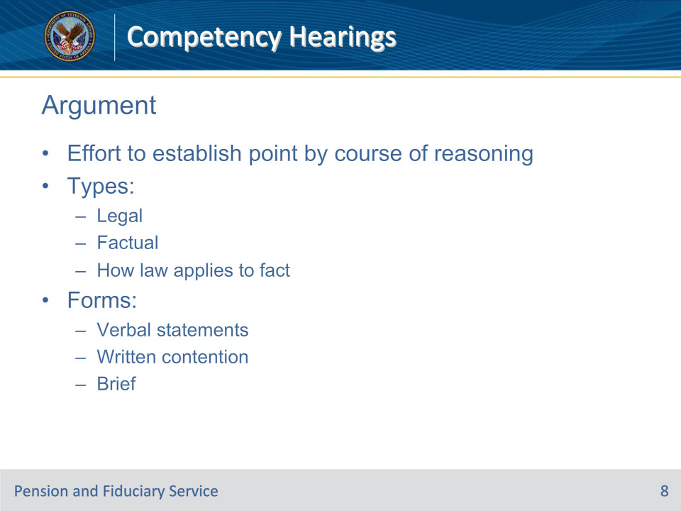
Slide notes

Policy Reference(s): M21-1 X.v.1.D.1.d.

Instructor Notes:

Argument is an effort to establish a point by a course of reasoning. There is legal argument, factual argument, and argument on how the law applies to fact. For example, a claimant and his representative might make arguments that

• certain items of evidence are competent, credible, and establish facts

• established facts meet the legal requirements

• the evidence is in relative balance regarding a point such that the benefit of the doubt may be applied

• a regulatory term has a particular meaning, or

• a particular case is precedential.

Forms of argument at a hearing include verbal statements made at hearing by the claimant/beneficiary or representative in an introductory or closing statement, or a written contention, or a brief filed at the hearing.

Slide 9 - Who Conducts Hearings
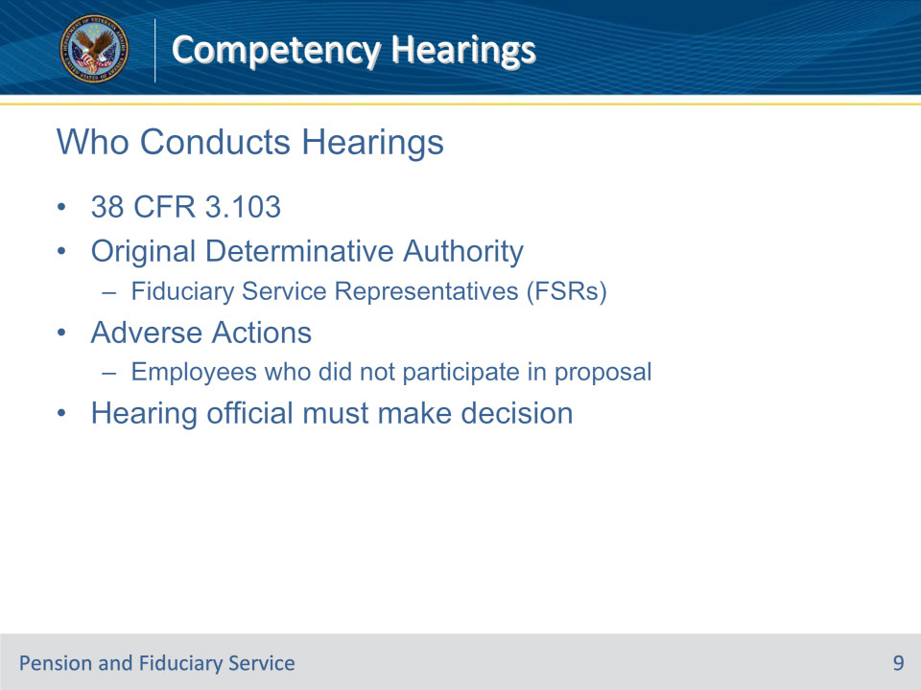
Slide notes

Policy Reference(s): M21-1 X.v.1.D.1.e.; f.; i.

Instructor Notes:

VA’s due process regulation, 38 CFR 3.103, provides only that all hearings must be conducted by an employee with original determinative authority over the issue(s).

Original determinative authority means, with respect to hearings, that in assigning hearing duties, management will assign a hearing to a person with the appropriate job title and decision-making authority to render a decision on the issue that is the subject of the hearing. For due process incompetency hearings under Fiduciary Hub jurisdiction, this employee would be an FSR.

Moreover, 38 CFR 3.103, provides that hearings held in connection with proposed adverse actions can only be conducted by employees who did not participate in the proposed action. Since incompetency proposals are generated by the VSC or PMC and not the fiduciary hub, this regulation should not eliminate any FSRs from consideration.

The hearing official must issue the subsequent decision based on the hearing testimony. This means that the FSR who conducts the hearing must be the same FSR who renders the rating decision.

The rationale for this is that a key facet of the hearing due process right is the right to present testimony in person before the decision maker. The in-person interaction gives the hearing official the ability to observe the appearance and demeanor of the witness, which may emphasize or highlight the credibility of that evidence among any conflicting evidence of record.

Slide 10 - When Official is Unable
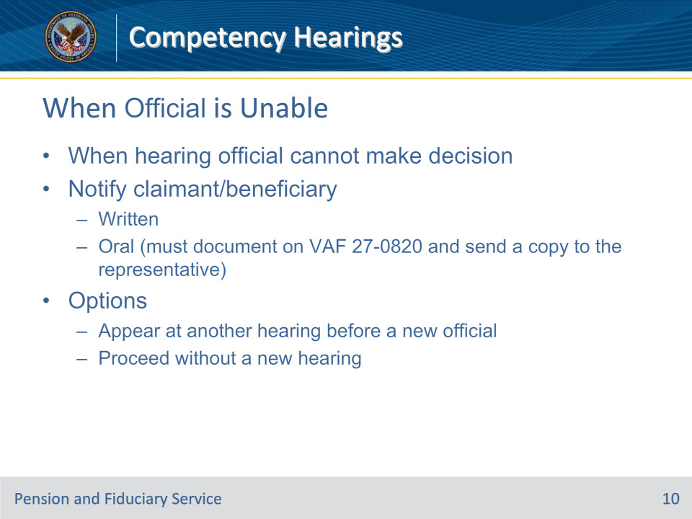
Slide notes

Policy Reference(s): M21-1 X.v.1.D.1.j.

Instructor Notes:

In some cases the hearing official may not be available to make the subsequent decision. For example, an employee may

• receive a promotion to management

• transfer to a different office in VA, or

• retire.

In such a case, notify the claimant/beneficiary that

• the hearing official is not available to make the decision, and

• he/she must elect one of the following options:

• appear at another hearing before a new hearing official, or

• proceed without a new hearing; the decision maker will review the prior hearing transcript in rendering the decision.

• Notification can be oral or in writing. However, in the event of oral communication document the conversation with VA Form 27-0820, Report of General Information, and send a copy to the representative if one exists.

• Although in the second option the claimant/beneficiary loses the potential for personal interaction with the decision maker, this is at his/her election. Evidence is generally taken at face value and a witness should only be found lacking in credibility as provided in M21-1, Part III, Subpart iv, 5.A.2.b.

Slide 11 - Where to Hold Hearings
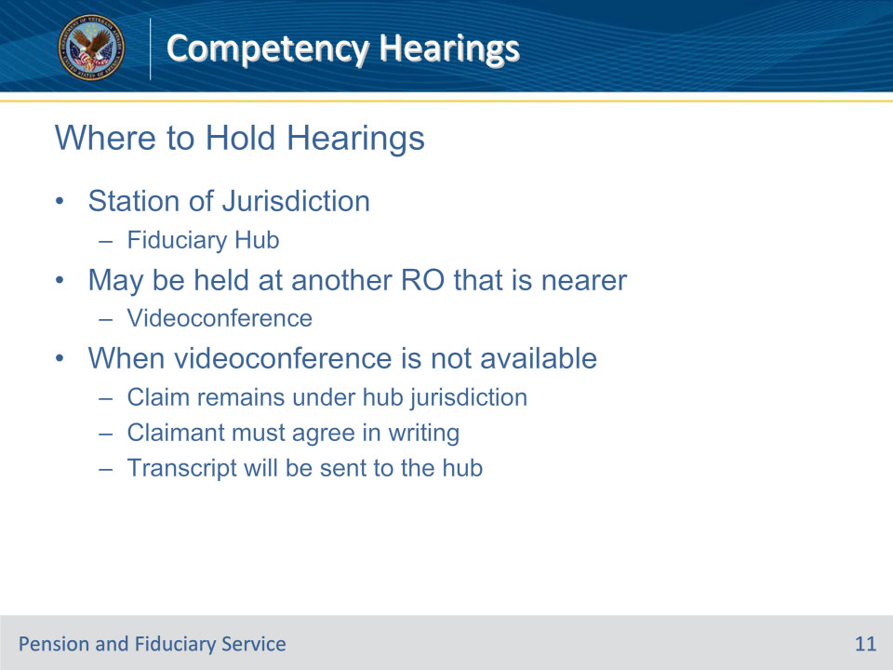
Slide notes

Policy Reference(s): M21-1 X.v.1.D.1.n.

Instructor Notes:

Hold hearings at the Station of Jurisdiction. For due process incompetency hearings, that will be the fiduciary hub.

A hearing may be held at another RO that is nearer to the claimant’s residence with the following qualifications:

• This hearing should be before a hearing official at the fiduciary hub via videoconference whenever possible.

• In the event that a videoconference hearing is not available, the hearing may be conducted by a hearing official at the RO nearer to the claimant’s residence. However, in such cases

• The claim remains under the jurisdiction of the fiduciary hub and the decision must be made by the hub.

• The claimant must be informed (and agree in writing) that he/she waives the right to have the decision made by the hearing official. (Retain this waiver in the claims folder.)

• The hearing official will send a transcript of the proceedings and any other evidence obtained to the hub.

• An employee of the fiduciary hub will make the decision based on the transcript and other evidence of record.

Subject to available resources, and at the option of VA, a formal hearing may be held at any other VA facility or Federal building where suitable hearing facilities are available. This hearing will be conducted by an employee of the fiduciary hub.

Slide 12 - Facility Requirements
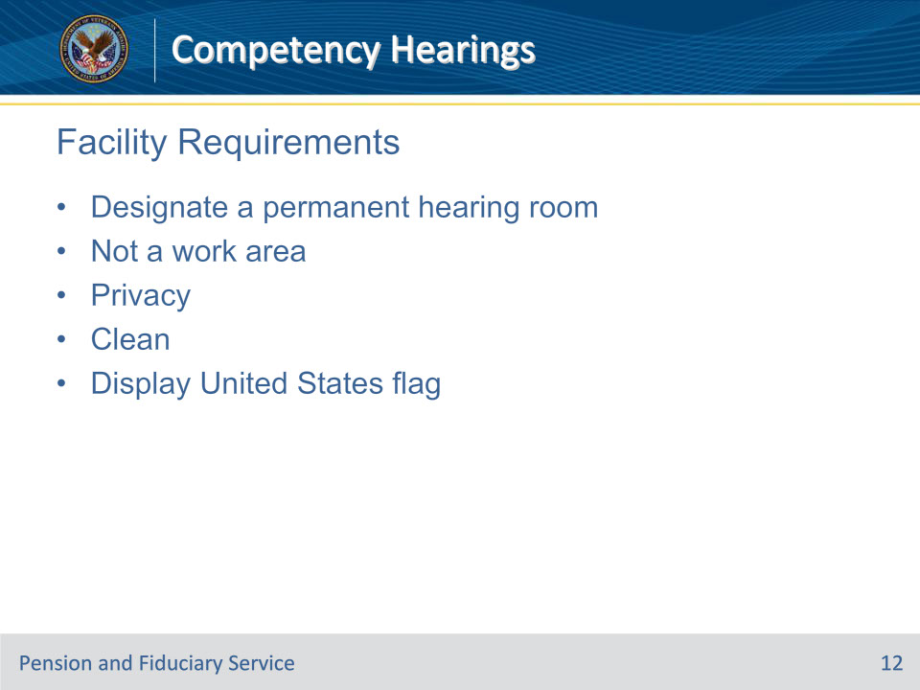
Slide notes

Policy Reference(s): M21-1 X.v.1.D.1.o.

Instructor Notes:

If RO facilities allow, designate a permanent hearing room. The following requirements apply to hearing facilities:

• Do not conduct hearings in a work area, or any location where the witnesses must pass through a work area with open access to restricted personally identifiable information on other claimants and beneficiaries.

• The hearing facility should provide privacy for witness testimony, including walls and a door.

• Ensure that the hearing room is clean and straightened for each hearing.

• Display the United States flag appropriately.

Slide 13 - Attendance
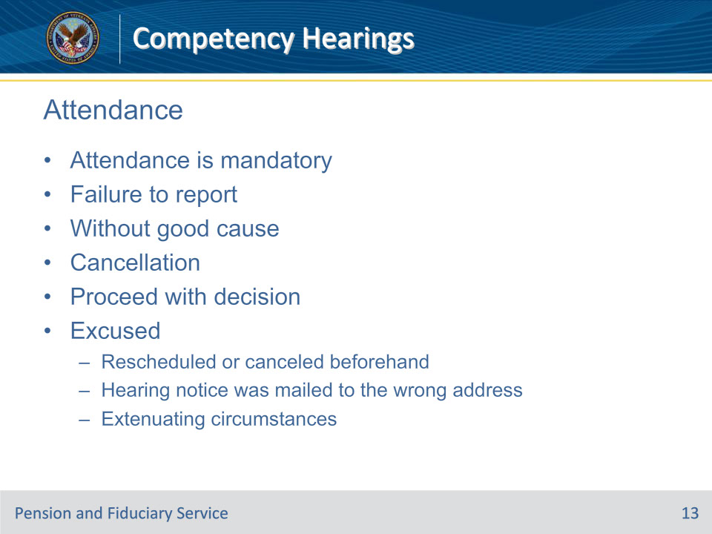
Slide notes

Policy Reference(s): M21-1 X.v.1.D.1.q.

Instructor Notes:

Attendance at an RO hearing by the claimant/beneficiary and witnesses on the date and time scheduled is mandatory.

When the claimant fails to report for the hearing without good cause, make a record annotation and update applicable systems indicating that the hearing was canceled for failure to report. Proceed with development or a decision as applicable.

Exceptions: Non-appearance at a scheduled hearing by the claimant/beneficiary will be excused if

• the hearing was rescheduled or canceled up to the scheduled time of the hearing

• VA mailed the hearing notice to an incorrect address, or

• there are extenuating circumstances such as

• incapacitation from a serious medical condition

• hospitalization

• death of an immediate family member, or

• incarceration.

Slide 14 - Non-Adversarial Questioning
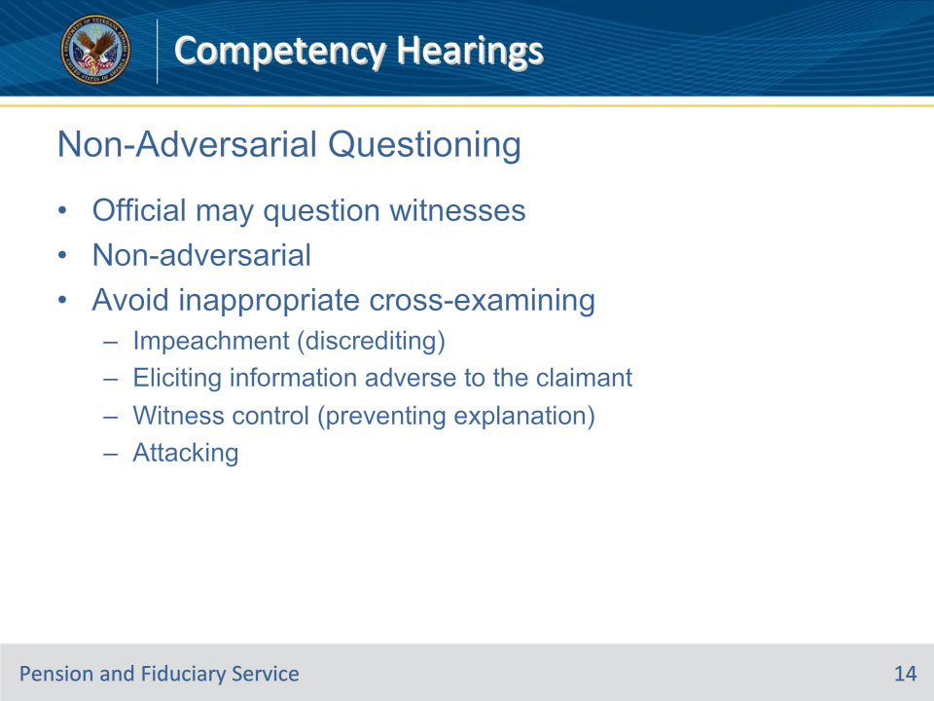
Slide notes

Policy Reference(s): M21-1 X.v.1.D.2.a.

Instructor Notes:

The hearing official may question witnesses, structuring all questions to fully explore the basis for claimed entitlement. However , proceedings before VA are non-adversarial in nature. VA does not oppose a claim. Accordingly, the hearing official must avoid inappropriate cross-examining style of questioning.

Cross-examination denotes supplemental questioning of a witness, called to testify in support of a party, by the advocate of the opposing party for one or more of the following purposes:

• impeachment (discrediting the witness by eliciting facts or opinions that diminish credibility or the weight of evidence offered by the witness)

• elicitation of facts or opinions that may be useful for additional development adverse to the party for whom the witness’s testimony was offered, and

• witness control (to prevent explanation or elaboration).

The term also connotes an attacking or aggressive style of questioning with a belligerent/antagonistic, sarcastic or skeptical tone that permits only “yes” or “no” answers.

The fact that an appropriate question by the hearing official may lead to information that results in, or is followed by, testimony that may show an inconsistency or otherwise negatively impact the witness’s credibility or the weight of evidence on a particular matter does not mean that the hearing official engaged in cross-examination or that the testimony is not admissible. This is not intent to refute evidence or discredit the claimant’s statements.

Slide 15 - Decorum
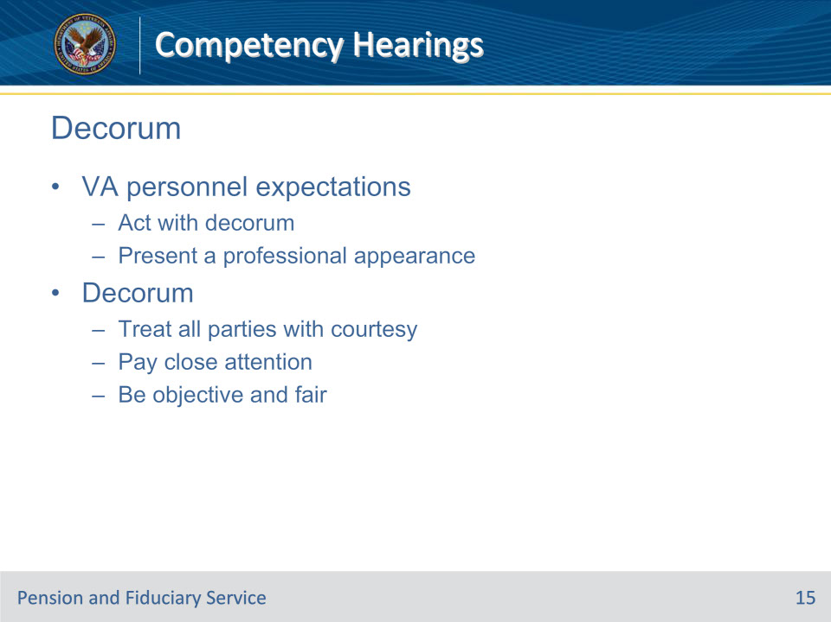
Slide notes

Policy Reference(s): M21-1 X.v.1.D.2.b.

Instructor Notes:

When conducting a hearing, VA personnel are expected to

• act with decorum, and

• present a professional appearance.

Decorum means that hearing officials must

• treat the claimant, witnesses, and representative with courtesy, even when witnesses may be angry, irritable, or critical

• pay close attention to the proceedings, and

• be objective and fair in questioning or comments made during the hearing.

• Do not express personal feelings or biases or allow those to influence the hearing proceedings.

• Do not express skepticism, sarcasm, or anger in response to testimony.

• Do not engage in a cross-examining style of questioning.

• Do not give any suggestion of having prejudged the issue.

Professional appearance must be judged by local office directives for the standard of dress expected for interaction with claimants. Except in the case of unusual or unforeseen circumstances (for example, an employee is assigned the task of holding a priority hearing the same day and an alternative hearing official is not available), casual outfit such as tennis shoes, shorts, tee shirts, and jeans, are not acceptable.

Slide 16 - Expectations
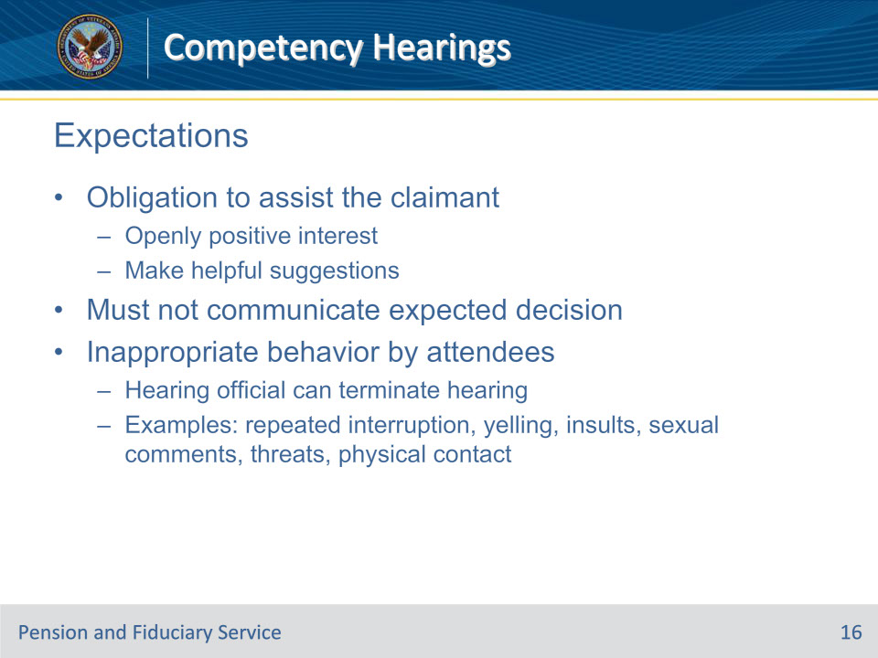
Slide notes

Policy Reference(s): M21-1 X.v.1.D.2.c.; d.; e.

Instructor Notes:

VA is obligated to assist the claimant in developing facts pertinent to the claim. Express an openly positive interest in assisting the claimant and, as indicated by the claims folder and the hearing proceedings, make suggestions to the claimant as to the submission of evidence that

• the claimant may have overlooked, and

• would be advantageous to his/her position.

The hearing official must not communicate a planned, anticipated, or expected decision or imply that a decision has been reached during the hearing.

If the claimant/beneficiary, representative, or other hearing attendee asks what the decision will be, the hearing official may say only that the decision will be communicated in writing after all the evidence is obtained and considered.

The hearing official has discretion to terminate a hearing for inappropriate (abusive, disrespectful, aggressive, or violent) behavior by hearing attendees. Such behavior includes, but is not limited to,

• repeated interruption of the hearing official

• yelling

• insults or demeaning/disrespectful comments directed at the hearing official or any other hearing participant

• sexual comments directed at the hearing official or any other hearing participant or that do not bear on the issues (for example, a sexual assault posttraumatic stress disorder issue)

• threatening/menacing behavior, and/or

• inappropriate touching, assault, or battery.

If there is any perceived risk of violence/harm to any hearing attendee, then follow local office emergency/security procedures. In emergency circumstances, the hearing official is not expected to notify the hearing attendees that the hearing is being terminated.

If behavior from a hearing attendee is grossly inappropriate, or repeatedly inappropriate, then follow local office emergency/security procedures if warranted by the facts. In non-emergency circumstances, inform the hearing attendees that the hearing is being terminated for inappropriate conduct.

If inappropriate conduct is not violent or not otherwise grossly inappropriate, consider giving a warning before terminating the hearing. Inform the hearing attendees in a courteous manner that the behavior is inappropriate, and further instances of inappropriate behavior will result in the hearing being terminated. If, in the judgment of the hearing official, termination is warranted, inform the hearing attendees in a courteous manner that the hearing is terminated for inappropriate conduct.

• In exercising discretion over whether to terminate the hearing where inappropriate behavior does not rise to the level of an emergency, the hearing official should keep in mind that for many individuals a hearing is their only exposure to an actual VA employee involved in their claim. It is understandable that they may be frustrated or angry at the claim process or a decision they have received. They may also have serious disabilities, such as a mental disorder or traumatic brain injury, manifested by social impairment, diminished impulse control, or anger that predisposes them to inappropriate behavior.

• In any cases where a hearing is terminated for inappropriate behavior, annotate the claims folder and applicable systems.

• In any case where a hearing is terminated for inappropriate behavior, rescheduling will be permitted only upon RO discretion, and rescheduling may be conditioned on the availability of additional security for the hearing.

Slide 17 - Scheduling and Preparing
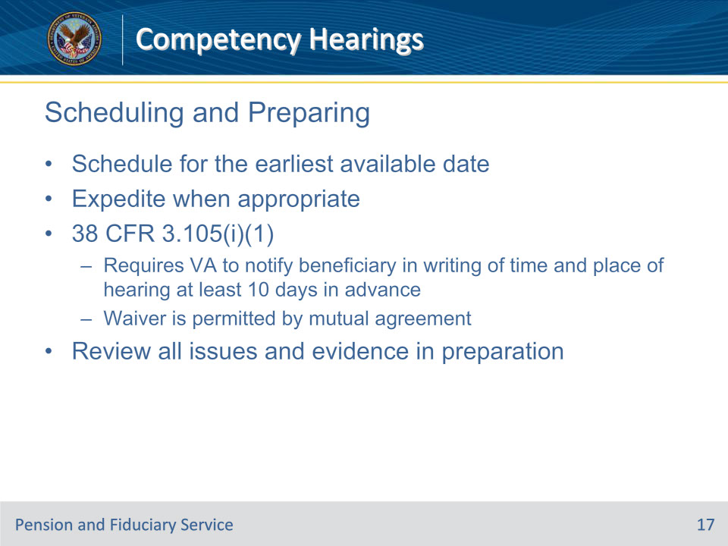
Slide notes

Policy Reference(s): M21-1 X.v.1.D.3.a.; b.; c.

Instructor Notes:

Schedule hearings within a reasonable amount of time from the date the request is received. Since due process incompetency hearings are pre-determination hearings, schedule the hearing for the earliest available date.

Expedite scheduling of hearings for all cases entitled to priority handling.

When a beneficiary timely requests a hearing in response to a notice of proposed adverse action, 38 CFR 3.105(i)(1) requires VA to notify the beneficiary in writing of the time and place of the hearing at least 10 days in advance of the scheduled hearing date.

A waiver of the 10-day advance notice is permissible by mutual agreement between VA and the beneficiary, and/or his/her representative (if any).

To prepare for the hearing, review all of the issues and evidence.

Slide 18 - Conducting the Hearing
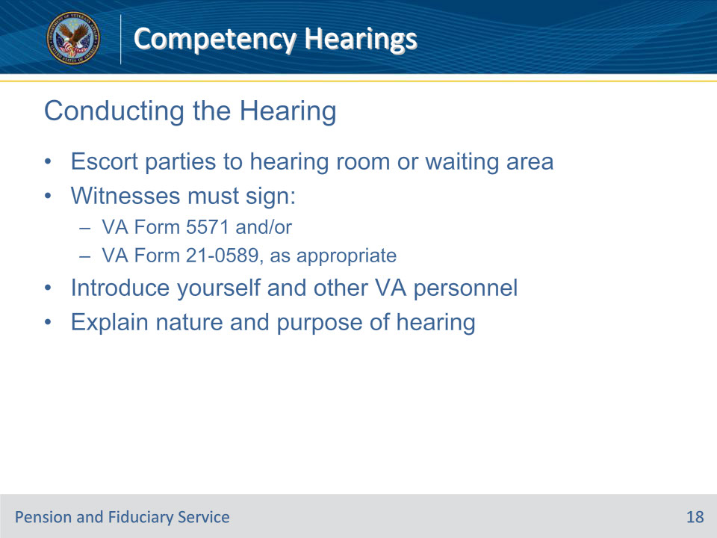
Slide notes

Policy Reference(s): M21-1 X.v.1.D.4.a.

Instructor Notes:

• Escort the claimant, witnesses, and his/her representative to the hearing room or appropriate waiting area.

• Where witnesses will be present at the hearing, ensure that VA Form 5571, Authorization to Disclose a Record in the Presence of a Third Party, and/or VA Form 21-0589, Authorization to Disclose a Record in the Presence of a Third Party (as appropriate), is completed.

• Introduce yourself and other VA personnel present, and begin the hearing without delay.

Notes:

• Listen carefully to the correct pronunciation of names.

• VA Form 5571 authorizes VA under the Privacy Act of 1974 to review and discuss VA records on a specified topic relating to the Veteran or claimant in the presence of an accompanying person.

• VA Form 21-0589 permits VA to review and discuss records containing medical treatment for specified conditions in front of named persons. The claimant can include or exclude information on drug abuse, alcoholism or alcohol abuse, human immunodeficiency virus, or sickle cell anemia.

Explain the nature and purpose of the hearing

Slide 19 - Conducting the Hearing (Cont.)
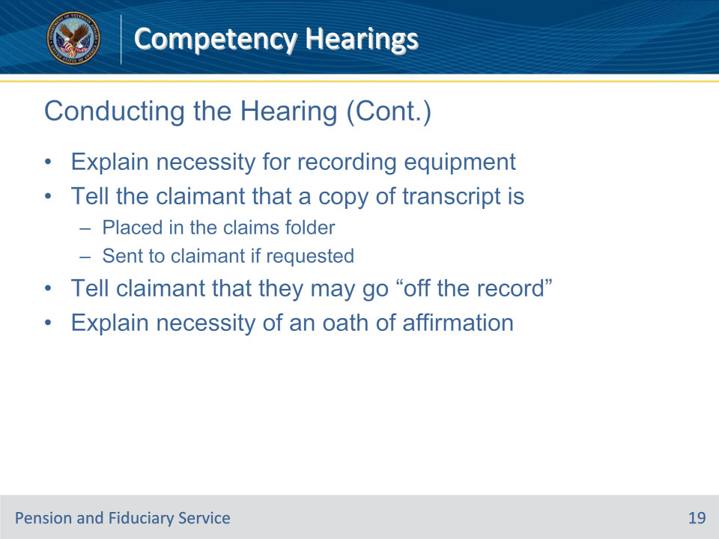
Slide notes

Policy Reference(s): M21-1 X.v.1.D.4.a.

Instructor Notes:

Explain the necessity for and use of recording equipment.

Tell the claimant that a copy of the transcript is

• placed in the claims folder, and

• sent to the claimant, if requested.

Tell the claimant and witnesses that they may “go off the record” to

• collect their thoughts, or

• clarify any matter

Explain the necessity of an oath or affirmation.

The above steps may be done before the transcription recording is started. If so, once on the record, briefly state that the matters were discussed beforehand.

Slide 20 - Attorneys
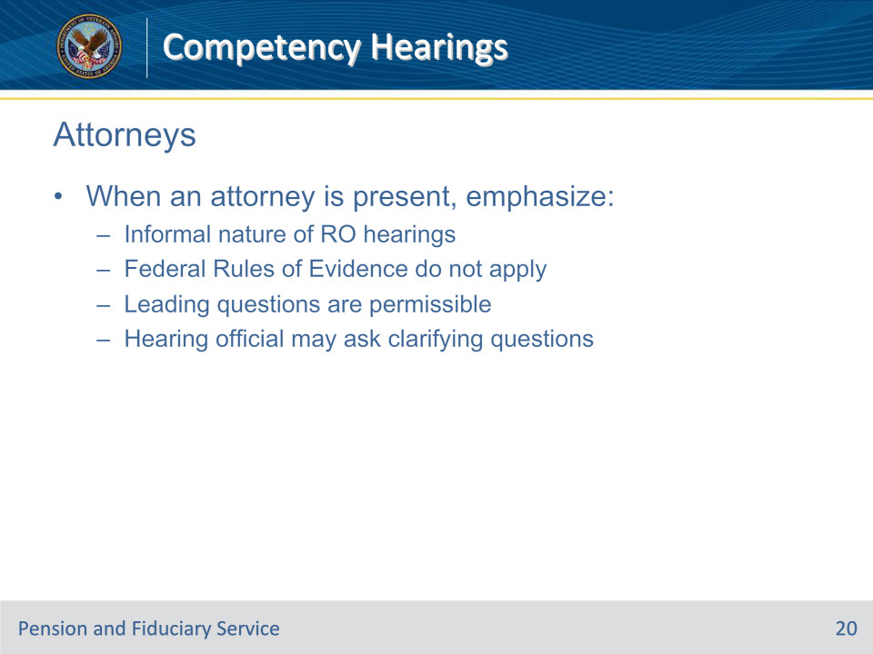
Slide notes

Policy Reference(s): M21-1 X.v.1.D.4.b.

Instructor Notes:

When the claimant’s representative is an attorney, emphasize the informal nature of RO hearings, specifically

• that the Federal Rules of Evidence do not apply

• that leading questions are permissible, and

• that the hearing official may ask questions to clarify testimony or ensure that facts important to the legal standard of entitlement are addressed; the questioning will not constitute cross-examination.

Slide 21 - Rights to Representation
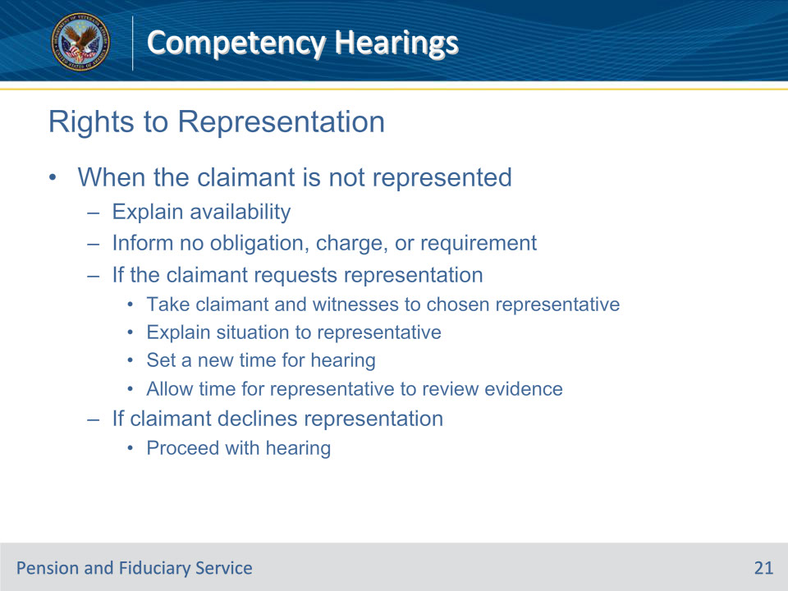
Slide notes

Policy Reference(s): M21-1 X.v.1.D.4.c.

Instructor Notes:

Follow these steps when the claimant is not represented by an attorney, VSO, agent, or other third party.

Explain the availability of

• a representative, or

• assistance by a member of the RO.

Inform the claimant of the following:

• there is no obligation to join a Veterans service organization

• there is no charge for representation, and

• representation is not mandatory.

Did the claimant request a representative?

• If yes,

• take the claimant and his/her witnesses to the chosen representative

• explain the situation to the representative, and

• Set a new time for the hearing to begin, and

• allow adequate time for the representative to review the evidence.

• If no,

• proceed with the hearing

Slide 22 - Before Testimony Begins
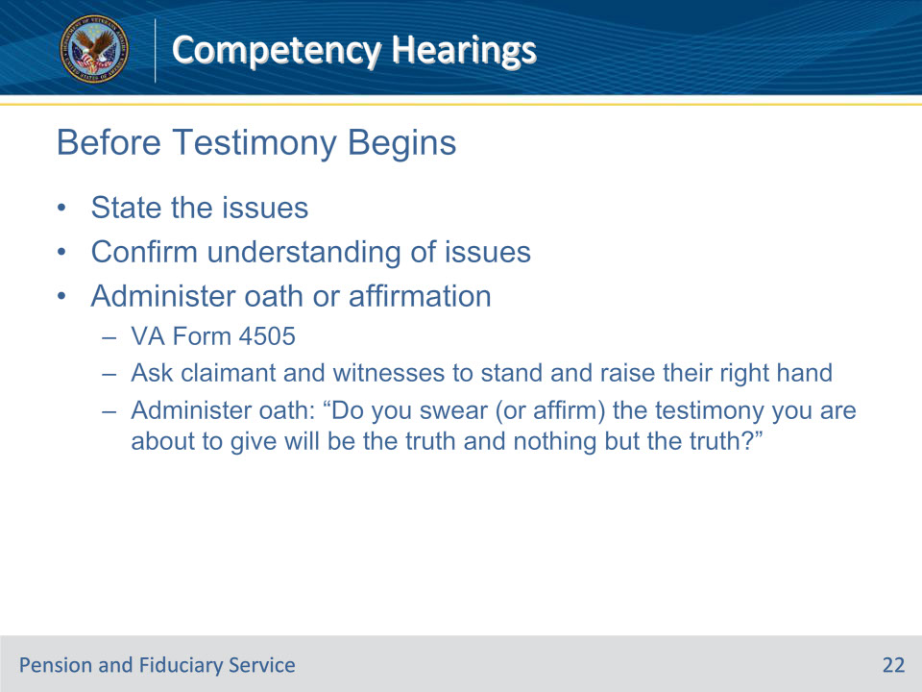
Slide notes

Policy Reference(s): M21-1 X.v.1.D.4.d.; e.

Instructor Notes:

State the issue(s) in detail before testimony begins. This will not be used to limit the scope of the relevant issue(s) or indicate to the claimant that testimony is to be curtailed.

Ask the claimant and his/her representative if this is their understanding of the issue(s) and clarify any misunderstandings at this time.

All hearing testimony is to be given under oath or affirmation. Administer the oath or affirmation before recording begins.

The hearing official has the authority to administer oaths and certify documents as evidenced by VA Form 4505, Identification Card-Delegation of Authority.

Follow these steps to administer the oath or affirmation:

Step 1: Ask the claimant and his/her witness(es) to stand and raise their right hand.

Step 2: Administer the oath substantially as follows: “Do you swear (or affirm) the testimony you are about to give will be the truth and nothing but the truth?”

Slide 23 - Starting the Hearing
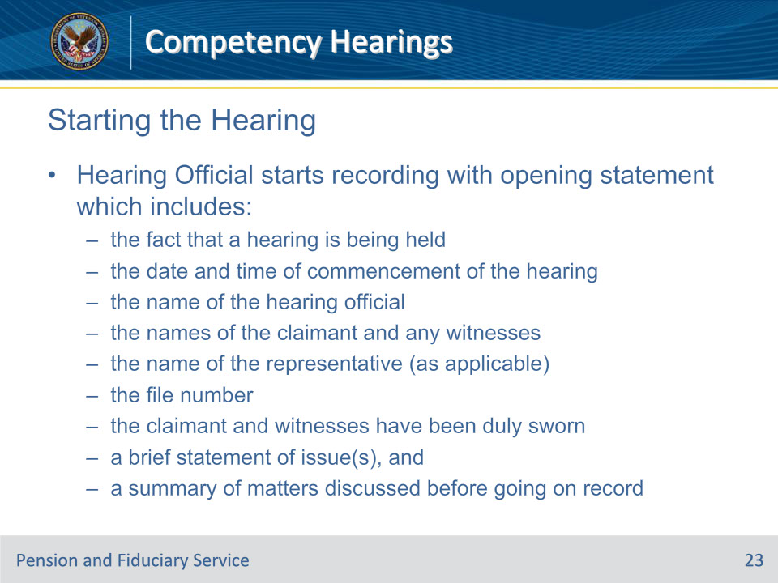
Slide notes

Policy Reference(s): M21-1 X.v.1.D.4.f.

Instructor Notes:

The hearing official starts recording the hearing with the opening statement which includes

• the fact that a hearing is being held

• the date and time of commencement of the hearing

• the name of the hearing official

• the names of the claimant/beneficiary and any other witnesses who will testify

• the name of the representative (as applicable)

• the file number

• the fact that the claimant and any witnesses have been duly sworn

• a brief statement of issue(s), and

• a brief summary of matters discussed before going on the record such as the informal and non-adversarial nature of the proceedings, that the Federal Rules of Evidence do not apply, that the hearing official may ask questions but there will be no cross examination, or that an unrepresented claimant/beneficiary was advised of the right of representation.

Slide 24 - Testimony: Stages
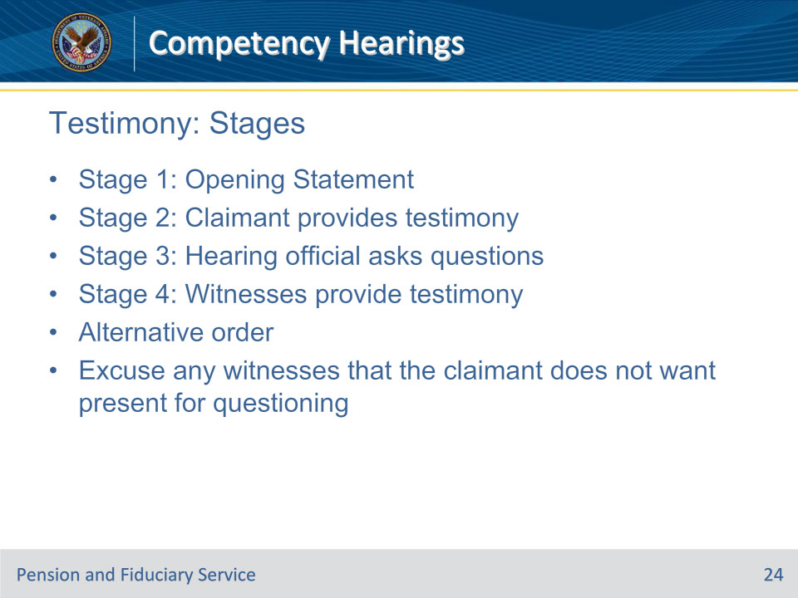
Slide notes

Policy Reference(s): M21-1 X.v.1.D.4.g.; h.

Instructor Notes:

These are the stages of how to elicit testimony and ask questions.

Stage 1: Hearing official asks the representative, if present, and/or claimant if he/she desires to make an opening statement. A representative is allowed to introduce the claimant’s testimony and ask questions about it.

Stage 2: Claimant provides testimony

Stage 3: Hearing official asks questions that are consistent with the non-adversarial nature of the hearing, and elicits all relevant testimony.

Stage 4: Witnesses provide testimony. Repeat stages three and four for any additional witnesses.

Some representatives may ask that the witness testify immediately after the claimant and before questioning. In this circumstance, question the claimant and witness after completion of all testimony.

Before questioning the claimant,

• ask if he/she objects to any of the witnesses being present, and

• if so, excuse the witness(es).

Slide 25 - Conduct
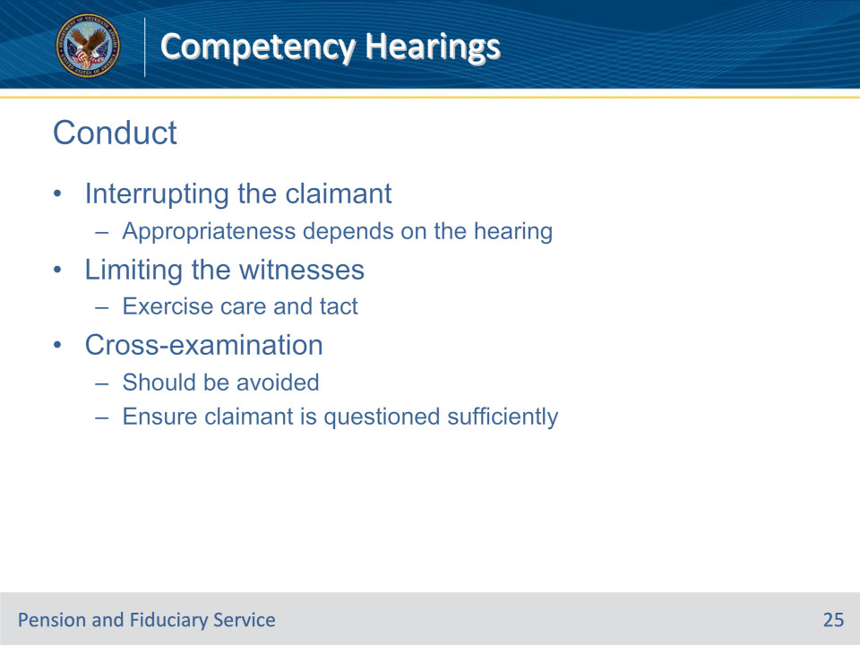
Slide notes

Policy Reference(s): M21-1 X.v.1.D.4.i.

Instructor Notes:

Interrupting the Claimant

The appropriateness of interrupting the claimant or the witness(es), or suggesting areas that should be further developed during the course of testimony, depends on the individual hearing.

Limiting the Witness(es)

Exercise care and tact in limiting the witness(es) and guard against any suggestion that the testimony is not important.

Cross-examination

While cross-examination should be avoided, it is important that the claimant be questioned sufficiently to elicit all relevant testimony.

Slide 26 - Ending the Hearing
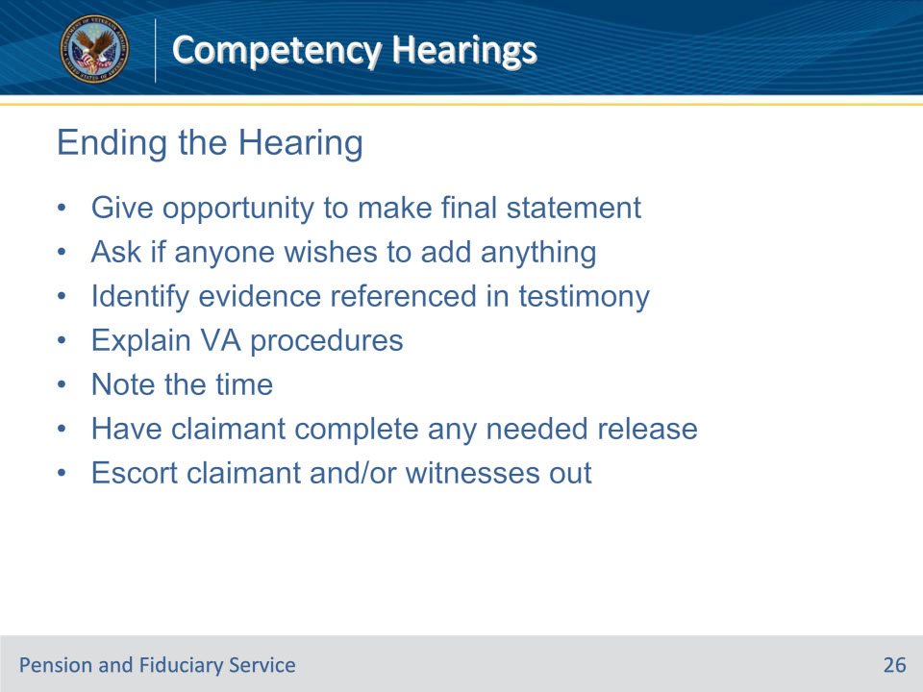
Slide notes

Policy Reference(s): M21-1 X.v.1.D.4.j.

Instructor Notes:

These are the steps to ending the hearing:

Step 1:

• Give the claimant and his/her representative an opportunity to make a final statement when

• testimony is complete, and/or

• discussion of any area raised by questioning has been concluded

• ask if anyone wishes to add anything, and

• identify any evidence referenced in the hearing testimony that

• the claimant has agreed to furnish, and/or

• VA will attempt to acquire.

Step 2: Explain VA’s procedures regarding decision notification, specifically that the claimant will not be provided with oral or written notification of the formal written decision until it has been signed and, if necessary, approved.

Step 3:

• Note the time the hearing concludes for the record

• have the claimant complete any medical release forms needed to obtain private treatment records, and

• escort the claimant and/or witness(es) from the hearing area.

This procedure is not applicable for termination of the hearing due to inappropriate conduct by hearing attendees

Slide 27 - Transcribing the Hearing
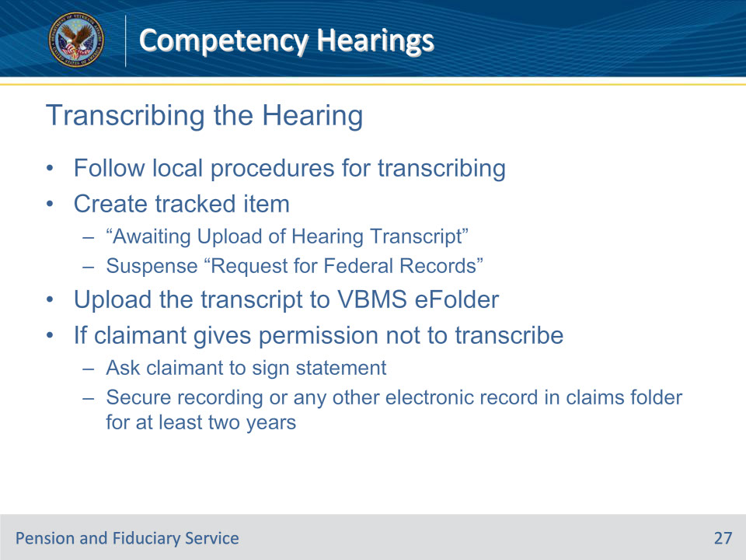
Slide notes

Policy Reference(s): M21-1 X.v.1.D.6.

Instructor Notes:

Follow local procedures for transcribing hearings.

If processing the claim in VBMS, create a tracked item Awaiting Upload of Hearing Transcript with the suspense reason Request for Federal Records and a suspense date in accordance with local procedures while transcription of the hearing is pending.

Follow these procedures to add the hearing transcript to the claims folder:

• If the hearing transcript is received electronically, upload the document to the electronic claims folder (eFolder) in VBMS.

• If a hard copy of the hearing transcript is received, send the transcript to the scanning vendor for upload into VBMS.

If the claimant gives his/her permission not to prepare a typed transcript of the hearing,

• ask the claimant to sign the following statement at the hearing: I hereby waive any requirement that the record of my hearing will be transcribed. A hearing transcript will be prepared if my records are eventually referred to BVA for a decision on this issue, and

• secure any tape recording or other electronic record in the claims folder for a period of at least two years after the hearing, at which time it will be recycled or destroyed.

Slide 28 - Reviewing the Evidence
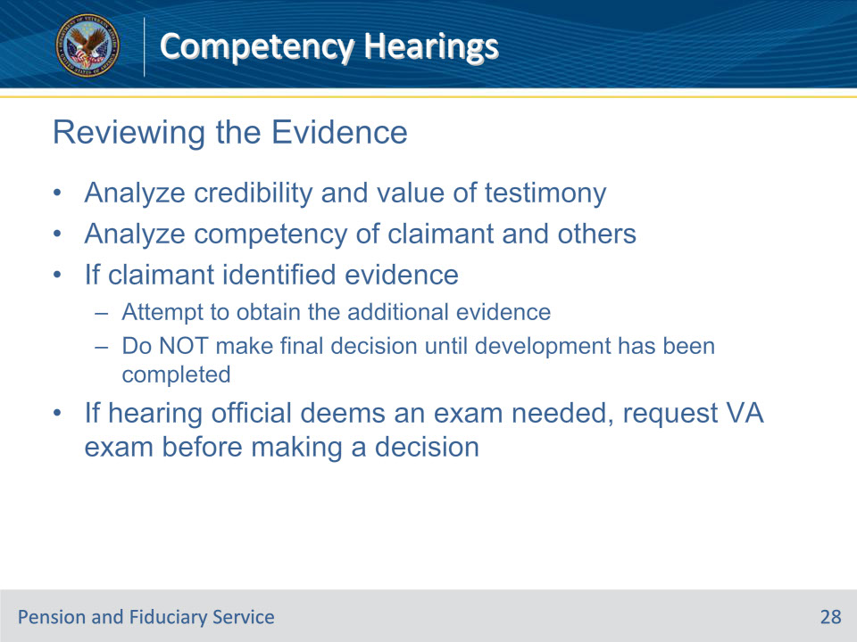
Slide notes

Policy Reference(s): M21-1 X.v.1.D.7.

Instructor Notes:

Analyze the credibility and value of testimony presented by the claimant and others who testified on the claimant’s behalf. Take care to distinguish between testimony and argument.

Analyze the competency of the claimant and others who testified on the claimant’s behalf to establish specific factual matters.

If the claimant identified sources of information or evidence while testifying that corroborates the claim,

• attempt to obtain the additional evidence, and

• do not make a final decision on the claim until development has been completed.

Example: The claimant states that he was treated by Dr. John Smith, and Dr. Smith’s report is not in the claims folder. Reasonable efforts must be made to obtain that report before making a decision.

If, during the course of a hearing or review of the claims folder after the hearing, the hearing official concluded that an examination should have been or should now be ordered based on new evidence, request a VA examination before making a decision.

Slide 29 - Questions?
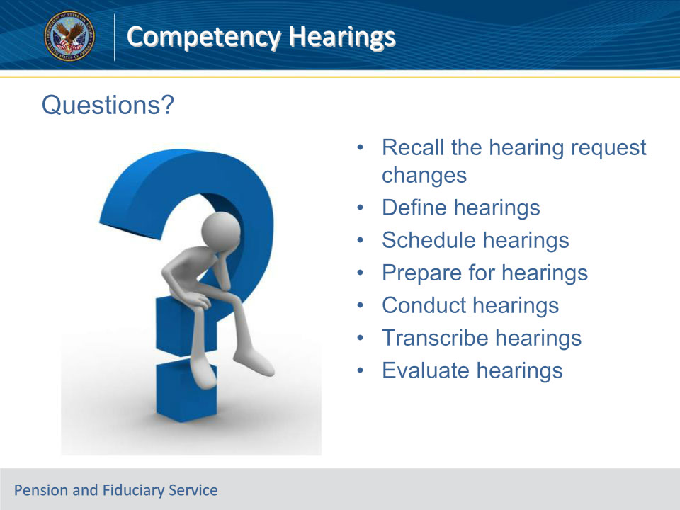
Slide notes

Instructor Notes:

(Recall) These are our learning objectives as stated from the beginning of the training:

Recall the hearing request changes

Define hearings

Schedule hearings

Prepare for hearings

Conduct hearings

Transcribe hearings

Evaluate hearings

Please submit any questions to the P&F Service mailbox listed on this slide.

Questions should be filtered through your QRT team. They will submit your questions to the Field Inquiry Tool (FIT) on your behalf.

Slide 30 - TMS Survey/Assessment
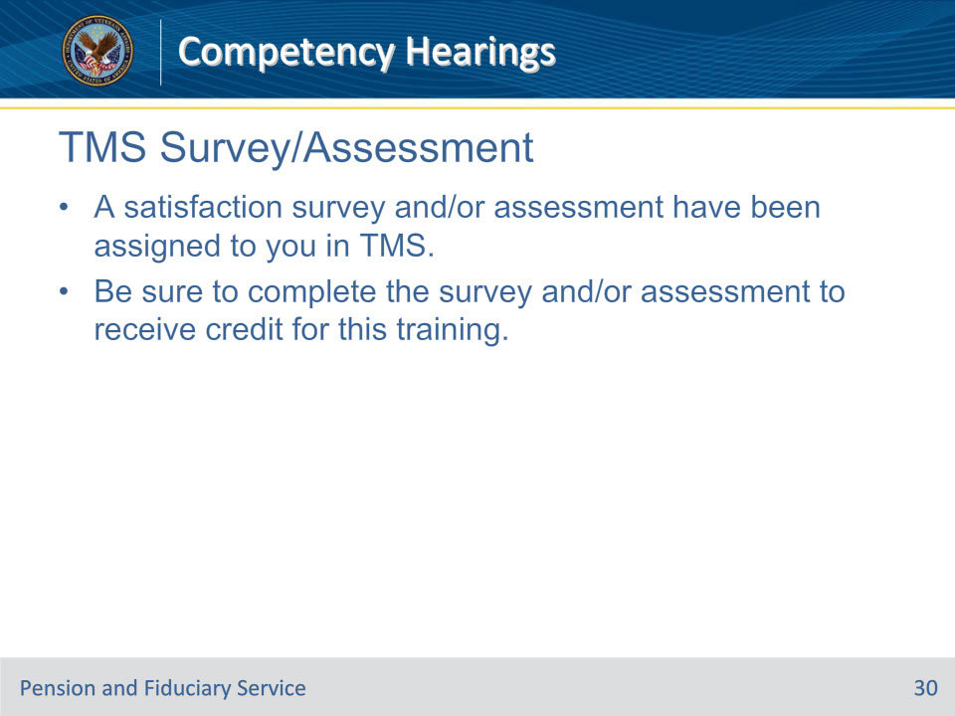
Slide notes

Instructor Notes

A satisfaction survey and/or assessment have been assigned to you in TMS.

Be sure to complete the survey and/or assessment to receive credit for this training.

