Slide 1 - Unscheduled Follow-up Field Examinations
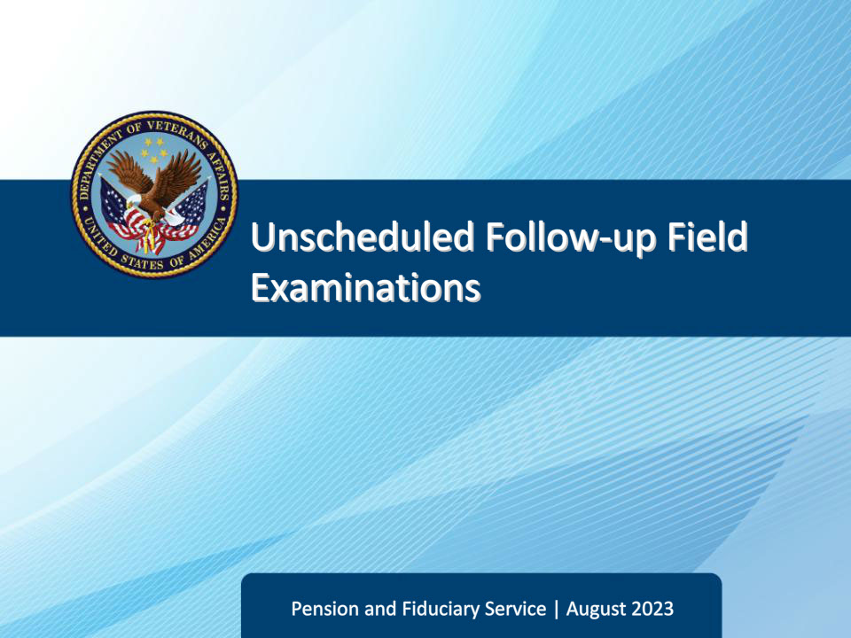
Slide notes

Course Description:

The lesson teaches learners about the purpose, critical elements, and specific requirements of unscheduled follow-up field examinations to include how an unscheduled and/or non-program field examination is initiated, documented, and reported.

Slide 2 - Navigation
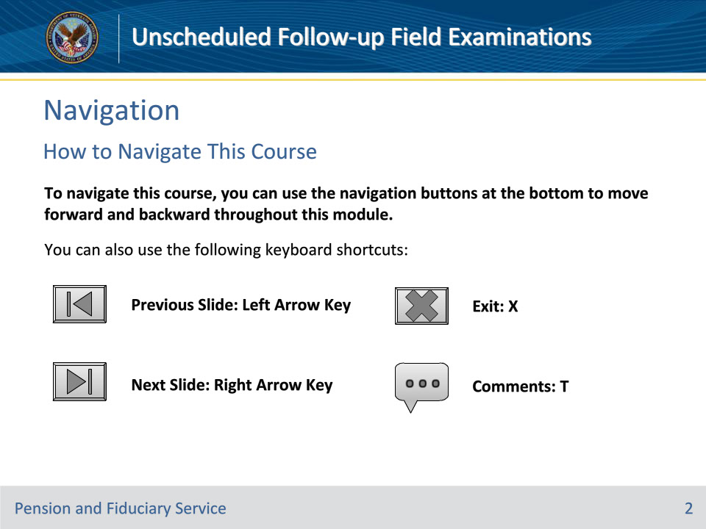
Slide notes

To navigate this course, you can use the navigation buttons at the bottom to move forward and backward throughout this module.

You can also use the following keyboard shortcuts:

• Previous Slide: Left Arrow Key

• Next Slide: Right Arrow Key

• Exit: X

• Comments: T

Slide 3 - Objectives
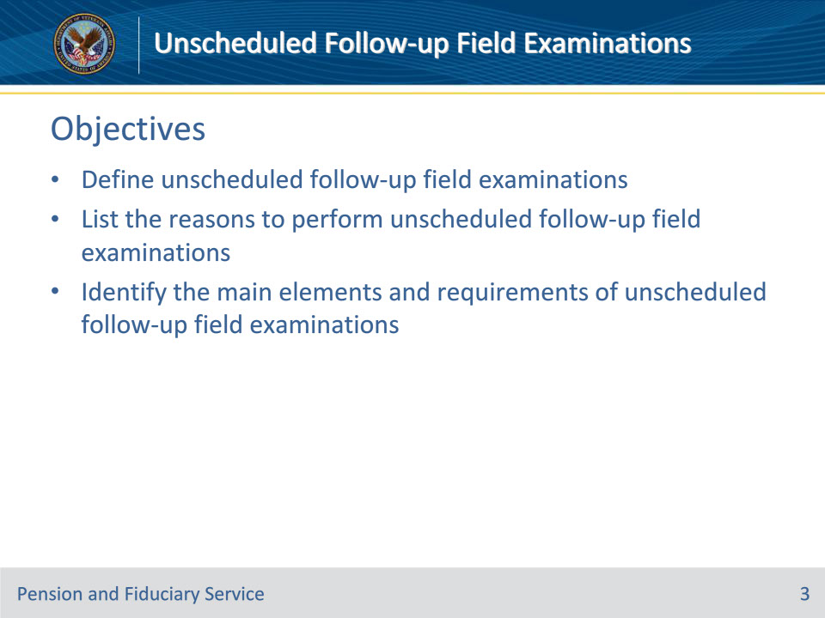
Slide notes

At the end of this lesson, given the training and references, the learner will be able to do the following:

• Define unscheduled follow-up field examinations

• List the reasons to perform unscheduled follow-up field examinations

• Identify the main elements and requirements of unscheduled follow-up field examinations

Slide 4 - References
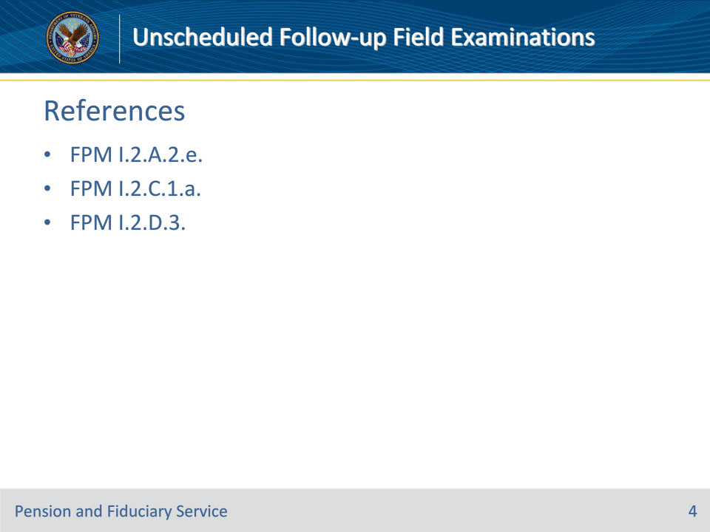
Slide notes

Instructor Notes:

These are the relevant references pertaining to this course:

• FPM I.2.A.2.e. Types of Follow-up Field Examinations

• FPM I.2.C.1.a. Documenting the Interview Logistics

• FPM I.2.D.3. Unscheduled Field Examinations

Slide 5 - Definition
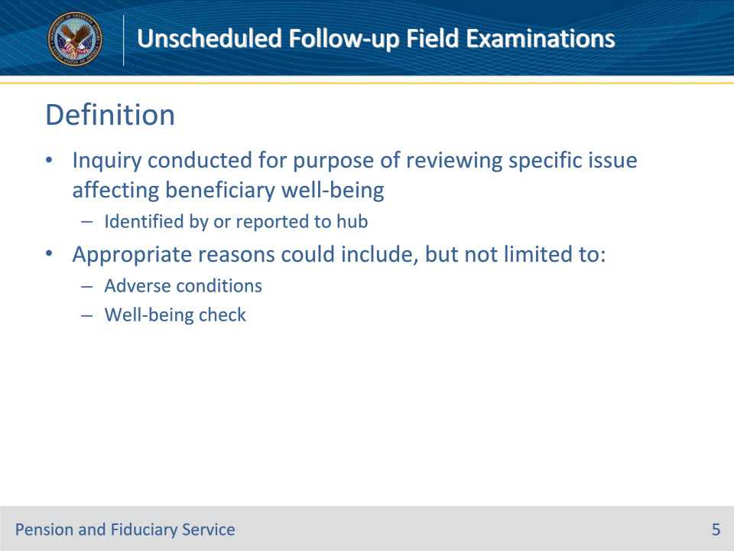
Slide notes

Policy Reference(s): FPM I.2.A.2.e.

Instructor Notes:

Unscheduled follow-up field examinations: The inquiry conducted for the purpose of reviewing a specific issue affecting the beneficiary’s well-being, which was identified by or reported to the hub. Appropriate reasons for unscheduled follow-up field examination requests could include, but are not limited to

• adverse conditions, or

• a well-being check.

Slide 6 - Purpose
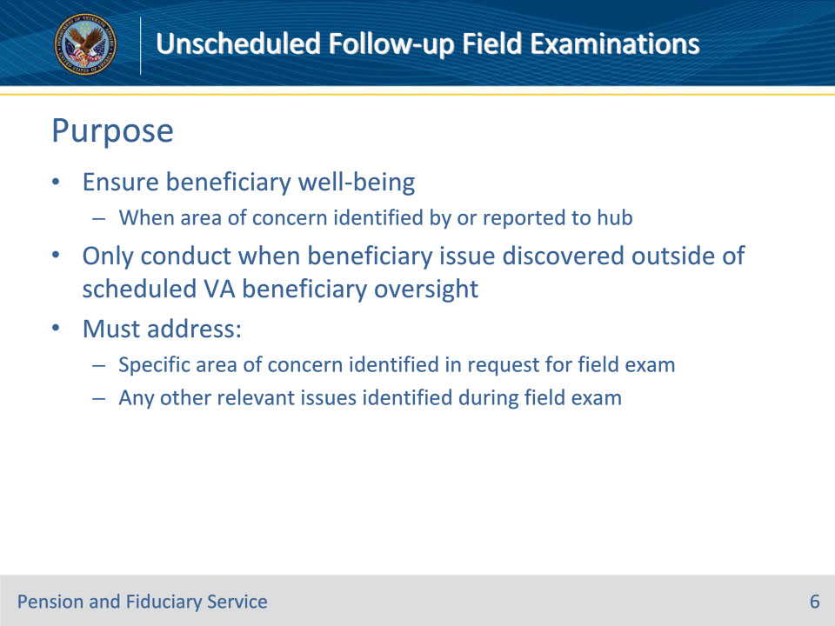
Slide notes

Policy Reference(s): FPM I.2.D.3.a.

Instructor Notes:

VA uses unscheduled field examinations to ensure beneficiary well-being when an area of concern with the beneficiary is identified by or reported to the hub. Therefore, only conduct unscheduled follow-up field examinations when a beneficiary issue is discovered outside of VA’s scheduled beneficiary oversight.

The unscheduled follow-up field examination must address

• the specific area of beneficiary well-being concern identified in the request for the field examination, and

• any other relevant issues identified during the field examination.

Slide 7 - Reasons
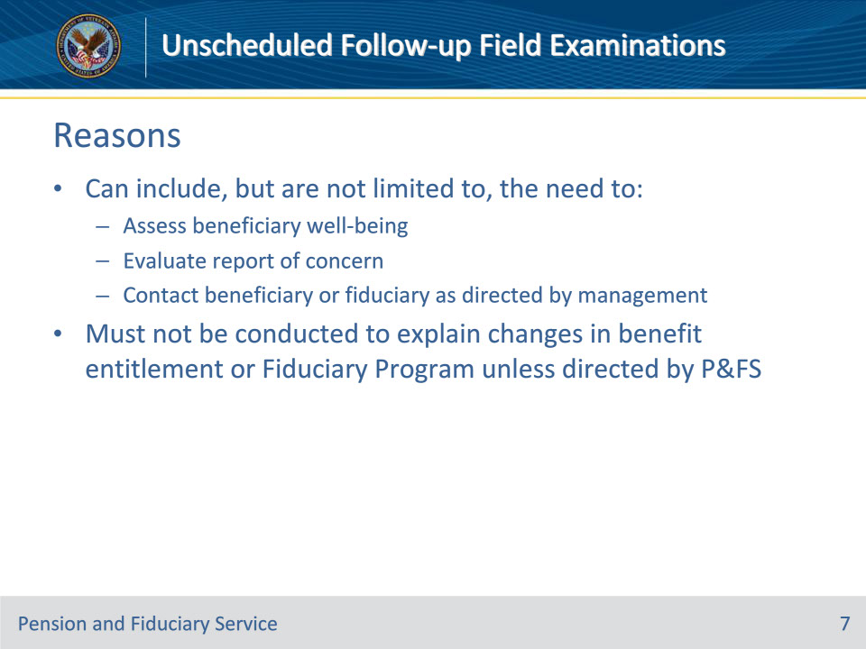
Slide notes

Policy Reference(s): FPM I.2.D.3.b.

Instructor Notes:

Reasons for conducting unscheduled follow-up field examinations can include, but are not limited to, the need to

• assess a beneficiary’s well-being

• evaluate a report of concern received from an internal or external source, and

• contact a beneficiary or fiduciary as directed by management consistent with the purpose of the unscheduled field examination

Unscheduled field examinations must not be conducted to explain changes in benefit entitlement or the Fiduciary Program unless directed by Pension and Fiduciary Service.

Slide 8 - Logistics
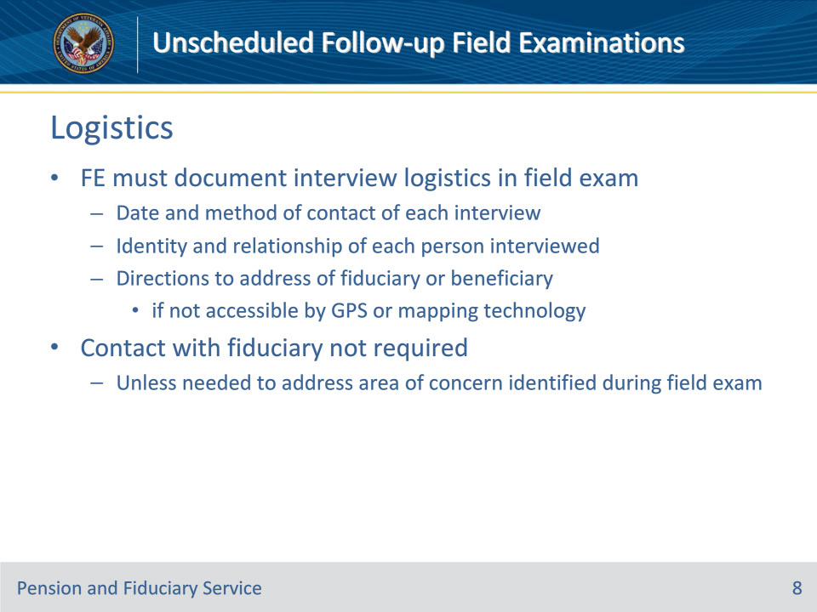
Slide notes

Policy Reference(s): FPM I.2.D.3.c.; FPM I.2.C.1.a.

Instructor Notes:

The FE must document the interview logistics.

The Field Examiner (FE) must provide information in the field examination that adequately details the interview, including

• date and method of contact of each interview

• identity and relationship of each person interviewed, and

• directions to the address of the fiduciary or beneficiary if it is not accessible by global positioning system or mapping technology.

Contact with the fiduciary is not required during unscheduled field examinations unless needed to address an area of concern identified during the field examination.

Slide 9 - Beneficiary Contact
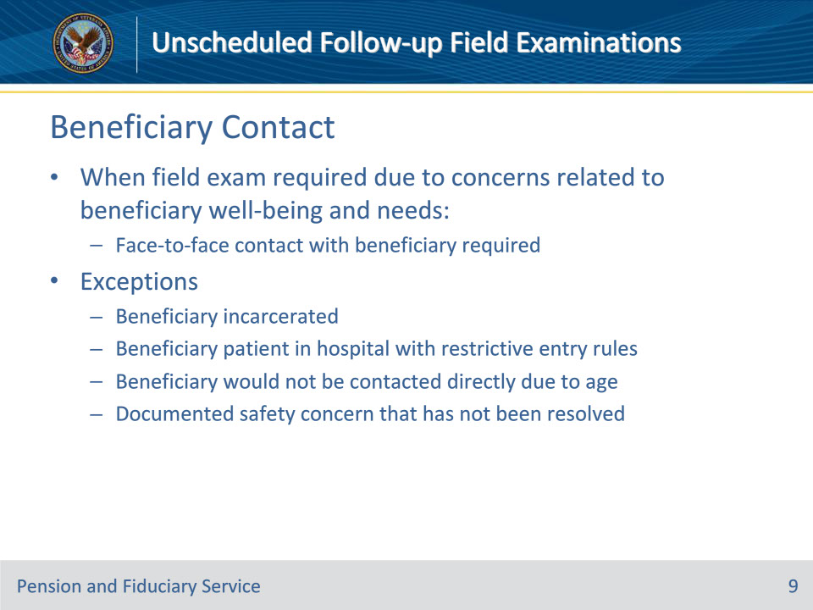
Slide notes

Policy Reference(s): FPM I.2.D.3.d.

Instructor Notes:

When an unscheduled field examination is required due to concerns related to the beneficiary’s well-being and needs, face-to-face contact with the beneficiary is required.

Exceptions: The FE must bypass the face-to-face field examination when

• the beneficiary

• is incarcerated

• is a patient in a hospital with restrictive entry rules, such as a facility for the criminally insane that requires warden approval, or

• would not be contacted directly because of their age, or

• there is a documented safety concern that has not been resolved.

Slide 10 - Beneficiary Contact
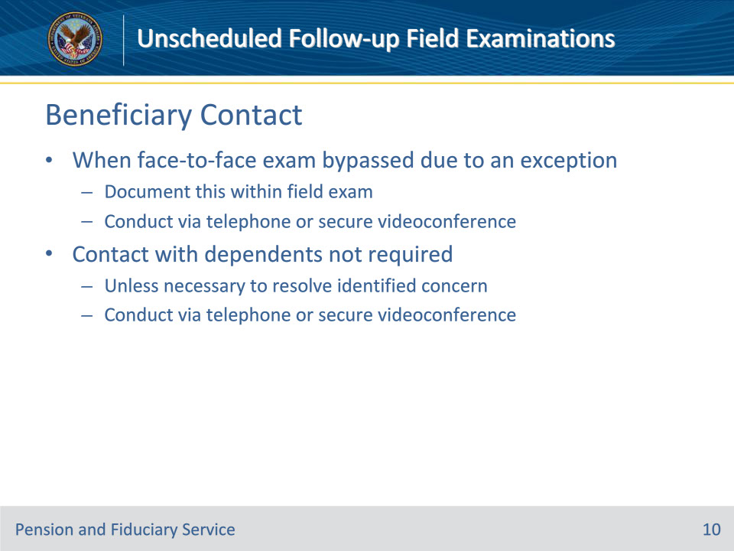
Slide notes

Policy Reference(s): FPM I.2.D.3.d.

Instructor Notes:

When the face-to-face exam is bypassed due to one of the exceptions listed above, the FE must document this information within the field examination.

• When face-to-face contact is not possible due to one of the exceptions listed on the previous slide, the FE must attempt to conduct the unscheduled field examination with the beneficiary telephonically, or via secure videoconferencing, if available.

• Contact with the beneficiary’s dependent(s) is not required unless a concern has been identified which requires contact with one or more dependents for resolution. When required, contact dependents telephonically or via secure videoconferencing.

Slide 11 - Well-Being Concerns
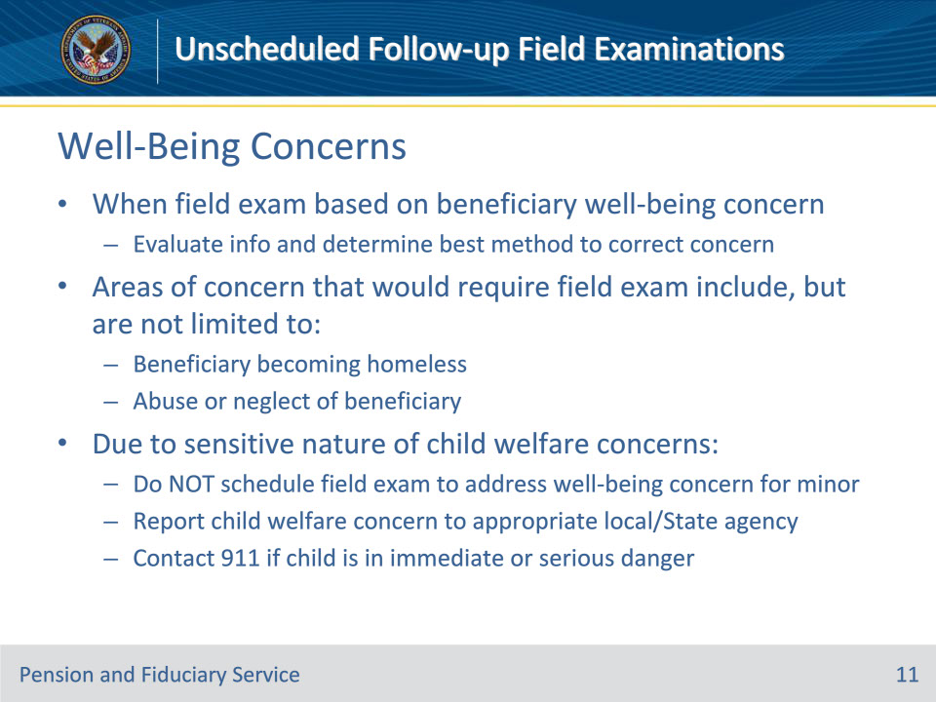
Slide notes

Policy Reference(s): FPM I.2.D.3.e.

Instructor Notes:

When an unscheduled field examination is based on a concern for the well-being of the adult beneficiary, the FE must evaluate the information received and determine the best method to correct the concern. Areas of concern related to the beneficiary that would require a field examination include, but are not limited to reports of

• a beneficiary becoming homeless, or

• abuse or neglect of the beneficiary.

Due to the sensitive nature of child welfare concerns that may involve abuse or neglect, do not schedule an unscheduled field examination to address a well-being concern for a beneficiary or dependent who is under the age of majority. Instead, the hub must report the child welfare concern to the appropriate local/State agency and contact 911 if the child is in immediate or serious danger.

Slide 12 - Well-Being Concerns
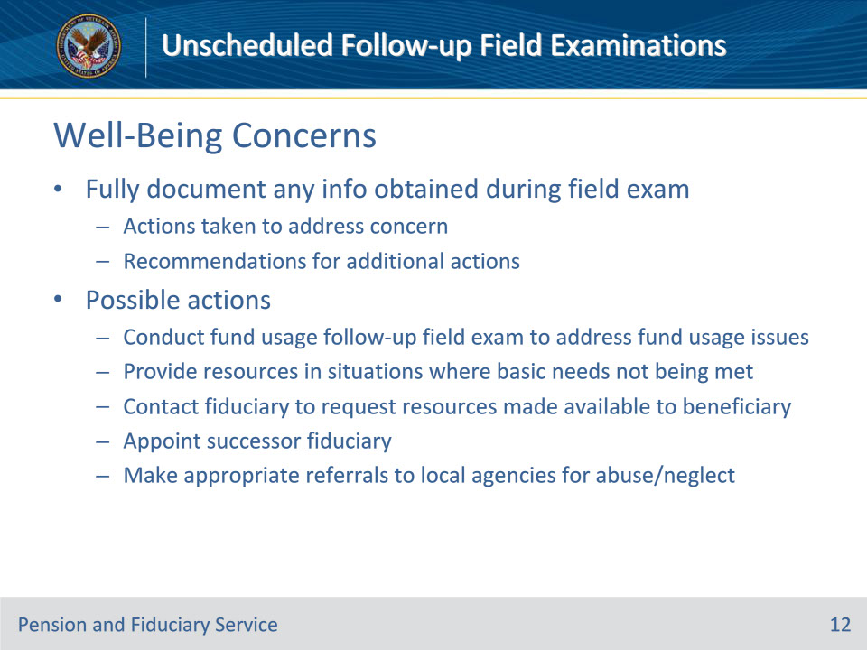
Slide notes

Policy Reference(s): FPM I.2.D.3.e.

Instructor Notes:

Any information obtained during the unscheduled follow-up field examination must be fully documented including actions taken to address the concern and recommendations for additional actions. Possible actions to take to correct the problem include

• conducting a fund usage follow-up field examination to address issues associated with the use of the beneficiary’s VA funds

• providing resources to the beneficiary in situations where basic needs are not being met

• contacting the fiduciary to request resources be made available to the beneficiary, if possible

• appointing a successor fiduciary, and/or

• making appropriate referrals to local agencies, where abuse/neglect are at issue.

Slide 13 - Scheduling
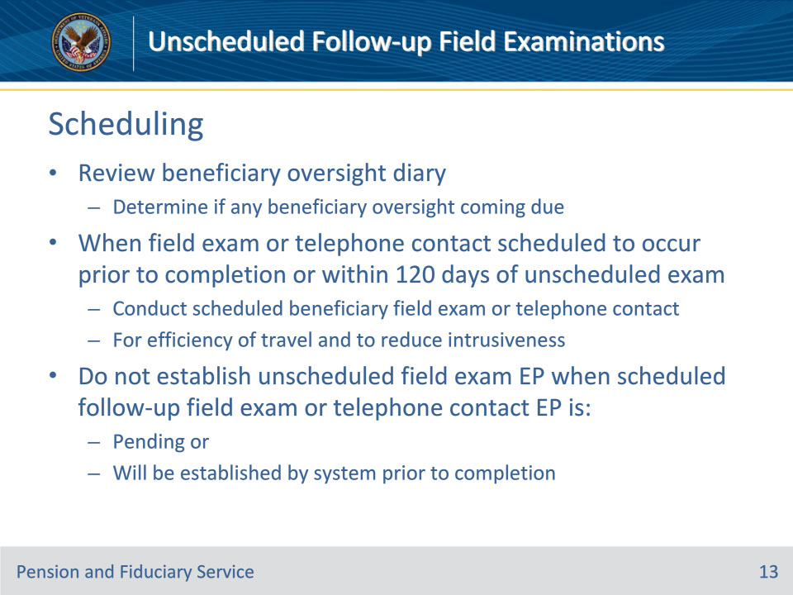
Slide notes

Policy Reference(s): FPM I.2.D.3.f.

Instructor Notes:

When an unscheduled follow-up field examination is requested, the hub must review the beneficiary’s oversight diary to determine if any beneficiary oversight is coming due.

When either a scheduled follow-up field examination or telephone contact oversight is due, or coming due, prior to the completion of the unscheduled field examination, complete the oversight and address the beneficiary concern.

For efficiency of travel and to reduce intrusiveness, the FE must review the upcoming beneficiary oversight diary date. When the beneficiary oversight diary (field examination or telephone) is scheduled to occur prior to completion of or within 120 days of the unscheduled field examination, conduct the scheduled beneficiary field examination or telephone contact.

Hubs should not establish a separate unscheduled field examination EP when a scheduled follow-up field examination or telephone contact EP is

• pending, or

• will be automatically by the system established prior to the completion of the unscheduled field examination.

Slide 14 - 31. Questions?
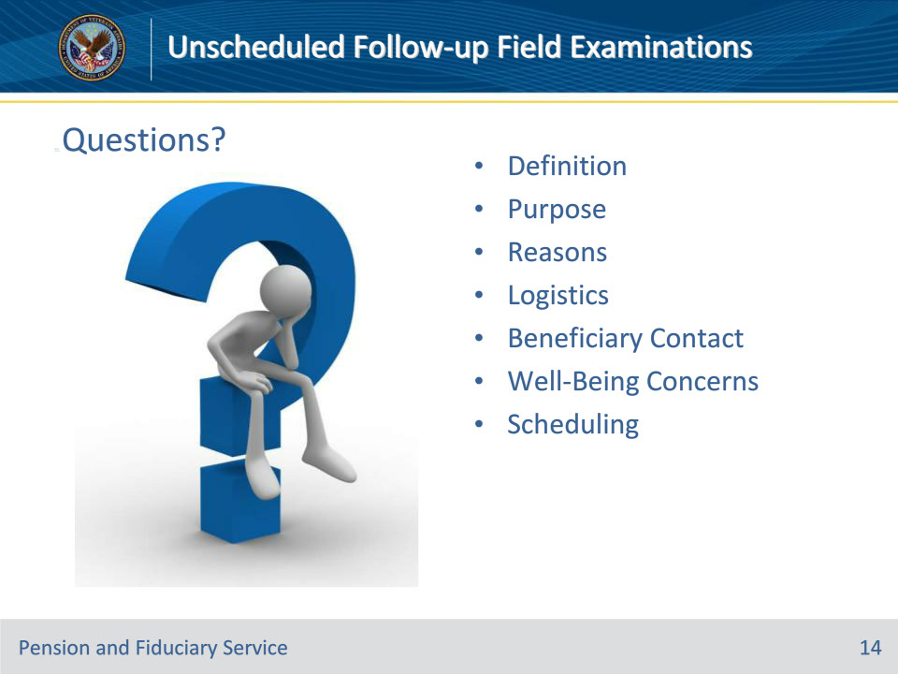
Slide notes

Instructor Notes:

(Recall) These are our learning objectives as stated from the beginning of the training:

• Define unscheduled follow-up field examinations

• List the reasons to perform unscheduled follow-up field examinations

• Identify the main elements and requirements of unscheduled follow-up field examinations

(Recap) We discussed each of these learning objectives through the following topics in each slide today:

• Definition

• Purpose

• Reasons
• Logistics

• Beneficiary Contact

• Well-Being Concerns

• Scheduling

Are there any additional questions?

Slide 15 - TMS Survey
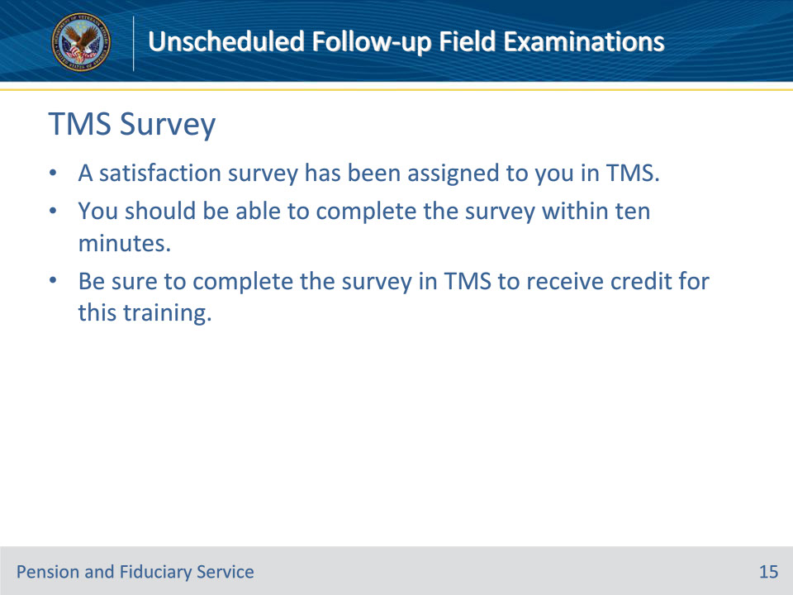
Slide notes

Instructor Notes:

A satisfaction survey has been assigned to you in TMS. You should be able to complete the survey within ten minutes. Completing the survey will allow you to receive credit for this training.

