Slide 1 - Termination of Supervision
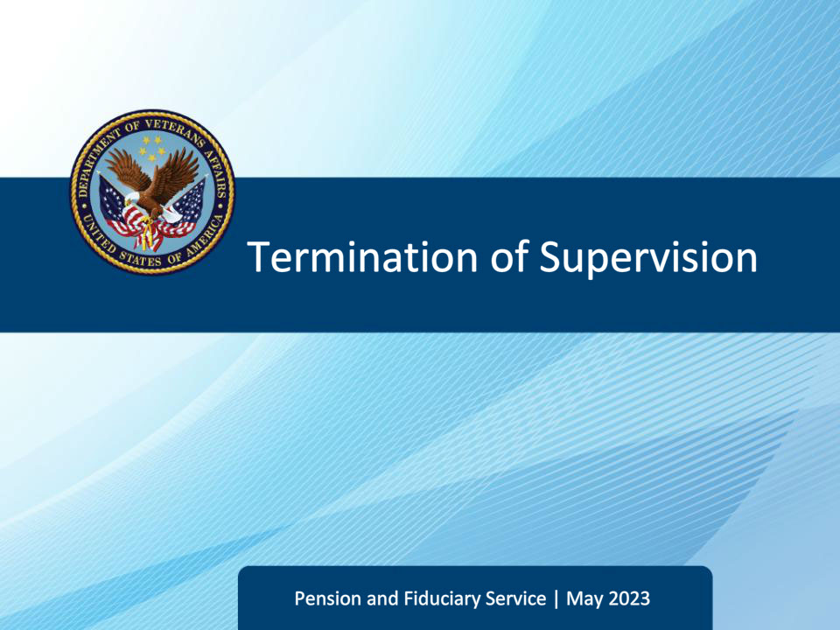
Slide notes

Course Description:

This course teaches how to recognize the situations and criteria for terminating fiduciary supervision and describes the procedures for how to terminate supervision and deactivate the beneficiary record.

Slide 2 - Navigation
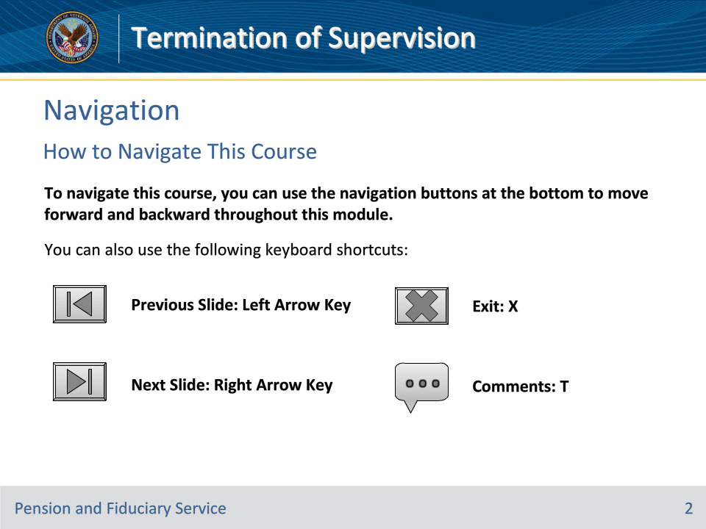
Slide notes

To navigate this course, you can use the navigation buttons at the bottom to move forward and backward throughout this module.

You can also use the following keyboard shortcuts:

• Previous Slide: Left Arrow Key

• Next Slide: Right Arrow Key

• Exit: X

• Comments: T

Slide 3 - Objectives
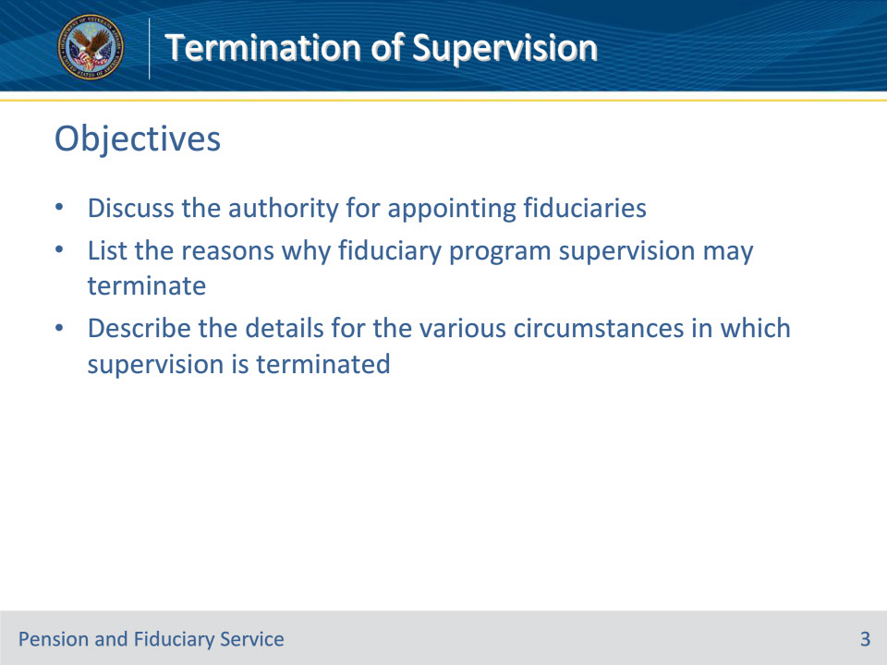
Slide notes

Instructor Notes:

At the end of this lesson, given the training and references, the learner will be able to do the following:

• Discuss the authority for appointing fiduciaries

• List the reasons why fiduciary program supervision may terminate

• Describe the details for the various circumstances in which supervision is terminated

Slide 4 - References
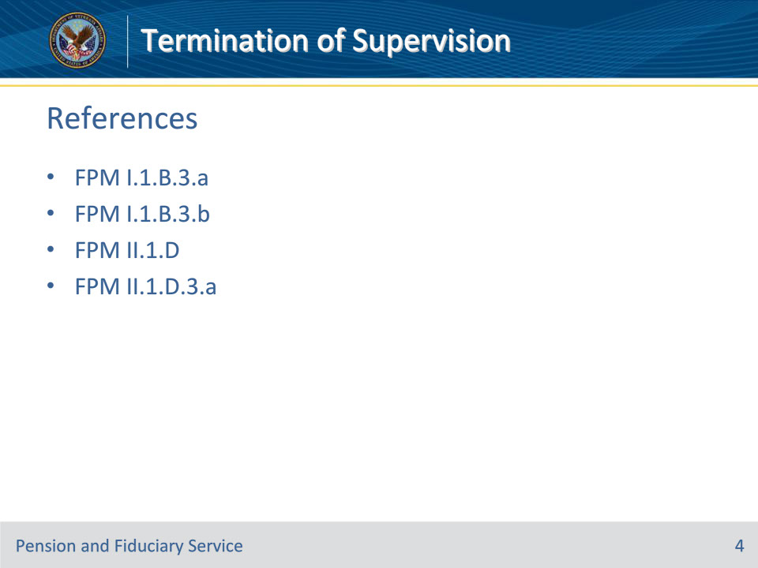
Slide notes

Instructor Notes:

These are the relevant references pertaining to this course:

• FPM I.1.B.3.a, Purpose of the Fiduciary Program

• FPM I.1.B.3.b, Assessing the Competence and Personal Well-Being of Beneficiaries

• FPM II.1.D, Managing Beneficiary and Fiduciary Records

• FPM II.1.D.3.a. Requirements for Deactivating an SDP Case

Slide 5 - Fiduciary Appointments
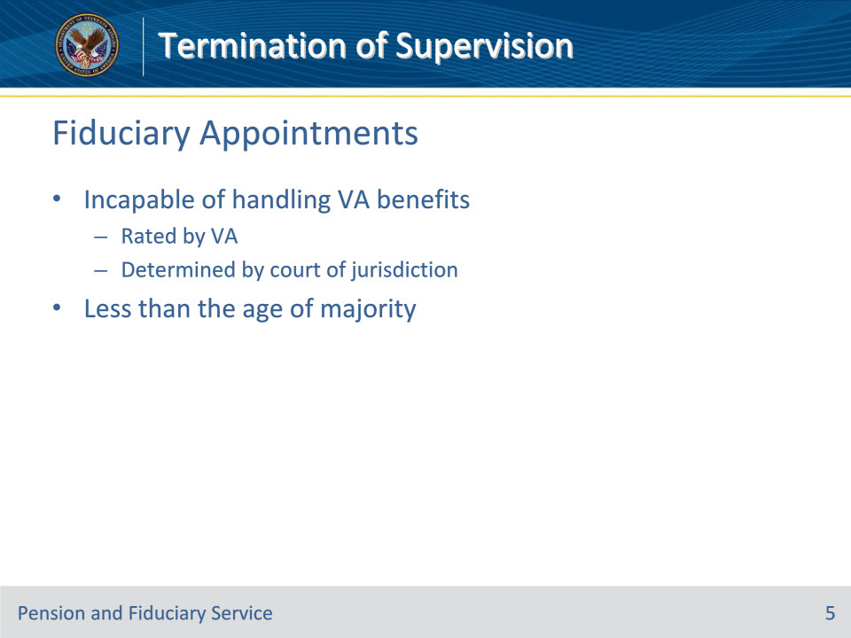
Slide notes

Policy Reference(s): FPM I.1.B.3.a.; b

Instructor Notes:

Before we discuss when it is appropriate to terminate fiduciary supervision, let’s review why, and when, the fiduciary program does provide supervision and appoints a fiduciary to manage the funds of a VA beneficiary.

VA appoints a fiduciary for a beneficiary who:

(1) Has been rated by VA as being unable to manage his or her VA benefits as a result of injury, disease, or infirmities of advanced age,

(2) Has been determined by a court with jurisdiction as being unable to manage his or her financial affairs, or

(3) Has not reached age of majority.

Now let’s move on to discuss the reasons why VA may terminate supervision in the fiduciary program…

Slide 6 - Supervision Termination
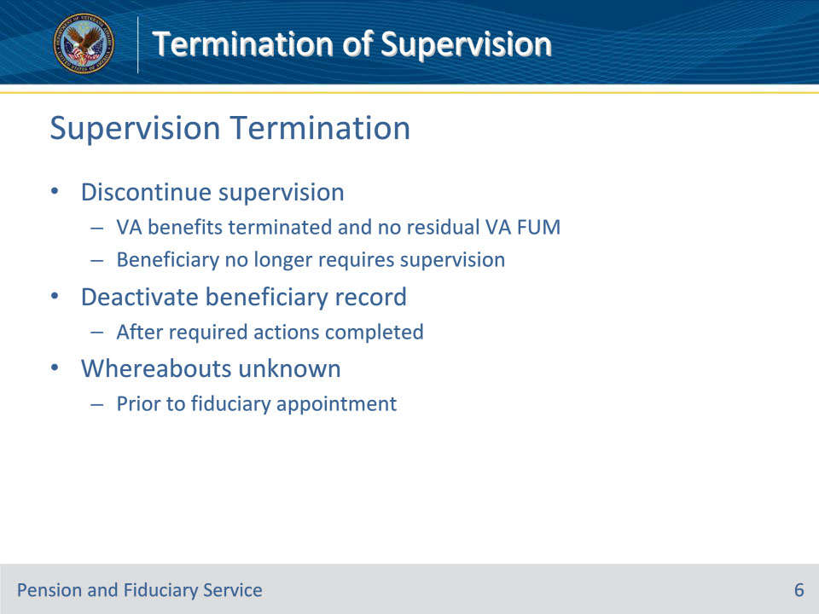
Slide notes

Policy Reference(s): FPM II.1.D.1.c; d; FPM II.1.D.2.a.-b

Instructor Notes:

Supervision of beneficiaries is discontinued when

• Department of Veterans Affairs (VA) benefits are terminated permanently, and no residual VA funds under management (FUM) exists, or

• the beneficiary no longer requires supervision in the handling of VA FUM.

Residual VA FUM does not include benefit debt/overpayment.

Usually, a beneficiary record is deactivated when supervision is terminated. Depending upon the type of beneficiary and fiduciary, certain actions may be required prior to deactivating the beneficiary record.

The beneficiary record must also be deactivated when the beneficiary cannot be located prior to the appointment of a fiduciary and benefits are suspended at the conclusion of the whereabouts unknown process. If the beneficiary is located, the hub must reactivate the record, resume benefits, and appoint a fiduciary.

The beneficiary record should not be deactivated when whereabouts are unknown, and a fiduciary has already been appointed.

Slide 7 - Adult Beneficiaries
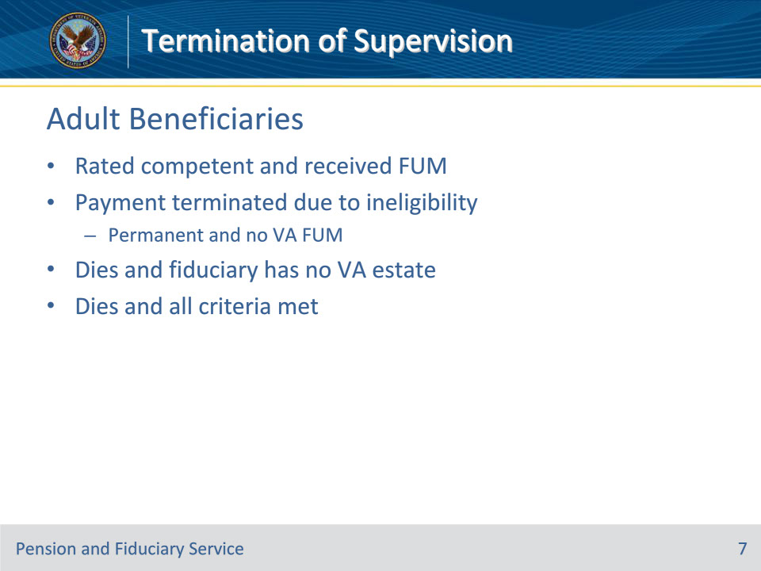
Slide notes

Policy Reference(s): FPM II.1.D.2.b

Instructor Notes:

Beneficiary records for cases in which there is a VA-appointed fiduciary for an adult should be deactivated when any of the following situations occur:

• the beneficiary has been rated competent and has acknowledged receipt of VA FUM

• payment is terminated because of ineligibility, there is no VA FUM, and termination of benefits appears to be permanent

• the beneficiary dies and there is no estate derived from VA benefits in the hands of the fiduciary, or

• the beneficiary dies and all criteria has been met.

Slide 8 - Minor Beneficiaries
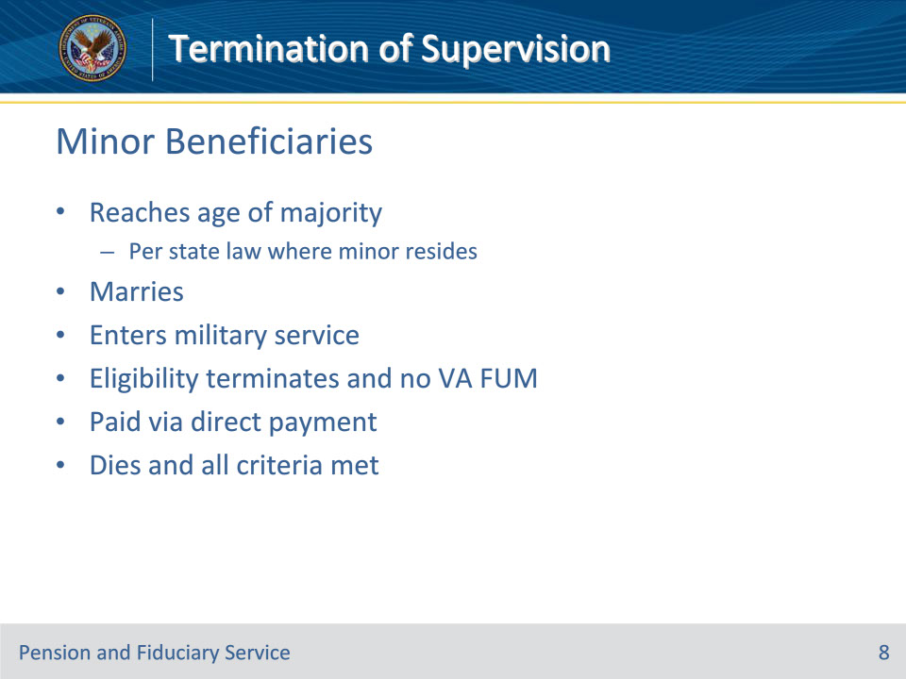
Slide notes

Policy Reference(s): FPM II.1.D.2.a

Instructor Notes:

Beneficiary records for cases involving minors are usually deactivated when the minor

• attains majority under the law of the State in which he/she resides

• marries

• enters military service

• has eligibility terminated and there is no VA FUM

• is paid via direct payment, or

• dies and the criteria has been met.

Notes:

• If a minor attains majority under the law of the State in which he/she resides, the case should be deactivated even if the minor is moving to another state having a different age of majority. When the beneficiary is entitled to benefits after majority, the hub must take action to notify the authorization activity and/or insurance center.

• A case must not be deactivated if the beneficiary requires supervision as a helpless child who is rated incompetent.

• If there is a VA-appointed fiduciary who is also court-appointed, the court must be notified when VA no longer has any interest in the case.

Slide 9 - Facilities
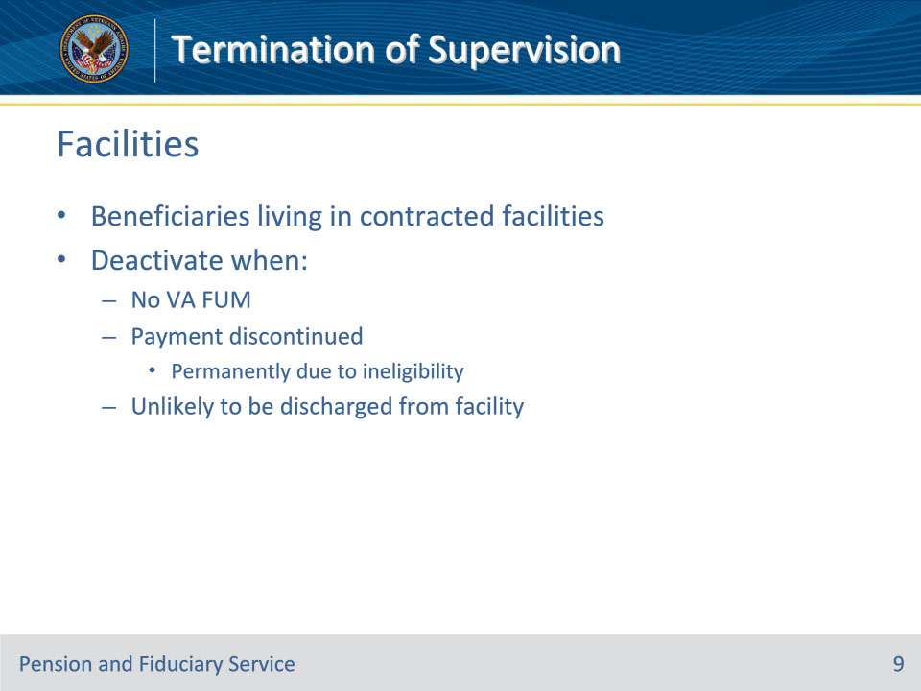
Slide notes

Policy Reference(s): FPM II.1.D.2.c

Instructor Notes:

Beneficiary records for cases involving a beneficiary living in a contracted facility should be deactivated when all of the following conditions are met:

• there is no VA FUM

• payment has been discontinued because of ineligibility and discontinuation of payment appears to be permanent, and

• the beneficiary is unlikely to be discharged from the facility.

Slide 10 - Death of Beneficiary
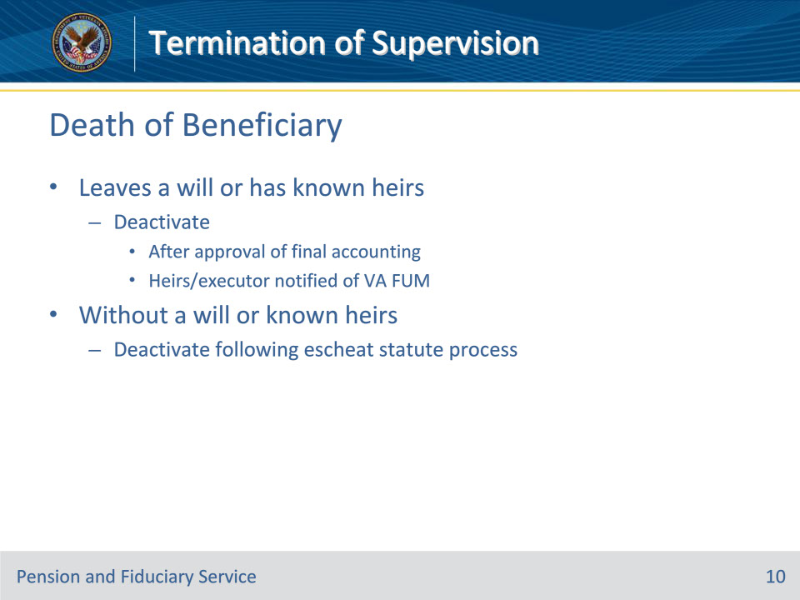
Slide notes

Policy Reference(s): FPM II.1.D.2.d

Instructor Notes:

Beneficiary records must be deactivated when a beneficiary has died.

The record of a deceased beneficiary must be deactivated when the beneficiary:

• leaves a will or there are known heirs, and the

• final accounting has been approved, if required, and

• heirs or administrator/executor have been notified of any remaining VA FUM, or

• dies without a will and without known heirs, after completion of the escheat actions.

Slide 11 - Spouse Fiduciaries
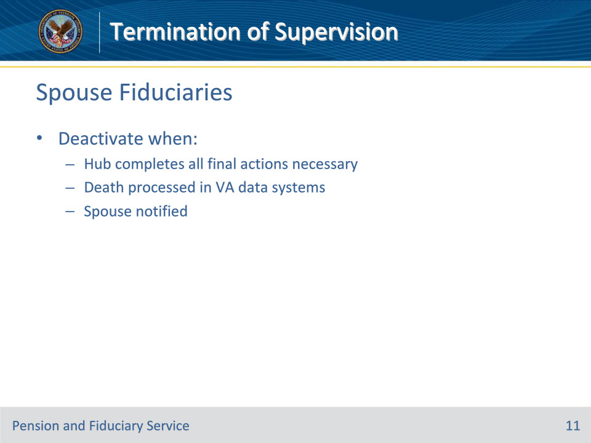
Slide notes

Policy Reference(s): FPM II.1.D.2.e

Instructor Notes:

Beneficiary records for cases in which there is a spouse fiduciary must be deactivated when the hub completes all final actions necessary to deactivate the beneficiary record, including processing of the beneficiary death in VA data systems and notification to the spouse payee of discontinuance of VA supervision.

Slide 12 - Temporary Fiduciaries
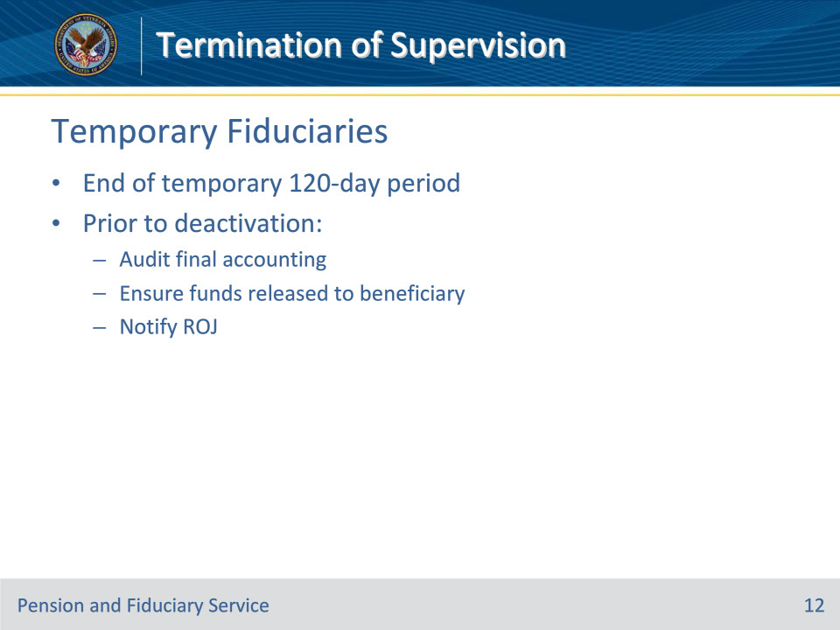
Slide notes

Policy Reference(s): FPM II.1.D.2.f

Instructor Notes:

Beneficiary records for cases in which there is a temporary fiduciary must be deactivated at the end of the temporary, 120-day period.

Prior to deactivating the beneficiary records, for a beneficiary that no longer requires supervision in the handling of VA FUM, fiduciary personnel must

• obtain and audit a final accounting from the temporary fiduciary

• ensure that any funds remaining in the hands of the temporary fiduciary have been released to the beneficiary, and

• notify the regional office of jurisdiction that the temporary period of supervision has expired.

Slide 13 - Restored Ability to Manage Affairs
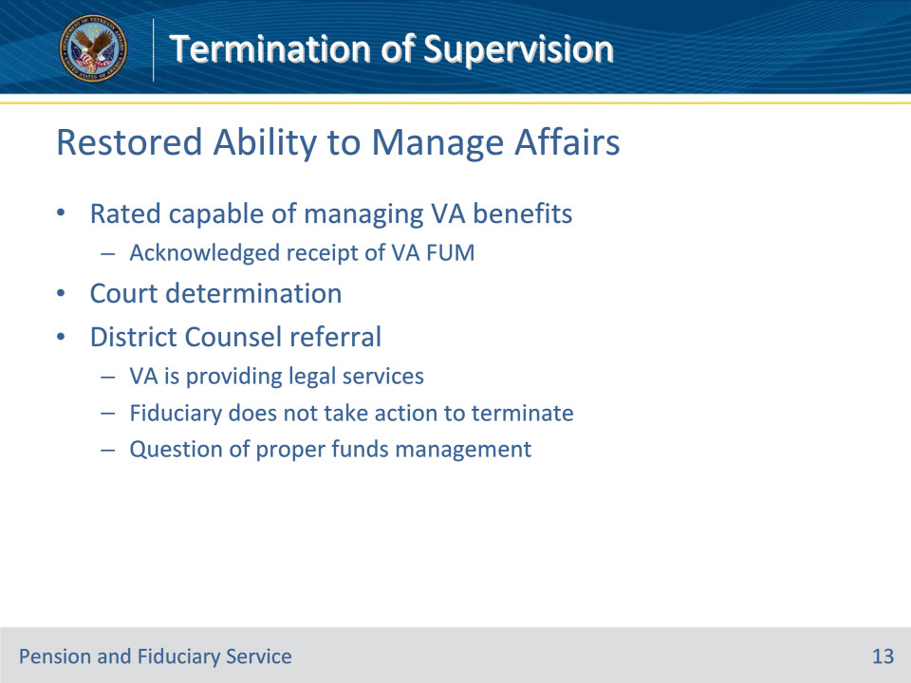
Slide notes

Policy Reference(s): FPM II.1.D.2.g

Instructor Notes:

Beneficiary records for cases in which there is a VA-appointed fiduciary for an adult should be deactivated when the beneficiary has been rated competent and has acknowledged receipt of VA FUM

A case that involves a court-appointed fiduciary for an adult payee must be deactivated at the earliest practical time after the hub has been notified that the beneficiary has been rated competent. The fiduciary activity must refer cases to the District Counsel for necessary action if restoration of competency is in order and VA

• is providing legal services, or

• is not providing legal services, but

• the fiduciary does not take action to terminate the court appointment in due course, or

• there is a question of proper FUM.

If the beneficiary is rated competent by VA, the case must be deactivated when direct payment has been certified and the District Counsel has been requested to take restoration action, regardless of whether the court restores the beneficiary to competency. The case does not remain active while the beneficiary works with the courts for restoration of competency.

Slide 14 - Benefits Terminated
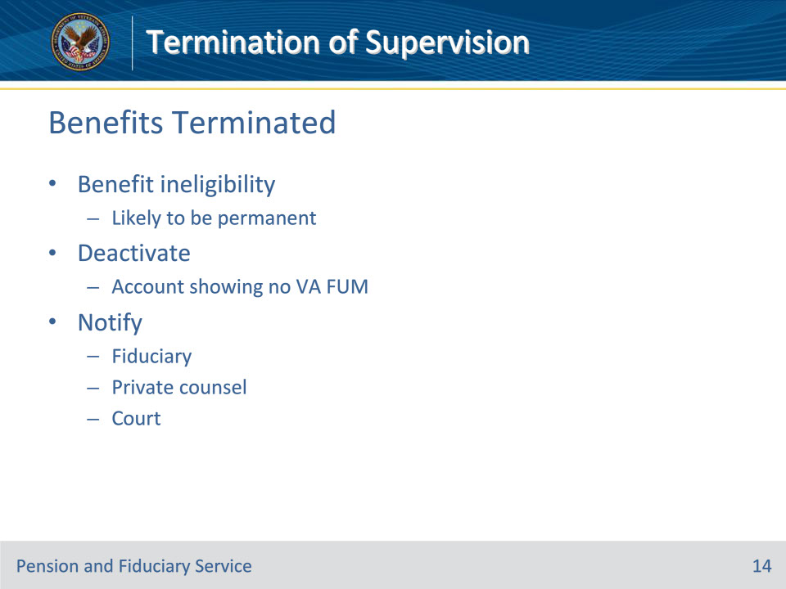
Slide notes

Policy Reference(s): FPM II.1.D.2.h

Instructor Notes:

Hub personnel must deactivate the beneficiary record as soon as is practical when a beneficiary is no longer eligible for VA benefits, and that ineligibility is likely to be permanent.

If restoration of competency is not in order, the

• case must be deactivated upon receipt of the first satisfactory account showing no VA FUM, and

• fiduciary, or private counsel, as appropriate, and the court must be notified of VA’s withdrawal and the reason.

These deactivating criteria also apply to cases in which a court-appointed fiduciary is still required for non-VA purposes, such as in cases involving a beneficiary with a large non-VA estate.

Slide 15 - Supervised Direct Pay
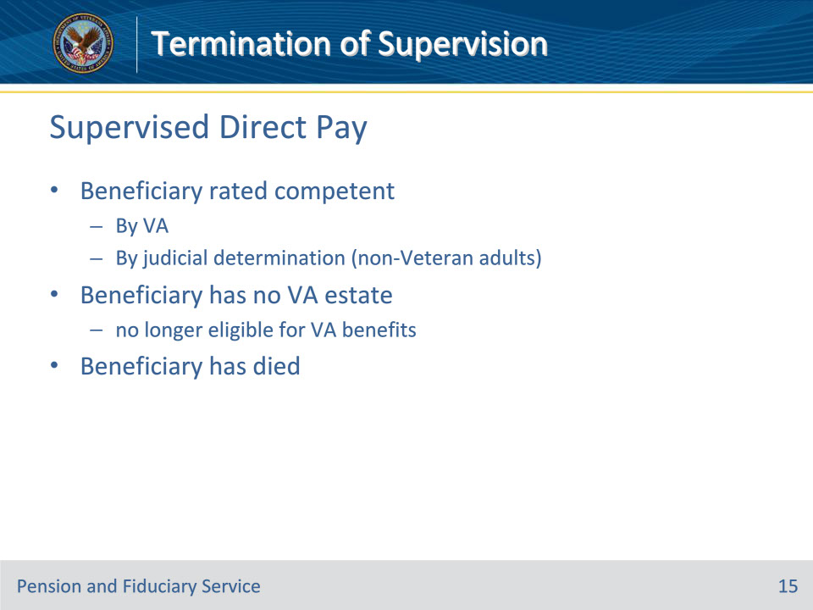
Slide notes

Policy Reference(s): FPM II.1.D.3.a

Instructor Notes:

The beneficiary record, for cases that involve a supervised direct payment (SDP) beneficiary, must be deactivated when any of the following situations occur:

• the beneficiary has been/is

• rated competent by VA, or

• determined to be competent by judicial determination for a non-veteran adult, and

• capable of handling VA benefits payable without supervision

• the beneficiary has no VA estate and is no longer eligible for VA benefits, or

• the beneficiary has died.

Slide 16 - Questions?
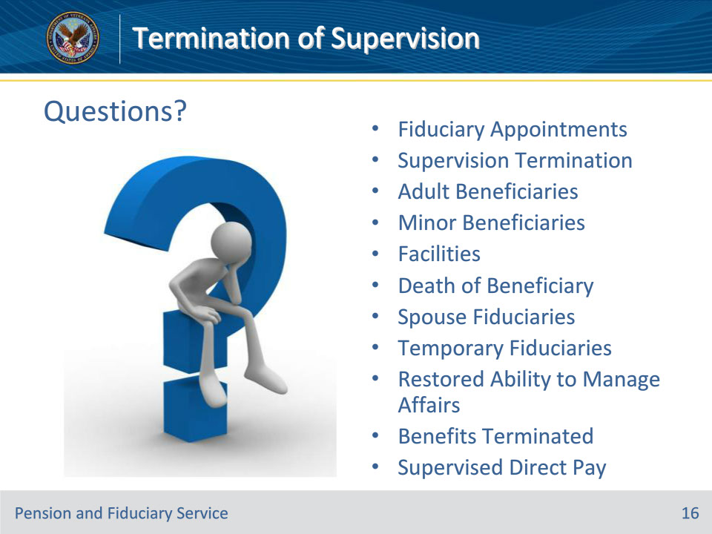
Slide notes

Instructor Notes:

(Recall) These are our learning objectives as stated from the beginning of the training:

• Discuss the authority for appointing fiduciaries

• List the reasons why fiduciary program supervision may terminate

• Describe the details for the various circumstances in which supervision is terminated

(Recap) We discussed each of these learning objectives through the following topics in each slide today:

• Fiduciary Appointments

• Supervision Termination

• Adult Beneficiaries

• Minor Beneficiaries

• Facilities

• Death of Beneficiary

• Spouse Fiduciaries

• Temporary Fiduciaries

• Restored Ability to Manage Affairs

• Benefits Terminated

• Supervised Direct Pay

Are there any additional questions?

Slide 17 - TMS Survey
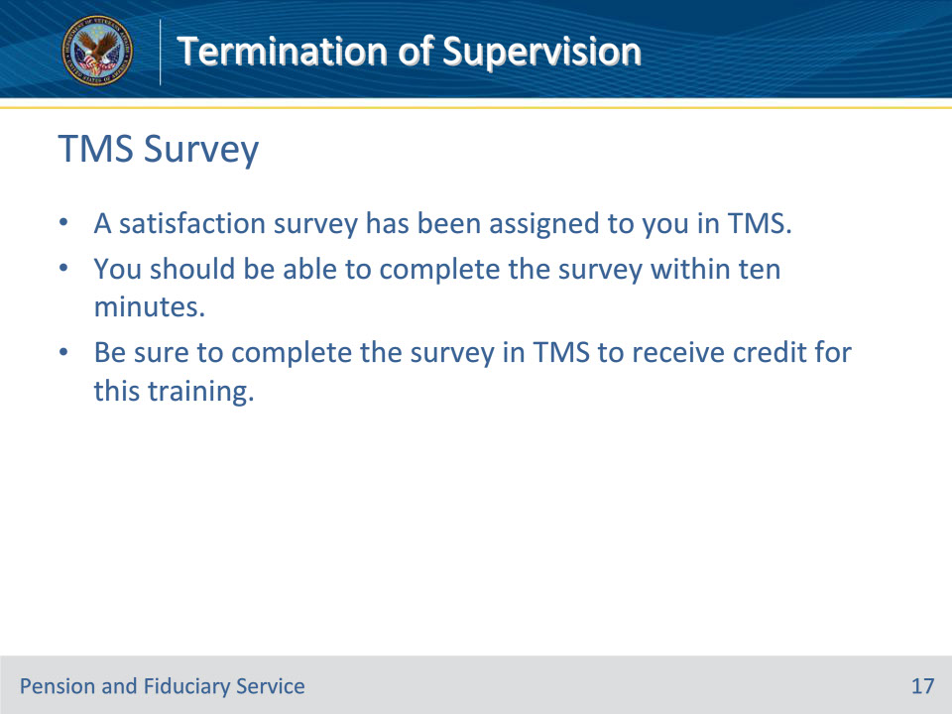
Slide notes

Instructor Notes:

A satisfaction survey has been assigned to you in TMS. You should be able to complete the survey within ten minutes. Completing the survey will allow you to receive credit for this training.

