Slide 1 - Minor Beneficiaries
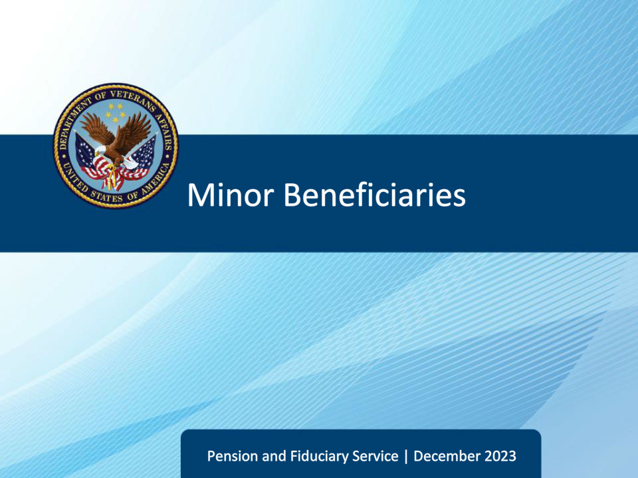
Slide notes

Course Description:

The lesson teaches learners about minor beneficiaries, to include the purpose, critical elements, and specific requirements of minor field examinations.

Slide 2 - References
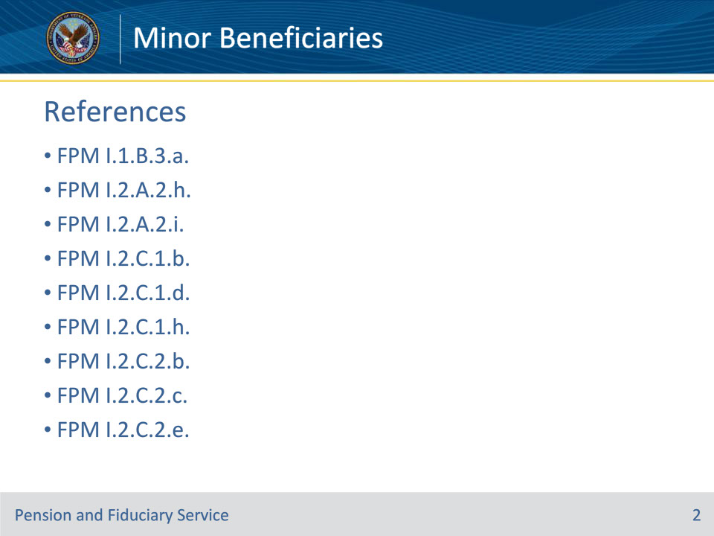
Slide notes

Instructor Notes:

The following are the relevant references pertaining to this course:

• FPM I.1.B.3.a. Purpose of the Fiduciary Program

• FPM I.2.A.2.h. Special Considerations for a Beneficiary Under the Age of Majority

• FPM I.2.A.2.i. When Fiduciary Supervision Is Required

• FPM I.2.C.1.b. Contact With the Beneficiary

• FPM I.2.C.1.d. Contact With Child Dependents and Minor Beneficiaries

• FPM I.2.C.1.h. When the Minor Beneficiary’s Caregiver Is Not the Fiduciary

• FPM I.2.C.2.b. Evaluating Physical and Mental Well-Being

• FPM I.2.C.2.c. Evaluating Environmental and Social Conditions

• FPM I.2.C.2.e. Documenting Beneficiary Well-Being

Slide 3 - Objectives
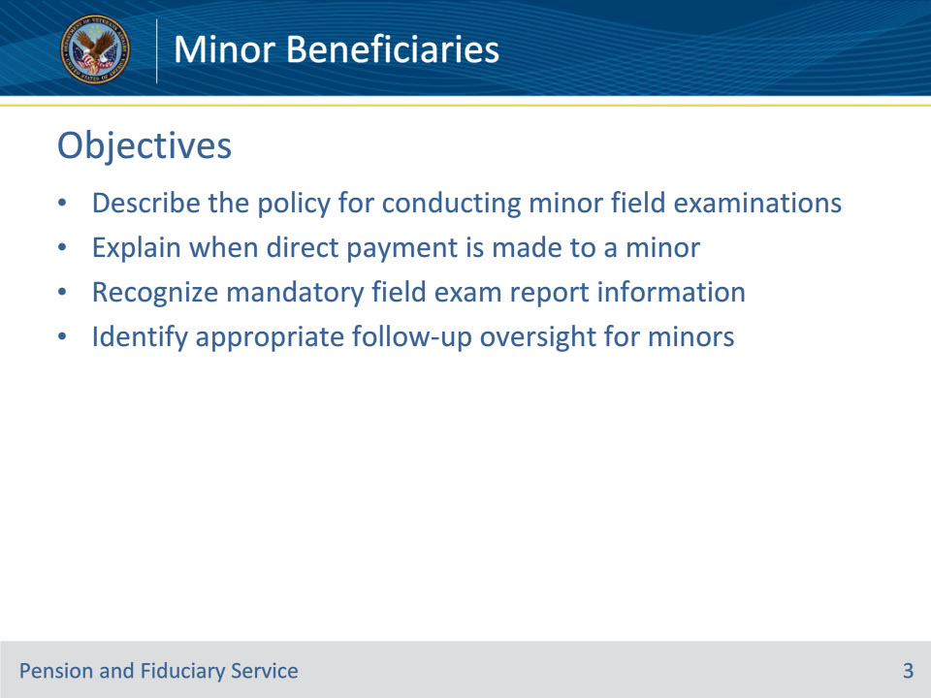
Slide notes

Instructor Notes

At the end of this lesson, given the training and references, the learner will be able to do the following:

• Describe the policy for conducting minor field examinations

• Explain when direct payment is made to a minor

• Recognize mandatory field exam report information

• Identify appropriate follow-up oversight for minors

Slide 4 - References
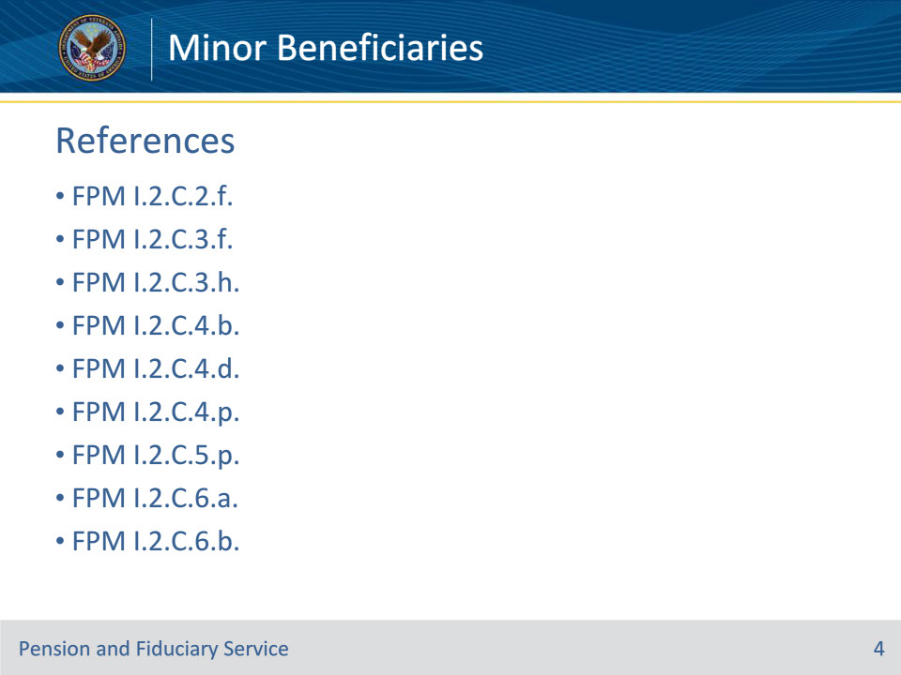
Slide notes

Instructor Notes:

The following are the relevant references pertaining to this course:

• FPM I.2.C.2.f. Minor Beneficiaries in Institutions

• FPM I.2.C.3.f. Documenting Recurring Income

• FPM I.2.C.3.h. Documenting Expenses

• FPM I.2.C.4.b. Beneficiary’s Fiduciary Preference

• FPM I.2.C.4.d. Fiduciary Suitability and Type

• FPM I.2.C.4.p. Bypassing an Existing Court Fiduciary in Favor of a VA-Appointed Fiduciary

• FPM I.2.C.5.p. Preventing Misuse of a Minor’s VA Funds

• FPM I.2.C.6.a. Overview of EIAs

• FPM I.2.C.6.b. When an EIA Is Not Appropriate

Slide 5 - References
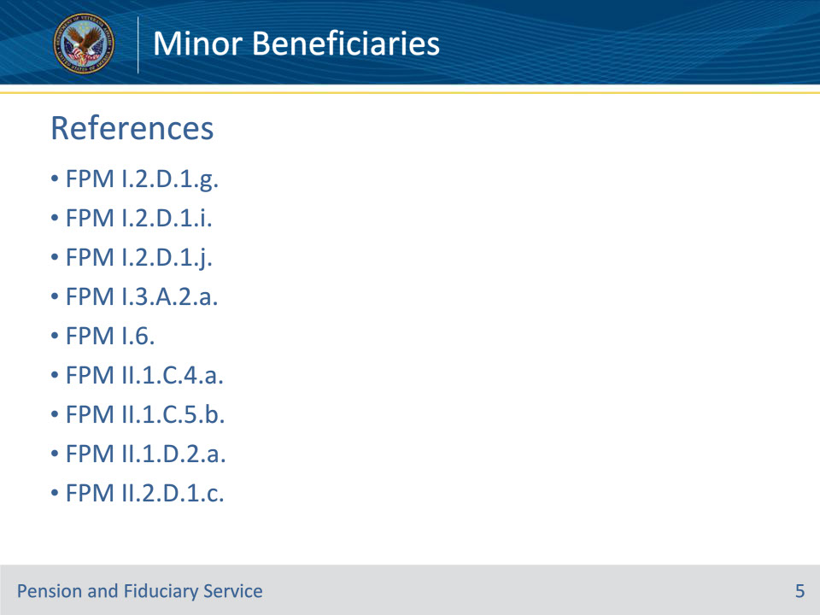
Slide notes

Instructor Notes:

The following are the relevant references pertaining to this course:

• FPM I.2.D.1.g. Oversight for Insurance Cases

• FPM I.2.D.1.i. Reviewing the eFolder for a Minor Beneficiary

• FPM I.2.D.1.j. Actions to Take When a Helpless Child Is Rated Incompetent Upon Reaching the Age of Majority

• FPM I.3.A.2.a. VA-Appointed Fiduciaries

• FPM I.6. Funds Usage Oversight

• FPM II.1.C.4.a. Policy on Authorizing Fiduciary Fees

• FPM II.1.C.5.b. Requiring a Surety Bond

• FPM II.1.D.2.a. Criteria for Deactivating the Beneficiary Record of a Minor

• FPM II.2.D.1.c. Eligibility for Annual Written Contact Only

Slide 6 - Policy
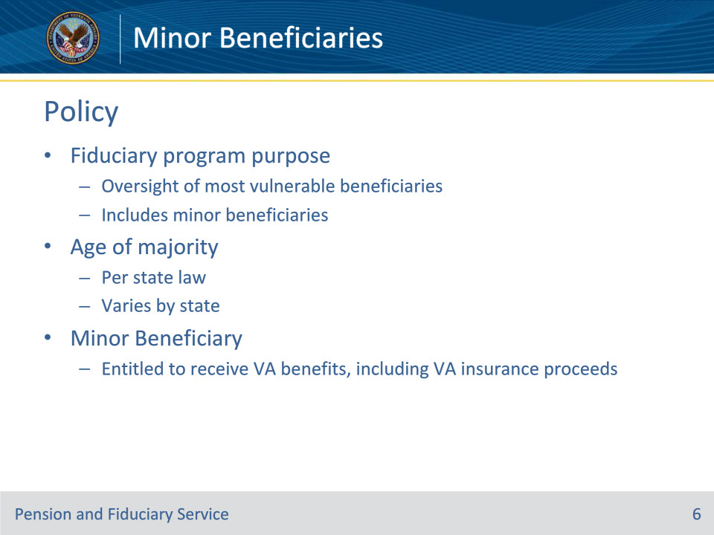
Slide notes

Policy Reference(s): FPM I.1.B.3.a.

Instructor Notes:

The Fiduciary Program provides oversight of the VA’s most vulnerable beneficiaries who are unable to manage their VA benefits because of injury, disease, the infirmities of advanced age, or are minor children who have not yet reached the age of majority.

“Less than age of majority” refers to a minor who has not attained the age of majority per the State law in which they reside. Each state has their own age of majority; it is not necessarily 18 years of age.

A minor beneficiary is an individual entitled to receive VA benefits, including proceeds of VA insurance.

Slide 7 - Supervision Not Required
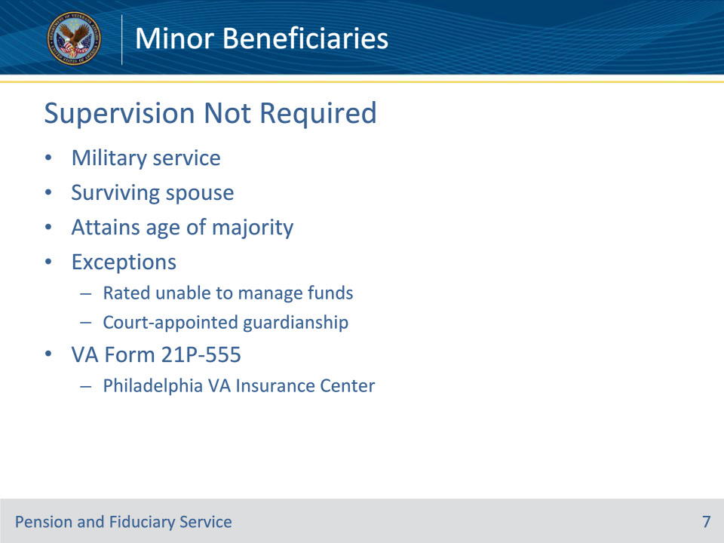
Slide notes

Policy Reference(s): FPM I.2.A.2.h.

Instructor Notes:

Direct payment is made to a beneficiary under the age of majority when the beneficiary

• is in, or was discharged from, military service, or

• receives benefits as the surviving spouse of a Veteran.

When any of the above criteria are met, hub supervision is not required.

Direct payment is made to a beneficiary when the beneficiary attains the age of majority under State law, unless the child is rated unable to manage funds or is under a court-appointed guardianship.

When direct payment to a beneficiary under the age of majority is authorized, complete a VA Form 21P-555, Certificate of Legal Capacity to Receive and Disburse Benefits and Fee Authorization, annotate the reason the beneficiary is paid directly and refer VA Form 21P-555 to the VA Insurance Center in Philadelphia, by email for action. If the beneficiary is in military service, the report should include the beneficiary’s last known address in military service.

Slide 8 - VA Insurance Policy
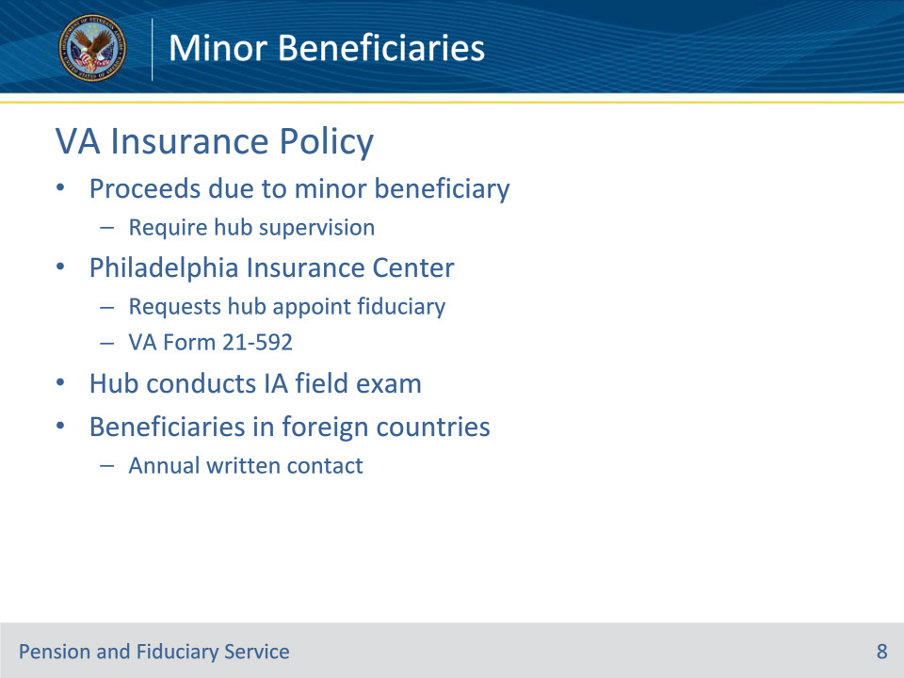
Slide notes

Policy Reference(s): FPM I.2.A.2.h.

Instructor Notes:

Insurance payments due to a beneficiary under the age of majority are considered VA benefits. VA insurance policy requires that these payments are supervised by the hub. In this case, the Philadelphia Insurance Center will request that the hub appoint and supervise a fiduciary using a VA Form 21-592. The hub will conduct an IA field examination and take all necessary actions.

The supervision and future actions for VA benefits and insurance payments for beneficiaries under the age of majority living in foreign countries is accomplished through annual written contact.

Slide 9 - Supervision Required
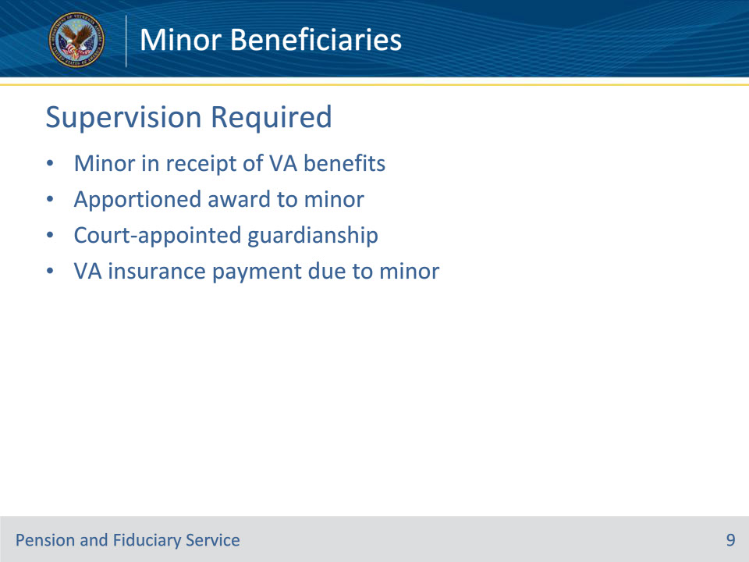
Slide notes

Policy Reference(s): FPM I.2.A.2.i.

Instructor Notes:

Fiduciary supervision is required when

• the beneficiary under the age of majority is in receipt of

• VA benefits, or

• an apportioned award

• a court-appointed guardianship is in effect or pending, or

• VA insurance payment is due to a beneficiary under the age of majority.

Slide 10 - Expedited IA Criteria for Minors
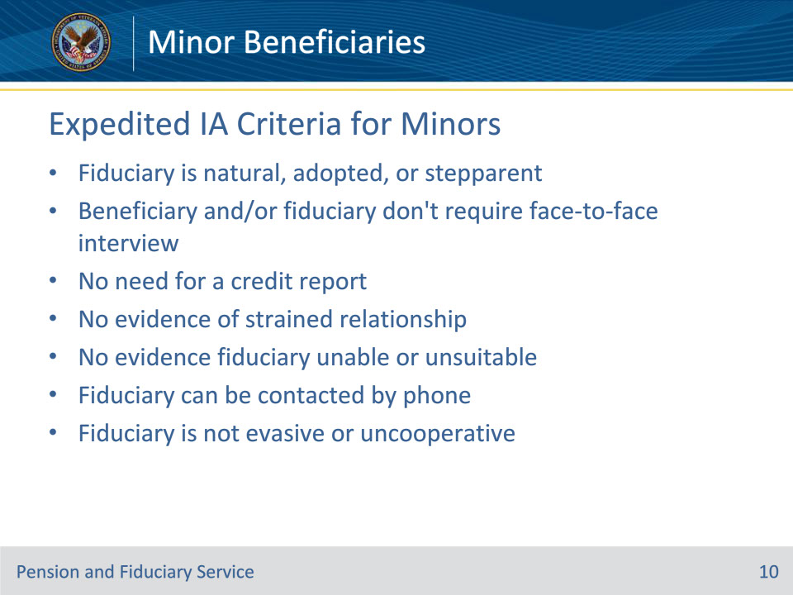
Slide notes

Policy Reference(s): FPM I.2.C.6.a.-b.

Instructor Notes:

The hub will not conduct a face-to-face interview or credit check of the proposed fiduciary when the proposed fiduciary is the beneficiary’s natural, adopted, or step parent and the beneficiary is under the age of majority.

An EIA is not appropriate when

• there is evidence indicating

• The beneficiary and/or fiduciary require a face-to-face interview

• The need for a credit report

• of a strained relationship between the beneficiary and proposed fiduciary, or

• indicating the proposed fiduciary is unable or unsuitable, or

• the proposed fiduciary

• cannot be contacted via telephone, or

• is being evasive or uncooperative.

Slide 11 - Excluded From EIA
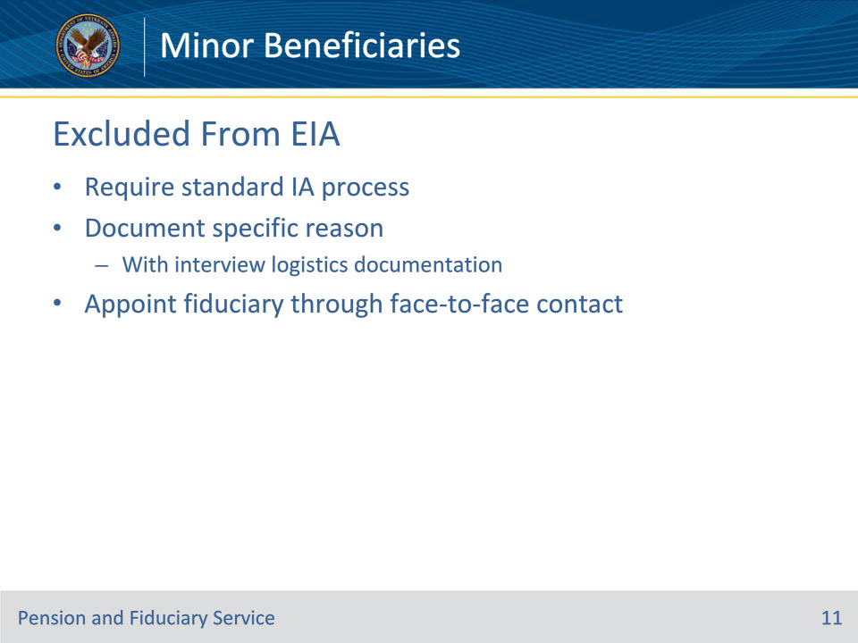
Slide notes

Policy Reference(s): FPM I.2.C.6.b.

Instructor Notes:

If the situation meets the criteria for an EIA, but is excluded from the EIA per this slide, the FE must document the specific reason for requiring the standard IA or SIA process. Include this information with the interview logistics.

When an EIA is not appropriate, appoint a fiduciary through face-to-face contact.

Slide 12 - Beneficiary Contact
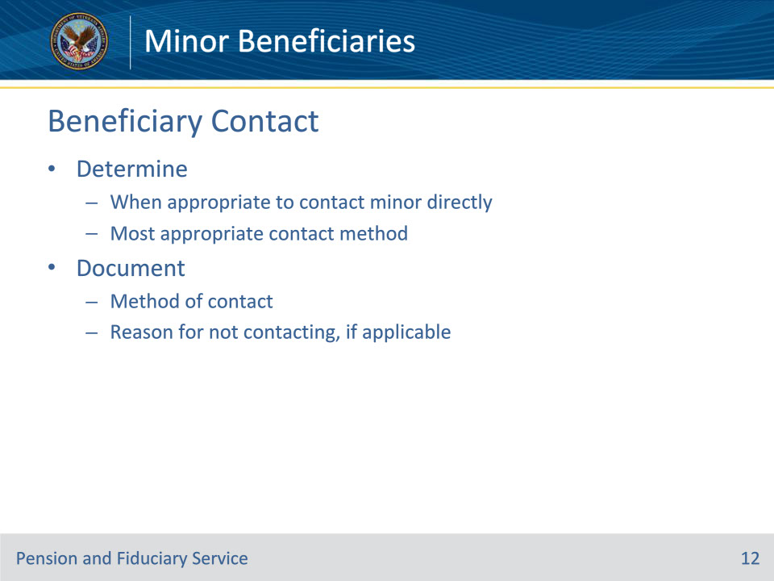
Slide notes

Policy Reference(s): FPM I.2.C.1.b., I.2.C.1.d.

Instructor Notes:

Determine:

• when it is appropriate to contact the minor beneficiary directly, and

• the most appropriate method for contacting the minor beneficiary, when applicable.

The field examination will document the method of contact or, if applicable, explain the reason the minor beneficiary was not contacted.

Slide 13 - Beneficiary Contact
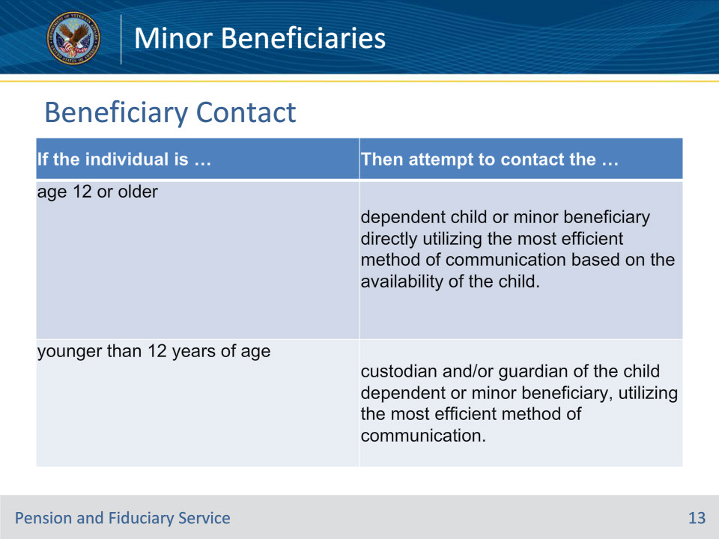
Slide notes

Policy Reference(s): FPM I.2.C.1.d.

Instructor Notes:

FEs will minimize direct contact with minor beneficiaries who are in the Fiduciary Program by reason of being less than the age of majority.

Use this table to determine the appropriate method of

• obtaining financial information, and

• assessing a minor beneficiary’s situation

Notes for age 12 and older:

• If the FE is unable to contact the individual, request the information from the

• individual’s custodian and/or guardian

• beneficiary, or

• proposed fiduciary.

Requesting telephone or face-to-face contact should be avoided and only completed in rare circumstances

Slide 14 - Evaluating Well-Being
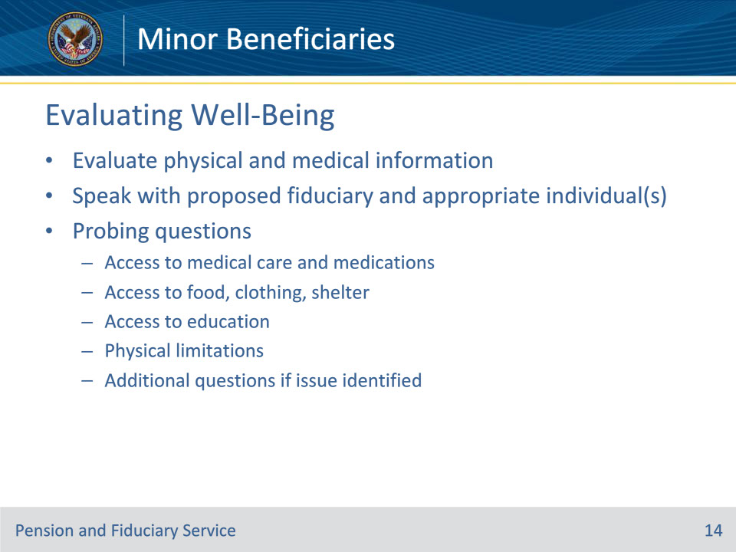
Slide notes

Policy Reference(s): FPM I.2.C.2.b.

Instructor Notes:

For minor beneficiaries, the FE must evaluate the following physical and medical information by speaking with the proposed fiduciary and the appropriate individual. The FE must ask probing questions about the beneficiary’s

• access to

• medical care and medications, if needed

• food, clothing, and shelter, and

• education, and

• any physical limitations.

Additional probing questions may be required if there is an indication of an issue reported by the beneficiary.

Slide 15 - Evaluating Environment and Social Conditions
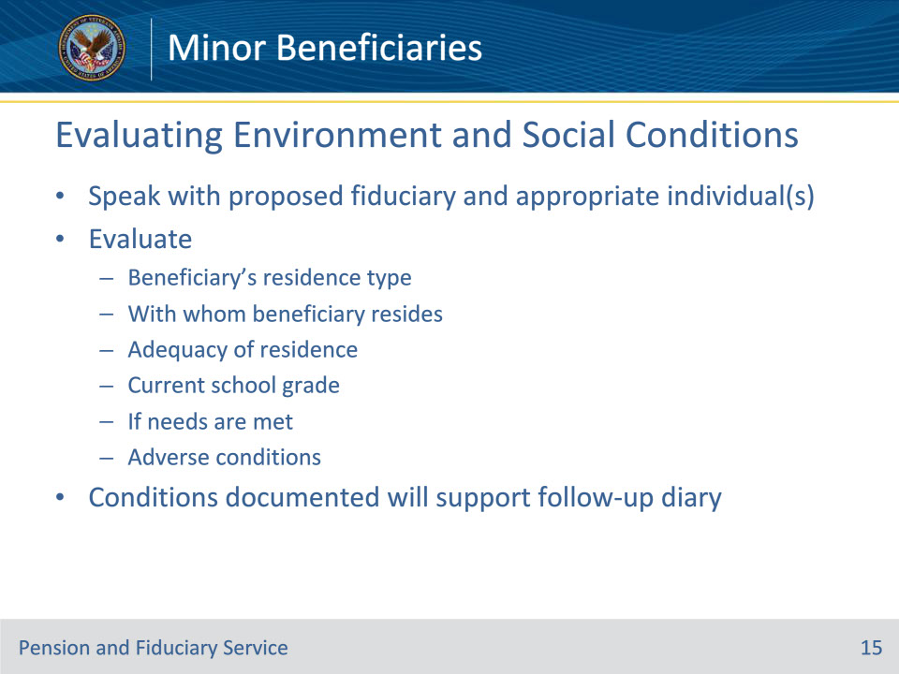
Slide notes

Policy Reference(s): FPM I.2.C.2.c.

Instructor Notes:

For minor beneficiaries, the FE must evaluate the following by speaking with both the proposed fiduciary and the appropriate individual:

• the type of place where the minor beneficiary resides

• with whom the minor beneficiary lives

• if the residence is adequate

• current school grade

• if the minor beneficiary’s needs are met, and

• any adverse conditions.

The environmental and social conditions documented in the field examination will support the follow-up examination diary.

Slide 16 - Well-Being Concern
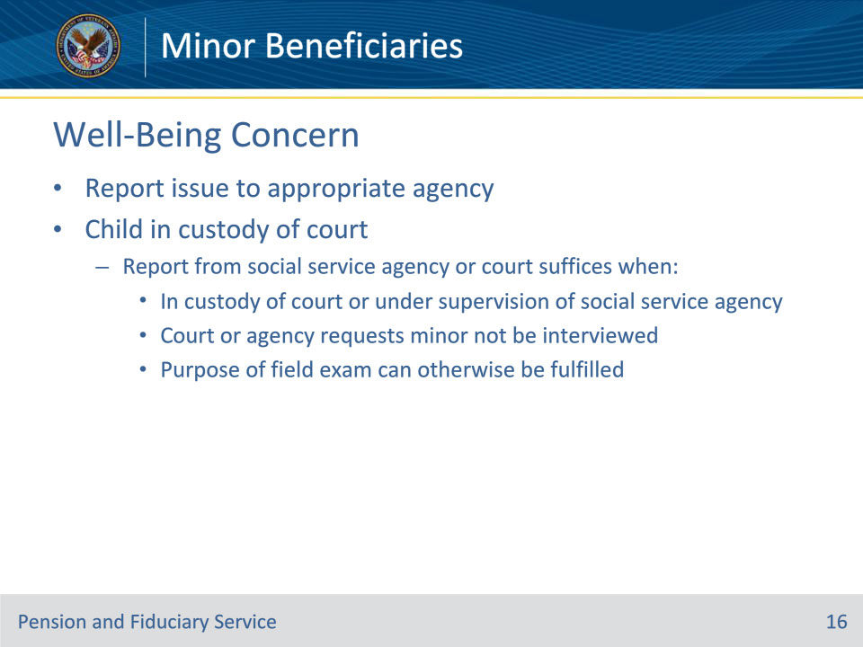
Slide notes

Policy Reference(s): FPM I.2.C.1.d., I.2.C.2.e.

Instructor Notes:

• If there is a well-being concern for a beneficiary or dependent who is under the age of majority, report the issue to the appropriate local, State, or Federal agencies. Report the concern to local child protective services for investigation, if applicable.

• If the child dependent or minor beneficiary is in the custody of a court, a report from a social service agency or court will suffice for contact when the

• minor is in the custody of the court or under the supervision of a social service agency through court orders

• court or agency specifically requests that the minor not be interviewed, and

• purpose of the field examination can otherwise be fulfilled.

Slide 17 - Minors in Institutions
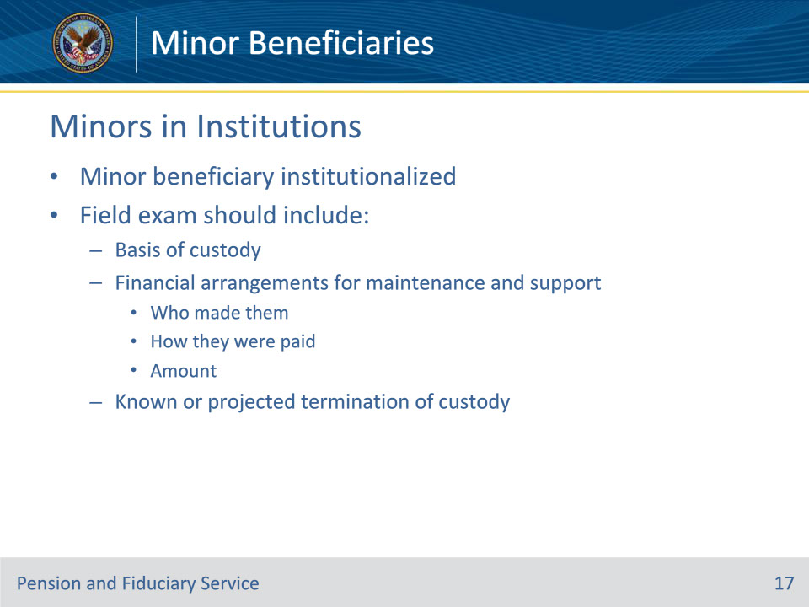
Slide notes

Policy Reference(s): FPM I.2.C.2.f.

Instructor Notes:

When the field examination discloses that the minor beneficiary is institutionalized, the field examination should include the following information:

• basis of custody

• financial arrangements for maintenance and support including

• who made them

• how they were paid, and

• the amount, and

• known or projected termination of custody.

Slide 18 - When Fiduciary Not Caregiver
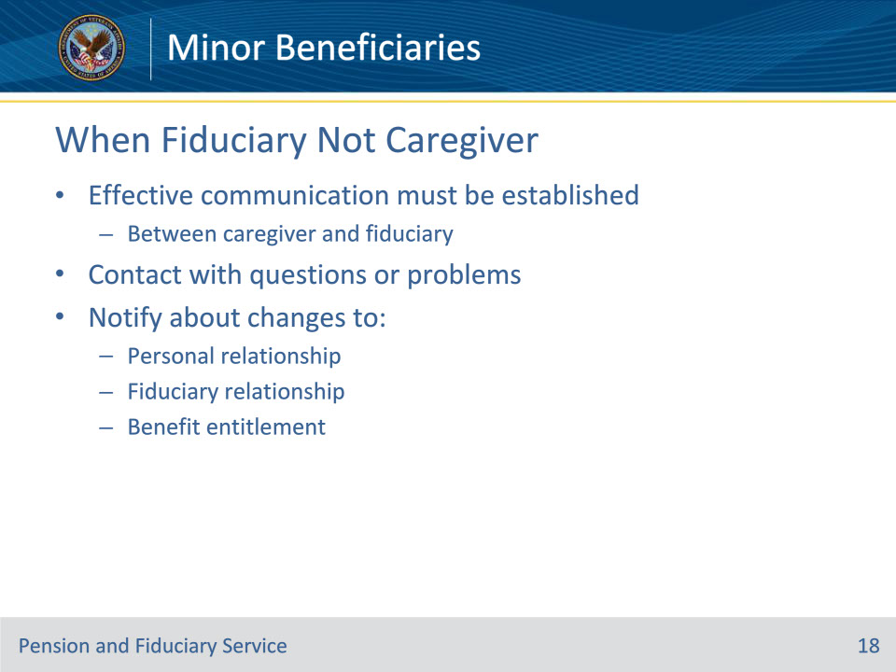
Slide notes

Policy Reference(s): FPM I.2.C.1.h.

Instructor Notes:

If the minor beneficiary’s caregiver is not the fiduciary, effective communication must be established between the minor’s caregiver and their fiduciary so that they know whom to

• contact with questions or problems, and

• notify about changes to the

• personal relationship

• fiduciary relationship, and/or

• benefit entitlement.

Slide 19 - Documenting Income
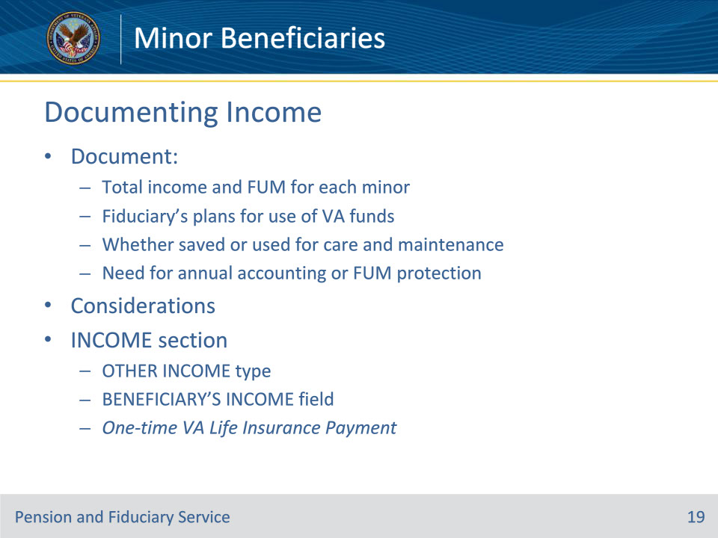
Slide notes

Policy Reference(s): FPM I.2.C.3.f.

Instructor Notes:

For minor beneficiaries, the field examination must document the total income and FUM of each minor. The FE must also document the proposed fiduciary’s plans for the use of VA funds, whether the minor’s funds will be saved or used for their care and maintenance, and the need for an annual accounting or protection of the FUM, if required. Matters for consideration include, but are not limited to, the minor’s total income, reasonable use of the minor’s funds, and fiduciary’s responsibility for the minor.

The INCOME section is intended for recording recurring income, except for VA insurance payments. Within the INCOME section, utilize the VA OTHER INCOME type and enter the following within the BENEFICIARY’S INCOME field: One-time VA Life Insurance Payment.

Slide 20 - Documenting Expenses
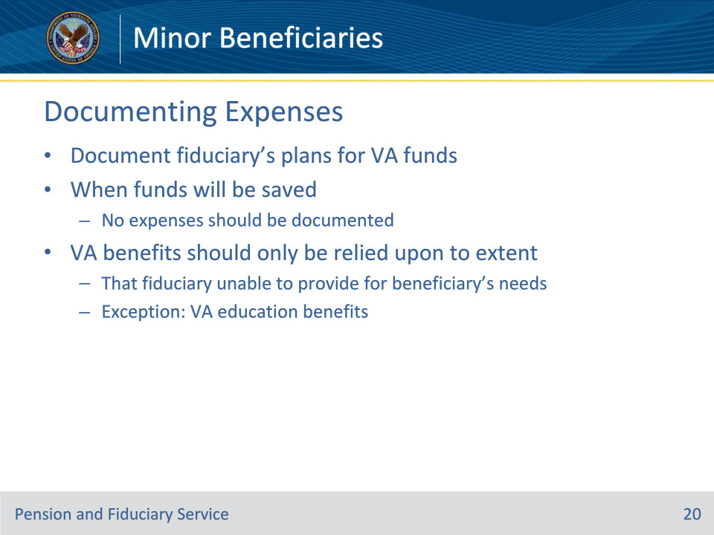
Slide notes

Policy Reference(s): FPM I.2.C.3.h.

Instructor Notes:

For minor beneficiaries, the FE must document the proposed fiduciary’s plans for VA funds. If the funds will be saved, no expenses should be documented.

VA benefits should only be relied upon to the extent that the fiduciary is unable to provide for the beneficiary’s needs.

Exception: A fiduciary who receives VA education benefits on behalf of a beneficiary who is less than the age of majority may use the benefits for the beneficiary’s education regardless of the ability of the fiduciary to pay for the beneficiary’s education.

Slide 21 - Fiduciary Preference
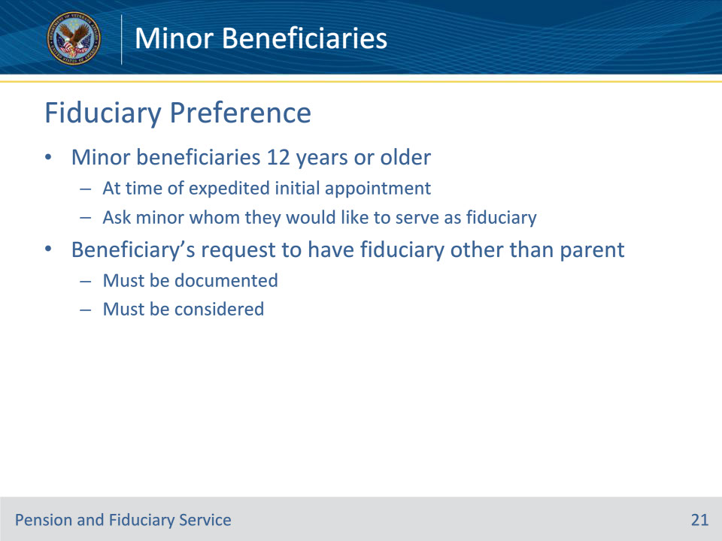
Slide notes

Policy Reference(s): FPM I.2.C.4.b.

Instructor Notes:

For minor beneficiaries 12 years or older at the time of an EIA, the FE must ask the minor whom they would like to serve as their fiduciary to manage their funds. A minor beneficiary’s request to have a fiduciary other than the parent must be documented and considered.

Slide 22 - Documenting Expenses
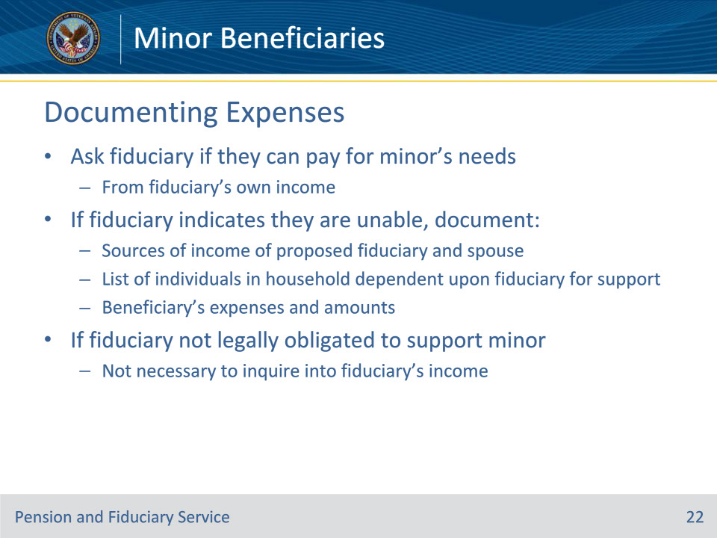
Slide notes

Policy Reference(s): FPM I.2.C.3.h.

Instructor Notes:

The FE must ask the proposed fiduciary if they are able to pay for the minor’s needs from the proposed fiduciary’s own income. If the proposed fiduciary indicates that they are unable to provide for the beneficiary’s needs, the field examination must document

• the source(s) of income of the

• proposed fiduciary, and

• proposed fiduciary’s spouse, if any

• a list of individuals in the household dependent upon the fiduciary for support, and

• the beneficiary’s expenses and amounts.

For minor beneficiaries, it is not necessary to inquire into the details of the proposed fiduciary’s income if they are not legally obligated to support the minor.

Slide 23 - Fiduciary Suitability and Type
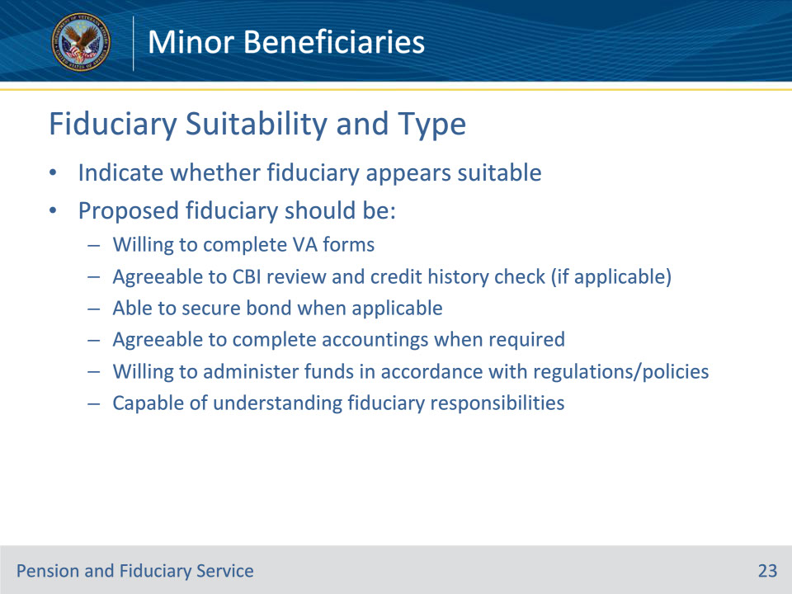
Slide notes

Policy Reference(s): FPM I.2.C.4.d.

Instructor Notes:

For a minor beneficiary, each field examination must indicate whether the proposed fiduciary appears suitable to administer the minor’s current and future financial affairs. The proposed fiduciary should be

• willing to complete VA forms as necessary

• agreeable to a CBI review and credit history check (if applicable)

• able to secure a bond when applicable

• agreeable to complete accountings when required

• willing to administer funds in accordance with VA regulations and policies and State and/or Federal laws, and

• capable of understanding their responsibility as a fiduciary.

Slide 24 - Bypassing Court Fiduciary
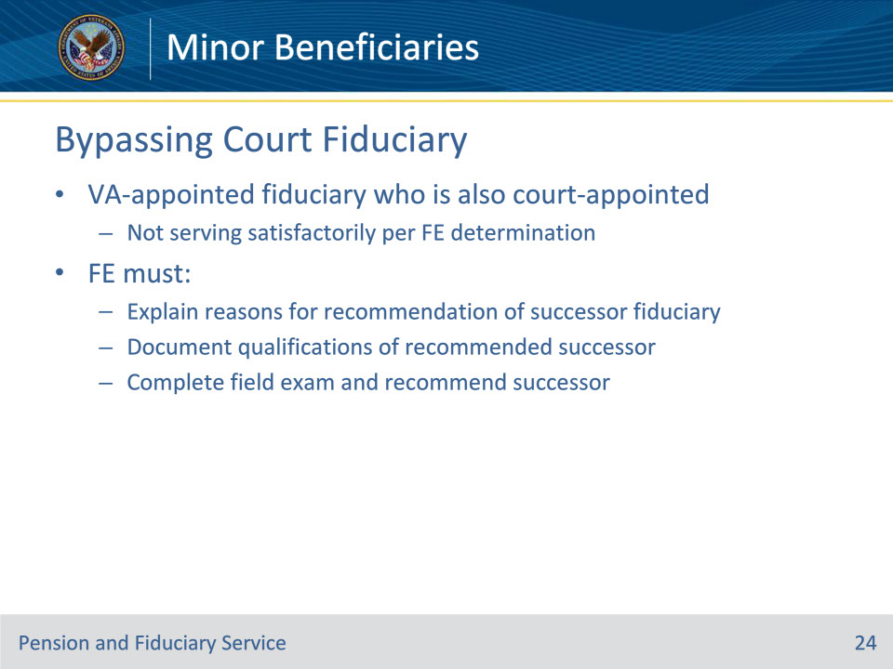
Slide notes

Policy Reference(s): FPM I.2.C.4.f.

Instructor Notes:

In minor beneficiary cases where the FE determines that the VA-appointed fiduciary who is also a court-appointed fiduciary or court guardian is not serving satisfactorily, the FE must

• provide a detailed explanation of the reason(s) for recommendation of a successor fiduciary

• document the qualifications of the recommended successor VA-appointed fiduciary, and

• complete the field examination and recommend the successor fiduciary identified.

Slide 25 - Beneficiary Oversight
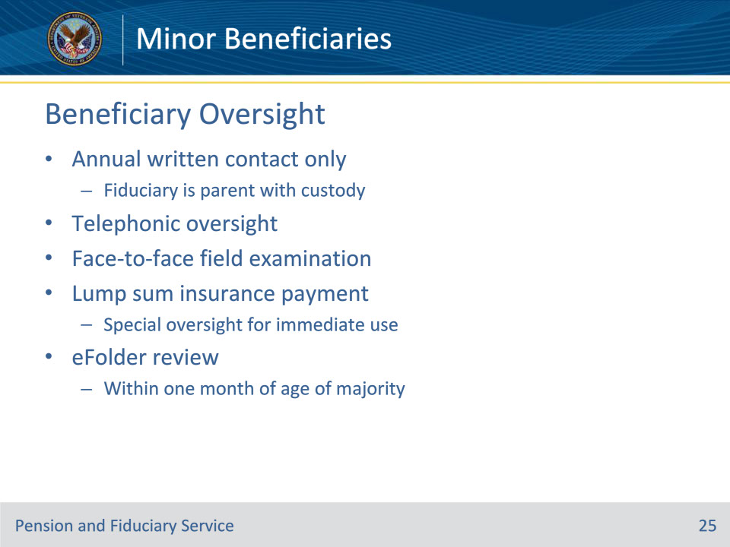
Slide notes

Policy Reference(s): FPM II.2.D.1.c., FPM I.2.D.1.g.

Instructor Notes:

Follow-up oversight of minor beneficiaries is conducted mostly the same as adults with a couple of additional aspects to consider.

If the beneficiary is a minor in the custody of a parent (natural, adopted, or stepparent) then they are eligible for annual written contact only due to VA’s long-standing policy to avoid undue intrusion into the relationship between a minor beneficiary and the beneficiary’s parent.

If the minor does not meet the criteria for annual written contact only then they should be scheduled for either telephonic or face-to-face oversight depending on the circumstances. The least intrusive oversight method which the beneficiary qualifies for should be selected.

When the only VA payment is a lump sum insurance payment and the fiduciary has plans for the specific immediate use of these funds at the time of the IA field examination, leaving no residual funds, supervision is only maintained until the VA funds under management (FUM) are exhausted. The fiduciary must submit a fund usage report, or an accounting if required, to show that no residual VA FUM exist.

To ensure proper oversight, a diary will be established when the IA field examination is completed to request either a fund usage report or accounting, as applicable, with a review date to occur on the last day of the month that follows the estimated date the fiduciary indicates the funds will be exhausted.

Example: The fiduciary indicates that the VA FUM will be exhausted at the end of the second month from the appointment. While closing the IA field examination, the hub establishes a diary with a review date to occur on the last day of the third month from the appointment.

When there is an agreement to save any part of the insurance proceeds, the appropriate beneficiary and fiduciary oversight is scheduled.

Slide 26 - Preventing Misuse
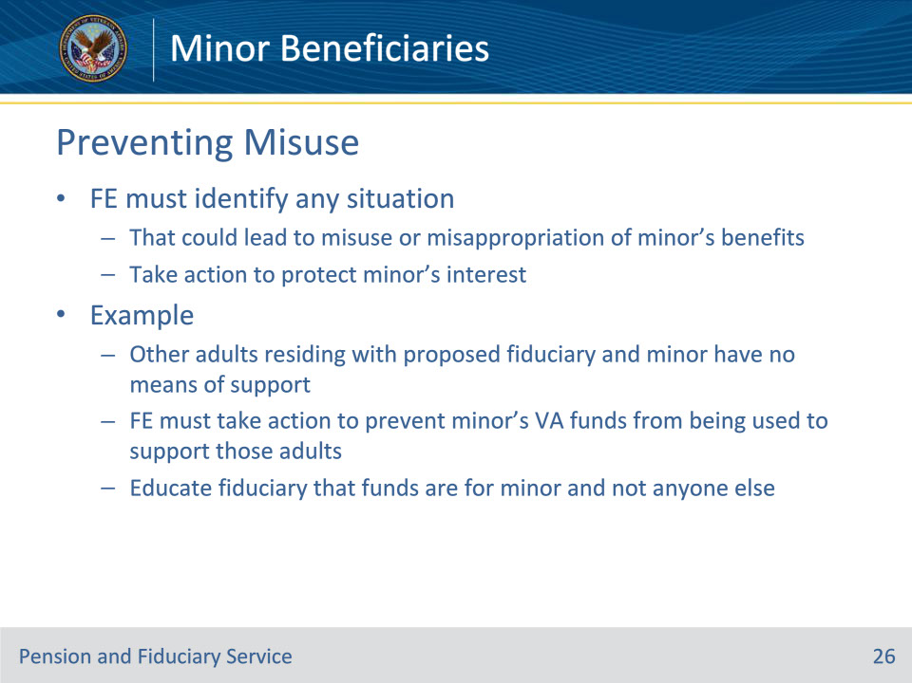
Slide notes

Policy Reference(s): FPM I.2.C.5.p.

Instructor Notes:

The FE must identify any situation that could lead to the misuse or misappropriation of the minor’s benefits and take action to protect the interest of the minor.

Example: If other adults residing with the proposed fiduciary and minor have no means of support, the FE must take action to prevent the minor’s VA funds from being used to support those adults, by educating the fiduciary the funds are for the minor and not for anyone else.

Slide 27 - Helpless Child
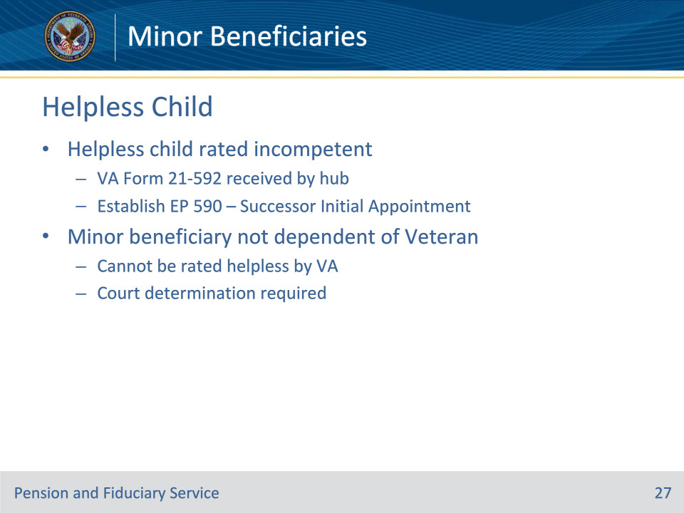
Slide notes

Policy Reference(s): FPM I.2.D.1.j.

Instructor Notes:

Upon receipt of a VA Form 21-592, Request for Appointment of a Fiduciary, Custodian or Guardian, indicating a helpless child has been rated incompetent, establish an EP 590 - Successor Initial Appointment Field Examination to ensure the appropriate fiduciary is in place for the beneficiary.

• If a minor beneficiary is not a dependent of the Veteran, the minor cannot be rated helpless by VA.

• A determination by a court of competent jurisdiction is required to determine if a minor who is not a dependent of a Veteran is incapable of self-support. After reviewing the eFolder, if there is no determination from the court that the minor who is not a dependent of a Veteran is incapable of self-support, do not conduct a field examination. Instead, deactivate the beneficiary record.

Slide 28 - Tracking Age of Majority
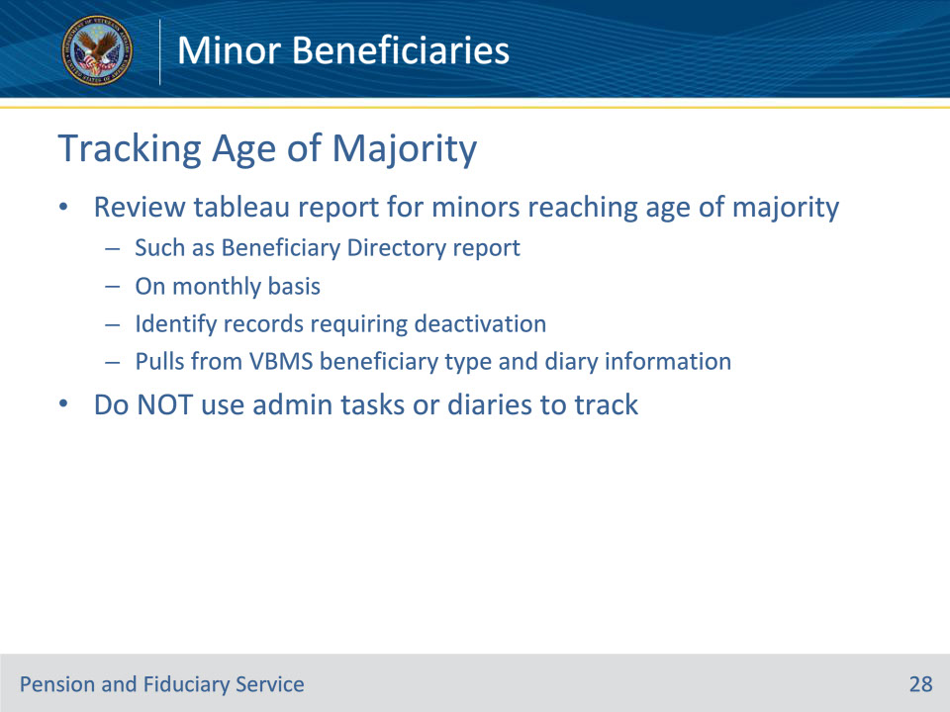
Slide notes

Policy Reference(s): FPM I.2.D.1.i.

Instructor Notes:

Hubs must review an appropriate Tableau report (such as the Beneficiary Directory report) on a monthly basis to identify records which require deactivation based on the beneficiary reaching the age of majority and no longer requiring fiduciary oversight.

Hubs must not use administrative tasks or follow-up field examination diaries to track minors reaching the age of majority.

In order to ensure the Tableau report listed above is accurate, hub personnel must ensure the beneficiary type is listed as minor in the Veterans Benefits Management System (VBMS) and that the DIARY INFORMATION section is updated appropriately.

Slide 29 - Deactivating Beneficiary Record
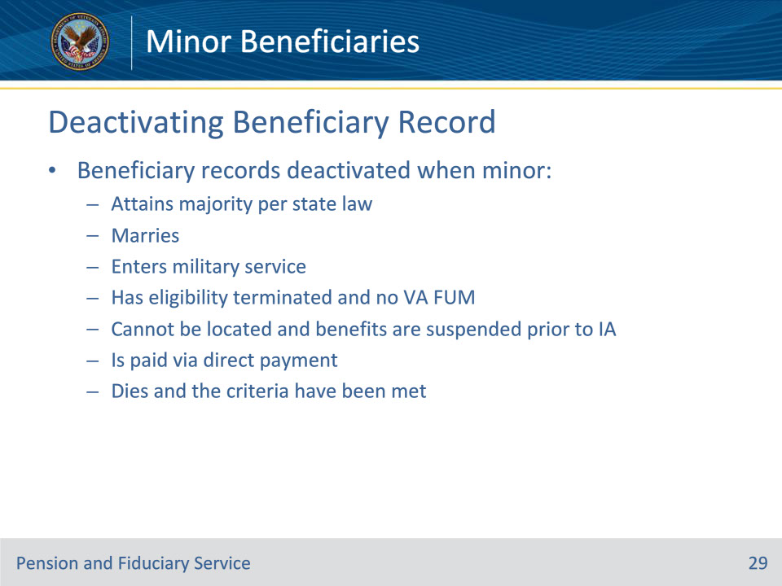
Slide notes

Policy Reference(s): FPM II.1.D.2.a.

Instructor Notes:

Beneficiary records for cases involving minors are usually deactivated when the minor

• attains majority under the law of the State in which they reside

• marries

• enters military service

• has eligibility terminated and there is no VA FUM

• cannot be located and benefits are suspended for whereabouts unknown prior to the appointment of an initial fiduciary

• is paid via direct payment, or

• dies and the criteria have been met

Notes:

• If a minor attains majority under the law of the State in which they reside, the case should be deactivated even if the minor is moving to another state having a different age of majority. When the beneficiary is entitled to benefits after majority, the hub must take action to notify the authorization activity and/or insurance center.

• A case must not be deactivated if the beneficiary requires supervision as a helpless child who is rated incompetent.

• If there is a VA-appointed fiduciary who is also court-appointed, the court must be notified when VA no longer has any interest in the case.

Slide 30 - Fiduciary Oversight
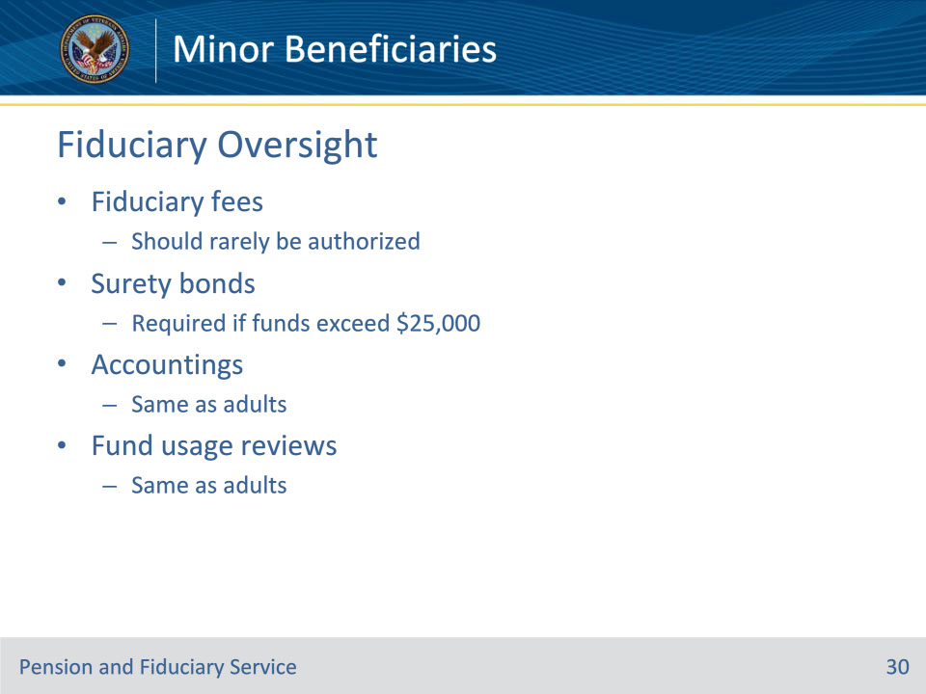
Slide notes

Policy Reference(s): FPM II.1.C.4.a., FPM II.1.C.5.b., FPM I.3.A.2.a., FPM I.6.

Instructor Notes:

For cases involving minor beneficiaries, because the minors are almost always in the custody of an individual or institution having legal responsibility for the care and supervision of the minor, fees for VA-appointed fiduciaries of minors should rarely be authorized.

The authority and procedures for authorizing fees for VA-appointed fiduciaries are the same for minors as for adult beneficiaries.

In cases involving minor beneficiaries, surety bonds are seldom required from the VA-appointed fiduciary of a minor due to the relatively small amount of funds involved. However, if FUM exceed $25,000, the FHM must require a corporate surety bond from a VA-appointed fiduciary for a minor unless the fiduciary is exempted.

The authority and procedures for requiring a surety bond for VA-appointed fiduciaries are the same for minors as for adult beneficiaries. The Fiduciary Hub Manager (FHM) or designee is permitted to authorize a reasonable monthly fiduciary fee if necessary to obtain the services of a qualified fiduciary

Accounting requirements are the same for a minor beneficiary as the requirements for an adult beneficiary.

Accountings are required when a VA-appointed fiduciary receives benefit payments on behalf of a minor beneficiary who receives a one-time insurance payment and the funds will be immediately consumed.

Fund Usage Review requirements are the same for a minor beneficiary as the requirements for an adult beneficiary.

Slide 31 - Questions?
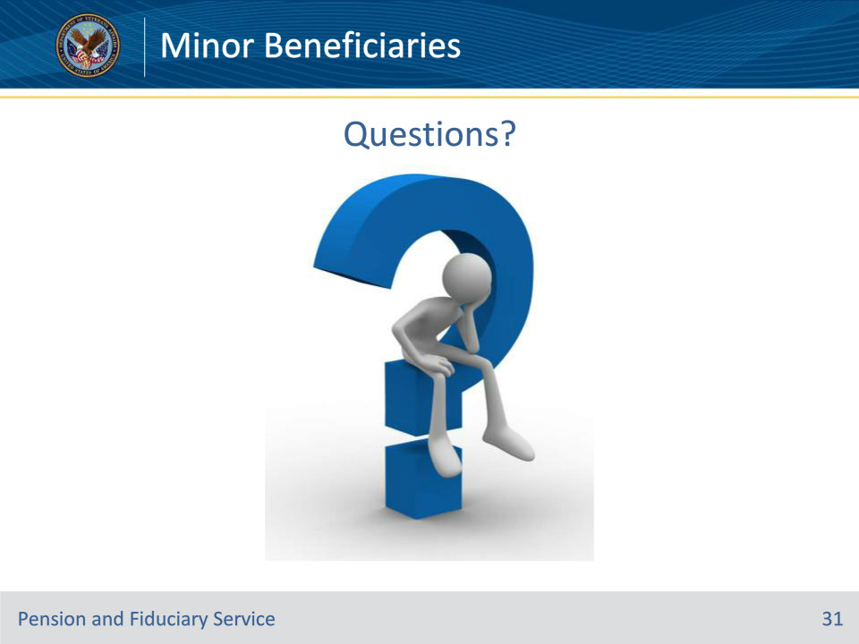
Slide notes

Instructor Notes:

(Recall) These are our learning objectives as stated from the beginning of the training:

• Describe the policy for conducting minor field examinations

• Explain when direct payment is made to a minor

• Recognize mandatory field exam report information

• Identify appropriate follow-up oversight for minors

Are there any additional questions?

Slide 32 - TMS Survey
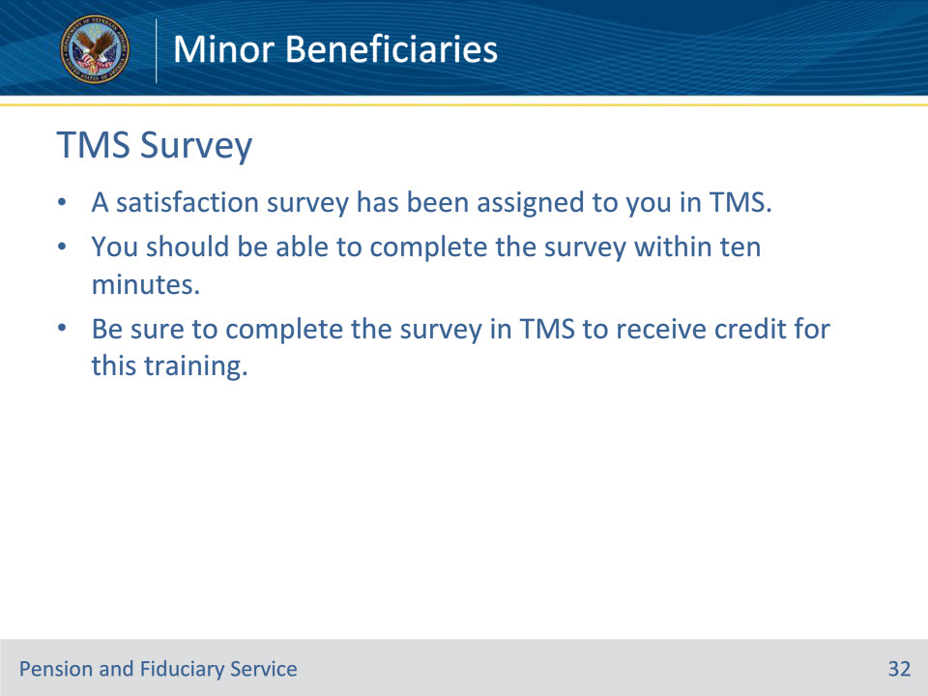
Slide notes

Instructor Notes:

A satisfaction survey has been assigned to you in TMS. You should be able to complete the survey within ten minutes. Completing the survey will allow you to receive credit for this training.

