Slide 1 - Interview Scheduling, Logistics, and Contacts
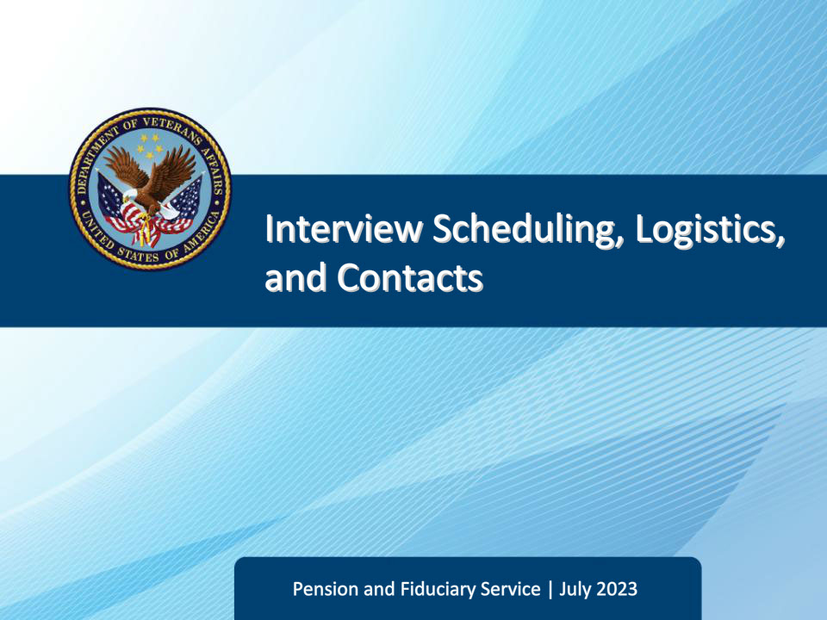
Slide notes

This lesson teaches field examiners how to schedule field examination appointments for the best use of time, and the importance and purpose of documenting all individuals contacted throughout the field examination process.

Slide 2 - Navigation
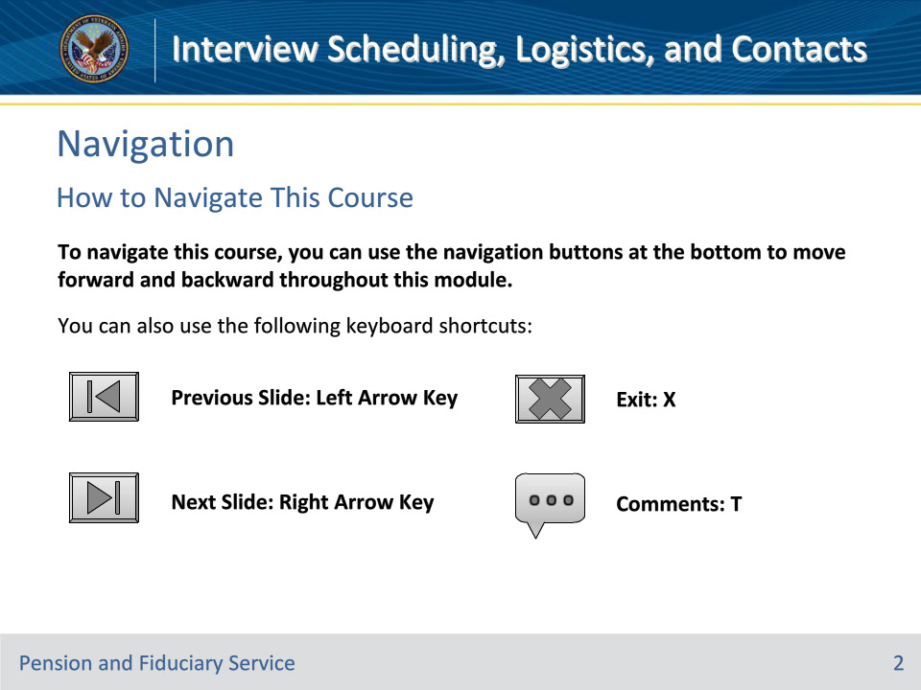
Slide notes

To navigate this course, you can use the navigation buttons at the bottom to move forward and backward throughout this module.

You can also use the following keyboard shortcuts:

• Previous Slide: Left Arrow Key

• Next Slide: Right Arrow Key

• Exit: X

• Comments: T

Slide 3 - Objectives
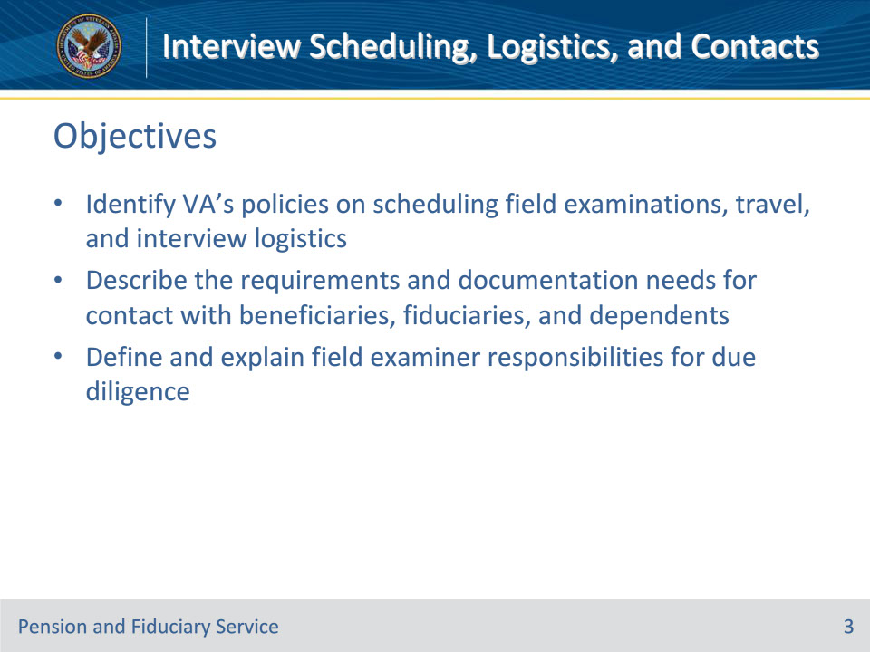
Slide notes

Instructor Notes:

By the end of this lesson, the student will be able to do the following:

• Identify VA’s policies on scheduling field examinations, travel, and interview logistics

• Describe the requirements and documentation needs for contact with beneficiaries, fiduciaries, and dependents

• Define and explain field examiner responsibilities for due diligence

Slide 4 - References
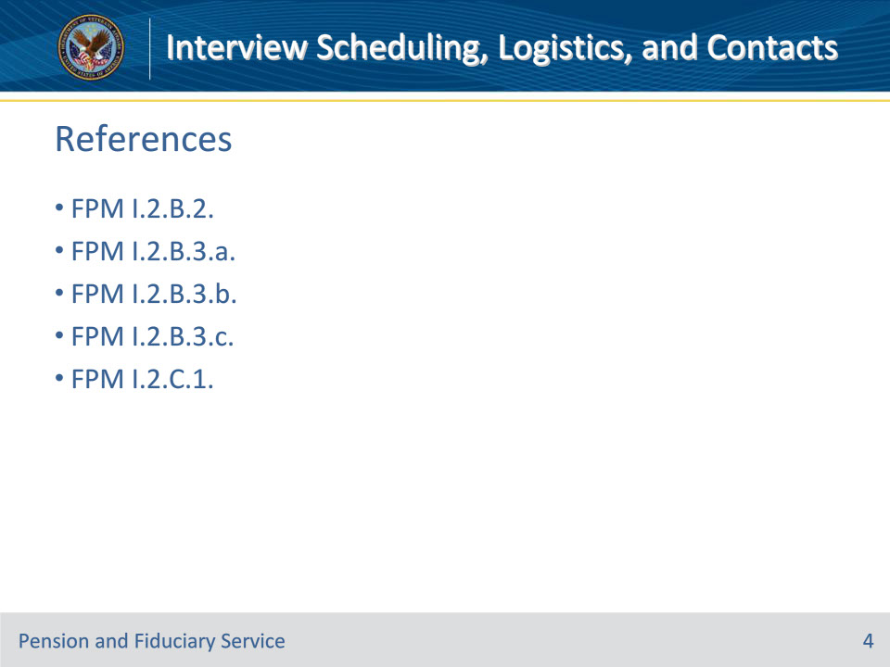
Slide notes

Instructor Notes:

These are the relevant references pertaining to this training:

• FPM I.2.B.2. Scheduling Field Examination Interviews

• FPM I.2.B.3.a. General Travel Policy

• FPM I.2.B.3.b. Economy of Travel

• FPM I.2.B.3.c. Traveling Beyond the Hub’s Jurisdiction

• FPM I.2.C.1. Interview Logistics and Contacts

Slide 5 - Location
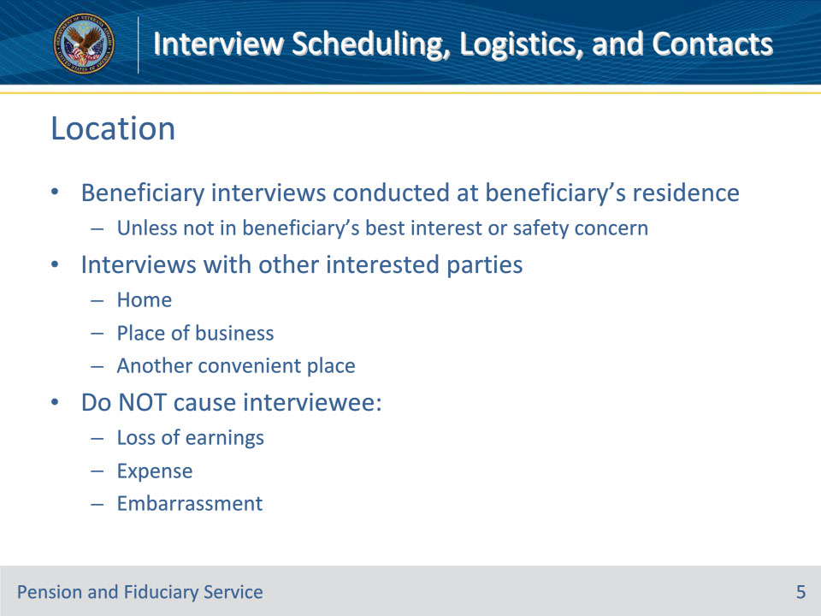
Slide notes

Policy Reference(s): FPM I.2.B.2.a., b., c.

Instructor Notes:

Interviews with beneficiaries are conducted at the beneficiary’s residence unless there is justification that meeting at the residence was not in the beneficiary’s best interest or raised a safety concern for the FE.

Interviews with other interested parties are conducted at the interviewee’s

• home

• place of business, or

• another place selected at the convenience of the interviewee.

Interviews must be conducted in a manner that will not cause the interviewee

• loss of earnings
• expense, or

• embarrassment.

Slide 6 - Scheduling
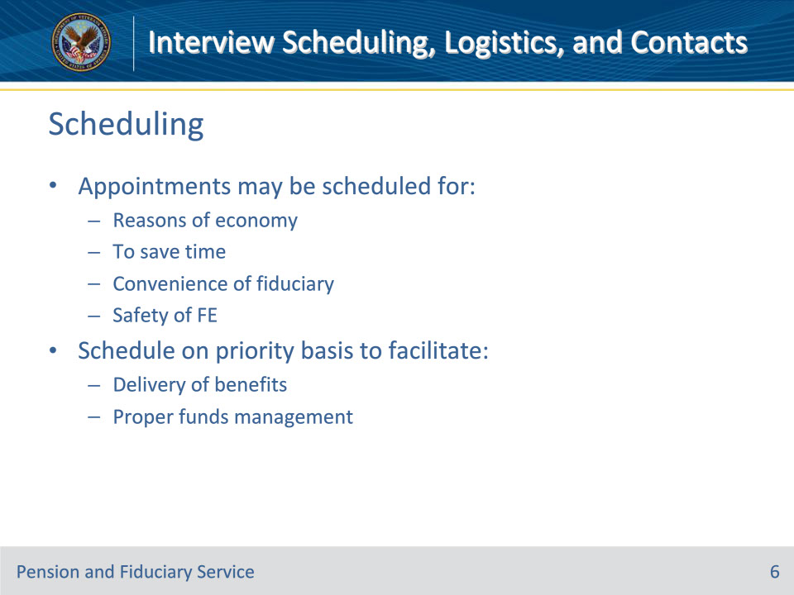
Slide notes

Policy Reference(s): FPM I.2.B.2.d., e.

Instructor Notes:

Appointments for interviews may be scheduled for

• reasons of economy or to save time

• the convenience of the fiduciary, or

• the safety of the FE.

It is VA policy to schedule initial appointment (IA) and successor IA (SIA) field examinations, fund usage, and non-program requests on a priority basis to facilitate delivery of benefits and ensure beneficiary funds are properly managed.
Slide 7 - Beneficiary Scheduling
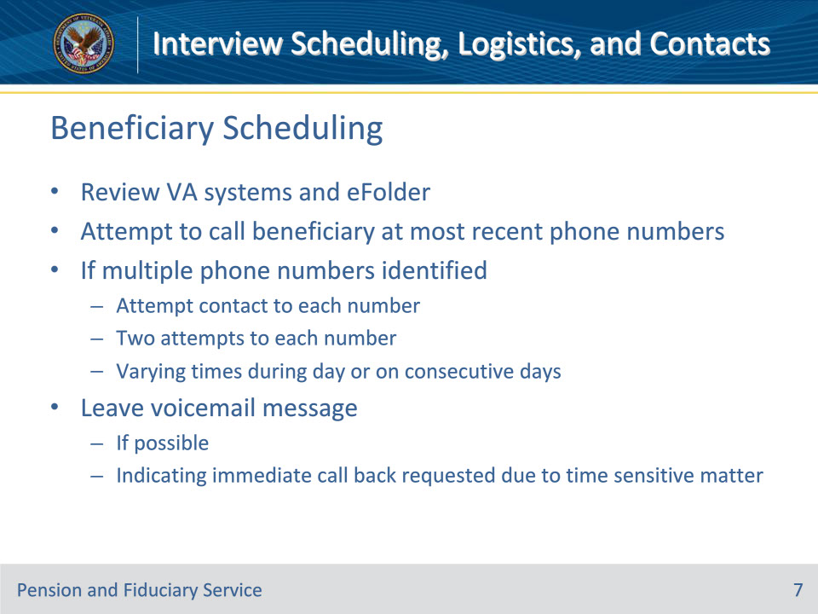
Slide notes

Policy Reference(s): FPM I.2.B.2.f.

Instructor Notes:

To schedule a field examination with a beneficiary, hub personnel will review VA systems and the eFolder and attempt to call the beneficiary at the most recent telephone number(s) available. If multiple telephone numbers are identified, attempt contact to each number. Two attempts to each number at varying times during the day or on consecutive days must be made. If possible, leave a voicemail message indicating an immediate call back is requested due to a time sensitive matter.

Slide 8 - Beneficiary Scheduling
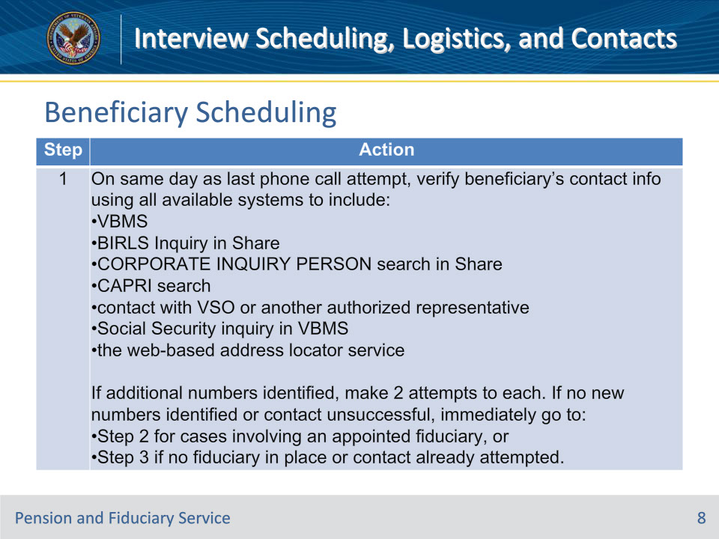
Slide notes

Policy Reference(s): FPM I.2.B.2.f.

Instructor Notes:

Follow the steps in this table when contact is unsuccessful. Follow the steps until successful contact is established or all associated steps have been completed.

Slide 9 - Beneficiary Scheduling
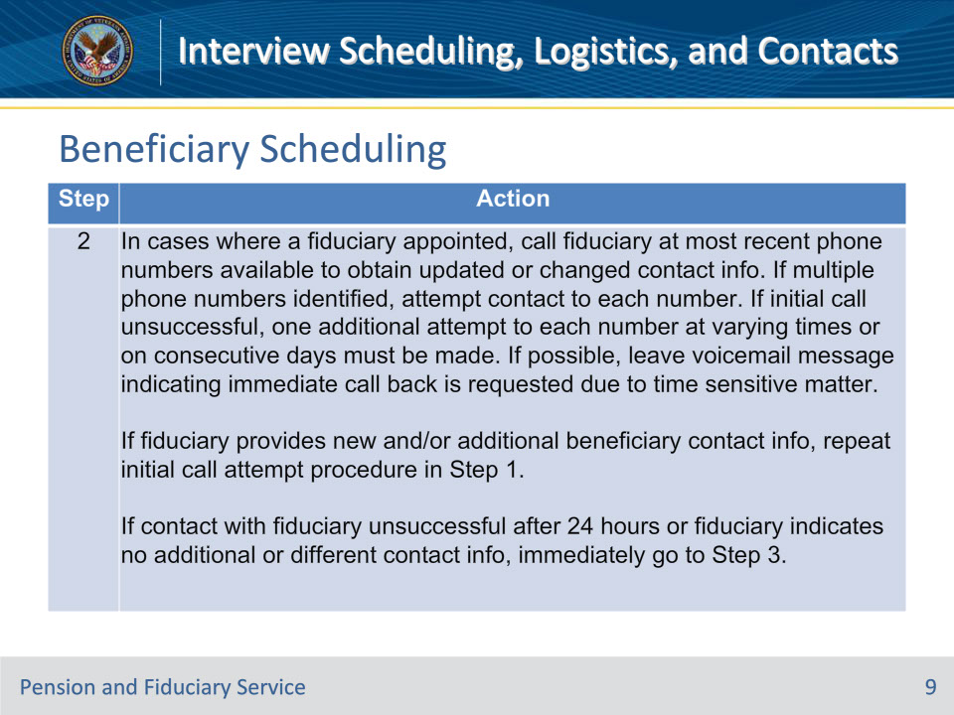
Slide notes

Policy Reference(s): FPM I.2.B.2.f.

Instructor Notes:

Follow the steps in this table when contact is unsuccessful. Follow the steps until successful contact is established or all associated steps have been completed.

Slide 10 - Beneficiary Scheduling
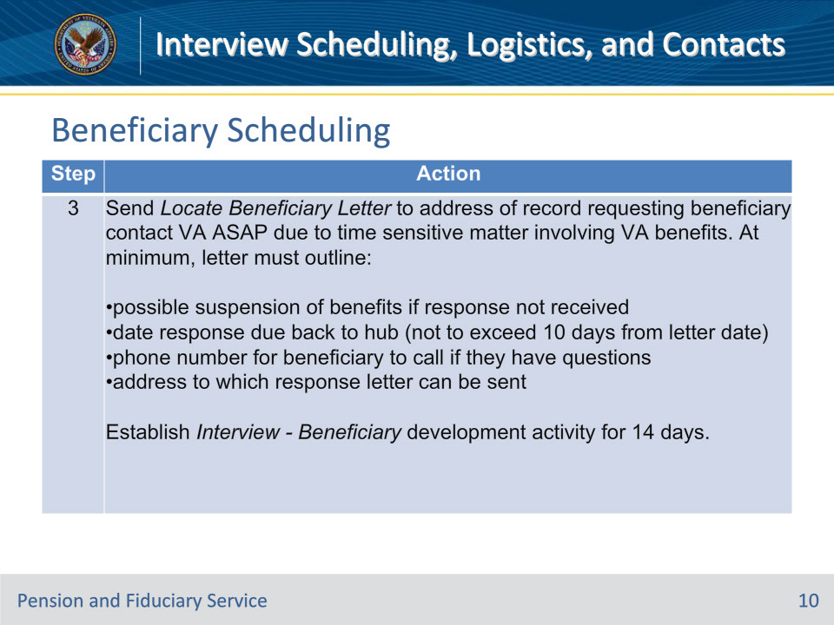
Slide notes

Policy Reference(s): FPM I.2.B.2.f.

Instructor Notes:

Follow the steps in this table when contact is unsuccessful. Follow the steps until successful contact is established or all associated steps have been completed.

Note: Do not initiate the whereabouts unknown process at this step by selecting the WHEREABOUTS UNKNOWN-1st ATTEMPT box in VBMS. The appropriate action will occur in this table as applicable in Step 7.

The steps to locate the beneficiary can be completed by an FE, LIE, or Fiduciary Service Representative (FSR). If initiated by an FE and contact is unsuccessful after completing Step 3, the case can be reassigned to an LIE or FSR to complete the remaining steps. If no hub personnel have access to the address locator service, the FE must obtain the address check report and include it in the eFolder for review by the LIE or FSR prior to reassignment.

Slide 11 - Step 4
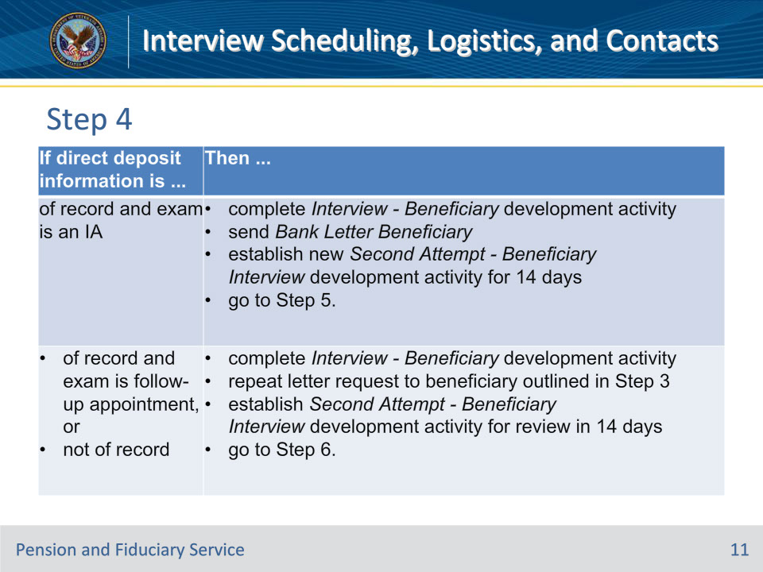
Slide notes

Policy Reference(s): FPM I.2.B.2.f.

Instructor Notes:

Step 4:

If no response to the call attempts or letter is received after 14 days, make an additional attempt to contact the beneficiary at all known numbers. If the additional phone call attempt(s) are unsuccessful, review the record for direct deposit information. Use this table to determine the next step.

Slide 12 - Step 5
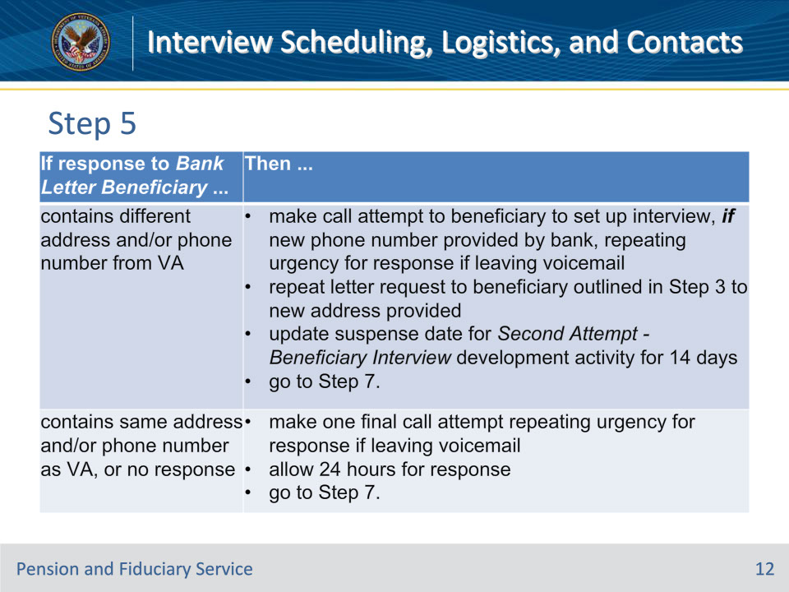
Slide notes

Policy Reference(s): FPM I.2.B.2.f.

Instructor Notes:

Step 5:

Review the file for a response to the Bank Letter Beneficiary after 14 days.

Use this table to determine the next step.

Slide 13 - Beneficiary Scheduling
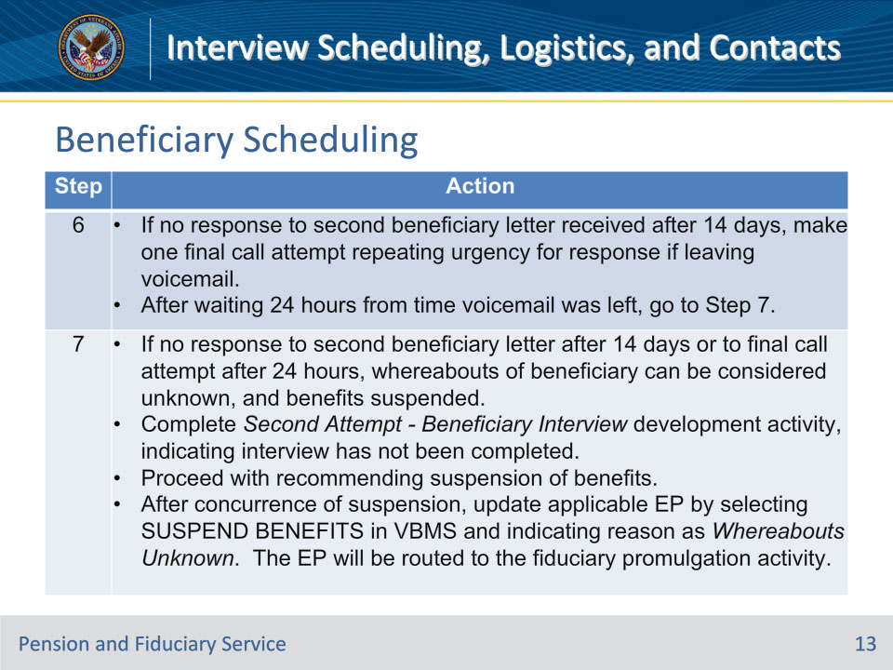
Slide notes

Policy Reference(s): FPM I.2.B.2.f.

Instructor Notes:

Follow the steps in this table when contact is unsuccessful. Follow the steps until successful contact is established or all associated steps have been completed.

Slide 14 - Beneficiary Scheduling
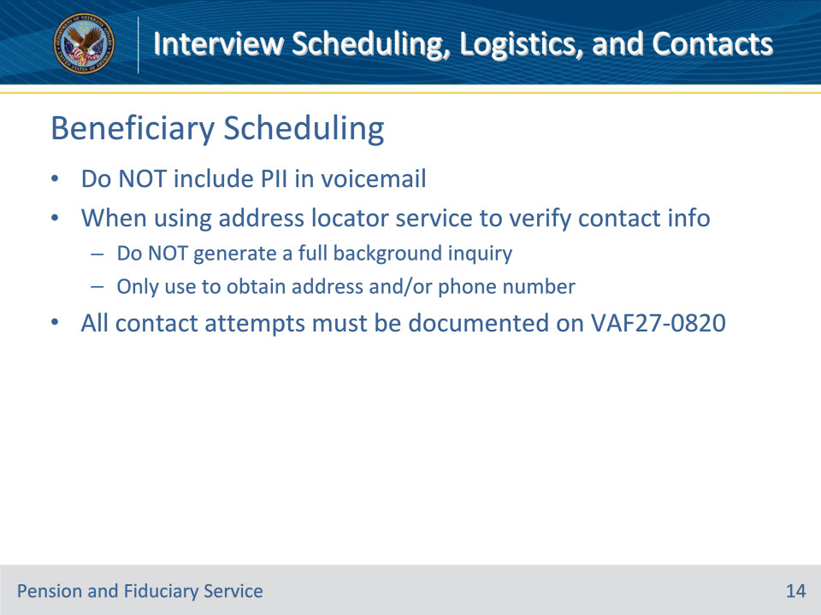
Slide notes

Policy Reference(s): FPM I.2.B.2.f.

Instructor Notes:

• Do not include personally identifiable information (PII) in the voicemail.

• When using the address locator service to verify a beneficiary’s contact information, do not generate a full background inquiry. Only use the locator service to obtain the address and/or contact phone number.

• All contact attempts must be documented on a VA Form 27-0820.

Slide 15 - Prospective Fiduciary Scheduling
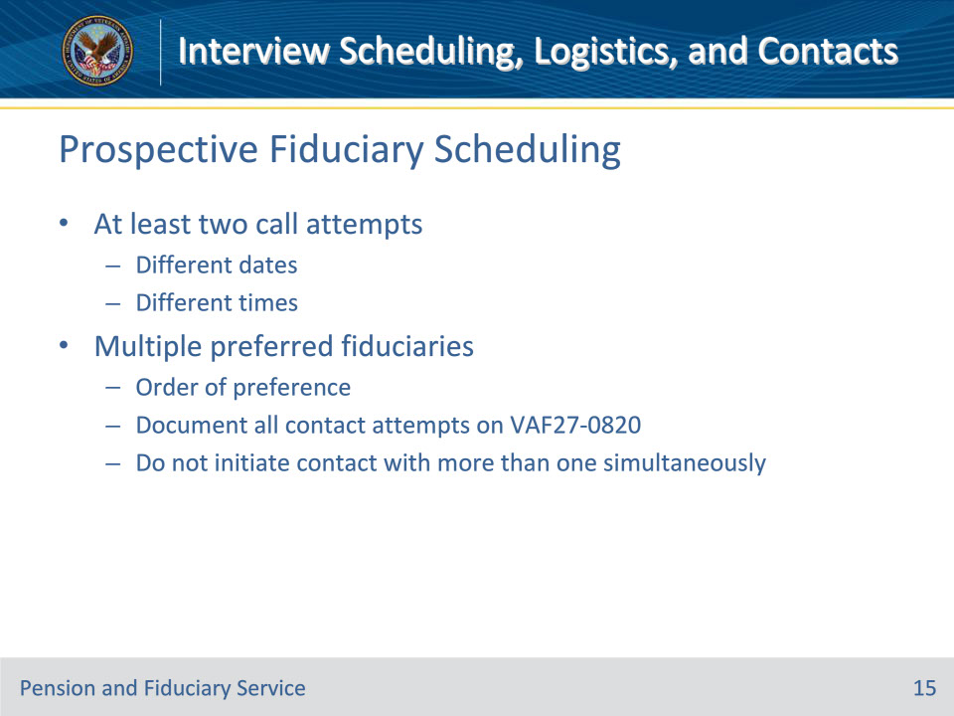
Slide notes

Policy Reference(s): FPM I.2.B.2.g.

Instructor Notes:

When attempting to contact each prospective fiduciary to schedule an IA or SIA field examination, hub personnel must attempt at least two telephone contacts on different dates and at different times.

When the beneficiary indicates multiple individuals as their preferred fiduciary, hubs must

• attempt to schedule a field examination with the most appropriate prospective fiduciary, according to the order of preference and

• document all attempts to contact the prospective fiduciary on a VA Form 27-0820.

Hub personnel should not initiate contact with multiple preferred fiduciaries simultaneously. If attempts to contact the first prospective fiduciary are unsuccessful, initiate contact with the next most suitable candidate.

Slide 16 - Prospective Fiduciary Scheduling
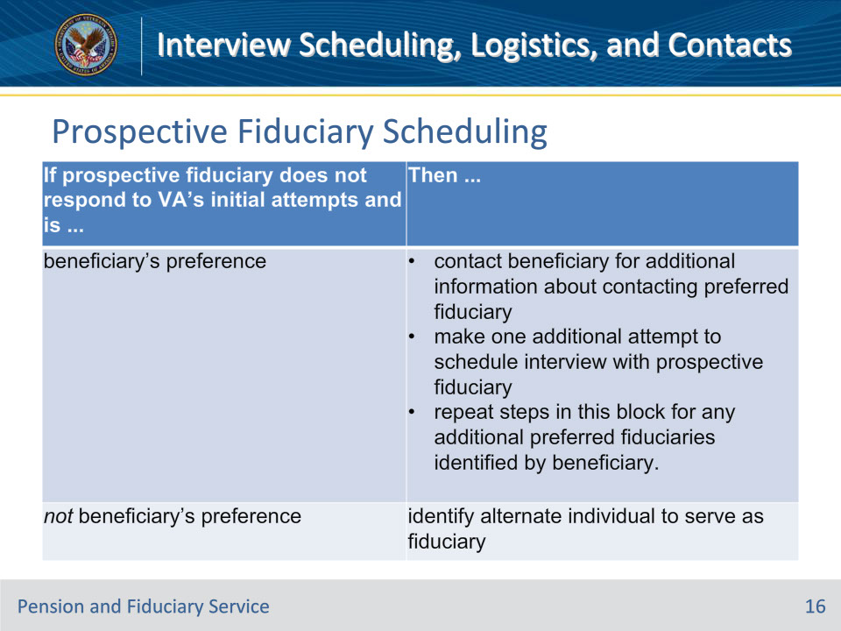
Slide notes

Policy Reference(s): FPM I.2.B.2.g.

Instructor Notes:

Use this table to determine the actions to take when the prospective fiduciary fails to respond to VA’s initial attempts to schedule the field examination.

Important: When the prospective fiduciary may have been impacted by a catastrophic event and is not able to respond to VA after multiple attempts, the hub must proceed with appointing the next most suitable fiduciary without delay. Appoint an alternate individual to protect the beneficiary’s funds and avoid unnecessary hardships.

Slide 17 - Prospective Fiduciary Scheduling
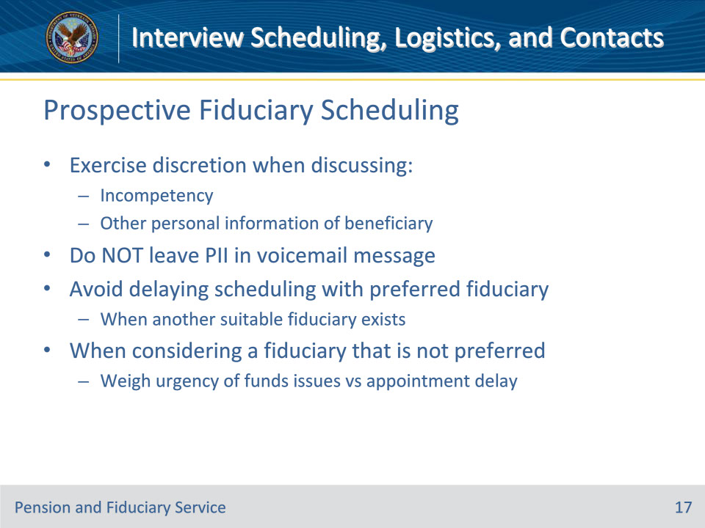
Slide notes

Policy Reference(s): FPM I.2.B.2.g.

Instructor Notes:

• Exercise discretion when discussing the finding of incompetency or other personal information of the beneficiary with the proposed fiduciary unless the beneficiary has authorized third party disclosures of record.

• When leaving a recorded voicemail for the prospective fiduciary, it must not contain any PII.

• Hubs must avoid delaying the scheduling of an interview with a preferred fiduciary for a period of time when another suitable fiduciary exists. When considering appointing a fiduciary that is not preferred, the FE must weigh the urgency of protecting VA funds and releasing retroactive payments against delaying the appointment.

Slide 18 - Appointed Fiduciary Scheduling
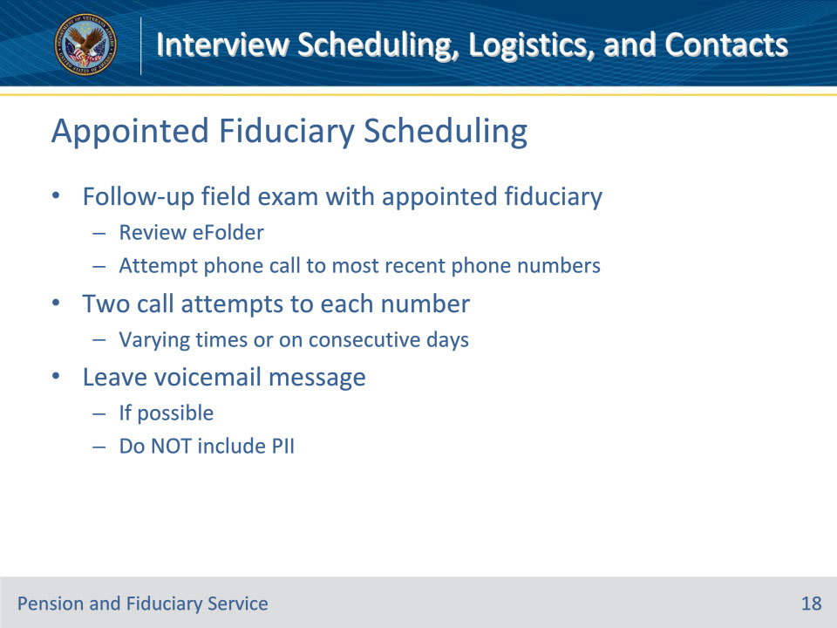
Slide notes

Policy Reference(s): FPM I.2.B.2.h.

Instructor Notes:

To schedule a follow-up field examination with an appointed fiduciary, hub personnel will review the eFolder and attempt to call the fiduciary at the most recent telephone number(s) available. If multiple telephone numbers are identified, attempt contact to each number. Two attempts to each number at varying times during the day or on consecutive days must be made. If possible, leave a voicemail message indicating an immediate call back is requested due to a time sensitive matter.

Important: Do not include PII in the voicemail.

Slide 19 - Appointed Fiduciary Scheduling
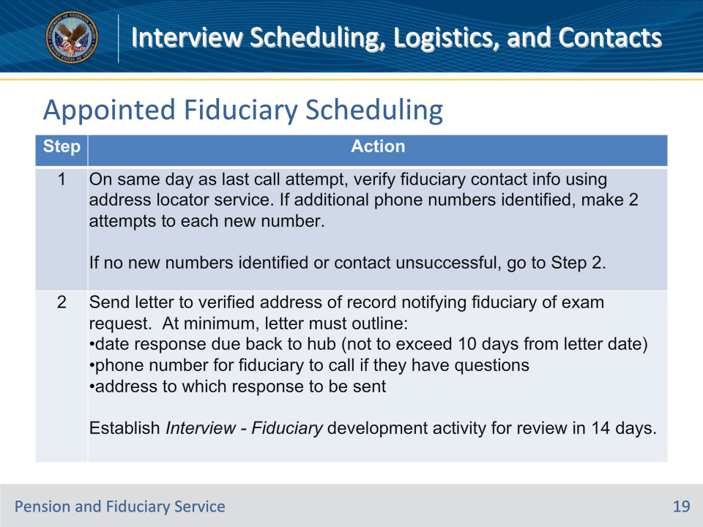
Slide notes

Policy Reference(s): FPM I.2.B.2.h.

Instructor Notes:

Follow the steps in this table when contact is unsuccessful. Follow the steps until successful contact is established or all steps are exhausted.

Note for step 2: Do not initiate the whereabouts unknown process as part of this step by selecting the FIDUCIARY WHEREABOUTS UNKNOWN box. The appropriate action will occur in this table as applicable in Step 5.

Slide 20 - Appointed Fiduciary Scheduling
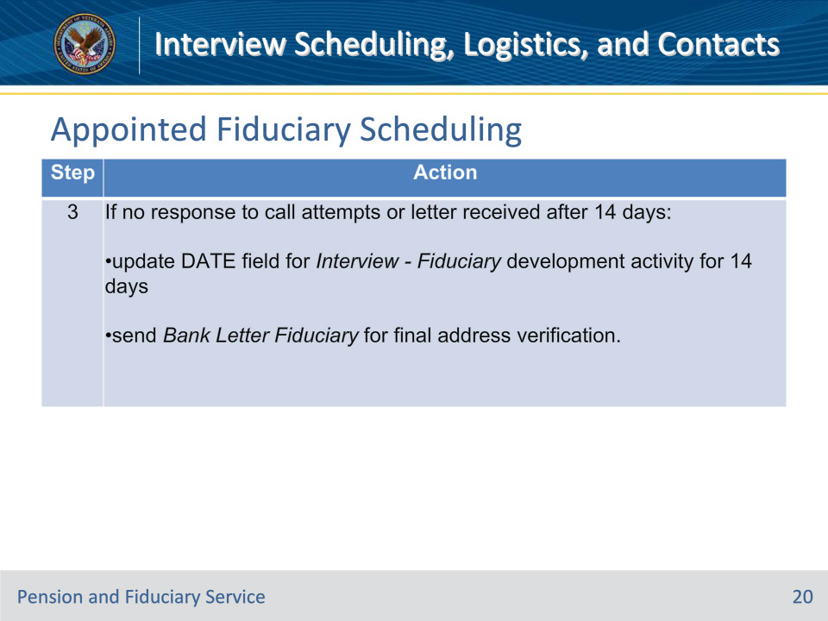
Slide notes

Policy Reference(s): FPM I.2.B.2.h.

Instructor Notes:

Follow the steps in this table when contact is unsuccessful. Follow the steps until successful contact is established or all steps are exhausted.

The steps to locate the beneficiary can be completed by an FE, LIE, or Fiduciary Service Representative (FSR). If initiated by an FE and contact is unsuccessful after completing Step 3, the case can be reassigned to an LIE or FSR to complete the remaining steps. If no hub personnel have access to the address locator service, the FE must obtain the address check report and include it in the eFolder for review by the LIE or FSR prior to reassignment.

All contact attempts must be documented on VA Form 27-0820.

Slide 21 - Step 4
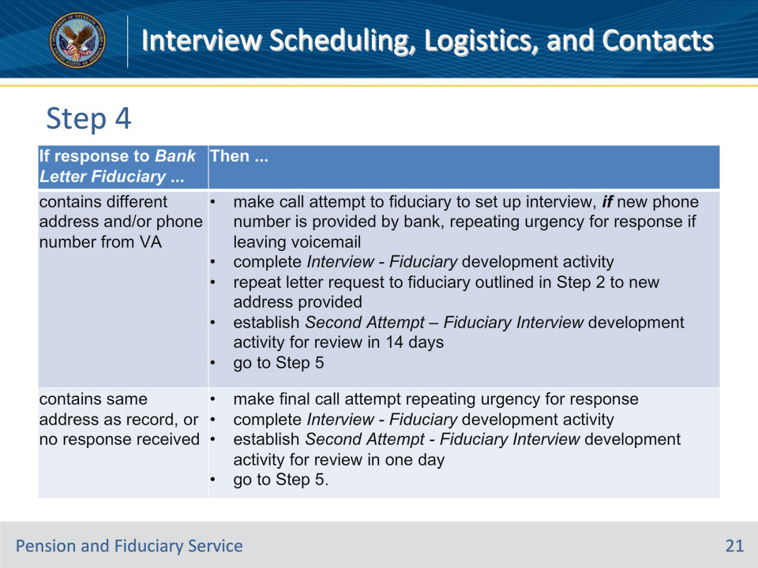
Slide notes

Policy Reference(s): FPM I.2.B.2.h.

Instructor Notes:

Follow the steps in this table when contact is unsuccessful. Follow the steps until successful contact is established or all steps are exhausted.

Step 4: Review the file for a response to the Bank Letter Fiduciary after 14 days. Use the table below to determine the actions to take.

Slide 22 - Appointed Fiduciary Scheduling
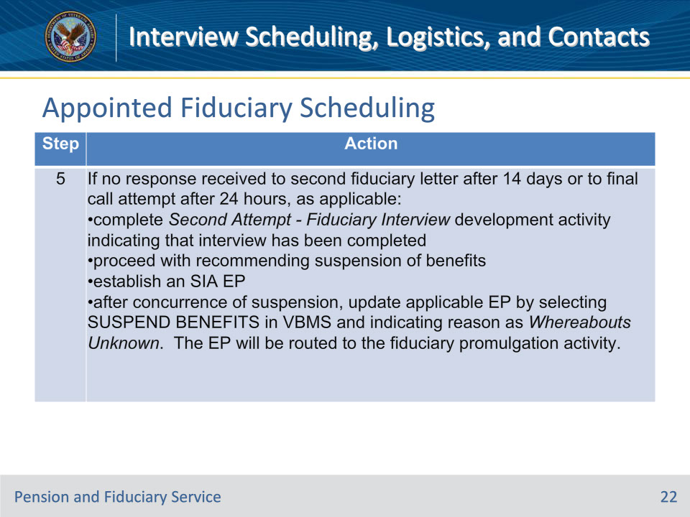
Slide notes

Policy Reference(s): FPM I.2.B.2.h.

Instructor Notes:

Follow the steps in this table when contact is unsuccessful. Follow the steps until successful contact is established or all steps are exhausted.

Slide 23 - Due Diligence
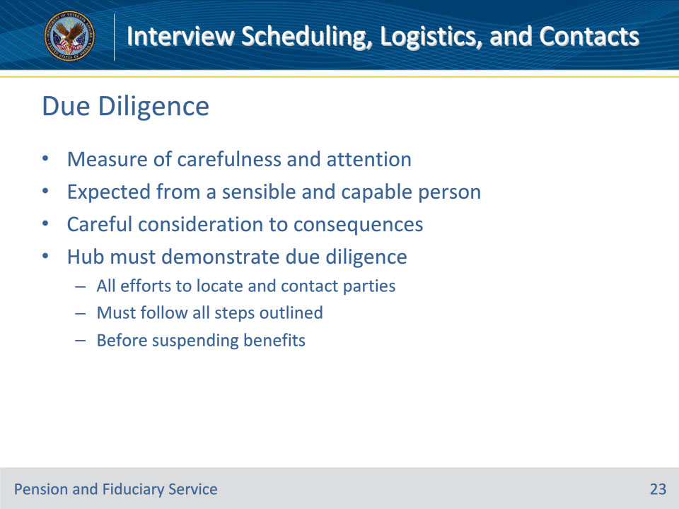
Slide notes

Policy Reference(s): FPM I.2.B.2.i

Instructor Notes:

Due diligence refers to a measure of carefulness and attention, as is expected from and exercised by a sensible and capable person with careful consideration to the consequences in a particular circumstance.

Hub personnel must adequately demonstrate due diligence in scheduling and completing a field examination with all efforts to locate and contact the party involved documented in the system of record. The steps outlined for beneficiaries and for appointed fiduciaries must be followed in order to show proper due diligence.

Any action by the hub personnel to suspend benefits when the whereabouts of the beneficiary or appointed fiduciary are unknown must be preceded by due diligence.

Slide 24 - Travel Guidelines
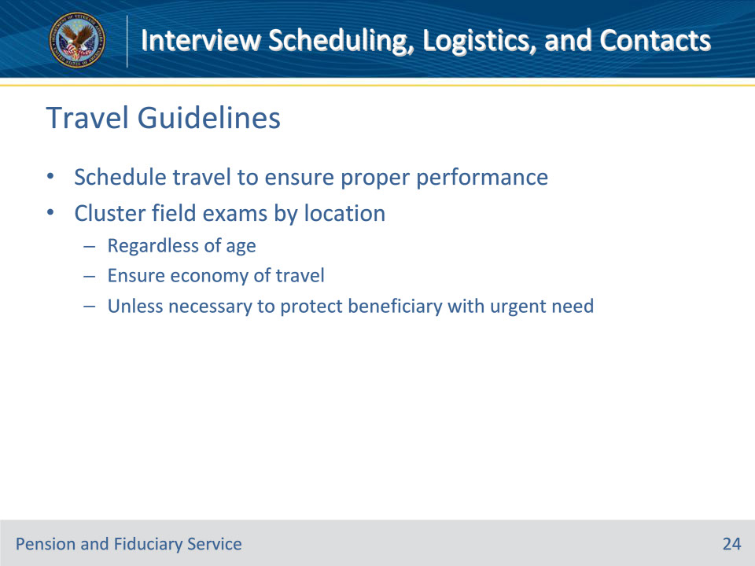
Slide notes

Policy Reference(s): FPM I.2.B.3.a., b.

Instructor Notes:

FEs should schedule travel as necessary to ensure the proper performance of Fiduciary Program responsibilities.

Whenever possible, FEs will cluster field examinations by location regardless of the age, to ensure economy of travel. However, clustering will not be a consideration if a field examination is necessary to protect the interests of a beneficiary with an urgent need. Examples of urgent need are suspected misuse, the need for a successor fiduciary or information that a beneficiary’s well-being is at risk.

Slide 25 - Travel Guidelines
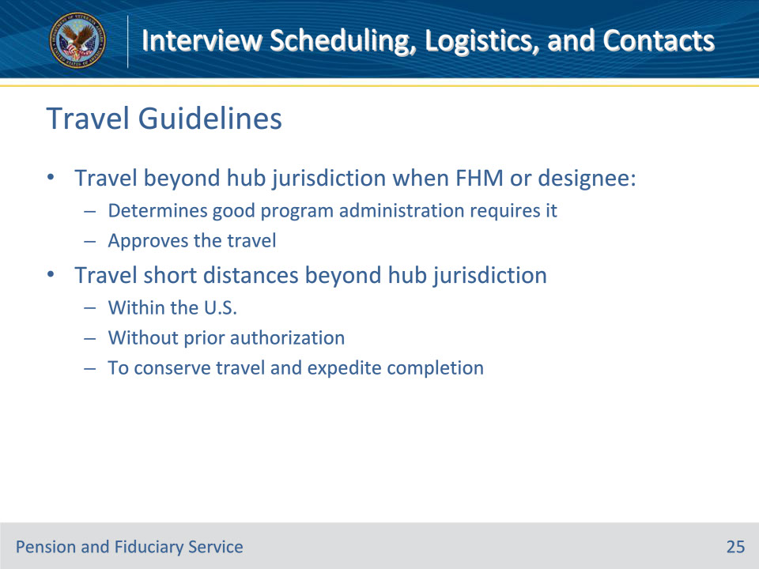
Slide notes

Policy Reference(s): FPM I.2.B.3.c.

Instructor Notes:

Generally, FEs may travel beyond hub jurisdiction when the Fiduciary Hub Manager (FHM) or designee

• determines that good program administration requires it, and

• approves the travel.

FEs may travel short distances beyond the hub’s jurisdiction within the U.S. without prior authorization when to do so will conserve travel and expedite completion of cases.

Slide 26 - Interview Logistics
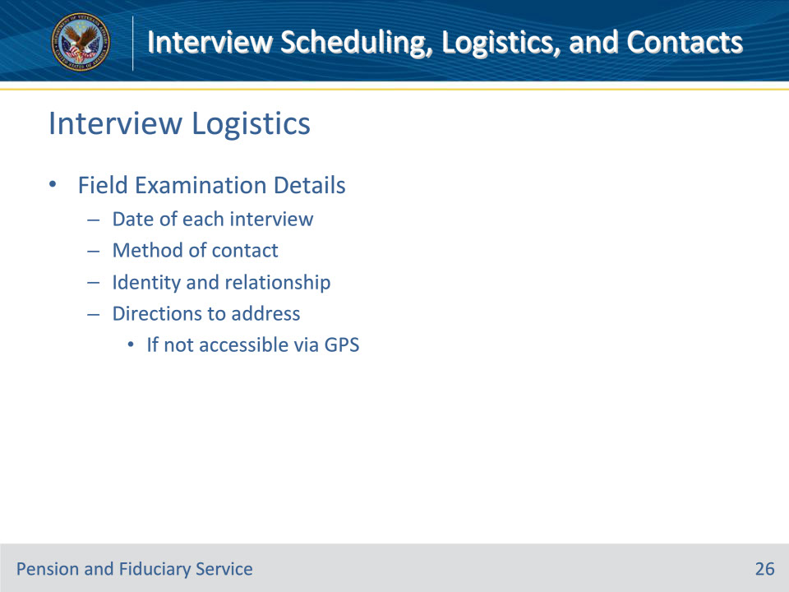
Slide notes

Policy Reference(s): FPM I.2.C.1.a

Instructor Notes:

The Field Examiner (FE) must provide information in the field examination that adequately details the interview, including:

• date and method of contact of each interview

• identity and relationship of each person interviewed, and

• directions to the address of the fiduciary or beneficiary, if it is not accessible by global positioning system or mapping technology.

Slide 27 - Beneficiary Contact
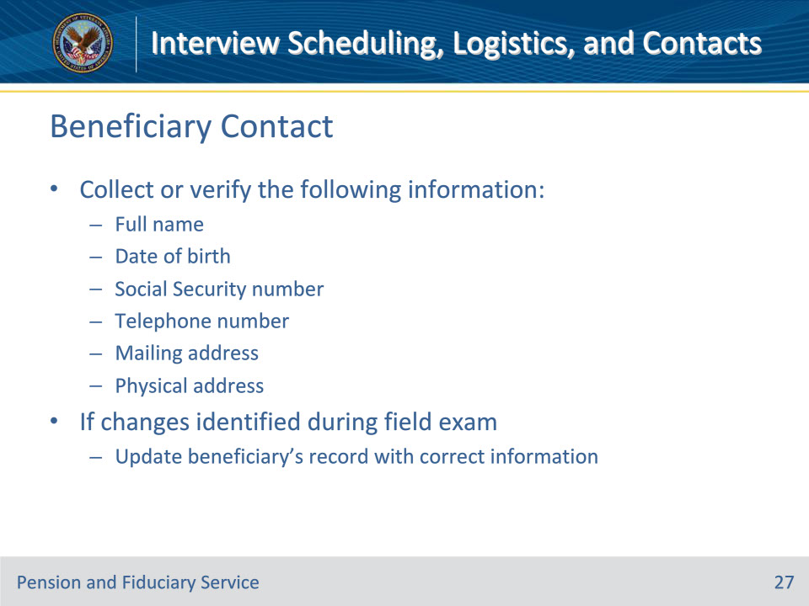
Slide notes

Policy Reference(s): FPM I.2.C.1.b.

Instructor Notes:

During the field examination process, the FE must collect or verify the following general information:

• full name

• date of birth

• Social Security number (SSN)

• telephone number

• mailing address, and

• physical address.

If the above information was collected and verified at the time of scheduling but the FE identifies changes during the field examination, the FE must update the beneficiary’s record with the correct information.

Slide 28 - Beneficiary Identity in Question
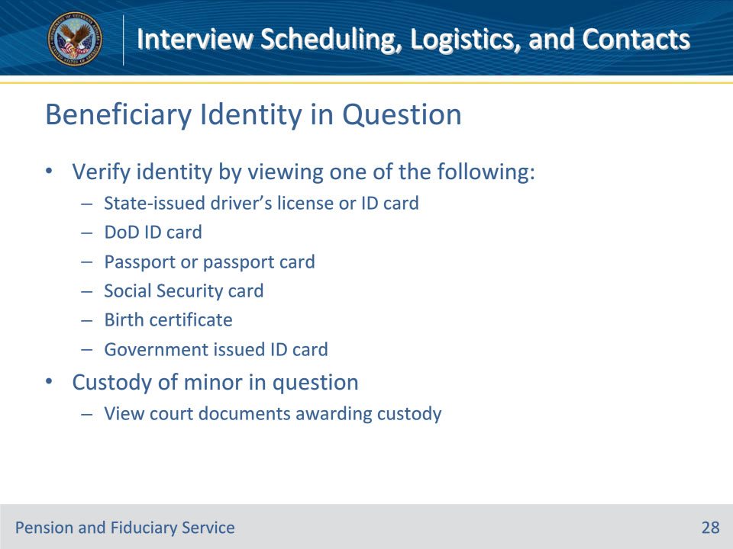
Slide notes

Policy Reference(s): FPM I.2.C.1.b.

Instructor Notes:

If the identity of a beneficiary is in question, the FE must verify the identity by viewing one of the following documents:

• State-issued driver’s license or identification card

• Department of Defense identification card

• passport or passport card

• Social Security card

• birth certificate, or
• government issued identification card.

If custody of a minor is in question, the FE must view the court documents awarding custody.

Slide 29 - Adult Beneficiary Contact
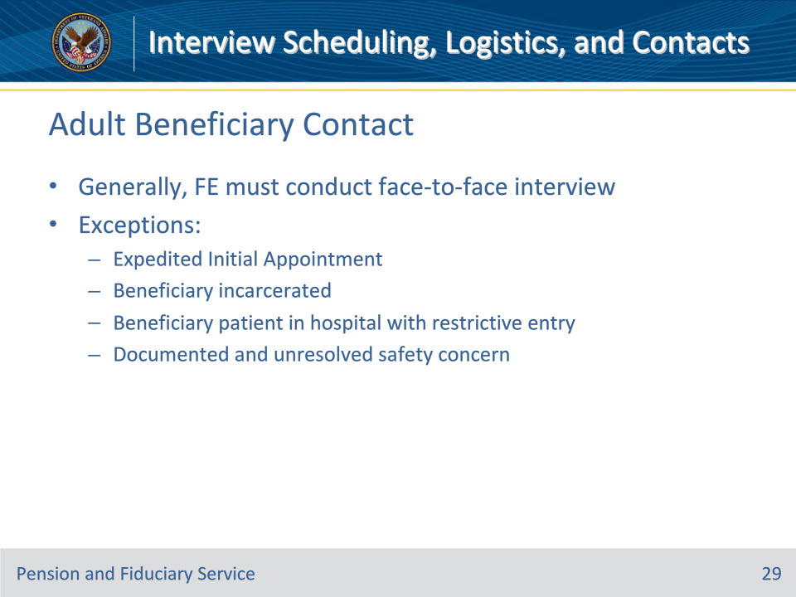
Slide notes

Policy Reference(s): FPM I.2.C.1.b.

Instructor Notes:

For adult beneficiaries:

Generally, the FE must conduct a face-to-face interview with the beneficiary.

Exception: A face-to-face interview with the beneficiary will not be conducted when

• the case qualifies for an expedited IA (EIA)

• the beneficiary is

• incarcerated, or

• a patient in a hospital with restrictive entry rules, such a facility for criminally insane that requires warden approval, or

• there is a documented safety concern that has not been resolved.

Slide 30 - Adult Beneficiary Contact
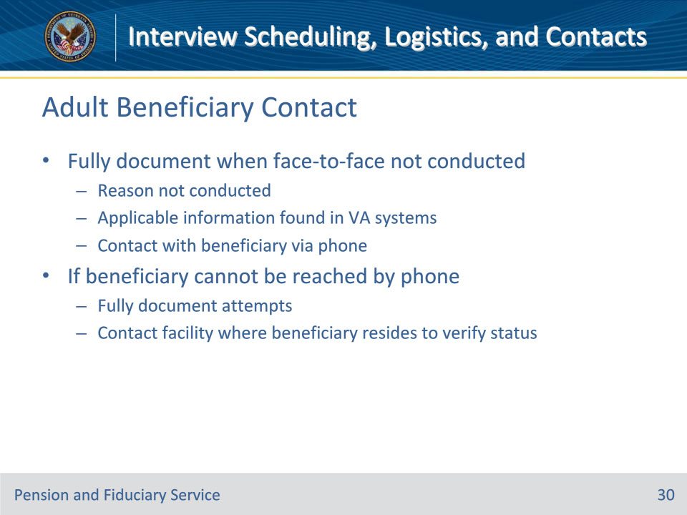
Slide notes

Policy Reference(s): FPM I.2.C.1.b.

Instructor Notes:

For adult beneficiaries:

The FE must fully document when a face-to-face interview with the beneficiary is not conducted in the field examination to include

• reason the face-to-face interview was not practicable

• applicable information found in the review of Department of Veterans Affairs (VA) systems, and

• contact with the beneficiary via telephone to obtain the beneficiary information. If any of the information cannot be obtained, the FE must explain the attempts at obtaining the information.

If the beneficiary cannot be reached by telephone, the FE must

• fully document the attempts, and

• contact the facility where the beneficiary resides to verify the beneficiary’s status.

Slide 31 - Minor Beneficiary Contact
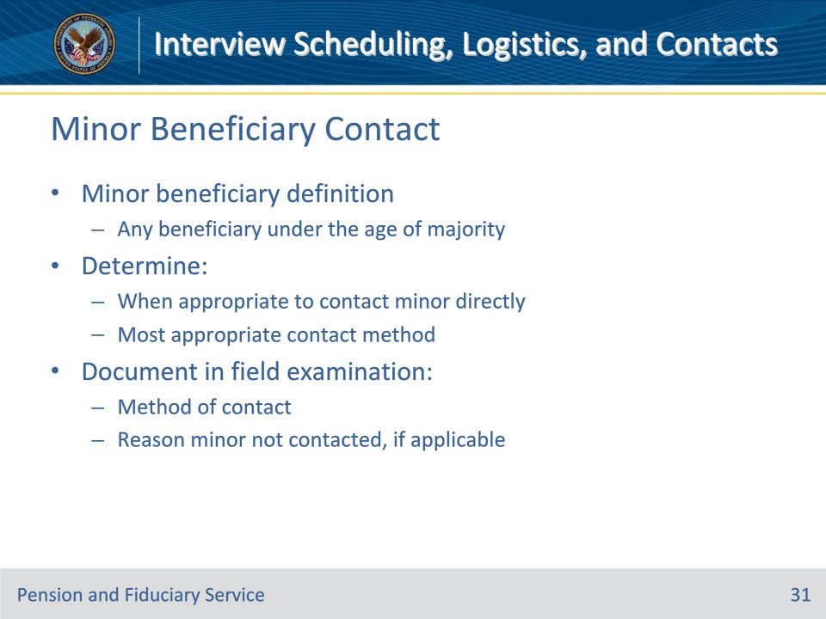
Slide notes

Policy Reference(s): FPM I.2.C.1.b.

Instructor Notes:

For minor beneficiaries:

A minor beneficiary is any beneficiary under the age of majority. A beneficiary under the age of majority, is also considered a child.

Follow the guidance to determine

• when it is appropriate to contact the minor beneficiary directly, and

• the most appropriate method for contacting the minor beneficiary, when applicable.

The field examination will document the method of contact or, if applicable, explain the reason the minor beneficiary was not contacted.

Slide 32 - Unable to Interview
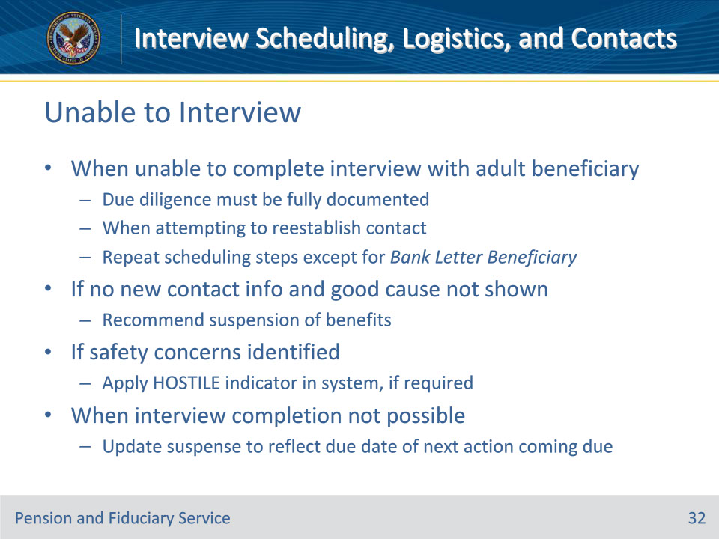
Slide notes

Policy Reference(s): FPM I.2.C.1.b.

Instructor Notes:

• In situations where the FE is unable to complete the interview with an adult beneficiary as scheduled (e.g., the beneficiary was absent), due diligence must be fully documented when attempting to reestablish contact with the beneficiary. Repeat the steps for scheduling an interview except for the steps involving sending the Bank Letter Beneficiary. These steps must be completed even if executed during initial scheduling as the beneficiary could have changed locations in the interim.

• If there is no new contact information and good cause is not shown for the beneficiary’s absenteeism, proceed with recommending suspension of benefits.

• If safety concerns with the beneficiary are identified, ensure proper application of the HOSTILE indicator in the system, if required.

Important: When completion of the interview is not possible, update the suspense date to reflect the due date of the next action coming due.

Slide 33 - Dependent Contact
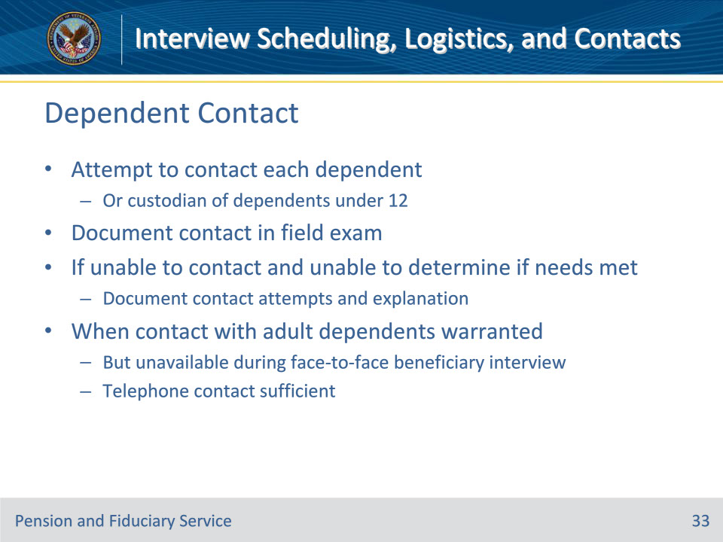
Slide notes

Policy Reference(s): FPM I.2.C.1.c.

Instructor Notes:

FEs must attempt to contact each adult beneficiary’s dependents, or the custodian of child dependents under the age of 12 and document the contact in the field examination. If the FE is unable to contact a dependent and the FE is otherwise unable to determine that the dependent’s needs are met, the field examination must document the FEs attempt to contact the dependent and provide an explanation as to why contact did not take place.

Where direct contact with a beneficiary’s adult dependents is warranted, but the dependents are unavailable for a face-to-face visit during the beneficiary interview, telephone contact is sufficient.
Slide 34 - Dependent Contact
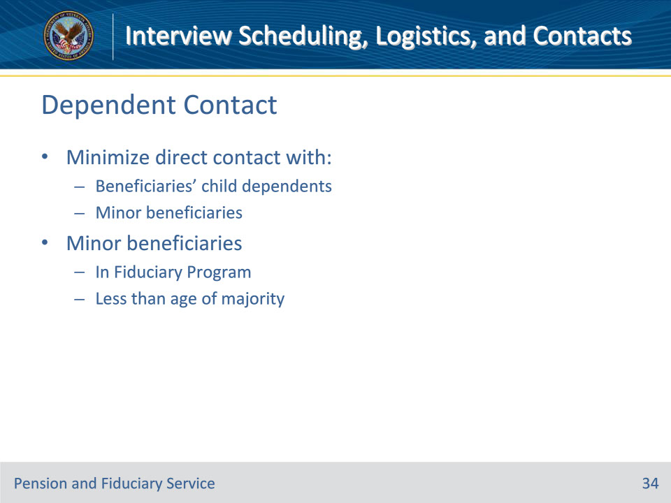
Slide notes

Policy Reference(s): FPM I.2.C.1.d.

Instructor Notes:

FEs will minimize direct contact with

• beneficiaries’ child dependents, and

• minor beneficiaries who are in the Fiduciary Program by reason of being less than the age of majority.

Slide 35 - Dependent Contact
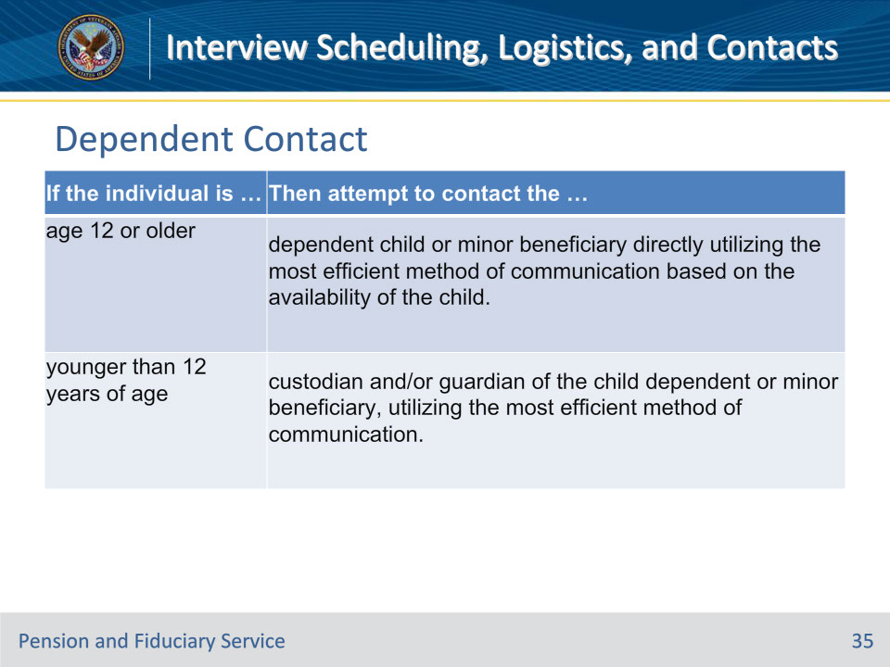
Slide notes

Policy Reference(s): FPM I.2.C.1.d.

Instructor Notes:

Use this table to determine the appropriate method of:

• obtaining financial information, and

• assessing a dependent child or minor beneficiary’s situation.

Notes for individuals age 12 or older:

• If the FE is unable to contact the individual, request the information from the

• individual’s custodian and/or guardian

• beneficiary, or

• proposed fiduciary.

• If the information is not available after all attempts, follow the dependent contact guidance.

Important: Requesting telephone or face-to-face contact should be avoided and only completed in rare circumstances for children under the age of 12.

Slide 36 - Dependent Contact
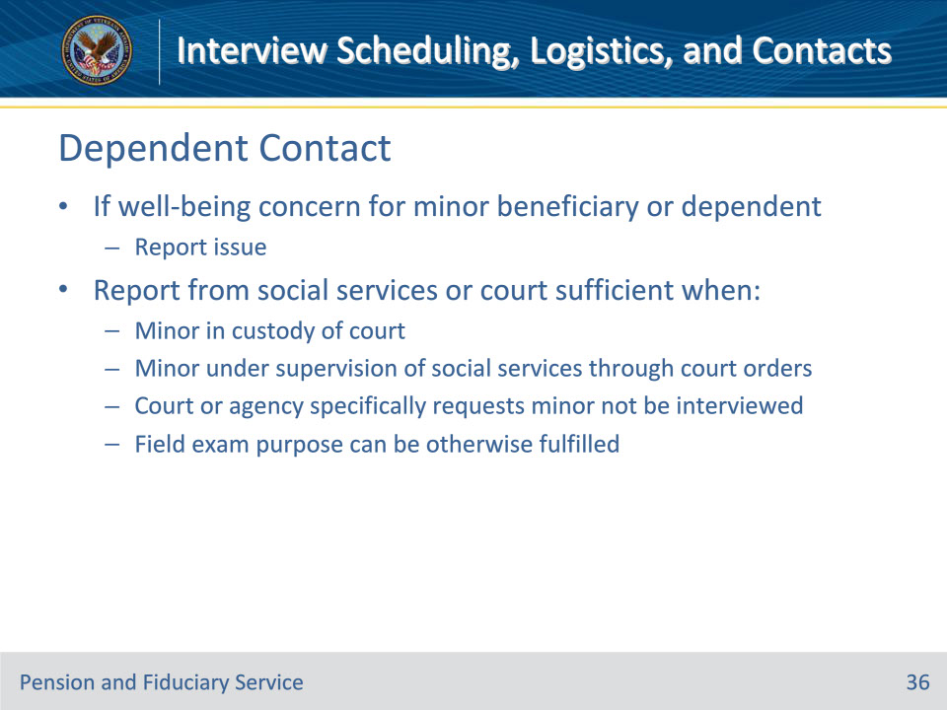
Slide notes

Policy Reference(s): FPM I.2.C.1.d.

Instructor Notes:

• If there is a well-being concern for a beneficiary or dependent who is under the age of majority, report the issue.

• If the child dependent or minor beneficiary is in the custody of a court, a report from a social service agency or court will suffice for contact when the

• minor is in the custody of the court or under the supervision of a social service agency through court orders

• court or agency specifically requests that the minor not be interviewed, and

• purpose of the field examination can otherwise be fulfilled.

Slide 37 - Fiduciary Contact
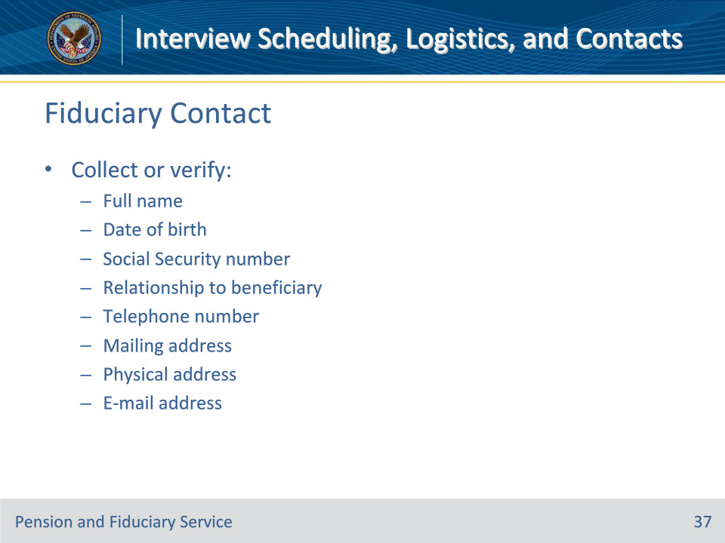
Slide notes

Policy Reference(s): FPM I.2.C.1.e.

Instructor Notes:

During the field examination process the FE must collect or verify the following general information:

• full name

• date of birth

• SSN

• relationship to the beneficiary

• telephone number

• mailing address

• physical address, and

• e-mail address, if available.

Slide 38 - Fiduciary Contact
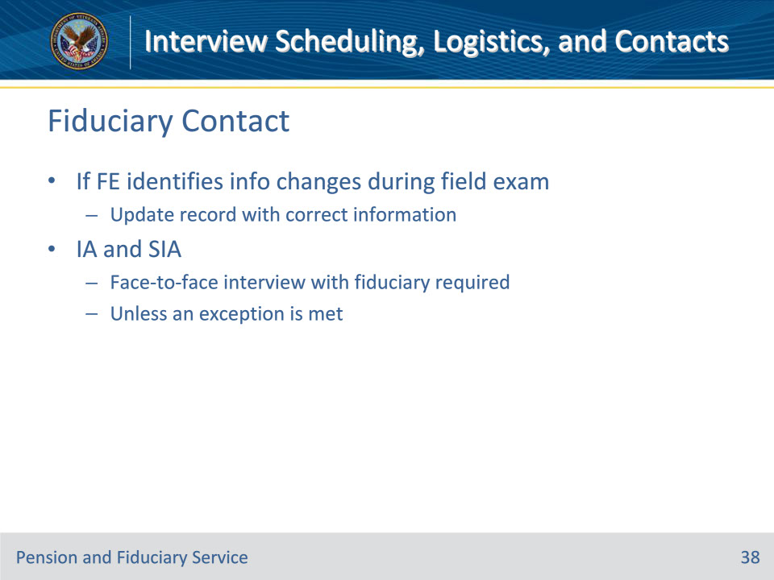
Slide notes

Policy Reference(s): FPM I.2.C.1.e.

Instructor Notes:

This information may have been collected and verified at the time of scheduling; however, if the FE identifies changes in this information during the field examination, the FE must update the record with the correct information.

For an IA and SIA, other than the situations listed as an exception, the FE must conduct a face-to-face interview with the fiduciary to complete the appointment process.

Slide 39 - Fiduciary Guidance
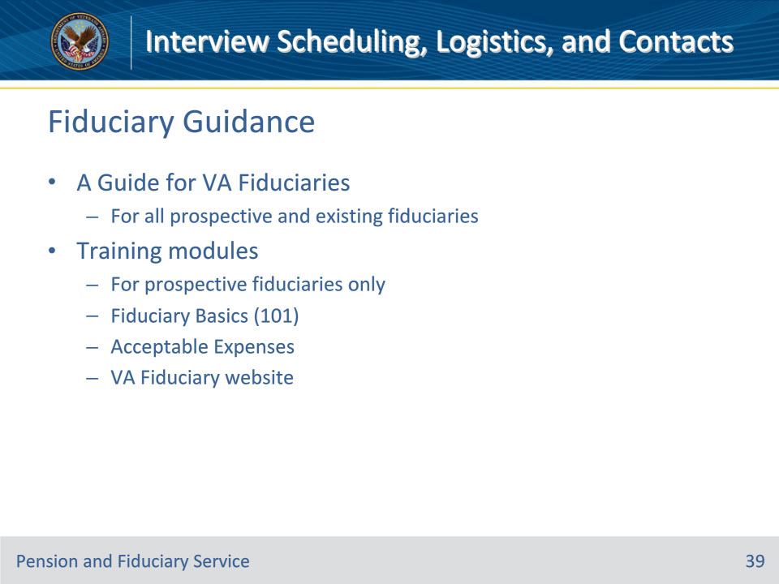
Slide notes

Policy Reference(s): FPM I.2.C.1.f.

Instructor Notes:

In addition to obtaining the fiduciary information listed on the previous slide, the FE must provide all prospective and existing fiduciaries with A Guide for VA Fiduciaries. For prospective fiduciaries only, FEs must also provide training information regarding the fiduciary process and request they complete the modules prior to the field examination. This training includes the Fiduciary Basics (101) and Acceptable Expenses training modules, which are located on the VA Fiduciary website along with A Guide for VA Fiduciaries. The FE may provide the link to the training modules and guide via email, telephone call, or text message when scheduling the field examination.

Slide 40 - Fiduciary Guidance
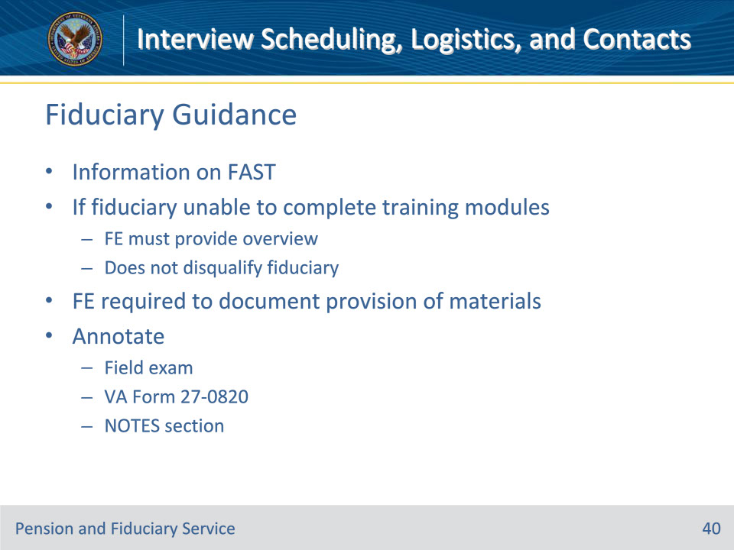
Slide notes

Policy Reference(s): FPM I.2.C.1.f.

Instructor Notes:

For prospective fiduciaries, FEs must also provide information on the use of the Fiduciary Accountings Submission Tool (FAST) for submission of

• accountings

• fund usage reports, and

• VA Form 21P-4703, Fiduciary Agreement, for the purposes of qualifying the fiduciary.

If the prospective fiduciary is unable to complete the training modules prior to the field examination, the FE must provide them with an overview of the content covered in the training. Failure to complete the on-line training does not disqualify the fiduciary from serving.

The FE is required to document the provision of the training modules, the guide, and the use of FAST. The FE must document this action by annotating the

• field examination

• VA Form 27-0820, Report of General Information, or

• NOTES section of the claims processing system.

Slide 41 - Fiduciary Contact
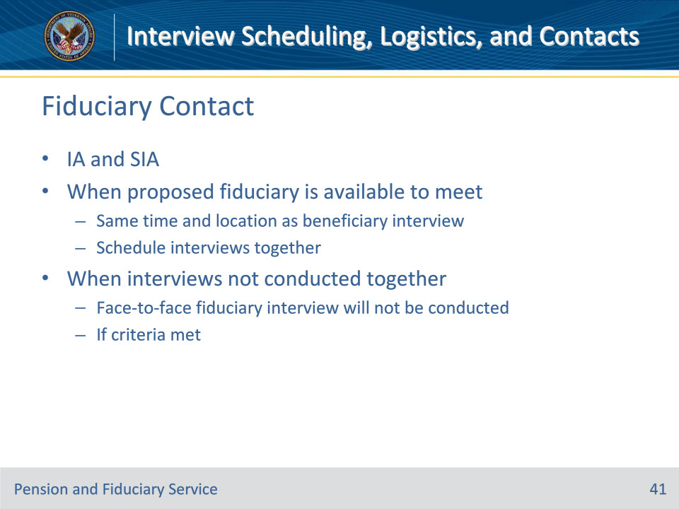
Slide notes

Policy Reference(s): FPM I.2.C.1.g.

Instructor Notes:

During IA and SIA field examinations, when the proposed fiduciary is available to meet at the same time and location of the beneficiary interview, the FE should schedule the interviews together. When the interview with the proposed fiduciary is not conducted with the beneficiary interview, a face-to-face interview with the proposed fiduciary will not be conducted when the proposed fiduciary meets the criteria discussed on the following slide.

Slide 42 - Fiduciary Face-to-Face Exceptions
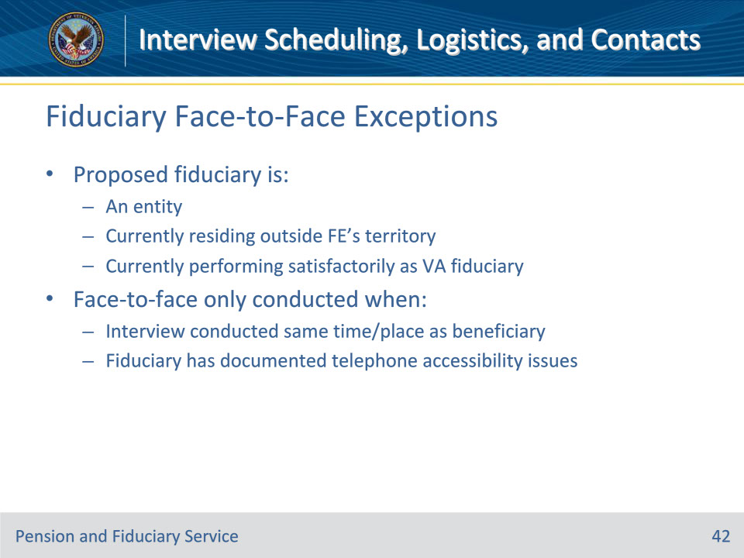
Slide notes

Policy Reference(s): FPM I.2.C.1.g.

Instructor Notes:

When the interview with the proposed fiduciary is not conducted with the beneficiary interview, a face-to-face interview with the proposed fiduciary will not be conducted when the proposed fiduciary is

• an entity, such as the trust department of a bank that provides fiduciary services per 38 CFR 13.100(f)(4)

• currently residing outside of the conducting FE’s territory and it is necessary to transfer the field examination work item to another FE creating unnecessary delays in processing, or

• currently performing satisfactorily as VA fiduciary for at least one other VA beneficiary and is determined to be suitable in accordance with all applicable elements, including up-to-date submissions of accountings.

A face-to-face interview with the proposed fiduciaries noted above will only be conducted when the

• interview with the proposed fiduciary is conducted at the same time and location as the beneficiary interview, or

• proposed fiduciary has telephone accessibility issues (e.g., deaf or telephone connection issues) and the accessibility issues are documented in the field examination.

Slide 43 - Fiduciary Face-to-Face Not Conducted
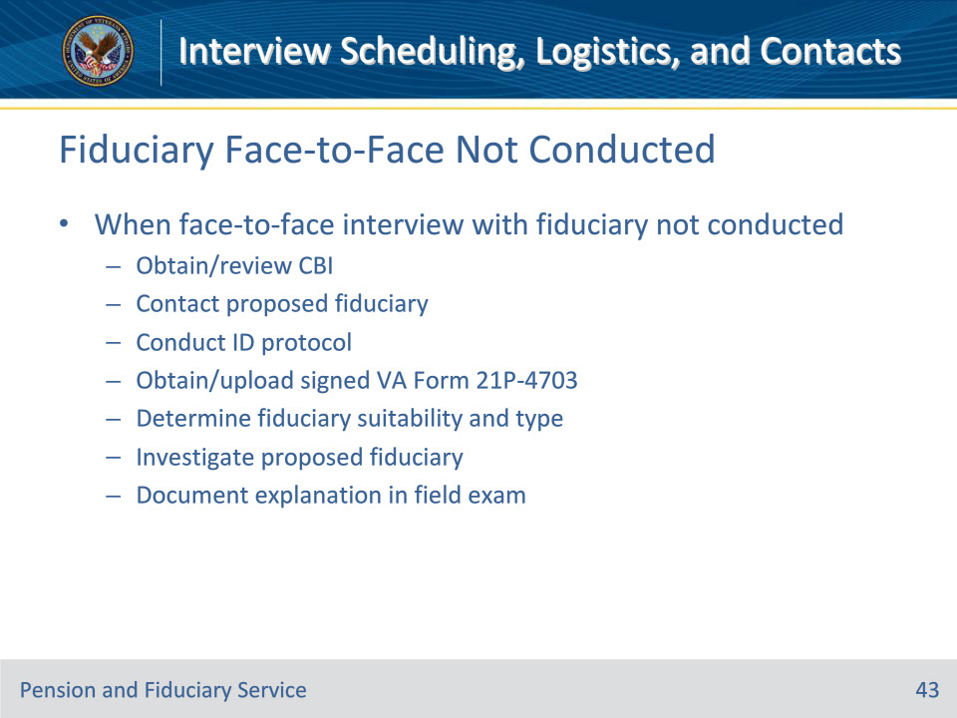
Slide notes

Policy Reference(s): FPM I.2.C.1.g.

Instructor Notes:

When the face-to-face interview with the fiduciary is not conducted, the FE must:

• obtain and review the criminal background inquiry (CBI) through CLEAR, unless the proposed fiduciary is an entity, prior to contacting the proposed fiduciary

• contact the proposed fiduciary via telephone or secure videoconferencing through approved methods to ensure the fiduciary understands the responsibilities of a VA fiduciary

• utilize the CBI to conduct identification protocol verifying the proposed fiduciary’s

• first, middle, and last name

• last four digits of their SSN, and

• date of birth

• obtain and upload a signed VA Form 21P-4703, through a secure method such as

• an encrypted e-mail

• an approved VA claims submission service website, or

• by mail

• determine the suitability and type of fiduciary

• investigate the proposed fiduciary, and

• document in the field examination that a face-to-face interview with the proposed fiduciary in this scenario has been determined to not be practicable and reference this manual citation.

Important: For adult beneficiaries, the order of preference must be followed.

Notes:

• Do not conduct the interview with the proposed fiduciary if the CBI indicates a bar to service.

• A VA Form 21P-4703 is not required prior to conducting the CBI.

Slide 44 - Other Parties
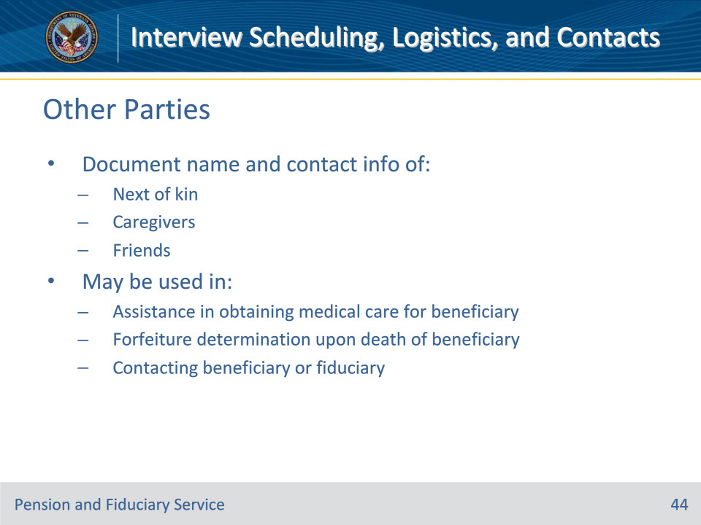
Slide notes

Policy Reference(s): FPM I.2.C.1.i.

Instructor Notes:

The FE must document the name and contact information (if available) of people considered to be the next of kin, caregiver, and/or friend to the beneficiary in the beneficiary profile. This information may be used in

• managing the case if there is need for someone to assist with obtaining medical care for the beneficiary

• making forfeiture determinations upon death of the beneficiary, and

• contacting the beneficiary or fiduciary.

Next of kin refers to a relationship resulting from a biological relationship, marriage, or from adoption proceedings. An ex-spouse, stepparent, sister-in-law, etc., are not next of kin, but can be listed as a friend and/or caregiver.

When scheduling additional interviews in the future, update the suspense date to reflect the due date of the next interview.

Slide 45 - Privacy Act
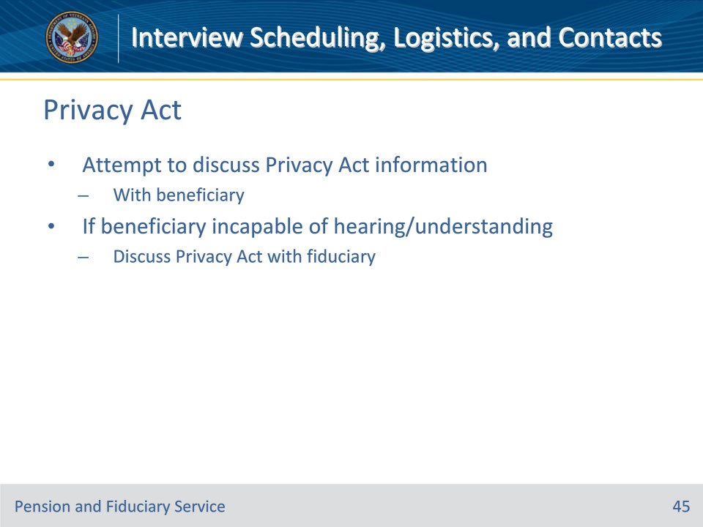
Slide notes

Policy Reference(s): FPM I.2.C.1.j.

Instructor Notes:

The FE must attempt to discuss the Privacy Act information with the beneficiary. If the beneficiary is not capable of hearing and/or understanding the conversation, the FE may discuss the Privacy Act with the fiduciary.

Slide 46 - Questions?
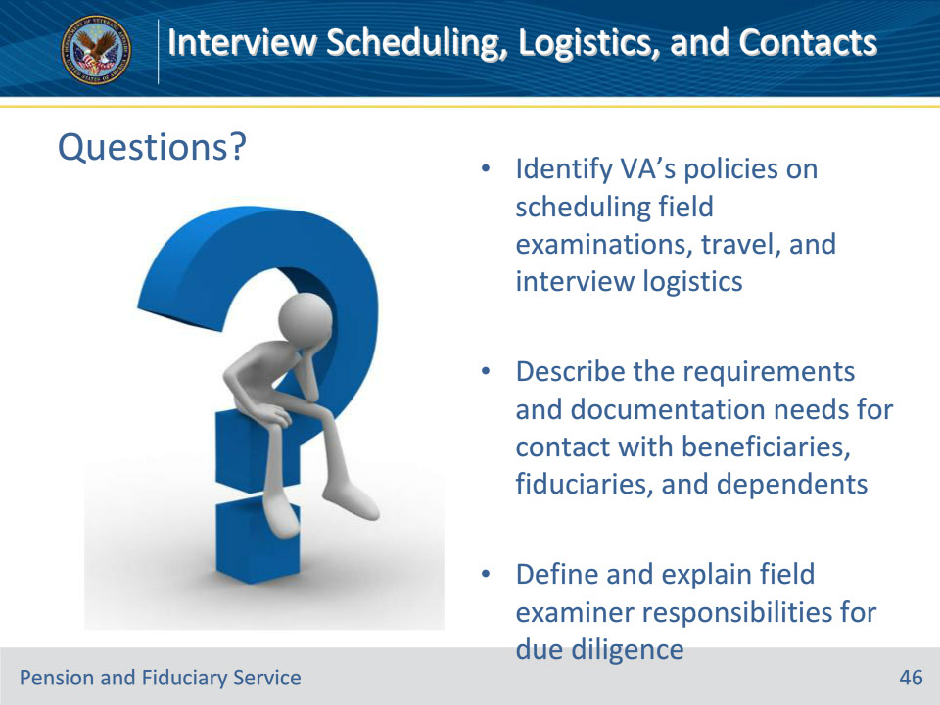
Slide notes

Instructor Notes:

(Recall) These are our learning objectives as stated from the beginning of the training:

• Identify VA’s policies on scheduling field examinations, travel, and interview logistics

• Describe the requirements and documentation needs for contact with beneficiaries, fiduciaries, and dependents

• Define and explain field examiner responsibilities for due diligence

Are there any additional questions?

Slide 47 - TMS Survey
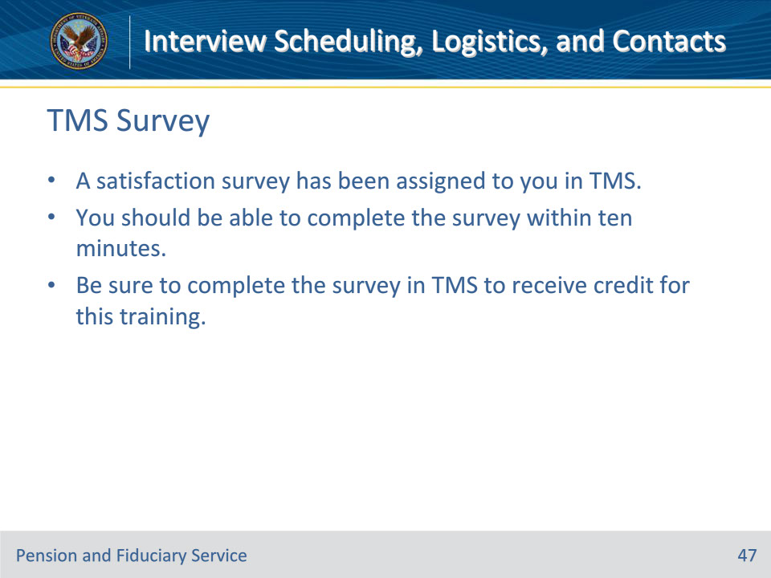
Slide notes

Instructor Notes:

A satisfaction survey has been assigned to you in TMS. You should be able to complete the survey within ten minutes. Completing the survey will allow you to receive credit for this training.

