Slide 1 - Funds Under Management
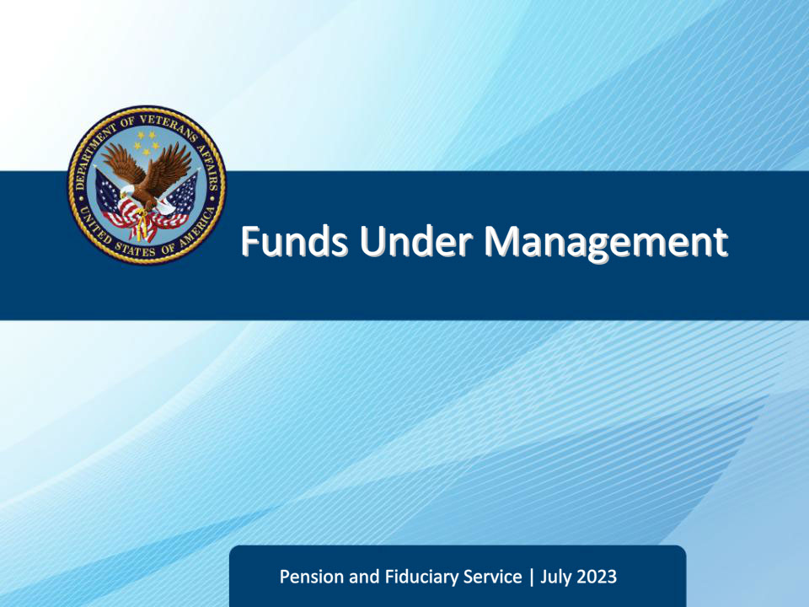
Slide notes

Course Description:

This lesson teaches how to calculate and verify funds under the management of a fiduciary to ensure proper protection of a beneficiary’s VA benefits.

Slide 2 - Navigation
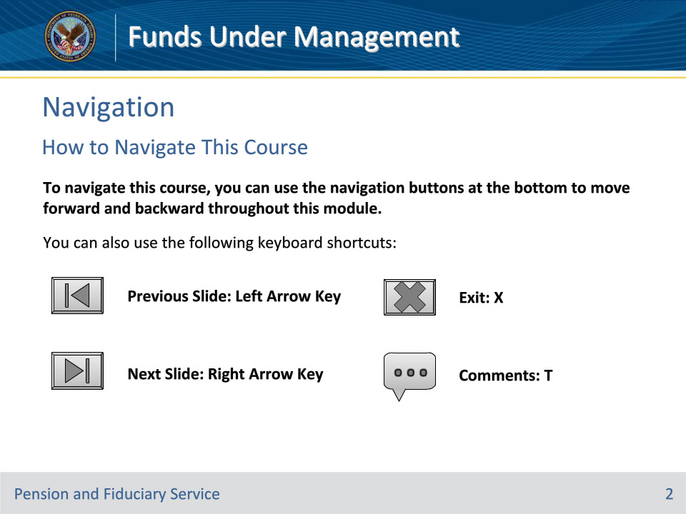
Slide notes

To navigate this course, you can use the navigation buttons at the bottom to move forward and backward throughout this module.

You can also use the following keyboard shortcuts:

• Previous Slide: Left Arrow Key

• Next Slide: Right Arrow Key

• Exit: X

• Comments: T

Slide 3 - Objectives
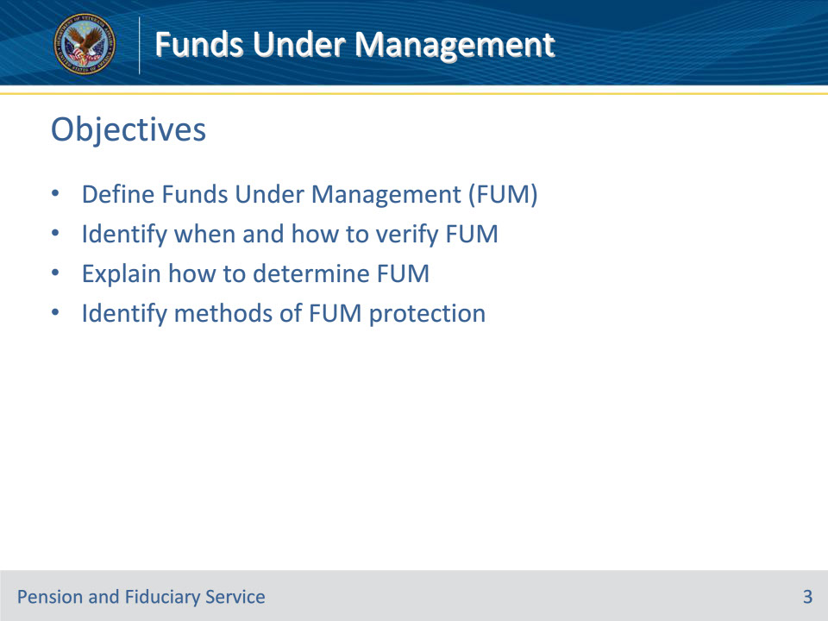
Slide notes

Instructor Notes:

At the end of this lesson, given the training and references, the learner will be able to do the following:

• Define Funds Under Management (FUM)

• Identify when and how to verify FUM

• Explain how to determine FUM

• Identify methods of FUM protection

Slide 4 - References
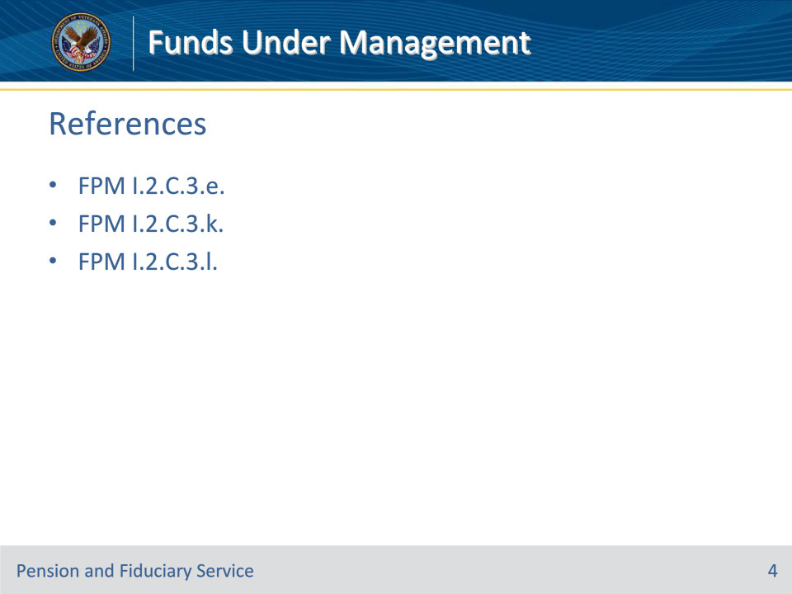
Slide notes

Instructor Notes:

These are the relevant references pertaining to this course:

• FPM I.2.C.3.e. Documenting and Verifying Liquid Assets

• FPM I.2.C.3.k. Determining VA FUM

• FPM I.2.C.3.l. Appropriate Actions if the FUM Exceeds Limits for Accounting and Protection of FUM Limits

Slide 5 - VA FUM
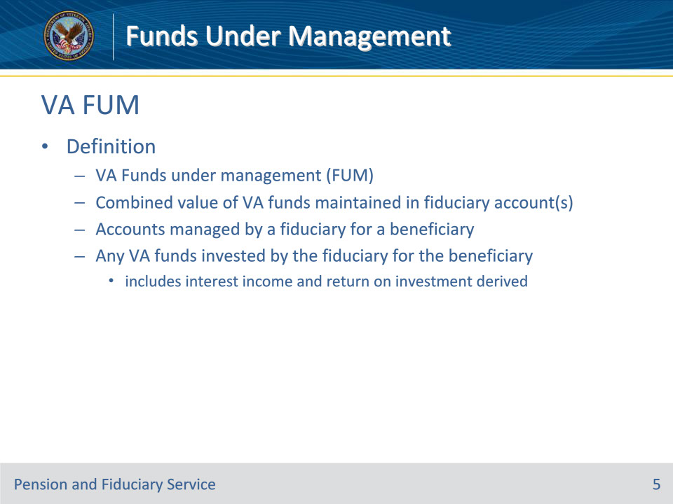
Slide notes

Policy Reference(s): FPM I.2.C.3.k.

Instructor Notes:

FUM means the combined value of the VA funds maintained in a fiduciary account or accounts managed by a fiduciary for a beneficiary and any VA funds invested by the fiduciary for the beneficiary, to include any interest income and return on investment derived from any account

Slide 6 - IA/EIA FUM
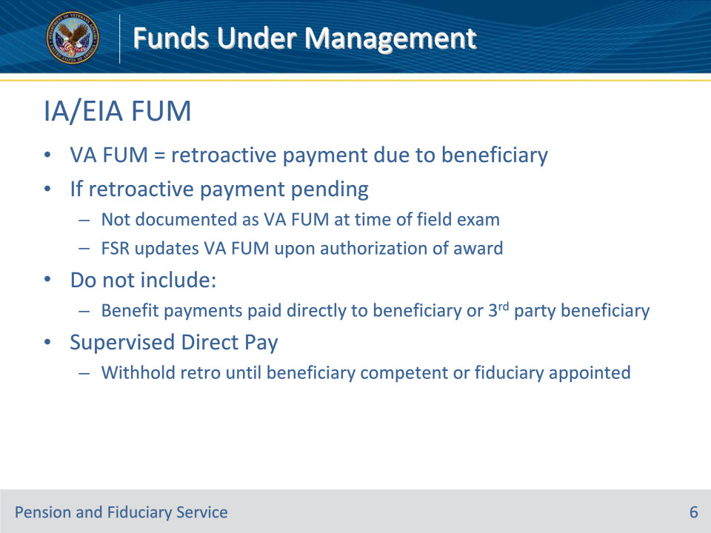
Slide notes

Policy Reference(s): FPM I.2.C.3.k.

Instructor Notes:

If the field examination type is an IA/EIA, then the VA FUM is the retroactive payment due to the beneficiary, if any, upon release to the fiduciary. If a retroactive payment is pending, the retroactive payment is not documented as VA FUM at the time of the field examination conducted by the FE. The Fiduciary Service Representative will update VA FUM within the beneficiary profile to reflect the amount of the retroactive payment released to the fiduciary immediately upon authorization of the award.

Determining VA FUM during an IA/EIA shall not include any regular or irregular benefit payments which are paid directly to a beneficiary or to a third-party beneficiary other than the potential fiduciary. This includes all non-VA benefits, as well as VA benefits which are structured to provide payments for specific expenses (for example, clothing expenses, education benefit, specially adapted housing/special home adaptation grants, automobile grants, etc.) which are not paid directly to the fiduciary. Any determination of VA FUM following an IA/EIA shall include any VA benefits deposited within a properly titled account managed by an existing or previous fiduciary.

When VA appoints a beneficiary under SDP, retroactive funds are withheld until the beneficiary is rated competent or a fiduciary is appointed. As a result, retroactive funds are not considered FUM upon authorization of an SDP award.
Slide 7 - SIA FUM
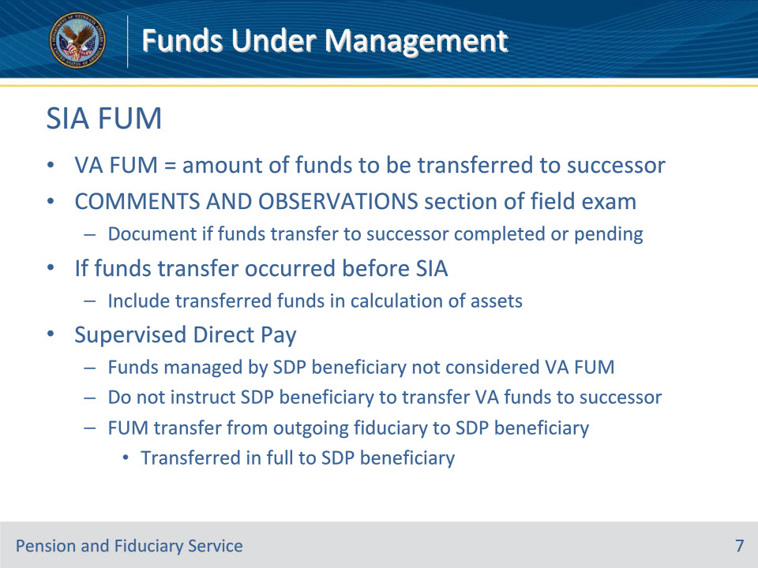
Slide notes

Policy Reference(s): FPM I.2.C.3.k.

Instructor Notes:

If the field examination type is an SIA, then the VA FUM is the amount of funds to be transferred to the appointed successor fiduciary or beneficiary with an SDP appointment.

The field examination must also document in the COMMENTS AND OBSERVATIONS section of the report if the funds transfer to the successor fiduciary has been completed or is pending. If the funds transfer has occurred before the SIA, include the transferred funds in the calculation of assets. The field examination may not be submitted for closure without documenting the status of the funds transfer.

Funds managed directly by a beneficiary under an SDP appointment are not considered VA FUM. Therefore, the hub should not instruct the beneficiary under an SDP appointment to transfer VA funds when VA appoints a fiduciary because SDP is no longer appropriate.

The hub must not consider FUM that is being transferred from an outgoing fiduciary appointed by VA to the beneficiary with an SDP appointment as a retroactive or one-time payment subject to withholding. The outgoing fiduciary must transfer all FUM to the beneficiary when the beneficiary receives an SDP appointment.
Slide 8 - FUM Verification
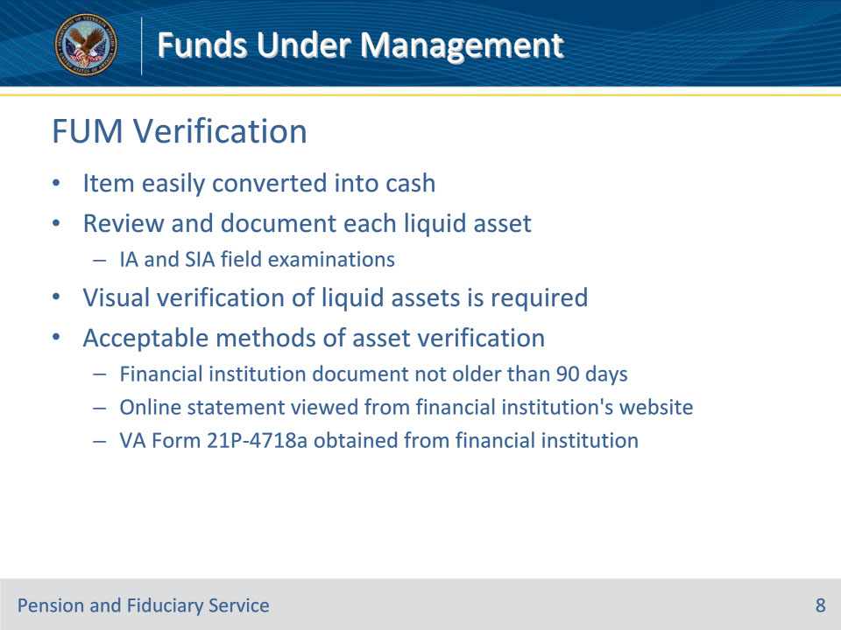
Slide notes

Policy Reference(s): FPM I.2.C.3.e.

Instructor Notes:

The FE must review and document each liquid asset identified during all IA and SIA field examinations. A liquid asset is an item that may easily be converted into cash.

Visual verification of liquid assets is necessary. Acceptable methods of asset verification include viewing one of the following items:

• an original, photocopied, or computer-generated financial institution document which does not exhibit any signs of alteration, not older than 90 days from the date of the field examination

• an online statement viewed from the financial institution’s website, or

• a VA Form 21P-4718a, Certificate of Balance on Deposit and Authorization to Disclose Financial Records, obtained from the financial institutions.

Slide 9 - FUM Verification
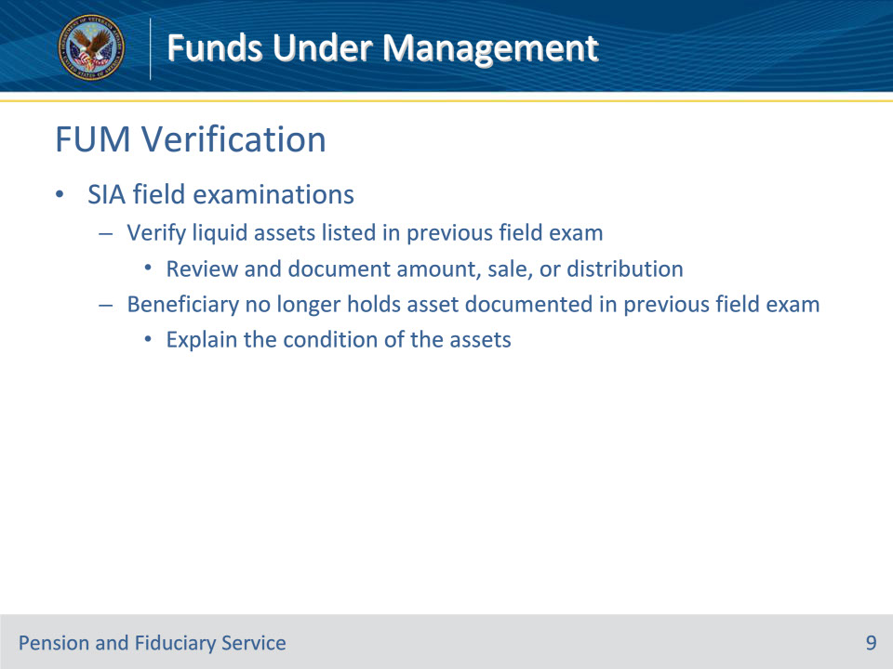
Slide notes

Policy Reference(s): FPM I.2.C.3.e.

Instructor Notes:

During SIA field examinations, the FE must verify liquid assets listed in the previous field examination by reviewing and documenting the amount, sale, or distribution of assets identified in the previous field examination. If the beneficiary no longer holds an asset (for example, sold property or closed an account) or has exhausted an asset that was documented in the previous field examination, the FE must explain the condition of the assets.

Slide 10 - FUM Verification
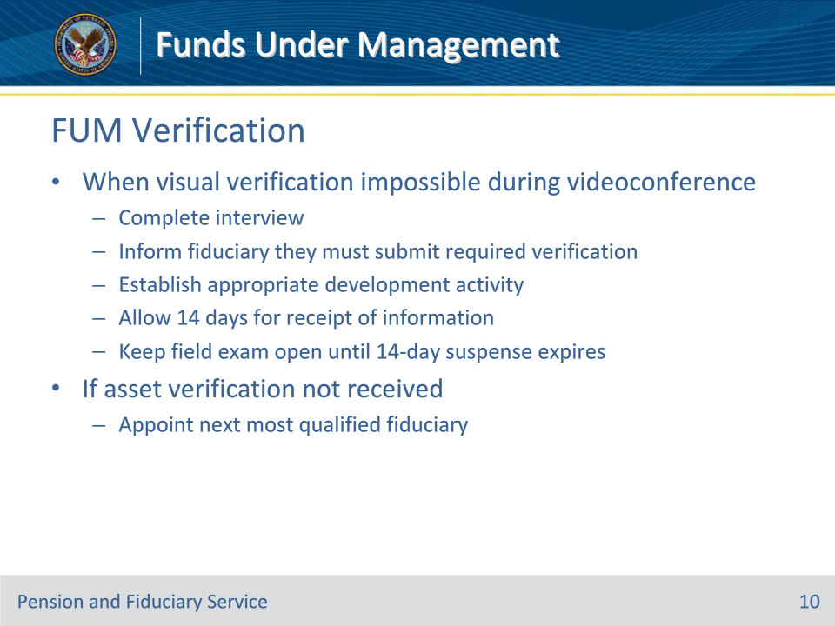
Slide notes

Policy Reference(s): FPM I.2.C.3.e.

Instructor Notes:

If the FE cannot visually verify liquid assets during videoconferencing

• complete the interview

• inform the fiduciary that they must submit the required verification to the hub using a secure communication method (for example, fax, mail)

• establish the appropriate development activity

• allow 14 days for receipt of the information, and

• keep the field examination open until the 14-day suspense expires.

If the proposed fiduciary does not submit the asset verification within the requested timeframe, the FE must proceed with appointing the next most qualified fiduciary.

Slide 11 - FUM Verification
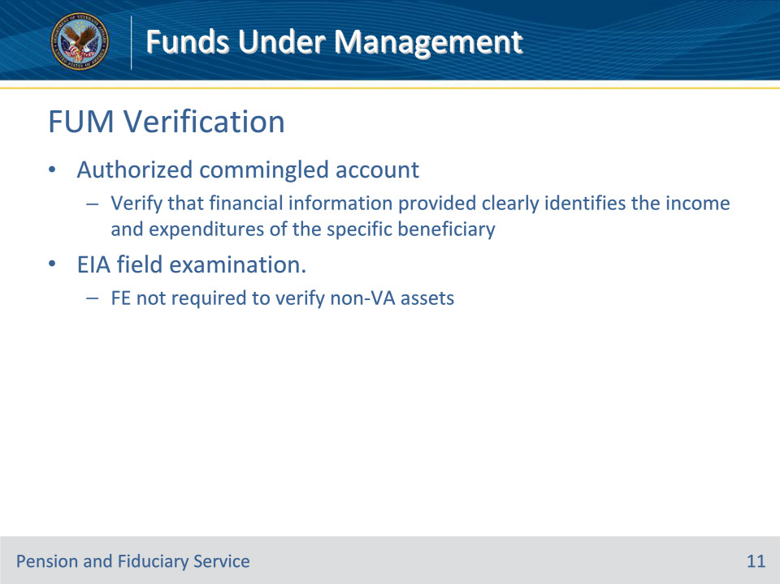
Slide notes

Policy Reference(s): FPM I.2.C.3.e.

Instructor Notes:

If the fiduciary has an authorized commingled financial account, the FE must verify that the financial information provided clearly identifies the income and expenditures of the specific beneficiary.

The FE is not required to verify non-VA assets during an EIA field examination.

Slide 12 - FUM Verification
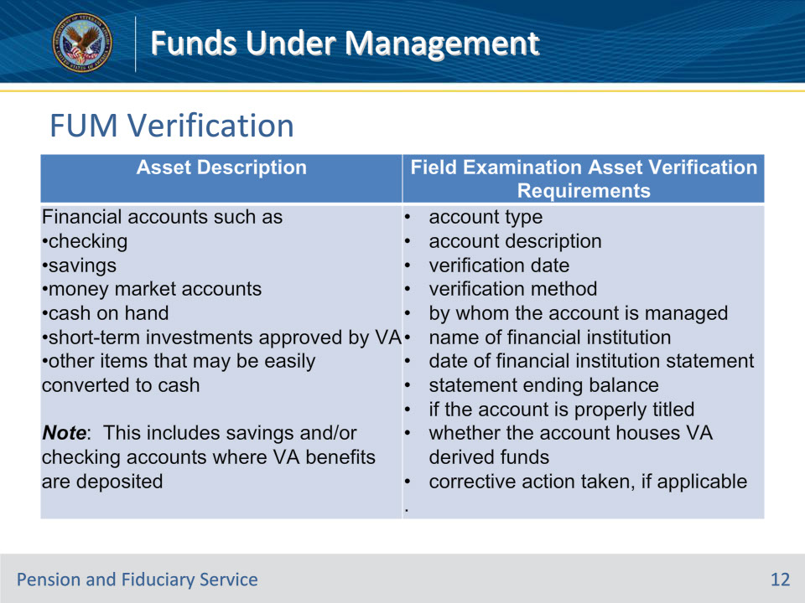
Slide notes

Policy Reference(s): FPM I.2.C.3.e.

Instructor Notes:

This table provides information on the types of liquid assets and the verification requirements.

Important: When adding an asset, enter the information in the appropriate fields. Use the DESCRIPTION field to document any required information for which there is not a designated field

Slide 13 - FUM protection
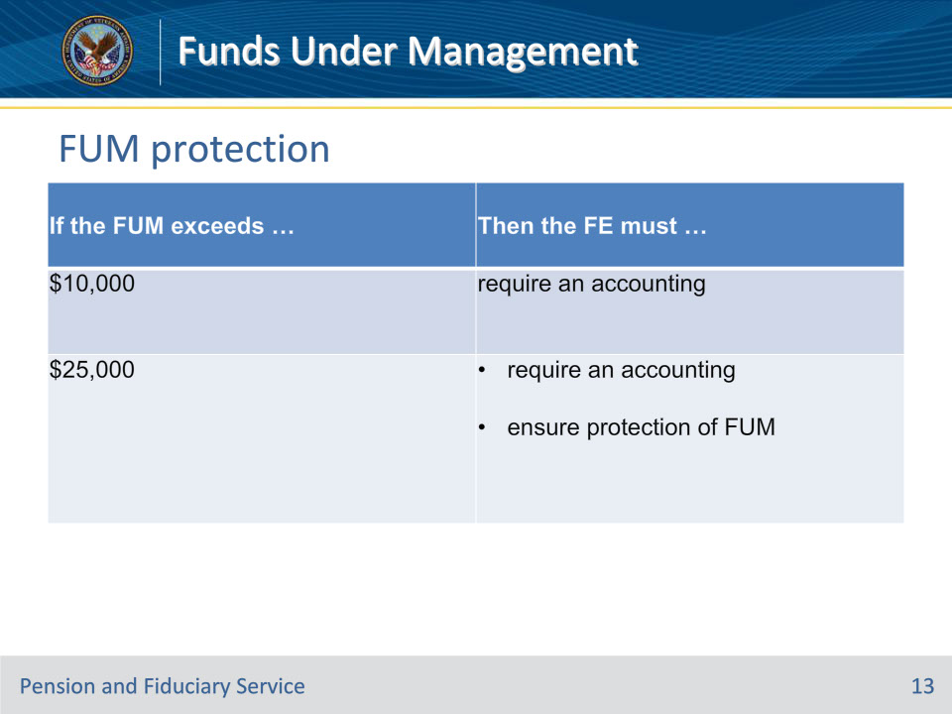
Slide notes

Policy Reference(s): FPM I.2.C.3.l.

Instructor Notes:

Use this table to determine the appropriate actions if the FUM exceeds the limits for accounting and protection of FUM limits.

Slide 14 - Questions?
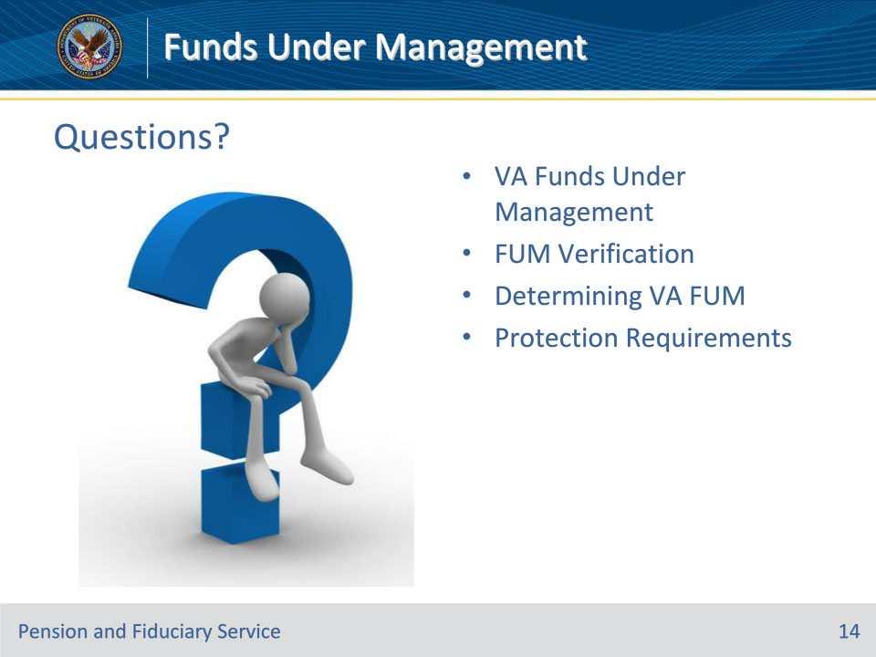
Slide notes

Instructor Notes:

(Recall) These are our learning objectives as stated from the beginning of the training:

• Define Funds Under Management (FUM)

• Identify when and how to verify FUM

• Explain how to determine FUM

• Identify methods of FUM protection

(Recap) We discussed each of these learning objectives through the following topics in each slide today:

• VA Funds Under Management

• FUM Verification

• Determining VA FUM

• Protection Requirements

Are there any additional questions?

Slide 15 - TMS Survey
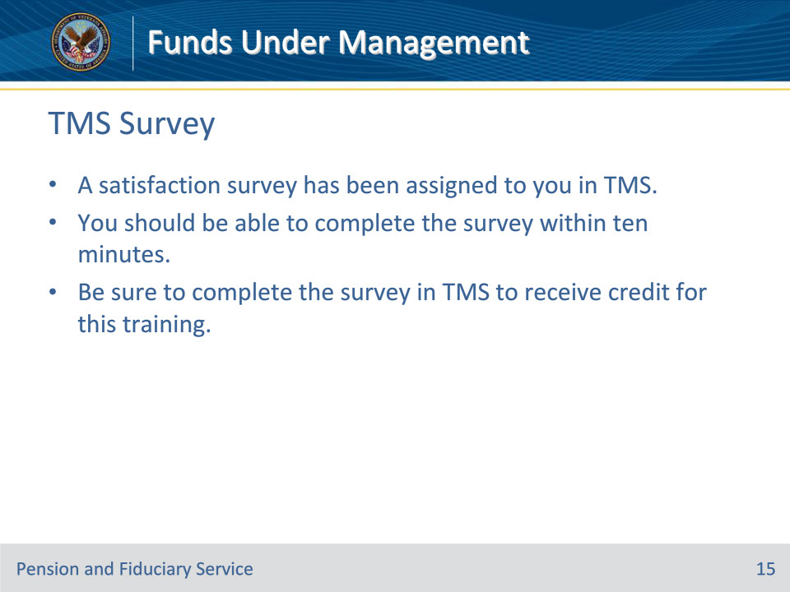
Slide notes

Instructor Notes:

A satisfaction survey has been assigned to you in TMS. You should be able to complete the survey within ten minutes. Completing the survey will allow you to receive credit for this training.

