Slide 1 - Fiduciary Fees

Slide notes

Course Description:

This lesson teaches the core knowledge related to authorizing and examining fiduciary fees, to include restrictions, documentation, and notification requirements.

Slide 2 - Objectives
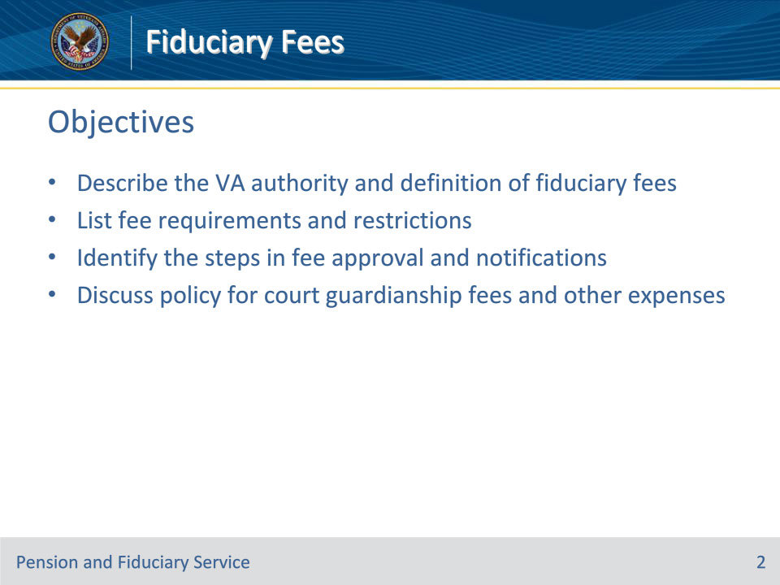
Slide notes

Instructor Notes:

At the end of this lesson, given the training and corresponding references, the learner will be able to do the following:

• Describe the VA authority and definition of fiduciary fees

• List fee requirements and restrictions

• Identify the steps in fee approval and notifications

• Discuss policy for court guardianship fees and other expenses

Slide 3 - References
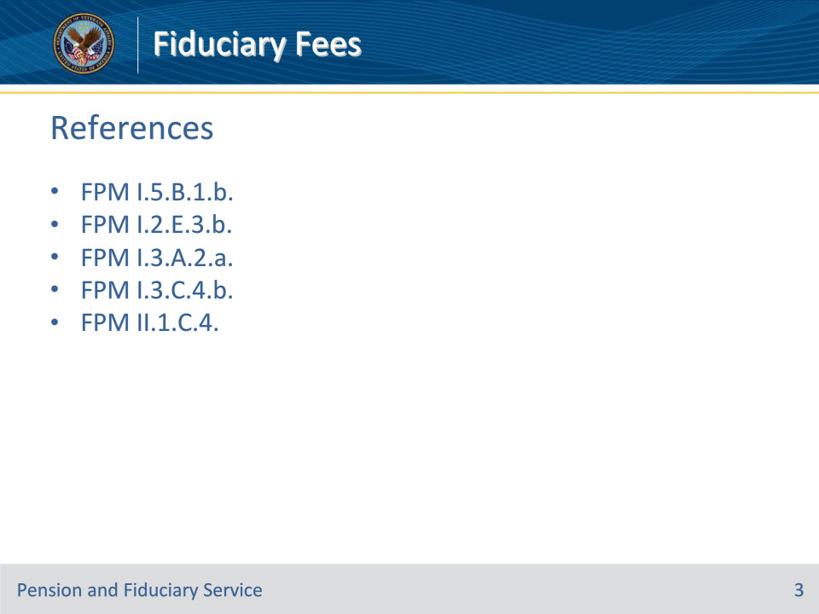
Slide notes

Instructor Notes:

These are the relevant references pertaining to this course:

• FPM I.5.B.1.b. Limitations and Responsibilities Applicable to Temporary Fiduciary Appointments

• FPM I.2.E.3.b. Approving the Fiduciary Fee

• FPM I.3.A.2.a. VA-Appointed Fiduciaries

• FPM I.3.C.4.b. Guardianship Fees for VA-Appointed Fiduciaries Who Are Also Court-Appointed

• FPM II.1.C.4. Authorizing Fees for Fiduciaries

Slide 4 - Fiduciary Fee
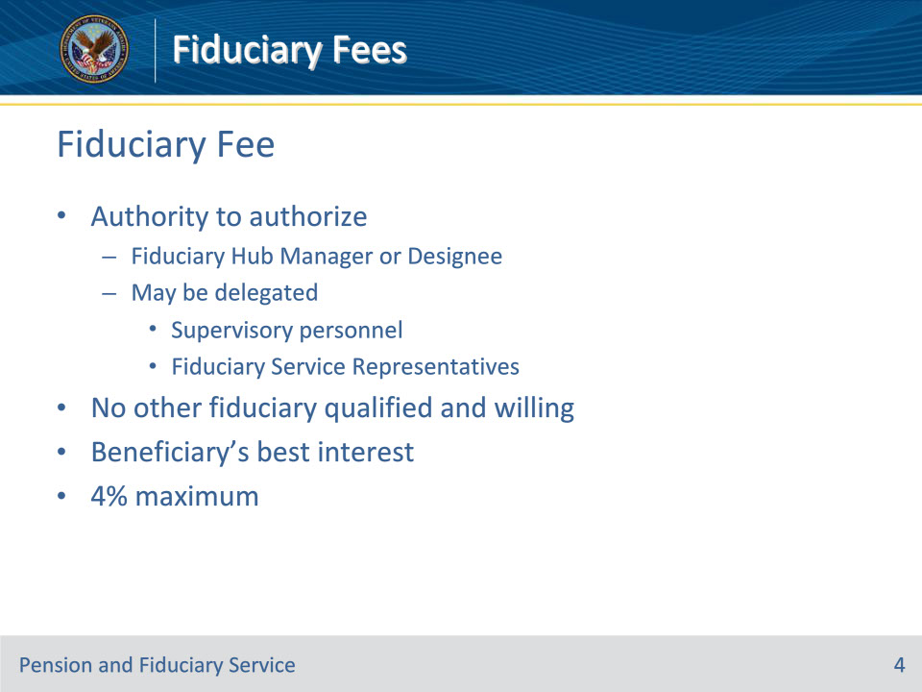
Slide notes

Policy Reference(s): FPM II.1.C.4.a.

Instructor Notes:The Fiduciary Hub Manager (FHM) or designee is permitted to authorize a reasonable monthly fiduciary fee if necessary to obtain the services of a qualified fiduciary.

A fiduciary fee is necessary only if no other person or entity is qualified and willing to serve without a fiduciary fee and the beneficiary’s interest would be served by the appointment of a qualified paid fiduciary. FEs may not recommend a fiduciary fee above 4 percent as a fiduciary fee in excess of 4 percent of the monetary benefits paid by VA on behalf of the beneficiary to the fiduciary during a year is not authorized. However, there are limited exceptions where a VA-appointed fiduciary who is also a court-appointed conservator or guardian may collect a fee in excess of 4 percent.

Slide 5 - Requirements
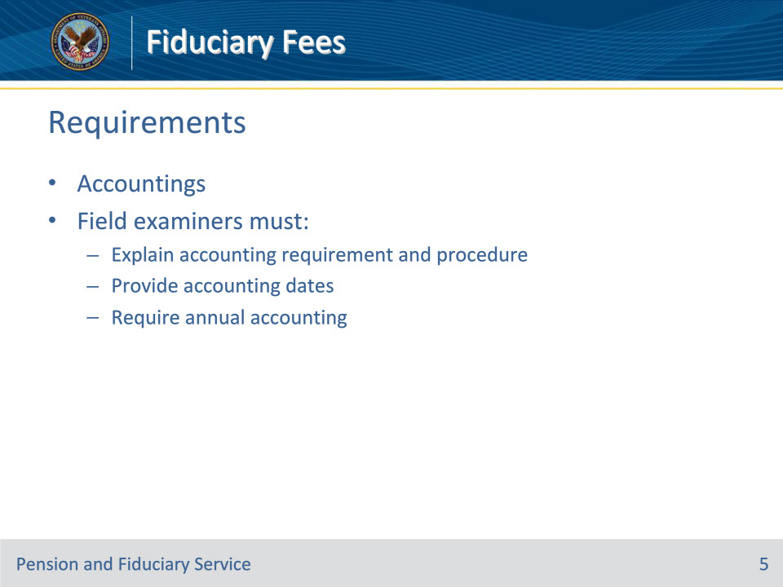
Slide notes

Policy Reference(s): FPM I.3.A.2.a., FPM II.1.C.4.c.

Instructor Notes:

Accountings are required when the fiduciary deducts a VA-authorized fee for fiduciary services from the beneficiary’s account.

In every instance where a fiduciary fee is recommended, the FE must:

• explain to the fiduciary the requirement and procedures for annual accountings

• provide the diary date for the accounting, and

• require an accounting no less than annually.

Slide 6 - Fee Limitations
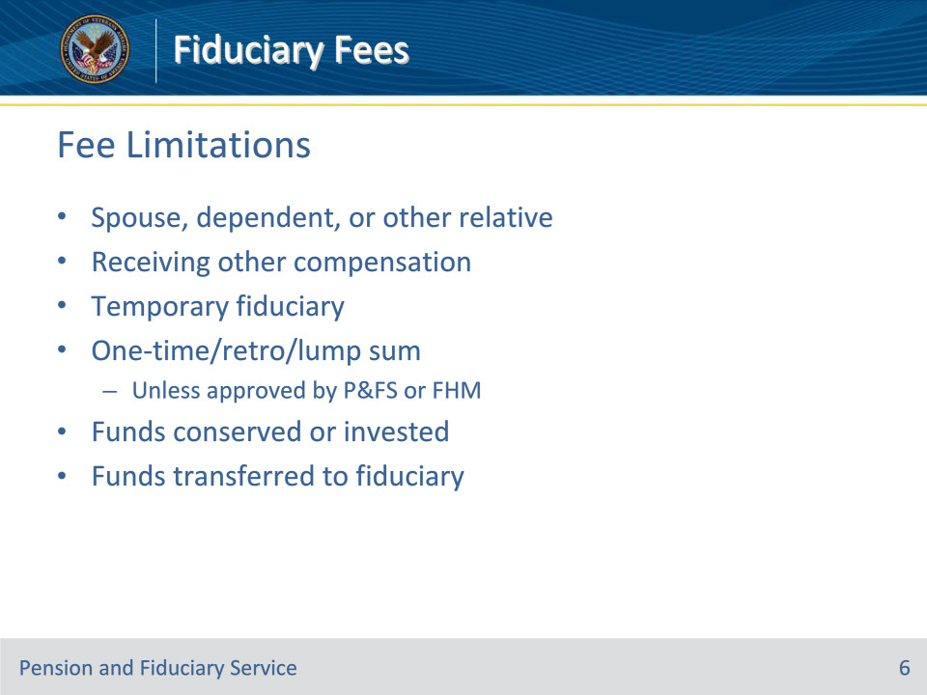
Slide notes

Policy Reference(s): FPM I.5.B.1.b., FPM II.1.C.4.a.-b.

Instructor Notes:

Hub Employees will not authorize a fee if the fiduciary

• is a spouse, dependent, or other relative of the beneficiary, or

• will receive any other form of payment for providing fiduciary services for the beneficiary’s VA benefits.

Temporary fiduciaries must serve without a fiduciary fee.

The fee must not be based on:

• any one-time, retroactive, or lump sum payment made to the fiduciary on behalf of the beneficiary unless approved by P&F Service or by the FHM in the scenario meeting the criteria provided later in this training

• any funds conserved or invested by the fiduciary for the beneficiary, including interest income and return on investment, or

• any funds transferred to the fiduciary from

• a preceding fiduciary

• the PFOP, or

• any other source.

Slide 7 - Fee Limitations
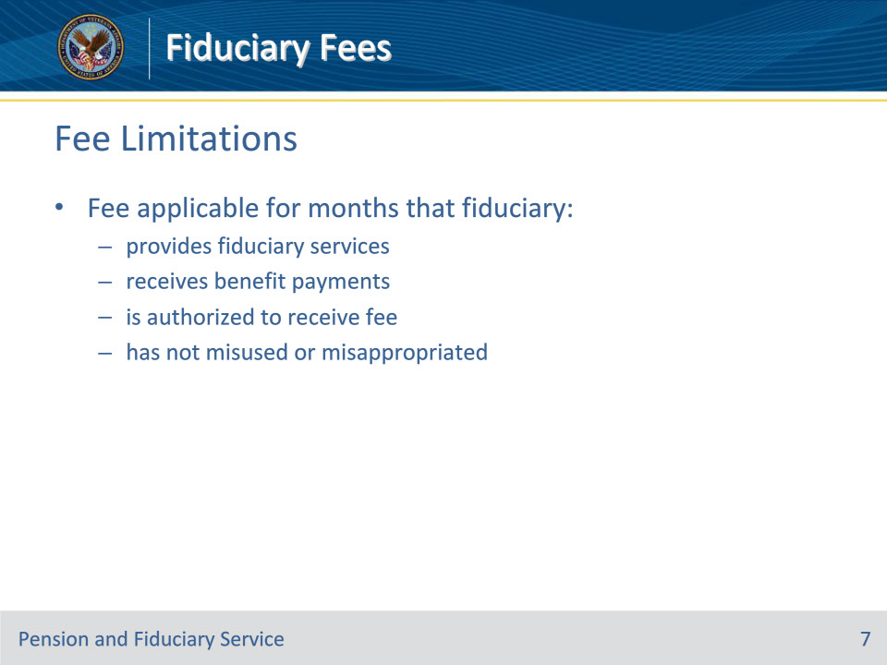
Slide notes

Policy Reference(s): FPM II.1.C.4.a.

Instructor Notes:

The fee is applicable for months in which the fiduciary

• provides fiduciary services

• receives benefits for the beneficiary for that month

• is authorized to receive a fee by the FHM, and

• has not been found by VA or a court with jurisdiction to have misused or misappropriated benefits.

Slide 8 - Exceptions
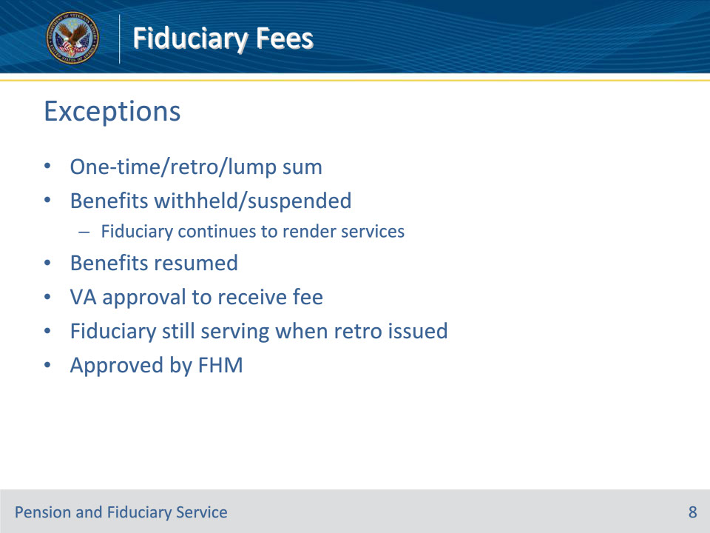
Slide notes

Policy Reference(s): FPM II.1.C.4.a.

Instructor Notes:

An exception to the rule against fees from one-time, retroactive, or lump sum payment may apply when a fiduciary continues to render necessary fiduciary services to a beneficiary during a period when a running award is temporarily withheld or suspended. In such cases, the fiduciary may receive a fiduciary fee based upon a retroactive payment of the withheld or suspended amount if periodic benefit payments are resumed and the fiduciary:

• received VA approval to collect a fee for the month which payment was made

• provided fiduciary services during the month for which payment was made, and

• was the beneficiary’s fiduciary when VA made the retroactive payment of the withheld or suspended amount.

Decisions regarding the authorization of a fiduciary fee under these circumstances will be made only upon the written and documented approval of the FHM.

Slide 9 - Other Expenses
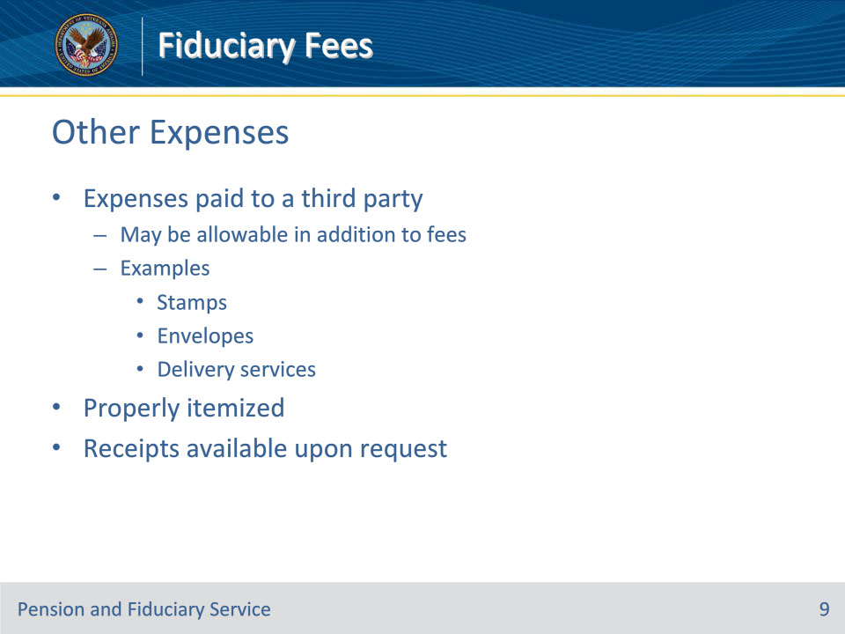
Slide notes

Policy Reference(s): FPM II.1.C.4.a.

Instructor Notes:

Reimbursement of expenses paid to a third party for items such as stamps, envelopes, and delivery services can be paid in addition to the fee, if properly itemized. Receipts must be available for inspection upon request.

Slide 10 - Minors
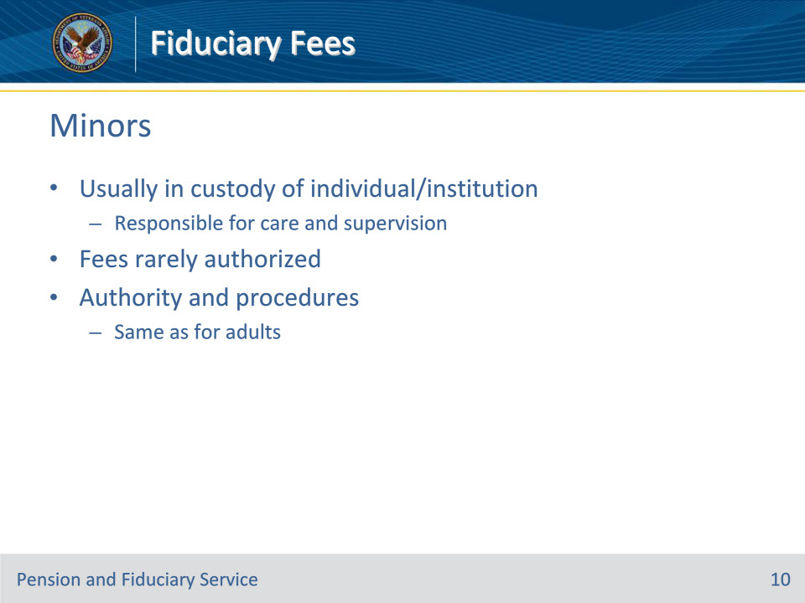
Slide notes

Policy Reference(s): FPM II.1.C.4.a.

Instructor Notes:

For cases involving minor beneficiaries, because the minors are almost always in the custody of an individual or institution having legal responsibility for the care and supervision of the minor, fees for VA-appointed fiduciaries of minors should rarely be authorized.

The authority and procedures for authorizing fees for VA-appointed fiduciaries are the same for minors as for adult beneficiaries.

Slide 11 - Fee Authorization Documentation
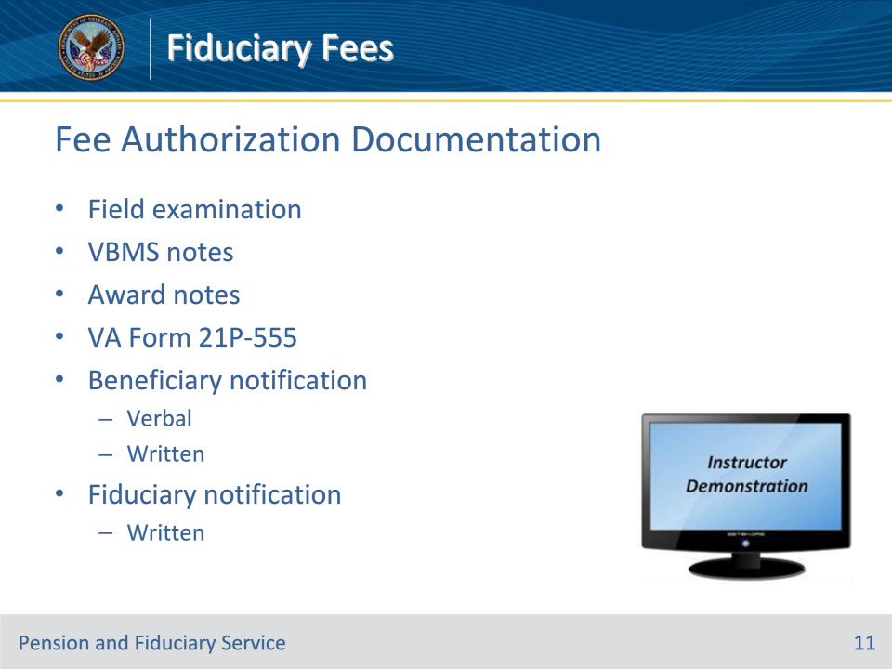
Slide notes

Policy Reference(s): FPM II.1.C.4.d.-e., FPM I.2.E.3.b.

Instructor Notes:

The FE is responsible for determining whether a fee is necessary during an initial appointment or successor initial appointment field examination.

The FE must update the field examination to document the

• recommended fee percentage in the FEE section, and

• justification for recommending that VA authorize a fiduciary fee in the COMMENTS AND OBSERVATIONS section.

The FSR or designee will review the facts of the case and approve the fee, if appropriate, and document the approval in the VBMS notes as well as on the award notes at authorization.

When a fiduciary fee is approvable, appropriate hub personnel must complete a VA Form 21P-555, and upload it to the beneficiary’s eFolder.

Once the fee is approved on the VA Form 21P-555, the beneficiary profile in VBMS must be updated to reflect the approval and the percentage authorized.

The FSR may not authorize a fee for a VA-appointed fiduciary selected in the course of, or designated as a result of, a field examination conducted by that delegated individual.

Each beneficiary whose fiduciary will be allowed to charge a fee must be notified of that decision. The beneficiary may be verbally notified of the possibility of paying a fiduciary fee during the field examination. In instances where the beneficiary does not have the capability to understand the fees, the person caring for the beneficiary may receive notice of the fees. The beneficiary must receive written notification when VA authorizes a fee.

When a fee is authorized , a letter must be sent to the fiduciary confirming the fee approval as well as any limitations imposed (for example, the approved percentage and no authorized fee for managing a lump sum retroactive payment).

Demonstration Notes:

• Minimize PowerPoint and demonstrate the actions discussed above.

Slide 12 - Fee Approval
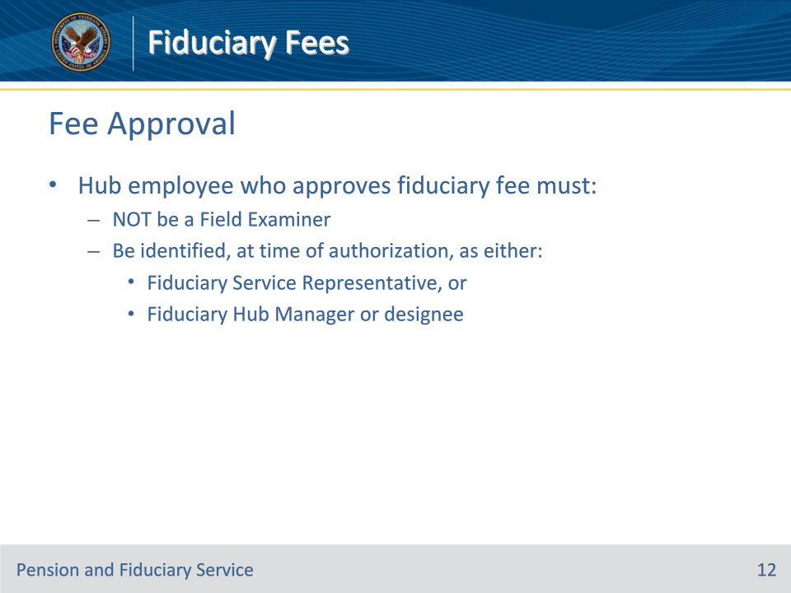
Slide notes

Policy Reference(s): FPM I.2.E.3.b.

Instructor Notes:

Important: The hub employee who approves a fiduciary fee must

• not be a Field Examiner (FE), and

• be identified, at the time of authorization, as either

• a Fiduciary Service Representative (FSR), or

• the Fiduciary Hub Manager (FHM) or designee.

Slide 13 - Court Guardianship Fees
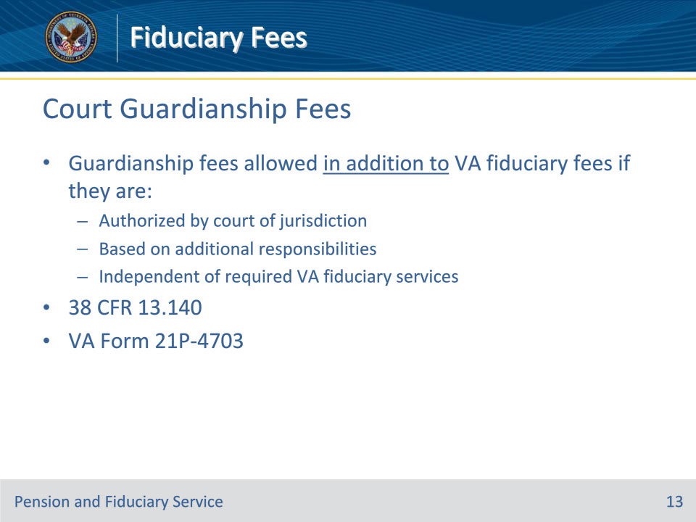
Slide notes

Policy Reference(s): FPM I.3.C.4.b.

Instructor Notes:

A VA-appointed fiduciary may collect conservator or guardian fees exceeding 4 percent of the VA FUM when authorized by the court of jurisdiction, based on responsibilities required beyond those of a VA-appointed fiduciary.

For listings of the responsibilities a fiduciary must provide in the VA as part of the VA fiduciary program, see 38 CFR 13.140(b) and (c), or a VA Form 21P-4703, Fiduciary Agreement.

A conservator or guardian fee may be paid from VA FUM in addition to a fiduciary fee established when a court authorizes services beyond those of a VA-appointed fiduciary. If the services provided are not independent of required VA fiduciary services, only one of the two fees may be authorized.

Example: A VA-appointed fiduciary who collects a 4 percent fiduciary fee is also the court-appointed guardian of the beneficiary. The guardianship directs that the fiduciary assists the beneficiary in making medical decisions and end of life decisions on their behalf, but does not include responsibilities a VA fiduciary must provide. Since the guardianship responsibilities extend beyond and do not overlap the responsibilities listed in 38 CFR 13.140(b) and (c), the fiduciary is authorized to receive an additional fee from VA FUM.

Slide 14 - Questions?
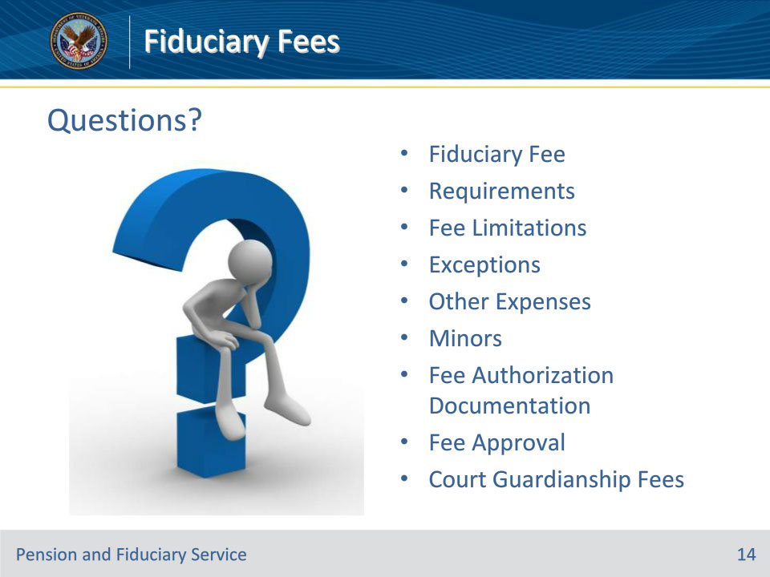
Slide notes

Instructor Notes:

(Recall) These are our learning objectives as stated from the beginning of the training:

• Describe the VA authority and definition of fiduciary fees

• List fee requirements and restrictions

• Identify the steps in fee approval and notifications

• Discuss policy for court guardianship fees and other expenses

(Recap) We discussed each of these learning objectives through the following topics in each slide today:

• Fiduciary Fee

• Requirements

• Fee Limitations

• Exceptions

• Other Expenses

• Minors

• Fee Authorization Documentation

• Fee Approval

• Court Guardianship Fees

Are there any additional questions?

Questions should be filtered through your QRT team. They will submit your questions to the Field Inquiry Tool (FIT) on your behalf.

Slide 15 - TMS Survey/Assessment
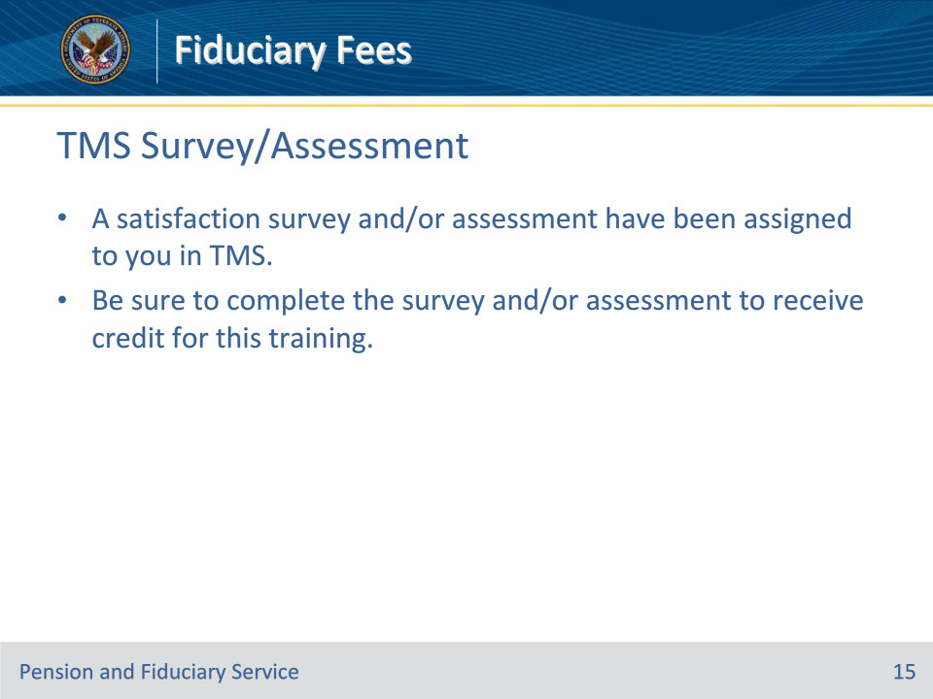
Slide notes

Instructor Notes:

A satisfaction survey and/or assessment have been assigned to you in TMS.

Be sure to complete the survey and/or assessment to receive credit for this training.

