Slide 1 - Fiduciary Accounts and Investments
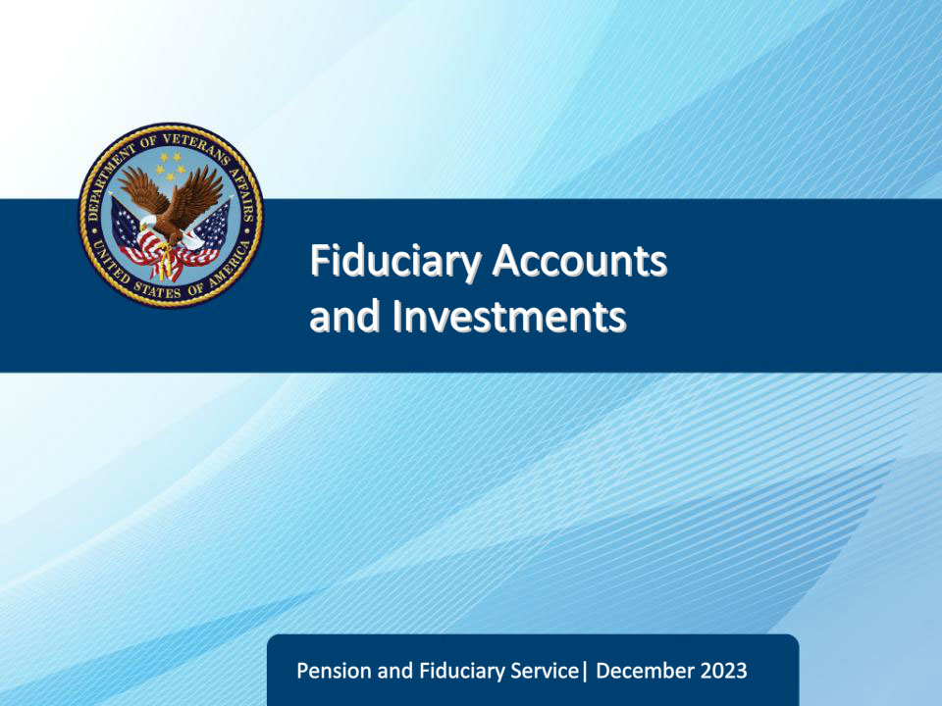
Slide notes

Course Description:

This lesson teaches learners about the responsibilities of fiduciary hub personnel for the review and protection of VA and other source funds under management, including investments by fiduciaries.

Slide 2 - Objectives
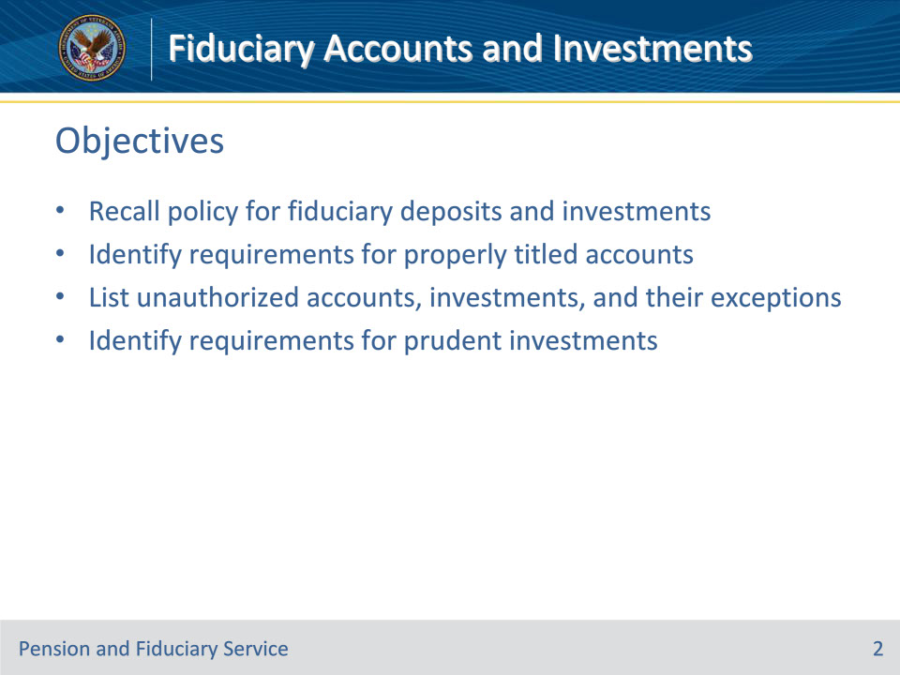
Slide notes

At the end of this lesson, given the training and references, students will be able to do the following:

• Recall the policy for fiduciary deposits and investments of beneficiary funds

• Identify requirements for properly titled accounts

• List unauthorized accounts, investments, and their exceptions

• Identify requirements for prudent investments

Slide 3 - References
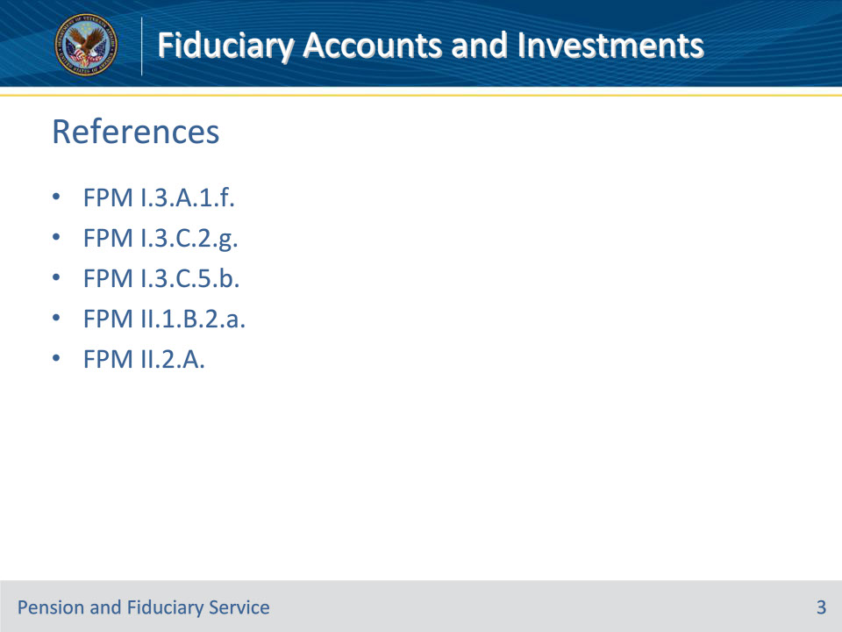
Slide notes

These are the relevant references pertaining to this course:

• FPM I.3.A.1.f. Definition: Bill-Pay Account

• FPM I.3.C.2.g. Commingled Financial Accounts

• FPM I.3.C.5.b. Verification of Accounts and FUM

• FPM II.1.B.2.a. Requirement for a Properly Titled Account

• FPM II.2.A. Accounts and Investments

Slide 4 - Funds Protection
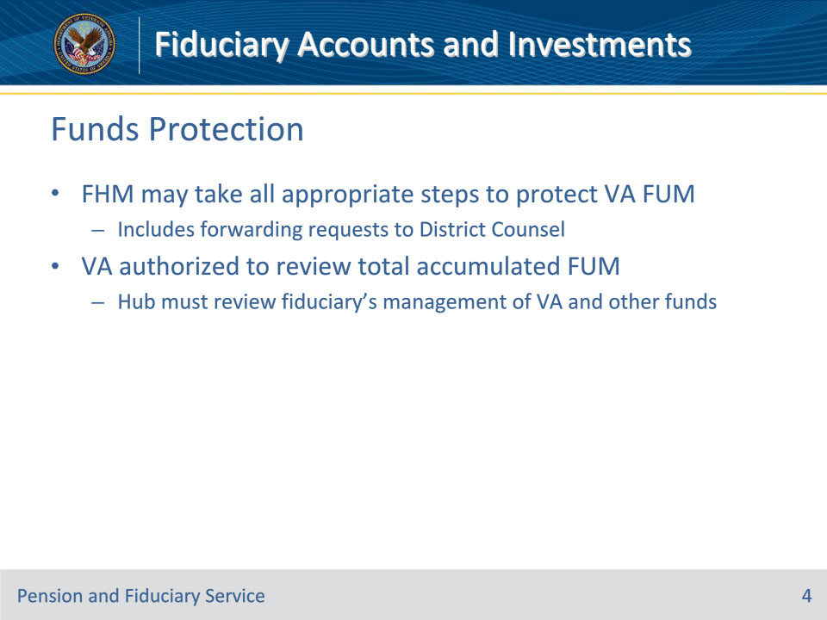
Slide notes

Policy Reference(s): FPM II.2.A.1.a.

Instructor Notes:

The Fiduciary Hub Manager (FHM) is authorized to take all appropriate steps to protect the Department of Veterans Affairs (VA) funds under management (FUM), including the forwarding of requests to District Counsel for legal proceedings.

VA is authorized to review a beneficiary’s total accumulated FUM. For this reason, fiduciary hub (hub) personnel must review a fiduciary’s management of both VA and other source funds.

Slide 5 - Misuse
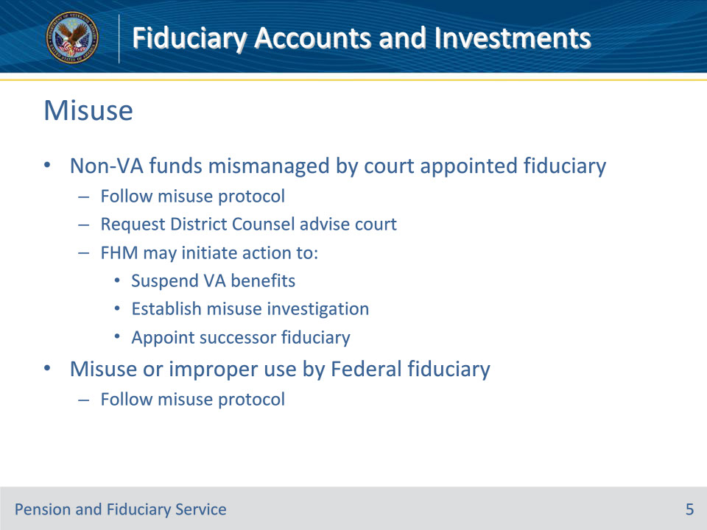
Slide notes

Policy Reference(s): FPM II.2.A.1.b.

Instructor Notes:

When non-VA funds are mismanaged by a fiduciary also appointed by the court, the FHM must follow the misuse protocol and request that District Counsel advise the court of this fact, formally if necessary. In addition, the FHM may initiate action to suspend VA benefit payments and establish a misuse investigation, including appointment of a successor fiduciary, if appropriate.

In cases of misuse or improper use by a Federal fiduciary, hub personnel must follow the misuse protocol.

Slide 6 - Presumption as to Use
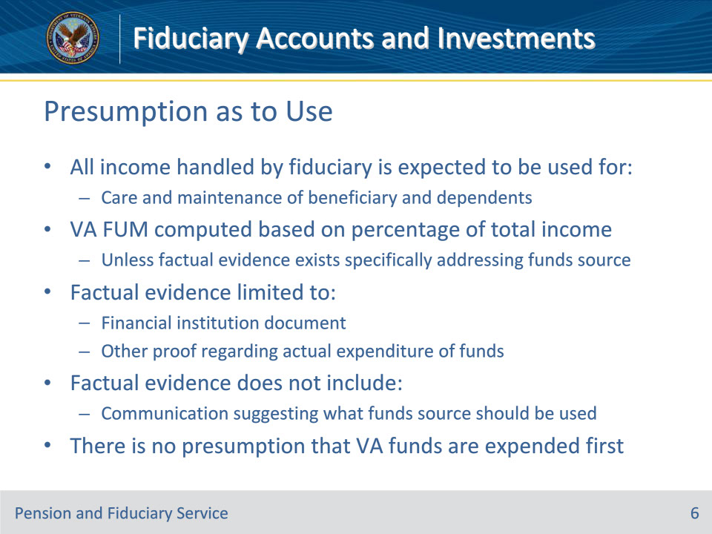
Slide notes

Policy Reference(s): FPM II.2.A.1.c., e.

Instructor Notes:

All income handled by a beneficiary’s fiduciary is expected to be used for the care and maintenance of the beneficiary and any dependents. Unless factual evidence exists that specifically addresses the source of funds, the FUM derived from VA benefits will be computed based on the percentage of total income received. Factual evidence is limited to a financial institution document or other proof regarding the actual expenditure of funds. Factual evidence does not include verbal or written communication that instructs or suggests from what source of funds a fiduciary should expend funds.

There is no presumption that VA funds are expended first.

The hub must not presume that the VA funds are used first when this would preclude or limit VA intervention in cases of fiduciary misconduct, or excessive fees are claimed.

Note: This applies unless the excessive fees pertained only to non-VA funds and the hub referred the matter to the court.

Slide 7 - Presumption as to Use
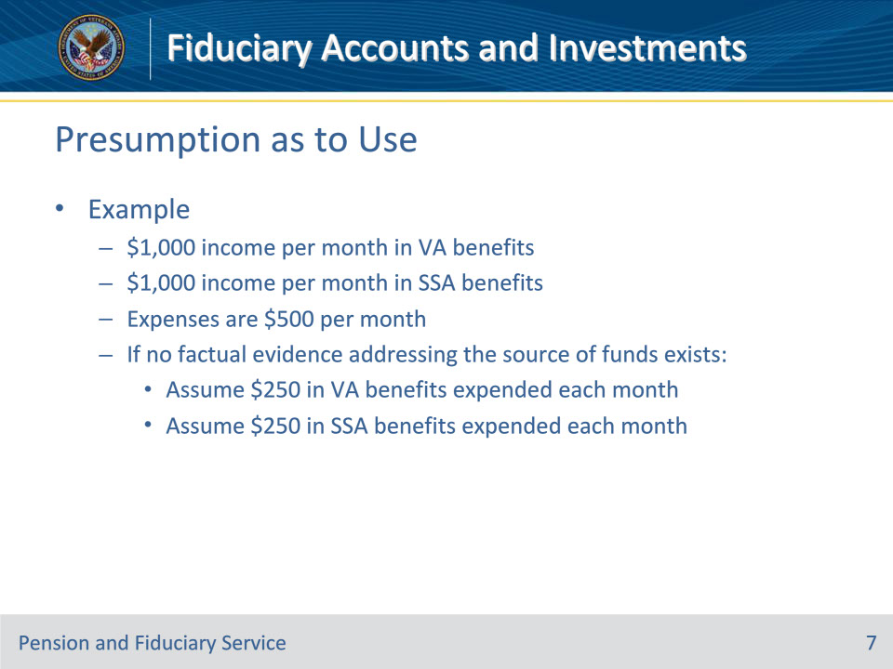
Slide notes

Policy Reference(s): FPM II.2.A.1.c.

Instructor Notes:

Example: A Veteran receives $1,000 per month in VA benefits and $1,000 per month from the Social Security Administration. The Veteran’s expenses are $500 per month. If no factual evidence addressing the source of funds exists, hub personnel will assume that $250 in VA benefits and $250 in Social Security benefits was expended each month to meet the Veteran’s expenses.

Slide 8 - Estate Administration
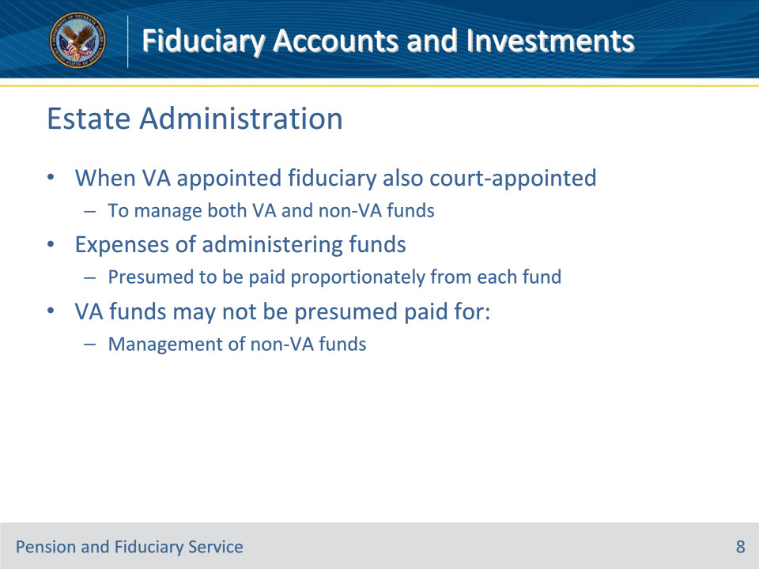
Slide notes

Policy Reference(s): FPM II.2.A.1.d.

Instructor Notes:

When a VA appointed fiduciary is also court-appointed to manage both VA and non-VA funds, the expenses of administering the funds are presumed to have been paid proportionately from each fund.

VA funds may not be presumed paid for the management of non-VA funds.

Slide 9 - Funds Maintenance Policy
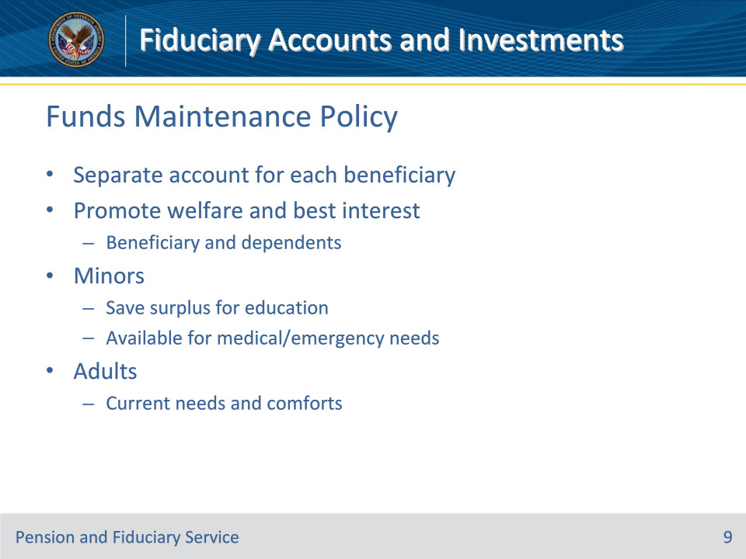
Slide notes

Policy Reference(s): FPM II.2.A.2.a.

Instructor Notes:

A fiduciary must establish and maintain a separate financial institution account(s) for each VA beneficiary unless the fiduciary is recognized as an exception.

VA benefits are to be used to promote the welfare and best interest of the beneficiary and the beneficiary’s dependents.

The hub should question why a fiduciary is saving and/or investing VA funds when the beneficiary and their dependents needs are not met.

For minor beneficiaries, VA recommends saving any surplus VA funds for education of the beneficiary and ensure that accrued funds are also readily available for medical or other emergency needs.

For adult beneficiaries, VA recommends using VA benefits generously for the current needs and comforts of the beneficiary, to the extent the funds can be used

Slide 10 - Account Requirements
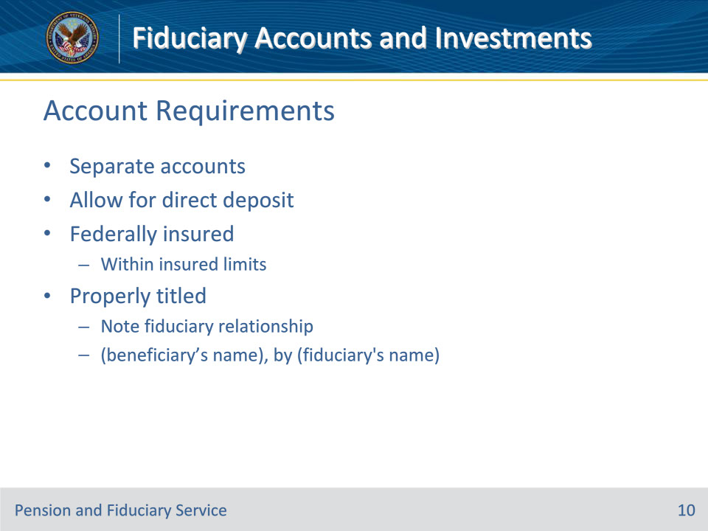
Slide notes

Policy Reference(s): FPM I.3.C.5.b.; FPM II.1.B.2.a.

Instructor Notes:

The fiduciary hub must ensure that all VA and other FUM by the fiduciary are deposited and meet all of the following requirements, unless exempt:

• The fiduciary must establish and maintain a separate financial institution account for each VA beneficiary served

• The account must be

• established to allow for the direct deposit of VA benefits

• Federally insured and not exceed current insured limits of protection, and

• properly titled in the beneficiary’s and fiduciary’s names and note the existence of the fiduciary relationship

Properly titled accounts are titled in the beneficiary’s and fiduciary’s names and note the existence of the fiduciary relationship; (beneficiary’s name), by (fiduciary’s name).

Slide 11 - Account Title Exceptions
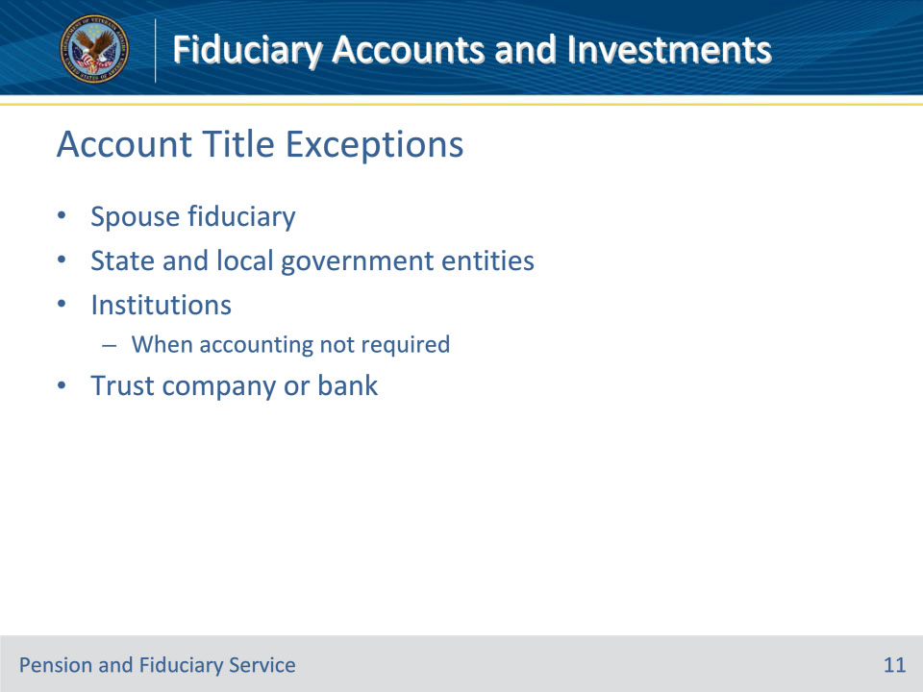
Slide notes

Policy Reference(s): FPM II.1.B.2.a.

Instructor Notes:

The following fiduciaries are excluded from the properly titled account requirement and may still request direct deposit changes via the National Call Center:

• the beneficiary’s spouse

• State and local government entities

• institutions, such as public or private medical care facilities, nursing homes, or other residential care facilities, when an annual accounting is not required, or

• a trust company or a bank with trust powers organized under the laws of the U.S. or a State.

All other fiduciaries must provide a properly titled account.

Slide 12 - Investments
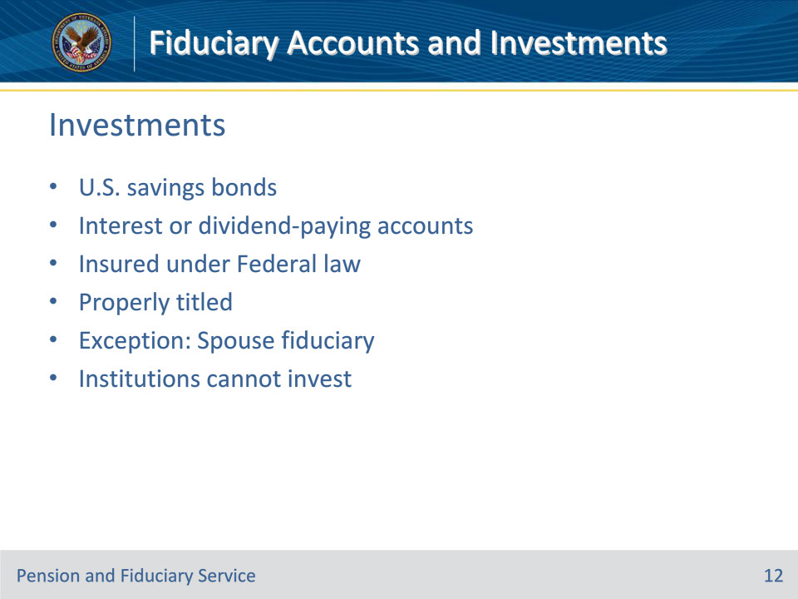
Slide notes

Policy Reference(s): FPM II.2.A.2.b.

Instructor Notes:

38 CFR 13.210, authorizes fiduciaries to invest in U.S. savings bonds or interest or dividend-paying accounts insured under Federal law. Any such investment must be clearly titled in the beneficiary’s and fiduciary’s names and identify the fiduciary relationship. VA does not authorize other types of investments, unless the fiduciary is appointed as a spouse fiduciary.

Spouse fiduciaries are not limited to investing in U.S. savings bonds or interest or dividend-paying accounts insured under Federal law and are not required to title investments in the beneficiary’s and fiduciary’s names.

A chief officer of an institution in which the beneficiary is being furnished hospital treatment or institutional, nursing, or domiciliary care appointed who is receiving VA benefit payments for a beneficiary as a VA appointed fiduciary may not invest VA benefit funds.

Slide 13 - Determining Prudence
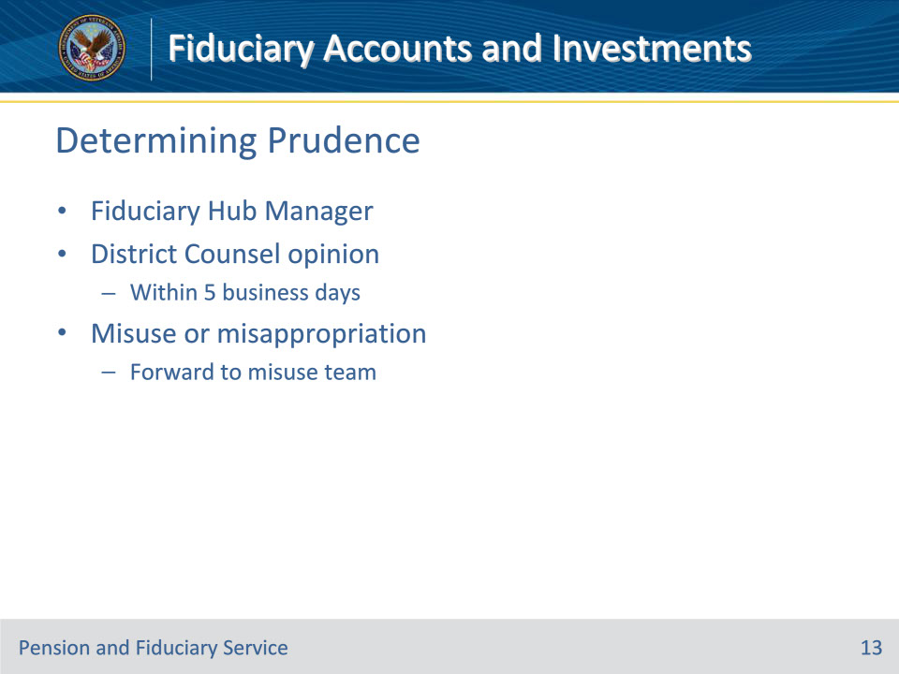
Slide notes

Policy Reference(s): FPM II.2.A.2.b.

Instructor Notes:

The FHM must review and, to the extent possible, determine the legality and prudence of investments involving VA income. When notice of a contemplated questionable or imprudent investment comes to the attention of the hub, the FHM must refer any question as to the legality of an investment to District Counsel for an opinion within five business days.

Hub personnel must immediately forward indications of misuse, misappropriation, or fraud to the Misuse Team for review and completion of the misuse protocol. Utilize a VA Form 27-0820, Report of General Information, to document the allegation and upload the document to the electronic claims folder.

Slide 14 - Security of Investments
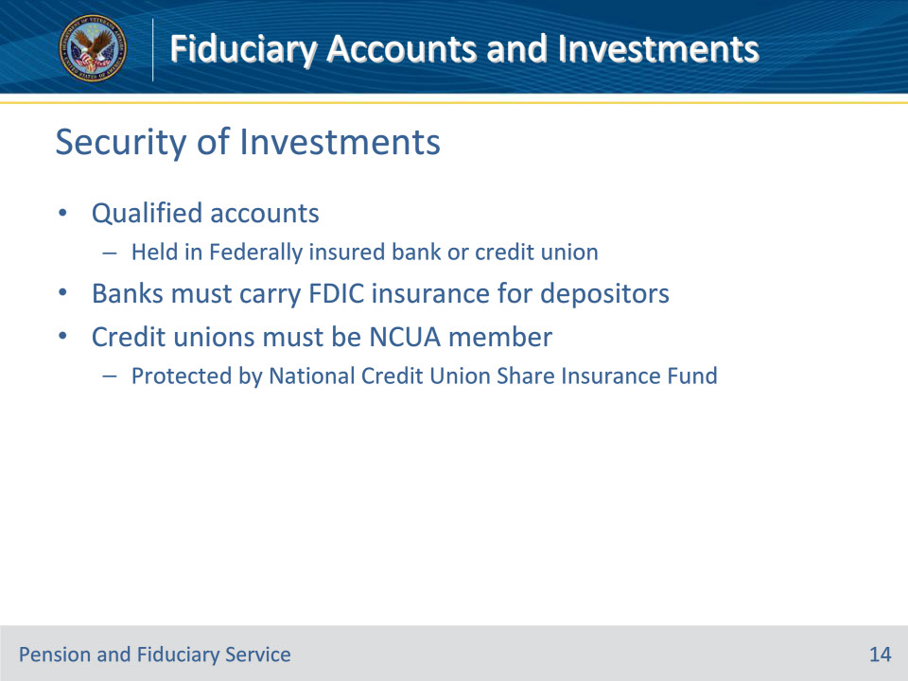
Slide notes

Policy Reference(s): FPM II.2.A.2.c.

Instructor Notes:

An investment is in an interest or dividend-paying account. Authorized investments include U.S. savings bonds or interest or dividend-paying accounts insured under Federal law.

A qualified account must be held in a bank or credit union that is Federally insured. For banks, the financial institution would need to carry Federal Deposit Insurance Corporation (FDIC) insurance for their depositors and credit unions must be a member of the National Credit Union Administration (NCUA) that is protected by the National Credit Union Share Insurance Fund.

Slide 15 - Security of Investments
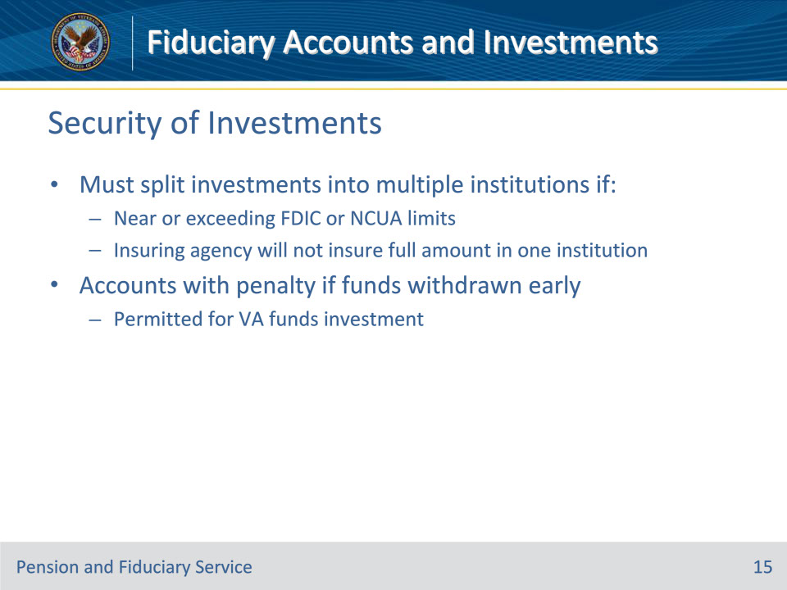
Slide notes

Policy Reference(s): FPM II.2.A.2.c.

Instructor Notes:

Any such investment must be clearly titled in the beneficiary’s and fiduciary’s names and identify the fiduciary relationship.

If investments are deposited in a singular financial institution, fiduciaries must be advised, and are required, to split Federally insured investments into two or more financial institutions if the

• investments are near to or exceed the current maximum amount allowed under FDIC or NCUA limits, and

• insuring agency or entity will not insure them in one institution up to the full amount of the deposit.

Investing VA funds in an account that requires a penalty or loss of interest if funds are withdrawn before a specified date is permitted.

Slide 16 - Account Title Verification
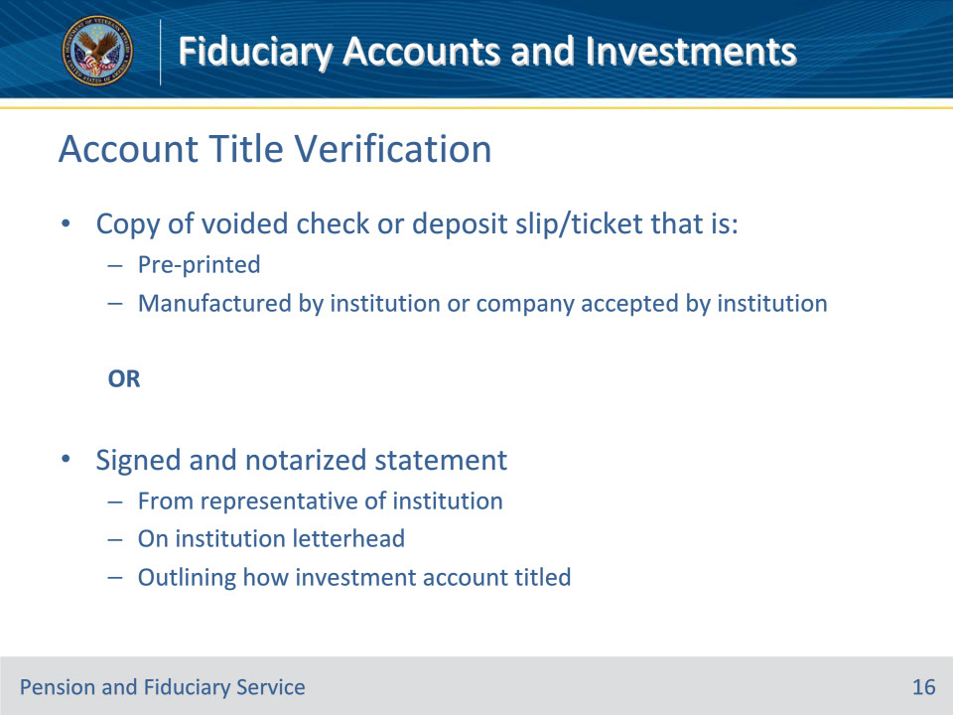
Slide notes

Policy Reference(s): FPM II.2.A.2.d.

Instructor Notes:

Investments must be clearly titled in the beneficiary’s and fiduciary’s names and identify the fiduciary relationship so that it clearly shows the fiduciary does not have a personal interest in the funds. Allowable forms of verification of a properly titled investment account include a

• copy of a voided check (where applicable) or deposit slip/ticket that is

• pre-printed, and

• manufactured by either the

• institution, or

• company accepted by the institution to generate them, or

• signed and notarized statement from a representative of the institution on their letterhead outlining how the investment account is titled.

The document(s) used to verify a properly titled account must clearly have all required elements as indicated above. If any element is missing, an alternate allowable document containing all elements must be used.

Slide 17 - Savings Bonds Verification
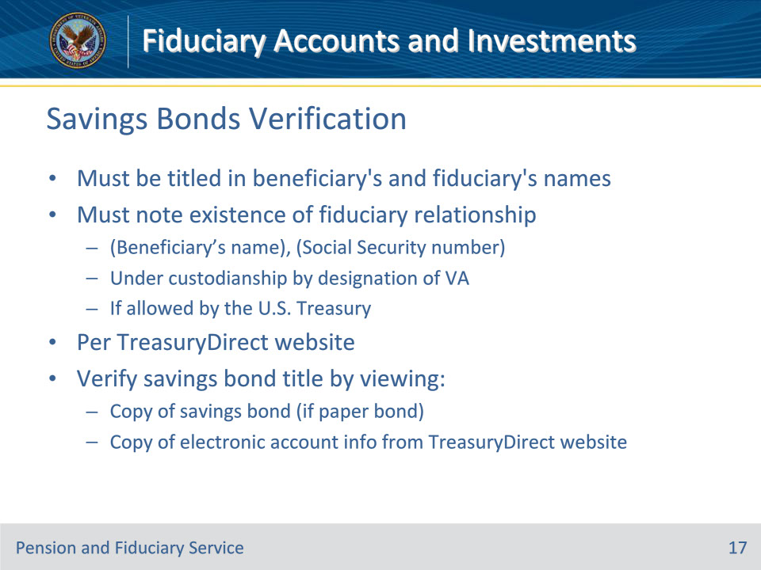
Slide notes

Policy Reference(s): FPM II.2.A.2.d.

Instructor Notes:

Savings bonds must be titled in the beneficiary’s and fiduciary’s names and note the existence of the fiduciary relationship; (beneficiary’s name), (Social Security number), under custodianship by designation of VA, if allowed by the U.S. Treasury per the TreasuryDirect website.

Verify the savings bond is properly titled by viewing a copy of the savings bond (if a paper bond), or a copy of the electronic account information from the TreasuryDirect website provided by the fiduciary.

Slide 18 - Qualified Accounts
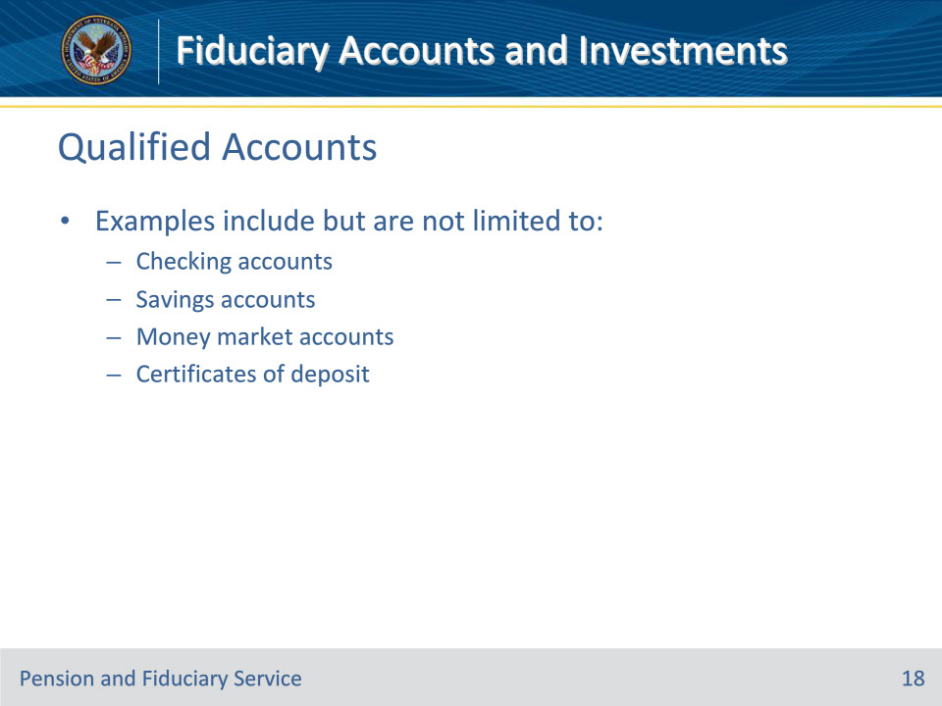
Slide notes

Policy Reference(s): FPM II.2.A.2.e.

Instructor Notes:

Examples of qualified interest or dividend paying accounts include but are not limited to

• checking

• savings

• money market deposit accounts, and

• certificates of deposit (CDs).

Slide 19 - Qualified Accounts
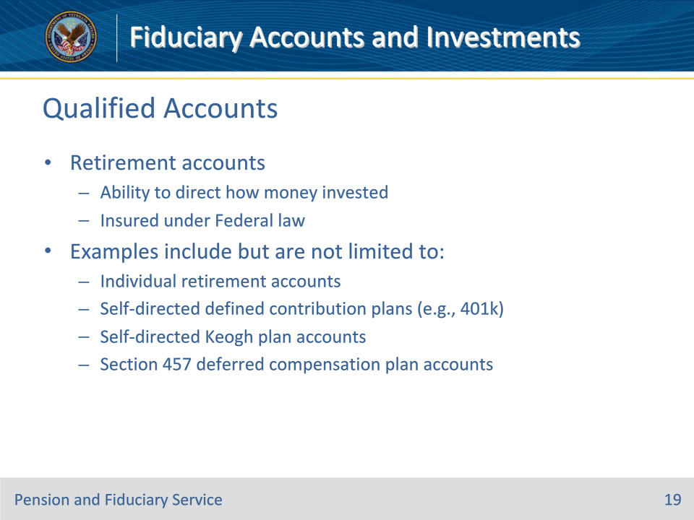
Slide notes

Policy Reference(s): FPM II.2.A.2.e.

Instructor Notes:

Certain retirement accounts in which plan participants have the right to direct how the money is invested are also insured under Federal law. Examples include but are not limited to

• individual retirement accounts

• self-directed defined contribution plans (e.g., 401k)

• self-directed Keogh plan accounts, and

• Section 457 deferred compensation plan accounts, whether self-directed or not.

Slide 20 - Unauthorized Accounts
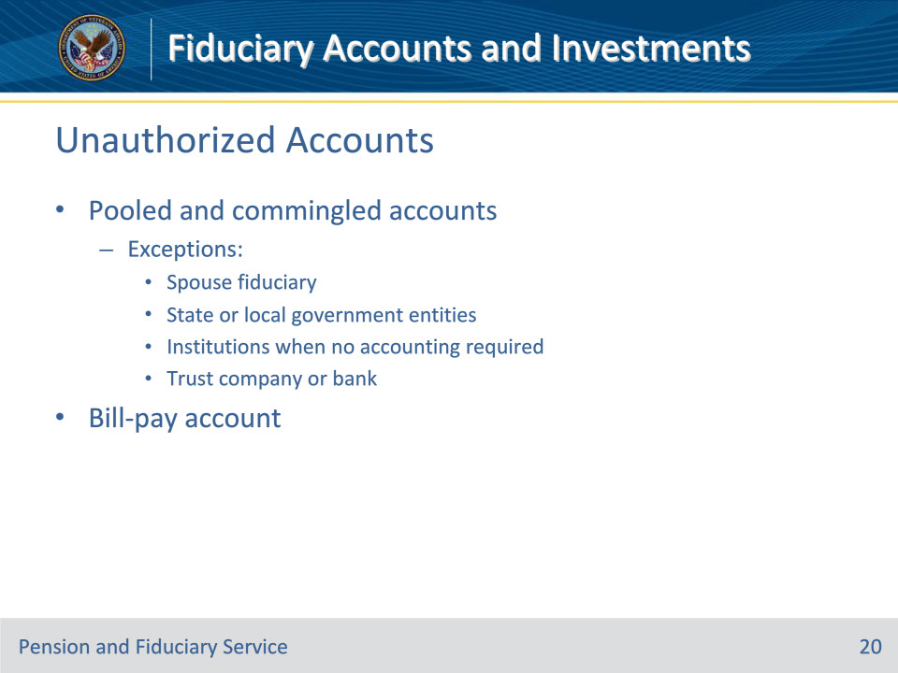
Slide notes

Policy Reference(s): FPM II.2.A.2.f.; FPM I.3.C.2.g.; FPM I.3.A.1.f.

Instructor Notes:

Pooled accounts are not acceptable as they contain multiple beneficiary funds and accounts are not properly registered for VA purposes. In addition, assets and transfers belonging to the beneficiary cannot be verified.

For VA purposes, a commingled financial account, whether custodial, personal or business, contains funds from multiple individuals. A fiduciary must not commingle funds.

The restriction for pooled and/or commingled accounts does not apply to:

• a beneficiary’s spouse, when designated as a spouse payee and recognized on the beneficiary’s award

• State or local government entities

• institutions, such as public or private medical care facilities, nursing homes, or other residential care facilities, when an annual accounting is not required, or

• a trust company or bank (financial institution) with trust powers organized under the laws of the U.S. or a State, who is also the financial institution holding the funds, and is FDIC or NCUA insured.

For Fiduciary Program purposes, a bill-pay account is a financial account, custodial, business or personal, in which a fiduciary commingles multiple beneficiary funds for payment of expenses from one financial account. The fiduciary transfers monthly expenses from each individual custodial account to one bill-pay account. Bill-pay accounts are not acceptable and are not to be confused with an acceptable pooled account.

Slide 21 - Court-Appointed
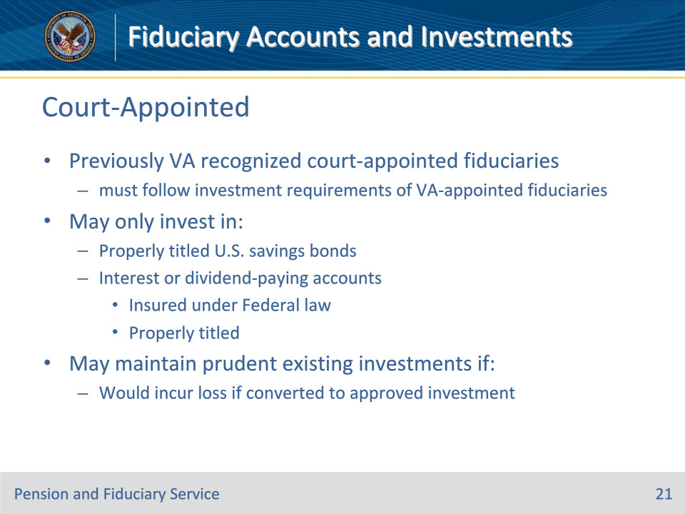
Slide notes

Policy Reference(s): FPM II.2.A.2.g.

Instructor Notes:

Previously recognized court-appointed (VA recognized) fiduciaries, must follow the investment requirements of VA-appointed fiduciaries and may only invest in

• U.S. savings bonds, if registration can denote the fiduciary relationship, or

• interest or dividend-paying accounts, which are insured under Federal law and registered in the form of (beneficiary’s name), by (fiduciary’s name), and (fiduciary designation).

While previously recognized court-appointed (VA recognized) fiduciaries investment allowances are now the same as VA-appointed fiduciaries, if an existing investment is prudent and would incur a loss to the beneficiary at conversion to an approved investment, the investment may be maintained. All other investments must be a VA approved investment.

Slide 22 - Real Estate
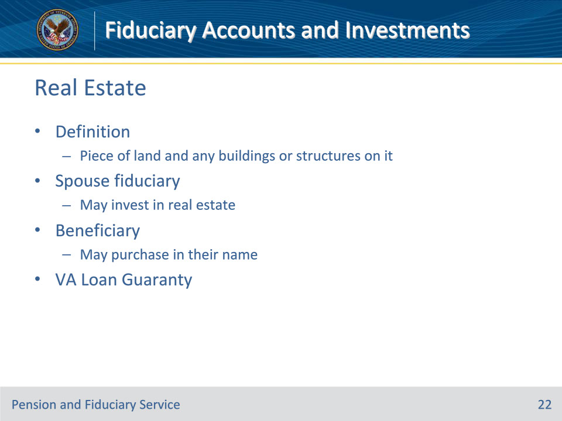
Slide notes

Policy Reference(s): FPM II.2.A.2.h.

Instructor Notes:

Only spouse fiduciaries may invest in real estate with VA funds. Beneficiaries may purchase real estate in their name unless prohibited by a court of jurisdiction.

For program purposes, real estate is defined as a piece of land, including the air above it and the ground below it, and any buildings or structures on it. A mobile home would generally not be considered real estate unless the purchase included land to which the mobile home would be permanently affixed.

Beneficiaries in the Fiduciary Program may be entitled to use a VA guaranteed home loan to purchase a primary residence. As a result of a beneficiary submitting an application for this benefit, VA Loan Guaranty Service is responsible for establishing eligibility for VA Loan Guaranty benefits. To make this determination, VA Loan Guaranty Service may review available documents within the applicable systems of record. The hub will not assess the ability of the fiduciary and beneficiary to pay for the VA home loan.

Hub personnel will not conduct field examinations to obtain income and assets information to support VA Loan Guaranty requests.

Slide 23 - Insurance Investments
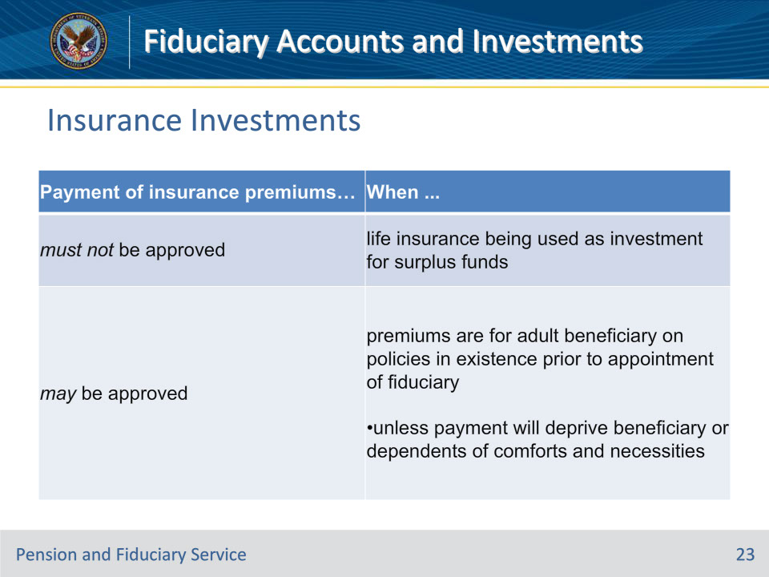
Slide notes

Policy Reference(s): FPM II.2.A.3.a.

Instructor Notes:

The FHM must distinguish between life insurance as an investment for surplus VA funds and life insurance to provide protection to the adult’s dependents or immediate family. Insurance as an investment is not an approved investment for excess VA funds.

This table contains information on approving the payment of life insurance premiums.

Slide 24 - VA and SGLI
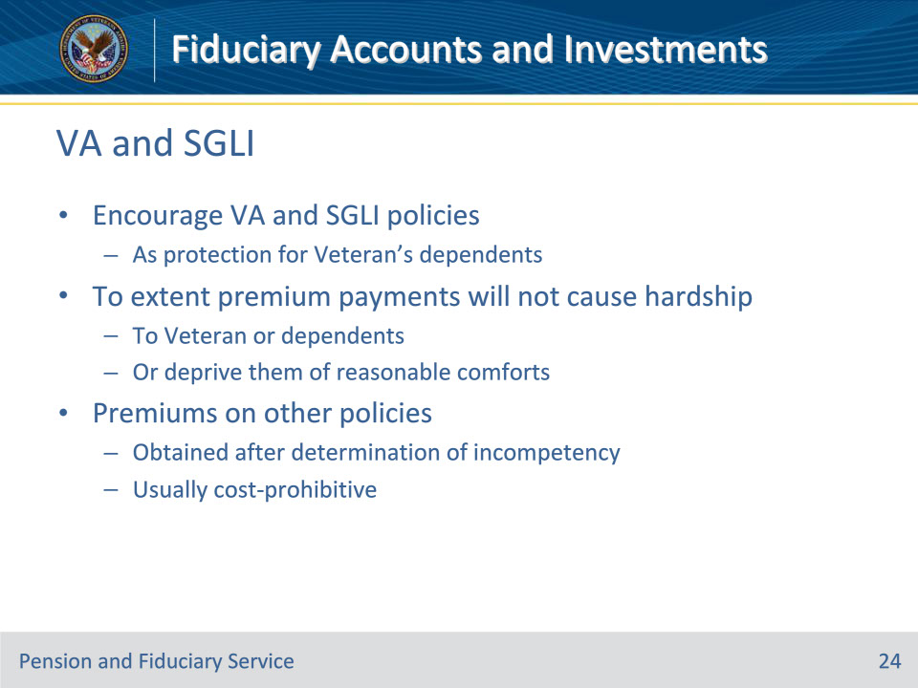
Slide notes

Policy Reference(s): FPM II.2.A.3.b.

Instructor Notes:

Hub personnel should encourage VA and Servicemen’s Group Life Insurance (SGLI) policies as a protection for a Veteran’s dependents to the extent that premium payments will not cause hardship to the Veteran or their dependents, or deprive them of reasonable comforts.

The premiums on other policies, which may be obtained after a determination of incompetency, are usually cost-prohibitive.

Slide 25 - Educational Policies
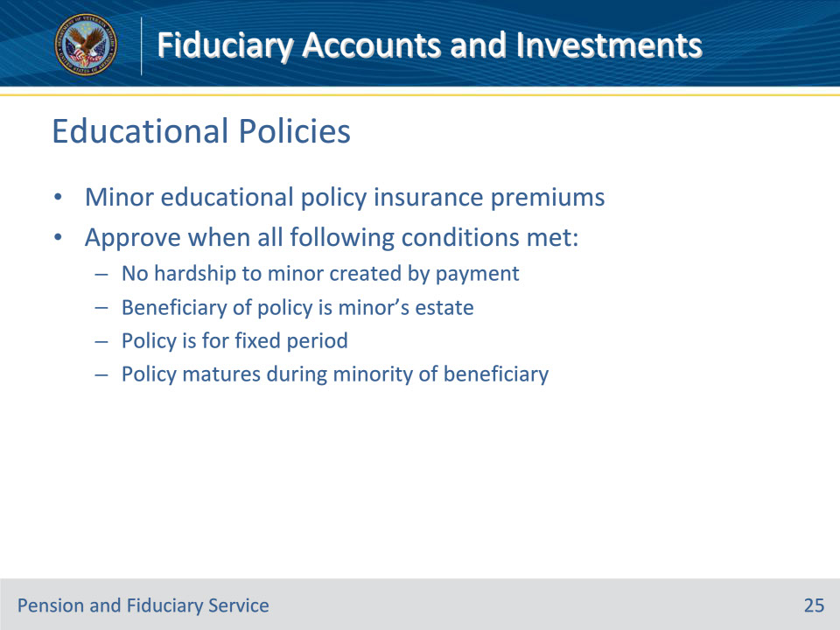
Slide notes

Policy Reference(s): FPM II.2.A.3.c.

Instructor Notes:

In cases of minors, payment of insurance premiums on educational policies in existence, when brought to the attention of VA, should be approved when all of the following conditions are met:

• no hardship to the minor is created by reason of such payment

• the beneficiary of the policy is the minor’s estate

• the policy is for a fixed period, and

• the policy matures during the minority of the beneficiary.

Slide 26 - Questions?
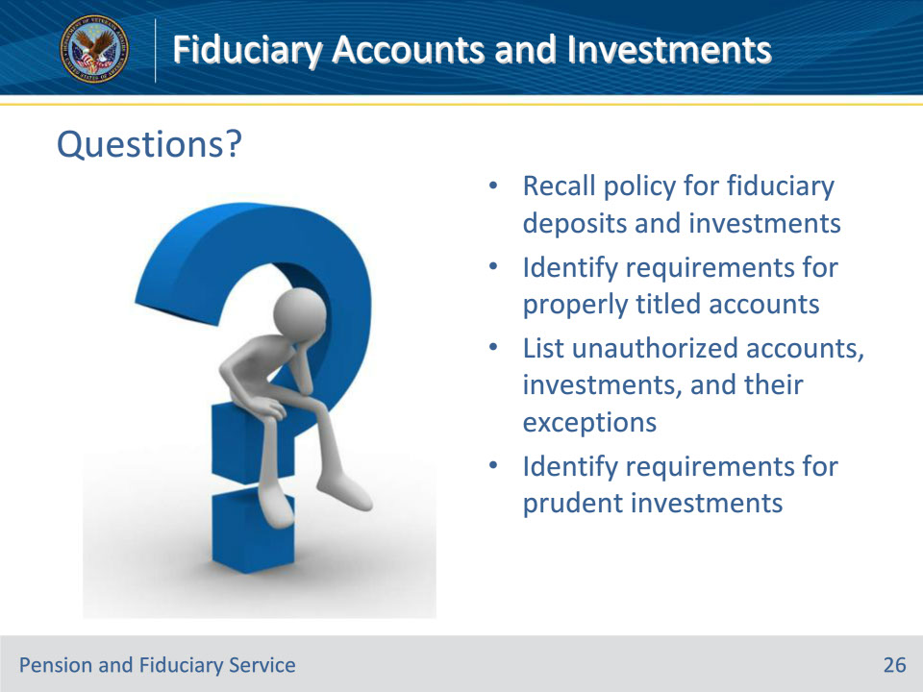
Slide notes

(Recall) These are our learning objectives as stated from the beginning of the training:

• Recall policy for fiduciary deposits and investments

• Identify requirements for properly titled accounts

• List unauthorized accounts, investments, and their exceptions

• Identify requirements for prudent investments

(Recap) we discussed each of these learning objectives through the following topics in each slide today:

• Funds Protection

• Misuse

• Presumption as to Use

• Estate Administration

• Funds Maintenance Policy

• Account Requirements

• Account Title Exceptions

• Investments

• Determining Prudence

• Security of Investments

• Account Title Verification

• Savings Bonds Verification

• Qualified Accounts

• Unauthorized Accounts

• Court-Appointed

• Real Estate

• Insurance Investments

• VA and SGLI

• Educational Policies

Are there any additional questions?

Slide 27 - TMS Survey
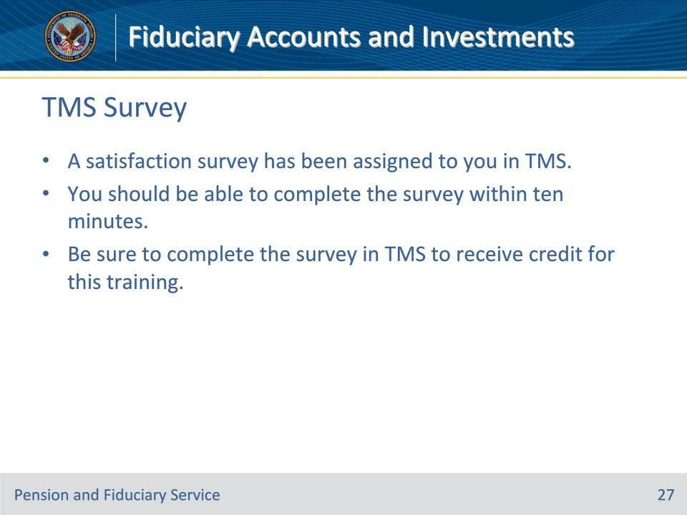
Slide notes

Instructor Notes:

A satisfaction survey has been assigned to you in TMS. You should be able to complete the survey within ten minutes. Completing the survey will allow you to receive credit for this training.

