Slide 1 - Surety Bond Requirements
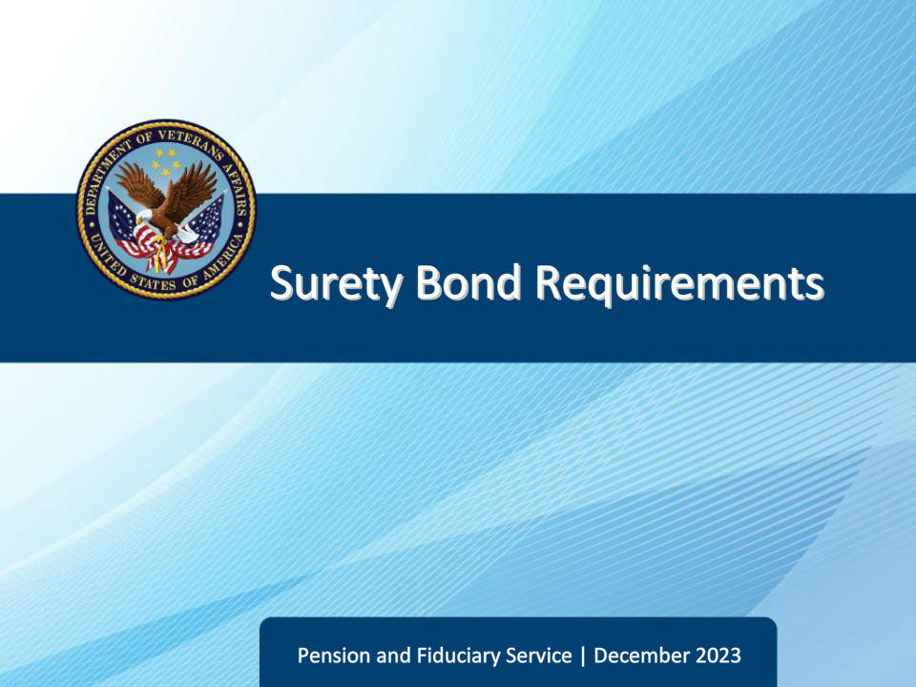
Slide notes

Course Description:

This lesson teaches learners how to determine if a case requires a surety bond to protect beneficiary funds, how to request bonds and changes in bonds, and to determine the adequacy of bonds.

Slide 2 - Objectives
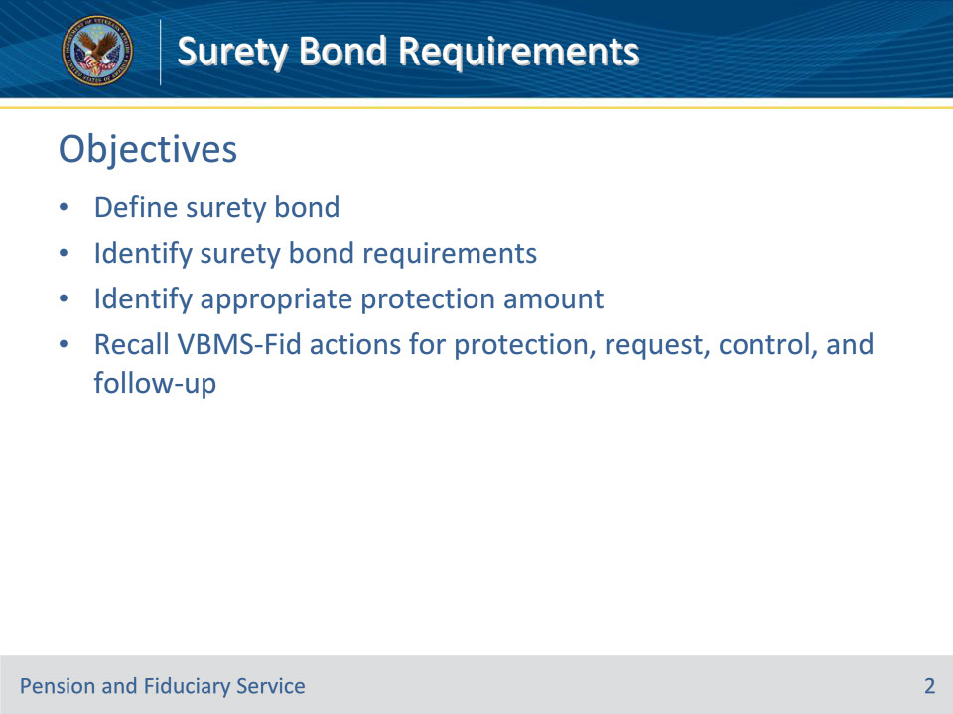
Slide notes

At the end of this lesson, given the training and references, the learner will be able to do the following:

• Define surety bond

• Identify surety bond requirements

• Identify appropriate protection amount

• Recall VBMS-Fid actions for protection, request, control, and follow-up

Slide 3 - References
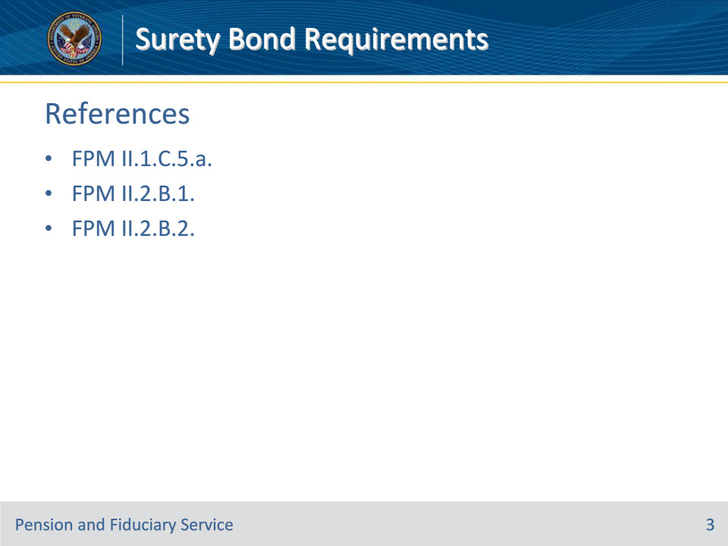
Slide notes

These are the relevant references pertaining to this course:

• FPM II.1.C.5.a. Definition: Surety Bond

• FPM II.2.B.1. General Information on Corporate Surety Bonds

• FPM II.2.B.2. Corporate Surety Bond Requirements for VA-Appointed Fiduciaries

Slide 4 - Definition and Purpose
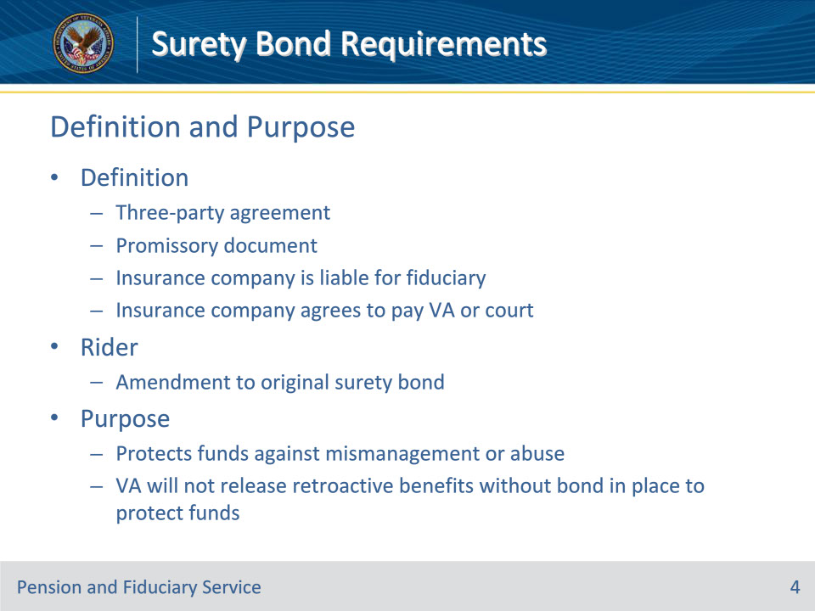
Slide notes

Policy Reference(s): FPM II.1.C.5.a.; FPM II.2.B.1.a.-c.

Instructor Notes:

Surety bond refers to a three-party agreement that legally binds together a principal (fiduciary) who needs the bond, an obligee (VA) who requires the bond and a surety company that sells the bond. The bond guarantees the principal will act in accordance with certain laws. If the principal fails to perform in this manner, the bond will cover resulting damages or losses.

A corporate surety bond protects the beneficiary’s Department of Veterans Affairs (VA) benefit funds under management (FUM) against mismanagement or abuse by the fiduciary.

A corporate surety bond is a promissory document issued by an insurance bonding agency (surety) issuing a pledge to compensate VA or the court of jurisdiction (obligee for the beneficiary) up to a specified amount (bond amount/penal sum) following any default on the part of the fiduciary (principal).

It is an agreement whereby an insurance company becomes liable for the performance of work or services provided by a fiduciary. If the fiduciary does not fulfill their responsibilities, the surety company is financially liable to pay the obligee.

A corporate surety bond rider is a change or amendment to an original corporate surety bond. An original corporate surety bond may have more than one rider.

The original bond and all bond riders combine to total the entire bond amount, unless specifically cancelled by the surety. A fiduciary should request reissuance of an original bond document containing all bond riders, if an original corporate surety bond has multiple riders, if it does not financially burden the beneficiary or cancel any previous protection afforded VA and the beneficiary.

Slide 5 - Bond Requirements
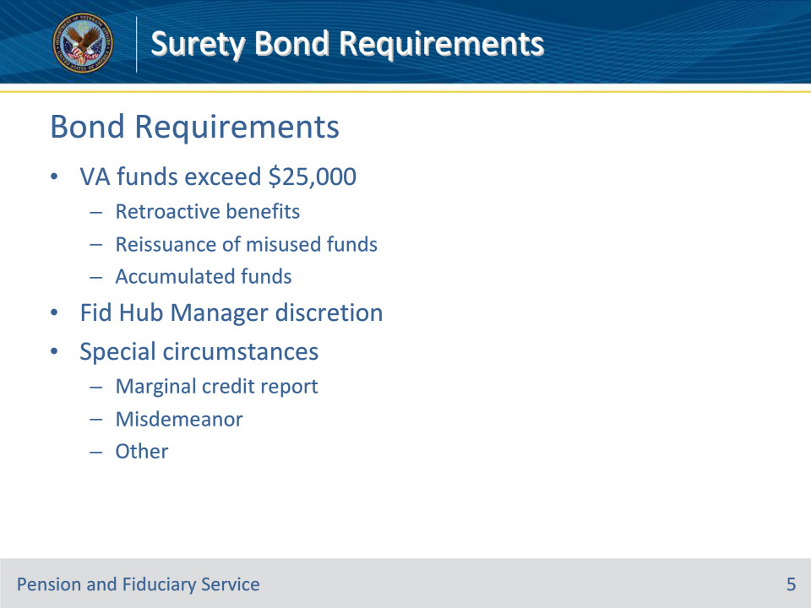
Slide notes

Policy Reference(s): FPM II.2.B.2.a.

Instructor Notes:

A bond is required when VA FUM exceeds $25,000. The threshold can be reached when

• release of any retroactive VA benefit or reissuance of misused funds

• exceeds $25,000, or

• increases the VA FUM to exceed $25,000, or

• review of a beneficiary case or accounting audit reveals the accumulated VA FUM exceeds $25,000.

The FHM may, at any time, require the fiduciary to obtain a bond without regard to the amount of the VA FUM by the fiduciary for the beneficiary, if special circumstances indicate that obtaining a bond would be in the beneficiary’s interest. Such special circumstances may include but are not limited to

• a marginal credit report for the fiduciary, or

• the fiduciary’s misdemeanor criminal conviction either before or after appointment.

Slide 6 - Bond Exceptions
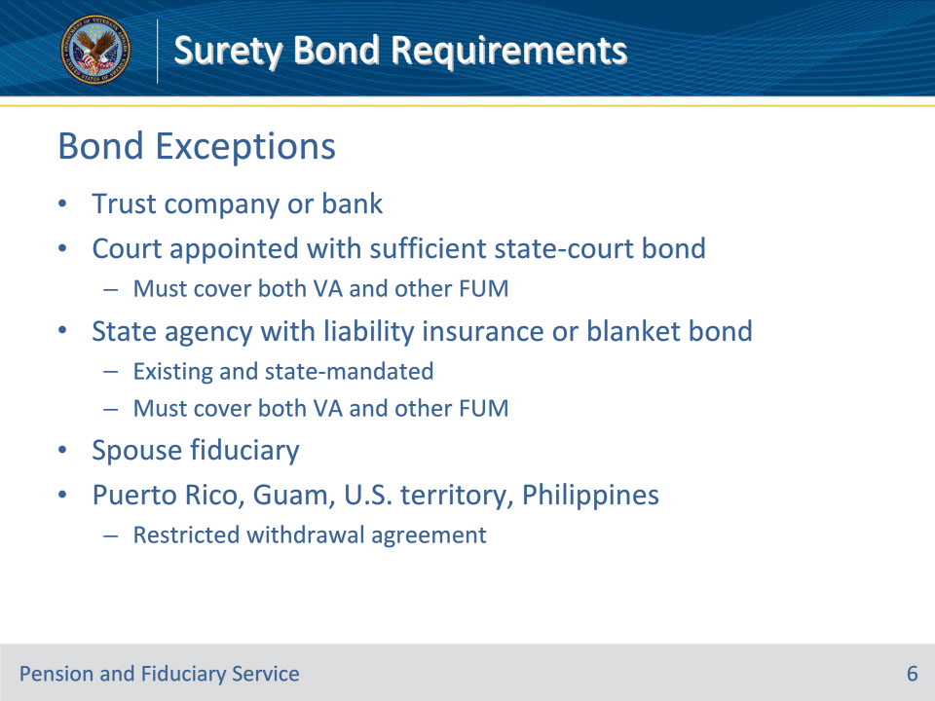
Slide notes

Policy Reference(s): FPM II.2.B.1.d.

Instructor Notes:

A fiduciary is exempted from obtaining a surety bond if the fiduciary is

• a trust company or a bank with trust powers organized under the laws of the U.S. or a State

• appointed by a court and has obtained a State-court bond sufficient to cover both VA and other FUM

• a State agency with existing, State-mandated liability insurance or a blanket bond sufficient to cover both VA and other FUM

• the beneficiary’s spouse, or

• in the Commonwealth of Puerto Rico, Guam, or another territory of the U.S., or in the Republic of the Philippines, who has entered into a restricted withdrawal agreement in lieu of a surety bond.

A corporation serving as a fiduciary refers to any entity or person, which serves using a tax identification number that is not a Social Security number. This may include but is not limited to a law firm, bank, or professional fiduciary service.

Slide 7 - Bond Criteria
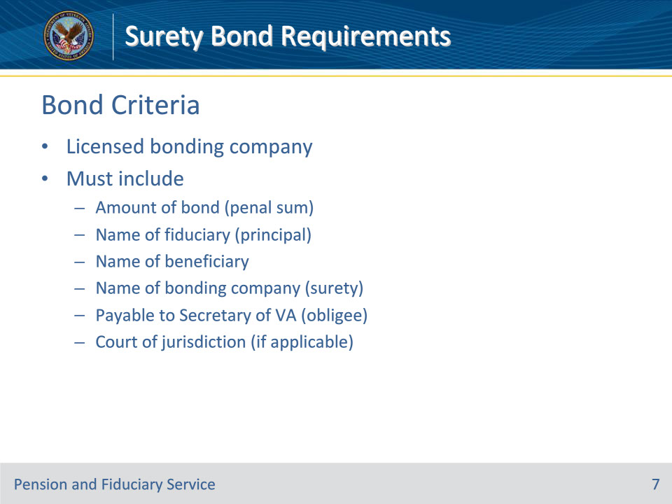
Slide notes

Policy Reference(s): FPM II.2.B.1.e.

Instructor Notes:

At a minimum, a VA-appointed fiduciary’s bond must be obtained from a bonding company licensed by a State having jurisdiction, and include

• the amount of the bond (penal sum)

• the name of the

• fiduciary (principal)

• beneficiary, and

• bonding company (surety), and

• a statement that the bond is payable to the Secretary of VA or the court of jurisdiction if a court ordered surety bond already exists (obligee).

Slide 8 - Amount of Protection
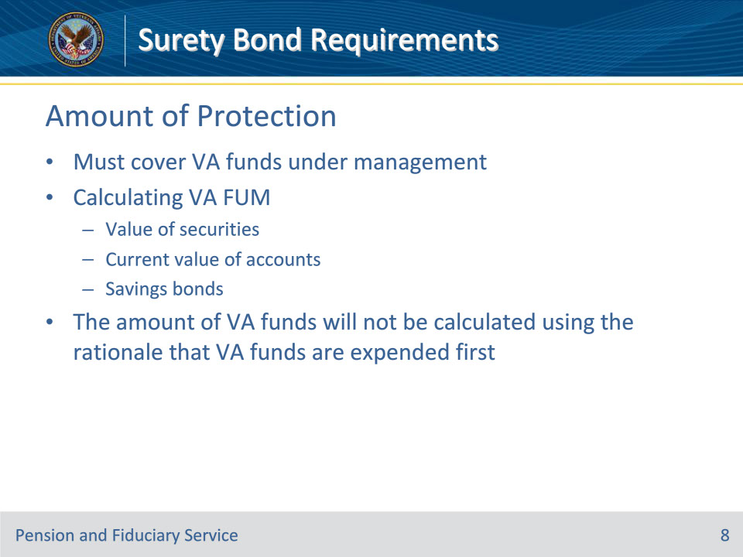
Slide notes

Policy Reference(s): FPM II.2.B.1.f., g.; FPM II.2.B.2.b.

Instructor Notes:

The fiduciary must obtain a corporate surety bond in an amount sufficient to cover the value of the VA benefit funds under management (FUM) by the fiduciary for the beneficiary.

The hub reviews the beneficiary’s assets in order to determine the value of the VA benefit FUM. When calculating FUM the hub must consider

• the actual value of the securities

• financial documentation that contains the current value of interest-bearing savings and checking accounts, and

• the initial cost of a U.S. savings bond to determine the original value (subtract the original value from the attained maturity value to determine the amount of increase of VA benefit FUM).

The hub must exclude real and personal property from the FUM calculation.

The hub must calculate the amount of the VA FUM unless the record contains clear evidence VA funds have and continue to be maintained in an account independent of all other income.

The amount of VA funds will not be calculated using the rationale that VA funds are expended first.

Slide 9 - Adjustments to Bond Amount
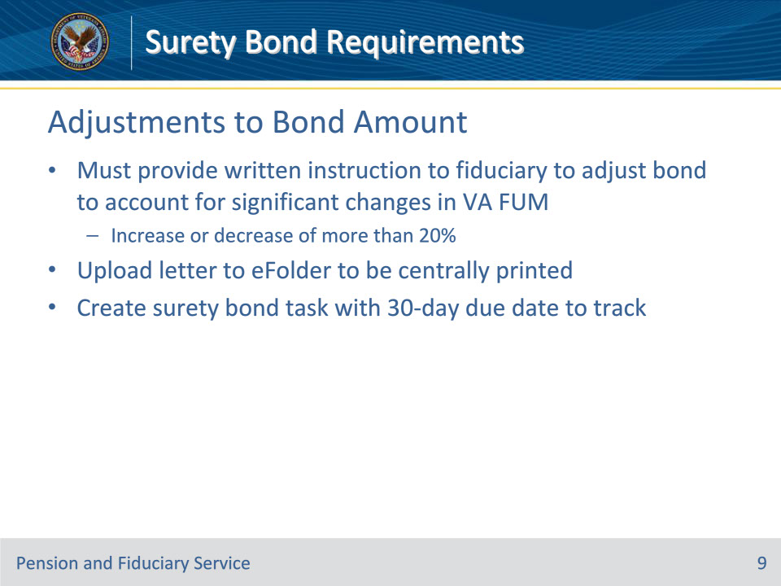
Slide notes

Policy Reference(s): FPM II.2.B.1.h.

Instructor Notes:

The Legal Instruments Examiner must provide written instruction to the fiduciary to adjust the bond to account for significant changes in the amount of VA benefit FUM. A VA-appointed fiduciary must adjust a corporate surety bond for any increase or decrease of more than 20 percent between the corporate surety bond and the current VA FUM

When generating correspondence, the hub must follow the guidance for uploading the letter into the electronic claims folder (eFolder) to be centrally printed.

The hub must create a SURETY BOND task with a 30-day due date to track requests for surety bond adjustments.

Requests to exonerate a corporate surety bond are not considered requests for surety bond adjustment and do not require follow-up action.

Slide 10 - Surety Company in Default
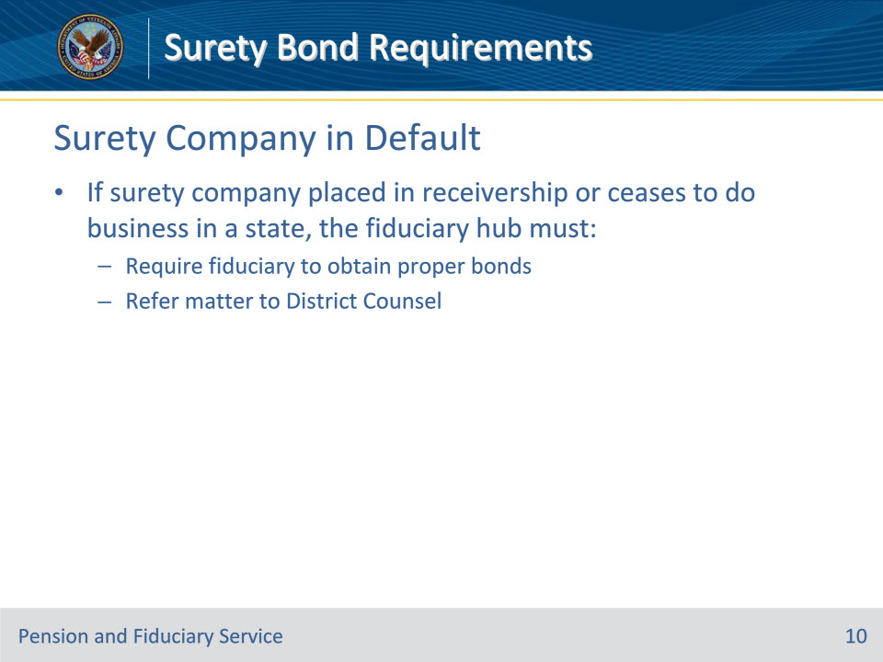
Slide notes

Policy Reference(s): FPM II.2.B.1.i.

Instructor Notes:

If any surety company is placed in receivership or ceases to do business in a State, the Fiduciary Hub Manager (FHM) or designee must

• require the fiduciary to obtain proper bonds, and

• refer the matter to District Counsel for any other appropriate action.

Slide 11 - Bonds Payable to Courts
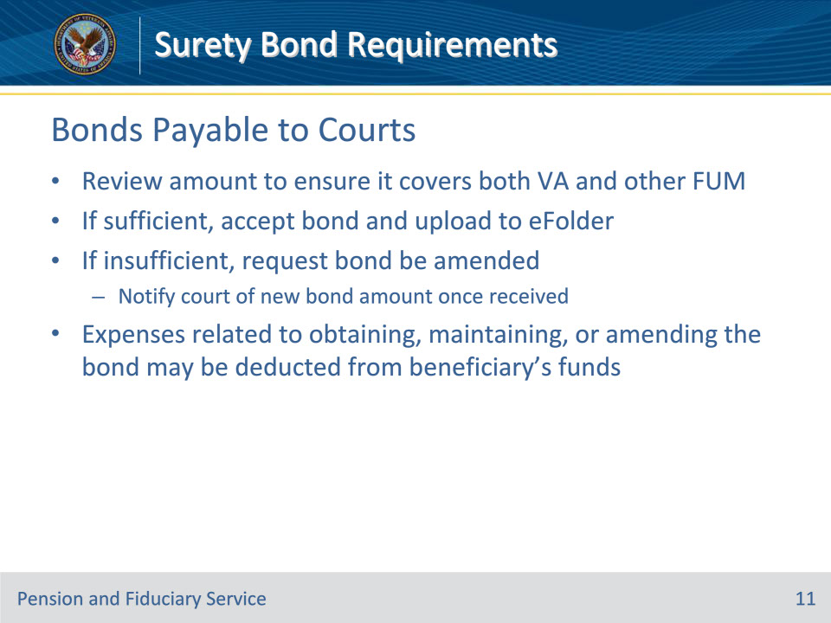
Slide notes

Policy Reference(s): FPM II.2.B.1.j.

Instructor Notes:

In some instances, the court of jurisdiction requires a VA-appointed fiduciary also serving as court-appointed fiduciary to obtain a surety bond with the court as the obligee.

If a surety bond payable to the Secretary is required at the time of fiduciary appointment, review the amount of the existing surety bond payable to the court to ensure it covers the combined amount of the VA and other FUM that the proposed fiduciary manages before releasing the retroactive payment.

If the amount of the existing surety bond that is payable to the court is high enough to fully cover both VA and other FUM, accept the surety bond and upload the documentation to the beneficiary’s eFolder.

If the existing surety bond does not adequately cover the amount of VA and other FUM, follow the procedures to have the bond amended. Once VA receives documentation of an adequate surety bond which covers the VA and other FUM, upload the documentation to the eFolder.

The fiduciary may deduct expenses from the beneficiary’s account related to obtaining, maintaining, or amending an existing court-ordered surety bond to meet the criteria.

Slide 12 - Bond Letters and Control
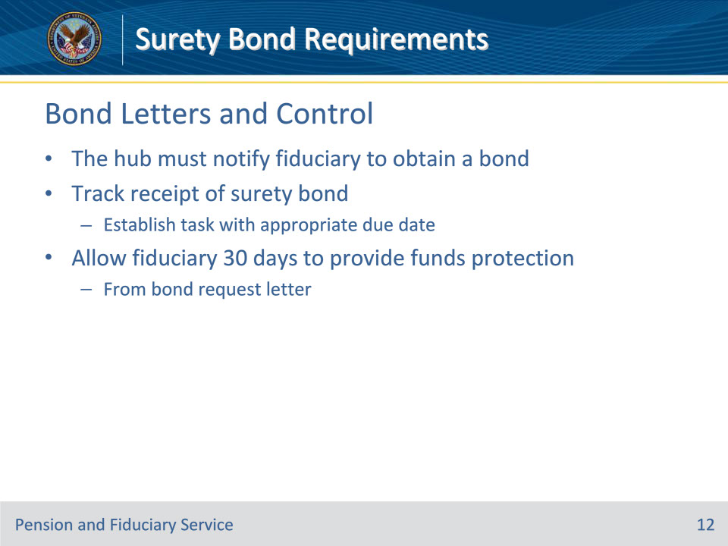
Slide notes

Policy Reference(s): FPM II.2.B.2.a.

Instructor Notes:

The hub must notify the fiduciary to obtain a bond. A task with the appropriate due date must be used to track for receipt of a surety bond when the hub discovers that the VA FUM exceeds $25,000.

Allow the fiduciary 30 days from the bond request letter to provide the FUM protection.

Slide 13 - Bond Letters and Control
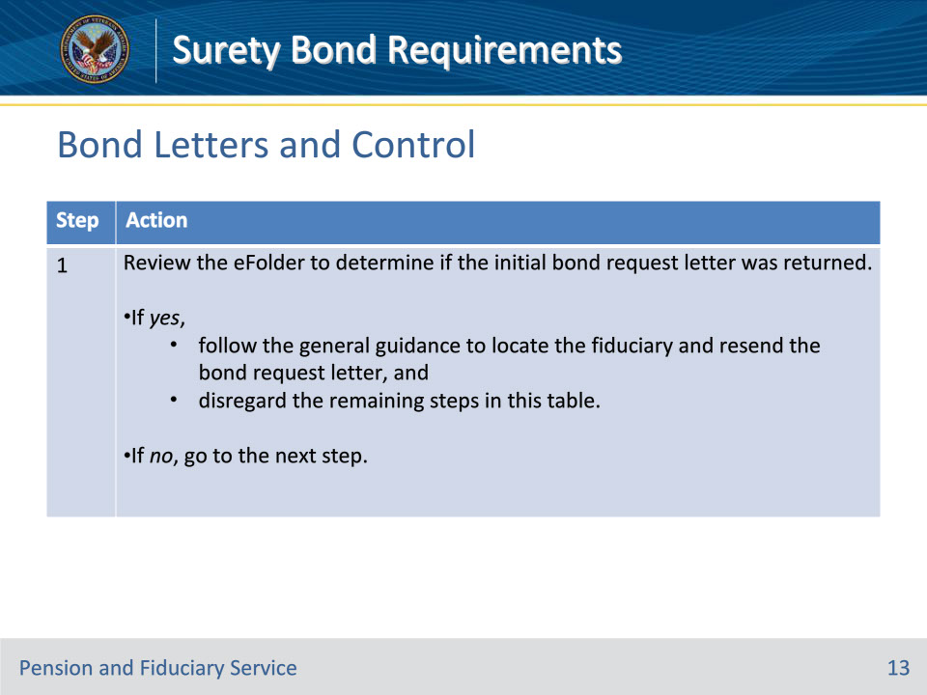
Slide notes

Policy Reference(s): FPM II.2.B.2.e.

Instructor Notes:

Follow the steps in this table when the surety bond is not available 30 days after VA’s request.

Slide 14 - Bond Letters and Control
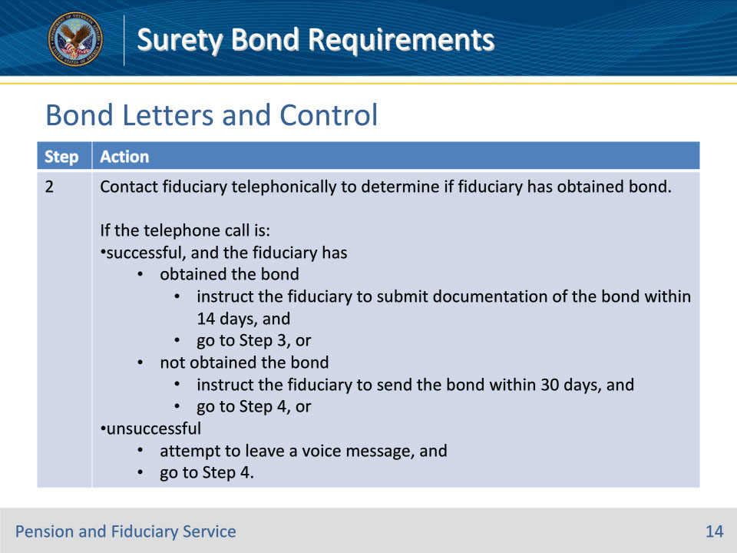
Slide notes

Policy Reference(s): FPM II.2.B.2.e.

Instructor Notes:

Follow the steps in this table when the surety bond is not available 30 days after VA’s request.

Notes:

• Document both successful and unsuccessful telephone contacts on a VA Form 27-0820, Report of General Information.

• When leaving a voice message, do not provide any personally identifiable information.

Slide 15 - Bond Letters and Control
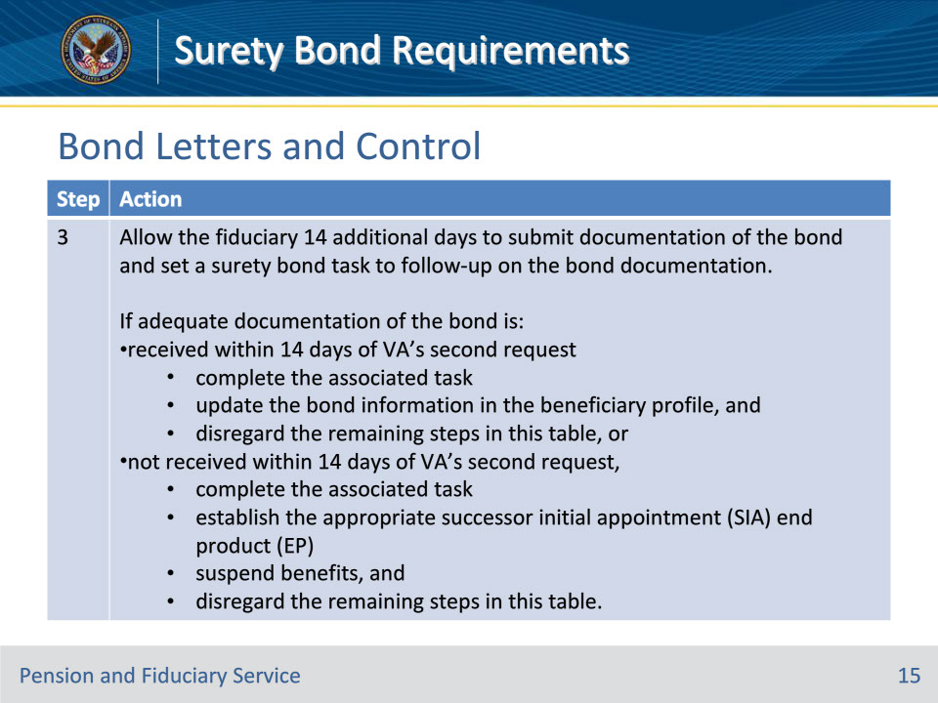
Slide notes

Policy Reference(s): FPM II.2.B.2.e.

Instructor Notes:

Follow the steps in this table when the surety bond is not available 30 days after VA’s request.

Note: It is not necessary to send a follow-up bond request letter when the fiduciary indicates that the bond has already been obtained. However, the VA Form 27-0820 must document that the fiduciary obtained the bond and was instructed to submit evidence of the bond within 14 days.

Slide 16 - Bond Letters and Control
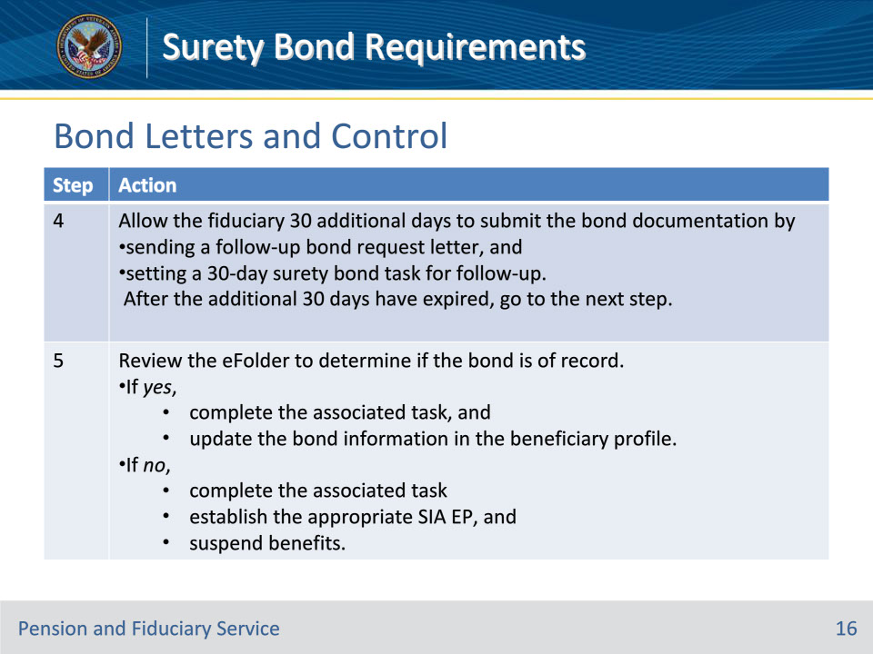
Slide notes

Policy Reference(s): FPM II.2.B.2.e.

Instructor Notes:

Follow the steps in this table when the surety bond is not available 30 days after VA’s request.

Slide 17 - Documentation
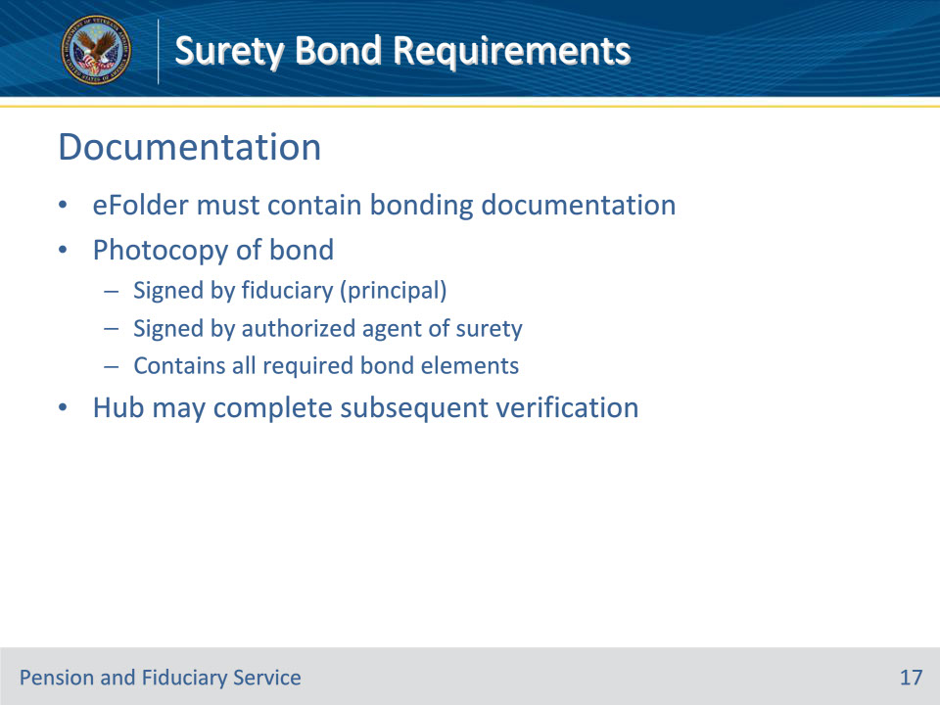
Slide notes

Policy Reference(s): FPM II.2.B.2.c.

Instructor Notes:

The Veteran’s eFolder must contain documentation to show evidence of adequate bonding.

Acceptable documentation consists of a photocopy of the corporate surety bond signed by the fiduciary (principal) and authorized agent of the surety that contains all required elements.

The hub may complete subsequent verification that a bond remains in effect.

Slide 18 - 31. Questions?
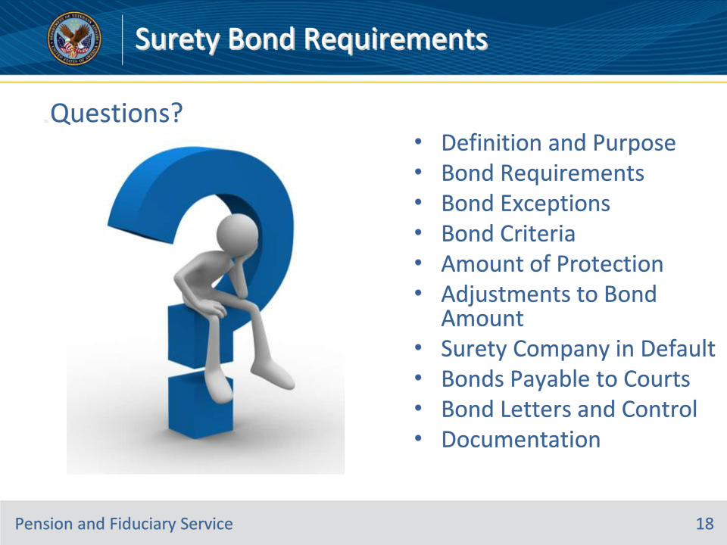
Slide notes

Instructor Notes:

(Recall) These are our learning objectives as stated from the beginning of the training:

• Define surety bond

• Identify surety bond requirements

• Identify appropriate protection amount

• Recall VBMS-Fid actions for protection, request, control, and follow-up

Are there any additional questions?

Slide 19 - TMS Survey
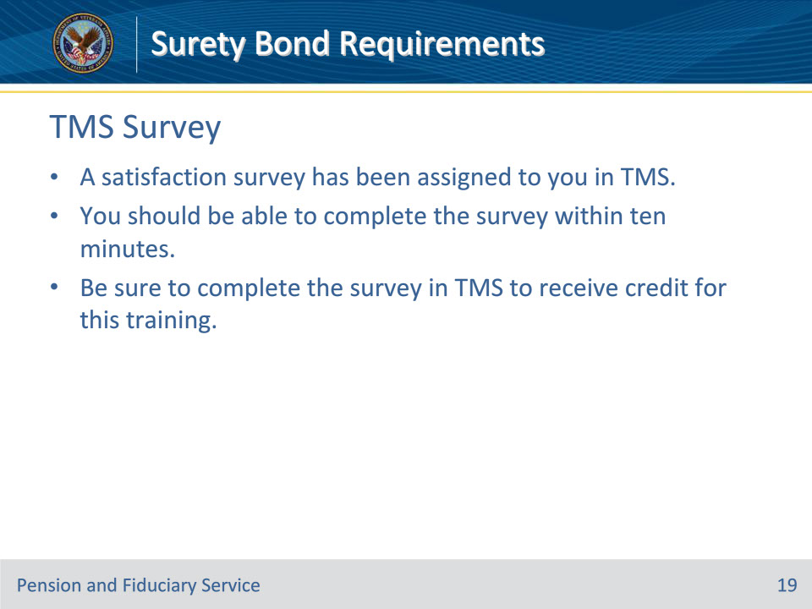
Slide notes

Instructor Notes:

A satisfaction survey has been assigned to you in TMS. You should be able to complete the survey within ten minutes. Completing the survey will allow you to receive credit for this training.

