Slide 1 - Fiduciary Preference and Suitability
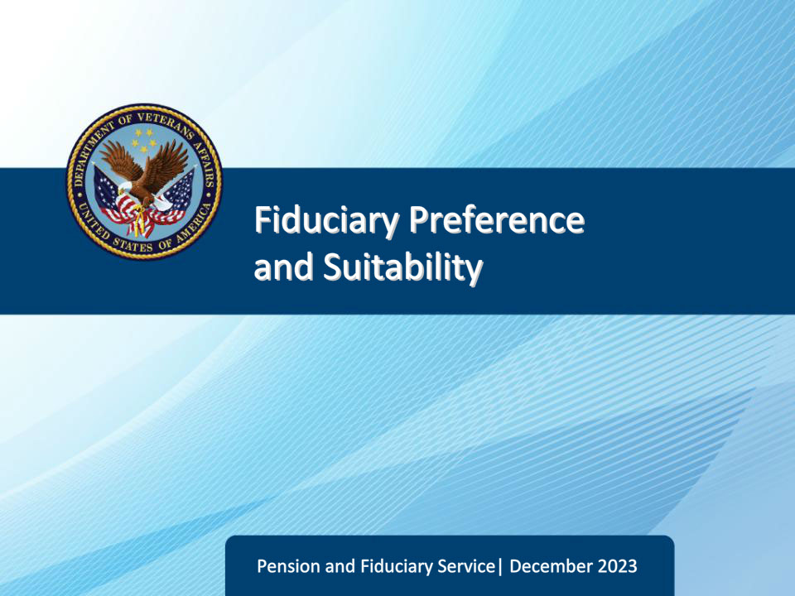
Slide notes

Course Description: The purpose of this lesson is to teach students about fiduciary preference, how to assess the suitability of a fiduciary, and to determine if the appointment is in the beneficiary’s best interest.

Slide 2 - Objectives
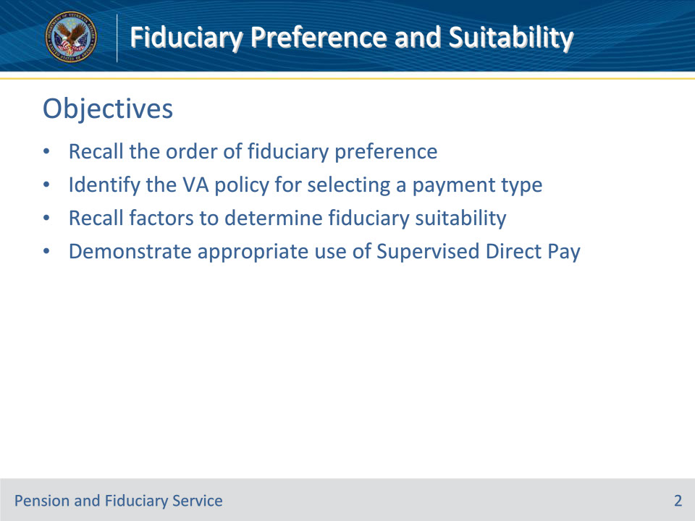
Slide notes

At the end of this lesson, given the training and references, the learner will be able to do the following:

• Recall the order of fiduciary appointment preference

• Identify the VA policy for selecting a payment type

• Recall factors to determine fiduciary suitability

• Demonstrate appropriate use of Supervised Direct Pay

Slide 3 - References
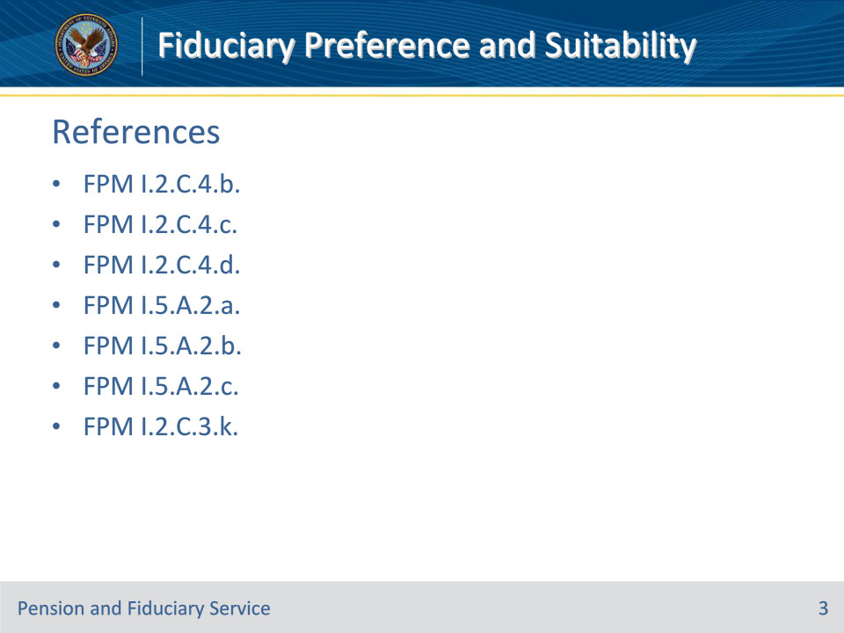
Slide notes

These are the relevant references pertaining to this course:

• FPM I.2.C.4.b. Beneficiary’s Fiduciary Preference

• FPM I.2.C.4.c. Documenting the Beneficiary’s Fiduciary Preference

• FPM I.2.C.4.d. Fiduciary Suitability and Type

• FPM I.5.A.2.a. General Information on SDP

• FPM I.5.A.2.b. Inappropriate Use of SDP

• FPM I.5.A.2.c. SDP When the Beneficiary Is Hospitalized or Institutionalized

• FPM I.2.C.3.k. Determining VA FUM

Slide 4 - Order of Preference
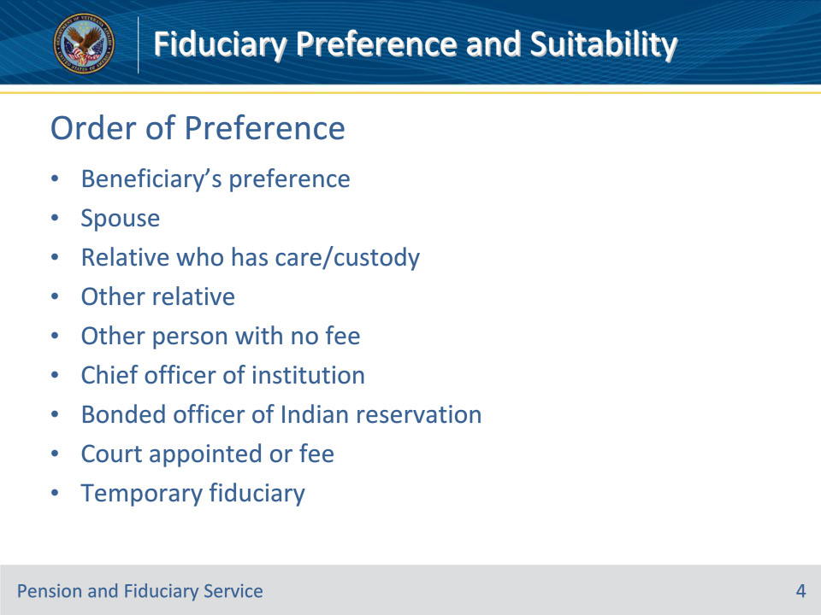
Slide notes

Policy Reference(s): FPM I.2.C.4.b.

Instructor Notes:

When selecting a fiduciary, the FE must consider individuals and entities for appointment in the following order of preference, provided that the proposed fiduciary is qualified, willing to serve, and the appointment would serve the beneficiary’s interest:

• the beneficiary’s preference

• the beneficiary’s spouse

• a relative who has care or custody of the beneficiary or his/her funds

• any other relative of the beneficiary

• any friend, acquaintance, or other person who is willing to serve as fiduciary for the beneficiary without a fee

• the chief officer of a public or private institution in which the beneficiary receives care or which has custody of the beneficiary

• the bonded officer of an Indian reservation, if applicable

• an individual or entity who

• has been appointed by a court with jurisdiction to handle the beneficiary’s affairs, or

• is not willing to serve without a fee, or

• a temporary fiduciary, if necessary.

If the beneficiary has a legal guardian appointed to handle the beneficiary’s affairs, the FE will presume that the beneficiary does not have the capacity to state a preference and will consider individuals and entities in the order of preference.

For minor beneficiaries 12 years or older at the time of an EIA, the FE must ask the minor whom they would like to serve as their fiduciary to manage their funds. A minor beneficiary’s request to have a fiduciary other than the parent must be documented and considered.

Slide 5 - Beneficiary’s Preference
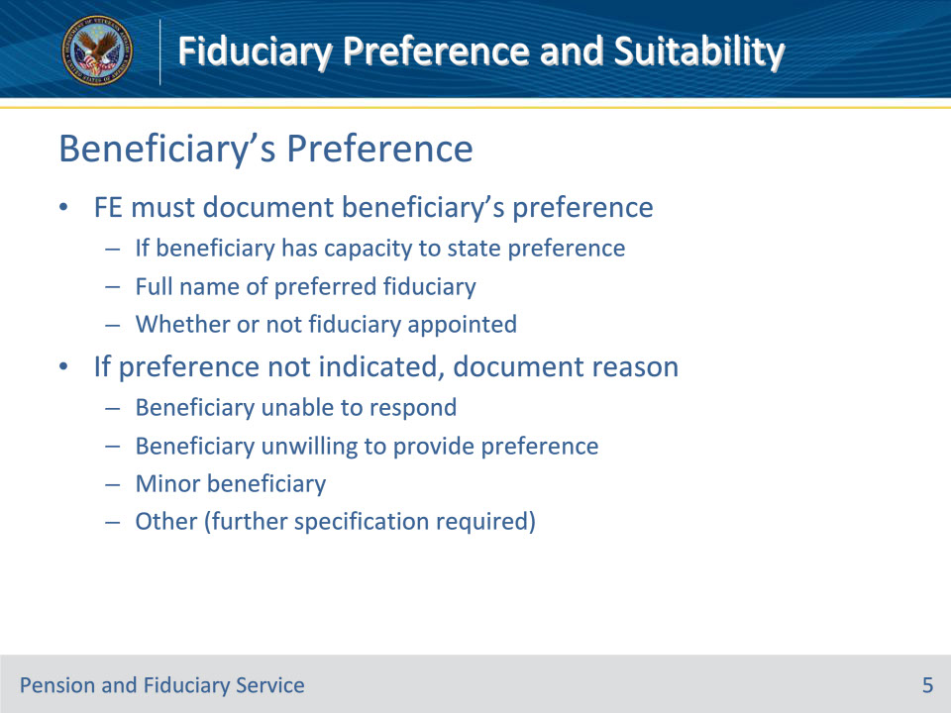
Slide notes

Policy Reference(s): FPM I.2.C.4.c.

Instructor Notes:

During the field examination, the FE must document the following information regarding the beneficiary’s fiduciary preference if the beneficiary had the capacity to state a preference:

• full name of the preferred fiduciary, and

• whether or not the fiduciary was appointed.

If a fiduciary preference is not indicated, the FE must document the reason why a preference was not provided by the beneficiary. Reasons may include

• the beneficiary was

• unable to respond to VA’s request for information

• unwilling to provide a preference, or

• a minor, or

• other (will need to specify).

Slide 6 - Reasons for Non-Selection
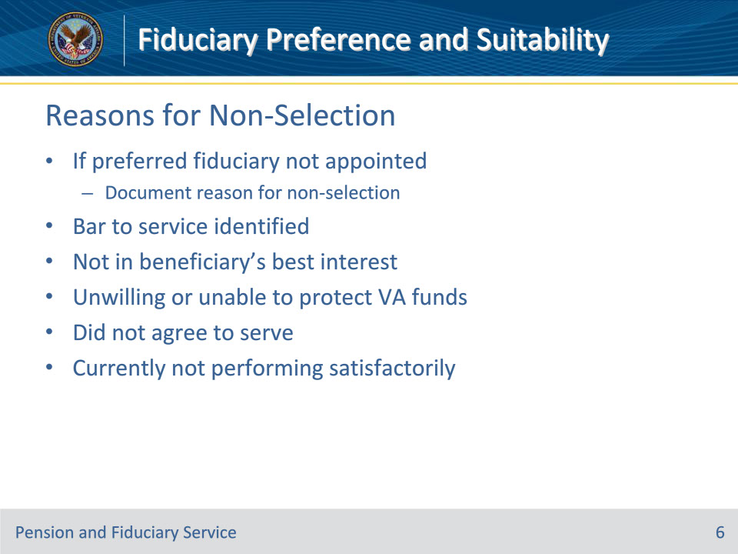
Slide notes

Policy Reference(s): FPM I.2.C.4.c.

Instructor Notes:

If the preferred fiduciary was not appointed, the FE must also document the reason for non-selection. Appropriate justification for non-selection include

• a bar to service was identified after investigation

• the appointment was not in the best interest of the beneficiary after investigation or during the interview process

• the preferred fiduciary was unwilling or unable to provide VA with the information to protect the beneficiary’s VA funds

• the preferred fiduciary did not agree to serve, or

• the preferred fiduciary is currently not performing satisfactorily

Slide 7 - Fiduciary Suitability
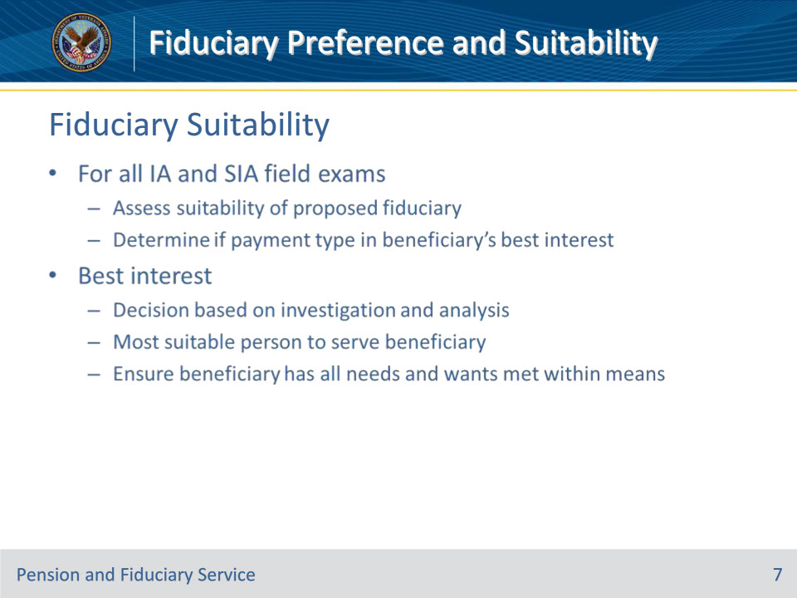
Slide notes

Policy Reference(s): FPM I.2.C.4.d.

Instructor Notes:

For all IA and SIA field examinations, the FE must

• assess the suitability of the proposed fiduciary, and

• determine whether the payment type is in the beneficiary’s best interest.

Best interest refers to the decision to appoint a fiduciary based on an investigation and analysis that the fiduciary is the most suitable person to serve the beneficiary. The fiduciary is expected to ensure the beneficiary has all their needs and wants met within their means.

Slide 8 - Fiduciary Suitability
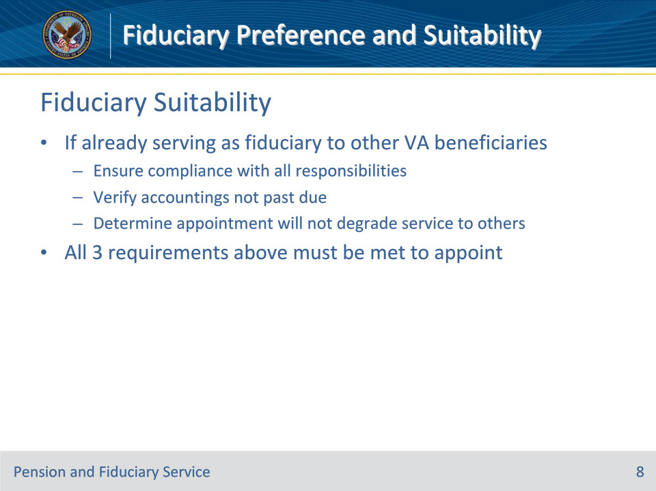
Slide notes

Policy Reference(s): FPM I.2.C.4.d.

Instructor Notes:

If the proposed fiduciary already serves as a fiduciary to other VA beneficiaries of the Fiduciary Program, the FE must

• ensure the fiduciary is compliant with all responsibilities of a fiduciary with respect to all beneficiaries the fiduciary currently serves

• verify accountings for current beneficiaries are not past due, and

• determine that an appointment of an additional beneficiary will not degrade service for any other beneficiary under the fiduciary’s appointment.

If all three requirements are not met, the FE will not assign an additional beneficiary to the fiduciary.

Slide 9 - Fiduciary Suitability
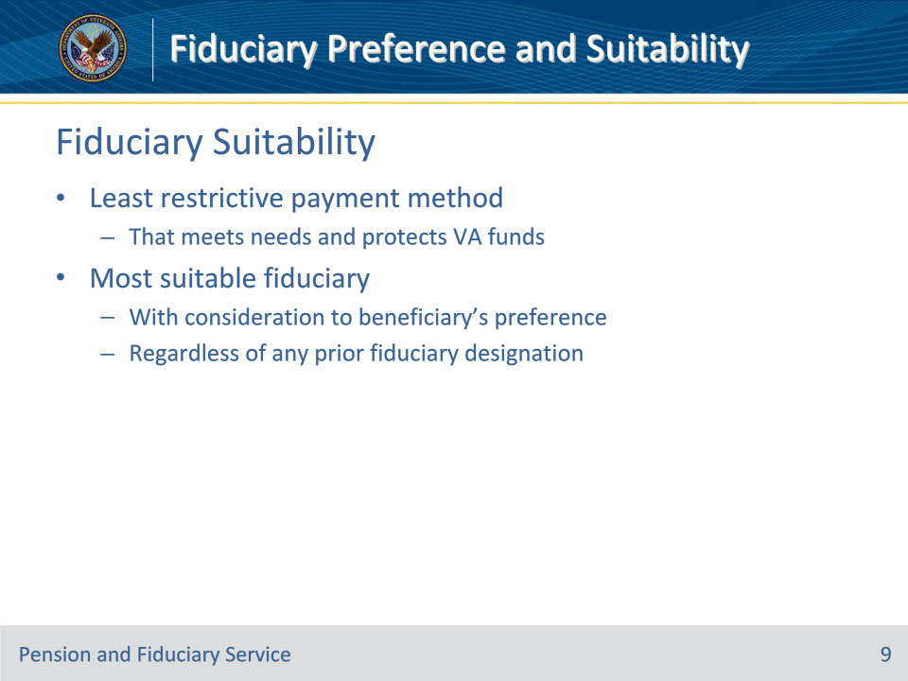
Slide notes

Policy Reference(s): FPM I.2.C.4.d.

Instructor Notes:

VA policy is to use the least restrictive payment method to meet the beneficiary’s needs and afford adequate protection of VA funds. VA must select the most suitable fiduciary with consideration to the beneficiary’s preference, regardless of any prior designation of a fiduciary. This includes any court designation of a guardian appointed under the authority of the State’s Uniform Veterans Guardianship Act.

Slide 10 - Fiduciary Suitability
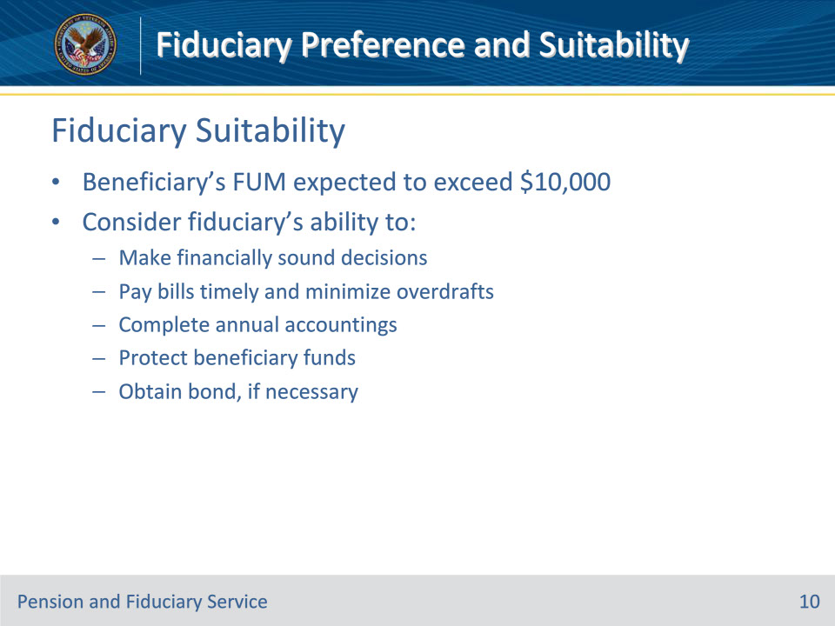
Slide notes

Policy Reference(s): FPM I.2.C.4.d.

Instructor Notes:

If the beneficiary’s FUM are expected to exceed $10,000, the FE must consider a fiduciary that is prepared to manage all responsibilities associated with service, to include the ability to

• make financially sound decisions, to include timely bill payment and minimal overdrafts

• complete annual accountings

• protect the beneficiary’s funds, and

• obtain a bond, if necessary.

Slide 11 - Minor Beneficiaries
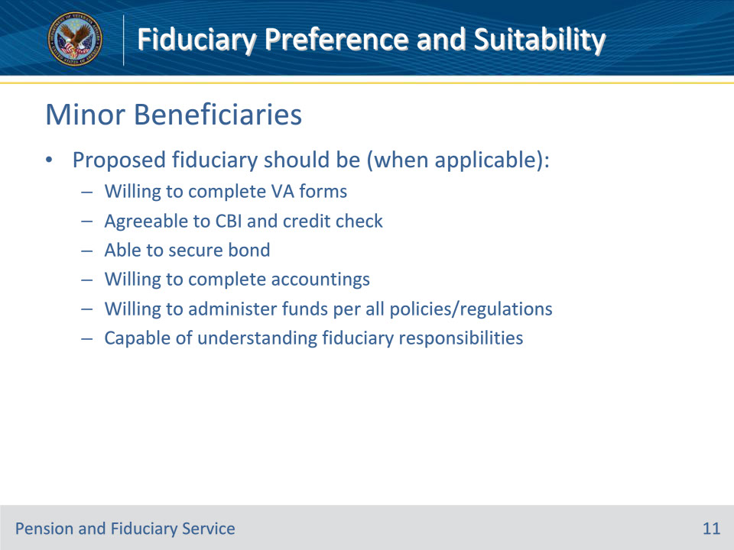
Slide notes

Policy Reference(s): FPM I.2.C.4.d.

Instructor Notes:

For a minor beneficiary, each field examination must indicate whether the proposed fiduciary appears suitable to administer the minor’s current and future financial affairs. The proposed fiduciary should be

• willing to complete VA forms as necessary

• agreeable to a CBI review and credit history check, if applicable (able to secure a bond when applicable)

• agreeable to complete accountings when required

• willing to administer funds in accordance with VA regulations and policies and State and/or Federal laws, and

• capable of understanding their responsibility as a fiduciary.

Slide 12 - Definitions
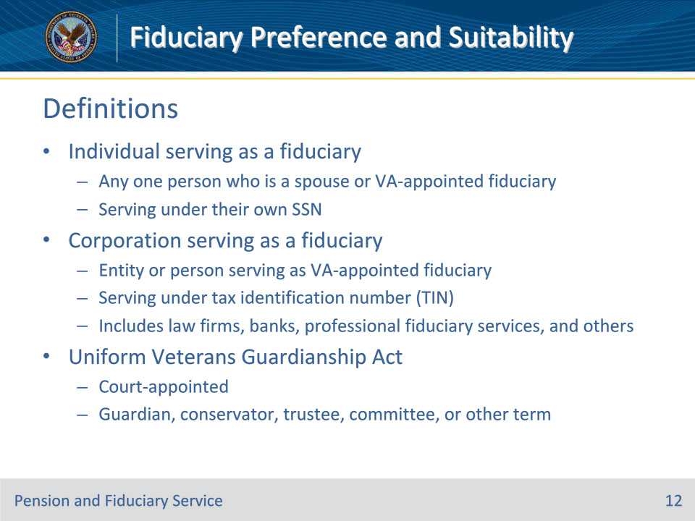
Slide notes

Policy Reference(s): FPM I.2.C.4.d.

Instructor Notes:

• Individual serving as a fiduciary refers to any one person, who is serving under their own SSN, who is a spouse or VA-appointed fiduciary.

• Corporation serving as a fiduciary refers to any entity or person, which serves using a tax identification number as a VA-appointed fiduciary. This may include, but is not limited to a law firm, bank, or professional fiduciary service.

• Special care must be taken to ensure that individuals affiliated with a corporation serving as fiduciary are not appointed as a fiduciary in their own right. Ensure the fiduciary record indicates the organization when establishing the fiduciary record. Example: VA would not appoint John Jones, an attorney, as an individual using an SSN and also appoint a corporation serving as fiduciary as the principle of John Jones Law Firm using a tax identification number.

• The Uniform Veterans Guardianship Act refers to a court-appointed guardian, conservator, trustee, committee, or other term used to denote a court-appointed responsibility over one’s VA benefits. These guardianships were established based on documentation provided to the court which indicated a person in receipt of and incapable of managing their VA benefits. These guardianships do not revoke any rights of the beneficiary and do not afford the guardian the right to enter into contracts or exercise any authority over the beneficiary’s person. VA will not consider this type of guardian as one who will speak for the beneficiary in all matters.

Slide 13 - Supervised Direct Pay
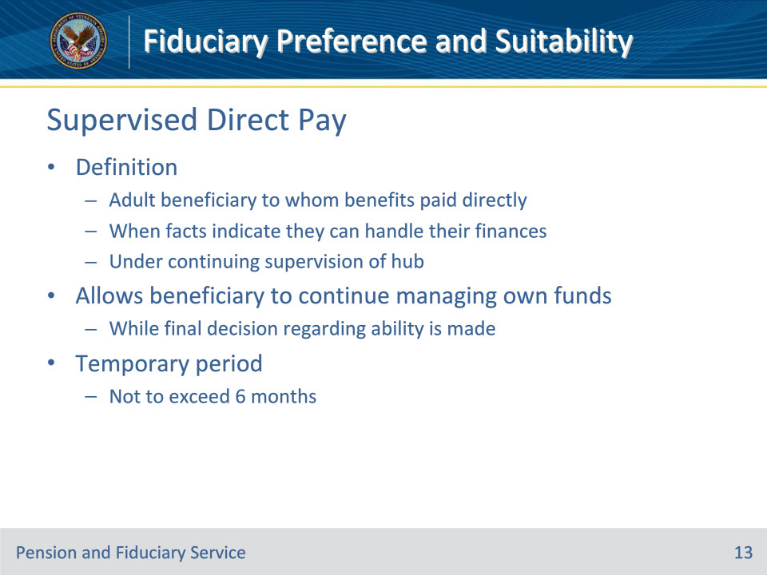
Slide notes

Policy Reference(s): FPM I.5.A.2.a.

Instructor Notes:

Supervised Direct Pay (SDP) refers to an adult beneficiary to whom benefits are paid directly when the facts indicate that they can handle their financial affairs under the continuing supervision of the Fiduciary Hub Manager (FHM).

If during the field examination, the hub finds that that the beneficiary can manage funds payable without limitation, the FHM may authorize the payment of VA benefits directly to an adult beneficiary in the Fiduciary Program. The SDP method allows the beneficiary to continue managing their funds while the evidence obtained during the field examination is being reviewed and a final decision regarding the beneficiary’s ability to manage funds is made.

During the temporary period, VA will provide limited supervision to ensure the beneficiary’s funds are managed properly. A rating must be completed within six months from the SDP appointment.

Slide 14 - Supervised Direct Pay
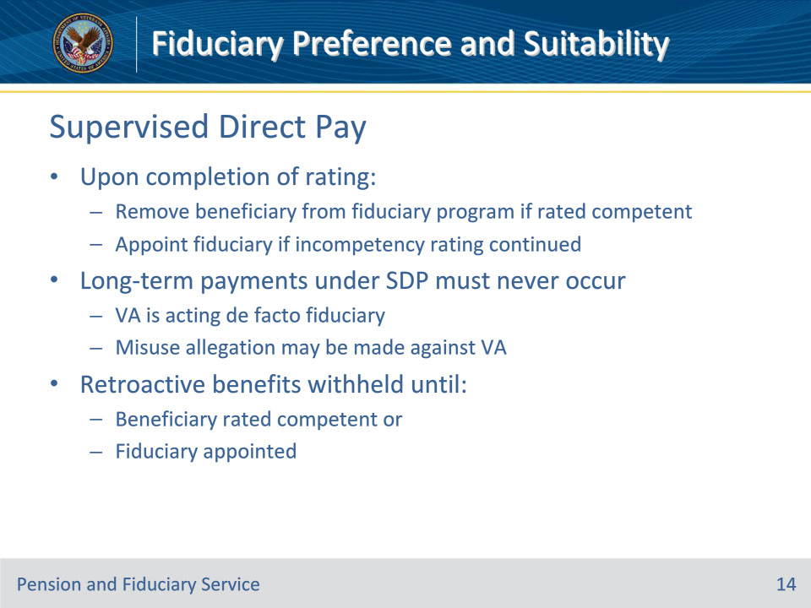
Slide notes

Policy Reference(s): FPM I.5.A.2.a.; FPM I.2.C.3.k.

Instructor Notes:

Upon completion of the rating, which should be completed within six months from the SDP appointment, the hub will

• remove the beneficiary from the Fiduciary Program if rated competent, or

• appoint a fiduciary if the rating of incompetency is continued.

Long-term payment of funds in an SDP capacity must never occur, as VA is acting as de facto fiduciary in these cases. If the SDP beneficiary gives away, or has been deprived of, all or part of their income, a misuse allegation may be made against VA.

While VA releases all monthly VA benefits during the SDP appointment, retroactive benefits are withheld until the beneficiary is rated competent or a fiduciary is appointed.

Slide 15 - Inappropriate Use of SDP
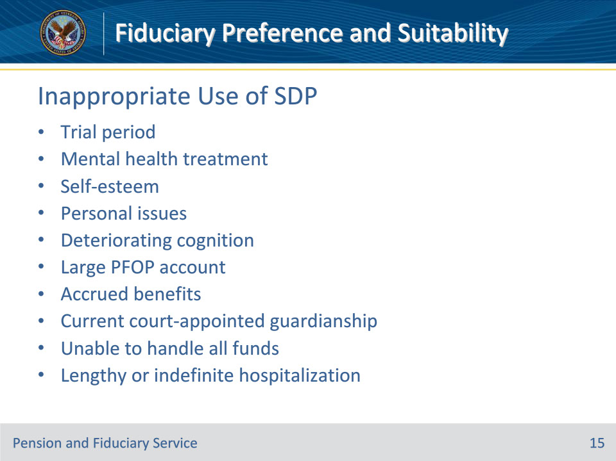
Slide notes

Policy Reference(s): FPM I.5.A.2.b., c.

Instructor Notes:

SDP is not appropriate to:

• allow a trial period to determine if the beneficiary has the capacity to manage funds

• satisfy the requirements of clinical mental health treatment

• lessen the impact to the self-esteem of the beneficiary, or

• solve other personal issues.

SDP is not appropriate for a beneficiary

• with documented cognitive conditions likely to deteriorate rapidly, for example, progressive dementia

• with substantial funds in a Personal Funds of Patient (PFOP) account

• with accrued monthly benefits

• currently under a court-appointed guardianship or Uniform Veterans Guardianship Act as they legally may not enter into any contracts, including maintaining a bank account and signing checks, or

• capable of only handling a portion of the insurance dividends or monthly installments to which he/she is entitled.

When a beneficiary is hospitalized or institutionalized at the time of the IA, consideration must be given to the reason for hospitalization and whether the stay is likely to be of long duration.

SDP is inappropriate when hospitalization is expected to continue for a lengthy or indefinite period.

Slide 16 - Questions?
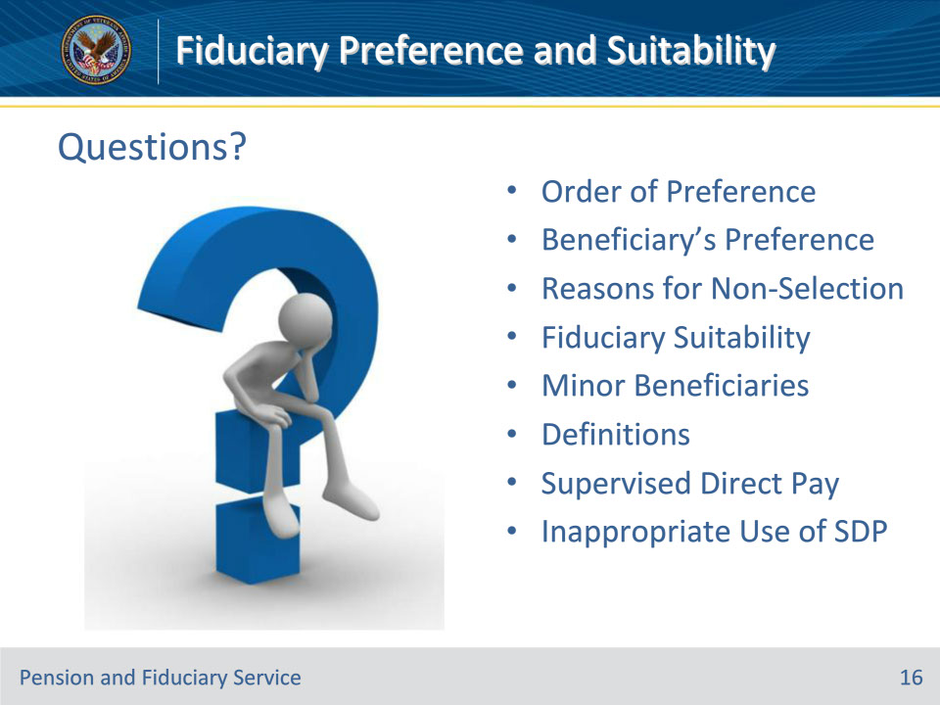
Slide notes

Instructor Notes:

(Recall) These are the learning objectives as stated from the beginning of the training:

• Recall the order of fiduciary appointment preference

• Identify the VA policy for selecting a payment type

• Recall factors to determine fiduciary suitability

• Demonstrate appropriate use of Supervised Direct Pay

(Recap) We discussed each of these learning objectives through the following topics in each slide today:

• Order of Preference

• Beneficiary’s Preference

• Reasons for Non-Selection

• Fiduciary Suitability

• Minor Beneficiaries

• Definitions

• Supervised Direct Pay

• Inappropriate Use of SDP

Are there any additional questions?

Slide 17 - TMS Survey
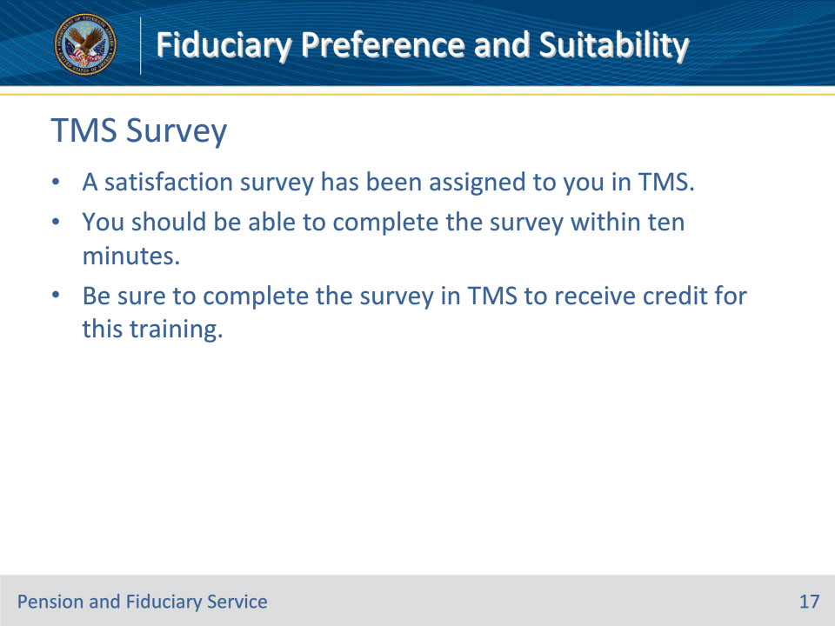
Slide notes

Instructor Notes:

A satisfaction survey has been assigned to you in TMS. You should be able to complete the survey within ten minutes. Completing the survey will allow you to receive credit for this training.

