**Slide 1 - Beneficiary Evaluation**

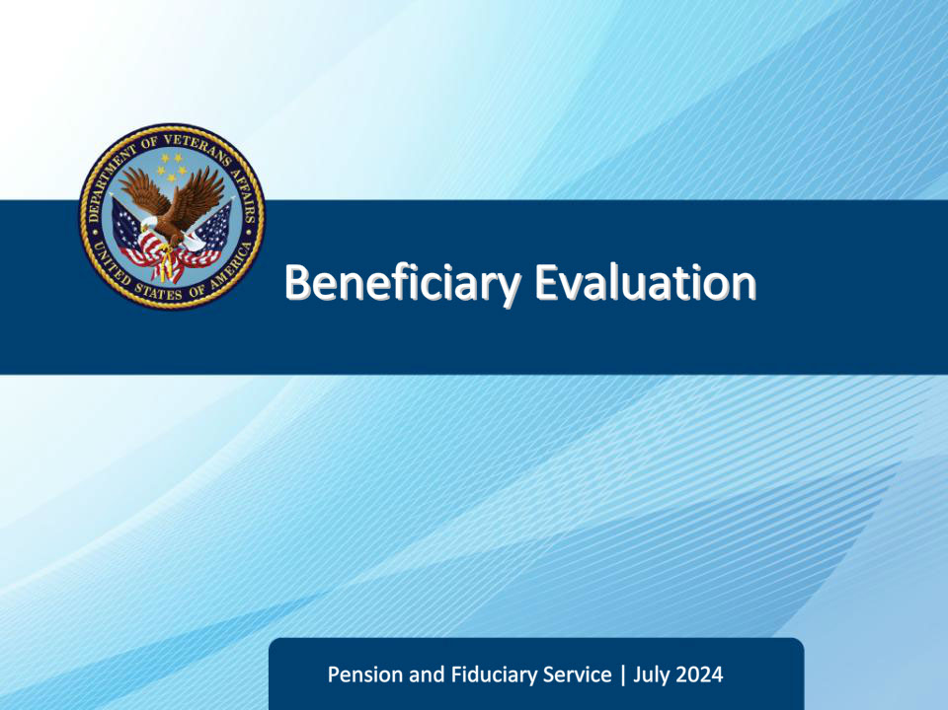

**Slide notes**

Course Description:

This course teaches students the required information that must be gathered about the beneficiary during every field examination.

**Slide 2 - Objectives**

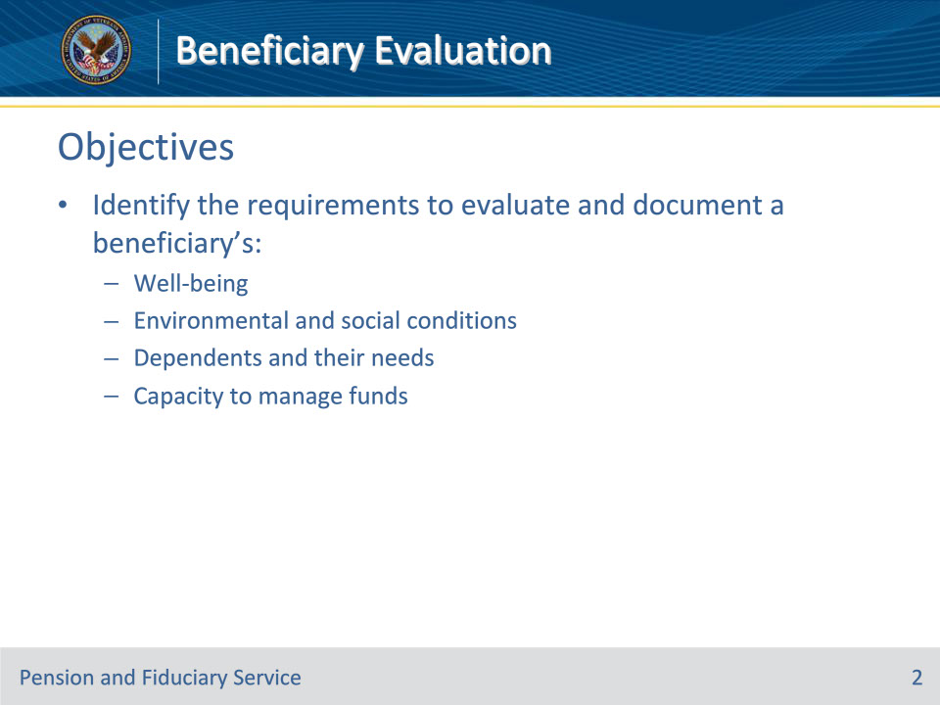

**Slide notes**

Instructor Notes:

At the end of this lesson, given the training and references, the learner will be able to do the following:

• Identify the requirements to evaluate and document beneficiary’s:

• Well-being

• Environmental and social conditions

• Dependents and their needs

• Capacity to manage funds

**Slide 3 - References**

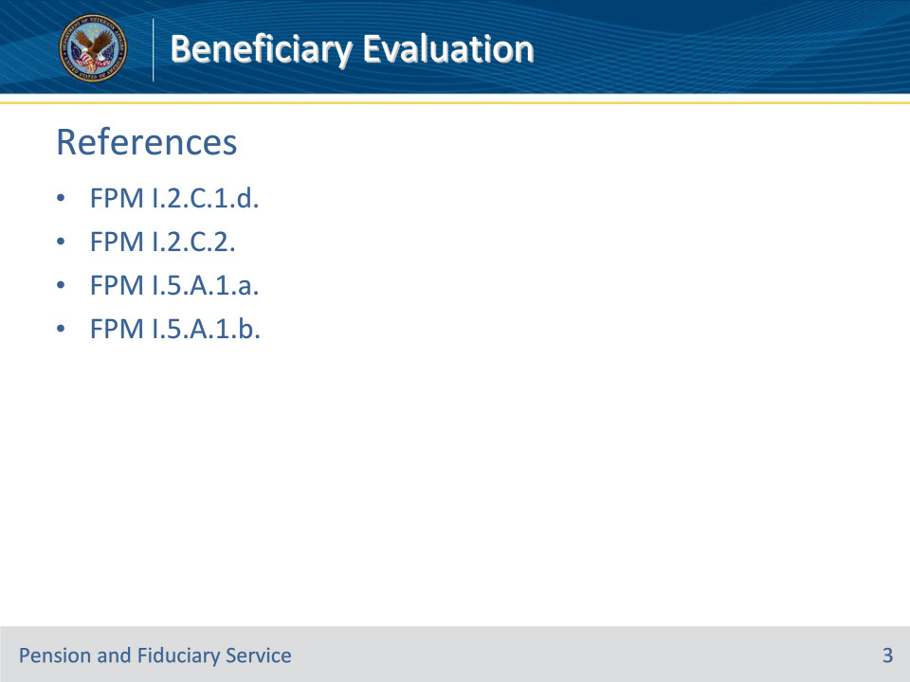

**Slide notes**

Instructor Notes:

These are the relevant references pertaining to this course:

• FPM I.2.C.1.d. Contact With Child Dependents and Minor Beneficiaries

• FPM I.2.C.2. Beneficiary Well-Being

• FPM I.5.A.1.a. General Information on Evaluating a Beneficiary’s Ability to Manage Their VA Funds

• FPM I.5.A.1.b. Evaluating and Documenting the Beneficiary’s Capacity to Manage Funds

**Slide 4 - Beneficiary Well-Being**

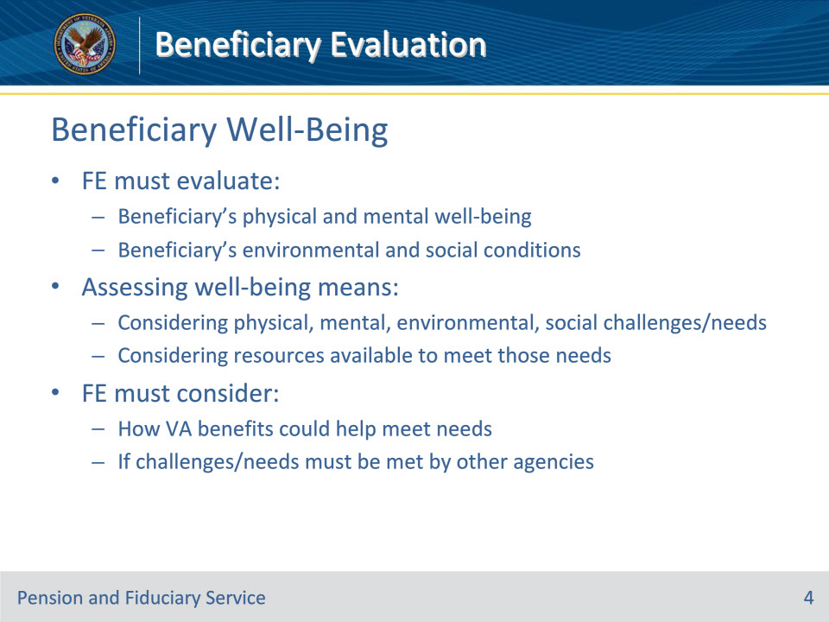

**Slide notes**

Policy Reference(s): FPM I.2.C.2.a.

Instructor Notes:

The FE must, to the extent possible, evaluate the beneficiary’s

• physical and mental well-being, and

• environmental and social conditions

For VA purposes, assessing the beneficiary’s well-being means considering the beneficiary’s physical, mental, environmental and/or social challenges/needs and, the resources the beneficiary has available to meet those needs, even if the beneficiary chooses not to employ available resources.

While assessing the beneficiary’s well-being, the FE must consider

• how VA benefits could help meet the needs of the beneficiary, and

• if the beneficiary’s physical, mental, environmental and/or social challenges/needs must be addressed by other State or Federal agencies.

**Slide 5 - Adult Well-Being**

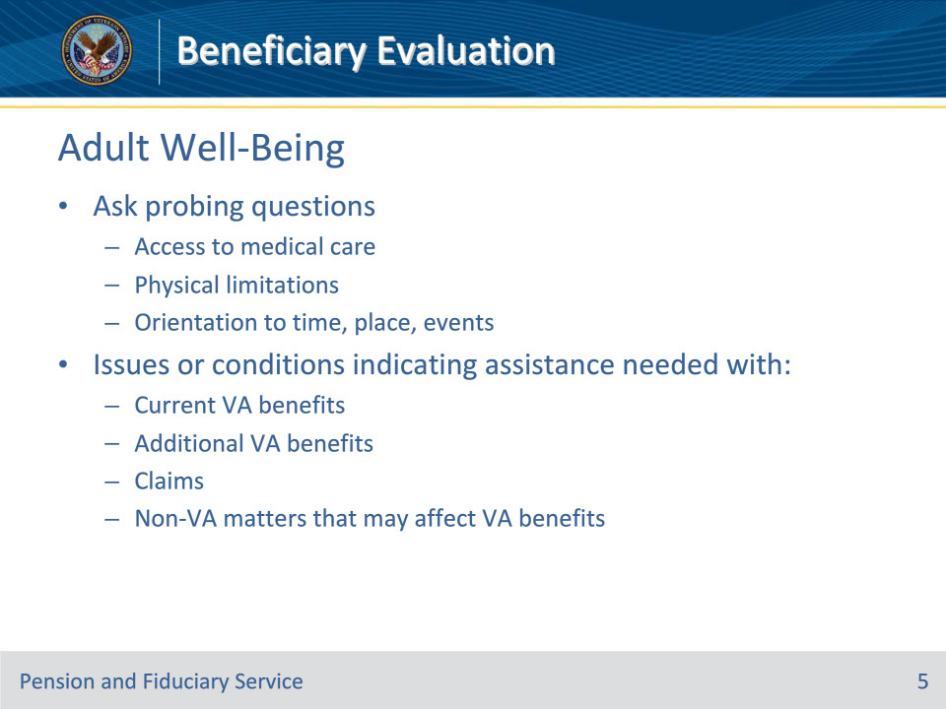

**Slide notes**

Policy Reference(s): FPM I.2.C.2.b.

Instructor Notes:

The FE must evaluate the beneficiary’s physical and mental well-being during the field examination.

For adult beneficiaries, the FE must ask probing questions about the beneficiary’s

• access to medical care

• physical limitations, including what condition or circumstance impact the ability to manage their funds, and

• apparent orientation to time, place, and events.

The FE should look for issues or conditions that indicate the beneficiary requires assistance with issues affecting current or additional VA benefits, claims, and non-VA matters that may affect or conflict with VA benefits.

**Slide 6 - Minor Well-Being**

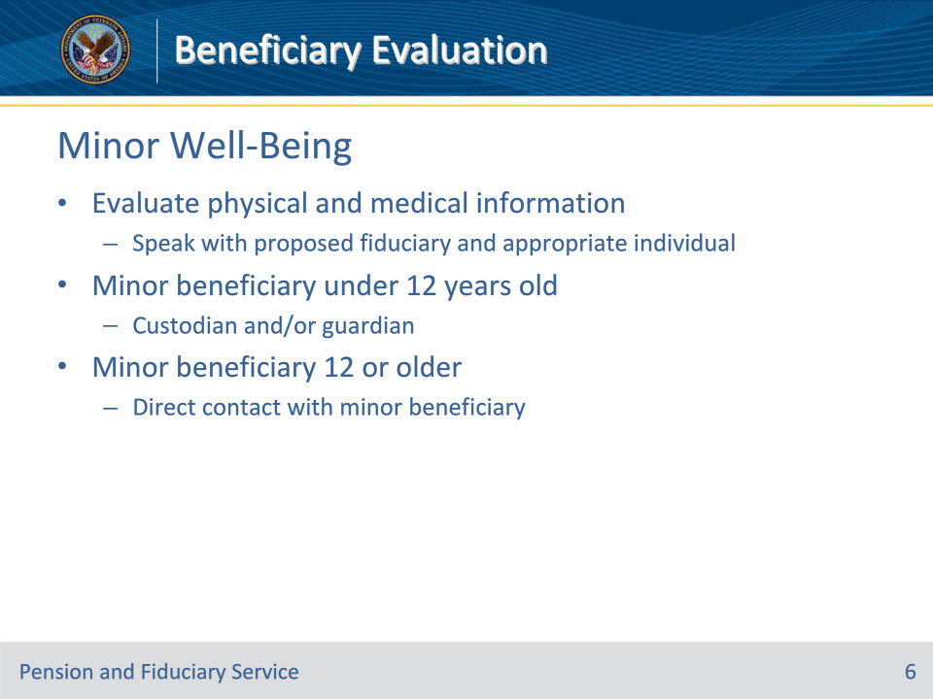

**Slide notes**

Policy Reference(s): FPM I.2.C.2.b.; FPM I.2.C.1.d.

Instructor Notes:

For minor beneficiaries, the FE must evaluate the following physical and medical information by speaking with the proposed fiduciary and the appropriate individual based on the minor beneficiary’s age.

If the minor beneficiary is under 12 years old, contact the custodian and/or guardian of the minor beneficiary.

If the minor beneficiary is age 12 or older, contact the minor beneficiary directly.

**Slide 7 - Minor Well-Being**

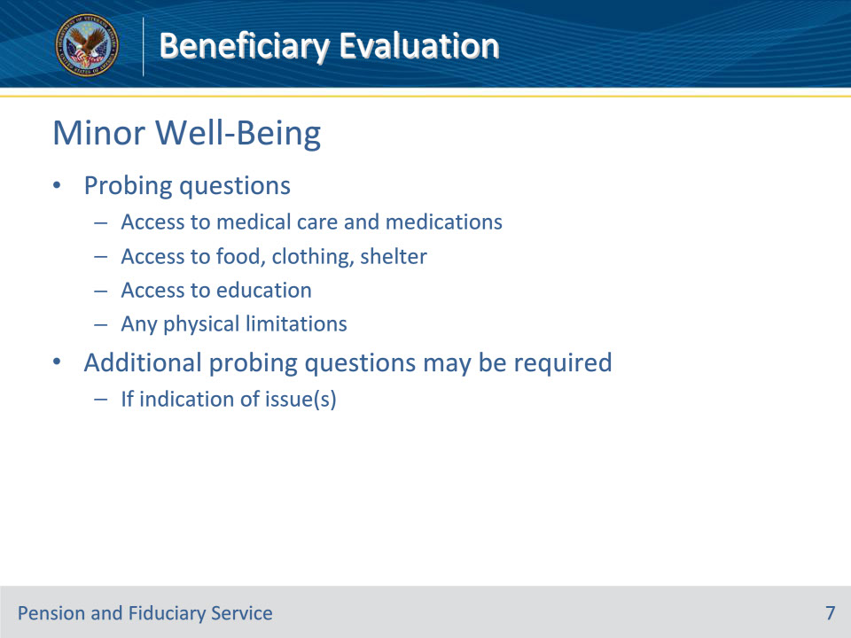

**Slide notes**

Policy Reference(s): FPM I.2.C.2.b.

Instructor Notes:

The FE must ask probing questions about the beneficiary’s

• access to

• medical care and medications, if needed

• food, clothing and shelter, and

• education, and

• any physical limitations.

Additional probing questions may be required if there is an indication of an issue reported by the beneficiary.

**Slide 8 - Adult Environment & Social Conditions**

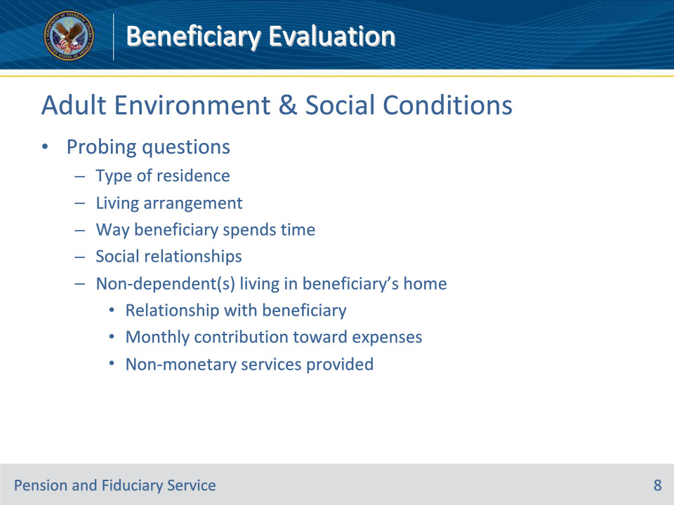

**Slide notes**

Policy Reference(s): FPM I.2.C.2.c.

Instructor Notes:

The FE must evaluate the beneficiary’s social and physical environment during the field examination.

For adult beneficiaries, the FE must ask probing questions about the

• type of place where the beneficiary resides

• living arrangement

• way the beneficiary spends their time

• beneficiary’s social relationships, and

• non-dependent(s) living in the beneficiary’s home including

• the relationship with the beneficiary, and

• any monthly contribution toward expenses, or non-monetary services provided, if non-dependent.

**Slide 9 - Minor Environment & Social Conditions**

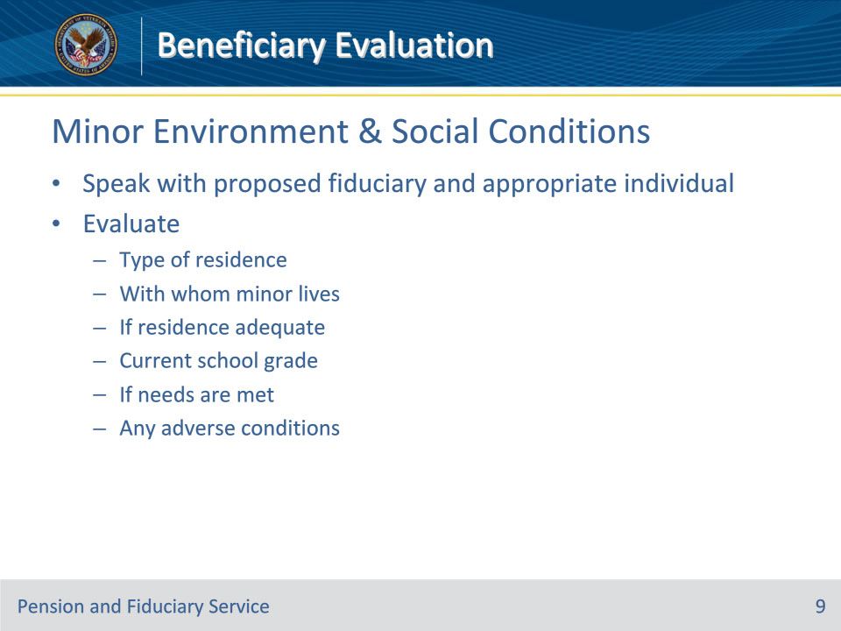

**Slide notes**

Policy Reference(s): FPM I.2.C.2.c.; FPM I.2.C.1.d.

Instructor Notes:

For minor beneficiaries, the FE must evaluate the following by speaking with both the proposed fiduciary and the appropriate individual based on the minor beneficiary’s age.

• the type of place where the minor beneficiary resides

• with whom the minor beneficiary lives

• if the residence is adequate

• current school grade

• if the minor beneficiary’s needs are met, and

• any adverse conditions.

**Slide 10 - Minor Environment & Social Conditions**

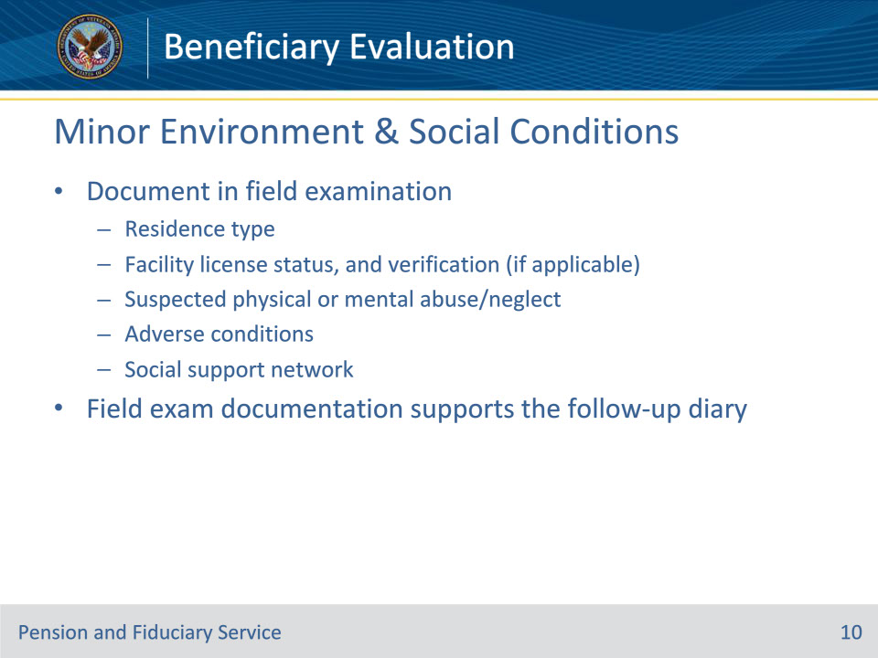

**Slide notes**

Policy Reference(s): FPM I.2.C.2.c.

Instructor Notes:

The FE must document the following information regarding the beneficiary’s environmental and social conditions within the field examination:

• beneficiary’s residence type

• if required, facility license

• status, and

• verification

• any suspected physical or mental abuse/neglect in the residence, and to whom the abuse/neglect was referred, if applicable

• whether there are any adverse conditions, to include the specific adverse conditions, when applicable, and

• if the beneficiary has a social support network.

The environmental and social conditions documented in the field examination will support the follow-up examination diary.

**Slide 11 - Dependents and Their Needs**

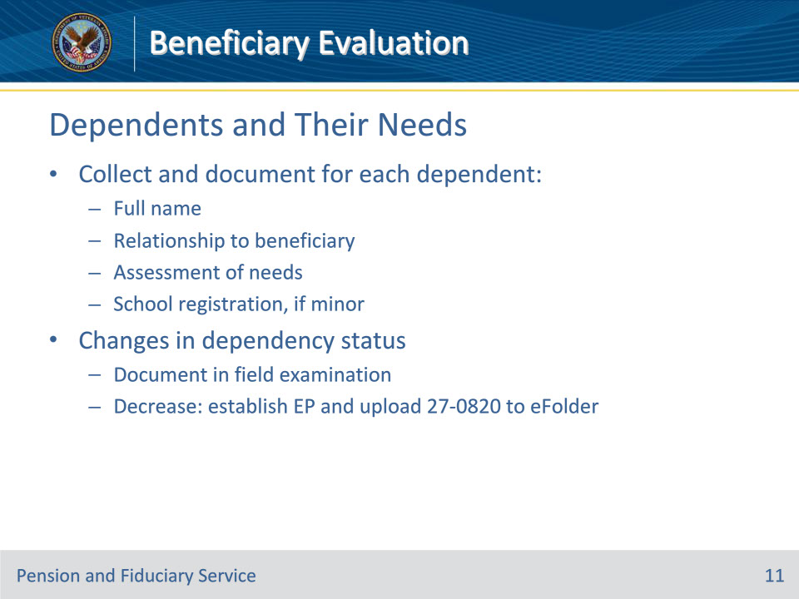

**Slide notes**

Policy Reference(s): FPM I.2.C.2.d.

Instructor Notes:

During the field examination, the FE must collect and document the following information for each dependent of an adult beneficiary:

• full name of dependent

• relationship to the beneficiary

• assessment of needs, and

• school registration if the beneficiary is a minor child.

If the fiduciary is also a dependent, the fiduciary’s information as a dependent must also be documented.

The FE must fully document any changes to dependency status in the field examination.  If the changes may result in a decrease in benefits, the FE must request establishment of the necessary end product (EP) and upload a VA Form 27-0820 documenting the change into the electronic claims folder (eFolder) for regional office review.

**Slide 12 - Adverse Conditions**

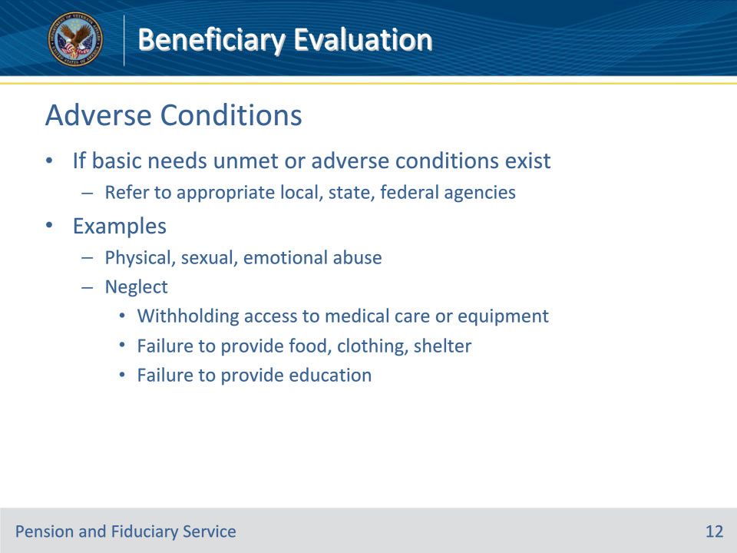

**Slide notes**

Policy Reference(s): FPM I.2.C.2.e.

Instructor Notes:

The FE must critically review the answers to the questions asked while assessing the beneficiary’s physical and mental well-being, and environmental and social conditions.  If the interview reveals basic needs are being unmet or adverse conditions exist, the FE must refer the case to the appropriate local, State, or Federal agencies.

Examples of potential findings include report of

• abuse such as physical, sexual, or emotional, and

• neglect such as

• withholding access of medical care or equipment, or

• failure to provide

• necessary food, clothing, and/or shelter, or

• education (e.g., the child is not enrolled in school).

**Slide 13 - Adverse Conditions**

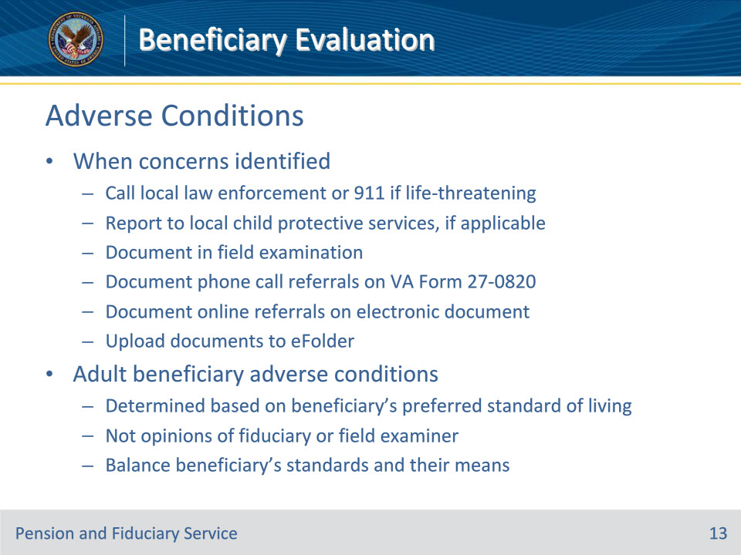

**Slide notes**

Policy Reference(s): FPM I.2.C.2.e.

Instructor Notes:

When concerns are identified during the interview with the proposed fiduciary or beneficiary, the FE must

• call the local law enforcement agency or 911 if the situation is a life-threatening emergency

• report the concern to local child protective services for investigation, if applicable

• document the unmet need or adverse condition in the field examination, and

• document phone call referrals on VA Form 27-0820, or create an electronic document that shows the online referral and upload the document to the eFolder.

For adult beneficiaries, adverse conditions must be determined based on the beneficiary’s preferred standard of living, not the opinions of the fiduciary or FE.  The FE must balance what the beneficiary is accustomed to and their means to decide if an adverse condition exists.

**Slide 14 - Institutionalized Minor**

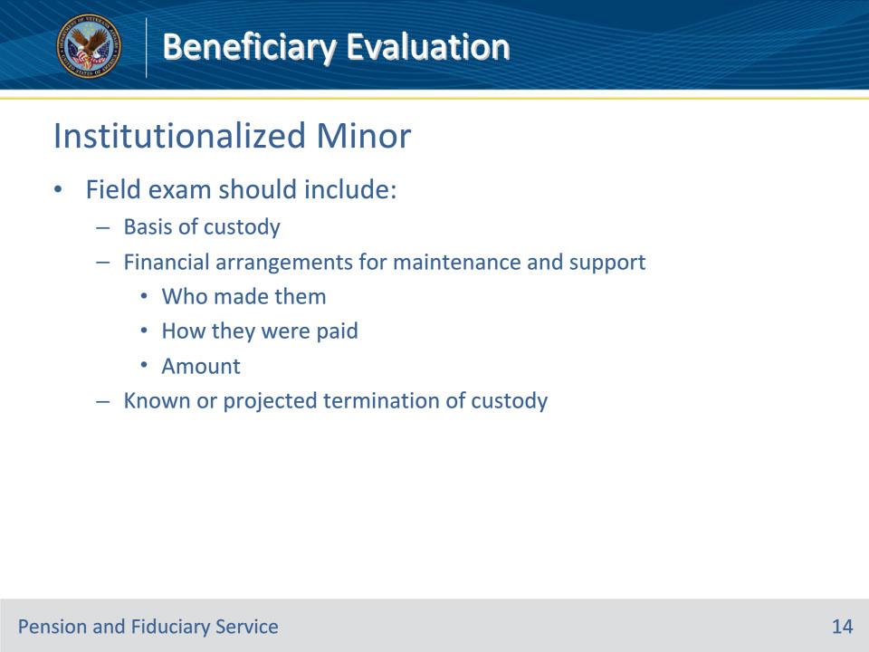

**Slide notes**

Policy Reference(s): FPM I.2.C.2.f.

Instructor Notes:

When the field examination discloses that the minor beneficiary is institutionalized, the field examination should include the following information:

• basis of custody

• financial arrangements for maintenance and support including

• who made them

• how they were paid, and

• the amount, and

• known or projected termination of custody.

**Slide 15 - Capacity to Manage Funds**

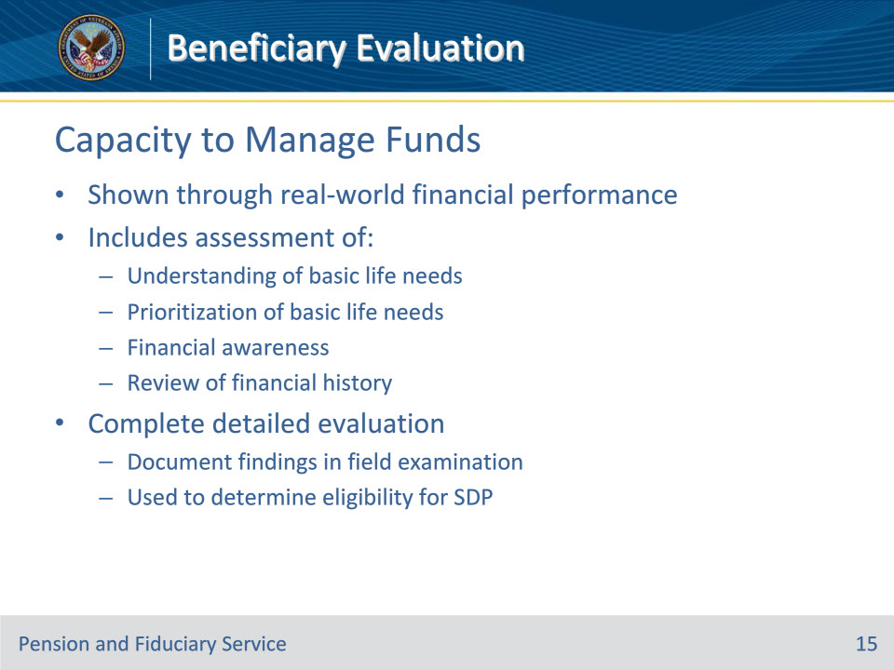

**Slide notes**

Policy Reference(s): FPM I.5.A.1.a.

Instructor Notes:

The FE must evaluate the adult beneficiary’s capacity to manage funds without VA supervision as is shown through the beneficiary’s real-world financial performance in meeting their basic needs.  This includes an assessment of the beneficiary’s understanding of basic life needs (i.e., food, shelter) and a prioritization for these needs, financial awareness, and a review of their financial history.  The FE must complete a detailed evaluation and document their findings in the field examination.

The FE’s evaluation is used to determine if the beneficiary who has been rated incompetent by VA may be eligible for supervised direct pay (SDP) temporarily.

**Slide 16 - Evaluating Capacity**

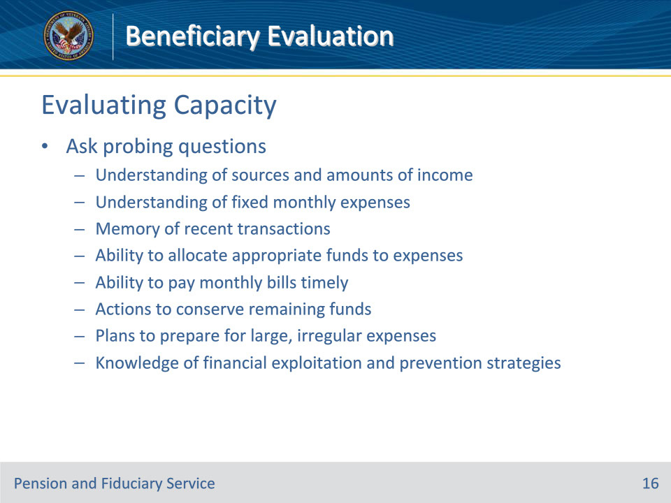

**Slide notes**

Policy Reference(s): FPM I.5.A.1.b.

Instructor Notes:

The FE must evaluate the beneficiary’s ability to independently manage funds in the best interest of the beneficiary and their dependents, if any, by asking probing questions about the beneficiary’s:

• understanding of the

• sources and amounts of their income, and

• fixed monthly expenses such as rent, mortgage, utilities, clothing, food, and medical bills

• memory of recent transactions and ability to allocate appropriate funds to fixed monthly expenses and discretionary items

• ability to pay monthly bills in a timely manner

• actions they currently take or would take to conserve funds remaining after the payment of expenses and plans to prepare for large, irregular purchases or unexpected expenses, and

• knowledge of financial exploitation and strategies to prevent being a victim.

**Slide 17 - Evaluating Capacity**

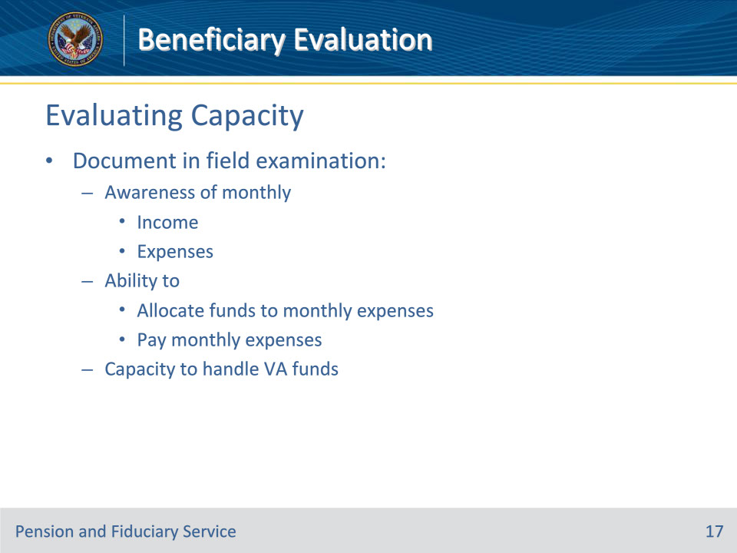

**Slide notes**

Policy Reference(s): FPM I.5.A.1.b.

Instructor Notes:

After completing the evaluation, document in the field examination the beneficiary’s

• awareness of monthly

• income, and

• expenses

• ability to

• allocate funds to monthly expenses, and

• pay monthly expenses, and

• capacity to handle VA funds.

**Slide 18 - Evaluating Capacity**

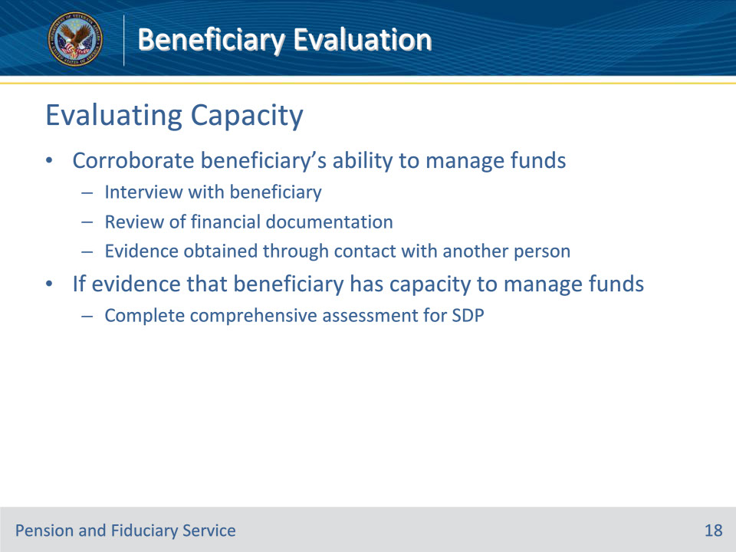

**Slide notes**

Policy Reference(s): FPM I.5.A.1.b.

Instructor Notes:

Additionally, the FE must corroborate the beneficiary’s ability to manage funds through their interview with the beneficiary and, to the extent possible, a review of

• financial documentation, and

• evidence obtained through contact in person, by telephone, or by letter with a person who has direct and regular contact with the beneficiary, such as the beneficiary’s friend, relative, or care provider when the beneficiary authorizes the FE to do so.

If there is evidence the beneficiary has the capacity to manage their funds and an SDP appointment is being considered, complete the required comprehensive assessment.

**Slide 19 - Evaluating Capacity**

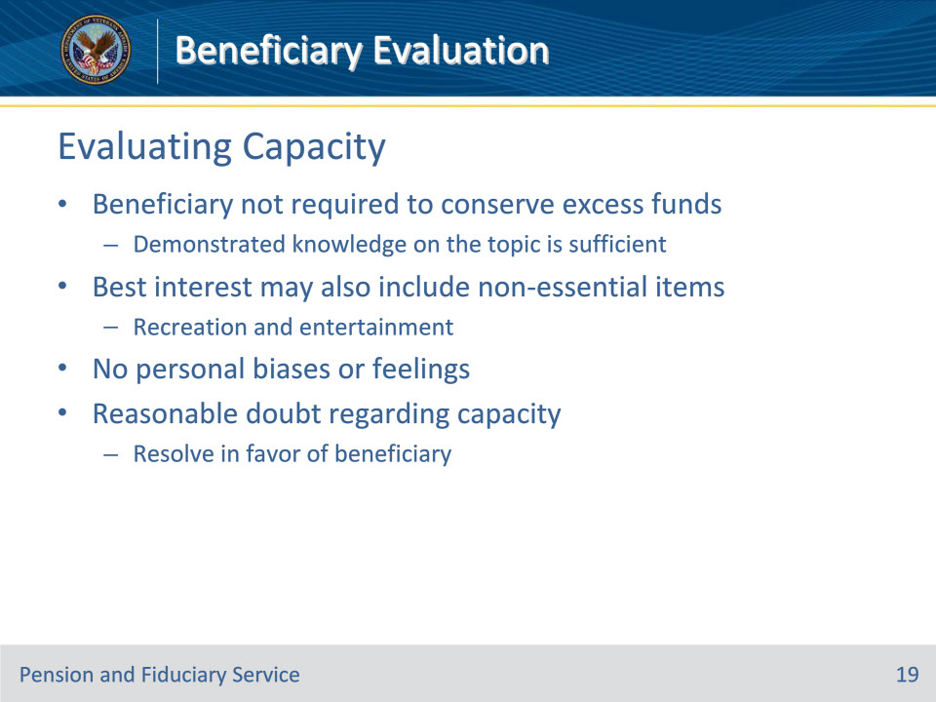

**Slide notes**

Policy Reference(s): FPM I.5.A.1.b.

Instructor Notes:

The beneficiary is not required to conserve excess funds.  If the beneficiary demonstrates knowledge in the ability to conserve excess funds, practical application of this action is not required.

A beneficiary’s best interest may also include the individual’s choice for non-essential items such as recreation and entertainment.  When assessing a capacity to manage funds, an allowance should be made for these discretionary purchases based on the beneficiary’s needs and/or wants while ensuring necessary expenses such as mortgage/rent, utilities, and food have first been prioritized.

Fiduciary hub (hub) personnel must not allow their personal biases or feelings to intrude in the course of assessing the abilities of a beneficiary.  Fairness and courtesy must be shown at all times.  When, after careful consideration of all procurable and assembled data, a reasonable doubt arises regarding the degree of capacity, such doubt will be resolved in favor of the beneficiary.

**Slide 20 - Questions?**

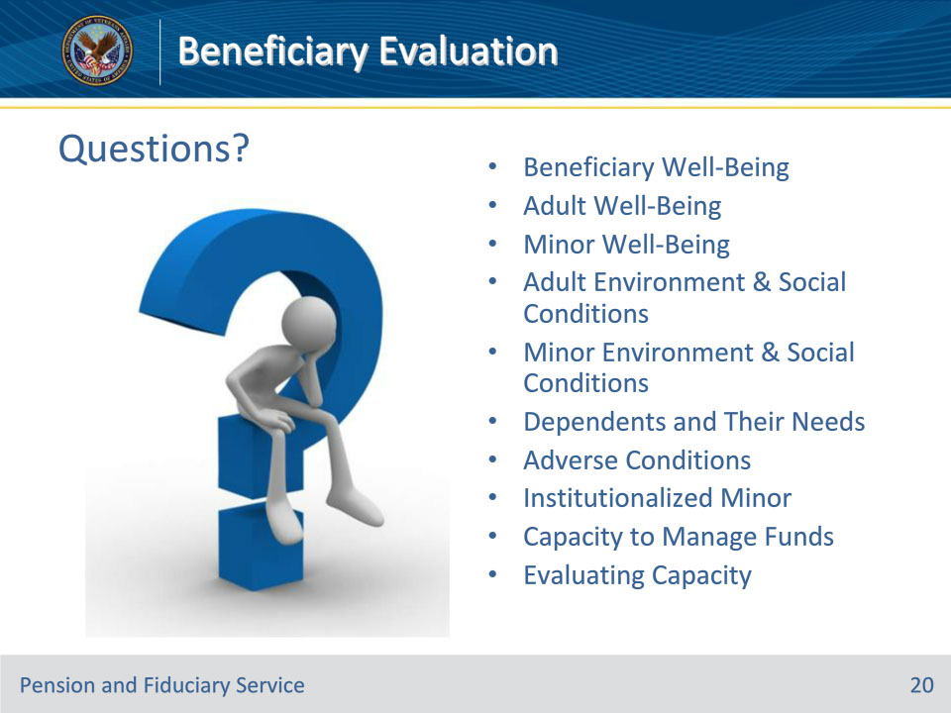

**Slide notes**

Instructor Notes:

(Recall) These are our learning objectives as stated from the beginning of the training:

• Identify the requirements to evaluate and document beneficiary’s:

• Well-being

• Environmental and social conditions

• Dependents and their needs

• Capacity to manage funds

(Recap) we discussed each of these learning objectives through the following topics in each slide today:

• Beneficiary Well-Being

• Adult Well-Being

• Minor Well-Being

• Adult Environment & Social Conditions

• Minor Environment & Social Conditions

• Dependents and Their Needs

• Adverse Conditions

• Institutionalized Minor

• Capacity to Manage Funds

• Evaluating Capacity

Are there any additional questions?

Questions should be filtered through your QRT team. They will submit your questions to the Field Inquiry Tool (FIT) on your behalf.

**Slide 21 - TMS Survey/Assessment**

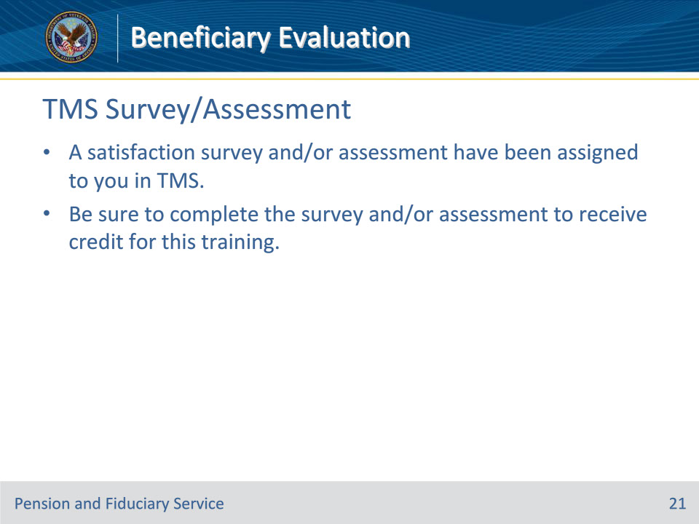

**Slide notes**

Instructor Notes

A satisfaction survey and/or assessment have been assigned to you in TMS.

Be sure to complete the survey and/or assessment to receive credit for this training.