Slide 1 - Accountings with Court Involvement
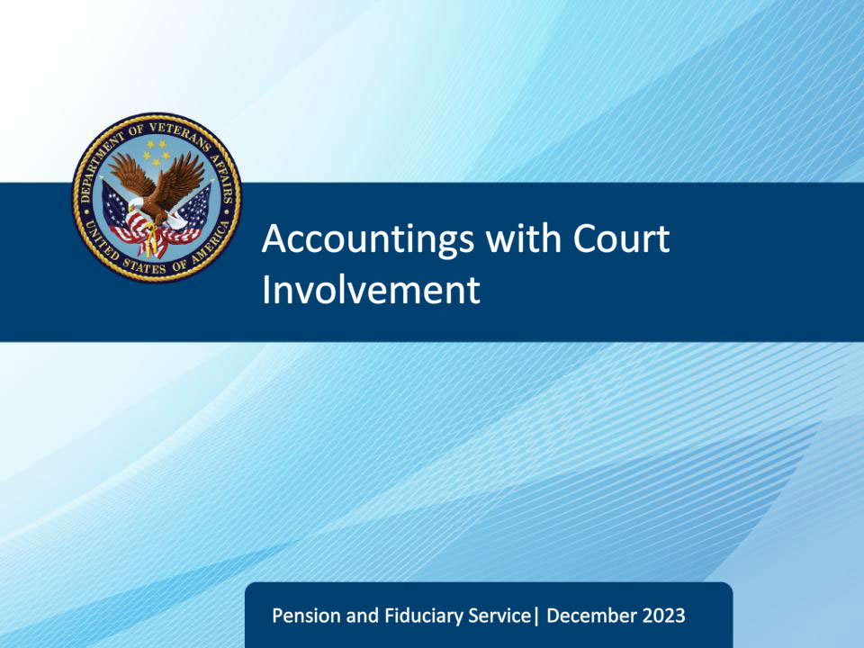
Slide notes

Course Description:

This course teaches fiduciary personnel unique aspects of conducting a VA Accounting with Court involvement.

Slide 2 - Objectives
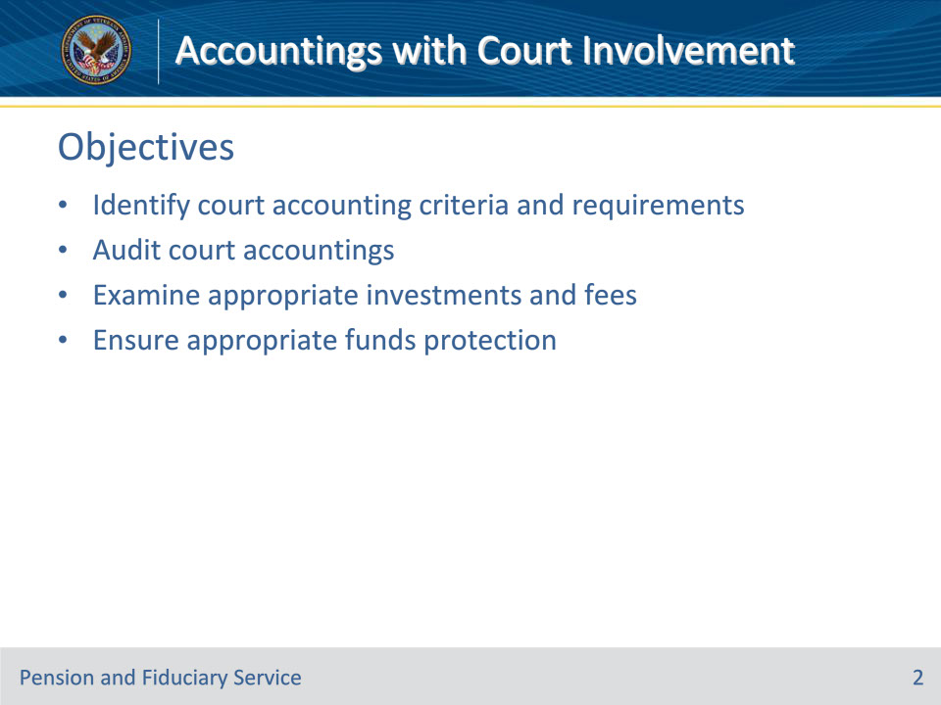
Slide notes

By the end of this course, given the training and corresponding references, learners will be able to do the following:

• Identify court accounting criteria and requirements

• Audit court accountings

• Examine appropriate investments and fees

• Ensure appropriate funds protection

Slide 3 - References
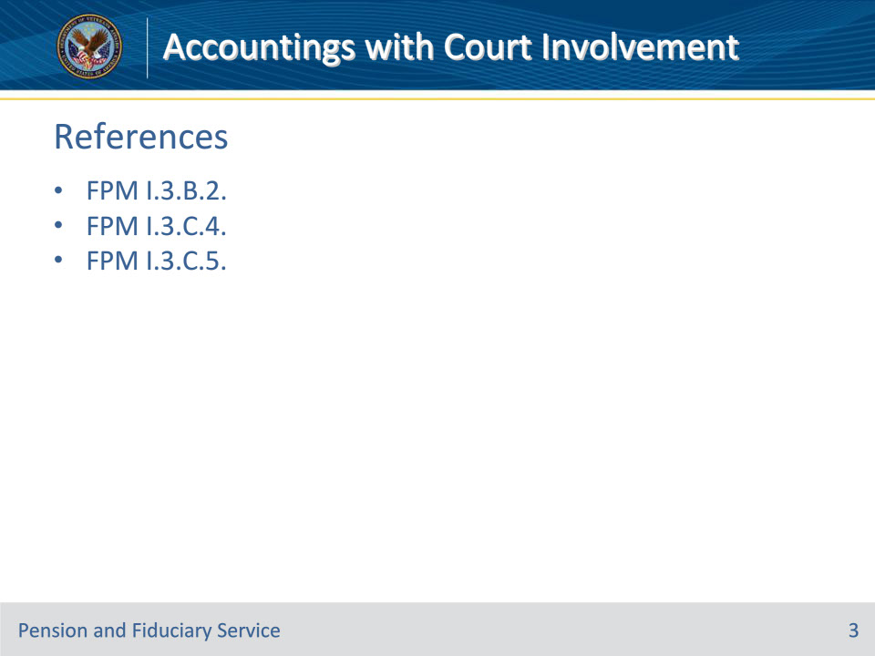
Slide notes

These are the references for today’s training:

• FPM I.3.B.2. Certified Copy of the Court Accounting

• FPM I.3.C.4. Examining VA-Appointed Fiduciary Fees

Slide 4 - Certified Copy of Court Accounting
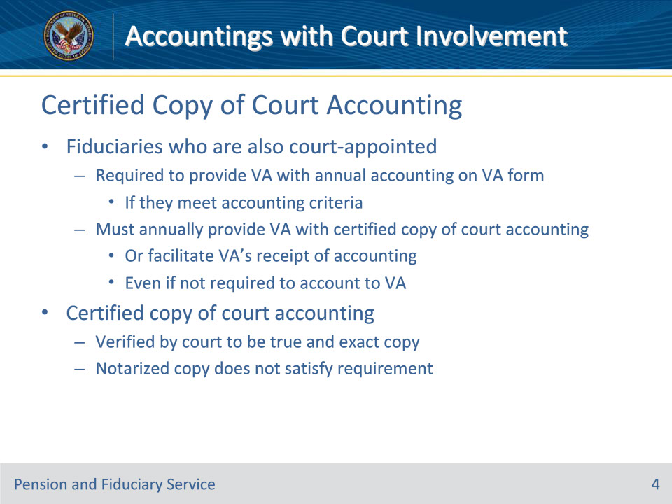
Slide notes

References: FPM I.3.B.2.a.

Instructor Notes:

Fiduciaries who are also court-appointed are required to provide VA with an annual accounting on the prescribed VA form, if they meet one of the accounting criteria.

A fiduciary who is also appointed by a court must annually provide to VA a certified copy of the court accounting or facilitate VA’s receipt of the accounting. Even if a VA-appointed fiduciary who is also court-appointed does not meet one of the accounting criteria, they are still required to provide VA with a certified copy of the court accounting.

A certified copy of the court accounting refers to the document(s) that have been verified by the court clerk to be a true and exact copy of the original accounting filed with the court. A notarized copy of the accounting does not satisfy the requirement of court certification.

Slide 5 - Certified Copy of Court Accounting
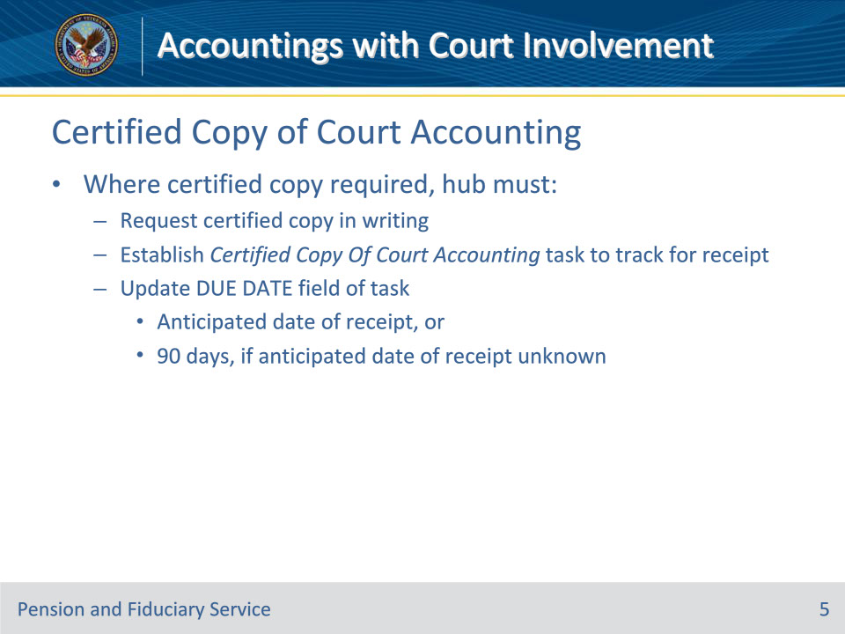
Slide notes

References: FPM I.3.B.2.b.

Instructor Notes:

Where a certified copy of the court accounting is required, the hub must

• request a certified copy of the court accounting in writing

• establish a Certified Copy Of Court Accounting task to track for the receipt of the certified court accounting, and

• update the DUE DATE field of the task based on the anticipated date of receipt, or for 90 days, if the anticipated date of receipt is unknown.

Slide 6 - Certified Copy of Court Accounting
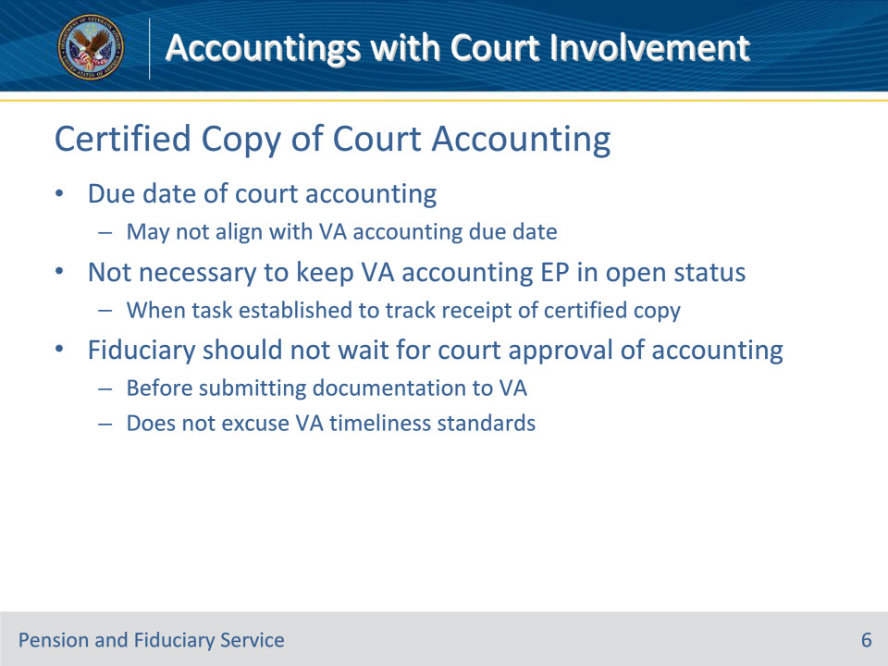
Slide notes

References: FPM I.3.B.2.b.

Instructor Notes:

• The due date of the court accounting may not align with the VA accounting due date.

• It is not necessary to maintain the VA accounting EP in open status when a task has been established to track for the receipt of the certified copy of the court accounting.

• A VA-appointed fiduciary who is also court-appointed should not wait until State court approval of an accounting before submitting documentation to VA, as this does not excuse VA timeliness standards.

Slide 7 - Non-Receipt
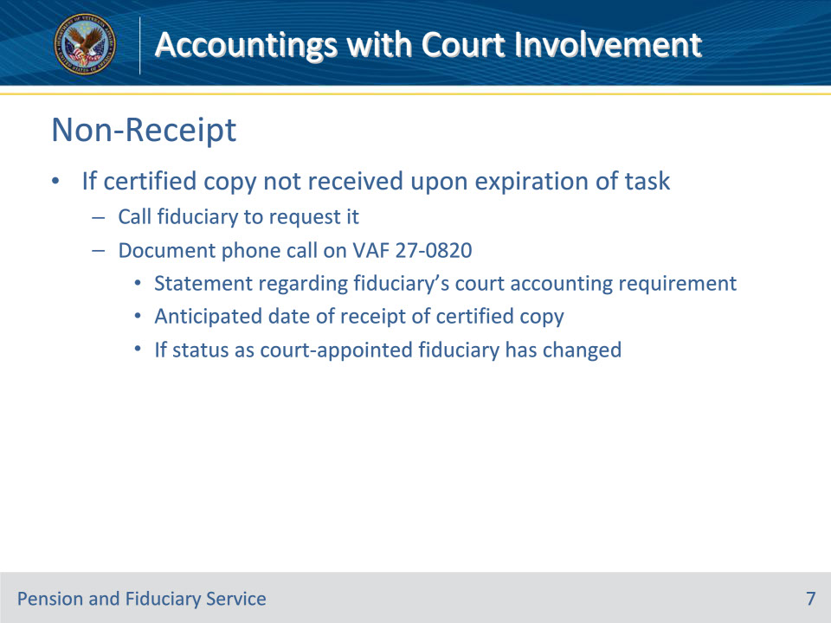
Slide notes

References: FPM I.3.B.2.b.

Instructor Notes:

If a copy of the certified court accounting has not been received upon expiration of the task, contact the fiduciary via the telephone to request it. Document the contact on a VA Form 27-0820 and include

• a statement regarding whether the fiduciary is required to account to the court

• the anticipated date of receipt of the certified court accounting, and

• if their status as a court-appointed fiduciary has changed.

Slide 8 - Non-Receipt
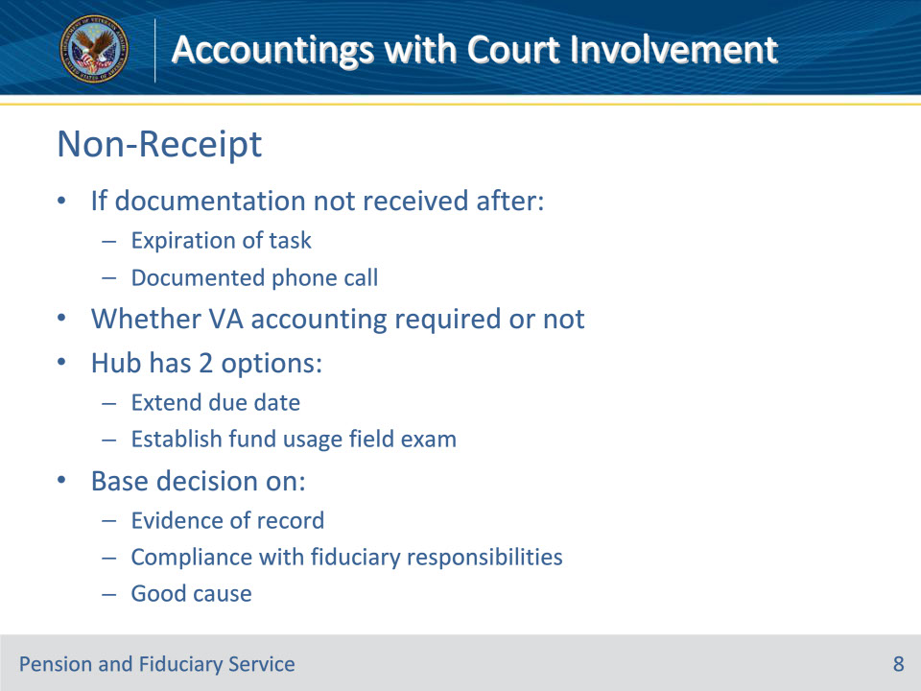
Slide notes

References: FPM I.3.B.2.b.

Instructor Notes:

Whether a VA accounting is required or not, if the requested documentation has not been received after the expiration of the task and the documented phone call, then the hub must decide, on a case-to-case basis, whether the due date should be extended or a funds usage examination should be established. This determination should be based on the evidence of record to include whether the fiduciary is complying with their fiduciary responsibilities and good cause has been provided.

Slide 9 - Reviewing Certified Copy
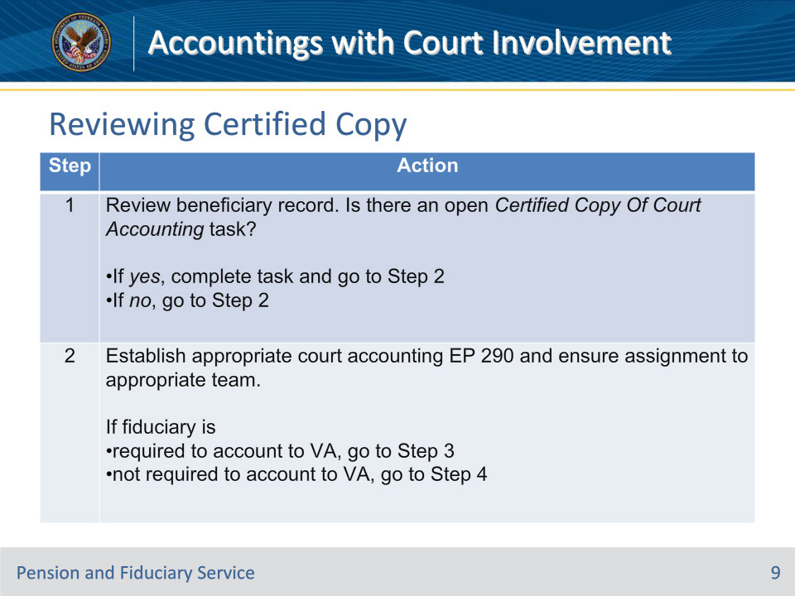
Slide notes

References: FPM I.3.B.2.c.

Instructor Notes:

Follow the steps in this table when VA receives a certified copy of the court accounting.

Slide 10 - Reviewing Certified Copy
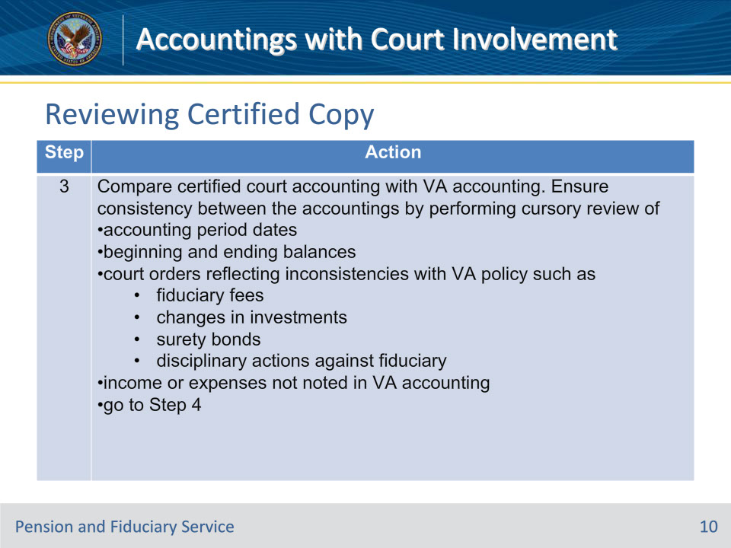
Slide notes

References: FPM I.3.B.2.c.

Instructor Notes:

Follow the steps in this table when VA receives a certified copy of the court accounting.

Slide 11 - Reviewing Certified Copy
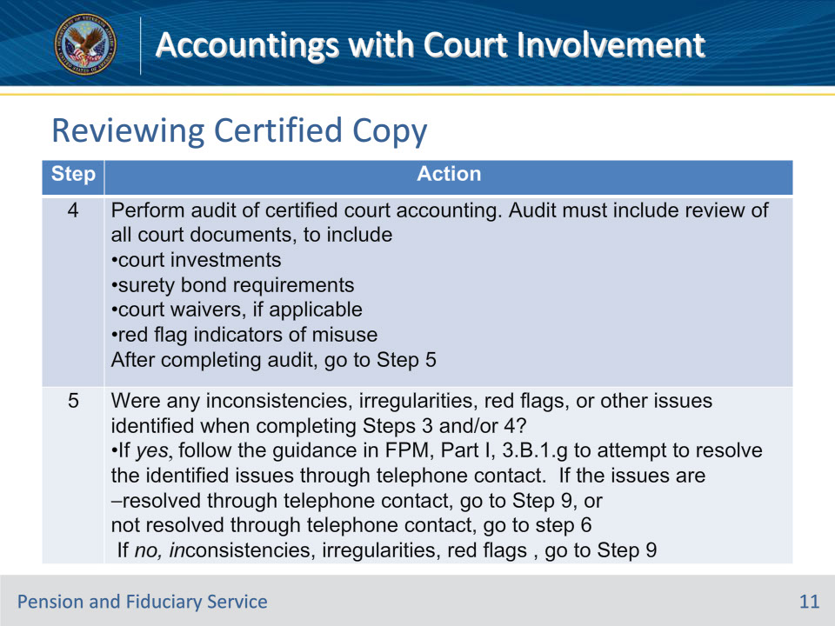
Slide notes

References: FPM I.3.B.2.c.

Instructor Notes:

Follow the steps in this table when VA receives a certified copy of the court accounting.

Note for Step 4: Completion of an Accounting Audit Tool is not required when auditing a certified copy of the court accounting.

Slide 12 - Reviewing Certified Copy
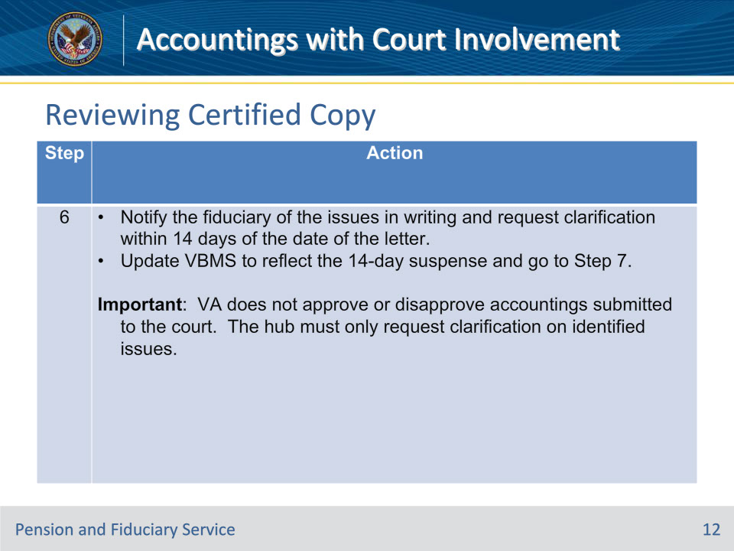
Slide notes

References: FPM I.3.B.2.c.

Instructor Notes:

Follow the steps in this table when VA receives a certified copy of the court accounting.

Important: VA does not approve or disapprove accountings submitted to the court. The hub must only request clarification on identified issues.

Slide 13 - Reviewing Certified Copy
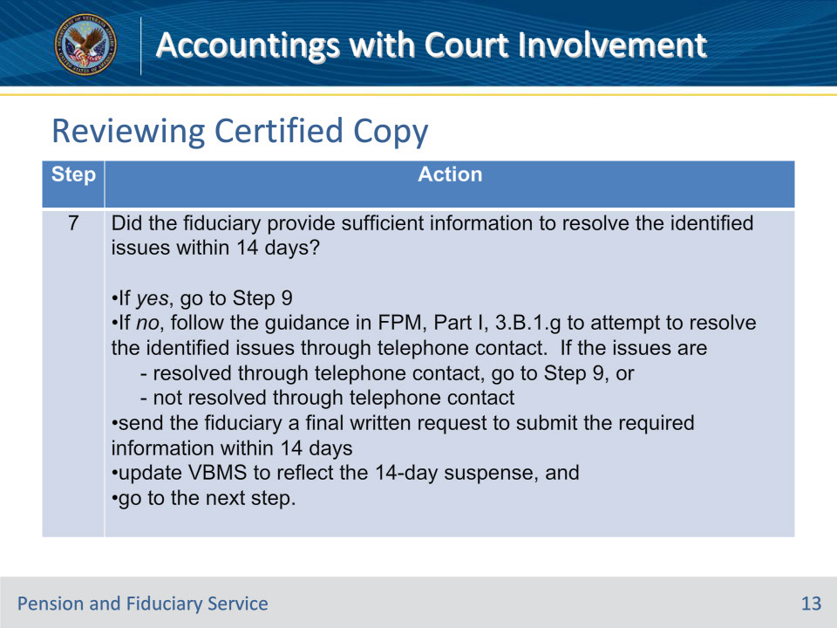
Slide notes

References: FPM I.3.B.2.c.

Instructor Notes:

Follow the steps in this table when VA receives a certified copy of the court accounting.

Slide 14 - Reviewing Certified Copy
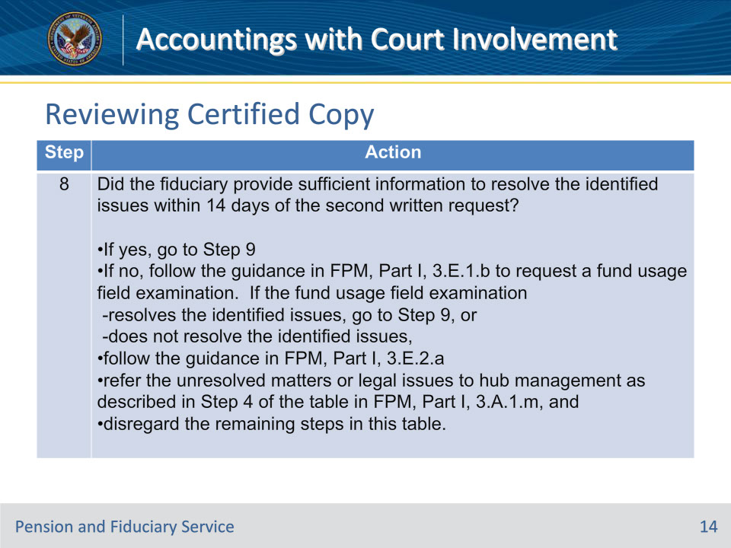
Slide notes

References: FPM I.3.B.2.c.

Instructor Notes:

Follow the steps in this table when VA receives a certified copy of the court accounting.

Important for Step 8: While VA does not approve or disapprove certified court accountings, the hub must use the disapproval functionality within VBMS to close the EP when issues identified within the court accounting cannot be resolved.

Slide 15 - Reviewing Certified Copy
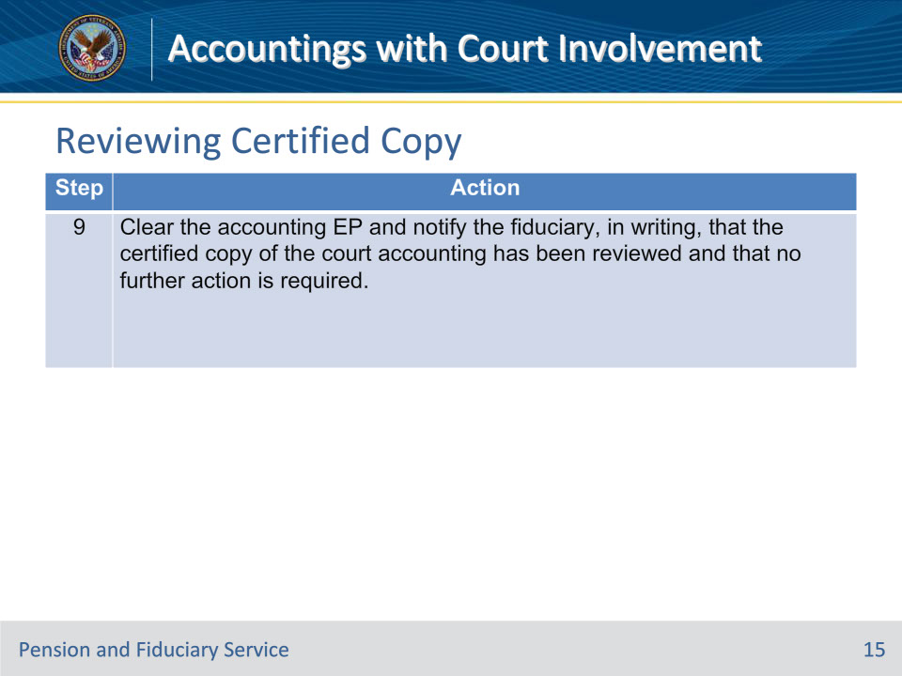
Slide notes

References: FPM I.3.B.2.c.

Instructor Notes:

Follow the steps in this table when VA receives a certified copy of the court accounting.

Important for Step 9:

• While VA does not approve or disapprove certified court accountings, the hub must use the approval functionality within VBMS to close the EP when the court accounting is accepted without the need for further clarification.

Slide 16 - Reviewing Certified Copy
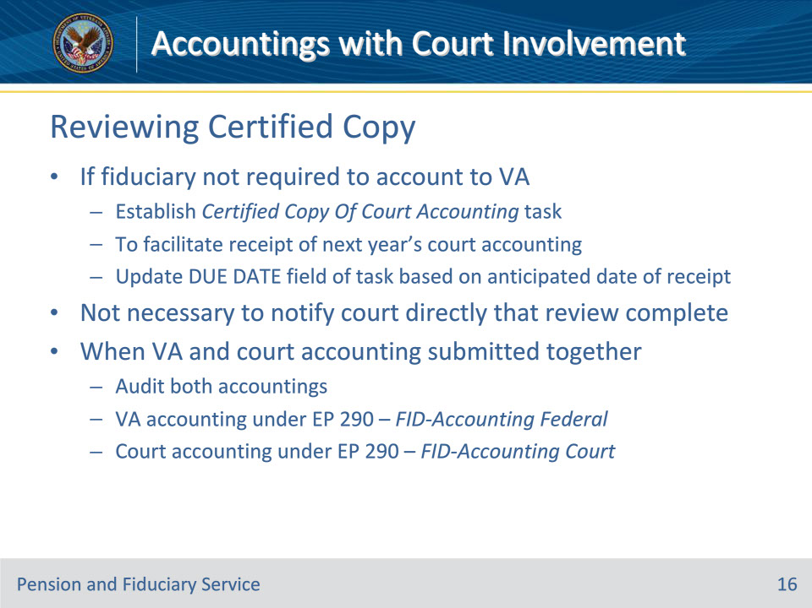
Slide notes

References: FPM I.3.B.2.c.

Instructor Notes:

• If the fiduciary is not required to account to VA, establish a Certified Copy Of Court Accounting task to facilitate receipt of the following year’s court accounting. Update the DUE DATE field of the task based on the anticipated date of receipt.

• It is not necessary for the hub to notify the court directly that the certified accounting review is complete, regardless of the outcome of the review.

When the fiduciary submits a VA accounting and a certified copy of the court accounting together, audit both accountings. Audit the

• VA accounting under EP 290 – FID-Accounting Federal, and

• certified copy of the court accounting under the EP 290 – FID-Accounting Court.

Slide 17 - Court Waivers
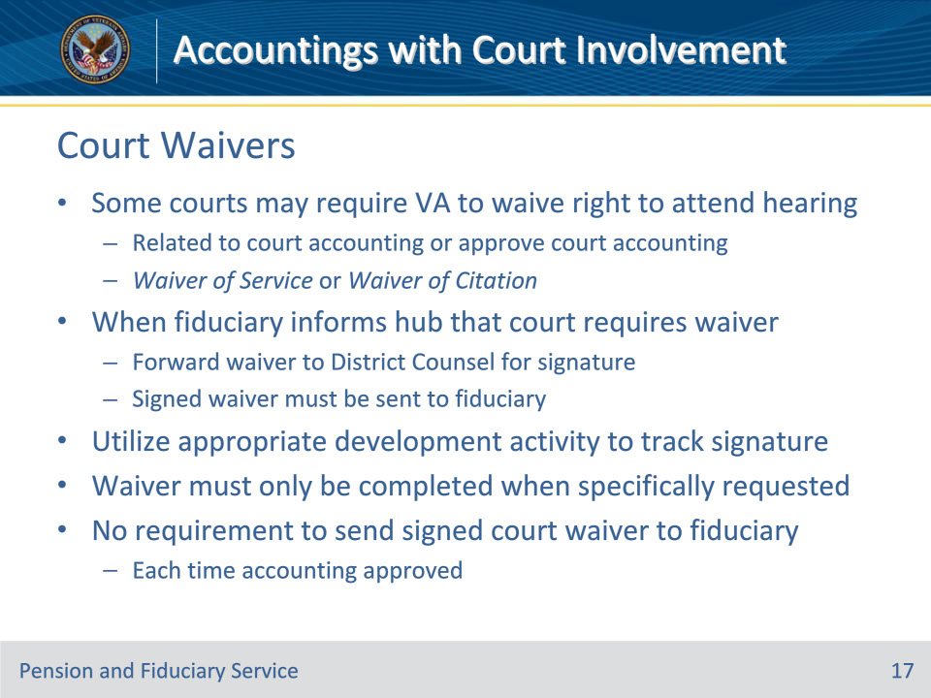
Slide notes

References: FPM I.3.B.2.d.

Instructor Notes:

Some State courts may require VA to waive the right to attend a hearing related to the court accounting or approve the court accounting. The waiver may be called a Waiver of Service or a Waiver of Citation.

When the fiduciary informs the hub that the court requires a waiver, the hub must forward the waiver to District Counsel for signature. The signed waiver must then be sent to the fiduciary.

Utilize the appropriate development activity to track the signature request.

The waiver must only be completed when specifically requested by the fiduciary. There is no requirement to send a signed court waiver to the fiduciary each time an accounting is approved and the fiduciary is also court-appointed.

Slide 18 - Court Authorized Fees
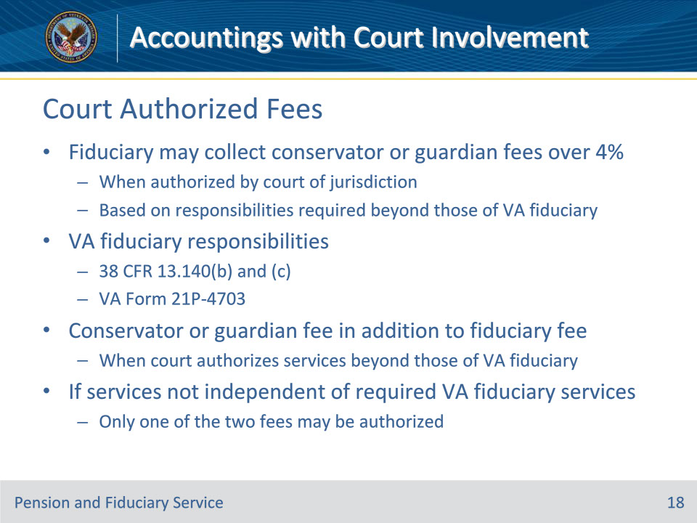
Slide notes

References: FPM I.3.C.4.b.

Instructor Notes:

A VA-appointed fiduciary may collect conservator or guardian fees exceeding 4 percent of the VA FUM when authorized by the court of jurisdiction, based on responsibilities required beyond those of a VA-appointed fiduciary.

For listings of the responsibilities a fiduciary must provide in the VA as part of the VA Fiduciary Program, see 38 CFR 13.140(b) and (c), or a VA Form 21P-4703, Fiduciary Agreement.

A conservator or guardian fee may be paid from VA FUM in addition to a VA authorized fiduciary fee when a court authorizes services beyond those of a VA-appointed fiduciary. If the services provided are not independent of required VA fiduciary services, only one of the two fees may be authorized.

Slide 19 - Court Authorized Fees
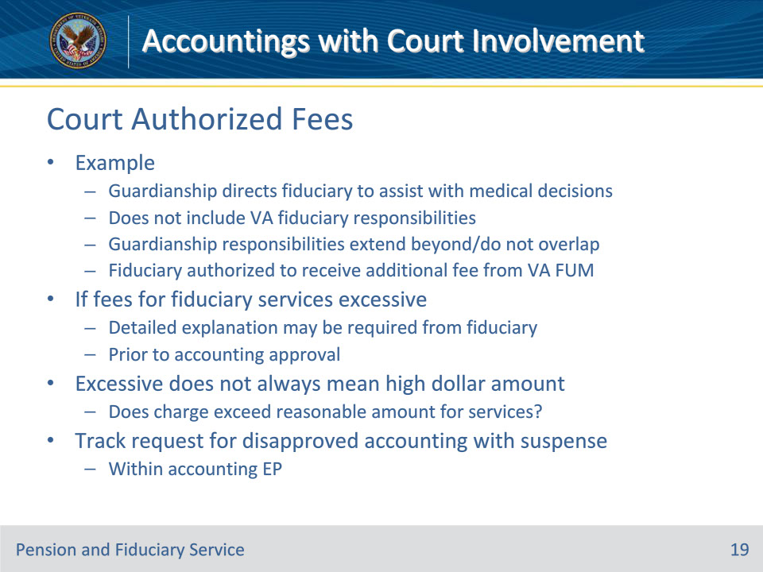
Slide notes

References: FPM I.3.C.4.b.

Instructor Notes:

Example: A VA-appointed fiduciary who collects a 4 percent fiduciary fee is also the court-appointed guardian of the beneficiary. The guardianship directs that the fiduciary assists the beneficiary in making medical decisions and end of life decisions on their behalf but does not include responsibilities a VA fiduciary must provide. Since the guardianship responsibilities extend beyond and do not overlap the responsibilities listed in 38 CFR 13.140(b) and (c), the fiduciary is authorized to receive an additional fee from VA FUM.

If the hub determines the fees for fiduciary services exceed the authorized amount or are excessive based on the service performed, a detailed explanation may be required from the fiduciary prior to accounting approval. Excessive does not always mean a high dollar amount, but rather does the charge exceed a reasonable amount for the services performed in an area of service.

The hub must track any request for a disapproved accounting with an appropriate suspense within the accounting EP.

Slide 20 - Fiduciary Responsibilities
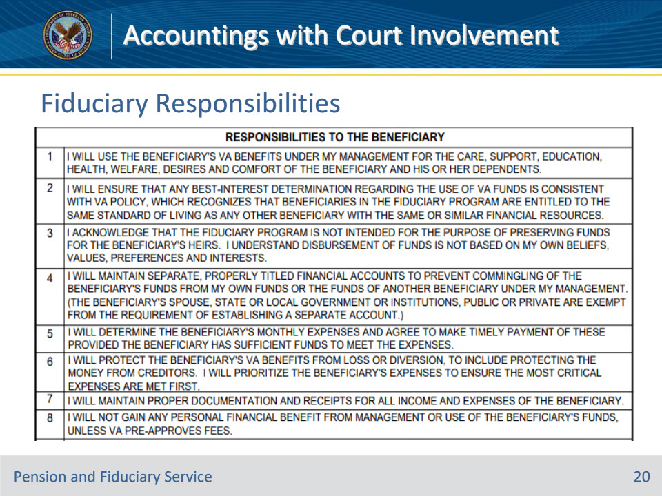
Slide notes

References: VA Form 21P-4703 (June 2021 version)

Instructor Notes:

These are the fiduciary responsibilities listed on the VA Form 21P-4703. A VA-appointed fiduciary must agree to fulfill these responsibilities and sign the VA Form 21P-4703.

Slide 21 - Fiduciary Responsibilities
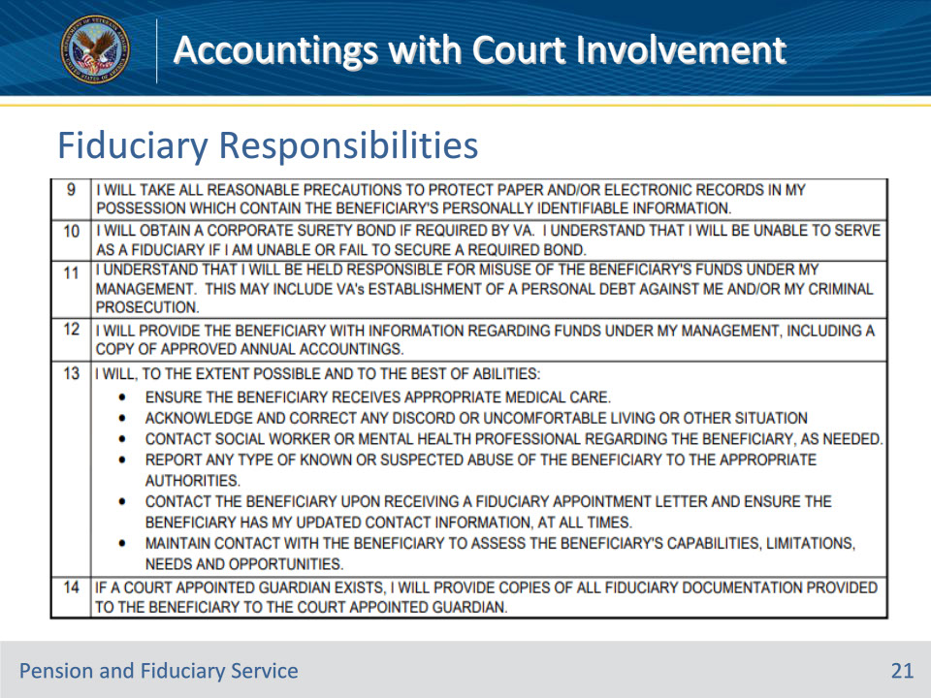
Slide notes

References: VA Form 21P-4703 (June 2021 version)

Instructor Notes:

These are the fiduciary responsibilities listed on the VA Form 21P-4703. A VA-appointed fiduciary must agree to fulfill these responsibilities and sign the VA Form 21P-4703.

Slide 22 - Fiduciary Responsibilities
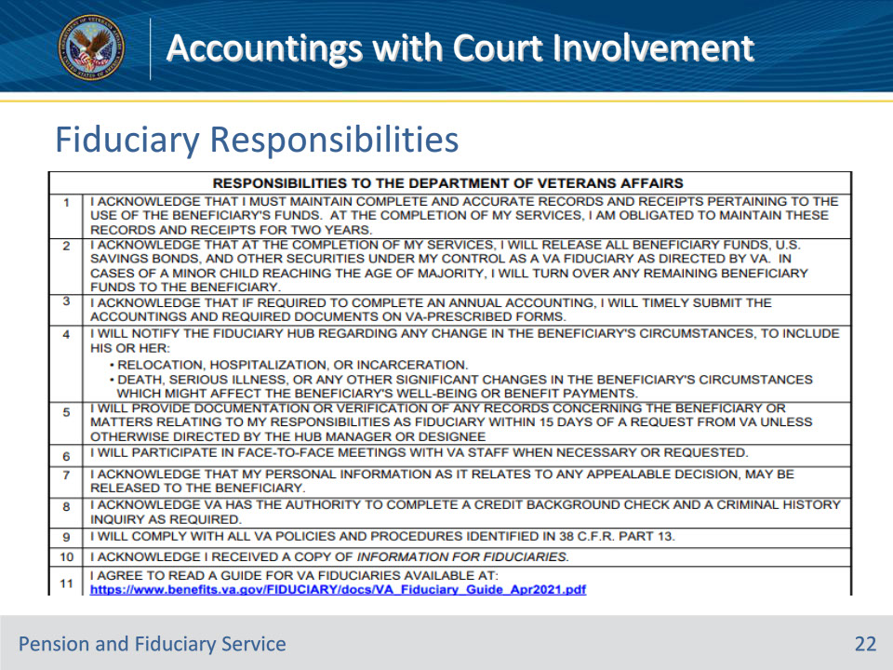
Slide notes

References: VA Form 21P-4703 (June 2021 version)

Instructor Notes:

These are the fiduciary responsibilities listed on the VA Form 21P-4703. A VA-appointed fiduciary must agree to fulfill these responsibilities and sign the VA Form 21P-4703.

Slide 23 - Fee Analysis
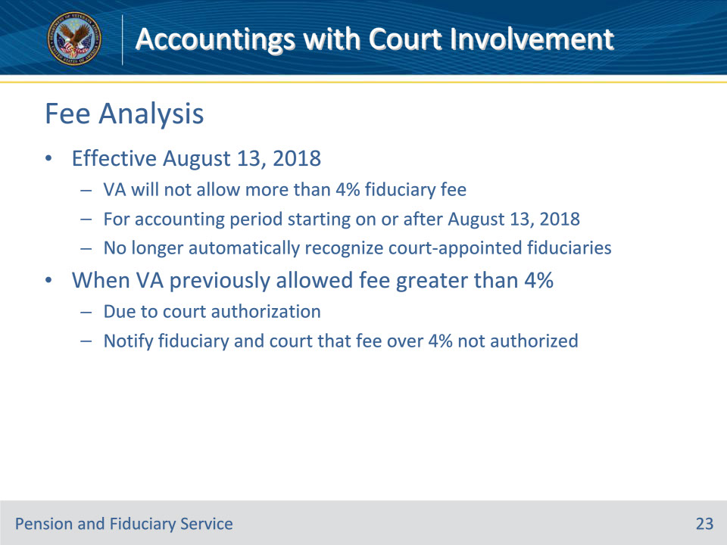
Slide notes

References: FPM I.3.C.4.c.

Instructor Notes:

Effective August 13, 2018, VA will not allow more than a 4 percent fiduciary fee to be taken from the beneficiary’s VA funds for an accounting period starting on or after August 13, 2018. For all cases in which VA previously allowed a fee greater than 4 percent due to a court authorization, VA must notify the fiduciary and the court of jurisdiction that a fee more than 4 percent of the VA benefits is not authorized.

Notes:

• When guardianship or conservatorship responsibilities extend beyond the responsibilities of a VA-appointed fiduciary, they may be authorized to receive a fee in excess of the 4-percent fee outlined in the table below.

• Effective August 13, 2018, VA no longer automatically recognizes court-appointed fiduciaries as a VA fiduciary.

Slide 24 - Fee Analysis
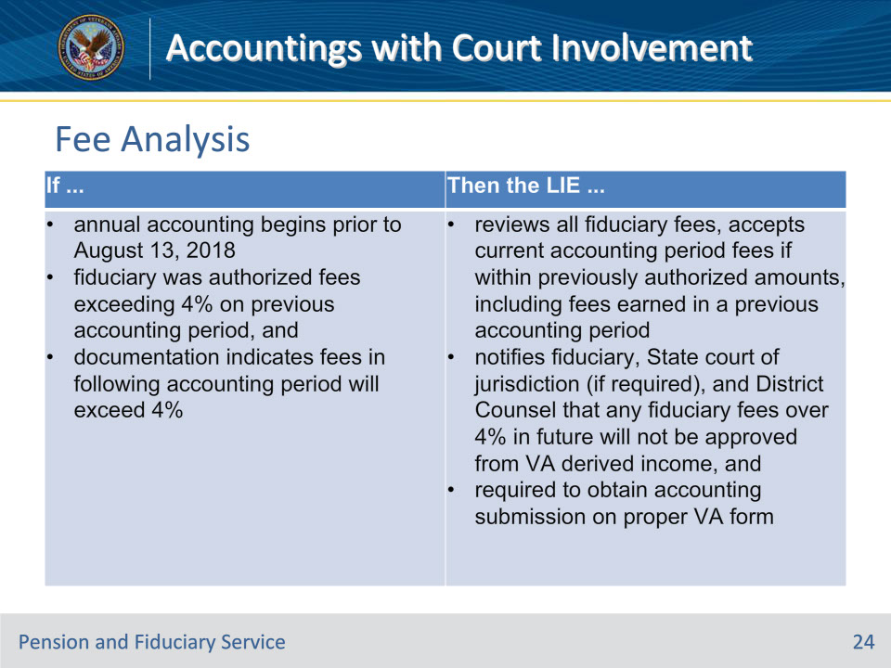
Slide notes

References: FPM I.3.C.4.c.

Instructor Notes:

Use this table to determine the actions to take for fiduciary fees earned prior to and after the effective date of August 13, 2018.

Slide 25 - Fee Analysis
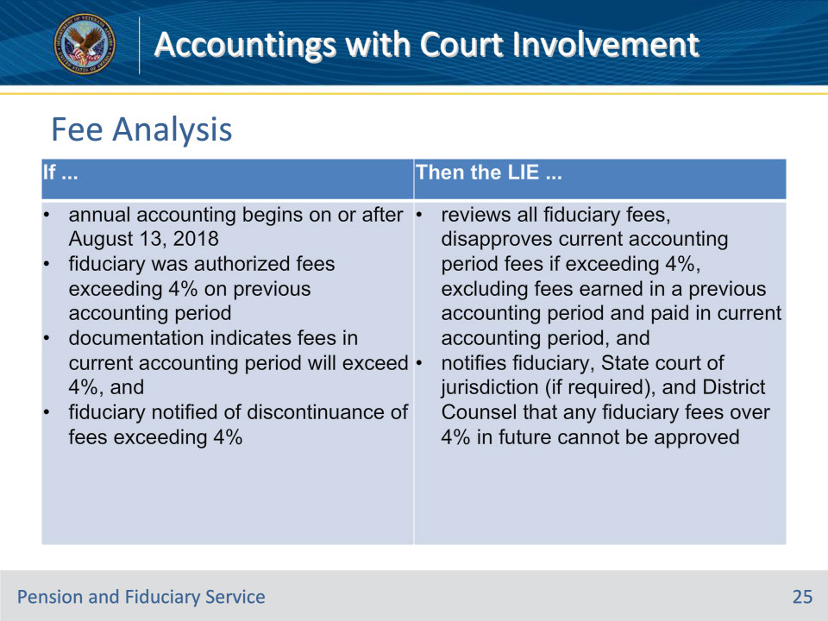
Slide notes

References: FPM I.3.C.4.c.

Instructor Notes:

Use this table to determine the actions to take for fiduciary fees earned prior to and after the effective date of August 13, 2018.

Slide 26 - Attorney Fees
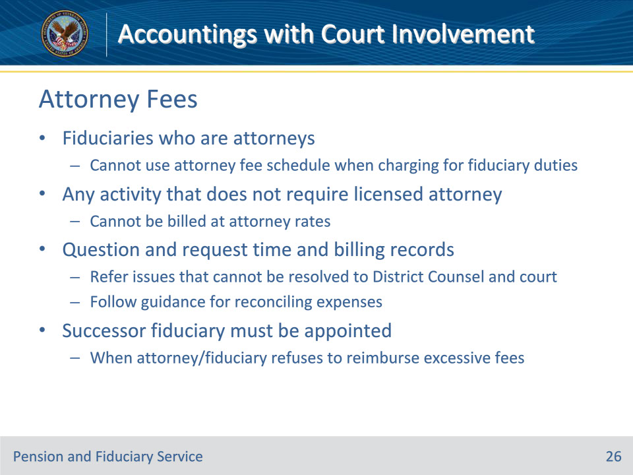
Slide notes

References: FPM I.3.C.4.d.

Instructor Notes:

VA-appointed fiduciaries who are attorneys and who may serve in a dual capacity cannot use their attorney fee schedule when charging for duties performed as a fiduciary, such as paying the monthly bills of the beneficiary. Any activity that does not require a licensed attorney cannot be billed at attorney rates.

The LIE must question and request time and billing records for such charges and refer issues that cannot be resolved to the District Counsel and the court of jurisdiction. Hubs must follow the guidance for reconciling expenses.

A successor fiduciary must be appointed in all cases in which an attorney serving as a VA-appointed fiduciary charges a fiduciary fee to the beneficiary from VA benefits and refuses to reimburse the amount charged in excess of the VA or court ordered authorized percentage or amount.

Slide 27 - Attorney Fees
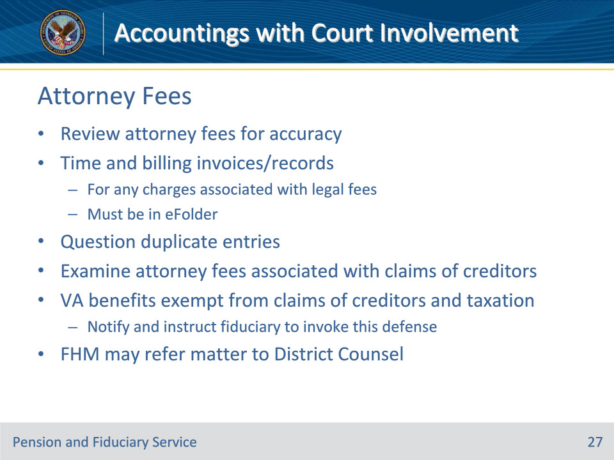
Slide notes

References: FPM I.3.C.4.e.

Instructor Notes:

The LIE must review attorney fees for accuracy. Time and billing invoices/records for any charges associated with legal fees must be in the eFolder. Hubs must question duplicate entries for the same service annotated on time and billing records.

Examine attorney fees associated with claims of creditors for accuracy and validity. VA benefit payments are exempt, both before and after receipt by the beneficiary, from the claims of creditors and taxation. The LIE must notify and instruct the fiduciary to invoke this defense in applicable circumstances. This does not preclude a just debt owed by the beneficiary, and a fiduciary or beneficiary cannot arbitrarily invoke this protection to avoid payment of a just debt. If the fiduciary does not do so, the FHM may refer the matter to District Counsel for evaluation and appropriate legal action.

Slide 28 - Attorney Fees
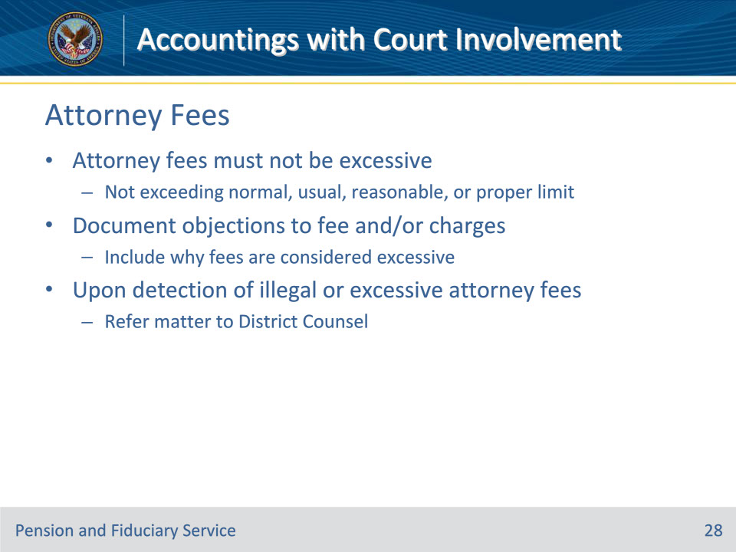
Slide notes

References: FPM I.3.C.4.e.

Instructor Notes:

Attorney fees must not be excessive, meaning not exceeding a normal, usual, reasonable, or proper limit. Excessive does not always equal a high dollar amount, but rather attorney fees not exceeding a reasonable limit for the services rendered. The hub must document objections to a fee and/or charges to include why the fees are considered excessive for the services performed.

Immediately upon detection of cases involving apparent illegal or excessive attorney fees, the FHM must refer the matter to District Counsel to take any action that may be appropriate to affect the reduction or recovery of the amount in question.

Slide 29 - Investments
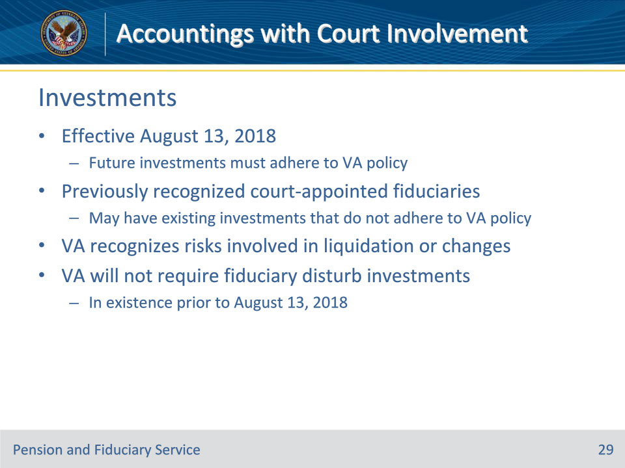
Slide notes

References: FPM I.3.C.5.a.

Instructor Notes:

Effective August 13, 2018, the effective date of new fiduciary regulations, all future investments must adhere to VA policy. Previously recognized court-appointed (VA recognized) fiduciaries may have existing investments that do not adhere to current VA policy. VA recognizes the risks that may be involved in any liquidation or changes and VA will not require the fiduciary to disturb investments in existence prior to August 13, 2018.

Slide 30 - Surety Bonds
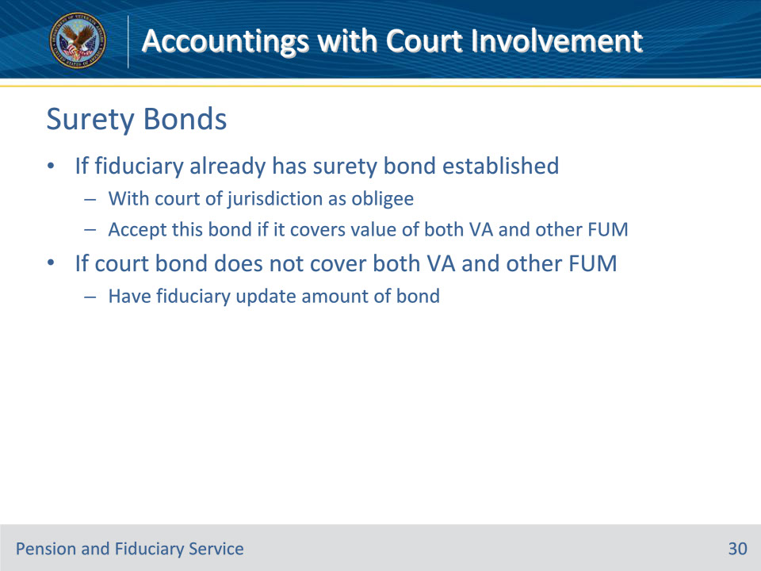
Slide notes

References: FPM I.3.C.5.c.

Instructor Notes:

If a VA-appointed fiduciary also serving as a court-appointed fiduciary already has a surety bond established with the court of jurisdiction as the obligee, accept this bond if it covers the value of both the VA and other FUM. If the value of the court ordered surety bond does not cover both the VA and other FUM, have the fiduciary update the amount of the existing surety bond.

Slide 31 - Questions?
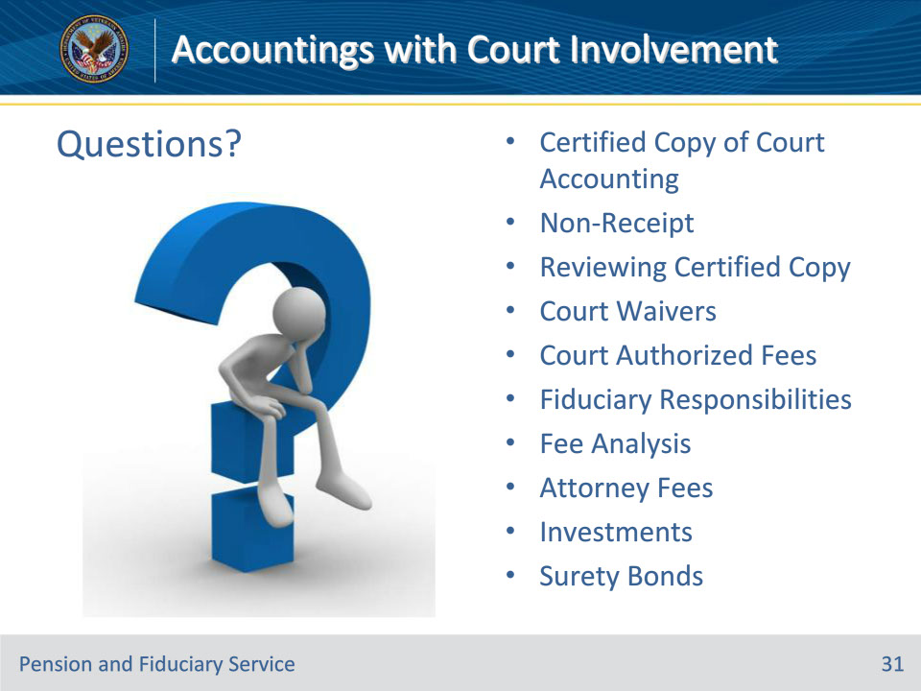
Slide notes

Instructor Notes:

(Recall) These are our learning objectives as stated from the beginning of the training:

• Identify court accounting criteria and requirements

• Audit court accountings

• Examine appropriate investments and fees

• Ensure appropriate funds protection

(Recap) We discussed each of these learning objectives through the topics on each of the slides:

• Certified Copy of Court Accounting

• Non-Receipt

• Reviewing Certified Copy

• Court Waivers

• Court Authorized Fees

• Fiduciary Responsibilities

• Fee Analysis

• Attorney Fees

• Investments

• Surety Bonds

Slide 32 - TMS Survey
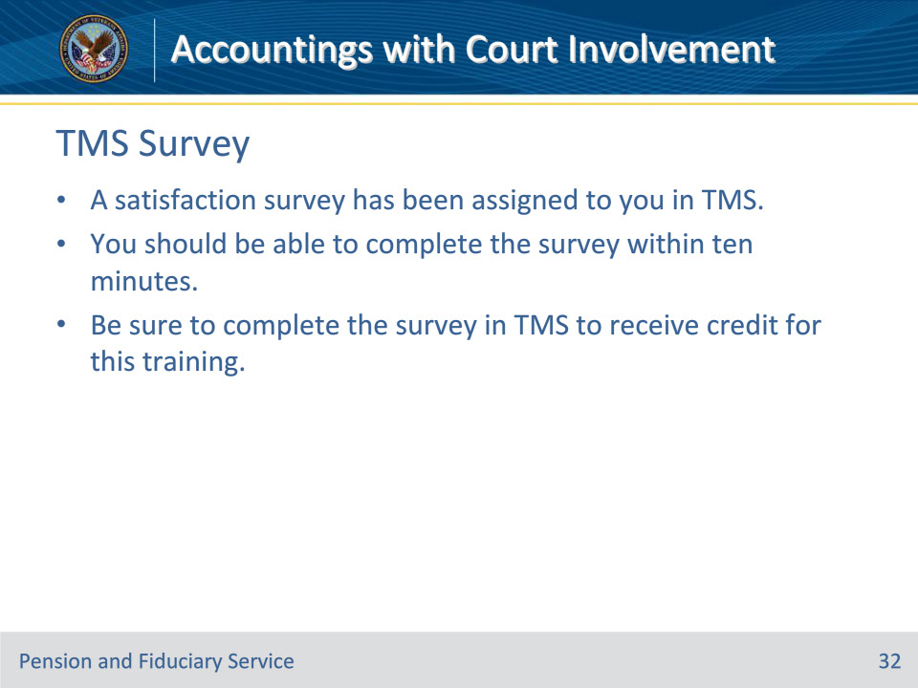
Slide notes

Instructor Notes:

A satisfaction survey has been assigned to you in TMS. You should be able to complete the survey within ten minutes. Completing the survey will allow you to receive credit for this training.

