Slide 1 - Accounting Solicitation (Core)
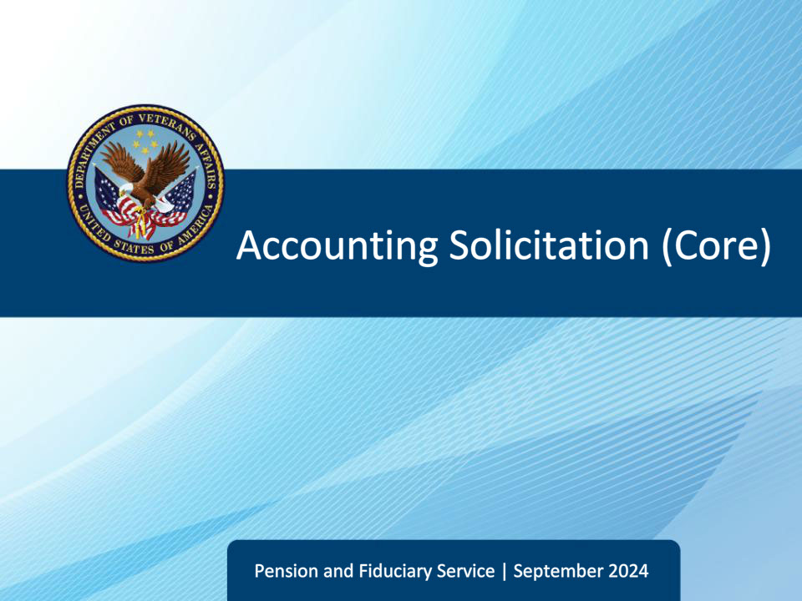
Slide notes

Course Description:

This course teaches fiduciary personnel the core knowledge of the accounting solicitation process to include the sequence of accounting solicitation activities, critical elements of solicitation letters, follow-up telephone calls, handling returned correspondence, and extension requests.

Slide 2 - Objectives
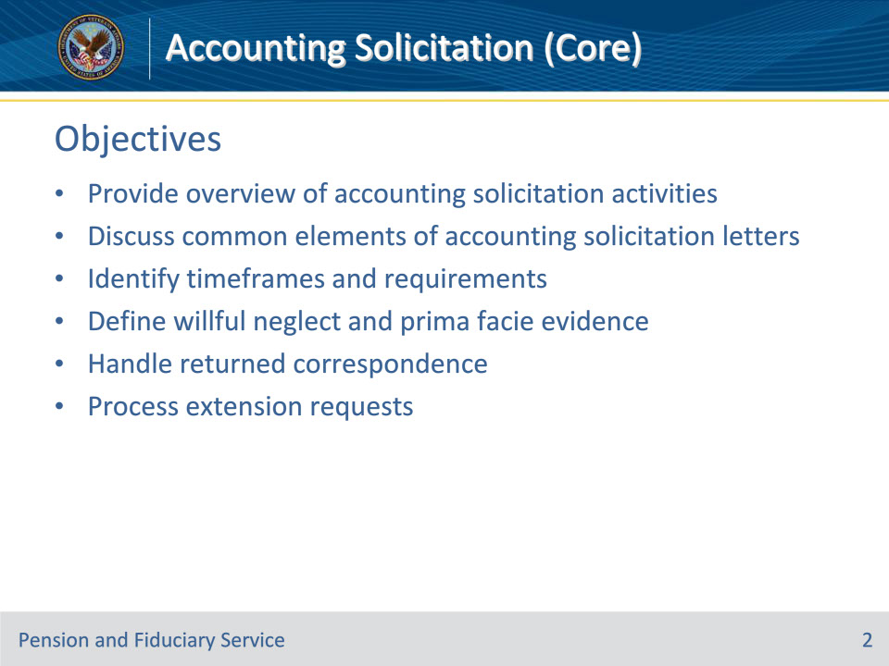
Slide notes

Instructor Notes:

At the end of this lesson, the learner will be able to:

• Provide overview of accounting solicitation activities

• Discuss common elements of accounting solicitation letters

• Identify timeframes and requirements

• Define willful neglect and prima facie evidence

• Handle returned correspondence

• Process extension requests

Slide 3 - References
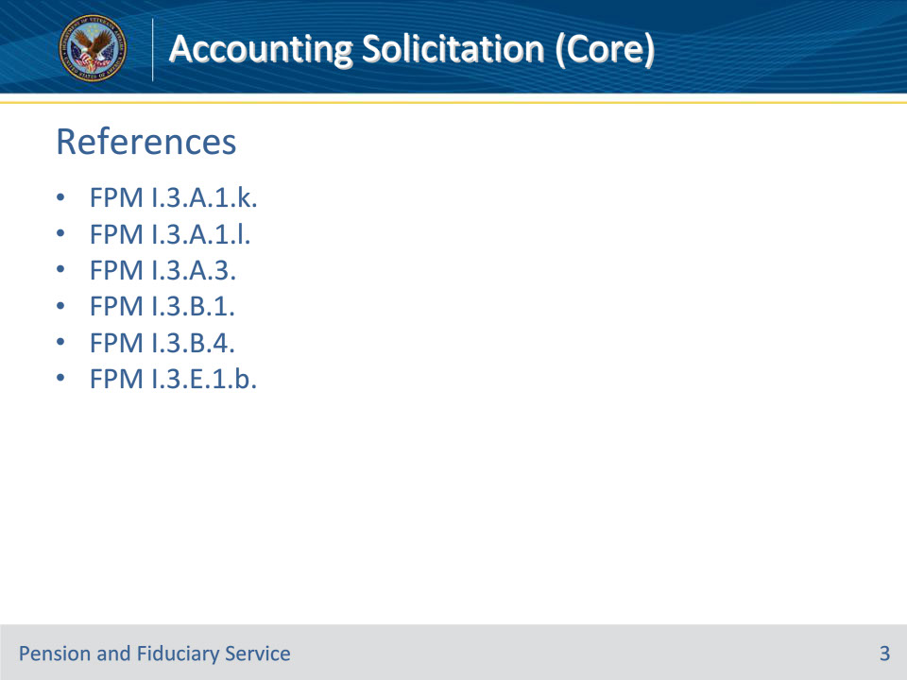
Slide notes

Instructor Notes:

This is the relevant reference for this training:

• FPM I.3.A.1.k. Handling Returned Accounting Correspondence

• FPM I.3.A.1.l. Suspension of Benefits Due to Returned Accounting Solicitation Mail

• FPM I.3.A.3. Accounting Reports and Submission Requirements

• FPM I.3.B.1. Accountings Solicitation

• FPM I.3.B.4. Follow-Up Activities Following Accounting Non-Receipt

• FPM I.3.E.1.b. When the Accounting Documents Are Incomplete or Not Received

Slide 4 - Accounting Solicitation
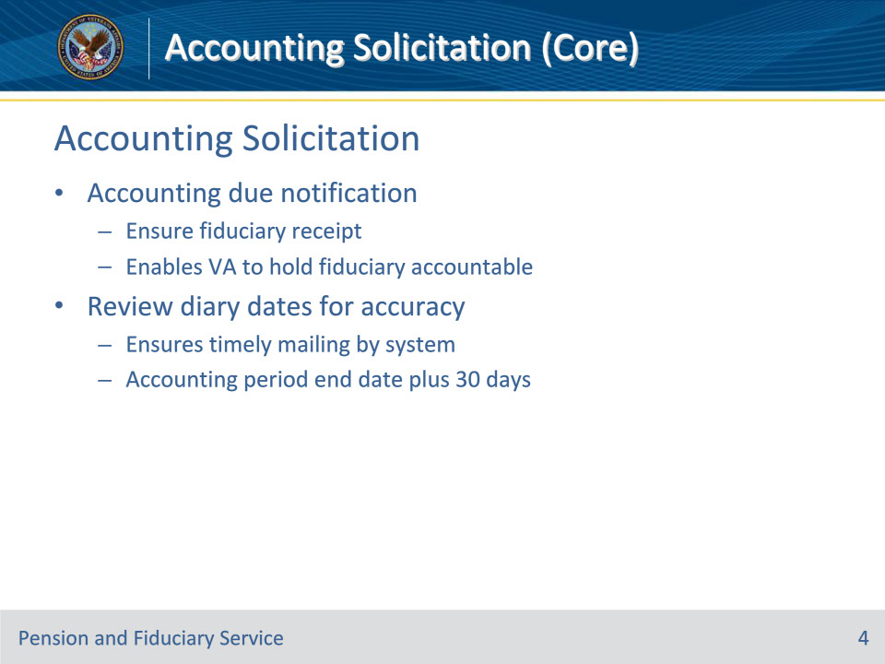
Slide notes

Policy Reference(s): FPM I.3.B.1.a.-b.

Instructor Notes:

The Department of Veterans Affairs (VA) must ensure the fiduciary receives the accounting due notification before it can take any action relating to a fiduciary’s failure to submit a timely accounting.

Failure to provide the fiduciary with notification of an accounting requirement and due date impairs VA’s ability to hold the fiduciary accountable for not submitting an accounting timely and delays oversight of fiduciaries.

The initial accounting solicitation is VA’s first written request to the fiduciary to provide the accounting report.

Fiduciary hubs must review accounting diary dates for accuracy to ensure that the appropriate accounting due letter is timely mailed by the system. Upon discovery that an accounting due letter was not sent by the system, send the letter manually to reduce any delays in the request for the accounting report.

The fiduciary is notified that the accounting is due based on the calculation accounting period end date plus 30 days.

Slide 5 - Accounting Due Letter
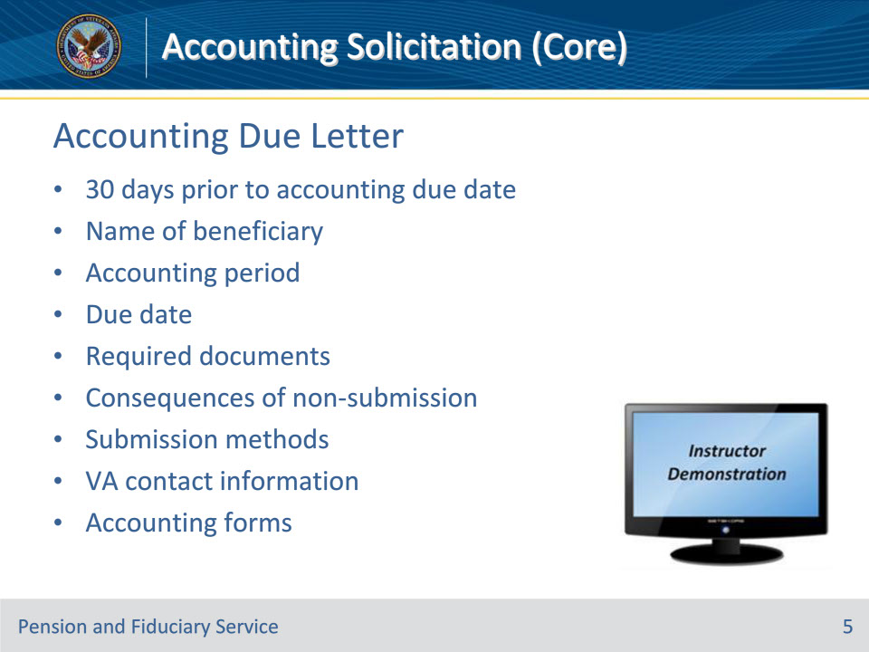
Slide notes

Policy Reference(s): FPM I.3.B.1.c.

Instructor Notes:

VA must provide the fiduciary with the appropriate accounting due letter to provide notice of their requirement to account no later than 30 days prior to the accounting due date.

The notification letter must contain the following information:

• name of the beneficiary for whom the accounting is due

• accounting period for which the fiduciary must report

• accounting period due date

• documents to be submitted

• consequences of not submitting the accounting timely

• how accountings are submitted by the fiduciary, which will occur primarily via the Fiduciary Accountings Submission Tool (FAST), and

• information on contacting VA with questions.

The notification must also include a VA Form 21P-4706b, VA Fiduciary’s Account, VA Form 21P-4718a, Certificate of Balance on Deposit and Authorization to Disclose Financial Records, and VA Form 21P-4706c, Court Appointed Fiduciary’s Account.

When generating correspondence, the hub must date and upload the letter into the eFolder to be centrally printed.

Instructor Actions: Open VBMS, share your screen and demo the information just discussed.

Slide 6 - Accounting Due Date
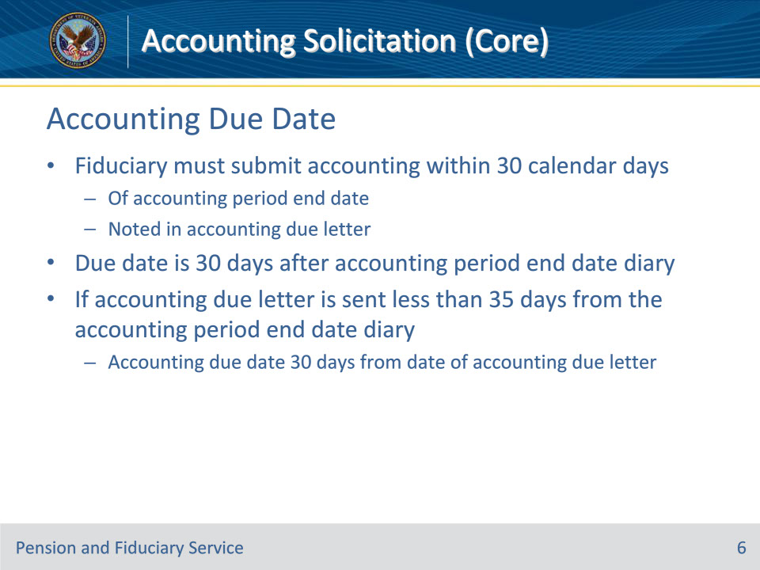
Slide notes

Policy Reference(s): FPM I.3.B.1.d.

Instructor Notes:

Generally, fiduciaries must submit their accounting within 30 calendar days of the accounting period end date, as noted in the accounting due letter.

The accounting due date is 30 days after the accounting period end date diary. If the accounting due letter is sent less than 35 days from the accounting period end date diary, the accounting due date is 30 days from the date of the accounting due notification letter.

Slide 7 - Example Accounting Dates
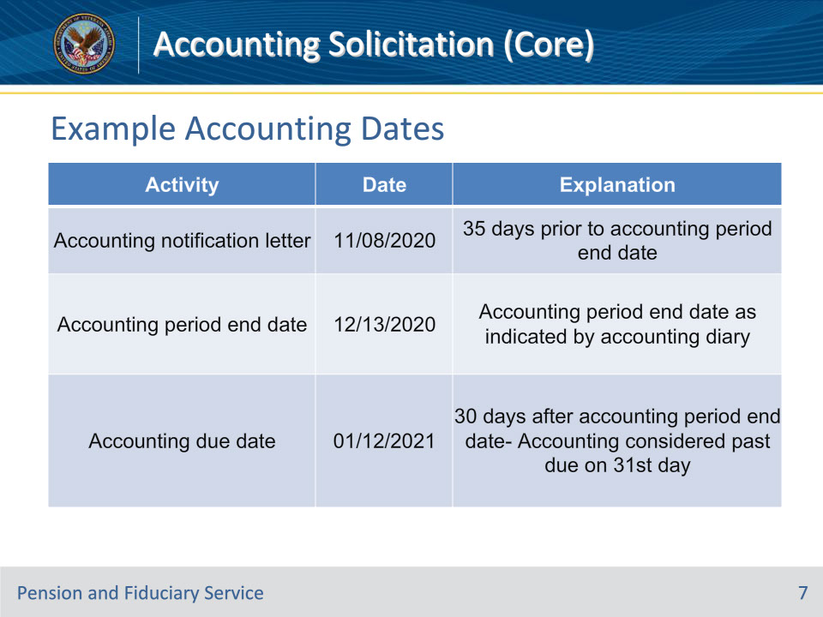
Slide notes

Policy Reference(s): FPM I.3.B.1.e.

Instructor Notes:

Here is an example of critical accounting dates:

The fiduciary’s accounting period is 12/14/2019 to 12/13/2020. This table describes various critical accounting dates for this example.

Slide 8 - Requesting Corrections
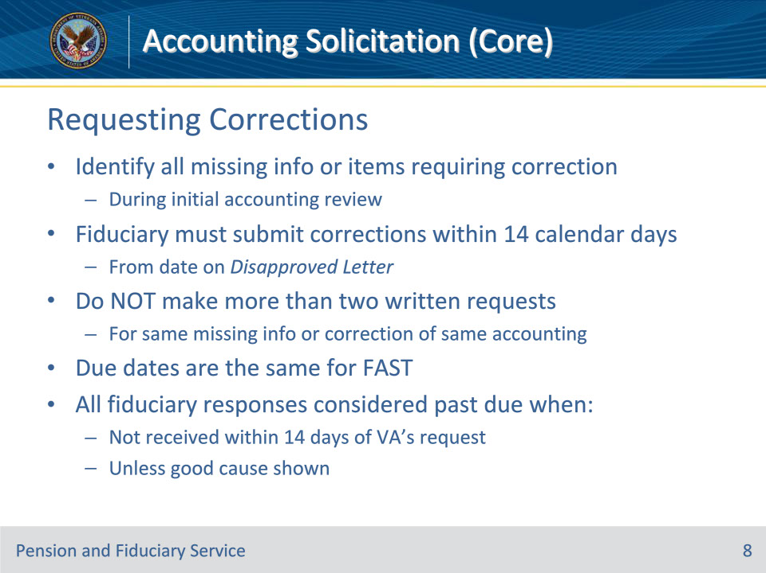
Slide notes

Policy Reference(s): FPM I.3.B.1.f.

Instructor Notes:

Identify all missing information or items requiring accounting correction during the initial review of an accounting report.

Fiduciaries must submit their accounting corrections or additional information within 14 calendar days of VA’s documented request, which has been properly uploaded to the eFolder. VA’s request date is the date on the Disapproved Letter that outlines what information VA requires to complete the accounting audit.

Important:

• Do not make more than two written requests for the same piece(s) of missing information or correction of the same accounting report when attempting to secure an approvable accounting.

• Due dates for missing or corrected accounting report information apply equally for accounting reports submitted through FAST, centralized mail, or other acceptable methods.

All fiduciary accounting responses are considered past due when VA has not received the missing information or accounting corrections requested within 14 days after the date of VA’s request unless good cause is shown.

Slide 9 - Telephone Contact
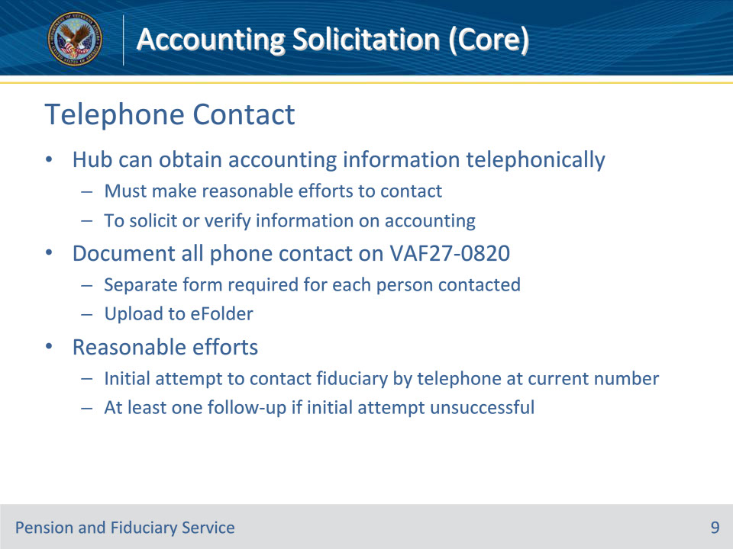
Slide notes

Policy Reference(s): FPM I.3.B.1.g.

Instructor Notes:

The hub can clarify or obtain information to complete the accounting audit telephonically. The hub must make reasonable efforts to contact the fiduciary or other entities to solicit or verify information on the accounting report.

The hub must document all phone call contact with fiduciaries, beneficiaries, or other parties on VA Form 27-0820, Report of General Information. An individual VA Form 27-0820 must be generated for each person with whom the hub speaks and uploaded to the eFolder.

Reasonable efforts generally consist of

• an initial attempt to contact the fiduciary by telephone, using their current telephone number, and

• at least one follow-up if the initial attempt is unsuccessful.

Slide 10 - Telephone Contact
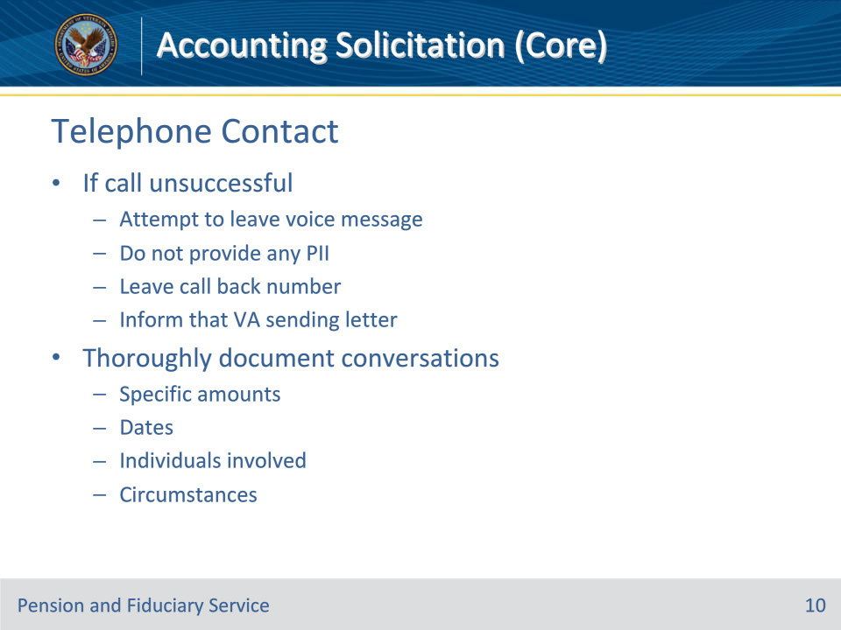
Slide notes

Policy Reference(s): FPM I.3.B.1.g.

Instructor Notes:

If the individual does not respond to the telephone call, the hub must attempt to leave a voice message.

Do not provide any personally identifiable information on the voice message. Leave a call back number for the fiduciary and inform the fiduciary that VA is also sending a follow-up letter detailing the information needed to approve the accounting.

Conversations must be thoroughly documented including specific amounts, dates, individuals involved, and circumstances as the information gathered during the call may be subject to appeal, if misuse is found.

Slide 11 - 27-0820 Content
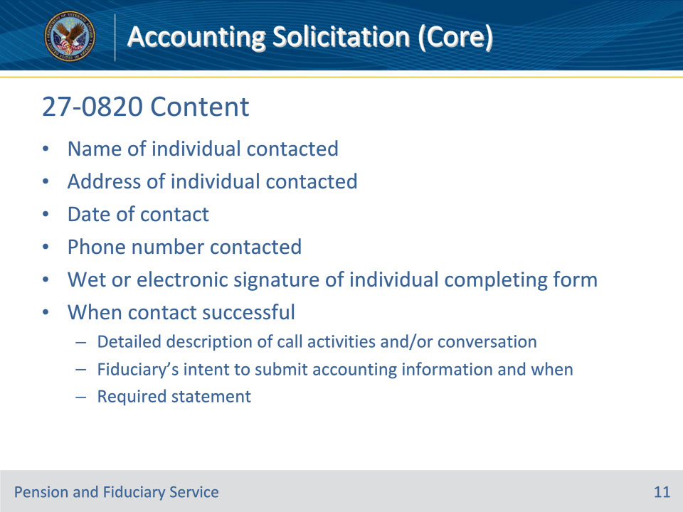
Slide notes

Policy Reference(s): FPM I.3.B.1.g.

Instructor Notes:

All phone calls during the accounting process, both successful and unsuccessful, require the creation of a VA Form 27-0820, which must be of record in the eFolder. The form must include the

• name of the individual contacted

• address of the individual contacted

• date of the contact

• phone number contacted, and

• wet or electronic signature of the individual completing the VA Form 27-0820.

When contact with the fiduciary is successful, the VA Form 27-0820 must also include

• a detailed description of the call activities and/or conversation

• the fiduciary’s intent to submit the accounting report information and when they plan to do so, and

• a statement that the caller advised the fiduciary that their statement would be documented and used in the fiduciary accounting review process.

Slide 12 - Incomplete Information
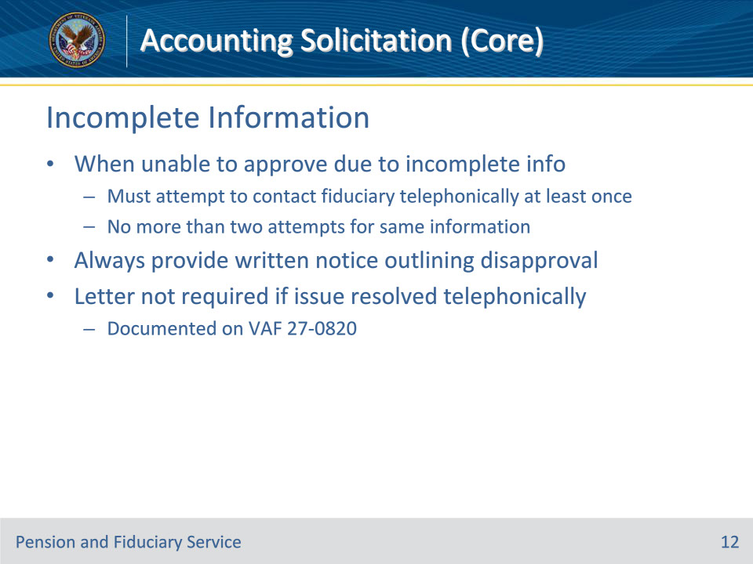
Slide notes

Policy Reference(s): FPM I.3.B.1.h.

Instructor Notes:

The hub must attempt to contact the fiduciary telephonically at least one time, when the hub is unable to approve the accounting due to missing or incomplete information. Do not make more than two telephone attempts to contact the fiduciary to request the same missing information before sending a written request for information.

In addition to telephone contact when an accounting is not approvable, the hub must always provide the fiduciary with written notice outlining the information VA requires to approve the accounting.

A letter is not required when the accounting issue is resolved telephonically and documented on a VA Form 27-0820

Slide 13 - Conversation Requirements
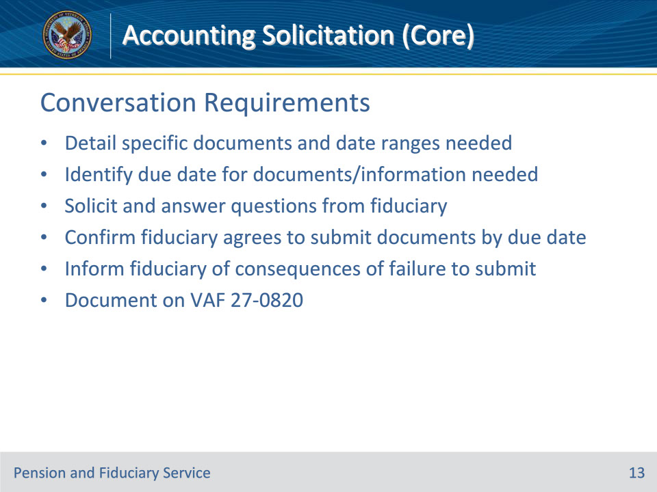
Slide notes

Policy Reference(s): FPM I.3.B.1.h.

Instructor Notes:

If telephone contact with the fiduciary is successful, the hub must document the conversation. The conversation with the fiduciary must:

• detail the specific documents and any applicable date ranges for the documents that the fiduciary must provide VA for accounting approval

• identify the date that VA must receive the documents and/or information being requested

• ask the fiduciary if they have any questions regarding accounting submission process

• confirm that the fiduciary agrees to submit the accounting report and/or necessary documents prior to the due date

• answer any questions regarding the accounting process during the phone call, and

• inform the fiduciary that if VA does not receive the information, VA may take actions to protect the beneficiary which may include appointing a successor fiduciary and an investigation to determine if the funds were used in the interest of the beneficiary.

Slide 14 - Non-Receipt
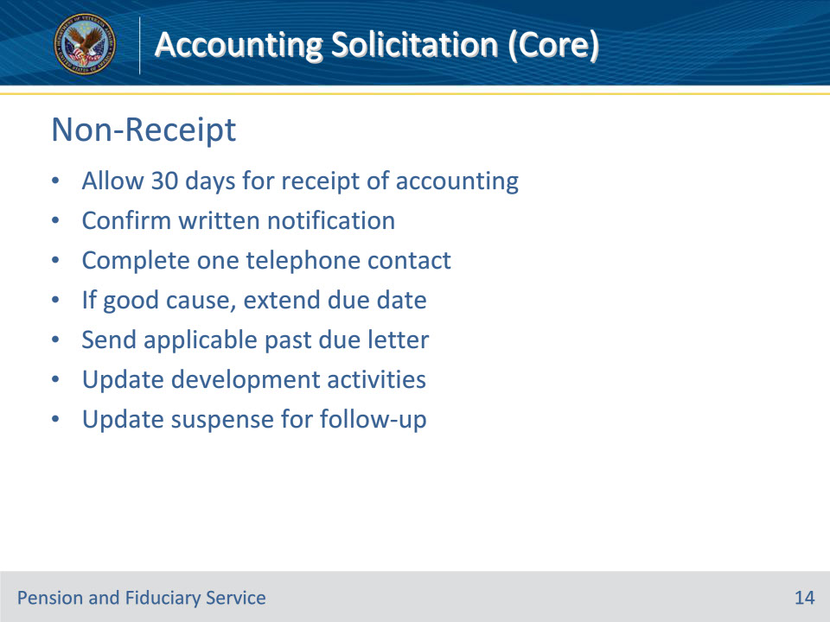
Slide notes

Policy Reference(s): FPM I.3.B.4.a.

Instructor Notes:

VA must take the following actions when the fiduciary does not provide an accounting report within 30 days of the due date and good cause was not shown to extend the due date:

• confirm that the fiduciary received one written notification of the requirement to account for a specific period under review

• complete one telephone contact and if good cause is

• found to extend the accounting due date, notify the fiduciary of the adjusted due date, or

• not found to extend the accounting due date, provide the fiduciary with a Federal or Court Past Due Accounting Letter, and

• add and/or update the appropriate development activities and suspense date to ensure timely follow-up.

Slide 15 - Confirm Notification
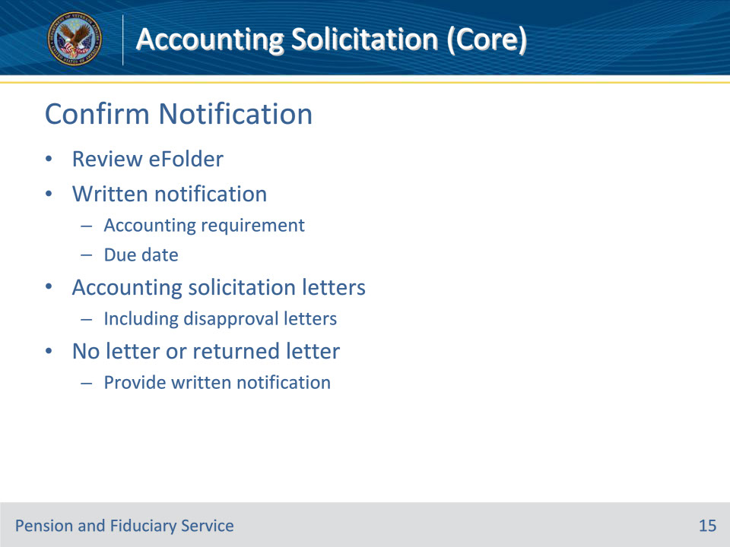
Slide notes

Policy Reference(s): FPM I.3.B.4.b.

Instructor Notes:

VA must first ensure the fiduciary received the appropriate accounting due notices before determining the fiduciary has failed to comply with VA’s request for the accounting report.

Review the eFolder to determine if attempts to notify the fiduciary of the accounting requirement and due date in writing are of record. The hub may have notified the fiduciary of their requirement to account in writing using any of the accounting solicitation letters, to include any accounting disapproval letters that outline the information required to approve the accounting and the due date to VA.

If the accounting due notification letter is not in the eFolder, provide written notification of the accounting requirement before determining the accounting is past due. A returned accounting due notification letter mail is evidence that the fiduciary did not receive notification of the accounting requirement.

Slide 16 - Telephone Contact
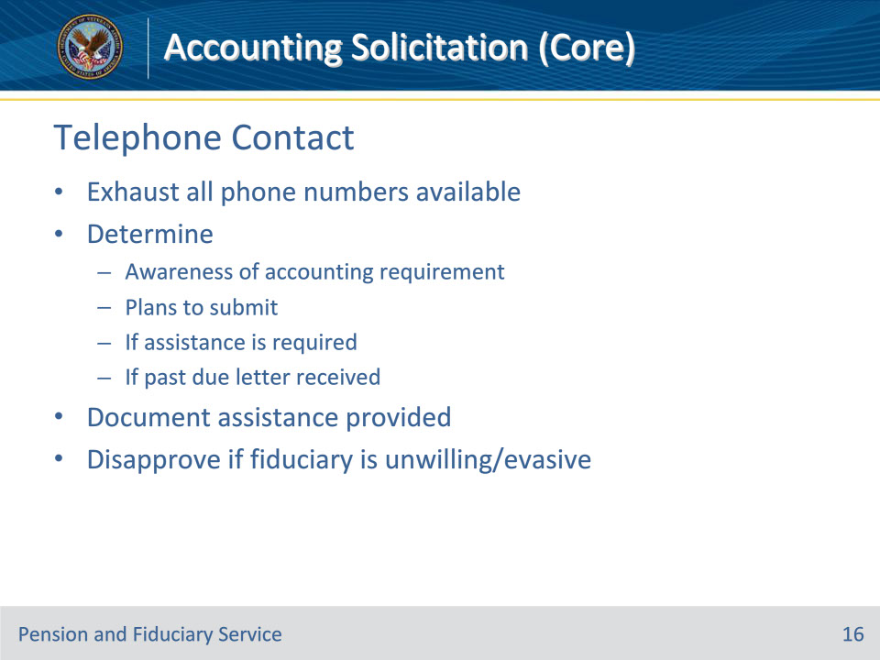
Slide notes

Policy Reference(s): FPM I.3.B.4.c.

Instructor Notes:

Hubs must make a required phone call to the fiduciary when 30 days have lapsed without receipt of an accounting report. When the call attempt is unsuccessful, the LIE must exhaust all other phone numbers for the fiduciary.

Hubs must make reasonable efforts to determine if the fiduciary

• was aware of the accounting requirement and plans to submit the accounting

• does not plan to submit the accounting

• requires assistance in completing the accounting, and

• was sent the accounting past due letter to submit the accounting.

In any situation where the fiduciary requires assistance with completion the accounting, the LIE must document the specific items for which fiduciary assistance is given.

When the fiduciary expresses an unwillingness to provide the report or is evasive, disapprove the accounting

Slide 17 - Due Date
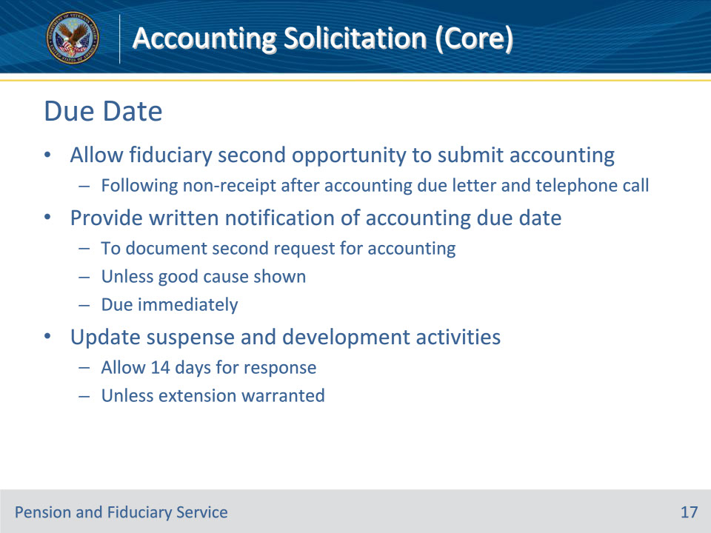
Slide notes

Policy Reference(s): FPM I.3.B.4.d.

Instructor Notes:

Allow fiduciaries a second opportunity to submit their accounting report following non-receipt of the accounting after the accounting due letter and telephone call.

Hubs must provide the fiduciary with written notification of the accounting due date to document the second request for the accounting report, unless good cause is shown. Notify the fiduciary that the second request for an accounting report is due immediately.

• Follow the guidance regarding sending the past due letter when the accounting report has not been received by the initial due date and the fiduciary resides in an area impacted by a catastrophic event.

• Update suspense date and development activities to allow the fiduciary 14-days to respond to VA’s request, unless an extension is warranted.

Slide 18 - Past Due Letter
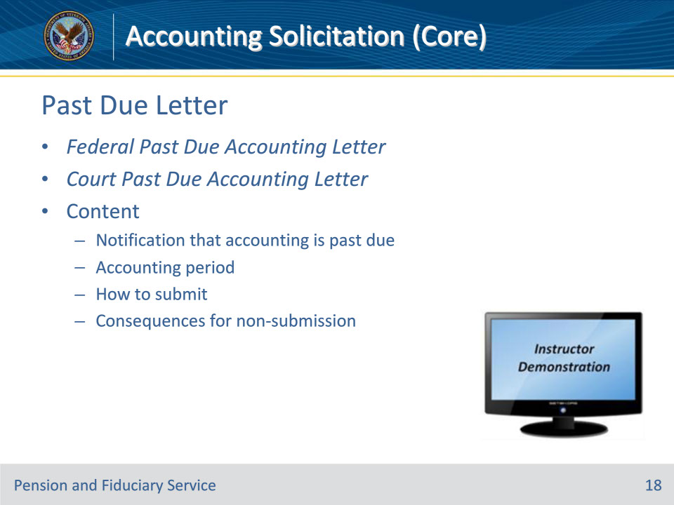
Slide notes

Policy Reference(s): FPM I.3.B.4.e.

Instructor Notes:

The Federal or Court Past Due Accounting Letter informs the fiduciary that their accounting is past due. At minimum, the notification must include the following:

• notification that the accounting report is past due

• the accounting period for which the accounting is due

• how to submit the accounting, and

• what VA will do if the accounting is not received.

Instructor Actions: Open VBMS, share your screen and demo the relevant letters.

Slide 19 - Failure to Comply
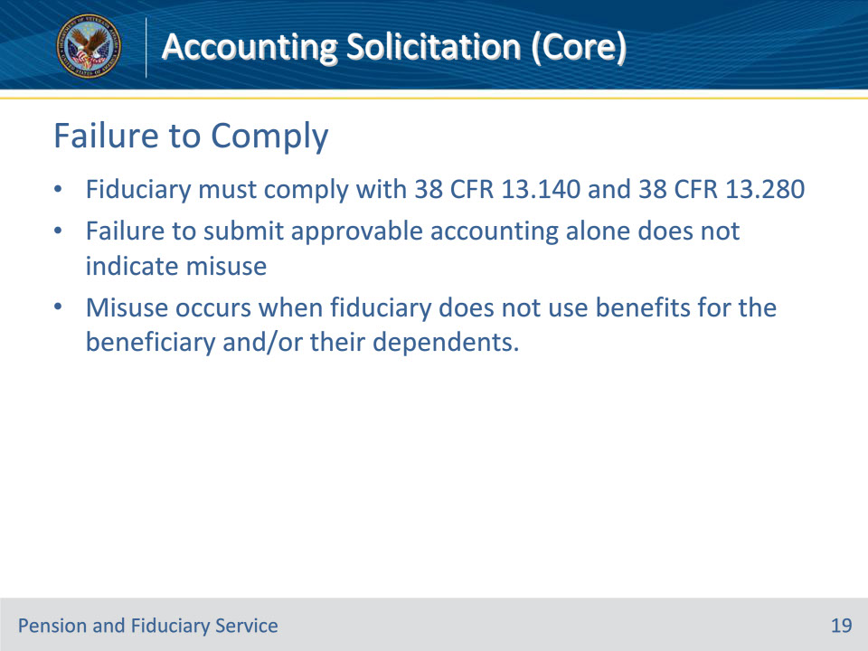
Slide notes

Policy Reference(s): FPM I.3.B.4.f.

Instructor Notes:

VA appointed fiduciaries must comply with 38 CFR 13.140 and 38 CFR 13.280.

A fiduciary’s failure to submit an approvable accounting alone does not indicate misuse. Misuse of benefits by a fiduciary occurs when the fiduciary receives VA benefit payments on behalf of a beneficiary and the fiduciary does not use the benefits for the beneficiary and/or their dependents.

Slide 20 - Willful Neglect
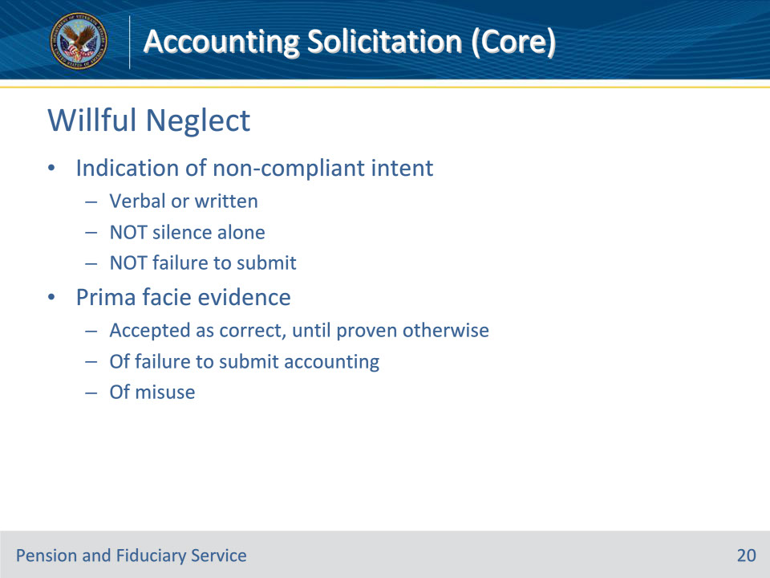
Slide notes

Policy Reference(s): FPM I.3.B.4.g.

Instructor Notes:

Willful neglect or refusal refers to the intentional disregard of a plain or obvious responsibility in the performance of which the public or the person injured has an interest. Generally, willful neglect or refusal refers to a knowing or intentional mistake without just cause or excuse. Specifically, as applicable here, it means that the fiduciary indicated verbally or in writing that they do not intend to comply with any aspect of the accounting requirement.

Silence alone on the part of the fiduciary, which includes failure to submit the requested accounting documentation (e.g., accounting forms or financial statements) or failure to provide a written or verbal statement of the intent not to submit, does not meet the standard for willful neglect or refusal.

VA will treat a fiduciary’s willful neglect or refusal as prima facie evidence of failure to submit an accounting.

Prima facie evidence is information that based on the first impression is accepted as correct, until proved otherwise.

If the fiduciary states that they will not comply with any element of VA’s accounting requirement at any time, regardless of whether VA has notified the fiduciary to submit the accounting, the hub must treat the statement as prima facie evidence of misuse.

Slide 21 - Field Examination
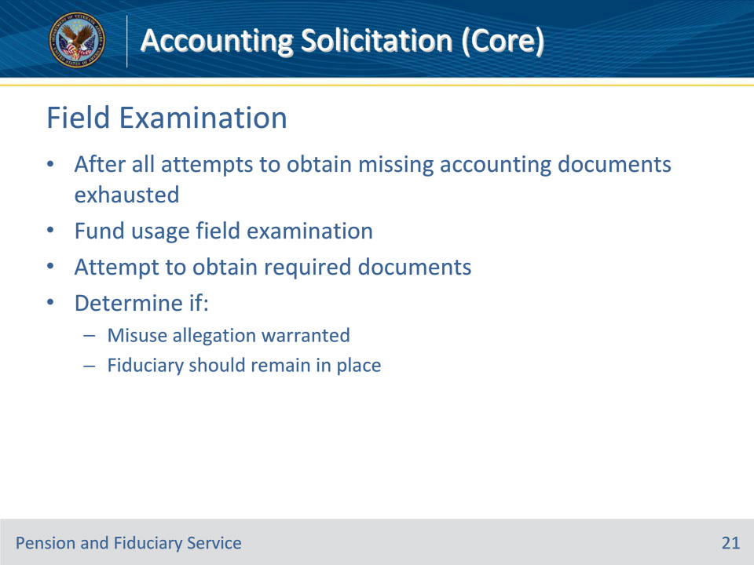
Slide notes

Policy Reference(s): FPM I.3.E.1.b.

Instructor Notes:

When accounting documents are incomplete or not received, follow required requests for the missing information. After all attempts to obtain the missing accounting documents have been exhausted, the fiduciary hub must conduct a fund usage field examination. The field examination is conducted to:

• attempt to obtain the required documents, and

• determine if

• an allegation of misuse is warranted, and

• the fiduciary should remain in place.

Slide 22 - Returned Correspondence
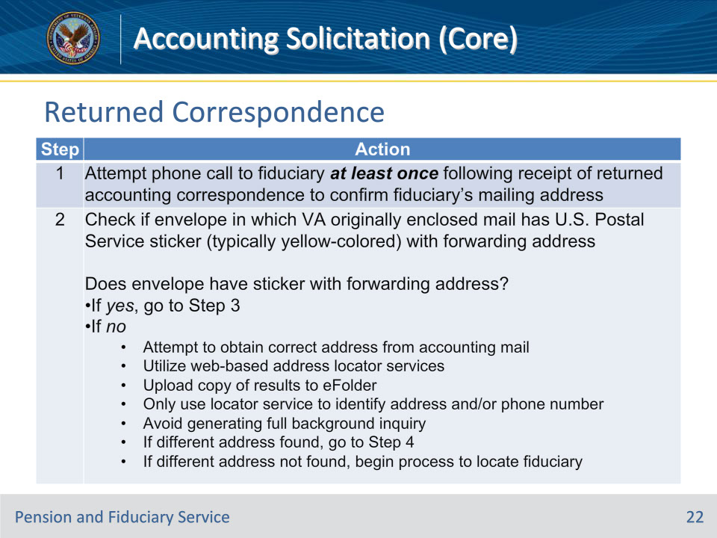
Slide notes

Policy Reference(s): FPM I.3.A.1.k.

Instructor Notes:Follow the steps in this table to resend all outgoing accounting correspondence that is returned due to an insufficient mailing address.

Notes:

• If no forwarding address is present and telephone development fails on the first attempt to contact the fiduciary, attempt to obtain the correct address from the accounting mail. The hub must utilize web-based address locator services, to include those for which VA pays to access.

• Upload a copy of the search results to the eFolder. Only use the locator service to identify a fiduciary’s address and/or contact phone number and avoid generating a full background inquiry.

• If a different address was

• found, follow the steps in the table above, beginning with Step 4, or

• not found, follow the procedures in FPM, Part I, 3.A.1.l.

Important: To avoid duplication of efforts, document all

• attempts to locate a correct address by associating screen prints of third-party address locator service results with the eFolder, and

• actions to locate the fiduciary in the Veteran’s eFolder. Add a note in VBMS to indicate all steps taken to identify the fiduciary’s mailing address.

Slide 23 - Returned Correspondence
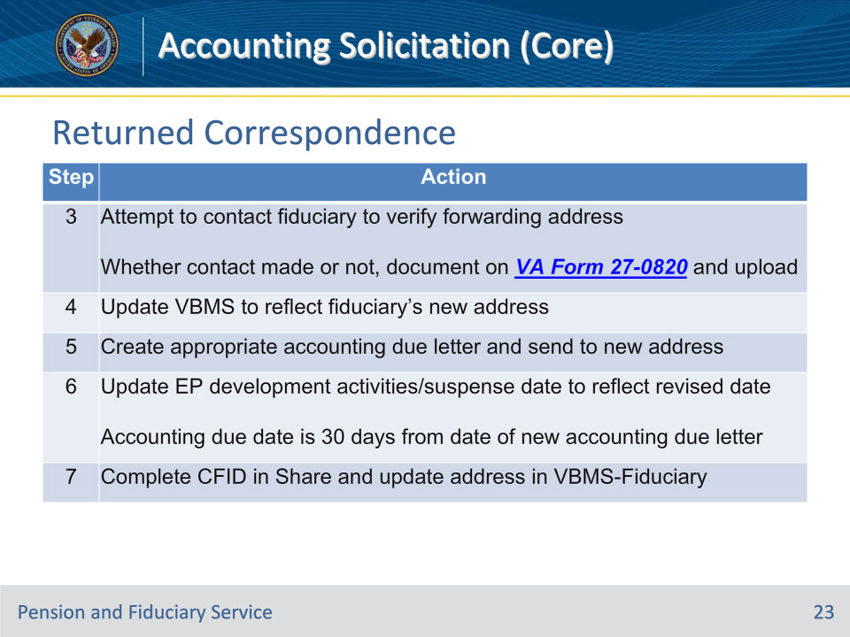
Slide notes

Policy Reference(s): FPM I.3.A.1.k.

Instructor Notes:Follow the steps in this table to resend all outgoing accounting correspondence that is returned due to an insufficient mailing address.

Slide 24 - Suspension of Benefits
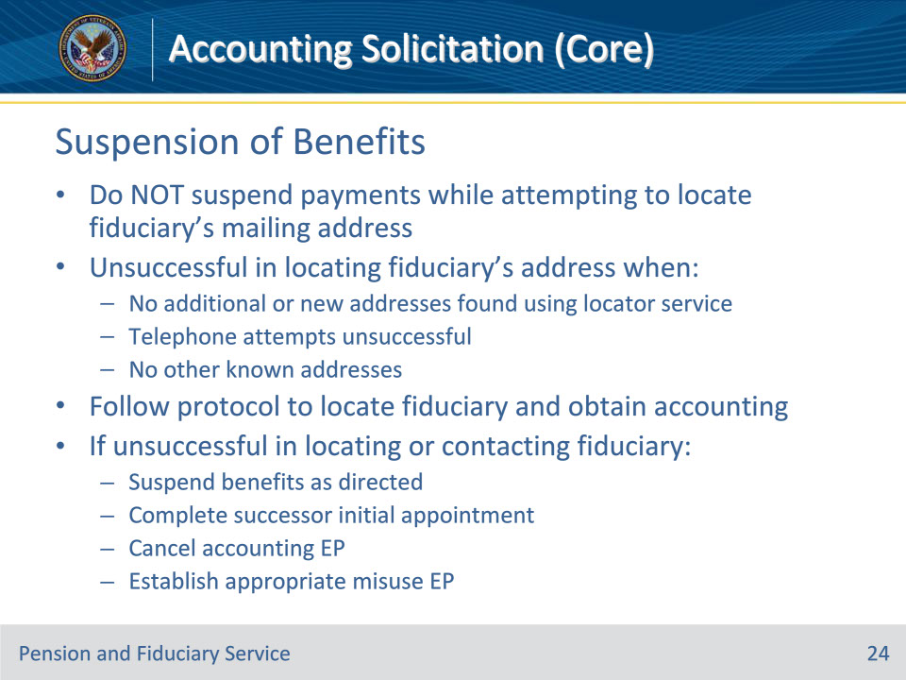
Slide notes

Policy Reference(s): FPM I.3.A.1.l.

Instructor Notes:

Take no action to suspend a beneficiary’s payments while attempting to locate the fiduciary’s mailing address to notify the fiduciary of their accounting requirement.

The hub is considered unsuccessful in locating a good address for a fiduciary when

• there are no additional and/or new addresses found for the fiduciary using the locator service

• telephone attempts to identify a better mailing address are unsuccessful, and/or

• there are no other known addresses for which the hub can mail the appropriate accounting due letter.

Follow the guidance in FPM, Part I, 2.B.2 to locate the fiduciary and make all necessary attempts to obtain the accounting. If after completing all steps and the fiduciary was not successfully located and/or contacted

• suspend benefits as directed

• complete the successor initial appointment (SIA)

• cancel the accounting EP, and

• establish the appropriate misuse EP.

Slide 25 - Extensions
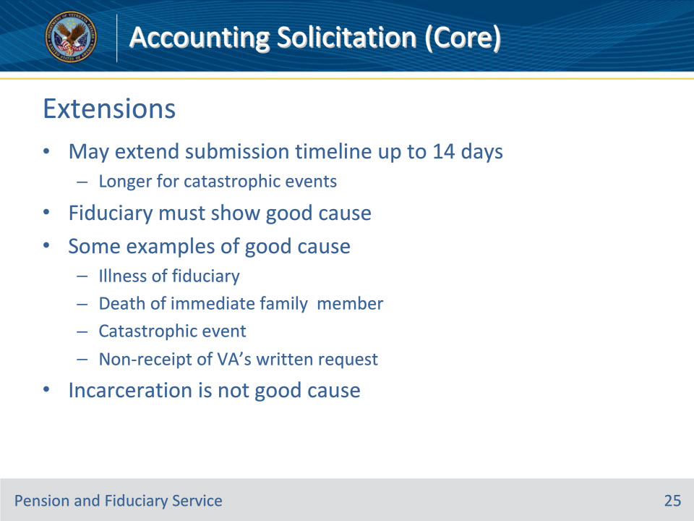
Slide notes

Policy Reference(s): FPM I.3.A.3.h.

Instructor Notes:

The hub may extend the accounting submission timeline by up to 14 days, unless the due date is extended longer per a catastrophic event. Extensions of the submission timeline may only be granted if the fiduciary shows good cause for not meeting the submission date established by VA.

Examples of good cause include, but are not limited to

• the illness or hospitalization of the fiduciary

• the death of an immediate family member

• a catastrophic event

• demonstrated non-receipt of VA’s written request.

Good cause to extend the accounting period is not shown solely because the fiduciary fails to provide a complete accounting without a request for an extension. A fiduciary’s incarceration also does not show good cause to extend the accounting period. Incarceration is grounds for immediate fiduciary removal.

Slide 26 - Extensions
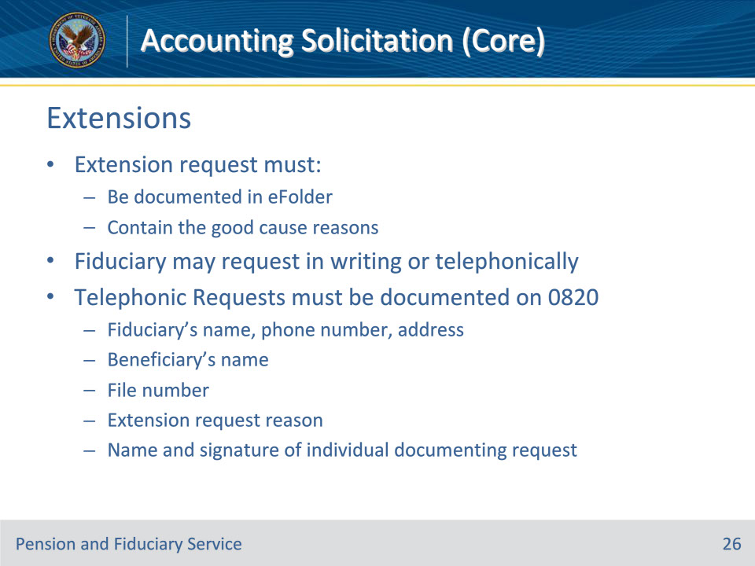
Slide notes

Policy Reference(s): FPM I.3.A.3.h.

Instructor Notes:

The fiduciary’s request for an extension must be documented in the Veteran’s eFolder and must contain the reasons (good cause) for not providing the accounting as requested by VA. Good cause must be shown as to why the fiduciary cannot meet the established due date.

The fiduciary may call or request an extension in writing. All requests received telephonically, must be documented in the eFolder on a VA Form 27-0820. The phone call must document the

• fiduciary’s

• name

• phone number, and

• address

• name of the beneficiary for whom the accounting is due

• Veteran’s file number

• reason why an extension is being requested, and

• name and signature of the individual documenting the request.

Slide 27 - Catastrophic Events
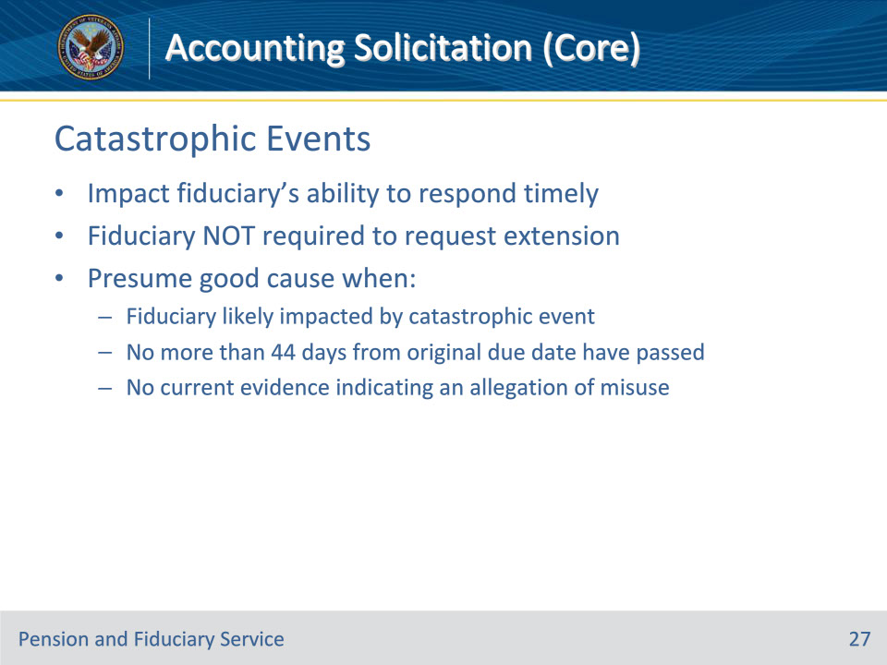
Slide notes

Policy Reference(s): FPM I.3.A.3.i.

Instructor Notes:

A fiduciary’s ability to respond timely to VA’s request for accounting information may be impacted by a catastrophic event. Hubs must presume good cause to allow the fiduciary additional time to respond when it is likely that the fiduciary was impacted by a catastrophic event.

When the hub presumes good cause, VA will extend the accounting due date and the fiduciary is not required to request an extension to submit the required accounting information. The hub may only presume good cause, when

• VA can determine that a fiduciary was likely impacted by a catastrophic event

• no more than 44 days from the original accounting due date have passed, and

• there is not current evidence indicating an allegation of misuse.

Slide 28 - Catastrophic Events
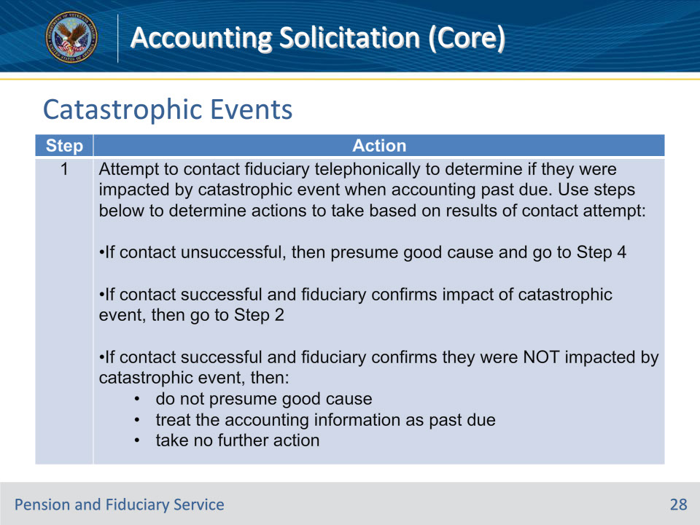
Slide notes

Policy Reference(s): FPM I.3.A.3.i.

Instructor Notes:

Follow the steps in this table when the accounting information is past due and the fiduciary has been impacted by a catastrophic event.

Note: Document successful contact on a VA Form 27-0820, and at minimum, document unsuccessful contacts as a note on the beneficiary profile.

Slide 29 - Catastrophic Events
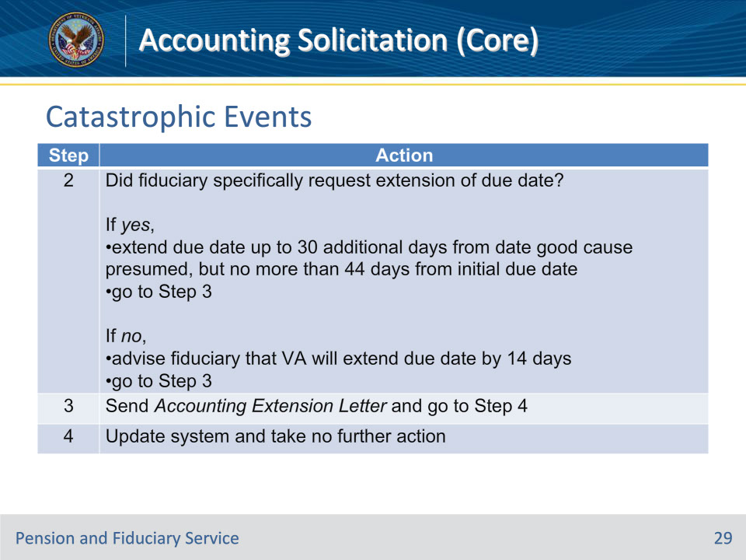
Slide notes

Policy Reference(s): FPM I.3.A.3.i.

Instructor Notes:

Follow the steps in this table when the accounting information is past due and the fiduciary has been impacted by a catastrophic event.

Important: If more than 44 days have passed from the initial accounting due date or the hub is otherwise unable to obtain supporting evidence to presume good cause, follow the procedures in FPM, Part I, 3.D and FPM, Part I, 3.B.4.

Slide 30 - Allowing Extensions
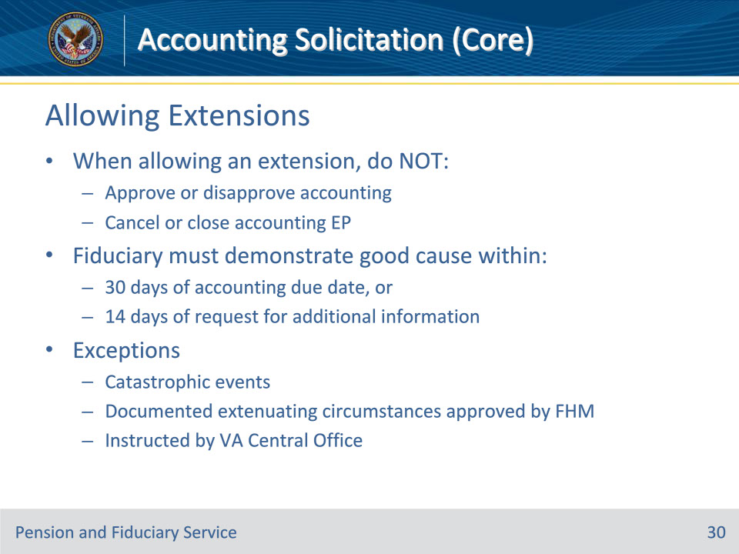
Slide notes

Policy Reference(s): FPM I.3.A.3.j.

Instructor Notes:

Fiduciaries may request an extension of the due date for accounting information when good cause is shown. When allowing the extension, do not act to approve or disapprove the accounting or cancel or close the accounting EP.

The hub should allow accounting extensions sparingly, and only in circumstances when there is no suspicion that the fiduciary is being evasive or misusing beneficiary funds.

When there is no evidence that the fiduciary was impacted by a catastrophic event, the hub may only allow an extension of the accounting due date if the fiduciary

• demonstrates good cause for an extension within

• 30 days of the accounting due date, or

• 14 days of VA’s request for additional information to approve the accounting or a complete accounting, and

• shows good cause for not submitting by the accounting due date listed in the VA notification letter.

Exceptions: Because the Fiduciary Program strives to provide oversight of the use of beneficiary funds to ensure that the fiduciary can meet their responsibilities, the hub may not extend the accounting due date more than 14 days, unless

• the fiduciary is impacted by a catastrophic event

• a documented extenuating circumstance exists beyond the fiduciary’s control and approval is granted by the FHM or their designee, or

• otherwise instructed by VA Central Office.

Slide 31 - Extensions in VBMS
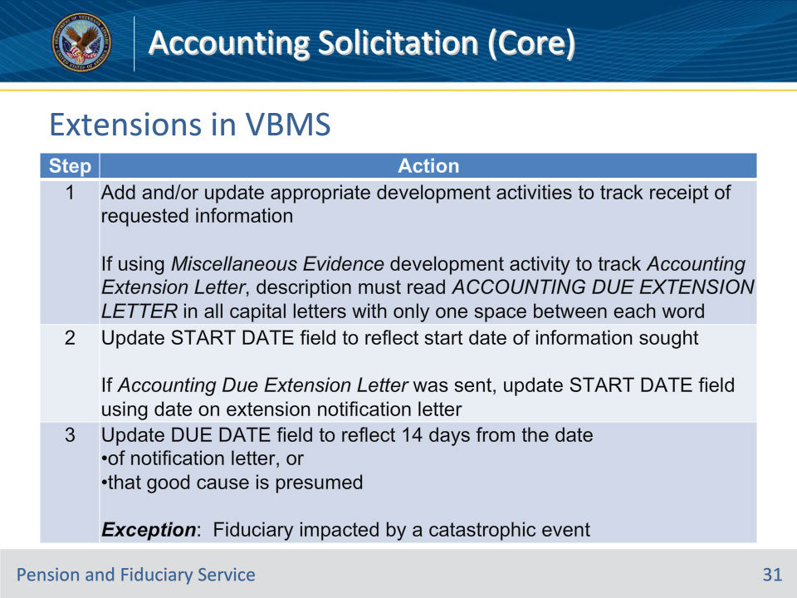
Slide notes

Policy Reference(s): FPM I.3.A.3.k.

Instructor Notes:

When the hub permits an extension of the accounting due date, the hub must update the system to reflect that the due date for accounting information has been extended. Do not change the accounting period end date or close the accounting EP.

Follow the steps in this table to update VBMS to reflect an extension request.

Exception: If the fiduciary requested an extension and was impacted by a catastrophic event, update the DUE DATE field as described in Step 2 of the table in FPM, Part I, 3.A.3.i.

Examples:

• VA received the fiduciary’s written request for more time to submit the accounting due to a family illness on December 22, 2018. The Accounting Due Extension Letter date is January 1, 2019. The new due date based on the good cause extension is January 15, 2019.

• A catastrophic event occurred on February 27, 2020. The fiduciary’s accounting report was due on March 1, 2020. Good cause was presumed on March 6, 2020, the date of review. The accounting report due date is March 20, 2020. The accounting report must be considered past due on March 21, 2020, unless the fiduciary requests additional time to submit the report due to a catastrophic event.

Slide 32 - Extensions in VBMS
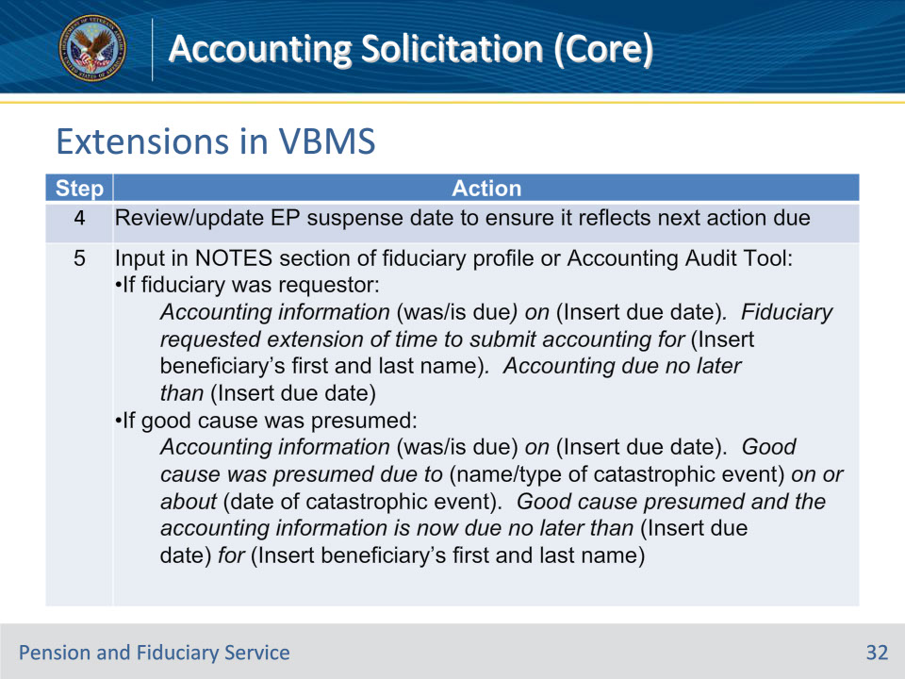
Slide notes

Policy Reference(s): FPM I.3.A.3.k.

Instructor Notes:

Follow the steps in this table to update VBMS to reflect an extension request.

Note: Add the note in step 5 to the:

• fiduciary profile, if the hub has not yet established an Accounting Audit Tool, or

• Accounting Audit Tool, if it exists at the time good cause is presumed.

Note: After VA finds good cause to extend the accounting information due date and the fiduciary has not submitted the required information after the extended due date expires, allow fiduciaries a second opportunity to submit their accounting report

Slide 33 - Extension Notification
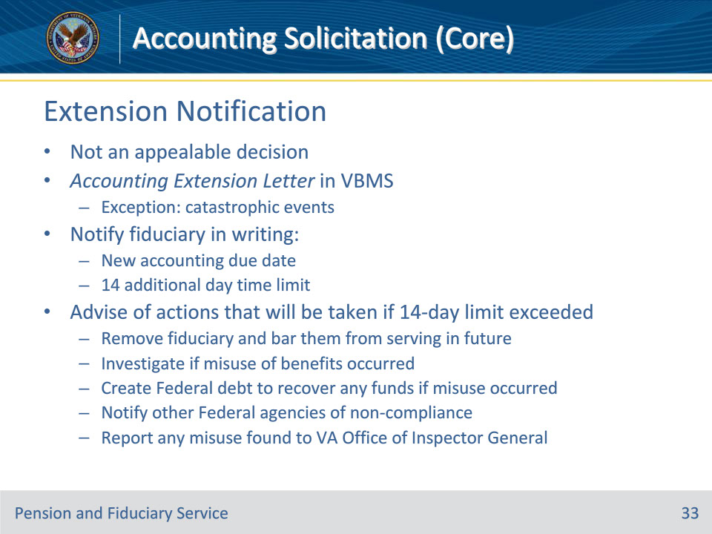
Slide notes

Policy Reference(s): FPM I.3.A.3.l.

Instructor Notes:

Allowing a fiduciary’s request for additional time to submit an accounting is not an appealable decision.

Utilize the Accounting Extension Letter in VBMS to notify the fiduciary when the extension is being granted.

The hub must notify the fiduciary in writing of the new accounting due date when granting an extension requested by the fiduciary. The written notification must specify a time limit of 14 additional days for the fiduciary to submit a complete accounting from the date of the notification letter.

The hub must further advise the claimant if the accounting is not submitted to VA within 14 days of the date of the notification letter, VA will take the following actions to ensure protection of the beneficiary:

• remove them as the beneficiary’s fiduciary and bar them from serving as a VA-appointed fiduciary in the future

• investigate to determine if misuse of the beneficiary’s benefits has occurred

• create a Federal debt to recover any funds if misuse of the beneficiary’s funds has occurred

• notify other Federal agencies of the non-compliance with VA regulations, and

• report any misuse found to the VA Office of Inspector General.

Exception: When the hub presumes good cause and extends the due date for accounting information due to a fiduciary being impacted by a catastrophic event, do not send the Accounting Extension Letter

Slide 34 - Disapproving Extensions
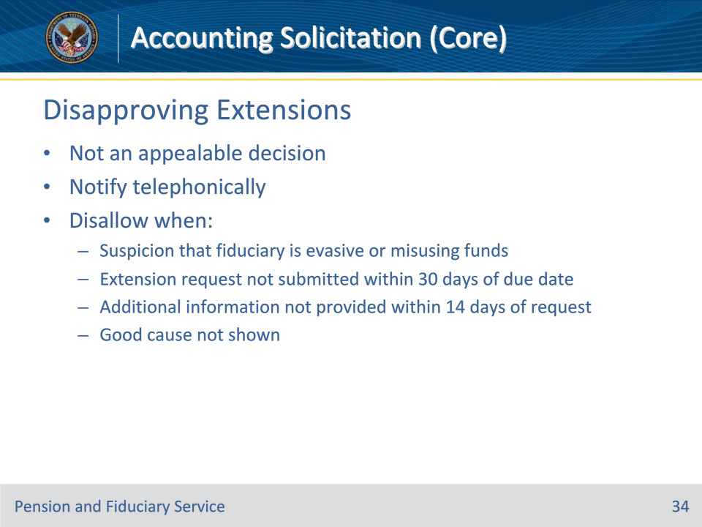
Slide notes

Policy Reference(s): FPM I.3.A.3.m.

Instructor Notes:

Disapproving a fiduciary’s request for an extension is not an appealable decision.

The hub must disallow an extension to submit accountings in circumstances when there is suspicion that the fiduciary is being evasive or misusing beneficiary funds. If the extension request is not granted, notify the fiduciary telephonically.

The hub may not allow an extension of the accounting due date if the fiduciary:

• fails to provide

• a written or telephonic request for an extension within 30 days of the accounting due date, or

• additional information to approve the accounting or a complete accounting within 14 days of VA’s request, or

• does not show good cause as described in FPM, Part I, 3.A.3.h.

Slide 35 - Questions?
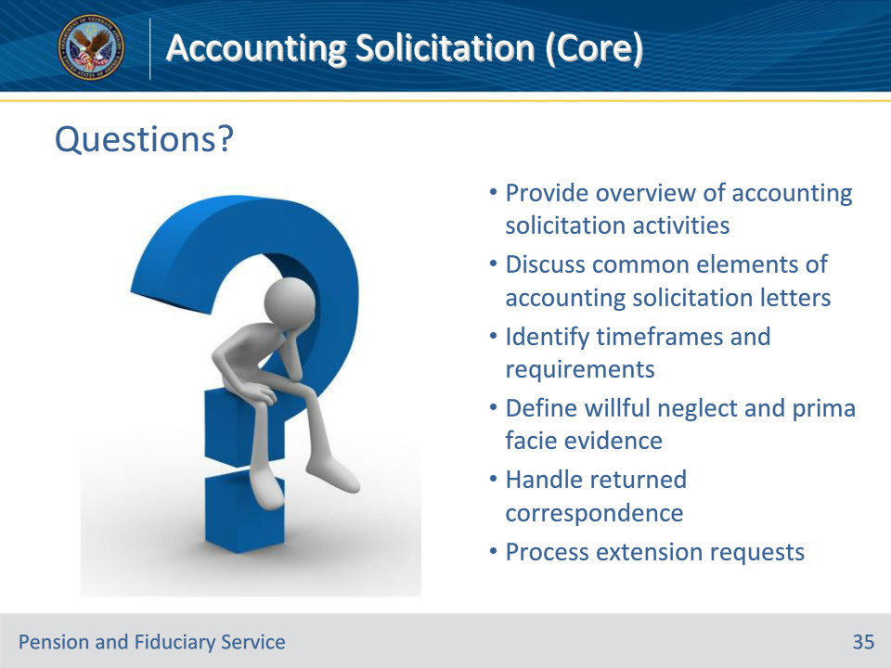
Slide notes

Instructor Notes:

(Recall) These are our learning objectives as stated from the beginning of the training:

• Provide overview of accounting solicitation activities

• Discuss common elements of accounting solicitation letters

• Identify timeframes and requirements

• Define willful neglect and prima facie evidence

• Handle returned correspondence

• Process extension requests

Are there any additional questions?

Questions should be filtered through your QRT team. They will submit your questions to the Field Inquiry Tool (FIT) on your behalf.

Slide 36 - TMS Survey/Assessment
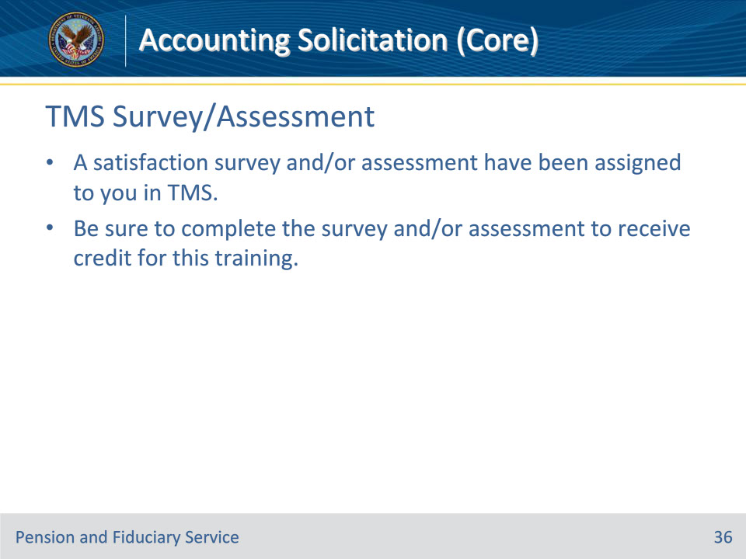
Slide notes

Instructor Notes

A satisfaction survey and/or assessment have been assigned to you in TMS.

Be sure to complete the survey and/or assessment to receive credit for this training.

