Slide 1 - Accounting Requirements
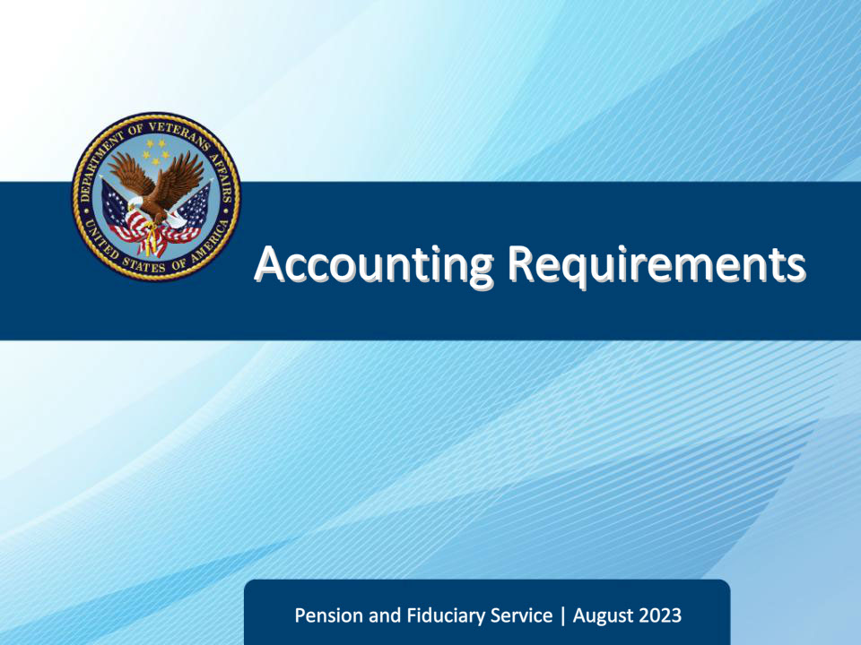
Slide notes

Course Description:

This lesson teaches basic accounting concepts, including common definitions, when an accounting is required, exceptions to accounting requirements, processes, timelines, and more.

Slide 2 - Navigation
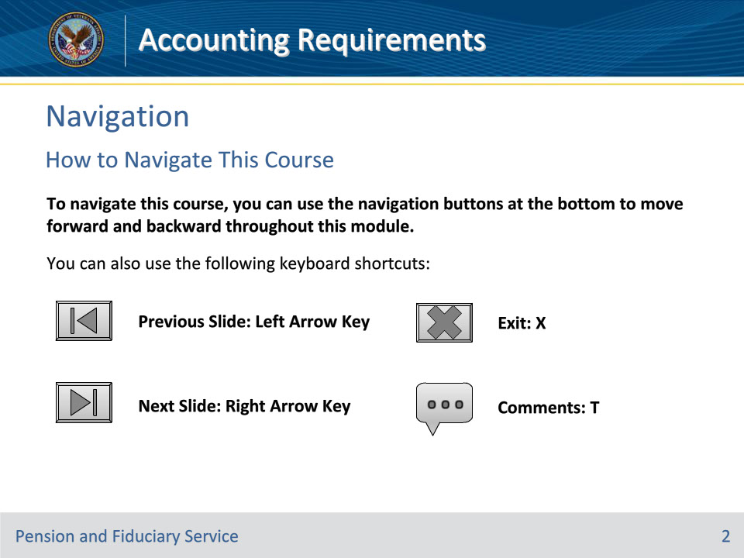
Slide notes

To navigate this course, you can use the navigation buttons at the bottom to move forward and backward throughout this module.

You can also use the following keyboard shortcuts:

• Previous Slide: Left Arrow Key

• Next Slide: Right Arrow Key

• Exit: X

• Comments: T

Slide 3 - Objectives
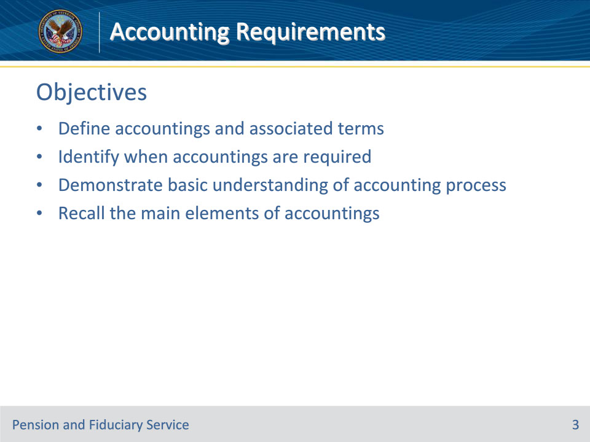
Slide notes

At the end of this lesson, given the training and references, the learner will be able to do the following:

• Define accountings and associated terms

• Identify when accountings are required

• Demonstrate basic understanding of accounting process

• Recall the main elements of accountings

Slide 4 - References
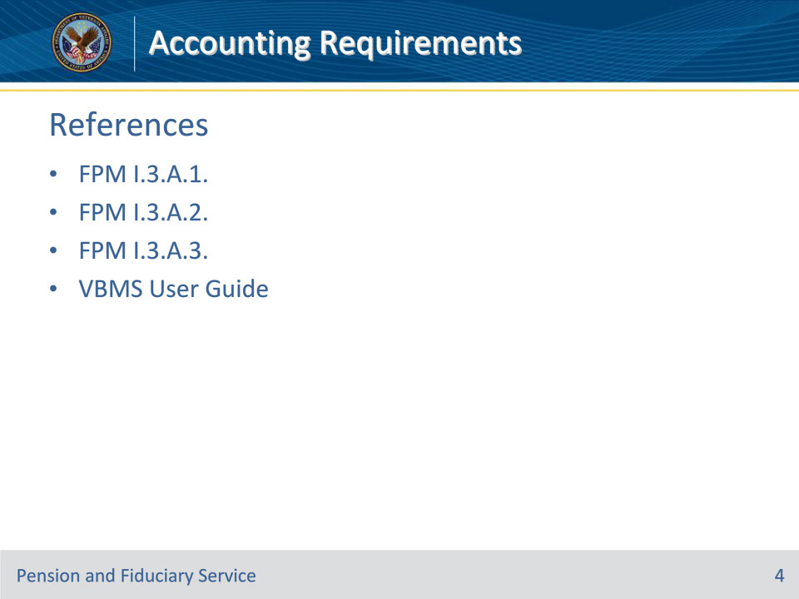
Slide notes

These are the relevant references pertaining to this course:

• FPM I.3.A.1. General Accounting Information

• FPM I.3.A.2. When a Fiduciary Must Account

• FPM I.3.A.3. Accounting Reports and Submission Requirements

• VBMS User Guide--https://www.vbms.vba.va.gov/vbmsp2/resources_p4/webhelp/core_webhelp/guides_for_download/vbms_user_guide.pdf

Slide 5 - Accounting Definition
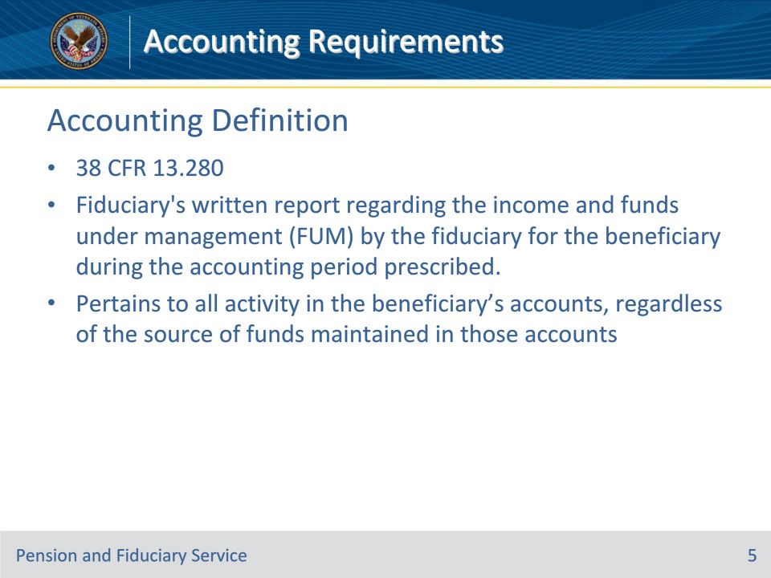
Slide notes

Policy Reference(s): FPM I.3.A.1.a

Instructor Notes:

Per 38 CFR 13.280, an accounting, is the fiduciary’s written report regarding the income and funds under management (FUM) by the fiduciary for the beneficiary during the accounting period prescribed by the Fiduciary Hub Manager (FHM).

An accounting pertains to all activity in the beneficiary’s accounts, regardless of the source of funds maintained in those accounts, e.g., Social Security payments and interest earned on deposits.

Slide 6 - Accounting Dates
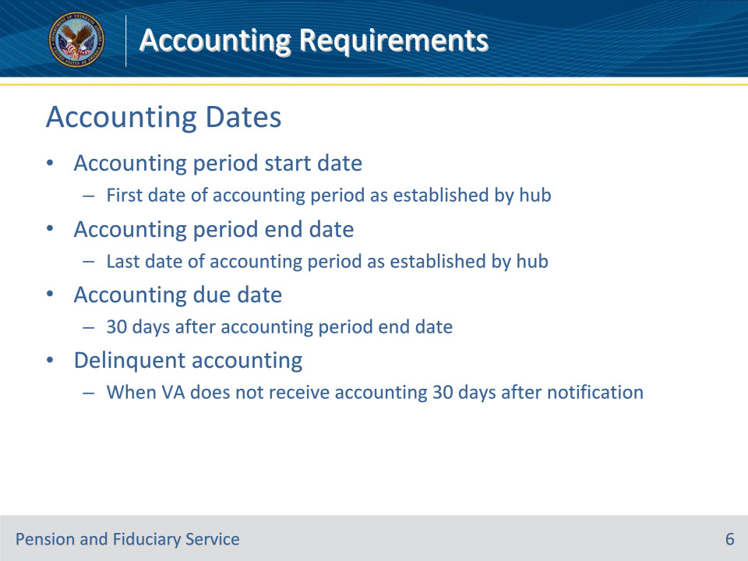
Slide notes

Policy Reference(s): FPM I.3.A.1.b; c; d; e

Instructor Notes:

The accounting period start date is the first date (month, day, year) of the accounting period as established by the fiduciary hub (hub).

The accounting period end date is the last date (month, day, year) of the accounting period as established by the hub.

The accounting due date is 30 days after the accounting period end date.

A delinquent accounting is when the Department of Veterans Affairs (VA) does not receive the fiduciary’s accounting report 30 days after being notified in writing by VA to provide the accounting report.

Slide 7 - Bill-Pay Account
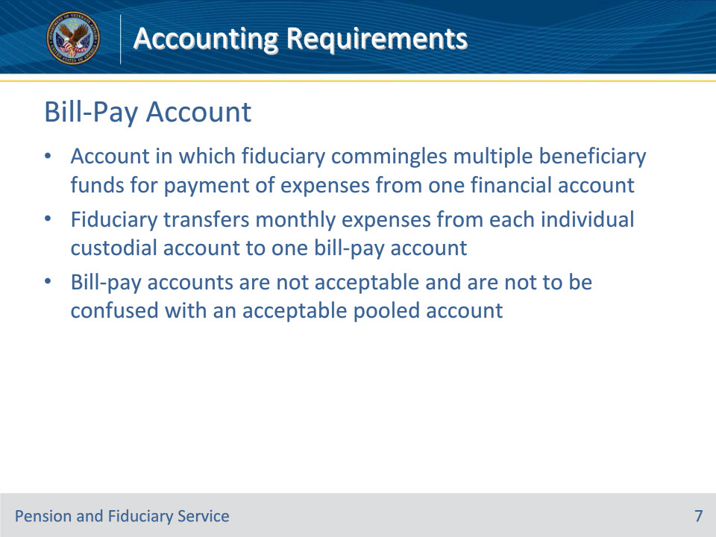
Slide notes

Policy Reference(s): FPM I.3.A.1.f

Instructor Notes:

For Fiduciary Program purposes, a bill-pay account is a financial account, custodial, business or personal, in which a fiduciary commingles multiple beneficiary funds for payment of expenses from one financial account. The fiduciary transfers monthly expenses from each individual custodial account to one bill-pay account. Bill-pay accounts are not acceptable and are not to be confused with an acceptable pooled account.

Slide 8 - Trust Company
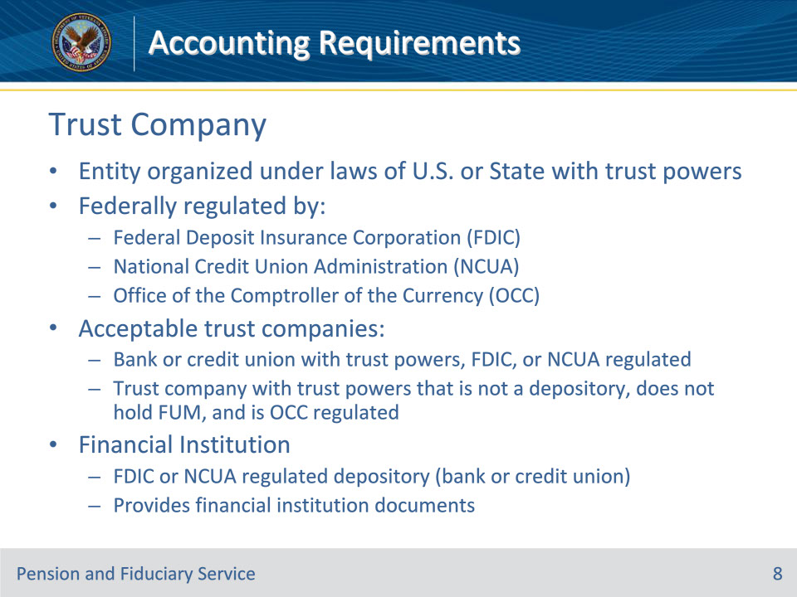
Slide notes

Policy Reference(s): FPM I.3.A.1.g; h

Instructor Notes:

For Fiduciary Program purposes, a trust company refers to an entity organized under the laws of the U.S. or State with trust powers that is Federally regulated by the Federal Deposit Insurance Corporation (FDIC), National Credit Union Administration (NCUA), or Office of the Comptroller of the Currency (OCC). Acceptable trust companies are either a

• bank or credit union (financial institution) with trust powers, FDIC, or NCUA regulated, or

• trust company with trust powers that is not a depository (financial institution), does not hold FUM, and is OCC regulated.

For Fiduciary Program purposes, a financial institution is an FDIC or NCUA regulated depository (bank or credit union) that provides financial institution documents reflecting receipts, expenses, and beginning and ending balances.

Slide 9 - Hub Accounting Responsibilities
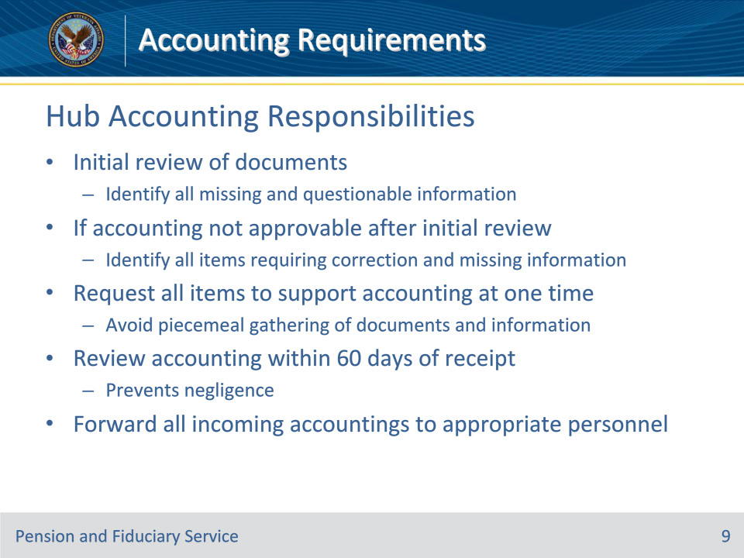
Slide notes

Policy Reference(s): FPM I.3.A.1.i; j

Instructor Notes:

Hub personnel must identify all missing and questionable information upon receipt of an accounting report on the initial review of documents.

If the accounting is not approvable after the initial review, hub personnel must identify all items requiring correction and missing information that the fiduciary must submit for the accounting to be approvable.

Hub personnel must make every effort to request all items to support an approvable accounting at one time and avoid piecemeal gathering of documents and information in the accounting process.

All accounting reports must be reviewed within 60 days of the date VA receives the accounting to prevent negligence in monitoring fiduciaries required to account.

The hub must take swift action to forward all incoming accounting mail for review to appropriate hub personnel.
Slide 10 - Accounting Process Overview
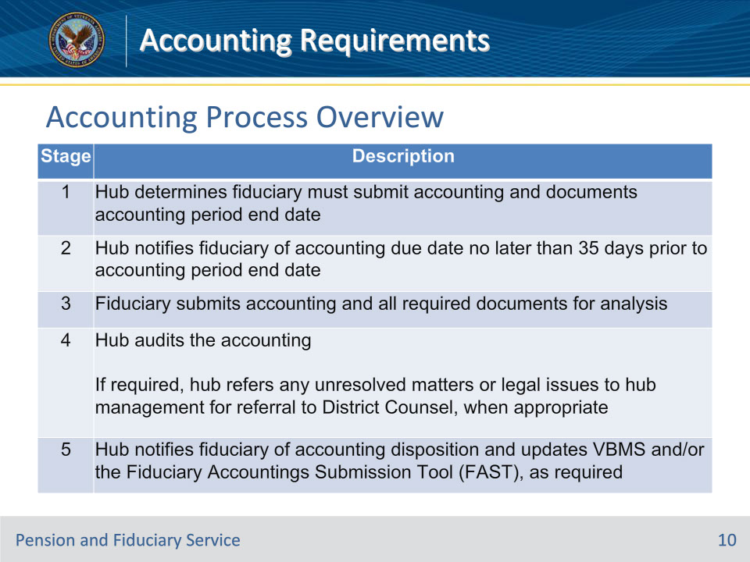
Slide notes

Policy Reference(s): FPM I.3.A.1.m

Instructor Notes:

All accounting reports must be reviewed within 60 days of the date VA receives the accounting report for review from the fiduciary.

This table describes the high-level stages in the accounting audit process following the receipt of the fiduciary’s accounting report.

Slide 11 - Accounting Requirements
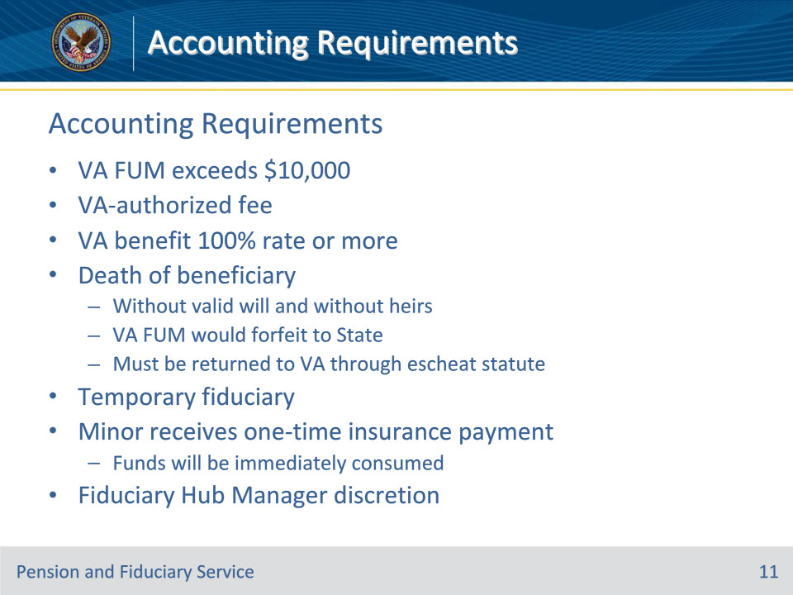
Slide notes

Policy Reference(s): FPM I.3.A.2.a

Instructor Notes:

Accountings are required when a VA-appointed fiduciary receives benefit payments on behalf of a beneficiary and any of the conditions listed below apply.

• The amount of VA FUM for the beneficiary exceeds $10,000.

• The fiduciary deducts a VA-authorized fee, under 38 CFR 13.220 for fiduciary services from the beneficiary’s account.

• The beneficiary receives VA benefits at a rate equal to or exceeding the amount paid for a 100 percent disability rating listed in the rate table.

• Upon the death of a beneficiary who dies without a valid will and without heirs, whose VA FUM would be forfeited to a State and must be returned to VA through the escheat statute.

• The fiduciary is appointed as a temporary fiduciary.

• Minor beneficiary receives a one-time insurance payment and the funds will be immediately consumed.
The FHM may determine that an accounting is necessary to ensure the fiduciary will or has properly managed the beneficiary’s VA funds in a situation outside of those listed above.

Slide 12 - Accounting Requirements
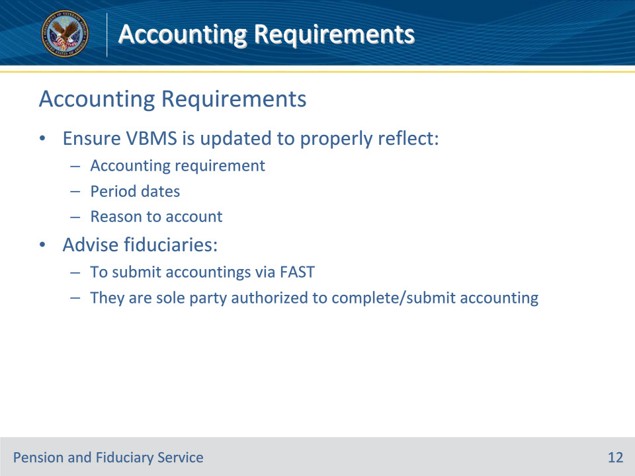
Slide notes

Policy Reference(s): FPM I.3.A.2.a

Instructor Notes:

Hub personnel must ensure that VBMS is updated to properly reflect the accounting requirement, period dates, and reason to account. When discussing accounting requirements with VA fiduciaries, hub personnel shall advise fiduciaries to submit accountings via FAST. Fiduciaries must also be advised that they are the sole party authorized to complete and submit the accounting in order to ensure the protection of the beneficiary’s private information.

Slide 13 - Accounting Frequency
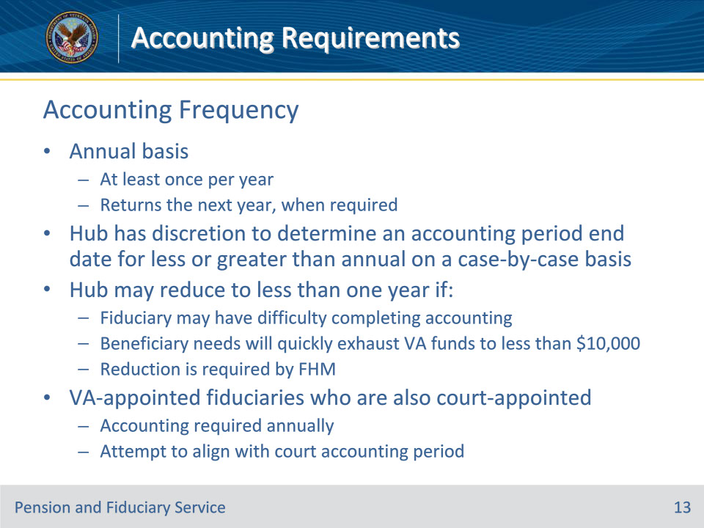
Slide notes

Policy Reference(s): FPM I.3.A.2.b

Instructor Notes:

VA-appointed fiduciaries must submit accountings on an annual basis.

The term annual accounting refers to something that is executed on a yearly basis. Specifically, as applied to 38 CFR 13.280 the annual accounting period is determined by the hub as outlined in FPM, Part I, 3.A.3 and occurs at least once a year and returns the next year, when required.

The hub has discretion to determine an accounting period end date for less or greater than annual on a case-by-case basis.

For VA-appointed fiduciaries who are also court-appointed, VA will require accountings annually, but will attempt to align the VA accounting period with the court accounting period per FPM, Part I, 3.B.2.

Example: The hub, on a case-by-case basis, may reduce the accounting period to less than one year if the

• fiduciary may have difficulty completing an accounting

• needs of the beneficiary will quickly exhaust accumulated VA funds to less than $10,000, or
• reduction is required by the FHM.

Slide 14 - Accounting Exceptions
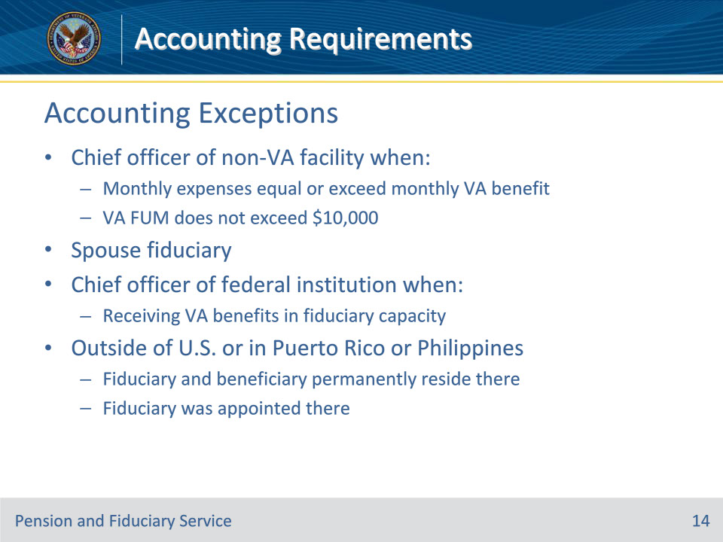
Slide notes

Policy Reference(s): FPM I.3.A.2.c

Instructor Notes:

If the situation involves a chief officer of a non-VA facility receiving benefits for a beneficiary institutionalized in the facility, then an accounting does not apply to a fiduciary where:

• the beneficiary’s monthly care, maintenance, and personal use expenses equal or exceed the amount of the beneficiary’s monthly VA benefit, and

• the amount of VA benefit funds under management (FUM) by the fiduciary does not exceed $10,000.

• This includes beneficiaries paid at a rate equal to or exceeding the amount paid for a 100 percent disability rating.

• This decision is at the discretion of the Fiduciary Hub Manager. However, temporary fiduciaries are required to account.

If the situation involves a spouse, recognized as a dependent by VA and designated as a spouse fiduciary, then an accounting does not apply.
If the situation involves a chief officer of a Federal institution, then an accounting does not apply if the officer is receiving VA benefits in a fiduciary capacity.

If the situation involves fiduciaries and beneficiaries who permanently reside, and the fiduciary was appointed outside the United States, or in the Commonwealth of Puerto Rico, or the Republic of the Philippines, then an accounting does not apply.

• Generally, fiduciaries in the situations above are not required to complete an accounting report, unless the hub determines that an accounting is necessary to ensure the fiduciary has properly managed the beneficiary’s funds.

• Chief Officer is a position within an institution that is filled by an individual for the purpose of representing that institution in a legal capacity. As such, the person in that position is not the fiduciary, but rather acts as a representative of the entity that is their institution. The institution’s Federal Employer Identification number would be used to represent the institution and not the Chief Officer’s Social Security number (SSN).

Slide 15 - Complete Accounting
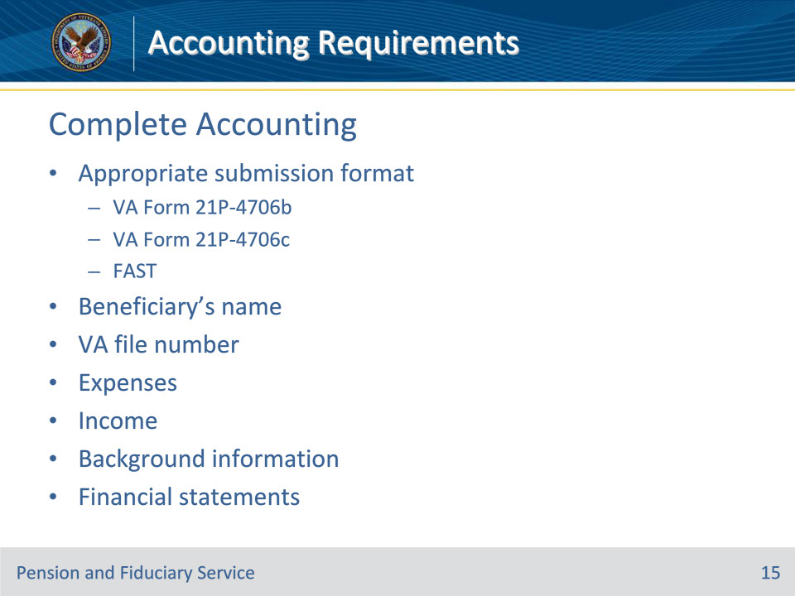
Slide notes

Policy Reference(s): FPM I.3.A.3.a.

Instructor Notes:

Hub’s must review all documents the fiduciary submits in response to a VA request for an annual accounting. The hub must determine if the accounting submission is complete before auditing an accounting submission by the fiduciary.

A complete accounting means that the accounting contains enough information for VA to review all income and expenditures during the accounting period.

An accounting report submission by a fiduciary is considered complete and ready for audit if all the conditions below are met:

• the VA Form 21P-4706b, VA Fiduciary’s Account, VA Form 21P-4706c, Court Appointed Fiduciary’s Account, or an accounting submitted via the FAST online submission portal contains the

• name of the beneficiary

• VA file number associated with the beneficiary

• expenses, and

• income, and

• the fiduciary

• completes the background information, and

• provides financial statements detailing account transactions during the entire accounting period.

Slide 16 - Unsigned 21P-4706b
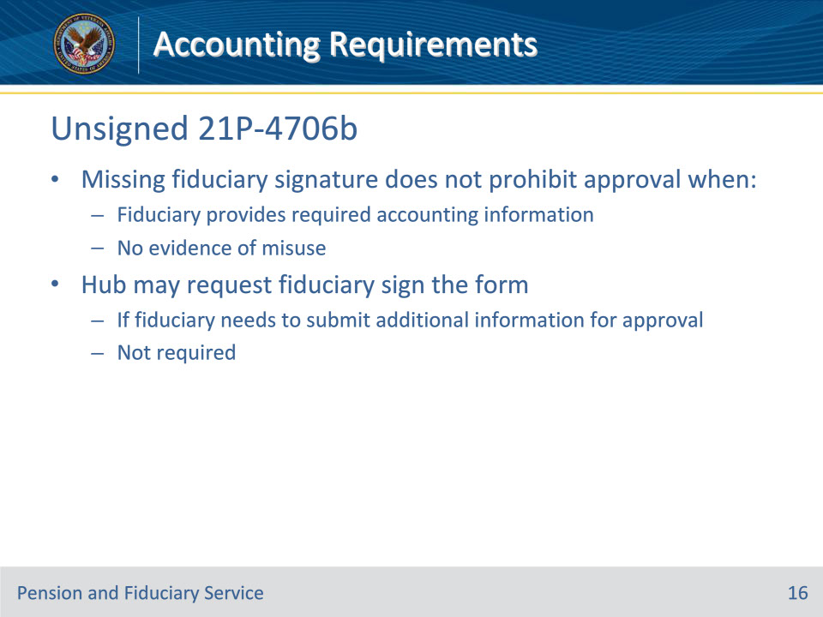
Slide notes

Policy Reference(s): FPM I.3.A.3.b.

Instructor Notes:

While the fiduciary should sign the VA Form 21P-4706b as a best practice, the lack of a fiduciary’s signature on the form does not prohibit VA from approving the accounting when the fiduciary provides the required accounting information and there is no evidence of misuse during the audit.

Upon completion of an audit of an accounting report involving an unsigned VA Form 21P-4706b that is approvable, approve the accounting.

Although not required, the LIE may request that the fiduciary sign the VA Form 21P-4706b if the LIE determines that the fiduciary needs to submit additional information or clarification before the accounting is approvable.

Slide 17 - Accounting Forms
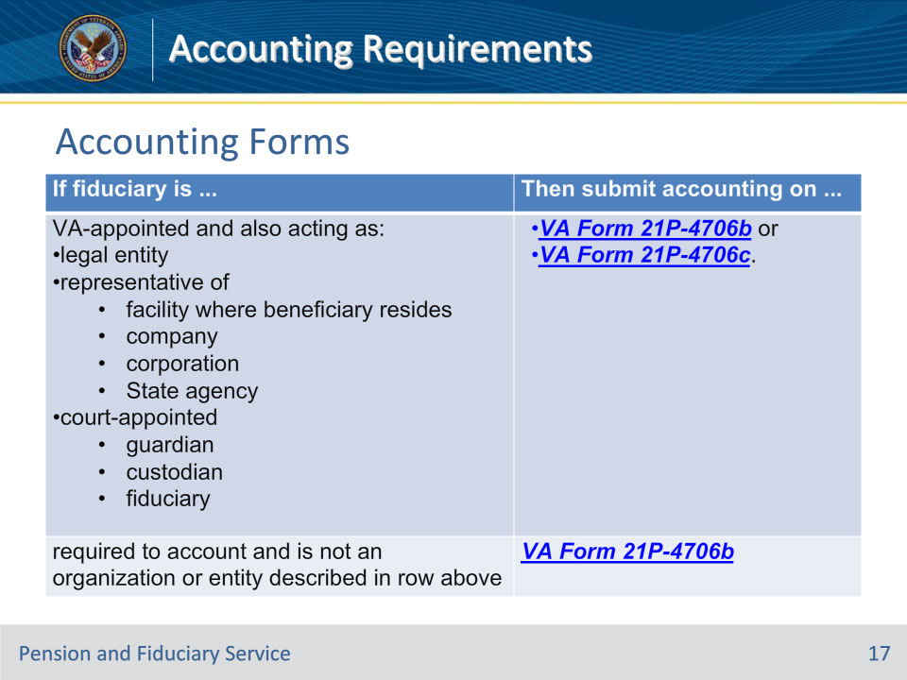
Slide notes

Policy Reference(s): FPM I.3.A.3.c.

Instructor Notes:

Fiduciaries must submit accounting reports on an appropriate VA form per 38 CFR 13.280(c).

Use this table to determine the appropriate form that a fiduciary must submit.

Slide 18 - Background Information
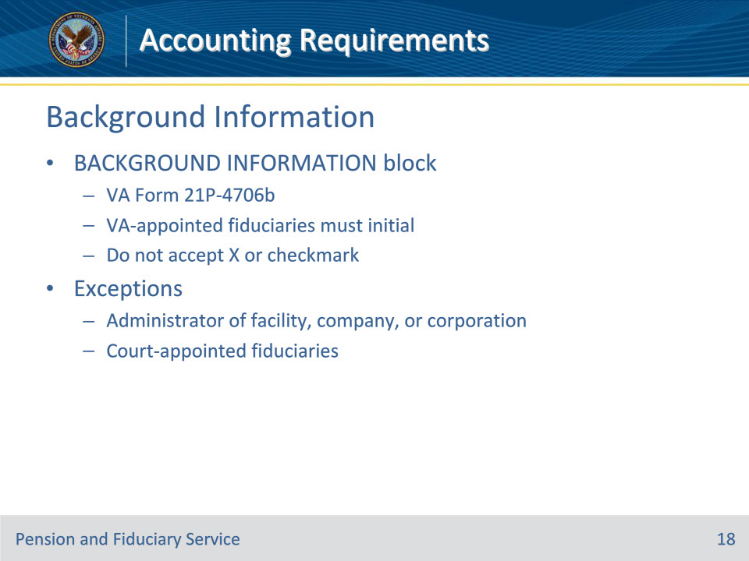
Slide notes

Policy Reference(s): FPM I.3.A.3.d.

Instructor Notes:

Generally, individuals serving as VA appointed fiduciaries must initial on the BACKGROUND INFORMATION block on the VA Form 21P-4706b. Do not accept an X or a checkmark as initialing the BACKGROUND INFORMATION block.

VA-appointed fiduciaries who are either an administrator of a facility, company, or corporation, or a court-appointed fiduciary, are not required to complete the BACKGROUND INFORMATION block.

This topic is covered in greater detail in Credit Reports and Criminal Background Inquiries trainings.

Slide 19 - Submission Timelines
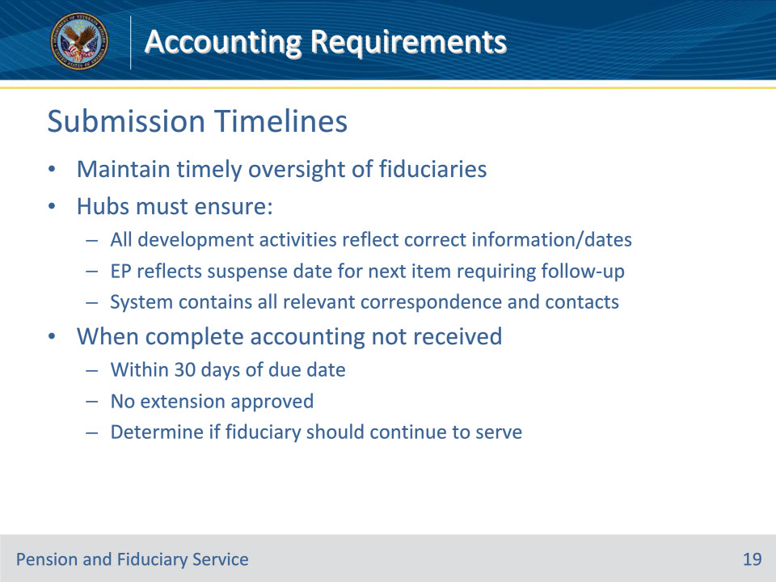
Slide notes

Policy Reference(s): FPM I.3.A.3.e.

Instructor Notes:

The fiduciary is required to submit accountings as prescribed by the FHM so that VA maintains timely oversight of fiduciaries. Upon notification that accounting information is due, fiduciaries must provide a timely response to VA.

To ensure appropriate follow-up, hubs must ensure

• that all development activities for information being sought to complete the accounting reflect the correct information, to include start and end dates

• the EP reflects the suspense date for the next item requiring follow-up action, and

• the system contains all correspondence and contacts relating to the accounting solicitation.

When VA does not receive a complete accounting within 30 days of the accounting due date and an extension is not approved, complete the procedures listed in FPM, Part I, 3.B.4 to determine

• the fiduciary’s capacity to comply with 38 CFR 13.140, and
• if the fiduciary is subject to removal under 38 CFR 13.500.

Slide 20 - Submission Timelines
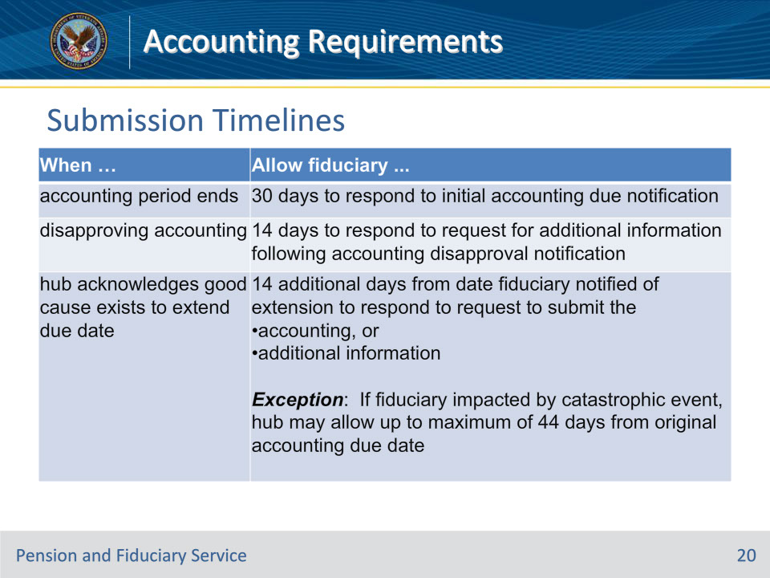
Slide notes

Policy Reference(s): FPM I.3.A.3.e.

Instructor Notes:

This table describes the timeliness of accounting submissions under differing circumstances.

Note: The notification letter must instruct the fiduciary to provide the requested information within 30 days.

Note: The notification letter must instruct the fiduciary to provide the requested information within 14 days.

Slide 21 - Early Submissions
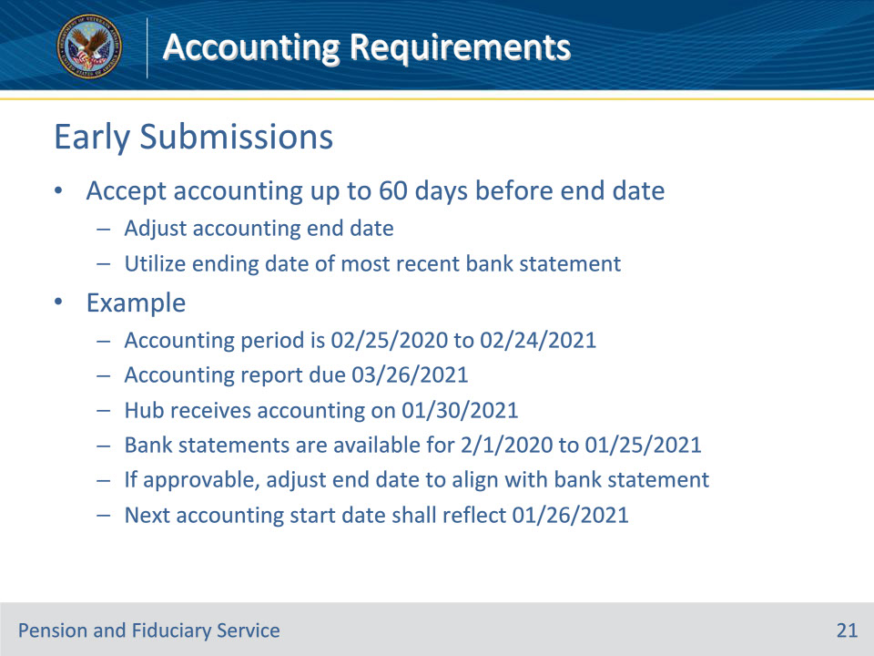
Slide notes

Policy Reference(s): FPM I.3.A.3.f.

Instructor Notes:

The hub shall accept a fiduciary’s accounting report up to 60 days before the accounting period end date.

In any situation where the fiduciary provides the accounting report within 60 days before the accounting period end date, the LIE shall adjust the accounting end date utilizing the ending date of the most recent bank statement for the period that the accounting is approved.

Example:

• The current accounting period for the fiduciary is from 02/25/2020 to 02/24/2021.

• The accounting report is due on 03/26/2021 (30 days after the end of the accounting period).

• The hub receives the accounting report (VA Form 21P-4706b and bank statements) on 01/30/2021.

• The bank statements are available for review from 2/1/2020 to 01/25/2021.

• If the accounting is approvable, per FPM, Part I, 3.D.1, adjust the accounting period end date to align with the bank statement.

• The next accounting period start date shall reflect 01/26/2021 through 01/25/2022.

Slide 22 - Financial Statements
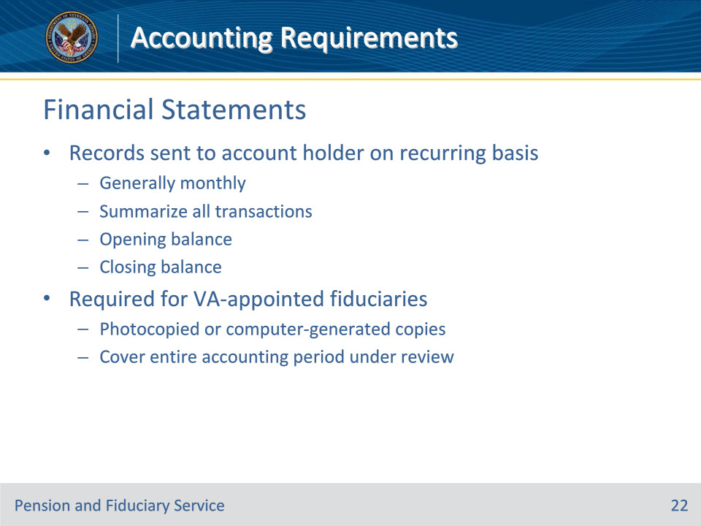
Slide notes

Policy Reference(s): FPM I.3.A.3.g.

Instructor Notes:

Financial institution statements are records sent to the account holder on a reoccurring basis, generally monthly, that summarize all the transactions in an account from the previous statement to the current. The opening balance from the previous month added to the total of all transactions during the period results in the closing balance for the current statement.

Generally, all VA appointed fiduciaries must submit photocopied or computer-generated bank copies of financial institution documents (bank statements) for the accounting period under review.

Slide 23 - Financial Statements
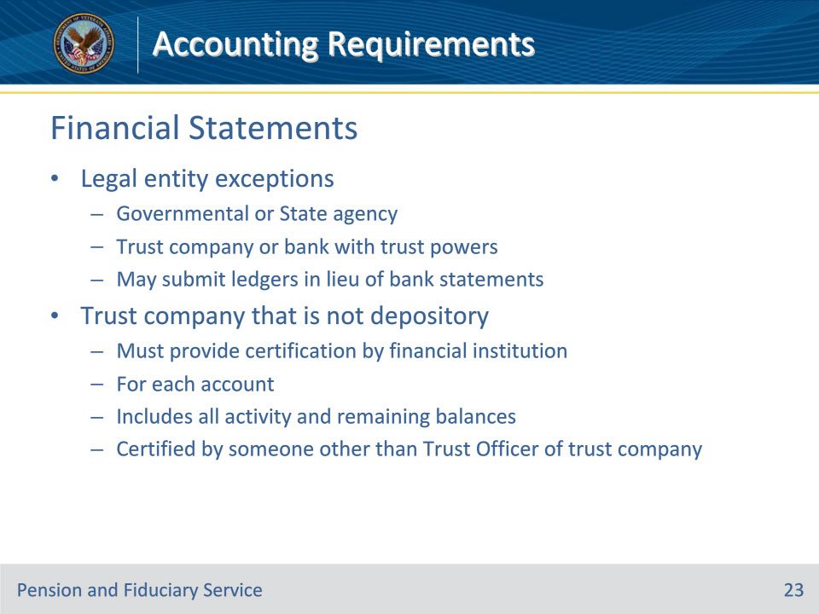
Slide notes

Policy Reference(s): FPM I.3.A.3.g.

Instructor Notes:

Financial institution statements are records sent to the account holder on a reoccurring basis, generally monthly, that summarize all the transactions in an account from the previous statement to the current. The opening balance from the previous month added to the total of all transactions during the period results in the closing balance for the current statement.

Generally, all VA appointed fiduciaries must submit photocopied or computer-generated bank copies of financial institution documents (bank statements) for the accounting period under review. However, a legal entity such as a governmental or State agency, trust company or bank with trust powers may submit ledgers in lieu of bank statements.

Note: A trust company, which is not the depository, must provide certification by the financial institution for each financial institution account that includes all activity including remaining balances and certified by someone other than the Trust Officer of the trust company.

Slide 24 - Determining Accounting Period
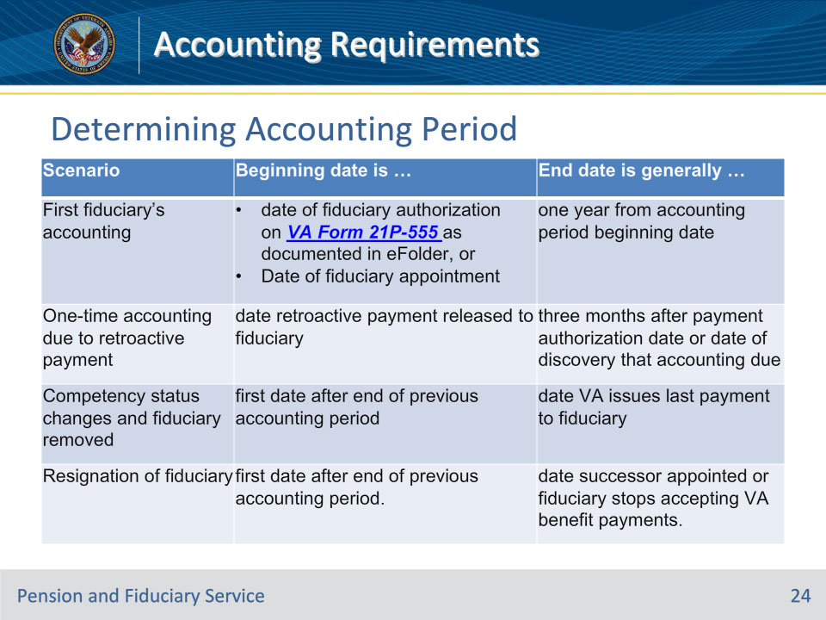
Slide notes

Policy Reference(s): FPM I.3.A.3.n.

Instructor Notes:

The beginning date of the accounting period varies depending on several factors. Use this table as a guide to identify the appropriate beginning and ending dates for the accounting period.

Note for row 2: Retro release date information may be located by reviewing the corporate record in Share.

Note for rows 3 and 4: This accounting is only required when the fiduciary was previously required to account

Slide 25 - Determining Accounting Period
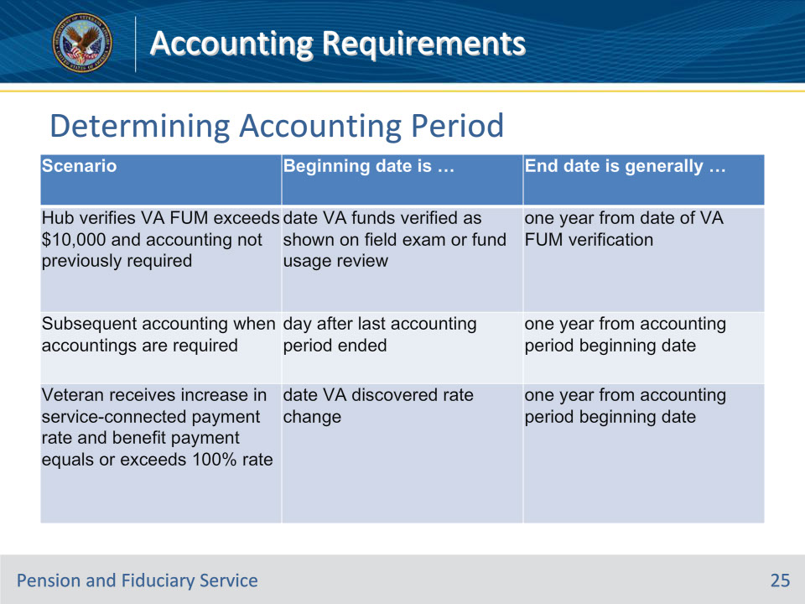
Slide notes

Policy Reference(s): FPM I.3.A.3.n.

Instructor Notes:

The beginning date of the accounting period varies depending on several factors. Use this table as a guide to identify the appropriate beginning and ending dates for the accounting period.

Note for row 1: Establish a 3 or 6-month accounting period, as supported by the FE’s justification, when the FE identifies that the VA FUM

• does not consistently remain over $10,000 during a follow-up field examination, or

• are likely to fall below $10,000 within the next six months.

The LIE must establish an annual accounting if the VA FUM remains over $10,000 at the accounting approval.

Note for row 2: Beginning date is generally the first day after the end of the previously approved accounting period.

Slide 26 - Review of Credit Reports
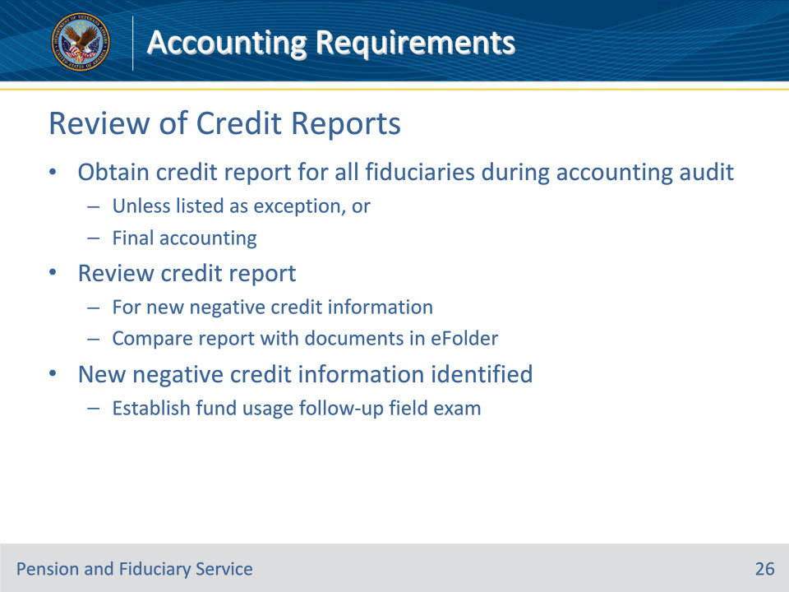
Slide notes

Policy Reference(s): FPM I.3.A.3.o.

Instructor Notes:

LIEs must obtain a credit report for all fiduciaries during the accounting audit unless listed as an exception or for a final accounting. LIEs must then review the credit report for any new negative credit information by comparing the report with documents available within the eFolder. When the review of the credit report identifies new negative credit information, a fund usage follow-up field examination must immediately be established to investigate.

More detailed guidance on this procedure is covered in Credit Reports and Criminal Background Inquiries training(s).

Slide 27 - Review of CBIs
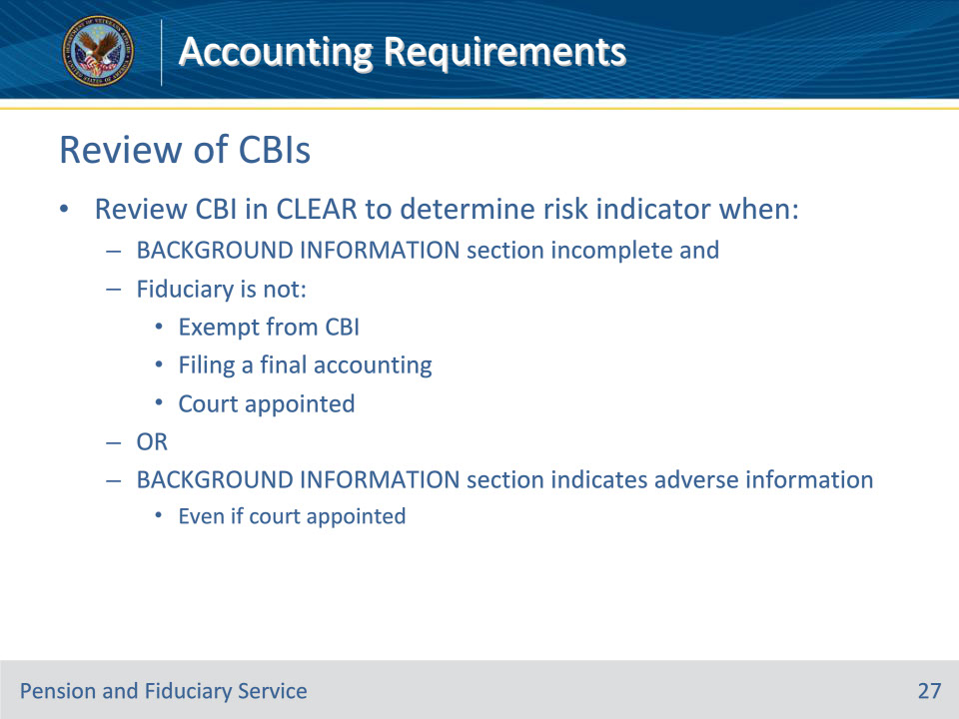
Slide notes

Policy Reference(s): FPM I.3.A.3.p.

Instructor Notes:

Review the CBI in CLEAR to determine the risk indicator when the BACKGROUND INFORMATION block on the VA Form 21P-4706b

• is not completed and the fiduciary is not

• exempt from a CBI

• filing a final accounting, or

• a court appointed fiduciary, or

• indicates adverse information even if the fiduciary is classified as a court-appointed fiduciary.

More detailed guidance on this procedure is covered in Credit Reports and Criminal Background Inquiries training(s).

Slide 28 - VBMS-Fiduciary
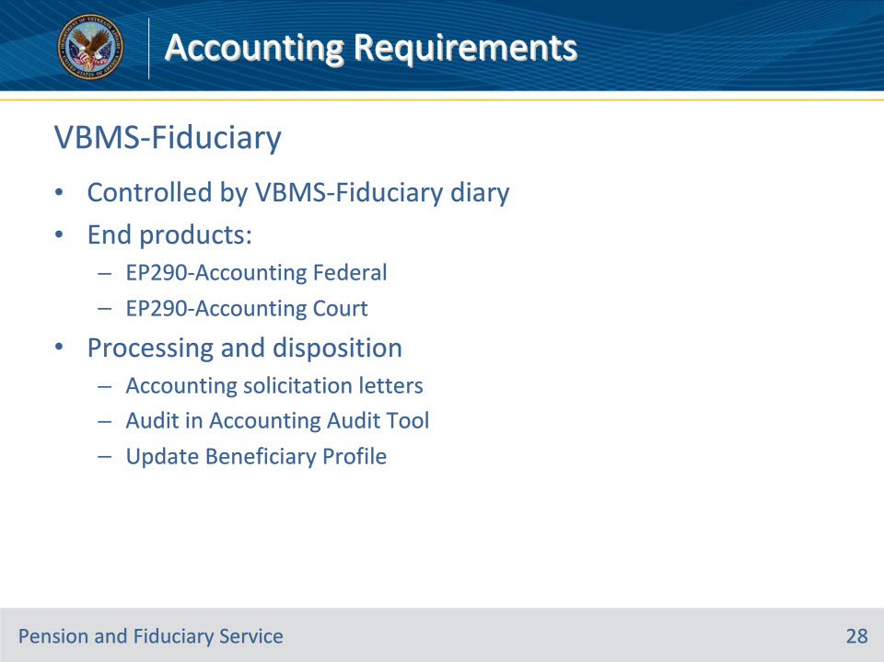
Slide notes

Policy Reference(s): VBMS User Guide

Instructor Notes:

VBMS-Fid creates an accounting end product to control for solicitation, receipt, processing and disposition of an accounting based on the date placed in the “Accounting Period End Date” field in the beneficiary profile.

Accounting end products are either under an EP 290 Accounting Federal for a VA-appointed fiduciary or an EP 290 Accounting Court for a fiduciary that is also court-appointed.

Legal Instruments Examiner (LIE) are responsible for auditing and making decisions on accountings. Accounting solicitation letters are generated and sent to the fiduciaries to let them know their accounting is coming due.

Once the complete accounting is received, the audit is documented within the VBMS-Fid Accounting Audit Tool. Upon audit completion and approval, LIEs must ensure that the VBMS-Fid Beneficiary Profile is updated with all current information and diaries.

Slide 29 - 31. Questions?
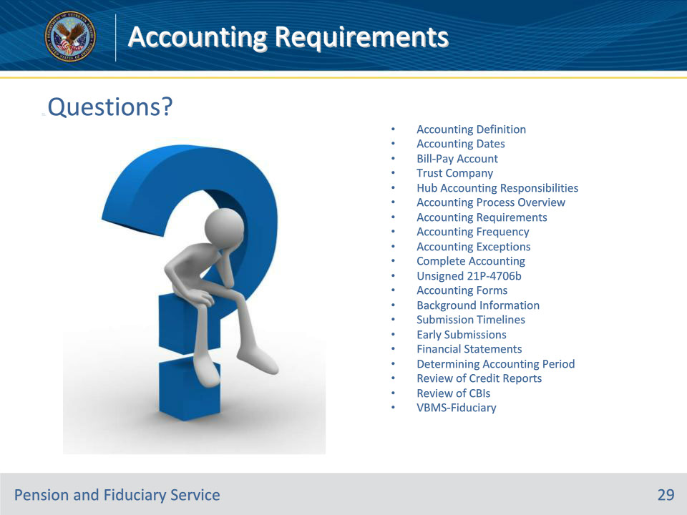
Slide notes

(Recall) These are our learning objectives as stated from the beginning of the training:

• Define accountings and associated terms

• Identify when accountings are required

• Demonstrate basic understanding of accounting process

• Recall the main elements of accountings

(Recap) we discussed each of these learning objectives through the following topics in each slide today:

• Accounting Definition

• Accounting Dates

• Bill-Pay Account

• Trust Company
• Hub Accounting Responsibilities

• Accounting Process Overview

• Accounting Requirements

• Accounting Frequency

• Accounting Exceptions

• Complete Accounting

• Unsigned 21P-4706b

• Accounting Forms

• Background Information

• Submission Timelines

• Early Submissions

• Financial Statements

• Determining Accounting Period

• Review of Credit Reports

• Review of CBIs

• VBMS-Fiduciary

Slide 30 - TMS Survey
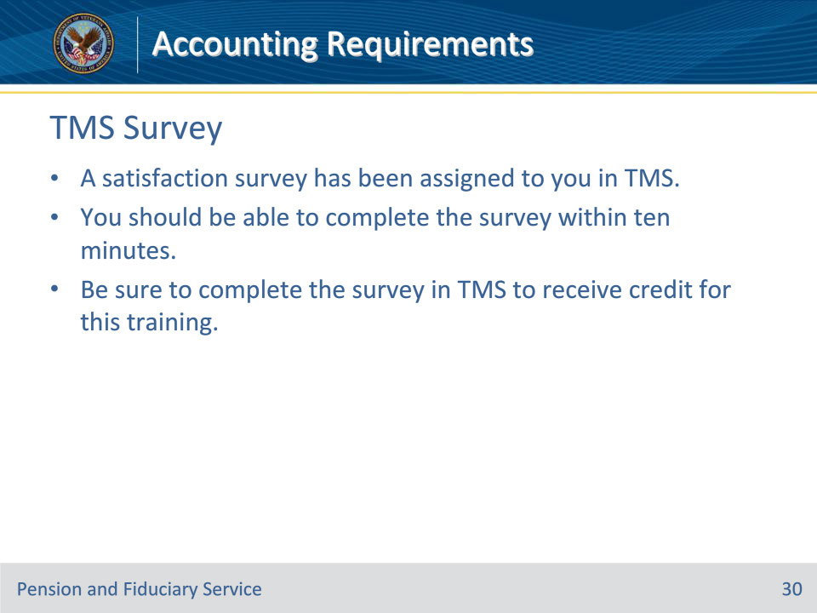
Slide notes

Instructor Notes:

A satisfaction survey has been assigned to you in TMS. You should be able to complete the survey within ten minutes. Completing the survey will allow you to receive credit for this training.

