Slide 1 - Accounting Disposition (Core)
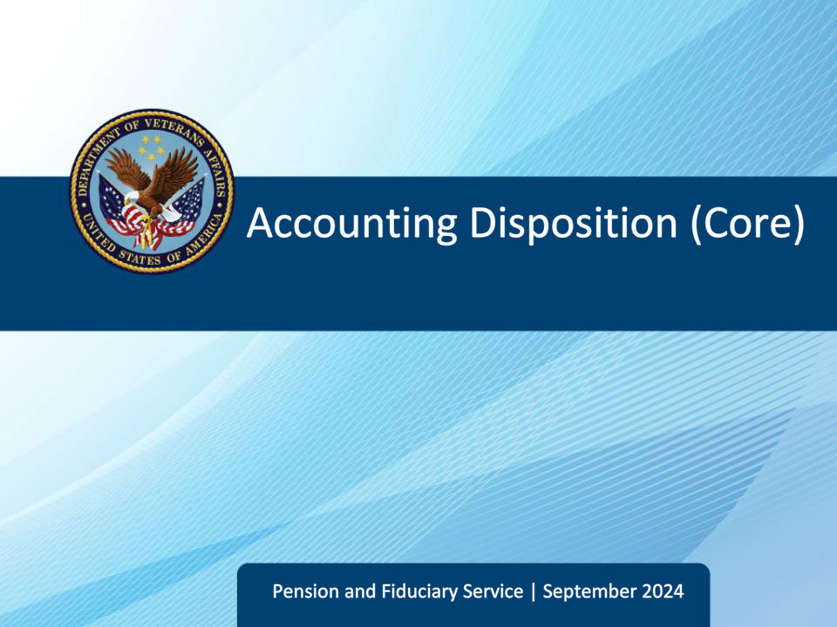
Slide notes

Course Description:

This course teaches fiduciary personnel the required actions they must conduct after making an accounting decision such as drafting correspondence, updating accounting end products, and managing associated tasks.

Slide 2 - Objectives
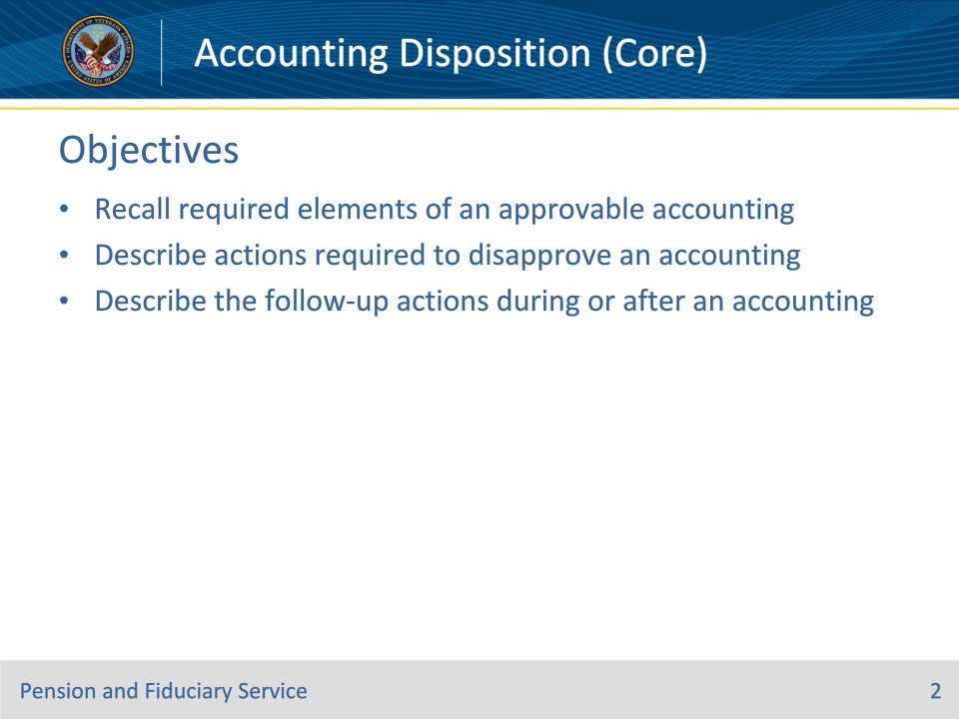
Slide notes

Instructor Notes:

At the end of this lesson, the learner will be able to:

• Recall required elements of an approvable accounting

• Describe actions required to disapprove an accounting

• Describe the follow-up actions during or after an accounting

Slide 3 - References
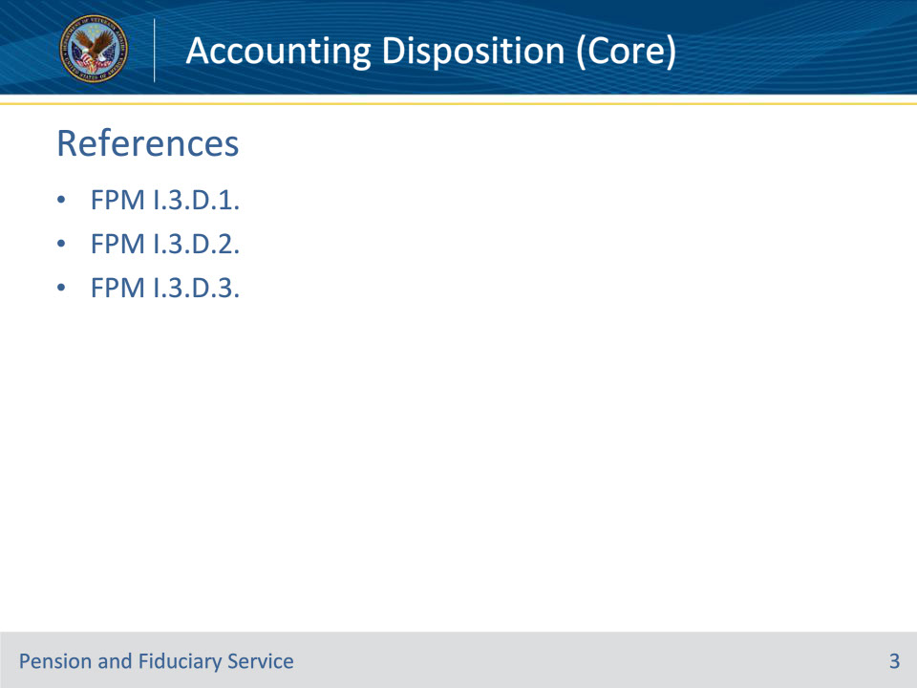
Slide notes

Instructor Notes:

These are the relevant references for this training:

• FPM I.3.D.1. Accounting Approval

• FPM I.3.D.2. Accounting Disapproval

• FPM I.3.D.3. Special Situations Where the Fiduciary is Unable to Account

Slide 4 - Approval Requirements
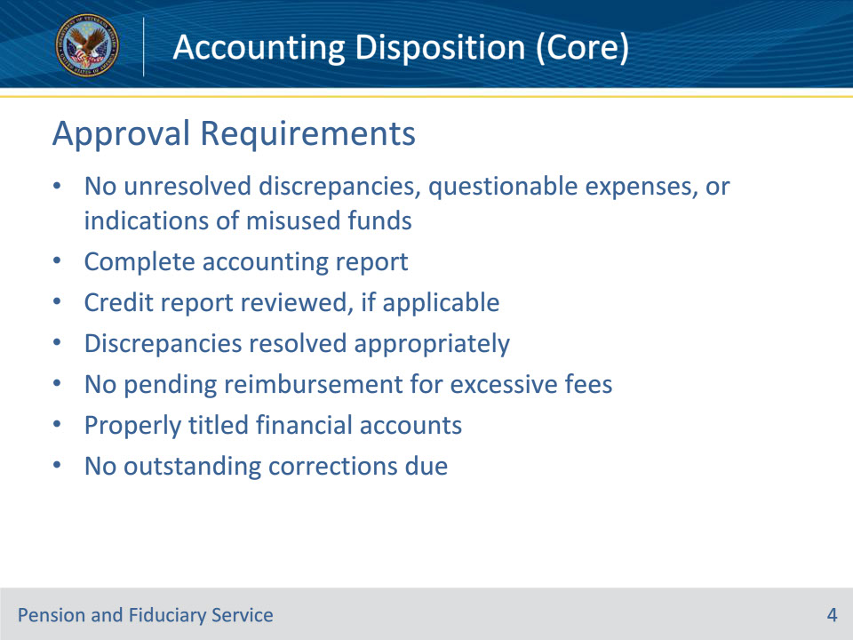
Slide notes

Policy Reference(s): FPM I.3.D.1.a.

Instructor Notes:

Generally, accountings that do not contain unresolved discrepancies, questionable expenses or indications of misused beneficiary funds should be approved.

Approve an accounting when

• the fiduciary submits a complete accounting report.

• a credit report has been obtained and reviewed, if applicable.

• differences in the amounts listed on the accounting form can be resolved by determining that unaltered financial documentation or receipts contain the correct amounts

• the fiduciary is not required to reimburse fees taken in excess of those authorized by the Department of Veterans Affairs (VA), and

• the financial accounts are properly titled.

The fiduciary hub will not approve an accounting with outstanding corrections due by the fiduciary.

Slide 5 - Approval Requirements
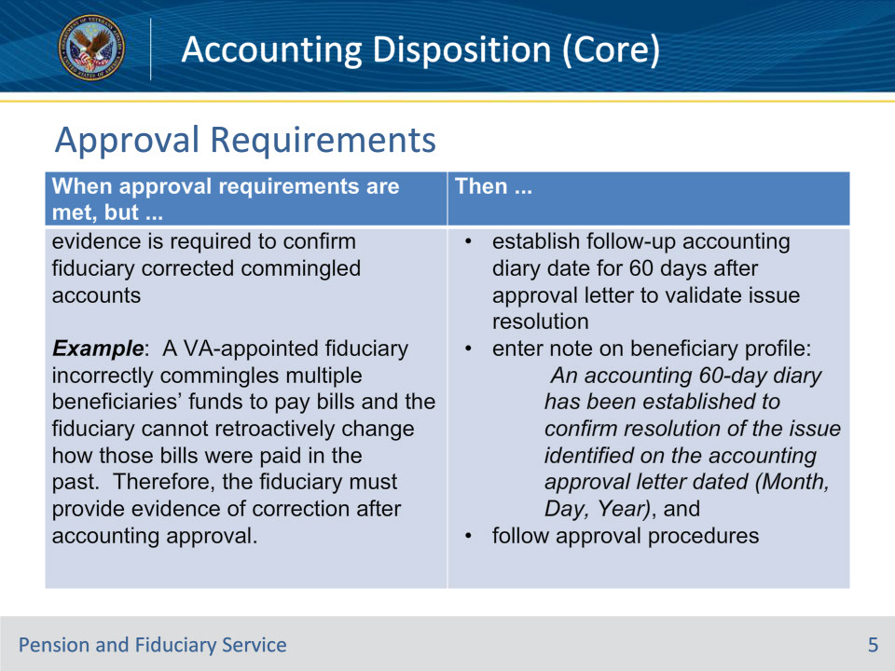
Slide notes

Policy Reference(s): FPM I.3.D.1.a.

Instructor Notes:

Use this table to identify additional actions required when special conditions exist.

Slide 6 - Approval Requirements
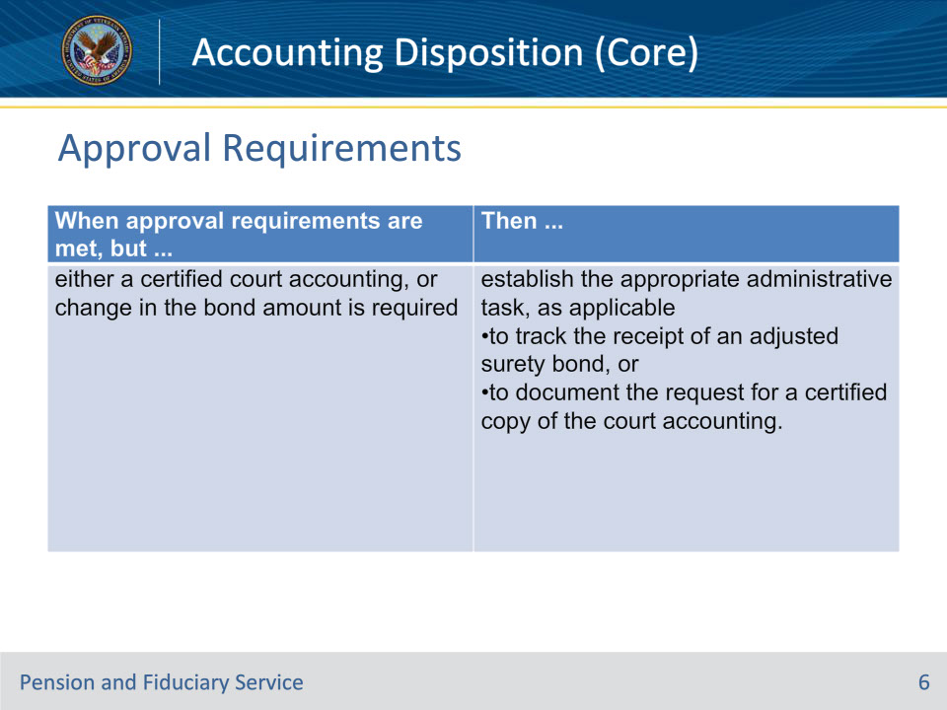
Slide notes

Policy Reference(s): FPM I.3.D.1.a.

Instructor Notes:

Use this table to identify additional actions required when special conditions exist.

Slide 7 - Approval Requirements
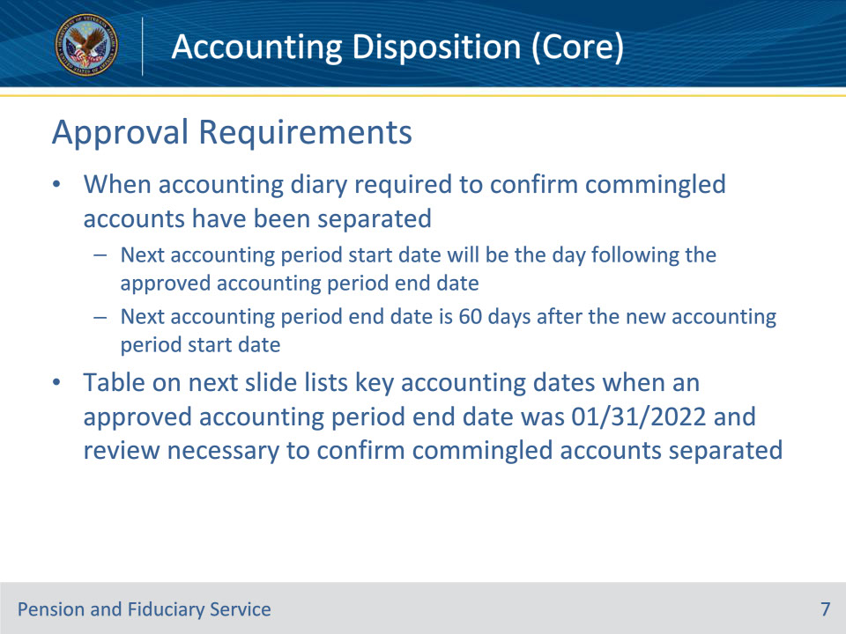
Slide notes

Policy Reference(s): FPM I.3.D.1.a.

Instructor Notes:

When an accounting diary is required to confirm that commingled accounts have been separated, the next accounting period start date will be the day following the approved accounting period end date. The next accounting period end date is 60 days after the new accounting period start date.

Slide 8 - Approval Requirements
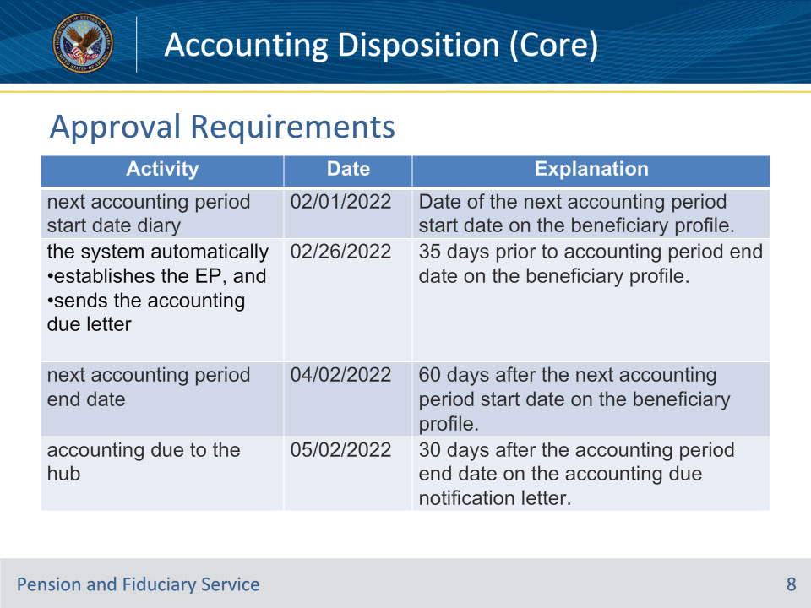
Slide notes

Policy Reference(s): FPM I.3.D.1.a.

Instructor Notes:

This table describes the key accounting dates when the fiduciary’s approved accounting period end date was 01/31/2022 and review is necessary to confirm that commingled accounts have been separated.

Slide 9 - Approval Notification
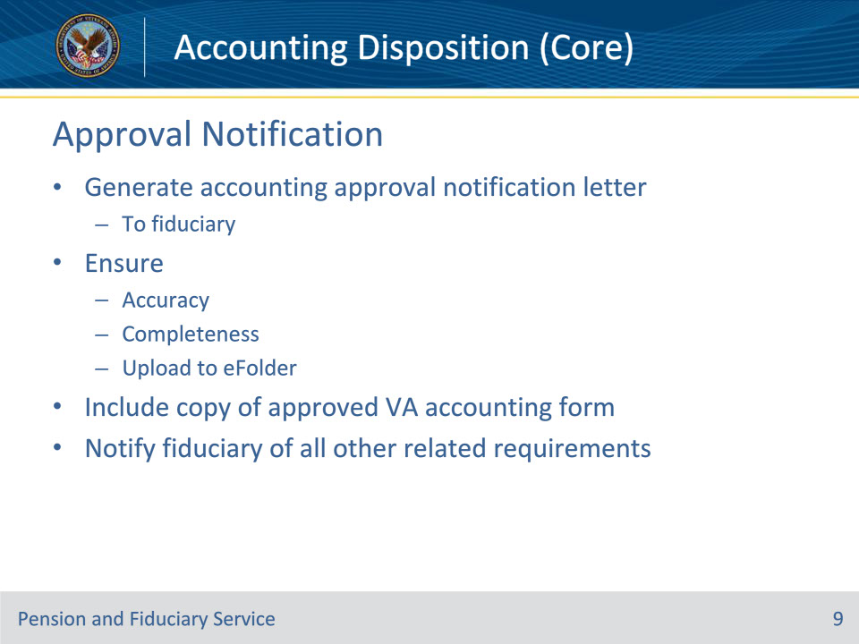
Slide notes

Policy Reference(s): FPM I.3.D.1.b.

Instructor Notes:

The auditing Legal Instruments Examiner (LIE) must generate the appropriate accounting approval notification letter for the fiduciary. The hub must ensure that the appropriate accounting approval notification letter is accurate, complete, and uploaded to the Veteran’s electronic claims folder (eFolder) upon completion.

The appropriate accounting approval notification letter must include a copy of the approved

• VA Form 21P-4706b, VA Fiduciary’s Account, whether submitted via mail or extracted from FAST, or

• VA Form 21P-4706c, Court Appointed Fiduciary’s Account.

The LIE must also notify the fiduciary of all other requirements relating to the audit of the accounting.

Important:

• Electronic notification through FAST without an approval letter is not sufficient to inform the fiduciary of an accounting approval.

• It is not necessary for the hub to provide a copy of the VA accounting approval letter to the court when the VA-appointed fiduciary is also court-appointed. E-mail unresolved matters or legal issues to hub management for referral to District Counsel.

Slide 10 - Required Approval Letter Content
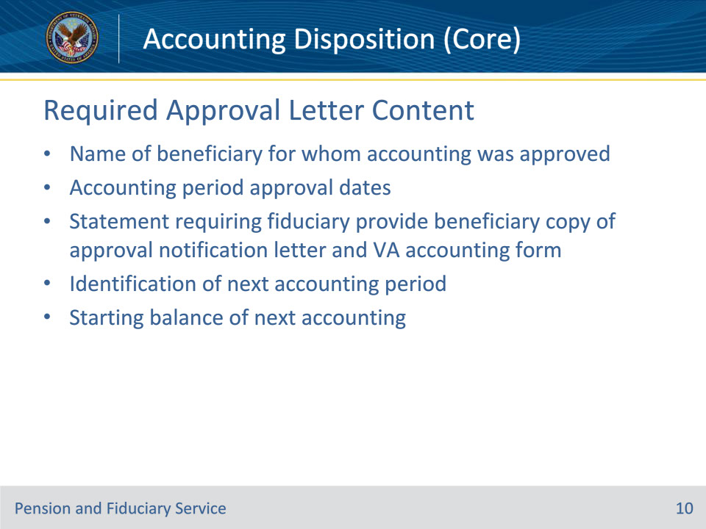
Slide notes

Policy Reference(s): FPM I.3.D.1.c.

Instructor Notes:

Hubs must notify the fiduciary of the approved accounting using the appropriate notification letter. The appropriate accounting approval notification letter must include the following information for the fiduciary:

• the name of the beneficiary for whom the accounting was approved

• the accounting period approval dates

• a statement requiring that the fiduciary provides the beneficiary a copy of the approval notification letter and VA accounting form

• identification of the next accounting period for which the fiduciary must account, and

• the starting balance of the next accounting for the fiduciary.

Slide 11 - Additional Notification Requirements
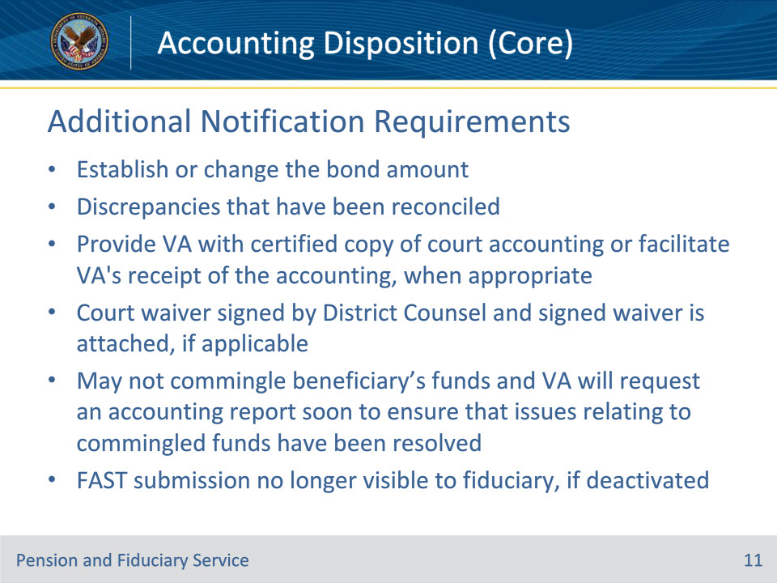
Slide notes

Policy Reference(s): FPM I.3.D.1.c.

Instructor Notes:

Where applicable, additional notification requirements include, but are not limited to, notice to the fiduciary

• to establish or change the bond amount

• of discrepancies that have been reconciled

• to provide VA with a certified copy of the court accounting or facilitate VA’s receipt of the accounting, when appropriate

• that a court waiver has been signed by District Counsel and that the signed waiver is attached, if applicable

• that they may not commingle the beneficiary’s funds and VA will request an accounting report soon to ensure that issues relating to commingled funds have been resolved, and

• that FAST submission will no longer be visible to the fiduciary, if deactivated

Important: When an accounting is no longer required, follow the guidance in FPM, Part I, 3.B.3.b for notification requirements specific to a final accounting.

Slide 12 - Consolidating FAST Reports
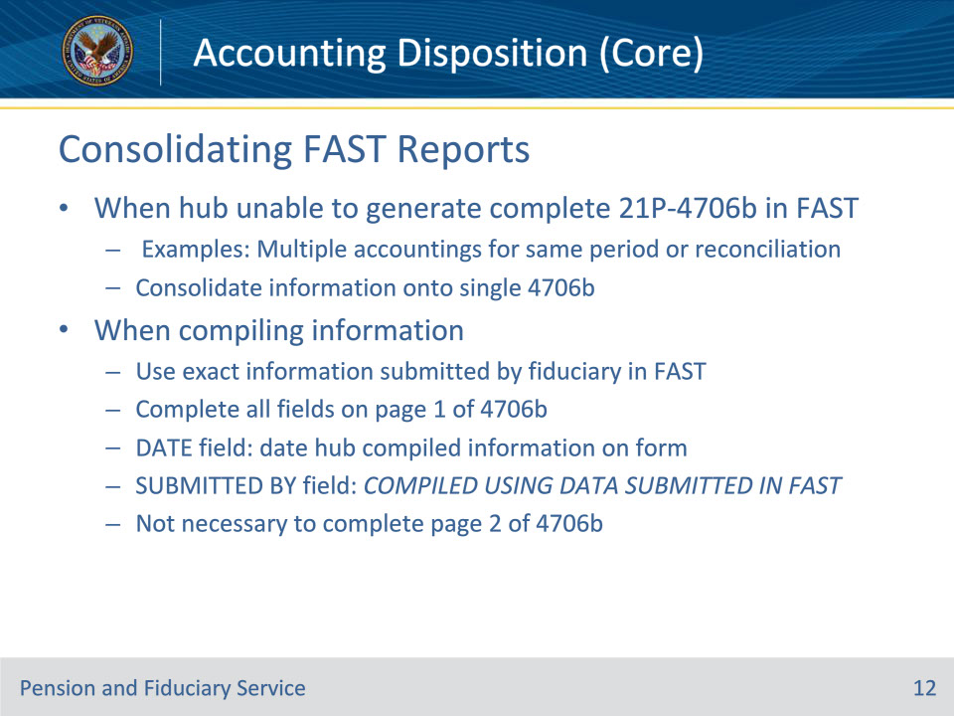
Slide notes

Policy Reference(s): FPM I.3.D.1.d.

Instructor Notes:

Fiduciaries should submit their accounting report correctly so that VA may approve the submission and generate a VA Form 21P-4706b within FAST.

When the hub is unable to generate a complete VA Form 21P-4706b in FAST for an approvable accounting period (for example, the fiduciary submitted multiple accountings for the same period, or the hub reconciled the accounting), consolidate the information onto a single VA Form 21P-4706b using the information provided by the fiduciary in FAST.

When compiling the information, the hub must use the exact information submitted by the fiduciary in FAST for the accounting period to calculate the total money received, money spent, and assets at the end of the period. Hubs must also complete all fields on page one of the VA Form 21P-4706b.

Important:

• The DATE field is the date that the hub compiles the information on the form, and the SUBMITTED BY field must read COMPILED USING DATA SUBMITTED IN FAST when populating page one of the VA Form 21P-4706b.

• It is not necessary to complete page 2 of the VA Form 21P-4706b because the information is available in FAST and does not need to be provided to the beneficiary.

Slide 13 - Approval in Accounting Audit Tool
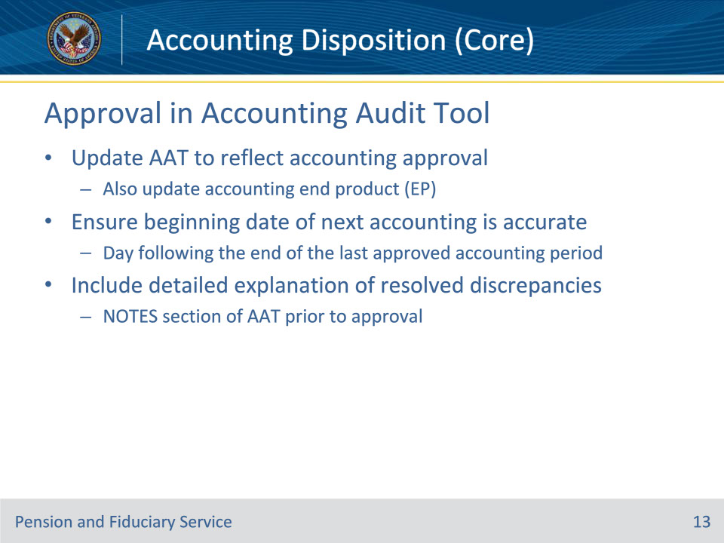
Slide notes

Policy Reference(s): FPM I.3.D.1.e.

Instructor Notes:

The LIE must update the Accounting Audit Tool to reflect the accounting approval as described in the Veterans Benefits Management System (VBMS) Core User Guide. The hub must also update the accounting end product (EP) to reflect the accounting approval.

LIEs must ensure that the beginning date of the next accounting will be the day following the end of the last approved accounting period.

Include a detailed explanation of any resolved discrepancies noted (e.g., identification of discrepancies between financial statements and the fiduciary’s report, and which amounts were accepted for accounting purposes) in the NOTES section of the Accounting Audit Tool prior to approval.

Slide 14 - Approval in FAST
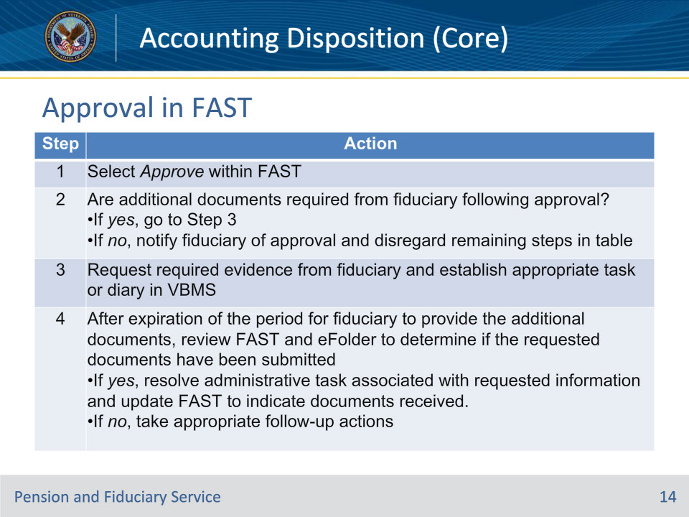
Slide notes

Policy Reference(s): FPM I.3.D.1.f.

Instructor Notes:

When an accounting is submitted via FAST, the LIE must update FAST to reflect the approval. Follow the steps in this table to determine the appropriate status.

Note: When the accounting is approvable, clear the end product (EP) regardless of the specific accounting approval status selected within FAST.

Slide 15 - Updating Beneficiary Profile
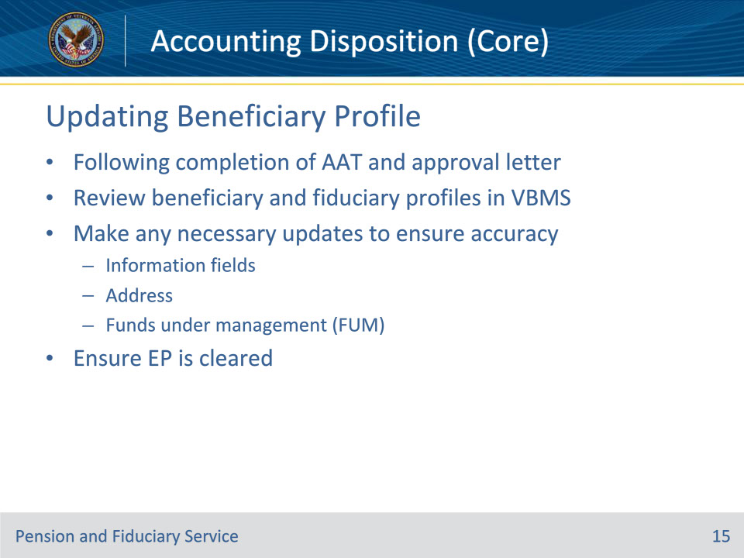
Slide notes

Policy Reference(s): FPM I.3.D.1.g.

Instructor Notes:Following the updates to the Accounting Audit Tool and completion of the appropriate accounting approval notification letter, review the beneficiary and fiduciary profiles in VBMS and make any necessary updates to ensure that the sections below are accurate

• information fields

• address, and

• funds under management (FUM).

Ensure the EP is cleared after finishing the update of the Accounting Audit Tool, beneficiary profile, and notification letter.

Slide 16 - Scheduling Example 1
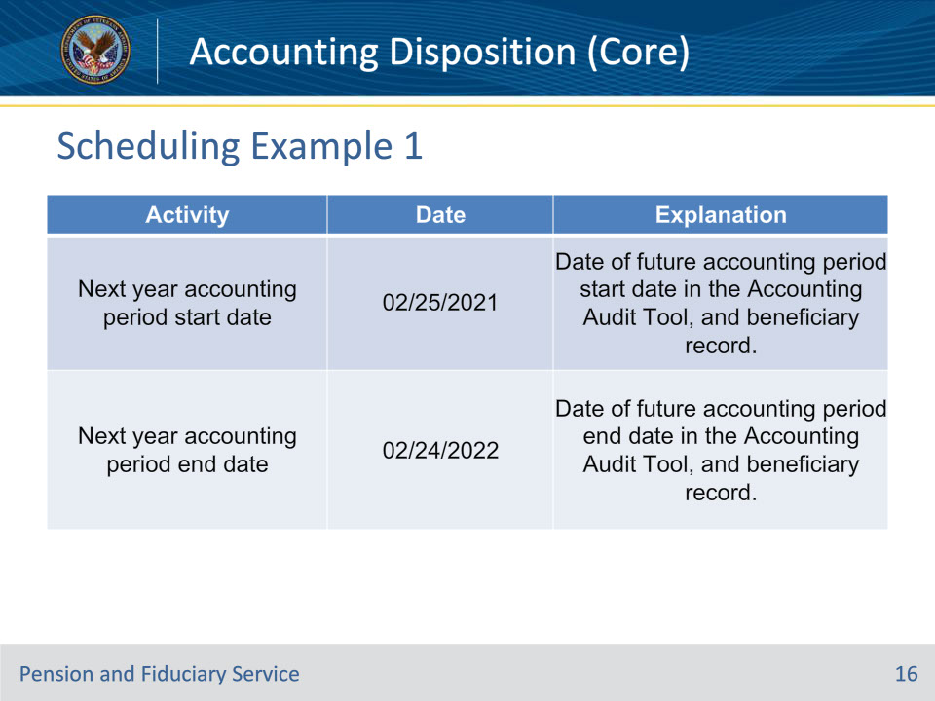
Slide notes

Policy Reference(s): FPM I.3.D.1.h.

Instructor Notes:Example 1: The fiduciary’s approved accounting period is 02/25/2020 to 02/24/2021 when the follow-up accounting period is one year from the date of the last approved accounting period.

Slide 17 - Scheduling Example 2
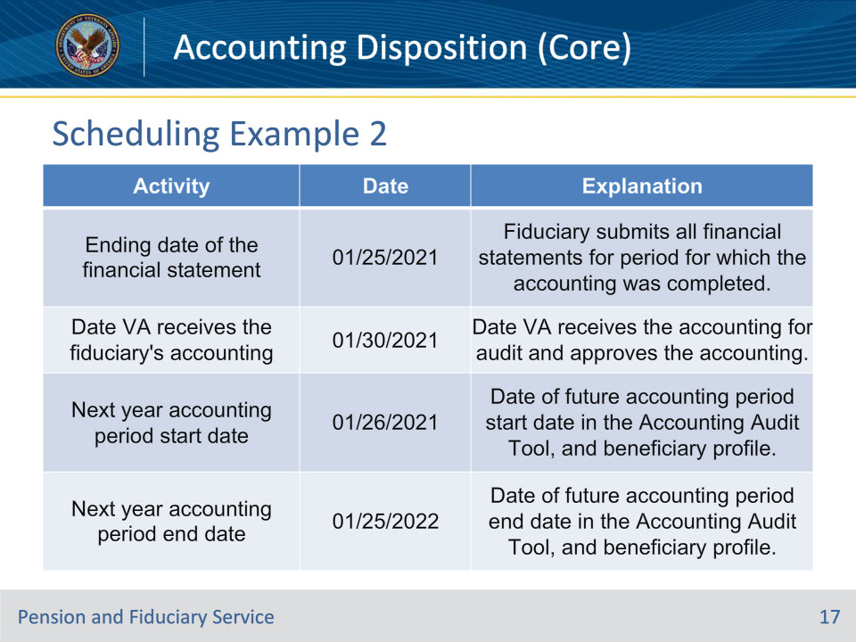
Slide notes

Policy Reference(s): FPM I.3.D.1.h.

Instructor Notes:Example 2: The fiduciary’s accounting period is 02/25/2020 to 02/24/2021. VA receives the accounting on 01/30/2021. The approved accounting period is 02/25/2020 to 01/25/2021, the date of the ending balance on the financial statement. The follow-up accounting period is one year from the date of the last approved accounting period.

Note: Do not overlap accounting period due dates to avoid counting the same income or expense in two different accounting periods. The VA accounting period should not exceed an annual period for a VA-appointed fiduciary.

If the fiduciary no longer meets the accounting requirement, determine if a fund usage review follow-up date is necessary.

Slide 18 - Closing Field Examinations
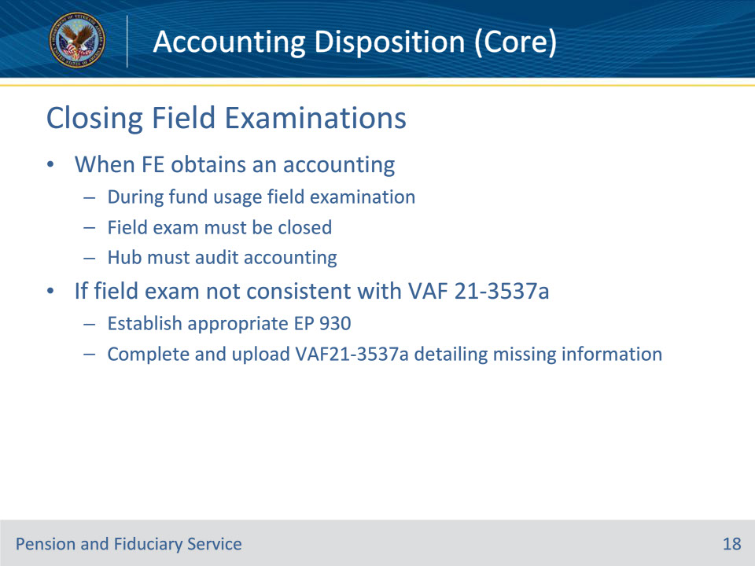
Slide notes

Policy Reference(s): FPM I.3.D.1.i.

Instructor Notes:When a Field Examiner (FE) obtains an accounting during a follow-up fund usage field examination, the field examination must be closed. The LIE must complete the accounting audit or notify the appropriate team member responsible for completing the audit of the receipt of the accounting.

If the auditing LIE identifies that field examination was not completed consistent with the VA Form 21-3537a, Field Examination Request, the LIE must

• establish the appropriate EP 930, and

• complete and upload a VA Form 21-3537a detailing the information that was not previously provided, but requested.

Slide 19 - Disapproval Requirements
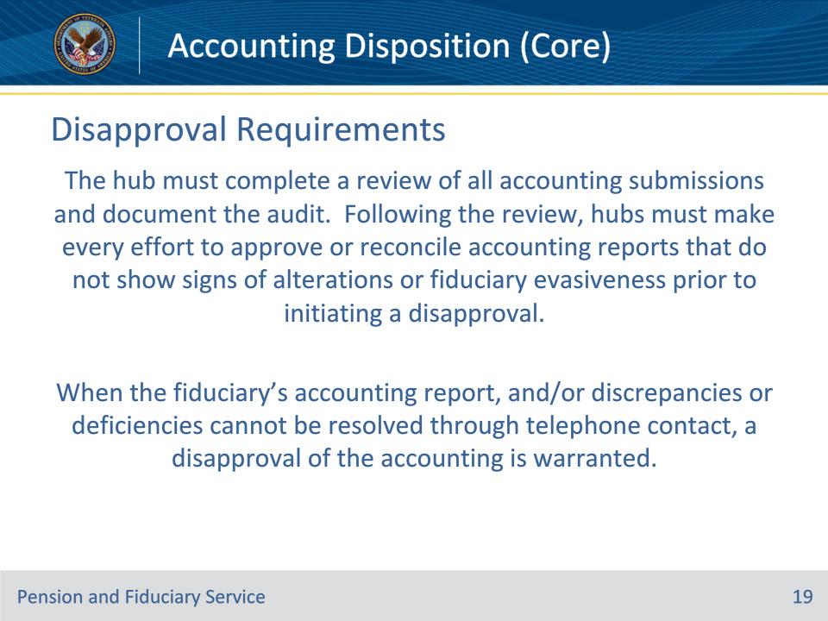
Slide notes

Policy Reference(s): FPM I.3.D.2.a.

Instructor Notes:The hub must complete a review of all accounting submissions and document the audit. Following the review, hubs must make every effort to approve or reconcile accounting reports that do not show signs of alterations or fiduciary evasiveness prior to initiating a disapproval.

When the fiduciary’s accounting report, and/or discrepancies or deficiencies cannot be resolved through telephone contact, a disapproval of the accounting is warranted.

Slide 20 - Disapproval Requirements
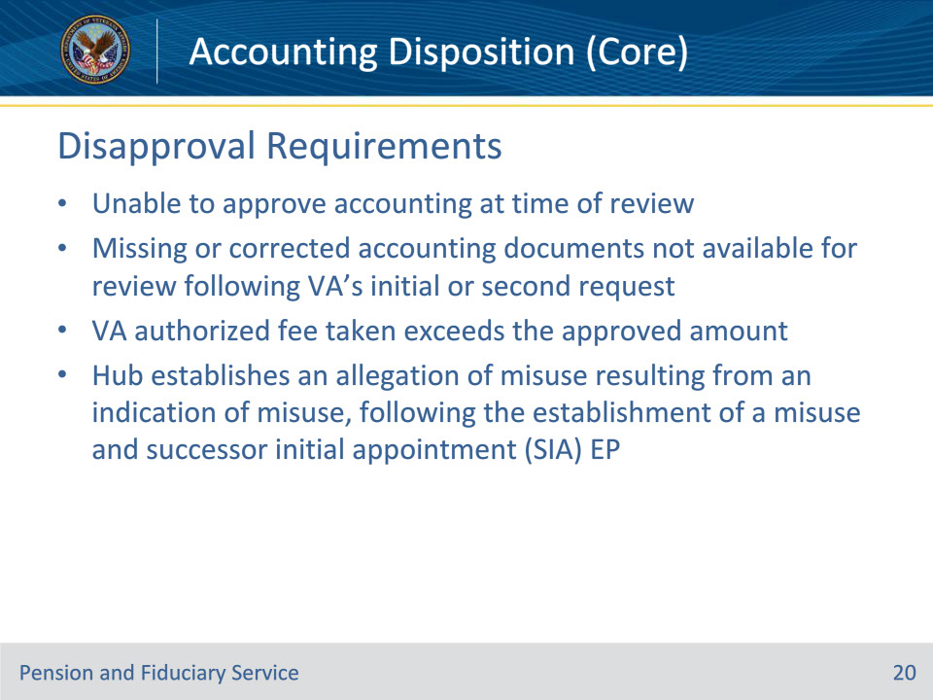
Slide notes

Policy Reference(s): FPM I.3.D.2.a.

Instructor Notes:

Generally, accountings are disapproved when, on the date of review, one or more of the following conditions are met

• the hub is unable to approve the accounting at the time of review

• missing or corrected accounting documents are not available for review following VA’s initial or second request

• the VA authorized fee taken exceeds the approved amount, or

• the hub establishes an allegation of misuse resulting from an indication of misuse, following the establishment of a misuse and successor initial appointment (SIA) EP.

Slide 21 - Disapproval Requirements
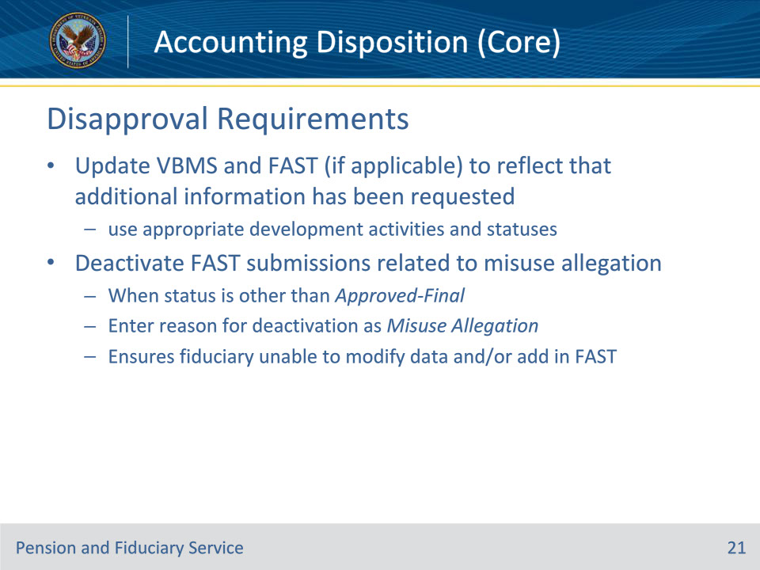
Slide notes

Policy Reference(s): FPM I.3.D.2.a.

Instructor Notes:

When disapproval is warranted, hubs must update VBMS and when applicable, FAST, to reflect that additional information has been requested using the appropriate development activities and statuses.

To ensure that the fiduciary who is the subject of a misuse allegation is unable to modify data and/or add in FAST, the hub must immediately act to deactivate any FAST submission associated with the misuse allegation when the FAST status is other than Approved-Final. Enter the reason for the deactivation as Misuse Allegation.

Slide 22 - Disapproval Notification
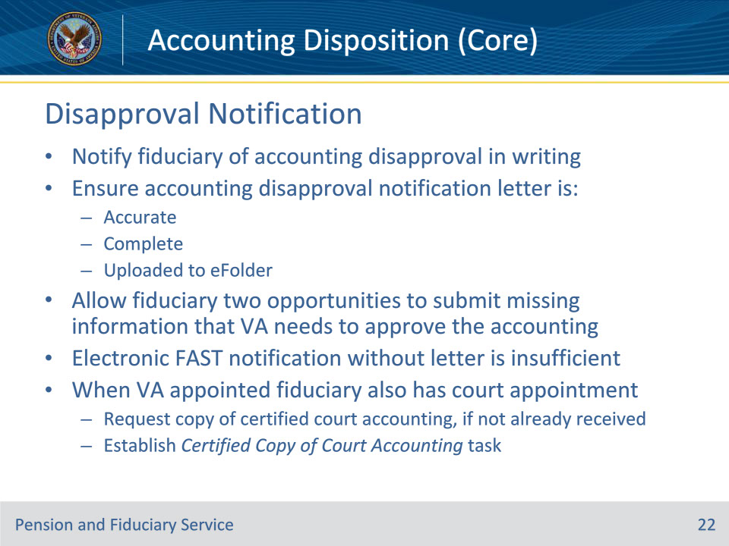
Slide notes

Policy Reference(s): FPM I.3.D.2.b.

Instructor Notes:

Notify the fiduciary of the accounting disapproval in writing following an accounting audit where the LIE cannot approve the accounting without additional information. The hub must ensure that the accounting disapproval notification letter is accurate, complete, and uploaded to the Veteran’s eFolder upon completion.

Allow the fiduciary two opportunities to submit missing information that VA needs to approve the accounting.

Important:

• Electronic notification through FAST without a disapproval letter is not sufficient to inform the fiduciary of accounting disapproval.

• When the VA appointed fiduciary also has a court appointment, request that the fiduciary provide a copy of their most recent certified court accounting, if not already received, and establish a Certified Copy of Court Accounting task.

Slide 23 - Disapproval Notification
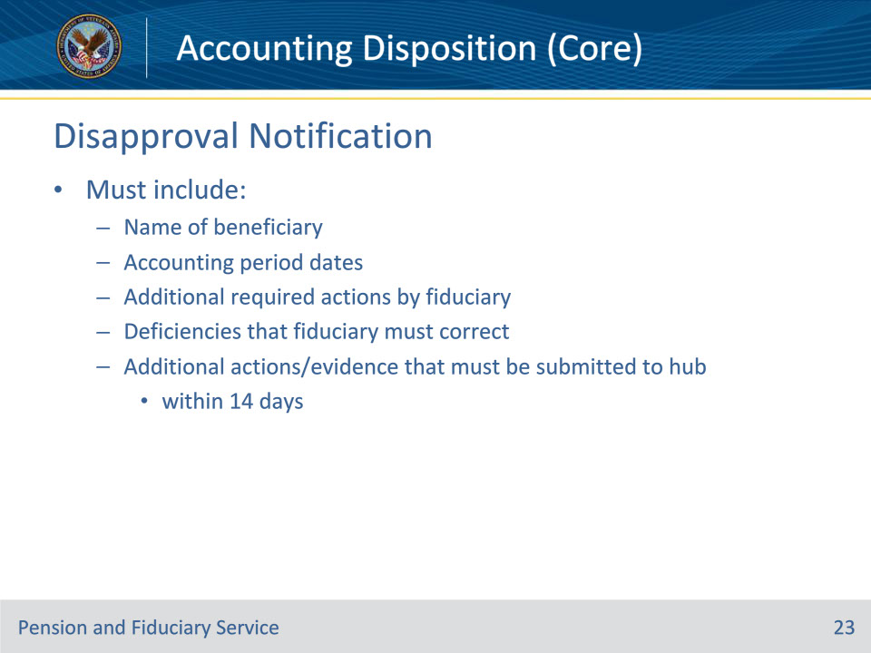
Slide notes

Policy Reference(s): FPM I.3.D.2.b.

Instructor Notes:

The Disapproved Letter must include the following information:

• the name of the beneficiary for whom the accounting was disapproved

• the accounting period dates

• any additional required actions by the fiduciary (e.g., requirement to obtain a properly titled account, identification of discrepancies between financial statements and the fiduciary’s report, and which amounts were accepted for accounting purposes)

• the deficiencies that the fiduciary must correct, and

• any additional actions or evidence that must be submitted to the hub within 14 days.

Note: When the VA has not received any accounting documents 30 days after the accounting due notification

• do not send a disapproval notification letter to the fiduciary

• leave the EP pending, and

• follow the steps in FPM, Part I, 3.B.4 to handle cases when no accounting report is of record.

Slide 24 - Insufficient Accounting Information
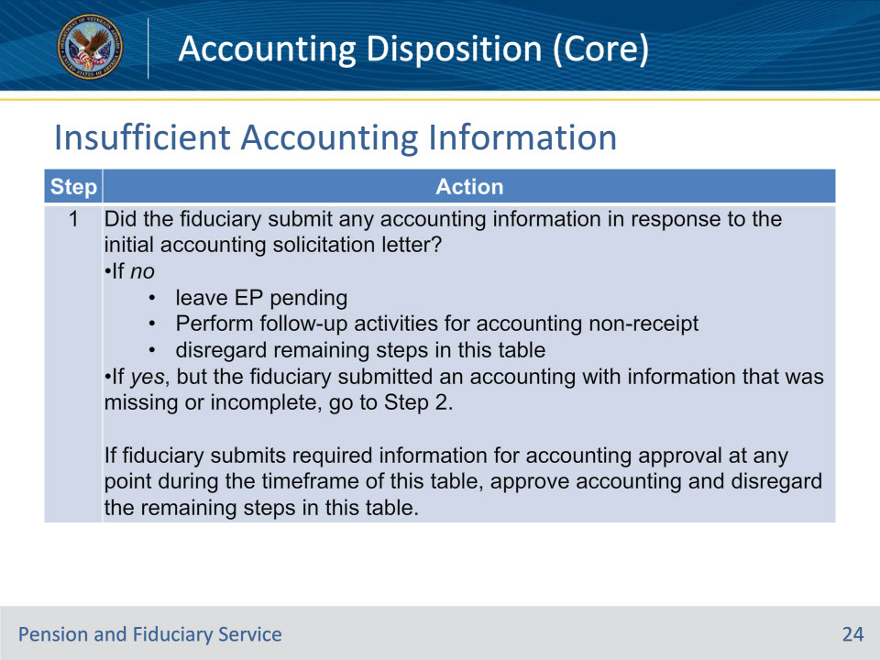
Slide notes

Policy Reference(s): FPM I.3.D.2.c.

Instructor Notes:

Follow the steps in this table when a fiduciary does not respond, within 30 days of the accounting due notification, to VA’s request for an accounting with sufficient information to approve the accounting.

Slide 25 - Insufficient Accounting Information
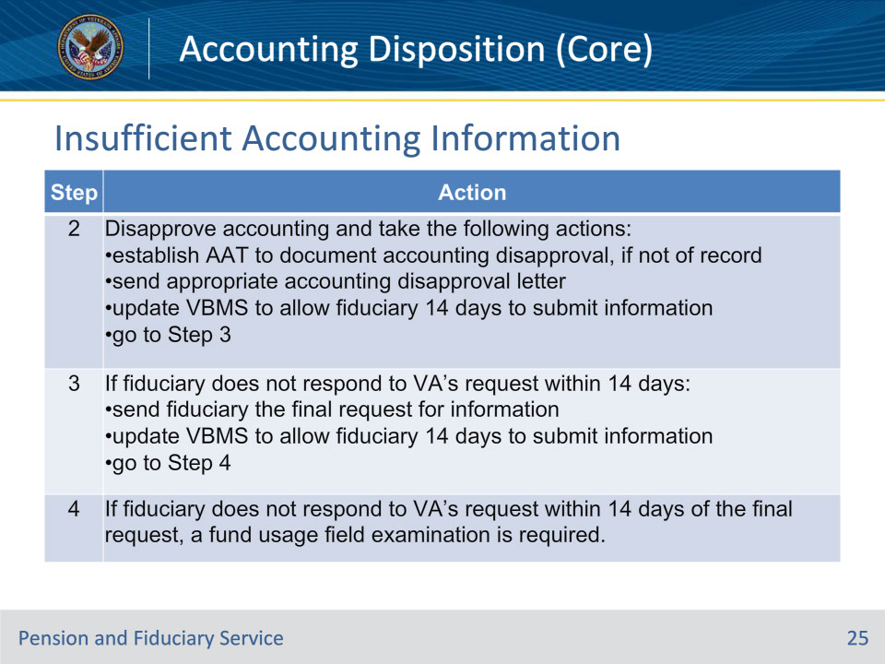
Slide notes

Policy Reference(s): FPM I.3.D.2.c.

Instructor Notes:

Follow the steps in this table when a fiduciary does not respond, within 30 days of the accounting due notification, to VA’s request for an accounting with sufficient information to approve the accounting.

Slide 26 - First Request for Additional Information
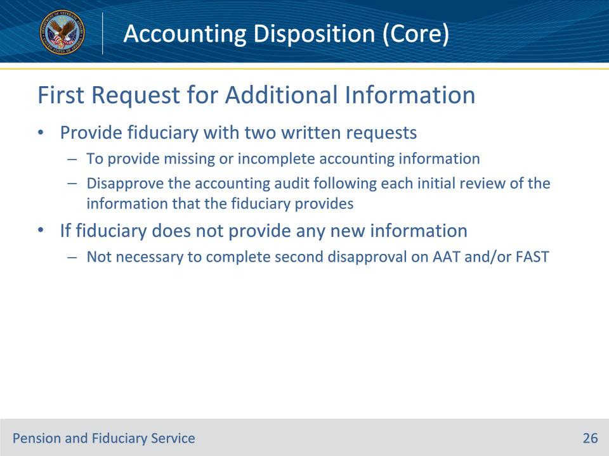
Slide notes

Policy Reference(s): FPM I.3.D.2.d.

Instructor Notes:

Provide the fiduciary with two written requests to provide missing or incomplete accounting report information. Disapprove the accounting audit following each initial review of the information that the fiduciary provides.

It is not necessary to complete a second disapproval of the accounting report on the Accounting Audit Tool and/or FAST if the fiduciary does not provide any new information after the initial request for additional information.

Slide 27 - First Request for Additional Information
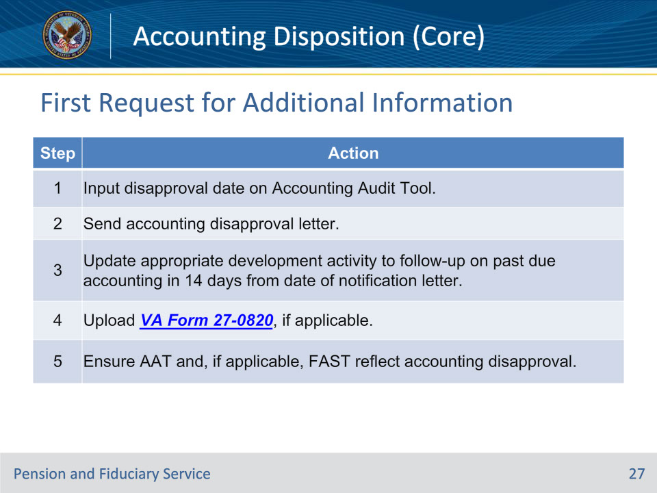
Slide notes

Policy Reference(s): FPM I.3.D.2.d.

Instructor Notes:

Follow the steps in this table when updating the system following the disapproval letter for missing or incomplete accounting information.

Note: The disapproval date must match the date on the disapproval notification letter package that was created in VBMS Package Manager and transmitted for centralized printing and mailing.

Slide 28 - First Accounting Disapproval
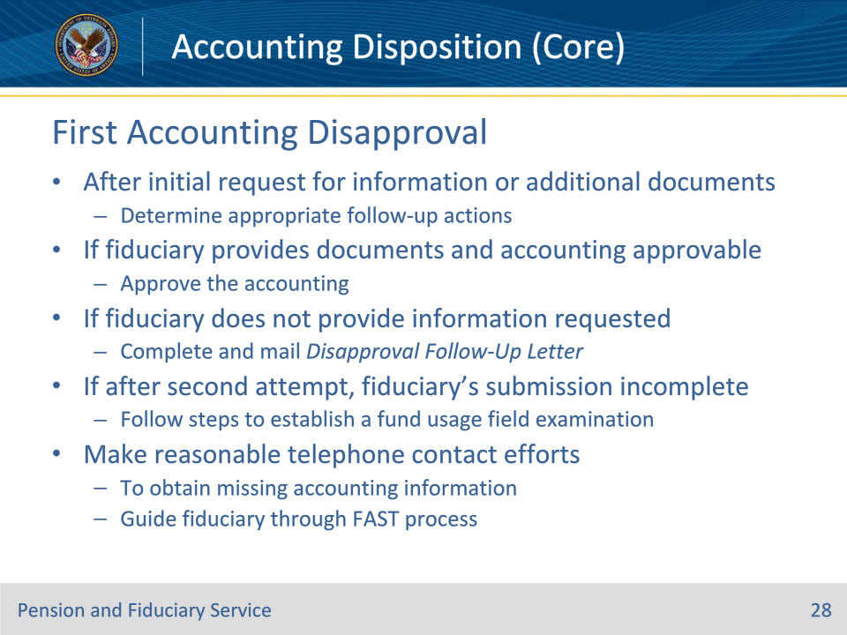
Slide notes

Policy Reference(s): FPM I.3.D.2.e.

Instructor Notes: After the initial request for information or additional accounting documents in the Disapproved Letter, determine the appropriate follow-up actions.

If the fiduciary provides additional accounting documents in response to VA’s request for more information and the accounting is approvable, then follow the guidance for approving the accounting.

If the LIE is unable to approve the accounting because the fiduciary does not provide the information that VA requested, complete and mail the Disapproval Follow-Up Letter to request the missing accounting information.

If after the second attempt, the fiduciary’s submission includes an incomplete accounting, immediately follow the steps to establish a fund usage field examination.

Beyond the initial and follow-up requests specified in this block, do not initiate further written requests for the missing accounting information. However, LIEs must make reasonable efforts to make telephone contact with the fiduciary to obtain missing accounting information. Telephone contact is also appropriate to guide the fiduciary through the process of uploading the required information or updating data in FAST.

Slide 29 - Documenting Requests
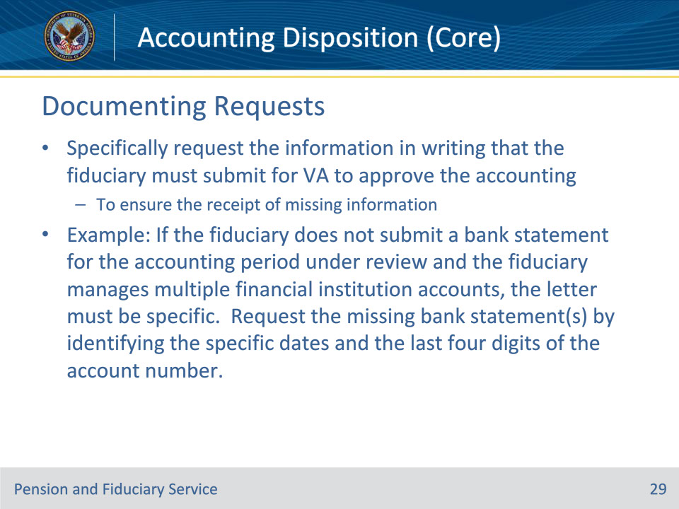
Slide notes

Policy Reference(s): FPM I.3.D.2.f.

Instructor Notes: To ensure the receipt of missing information, the hub must specifically request the information in writing that the fiduciary must submit for VA to approve the accounting.

The scenario below describes how to provide written notification to the fiduciary.

Example: If the fiduciary does not submit a bank statement for the accounting period under review and the fiduciary manages multiple financial institution accounts, the letter must be specific. Request the missing bank statement(s) by identifying the specific dates and the last four digits of the account number.

Bank statement for accounting ending (1234) for May 1, 2020, through May 30, 2020.

Slide 30 - Suspension of Benefits
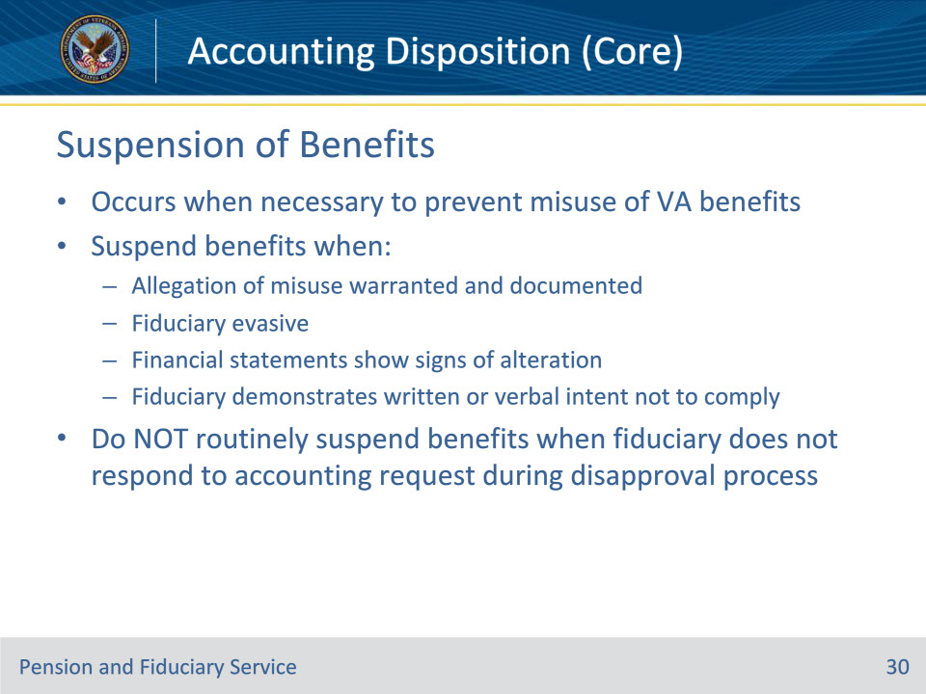
Slide notes

Policy Reference(s): FPM I.3.D.2.g.

Instructor Notes: Generally, VA benefit payment suspension occurs when it is necessary to prevent misuse or continued misuse of VA benefits being paid to the fiduciary on behalf of the beneficiary.

During the accounting review the hub must suspend benefit payments to the fiduciary when a(n)

• allegation of misuse is warranted and is documented in the file

• fiduciary is evasive when attempting to clarify information during the accounting process

• hub identifies financial statements that show signs of alteration, or

• fiduciary demonstrates a written or verbal intent not to comply with VA’s request.

Do not routinely suspend benefit payments because the fiduciary does not respond to VA’s request for an accounting during the accounting disapproval process.

Slide 31 - Unable to Account
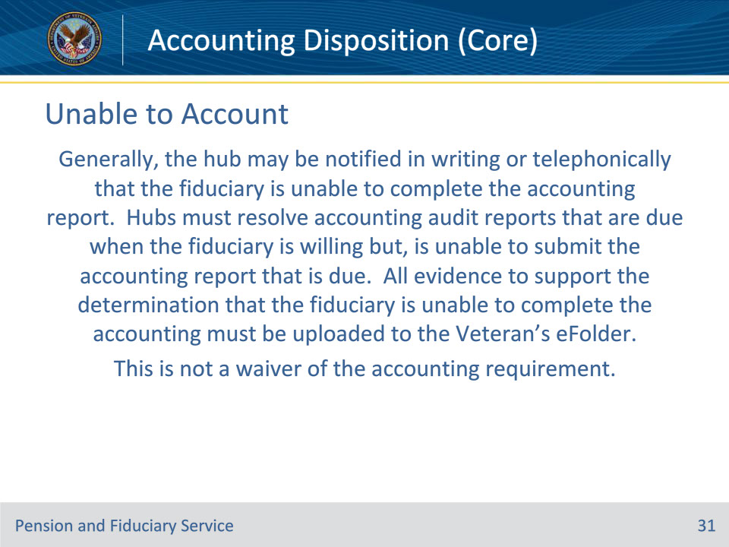
Slide notes

Policy Reference(s): FPM I.3.D.3.a.

Instructor Notes: Generally, the hub may be notified in writing or telephonically that the fiduciary is unable to complete the accounting report. Hubs must resolve accounting audit reports that are due when the fiduciary is willing but, is unable to submit the accounting report that is due. All evidence to support the determination that the fiduciary is unable to complete the accounting must be uploaded to the Veteran’s eFolder.

Important: This is not a waiver of the accounting requirement.

Slide 32 - Death of Fiduciary
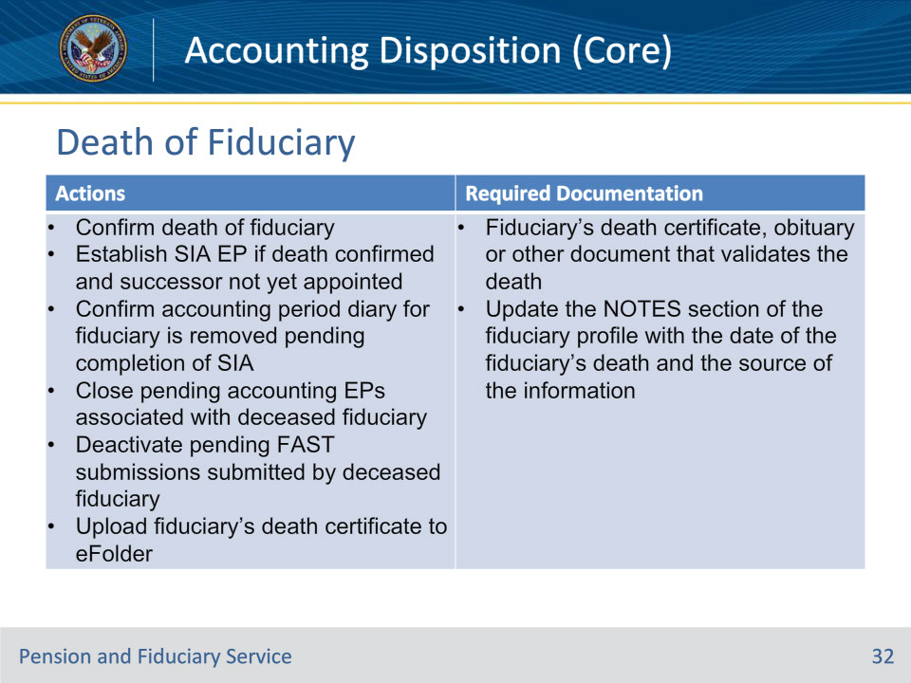
Slide notes

Policy Reference(s): FPM I.3.D.3.a.

Instructor Notes: Use this table to determine how to handle an accounting when special circumstances exist, and the fiduciary is unable to submit their accounting.

Slide 33 - Incapacitation Due to Illness
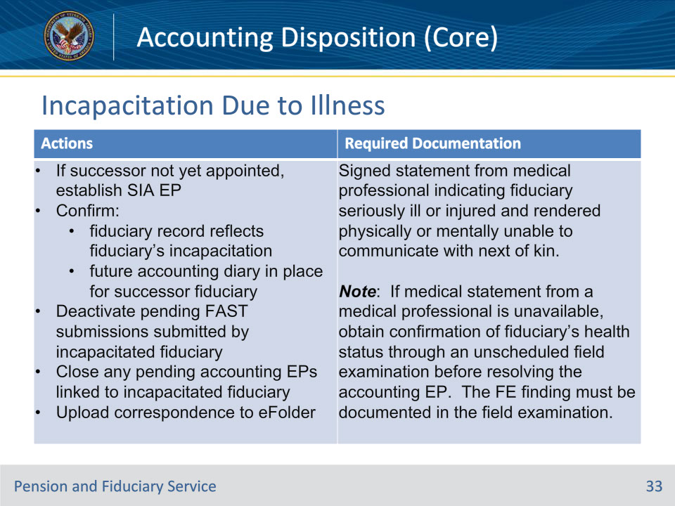
Slide notes

Policy Reference(s): FPM I.3.D.3.a.

Instructor Notes: Use this table to determine how to handle an accounting when special circumstances exist, and the fiduciary is unable to submit their accounting.

Slide 34 - Fiduciary Incarceration
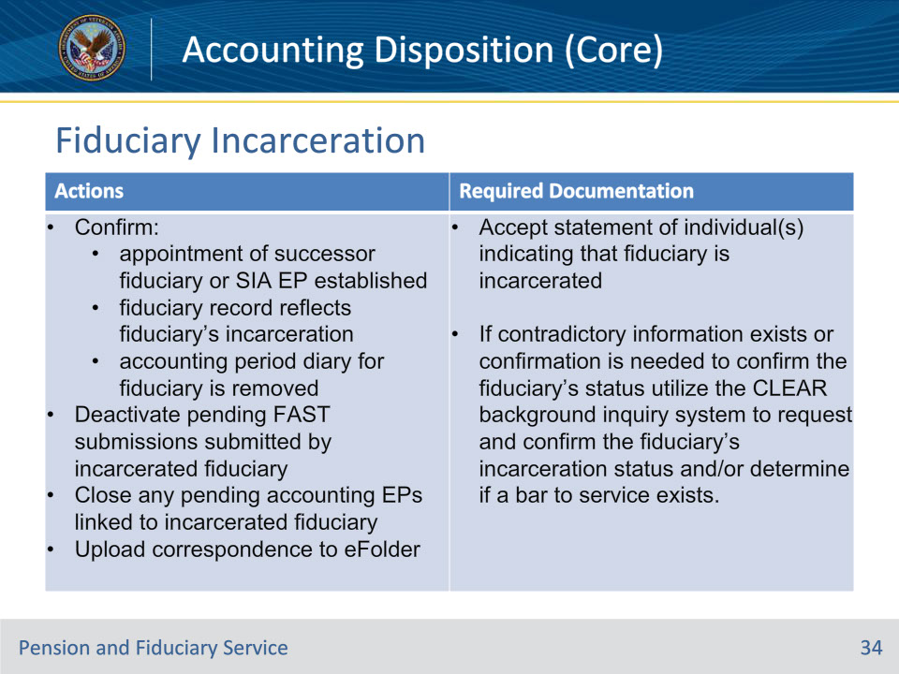
Slide notes

Policy Reference(s): FPM I.3.D.3.a.

Instructor Notes: Use this table to determine how to handle an accounting when special circumstances exist, and the fiduciary is unable to submit their accounting.

Slide 35 - Successor Fiduciary
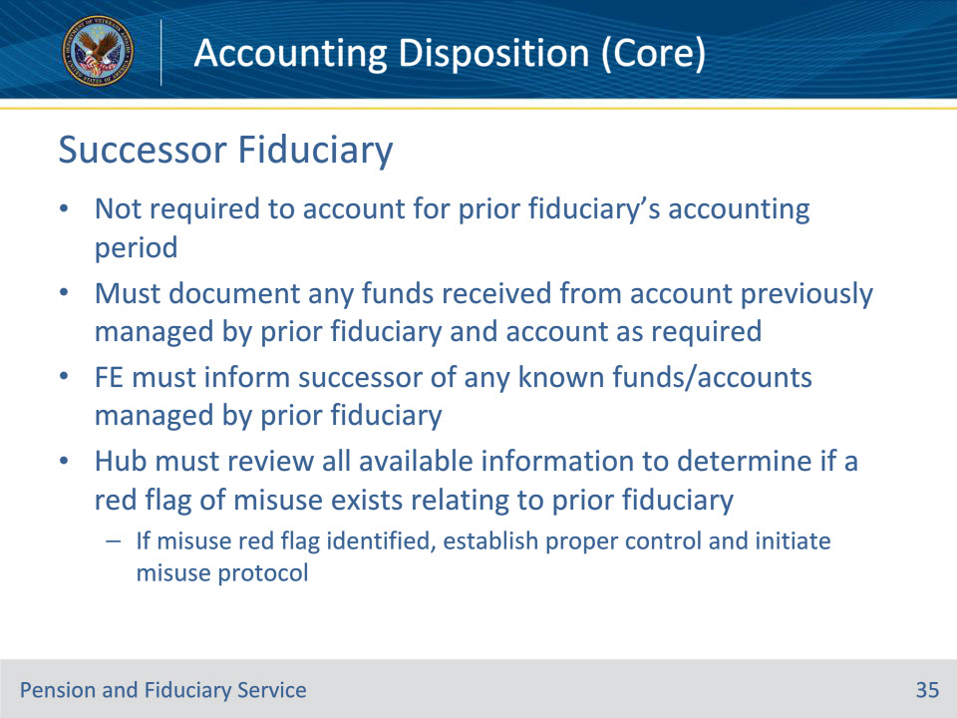
Slide notes

Policy Reference(s): FPM I.3.D.3.a.

Instructor Notes:

The successor fiduciary is not required to account for the accounting period of the prior fiduciary. The successor fiduciary must document any funds received from the custodial/guardianship account previously managed by the prior fiduciary and account as required.

It is the responsibility of the FE to inform the successor fiduciary of any known funds and accounts managed by the fiduciary who can no longer fulfill their accounting requirements.

The hub is responsible for reviewing all available information to determine if a red flag of misuse exists relating to the use of the beneficiary’s funds by the fiduciary who is unable to account. If the hub identifies a red flag of misuse, the hubs must establish proper control and take corresponding actions as required.

Slide 36 - Removing Accounting Requirement
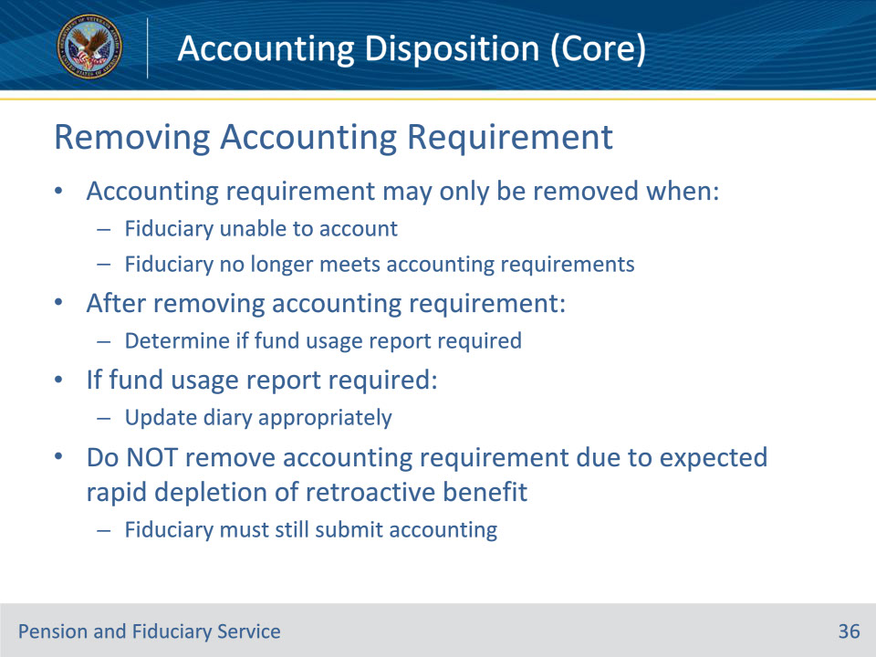
Slide notes

Policy Reference(s): FPM I.3.D.3.b.

Instructor Notes:

An accounting requirement may only be removed when a fiduciary is no longer required to account because they are unable to do so, or they no longer meet the accounting requirements.

The hub must review the accounting requirements and remove the accounting requirement if the fiduciary is no longer required to account.

After removing the accounting requirement, determine if the fiduciary is required to provide a fund usage report. If the fiduciary is required to submit a fund usage report update the diary appropriately.

The hub must not remove an accounting requirement when the hub expects rapid depletion of a retroactive benefit greater than $10,000. The fiduciary must still submit the accounting.

Slide 37 - Questions?
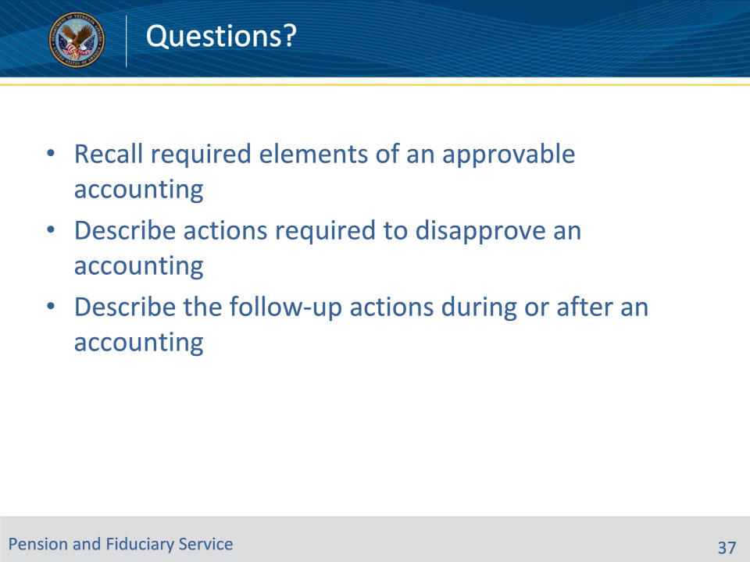
Slide notes

Instructor Notes:

(Recall) These are our learning objectives as stated from the beginning of the training:

• Recall required elements of an approvable accounting

• Describe actions required to disapprove an accounting

• Describe the follow-up actions during or after an accounting

Are there any questions?

Questions should be filtered through your QRT team. They will submit your questions to the Field Inquiry Tool (FIT) on your behalf.

Slide 38 - TMS Survey/Assessment
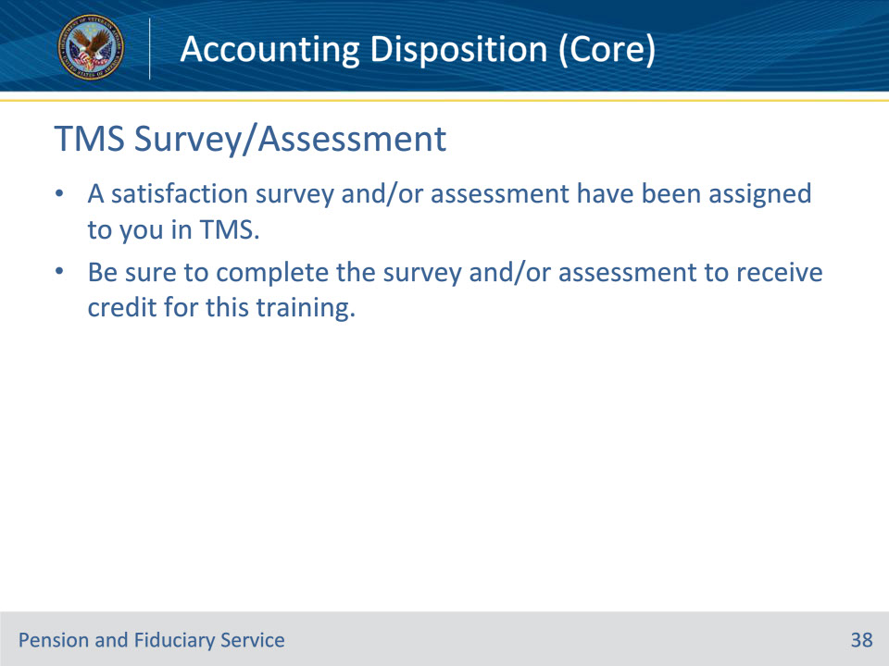
Slide notes

Instructor Notes

A satisfaction survey and/or assessment have been assigned to you in TMS.

Be sure to complete the survey and/or assessment to receive credit for this training.

