Slide 1 - VA-Appointed Fiduciary
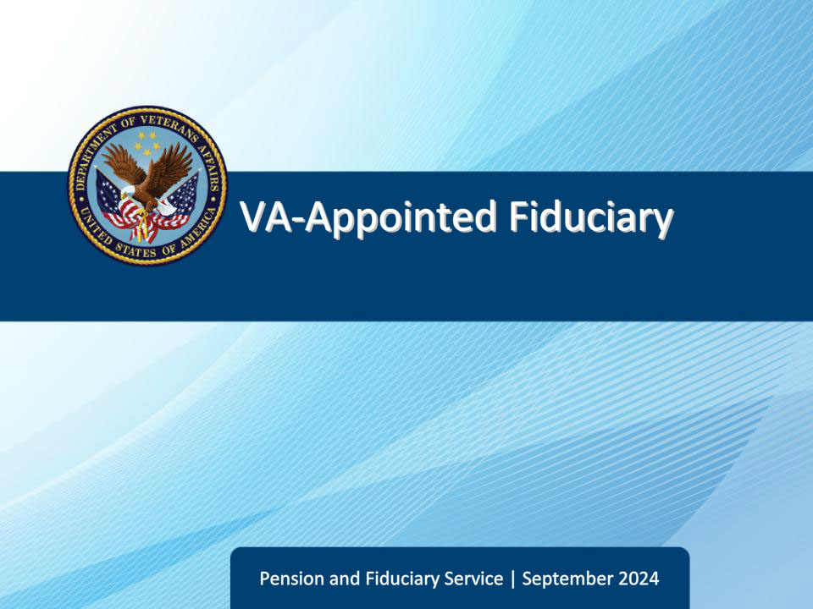
Slide notes

Course Description:

This course teaches learners about the basic factors of investigating, appointing, and supervising VA-appointed fiduciaries.

Slide 2 - References
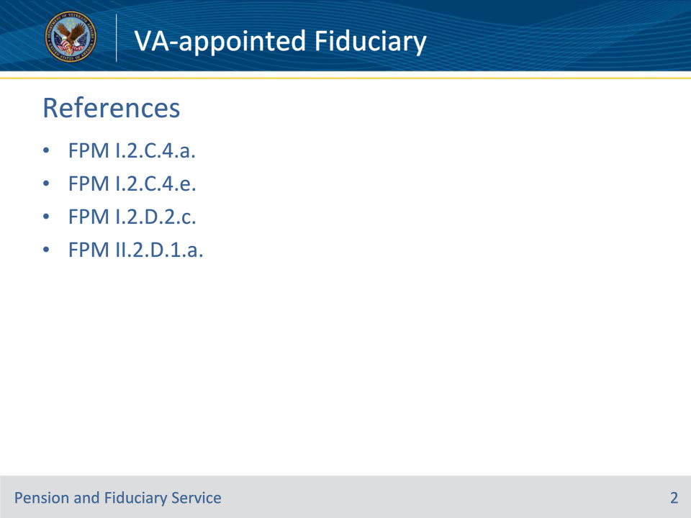
Slide notes

Instructor Notes:

The following are relevant references relating to the fiduciary appointment type VA-appointed fiduciary:

• FPM I.2.C.4.a.

• FPM I.2.C.4.e.

• FPM I.2.D.2.c.

• FPM II.2.D.1.a.

Slide 3 - Objectives
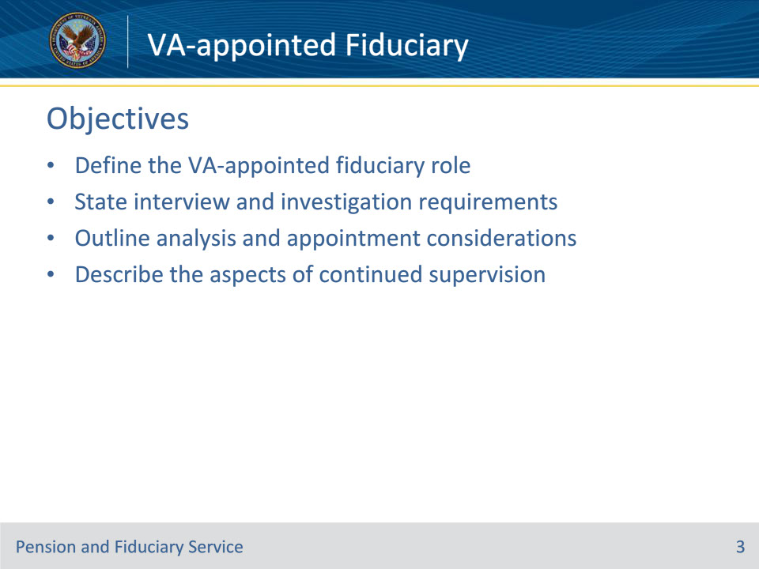
Slide notes

At the end of this lesson, given the training and references, the learner will be able to do the following:

• Define the role of a VA-appointed fiduciary

• State interview and investigation requirements prior to fiduciary appointment

• Outline the considerations a field examiner must take during the analysis and appointment process

• Describe the aspects of continued supervision of a VA-appointed fiduciary by the fiduciary hub

Slide 4 - VA-appointed Fiduciary
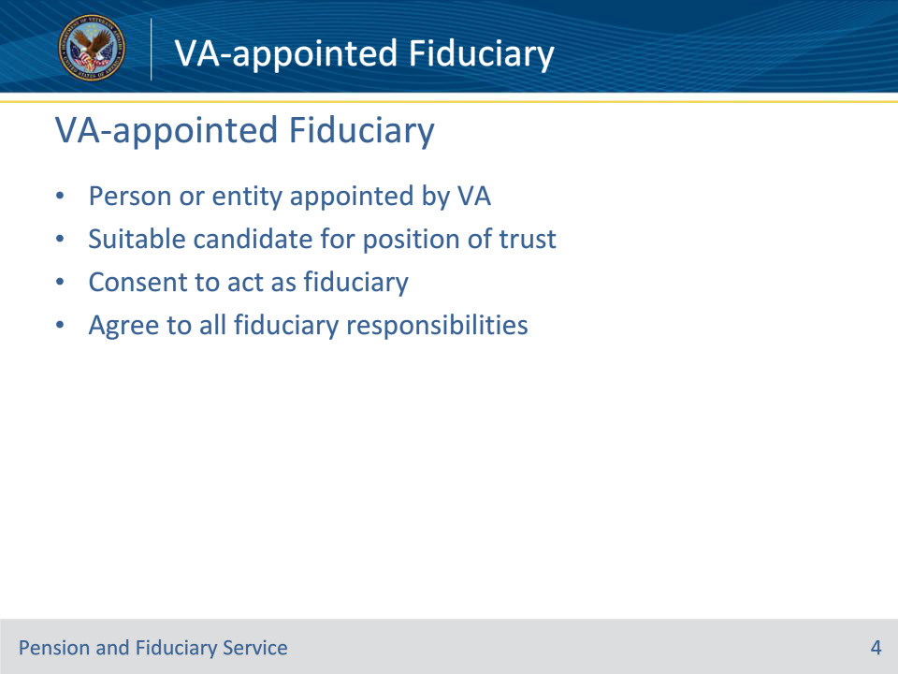
Slide notes

Policy Reference(s): FPM I.2.C.4.a., FPM I.2.C.4.e.

Instructor Notes:

A VA-appointed fiduciary refers to a person or legal entity appointed by VA to serve as fiduciary for VA benefits for a beneficiary who is unable to manage their VA funds.

The fiduciary must

• be a suitable candidate for this position of trust

• consent to act as fiduciary, and

• agree to the fiduciary responsibilities outlined on the VA Form 21P-4703.

Slide 5 - Interview and Investigation
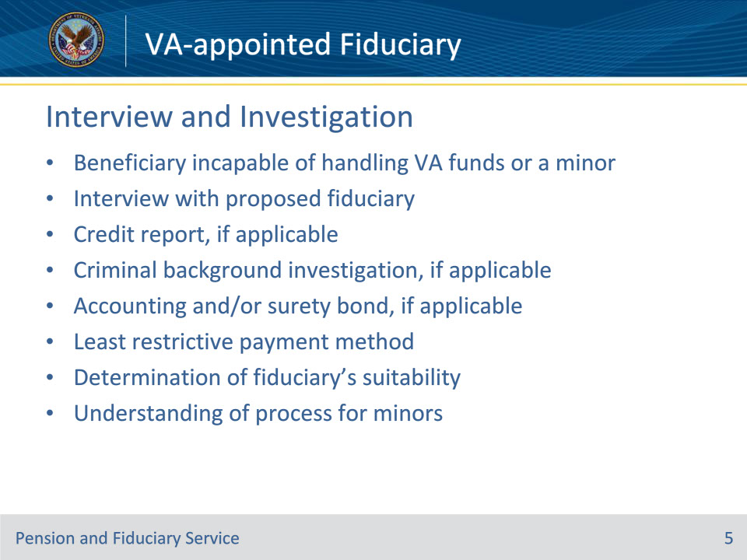
Slide notes

Policy Reference(s): FPM I.2.C.4.e.

Instructor Notes:

The decision to appoint a VA-appointed fiduciary must be based on:

• the beneficiary being

• incapable of handling their VA funds without supervision, or

• under the age of majority

• an interview with the proposed fiduciary

• a credit report dated within 30 days prior to the appointment, if applicable

• a CBI within one year prior to the appointment, if applicable

• the fiduciary’s ability to complete accountings and obtain protection of the FUM, if required

• the least restrictive payment method to meet the beneficiary’s needs and afford adequate protection of VA funds

• a determination of the fiduciary’s suitability, and

• the understanding that any remaining assets in the case of a minor beneficiary are to be turned over to the minor when they reach the age of majority, if applicable.

Slide 6 - Analysis
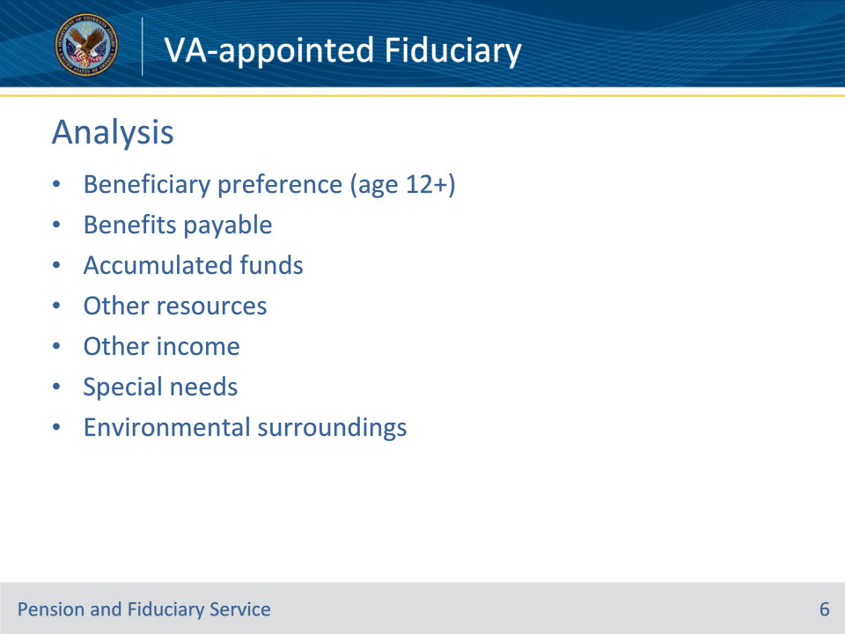
Slide notes

Policy Reference(s): FPM I.2.C.4.e.

Instructor Notes:

When appointing a fiduciary, consideration should be given to the

• preference of the beneficiary, for adult and minor beneficiaries age 12 or older

• amount of VA benefits payable

• amount of accumulated FUM, if any

• other resources and income of the beneficiary, and

• the beneficiary’s special needs and environmental surroundings.

Slide 7 - Continued Supervision
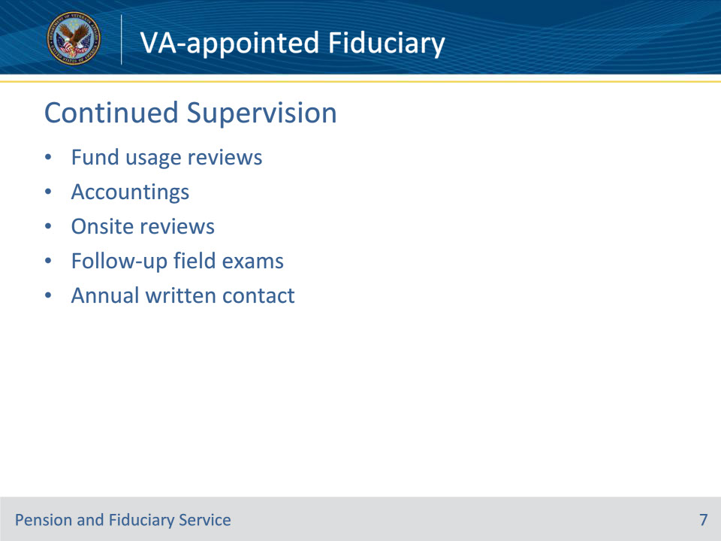
Slide notes

Policy Reference(s): FPM I.2.D.2.c., FPM II.2.D.1.a.

Instructor Notes:

Fiduciary performance is primarily monitored through fund usage reviews, accountings, and/or onsite reviews. However, the FE must evaluate the beneficiary’s fiduciary relationship for continued suitability during follow-up field examinations.

Hubs will initiate the use of the Annual Written Contact Letter to improve the frequency of contact with all beneficiaries in the Fiduciary Program. The letter helps to remind beneficiaries in the program how to contact the Department of Veterans Affairs (VA) if an issue or concern with their fiduciary exists.

Slide 8 - Questions?
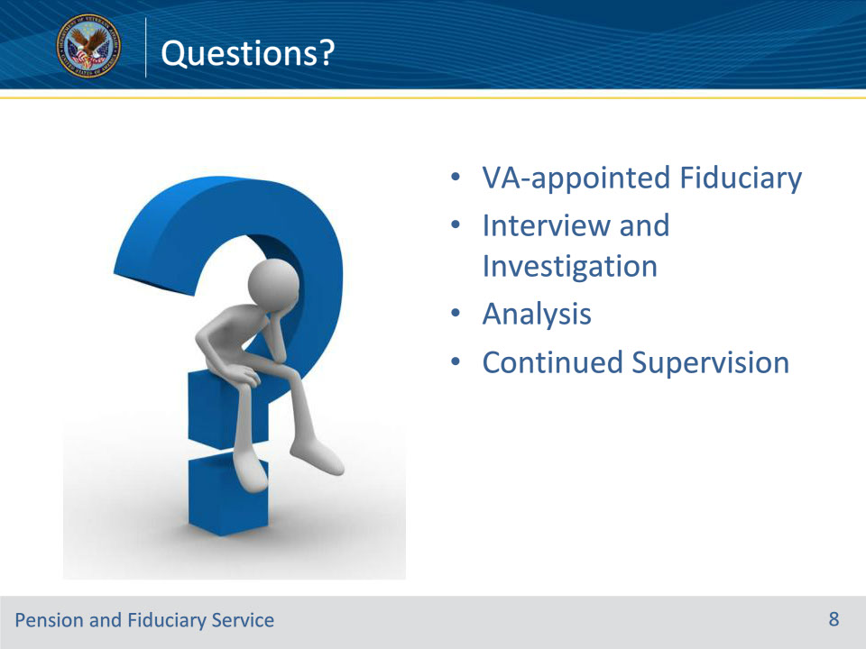
Slide notes

Instructor Notes:

(Recall) These are our learning objectives as stated from the beginning of training:

• Define the role of a VA-appointed fiduciary

• State interview and investigation requirements prior to fiduciary appointment

• Outline the considerations a field examiner must take during the analysis and appointment process

• Describe the aspects of continued supervision of a VA-appointed fiduciary by the fiduciary hub

(Recap) We discussed each of these learning objectives through the following topics in each slide today:

• VA-appointed Fiduciary

• Interview and Investigation

• Analysis

• Continued Supervision

Are there any other questions?

Questions should be filtered through your QRT team. They will submit your questions to the Field Inquiry Tool (FIT) on your behalf.

Slide 9 - TMS Survey/Assessment
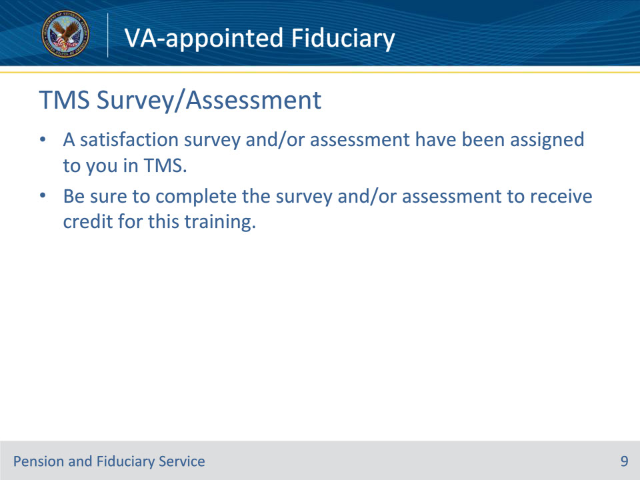
Slide notes

Instructor Notes:

A satisfaction survey and/or assessment have been assigned to you in TMS.

Be sure to complete the survey and/or assessment to receive credit for this training.

