**Slide 1 - Supervised Direct Pay**

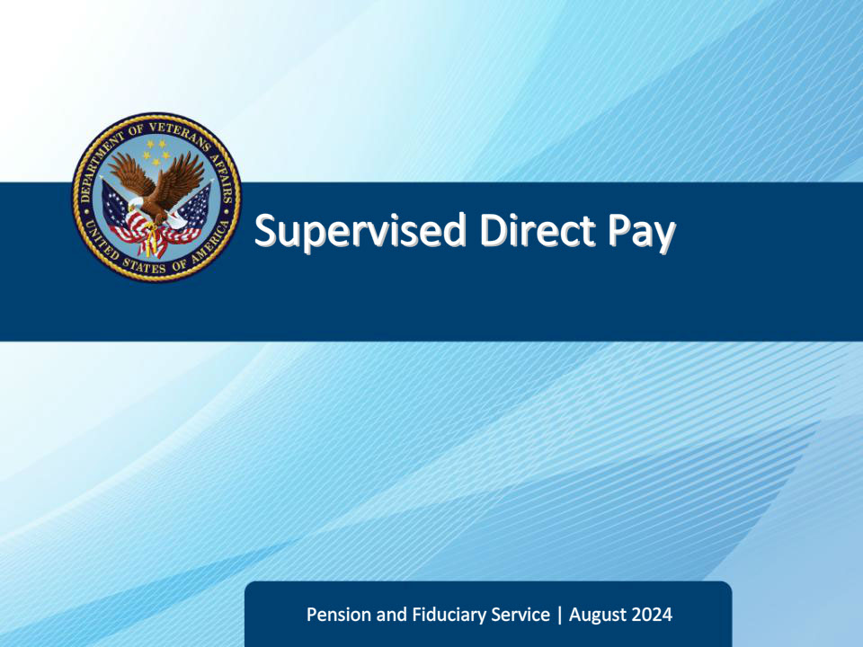

**Slide notes**

Course Description:

This course teaches learners about the basic factors of appointing, supervising, and terminating Supervised Direct Pay supervision.

**Slide 2 - Objectives**

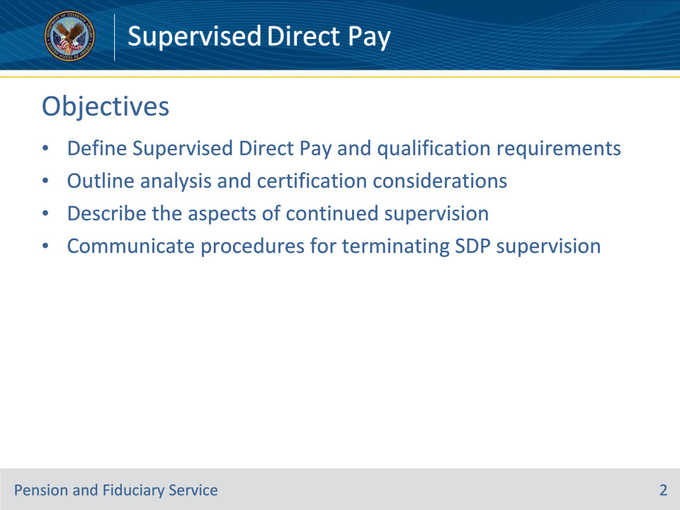

**Slide notes**

At the end of this lesson, given the training and references, the learner will be able to do the following:

• Define Supervised Direct Pay (SDP) and qualification requirements

• Outline analysis and certification considerations

• Describe the aspects of continued supervision

• Communicate procedures for terminating SDP supervision

**Slide 3 - References**

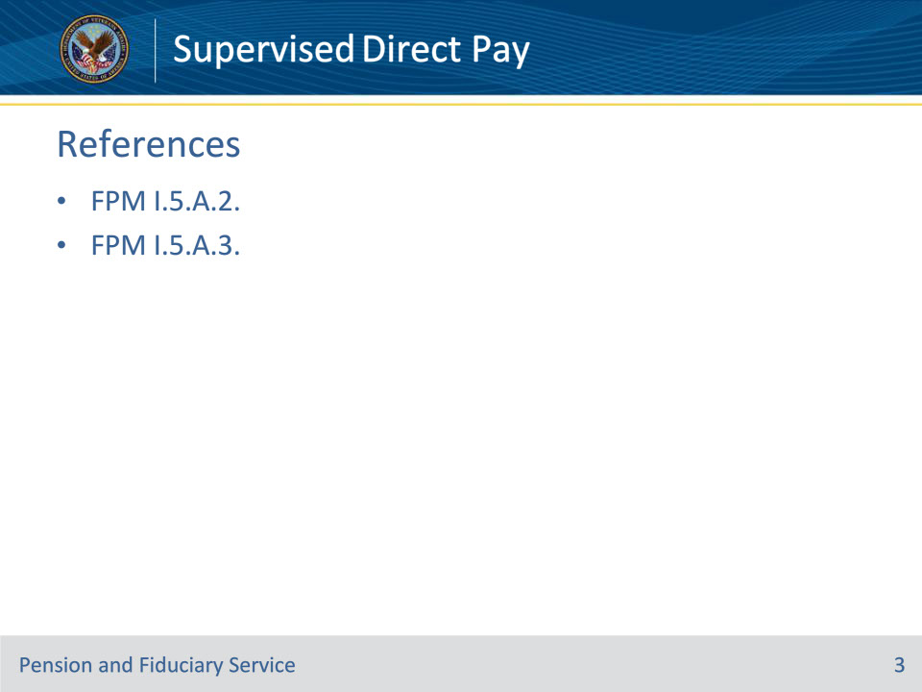

**Slide notes**

Instructor Notes:

The following are relevant references relating to the fiduciary appointment type VA-appointed fiduciary:

• FPM I.5.A.2. SDP Appointments

• FPM I.5.A.3. Restoring Competency For Beneficiaries on SDP

**Slide 4 - Supervised Direct Pay (SDP)**

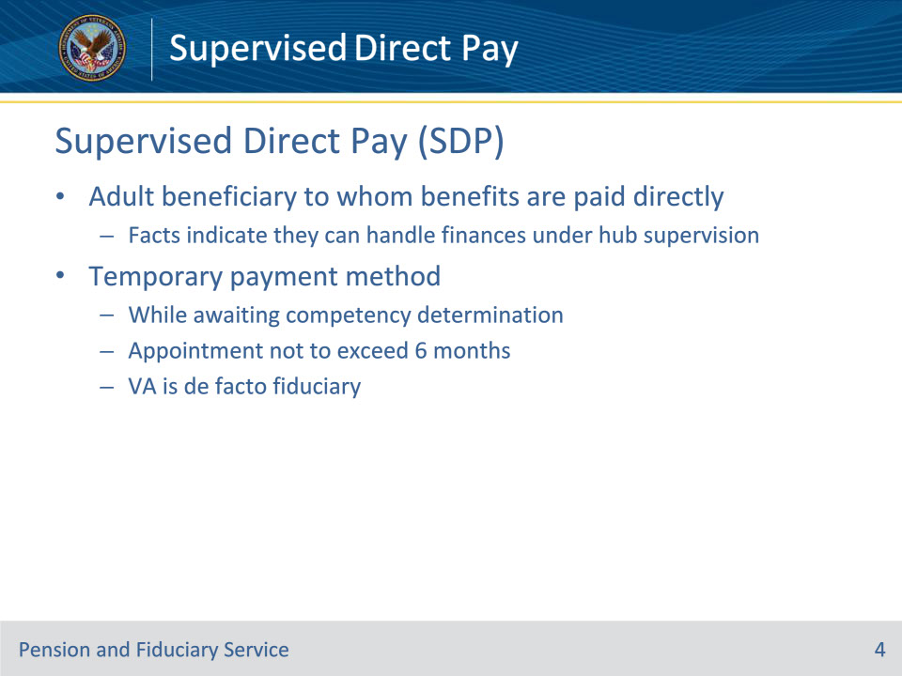

**Slide notes**

Policy Reference(s): FPM I.5.A.2.a.

Instructor Notes:

Supervised Direct Pay (SDP) refers to an adult beneficiary to whom benefits are paid directly when the facts indicate that they can handle their financial affairs under the continuing supervision of the Fiduciary Hub Manager (FHM).

If during the field examination, the hub finds that that the beneficiary can manage funds payable without limitation, the FHM may authorize the payment of VA benefits directly to an adult beneficiary in the Fiduciary Program.  The SDP method allows the beneficiary to continue managing their funds while the evidence obtained during the field examination is being reviewed and the rating issue of the beneficiary’s competency is re-evaluated.

During the temporary period, VA will provide limited supervision to ensure the beneficiary is capable of managing their funds without the appointment of a fiduciary.  Upon completion of the rating to re-evaluate the beneficiary’s competency, which should be completed within six months from the SDP appointment, the hub will

• remove the beneficiary from the Fiduciary Program if rated competent, or

• appoint a fiduciary if the rating of incompetency is continued.

Long-term payment of funds in an SDP capacity must never occur, as VA is acting as de facto fiduciary in these cases.  If the SDP beneficiary gives away, or has been deprived of, all or part of their income, a misuse allegation may be made against VA.

**Slide 5 - Inappropriate Use**

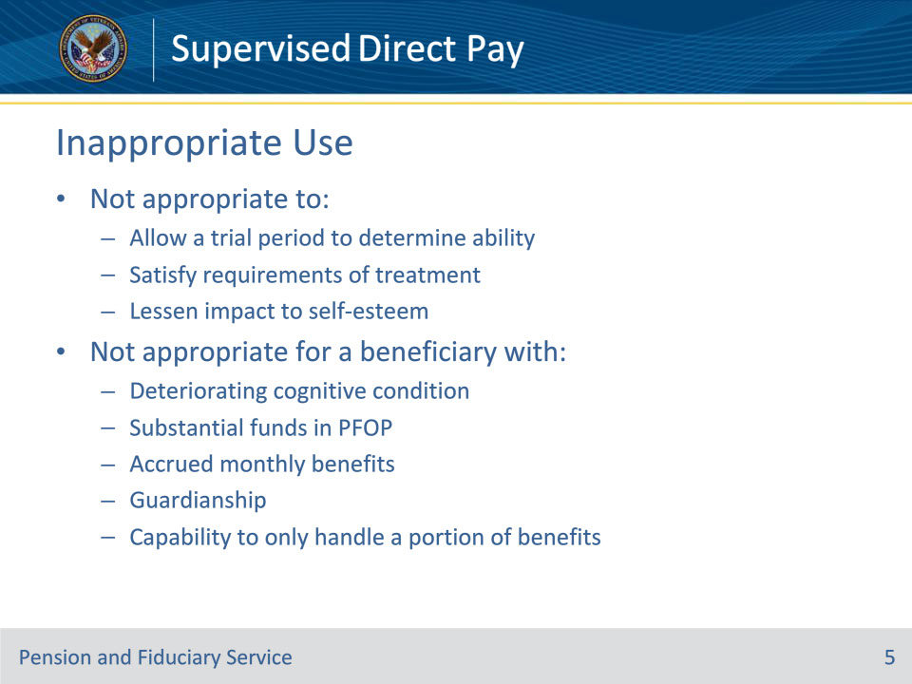

**Slide notes**

Policy Reference(s): FPM I.5.A.2.b.

Instructor Notes:

SDP is not appropriate to:

• allow a trial period to determine if the beneficiary has the capacity to manage funds

• satisfy the requirements of clinical mental health treatment

• lessen the impact to the self-esteem of the beneficiary, or

• solve other personal issues.

SDP is not appropriate for a beneficiary

• with documented cognitive conditions likely to deteriorate rapidly, for example, progressive dementia

• with substantial funds in a Personal Funds of Patient (PFOP) account

• with accrued monthly benefits

• currently under a court-appointed guardianship or Uniform Veterans Guardianship Act as they legally may not enter into any contracts, including maintaining a bank account and signing checks, or

• capable of only handling a portion of the insurance dividends or monthly installments to which they are entitled.

**Slide 6 - Hospitalization**

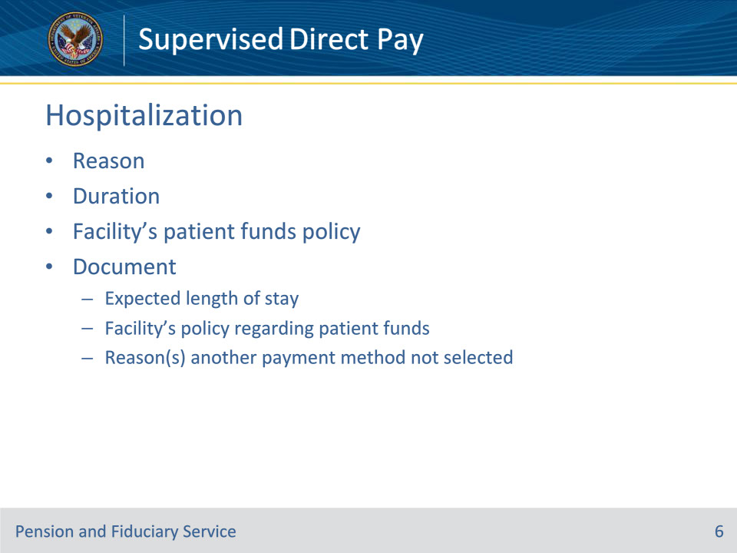

**Slide notes**

Policy Reference(s): FPM I.5.A.2.c.

Instructor Notes:

When a beneficiary is hospitalized or institutionalized at the time of the IA, consideration must be given to the reason for hospitalization and whether the stay is likely to be of long duration.

SDP is inappropriate when hospitalization is expected to continue for a lengthy or indefinite period.  The facility’s policy regarding patient receipt of funds must be reviewed when considering SDP method of payment.  If the FE determines that SDP is appropriate for the hospitalized or institutionalized beneficiary, the field examination report must document the

• expected length of stay in the facility

• facility’s policy regarding a patient in receipt of funds, and

• reason(s) another method of payment was not selected.

**Slide 7 - Evidence of Capacity**

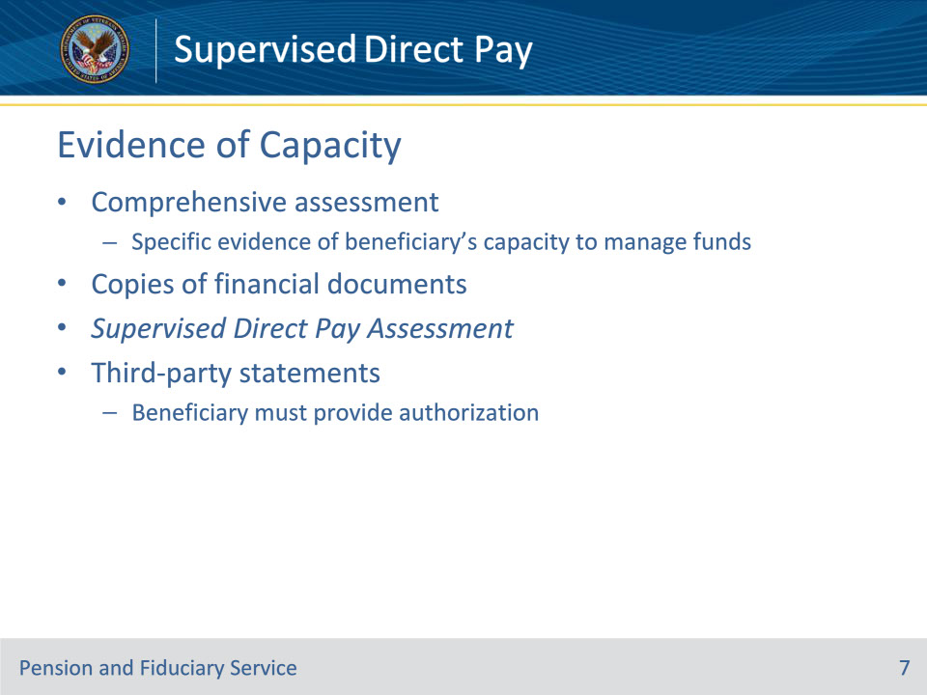

**Slide notes**

Policy Reference(s): FPM I.5.A.2.d.

Instructor Notes:

The FE must identify specific evidence that demonstrates the beneficiary’s capacity to manage their funds through a comprehensive assessment.

Additionally, the FE must attempt to obtain copies of financial documents demonstrating the beneficiary’s ability to manage funds.  If unable to obtain copies during the field examination, the FE must

• advise the beneficiary to send in copies of the financial documents, and

• record the period of financial documentation reviewed for inclusion in the Supervised Direct Pay Assessment.

The FE may also obtain and document any authorized third-party statements that support the determination regarding the beneficiary’s abilities when the beneficiary authorizes the FE to do so.

**Slide 8 - Advising**

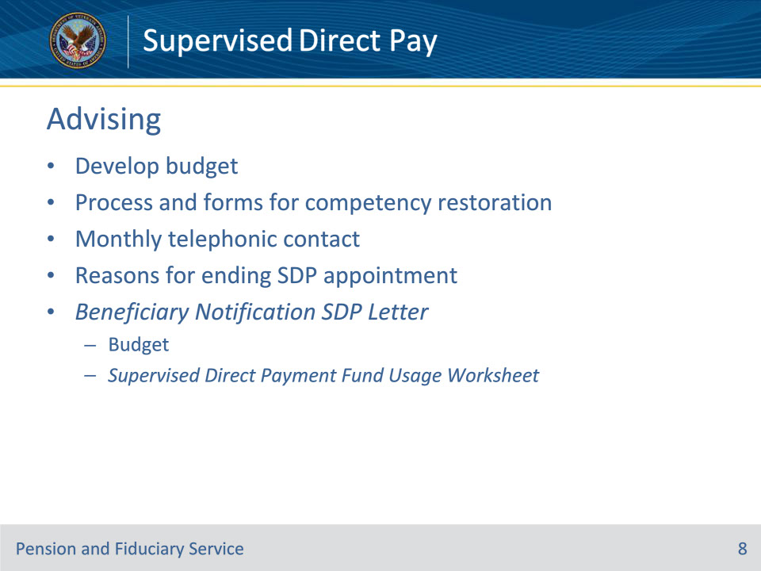

**Slide notes**

Policy Reference(s): FPM I.5.A.2.e.

Instructor Notes:

Upon determining that an SDP appointment is appropriate, the FE must assist the beneficiary in the development of a budget.  The budget is developed based on the

• recurring income documented

• expenses documented

The FE shall advise the SDP beneficiary

• of the process and required evidence necessary to be rated as able to manage their VA funds and assist the beneficiary in filling out the VA forms, if necessary

• that the VA will

• conduct monthly telephonic contact to ensure monthly expenses are paid, and funds are managed in a way that routinely meets their best interests, and

• end the SDP appointment if the beneficiary does not use VA funds (monthly, one-time retroactive, or transferred funds) for timely payment of expenses associated with their or their dependent’s care, support, or maintenance (for example, food, shelter, or medicines).

The FE will also ask the beneficiary for a preferred day of the week and time they would like to be contacted for each of the monthly calls.  This information will be documented in the final field examination.

The Beneficiary Notification SDP Letter contains the budget and a Supervised Direct Payment Fund Usage Worksheet to assist the beneficiary in tracking expenses.

**Slide 9 - Restoring Competency**

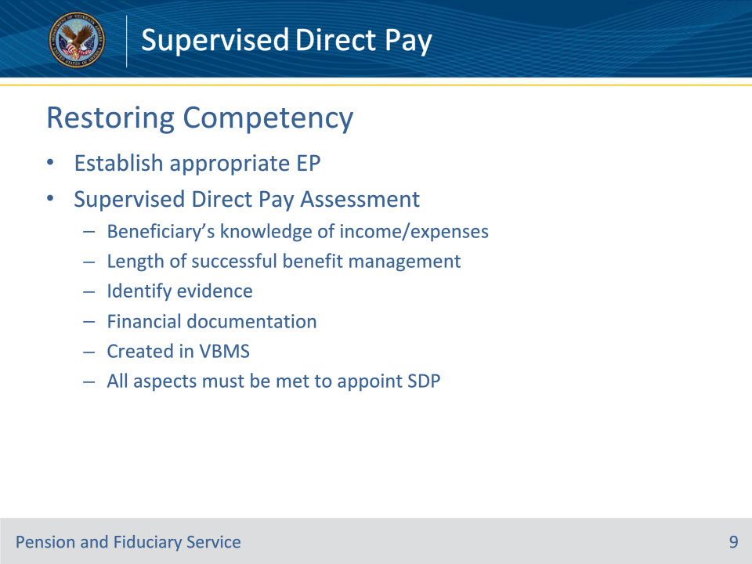

**Slide notes**

Policy Reference(s): FPM I.5.A.3.a., b.

Instructor Notes:

If evidence supports the beneficiary is capable of managing funds payable without limitation, the FE must request the establishment of the appropriate end product (EP) with special issue indicator for restored competency evaluation to remove the beneficiary from the program.  The Supervised Direct Pay Assessment must accompany the request.

A Supervised Direct Pay Assessment detailing the comprehensive assessment evidence obtained during the field examination must be completed to support determinations of competency.  This assessment must

• describe the

• beneficiary’s knowledge of their income and expenses, and

• length of time that the beneficiary has managed their VA benefits successfully, and

• identify

• the medical evidence utilized in the rating of incompetency and describe how the evidence obtained during the field examination conflicts with the evidence previously of record

• the financial documentation that demonstrates the beneficiary’s payment history, and

• any other evidence demonstrating the beneficiary’s ability to manage funds.

A sample of the Supervised Direct Pay Assessment outlining the comprehensive evidentiary requirements can be found in the FPM for reference purposes.  Hubs will create the assessment within VBMS.

If the evidence is not sufficient to support all aspects of the Supervised Direct Pay Assessment to confirm a capacity to manage funds, a referral for a rating of competency is not appropriate and the beneficiary cannot be appointed SDP.

**Slide 10 - Supervised Direct Pay**

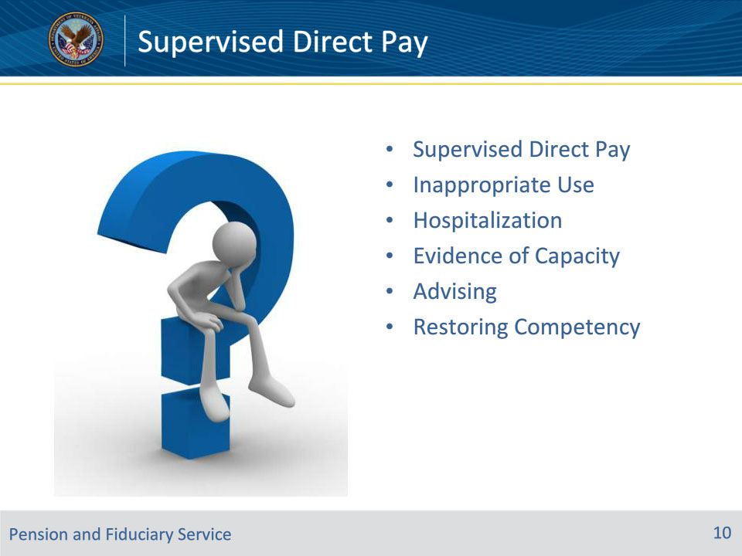

**Slide notes**

Instructor Notes:

(Recall) These are our learning objectives as stated from the beginning of training:

• Define Supervised Direct Pay (SDP) and qualification requirements

• Outline analysis and certification considerations

• Describe the aspects of continued supervision

• Communicate procedures for terminating SDP supervision

Are there any other questions?

Questions should be filtered through your QRT team. They will submit your questions to the Field Inquiry Tool (FIT) on your behalf.

**Slide 11 - TMS Survey/Assessment**

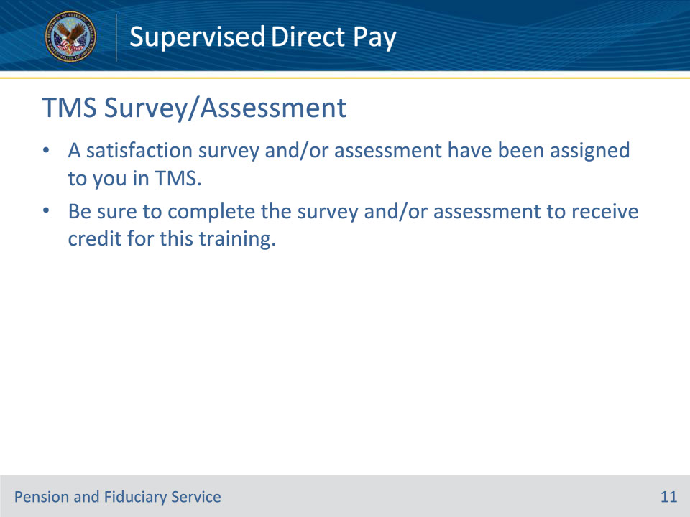

**Slide notes**

Instructor Notes:

Instructor Notes

A satisfaction survey and/or assessment have been assigned to you in TMS.

Be sure to complete the survey and/or assessment to receive credit for this training.