Slide 1 - Successor Initial Appointment Field Examinations
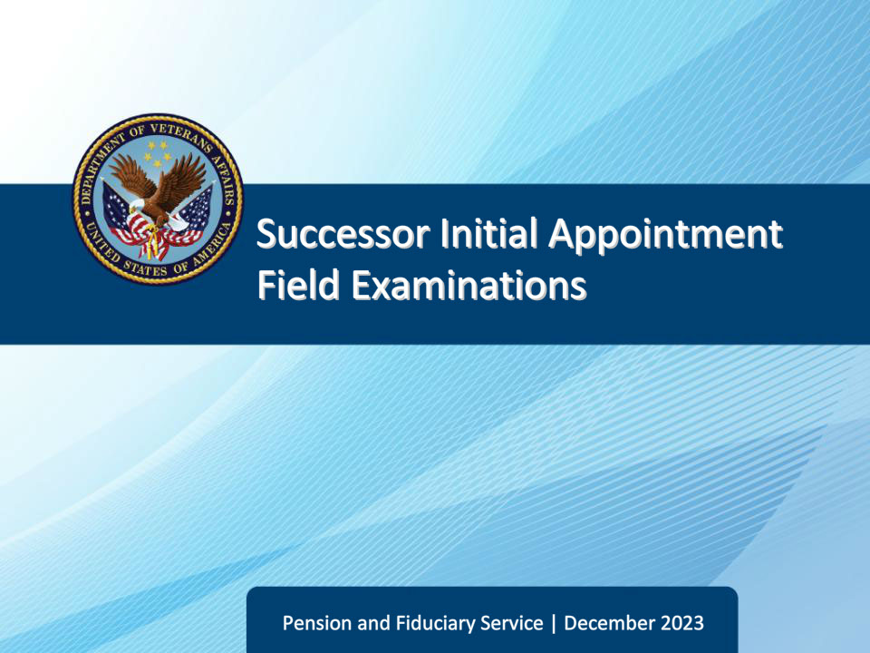
Slide notes

Course Description:

The lesson teaches learners about the purpose, critical elements, and specific requirements of successor initial appointment field examinations to include how a successor initial appointment field examination is initiated, documented, and reported.

Slide 2 - Objectives
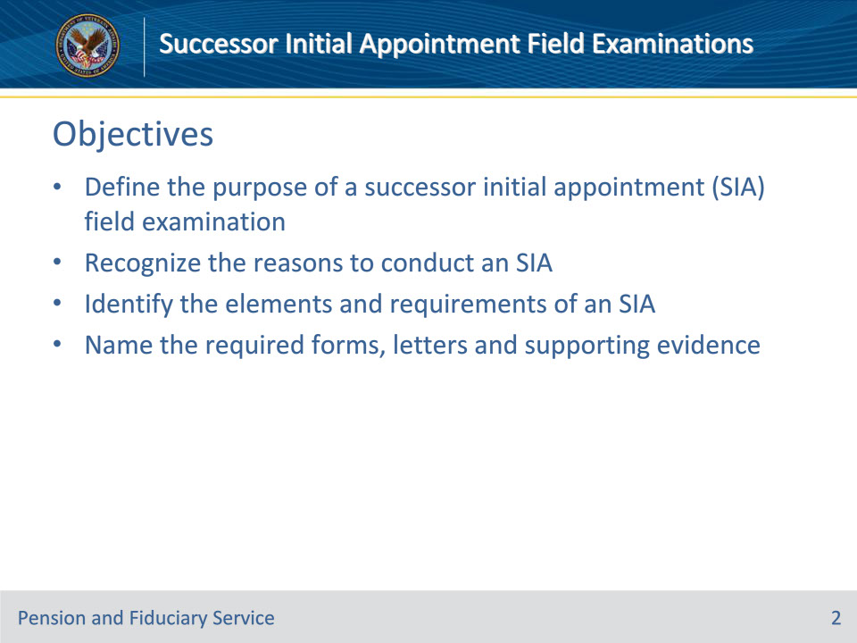
Slide notes

Instructor Notes:

At the end of this lesson, given the training and references, the learner will be able to do the following:

• Define the purpose of a successor initial appointment field examination (SIA)

• Recognize the reasons to conduct an SIA

• Identify the elements and requirements of an SIA

• Name the required forms, letters and supporting evidence

Slide 3 - References
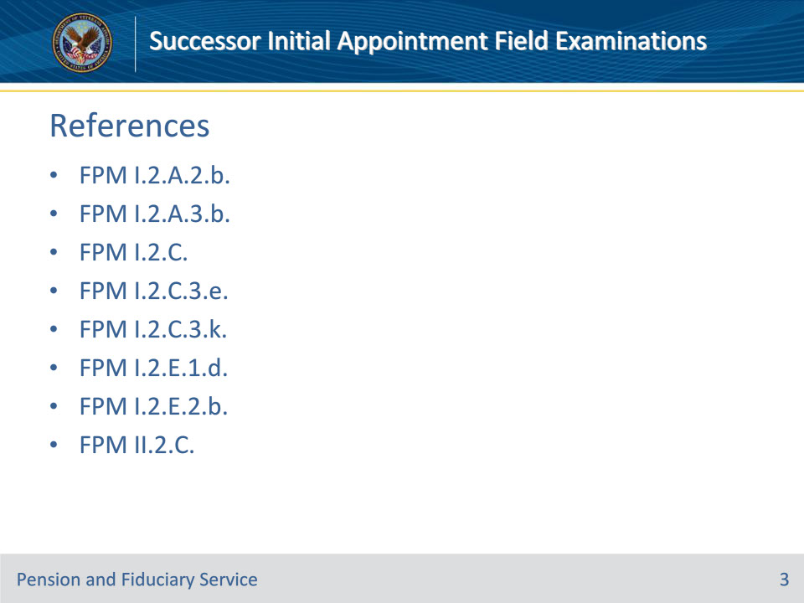
Slide notes

Instructor Notes:

These are the relevant references pertaining to this course:

• FPM I.2.A.2.b. Types of IA Field Examinations

• FPM I.2.A.3.b. Content Requirements for Requests

• FPM I.2.C. Initial Appointments (IAs) and Successor IAs (SIAs)

• FPM I.2.C.3.e. Documenting and Verifying Liquid Assets

• FPM I.2.C.3.k. Determining VA FUM

• FPM I.2.E.1.d. How to Prepare Field Examination Documentation

• FPM I.2.E.2.b. Reviewing and Sending Notification Letters

• FPM II.2.C. Fiduciary Removal or Withdrawal From Fiduciary Service

Slide 4 - Definition
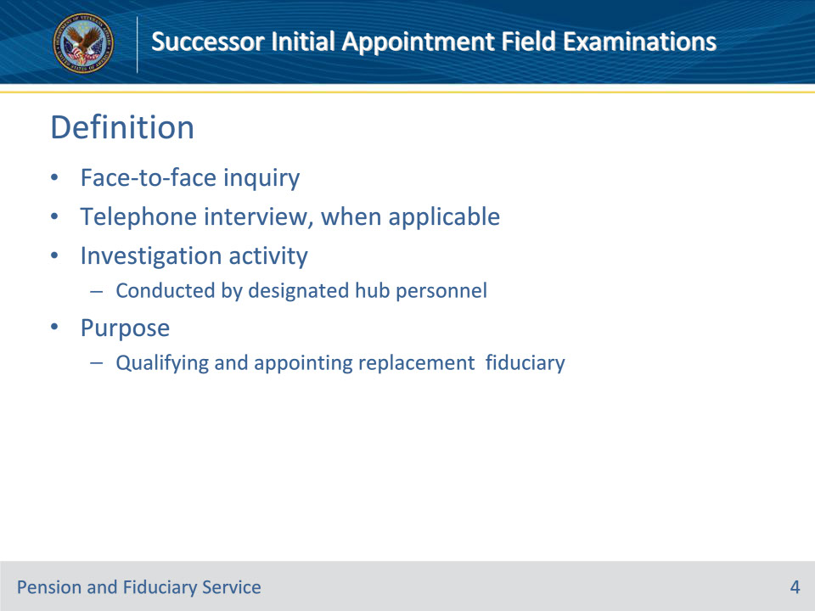
Slide notes

Policy Reference(s): FPM I.2.A.2.b.

Instructor Notes:

Successor IA (SIA): A face-to-face inquiry or telephone interview, when applicable, and investigation activity conducted by the designated hub or other qualified VA personnel for the purpose of qualifying and appointing a replacement fiduciary for the beneficiary.

Slide 5 - Reasons
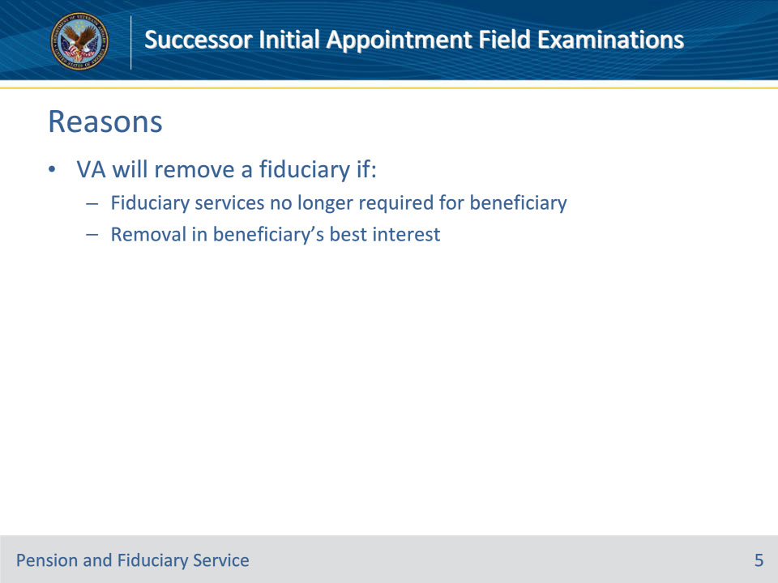
Slide notes

Policy Reference(s): FPM II.2.C.1.a.

Instructor Notes:

The Department of Veterans Affairs (VA) will remove a fiduciary if it is determined that

• fiduciary services are no longer required for a beneficiary, or

• removal is in the beneficiary’s best interest.

.

Slide 6 - Reasons
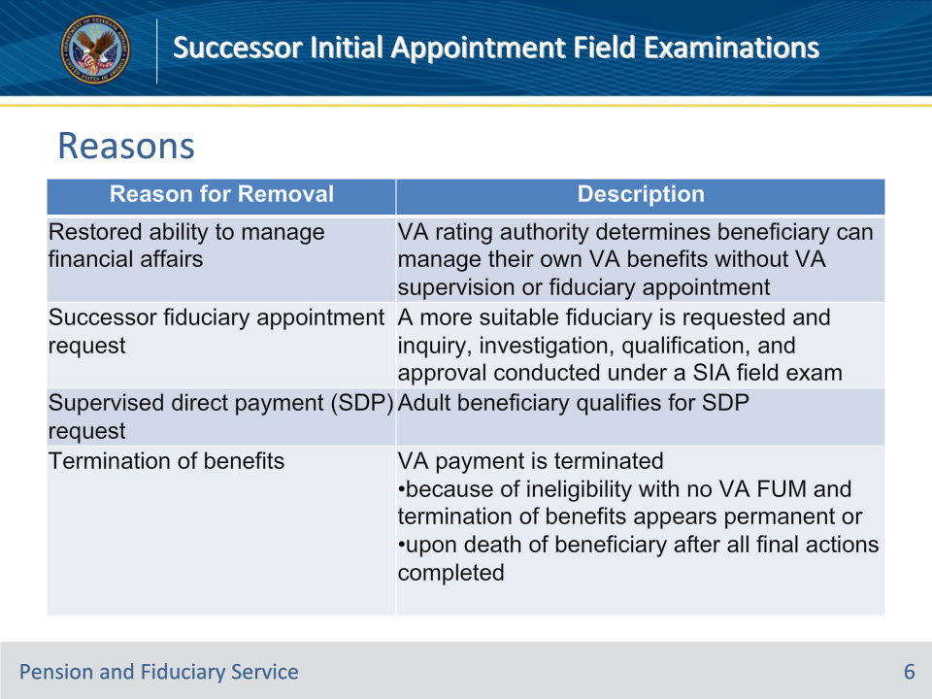
Slide notes

Policy Reference(s): FPM II.2.C.1.b.

Instructor Notes:

This table describes the reasons for fiduciary removal.

Slide 7 - Reasons
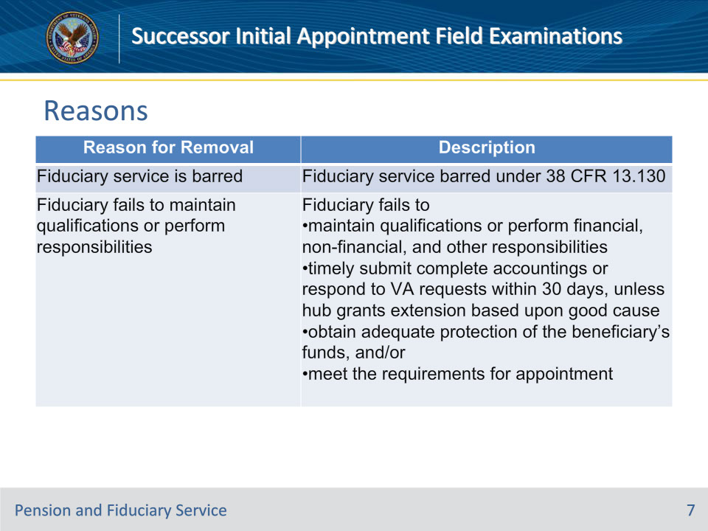
Slide notes

Policy Reference(s): FPM II.2.C.1.b.

Instructor Notes:

This table describes the reasons for fiduciary removal.

When a fiduciary is removed due to being barred from service, fiduciary hub personnel must select the DO NOT APPOINT flag on the fiduciary profile in VBMS.

Slide 8 - Reasons
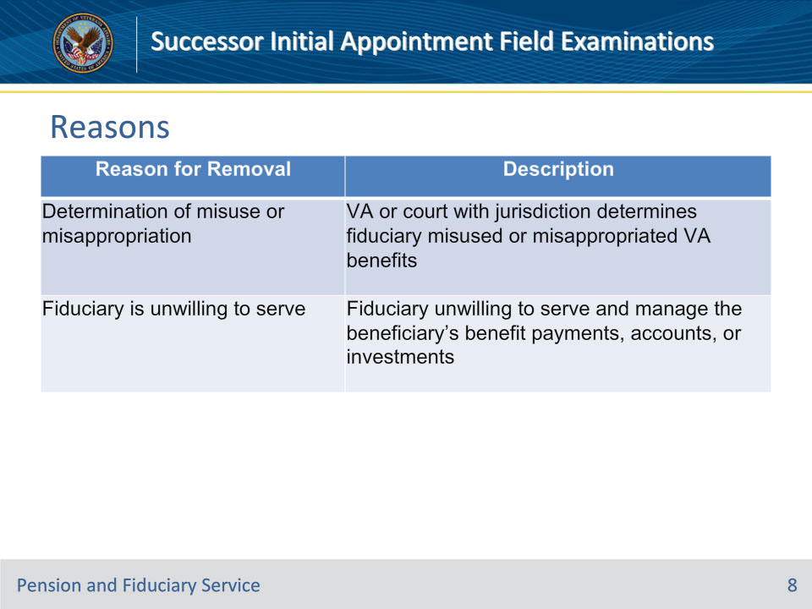
Slide notes

Policy Reference(s): FPM II.2.C.1.b.

Instructor Notes:

This table describes the reasons for fiduciary removal.

Slide 9 - Fiduciary Withdrawal
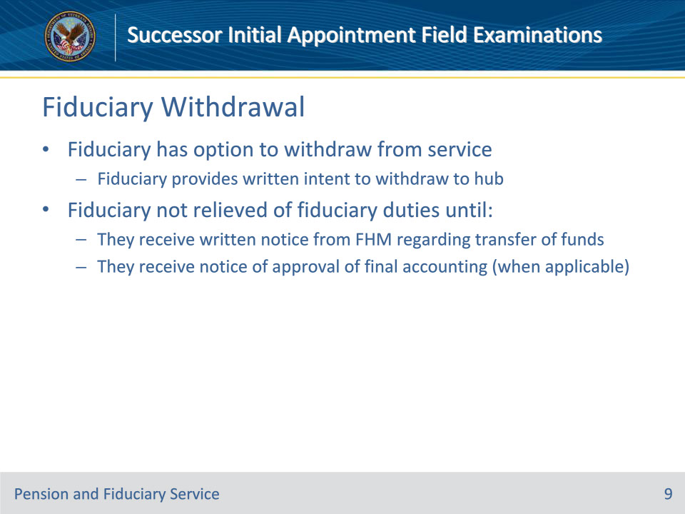
Slide notes

Policy Reference(s): FPM II.2.C.2.a.

Instructor Notes:

A fiduciary has the option to withdraw from fiduciary service to a VA beneficiary.

A fiduciary may withdraw from fiduciary service by providing a written intent to withdraw to the hub of jurisdiction. However, a fiduciary is not relieved of their fiduciary duties until they receive written notice from the Fiduciary Hub Manager (FHM) regarding transfer of the beneficiary’s funds to a successor fiduciary and receive notice of approval of their final accounting, when applicable.

Slide 10 - Fiduciary Withdrawal
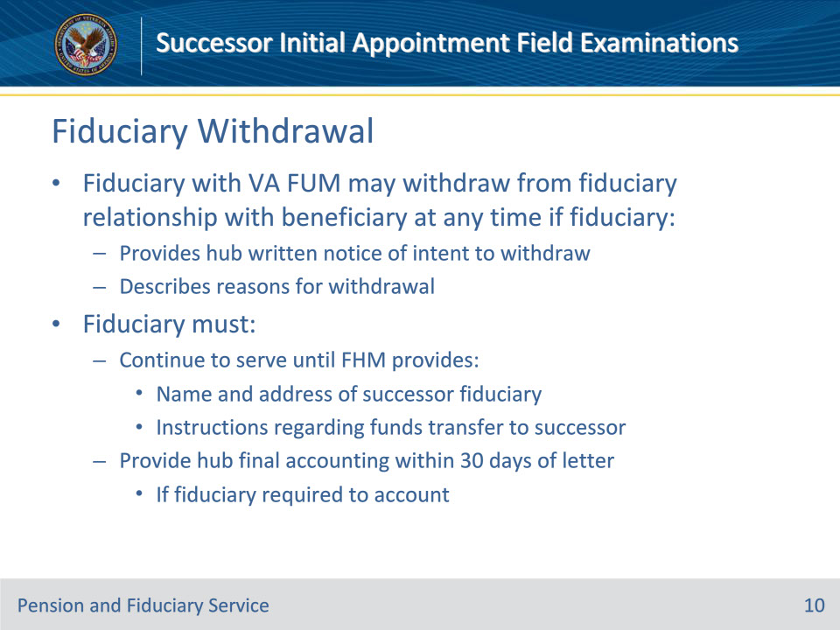
Slide notes

Policy Reference(s): FPM II.2.C.2.b.

Instructor Notes:A fiduciary who has VA FUM for a beneficiary may withdraw from the fiduciary relationship with the beneficiary at any time if the fiduciary

• provides the hub of jurisdiction written notice of their intent to withdraw as fiduciary for the beneficiary, and

• describes the reason(s) for withdrawal.

The fiduciary must

• continue to serve as fiduciary until the FHM provides the fiduciary with the name and address of the successor fiduciary and instructions regarding the transfer of funds to the successor fiduciary, and

• provide the hub of jurisdiction a final accounting within 30 days of the notification letter, if the fiduciary was required to account.

Slide 11 - Continued Supervision
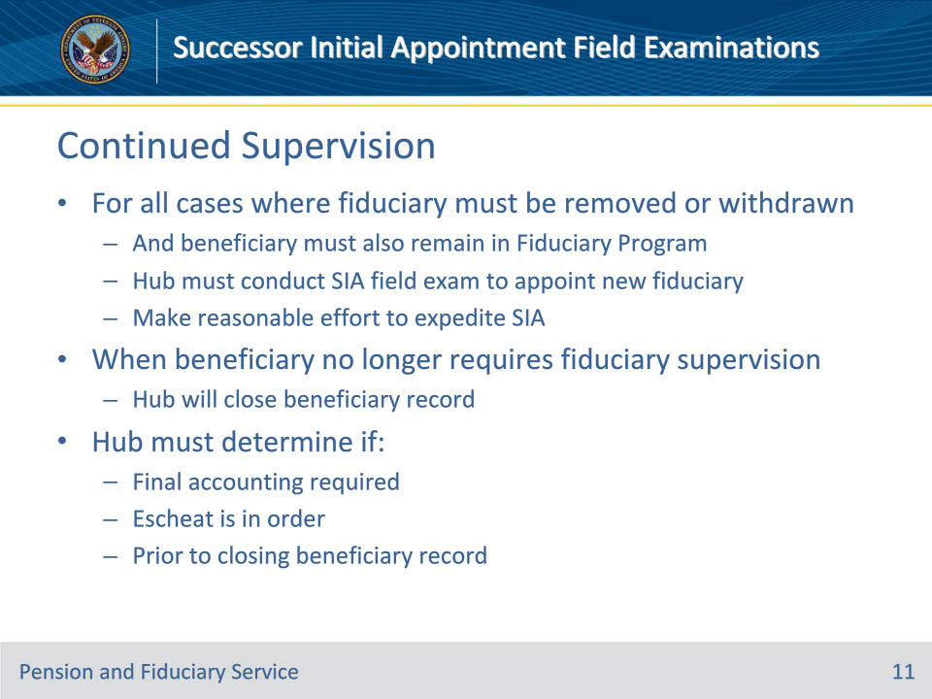
Slide notes

Policy Reference(s): FPM II.2.C.3.a., b.

Instructor Notes:For all cases in which a fiduciary must be removed or has submitted a written request to withdraw, and the beneficiary must also remain in the Fiduciary Program due to the inability to manage financial affairs, the hub must conduct an SIA field examination to appoint a new fiduciary. The hub must make a reasonable effort to expedite the appointment of a successor fiduciary.

For all cases in which a fiduciary must be removed because the beneficiary no longer requires Fiduciary Program supervision, the hub will close the beneficiary record.

Prior to closing the beneficiary record, the hub must determine if a final accounting is required and if escheat is in order.

Slide 12 - Transfer
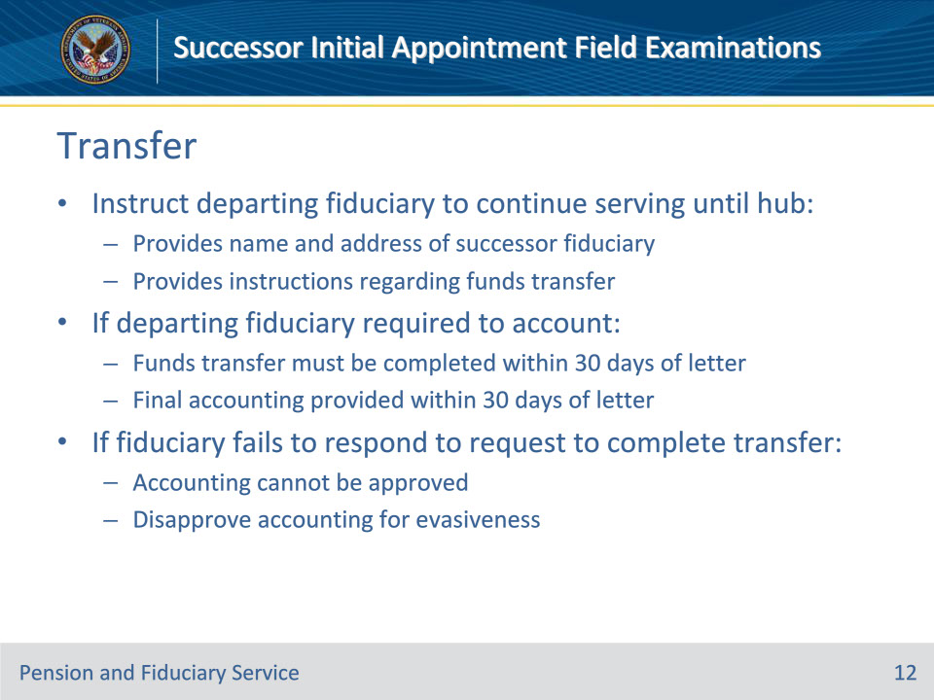
Slide notes

Policy Reference(s): FPM II.2.C.3.c.

Instructor Notes:

The hub must instruct the previous fiduciary to continue as fiduciary for the beneficiary until the hub provides them with

• the name and address of the successor fiduciary, if applicable, and

• instructions regarding the transfer of funds to the successor fiduciary or beneficiary (who has been rated competent or placed on SDP).

The hub must notify the previous fiduciary in writing of the requirement to transfer funds. If the departing fiduciary is required to account, the fund transfer must be completed within 30 days of the applicable notification letter. If the fiduciary fails to respond to the request to complete the transfer, the accounting cannot be approved. Follow the guidance for accounting disapproval if the fiduciary is showing signs of evasiveness.

Slide 13 - Transfer
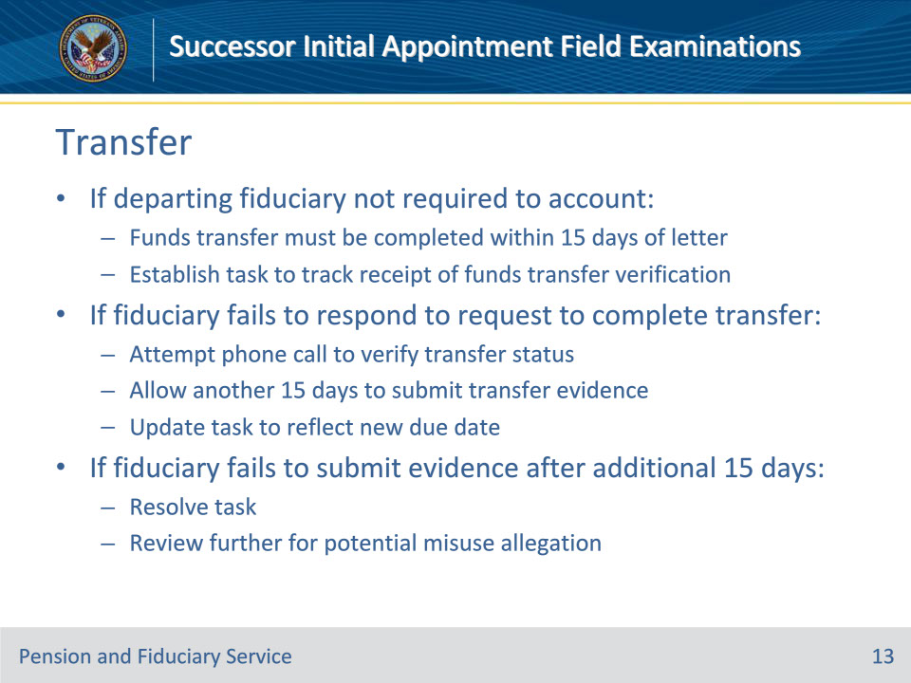
Slide notes

Policy Reference(s): FPM II.2.C.3.c.

Instructor Notes:

If the departing fiduciary is not required to account, the fund transfer must be completed within 15 days of the applicable notification letter. The hub must establish an administrative task to track for receipt of verification that funds were transferred. If the fiduciary fails to respond to the request to complete the transfer, make a reasonable effort to contact the fiduciary telephonically regarding the status of the transfer. Allow the fiduciary another 15 days to submit evidence of the transfer and update the administrative task to reflect the new due date. If the fiduciary fails to transfer the funds after the additional 15 days, resolve the administrative task and review further for a potential misuse allegation.

Slide 14 - Transfer
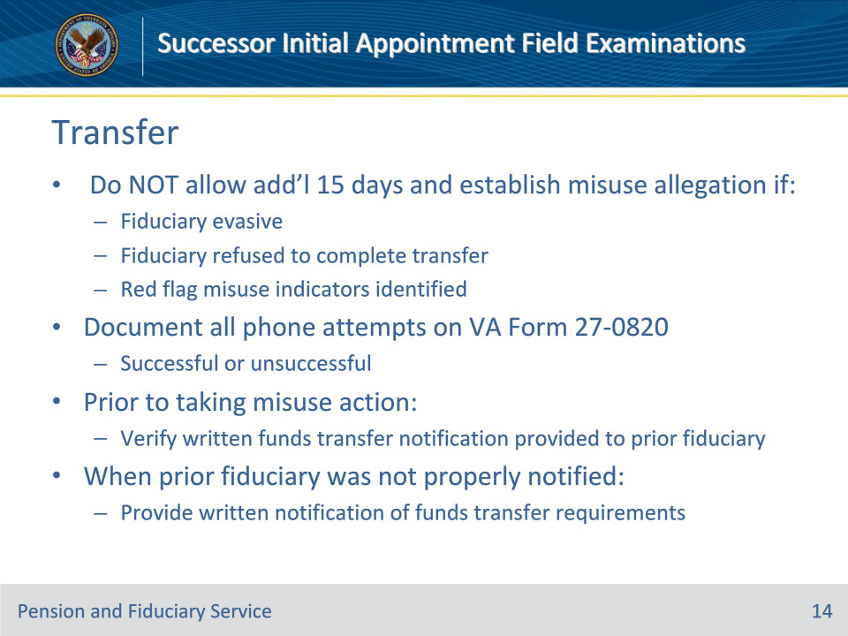
Slide notes

Policy Reference(s): FPM II.2.C.3.c.

Instructor Notes:

Exception: Do not allow the fiduciary an additional 15 days to transfer funds if they are evasive, have refused to complete the transfer, or other red flag indicators of misuse are identified. In these situations, establish a misuse allegation.

The hub must document all telephone attempts, successful and unsuccessful, on a V A Form 27-0820, Report of General Information.

Prior to taking any misuse action for failure to transfer funds, the hub must verify that the previous fiduciary was notified in writing to transfer funds. When the previous fiduciary was not properly notified, follow the guidance above to provide written notification of the requirement to transfer funds.

Slide 15 - Transfer
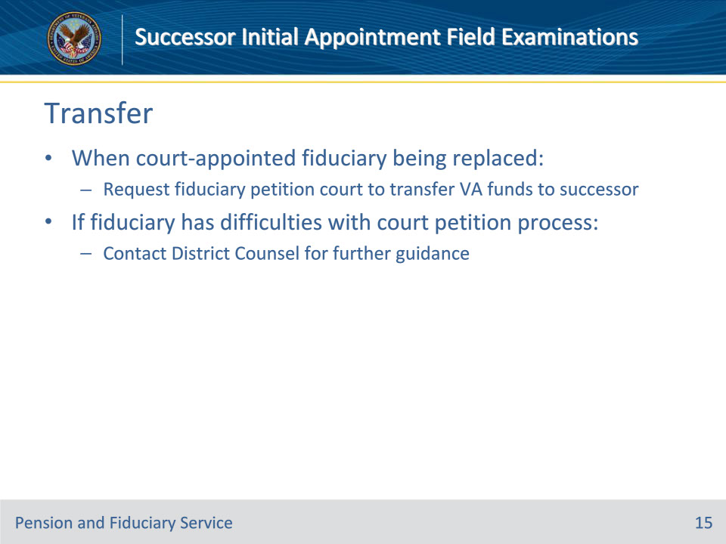
Slide notes

Policy Reference(s): FPM II.2.C.3.c.

Instructor Notes:

When a court-appointed fiduciary is being replaced, hubs must contact the fiduciary to request that they petition the court to transfer any VA funds to the designated successor fiduciary. If the court-appointed fiduciary has any difficulties with the court petition process, contact District Counsel for further guidance.

Slide 16 - Verification
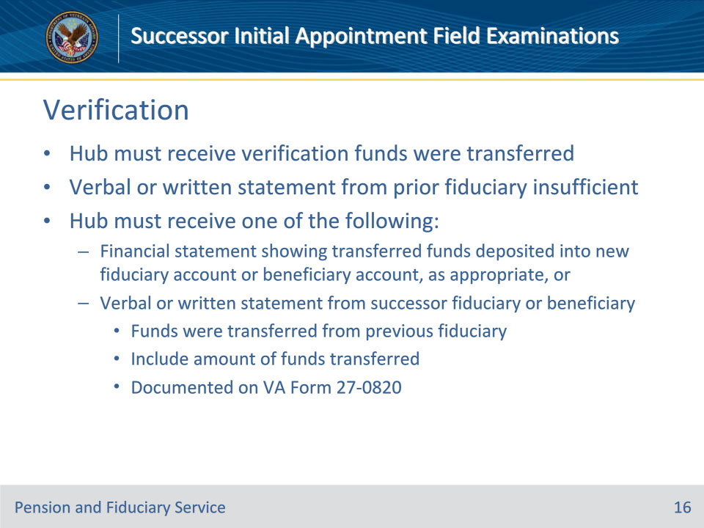
Slide notes

Policy Reference(s): FPM II.2.C.3.d.

Instructor Notes:

The hub must receive verification that funds were transferred to the successor fiduciary or beneficiary, as applicable. A verbal or written statement from the previous fiduciary is not sufficient to establish that the funds were transferred. The hub must receive one of the following to verify that the fiduciary transferred funds:

• a financial statement showing the transferred funds deposited into the new fiduciary account or beneficiary account, as appropriate, or

• a verbal or written statement from the successor fiduciary or beneficiary, as appropriate, that funds were transferred from the previous fiduciary, to include the amount of funds transferred. All verbal statements must be documented on a VA Form 27-0820, Report of General Information.

Computer-generated financial statements must bear the financial institution’s internet address.

Slide 17 - Verification
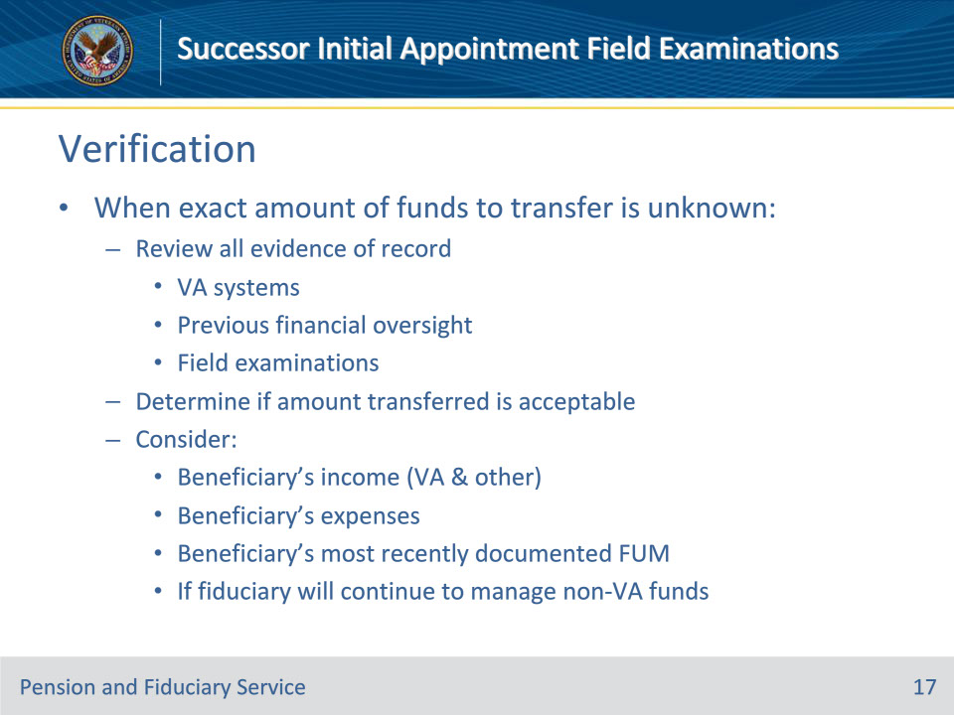
Slide notes

Policy Reference(s): FPM II.2.C.3.d.

Instructor Notes:

When the exact amount of remaining funds to be transferred is unknown, the hub must review all evidence of record, to include VA systems, previous financial oversight, and field examinations to determine whether the amount transferred is acceptable. The hub must consider the beneficiary’s VA and other income, expenses, and most recently documented FUM. The hub must also consider whether the fiduciary will continue to manage non-VA funds

Slide 18 - Verification Example
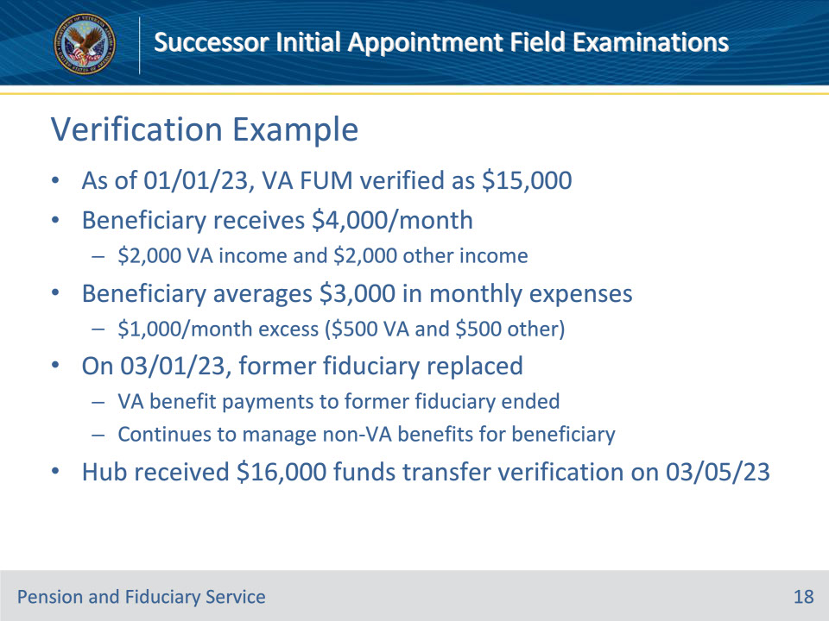
Slide notes

Policy Reference(s): FPM II.2.C.3.d.

Instructor Notes:

Example:

A review of all evidence of record indicates the following:

• As of January 1, 2023, the VA FUM was verified as $15,000.

• The beneficiary receives and manages $4,000 per month. ($2,000 in VA income and $2,000 in other income).

• The beneficiary has an average of $3,000 in monthly expenses, leaving an excess of approximately $1,000 per month (approximately $500 in VA income and $500 in other income)dA.

• On March 1, 2023, the former fiduciary was replaced and VA benefit payments to the former fiduciary ended. The former fiduciary will continue to manage non-VA benefits on behalf of the beneficiary.

• The hub received verification that the fiduciary transferred funds to the successor fiduciary on March 5, 2023, in the amount of $16,000.

Slide 19 - Verification Example
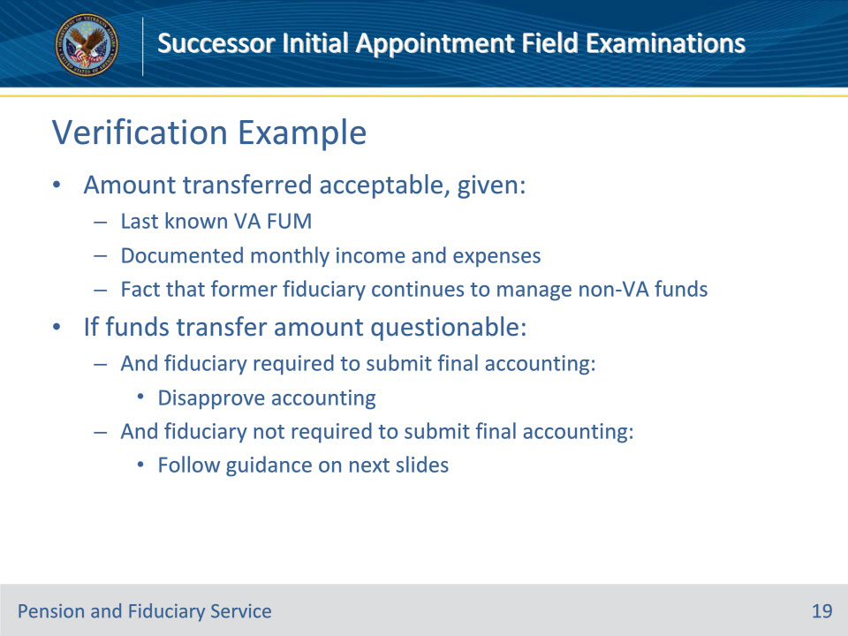
Slide notes

Policy Reference(s): FPM II.2.C.3.d.

Instructor Notes:

Result:

The amount transferred is acceptable, given the

• last known VA FUM

• documented monthly income and expenses, and

• fact that the former fiduciary will continue to manage non-VA Funds.

If the amount of funds transferred is questionable and the fiduciary is

• required to submit a final accounting, follow the guidance to disapprove the accounting, or

• not required to submit a final accounting, follow the guidance in the next slides.

Slide 20 - Questioning Funds Transfer
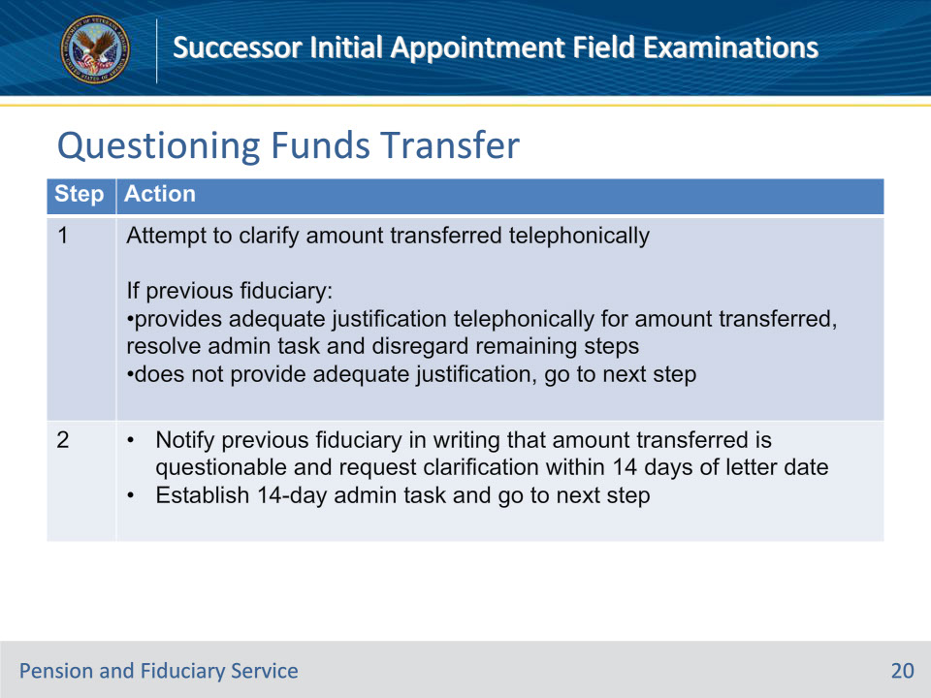
Slide notes

Policy Reference(s): FPM II.2.C.3.e.

Instructor Notes:

Follow the steps in this table when the previous fiduciary is not required to submit a final accounting and the amount of transferred FUM is questionable.

Notes for Step 1:

• The hub must determine, on a case-by-case basis, whether the explanation provided by the prior fiduciary requires further verification. For example, a statement from the beneficiary that an unusual expense or purchase was used for their benefit.

• The hub is not required to follow documentation requirements that are specific to accountings only.

Slide 21 - Questioning Funds Transfer
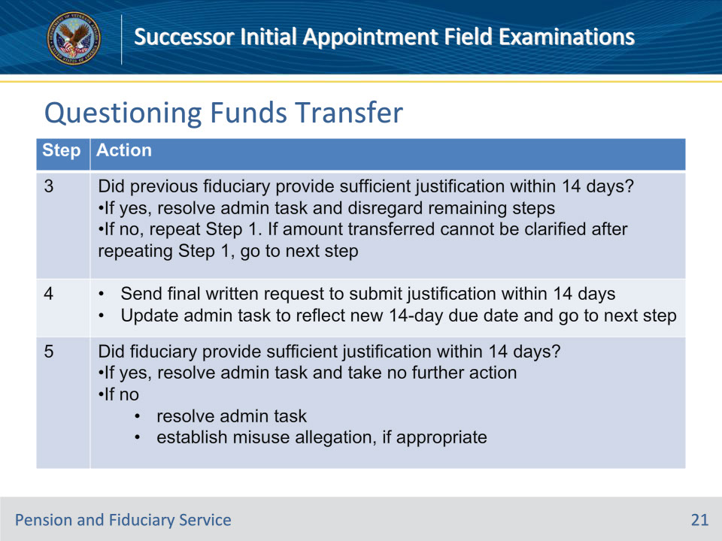
Slide notes

Policy Reference(s): FPM II.2.C.3.e.

Instructor Notes:

Follow the steps in this table when the previous fiduciary is not required to submit a final accounting and the amount of transferred FUM is questionable.

Important for Step 3:

Acceptable documentation justifying the amount of FUM transferred may include, but is not limited to:

• financial statements

• receipts

• invoices, or

• copies of checks.

Slide 22 - Notification Letters
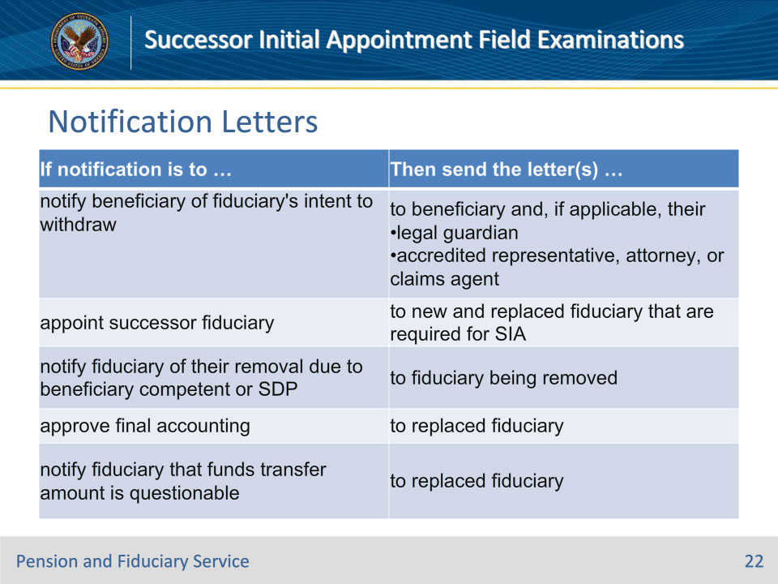
Slide notes

Policy Reference(s): FPM II.2.C.3.f.

Instructor Notes:

Use this table to determine which required notification letter to send during each step in the fiduciary removal and withdrawal process.

Slide 23 - Request Requirements
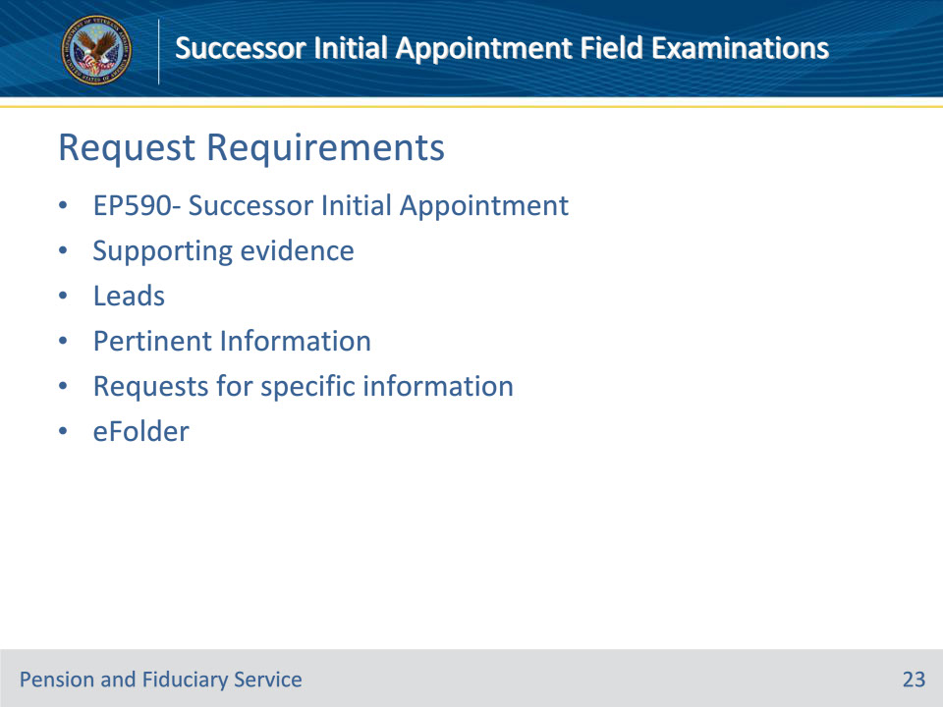
Slide notes

Policy Reference(s): FPM I.2.A.3.b.

Instructor Notes:

SIA field examination requests must include the following and be available for review in the appropriate system of record:

• establishment of an SIA EP 590 in VBMS

• evidence supporting the reason for the SIA uploaded to the electronic claims folder (eFolder), and

• all available leads and pertinent information, including requests for specific information.

Example: If the SIA is being requested due to the fiduciary’s inability to complete an accounting, the fiduciary’s written statement or a VA Form 27-0820, if verbally received, must be uploaded to the eFolder.

Slide 24 - Required Exam Elements
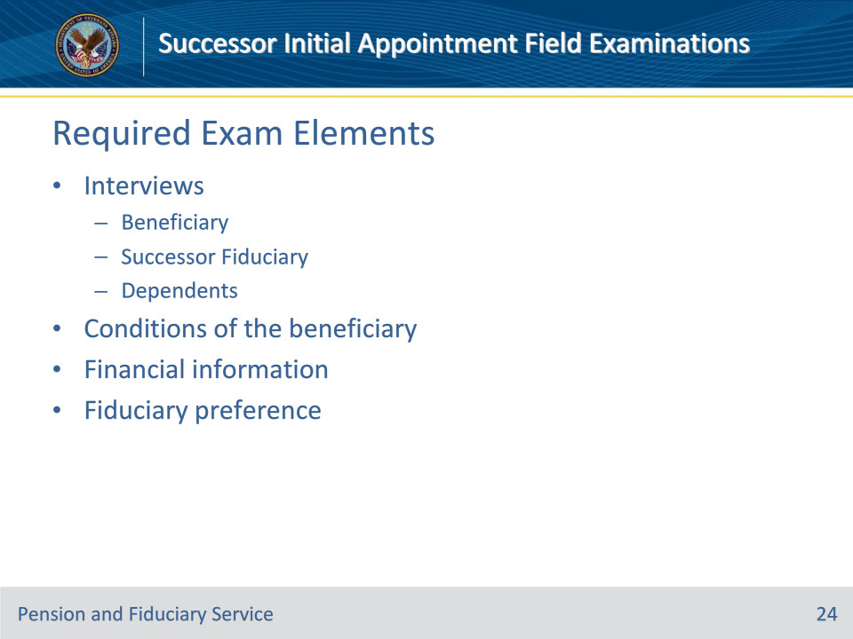
Slide notes

Policy Reference(s): FPM I.2.C.

Instructor Notes:

Successor initial appointment field examinations have the same investigation, inquiry, and reporting elements as an initial appointment field examination. (More detailed requirements can be found in the Initial Appointment Field Examinations training)

The Field Examiner (FE) must provide information in the Field Examination Report that adequately details the interview, including:

• date and method of contact of each interview

• identity and relationship of each person interviewed, and

• directions to the address of the fiduciary or beneficiary, if it is not accessible by GPS or mapping technology.

Generally, the FE must conduct face-to-face interviews with the beneficiary and proposed successor fiduciary, unless an exception is met.

Additionally, the FE must attempt to contact each dependent to determine if their needs are met.

The FE must, to the extent possible, evaluate the beneficiary’s

• physical and mental well-being, and

• environmental and social conditions.

The FE must evaluate the beneficiary’s ability to manage funds by asking probing questions.

Like IA’s, the FE must address:

• Retroactive VA benefit payments

• Possible changes to benefit entitlement

• Assets

• Income

• Expenses

• Debts and Loans

• FUM

• Claims

When selecting a fiduciary, the FE must consider individuals and entities in the established order of preference in the FPM. During the field examination, the FE must document the beneficiary’s fiduciary preference.

Slide 25 - Required Exam Elements (Cont.)
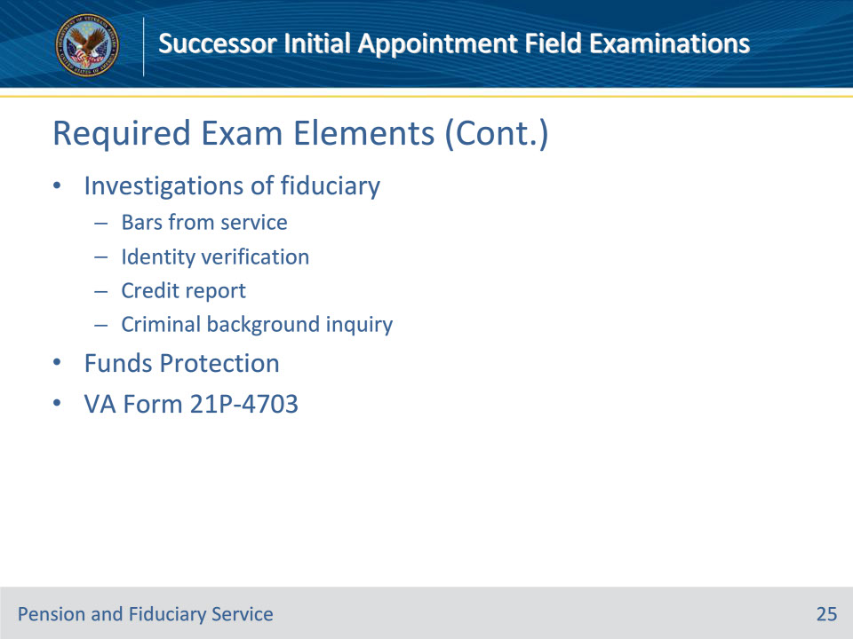
Slide notes

Policy Reference(s): FPM I.2.C.

Instructor Notes:

VA has a duty to thoroughly investigate fiduciaries prior to their appointment. VA’s failure to properly investigate a fiduciary may result in a finding of negligence, which will require VA to reissue any misused benefits.

VA will not conduct the investigation if the proposed fiduciary is an entity, such as the trust department of a bank that provides fiduciary services.

The FE must ensure that the fiduciary is not barred from service.

The FE must verify the proposed fiduciary’s identity.

The FE’s decision to recognize a fiduciary must be based, in part, on a review of a credit report issued within 30 days prior to the proposed appointment, unless an exception is met.

38 U.S.C. 5507 requires that VA request information on the criminal background of any person before appointing that person as fiduciary, unless an exception is met.

If it is determined that a bond is necessary at the time of the field examination, the FE must notify the fiduciary of the requirement to secure a bond.

It is the responsibility of the FE to recommend if a VA-appointed fiduciary should be required to submit an accounting.

During each adult and minor beneficiary IA field examination, the FE must discuss with the proposed fiduciary the responsibilities and information outlined on the VA Form 21P-4703 as well as any other fiduciary responsibilities and considerations not addressed in the form.

Slide 26 - Liquid Assets
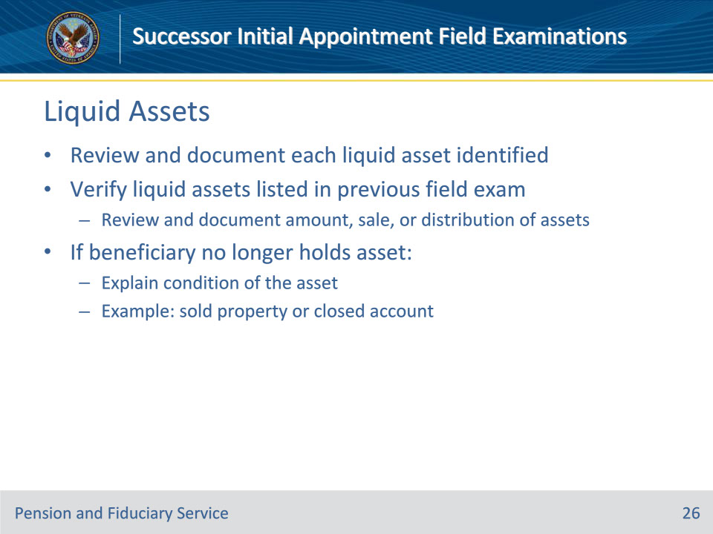
Slide notes

Policy Reference(s): FPM I.2.C.3.e.

Instructor Notes:

The FE must review and document each liquid asset identified during all IA and SIA field examinations.

During SIA field examinations, the FE must verify liquid assets listed in the previous field examination by reviewing and documenting the amount, sale, or distribution of assets identified in the previous field examination. If the beneficiary no longer holds an asset (for example, sold property or closed an account) or has exhausted an asset that was documented in the previous field examination, the FE must explain the condition of the assets.

Slide 27 - VA FUM
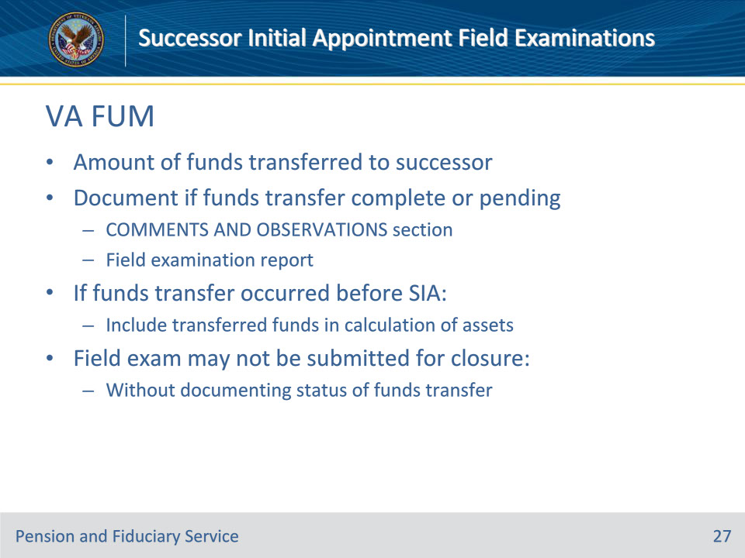
Slide notes

Policy Reference(s): FPM I.2.C.3.k.

Instructor Notes:

VA FUM for SIAs:

the amount of funds to be transferred to the appointed successor fiduciary or beneficiary with an SDP appointment.

The field examination must also document in the COMMENTS AND OBSERVATIONS section of the report if the funds transfer to the successor fiduciary has been completed or is pending. If the funds transfer has occurred before the SIA, include the transferred funds in the calculation of assets. The field examination may not be submitted for closure without documenting the status of the funds transfer.

Important:

• Funds managed directly by a beneficiary under an SDP appointment are not considered VA FUM. Therefore, the hub should not instruct the beneficiary under an SDP appointment to transfer VA funds when VA appoints a fiduciary because SDP is no longer appropriate.

• The hub must not consider FUM that is being transferred from an outgoing fiduciary appointed by VA to the beneficiary with an SDP appointment as a retroactive or one-time payment subject to withholding. The outgoing fiduciary must transfer all FUM to the beneficiary when the beneficiary receives an SDP appointment.

Slide 28 - Required Documents
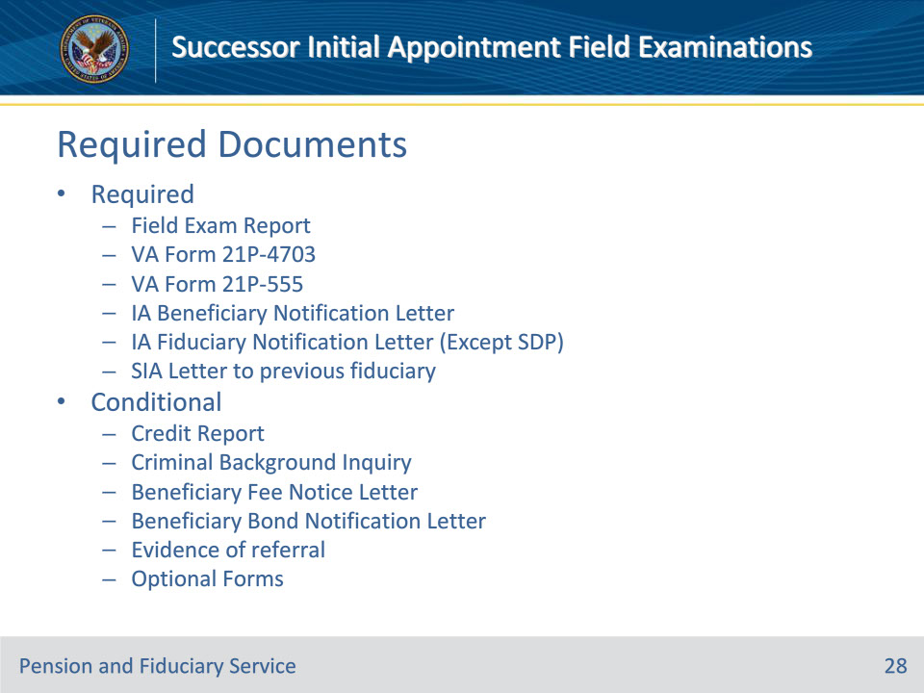
Slide notes

Policy Reference(s): FPM I.2.E.1.d., FPM I.2.E.2.b.

Instructor Notes:

Hub personnel must enter the information gathered during the field examination process in the appropriate system or on the appropriate form. Hub personnel must also generate the applicable field examination report and upload the report and required form(s) to the electronic claims folder (eFolder).

For an SIA, the required documents are:

• field examination report

• VA Form 21P-4703, Fiduciary Agreement (not required for SDP)

• VA Form 21P-555, Certificate of Legal Capacity to Receive and Disburse Benefits and Fee Authorization

• credit report, if required

• criminal background inquiry (CBI), if required, and

• evidence of referrals to other agencies, if required.

For an SIA, the required notification letters are:

• SIA Letter to the previous fiduciary

• IA Beneficiary Notification Letter, with a copy to the power of attorney (POA) and/or court-appointed guardian, if applicable.

• Beneficiary Fee Notice Letter, if applicable.

• Beneficiary Bond Notification Letter, if applicable.

• IA Fiduciary Notification Letter to the fiduciary, if applicable, including a copy of a signed VA Form 21P-4703.

• Optional forms to attach include a VA Form 21P-4718a, and a Standard Form 1199A, Direct Deposit Sign-Up Form.

Slide 29 - Questions?
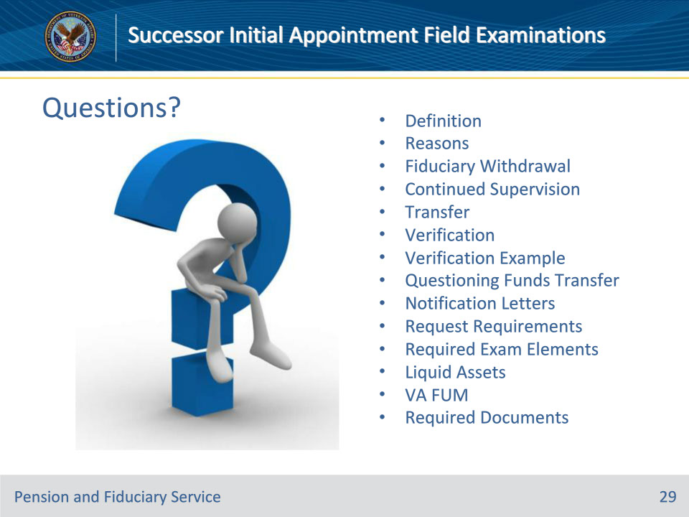
Slide notes

Instructor Notes:

(Recall) These are our learning objectives as stated from the beginning of the training:

• Define the purpose of a successor initial appointment field examination (SIA)

• Recognize the reasons to conduct an SIA

• Identify the elements and requirements of an SIA

• Name the required forms, letters and supporting evidence

(Recap) We discussed each of these learning objectives through the following topics in each slide today:

• Definition

• Reasons

• Fiduciary Withdrawal

• Continued Supervision

• Transfer

• Verification

• Verification Example

• Questioning Funds Transfer

• Notification Letters

• Request Requirements

• Required Exam Elements

• Liquid Assets

• VA FUM

• Required Documents

Are there any additional questions?

Slide 30 - TMS Survey
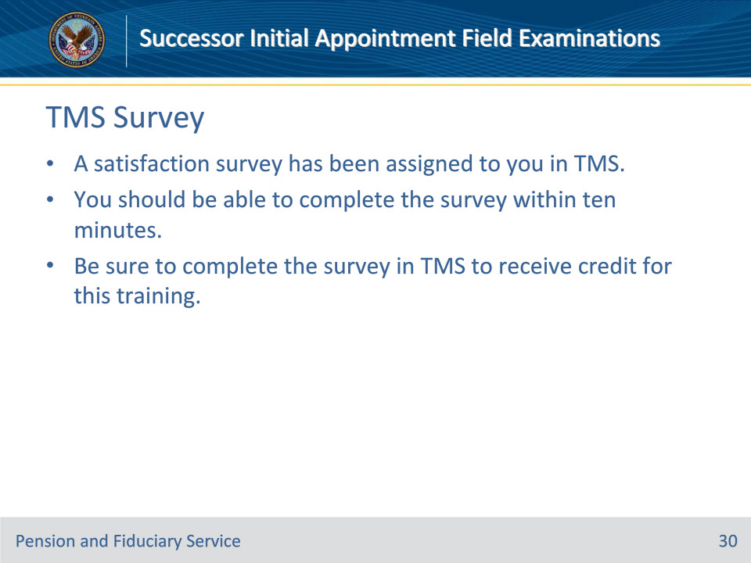
Slide notes

Instructor Notes:

A satisfaction survey has been assigned to you in TMS. You should be able to complete the survey within ten minutes. Completing the survey will allow you to receive credit for this training.

