Slide 1 - Spouse Fiduciary
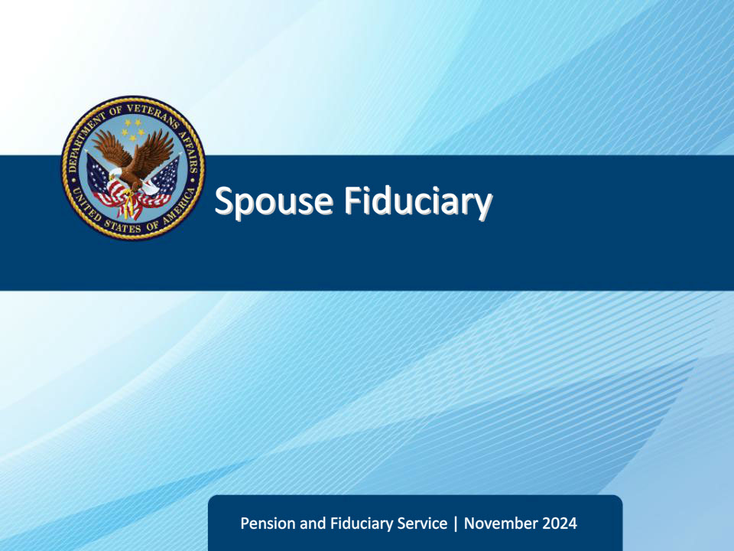
Slide notes

Course Description:

This course teaches learners about the basic factors of investigating, appointing, and supervising Spouse Fiduciaries.

Slide 2 - Objectives
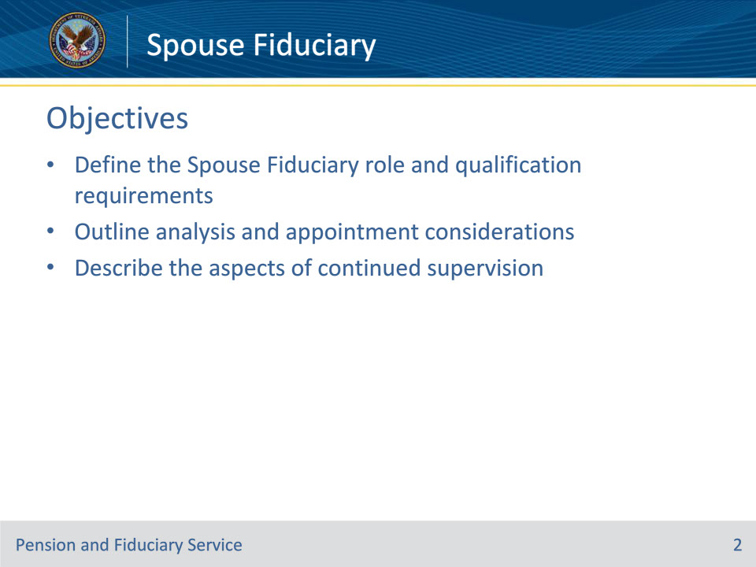
Slide notes

At the end of this lesson, given the training and references, the learner will be able to do the following:

• Define the Spouse Fiduciary role and qualification requirements

• Outline analysis and appointment considerations

• Describe the aspects of continued supervision

Slide 3 - References
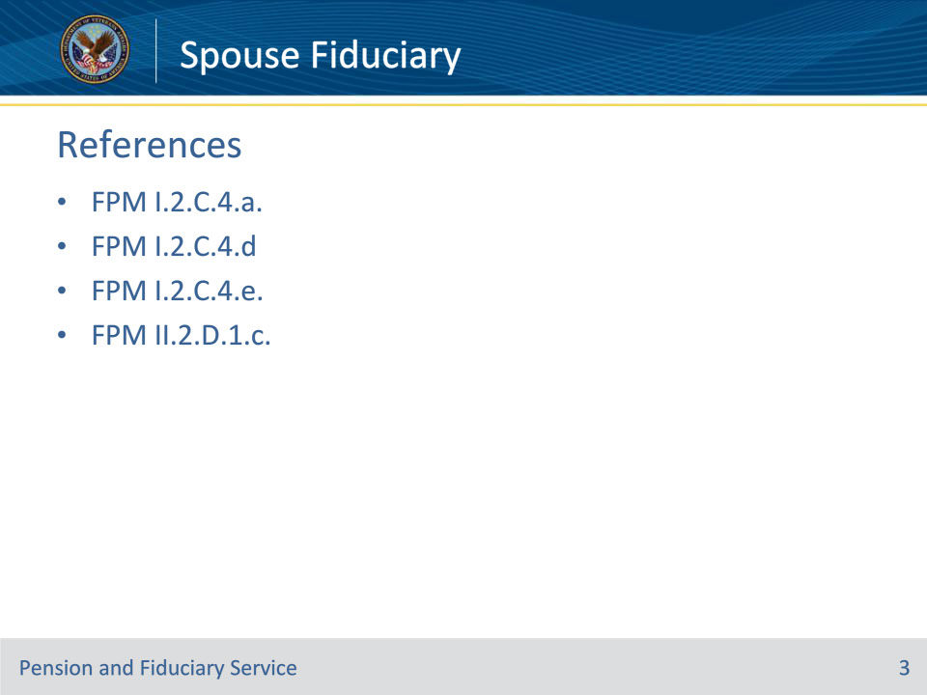
Slide notes

Instructor Notes:

The following are relevant references relating to the fiduciary appointment type VA-appointed fiduciary:

• FPM I.2.C.4.a. General Policy on Appointment and Fiduciary Types

• FPM I.2.C.4.d. Fiduciary Suitability and Type

• FPM I.2.C.4.e. Selecting a VA-Appointed Fiduciary or Spouse Fiduciary

• FPM II.2.D.1.c. Eligibility for Annual Written Contact Only

Slide 4 - Spouse Fiduciary
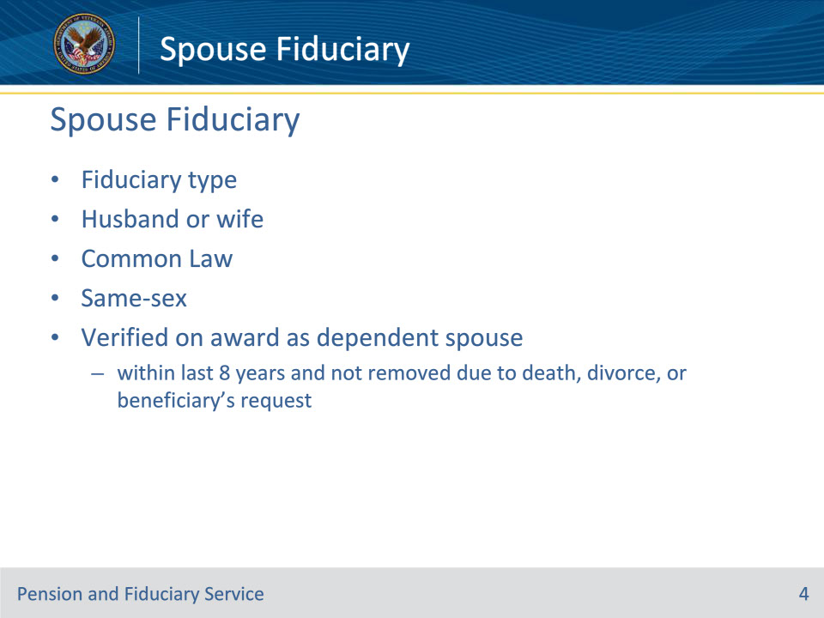
Slide notes

Policy Reference(s): FPM I.2.C.4.a.

Instructor Notes:

A spouse fiduciary refers to a husband or wife whose marriage meets the requirements of 38 U.S.C. 103(c), including common law marriage and same-sex marriage, who is appointed by the VA. Hubs may consider the spouse as valid for appointment as a spouse fiduciary when the spouse has been verified on the award as a dependent spouse within the last eight years and since that time was not removed due to death, divorce, or the beneficiary’s request.

Slide 5 - Analysis and Appointment
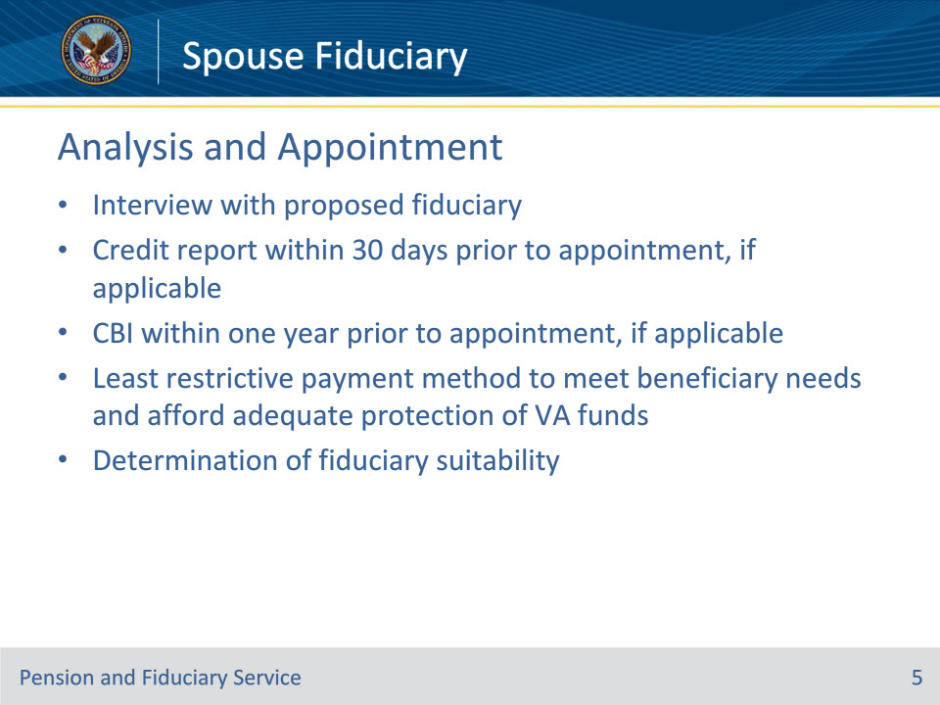
Slide notes

Policy Reference(s): FPM I.2.C.4.e.

Instructor Notes:

The decision to appoint a VA-appointed fiduciary or spouse fiduciary must be based on

• the beneficiary being

• incapable of handling their VA funds without supervision, or

• under the age of majority

• an interview with the proposed fiduciary

• a credit report dated within 30 days prior to the appointment, if applicable

• a CBI within one year prior to the appointment, if applicable

• the fiduciary’s ability to complete accountings and obtain protection of the FUM, if required

• the least restrictive payment method to meet the beneficiary’s needs and afford adequate protection of VA funds

• a determination of the fiduciary’s suitability, and

• the understanding that any remaining assets in the case of a minor beneficiary are to be turned over to the minor when they reach the age of majority, if applicable.

Slide 6 - Analysis and Appointment
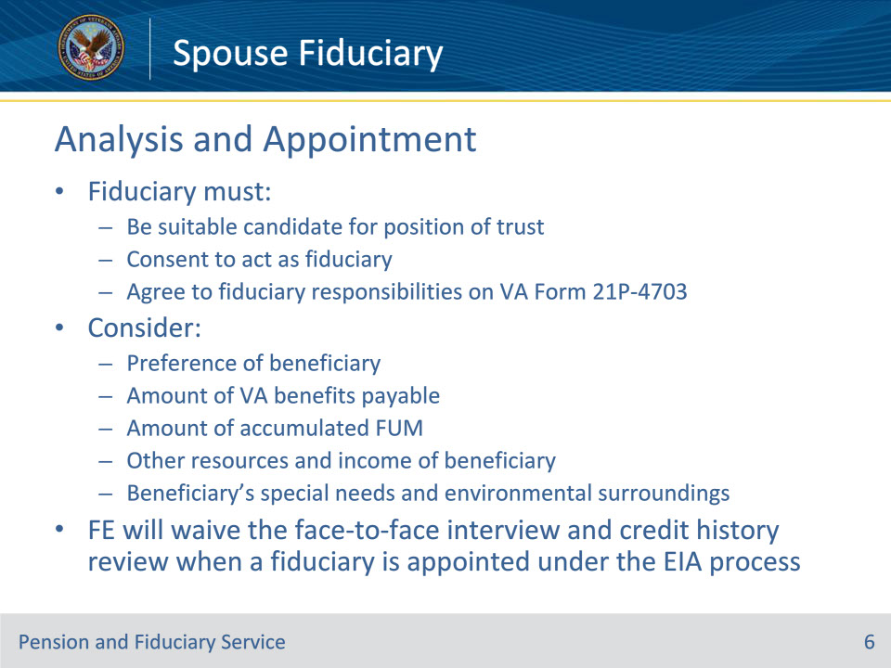
Slide notes

Policy Reference(s): FPM I.2.C.4.e.

Instructor Notes:The fiduciary must

• be a suitable candidate for this position of trust

• consent to act as fiduciary, and

• agree to the fiduciary responsibilities outlined on the VA Form 21P-4703.

When appointing a fiduciary, consideration should be given to the

• preference of the beneficiary, for adult and minor beneficiaries age 12 or older

• amount of VA benefits payable

• amount of accumulated FUM, if any

• other resources and income of the beneficiary, and

• the beneficiary’s special needs and environmental surroundings.

The FE will waive the face-to-face interview and credit history review when a fiduciary is appointed under the Expedited Initial Appointment (EIA) process

Slide 7 - Oversight
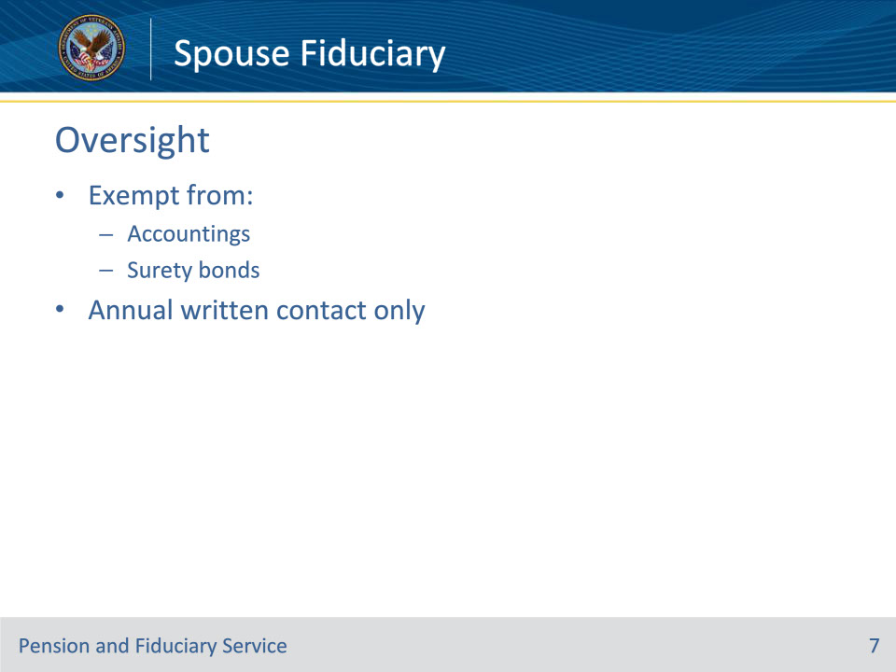
Slide notes

Policy Reference(s): FPM I.2.C.4.d.; FPM II.2.D.1.c.

Instructor Notes:

Spouse fiduciaries will generally be exempt from accounting and surety bond requirements. Should the FE determine that VA FUM require oversight not required of a spouse fiduciary, a fiduciary type other than a spouse fiduciary will be appointed.

While all beneficiaries in the Fiduciary Program receive written contact from VA annually, some beneficiaries fall into a sub-category of written contact called annual written contact only. Annual written contact only is the least invasive form of regular contact while continuing contact and oversight of the beneficiary.

If the eligible beneficiary has a spouse fiduciary, then the fiduciary hub will implement annual written contact only oversight due to VA’s long-standing policy to avoid undue intrusion into the relationship between a beneficiary and the beneficiary’s spouse

Slide 8 - Questions?
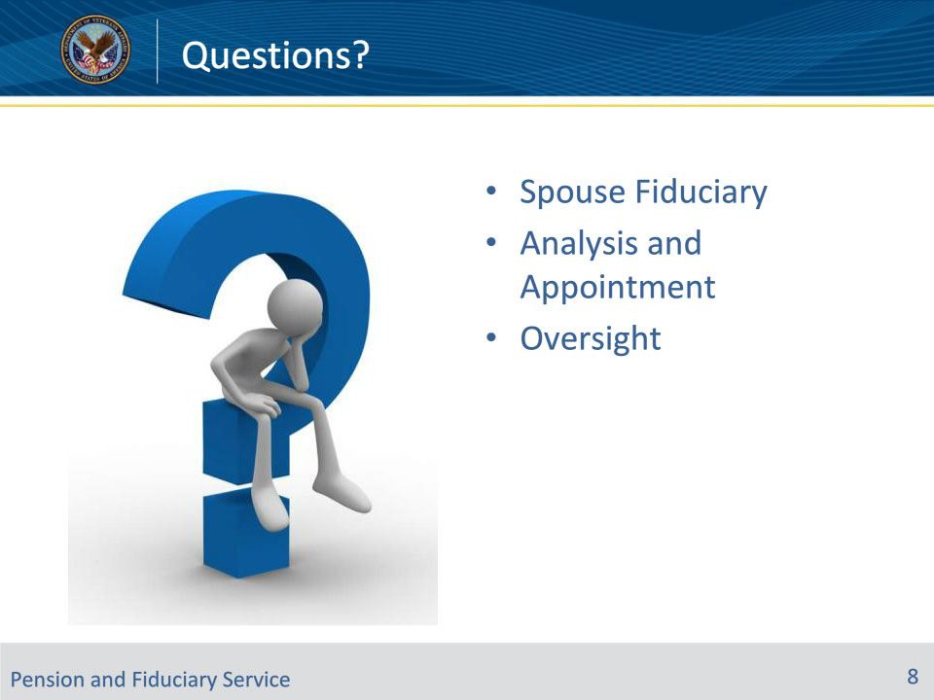
Slide notes

Instructor Notes:

(Recall) These are our learning objectives as stated from the beginning of training:

• Define the Spouse Fiduciary role and qualification requirements

• Outline analysis and appointment considerations

• Describe the aspects of continued supervision

(Recap) We discussed each of these learning objectives through the following topics in each slide today:

• Spouse Fiduciary

• Analysis and Appointment

• Oversight

Are there any additional questions?

Questions should be filtered through your QRT team. They will submit your questions to the Field Inquiry Tool (FIT) on your behalf.

Slide 9 - TMS Survey/Assessment
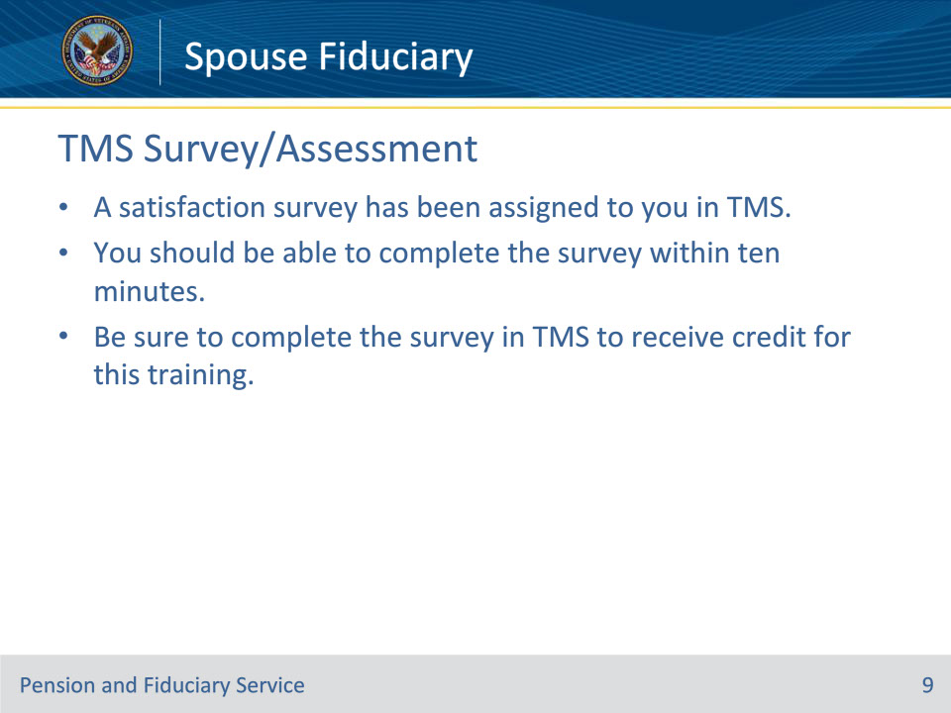
Slide notes

Instructor Notes:

A satisfaction survey and/or assessment have been assigned to you in TMS.

Be sure to complete the survey and/or assessment to receive credit for this training.

