**Slide 1 - Initial Appointment Field Examinations**

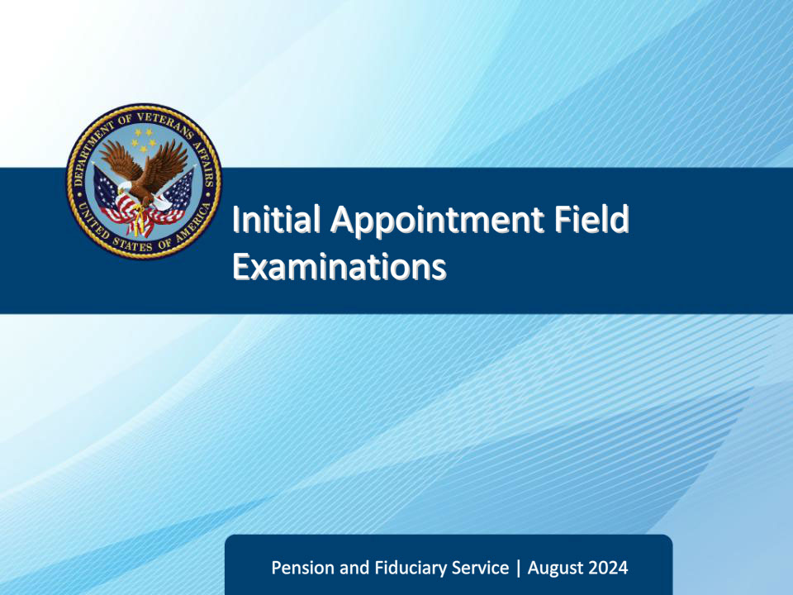

**Slide notes**

Course Description:

The lesson teaches learners about the purpose, critical elements, and specific requirements of initial appointment field examinations to include how an initial appointment field examination is initiated, documented, and reported.

**Slide 2 - Objectives**

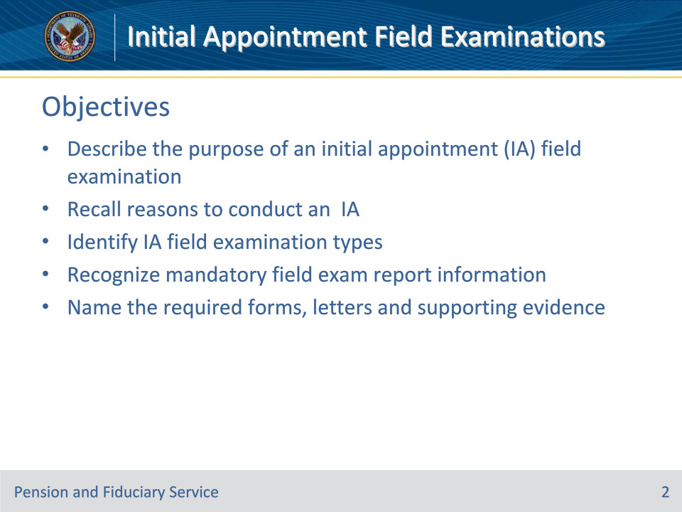

**Slide notes**

Instructor Notes:

At the end of this lesson, given the training and references, the learner will be able to do the following:

• Describe the purpose of an initial appointment (IA) field examination

• Recall reasons to conduct an IA

• Identify IA field examination types

• Recognize mandatory field exam report information

• Name the required forms, letters and supporting evidence

**Slide 3 - References**

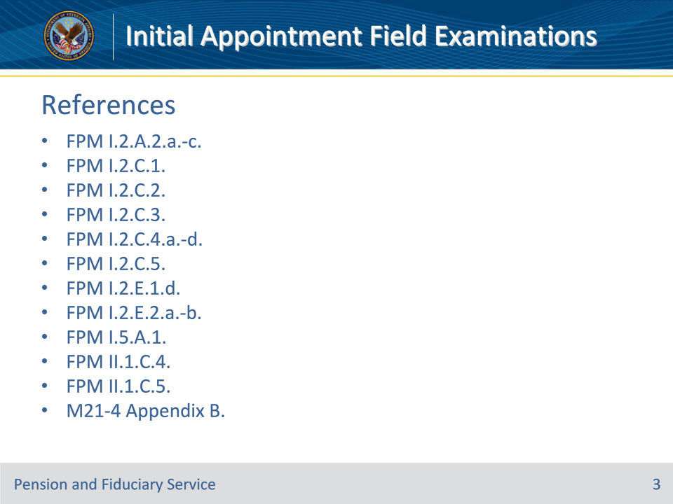

**Slide notes**

Instructor Notes:

These are the references for today’s training:

• FPM I.2.A.2.a.-c.

• FPM I.2.C.1.

• FPM I.2.C.2.

• FPM I.2.C.3.

• FPM I.2.C.4.a.-d.

• FPM I.2.C.5.

• FPM I.2.E.1.d.

• FPM I.2.E.2.a.-b.

• FPM I.5.A.1.

• FPM II.1.C.4.

• FPM II.1.C.5.

• M21-4 Appendix B.

**Slide 4 - Purpose**

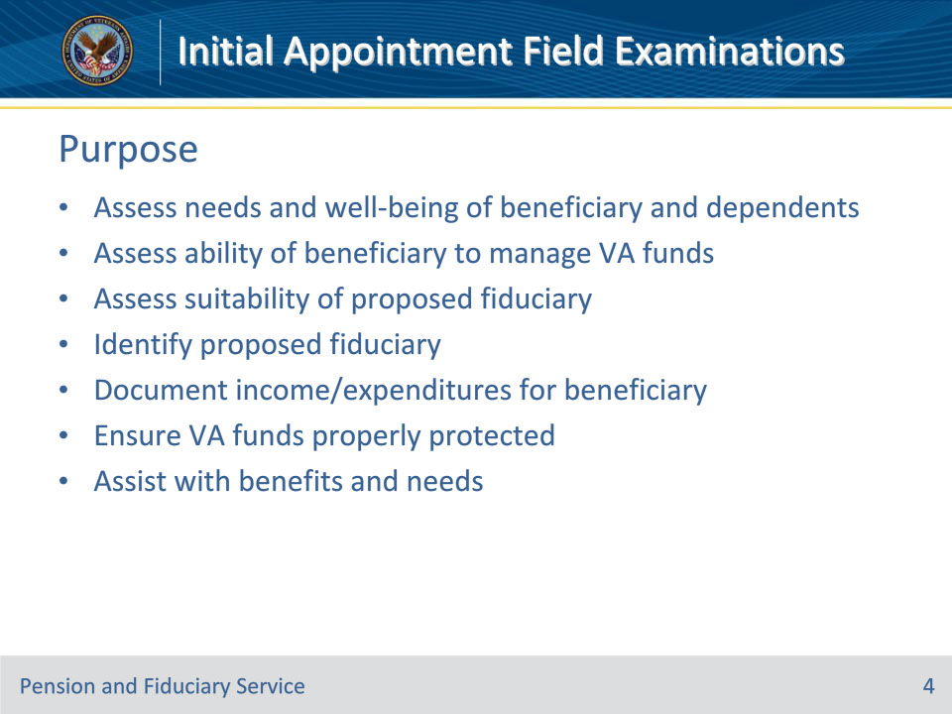

**Slide notes**

Policy Reference(s): FPM I.2.A.2.a.

Instructor Notes:

An initial appointment (IA) field examination involves the need for and, when necessary, the qualification and appointment of a fiduciary to receive VA benefits or insurance payments.  The appointment is made on behalf of a beneficiary who is determined to be unable to manage their benefits, has not reached age of majority, or is under a court-appointed general law or plenary guardianship or Uniform Veterans Guardianship Act guardianship.

IA field examinations are completed to:

• assess the

• needs and well-being of the beneficiary and his/her dependents

• ability of an adult beneficiary to manage funds, and

• suitability of the proposed fiduciary

• identify a proposed fiduciary

• document income and expenditures for the beneficiary

• ensure VA funds are properly protected, if required, and

• provide advice and assistance with benefits and needs.

**Slide 5 - Types of IA Field Exams**

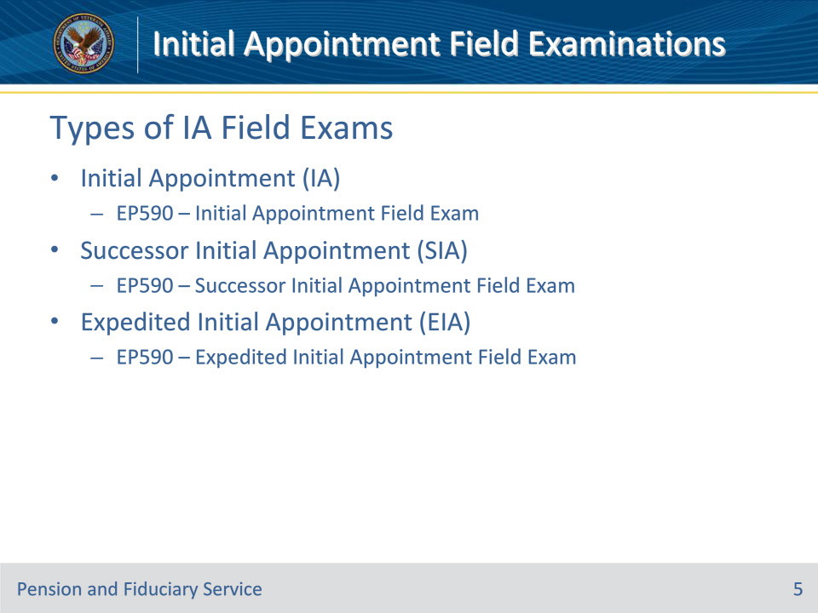

**Slide notes**

Policy Reference(s): FPM I.2.A.2.b.; M21-4 Appendix B.

Instructor Notes:

There are three types of IA field examinations: IA, successor and Expedited.

Initial Appointment (IA)--A face-to-face interview or telephone interview, when applicable, and investigation activity conducted by designated hub or other qualified VA personnel for the purpose of qualifying and appointing a fiduciary for an individual who is not currently under hub supervision.

• EP590IAFE – Initial Appointment Field Exam is the associated End Product for this work product.

Successor IA (SIA):  A face-to-face inquiry or telephone interview, when applicable, and investigation activity conducted by designated hub or other qualified VA personnel for the purpose of qualifying and appointing a replacement fiduciary for the beneficiary.

• EP590SIAFE – Successor Initial Appointment Field Exam is the associated End Product for this work product.

Expedited IA (EIA):  A telephone interview and investigation activity conducted by designated hub or other qualified VA personnel for the purpose of expediting the qualification and appointment of a fiduciary.

• EP590EIAFE – Expedited Initial Appointment Field Exam is the associated End Product for this work product.

**Slide 6 - Stages**

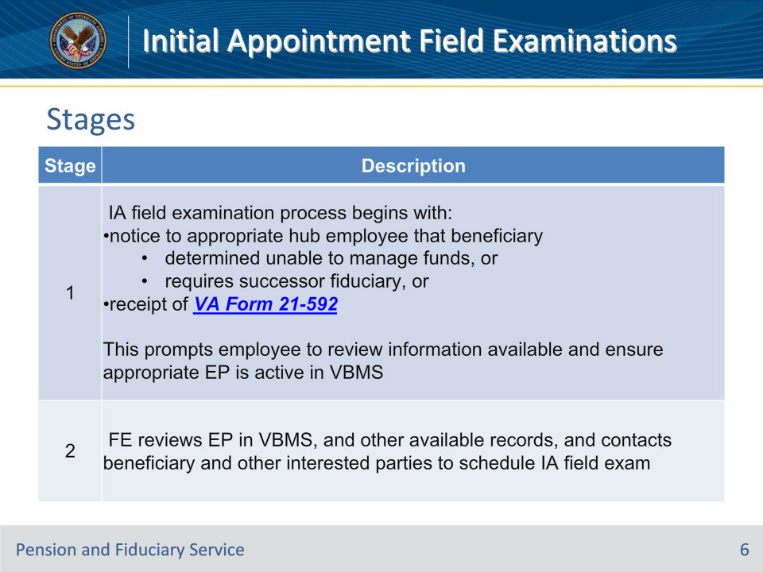

**Slide notes**

Policy Reference(s): FPM I.2.A.2.c.

Instructor Notes:

This table describes the general stages of the IA field examination process.

**Slide 7 - Stages**

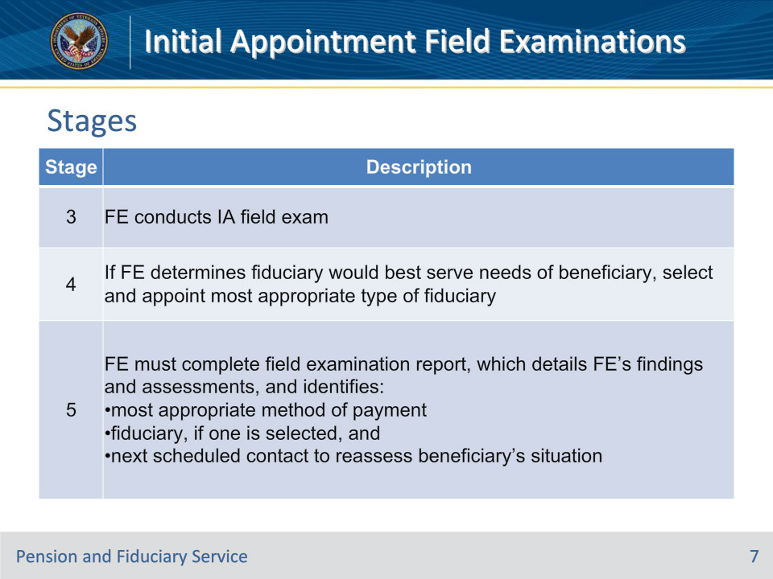

**Slide notes**

Policy Reference(s): FPM I.2.A.2.c.

Instructor Notes:

This table describes the general stages of the IA field examination process.

Note for stage 3:  EIA field examinations must not be completed via face-to-face appointment.

**Slide 8 - Interview Logistics and Contacts**

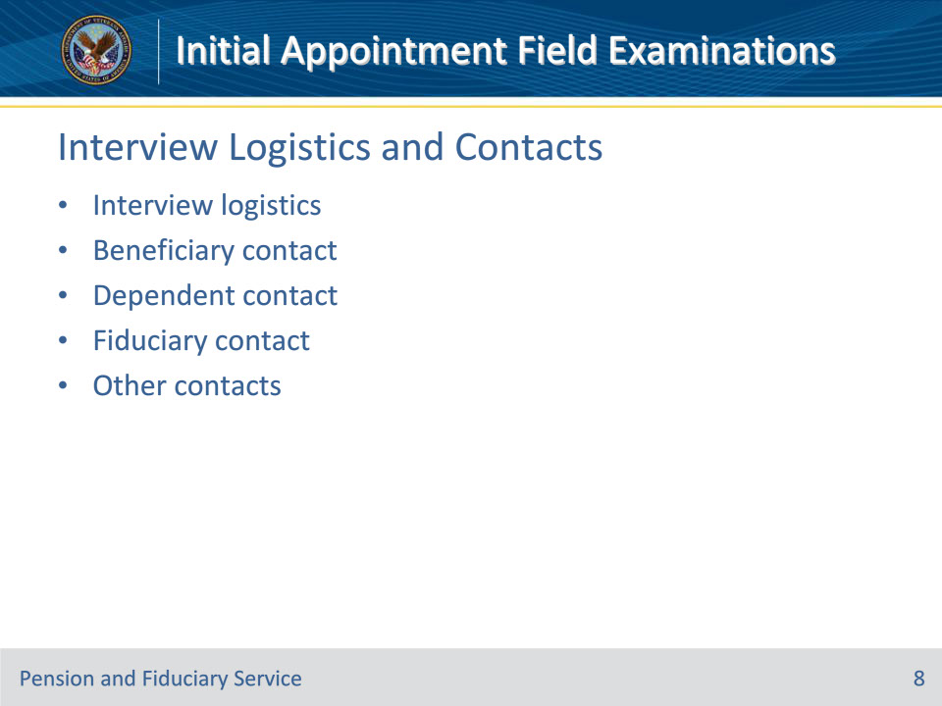

**Slide notes**

Policy Reference(s): FPM I.2.C.1.

Instructor Notes:

This slide covers the basics of interview logistics and contacts (this topic is covered more in depth in the Interview Scheduling, Logistics, and Contacts Training).

Interview Logistics

The Field Examiner (FE) must provide information in the field examination that adequately details the interview.

Beneficiary contact

During the field examination process, the FE must collect or verify required general information of the beneficiary.

Generally, the FE must conduct a face-to-face interview with the beneficiary, unless an exception is met.

Dependent ContactFEs must attempt to contact each adult beneficiary’s dependents, or the custodian of child dependents under the age of 12 and document the contact in the field examination.

Fiduciary Contact

During the field examination process the FE must collect or verify required general information of the fiduciary.

For an IA or SIA, the FE must conduct a face-to-face interview with the fiduciary to complete the appointment process, unless an exception is met.

The FE must provide all prospective and existing fiduciaries with the VA Fiduciary Guide. For prospective fiduciaries, FEs must also provide training information regarding the fiduciary process and request they complete the modules prior to the field examination. FEs must also provide information on the use of the Fiduciary Accountings Submission Tool (FAST).

Other ContactsThe FE must document the name and contact information (if available) of people considered to be the next of kin, caregiver, and/or friend to the beneficiary in the beneficiary profile.

**Slide 9 - Conditions of the Beneficiary**

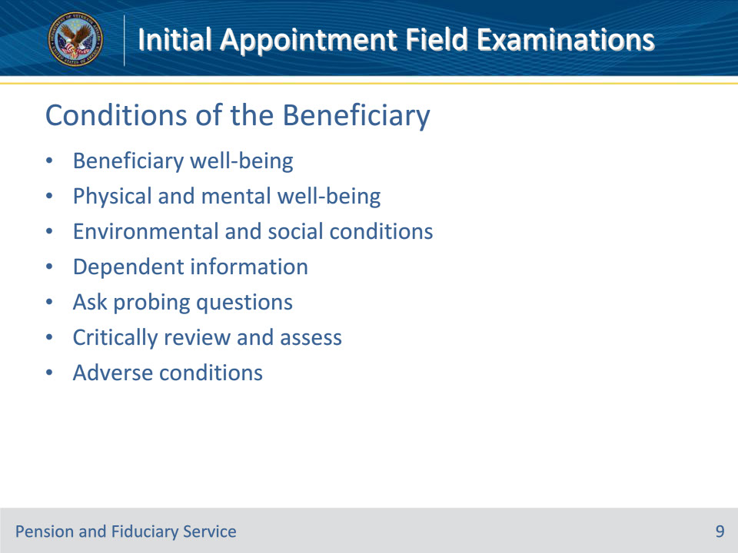

**Slide notes**

Policy Reference(s): FPM I.2.C.2.

Instructor Notes:

This slide covers the basics of evaluating beneficiary well-being (this topic is covered more in depth in the Beneficiary Evaluation Training).

The FE must, to the extent possible, evaluate the beneficiary’s

• physical and mental well-being, and

• environmental and social conditions.

For VA purposes, assessing the beneficiary’s well-being means considering the beneficiary’s physical, mental, environmental and/or social challenges/needs and, the resources the beneficiary has available to meet those needs, even if the beneficiary chooses not to employ available resources.

The FE must evaluate the beneficiary’s physical and mental well-being and social and physical environment during the field examination. They must also collect and document specific, required information for each dependent of an adult beneficiary.

Evaluation is achieved by asking probing questions regarding specific topics.

The FE must critically review the answers to the questions asked while assessing the beneficiary’s physical and mental well-being, and environmental and social conditions.  If the interview reveals basic needs are being unmet or adverse conditions exist, the FE must refer the case to the appropriate local, State, or Federal agencies.

**Slide 10 - Capacity to Manage Funds**

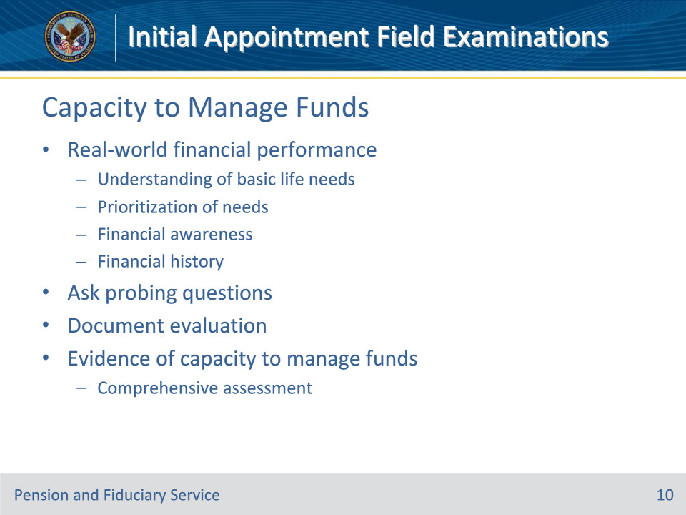

**Slide notes**

Policy Reference(s): FPM I.5.A.1.

Instructor Notes:

The Field Examiner (FE) must evaluate the adult beneficiary’s capacity to manage funds without Department of Veteran’s Affairs (VA) supervision as is shown through the beneficiary’s real-world financial performance in meeting their basic needs. This includes an assessment of the beneficiary’s understanding of basic life needs (i.e., food, shelter) and a prioritization for these needs, financial awareness, and a review of their financial history. The FE must complete a detailed evaluation and document their findings in the field examination.

The FE must evaluate the beneficiary’s ability to manage funds by asking probing questions.

If there is evidence the beneficiary has the capacity to manage their funds and an SDP appointment is being considered, the FE must complete a required comprehensive assessment.

**Slide 11 - Financial Information (Cont.)**

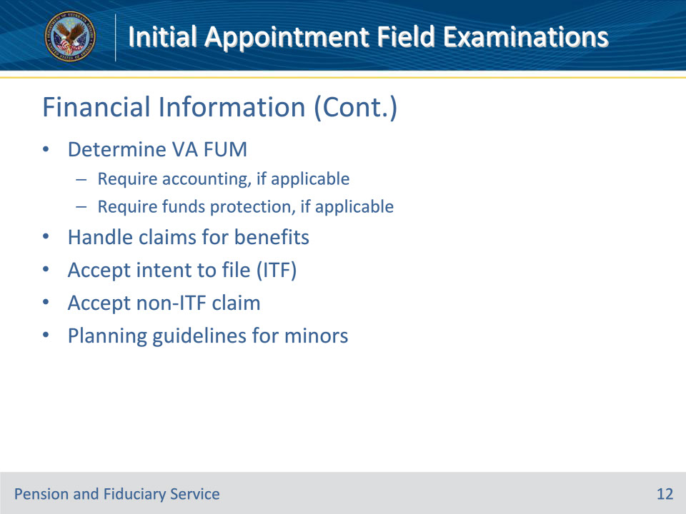

**Slide notes**

Policy Reference(s): FPM I.2.C.3.

Instructor Notes:

This slide covers the basics of evaluating financial information. This topic is covered more in depth in the following trainings:

• Income and Retroactive Benefits

• Assets (core)

• Expenses, Debts, and Loans

• Funds Under Management (core)

Determining VA FUM

The FE must determine and document the VA FUM amount.

Appropriate Actions if the FUM Exceeds Limits for Accounting and Protection of FUM Limits

Determine the appropriate actions if the FUM exceeds the limits for accounting and protection of FUM limits.

Handling Claims for Benefits

FEs should encourage claimants to utilize VA paperless claims submission tools, when possible, to complete VA benefit applications. In situations when the claimant does not have the ability to complete or print applications online, the FE must provide the claimant with the appropriate form(s) and submission information. If the FE receives claim document(s) during the field examination, the FE must follow specific procedures for submitting the documents on the claimant’s behalf.

Accepting an ITF

When a beneficiary verbally communicates to a VA employee an intent to file (ITF) a claim for compensation, pension, Survivors Pension or Dependency and Indemnity Compensation (DIC), the beneficiary does not need to complete a VA Form 21-0966. The FE must notify the claimant of the ITF procedures, document the ITF in the field examination and request input of the ITF in VBMS.

Accepting a Claim Request Other Than an ITF

For requests to file a claim for benefits other than compensation, pension, or DIC, the FE will provide the beneficiary with the required application form(s), record the information on VA Form 27-0820, and upload VA Form 27-0820 to VBMS. If the FE does not have the appropriate VA claim form available during the field examination, the FE must request the application be provided to the claimant by hub personnel.

Educational and Financial Planning Guidelines in Minor Beneficiary Cases

The FE must discuss with the fiduciary and minor, if the minor is of a suitable age, information regarding education plans and expenses, and benefits available beyond age 18.

**Slide 12 - Fiduciary Appointment**

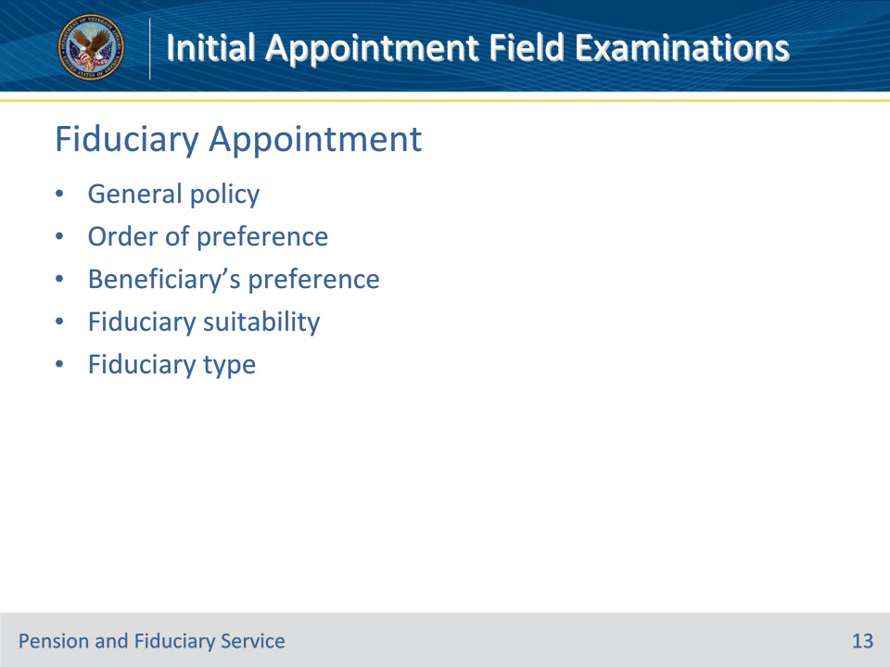

**Slide notes**

Policy Reference(s): FPM I.2.C.4.a-.d.

Instructor Notes:

This slide covers the basics of fiduciary appointments. This topic is covered more in depth in the following trainings:

• Fiduciary Preference and Suitability

• VA-Appointed Fiduciary

• Spouse Fiduciary

• Supervised Direct Payment

• Court Appointments and Temporary Fiduciaries

General Policy on Appointment and Fiduciary Types

VA is authorized to make payments

• directly to the beneficiary under SDP in adult beneficiary cases, or

• to a fiduciary on behalf of the beneficiary.

Beneficiary’s Fiduciary Preference

When selecting a fiduciary, the FE must consider individuals and entities for appointment in a specific, mandated order of preference, provided that the proposed fiduciary is qualified, willing to serve, and the appointment would serve the beneficiary’s interest.

Documenting the Beneficiary’s Fiduciary Preference

During the field examination, the FE must document information regarding the beneficiary’s fiduciary preference if the beneficiary had the capacity to state a preference. If the preferred fiduciary was not appointed, the FE must also document the reason for non-selection. If a fiduciary preference is not indicated, the FE must document the reason why a preference was not provided by the beneficiary.

Fiduciary Suitability and Type

For all IA and SIA field examinations, the FE must

• assess the suitability of the proposed fiduciary, and

• determine whether the payment type is in the beneficiary’s best interest.

**Slide 13 - Investigations of Fiduciaries**

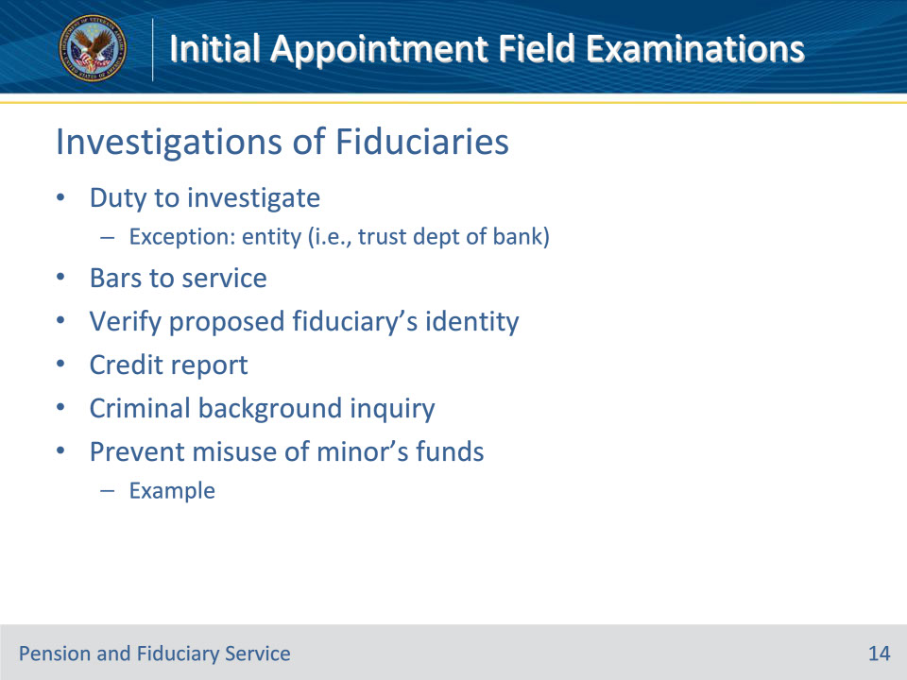

**Slide notes**

Policy Reference(s): FPM I.2.C.5.a.-d., i., p.

Instructor Notes:

This slide covers the basics of investigations of fiduciaries. This topic is covered more in depth in the Credit Reports and Criminal Background Inquiries trainings.

Duty to Investigate Proposed Fiduciaries

VA’s failure to properly investigate a proposed fiduciary may result in a finding of negligence. VA will not conduct the investigation if the proposed fiduciary is an entity, such as the trust department of a bank that provides fiduciary services.  This includes the face-to-face interview, credit report, CBI, and proof of identity.

Bars to Serving as a Fiduciary

An individual or entity may not serve as a fiduciary for a VA beneficiary if the individual or entity is barred from service.

Verifying Proof of the Proposed Fiduciary’s Identity

The FE must verify the proposed fiduciary’s identity.

Obtaining a Credit Report and CBI During an IA38 U.S.C. 5507 provides authority for VA to obtain credit reports from prospective fiduciaries. It also requires that VA request information on the criminal background of any person before appointing that person as fiduciary.

Preventing Misuse of a Minor’s VA Funds

The FE must identify any situation that could lead to the misuse or misappropriation of the minor’s benefits and take action to protect the interest of the minor.

Example:  If other adults residing with the proposed fiduciary and minor have no means of support, the FE must take action to prevent the minor’s VA funds from being used to support those adults, by educating the fiduciary the funds are for the minor and not for anyone else.

**Slide 14 - Credit Reports**

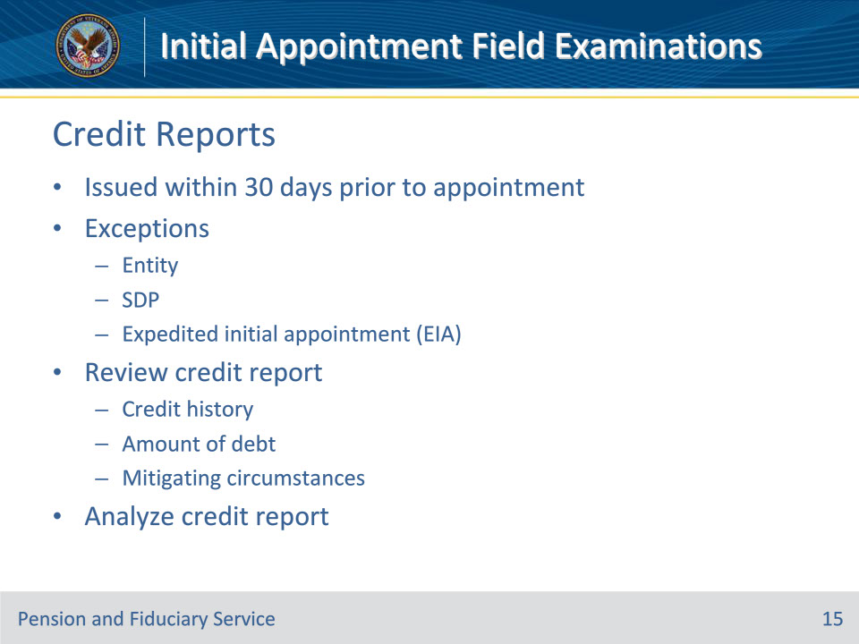

**Slide notes**

Policy Reference(s): FPM I.2.C.5.d.-f.

Instructor Notes:

This slide covers the basics of investigations of fiduciaries. This topic is covered more in depth in the Credit Reports and Criminal Background Inquiries trainings.

Obtaining a Credit Report During an IA

The FE’s decision to recognize a fiduciary must be based, in part, on a review of a credit report issued within 30 days prior to the proposed appointment.

Credit reports are not required for

• an entity, such as a trust department in a bank that provides trust services

• a beneficiary appointed as SDP, or

• a fiduciary appointed under the EIA process

Review of Credit Reports During an IA

For IAs, the FE must evaluate all information from the proposed fiduciary’s credit report to include the credit history and the amount of debt. A proposed fiduciary with an unsatisfactory credit report will not qualify as a VA fiduciary without the FE documentation of mitigating circumstances and decision to appoint..

Analyzing the Credit Report

If the credit report contains negative information, such as late payments, collections, foreclosures, and/or bankruptcies, the FE must consider the facts and circumstances surrounding the issue and how that information relates to the prospective fiduciary’s ability to manage the beneficiary’s funds.

**Slide 15 - Criminal Background Inquiries**

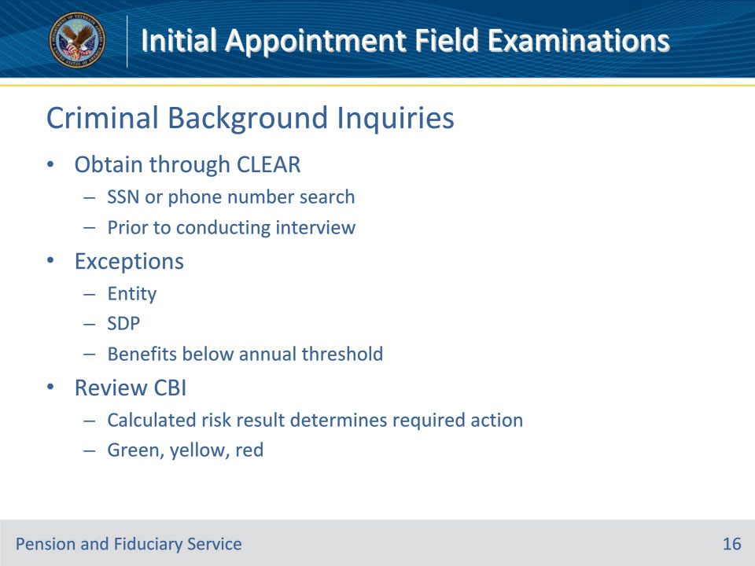

**Slide notes**

Policy Reference(s): FPM I.2.C.5.i.-k.

Instructor Notes:

This slide covers the basics of investigations of fiduciaries. This topic is covered more in depth in the Credit Reports and Criminal Background Inquiries trainings.

Obtaining a CBI During an IA

FEs obtain the CBI through CLEAR prior to conducting the interview.

CBIs are not required for

• an entity, such as a trust department in a bank that provides trust services

• a beneficiary appointed as SDP, or

• a proposed fiduciary when the beneficiary receives benefits less than the adjusted annual rate pursuant to 38 U.S.C. 5312.

CBI Search Methods and Assistance

Prospective fiduciaries can be searched in CLEAR by performing either an SSN or phone number search.

Review of CBI During an IA

The CLEAR report will return a calculated risk result of either green, yellow, or red.  The FPM dictates appropriate actions to take based on the calculated risk result.

**Slide 16 - Authorizing Fiduciary Fees**

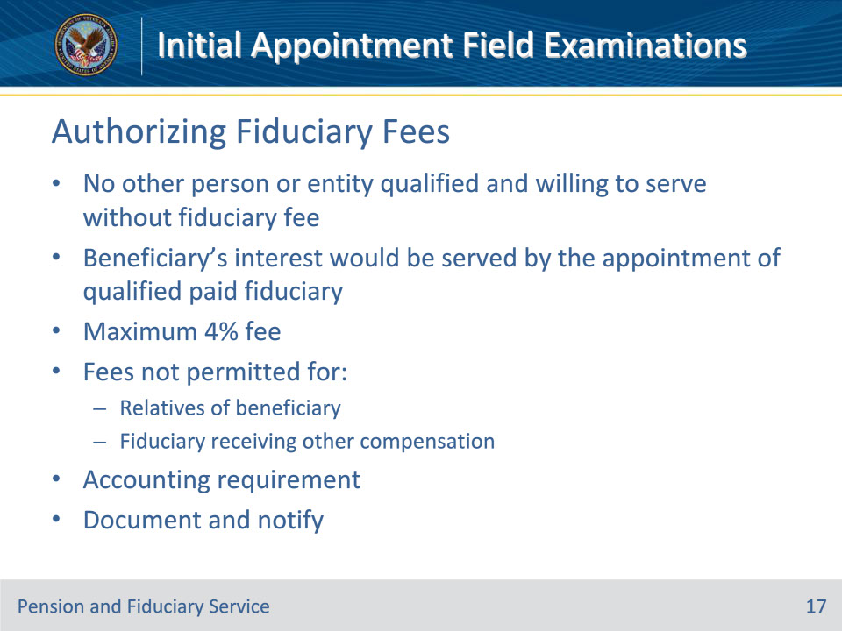

**Slide notes**

Policy Reference(s): FPM II.1.C.4.

Instructor Notes:

This slide covers the basics of fiduciary fees. This topic is covered more in depth in the following trainings:

• Fiduciary Fees (core)

• Assets and Fiduciary Fees

Policy on Authorizing Fiduciary Fees

The Fiduciary Hub Manager (FHM) or designee is permitted to authorize a reasonable monthly fiduciary fee if necessary to obtain the services of a qualified fiduciary.

A fiduciary fee is necessary only if no other person or entity is qualified and willing to serve without a fiduciary fee and the beneficiary’s interest would be served by the appointment of a qualified paid fiduciary.  FEs may not recommend a fiduciary fee above 4 percent as a fiduciary fee in excess of 4 percent of the monetary benefits paid by VA on behalf of the beneficiary to the fiduciary during a year is not authorized.  However, there is a limited exception when a VA-appointed fiduciary who is also a court-appointed conservator or guardian may collect a fee in excess of 4 percent.

Limitations on Fees

Hub employees will not authorize a fee if the fiduciary

• is a spouse, dependent, or other relative of the beneficiary, or

• will receive any other compensation of any kind for managing the beneficiary’s VA benefits.

Accounting Requirements Associated With Fees

In every instance where a fiduciary fee is recommended, the FE must

• explain to the fiduciary the requirement and procedures for annual written accountings

• provide the diary date for the accounting, and

• require an accounting no less than annually.

Documentation Requirements for Authorizing Fees

The FE is responsible for determining whether a fee is necessary during an IA or SIA field examination.  The FE must complete the fee section of the field examination to document the:

• recommended fee percentage in the FEE section, and

• justification for recommending that VA authorize a fiduciary fee in the COMMENTS AND OBSERVATIONS section

Notification Requirements Regarding the Authorization of Fees

Each beneficiary whose fiduciary will be permitted to charge a fee must be notified of that decision.

**Slide 17 - Protection of Funds**

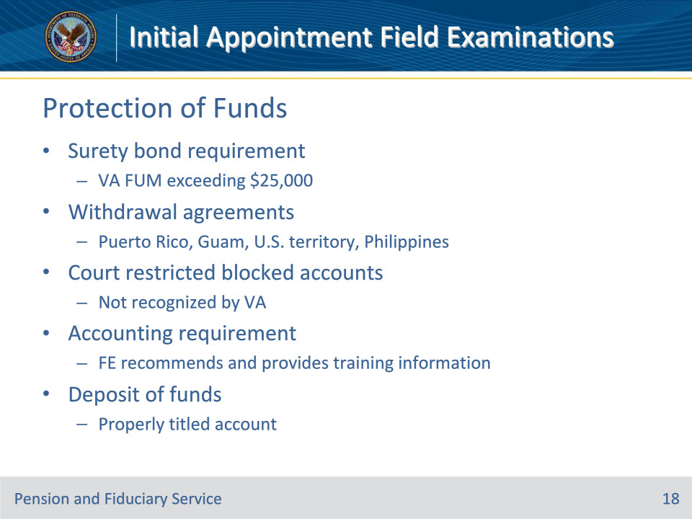

**Slide notes**

Policy Reference(s): FPM II.1.C.5.

Instructor Notes:

This slide covers the basics of funds protection. This topic is covered more in depth in the following trainings:

• Bond Requirements

• Benefit Funds Protection

Requiring a Surety Bond

The FHM is authorized to require a corporate surety bond from a VA-appointed fiduciary, if considered necessary to protect the beneficiary’s VA FUM.

A bond is required when VA FUM exceed $25,000, unless the fiduciary is exempted from obtaining a surety bond.

If it is determined that a bond is necessary at the time of the field examination, the FE must notify the fiduciary of the requirement to secure a bond.

When a Withdrawal Agreement Can Be Used In Lieu of a Surety Bond

A withdrawal agreement is only acceptable in lieu of a corporate surety bond if the fiduciary is located in the Commonwealth of Puerto Rico, Guam, or another territory of the U.S., or in the Republic of the Philippines.

Use of a Court Restricted Blocked Account

Court appointed fiduciaries may be subject to court restricted accounts.  However, VA will not recognize a court restricted account as a form of protection of VA FUM.  In this instance, a bond will be required irrespective of the existence of a court restricted account.

Requiring an Accounting

it is the responsibility of the FE to recommend if a VA-appointed fiduciary should be required to submit an accounting. For prospective fiduciaries, FEs must also provide training information regarding the fiduciary online portal and FAST process.

Policy Regarding Deposit of Funds

The FE must instruct VA-appointed fiduciaries to deposit any VA benefits in a properly titled checking or savings account that is federally insured.

When the VA-appointed fiduciary plans to save VA benefits or insurance payments of a minor beneficiary, the FE must instruct the fiduciary to establish separate accounts for each minor family member for which the fiduciary serves.

**Slide 18 - Required Documents**

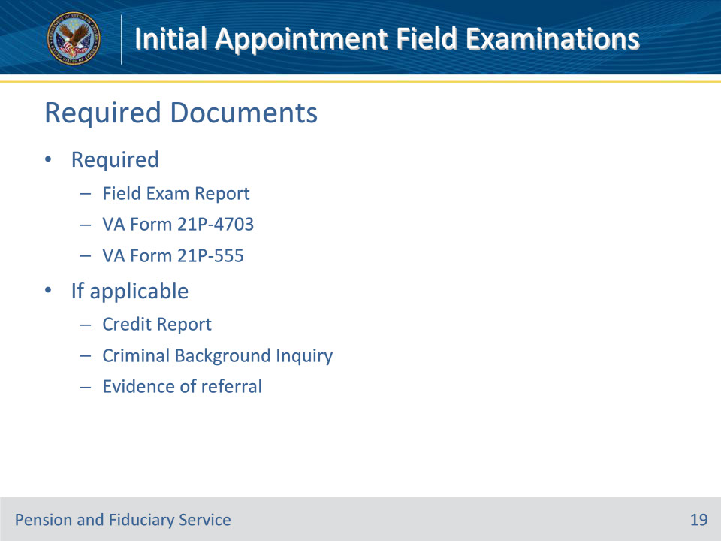

**Slide notes**

Policy Reference(s): FPM I.2.E.1.d.

Instructor Notes:

This slide covers the basics of required field exam documentation. . Requirements for SDP appointments differ. This topic is covered more in depth in the Field Exam Documentation and Notification training.

Hub personnel must enter the information gathered during the field examination process in the appropriate system or on the appropriate form.  Hub personnel must also generate the applicable field examination and upload the report and required form(s) to the eFolder.

For an IA/SIA,  the required forms and supporting evidence include, but are not limited to:

• Completed FIELD EXAM REPORT activity within the EP in the VBMS

• VA Form 21P-4703, Fiduciary Agreement

• VA Form 21P-555, Certificate of Legal Capacity to Receive and Disburse Benefits and Fee Authorization

• credit report, if required

• criminal background inquiry (CBI), if required, and

• evidence of referrals to other agencies, if required.

**Slide 19 - Required Notifications**

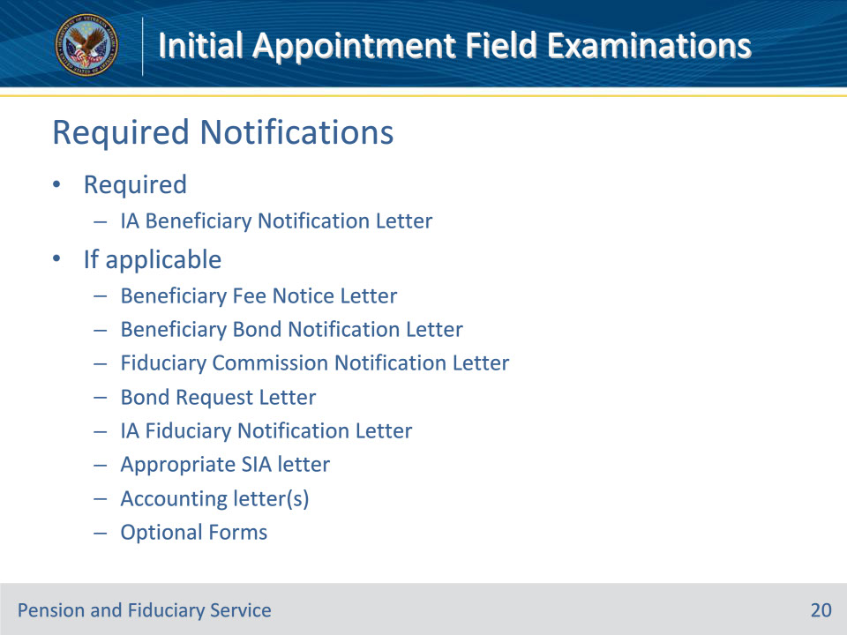

**Slide notes**

Policy Reference(s): FPM I.2.E.2.a., b.

Instructor Notes:

This slide covers the basics of required field exam notifications. Requirements for SDP appointments differ. This topic is covered more in depth in the Field Exam Documentation and Notification training.

Hubs must generate letters associated with field examinations using the templates available in VBMS, unless otherwise specified.  The letters available in the system contain sufficient language to fulfill notification requirements.

For an IA, the required notification letters are:

• IA Beneficiary Notification Letter, with a copy to the power of attorney (POA) and/or court-appointed guardian, if applicable.

• Beneficiary Fee Notice Letter, if applicable.

• Beneficiary Bond Notification Letter, if applicable.

• Fiduciary Commission Notification Letter, if applicable.

• Bond Request Letter to the fiduciary, if applicable.

• IA Fiduciary Notification Letter to the fiduciary, if applicable, including a copy of a signed VA Form 21P-4703.

• Optional forms to attach include a VA Form 21P-4718a, and a Standard Form (SF) 1199A, Direct Deposit Sign-Up Form.

For an SIA, the required letters are the same with the addition of the appropriate fiduciary SIA letter to the previous fiduciary, including accounting forms if a final accounting is required.  A copy of the letter is sent to the new fiduciary. Send a Bond Request Letter to the new fiduciary, if applicable.

You may also need to send the Certified Court Accounting Due Letter and/or VA Accounting Due Letter if applicable.

**Slide 20 - Questions?**

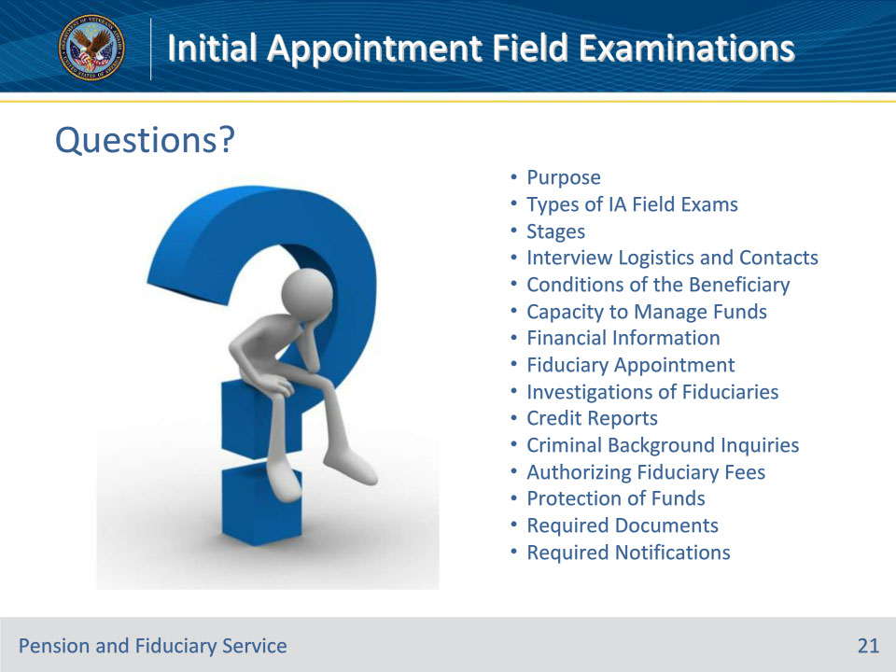

**Slide notes**

Instructor Notes:

(Recall) These are our learning objectives as stated from the beginning of the training:

• Describe the purpose of an initial appointment (IA) field examination

• Recall reasons to conduct an IA

• Identify IA field examination types

• Recognize mandatory field exam report information

• Name the required forms, letters and supporting evidence

(Recap) We discussed each of these learning objectives through the following topics in each slide today:

• Purpose

• Types of IA Field Exams

• Stages

• Interview Logistics and Contacts

• Conditions of the Beneficiary

• Capacity to Manage Funds

• Financial Information

• Fiduciary Appointment

• Investigations of Fiduciaries

• Credit Reports

• Criminal Background Inquiries

• Authorizing Fiduciary Fees

• Protection of Funds

• Required Documents

• Required Notifications

Are there any additional questions?

Questions should be filtered through your QRT team. They will submit your questions to the Field Inquiry Tool (FIT) on your behalf.

**Slide 21 - TMS Survey/Assessment**

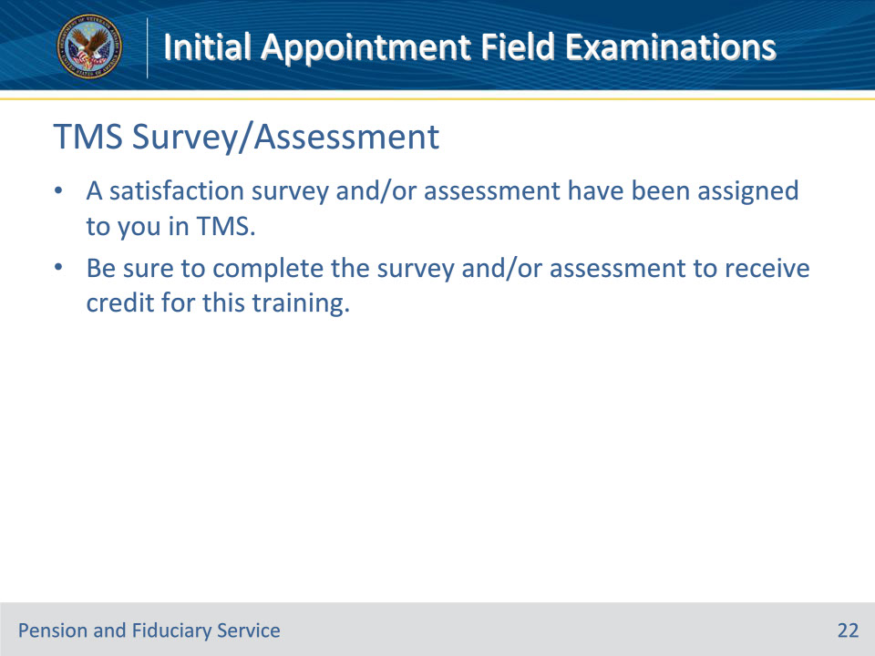

**Slide notes**

Instructor Notes

A satisfaction survey and/or assessment have been assigned to you in TMS.

Be sure to complete the survey and/or assessment to receive credit for this training.