Slide 1 - Scheduled Follow-Up Field Examinations
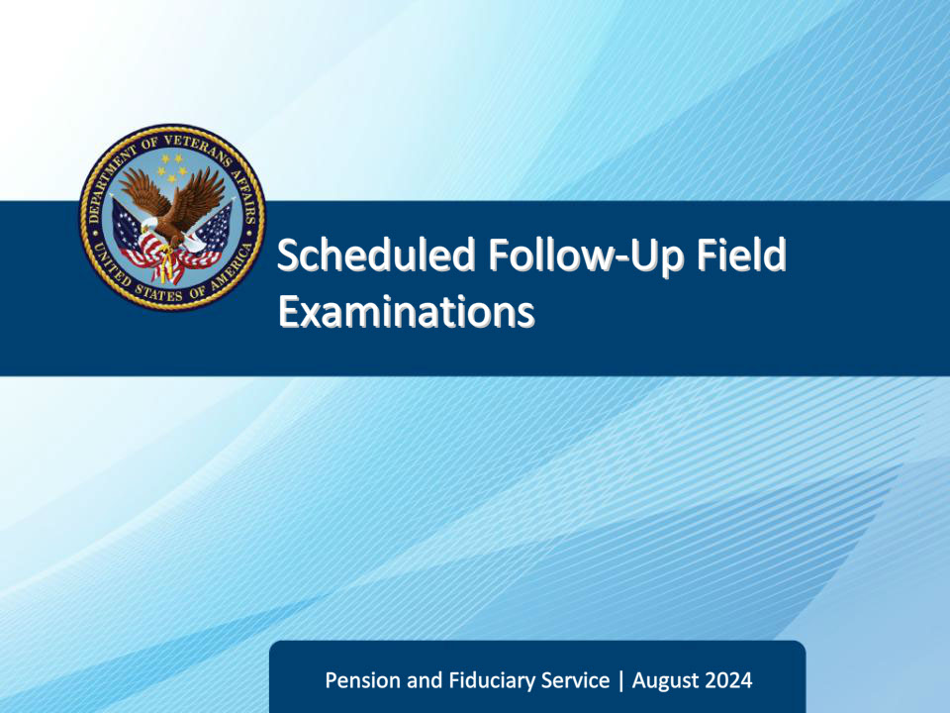
Slide notes

Course Description:

The lesson teaches learners about the purpose, critical elements, and specific requirements of scheduled follow-up field examinations to include how a scheduled follow-up field examination is initiated, documented, and reported.

Slide 2 - Objectives
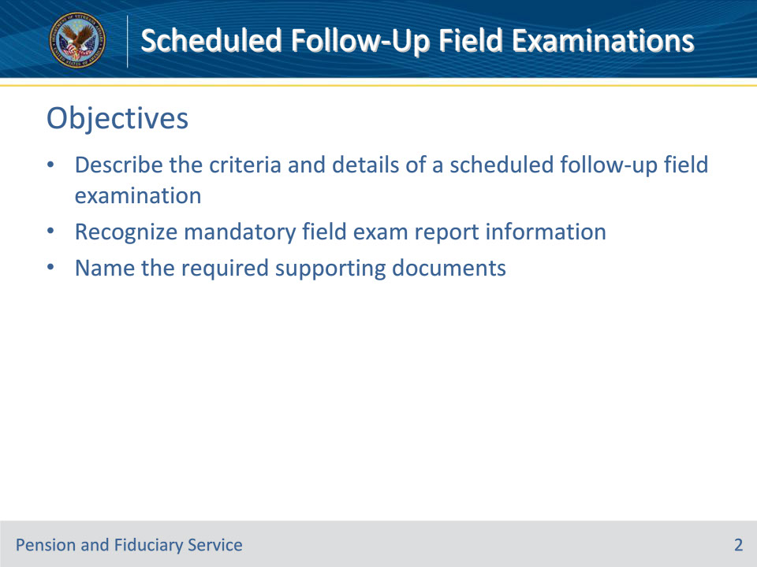
Slide notes

Instructor Notes:

At the end of this lesson, given the training and references, the learner will be able to do the following:

• Describe the criteria and details of a scheduled follow-up field examination

• Recognize mandatory field exam report information

• Name the required supporting documents

Slide 3 - References
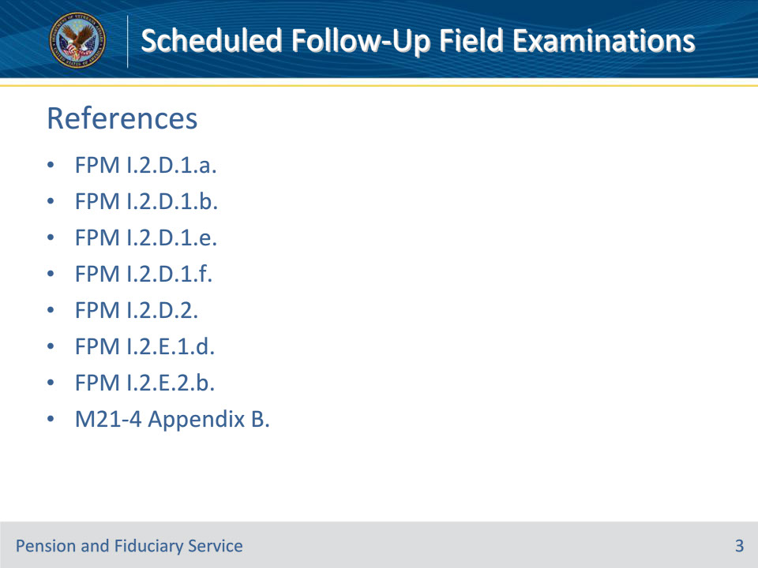
Slide notes

Instructor Notes:

The following are relevant references pertaining to follow-up field examinations:

• FPM I.2.D.1.a. Overview of Scheduling Future Oversight Actions

• FPM I.2.D.1.b. Policy Regarding Beneficiary Oversight

• FPM I.2.D.1.e. Scheduling Biennial Face-to-Face Contact

• FPM I.2.D.1.f. Exceptions to the Requirements for Beneficiary Oversight

• FPM I.2.D.2. Scheduled Follow-Up Field Examinations

• FPM I.2.E.1.d. How to Prepare Field Examination Documentation

• FPM I.2.E.2.b. Reviewing and Sending Notification Letters

• M21-4 Appendix B. End Product (EP) Codes

Slide 4 - Beneficiary Oversight
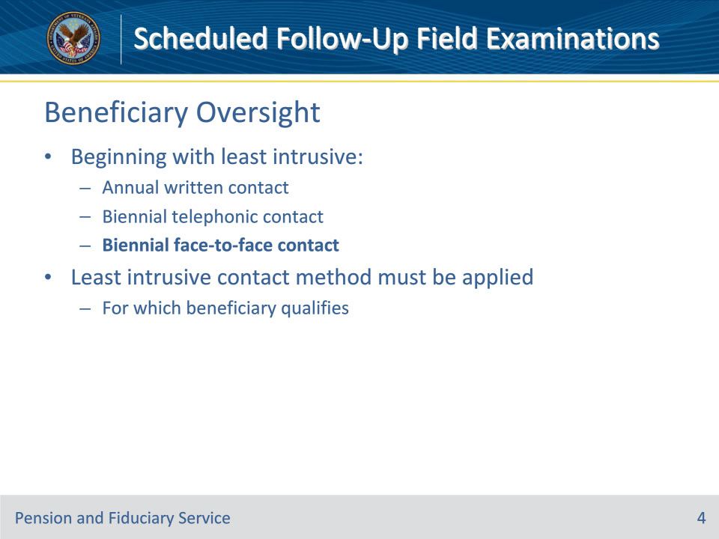
Slide notes

Policy Reference(s): FPM I.2.D.1.a., b.

Instructor Notes:

VA ensures beneficiary well-being through face-to-face follow-up field examinations, telephone interviews (or secure videoconferencing), and annual letters.

Following each field examination, fiduciary hubs must schedule future beneficiary and fiduciary oversight based on the unique circumstances of each case in accordance with the fiduciary program manual.

The following are three scheduled contact methods VA utilizes to oversee beneficiaries’ well-being, beginning with the least intrusive:

• annual written contact

• biennial telephonic contact, and

• biennial face-to-face contact.

Biennial face-to-face contact consists of scheduled follow-up field examinations which is the topic of this training.

The contact method that is least intrusive, and in which the beneficiary meets the qualifications, must be applied.

Slide 5 - Criteria
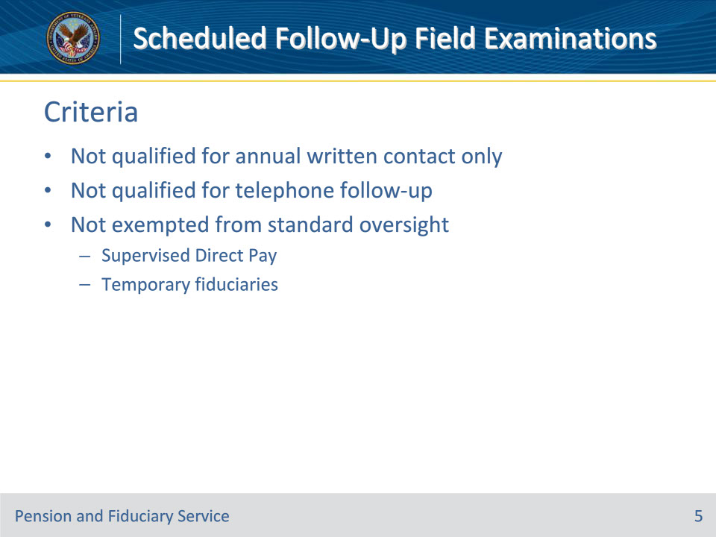
Slide notes

Policy Reference(s): FPM I.2.D.1.e., f.

Instructor Notes:

Scheduled follow-up field examinations consist of face-to-face contact and are thus the most intrusive of the 3 oversight methods. Therefore, for a beneficiary to qualify for scheduled follow-up field examinations, they must not be eligible for annual written contact only or telephone follow-up.

SDP beneficiaries require temporary and limited supervision through monthly telephonic contact to ensure funds are managed properly. Additionally, if the beneficiary is not rated competent within six months of the SDP appointment, the hub must follow the guidance in FPM, Part I, 5.A.4.g and h to remove the beneficiary from SDP.

Slide 6 - Details
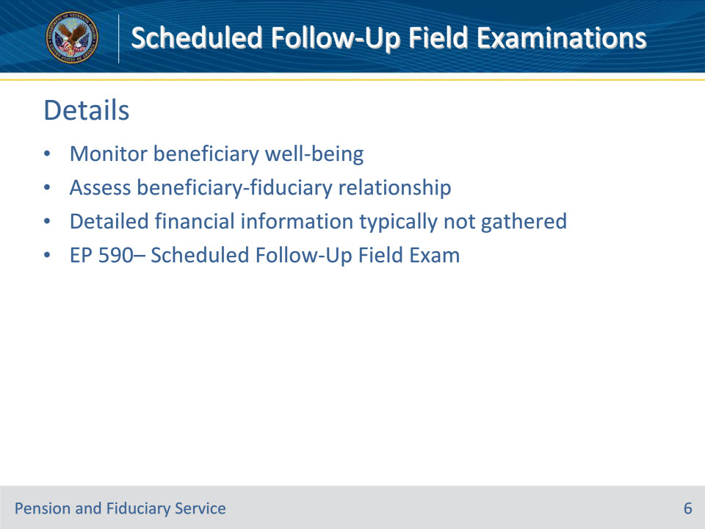
Slide notes

Policy Reference(s): FPM I.2.D.2.a.; M21-4 Appendix B.

Instructor Notes:

VA uses scheduled follow-up field examinations with qualifying beneficiaries to

• monitor the beneficiaries’ well-being, and

• assess the beneficiary-fiduciary relationship.

Detailed financial information is typically not gathered during the contact because the fiduciary will be required to provide VA with three months of bank statements.

EP 590SFUFE – is the appropriate EP to initiate and control Scheduled Follow-Up Field Exams

Slide 7 - Critical Elements
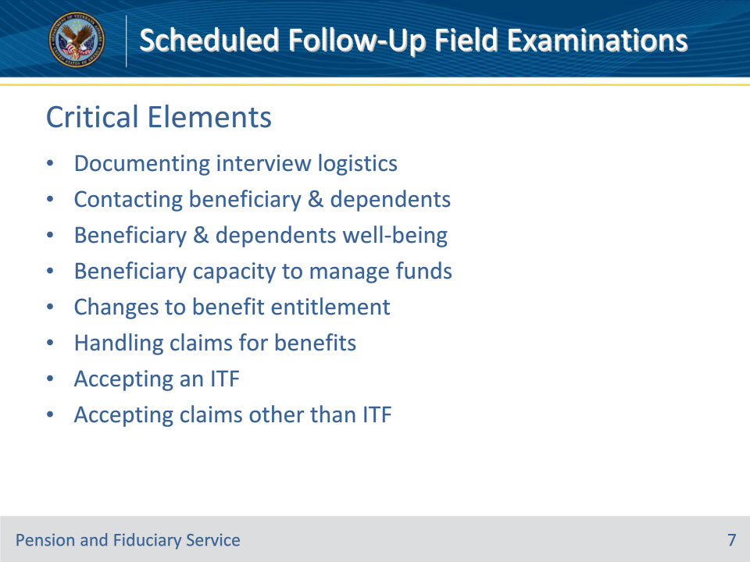
Slide notes

Policy Reference(s): FPM I.2.D.2.a.

Instructor Notes:

These are the critical elements of the field examination:

• documenting the interview logistics

• contacting the

• beneficiary

• dependents

• the beneficiary’s and dependents’ well-being

• the beneficiary’s capacity to manage funds

• documenting changes to benefit entitlement

• handling claims for benefits

• accepting an intent to file (ITF)

• accepting a claim other than an ITF

These topics are discussed more in-depth in their relevant trainings.

Slide 8 - Fiduciary Contact
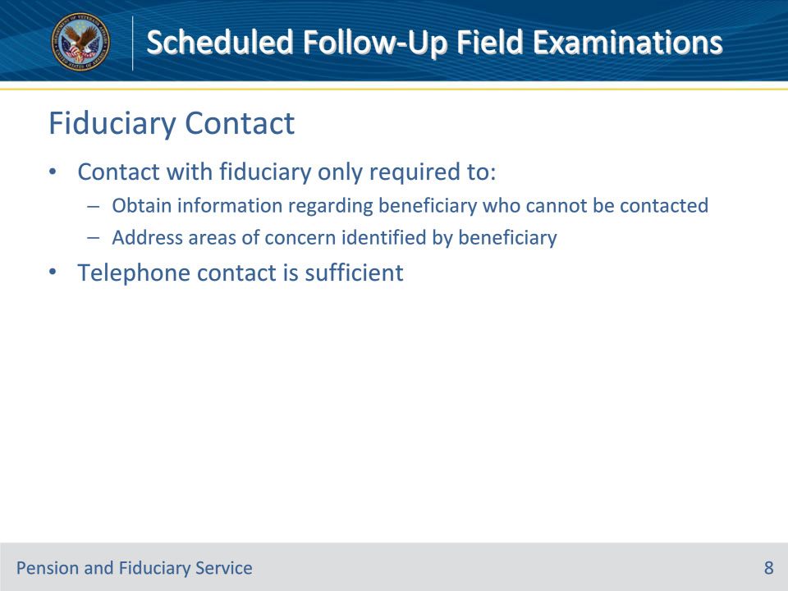
Slide notes

Policy Reference(s): FPM I.2.D.2.b.

Instructor Notes:

Contact with the fiduciary is only required to

• obtain information regarding a beneficiary who cannot be contacted, or

• address areas of concern identified by the beneficiary.

Telephone contact is sufficient.

Slide 9 - Evaluating Fiduciary Relationship
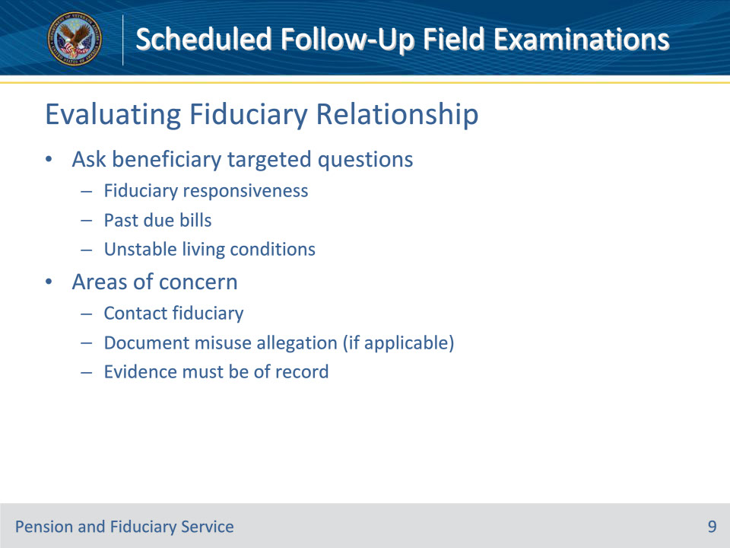
Slide notes

Policy Reference(s): FPM I.2.D.2.c

Instructor Notes:

Fiduciary performance is primarily monitored through fund usage reviews, accountings, and/or onsite reviews. However, the FE must evaluate the beneficiary’s fiduciary relationship for continued suitability during follow-up field examinations. The beneficiary should be asked targeted questions in order to identify areas of concern such as (but not limited to):

• fiduciary responsiveness to requests for information about how the VA benefits are spent

• past due bills received or known by the beneficiary, and/or

• unstable living conditions not resolved by the fiduciary.

When areas of concern with the beneficiary-fiduciary relationship are identified, hub personnel must:

• contact the fiduciary to address the area(s) identified, and/or

• document an allegation of misuse for any instances where the beneficiary indicates the possibility of misuse.

Any evidence that the fiduciary is not meeting the fiduciary responsibilities must be of record. If documentation is available, it must be identified in the field examination and uploaded to the eFolder.

Slide 10 - Documenting Resolution
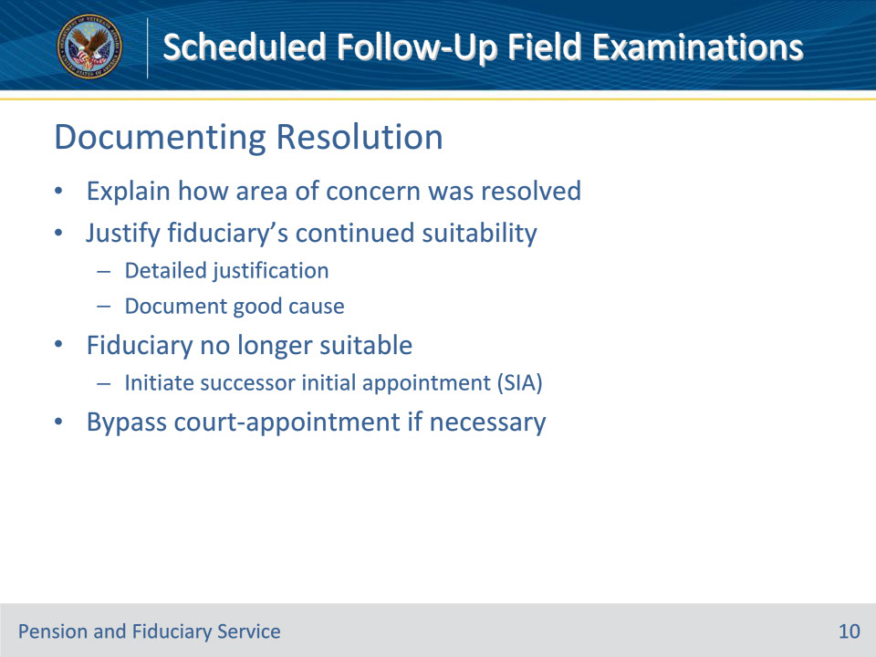
Slide notes

Policy Reference(s): FPM I.2.D.2.c., d.

Instructor Notes:

If an identified area of concern was resolved, the FE must explain how it was resolved in the field examination and justify the fiduciary’s suitability to continue to serve. A note indicating the fiduciary is in the best interest of the beneficiary is not sufficient to meet detailed justification in these situations. To appropriately justify continued suitability, the FE must document that the fiduciary showed good cause for being unable to fulfill the duties as identified.

If the determination of suitability indicates the fiduciary should no longer serve, the FE must initiate an SIA field examination to replace the fiduciary.

During a follow-up field examination, the FE must carefully evaluate whether to by-pass a previously recognized court-appointed fiduciary arrangement involving VA benefits in favor of appointing another person or entity as a VA-appointed fiduciary.

Slide 11 - Supporting Documents
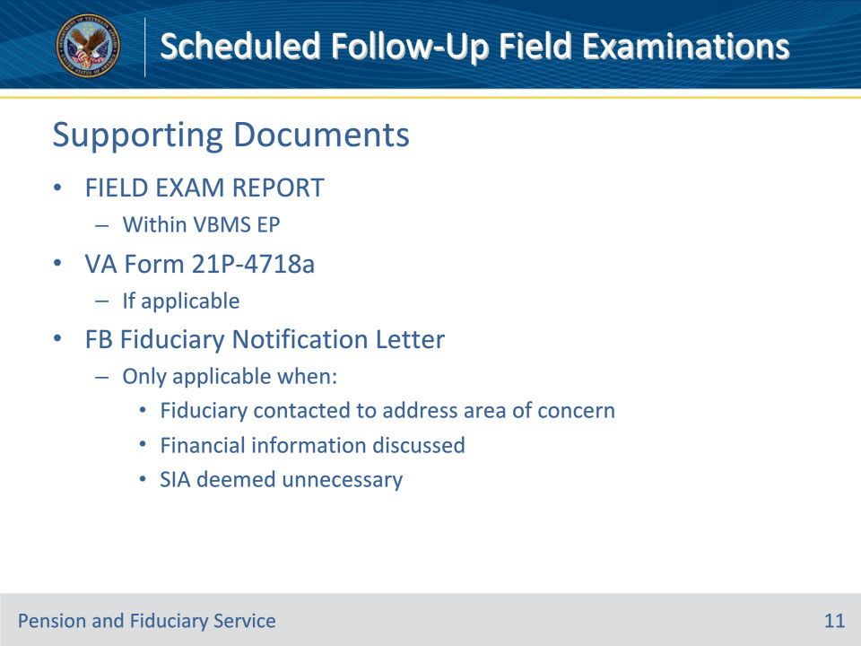
Slide notes

Policy Reference(s): FPM I.2.E.1.d, FPM I.2.E.2.b

Instructor Notes:

Hub personnel must enter the information gathered during the field examination process in the appropriate system or on the appropriate form. Hub personnel must also generate the applicable field examination report and upload the report and required form(s) to the electronic claims folder (eFolder).

For a scheduled follow-up field examination, the required forms and supporting evidence include, but are not limited to:

• completed FIELD EXAM REPORT activity within the EP in VBMS, and

• VA Form 21P-4718a, Certificate of Balance on Deposit and Authorization to Disclose Financial Records, if applicable.

The only required correspondence for a scheduled follow-up field examination is the FB Fiduciary Notification Letter to the fiduciary, if applicable.

This notification is only required when the fiduciary is contacted to address an area of concern, financial information is discussed, and an SIA appointment was found to be unnecessary.

Slide 12 - Questions?
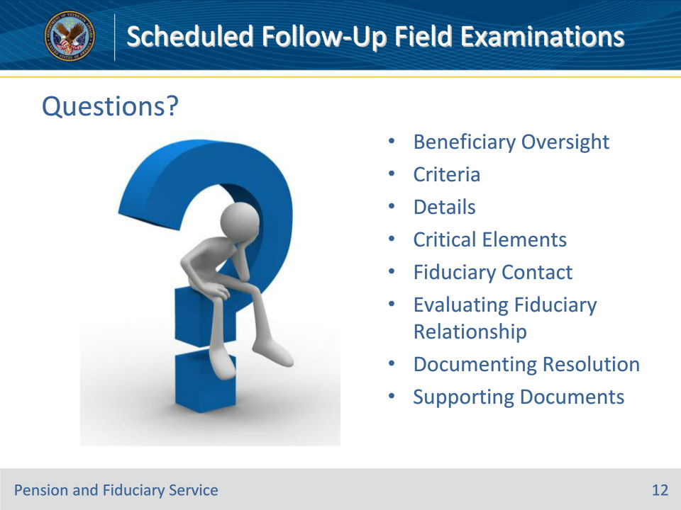
Slide notes

Instructor Notes:

(Recall) These are our learning objectives as stated from the beginning of the training:

• Describe the criteria and details of a scheduled follow-up field examination

• Recognize mandatory field exam report information

• Name the required supporting documents

(Recap) We discussed each of these learning objectives through the following topics in each slide today:

• Beneficiary Oversight

• Criteria

• Details

• Critical Elements

• Fiduciary Contact

• Evaluating Fiduciary Relationship

• Documenting Resolution

• Supporting Documents

Are there any additional questions?

Questions should be filtered through your QRT team. They will submit your questions to the Field Inquiry Tool (FIT) on your behalf.

Slide 13 - TMS Survey/Assessment
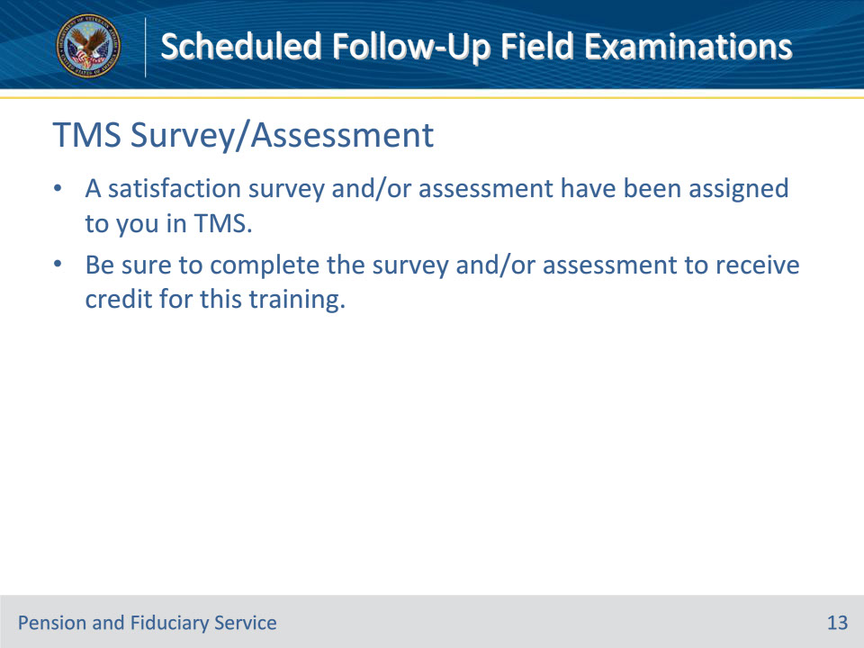
Slide notes

Instructor Notes

A satisfaction survey and/or assessment have been assigned to you in TMS.

Be sure to complete the survey and/or assessment to receive credit for this training.

