Slide 1 - Field Examination Authority and Purpose
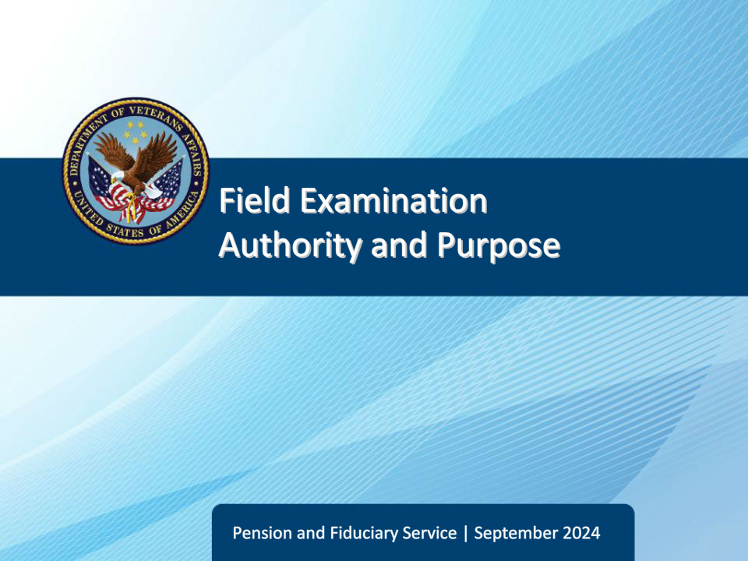
Slide notes

Course Description:

The purpose of this lesson is to teach students about the purpose of field examinations, the authority granted for VBA fiduciary program employees to conduct field examinations, and actions that do – and do not – constitute field examinations.

Slide 2 - Objectives
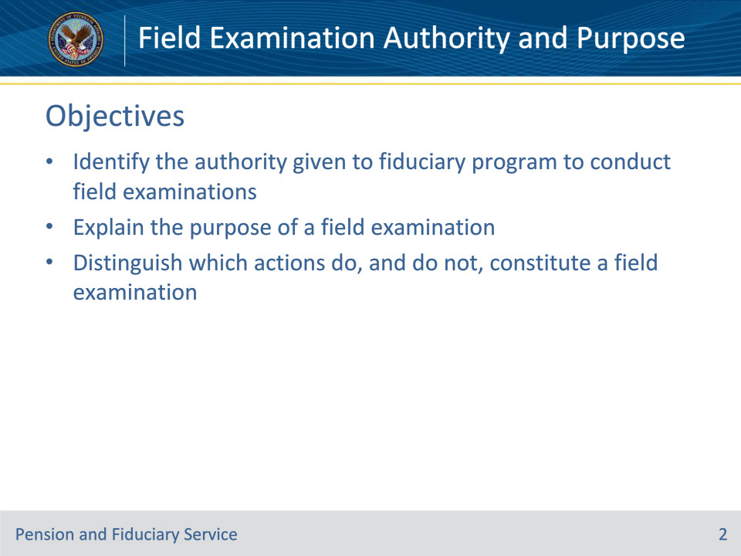
Slide notes

Instructor Notes:

At the end of this lesson, given the training and references, the learner will be able to do the following:

• Identify the authority given to fiduciary program to conduct field examinations

• Explain the purpose of a field examination

• Distinguish which actions do, and do not, constitute a field examination

Slide 3 - References
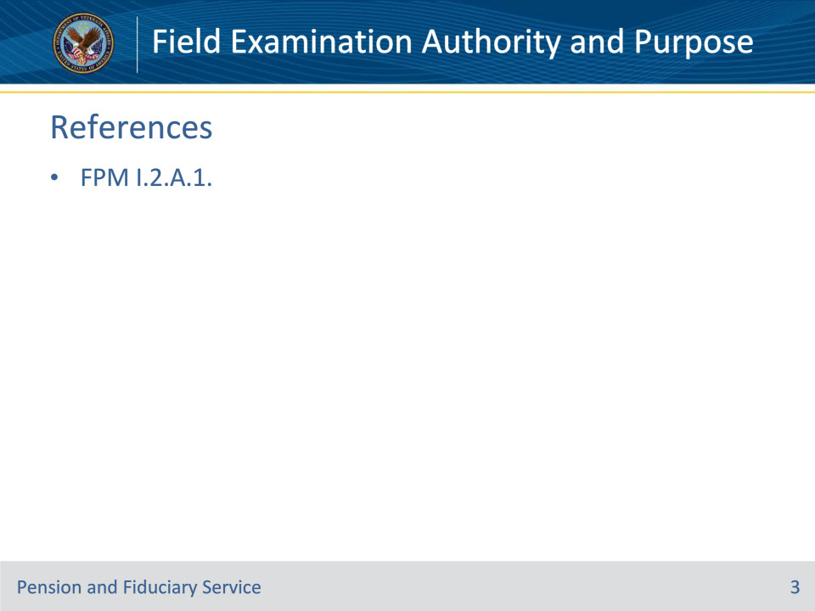
Slide notes

Instructor Notes:

These are the relevant references pertaining to this course:

• FPM I.2.A.1., Authority and Purpose of Field Examinations

Slide 4 - Authority
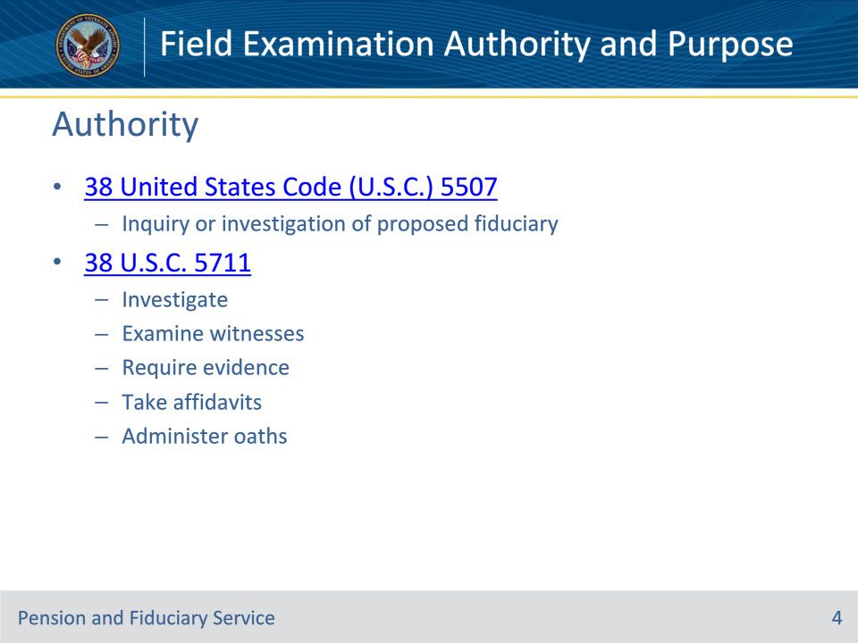
Slide notes

Policy Reference(s): FPM I.2.A.1.a.

Instructor Notes:

38 U.S.C. 5507 requires the Department of Veterans Affairs (VA) to conduct an inquiry or investigation regarding the fitness of a person to serve as fiduciary for a beneficiary.

38 U.S.C. 5711 authorizes VA to conduct investigations and examine witnesses upon any matter within the jurisdiction of VA, require the production of books, papers, documents, and other evidence; and take affidavits and administer oaths and affirmations.

Slide 5 - Purpose
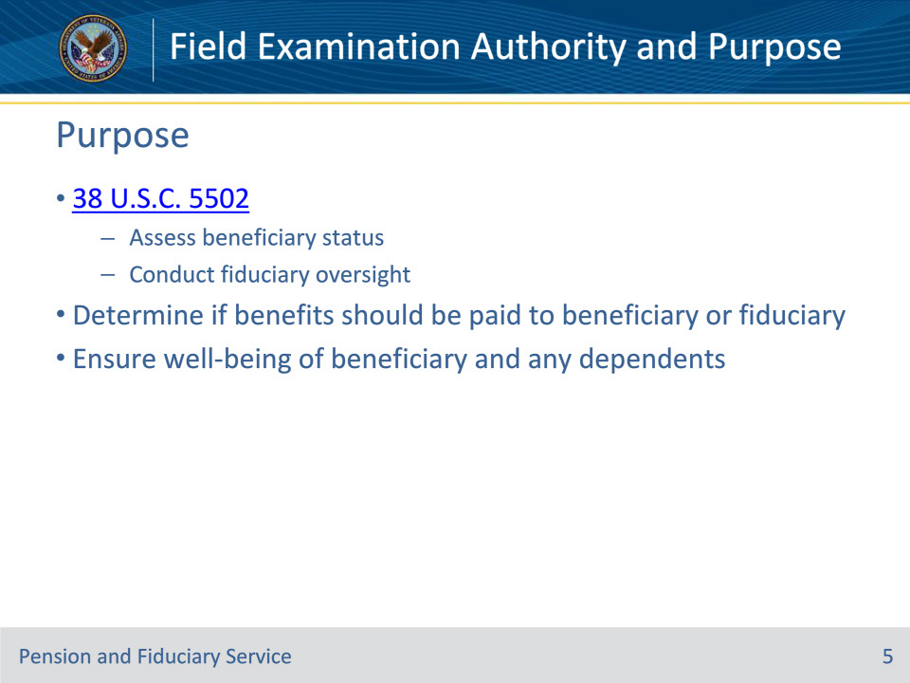
Slide notes

Policy Reference(s): FPM I.2.A.1.b., FPM I.2.A.1.c.

Instructor Notes:

In accordance with 38 U.S.C. 5502, VA makes benefit payments directly to adult beneficiaries unless VA determines payment to a duly recognized fiduciary is in the best interest of the beneficiary. When the payment method is anything other than direct and unsupervised, the fiduciary hub (hub) must conduct periodic field examinations or other approved means of supervision to continually assess the beneficiary’s status and integrity of services provided by the fiduciary.

The reasons for conducting a field examination include

• determining whether benefits should be paid directly to the beneficiary or continue to be made to the fiduciary, and

• ensuring the well-being of a beneficiary and the beneficiary’s dependents.

Slide 6 - Field Examination Requirements
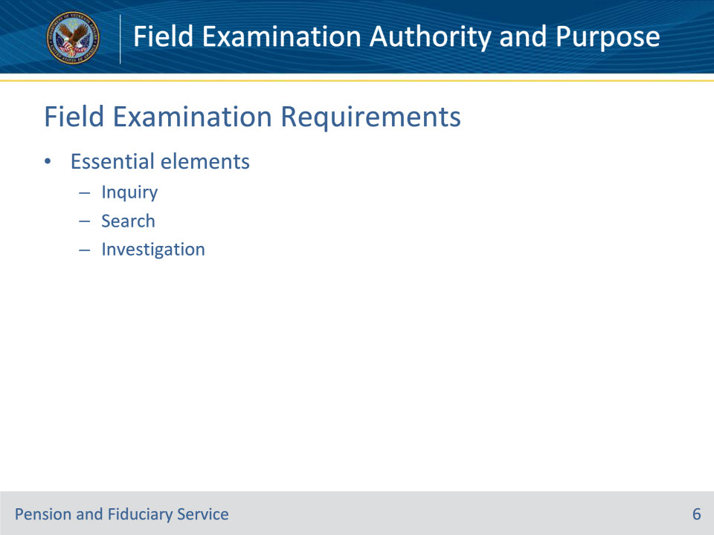
Slide notes

Policy Reference(s): FPM I.2.A.1.d.

Instructor Notes:

To be considered a field examination, it is essential that the elements of inquiry, search, or investigation are present.

Slide 7 - Not a Field Examination
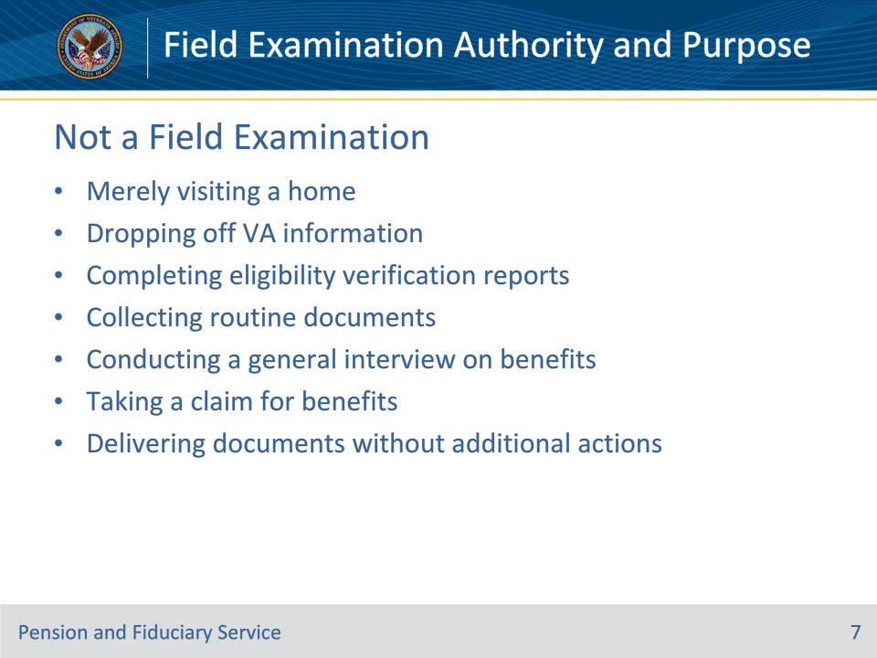
Slide notes

Policy Reference(s): FPM I.2.A.1.d.

Instructor Notes:

The following actions do not constitute Fiduciary Program field examinations of any type and do not fulfill VA’s responsibility to perform oversight:

• merely visiting a home

• dropping off VA information

• completing eligibility verification reports

• collecting routine documents

• conducting an away-from-office general interview on benefits

• taking a claim for benefits, or

• delivering letters, subpoenas, or similar documents without gathering and documenting facts, or developing evidence.

Slide 8 - Responsibility
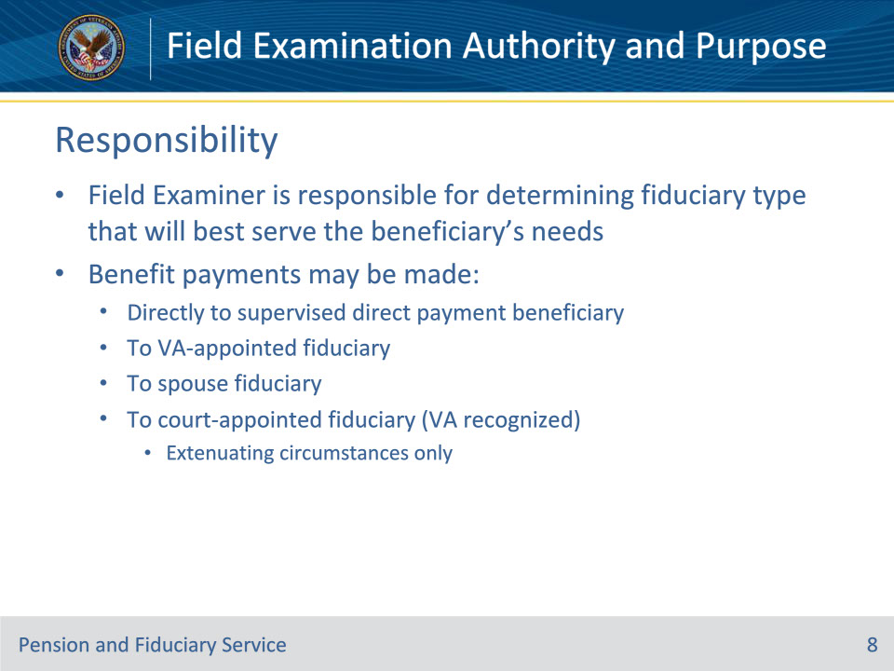
Slide notes

Policy Reference(s): FPM I.2.A.1.e.

Instructor Notes:

If the beneficiary is rated unable to manage their funds, or is under a court appointed guardianship, the Field Examiner (FE) is responsible for determining the type of fiduciary relationship that will best serve the needs of the beneficiary. Benefit payments may be made

• directly to a supervised direct payment beneficiary

• to a VA-appointed fiduciary

• to a spouse fiduciary, or

• in extenuating circumstances only, to a court-appointed fiduciary (VA recognized).

Slide 9 - Questions?
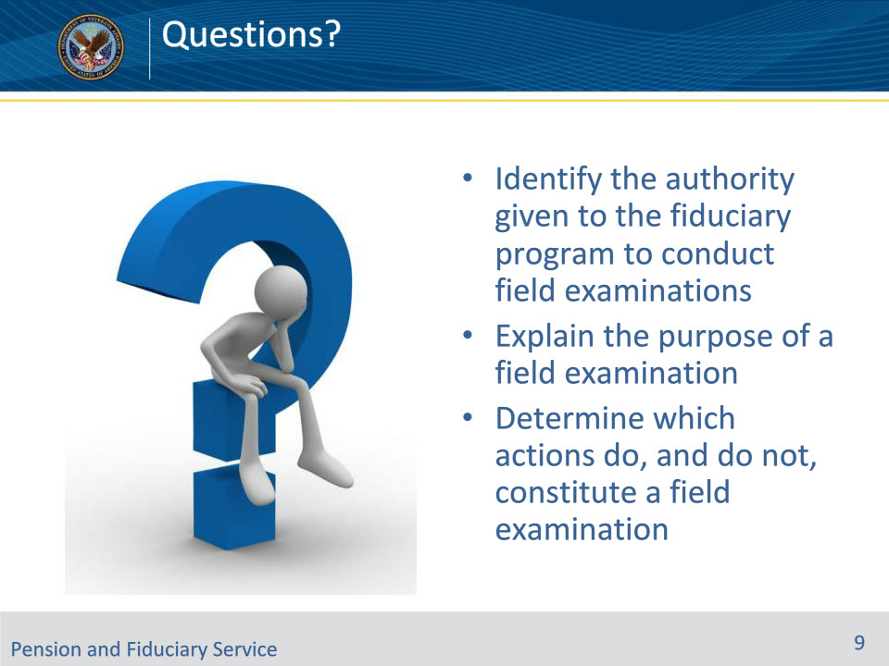
Slide notes

Instructor Notes:

(Recall) These are our learning objectives as stated from the beginning of the training:

• Identify the authority given to the fiduciary program to conduct field examinations

• Explain the purpose of a field examination

• Determine which actions do, and do not, constitute a field examination

Are there any additional questions?

Questions should be filtered through your QRT team. They will submit your questions to the Field Inquiry Tool (FIT) on your behalf.

Slide 10 - TMS Survey/Assessment
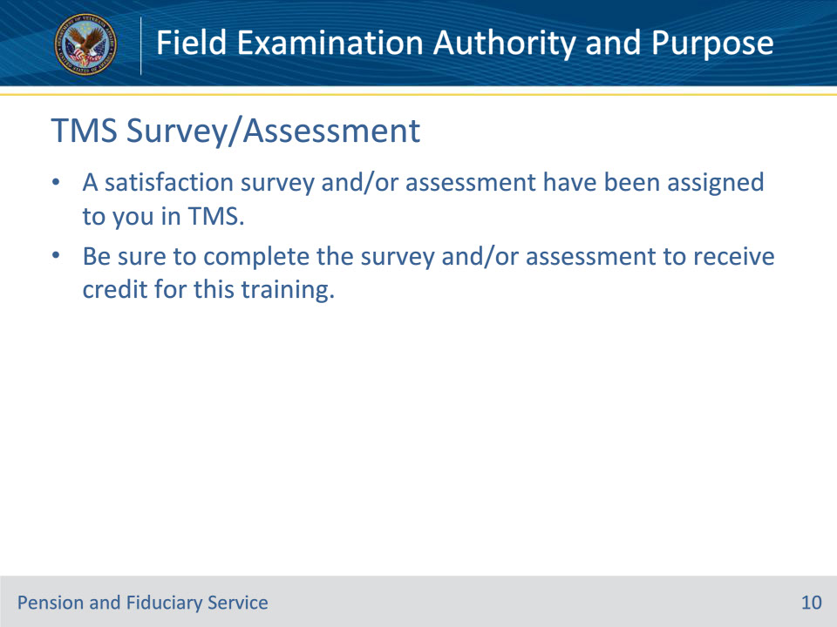
Slide notes

Instructor Notes

A satisfaction survey and/or assessment have been assigned to you in TMS.

Be sure to complete the survey and/or assessment to receive credit for this training.

