Slide 1 - Fiduciary Program Lifecycle
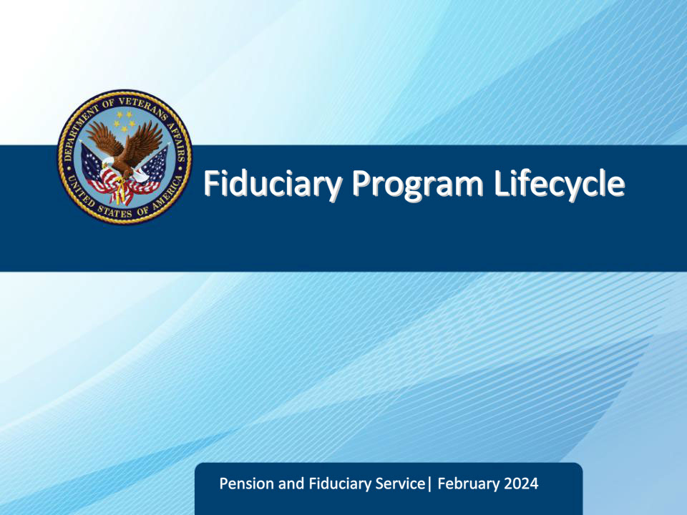
Slide notes

Course Description:

This course provides an overview of fiduciary program supervision, including the reasons that a beneficiary enters the program and the reasons that fiduciary program supervision terminates.

Slide 2 - Objectives
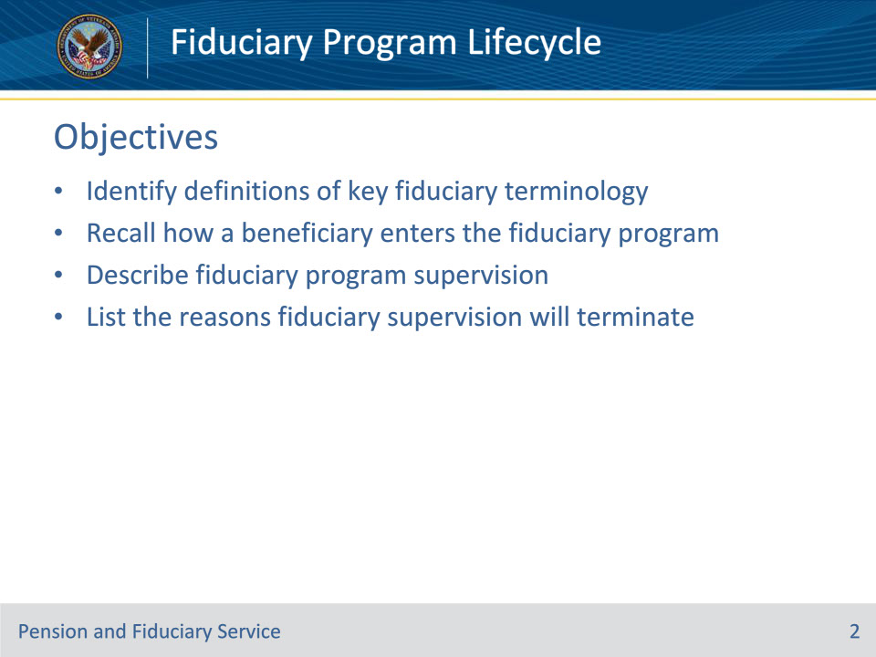
Slide notes

Instructor Notes:

At the end of this lesson, given the training and references, the learner will be able to do the following:

• Identify definitions of key fiduciary terminology

• Recall how a beneficiary enters the fiduciary program

• Describe fiduciary program supervision

• List the reasons fiduciary supervision will terminate

Slide 3 - References
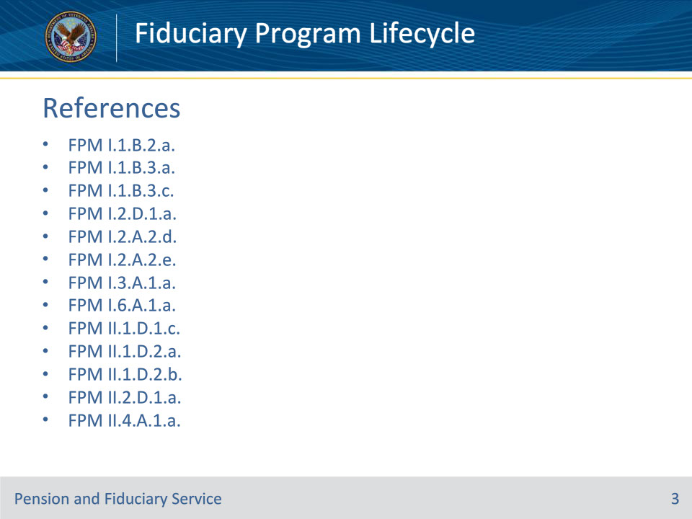
Slide notes

Instructor Notes:

These are the relevant references pertaining to this course:

• FPM I.1.B.2.a. Fiduciary Adjustments

• FPM I.1.B.3.a. Purpose of the Fiduciary Program

• FPM I.1.B.3.c. Selecting a Qualified Fiduciary

• FPM I.2.D.1.a. Overview of Scheduling Future Oversight Actions

• FPM I.2.A.2.d. Follow-up Field Examinations

• FPM I.2.A.2.e. Types of Follow-up Field Examinations

• FPM I.3.A.1.a. Definition: Accounting

• FPM I.6.A.1.a. General Information on Fiduciary Fund Usage Oversight

• FPM II.1.D.1.c. Discontinuation of VA Supervision

• FPM II.1.D.2.a. Criteria for Deactivating the Beneficiary Record of a Minor

• FPM II.1.D.2.b. Criteria for Deactivating the Beneficiary Record of an Adult With a VA-Appointed Fiduciary

• FPM II.2.D.1.a. Overview of Annual Written Contact

• FPM II.4.A.1.a. Authority Regarding Onsite Reviews

Slide 4 - Fiduciary Program Definitions
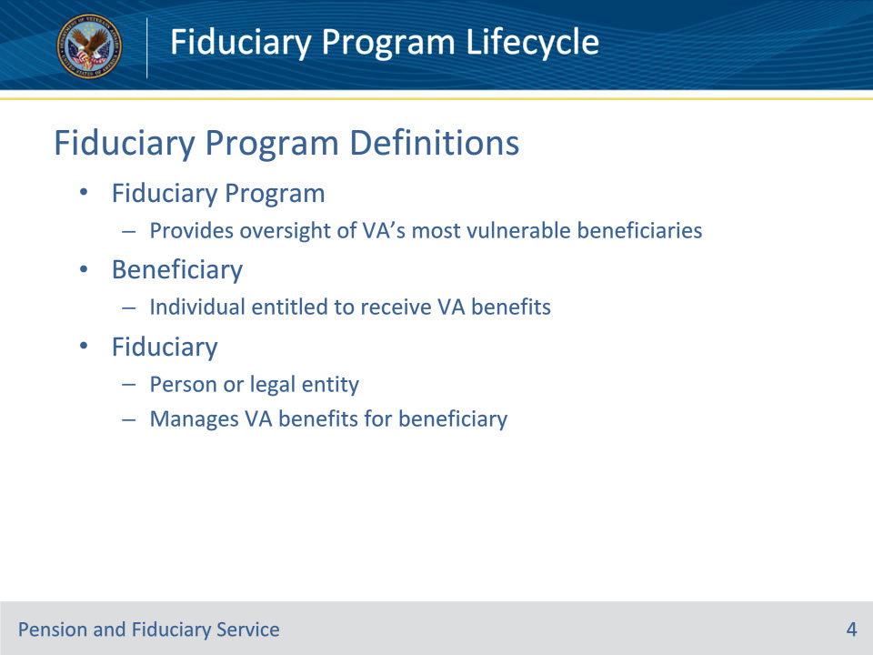
Slide notes

Policy Reference(s): FPM I.1.B.3.a.

Instructor Notes:

The Fiduciary Program provides oversight of VA’s most vulnerable beneficiaries who are unable to manage their VA benefits because of injury, disease, the infirmities of advanced age, or are minor children who have not yet reached the age of majority. VA appoints fiduciaries who manage VA benefits for these beneficiaries and conducts oversight of VA-appointed fiduciaries to ensure that they are meeting the needs of the beneficiaries they serve.

A beneficiary is an individual entitled to receive VA benefits, including proceeds of VA insurance.

A fiduciary is a person or legal entity (such as a bank) charged with the duty of managing the estate of an incompetent beneficiary.

Slide 5 - Beneficiary Types
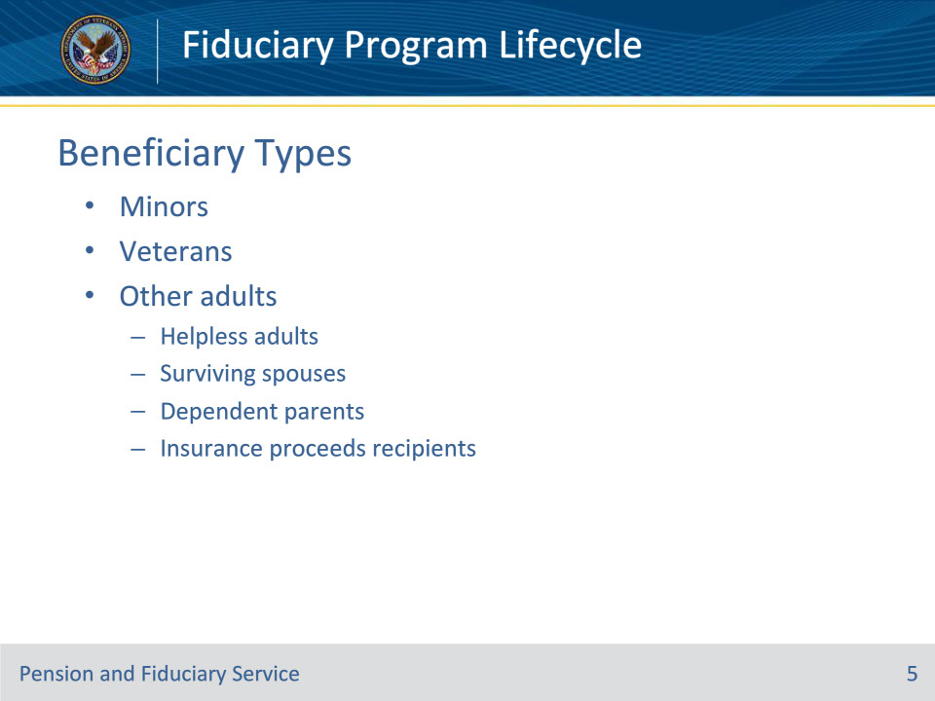
Slide notes

Policy Reference(s): FPM I.1.B.3.a.

Instructor Notes:

Beneficiaries are classified as

• minors

• Veterans, and

• other adults, including

• helpless adults

• surviving spouses

• dependent parents, and

• insurance proceeds recipients.

Slide 6 - Enter Fiduciary Program
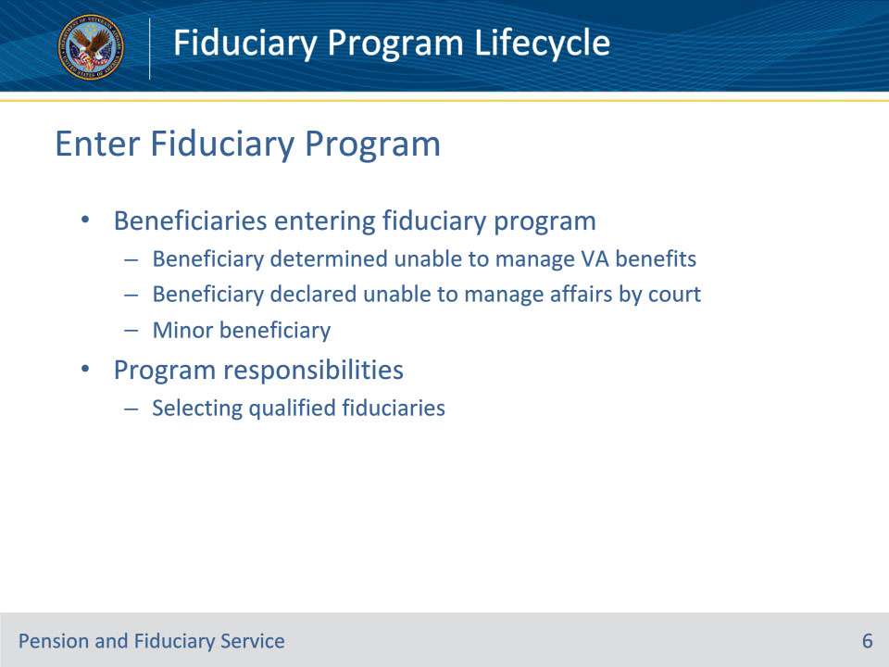
Slide notes

Policy Reference(s): FPM I.1.B.2.a.; I.1.B.3.c.

Instructor Notes:

The hub may receive a request for appointment of a fiduciary for a beneficiary who

• VA has determined unable to manage VA benefits

• a court of jurisdiction declared unable to manage affairs, or

• is a minor.

Program responsibilities include selecting a qualified fiduciary best suited to meet the needs and situation of the beneficiary.

Slide 7 - Fiduciary Program Supervision
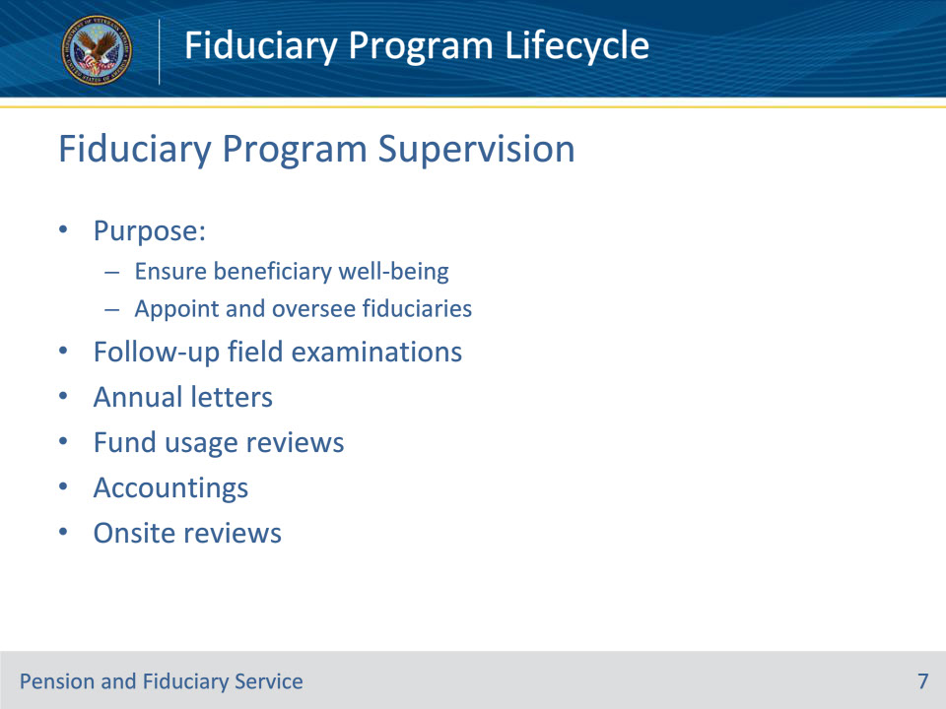
Slide notes

Policy Reference(s): FPM I.2.D.1.a.

Instructor Notes:

The purpose of the Department of Veterans Affairs’ (VA) Fiduciary Program is to oversee vulnerable beneficiaries to

• ensure their well-being, and

• appoint and oversee fiduciaries’ management of beneficiaries’ benefits.

VA ensures beneficiary well-being through face-to-face follow-up field examinations, telephone interviews (or secure videoconferencing), and annual letters. VA oversees fiduciaries’ management of beneficiaries’ benefits through fund usage reviews, accountings, and onsite reviews.

Slide 8 - Follow-up Field Examinations
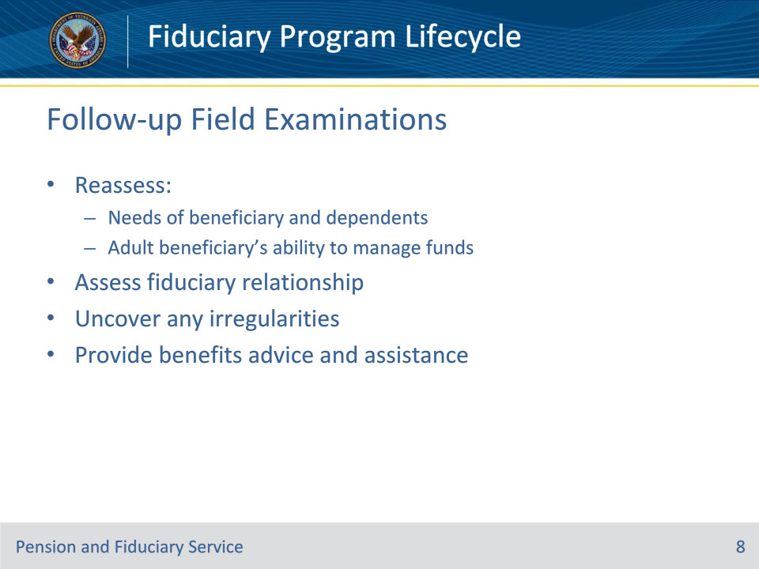
Slide notes

Policy Reference(s): FPM I.2.A.2.d.

Instructor Notes:

Follow-up field examinations are performed subsequent to an IA field examination. These examinations may include the need to

• reassess the

• needs of the beneficiary and dependents, and

• adult beneficiary’s ability to manage funds

• assess the fiduciary relationship

• uncover any irregularities, and

• provide advice and assistance in relation to VA or other benefits based on the beneficiary’s needs.

Slide 9 - Follow-up Field Exam Types
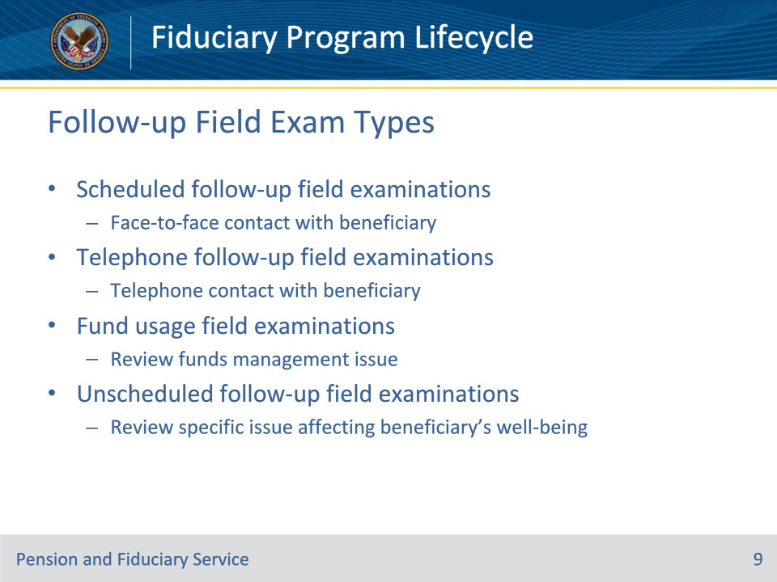
Slide notes

Policy Reference(s): FPM I.2.A.2.e.

Instructor Notes:

The four types of follow-up field examinations are listed below.

Scheduled follow-up field examinations: The inquiry and monitoring activity conducted for the purpose of protecting the beneficiary and their VA benefits through face-to-face contact with the beneficiary.

Telephone follow-up field examinations: The inquiry and monitoring activity conducted for the purpose of monitoring the beneficiary and their VA benefits through telephone contact with the beneficiary.

Fund usage field examinations: The specific inquiry into the fiduciary’s use of the beneficiary’s funds for the purpose of reviewing an issue affecting the fiduciary’s management of VA benefits, which was identified or reported to the hub, and determining if the fiduciary’s appointment should continue. Appropriate reasons for fund usage field examination requests could include, but are not limited to

• accounting assistance issues, or

• fund usage review documentation issues.

Unscheduled follow-up field examinations: The inquiry conducted for the purpose of reviewing a specific issue affecting the beneficiary’s well-being, which was identified by or reported to the hub. Appropriate reasons for unscheduled follow-up field examination requests could include, but are not limited to

• adverse conditions, or

• a well-being check.

Slide 10 - Other Supervision
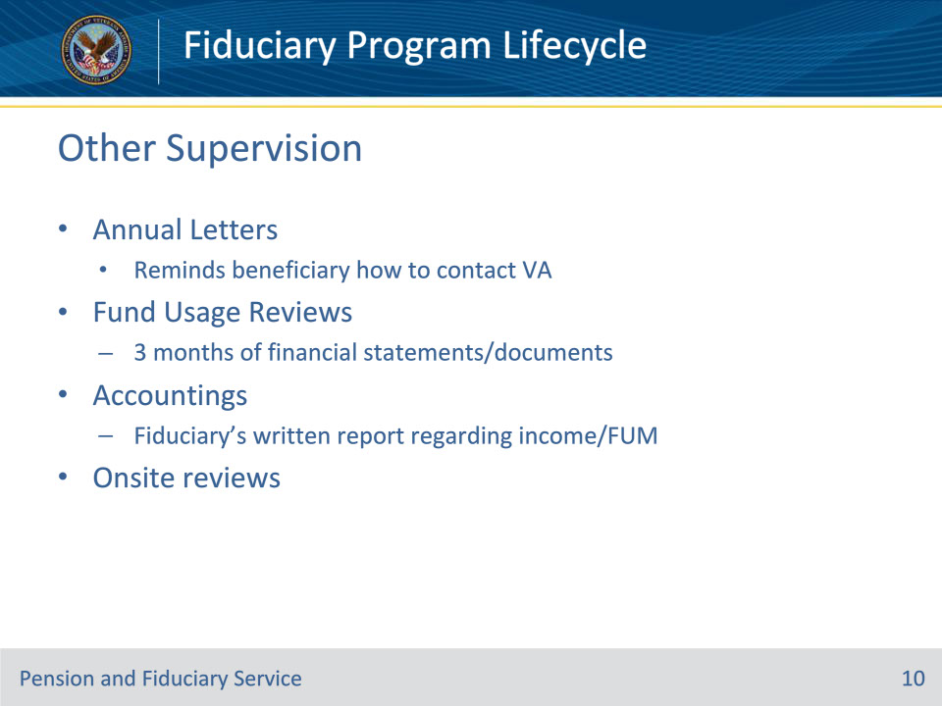
Slide notes

Policy Reference(s): FPM II.2.D.1.a.; I.3.A.1.a.; I.6.A.1.a.; II.4.A.1.a.

Instructor Notes:

Hubs use the Annual Written Contact Letter to improve the frequency of contact with all beneficiaries in the Fiduciary Program. The letter helps to remind beneficiaries in the program how to contact the Department of Veterans Affairs (VA) if an issue or concern with their fiduciary exists.

A fund usage review consists of three months of all financial statements containing VA funds for each beneficiary that the fiduciary manages. The fund usage report may also include any supporting documents (receipts, invoices, etc.) that show irregular purchases so that VA can confirm the funds are being spent in the beneficiary’s best interest.

An accounting is the fiduciary’s written report regarding the income and funds under management (FUM) by the fiduciary for the beneficiary during the accounting period prescribed by the fiduciary hub.

Department of Veterans Affairs (VA) conducts periodic onsite reviews of any fiduciary residing in the U.S., whether the fiduciary is an individual or entity, when that fiduciary is serving 20 or more beneficiaries and the total annual amount of such benefits exceeds the threshold listed in the fiduciary program manual, as adjusted annually. In addition, the law grants VA the authority to conduct unscheduled onsite reviews of any fiduciary without regard to the number of beneficiaries served by the fiduciary or the amount of funds under management (FUM) by the fiduciary to ensure the well-being of beneficiaries or prevent exploitation of beneficiary funds.

Slide 11 - Discontinue Supervision
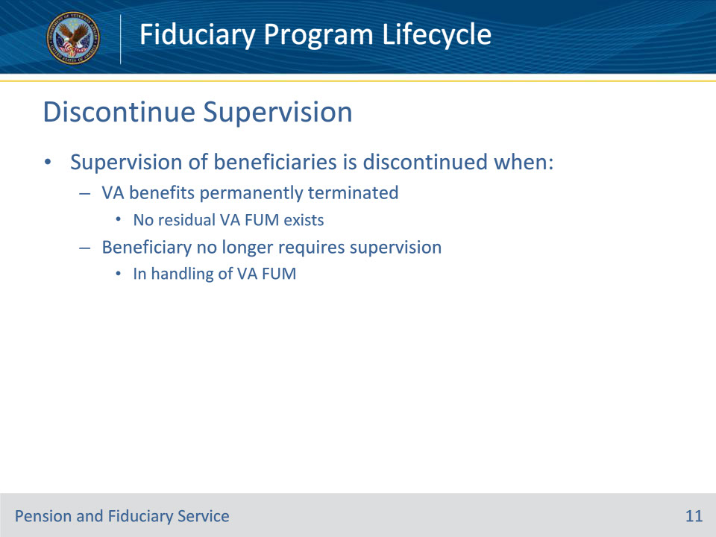
Slide notes

Policy Reference(s): FPM II.1.D.1.c.

Instructor Notes:

Supervision of beneficiaries is discontinued when

• Department of Veterans Affairs (VA) benefits are terminated permanently, and no residual VA funds under management (FUM) exists, or

• the beneficiary no longer requires supervision in the handling of VA FUM.

Residual VA FUM does not include benefit debt/overpayment.

Slide 12 - Deactivating Beneficiary Record- Minors
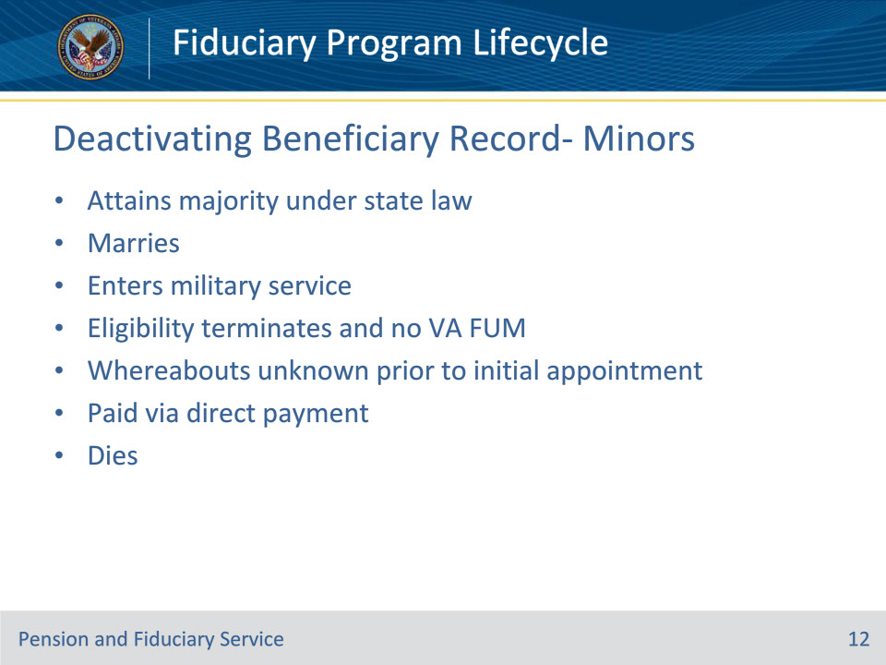
Slide notes

Policy Reference(s): FPM II.1.D.2.a.

Instructor Notes:

Beneficiary records for cases involving minors are usually deactivated when the minor

• attains majority under the law of the State in which they reside

• marries

• enters military service

• has eligibility terminated and there is no VA FUM

• cannot be located and benefits are suspended for whereabouts unknown prior to the appointment of an initial fiduciary

• is paid via direct payment, or

• dies

Slide 13 - Deactivating Beneficiary Record- Adults
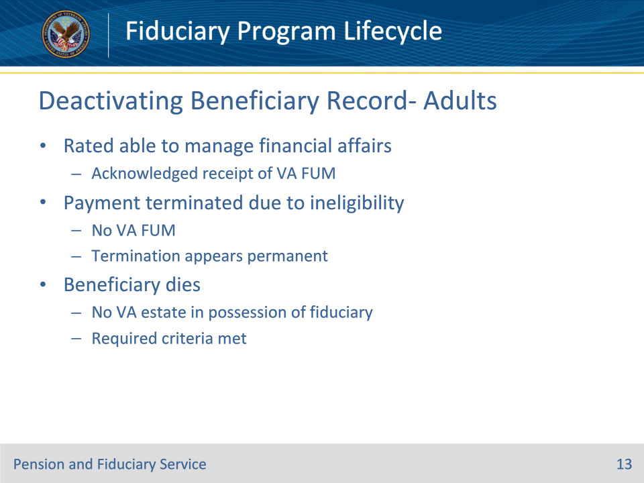
Slide notes

Policy Reference(s): FPM II.1.D.2.b.

Instructor Notes:

Beneficiary records for cases in which there is a VA-appointed fiduciary for an adult should be deactivated when any of the following situations occur:

• the beneficiary has been rated competent and has acknowledged receipt of VA FUM

• payment is terminated because of ineligibility, there is no VA FUM, and termination of benefits appears to be permanent

• the beneficiary dies and there is no estate derived from VA benefits in the hands of the fiduciary, or

• the beneficiary dies and the criteria outlined in the FPM have been met.

Slide 14 - Questions?
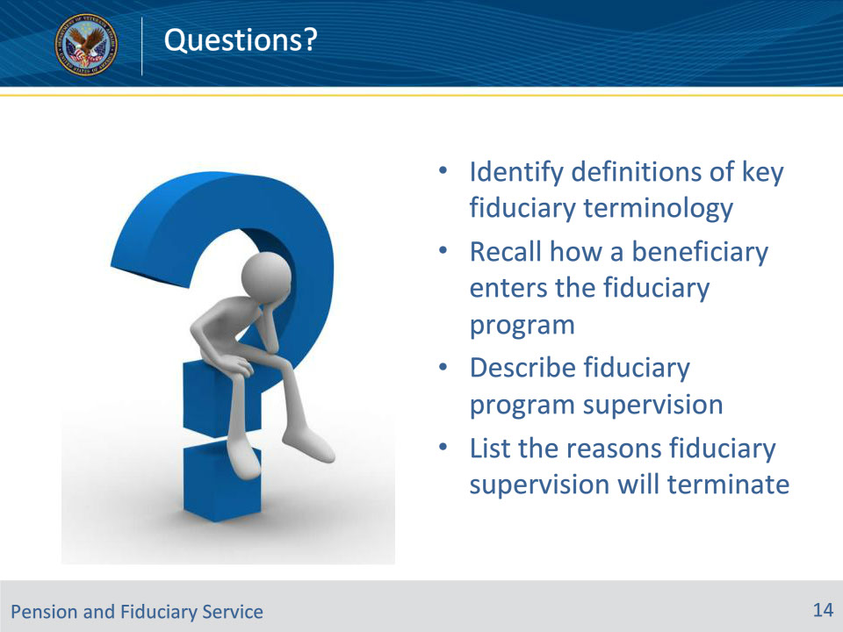
Slide notes

Instructor Notes:

(Recall) These are our learning objectives as stated from the beginning of the training:

• Identify definitions of key fiduciary terminology

• Recall how a beneficiary enters the fiduciary program

• Describe fiduciary program supervision

• List the reasons fiduciary supervision will terminate

Are there any additional questions?

Slide 15 - TMS Survey
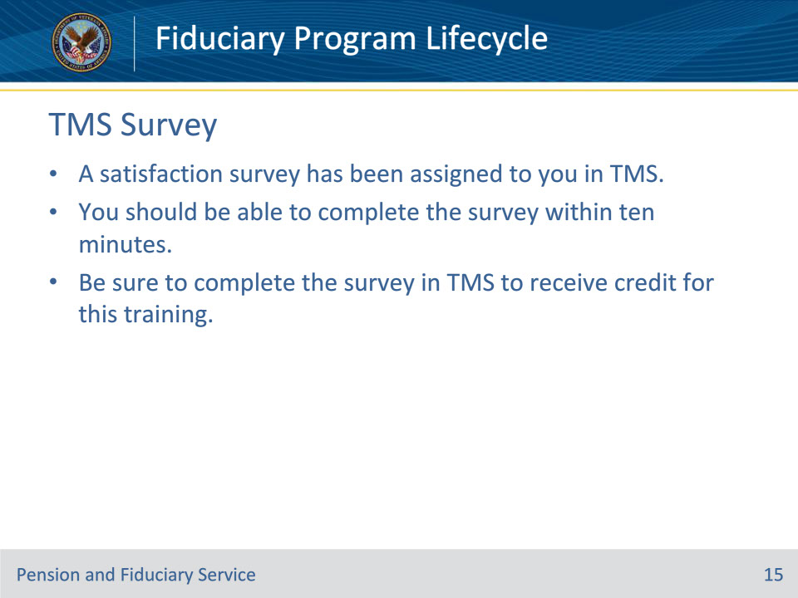
Slide notes

Instructor Notes:

A satisfaction survey has been assigned to you in TMS. You should be able to complete the survey within ten minutes. Completing the survey will allow you to receive credit for this training.

