Slide 1 - Dual Jurisdiction Field Examinations
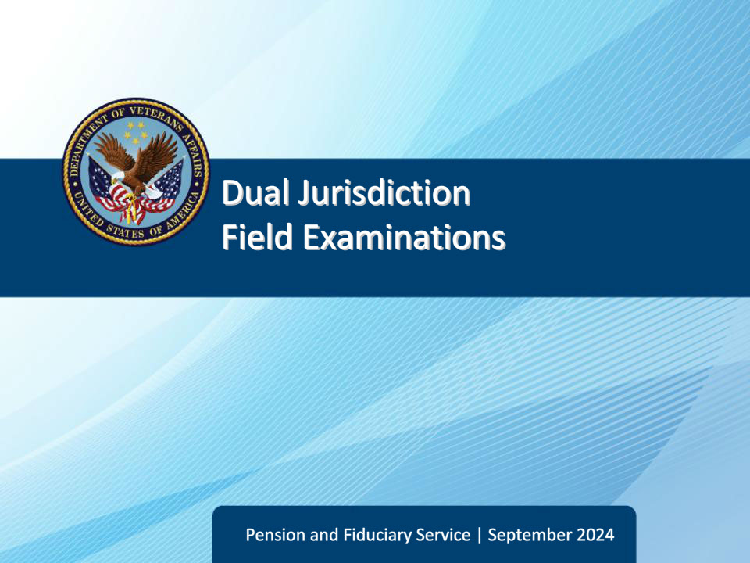
Slide notes

Course Description:

This course teaches learners about identifying and processing dual jurisdiction field examinations.

Slide 2 - Objectives
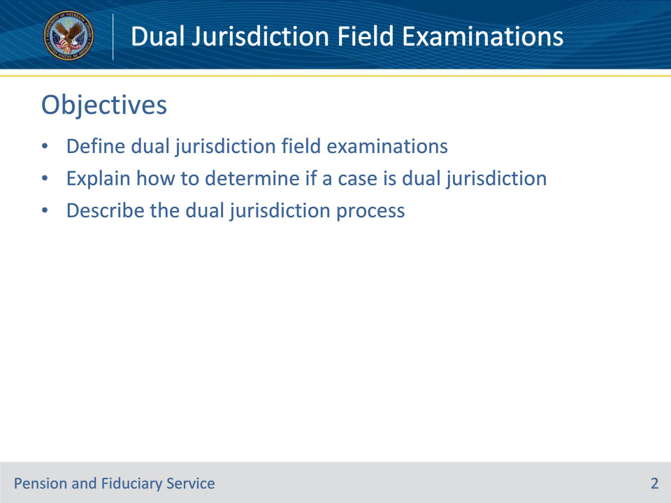
Slide notes

Instructor Notes:

At the end of this lesson, given the training and references, the learner will be able to do the following:

• Define dual jurisdiction field examinations

• Explain how to determine if a case is dual jurisdiction

• Describe the dual jurisdiction process

Slide 3 - References
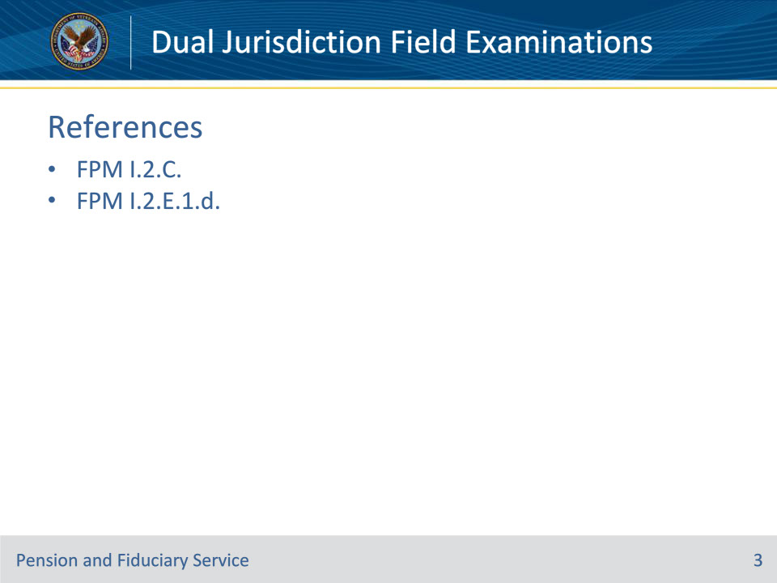
Slide notes

Instructor Notes:

These are the relevant references pertaining to this course:

• FPM I.2.C. Initial Appointments (IA) and Successor IA (SIA)

• FPM I.2.E.1.d. How to Prepare Field Examination Documentation

Slide 4 - Dual Jurisdiction
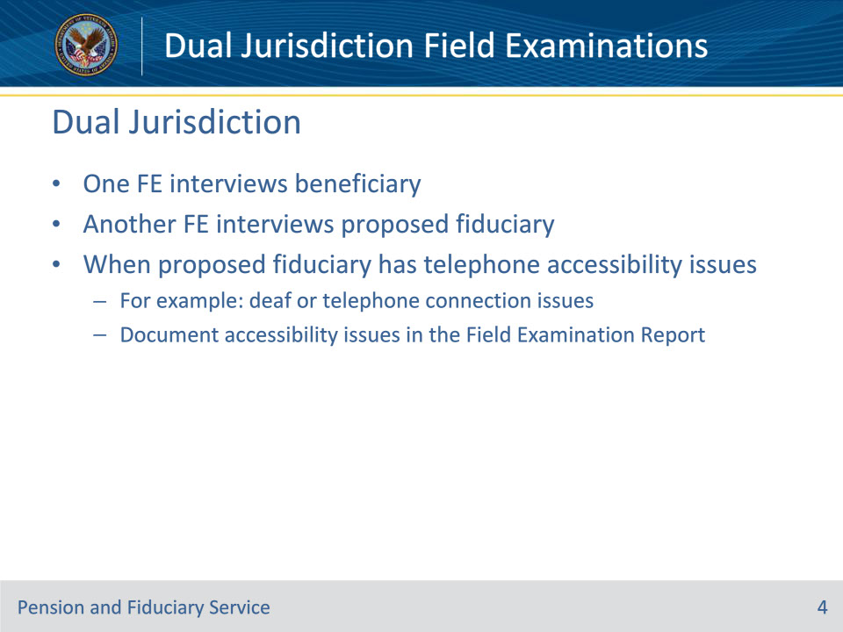
Slide notes

Policy Reference(s): FPM I.2.C.1.g.

Instructor Notes:

A dual jurisdiction field examination is a field examination in which one field examiner interviews the beneficiary and a different field examiner in a different jurisdiction interviews the proposed fiduciary separately. Due to current manual guidance, this type of field examination should only be performed in the following circumstance:

The proposed fiduciary has telephone accessibility issues (for example, deaf or telephone connection issues) and the accessibility issues are documented in the field examination.

Slide 5 - Beneficiary Portion
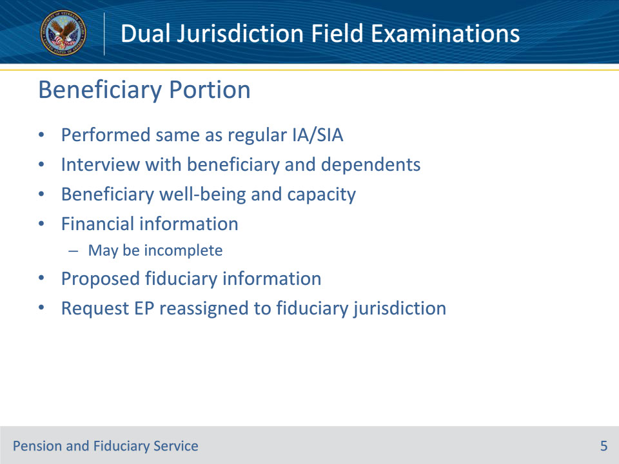
Slide notes

Policy Reference(s): FPM I.2.C.1.-5., FPM I.2.E.1.d.

Instructor Notes:

The first part of a Dual Jurisdiction case is the portion where the beneficiary is interviewed. This field examination is conducted the same as a non-dual jurisdiction case except the fiduciary is not interviewed during this portion.

The field examiner will adhere to the same requirements as a regular IA/SIA while addressing:

• (I.2.C.1.) Interview Logistics and Contacts

• (I.2.C.2.) Beneficiary Well-Being

• (I.2.C.3.) Financial Information of the Beneficiary

• Note: The beneficiary’s financial information may be incomplete if the beneficiary does not currently manage his/her finances. The FE conducting the fiduciary portion of the field exam will attempt to get this information from the proposed fiduciary.

• (I.2.E.1.d.) If a partial field exam is completed and a second interview must be conducted in a different jurisdiction, hub personnel must ensure the appropriate end product (EP) is reassigned to the appropriate hub.

• Document all required information on Field Exam Report.

• Request and ensure that the appropriate EP is then assigned to the appropriate jurisdiction for the fiduciary portion of the field examination process to be completed.

Slide 6 - Fiduciary Portion
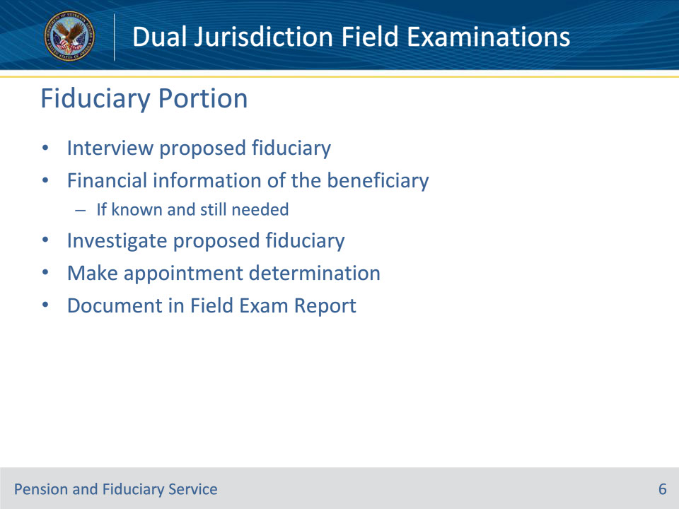
Slide notes

Policy Reference(s): FPM I.2.C.1., FPM I.2.C.3.-5.

Instructor Notes:

The second part of a Dual Jurisdiction case is the portion where the fiduciary is interviewed. This field examination is also conducted the same as a non-dual jurisdiction case except the field examiner is usually only interviewing and investigating the proposed fiduciary and obtaining financial information of the beneficiary.

The field examiner will adhere to the same requirements as a regular IA/SIA while addressing:

• (I.2.C.1.) Interview Logistics and Contacts

• (I.2.C.3.) Financial Information of the Beneficiary

• Note: Depending on the situation, the FE who conducted the beneficiary portion may or may not have some or all of the beneficiary’s financial information. The FE conducting the fiduciary portion of the field exam should attempt to get this information from the proposed fiduciary, if needed.

• (I.2.C.4.) Fiduciary Appointments

• (I.2.C.5.) Investigations of Fiduciaries

Document all required information in the Field Exam Report.

Slide 7 - Questions?
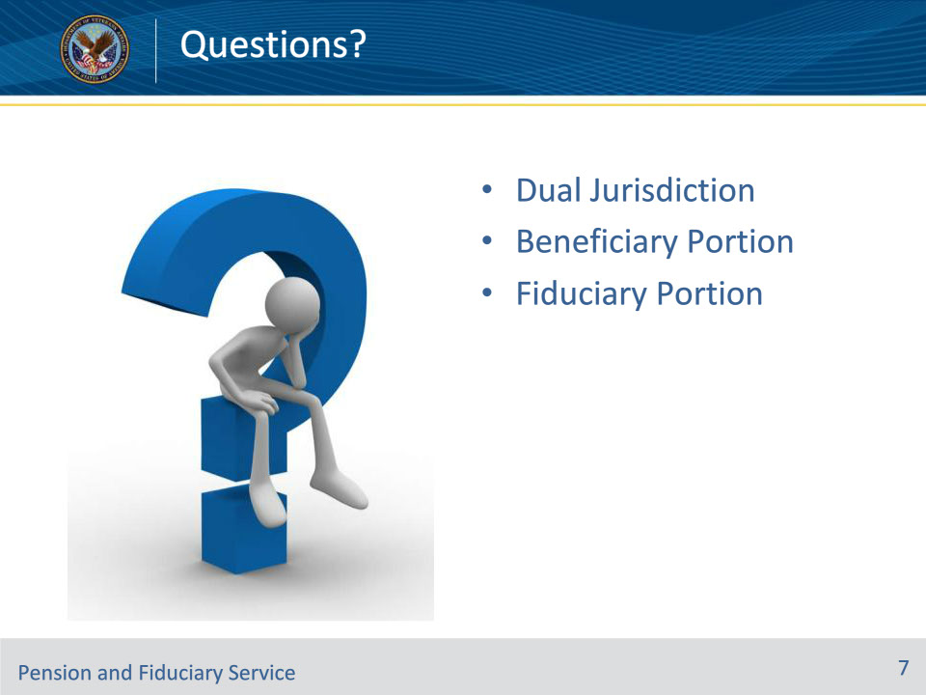
Slide notes

Instructor Notes:

(Recall) These are our learning objectives as stated from the beginning of the training:

• Define dual jurisdiction field examinations

• Explain how to determine if a case is dual jurisdiction

• Describe the dual jurisdiction process

(Recap) We discussed each of these learning objectives through the following topics in each slide today:

• Dual Jurisdiction

• Beneficiary Portion

• Fiduciary Portion

Are there any additional questions?

Questions should be filtered through your QRT team. They will submit your questions to the Field Inquiry Tool (FIT) on your behalf.

Slide 8 - TMS Survey/Assessment
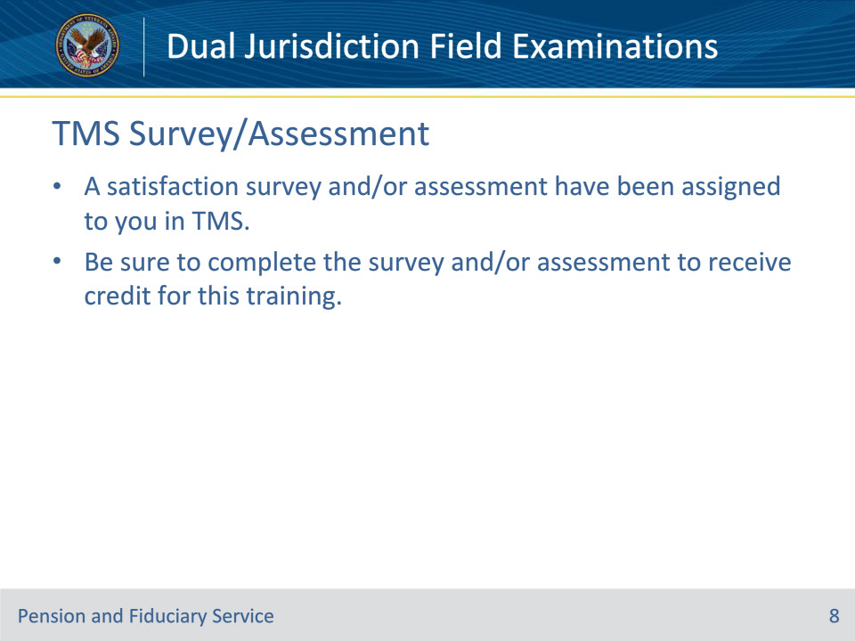
Slide notes

Instructor Notes:

A satisfaction survey and/or assessment have been assigned to you in TMS.

Be sure to complete the survey and/or assessment to receive credit for this training.

