Slide 1 - Benefit Funds Protection
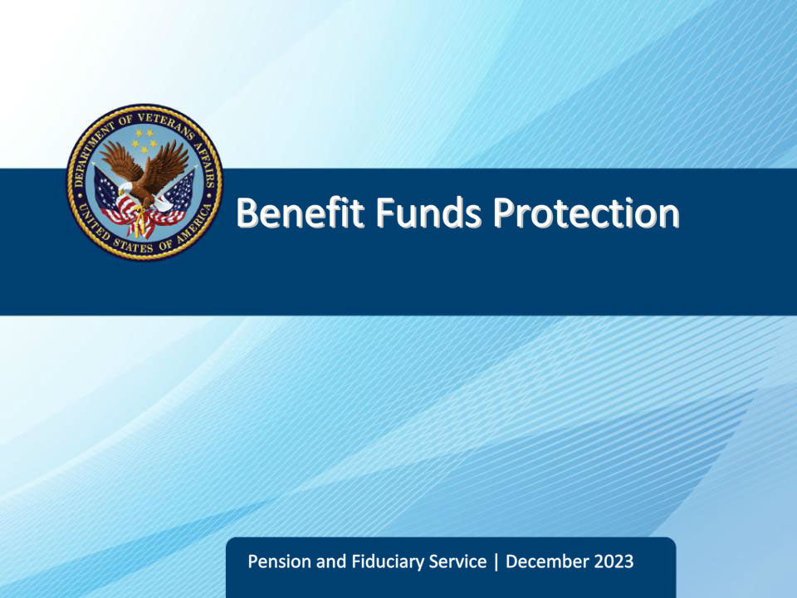
Slide notes

Course Description:

This lesson provides an overview of the major elements of benefits funds protection conducted by fiduciary hubs.

Slide 2 - Objectives
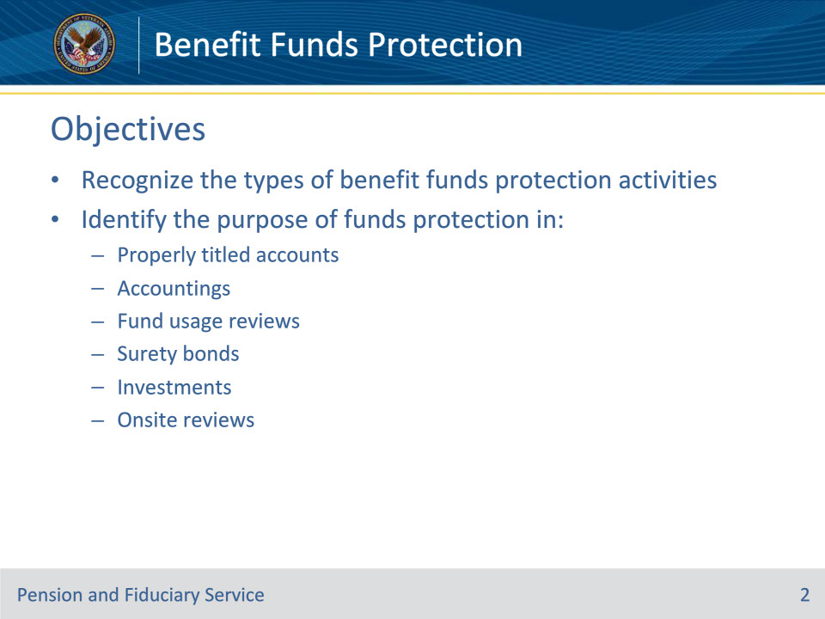
Slide notes

Instructor Notes:

At the end of this lesson, given the training and references, the learner will be able to do the following:

• Recognize the types of benefit funds protection activities

• Identify the purpose of funds protection in:

• properly titled accounts

• accountings

• fund usage reviews

• Surety bonds

• investments

• onsite reviews

Slide 3 - References
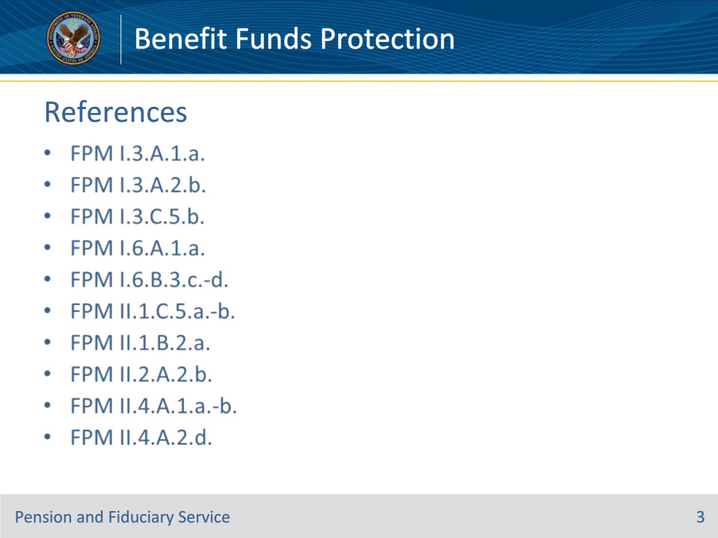
Slide notes

Instructor Notes:

The following are relevant references of Benefit Funds Protection:

• FPM I.3.A.1.a.

• FPM I.3.A.2.b.

• FPM I.3.C.5.b.

• FPM I.6.A.1.a.

• FPM I.6.B.3.c.-d.

• FPM II.1.C.5.a.-b.

• FPM II.1.B.2.a.

• FPM II.2.A.2.b.

• FPM II.4.A.1.a.-b.

• FPM II.4.A.2.d.

Slide 4 - Fund Protection Activities
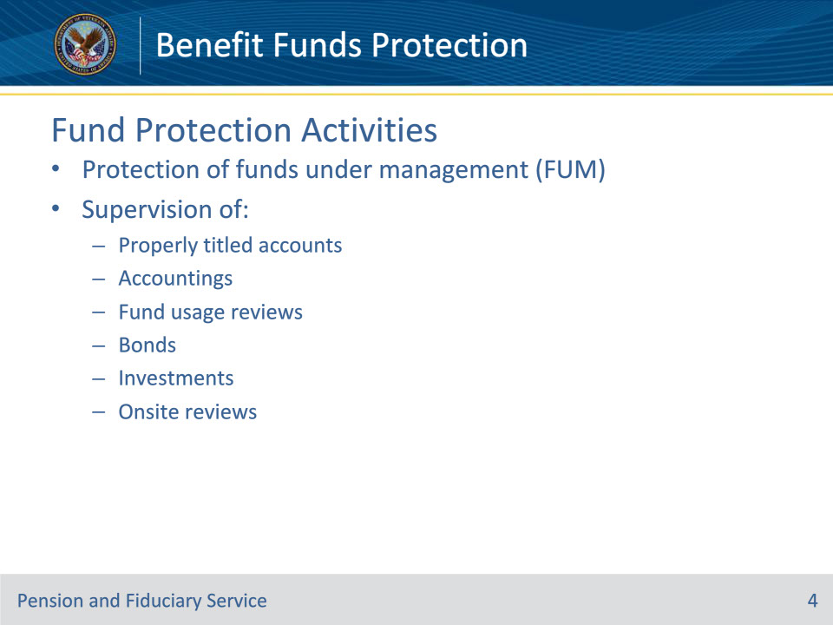
Slide notes

Instructor Notes:

There are various types of activities and supervision the fiduciary hub provides to ensure the protection of beneficiaries’ VA benefits; especially the funds that accumulate. These are all considered funds under management, or FUM.

These activities, which we will discuss in more detail in this training, are:

• Properly titled accounts

• Accountings

• Fund usage reviews

• Bonds

• Investments

• Onsite reviews

Slide 5 - Properly Titled Accounts
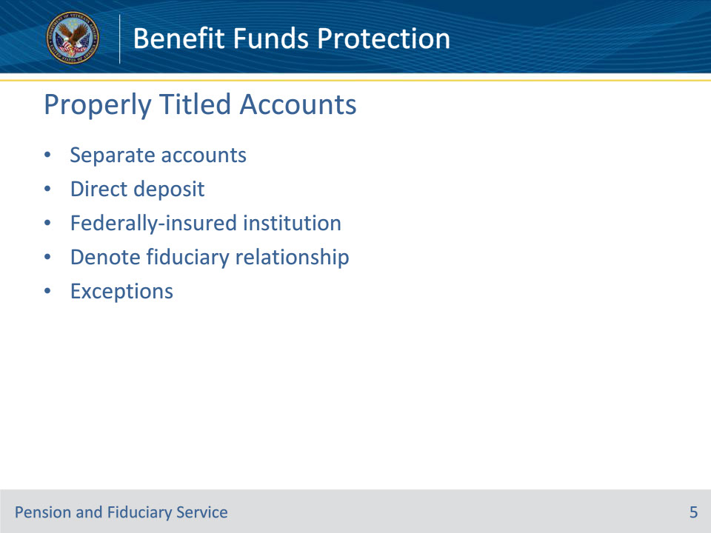
Slide notes

Policy Reference(s): FPM I.3.C.5.b., FPM II.1.B.2.a.

Instructor Notes:

The fiduciary hub must ensure that all VA and other FUM by the fiduciary are deposited and meet all of the following requirements, unless exempt:

• The fiduciary must establish and maintain a separate financial institution account for each VA beneficiary served and

• The account must be

• established to allow for the direct deposit of VA benefits

• Federally insured and not exceed current insured limits of protection, and

• properly titled in the beneficiary’s and fiduciary’s names and note the existence of the fiduciary relationship

Exceptions to these account requirements are afforded to:

• the beneficiary’s spouse

• State and local government entities

• Institutions, such as public or private medical care facilities, nursing homes, or other residential care facilities, when an annual accounting is not required

• A trust company or bank with trust powers organized under the laws of the U.S. or a State.

Custodial financial accounts, established by VA-appointed fiduciaries on behalf of a beneficiary, must be properly titled, when required. This applies to direct deposit accounts for VA benefits and investment accounts containing VA funds under management.

Properly titled accounts are titled in the beneficiary’s and fiduciary’s names and note the existence of the fiduciary relationship; (beneficiary’s name), by (fiduciary’s name).

Slide 6 - Accountings
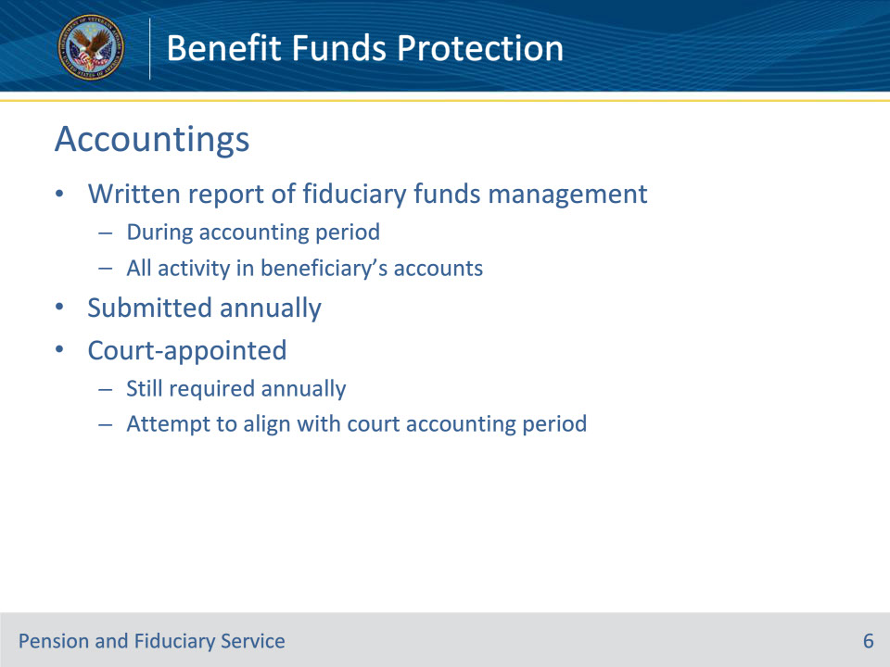
Slide notes

Policy Reference(s): FPM I.3.A.1.a., FPM I.3.A.2.b.

Instructor Notes:

Another method the VA utilizes to protect beneficiary funds is to require an accounting from certain fiduciaries.

An accounting is the fiduciary’s written report regarding the income and funds under management (FUM) by the fiduciary for the beneficiary during the accounting period.

An accounting pertains to all activity in the beneficiary’s accounts, regardless of the source of funds maintained in those accounts, e.g., Social Security payments and interest earned on deposits.

VA-appointed fiduciaries must submit accountings on an annual basis. The term annual accounting refers to something that is executed on a yearly basis. The annual accounting period is determined by the hub and occurs at least once a year and returns the next year, when required.

For VA-appointed fiduciaries who are also court-appointed, VA will require accountings annually, but will attempt to align the VA accounting period with the court accounting period

Slide 7 - Fund Usage Review
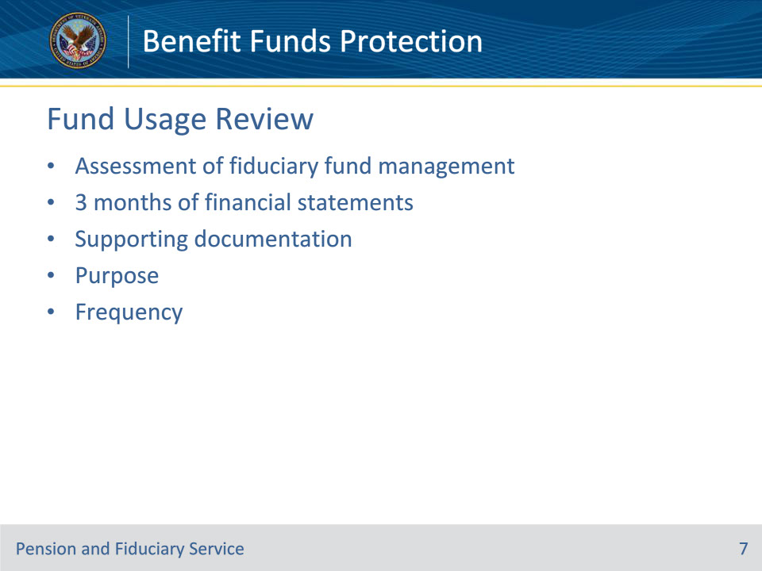
Slide notes

Policy Reference(s): FPM I.6.A.1.a.; FPM I.6.B.3.c., d.

Instructor Notes:

Fund usage reviews are another method of fiduciary financial oversight used by fiduciary hubs.

A fund usage report consists of three months of all financial statements containing VA funds for each beneficiary that the fiduciary manages.

The fund usage report may also include any supporting documents (receipts, invoices, etc.) that show irregular purchases so that VA can confirm the funds are being spent in the beneficiary’s best interest.

Fund usage reviews are completed by hub personnel and are an assessment of the three months of financial statements and supporting documentation. The purpose of the review is to provide targeted oversight of fiduciary use and management of VA beneficiary funds by:

• identifying expenditures that may not be for the use and benefit of the beneficiary and their dependents

• confirming that VA-appointed fiduciaries maintain properly titled accounts when required

• establishing bond and accounting requirements when necessary, and

• ensuring fiduciary compliance with VA responsibilities

The first Fund Usage Review can occur anywhere from 3-12 months from the most recent oversight activity, depending on the circumstances. Thereafter, the review occurs every two years.

Slide 8 - Surety Bonds
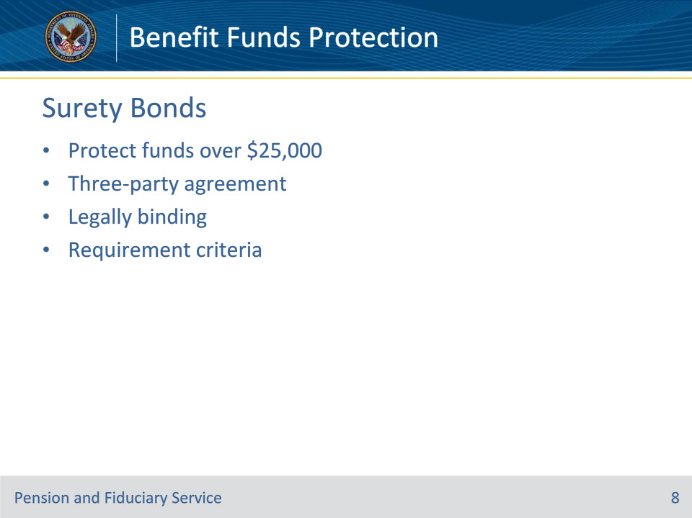
Slide notes

Policy Reference(s): FPM II.1.C.5.a., b.

Instructor Notes:

Surety bond refers to a three-party agreement that legally binds together a principal (fiduciary) who needs the bond, an obligee (VA) who requires the bond and a surety company that sells the bond. The bond guarantees the principal will act in accordance with certain laws. If the principal fails to perform in this manner, the bond will cover resulting damages or losses.

The fiduciary hub is authorized to require a corporate surety bond from a VA-appointed fiduciary, if considered necessary to protect the beneficiary’s VA funds under management (FUM).

A bond is required when VA FUM exceed $25,000, unless the fiduciary is exempt.

The threshold can be reached by

• pending release of

• any retroactive VA benefits exceeding $25,000, or

• reissuance of misused funds exceeding $25,000

• release of any retroactive VA benefits that would increase the VA FUM to more than $25,000, or

• audit of an account which reveals accumulated VA FUM exceeding $25,000.

The Fiduciary Hub Manager may request a fiduciary obtain a corporate surety bond at any time even if the $25,000 threshold is not met, if it is considered necessary to protect the beneficiary’s VA FUM.

Slide 9 - Investments
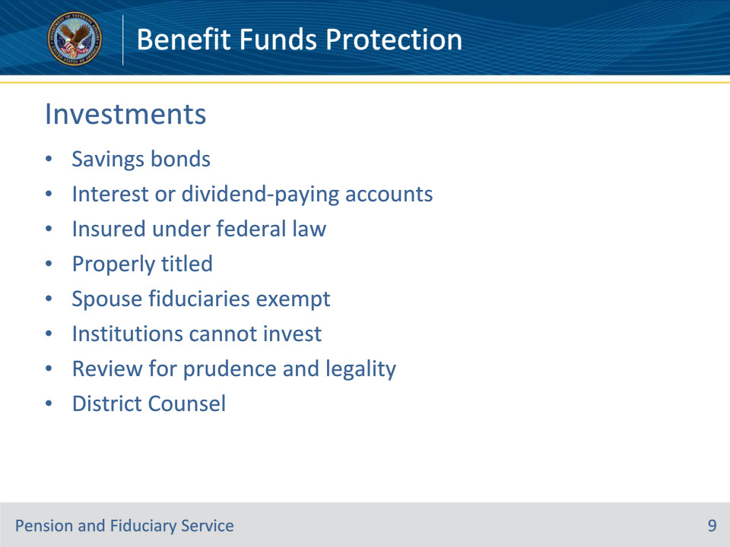
Slide notes

Policy Reference(s): FPM II.2.A.2.b.

Instructor Notes:

Fiduciaries are authorized to invest in U.S. savings bonds or interest or dividend-paying accounts insured under Federal law. Any such investment must be clearly titled in the beneficiary’s and fiduciary’s names and identify the fiduciary relationship. VA does not authorize other types of investments, unless the fiduciary is appointed as a spouse fiduciary.

Spouse fiduciaries are not limited to investing in U.S. savings bonds or interest or dividend-paying accounts insured under Federal law and are not required to title investments in the beneficiary’s and fiduciary’s names.

A chief officer of an institution in which the beneficiary is being furnished hospital treatment or institutional, nursing, or domiciliary care appointed who is receiving VA benefit payments for a beneficiary as a VA appointed fiduciary may not invest VA benefit funds.

The Fiduciary Hub must review and, to the extent possible, determine the legality and prudence of investments involving VA income. When notice of a contemplated questionable or imprudent investment comes to the attention of the hub, the hub must refer any question as to the legality of an investment to District Counsel for an opinion within five business days.

Slide 10 - Onsite Reviews
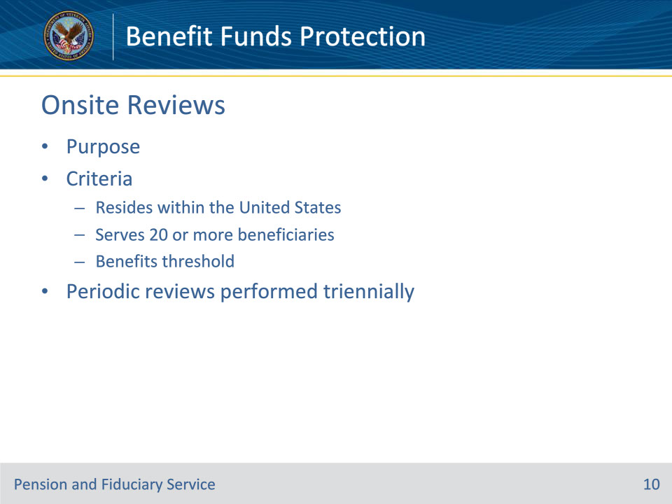
Slide notes

Policy Reference(s): FPM II.4.A.1.a., b.; FPM II.4.A.2.d.

Instructor Notes:

Department of Veterans Affairs (VA) is required to conduct periodic onsite reviews of any fiduciary in the U.S., whether the fiduciary is an individual or entity, when that fiduciary is serving 20 or more beneficiaries and the total annual amount of such benefits exceeds $50,000, as adjusted. In addition, the law grants VA the authority to conduct unscheduled onsite reviews of any fiduciary without regard to the number of beneficiaries served by the fiduciary or the amount of funds under management (FUM) by the fiduciary to ensure the well-being of beneficiaries or prevent exploitation of beneficiary funds

Onsite reviews are a necessary tool VA uses to determine if VA-appointed fiduciaries are performing satisfactorily, and the reviews fulfill VA’s statutory obligation for fiduciary oversight. Moreover, onsite reviews are intended to ensure the well-being of beneficiaries, prevent misuse and exploitation of beneficiary funds, and supplement oversight provided by field examinations and the accounting processes. These reviews also provide VA with an opportunity to provide guidance to fiduciaries.

Periodic onsite reviews are completed at least triennially.

Slide 11 - Questions?
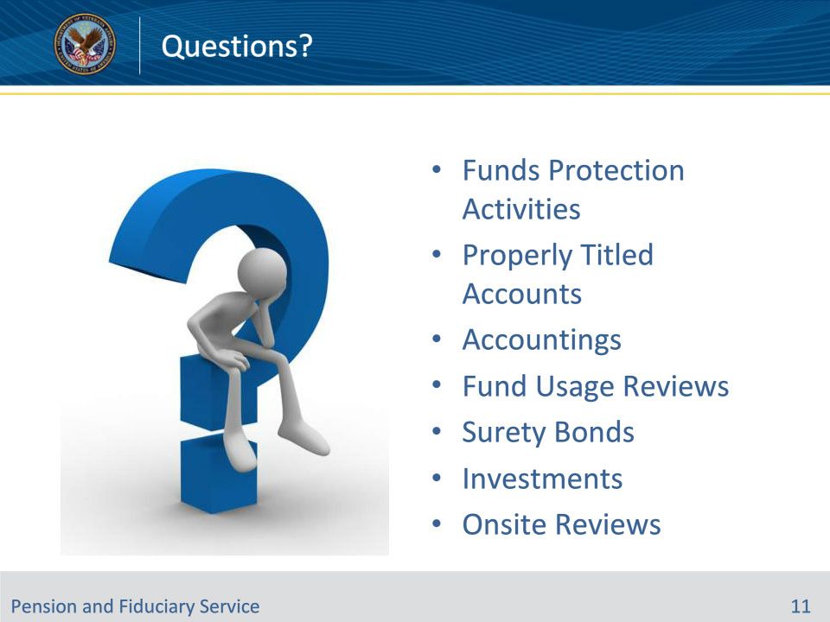
Slide notes

Instructor Notes:

(Recall) These are our learning objectives as stated from the beginning of the training:

• Recognize the types of benefit funds protection activities

• Identify the purpose of funds protection in:

• properly titled accounts

• Accountings

• Fund Usage reviews

• Surety bonds

• investments

• onsite reviews

(Recap) We discussed each of these learning objectives through the following topics in each slide today:

• Funds Protection Activities

• Properly Titled Accounts

• Accountings

• Fund Usage Review

• Surety Bonds

• Investments

• Onsite Reviews

Slide 12 - TMS Survey
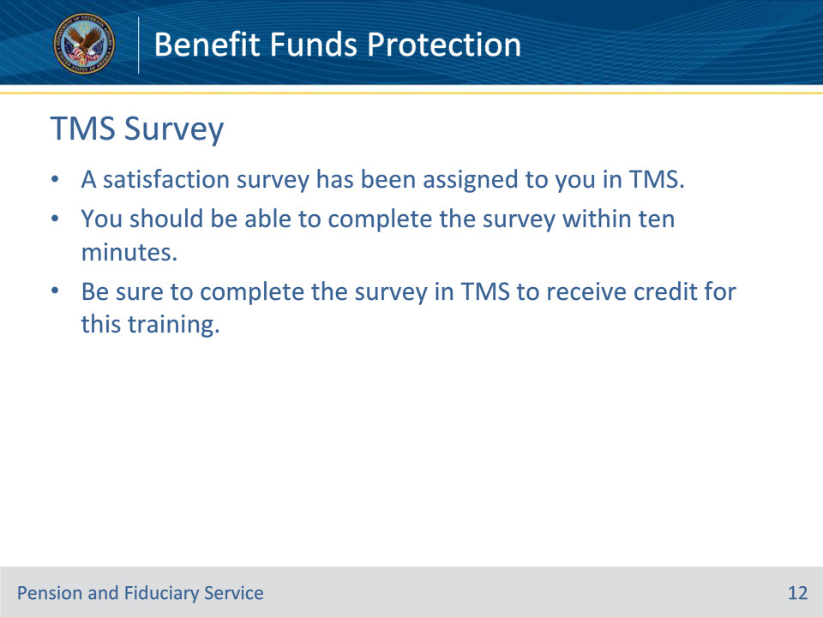
Slide notes

Instructor Notes:

A satisfaction survey has been assigned to you in TMS. You should be able to complete the survey within ten minutes. Completing the survey will allow you to receive credit for this training.

