Slide 1 - Veterans Affairs and Its Mission
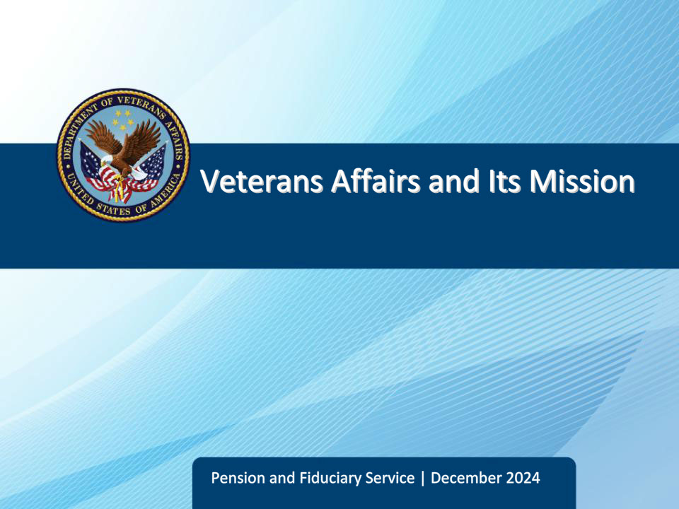
Slide notes

Course Description:

This course provides the learner with an overview of the U.S. Department of Veterans Affairs, its history, mission, core values, and an introduction to its three administrations – the Veterans Health Administration, Veterans Benefits Administration, and National Cemetery Administration.

Slide 2 - Objectives
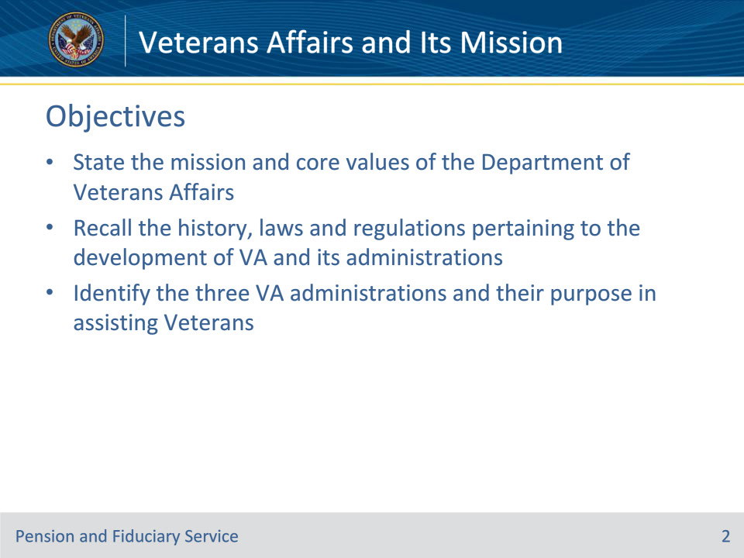
Slide notes

At the end of this lesson, given the training and references, the learner will be able to do the following:

• State the mission and core values of the Department of Veterans Affairs

• Recall the history, laws and regulations pertaining to the development of VA and its administrations

• Identify the three VA administrations and their purpose in assisting Veterans.

Slide 3 - References
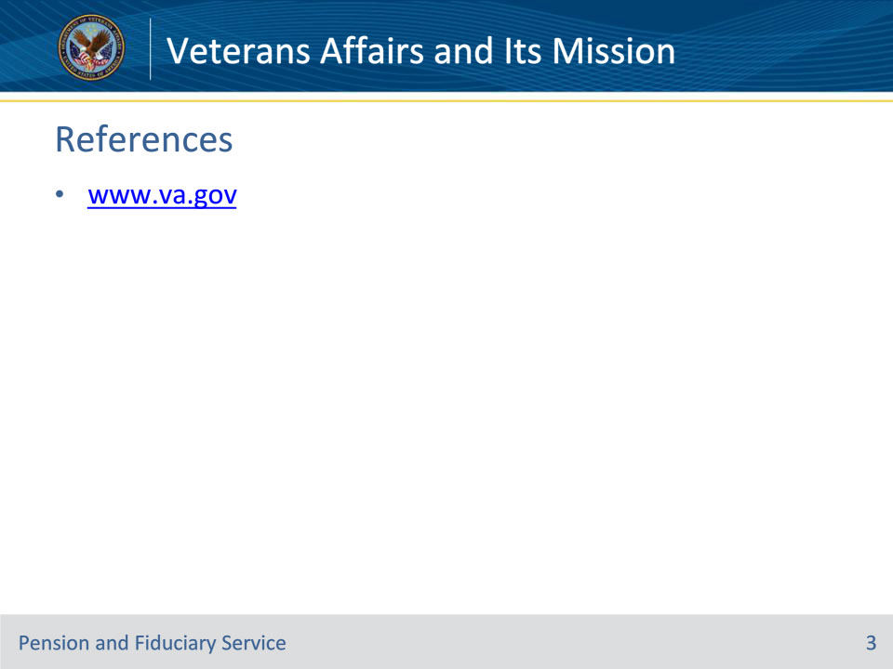
Slide notes

These are the relevant references pertaining to this course:

• www.va.gov

Slide 4 - VA Mission
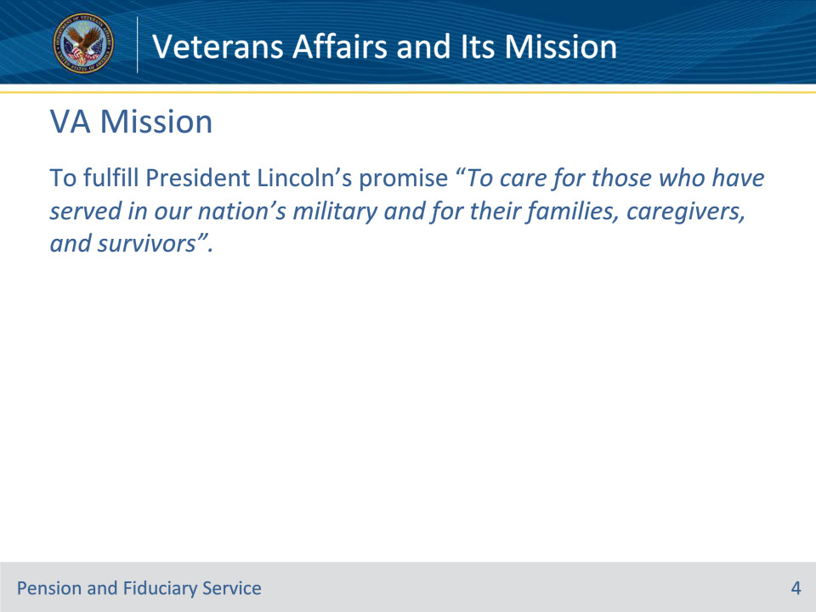
Slide notes

Policy Reference(s): https://department.va.gov/about/

Instructor Notes:

VA’s mission is to fulfill President Lincoln’s promise: To fulfill President Lincoln’s promise “To care for those who have served in our nation’s military and for their families, caregivers, and survivors”. This mission statement was updated on March 16, 2023.

The new mission statement is inclusive of all those who have served in our nation’s military — including women Veterans — as well as Veteran families, caregivers, and survivors.

VA currently serves more than 600,000 women Veterans, the fastest growing cohort of Veterans. VA also serves more than 50,000 Veteran caregivers, more than 600,000 Veteran survivors, and millions of Veterans who did not serve in combat.

Slide 5 - Core Values
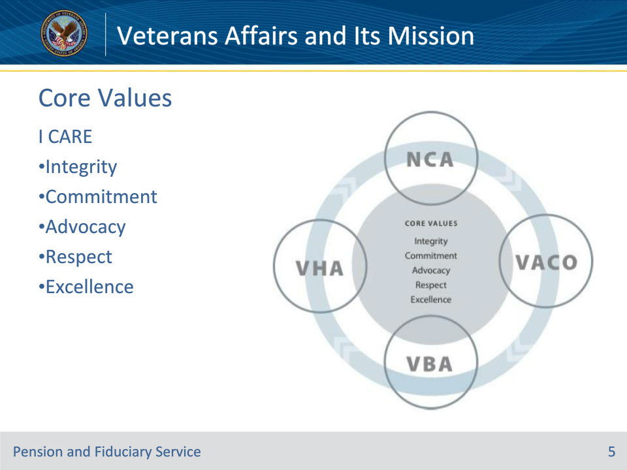
Slide notes

Policy Reference(s): https://www.va.gov/icare/

Instructor Notes:

The Department of Veterans Affairs (VA) Core Values and Characteristics apply across the entire VA organization. These core organizational values are the foundation of VA culture and support VA’s mission to provide the best care and services to Veterans, their families, and beneficiaries. Our core values focus our minds on our mission of caring and thereby guide our actions toward service to others.

Because I CARE, I WILL:

Integrity: Act with high moral principle. Adhere to the highest professional standards. Maintain the trust and confidence of all with whom I engage.

Commitment: Work diligently to serve Veterans and other beneficiaries. Be driven by an earnest belief in VA’s mission. Fulfill my individual responsibilities and organizational responsibilities.

Advocacy: Be truly Veteran-centric by identifying, fully considering, and appropriately advancing the interests of Veterans and other beneficiaries.

Respect: Treat all those I serve and with whom I work with dignity and respect. Show respect to earn it.

Excellence: Strive for the highest quality and continuous improvement. Be thoughtful and decisive in leadership, accountable for my actions, willing to admit mistakes, and rigorous in correcting them

Slide 6 - Veterans Benefits (Pre-Civil War)
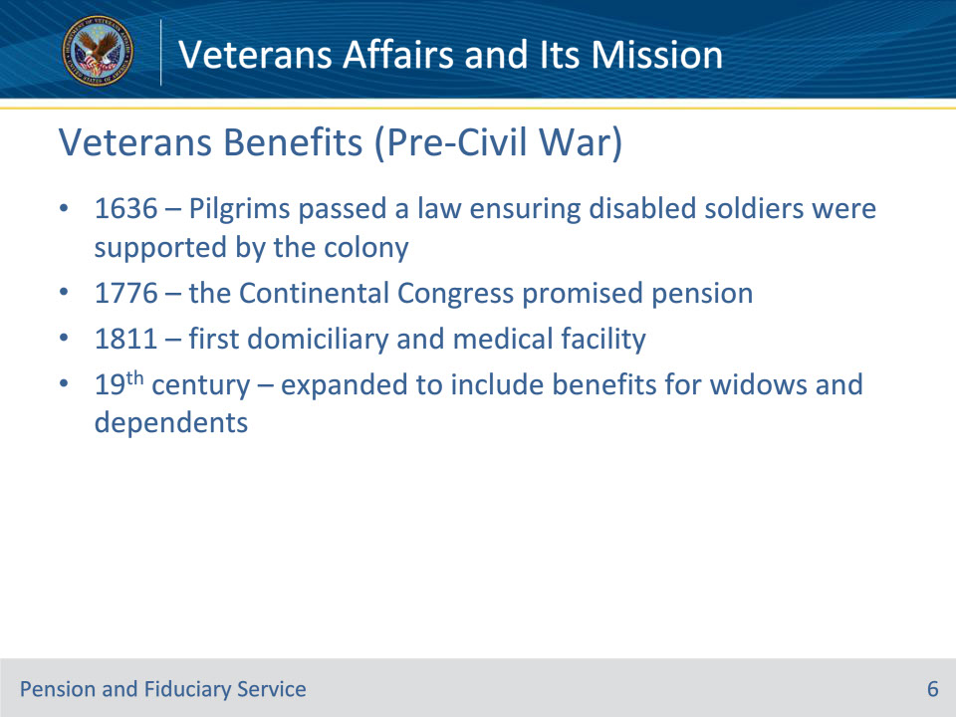
Slide notes

Policy Reference(s): www.va.gov

Instructor Notes:

The United States has the most comprehensive system of assistance for Veterans of any nation in the world, with roots that can be traced back to 1636, when the Pilgrims of Plymouth Colony were at war with the Pequot Indians. The Pilgrims passed a law that stated that disabled soldiers would be supported by the colony.

The Continental Congress of 1776 encouraged enlistments in the Revolutionary War, providing pension to disabled soldiers.

In 1811, the federal government authorized the first domiciliary and medical facility for Veterans

In the 19th century, the nation’s Veterans assistance program was expanded to include benefits and pensions not only for Veterans, but for their widows and dependents.

Slide 7 - History of Benefits (Post-Civil War)
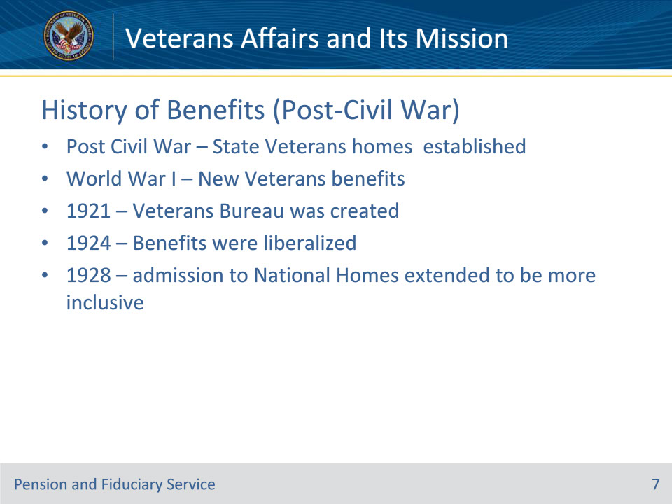
Slide notes

Policy Reference(s): www.va.gov

Instructor Notes:

Following the civil war, many state Veterans homes were established. Indigent and disabled Veterans of the Civil War, Indian Wars, Spanish-American War and Mexican Border period, as well as the discharged regular members of the Armed Forces, received care at these homes.

During WWI Congress established a new system of Veterans benefits to include: disability compensation, insurance for service personnel and Veterans and vocational rehabilitation. By the 1920s, three federal agencies administered the benefits: the Veterans Bureau, the Bureau of Pensions of the Interior Department and the National Home for Disabled Volunteer soldiers.

In 1921 Congress combined all WWI Veterans programs to create the Veterans Bureau. Public Health Service Veterans’ hospitals were transferred to the bureau and an ambitious hospital construction took place

In 1924 Veterans benefits were liberalized to cover disabilities not service related

In 1928 admission to the National Homes was extended to women, National Guard and militia Veterans

Slide 8 - Veterans Administrations
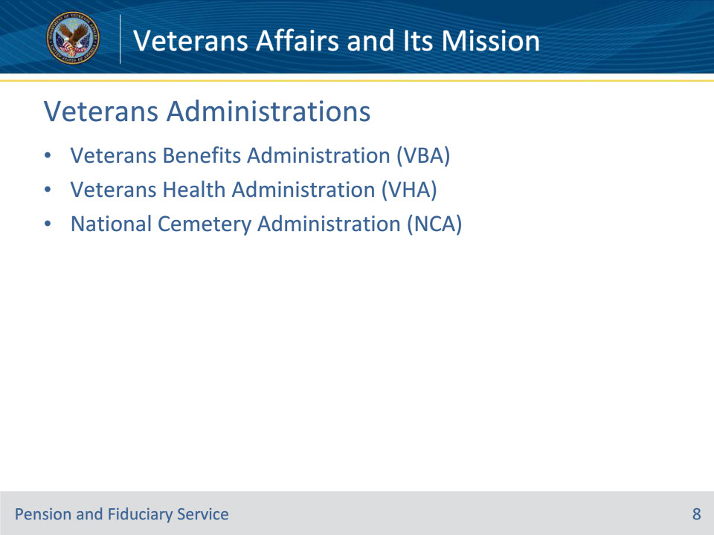
Slide notes

Policy Reference(s): www.va.gov

Instructor Notes:

VBA: The Veterans Benefits Administration (VBA) provides a variety of benefits and services to Servicemembers, Veterans, and their families.

VHA: VA, the nation’s largest health care system, employs more than 306,000 full time health care professionals and support staff at 1,240 health care facilities, including 170 VA Medical Centers and 1,061 outpatient sites of care of varying complexity (VHA outpatient clinics).VHA is the nation’s largest provider of graduate medical education and a major contributor to medical and scientific research. More than 73,000 active volunteers, 127,000 health professions trainees, and approximately 15,000 affiliated medical faculty are also an integral part of the VHA community.

NCA: VA is committed to the development and expansion of cemeteries for Veterans. Today, approximately 95% of Veterans live within 75 miles of an open national or state/tribal run Veteran’s cemetery.

Slide 9 - History of VBA
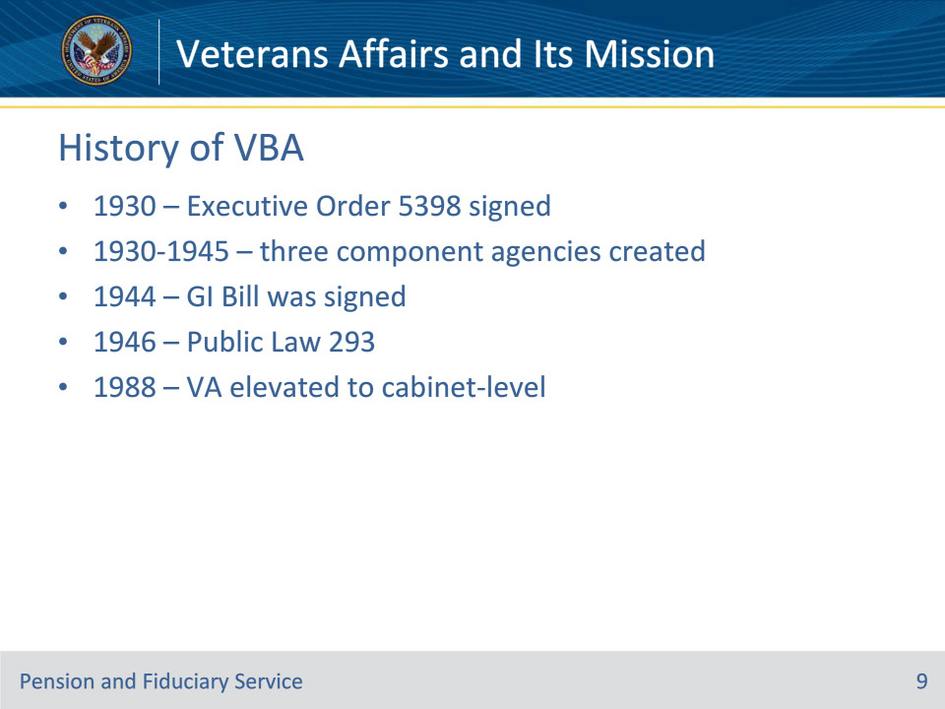
Slide notes

Policy Reference(s): www.va.gov

Instructor Notes:

7/21/1930 President Herbert Hoover signed Executive Order 5398 and elevated the Veterans Bureau to a federal administration – creating the Veterans Administration (VA)– to “consolidate and coordinate Government activities affecting war Veterans.” The National Homes and Pension Bureau joined the VA at that time also. The three component agencies became bureaus within the VA during the time Brig. General Frank T. Hines directed the VA. He was named the first Administrator of the VA and served until 1945.

On June 22, 1944, the WWII GI Bill was signed into law. It’s said this had more impact on the American way of life than any law since the Homestead Act of 1862. This Bill was crucial for modernizing the VA for a new generation of Veterans. The G.I. Bill ushered in a whole new kind of benefit program: readjustment benefits. These included three major parts. First, was the education program. Since there were no jobs available for returning soldiers, they were encouraged to return to school with tuition and a monthly living allowance at the cost of the government. Many Veterans were students prior to enlisting in service, so returning to the classroom was a natural transition. The second part of the original G.I. Bill was Home Loan Guarantee program. The intention was to help Veterans get settled into homes within their communities. Many Service members had not saved much money on soldiers’ pay, so the government decided to help them buy their own homes. They did this by guaranteeing a loan that would allow Veterans to purchase homes without a down payment. The third part of the G.I. Bill was a program called the 52-20 club. It gave Veterans 52 weeks of unemployment benefits at $20 a week.

The only provision of the original GI Bill still in force is the VA Home Loan Guaranty Program.

In 1946, Public Law 293 established the Department of Medicine and Surgery within VA, along with numerous other programs like the VA Voluntary Service. By 1948 there were 125 VA hospitals.

In October 1988, President Ronald Reagan elevated the VA to a cabinet-level executive department. This change took effect 3/15/89, and administrative changes occurred at all levels. The VA was re-named the Department of Veterans Affairs.

Slide 10 - History of VHA
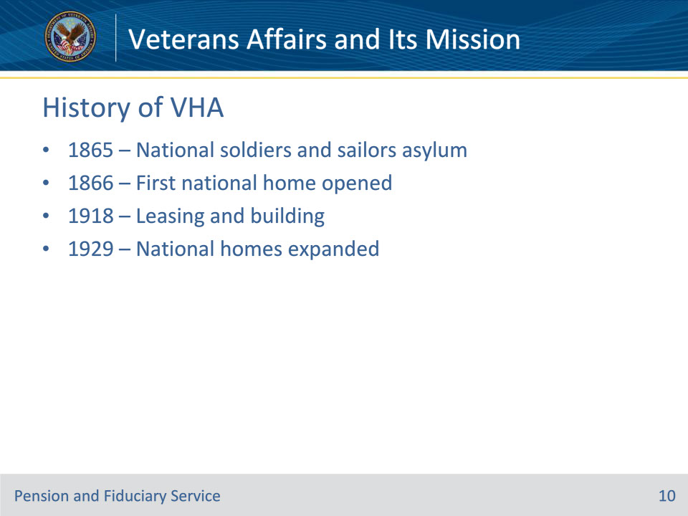
Slide notes

Policy Reference(s): www.va.gov

Instructor Notes:

On 3/3/1865, President Abraham Lincoln signed a law to establish a national soldiers and sailors asylum, it was the first-ever government institution created specifically for honorably discharged volunteer soldiers

The first national home opened November 1, 1866, near Augusta, Maine. The national homes were often called soldiers homes or military homes and only soldiers who fought for the Union Army, including U.S. Colored Troops, were eligible for admittance.

In 1918, Congress tasked two Treasury agencies with operating hospitals specifically for returning WWI Veterans. They leased hundreds of private hospitals and hotels for the rush of returning injured war Veterans and began a program of building new hospitals.

By 1929, the federal system of national homes had grown to 11 institutions that spanned the country and accepted Veterans of all American wars.

Slide 11 - History of NCA
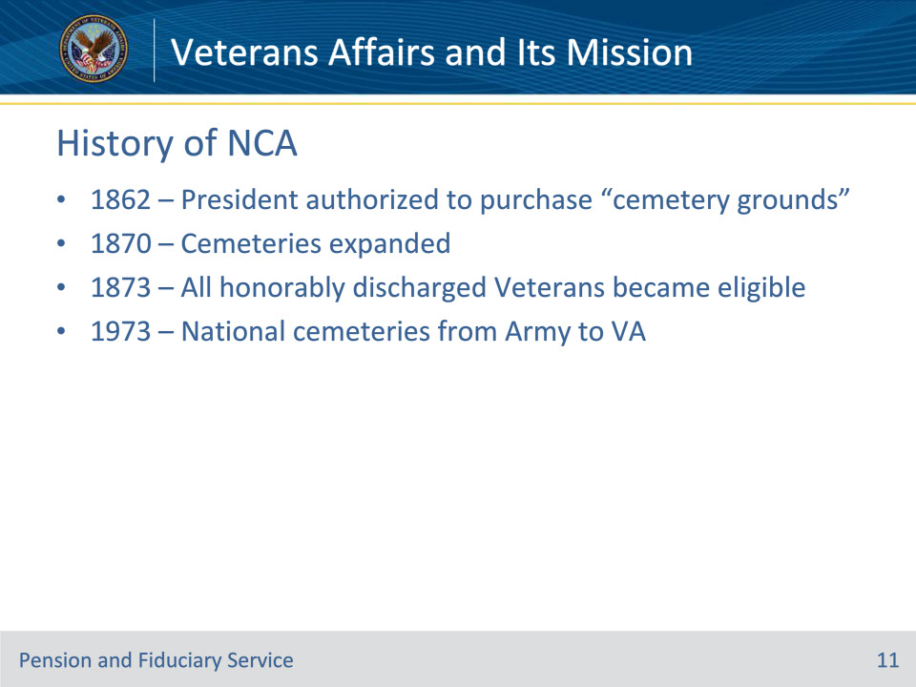
Slide notes

Policy Reference(s): www.va.gov

Instructor Notes:

On July 17, 1862, Congress enacted legislation that authorized the President to purchase “cemetery grounds” to be used as national cemeteries “for soldiers who shall have died in the service of the country.” The first year, 14 cemeteries were established.

By 1870, the remains of nearly 300,000 Union dead from the Civil War had been buried in 73 national cemeteries.

In 1873 national cemeteries evolved to allow all honorably discharged veterans to be buried there.

In 1973, Public Law 93-43 authorized the transfer of 82 national cemeteries from the Department of the Army to the Veterans Administration.

Slide 12 - VBA
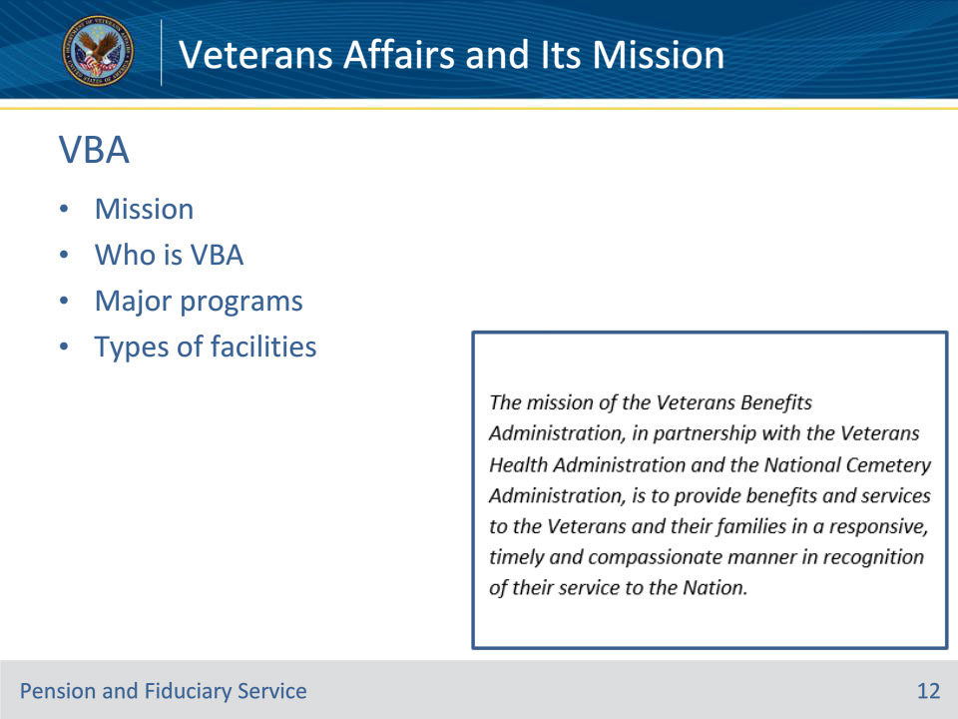
Slide notes

Policy Reference(s): www.va.gov

Instructor Notes:

VBA Mission:

The mission of the Veterans Benefits Administration, in partnership with the Veterans Health Administration and the National Cemetery Administration, is to provide benefits and services to the veterans and their families in a responsive, timely and compassionate manner in recognition of their service to the Nation.

Who is VBA

VBA includes a network of regional offices and tens of thousands of employees

Millions of Veterans receive compensation for disabilities incurred in service or pensions for wartime Veterans, who became totally disabled in civilian life

More than a half million widows, children and parents of deceased Veterans are paid survivor compensation or death pensions

Programs:

Compensation (disability, dependency)

Pension

Fiduciary (disability, survivor)

Insurance (Life, Mortgage)

Home Loan Guaranty

Education Programs (GI Bill, retraining and Educational Assistance Programs (EAP))

Vocational Rehabilitation and Employment

Records Management Center

Facilities:

Regional Loan Centers

Regional Processing Centers –These handle processing the GI Bill claims

Regional Offices

Veteran Employment Centers – virtual

Insurance Centers

Fiduciary Hubs

Slide 13 - VHA
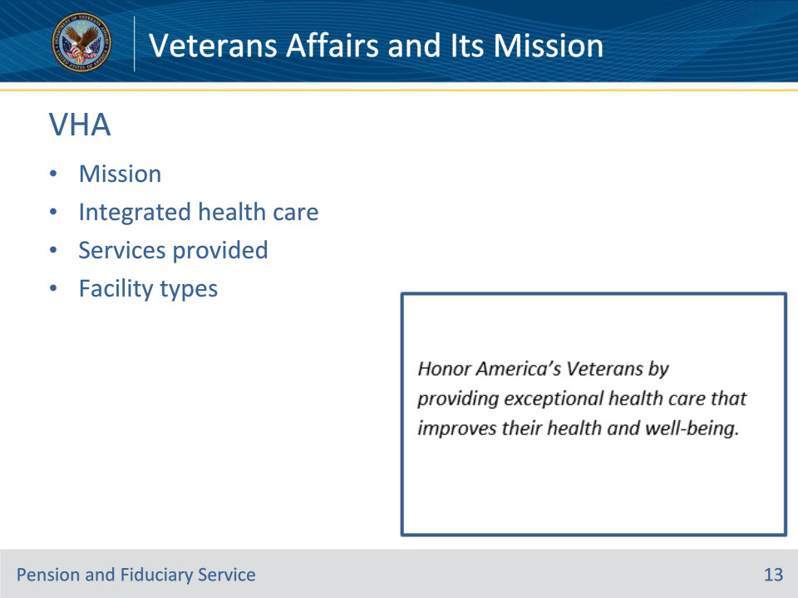
Slide notes

Policy Reference(s): www.va.gov

Instructor Notes:

VHA Mission:

Honor America’s Veterans by providing exceptional health care that improves their health and well-being.

Integrated Health Care:

The Veterans Health Administration (VHA) is the largest integrated health care system in the United States, providing care at over a thousand health care facilities, including VA Medical Centers and outpatient sites of care of varying complexity (VHA outpatient clinics) to millions of Veterans enrolled in the VA health care program.

Services provided:

Dental Care

Mental Health Care

Long Term Care and Programs

Pharmacies

Chaplain Support

Caregiver Support and Housing

Women’s Health Care

Geriatrics and Palliative Care

Preventive, Primary and Specialty Care

Substance Abuse and Weight Management Programs

Integrative Health

Facility types:

• Medical centers – inpatient, outpatient, emergency options

• Community-Based Outpatient Clinic (CBOC) - These clinics provide the most common outpatient services, including health and wellness visits, without the hassle of visiting a larger medical center. VHA continues to expand the network of CBOCs to include more rural locations, putting access to care closer to home.

• Community Living Center (CLC) - Community Living Centers (CLC) are skilled nursing facilities, often referred to as nursing homes. Veterans with chronic stable conditions such as dementia, those requiring rehabilitation or those who need comfort and care at the end of life are served within one of our Community Living Centers

• Domiciliary - provide a variety of care to Veterans who suffer from a wide range of medical, psychiatric, vocational, educational, or social problems and illnesses in a safe, secure homelike environment.

• Vet Center - provide readjustment counseling and outreach services to all Veterans who served in any combat zone. Services are also available for family members dealing with military related issues.

Slide 14 - NCA
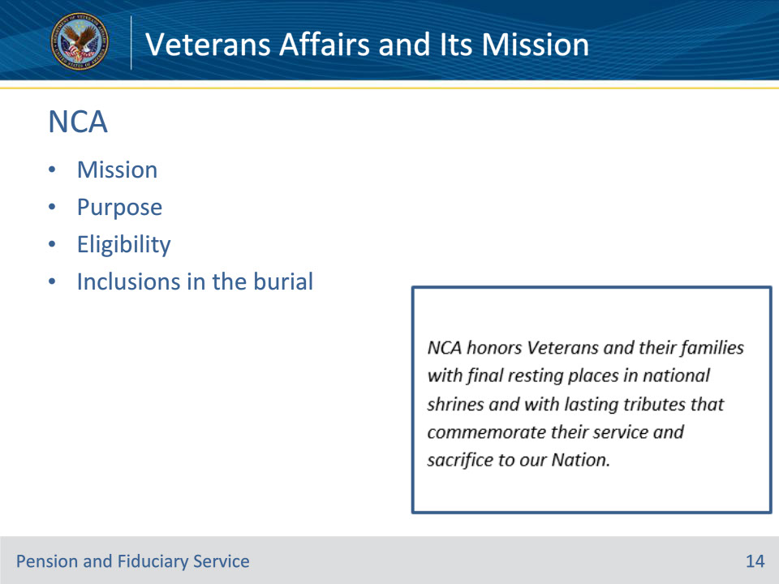
Slide notes

Policy Reference(s): www.va.gov

Instructor Notes:

NCA Mission:

NCA honors Veterans and their families with final resting places in national shrines and with lasting tributes that commemorate their service and sacrifice to our Nation.

NCA Purpose:

• To provide burial space for Veterans and their eligible family members.

• To maintain national cemeteries as national shrines, sacred to the honor and memory of those interred or memorialized there.

• To mark Veterans’ graves with a Government-furnished headstone, marker or medallion and to provide Presidential Memorial Certificates in recognition of their service to a grateful nation.

• To administer grants for establishing or expanding state and tribal government veterans cemeteries.

Eligibility: Burial in a VA national cemetery is open to all members of the armed forces and Veterans who have met minimum active duty service requirements, as applicable, and were discharged under conditions other than dishonorable.

Members of the reserve components of the armed forces who die while on active duty or who die while on training duty under certain circumstances are also eligible for burial, as are service members and former service members who were eligible for retired pay at the time of their death.

A Veteran’s spouse, widow or widower, minor children, and, under certain conditions, unmarried adult children with disabilities, may also be eligible for burial. Eligible spouses and children may be buried even if they predecease the Veteran.

Inclusions in the burial:

• Gravesite

• Grave liner

• Open/close of grave

• Government headstone or marker

• Presidential Memorial Certificate

• Perpetual care of the gravesite at no cost to the family

Facts

• National Cemeteries and soldiers’ lots and monument sites

• Located in most states and Puerto Rico

• Millions of Americans, including Veterans from every war and conflict are buried in VA’s national cemeteries

• VA also provides funding to establish, expand, improve and maintain Veteran cemeteries in most states and territories

• For Veterans not buried in in a VA national cemetery, VA provides headstones, markers or medallions to commemorate their service.

Slide 15 - Questions?
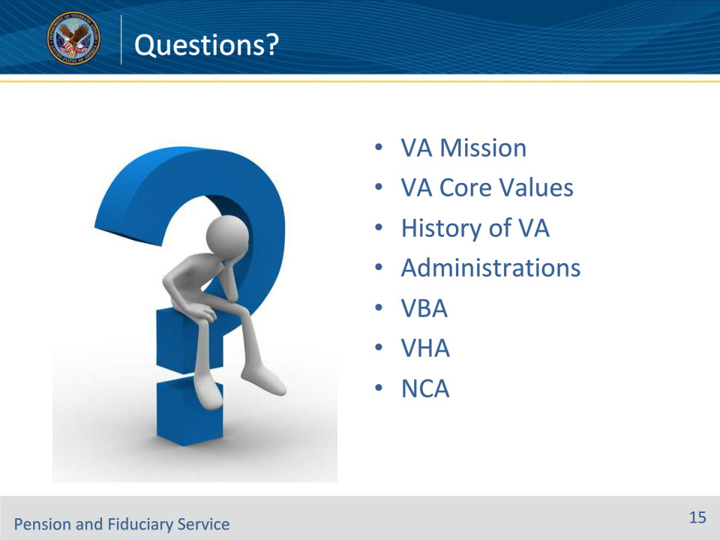
Slide notes

Instructor Notes:

(Recall) These are our learning objectives as stated in the beginning of the training:

• State the mission and core values of the Department of Veterans Affairs

• Recall the history, laws and regulations pertaining to the development of VA and its administrations

• Identify the three VA administrations and their purpose in assisting Veterans.

Are there any additional questions?

Questions should be filtered through your QRT team. They will submit your questions to the Field Inquiry Tool (FIT) on your behalf.

Slide 16 - TMS Survey/Assessment
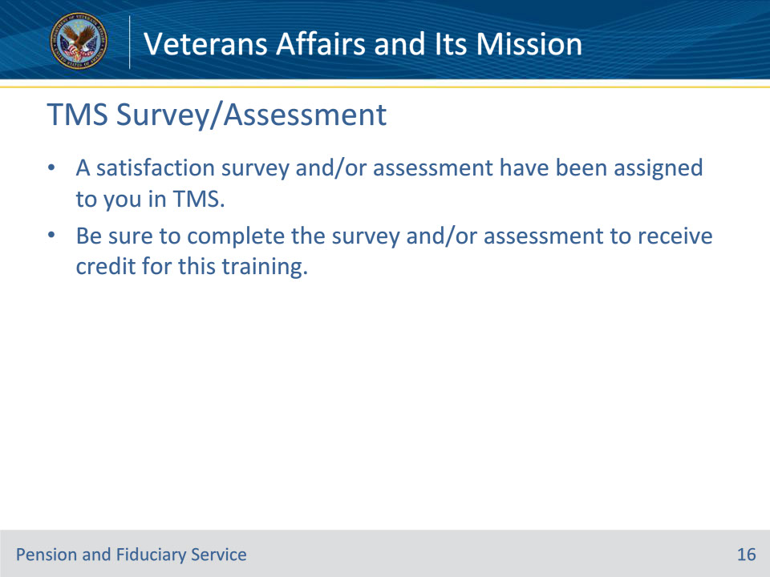
Slide notes

Instructor Notes:

A satisfaction survey and/or assessment have been assigned to you in TMS.

Be sure to complete the survey and/or assessment to receive credit for this training.

