Slide 1 - VA Benefits Overview
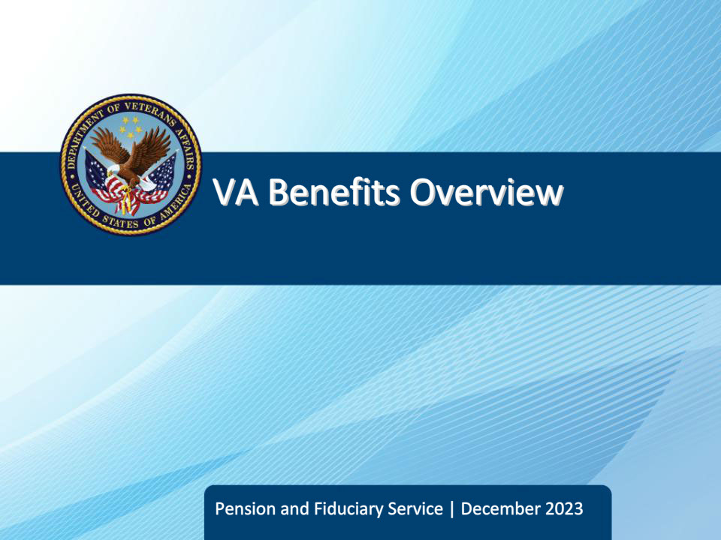
Slide notes

Course Description:

This course provides the learner with an overview of the various benefits and services available to Veterans, their dependents, and survivors through the Veterans Benefits Administration and the Veterans Health Administration, and the basic eligibility and application requirements for each. This includes but is not limited to Service-Connected Compensation, Non-Service Connected Pension, Vocational Rehabilitation & Employment, Education & Training, Home Loans, Life Insurance, and health care benefits, burial benefits, and Dependency and Indemnity Compensation.

Slide 2 - Objectives
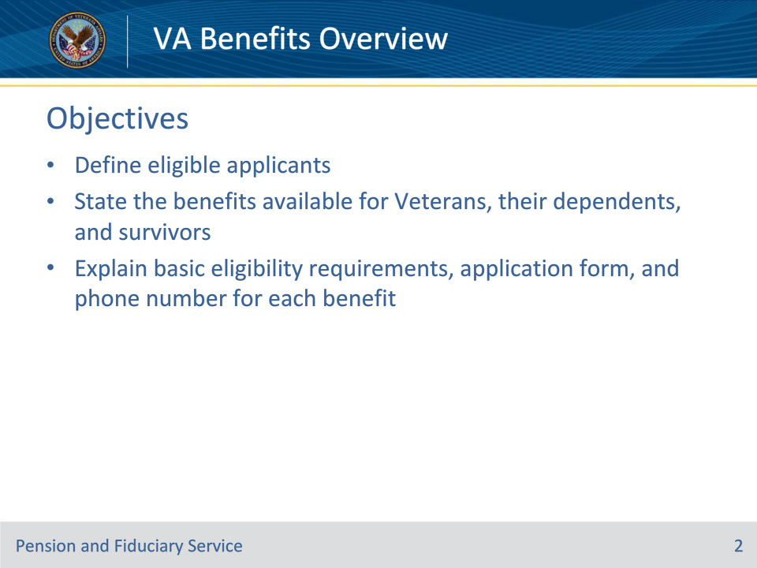
Slide notes

Instructor Notes:

At the end of this lesson, given the training and references, the learner will be able to do the following:

• Define the different types of eligible applicants

• State the different benefit programs available for Veterans, their dependents, and survivors

• Explain basic eligibility requirements, application form, and phone number for each benefit

Slide 3 - References
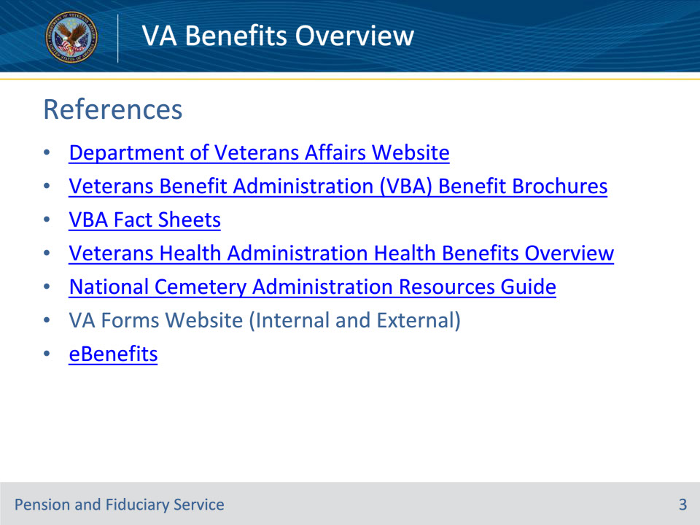
Slide notes

Instructor Notes:

The following are relevant references for VA Benefits Overview:

• Department of Veterans Affairs Website

• Website: www.va.gov

• Veterans Beneficiary Administration (VBA) Benefit Brochures

• Website: https://benefits.va.gov/BENEFITS/Benefits_Summary_Materials.asp

• VBA Benefit Fact Sheets

• Website: https://benefits.va.gov/BENEFITS/factsheets.asp

• Veterans Health Administration Health Benefits Overview

• Website: https://www.va.gov/healthbenefits/resources/epublications.asp

• National Cemetery Administration Resources Guide

• Website: https://www.cem.va.gov/resources.asp

• VA Forms (Internal) available to VA employees:

• Website: http://vaww.va.gov/vaforms/

• VA Forms (External) available to Veterans:

• Websitehttp://www.va.gov/vaforms/

• eBenefits

• Website: https://www.ebenefits.va.gov/ebenefits/homepage

Slide 4 - Eligibility
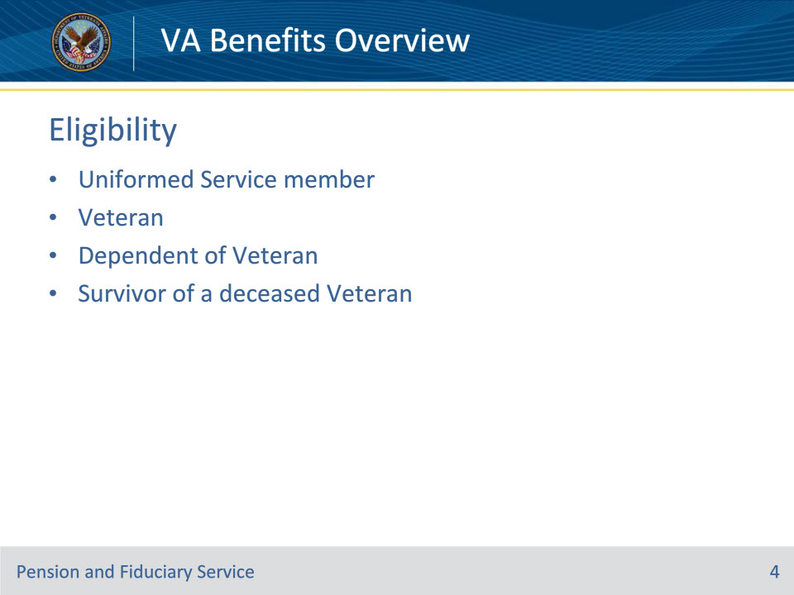
Slide notes

Policy Reference(s): N/A

Instructor Notes:

The following people may be eligible for VA benefits:

Uniformed Servicemember

• Active-duty military service member

• Active member of the Reserve or National Guard

Veteran

• Individual that has separated from active duty, the Reserves, or the National Guard

• Individual that retired from active duty, the Reserves, or the National Guard

Dependent of Veteran

• Spouse

• Dependent parent(s)

• Children

• Unmarried children under 18

• Unmarried children between 18-23 who are attending an approved school

• Unmarried children who are permanently incapable of self-support before age 18 as dependents

Survivor of a Deceased Veteran

• Spouse

• Dependent parent(s)

• Children

• Unmarried under 18

• Unmarried between 18-23 who are attending an approved school

• Unmarried who are permanently incapable of self-support before age 18 as dependents

Slide 5 - Benefit Programs
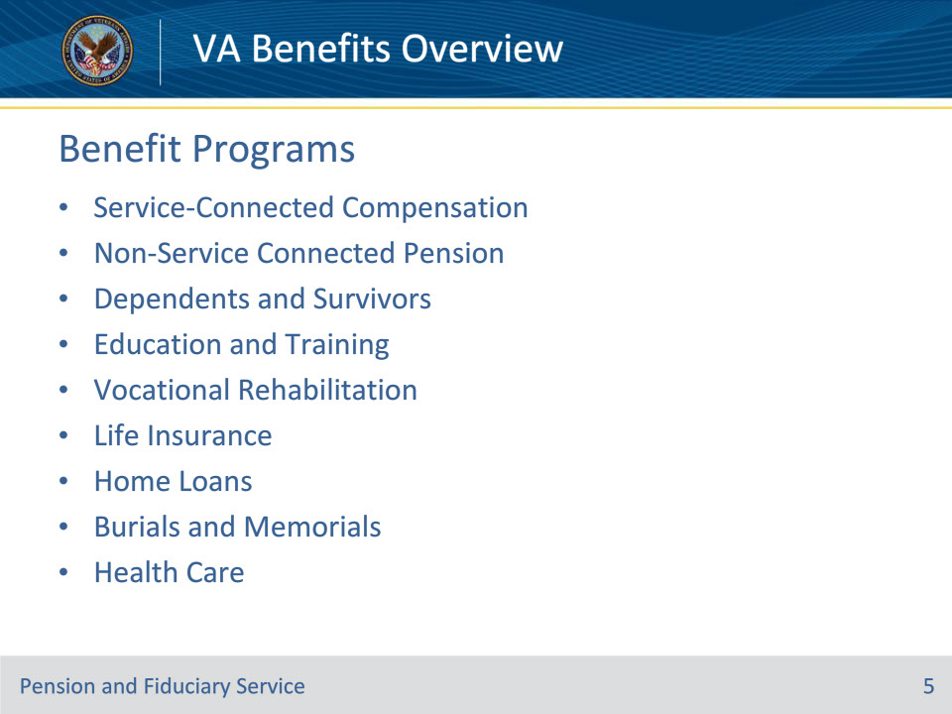
Slide notes

Policy Reference(s): N/A

Instructor Notes:

Benefits Available

• VA has many different benefit programs that uniformed Servicemembers; Veterans; or spouse, children or parents of decease or disabled Servicemembers or Veterans maybe eligible for. The following or the different categories of VA Benefits:

• Service-Connected Compensation

• Non-Service-Connected Pension

• Dependents and Survivors

• Education and Training

• Vocational Rehabilitation & Employment

• Life Insurance

• Home Loans

• Burials and Memorials

• Health Care

• We will review each of these benefits in-depth during this lesson.

Slide 6 - Service-Connected Compensation
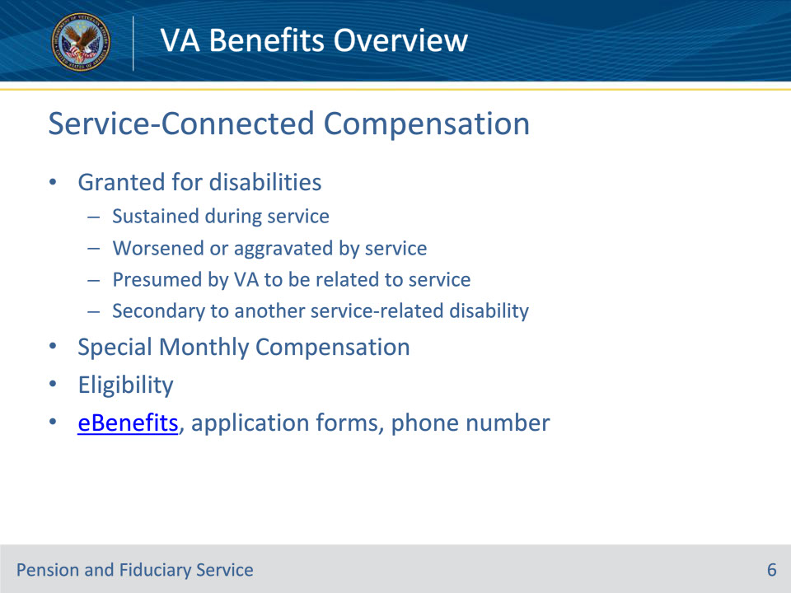
Slide notes

Policy Reference(s): N/A

Instructor Notes:

Service-Connected Compensation

• Service-Connected Compensation is a tax free monetary benefit paid to Veterans with disabilities that are the result of a disease or injury incurred or aggravated during active military service. Compensation may also be paid for post-service disabilities that are considered related or secondary to disabilities occurring in service and for disabilities presumed to be related to circumstances of military service, even though they may arise after service. Generally, the degrees of disability specified are also designed to compensate for considerable loss of working time from exacerbations or illnesses

• Service-Connected Compensation can also be granted for injuries caused at a Department of Veterans Affairs Healthcare Facility

• Commonly called an 1151 claim

• Service-Connected Compensation is a tax free benefit which the entitlement amount is determined by an evaluation of medical records and sometimes, a physical examination. The evaluations range between 0% - 100% service-connected; however, monetary benefits begin at 10% service-connected.

• Veteran’s rated at 0% service-connected are entitled to medical care and treatment for the service-connected condition through the VA health care system.

• Additional payment maybe authorized for severe disabilities or loss of limb(s), a spouse, child(ren), or dependent parents(s), and Veterans who have a seriously disabled spouse.

• Claims processed at one of the 56 Regional Offices

Special Monthly Compensation

• Service-Connected Compensation recipients may be eligible for this additional tax-free benefit due to the special circumstances of his/her disability, if he/she is housebound, or requires help performing daily living functions

• May apply for Special Monthly Compensation after grant of Service-Connected Compensation or at the same time as applying for Service-Connected Compensation

Eligibility

• Service-Connected Compensation benefits require that the disability be service-connected

• The applicant must also have separated or been discharged from service under other than dishonorable conditions

Application

• Veterans are encouraged to apply for Service-Connected-Compensation or Special Monthly Compensation electronically through eBenefits

• Website: https://www.ebenefits.va.gov/ebenefits/homepage

• Veterans may apply for Service-Connected-Compensation by completing a VA Form 21-526EZ, Application for Disability Compensation and Related Compensation Benefits

• Veterans may apply for Special Monthly Compensation by completing a VA Form 21-2680, Examination for Housebound Status or Permanent Need For Regular Aid and Attendance

• Applicants may call 1-800-827-1000 to seek assistance with the application process, or obtain claim processing status

Slide 7 - Non-Service Connected Pension
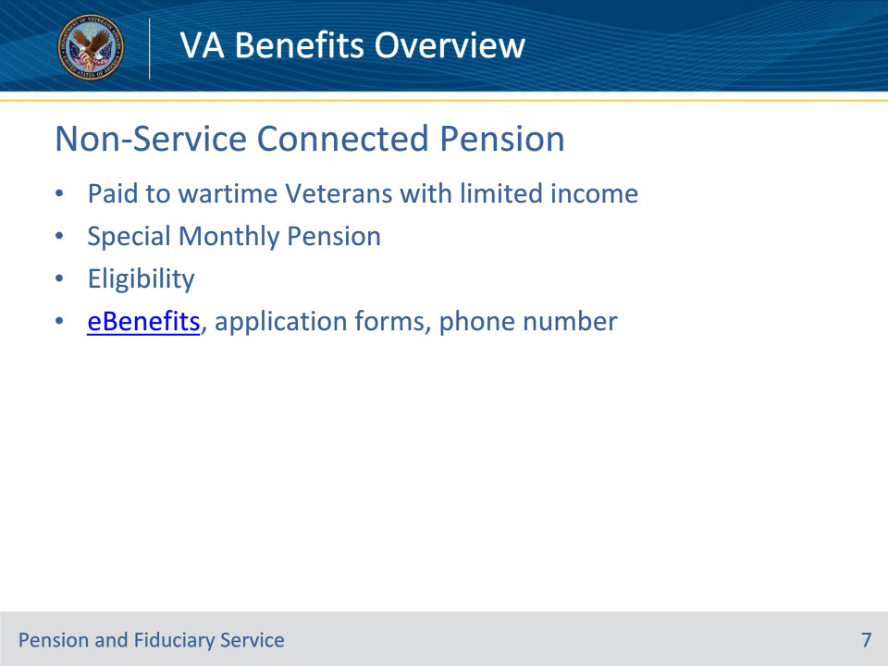
Slide notes

Policy Reference(s): N/A

Instructor Notes:

Non-Service-Connected Pension

• The Department of Veterans Affairs helps Veterans and their families cope with financial challenges by providing supplemental income through the Veterans Non-Service-Connected Pension benefit.

• Non-Service-Connected Pension is an income and assets based program, payable to low-income wartime Veterans who are aged 65 or older or who are permanently and totally disabled due to a non-service-connected cause.

• Veterans Non-Service Connected Pension is a tax-free monetary benefit.

• Claims processed by one of the three Pension Management Centers (PMC)

Special Monthly Pension (Housebound or Aid and Attendance)

• Veterans who are eligible for Non-Service-Connected Pension benefits and are housebound or require the aid and attendance of another person may be eligible to receive additional monetary amounts, called Special Monthly Pension.

• May apply for Special Monthly Pension after grant of Non-Service-Connected Pension or at the same time as applying for Non-Service-Connected Pension

• NOTE: Special Monthly Pension may be granted as Housebound or as Aid and Attendance, but not both.

Eligibility

• A Veteran may be eligible for Non-Service-Connected Pension if:

• discharged from service under other than dishonorable conditions, AND

• served 90 days or more of active duty with at least 1 day during a period of war time*,AND

• countable income is below the maximum annual pension rate (MAPR), AND

• meets the net worth limitations, AND

• age 65 or older, OR, permanent and total non-service connected disability, OR, patient in a nursing home, OR receiving Social Security disability insurance, OR Supplemental Security Income.

*Veterans who entered active duty after September 7, 1980, must also serve at least 24 months of active duty service. If the total length of service is less than 24 months, the Veteran must have completed their entire tour of active duty.

Application

• Veterans are encouraged to apply for Service-Connected-Compensation or Special Monthly Compensation electronically through eBenefits

• Website: https://www.ebenefits.va.gov/ebenefits/homepage

• Veterans may apply for Non-Service Connected Pension by completing a VA Form 21-527EZ, Application for Veterans Pension, (or on a VA Form 21-526EZ, Application for Disability Compensation and Related Compensation Benefits if applying for Compensation and Pension.)

• Veterans may apply for Special Monthly Pension (Housebound or Aid and Attendance) by completing a VA Form 21-2680, Examination for Housebound Status or Permanent Need For Regular Aid and Attendance

• Applicants may call 1-877-294-6380 to seek assistance with the application process, or obtain claim processing status

Slide 8 - Dependents and Survivors
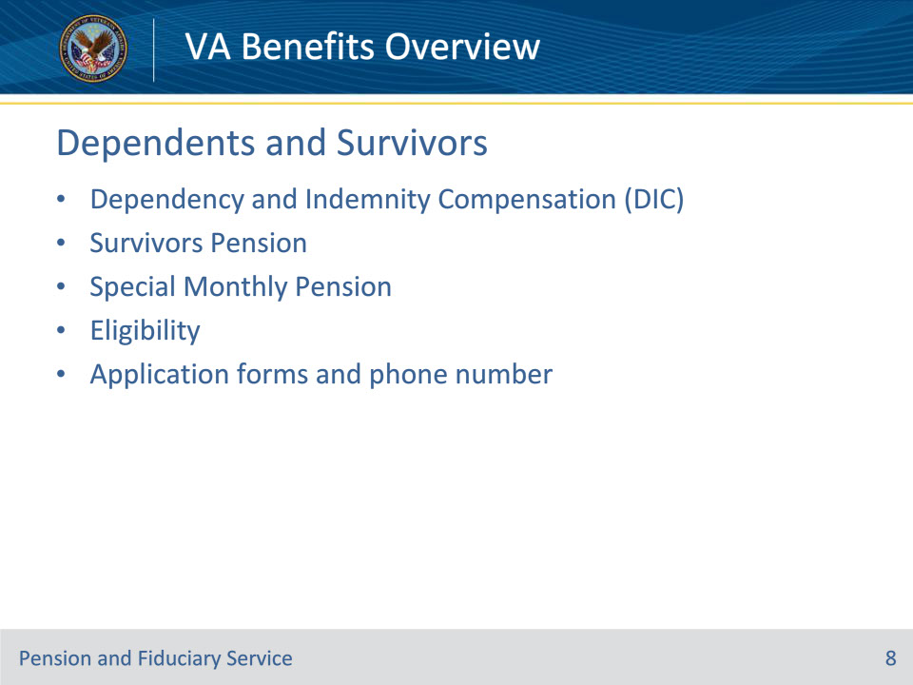
Slide notes

Policy Reference(s): N/A

Instructor Notes:

The Department of Veterans Affairs honors the sacrifices of Servicemembers’ and Veterans’ dependents and survivors through the following benefit programs:

Dependency and Indemnity Compensation (DIC)

• Dependency and Indemnity Compensation (DIC) is a monthly benefit paid to a surviving spouse, including additional payments for dependent children. It is available to an eligible spouse of a Servicemember who died during active military service or from a service-connected disability, or of a Veteran who was rated totally disabled at the time of death.

• Parents’ DIC is an income-based monthly tax-free benefit, and may be available if his/her child was a Servicemember or Veteran who died from a service-related cause and he/she was financially dependent on the deceased child.

• Parents DIC is paid to surviving parents based on financial need.

• DIC may be paid to dependent children if not included in the surviving parent’s DIC benefit

Survivors Pension

• Survivors Pension is a tax-free monetary benefit payable to a low-income, un-remarried surviving spouse and/or unmarried child(ren) of a deceased Veteran with wartime service.

Eligibility

• DIC

• A surviving spouse, dependent child, or parent of a Veteran may be eligible for DIC if:

• Servicemember died while on active duty or training, OR

• Veteran who died as a result of a service-related disability, OR

• Veteran who was receiving or entitled to receive VA compensation for a service-connected disability that was rated as totally disabling:

• for at least 10 years immediately preceding death, OR

• since the Veteran’s release from active duty and for at least five years immediately preceding death, OR

• for at least one year immediately preceding death if the Veteran was a former prisoner of war (POW)

• Children applying for DIC must not be:

• married and are younger than 18 or between ages 18 and 23, if attending school

• NOTE: Certain adult children who become seriously disabled prior to age 18 may also be entitled to DlC.

• Survivors Pension

• Survivors may be eligible if he/she is the surviving spouse or dependent child of a Veteran who:

• Received a discharge from service under conditions other than dishonorable, AND

• Served at least 90 days of active military service with at least one day during a wartime period (the 90-day active service requirement does not apply to Veterans with a service-connected disability justifying discharge from the military), OR

• Served at least 24 months, or the full period for which the Veteran was called or ordered to active duty (with some exceptions), with at least one day during a wartime period if the Veteran entered active duty after September 7, 1980

• Surviving spouses may be eligible for Survivors Pension if they continuously lived with the Veteran from the date of marriage until the Veteran’s death and have not remarried, with certain exceptions.

• Dependent children may be eligible for Survivors Pension if they are:

• permanently incapable of self-support due to a disability incurred before age 18,

• not married, and

• are younger than 18 or between ages 18 and 23, if attending school.

Application

• Survivors may apply for DIC and Survivors Pension by completing a VA Form 21-534EZ, Application for DIC, Death Pension, and/or Accrued Benefits

• Survivors may apply for Special Monthly Pension (Housebound or Aid and Attendance) by completing a VA Form 21-2680, Examination for Housebound Status or Permanent Need For Regular Aid and Attendance

• Survivors approved for DIC may apply for CHAMPVA by completing VA Form 10-10d, Application for CHAMPVA Benefits, and VA Form 10-7959c, Other Health Insurance (OHI) Certification.

• Applicants may call 1-877-294-6380 to seek assistance with the application process, or obtain claim processing status

Slide 9 - Education and Training
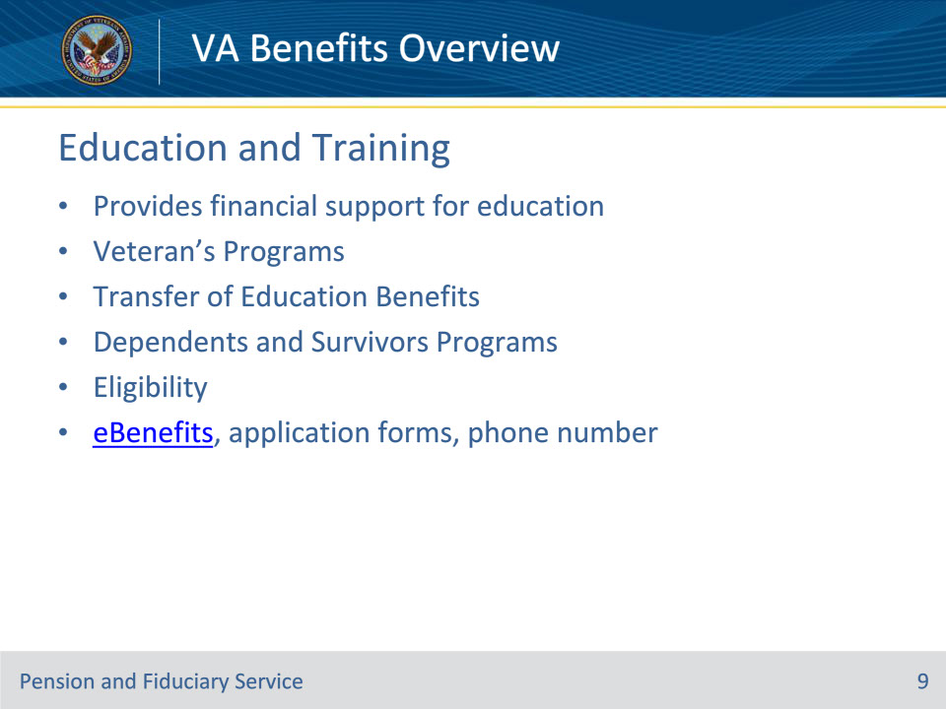
Slide notes

Policy Reference(s): N/A

Instructor Notes:

The Department of Veterans Affairs (VA) pays benefits to eligible Servicemembers and Veterans pursuing an approved education or training program. Servicemembers, Veterans and certain dependents and survivors may receive financial support for undergraduate and graduate degrees, vocational and technical training, licensing and certification tests, apprenticeships, on-the-job training, and more.

Eligible to receive funds for:

• School tuition and fees for public, private, or foreign schools; flight programs; correspondence training; and distance learning

• Books and supplies

• License or certification tests

• National exams, including SATs, ACTs, GMATs, and LSATs

• On-the-job and apprenticeship training

• Vocational/technical training

• Relocating from highly rural areas

• A monthly housing allowance

Veteran’s Programs

Post-9/11 GI Bill (Chapter 33)

• The Post 9/11 GI Bill covers the full tuition and fees directly to the school for all public school in-state students.

• For those attending private or foreign schools tuition and fees are capped at the national maximum rate.

• For more expensive institutions, students may be eligible to apply for the Yellow Ribbon Program, which allows institutions of higher learning (degree-granting institutions) in the United States to enter voluntarily into an agreement with VA to fund tuition and fee expenses that exceed VA’s maximum amount payable. The institution can contribute a specified dollar amount of those expenses and VA will match the same amount as the institution not to exceed 50% of the difference.

• The Post 9/11 GI Bill provides a monthly housing allowance (MAH); generally the same as the military Basic Allowance for Housing (BAH) for an E-5 with dependents. MHA is based on the ZIP code of the school.

• The Post 9/11 GI Bill provides an annual books and supplies stipend – paid to the student - up to $1,000, paid proportionately based on enrollment

Forever GI Bill

• The Harry W. Colmery Veterans Educational Assistance Act of 2017, commonly known as the “Forever GI Bill”, removes the time-limit for using the Post-9/11 GI Bill for certain Veterans and dependents.

Montgomery GI Bill-Active Duty (MGIB) (Chapter 30)

• The Montgomery GI Bill-Active Duty provides up to 36 months of education benefits

• The monthly benefit paid to the student is based on the type of training he/she takes length of service, and if DoD put extra money in your MGIB Fund (called “kickers”). Typically, he/she have ten years to use your MGIB benefits.

NOTE: Students eligible for Post 9/11 and MGIB must elect which education benefit he/she will take when applying for benefits.

Transfer of Education Benefits

• The transferability option under the Post-9/11 GI Bill allows Servicemembers to transfer all or some unused benefits to their spouse or dependent children.

• The request to transfer unused GI Bill benefits to eligible dependents must be completed while serving as an active member of the Armed Forces. The Department of Defense (DoD) determines whether or not the Servicemember can transfer benefits to his/her family; this option is typically used as a retention tool. If the DoD approves transfer, the Servicemember is obligated to serve for an additional period of time.

• NOTE: Effective 7/20/19, eligibility to transfer benefits will be limited to Servicemembers with less than 16 years of active duty or selected reserve service.

• Once the DoD approves benefits for transfer, the new beneficiaries apply for them at VA.

Dependents and Survivors Programs

Dependents’ Educational Assistance Program (DEA)

• The surviving spouse and child(ren) who are eligible for DIC are also eligible for the Survivors’ and Dependents’ Educational Assistance Program (DEA) (Chapter 35) which provides assistance to obtain a degree and pursue other eligible education and training.

Fry Scholarship

• The surviving spouse and child(ren) of servicemembers who died in the line duty between September 11, 2001 and December 31, 2005 are eligible for the Fry Scholarship which provides full tuition & fees paid to the school, a monthly housing allowance, and a books & supplies stipend.

• If a child is eligible for the Fry Scholarship, and he/she is eligible for DEA, the benefits cannot be used at the same time, but a child may be eligible for up to 48 months of benefits between the two programs.

• Surviving spouses must make an irrevocable election of which benefit he/she wishes to receive. An election to receive DEA will forfeit the individual’s right to receive Fry Scholarship in the future and vice versa.

Eligibility

• Applying for education and training benefits is the best way to determine eligibility.

Application

• Veterans are encouraged to apply for education and training benefits electronically through eBenefits

• Website: https://www.ebenefits.va.gov/ebenefits/homepage

• Veterans may apply for Education and Training benefits by completing VA Form 22-1990, Application for VA Education Benefits, or by consulting with the VA Certifying Official; the VA Certifying Official is usually in the Registrar’s or Financial Aid office at the school of choice

• Survivors approved for DIC may apply for DEA (Chapter 35) by completing VA Form 22-5490, Dependents’ Application for VA Education Benefits

Slide 10 - Veteran Readiness & Employment
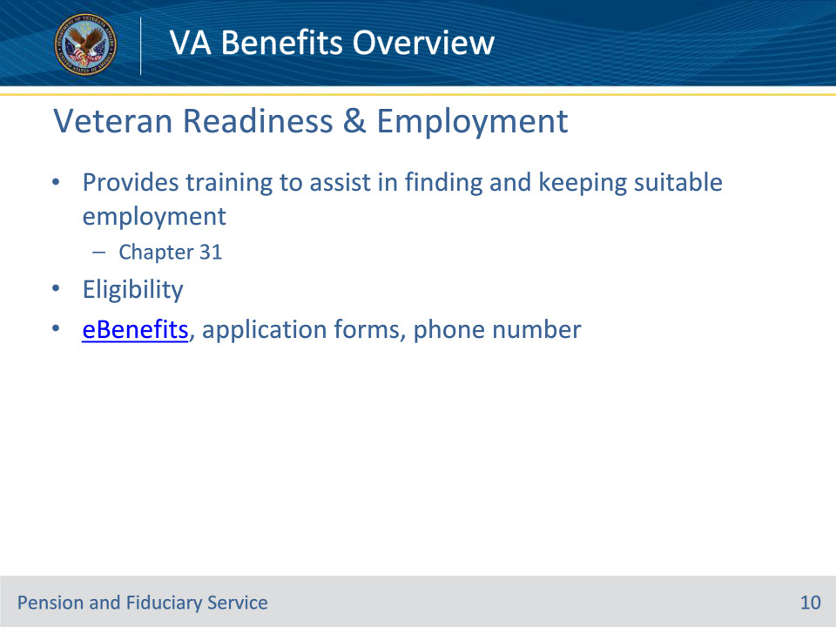
Slide notes

Policy Reference(s): N/A

Instructor Notes:

The Department of Veterans Affairs (VA) Veteran Readiness & Employment Service (formerly known as Vocational Rehabilitation and Employment) (VR&E) assists Veterans with service-connected disabilities and an employment handicap and Servicemembers who are in the process of transitioning from military to civilian employment prepare for, find, and keep suitable employment. For Veterans and Servicemembers with service-connected disabilities so severe that they cannot immediately consider work, VR&E offers services to improve their ability to live as independently as possible.

VR&E Services (Chapter 31)

• Depending on an individual’s needs, VA may provide the following VR&E services:

• an evaluation of the individual’s abilities, skills, and interests

• assistance in finding and maintaining suitable employment

• vocational counseling and planning

• training, such as

• on-the-job and work experience programs, and

• certificate, two- or four-year college, or technical programs

• supportive rehabilitation services and additional counseling, and

• a program of services to assist in achieving independence in daily living.

• Veterans with service-connected disabilities may apply for VR&E benefits at any time.

• Generally, Veterans must complete a VR&E program within 12 years from the date

• they separate from military service, or

• VA notifies them that they have a compensable service-connected disability

• VR&E benefits may be available in addition to Education and Training benefits!

Eligibility

• Servicemembers and Veterans are eligible for VR&E services under the following circumstances:

• Obtained a service-connected disability rating from VA of at least 10%, or a pre-discharge disability rating (“memorandum rating”) of 20% or more from VA, AND

• Received, or will receive, a discharge from service that is other than dishonorable, OR

• May qualify without a VA rating if he/she is severely ill or injured and have been referred to a military Physical Evaluation Board or are participating in the DoD/VA Integrated Disability Evaluation System (IDES) process

Application

• Veterans and Servicemembers are encouraged to apply for VR&E benefits electronically through eBenefits

• Website: Website: https://www.ebenefits.va.gov/ebenefits/homepage

• Veterans and Servicemembers may apply for VR&E benefits by completing VA Form 28-1900, Disabled Veterans Application for Vocational Rehabilitation

• Applicants may call 202-461-9600 to seek assistance with the application process or obtain claims processing status

Slide 11 - Life Insurance
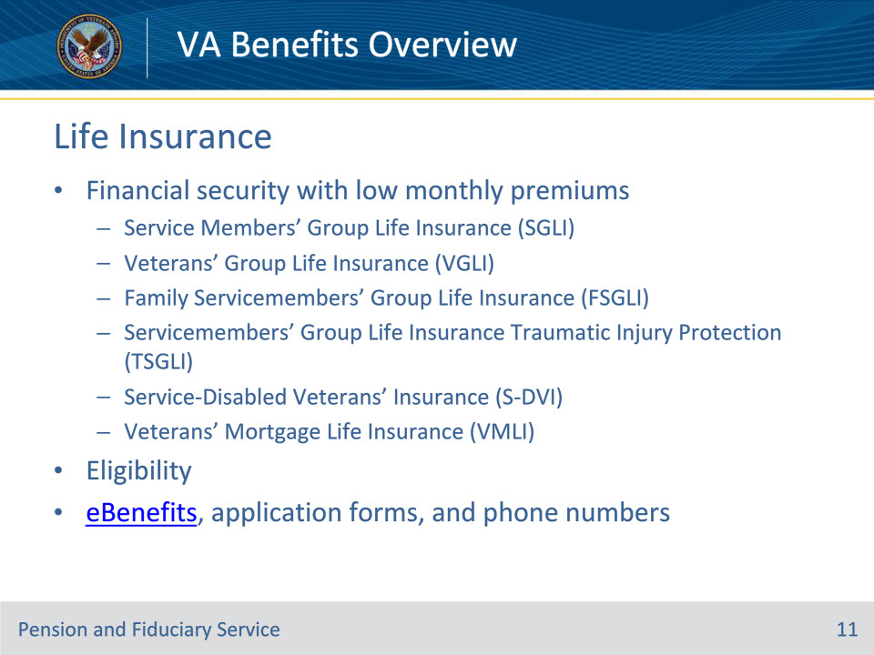
Slide notes

Policy Reference(s): N/A

Instructor Notes:

The Department of Veterans Affairs (VA) provides valuable insurance benefits to Servicemembers and Veterans to provide peace of mind knowing that his/her family is protected.

Servicemembers’ Group Life Insurance (SGLI)

• SGLI is a low-cost group term life insurance program for Servicemembers.

• Servicemembers are automatically issued maximum SGLI coverage upon entry to active duty.

• He/she must indicate in writing if they wish to decline coverage, select a lesser amount, or designate beneficiaries.

• Servicemembers who are totally disabled at separation may extend coverage for up to two years .

• Servicemembers unable to work due to total disability at the time of separation, can apply for the SGLI Disability Extension, which provides free coverage for up to two years. At the end of the extension period, he/she automatically qualify for Veterans’ Group Life Insurance as long as you pay the premiums.

Veterans’ Group Life Insurance (VGLI)

• VGLI allows Veterans to convert their SGLI to a civilian program of renewable term coverage after separation from service.

• Converting SGLI to VGLI is time sensitive!

• Veterans who were separated from military service on or after November 1, 2012, may apply to convert SGLI to VGLI within one year and 240 days from separation.

• Evidence of good health is not required for those who apply within 240 days of separation.

• All applications for VGLI must include the first month’s premium.

Family Servicemembers’ Group Life Insurance (FSGLI)

• FSGLI insures spouses and children of Servicemembers with SGLI coverage.

• Spousal coverage may not exceed the Servicemember’s SGLI coverage.

• Dependent children are automatically covered at no charge

• Family coverage is not available to individuals insured under the VGLI program

Servicemembers’ Group Life Insurance Traumatic Injury Protection (TSGLI)

• TSGLI is an automatic feature of SGLI that provides payments to Servicemembers who suffer severe losses, such as amputations, blindness, and paraplegia, due to traumatic injuries that occur in service

• TSGLI coverage automatically ends when members are discharged from service or decline SGLI coverage

• Spouses and children covered under FSGLI are not covered by TSGLI

Service-Disabled Veterans’ Insurance (S-DVI)

• S-DVI provides life insurance coverage to Veterans whom VA has granted service connection for a new disability within the last two years.

• Totally disabled Veterans are eligible for free coverage and have the opportunity to purchase additional insurance

Veterans’ Mortgage Life Insurance (VMLI)

• VMLI provides mortgage life insurance protection to severely disabled Servicemembers and Veterans whom VA has granted Specially Adapted Housing (SAH)

• VMLI protection is issued automatically following SAH approval, provided applicant submits information required to establish a premium and does not decline coverage

• Coverage automatically terminates when the mortgage is paid off

• If applicant sells his/her house and pays off the mortgage, he/she can obtain VMLI on the mortgage of another home

Eligibility

SGLI

• Servicemembers are automatically insured under full-time SGLI if he/she is one of the following:

• An active duty member of the Army, Navy, Air Force, Marines, or Coast Guard

• A commissioned member of the National Oceanic and Atmospheric Administration (NOAA) or the U.S. Public Health Service (USPHS)

• A cadet or midshipman of the U.S. military academies

• A member, cadet, or midshipman of the Reserve Officers Training Corps (ROTC) engaged in authorized training or practice cruises

• A member of the Ready Reserve or National Guard scheduled to perform at least 12 periods of inactive training per year, or

• A Servicemember who volunteers for a mobilization category in the Individual Ready Reserve

VGLI

• Servicemembers qualify for VGLI if you are one of the following:

• Servicemember being released from active duty who was covered by SGLI, OR

• Servicemember separating, retiring, or being released from assignment in the Ready Reserve or National Guard who was covered by SGLI, OR

• National Guard or Reserve member covered by part-time SGLI who incurred a disability or aggravated a pre-existing disability while performing inactive duty or traveling to/from duty, OR

• Member of the Individual Ready Reserve or Inactive National Guard

FSGLI

• Spouses and dependent children of the following are eligible for FSGLI:

• Active duty Servicemembers covered by full-time SGLI, OR

• Members of the National Guard or Ready Reserve covered by full-time SGLI

TSGLI

• All members of the uniformed services who have SGLI are automatically covered by TSGLI

• If members suffered an injury between October 7, 2001, and November 30, 2005, that resulted in a qualifying loss, they are covered by TSGLI, regardless of whether they had SGLI coverage at the time of the injury

S-DVI

• To obtain S-DVI, Veterans’ meet the following criteria:

• VA granted service connection for any disability (even if evaluated at zero percent), AND

• Veteran applied within two years from the date VA notified him/her of a new service-connected disability, AND

• Veteran is in good health, except for any service-connected conditions

VMLI

• VMLI is only available to Servicemembers and Veterans with severe service-connected disabilities who:

• Received Specially Adapted Housing (SAH) to help build, remodel, or purchase a home, AND

• Have the title to the home, AND

• Have a mortgage on the home

• Veterans must apply for VMLI before their 70th birthday.

Application

• Servicemembers and Veterans are encouraged to apply for Insurance benefits electronically through eBenefits

• Website: https://www.ebenefits.va.gov/ebenefits/homepage

• Veterans may apply for VGLI by completing Form SGLV 8714, Application for Veterans’ Group Life Insurance

• Veterans may apply for FSGLI by completing Form SGLV 8286A, Request for Family Coverage for Spouse

• Servicemembers may apply for TSGLI by completing Form SGLV 8600, Application for TSGLI Benefits

• Veterans may apply for S-DVI by completing VA Form 29-4364, Application for Service-Disabled Veterans Insurance

• Veterans may apply for VMLI by completing VA Form VA Form 29-8636, Veterans Mortgage Life Insurance Statement

• Information regarding SGLI, TSGLI, FSGLI, or VGLI, can be obtained by calling the Office of Servicemembers’ Group Life Insurance at 1-800-419-1473.

• Information regarding S-DVI and VMLI, can be obtained by calling the VA Insurance Toll-Free Customer Service Center at 1-800-669-8477.

Slide 12 - Home Loans
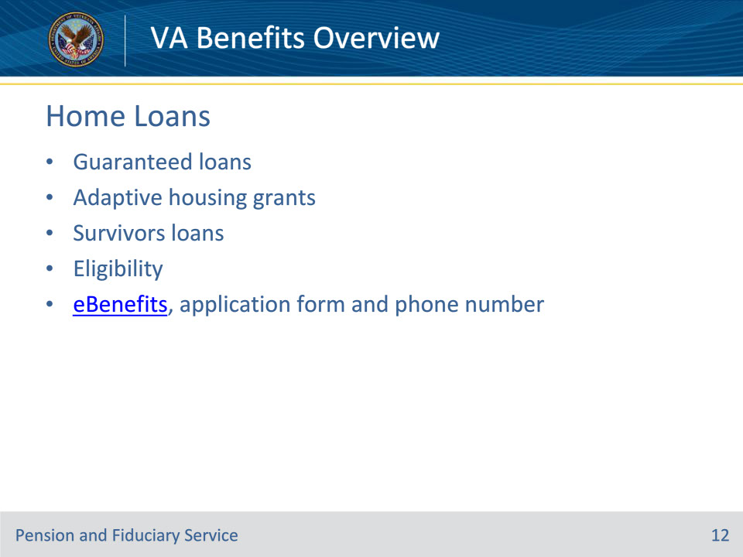
Slide notes

Policy Reference(s): N/A

Instructor Notes:

The Department of Veterans Affairs (VA) helps Servicemembers, Veterans, and eligible surviving spouses become homeowners. As part of VA’s mission to serve, VA provides a home loan guaranty benefit and other housing-related programs to help you buy, build, repair, retain, or adapt a home for your own personal occupancy.

Home Loan Guaranty

• A VA-guaranteed loan can be used to:

• buy a home, either existing or pre-construction, as a primary residence

• refinance an existing loan (whether it is a VA or non-VA mortgage)

• VA Home Loans are provided by private lenders, such as banks and mortgage companies. VA does not provide the loan but, VA guarantees a portion of the loan, enabling the lender to provide a Servicemember or Veteran with more favorable loan terms

• VA home loan benefits do not expire and may be used anytime.

• Benefits of a guaranteed loan:

• Equal opportunity for all qualified Veterans to obtain a VA loan

• Reusable

• No down payment (unless required by the lender or the purchase price is more than the reasonable value of the property)

• No mortgage insurance

• One time VA funding fee that can be included in the loan

• Veterans receiving VA disability compensation are exempt from the VA funding fee

• VA limits certain closing costs a Veteran can pay

• Can be assumed by qualified persons

• Minimum property requirements to ensure the property is safe, sanitary, and sound

• VA staff dedicated to assisting Veterans who become delinquent

Adaptive Housing Grants

• Servicemembers or Veterans with certain permanent and total service-connected physical disabilities may be entitled to grant funds, which can help enable or maintain his/her independence.

• Three different grant types can be used to purchase or construct an adaptive home, or to modify an existing home to meet the Servicemember or Veteran’s needs:

1. Specially Adapted Housing (SAH) Grant

• SAH grants help Veterans with certain service-connected disabilities live independently in a barrier-free environment

• This grant is limited to 30 recipients per fiscal year

1. Special Housing Adaptation (SHA) Grant

• SHA grants help Veterans with certain service-connected disabilities adapt or purchase a home to accommodate the disability

1. Temporary Residence Adaptation (TRA) Grant

• A temporary grant may be available to SAH/SHA eligible Veterans and Servicemembers who are or will be temporarily residing in a home owned by a family member

Surviving Spouse

• Certain surviving spouses may be eligible for a guaranteed loan to be used to help purchase, construct, or improve a home.

• If he/she obtained a VA home loan with his/her spouse prior to the spouse’s death, he/she may be eligible to obtain a lower interest rate by refinancing your existing VA loan.

Eligibility

• Home Loan Guaranty

• To be eligible for a VA-guaranteed loan, you must meet credit and income standards and have a valid Certificate of Eligibility (COE).

• The home must be for your own personal occupancy.

• Adaptive Housing Grants

• Veterans may be eligible for the Specially Adapted Housing (SAH) Grant if he/she has:

• Loss of or loss of use of both legs, OR

• Loss of or loss of use of both arms, OR

• Blindness in both eyes having only light perception, plus loss of or loss of use of one leg, OR

• The loss of or loss of use of one lower leg together with residuals of organic disease or injury, OR

• The loss of or loss of use of one leg together with the loss of or loss of use of one arm, OR

• Certain severe burns, OR

• The loss, or loss of use of one or more lower extremities due to service on or after September 11, 2001, which so affects the functions of balance or propulsion as to preclude ambulating without the aid of braces, crutches, canes, or a wheelchair

• A permanent living situation

• Home is owned by an eligible individual

• Veterans may be eligible for the Special Housing Adaptation (SHA) Grant if he/she has:

• Blindness in both eyes with 20/200 visual acuity or less, OR

• Loss of or loss of use of both hands, OR

• Certain severe burn injuries, OR

• Certain severe respiratory injuries

• A permanent living situation

• Home is owned by an eligible individual or family member

• Veterans may be eligible for the Temporary Residence Adaptation (TRA) Grant if he/she is:

• Eligible for SAH or SHA

• Temporarily residing in a home owned by a family member.

1. Surviving Spouse

• A surviving spouse may be eligible for a VA home loan if you have a good credit score and sufficient income, and if he/she is:

1. An unmarried surviving spouse of a Veteran who died of a service-connected disability, OR

2. A surviving spouse of a Servicemember or a Veteran who died during active duty or of a service-connected disability, who remarried on or after December 16, 2003 at age 57 or older, OR

3. A spouse of a Servicemember officially listed as either missing in action (MIA) or a prisoner of war (POW) for at least 90 days

Application

• Veterans and surviving spouse’s are encouraged to obtain a COE electronically through eBenefits, but the lender also has the ability to request the COE on the Veteran’s behalf.

• Veterans may apply for a housing grant by completing VA Form 26-4555, Application in Acquiring Specially Adapted Housing or Special Home Adaptation Grant

• Applicants may call 1-888-827-3702 to seek assistance with the application process, or obtain claim processing status

Slide 13 - Burials and Memorials
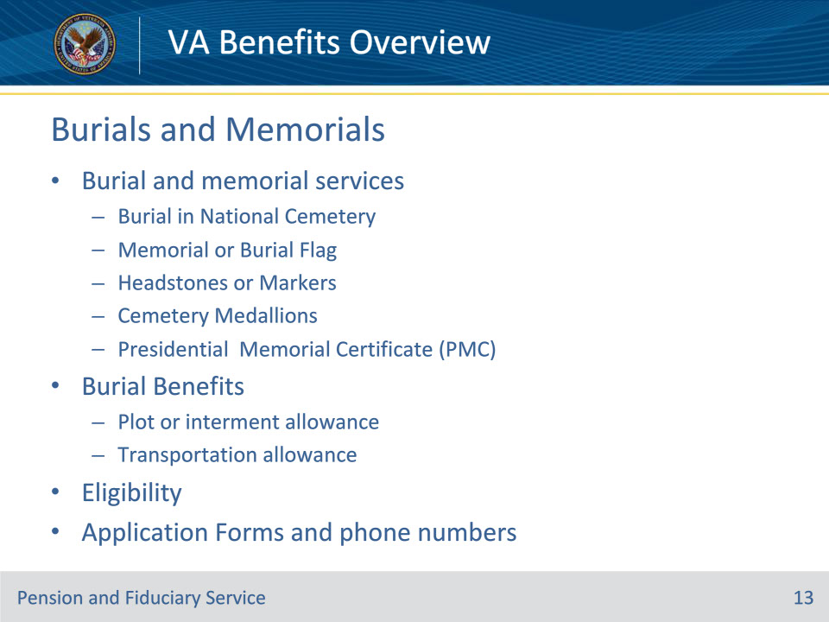
Slide notes

Policy Reference(s): N/A

Instructor Notes:

VA operates 153 national cemeteries, of which 75 are currently open for both new casket and cremation interments and 17 may accept new interment of cremated remains only. Burial options are limited to those available at a specific cemetery and may include in-ground casket, or interment of cremated remains in a columbarium, in ground, or in a scattering area.

Burial in VA National Cemeteries

• Burial in a VA national cemetery is available at no cost and includes the gravesite, grave-liner, opening and closing of the grave, a headstone or marker, and perpetual care as part of a national shrine

Memorial or Burial Flags

• A United States flag is provided, at no cost, to drape the casket or accompany the urn of a deceased Veteran who served honorably in the U. S. Armed Forces

• U.S. Post Offices are the primary issuing point for burial flags

• Each family of a decedent is entitled to one flag

Government Headstones or Markers

• VA can provide a single headstone, columbarium niche cover, or a flat marker for a Veteran’s final resting place (private, state or national cemeteries)

Cemetery Medallions

• VA can provide a medallion for use on a headstone or other memorial in a private cemetery to signify a decedent’s status as veteran.

• Multiple sizes are available

Presidential Memorial Certificates

• VA can provide a Presidential Memorial Certificate (PMC) to the family of the deceased Veteran.

• A PMC is an engraved paper certificate signed by the current President.

Burial Benefits and Burial Automatic Payments

• Burial benefits are paid to a spouse, designated family member, or executor to partially offset the cost of burial expenses, plot costs, and transportation costs for a Veteran’s remains

• Burial benefits are paid at different rates based on whether the Veteran’s death was service-connected or non-service connected

• Additional funds may be paid, or payment made to another party, if an application is completed

• Additional benefits, including a plot or interment allowance and transportation allowance, may also be payable

• An application for non-service-connected burial benefits must be submitted within two years from the date of death

• There is no time limit for a service-connected death.

Eligibility

• Burial in VA National Cemetery

• The National Cemetery Scheduling Office verifies eligibility for burial.

• A copy of the Veteran’s discharge document that specifies the period(s) of active duty and character of service is usually sufficient to determine eligibility.

• A copy of the deceased’s death certificate and proof of relationship to the Veteran (for eligible family members) may be required

• Memorial or Burial Flags

• A complete application

• Government Headstones or Markers

• Complete application

• A copy of the Veteran’s military discharge document is required for processing

• Cemetery Medallions

• A complete application

• A copy of the Veteran’s military discharge document is required for processing.

• Presidential Memorial Certificates

• A complete application

• A copy of the Veteran’s military discharge document or proof of honorable military service

• Burial Benefits

• If the Veteran was receiving VA benefits prior to their passing and had a spouse of record, these benefits will usually be paid automatically to that spouse

• Complete application

• Veteran’s military discharge document

• Death certificate

• For non-service-connected burial, an application must be submitted within two years from the date of death

Application

• A survivor may contact the National Cemetery Scheduling Office or a VA National Cemetery directly to apply for burial in a national cemetery, or visit the VA website to determine whether a particular cemetery is open for new burials and what other options are available

• Website: at http://www.cem.va.gov

• A survivor may apply for a burial flag at any VA Regional Office or U.S. Post Office by completing VA Form 27-2008, Application for United States Flag for Burial Purposes

• A survivor may submit a claim for a headstone or marker for a gravesite in a private cemetery, by completing VA form 40-1330, Claim For Standard Government Headstone or Marker

• A survivor may submit a claim for a medallion to be affixed to a private headstone/market in a private cemetery, by completing VA Form 40-1330M, Claim for Government Medallion for Placement in a Private Cemetery

• Next of kin, relatives and other loved ones may apply for a PMC completing a VA Form 40-0247, Presidential Memorial Certificate Request Form

• A survivor or additional party responsible for the payment of a Veteran’s last expenses may apply for burial benefits by completing a VA Form 21P-530, To apply for benefits VA Form 21P-530, Application for Burial Benefits, is needed and an attached copy of the Veteran’s military discharge document and death certificate

• Applicants for burial or memorial services may call 1-800-697-6947 to seek assistance with the application process or obtain claims processing status

• Applicants for Burial Benefits may call 1-877-294-6380 to seek assistance with the application process, or obtain claim processing status

Slide 14 - Health Care
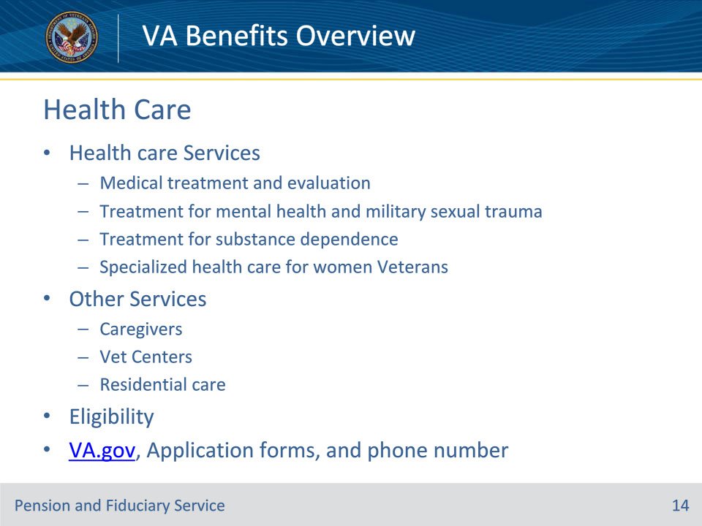
Slide notes

Policy Reference(s): N/A

Instructor Notes:

Health care Services

• VA provides a number of health care services, including:

• Hospital, outpatient medical, dental, pharmacy, and prosthetic services

• Treatment related to Military Sexual Trauma (MST)

• Readjustment counseling

• Alcohol and drug dependency treatment

• Medical evaluation for disorders related to Gulf War service or environmental hazards

• Specialized health care for women Veterans

• Once an application for healthcare is successfully processed, the Veteran will be assigned an enrollment Priority Group

• Certain Veterans may be eligible for more than one enrollment Priority Group. In that case, VA will always place the Veteran in the highest Priority Group that he/she is eligible.

• Under the VA Health Benefits Package, the same services are generally available to all enrolled Veterans.

• Once enrolled for VA health care, the Veteran will receive a personalized Veterans Handbook, which will detail his/her VA health benefits and provide important information concerning his/her access to VA health care.

Other Services

• Caregivers

• VA supports caregivers who provide personal care services to Veterans who are seriously injured, chronically ill, disabled, or are getting older and are no longer able to adequately care for themselves

• Vet Centers

• VA assists combat Veterans through a nationwide network of community-based Vet Centers

• Counselors provide individual, group, and family readjustment counseling to help you with the transition to civilian life, treat post-traumatic stress disorder, and help you with any other military- related problems

• Other services include: outreach, education, medical referral, homeless Veteran services, employment, and VA benefit referral.

• Residential Care

• VA’s State Home program provides an economical alternative to constructing, maintaining and operating VA facilities for the provision of care to eligible Veterans. Under this program, the states provide quality care for eligible Veterans in three different types of programs:

• nursing homes in the Veteran’s community,

• domiciliary, and

• adult day health care

• Community Living Centers (CLC)

• A CLC (VA Nursing Home) used to be called a nursing home

• CLCs are located on or very near VA Medical Center campuses

• Veterans may stay for a short time or, in rare instances, for the rest of their life

• CLCs provide Veteran’s with nursing home level of medical care, which includes help with activities of daily living such as

• bathing

• toileting

• getting dressed

• Domiciliary Care for Homeless Veterans

• Domiciliary care is an active clinical rehabilitation and treatment program for male and female Veterans

• Domiciliary programs are is now integrated with the Mental Heal Residential Rehabilitation and Treatment Programs

Basic Eligibility

• A person who served in the active military, naval, or air service and who was discharged or released under conditions other than dishonorable may qualify for VA health care benefits, including qualifying Reserve and National Guard members

• The best way to determine eligibility is to submit an enrollment application

Application

• Veterans can apply for healthcare by:

• calling 1-877-222-VETS (8387)

• completing an online application at va.gov

• completing a VA Form 10-10EZ, Enrollment Application for Health Benefits

Slide 15 - Questions?
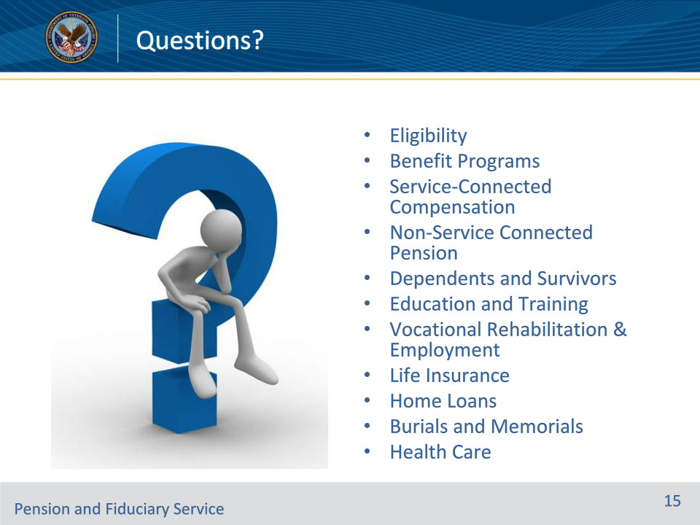
Slide notes

Instructor Notes:

(Recall) These are our learning objectives as stated from the beginning of training:

• Define eligible applicants

• State the benefits available

• Explain basic eligibility requirements, application form, and phone number for each benefit

(Recap) We discussed each of these learning objectives through the following topics in each slide today:

• Eligibility

• Benefit Programs

• Service-Connected Compensation

• Non-Service-Connected Pension

• Dependents and Survivors

• Education and Training

• Vocational Rehabilitation & Employment

• Life Insurance

• Home Loans

• Burials and Memorials

• Health Care

What questions to you have for me today?

Slide 16 - TMS Survey and Assessment
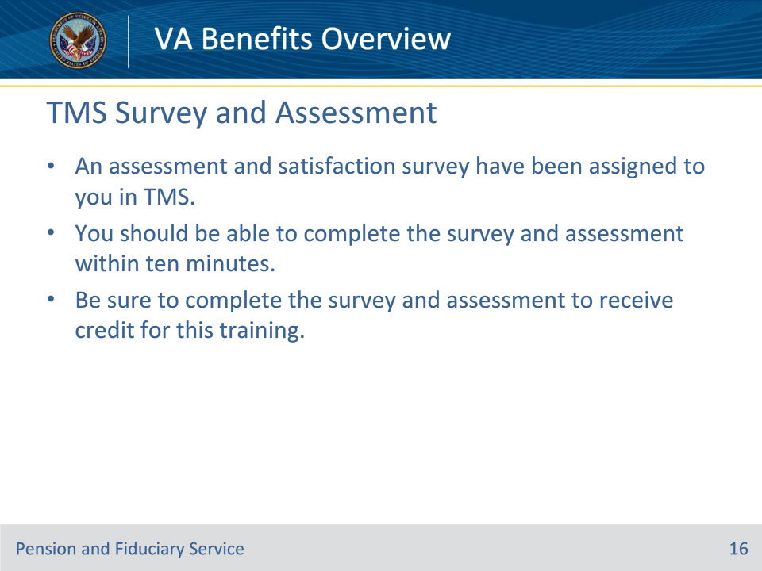
Slide notes

Instructor Notes:

An assessment and satisfaction survey have been assigned to you in TMS. You should be able to complete both within ten minutes. Completing both will allow you to receive credit for this training.

