Slide 1 - Legal Instruments Examiners
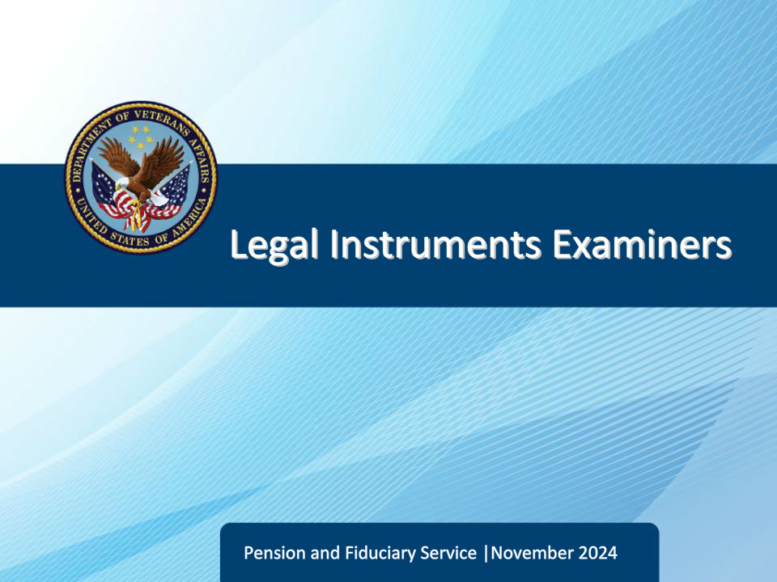
Slide notes

Course Description:

This lesson teaches learners about the Legal Instruments Examiner position and its critical work functions.

Slide 2 - Objectives
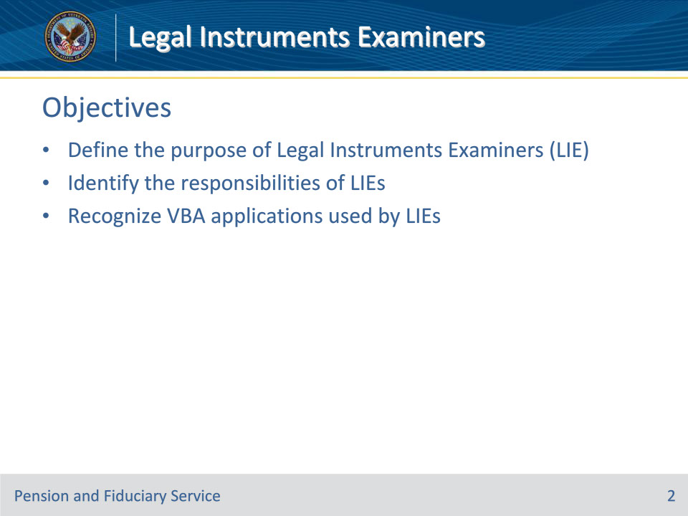
Slide notes

Instructor Notes:

At the end of this lesson, given the training and references, the learner will be able to do the following:

• Define the purpose of Legal Instruments Examiners (LIE)

• Identify the responsibilities of LIEs

• Recognize VBA Applications used by LIEs

Slide 3 - References
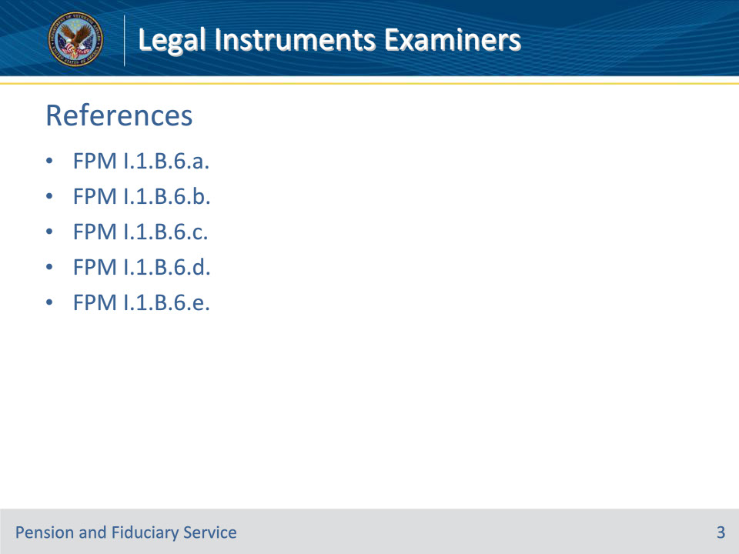
Slide notes

Instructor Notes:

The following are relevant references pertaining to this course:

• FPM I.1.B.6.a. Shared Responsibilities

• FPM I.1.B.6.b. General Monetary Responsibilities

• FPM I.1.B.6.c. Protecting and Advising on Issues Surrounding Benefits

• FPM I.1.B.6.d. Additional Benefit Responsibilities

• FPM I.1.B.6.e. Handling Issues Surrounding the Death of a Beneficiary

Slide 4 - What are Legal Instruments Examiners?
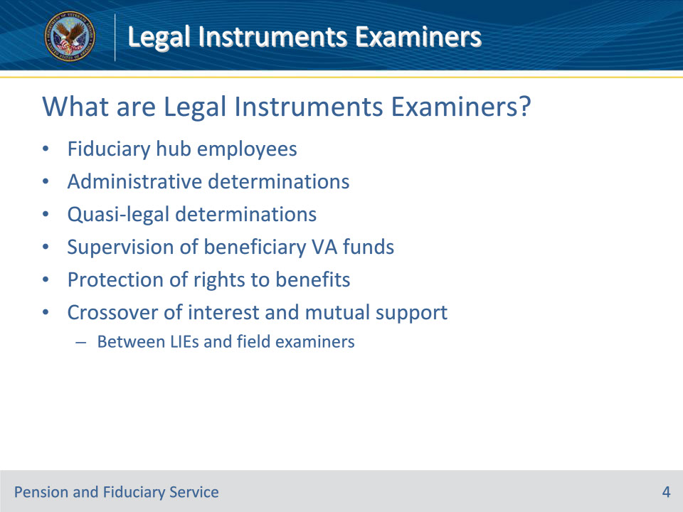
Slide notes

Policy Reference(s): FPM I.1.B.6.a.

Instructor Notes:

Legal Instruments Examiners (LIEs) are employees of the Department of Veterans Affairs (VA) who work in the fiduciary hub.

The Legal Instruments Examiner (LIE) shares responsibility with supervisors, FEs, and other fiduciary staff for making administrative and quasi-legal determinations involving the overall supervision of beneficiary VA funds under management and the protection of rights to benefits. There is considerable crossover of interests and mutual support between LIEs and FEs.

Slide 5 - General Monetary Responsibilities
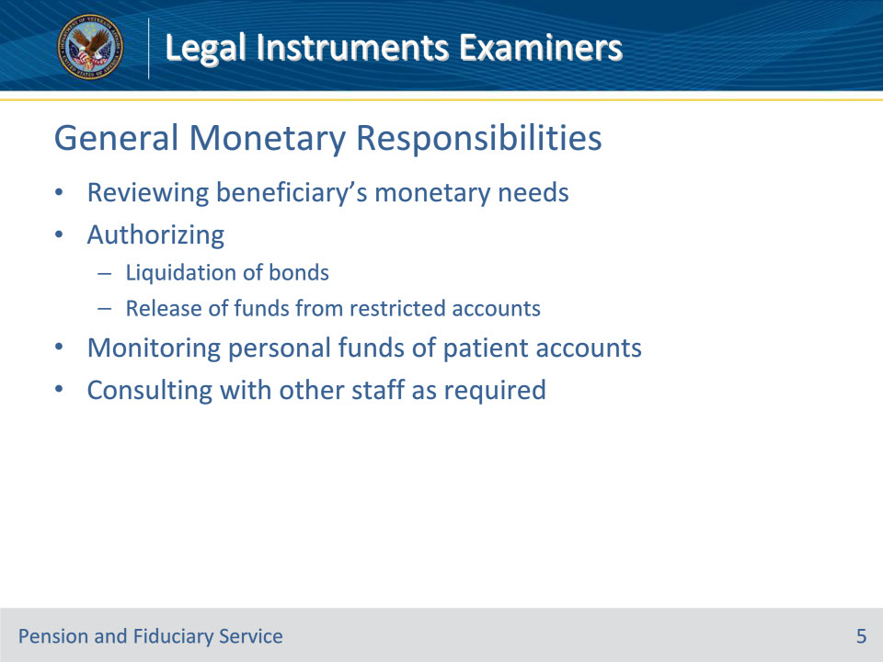
Slide notes

Policy Reference(s): FPM I.1.B.6.b.

Instructor Notes:

The LIE is responsible for

• reviewing the monetary needs of the beneficiary

• authorizing the

• liquidation of bonds, and

• release of funds from restricted accounts, after consultation with other fiduciary staff when in order, and

• monitoring personal funds of patient accounts held at Hines Benefits Delivery Center.

Consultation with other fiduciary staff may be required.

Slide 6 - Protecting and Advising on Benefits
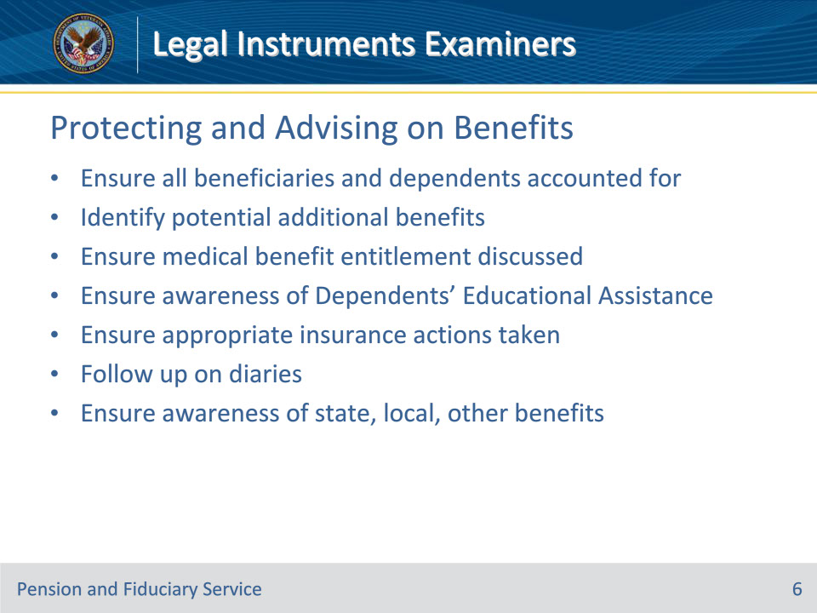
Slide notes

Policy Reference(s): FPM I.1.B.6.c.

Instructor Notes:

The LIE is responsible for acting to protect insurance and other rights to VA benefits, and advising fiduciaries of other Federal and State benefits to which the beneficiary may be entitled. This includes

• reviewing records to ensure that all beneficiaries and dependents are accounted for in award actions (such as dependent parents and children living with other relatives)

• identifying situations where there is a possibility for additional benefits (for example, aid and attendance or housebound benefits, or benefits for a child over age 18 who remains in school)

• ensuring that possible entitlement to medical benefits is discussed with the fiduciary and dependents

• making certain that the spouse and children are aware of possible entitlement to Dependents’ Educational Assistance

• ensuring that a request for waiver of insurance premium is submitted for National Service Life Insurance policies or application for reinstatement and waiver of lapsed policies, when indicated

• following up on diaries when there is a need for the beneficiary and/or the fiduciary to supply information necessary for continuation of benefits, such as income information, and

• ensuring that beneficiaries are aware of possible entitlement to State and local benefit programs, education benefits, and other community services.

Slide 7 - Additional Responsibilities
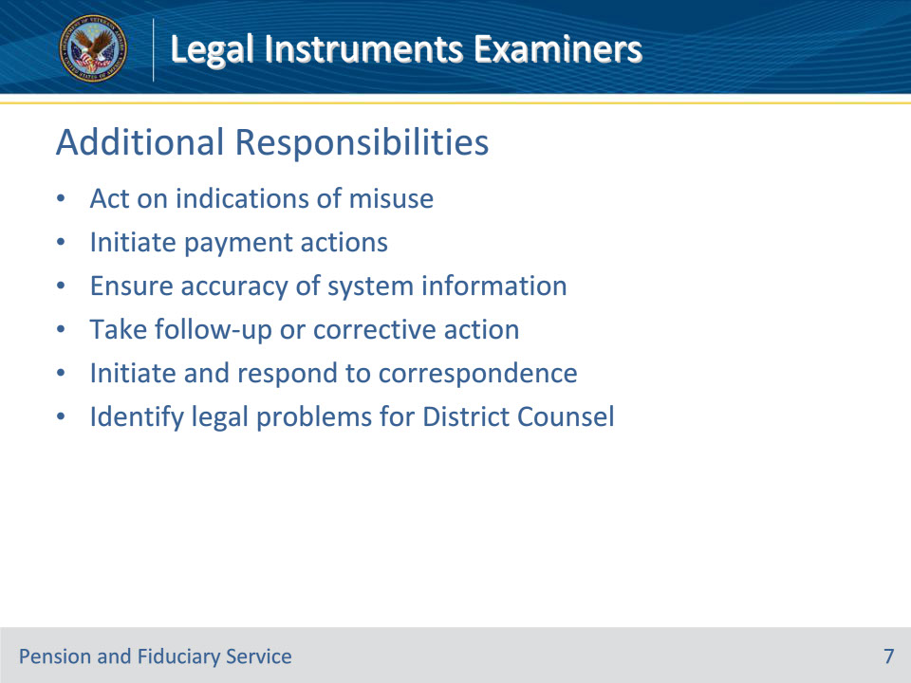
Slide notes

Policy Reference(s): FPM I.1.B.6.d., e.

Instructor Notes:

The LIE is responsible for

• taking prompt action on indications of fiduciary misuse received by mail, telephone, or as a result of a personal interview

• initiating action to have payments adjusted, suspended, resumed, or recovered, when appropriate

• ensuring all information within the claims processing system is both accurate and current, at the time of any record maintenance or updating

• taking follow-up or corrective action required in any case

• initiating and responding to correspondence pertaining to individual VA FUM supervision

• identifying legal problems for action by the District Counsel

Slide 8 - Additional Responsibilities
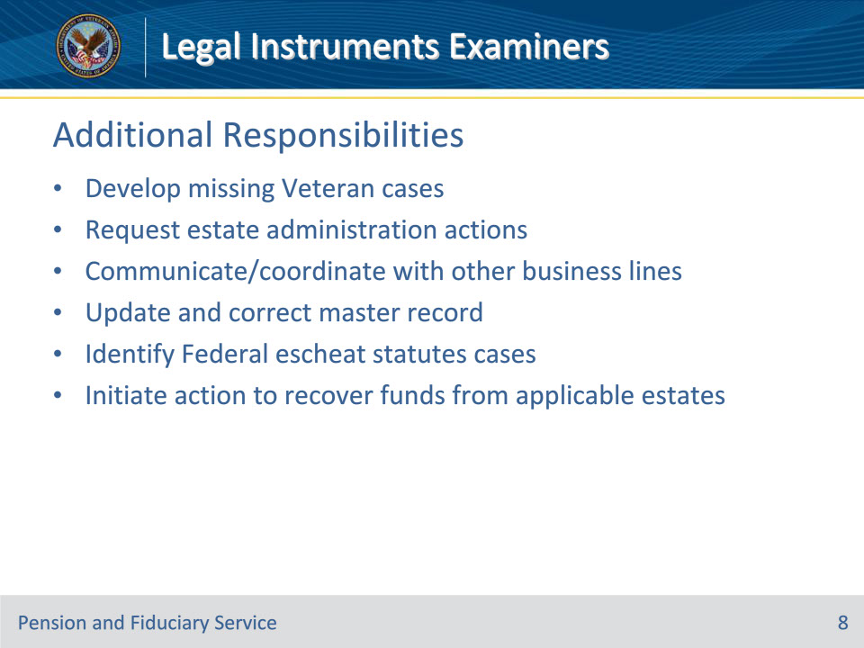
Slide notes

Policy Reference(s): FPM I.1.B.6.d., e.

Instructor Notes:

The LIE is responsible for

• developing missing Veteran cases

• requesting

• the transfer of institutional award funds to VA for disposition when the Veteran dies, and

• field examinations for estate administration problems and benefit issues

• communicating and/or coordinating with the Veterans Service Center (VSC), insurance, or finance activities to arrange prompt release of funds when financial hardship exists, and

• executing the CHANGE OF FIDUCIARY command to update and correct the master record, when assigned.

The LIE is responsible for

• identifying those cases in which the Federal escheat statutes may apply upon the death of a beneficiary, and

• initiating action to recover funds from those estates to which the government is entitled.

Slide 9 - VBA Applications
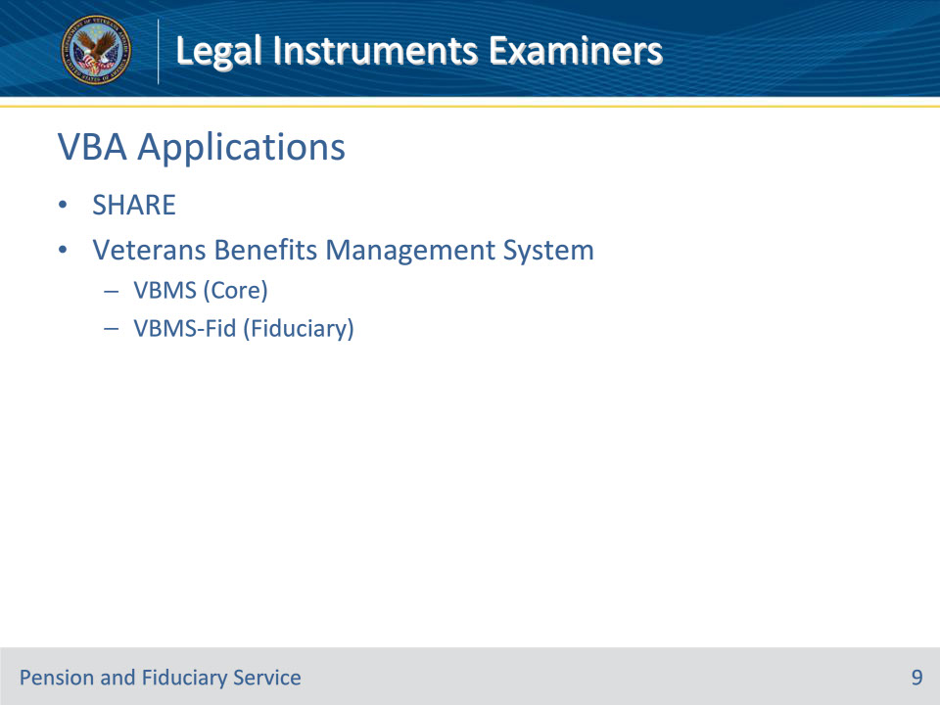
Slide notes

Policy Reference(s): N/A

Instructor Notes:

LIEs use multiple Veterans Benefits Administration (VBA) systems when completing their daily tasks; LIEs most commonly utilize:

SHARE

• SHARE is utilized by Department of Veterans Affairs (VA) employees to create and maintain beneficiary records to support case management.

• It is a single system that interfaces with other VBA systems and databased to retrieve data and create a ‘Corporate’ environment.

• Beneficiary records can be reviewed and updated through various commands in SHARE

• LIEs can use Share to confirm:

• benefit type (service-connected compensation, non-service-connected pension, etc.)

• benefit entitlement date

• service-connected and non-service-connected disabilities,

• date of rating decision

• benefit entitlement (payment) rate

• contact information

• dependency information

• overpayment information

• Social Security Administration benefit information

Veterans Benefits Management System (VBMS)

• VBMS (core) is a web-based, electronic claims processing solution, which provides the ability to:

• view claim documents and correspondence (development letters and award letters)

• view rating decisions

• view correspondence sent from the Beneficiary or Fiduciary to the Fiduciary Hub

• view correspondence sent from the Fiduciary Hub to the Beneficiary or Fiduciary

• VBMS-Fid is the official system of record for beneficiaries and fiduciaries in the Fiduciary Program.

• VBMS-Fid to:

• view field exams, accounting information, and fiduciary diary date information

• proposed incompetent beneficiaries - Beneficiary Profile

• active beneficiaries and fiduciaries –Beneficiary Profile and the Fiduciary Profile

• inactive records for beneficiaries and fiduciaries that are no longer in the Fiduciary Program – Beneficiary Record and Fiduciary Record

• view Field examination reports and generate associated notification letters

• view Accounting Audit Tools and generate associated notification letters

Slide 10 - Questions?
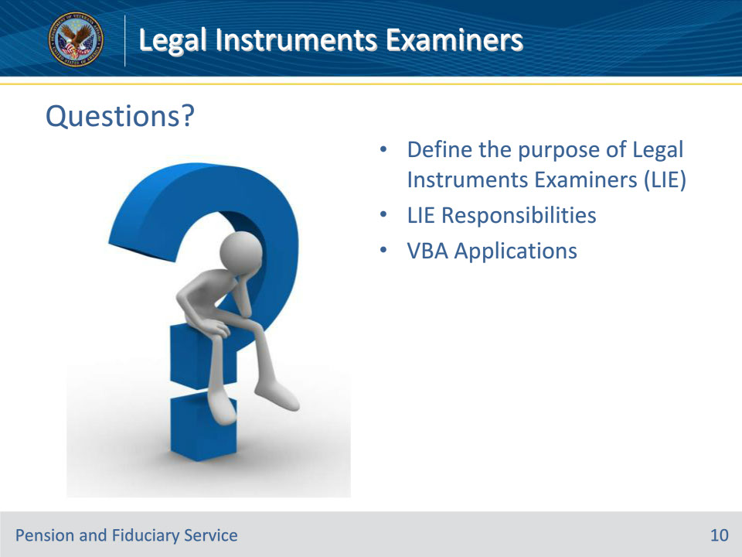
Slide notes

Instructor Notes:

(Recall) These are our learning objectives as stated from the beginning of the training:

• Define the purpose of Legal Instruments Examiners (LIE)

• Identify the responsibilities of LIEs

• Recognize VBA Applications used by LIEs

Are there any additional questions?

Questions should be filtered through your QRT team. They will submit your questions to the Field Inquiry Tool (FIT) on your behalf.

Slide 11 - TMS Survey/Assessment
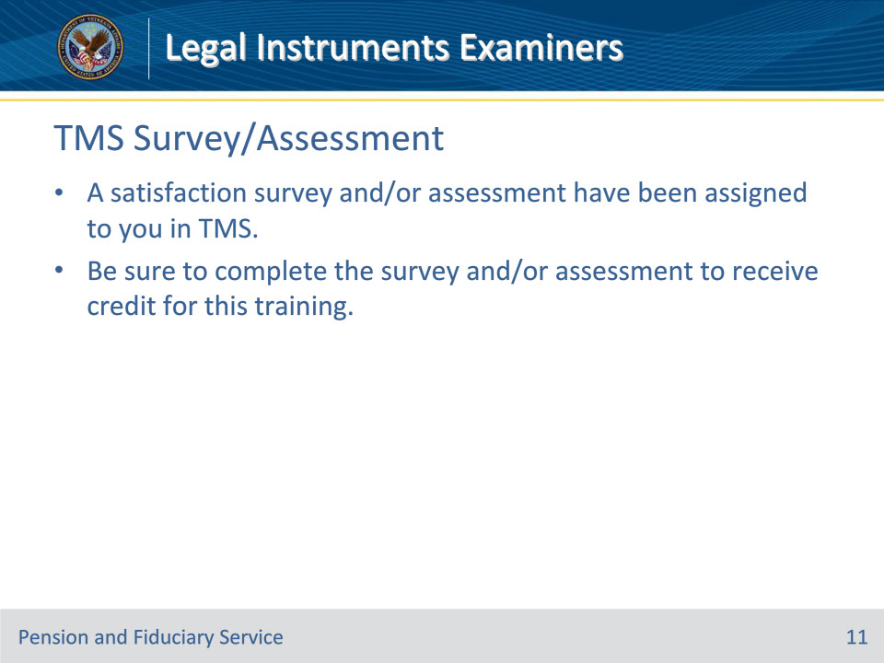
Slide notes

Instructor Notes:

A satisfaction survey and/or assessment have been assigned to you in TMS.

Be sure to complete the survey and/or assessment to receive credit for this training.

