Slide 1 - Introduction to VA Pension

Slide notes

Course Description:

The purpose of this lesson is to provide learners with the knowledge to assist beneficiaries in understanding and applying for VA non-service connected pension and special monthly pension (SMP) benefits.

Slide 2 - Objectives
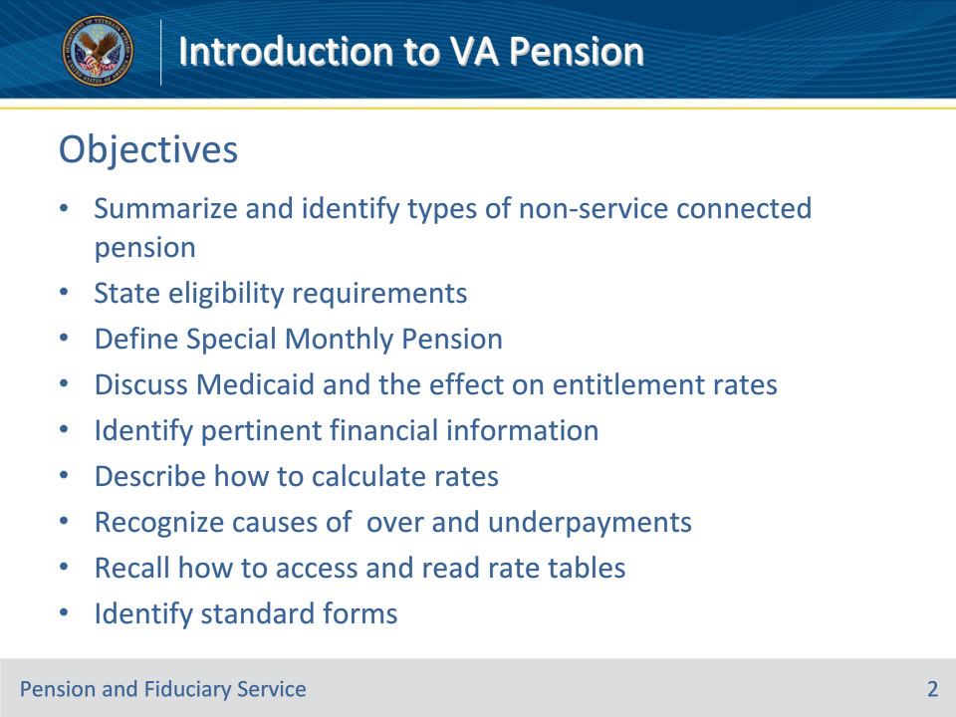
Slide notes

Instructor Notes:

By the end of this lesson, given the training and corresponding references, the learner will be able to do the following:

• Summarize and identify types of non-service-connected pension

• State eligibility requirements

• Define Special Monthly Pension

• Discuss Medicaid and the effect on entitlement rates

• Identify pertinent financial information

• Describe how to calculate rates

• Recognize causes of over and underpayments

• Recall how to access and read rate tables

• Identify standard forms

Slide 3 - References
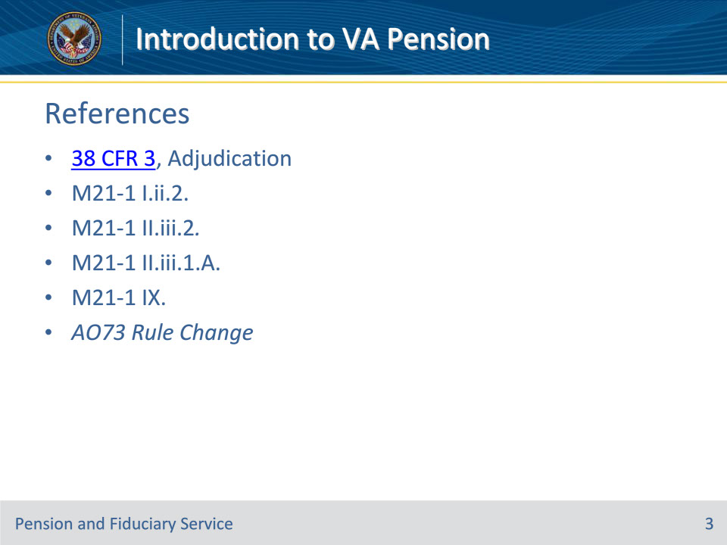
Slide notes

Instructor Notes:

These are the relevant references pertaining to VA Non-Service-Connected Pension:

• 38 CFR 3, Adjudication

• M21-1 I.ii.2., Department of Veterans Affairs (VA) Benefit Programs

• M21-1 II.iii.2., Types of Claims and Claims Actions

• M21-1 II.iii.1.A., Applications for Benefits

• M21-1 IX., Pension, Survivors’ Pension, and Parents’ Dependency and Indemnity Compensation (DIC)

• AO73 Rule Change

Slide 4 - References (Continued)
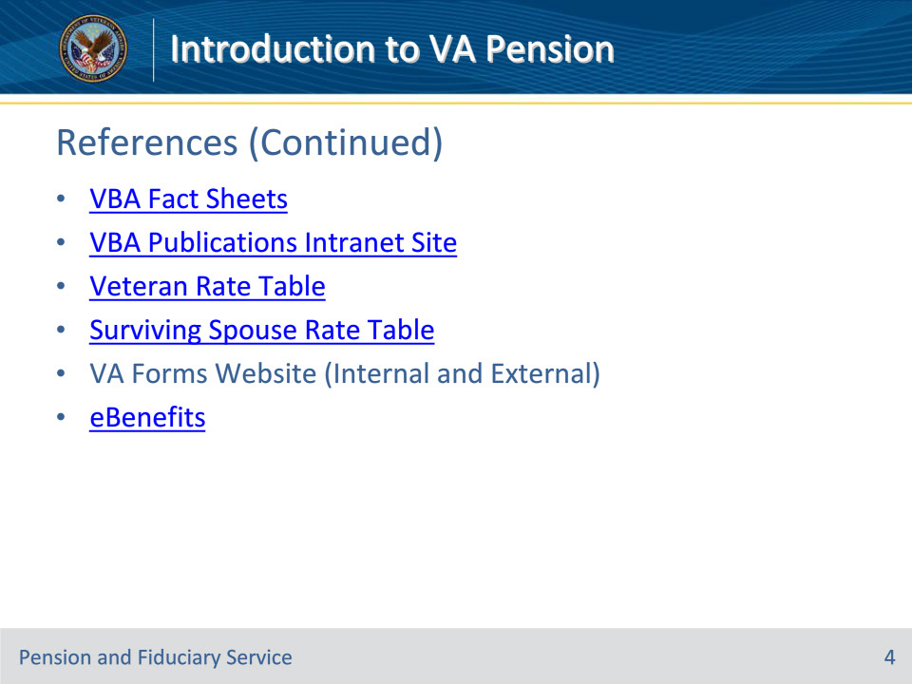
Slide notes

Instructor Notes:

These are the relevant references pertaining to VA Non-Service-Connected Pension:

• VBA Fact Sheets

• Webpage: https://benefits.va.gov/BENEFITS/factsheets.asp

• VBA Publications Intranet Website

• Webpage: https://vbaw.vba.va.gov/bl/21/publicat/pub_home.htm

• Veteran Rate Table

• Webpage: https://benefits.va.gov/PENSION/current_rates_veteran_pen.asp

• Surviving Spouse Rate Table

• Webpage: https://benefits.va.gov/PENSION/current_rates_survivor_pen.asp

• VA Forms (Internal) available to VA employees:

• Website: http://vaww.va.gov/vaforms/

• VA Forms (External) available to Veterans:

• Websitehttp://www.va.gov/vaforms/

Slide 5 - Non-Service Connected Pension
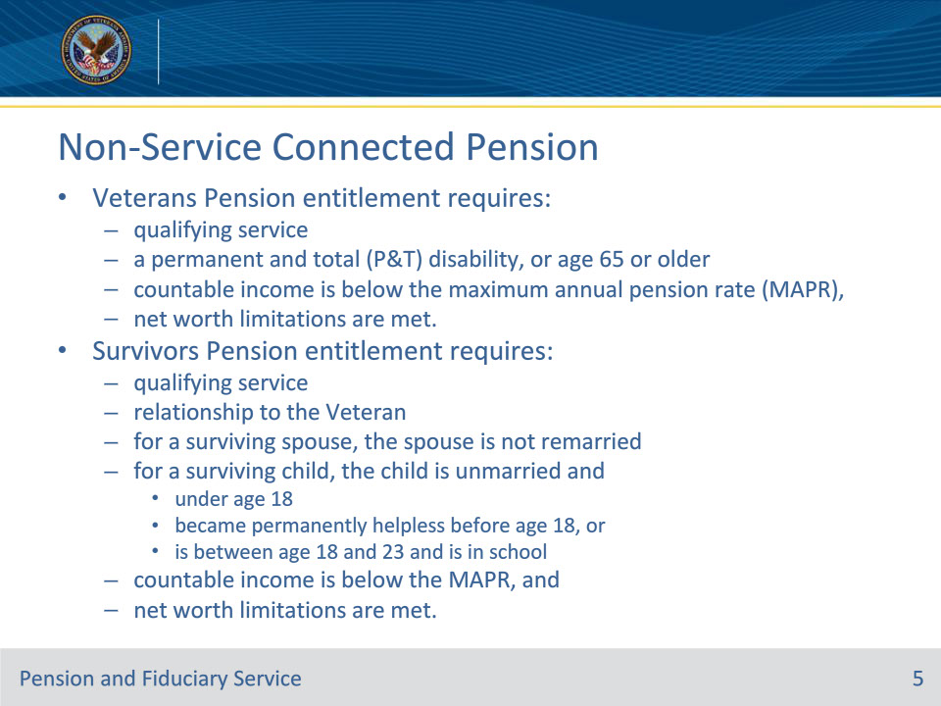
Slide notes

Instructor Notes:

Beneficiaries May Be:

• Non-service-connected pension is a needs-based benefit paid to:

• wartime Veteran because of permanent and total disability, or whom is age 65 or older

• surviving spouse or surviving child because of wartime Veteran’s death

Summary:

In order to establish entitlement to Veterans Pension, the following elements must be shown:

•qualifying service

•a permanent and total (P&T) disability, or age 65 or older

•countable income is below the maximum annual pension rate (MAPR), and

•net worth limitations are met.

In order to establish entitlement to Survivors Pension, the following elements must be shown:

•qualifying service

•relationship to the Veteran

•for a surviving spouse, the spouse is not remarried

•for a surviving child, the child is unmarried and

• under age 18

• became permanently helpless before age 18, or

• is between age 18 and 23 and is in school

•countable income is below the MAPR, and

•net worth limitations are met.

Other facts:

• Non-service-connected pension is different from service-connected compensation in that non-service-connected pension is not tied solely to a service-connected disability; non-service-connected pension is based on a non-service-connected disability or a combination of service-connected and non-service-connected disability.

• Non-service-connected pension takes into account the claimant’s financial situation – the program is an income and assets-based program.

• Maximum Annual Pension Rate (MAPR) set by Congress each year and MAPR is reduced dollar for dollar based on income

• A net worth limit applies

• The monthly benefit payments are tax-free.

• A claimant may qualify to receive service-connected compensation or non-service-connected pension, but he/she can’t receive both at the same time. If entitled to both, the Department of Veteran’s Affairs will pay the greater benefit. An exception to this rule may apply for Veteran’s married to Veterans.

• Non-service-connected pension claims are processed by one of the three Pension Management Centers

Slide 6 - Non-Service Connected Pension
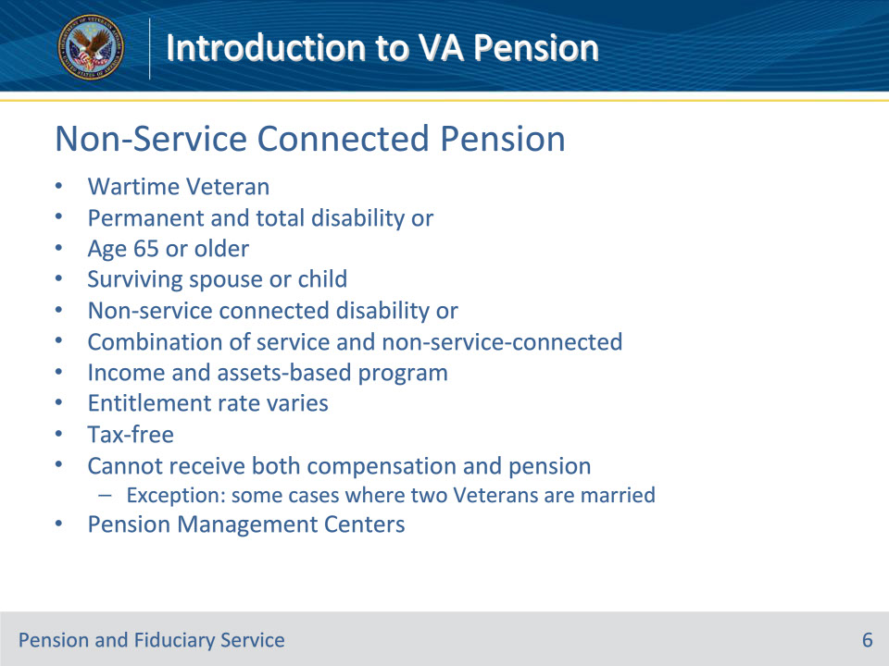
Slide notes

Instructor Notes:

Beneficiaries May Be:

• Non-service-connected pension is a needs-based benefit paid to:

• wartime Veteran because of permanent and total disability, or whom is age 65 or older

• surviving spouse or surviving child because of wartime Veteran’s death

Summary

• Non-service-connected pension is different from service-connected compensation in that non-service-connected pension is not tied solely to a service-connected disability; non-service-connected pension is based on a non-service-connected disability or a combination of service-connected and non-service-connected disability.

• Non-service-connected pension takes into account the claimant’s financial situation – the program is an income and assets-based program.

• Maximum Annual Pension Rate (MAPR) set by Congress each year and MAPR is reduced dollar for dollar based on income

• The monthly benefit payments are tax-free.

• A claimant may qualify to receive service-connected compensation or non-service-connected pension, but he/she can’t receive both at the same time. If entitled to both, the Department of Veteran’s Affairs will pay the greater benefit. Exception: some cases where two Veterans are married

• Non-service-connected pension claims are processed by one of the three Pension Management Centers

Slide 7 - Pension Types
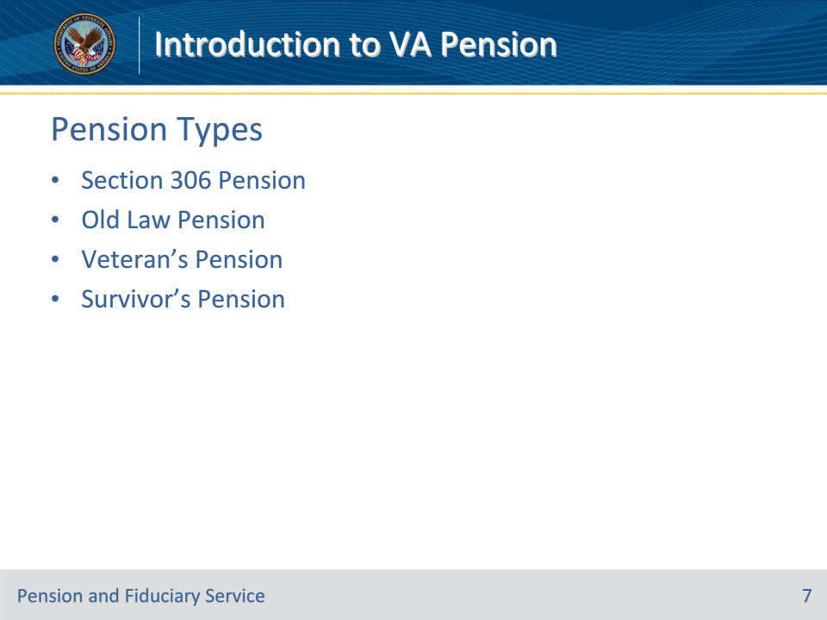
Slide notes

Instructor Notes:

There are four general types of non-service-connected pension:

• Section 306 Pension

• Old Law Pension

• Veteran’s Pension

• Survivor’s Pension

Section 306 Pension

• Old form of the benefit; not very common to have a beneficiary in receipt of Section 306 Pension

• Phased out 12/31/1978

Old Law Pension

• Old form of the benefit; not very common to have a beneficiary in receipt of Old Law Pension

• Phased out 6/30/1960

Veteran’s Pension

• Current version of the benefit; routinely referred to as “New and Improved” Veteran’s pension or live pension

Survivor’s Pension

• Current version of the benefit; routinely referred to as “New and Improved” survivor’s pension or death pension

Slide 8 - Live Pension Eligibility Factors
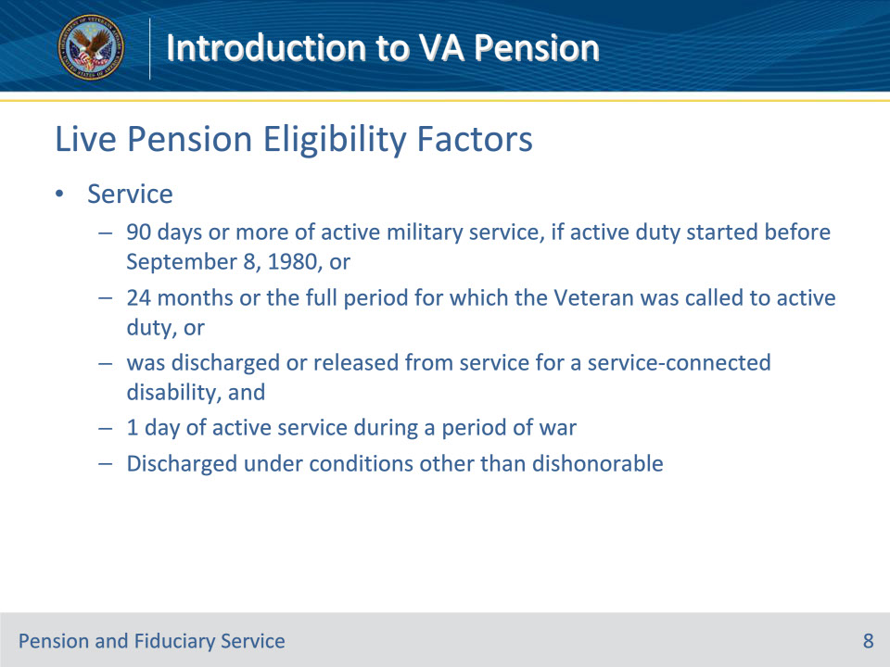
Slide notes

Instructor Notes

Live Pension

• Entitlement to non-service-connected pension benefits is based on a Veteran’s:

• character(s) of discharge, and

• meeting the wartime service requirement, and

• minimum active duty service requirement, where applicable.

• In addition, the Veteran’s and all dependents’ income and net worth are also considered.

Service Requirements

• Generally, the Veteran must have at least 90 days of active duty service, with at least one day during a wartime period to qualify for non-service-connected pension.

• If the Veteran entered active duty after September 7, 1980, generally he/she must have served at least 24 months or the full period for which he/she was called or ordered to active duty (with some exceptions), with at least one day during a wartime period.

• Wartime Periods Include:

• Mexican Border Period - May 9, 1916, through April 5, 1917 - for Veterans who served in Mexico, on its borders, or adjacent waters

• World War I –

• April 6, 1917, through November 11, 1918

• for Veterans who served in Russia, April 6, 1917, through April 1, 1920

• World War II - December 7, 1941, through December 31, 1946

• Korean Conflict - June 27, 1950, through January 31, 1955

• Vietnam Era

• If the adjudicative decision is rendered before January 5, 2021, Then qualifying service dates are February 28, 1961- May 7, 1975 (for Veterans who served “in country”), or August 5, 1964 - May 7, 1975 (for Veterans who did not serve “in country”)

• If the adjudicative decision is rendered on or after January 5, 2021, Then qualifying service dates are November 1, 1955 - May 7, 1975 (for Veterans who served “in country”), or August 5, 1964 - May 7, 1975 (for Veterans who did not serve “in country”)

• Gulf War - August 2, 1990, through a date to be set by law or Presidential Proclamation

• The Veteran must have separated from service under conditions other than dishonorable

Slide 9 - Live Pension Eligibility Factors
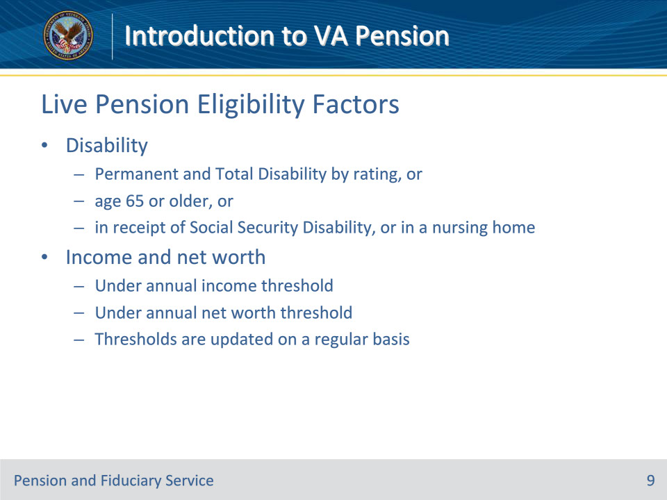
Slide notes

Instructor Notes

Disability

• In addition to meeting minimum service requirements, the Veteran must be:

• Age 65 or older, OR

• Totally and permanently disabled, OR

• A patient in a nursing home receiving skilled nursing care, OR

• Receiving Social Security Disability Insurance, OR

• Receiving Supplemental Security Income

Income and Net Worth

• The Veteran’s and all dependents’ income and assets are also considered when determining live pension entitlement because it is an income and assets-based program.

• The Veteran’s yearly family income must be less than the amount set by Congress

• The Veteran’s family net worth must be at or below the determined Bright line limit.

• Net worth for VA purposes = Assets + Income for VA purposes (IVAP)

Link to current net worth limit

https://www.benefits.va.gov/PENSION/current_rates_veteran_pen.asp

Slide 10 - Death Pension Eligibility Factors
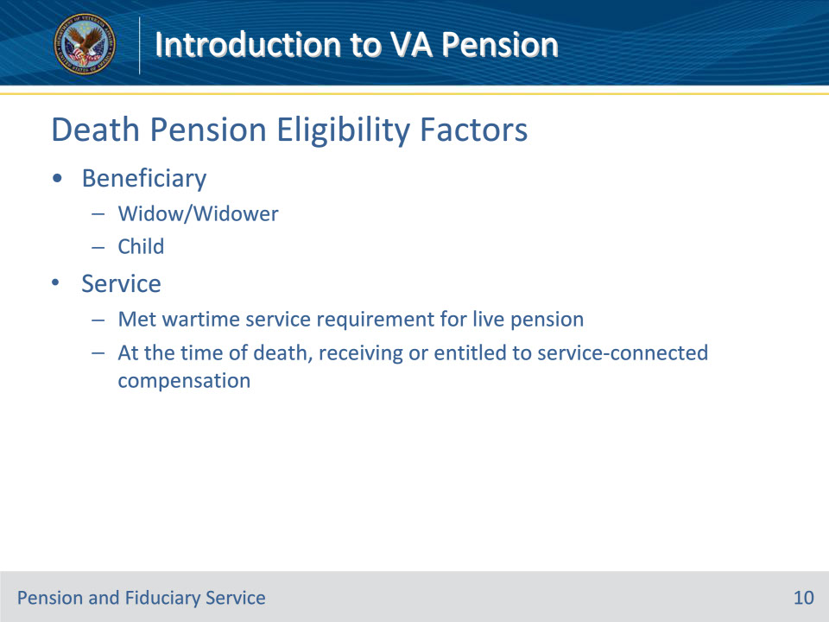
Slide notes

Instructor Notes:

Beneficiary

• Non-service-connected death pension benefits may be payable to a low-income:

• Widow

• meets marital requirements as a surviving spouse

• not remarried after the Veteran’s death

• no age requirements

• Child

• unmarried

• under 18, OR

• under age 23 if attending a VA-approved school, OR

• permanently incapable of self-support due to a disability before age 18

Service

• The Veteran must have met the requirement for live pension, to include:

• character(s) of discharge, and

• wartime service requirement, and

• minimum active duty service requirement, where applicable

• Or, at the time of the Veteran’s death, he/she must have been in receipt or entitled to service-connected compensation benefits

Slide 11 - Death Pension Eligibility Factors
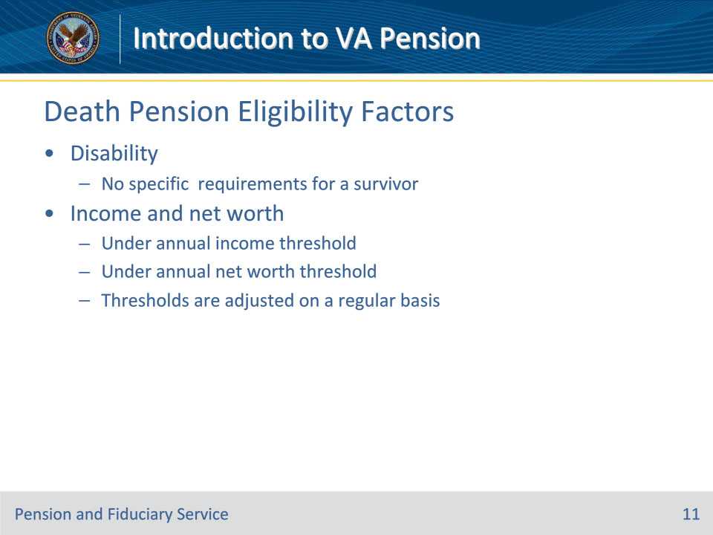
Slide notes

Instructor Notes:

Disability

• There is no disability requirements for death pension eligibility like there is with live pension

Income and Net Worth

• Just like with a Veteran, the claimant and all dependents’ income and assets are also considered when determining death pension entitlement because it is an income and assets based program.

• The claimant’s yearly family income must be less than the amount set by Congress

• The claimant’s family net worth typically must be under the pre-determined annual net worth limit

Link to current pension rates

https://www.benefits.va.gov/PENSION/current_rates_veteran_pen.asp

Slide 12 - Special Monthly Pension
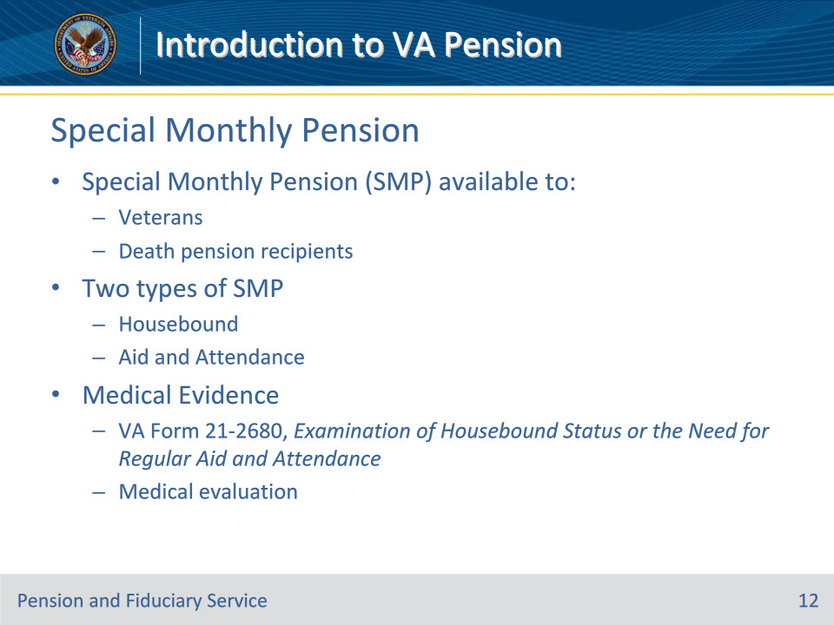
Slide notes

Instructor Notes:

Special Monthly Pension (SMP)

• Veterans and survivors who are eligible for a pension and require the aid and attendance of another person, or are housebound, may be eligible for this additional monetary payment.

• SMP benefits are paid in addition to monthly pension, and they are not paid without eligibility to pension.

• SMP allowances increase the pension amount, claimant’s not eligible for a basic pension due to excessive income may be eligible for pension at these increased rates.

Two Types

• Housebound

• Veterans who are eligible to receive pension qualify for pension at the housebound rate if they have a single, permanent disability that is assigned a 100 percent under a schedular evaluation and

• have other disabilities independently ratable at 60 percent or more or

• are permanently housebound by reason of their disabilities

• A surviving spouse eligible to receive pension or Dependency and Indemnity Compensation qualify for increased benefits based on being housebound if they are permanently housebound by reason of their disabilities

• Housebound benefits are lesser than Aid and Attendance (A&A) benefits

• A&A

• To be eligible for the A&A allowance, a Veteran or surviving spouse must be so helpless that he/she requires the aid of another person to

• perform the personal functions required in everyday living, also called activities of daily living, or

• protect himself/herself from hazards or dangers incident to daily life because of a mental or physical disability.

• A claimant who has bilateral vision of 5/200 or less, or contraction of the central visual field to five degrees or less, is eligible for A&A

• A&A benefits are greater than housebound benefits

NOTE: A claimant may not receive housebound benefits and A&A benefits at the same time

Medical Evidence

• Determination of a claimant’s need for housebound and A&A by rating is based on medical evidence such as:

• VA Form 21-2680, Examination of Housebound Status or the Need for Regular Aid and Attendance, completed by a licensed health care professional, including the claimant’s private medical provider

• Department of Veterans Affairs medical center (VAMC) examinations

• statements by licensed health care professionals

• NOTE:

• VAMC examinations of survivors are not generally conducted except at the discretion of the Pension Management Center Manager.

• The following are examples of licensed health care professionals accepted for signatures on evidence or to provide medical statements:

• medical doctor

• doctor of osteopathy

• nurse practitioner, or

• physician’s assistant.

Slide 13 - Medicaid Rate
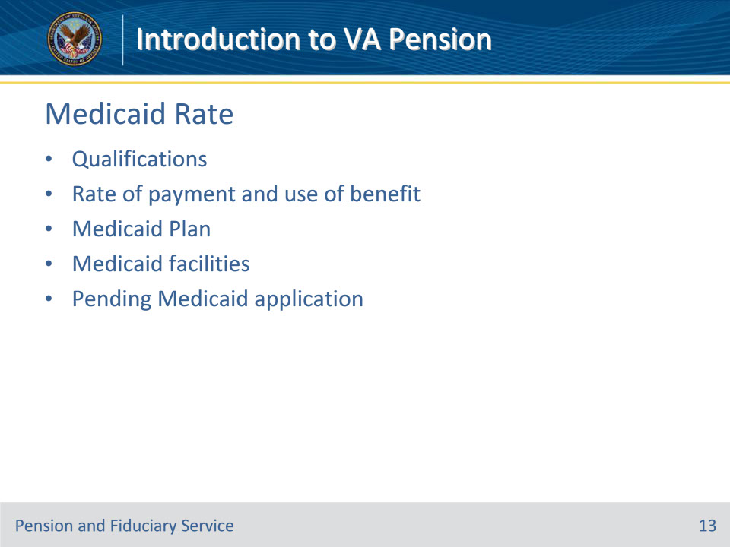
Slide notes

Instructor Notes:

Qualifications

• 38 USC 5503 reduces the payment of non-service-connected pension benefits for single Veterans or surviving spouses who reside in a Medicaid approved nursing facility and are also covered by Medicaid.

Payment Rate and Use of Benefit

• Eligible beneficiary’s will have his/her non-service-connected pension benefits reduced to $90.00.

• This is commonly referred to as the “$90.00 Medicaid Rate”

• Federal law prohibits counting the reduced pension toward the Veteran’s or surviving spouse’s cost of care (Medicaid Income); therefore, the entire amount of the $90.00 is to be used towards the beneficiary’s personal needs allowance and not allowed for to applied towards his/her cost of care at the facility.

Medicaid Plan

• A Medicaid Plan is a State plan for medical assistance per title XIX, section 1902(a), of the Social Security Act.

• Medicaid is available only to certain low-income individuals and families.

• Medicaid does not pay money to individuals; instead, it sends payments directly to health care providers or facilities.

Medicaid Approved Facilities

• You may determine if the facility the beneficiary resides in is a Medicaid approved facility by navigating to the Medicare Nursing Home Compare website and searching for the facility.

• Website: https://www.medicare.gov/NursingHomeCompare/search.html

• NOTE: The beneficiary must be covered by a Medicaid plan AND must reside in a Medicaid facility. Just because the beneficiary resides in a Medicaid approved facility, that does not mean the beneficiary is participating in a Medicaid plan. If the beneficiary is not covered by a Medicaid plan, the beneficiary will have a cost share amount, that will be comparable to the amount paid by private pay residents. By interviewing the facility’s business office manager and fiduciary, you can determine if the beneficiary is covered under a Medicaid plan.

Pending Medicaid Application

• A beneficiary may be residing in a Medicaid approved facility and have applied to be covered under a Medicaid plan, but the plan has not yet been approved by the state. In this situation, assume that the beneficiary will be covered by a Medicaid plan retroactive to the date of admission to the nursing facility. Fiduciary personnel must advise the beneficiary and/or fiduciary that VA will:

• assume that Medicaid coverage began the date of the beneficiary’s admission to the nursing facility, and if the assumption is incorrect, the beneficiary should provide confirmation of his/her Medicaid status

• take action to reduce his/her benefit to $90.00 per month and that once the reduction takes place, the money should be used for his/her monthly personal needs or spending.

• The Pension Management Center (PMC) of jurisdiction must be notified as soon as possible after the Medicaid application is submitted, NOT just when the beneficiary is approved.

• NOTE: A Medicaid application can be pending simultaneously with a claim for VA benefits. Medicaid eligibility can be established retroactive to the date of application and can be effective from the month of admission to the Medicaid approved facility.

Slide 14 - Countable Income
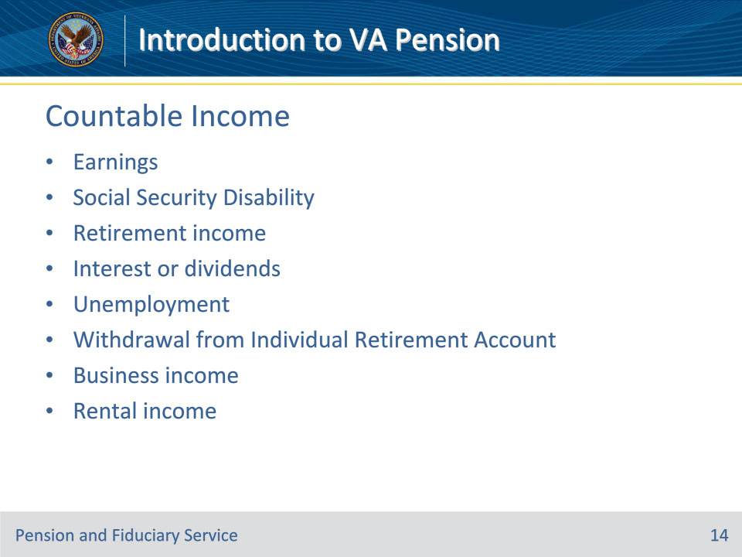
Slide notes

Instructor Notes:

Countable Income

• In Department of Veterans Affairs (VA) income-based benefit programs, the amount of a beneficiary’s income for VA purposes (IVAP) determines the VA benefit rate payable. The higher a beneficiary’s IVAP, the lower the benefit rate.

• The general rule is that all income is countable for VA purposes unless specifically excluded

• Examples of countable income include, but are not limited to:

• earnings

• Social Security disability benefits

• retirement income (i.e. Civil Service, Railroad Retirement, company, etc.)

• interest/Dividends

• unemployment compensation

• withdrawals from Individual Retirement Accounts

• business income

• rental income

Slide 15 - Countable Income Exclusions
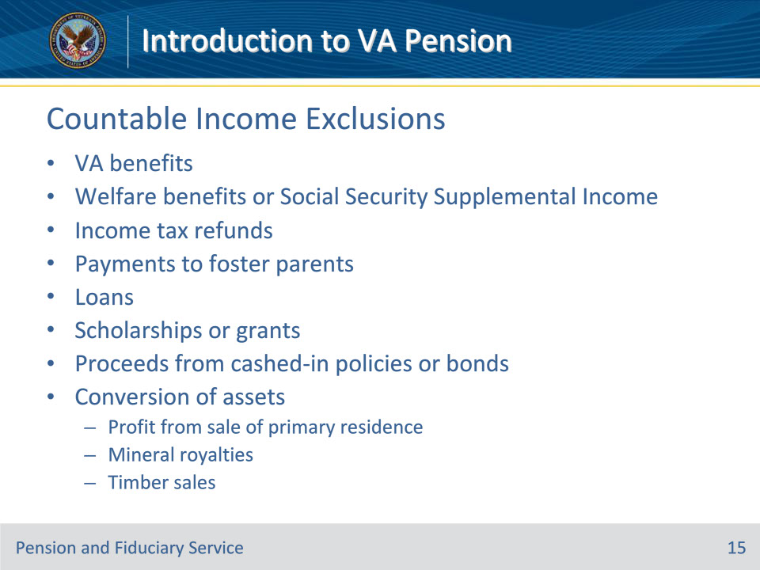
Slide notes

Instructor Notes:

Countable Income Exclusions

• Certain items are not countable, either because they are

• not considered to be income,

• deemed to fall under one of the specific exclusions, or

• excluded by Federal statute.

• Examples of income exclusions include, but are not limited to:

• Department of Veteran Affairs (VA) benefits, to include:

• Income from VHA work restoration, including Incentive Therapy and Compensated Work Therapy

• Veteran benefits

• Survivor benefits

• Welfare or Social Security Supplemental Income benefits

• Income tax refunds

• Withheld Social Security benefits

• Chore services

• Payments to foster parents

• Loans, including reverse mortgages

• Insurance dividends

• Joint accounts transferring on death

• Withdrawals from Bank Accounts and Certificates of Deposit

• Scholarships and grants

• Proceeds of cashed-in life insurance policies

• Proceeds of cashed-in savings bonds

• Individual Retirement Account (IRA) Interest

• In general, do not count interest on IRAs if it cannot be withdrawn without incurring a substantial penalty.

• Exception: When the claimant starts drawing down his/her IRA, all payments, including interest and principal, are countable income.

• Sale of Property

• This is considered a conversion of assets and while not countable as income, it is countable as net worth

• Mineral Royalties

• This is considered a conversion of assets and while not countable as income, it is countable as net worth

• Timber Sales

• This is considered a conversion of assets and while not countable as income, it is countable as net worth

Slide 16 - Unreimbursed Medical Expenses
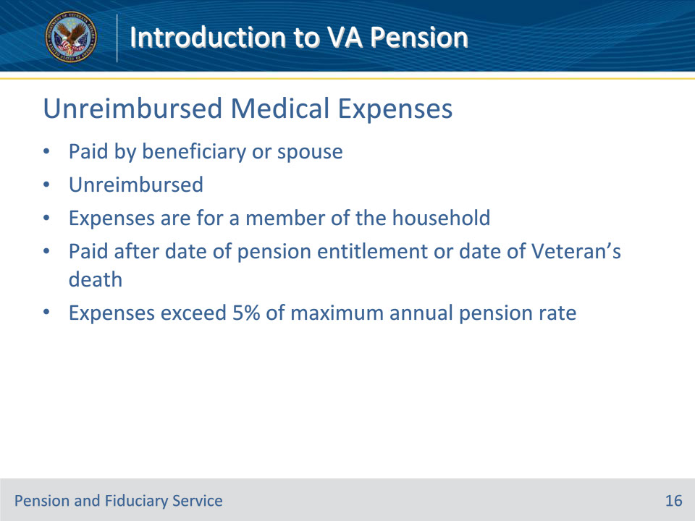
Slide notes

Instructor Notes:

Unreimbursed Medical expenses (UMEs)

• UMEs paid by a beneficiary (or by a Veteran’s spouse for Veteran awards) may be used to reduce the claimant’s countable income. A deduction for medical expenses is permitted if all of the following conditions:

• Expenses actually paid by beneficiary or beneficiary’s spouse

• Expenses are unreimbursed

• Expenses for beneficiary or relative who is a member of household

• Paid on or after date of pension entitlement or date of Veteran’s death (if after date of pension entitlement)

• Expenses exceed five percent 5% of maximum annual pension rate (MAPR)

Expenses actually paid by beneficiary or beneficiary’s spouse

• The beneficiary or spouse has actually paid the expenses.

• Unless medical expenses can be allowed prospectively, no deduction is allowed for expenses which are due, but not yet actually paid.

Expenses are unreimbursed

• The beneficiary or spouse has not received, and will not receive, reimbursement for the medical expenses from insurance or any other source; out-of-pocket expenses.

Expenses for beneficiary or relative who is a member of household

• The expenses were incurred on behalf of the beneficiary or a relative of the beneficiary (not necessarily a dependent for VA purposes) who is a member or constructive member of the beneficiary’s household.

• NOTE: “Constructive member” means that the expenses can be for a spouse in a nursing home, a child away at school, or a similar situation.

Paid on or after date of pension entitlement or date of Veteran’s death (if after date of pension entitlement)

• The expenses were paid on or after

• the effective date of entitlement to Improved Pension, or

• the date of the Veteran’s death, when the date of the Veteran’s death is later than the date of death pension entitlement.

Expenses exceed five percent deductible

• The unreimbursed expenses must exceed 5% of the applicable MAPR.

• Examples of common UMEs include, but are not limited to:

• Abdominal supports

• Acupuncture service

• Ambulance hire

• Anesthetist

• Arch supports

• Artificial limbs and teeth

• Back supports

• Braces

• Cardiographs

• Chiropodist

• Chiropractor

• Convalescent home (for medical treatment only

• Crutches

• Dental service, for example, cleaning, x- ray, filling teeth

• Dentures

• Dermatologist

• Drugs, prescription and nonprescription

• Gynecologist

• Hearing aids and batteries

• Home health services

• Hospital expenses

• Insulin treatment

• Insurance premiums, for medical insurance only

• Invalid chair

• Lab tests

• Lip reading lessons designed to overcome a disability

• Lodging incurred in conjunction with out-of-town travel for treatment (to be determined on a facts-found basis)

• Long-term care insurance

• Medical insurance premiums

• Medicare premiums

• Neurologist

• Nursing services for medical care, including nurse’s board paid by claimant

• Occupational therapist

• Ophthalmologist

• Optician

• Optometrist

• Oral surgery

• Osteopath, licensed

• Pediatrician examinations

• Physical examinations

• Physician

• Physical therapy

• Podiatrist

• Psychiatrist

• Psychoanalyst

• Psychologist

• Psychotherapy

• Radium therapy

• Sacroiliac belt

• Service animals and maintenance

• Speech therapist

• Splints

• Surgeon

• Telephone/teletype special communications equipment for the deaf

• Transportation expenses for medical purposes (plus parking and tolls or actual fares for taxi, buses)

• Vaccines

• Wheelchairs

• Whirlpool baths for medical purposes, and

• X-rays.

Slide 17 - Net Worth
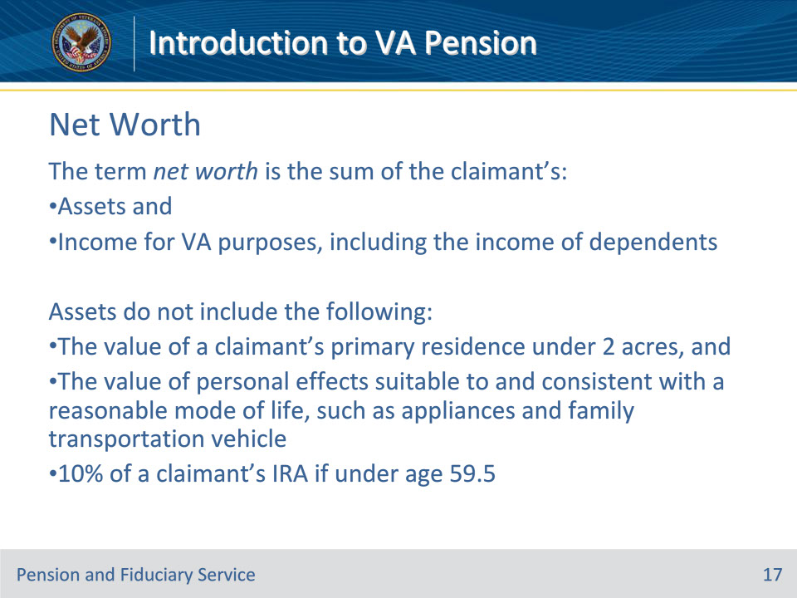
Slide notes

Instructor Notes:

When calculating annual income for net worth, subtract only reasonably predictable medical expenses.

If the total value of an annuity or similar financial instrument is used when calculating the asset amount, do not include the monthly income derived from the same annuity or similar financial instrument when calculating income for net worth

Slide 18 - Net Worth
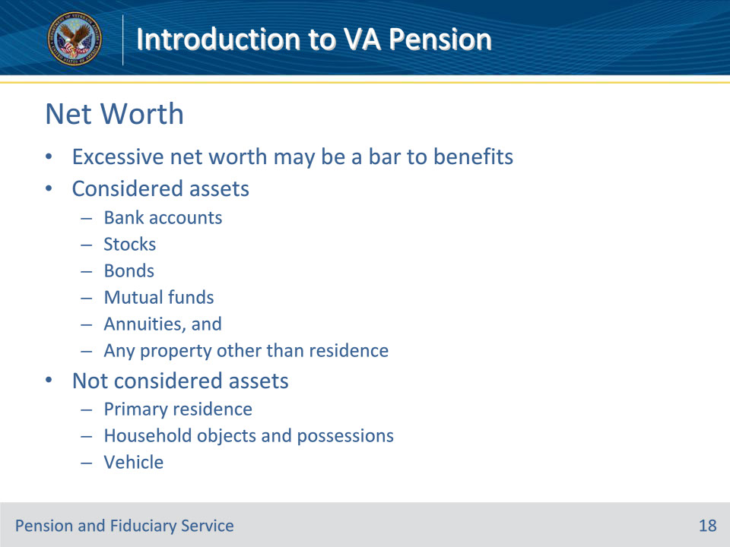
Slide notes

Instructor Notes:

Net Worth

• The basic issue in evaluating net worth is to determine whether or not the claimant’s financial resources are sufficient to meet the claimant’s basic needs without assistance from the Department of Veterans Affairs (VA).

• VA’s income-based programs are intended to give claimant’s a minimum level of financial security; they are not intended to protect substantial assets or build up the claimant’s estate for the benefit of heirs.

• The term net worth for VA purposes includes all personal property owned by the claimant, except for personal effects suitable to the claimant’s reasonable mode of life.

• For live pension, a Veteran’s net worth includes the net worth of his/her spouse.

• If a claimant’s assets are sufficiently large that the claimant could live off these assets for a reasonable period of time, non-service-connected pension will be denied for excessive net worth. If net worth is later depleted, the claimant can reapply for pension benefits.

• If a claimant transfers an interest in property to someone other than a relative residing in the claimant’s household, retaining a life estate in the property, the transfer may be disregarded in determining the claimant’s net worth for Improved Pension purposes, unless the right to ownership (control) is relinquished.

• This requirement is due to the fact that the life tenant retains ownership interest in the property during his/her lifetime.

• If a life estate or trust is discovered by the fiduciary hub, fiduciary personnel must notify the Pension management Center (PMC) of jurisdiction. If a copy of the life estate or trust is not of record already, the PMC will request a copy of the life estate to determine whether the right to ownership of the property has been relinquished.

• Example of how to estimate net worth when reporting to the PMC:

• If the claimant owns and resides in a multi-family dwelling, only the value of the unit occupied by the unit is excluded from net worth consideration; a claimant owns a duplex worth $200,000.00 and resides in one of the units. If both units are roughly comparable, consider net worth of $100,000.00.

• NOTE: If the claimant receives rental income he/she should have claimed the rental income on his/her application for non-service-connected pension benefits and submitted a VA Form 21P-4185, Report of Income from Property or Business. The value of the property is counted as part of the claimant net worth and the rental income is counted as part of the claimant’s monthly income. If the fiduciary hub discovers this information, fiduciary personnel must forward notice of said information to the PMC of jurisdiction.

Slide 19 - Terminology
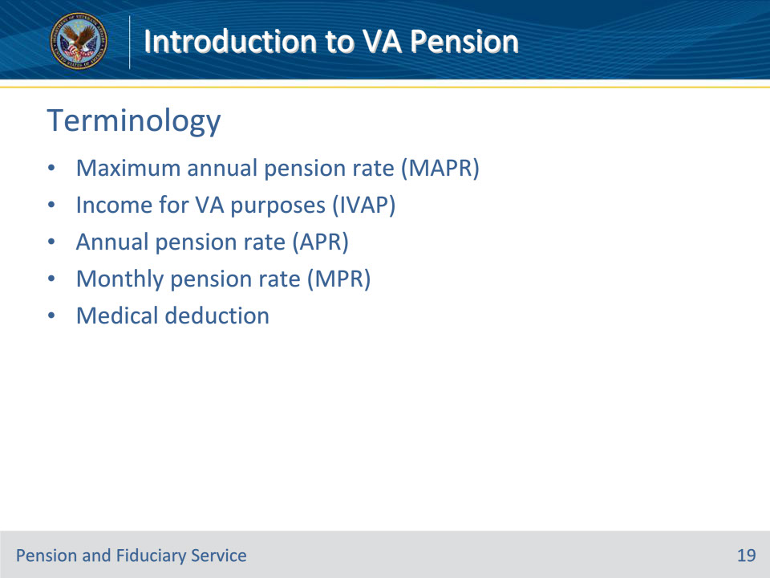
Slide notes

Instructor Notes:

Terminology

The following terms are important when calculating the rate of pension entitlement:

• Entitlement to Department of Veterans Affairs (VA) pension and Parents’ DIC is contingent on income, among other factors. A claim for

• Maximum annual pension rate (MAPR)

• The MAPR is set my Congress annual

• Income for VA purposes (IVAP)

• The amount of income a claimant has as determined by VA

• Annual pension rate (APR)

• The annual rate of pension payment the claimant receives from VA

• Monthly pension rate (MPR)

• The monthly rate of pension payment the claimant receives from VA

• Medical deduction

• This deduction is always 5% of the basic pension rate

Slide 20 - Calculating Entitlement Rate
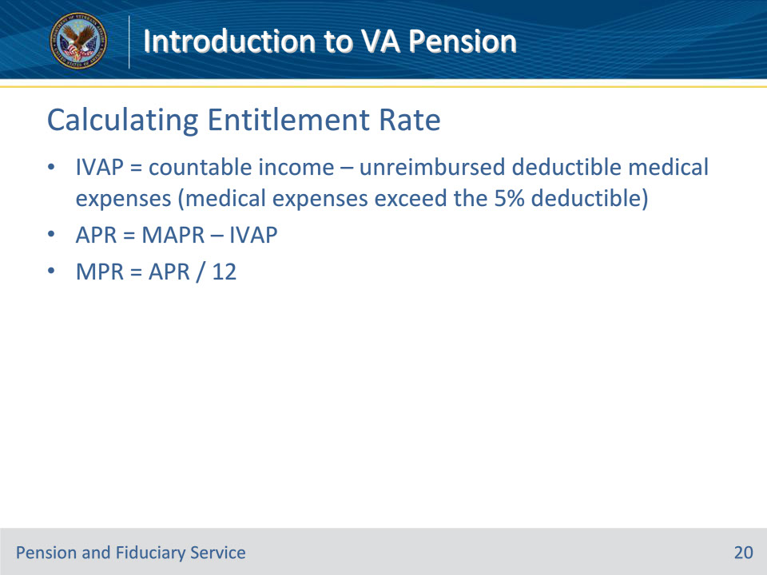
Slide notes

Instructor Notes:

Calculation Basics

• In order to qualify for the Department of Veterans Affairs (VA) pension benefit, the claimant’s yearly family income must be less than the amount set by Congress, the maximum annual pension rate (MAPR).

• Payment rate is the difference between the MAPR and the claimant’s income for VA purposes (IVAP) and the MAPR

• The amount of IVAP determines the payment amount of pension the claimant will receive; the higher the claimant’s IVAP, the lower the payment amount

• IVAP may not be computed on a calendar-year basis; the income-reporting period for pension claimant’s may extend over any 12-month period.

• IVAP can be recomputed within a 12-month income-reporting period if there is an intervening income change.

• Pension will be denied if IVAP is greater than MAPR

• NOTE: If income equals unreimbursed medical expenses, claimant will not receive max rate of pension; medical expenses must exceed income to potentially qualify for the max monthly pension rate.

• VA generally pays this difference in 12 equal monthly payments

How to Calculate Pension

• Calculating Income for VA Purpose (IVAP)

• IVAP = Countable income for year – unreimbursed medical expenses for the year + the medical deduction

• Countable income includes income from most sources as well as from any eligible dependents, as discussed on Slide 9.

• Unreimbursed medical expenses

• Medical deduction is 5% of the basic pension rate

• Calculating Annual Pension Rate (APR)

• APR = MAPR – IVAP

• The MAPR change each year, but is available for review in the pension rate tables

• Calculating the Monthly Pension Rate (MPR)

• MPR = APR/12 months

Slide 21 - Over and Underpayments
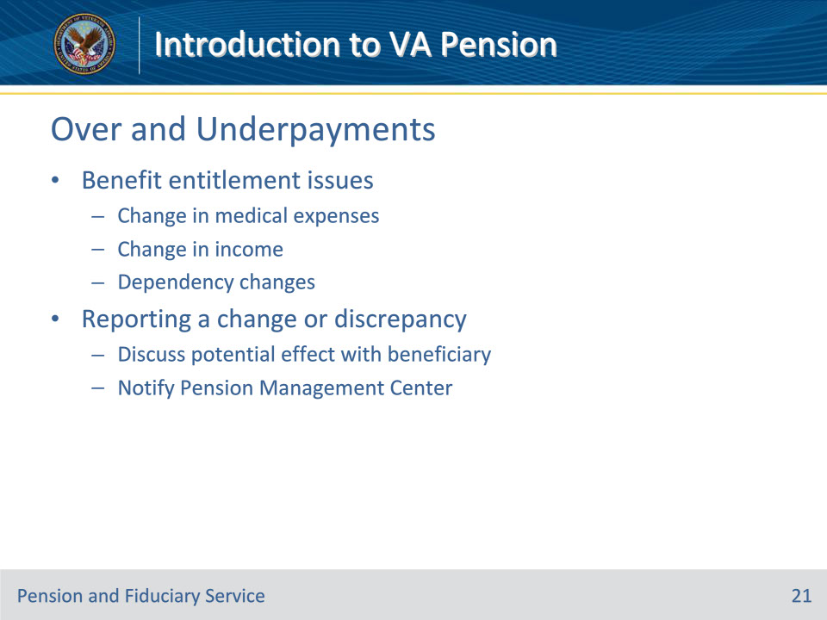
Slide notes

Instructor Notes:

Overpayments and Underpayments

• Now that you know the basics of VA Pension calculation, we can move on to discuss how Department of Veterans Affairs (VA) employees must react to situations where there may be a possible overpayment or underpayment of benefits

• an overpayment is a situation in which the beneficiary is receiving too much VA non-service-connected pension

• an underpayment is when the beneficiary is receiving too little VA non-service-connected pension

Benefit Entitlement Issues

• Again, non-service-connected pension is an income and assets based program; meaning that too much income, too many assets, too little medical expenses, or a change in income, assets, or medical expenses may increase, decrease, or terminate a beneficiary’s entitlement.

• Fiduciary hub personnel must be vigilant for changes in income, assets, and medical expenses so that:

• The change and the potential effect on entitlement can be explained to the beneficiary or fiduciary and

• Notification of the change can be sent to the Pension Management Center (PMC) of jurisdiction.

• Example situations:

• Change in medical expenses

• A beneficiary moves back into their home from a nursing home with 24/7 skilled nursing care and the in-home care provider he/she hired is $2,000.00 less each month than the nursing home.

• Change in income

• A beneficiary’s spouse becomes gainfully employed and makes $500.00 per week of income that was not considered when the beneficiary originally applied for non-service-connected pension benefits.

• Dependency change

• A beneficiary gets married, gets divorced, becomes a widow/widower, has a new child, adopts a child

• Change in net worth

• Remember: Non-service-connected pension is intended to help low-income beneficiaries secure the basic necessities of life; it is not intended to insure substantial assets against changes in market conditions.

Reporting a Change or Discrepancy

• When as change or discrepancy is discovered by fiduciary hub personnel, the information may be provided to the PMC of jurisdiction via a VA Form 27-0820, Report of General Information.

• Fiduciary hub personnel are responsible to act as a conduit for the information

• PMC personnel will review, develop for more information from the claimant (if necessary), and make an adjudication decision.

• Fiduciary hub personnel should also discuss the potential effect of the change on the beneficiary’s current benefit with the beneficiary and/or fiduciary. Fiduciary personnel must provide the appropriate application form to the beneficiary if there is the potential for an increase in benefits.

Slide 22 - Rate Tables
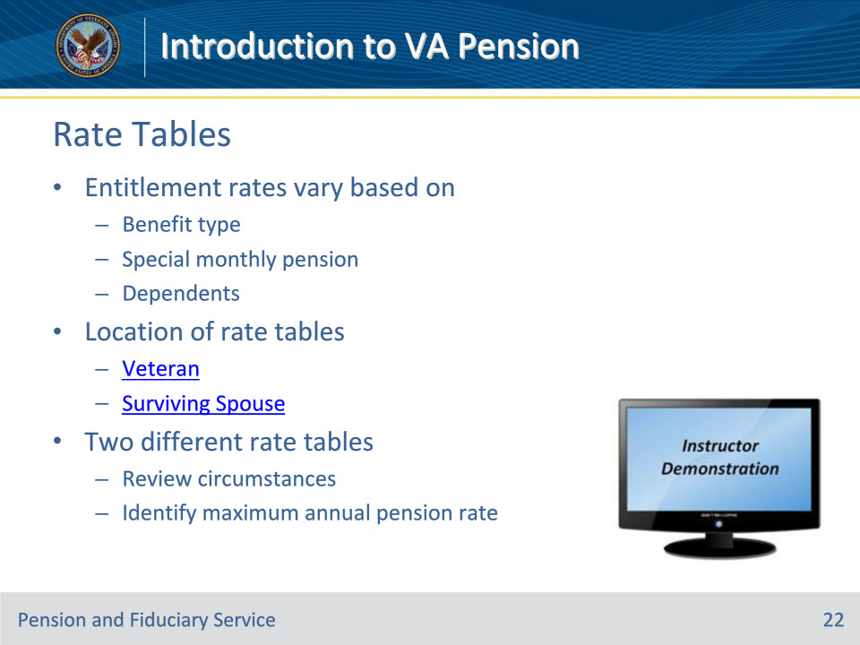
Slide notes

Instructor Notes:

Entitlement Rates

• As we’ve discussed throughout this lesson, entitlement rates vary based on many things, to include, but not limited to:

• Benefit type

• Special monthly compensation

• Number of dependents

Location of Rate Tables

• You can access the Pension Rate Tables webpage by:

• Navigating to the VBA Publications Intranet page

• Webpage: https://vbaw.vba.va.gov/bl/21/publicat/pub_home.htm

• Selecting “VBA Rate Tables” under the Miscellaneous column

• Webpage: https://vbaw.vba.va.gov/bl/21/Publicat/Manuals/Rates/rates_home.htm

• Selecting Pension Rate Tables at very bottom of page

• Webpage for Veteran’s Rate Table: https://benefits.va.gov/pension/current_rates_veteran_pen.asp

• Webpage for Surviving Spouse Rate Table: https://benefits.va.gov/PENSION/current_rates_survivor_pen.asp

How to Read Rate Tables

• There are two different rate tables for non-service-connected pension

• Veteran’s

• Surviving Spouse’s

• The non-service-connected pension rate tables have two columns:

• a description of the claimant’s dependency situation

• the Maximum Annual Pension Rate (MAPR)

• To find a rate:

• Locate the claimant’s dependency situation in the left hand column and

• Scroll over to the MAPR rate in the right hand column

Demonstration

Minimize PowerPoint and show students how to navigate to Veteran’s non-service-connected rate tables webpage

• Website: https://benefits.va.gov/PENSION/current_rates_veteran_pen.asp

Then show students how to determine the MAPR for:

• A single Veteran with no dependents and no aid and attendance ($13,931)

• Two Veteran’s married to each other and they are both receiving aid and attendance ($36,861)

Slide 23 - Standard Forms
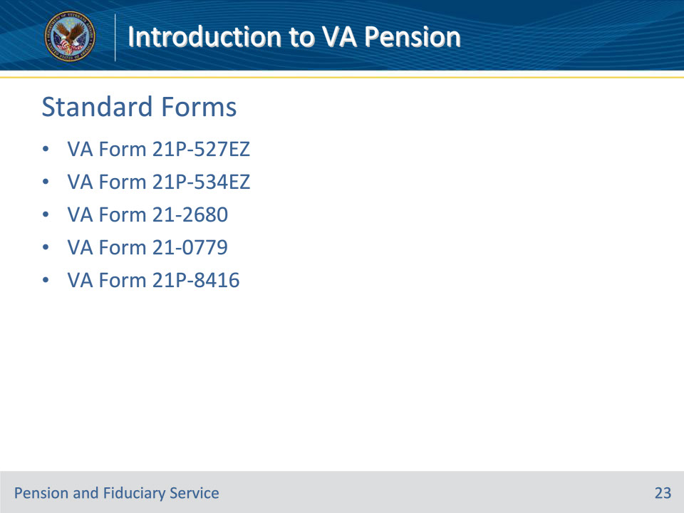
Slide notes

Instructor Notes:

Standard Forms

• Department of Veterans Affairs will only recognize non-service-connected pension claims if it is submitted on the required standard form. The required standard form to use is based on the type of benefit sought by the claimant.

Overview of Common Forms

• VA Form 21P-527EZ, Application for Veterans Pension

• Use of this form is recommended. (Note: The applicant may use VA Form 21P-527 for a non-original initial claim only.)

• VA Form 21P-534EZ, Application for DIC, Death Pension, and/or Accrued Benefits

• Use of this form is recommended so that claimants can take advantage of the Fully Developed Claim (FDC) program. FDC is the fastest way to have a claim processed because the claimant submits ALL evidence he/she has to support his/her claim at the time of application.

• VA Form 21-2680, Examination for Housebound Status or Permanent Need For Regular Aid and Attendance

• This form should be supplied if the claimant is specifically claiming special monthly compensation benefits based on aid and attendance and/or housebound

• VA Form 21P-0779, Request for Nursing Home Information in Connection with Claim for Aid and Attendance

• This form should only be utilized by a claimant who is the resident of a nursing home. The form will support his/her claim for special monthly pension

• VA From 21P-08416, Medical Expense Report

• This form allows the claimant to report unreimbursed medical expenses to the Pension Management Center and should be used when asking for an adjustment of benefit rate

Slide 24 - Questions?
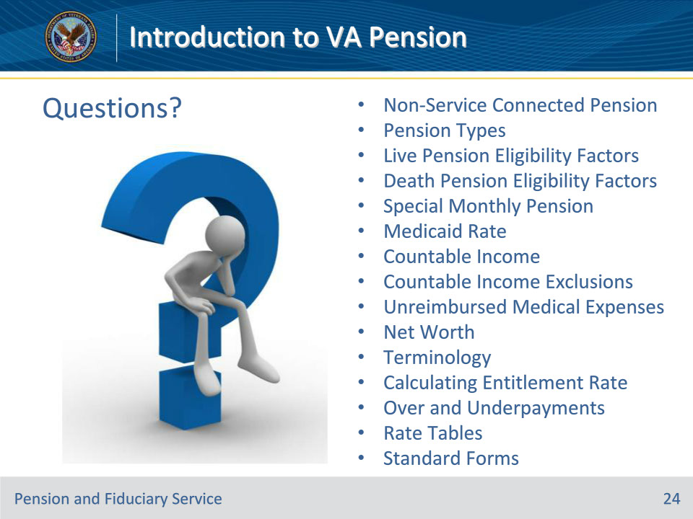
Slide notes

(Recall) These are our learning objectives as stated from the beginning of the training:

• Summarize and identify types of non-service connected pension

• State eligibility requirements

• Define Special Monthly Pension

• Discuss Medicaid and the effect on entitlement rates

• Identify pertinent financial information

• Describe how to calculate rates

• Recognize causes of over and underpayments

• Recall how to access and read rate tables

• Identify common forms

Are there any additional questions?

Slide 25 - TMS Survey
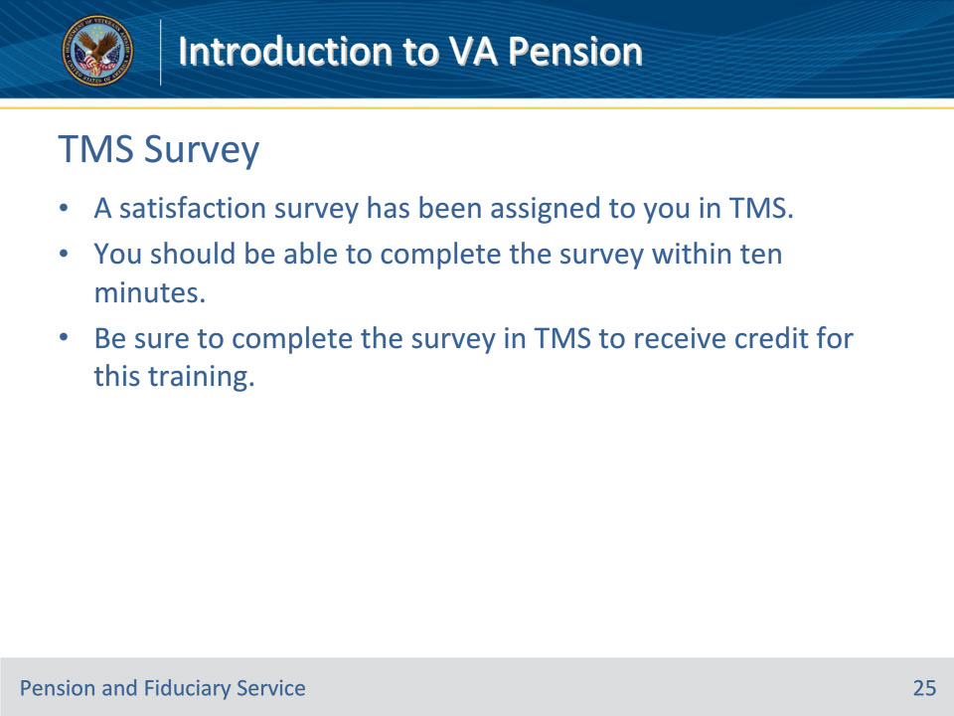
Slide notes

Instructor Notes:

A satisfaction survey has been assigned to you in TMS. You should be able to complete the survey within ten minutes. Completing the survey will allow you to receive credit for this training.

