Slide 1 - Introduction to VA Service-Connected Compensation
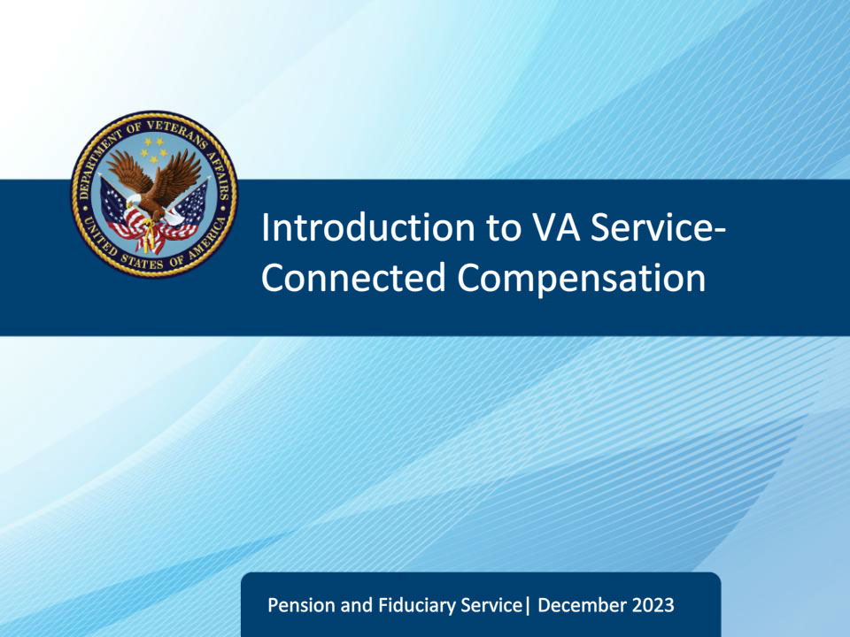
Slide notes

Instructor Notes:

The purpose of this lesson is to provide learners with the knowledge to assist Veterans in understanding and applying for VA service-connected disability compensation and special monthly compensation (SMC).

Slide 2 - Objectives
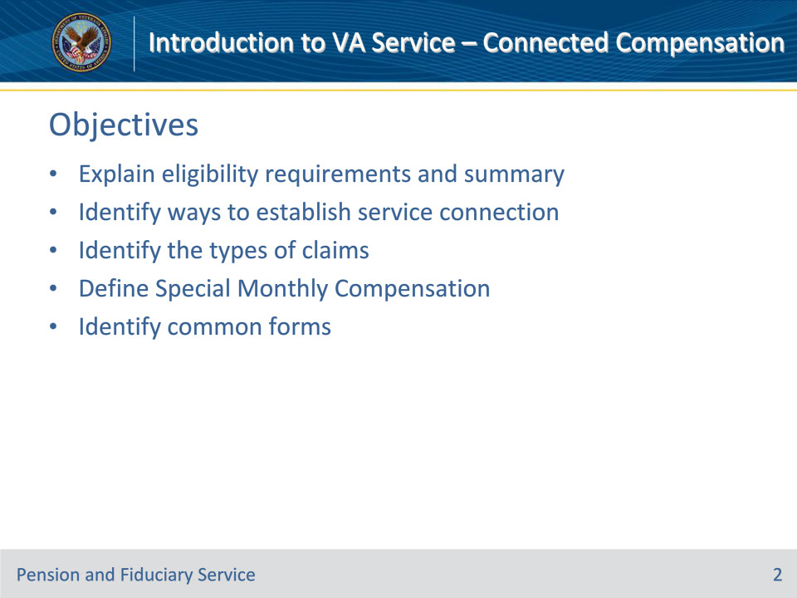
Slide notes

Instructor Notes:

By the end of this lesson, given the training and corresponding references, the learner will be able to do the following:

• Explain eligibility requirements and summary of service-connected compensation

• Identify ways to establish service connection

• Identify the types of service-connected compensation claims

• Define Special Monthly Compensation

• Identify forms used to apply for service-connection

Slide 3 - References
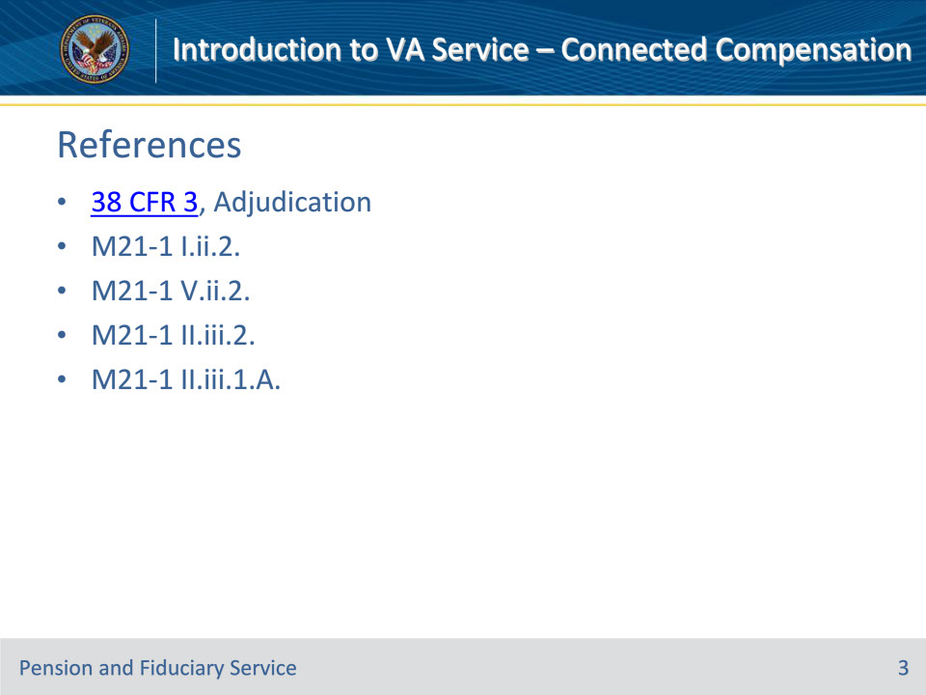
Slide notes

Instructor Notes:

These are the relevant references pertaining to VA Service-Connected Compensation:

• 38 CFR 3, Adjudication

• Website: https://www.ecfr.gov/cgi-bin/text-idx?SID=ff006f75c6eb2904cc88083ed0d0f265&mc=true&node=pt38.1.3&rgn=div5#se38.1.3_14

• M21-1 I.ii.2., Department of Veterans Affairs (VA) Benefit Programs

• M21-1 V.ii.2., Determining Service Connection

• M21-1 II.iii.2., Types of Claims and Claims Actions

• M21-1 II.iii.1.A., Applications for Benefits

Slide 4 - References (Continued)
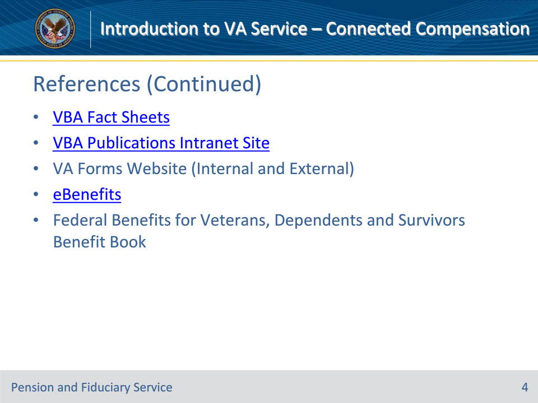
Slide notes

Instructor Notes:

These are the relevant references pertaining to VA Service-Connected Compensation:

• VBA Fact Sheets

• Webpage: https://benefits.va.gov/BENEFITS/factsheets.asp

• VBA Publications Intranet Website

• Webpage: https://vbaw.vba.va.gov/bl/21/publicat/pub_home.htm

• VA Forms (Internal) available to VA employees:

• Website: http://vaww.va.gov/vaforms/

• VA Forms (External) available to Veterans:

• Websitehttp://www.va.gov/vaforms/

• eBenefits

• Website: https://www.ebenefits.va.gov/ebenefits/homepage

• Federal Benefits for Veterans, Dependents and Survivors Benefits Book

Slide 5 - Service-Connected Compensation
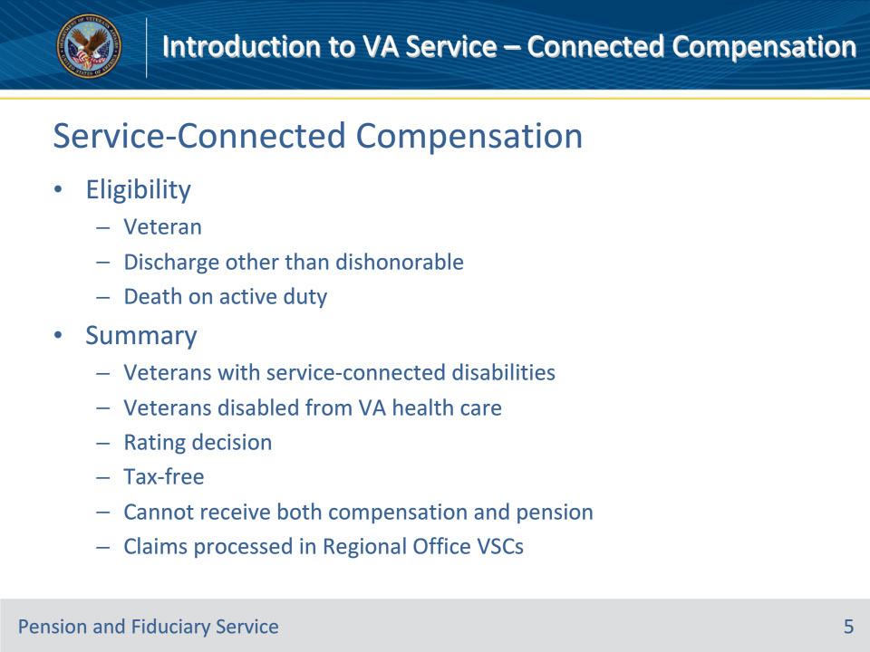
Slide notes

Policy Reference(s): 38 CFR 3.4, 38 CFR 3.12

Other Reference(s): Federal Benefits for Veterans, Dependents and Survivors Benefits Book

Instructor Notes:

Eligibility

• To be eligible for service-connected compensation, a Veteran must have been released from active duty from the Armed Forces of the United States under conditions other than dishonorable (which includes a person who died on active duty) and incurred a medical disability that can be rated as service-connected.

Summary

• Service-connected compensation is a monetary benefit paid to Veterans because of service-connected disabilities.

• Service-connected disabilities are injuries or diseases incurred while on active duty or made worse by active military service.

• Service-connected compensation is also paid to certain Veterans disabled from VA health care.

• The Veteran applies for service-connected compensation by claiming conditions he/she believes are related to his/her service, supplies the Department of Veterans Affairs (VA) with medical evidence to support his/her claim or attends a physical to evaluation the condition(s) claimed. The VA reviews and analyzes all medical evidence and produced what is called a rating decision to notify the Veteran of VA’s decision on each of the conditions he/she claimed as service-connected.

• Rating decisions may state a condition is:

• Not service-connected

• 0% service connected

• This is important because even a decision of 0% service-connected is the VA stating there is a link between the condition and the Veteran’s service

• 10% – 100% service connected (current and historic rate tables can be found at va.gov)

• Monthly monetary payments are made to Veterans who have one or more service-connected disabilities rated at 10% or more disabling or have multiple zero percent ratings which may be combined to be paid at the 10% rate.

• The monthly benefit payments are tax-free.

• Website: https://www.va.gov/opa/publications/benefits_book.asp

• A Veteran may qualify to receive service-connected compensation or non-service-connected pension, but he/she can’t receive both at the same time. If entitled to both, the VA will pay the greater benefit.

• Claims for service-connected compensation are processed at a Veteran Service Center in one of the 58 Regional Offices

Slide 6 - Establish Service Connection
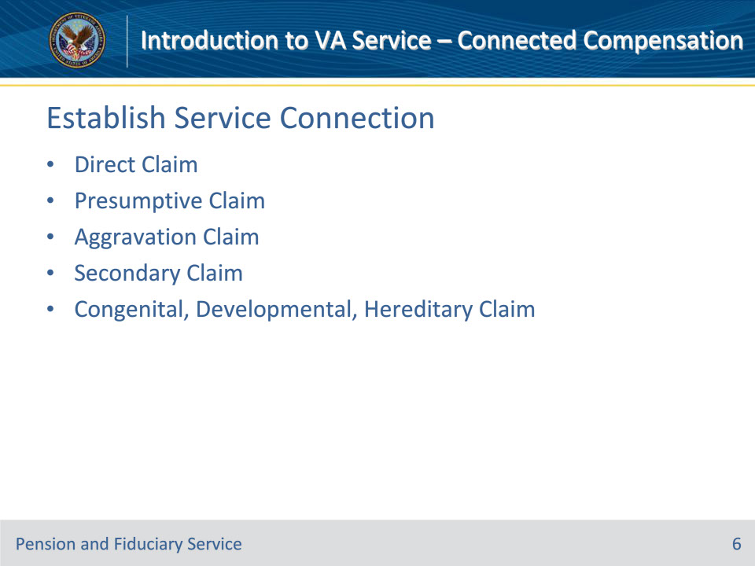
Slide notes

Policy Reference(s): 38 CFR 3.303 – 38 CFR 3.310 ; M21-1 V.ii.2.

Instructor Notes:

In order to receive monetary benefits for service-connected condition(s), a Veteran must have a compensable service connected disability.

There are various ways a disability can be granted service connection:

• Direct

• Presumptive Conditions

• Aggravation

• Secondary

• Congenital, Developmental, Hereditary

Direct Disability Claims:

• Direct claims are claims for a particular disease or injury was incurred in service. This is accomplished by affirmatively showing inception during service.

Presumptive Disability Claims:

• A presumptive illness means the Veteran is presumed to have incurred a disease within the dates of his/her qualifying service even though there is no evidence of such disease during the period of service.

• Presumptive illnesses are chronic, tropical, or prisoner of war related diseases, a disease associated with exposure to certain herbicide agents, or a disease associated with exposure to contaminants in the water supply at Camp Lejeune.

Aggravated Disability Claims:

• An illness aggravated by service means the Veteran was injured or contracted a disease before the dates of his/her qualifying service and the residuals of that injury or disease were worsened by his/her participation in service.

Secondary Disability Claims

• A secondary disability is a disability caused by a primary, service-connected condition. The secondary condition may be considered even if that secondary disability was not incurred or aggravated by military service. However, it is necessary to prove that there is a causal relationship between the primary and secondary conditions, which is determined by medical evidence. [38 CFR §§3.310]

• Example: Veteran Joe has a service-connected rated disability for diabetes Type II. Subsequent to release from military service, Veteran Joe has lost feeling in some of his extremities. Veteran Joe may apply for diabetic neuropathy as a secondary disability to diabetes.

Congenital, Developmental, Hereditary Claim

• Congenital or developmental defects refer to normally static, structural or inherent body abnormalities which are typically present at birth and are generally incapable of improvement or deterioration.

• Congenital, developmental, or hereditary diseases refer to diseases that are recognized to be congenital, developmental, or familial in origin. A congenital, developmental, or hereditary disease may appear in adulthood and is capable of improvement or deterioration.

• diseases of congenital, developmental, or familial, hereditary origin that

• first manifest themselves during service, or

• pre-exist service and progress at an abnormally high rate during service

• a hereditary or familial disease that first became manifest to a compensable degree within the presumptive period following discharge from service pursuant to 38 CFR 3.309(a), provided the rebuttable presumption provisions of 38 CFR 3.307 are satisfied, and

• disabilities resulting from an overlying injury or disease of a congenital defect.

Slide 7 - Establish Service Connection (Continued)
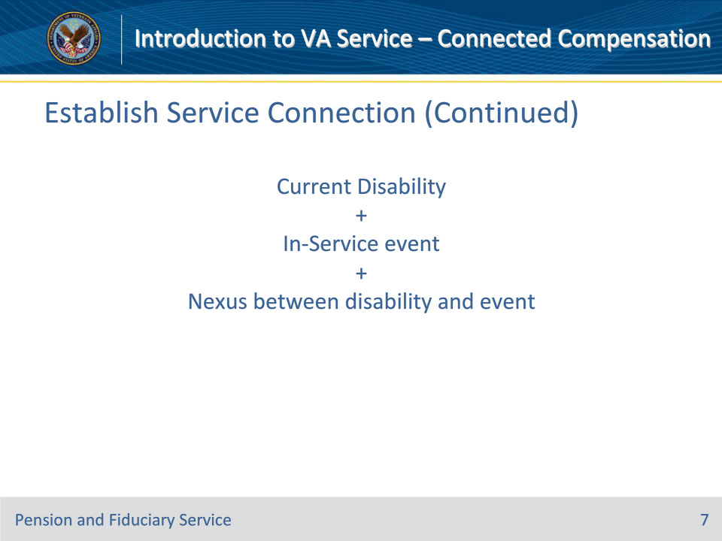
Slide notes

Policy Reference(s): 38 CFR 3.303; M21-1 V.ii.2.

Instructor Notes:

In order for a service-connected disability to be established, the evidence must show:

• a current disability,

• an in-service event, and

• a nexus (connection) between the in-service event and the current disability.

The in-service event may be an incident, first diagnosis, or disability. In the case of presumptive conditions, this may include exposure to certain hazards, locations, or experiences during military service. The Department of Veterans Affairs reviews all evidence of record in the claims folder to make a determination on service-connection.

Types of evidence that may be reviewed include:

• application package

• service records

• service treatment records

• service verification documents

• lay and personal statements

• additional medical evidence, to include:

• private provider medical records

• Compensation and Pension examination results

Slide 8 - Claim Types
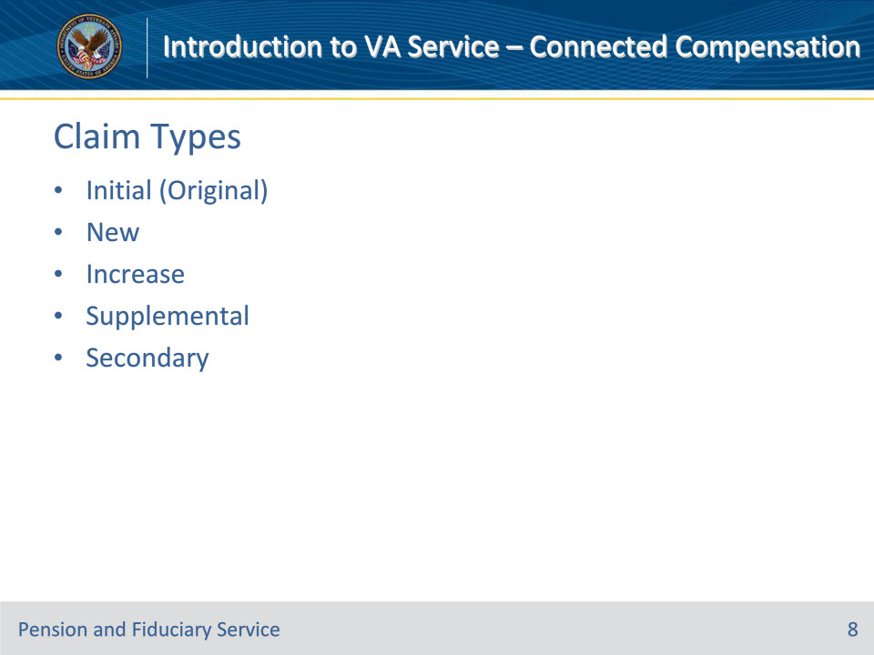
Slide notes

Policy Reference(s): 38 CFR 3.1; M21-1 II.iii.2.

Instructor Notes:

Initial (Original) Claim

• a claim for a condition never filed before

New claim

• A claim has already been filed with the VA, but the claimant is filing for a new condition

Claim for Increase

• a claim to increase the degree(or percentage) of a service-connected condition.

Supplemental (Reopened) Claim

• a claim to reopen a previously denied condition

• to reopen a claim, the Veteran must submit new and material evidence.

• New and material evidence means evidence that has never been considered or reviewed by the Department of Veterans Affairs

Secondary Claim

• Claim for a condition that was caused or made worse by an already existing service-connected condition.

Slide 9 - Special Monthly Compensation
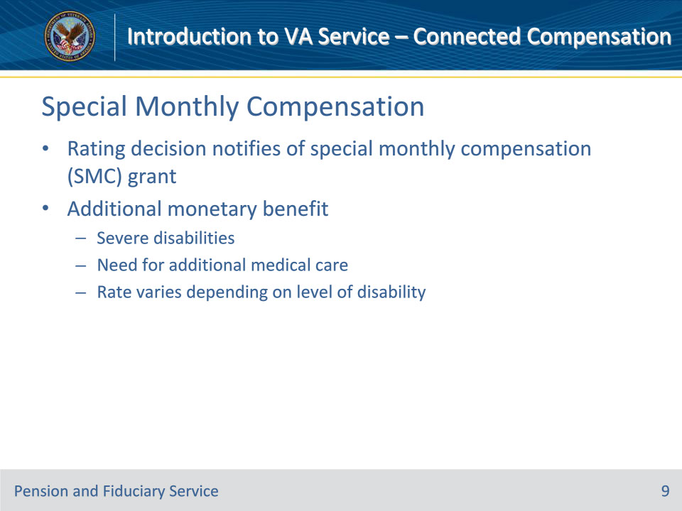
Slide notes

Policy Reference(s): 38 CFR 3.350

Instructor Notes:

Rating Decision

• A Department of Veterans Affairs (VA) rating decision notifies the Veteran of VA’s decision on Special Monthly Compensation (SMC).

• SMC may be:

• granted or denied in conjunction with the initial application for benefits

• granted or denied in a stand alone claim

• inferred by the VA based on medical evidence of record

Additional Benefit

• SMC is an additional financial benefit available to Veteran’s with service-connected condition(s). SMC is a special allowance for Veterans with severe disabilities or the need for additional medical care.

• VA can pay the additional service-connected compensation benefit to a Veteran who, as a result of military service, incurred the loss or loss of use of specific organs or extremities.

• The disabilities VA can consider for SMC include:

• loss, or loss of use, of a hand or foot

• immobility of a joint or paralysis

• loss of sight of an eye (having only light perception)

• loss, or loss of use, of a reproductive organ

• complete loss, or loss of use, of both buttocks

• deafness of both ears (having absence of air and bone conduction)

• inability to communicate by speech (complete organic aphonia)

• loss of a percentage of tissue from a single breast, or both breasts, from mastectomy or radiation treatment

• The VA will pay higher rates for combinations of these disabilities such as loss or loss of use of the feet, legs, hands, and arms, in specific monetary increments, based on the particular combination of the disabilities. There are also higher payments for various combinations of severe deafness with bilateral blindness.

• Additionally, if a Veteran is service-connected at the 100% rate and is housebound, bedridden, or is so helpless as to need the aid and attendance of another person, then payment of additional SMC can be considered. The amount of SMC varies depending on the level of disability.

Slide 10 - Standard Forms
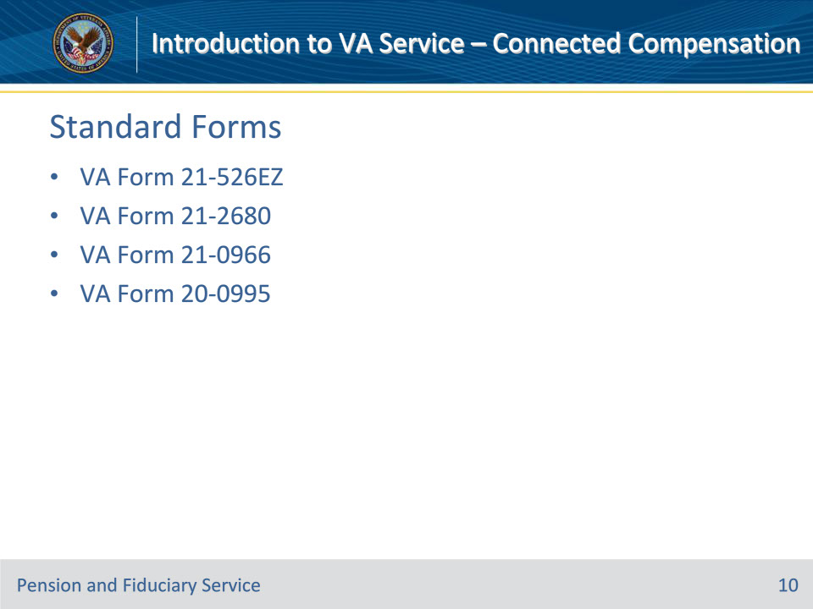
Slide notes

Policy Reference(s): M21-1 II.iii.1.A.

Instructor Notes:

Standard Forms

• The Department of Veterans Affairs will only recognize service-connected compensation claims if it is submitted on the required standard form. The required standard form to use is based on the type of benefit sought by the Veteran.

Overview of Common Forms

• VA Form 21-526EZ, Application for Disability Compensation and Related Compensation Benefits

• Use of this form is recommended so that claimants can take advantage of the Fully Developed Claim (FDC) program. FDC is the fastest way to have a claim processed because the Veteran submits ALL evidence he/she has to support his/her claim at the time of application.

• VA Form 21-2680, Examination for Housebound Status or Permanent Need For Regular Aid and Attendance

• This form should be supplied if the Veteran is specifically claiming special monthly compensation benefits based on aid and attendance and/or housebound

• VA Form 21-0966, Intent to File a Claim for Compensation and/or Pension, or Survivors Pension and/or DIC

• Use VA Form 21-0966 if you’re still gathering information to support your claim, and want to start the filing process. Submitting an intent to file can secure the earliest possible effective date for any retroactive payments you may be eligible to receive.

• VA Form 20-0995, Decision Review Request: Supplemental Claim

• Use VA Form 20-0995 if you disagree with a VA decision and want to provide new evidence to support your claim.

Slide 11 - Questions?
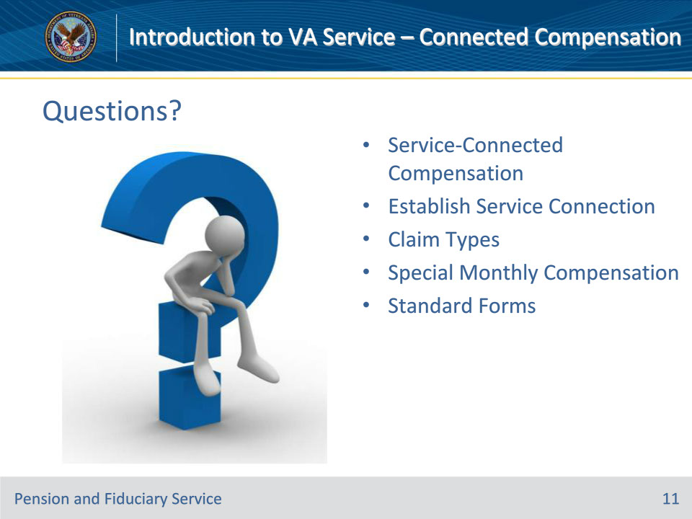
Slide notes

(Recall) These are our learning objectives as stated from the beginning of the training:

• Explain eligibility requirements and summary of service-connected compensation

• Identify ways to establish service connection

• Identify the types of service-connected compensation claims

• Define Special Monthly Compensation

• Identify common forms used to apply for service-connection

Are there any additional questions?

Slide 12 - TMS Survey
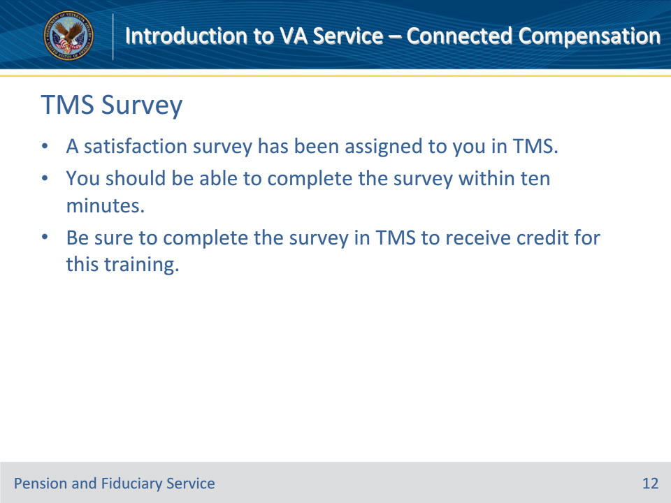
Slide notes

Instructor Notes:

A satisfaction survey has been assigned to you in TMS. You should be able to complete the survey within ten minutes. Completing the survey will allow you to receive credit for this training.

