Slide 1 - Fiduciary Service Representatives
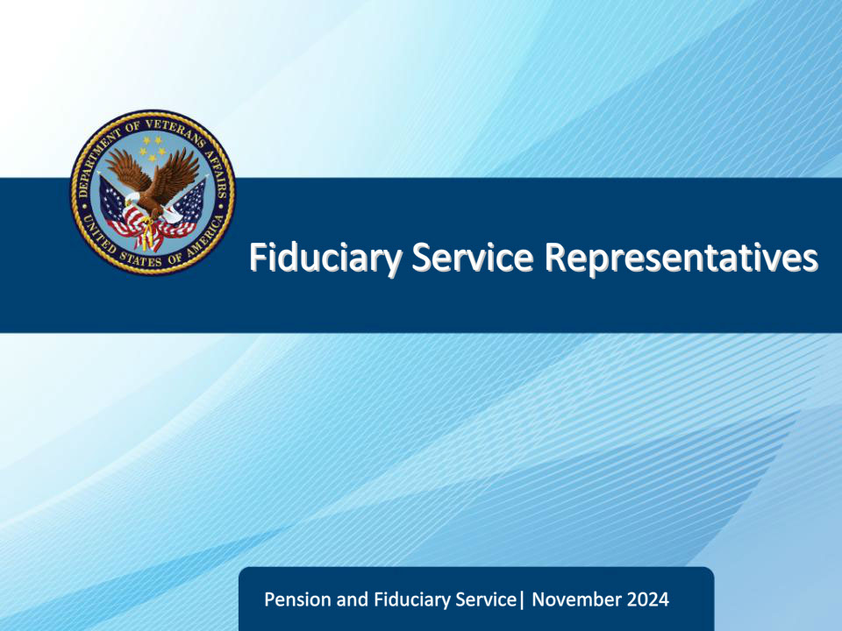
Slide notes

Course Description:

This lesson teaches the learner about the Fiduciary Service Representative position and its critical work functions.

Slide 2 - Objectives
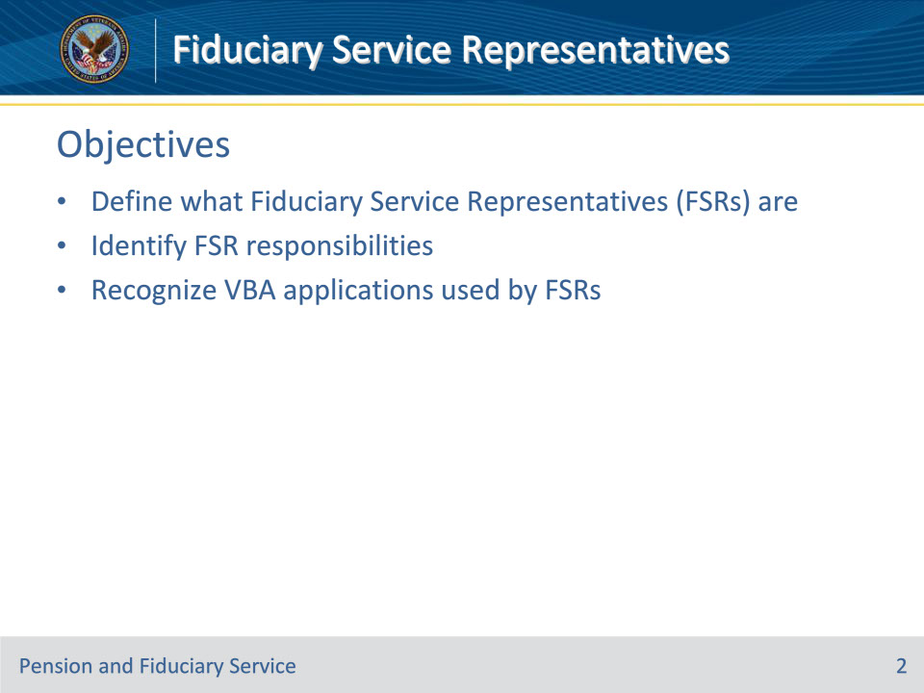
Slide notes

At the end of this lesson, given the training and corresponding references, the learner will be able to do the following:

• Define what fiduciary service representatives are

• Identify FSR responsibilities

• Recognize VBA Applications used by FSRs

Slide 3 - References
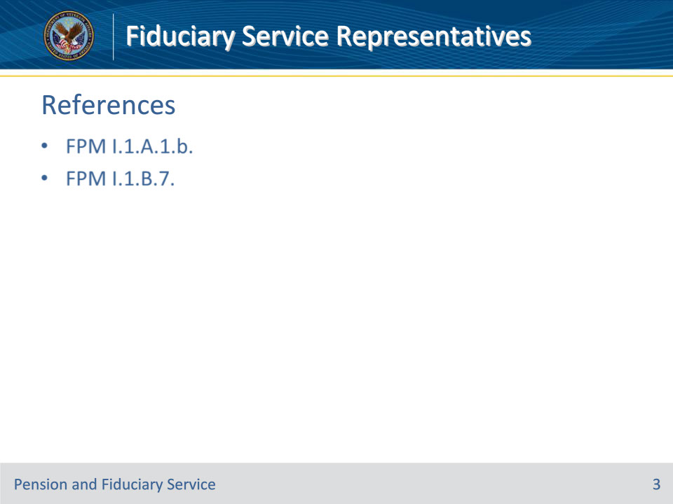
Slide notes

Instructor Notes:

The following are relevant references for this training:

• FPM I.1.A.1.b. Purpose of Fiduciary Promulgation Activity

• FPM I.1.B.7. Fiduciary Service Representative (FSR) Responsibilities

Slide 4 - What are Fiduciary Service Representatives?
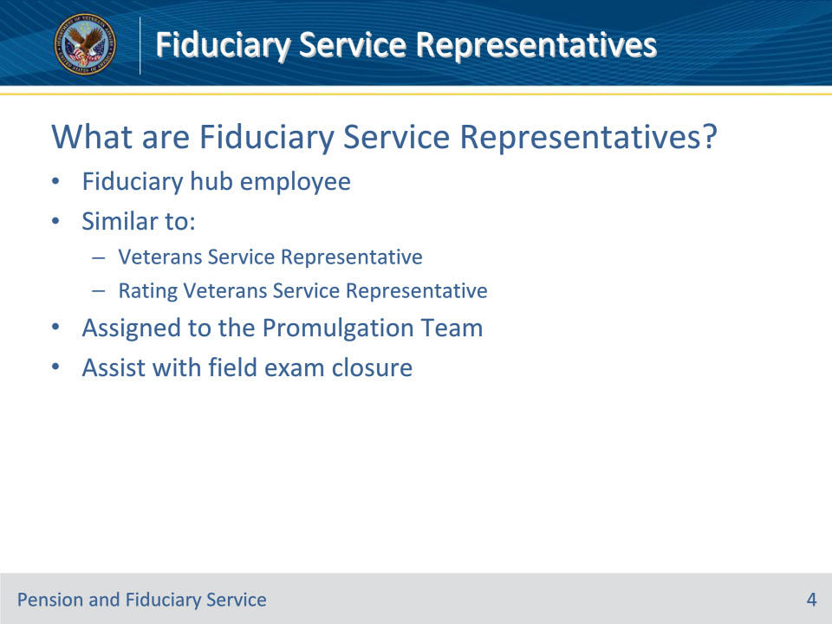
Slide notes

Policy Reference(s): FPM I.1.A.1.b.; FPM I.1.B.7.

Instructor Notes:

Fiduciary Hub Employee

• Fiduciary Service Representatives (FSRs) are employees of the Department of Veterans Affairs (VA) who work for the fiduciary hubs.

Similar to VSR and RVSR

FSRs are similar to the VSR and RVSR positions which exist in the Veterans Service Centers and Pension Management Centers. The difference is that FSR’s exist only in the fiduciary hub and thus focus only on several specific fiduciary functions.

Assigned to the Promulgation Team

FSRs are assigned to the promulgation team within the fiduciary hub.

The purpose of fiduciary promulgation activity is to expedite Department of Veterans Affairs (VA) benefit payment actions to beneficiaries by limiting the transfers of jurisdiction between the regional office (RO) and the hub when VA has evidence that a beneficiary is unable to manage his/her VA benefits.

FSRs also assist with closing certain field exams.

Slide 5 - General Responsibilities
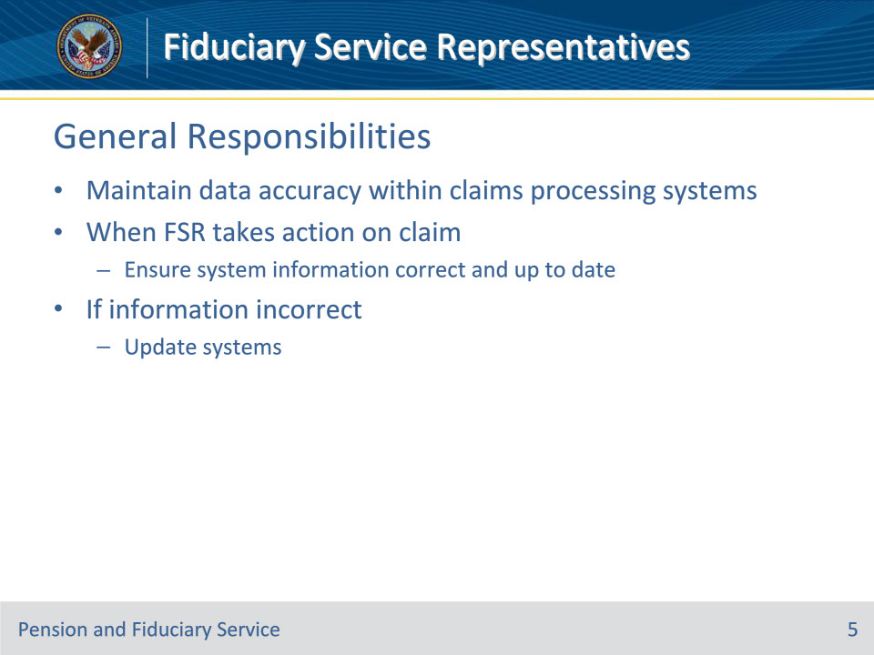
Slide notes

Policy Reference(s): FPM I.1.B.7.a.

Instructor Notes:

FSRs are responsible for maintaining the data accuracy within claims processing systems. When an FSR takes an action on a claim, they must ensure system information is correct and up to date. If the information is not correct, they must update the systems.

Slide 6 - Competency Determinations
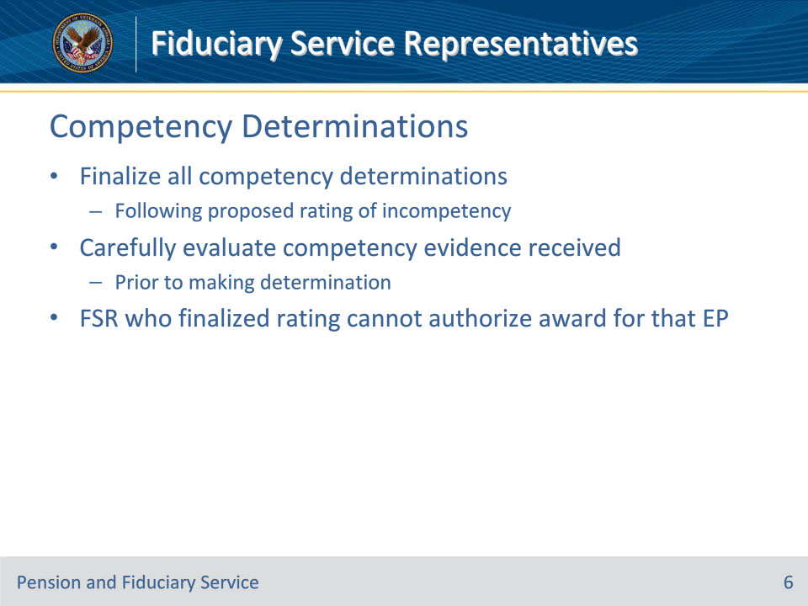
Slide notes

Policy Reference(s): FPM I.1.B.7.b.

Instructor Notes:

The FSR is responsible for finalizing all competency determinations following a proposed rating of incompetency. FSRs must carefully evaluate any evidence received regarding the competency of the beneficiary prior to making their determination.

Important: The FSR who finalized the rating of incompetency cannot authorize the award for that EP.

Slide 7 - Fiduciary Appointment
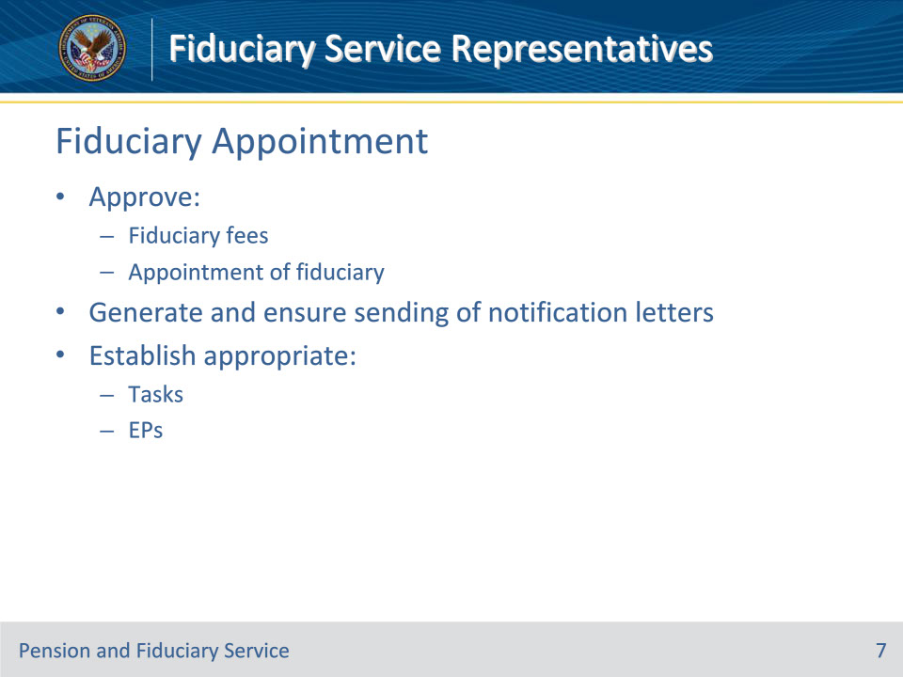
Slide notes

Policy Reference(s): FPM I.1.B.7.c.

Instructor Notes:

As part of the promulgation team, FSRs have additional responsibilities associated with the appointment of a fiduciary. These responsibilities include, but are not limited to

• approving

• fiduciary fees, and

• appointment of fiduciary

• generating and ensuring the sending of beneficiary and fiduciary notification letters, and

• establishing appropriate

• tasks, and

• EPs.

Slide 8 - Award Actions
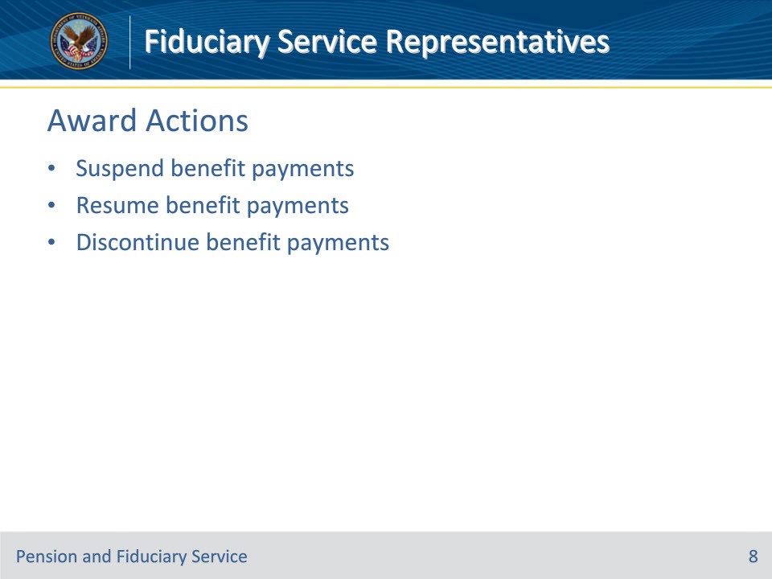
Slide notes

Policy Reference(s): FPM I.1.B.7.d.

Instructor Notes:

FSRs are responsible for suspending, resuming, or discontinuing benefit payments when action is identified as a result of a finding by the hub of jurisdiction.

Slide 9 - VBA Applications
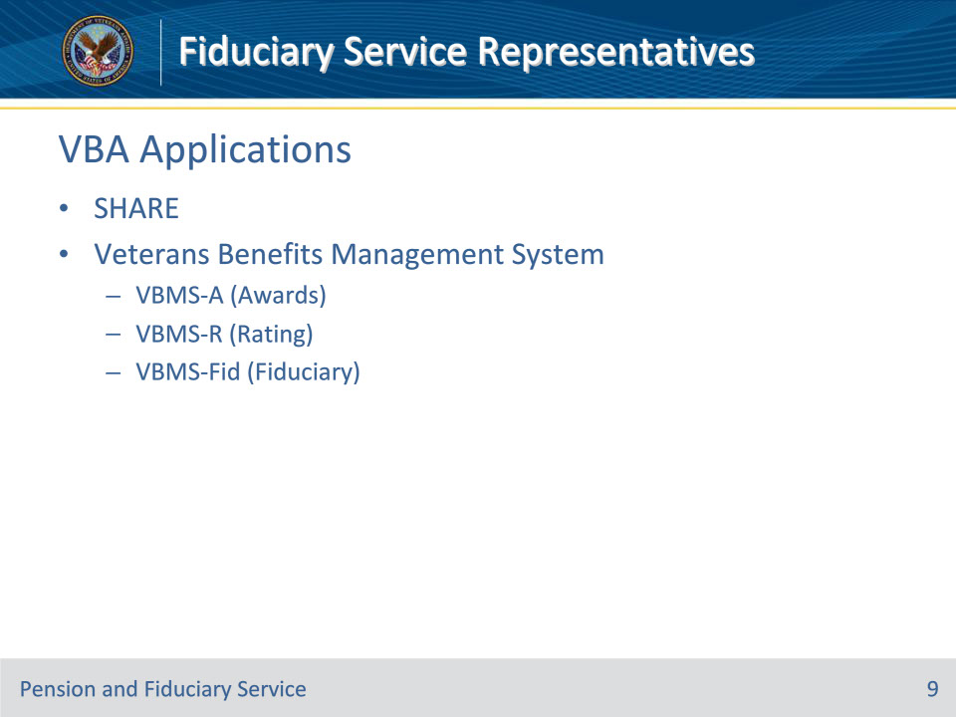
Slide notes

Instructor Notes:

SHARE

• SHARE is utilized by Department of Veterans Affairs (VA) employees to create and maintain beneficiary records to support case management.

• It is a single system that interfaces with other VBA systems and databased to retrieve data and create a ‘Corporate’ environment.

• Beneficiary records can be reviewed and updated through various commands in Share

• FSRs can use SHARE to confirm:

• benefit type (service-connected compensation, non-service-connected pension, etc.)

• benefit entitlement date

• service-connected and non-service-connected disabilities,

• date of rating decision

• benefit entitlement (payment) rate

• contact information

• dependency information

• overpayment information

• Social Security Administration benefit information

• Update fiduciary appointment information by conducting a Change in Fiduciary (CFID) command

Veterans Benefits Management System (VBMS)

• VBMS is a web-based, electronic claims processing solution, which provides the ability to:

• establish claims,

• view and store electronic documents in an electronic folder (eFolder),

• track evidence requested from beneficiaries,

• complete rating decisions,

• promulgate award decisions,

• provided end-users with web-accessible rules-based tools and calculators, and

• more

• FSRs can use VBMS to:

• VBMS-A to adjudicate and authorize awards

• VBMS-R to promulgate final rating decisions

• VBMS (core) to:

• view claim documents and correspondence (development letters and award letters)

• view rating decisions

• view correspondence sent from the Beneficiary or Fiduciary to the Fiduciary Hub

• view correspondence sent from the Fiduciary Hub to the Beneficiary or Fiduciary

• VBMS-Fid to view:

• field exams, accounting information, and fiduciary diary date information

• proposed incompetent beneficiaries - Beneficiary Profile

• active beneficiaries and fiduciaries –Beneficiary Profile and the Fiduciary Profile

• inactive records for beneficiaries and fiduciaries that are no longer in the Fiduciary Program – Beneficiary Record and Fiduciary Record

• Field examination reports and associated notification letters are documented using VBMS-Fid

• Other fiduciary specific information and EPs

Slide 10 - Questions?
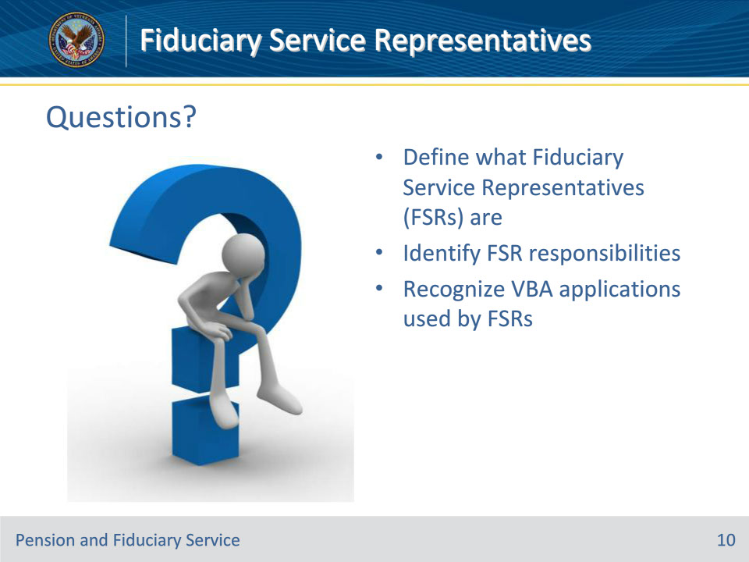
Slide notes

Instructor Notes:

(Recall) These are our learning objectives as stated from the beginning of the training:

• Define what fiduciary service representatives are

• Identify FSR responsibilities

• Recognize VBA Applications used by FSRs

Are there any additional questions?

Questions should be filtered through your QRT team. They will submit your questions to the Field Inquiry Tool (FIT) on your behalf.

Slide 11 - TMS Survey/Assessment
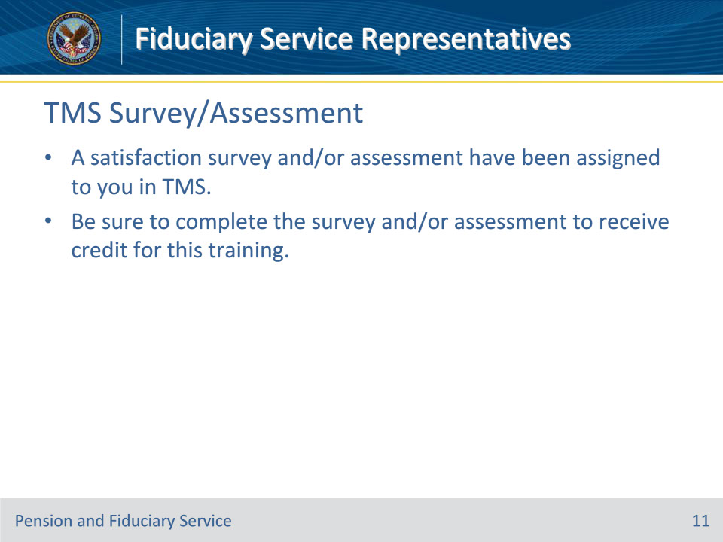
Slide notes

Instructor Notes:

A satisfaction survey and/or assessment have been assigned to you in TMS.

Be sure to complete the survey and/or assessment to receive credit for this training.

