Slide 1 - Fiduciary Hub Responsibilities
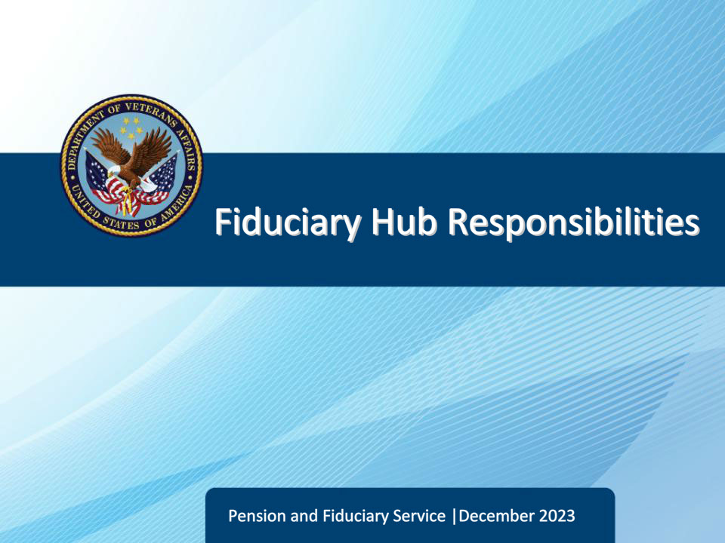
Slide notes

Course Description:

This course provides the learner with an understanding of the main responsibilities and functions of the fiduciary hubs.

Slide 2 - Objectives
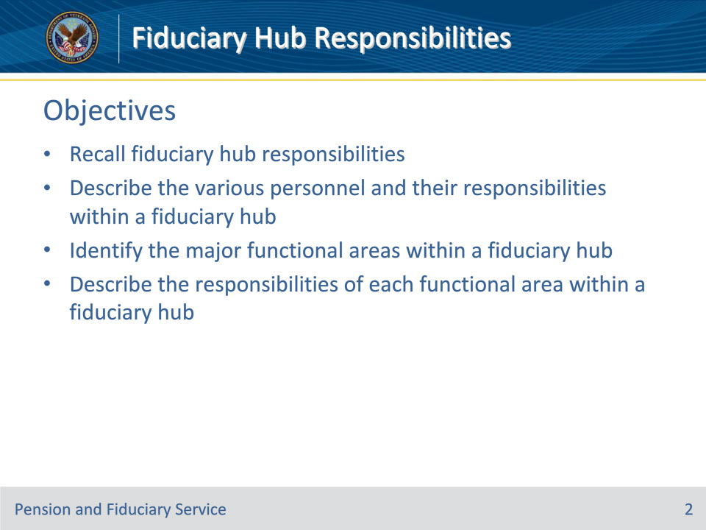
Slide notes

At the end of this lesson, given the training and corresponding references, the learner will be able to do the following:

• Recall fiduciary hub responsibilities

• Describe the various personnel and their responsibilities within a fiduciary hub

• Identify the major functional areas within a fiduciary hub

• Describe the responsibilities of each functional area within a fiduciary hub

Slide 3 - References
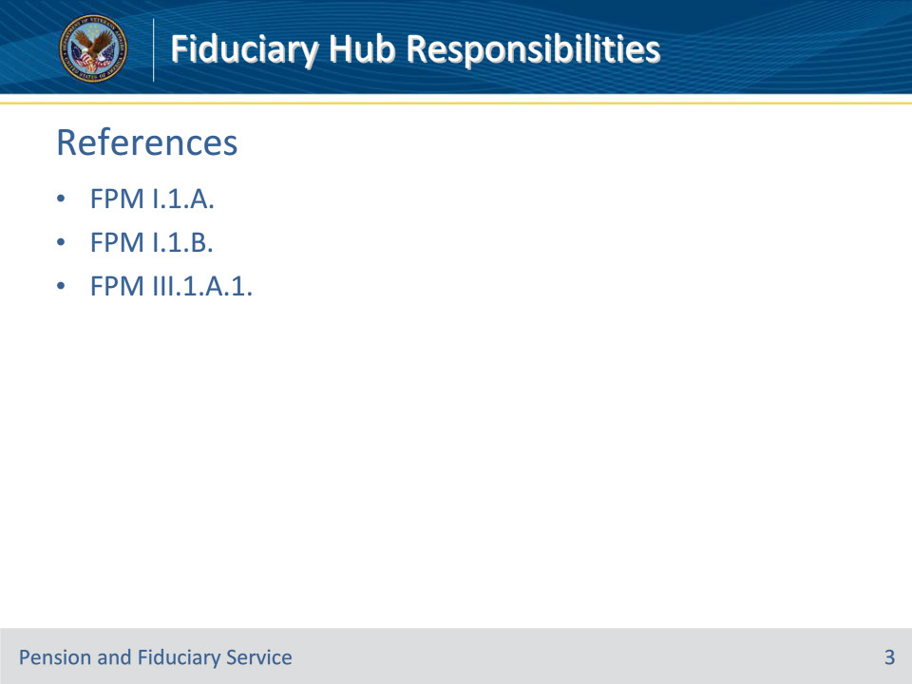
Slide notes

Instructor Notes:

The following are relevant references for Fiduciary Hub Responsibilities:

• FPM I.1.A., Fiduciary Hub Structure

• FPM I.1.B., General Information on the Fiduciary Program

• FPM III.1.A.1., Fiduciary Appeals Authority

Slide 4 - Fiduciary Hub Responsibilities
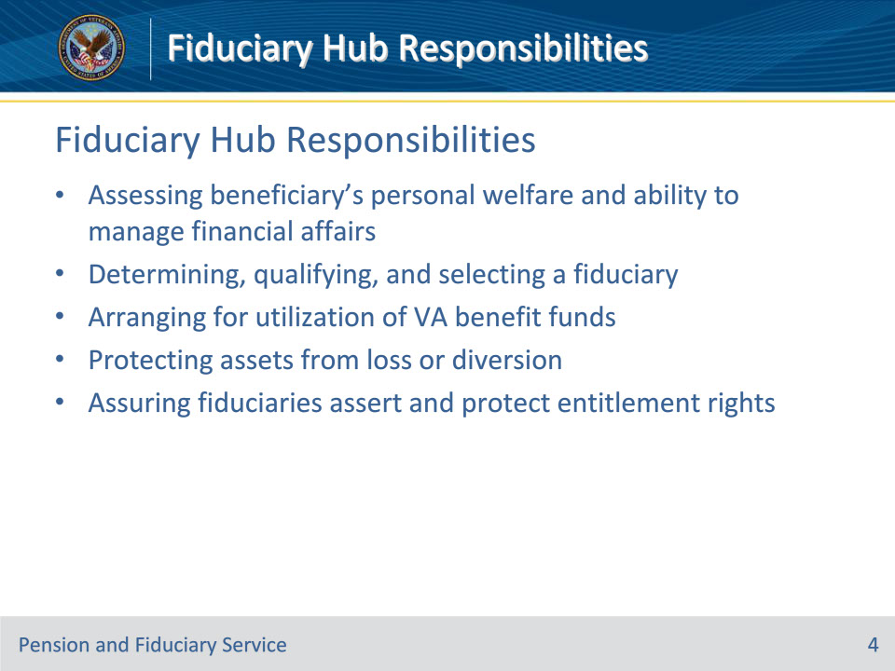
Slide notes

Policy Reference(s): FPM I.1.B.3.

Instructor Notes:

Fiduciary Program responsibilities include:

• Assessing the competency, adjustment, and personal welfare of beneficiaries to evaluate whether a beneficiary needs assistance in managing his or her Department of Veterans Affairs benefits.

• VA may receive notice or medical evidence of inability to manage financial affairs due to injury, disease, or age

• Determining, qualifying, and selecting a fiduciary that best suits the needs and situation of the beneficiary when that beneficiary is found to be unable to manage his or her VA benefits

• In deciding who should act as fiduciary for a beneficiary, VA will always select the most effective and least restrictive fiduciary arrangement.

• Arranging for the utilization of benefit funds for the beneficiary, and dependents, if any.

• Protecting a beneficiary’s assets from loss or diversion through regular or unscheduled field examinations, accounting audits, and requiring protection of VA funds under the management of the fiduciary (such as a bond). This protection helps prevent fraud, waste, and misuse of a beneficiary’s VA benefit payments, and/or identify such loss at the earliest stage possible

• Assuring that fiduciaries assert and protect entitlement rights of beneficiaries and dependents to VA benefits, other assets, income, and other benefits, regardless of source

Slide 5 - Responsibilities (Continued)
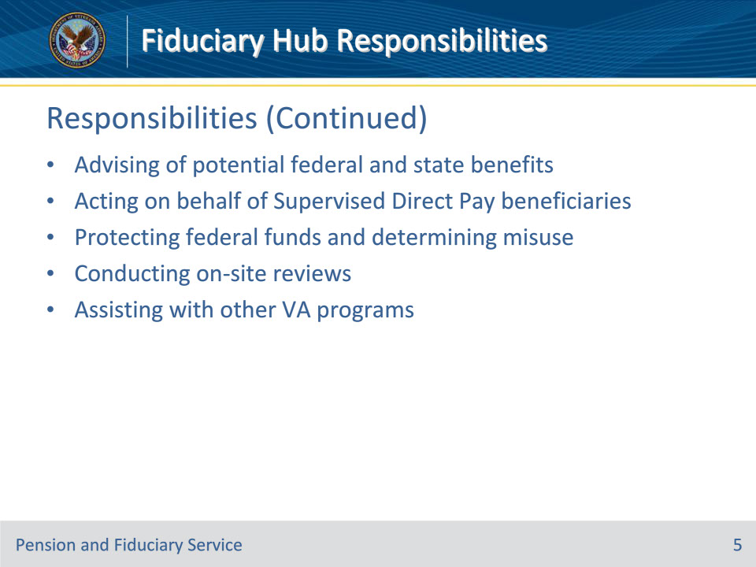
Slide notes

Policy Reference(s): FPM I.1.B.3.

Instructor Notes:

Fiduciary Program responsibilities include:

• Assuring that fiduciaries, beneficiaries, and representatives are fully advised of all potential federal and state benefits

• Acting on behalf of Supervised Direct Pay (SDP) beneficiaries via asserting and protecting their entitlements to VA and other federal and state benefits.

• protecting Federal funds from

• fraud

• waste, and

• misuse, and

• investigating and determining when a fiduciary’s misuse of a beneficiary’s funds is alleged or suspected.

• Conducting on-site reviews of certain fiduciaries serving multiple beneficiaries to ensure proper fund utilization, protection, and conservation.

• Obtaining and developing evidence that will enable the requesting element to make a determination on the issues involved with:

• Claims for benefits

• Violations of federal penal statues, and

• Administrative investigations

Slide 6 - Fiduciary Hubs
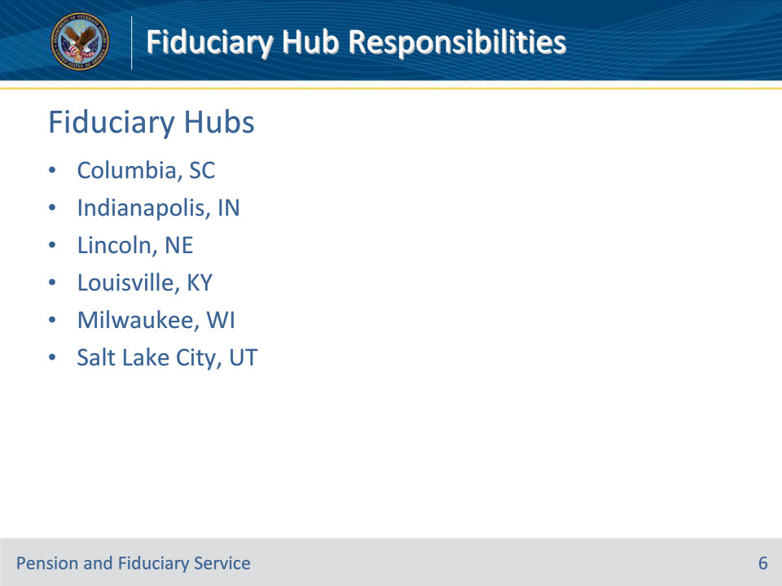
Slide notes

Policy Reference(s): FPM I.1.A.2.a.

Instructor Notes:

The 6 fiduciary hub locations are listed on this slide.

In order to determine and identify the correct hub of jurisdiction, consider the place of residence of the

• minor or incompetent beneficiary, or

• fiduciary, once one has been appointed.

Generally, the fiduciary’s physical address will establish the appropriate hub of jurisdiction. However, certain beneficiary oversight activities require a face-to-face visit with the beneficiary. In such cases, and if the physical address of the beneficiary falls within a different hub of jurisdiction, the hub which can best provide the oversight needed should conduct that oversight activity. This applies to face-to-face activities only. The hub of jurisdiction must complete all other activities, to include all rating or award actions.

The regional fiduciary hub jurisdictions will be explained further in the following slides.

Slide 7 - Columbia Jurisdiction
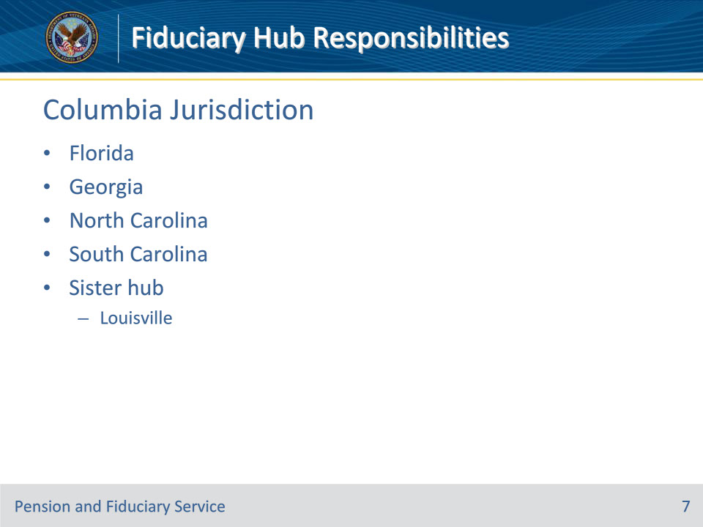
Slide notes

Policy Reference(s): FPM I.1.A.2.a.

Slide 8 - Indianapolis Jurisdiction
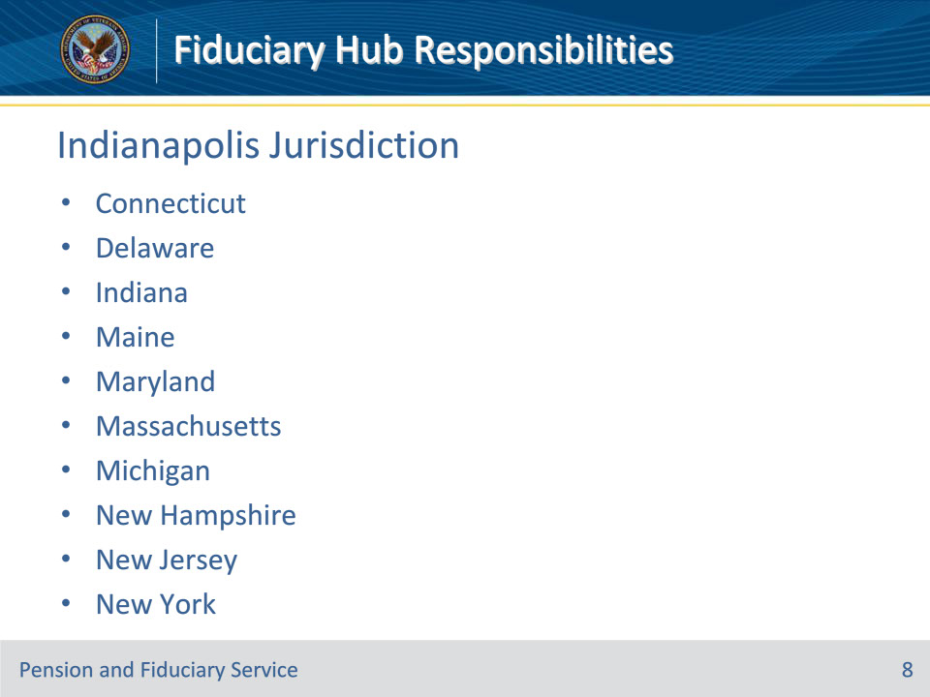
Slide notes

Policy Reference(s): FPM I.1.A.2.a.

Instructor Notes:

Continued on next slide….

Slide 9 - Indianapolis (Continued)
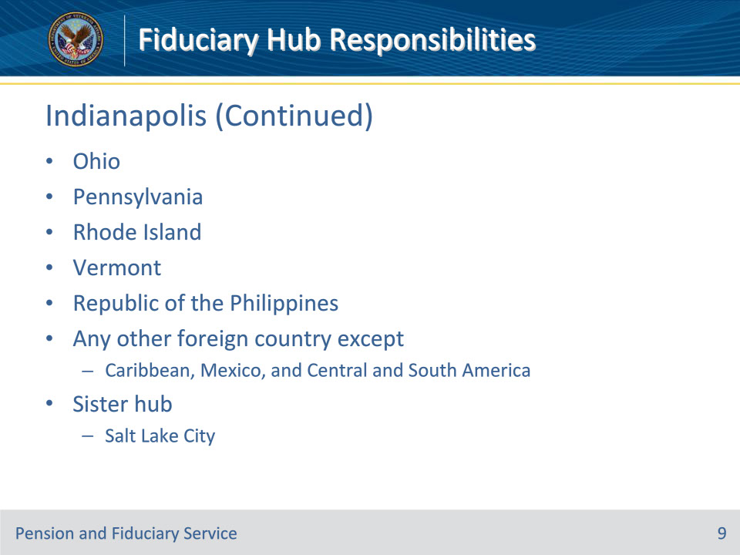
Slide notes

Policy Reference(s): FPM I.1.A.2.a.

Slide 10 - Lincoln Jurisdiction
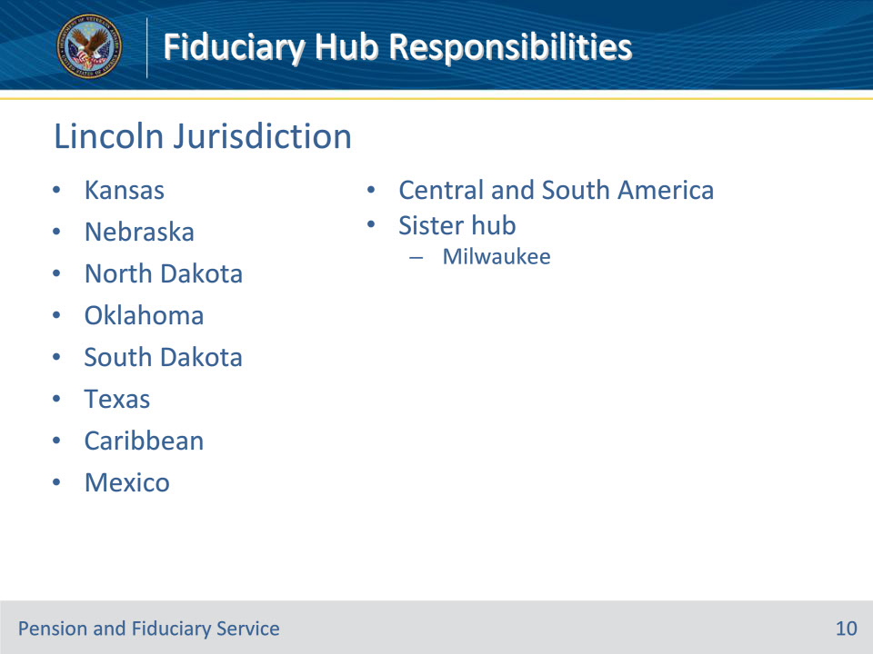
Slide notes

Policy Reference(s): FPM I.1.A.2.a.

Instructor Notes:

Slide 11 - Louisville Jurisdiction
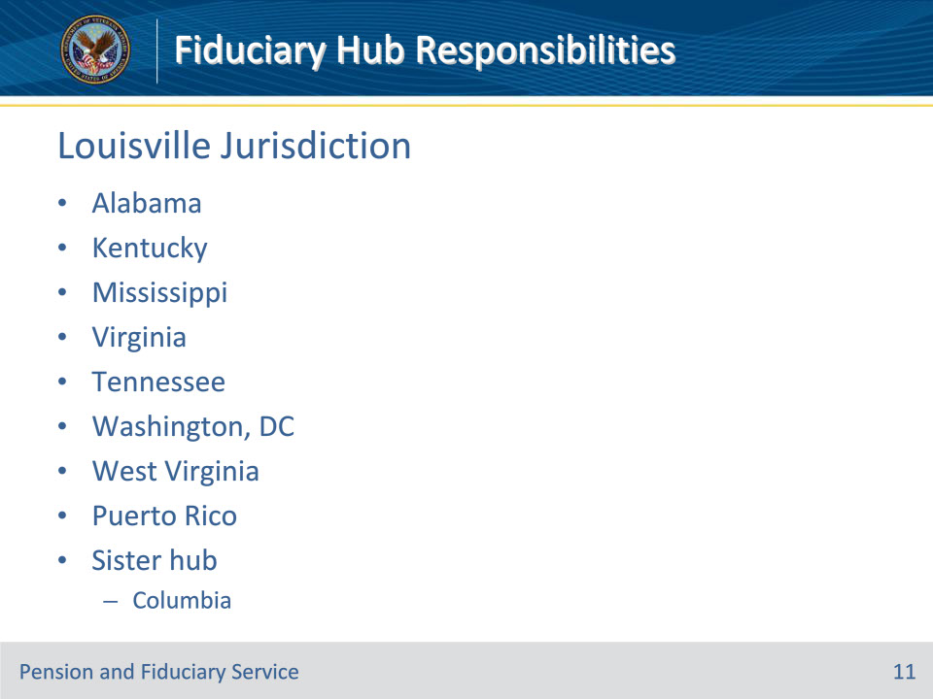
Slide notes

Policy Reference(s): FPM I.1.A.2.a.

Instructor Notes:

Slide 12 - Milwaukee Jurisdiction
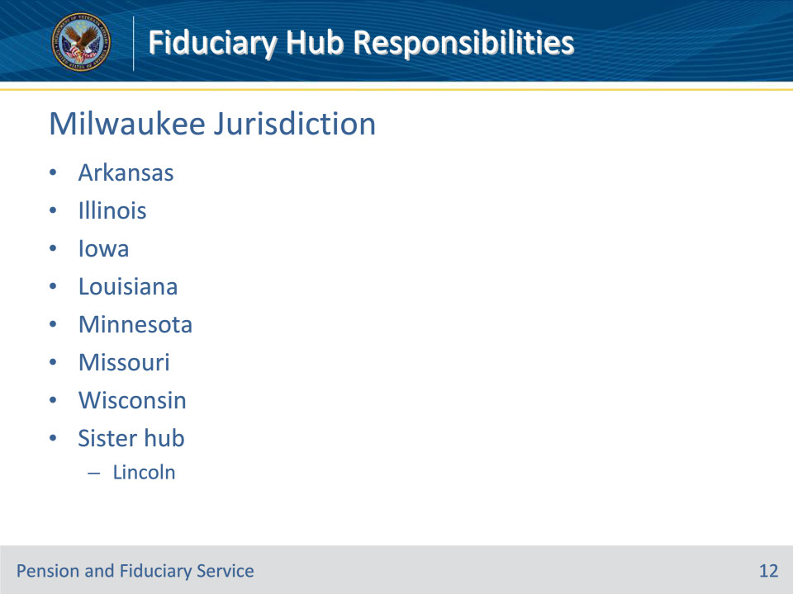
Slide notes

Policy Reference(s): FPM I.1.A.2.a.

Instructor Notes:

Slide 13 - Salt Lake City Jurisdiction
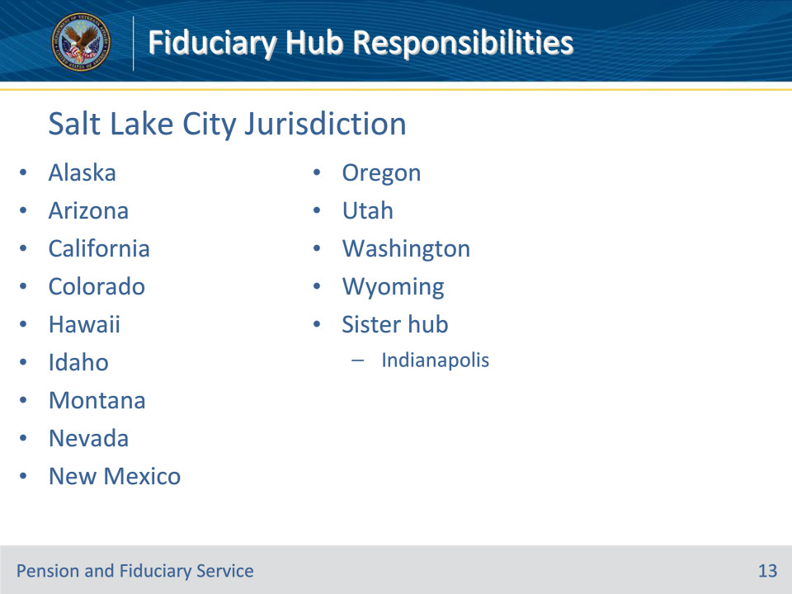
Slide notes

Policy Reference(s): FPM I.1.A.2.a.

Instructor Notes:

Slide 14 - Personnel
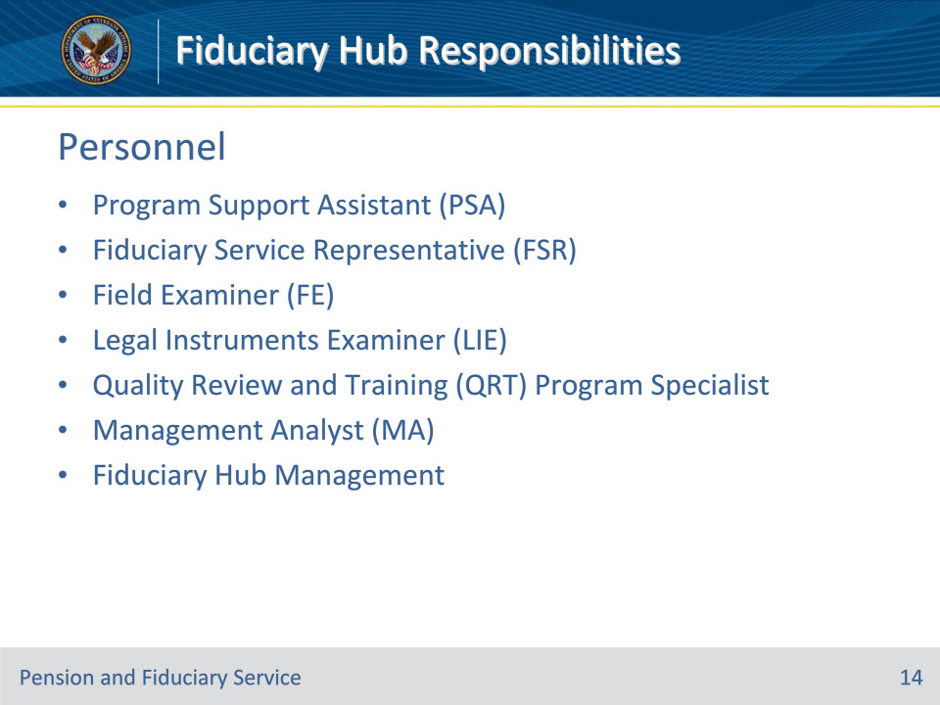
Slide notes

Policy Reference(s): FPM I.1.B.5, I.1.B.6, I.1.B.7

Instructor Notes:

These are the various positions and personnel that make up the fiduciary hubs. The descriptions for each position just provide a high-level overview of the position responsibilities, it is not all inclusive.

Program Support Assistants (PSA): provide critical support and administrative actions for successful fiduciary program operations such as receiving, managing, and processing mail, emails, faxes, scanning, and telephone calls.

Fiduciary Service Representatives (FSR): responsible for completing final determinations and notifications of a VA beneficiary’s inability to manage their own financial affairs due to disability. Responsible for reviewing, generating letters, establish appropriate follow-up tasks and EPs, and closing field examination reports submitted from Field Examiners. They also conduct various award actions to authorize and release VA benefit payments to appointed fiduciaries, and/or to suspend, resume, and discontinue VA benefit payments.

Field Examiners (FE): Conduct examinations to determine a VA beneficiary’s capacity to manage their VA benefit payments. If it is determined they are unable to manage their affairs with minimal or no supervision, then the FE conducts investigations to determine, qualify, and appoint a fiduciary best suited to manage the VA beneficiary’s benefit payments for them. FEs also investigate VA-appointed fiduciaries to determine proper management and use of beneficiary funds, to investigate allegations of misuse of benefits, to assist other VA divisions with making decisions on non-fiduciary matters, and to assist in locating the whereabouts of beneficiaries and fiduciaries.

Legal Instruments Examiners (LIE):, Ensuring the necessary protections are in place for beneficiary funds under the management of a fiduciary such as annual accountings, Fund Usage Reviews, and/or surety bonds. These tools help protect funds from loss or diversion. LIEs also assist in processing allegations and determinations of fiduciary misuse of benefits, initiating and responding to correspondence, and updating and maintaining accurate beneficiary and fiduciary records.

Quality Review and Training (QRT) Program Specialists: Conduct quality reviews of fiduciary hub personnel completed work to determine individual personnel and hub-wide accuracy, and to identify error trends and opportunities for training. QRT also create and instruct training on policies, procedures, emergent issues and error trends.

Management Analysts: Assist fiduciary hub management with analytical work to ensure efficient hub operations, adherence to the hub’s workload management plan, staffing projections and more.

Fiduciary Hub Management: Assistant Coaches, Coaches, Assistant Fiduciary Hub Managers, and Fiduciary Hub Managers with responsibilities of:

• Workload management

• Maintaining appropriate team staffing levels and assignments

• Ensuring accountability for meeting individual, team, and station goals

• Analyzing and improving processes

• Providing necessary tools for employees to be successful

• Ensuring program requirements are met to include supervisory visits

**Important Note**: There is considerable crossover of interests, shared responsibilities, and mutual support between all personnel in the fiduciary hub; especially between LIEs, FEs, and FSRs.

Slide 15 - Functional Areas
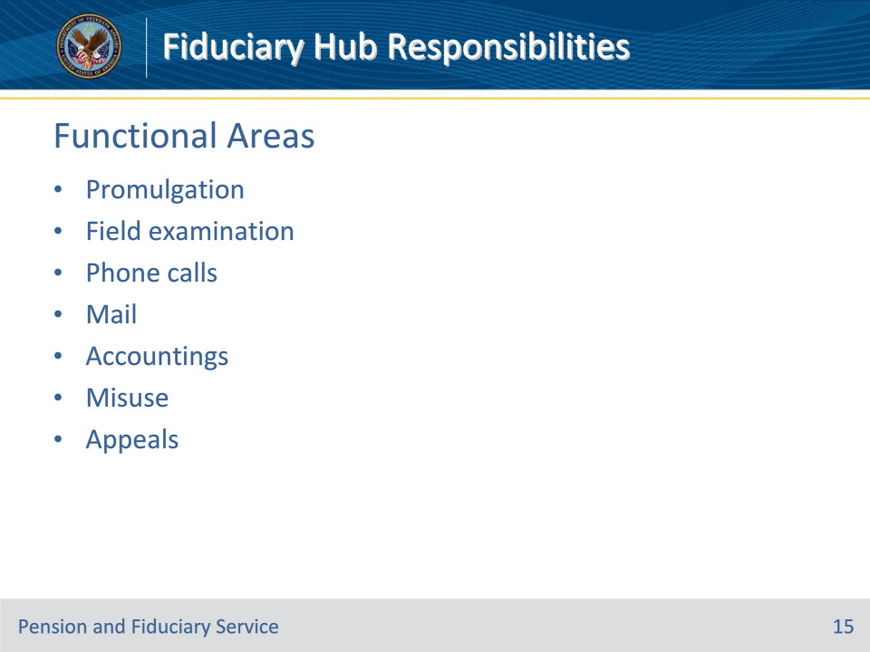
Slide notes

Policy Reference(s): FPM I.1.A

Instructor Notes:

Each fiduciary hub (hub) is structured to support the Fiduciary Program in the overall mission of the Veterans Benefits Administration. The basic functions of a hub include

• fiduciary promulgation

• field examination

• processing of

• phone calls, and

• mail

• accountings

• misuse, and

• appeals.

Slide 16 - Promulgation
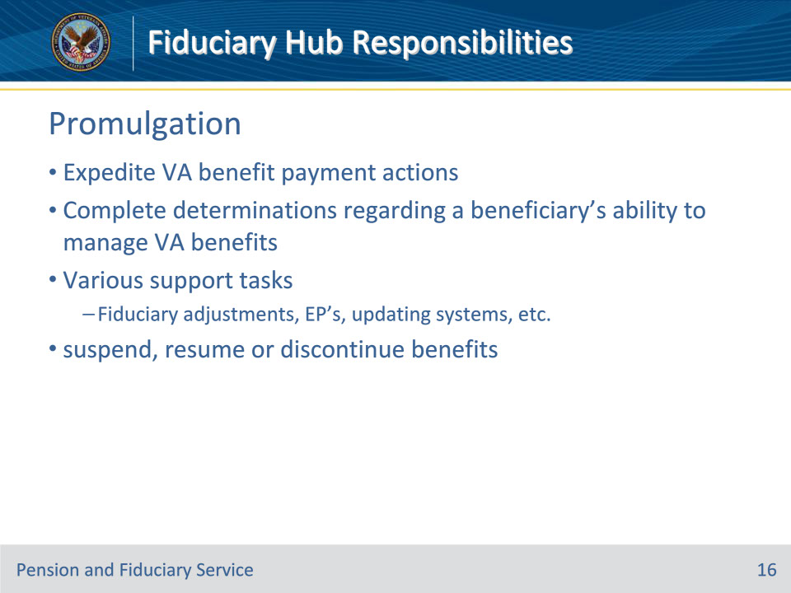
Slide notes

Policy Reference(s): FPM I.1.A.1.b.

Instructor Notes:

The purpose of fiduciary promulgation teams is to expedite VA benefit payment actions to beneficiaries by limiting the transfers of jurisdiction between the regional office and the fiduciary hub when VA has evidence that a beneficiary is unable to manage his/her VA benefits.

Fiduciary promulgation teams are responsible for completing final determinations that a beneficiary can or cannot manage his/her VA benefits.

Fiduciary promulgation activity is also responsible for

• processing fiduciary adjustments for all cases requiring a fiduciary appointment

• ensuring the appropriate end product (EP) is established

• updating the beneficiary oversight and fund usage oversight diary date

• processing the appointment of the fiduciary and fee authorization

• completing all award adjustments that are ready for decision at the time the field examination work item is being completed

• ensuring the accuracy of system information, and

• ensuring fiduciary adjustments are completed within the established timeframe.

The fiduciary promulgation teams have authority to suspend, resume, or discontinue benefit payments when action is identified as a result of a finding by the fiduciary hub of jurisdiction. The fiduciary promulgation team will take applicable payment actions in situations involving

• suspected misuse

• fiduciary appointment pending

• beneficiary’s or fiduciary’s whereabouts unknown

• beneficiary or fiduciary withholds cooperation in appointment or oversight procedures

• first notice of death

Slide 17 - Field Examination
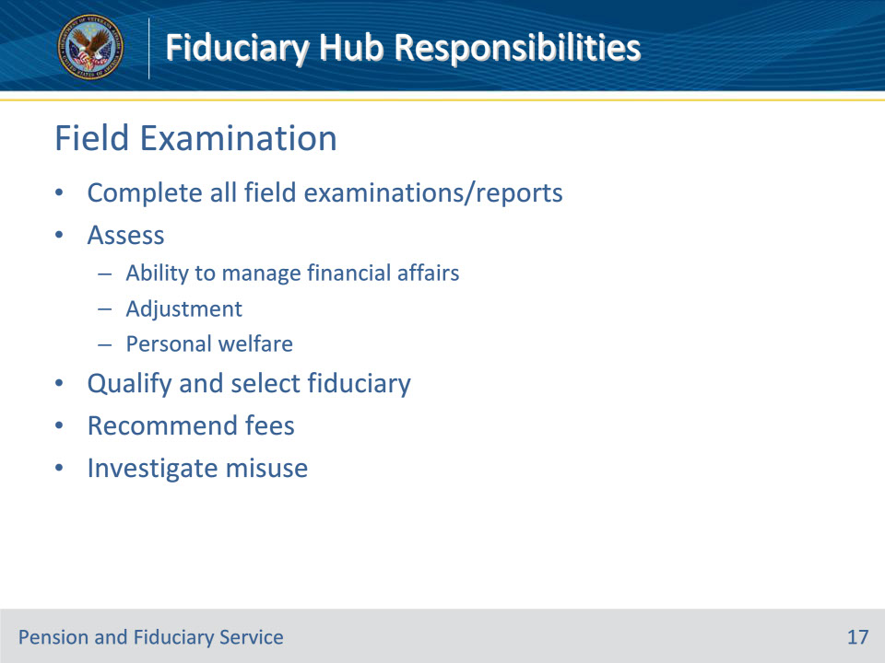
Slide notes

Policy Reference(s): FPM I.1.A.1.c.

Instructor Notes:

The purpose of field examination activity is to complete all program and non-program field examinations, and other reports as required.

Field examination activity is responsible for:

• assessing the beneficiaries’

• competence

• adjustment, and

• personal welfare

• qualifying and selecting a fiduciary that is best suited to the needs and situation of the beneficiary

• recommending fees, and

• investigating and determining when a fiduciary’s misuse of a beneficiary’s funds is alleged or suspected.

Members of field examination activity must review reports and accuracy of information relating to the beneficiary and fiduciary.

Slide 18 - Phone Calls and Mail
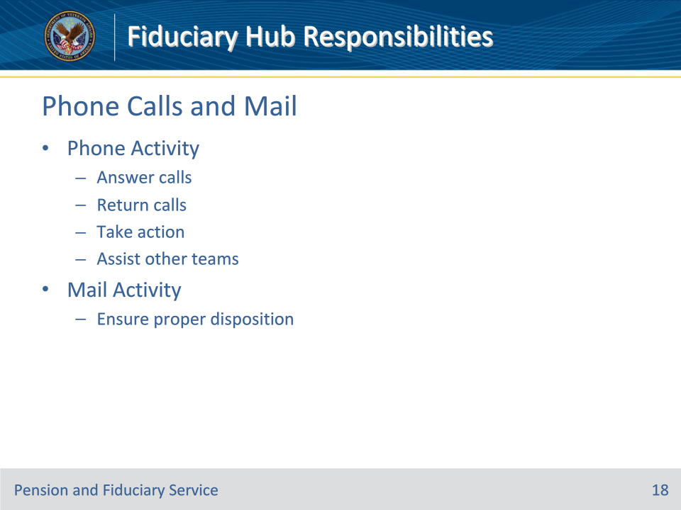
Slide notes

Policy Reference(s): FPM I.1.A.1.d; I.1.A.1.e

Instructor Notes:

The purpose of phone activity is to

• answer incoming calls

• return calls

• take action on issues arising from calls, and

• assist other teams as necessary.

Phone activity is responsible for answering incoming phone calls to the hub and returning calls when required to resolve any issue.

The purpose of the mail teams is to ensure proper disposition of all mail received by the hub.

Mail teams are responsible for processing all documents and correspondence coming via acceptable sources. Among these are incoming inquiries from beneficiaries, fiduciaries, and congressional requests.

Slide 19 - Accountings
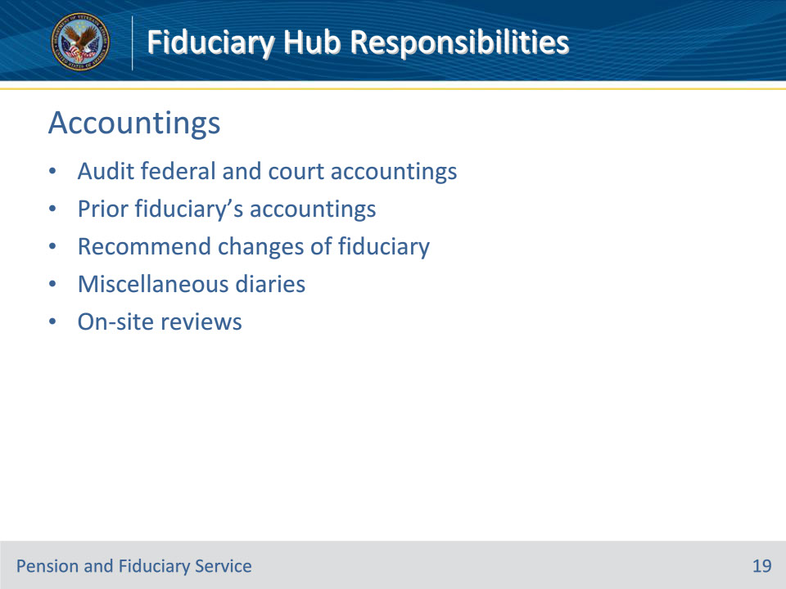
Slide notes

Policy Reference(s): FPM I.1.A.1.f

Instructor Notes:

The purpose of accounting activity is to conduct in-depth analysis of all accounting documents received in the hub.

The accounting team is responsible for

• auditing Federal and court accountings

• following-up on accountings due from prior fiduciaries when successor fiduciaries have been appointed

• recommending changes of fiduciary when serious problems with fiduciary compliance are evident

• following-up on miscellaneous diaries, and

• assisting with on-site reviews.

Slide 20 - Misuse
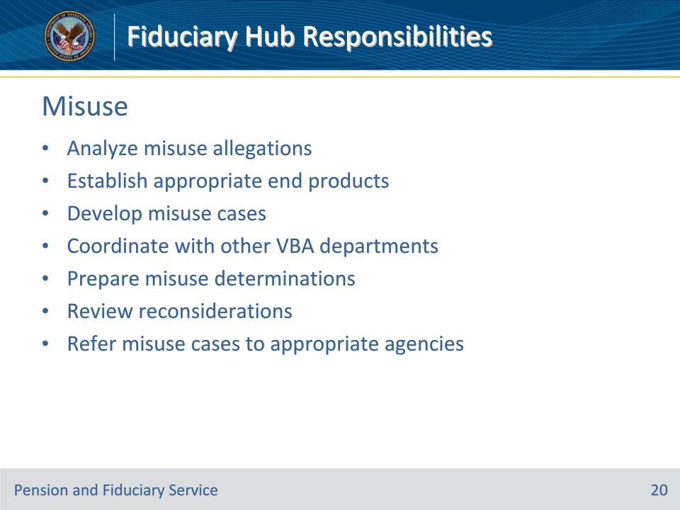
Slide notes

Policy Reference(s): FPM I.1.A.1.g

Instructor Notes:

The purpose of misuse activity is to work closely with Regional Counsel and the Office of Inspector General (OIG) to investigate and process misuse allegations.

Misuse activity is responsible for

• conducting an in-depth analysis, quasi-legal examination, detailed investigation and financial assessment of inquiries and documents pertaining to allegations of misuse

• establishing appropriate EPs for misuse allegations, investigations and reports

• preparing development of misuse cases

• working with Support Services Division and the Debt Management Center (DMC) to collect, investigate, and prepare evidence for referral to OIG or Regional Counsel

• preparing misuse determinations and notifications for management concurrence

• collecting VA derived assets from fiduciaries found to have misused the beneficiary’s benefits

• reviewing evidence and responding to reconsideration requests

• referring misuse cases to an appropriate agency, OIG, and Regional Counsel

• providing recommendations to management, and

• assisting with on-site reviews

Slide 21 - Appeals
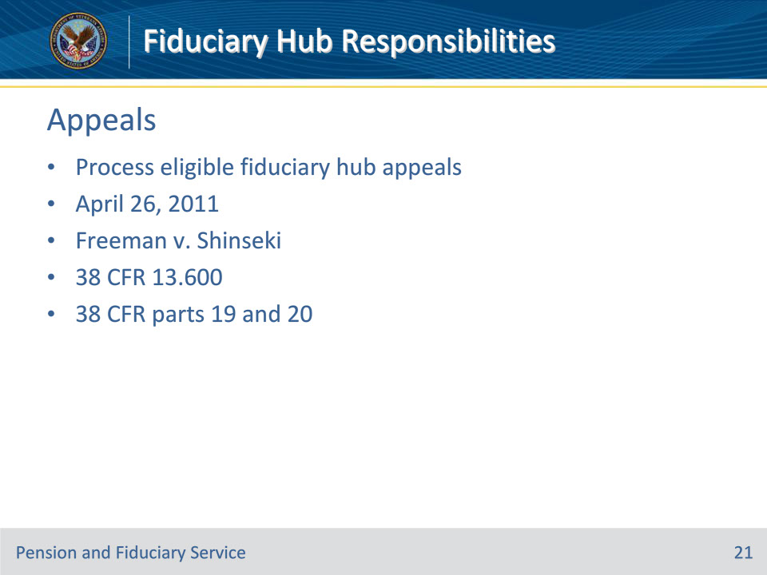
Slide notes

Policy Reference(s): FPM III.1.A.1.a.

Instructor Notes:

Generally, Department of Veterans Affairs (VA) decisions regarding fiduciary matters are committed to the Secretary of VAs’ discretion by law and cannot be appealed to the Board of Veterans’ Appeals (BVA) or any court.

On April 26, 2011, the Court of Appeals for Veterans Claims (CAVC) decided Freeman v. Shinseki, 24 Vet.App. 404 (2011) holding that VA’s appointment of a fiduciary is subject to appeal by the beneficiary to BVA and thereafter to the CAVC.

Although VA fiduciary appointments are appealable, the beneficiary cannot appeal the fact that VA did not appoint his/her family member or choice of fiduciary.

The Fiduciary Program has extended the holding in Freeman v. Shinseki, 24 Vet.App. 404 (2011) allowing a beneficiary to appeal to BVA the following decisions:

• the appointment of a fiduciary

• the removal of a fiduciary

• misuse determinations

• final decisions upon reconsideration of a misuse determination, and

• negligence determinations for the purposes of reissuance of misused benefits.

The fiduciary hub (hub) must accept any notice of disagreement (NOD) in conjunction with any appealable decisions which were not accompanied with appeal rights made on or after April 26, 2011, date of the Freeman v. Shinseki, 24 Vet.App. 404 (2011) decision, because 38 CFR 13.600 extended the holding in Freeman v. Shinseki, 24 Vet.App. 404 (2011) decision to any fiduciary decision that is made under a law that affects the provision of benefits to Veterans or to the dependents or survivors of Veterans.

Hubs are required to process fiduciary appeals in accordance with VA’s appeals regulations outlined in 38 CFR parts 19 and 20.

Slide 22 - Questions?
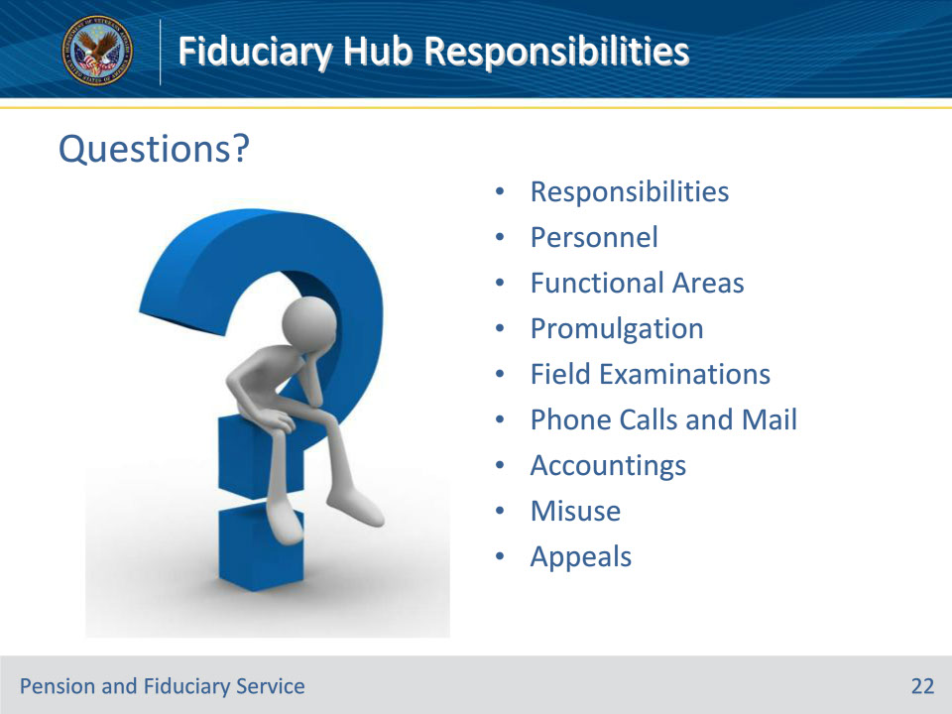
Slide notes

These are the topics we have discussed today. Are there any questions?

• Responsibilities

• Personnel

• Functional Areas

• Promulgation

• Field Examinations

• Phone Calls and Mail

• Accountings

• Misuse

• Appeals

Slide 23 - TMS Survey
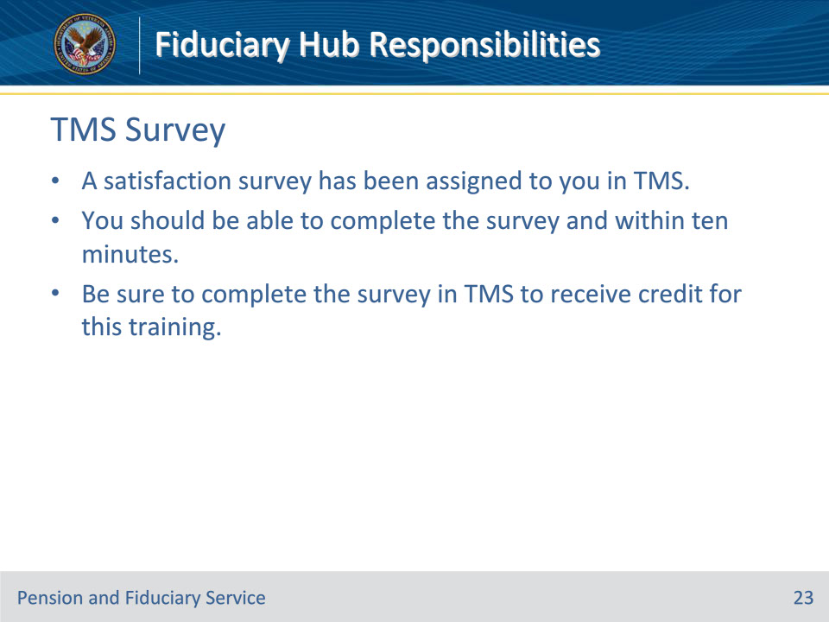
Slide notes

Instructor Notes:

A satisfaction survey has been assigned to you in TMS. You should be able to complete the survey within ten minutes. Completing the survey will allow you to receive credit for this training.

