Slide 1 - Fiduciary Program Overview
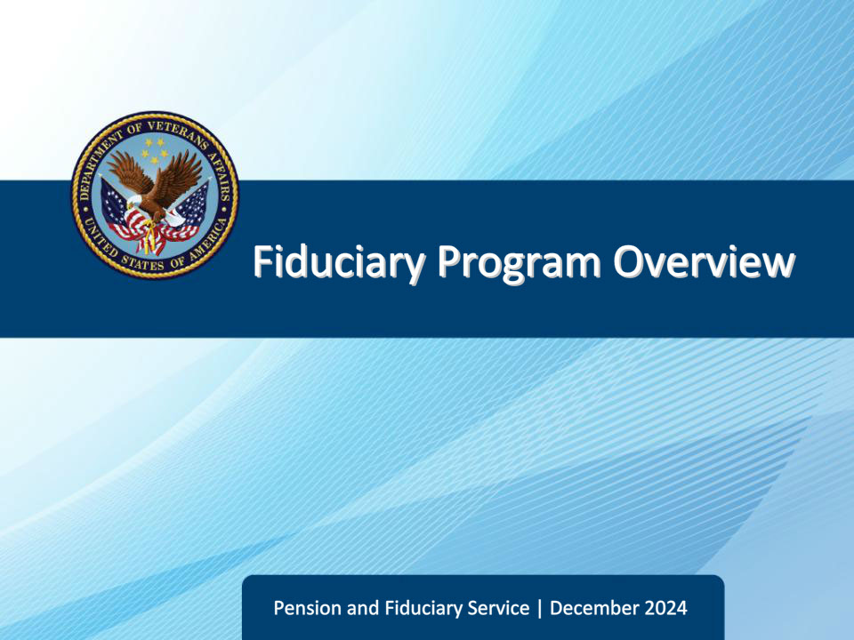
Slide notes

Course Description:

The purpose of this lesson is to provide new fiduciary employees, and all Veterans Benefits Administration (VBA) employees, a basic understanding of the fiduciary program, its history, mission, and its main objectives.

Slide 2 - Objectives
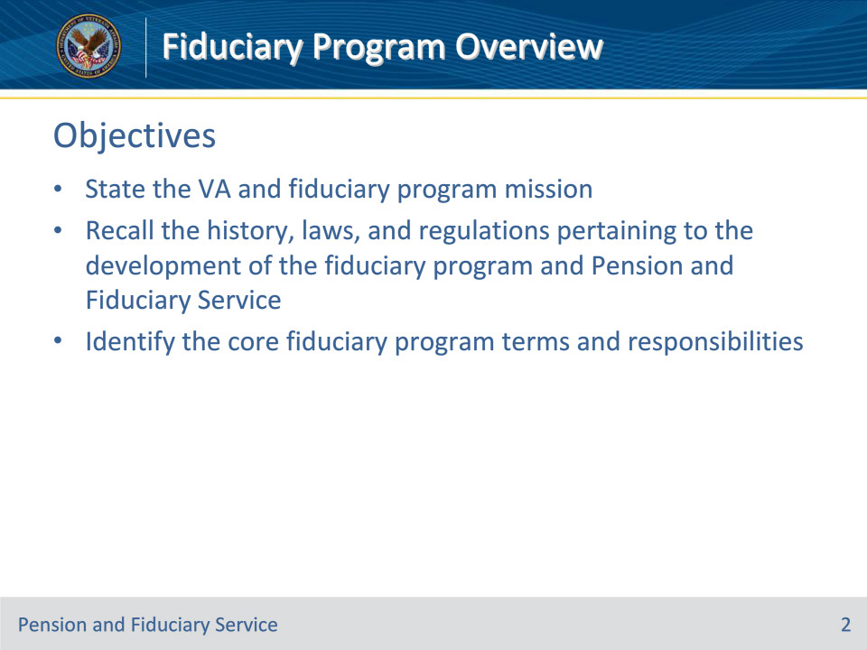
Slide notes

Instructor Notes:

By the end of this lesson, given the training and references, learners will be able to do the following:

• State the fiduciary program and VBA mission

• Recall the history, laws, and regulations pertaining to the development of the fiduciary program and Pension and Fiduciary Service

• Identify the core fiduciary program terms and responsibilities

Slide 3 - References
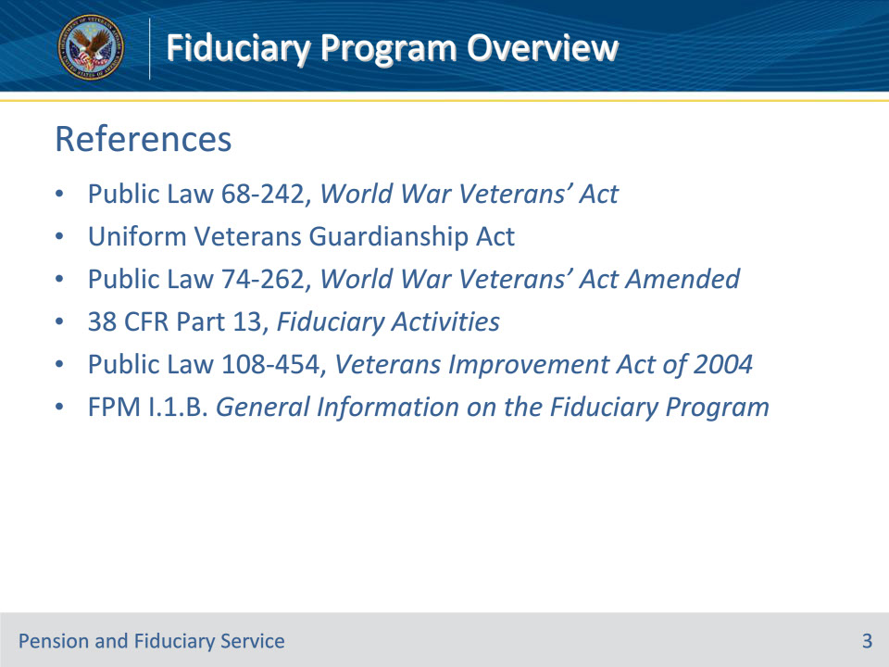
Slide notes

Instructor Notes:

These are the applicable references for today’s trainings:

• Public Law 68-242, World War Veterans’ Act

• Uniform Veterans Guardianship Act

• Public Law 74-262, World War Veterans’ Act Amended

• 38 CFR Part 13, Fiduciary Activities

• Public Law 108-454, Veterans Improvement Act of 2004

• FPM I.1.B. General Information on the Fiduciary Program

Slide 4 - Mission Statements
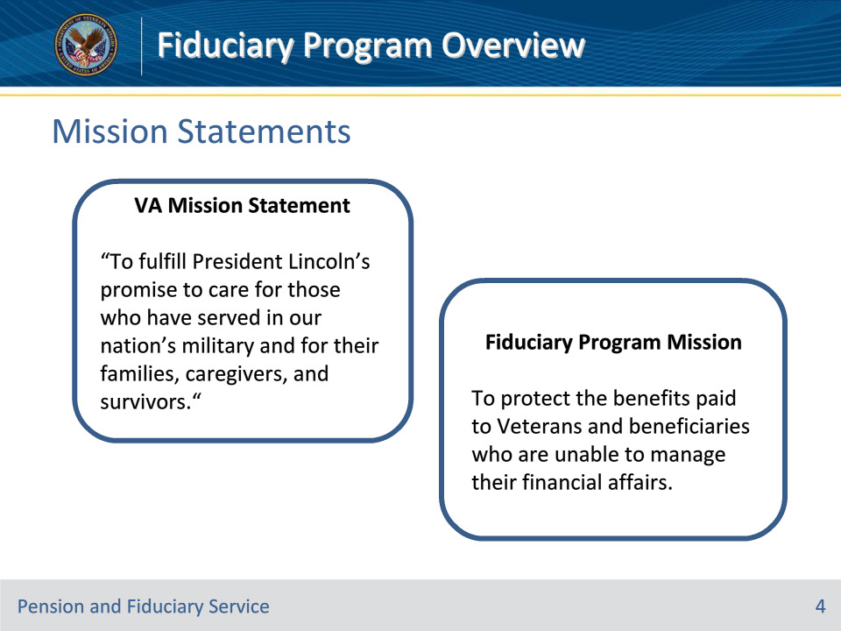
Slide notes

Policy Reference(s): n/a

Instructor Notes:

The purpose of the Department of Veterans Affairs (VA) fiduciary program is to ensure VA benefit payments made to a fiduciary on behalf of a beneficiary are used for the well-being of the beneficiary and the beneficiary’s dependents. Our mission is to protect Veterans and beneficiaries who are unable to manage their financial affairs; we often consider these individuals to be our Nation’s most vulnerable beneficiaries.

You will learn throughout the rest of this training the various laws, acts, and decisions made to form today’s VBA Fiduciary Program, and the program’s over-arching responsibilities to VA beneficiaries.

Slide 5 - World War Veterans’ Act
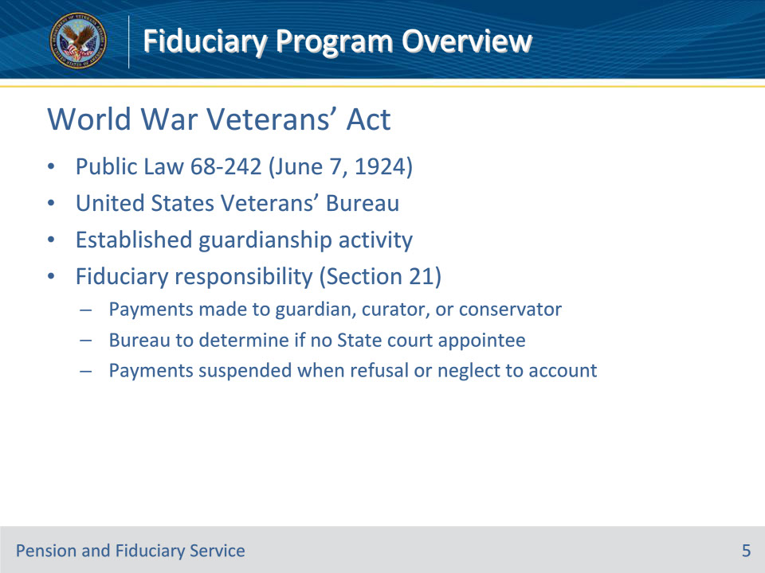
Slide notes

Policy Reference(s): Public Law 68-242

Instructor Notes:

Chapter 320 of the 1st Session of the 68th Congress listed Public Law 242 (68-242) , also known as the World War Veterans’ Act, was created to consolidate, codify, revise, and reenact the laws affecting the establishment of the United States Veterans’ Bureau and the administration of the War Risk Insurance Act, as amended, and the Vocational Rehabilitation Act, as amended.

United States Veterans’ Bureau

The Veterans Bureau was established by Congress in 1921 within the Treasury Department. PL 68-242 upgraded the Veterans Bureau to an independent bureau, separate of the Treasury Department and directly under the President, known as the United States Veterans’ Bureau. The director of the Bureau was appointed by the President by and with the advice and consent of the Senate.

Fiduciary Responsibility (Section 21 of Chapter 320)

Section 21 of Chapter 320 listed what is today known as the VA Fiduciary Program; it established a guardianship activity under direction of US Veterans’ Bureau General Counsel with responsibility for supervision of estates of incompetent beneficiaries to eliminate waste and embezzlement. Regional attorneys at each station carry out this responsibility.

This chapter (full text below) states that the Bureau should make payments to a guardian, curator, or conservator (by the laws of the State or residence of claimant) for minors, mentally incompetent individuals, or persons under other legal disability adjudged by a court of competent jurisdiction. Furthermore, if there is not a guardian, curator, or conservator that the Bureau will determine the best person who is legally vested with responsibility or care of the claimant or his/her estate.

This section also begins to establish the regulations for possible misuse of beneficiary funds – in that the Bureau will suspend payments for any person (fiduciary) that neglects or refuses to submit an accounting showing how the VA benefit payments were used.

Section 21 Full Text:

“Sec. 21. That where any payment under this Act is to be made to a minor, other than a person in the military or naval forces of the United States, or to a person mentally incompetent, or under other legal disability adjudged by a court of competent jurisdiction, such payment may be made to the person who is constituted a guardian, curator, or conservator by the laws of the State or residence of claimant, or is otherwise legally vested with responsibility or care of the claimant or his estate : Provided, That prior to receipt of notice by the bureau that any such person is under such other legal disability adjudged by some court of competent jurisdiction, payment may be made to such person direct: Provided further, That for the purpose of payments of benefits under Title II hereof, where no guardian, curator, or conservator of the person under a legal disability has been appointed under the laws of the State or residence of the claimant, the director shall determine the person who is otherwise legally vested with responsibility or care of the claimant or his estate: And provided further, That the director, in his discretion, may suspend such payments to any such guardian, curator, conservator, or other person who shall neglect or refuse, after reasonable notice, to render an account to the director from time to time showing the application of such payments for the benefit of such minor or incompetent beneficiary.”

Slide 6 - Uniform Veterans’ Guardianship Act
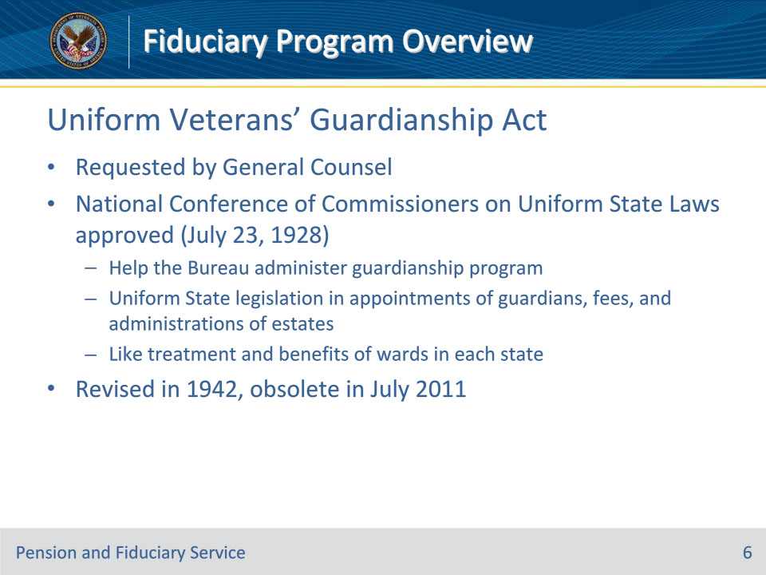
Slide notes

Policy Reference(s): Uniform Veterans’ Guardianship Act

Instructor Notes:

The General Counsel of the US Veterans’ Bureau requested that the National Conference of Commissioners on Uniform State Laws adopt a uniform act for the treatment of incompetent wards. The Conference approved the “Uniform Veterans’ Guardianship Act” (UVGA) on July 23, 1928 at its 38th Annual Conference held in Seattle, WA.

• Note: The National Conference of Commissioners on Uniform State Laws (also called the Uniform Law Commission ULC)), is a non-profit, American unincorporated association that recommends the enactment and adoption of acts to the legislatures of all states in areas of State law where there is lacking uniformity.

The UVGA was an act concerning the guardianship of incompetent veterans, orphans of deceased veterans and other incompetent and minor beneficiaries of the Veterans’ Bureau. It was adopted to promote that equal ‘like’ benefits, treatment, and protections be offered to incompetent wards of the US government (incompetent Veteran or incompetent Veteran dependents / minors) in each state. Examples:

• A ward can receive benefits in in their local legislation, but a ward of a different jurisdiction is deprived of that same benefit

• A ward in one state could have their benefit taxed 15% for estate administration, but 5% in a different state

In 1942, the UVGA was revised, and again recommended, for enactment in all states by the NCC on Uniform State Laws. The UVGA was deemed obsolete by the Uniform Law Commission in July 2011. Although obsolete, many states continue to have laws based on the former UVGA.

Slide 7 - WW Veterans’ Act Amended
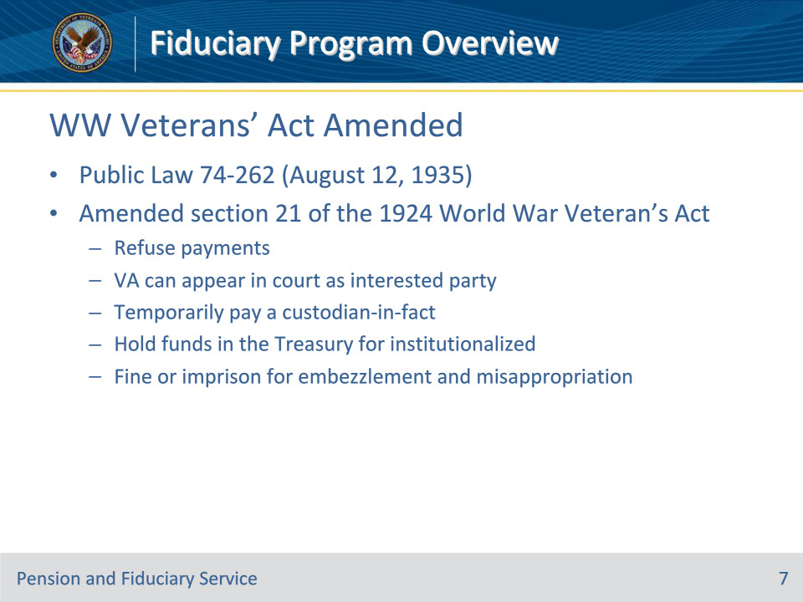
Slide notes

Policy Reference(s): Public Law 74-262

Instructor Notes:

The World War Veterans’ Act was amended on August 12, 1935.

In this amendment, Section 21 of the Act was expanded from one subsection to five providing that:

• The Veterans’ Administration Administrator can choose to refuse payment to a person who acts as fiduciary for such a number of cases as to make it impracticable to properly conserve or supervise estates

• If a fiduciary is not properly executing duties, is collecting inequitable or excessive fees, is failing to pay expenses necessary for the benefit of the ward or dependents, or is not rendering accountings, then the VA can appear in court as an interested party in any litigation against the fiduciary

• Can temporarily pay suspended or withheld benefits to the person that has custody of the beneficiary (established custodian-in-facts)

• Funds can be held in the Treasury (now personal funds of patient (PFOP)) to the credit of Veterans who are institutionalized and do not have an apportionment established, and can be disbursed to the beneficiary upon recovery, or if competence is restored, or if a minor attains majority, or to a personal representative in the event of the beneficiary’s death so long as the payment does not escheat to the State.

• Fiduciaries found to embezzle or misappropriate beneficiary funds can be fined and/or imprisoned

Slide 8 - Fiduciary Program History
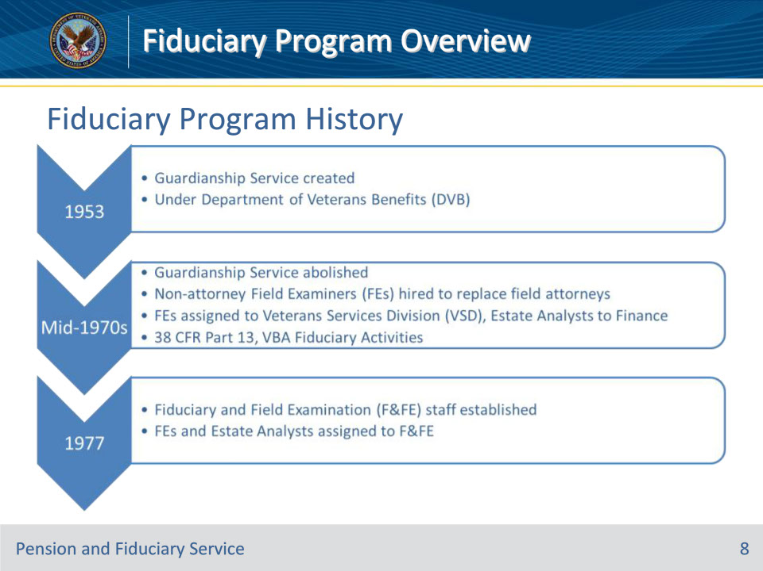
Slide notes

Policy Reference(s): 38 CFR Part 13

Instructor Notes:

Central Office (CO) was reorganized in September 1953. The agency’s broad responsibility to incompetent beneficiaries was moved to the Department of Veterans Benefits (DVB), and the Guardianship Service is created.

In the mid-1970s:

• April 1973: Subsequent CO reorganization abolishes Guardianship Service. Office of General Counsel assumes direct organizational jurisdiction over Chief Attorney functions pertaining to legal matters. Fiduciary activity and its personnel remain in DVB.

• Non-attorney Field Examiners (FEs) hired to replace field attorneys in fiduciary certification and oversight.

• June 1973: Special task force completes intensive study resulting in transfer of Field Examiners to Veterans Services Division (VSD) and Estate Analysts (now Legal Instruments Examiners) to Finance effective August 1, 1973.

• July 1, 1974: Estate Analysts and accounting audit function are reassigned to VSD.

• November 1975: VA implemented its authority to administer a fiduciary program (per 38 USC Chapters 55 and 61) in current 38 CFR Part 13, Veterans Benefits Administration, Fiduciary Activities

January 1977: Fiduciary and Field Examination Staff established within Veterans Assistance Services in Central Office. Brings new attention to the program and gives support and guidance to fiduciary activity.

Slide 9 - History (Continued)
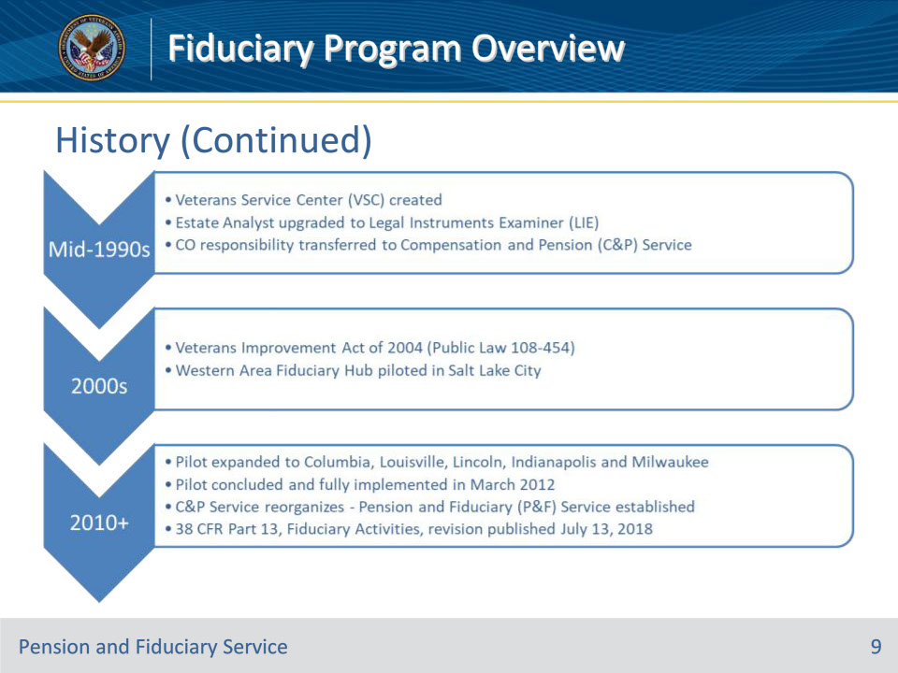
Slide notes

Policy Reference(s): Public Law 108-454

Instructor Notes:

Mid-1990s: the VSD and Adjudication Divisions merge to form the Veterans Service Center (VSC). Technical expertise required of the Estate Analyst results in upgrade in position and change in title from Estate Analyst to Legal Instruments Examiner. F&FE Activity remains relatively unchanged.

1997: Fiduciary Program responsibility transferred to Compensation and Pension (C&P) Service

2004: Public Law 108-454, Veterans Benefits Improvement Act of 2004 - Congress amended 38 U.S.C. chapters 55 and 61 to add new provisions, which, among other things, authorize VA to conduct specific investigations regarding the fitness of individuals to serve as fiduciaries, conduct onsite reviews of fiduciaries who serve more than 20 beneficiaries, require fiduciaries to file reports or accountings, and reissue certain benefits that are misused by fiduciaries.

2008: The Western Area Fiduciary Hub Pilot commenced which centrally managed and administered fiduciary services for the following jurisdictions from multiple states out of the Salt Lake City Regional Office:

• Salt Lake City, Fort Harrison, Anchorage, Seattle, Honolulu, Oakland, Phoenix, Los Angeles, Albuquerque, San Diego, Portland, Denver, Boise, and Reno Regional Offices

2010 - 2011: The Hub pilot was concluded and expanded the use of fiduciary hubs and consolidated all remaining activities to Columbia, Louisville, Lincoln, Indianapolis and Milwaukee. This project was completed in March 2012. VA found that the consolidation improved the timeliness and accuracy of fiduciary operations.

April 16, 2011: C&P Service reorganizes to form Compensation Service and the new Pension and Fiduciary (P&F) Service. P&F Service is responsible for fiduciary activities in VA Central Office.

July 13, 2018: 38 CFR 13, Fiduciary Activities, is revised and published for the first time since its original publication in 1975. The final rule was published July 13, 2018, and is effective August 13, 2018. The amendments updated and reorganized regulations consistent with current law, VA policies and procedures, and VA’s reorganization of its fiduciary activities. They also clarified the rights of beneficiaries in the program, and the roles of VA and fiduciaries in ensuring that VA benefits are managed in the best interest of beneficiaries and their dependents. They are also in line with the law’s goals to streamline and modernize the fiduciary program and processes, and improve services for Veterans.

Slide 10 - Key Terms
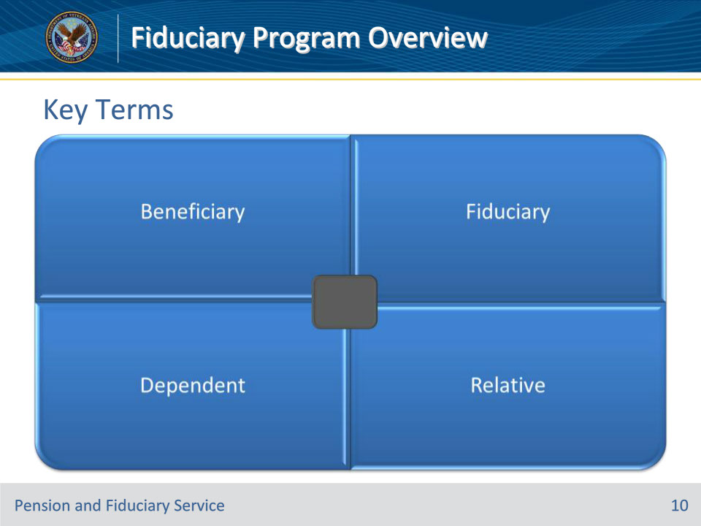
Slide notes

Policy Reference(s): FPM I.1.B.3.a.

Instructor Notes:

A beneficiary is an individual entitled to receive VA benefits, including proceeds of VA insurance. Beneficiaries are classified as

• minors

• Veterans, and

• other adults, including

• helpless adults

• surviving spouses

• dependent parents, and

• insurance proceeds recipients.

A fiduciary is a person or legal entity (such as a bank) charged with the duty of managing the estate of an incompetent beneficiary.

A dependent is the beneficiary’s spouse, child, or parent who obtains support for their needs from the beneficiary.

A relative is an adopted child or a person who is related to a beneficiary by blood or marriage.

Slide 11 - Responsibilities
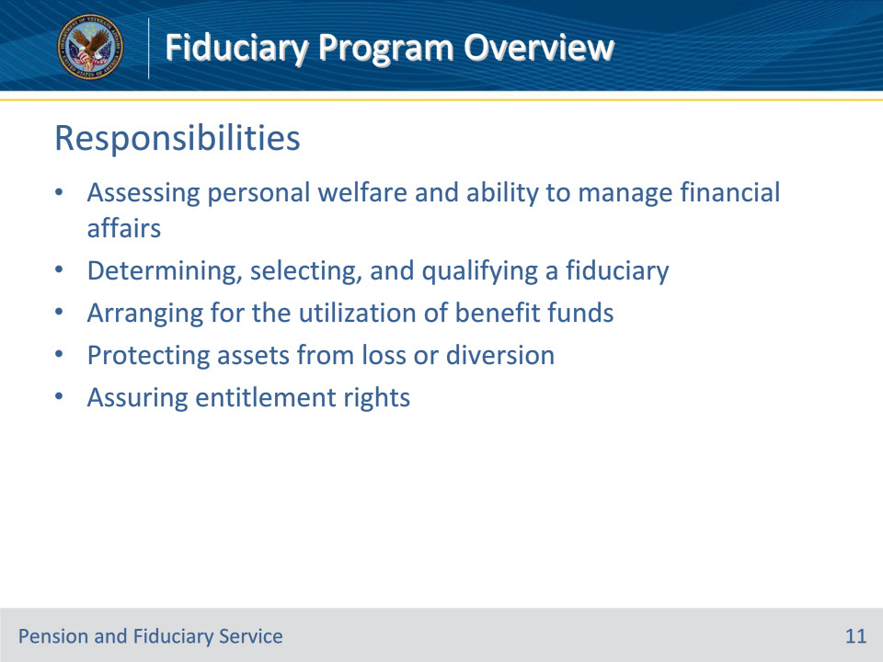
Slide notes

Policy Reference(s): FPM I.1.B.3.a.-g.

Instructor Notes:

The Fiduciary Program provides oversight of VA’s most vulnerable beneficiaries who are unable to manage their VA benefits because of injury, disease, the infirmities of advanced age, or are minor children who have not yet reached the age of majority. VA appoints fiduciaries who manage VA benefits for these beneficiaries and conducts oversight of VA-appointed fiduciaries to ensure that they are meeting the needs of the beneficiaries they serve.

Fiduciary Program responsibilities include:

• assessing the competence and personal well-being of beneficiaries

• selecting a qualified fiduciary best suited to meet the needs and situation of the beneficiary

• certifying the appointment of a fiduciary

• arranging for the utilization of benefit funds for the beneficiary and any dependents

• protecting a beneficiary’s assets from loss or diversion

• assuring that fiduciaries assert and protect entitlement rights of beneficiaries and dependents to VA benefits, other assets, income, and other benefits, regardless of source

Slide 12 - Responsibilities (Continued)
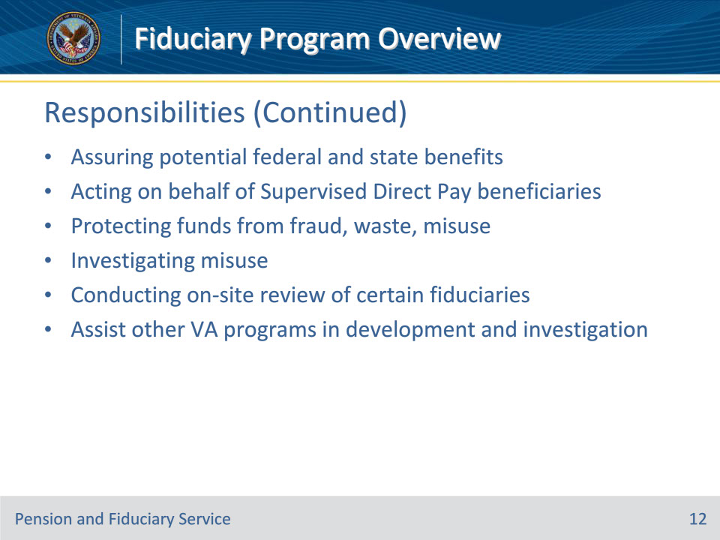
Slide notes

Policy Reference(s): FPM I.1.B.3.g.-k.

Instructor Notes:

Fiduciary Program responsibilities include:

• assuring that hubs fully advise fiduciaries and beneficiaries of all potential Federal and State benefits available

• acting on behalf of SDP beneficiaries by asserting and protecting their entitlement to VA and other Federal and State benefits

• protecting Federal funds from fraud, waste, and misuse

• investigating and determining when a fiduciary’s misuse of a beneficiary’s funds is alleged or suspected

• conducting onsite reviews of certain fiduciaries serving multiple beneficiaries

The non-fiduciary program responsibilities include obtaining and developing evidence that will enable the requesting element to make a determination on the issues involved.

Slide 13 - Questions?
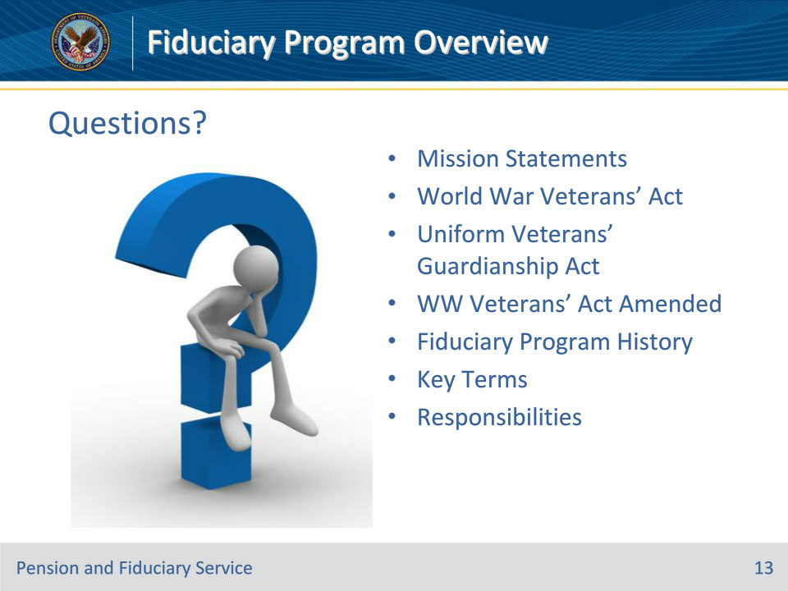
Slide notes

(Recall) These are our learning objectives as stated from the beginning of the training:

• State the VA and fiduciary program mission

• Recall the history, laws, and regulations pertaining to the development of the fiduciary program and Pension and Fiduciary Service

• Identify the core fiduciary program terms and responsibilities

(Recap) We discussed each of these learning objectives through the topics listed here on this slide:

• Mission Statements

• World War Veterans’ Act

• Uniform Veterans’ Guardianship Act

• WW Veterans’ Act Amended

• Fiduciary Program History

• Key Terms

• Responsibilities

Are there any additional questions?

Questions should be filtered through your QRT team. They will submit your questions to the Field Inquiry Tool (FIT) on your behalf.

Slide 14 - TMS Survey/Assessment
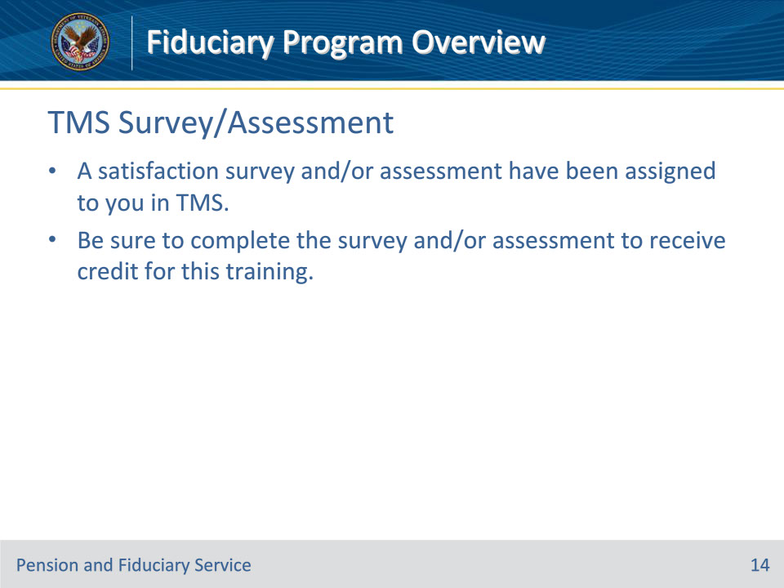
Slide notes

Instructor Notes:

A satisfaction survey and/or assessment have been assigned to you in TMS.

Be sure to complete the survey and/or assessment to receive credit for this training.

