Slide 1 - Submitting Field Examinations for Closure
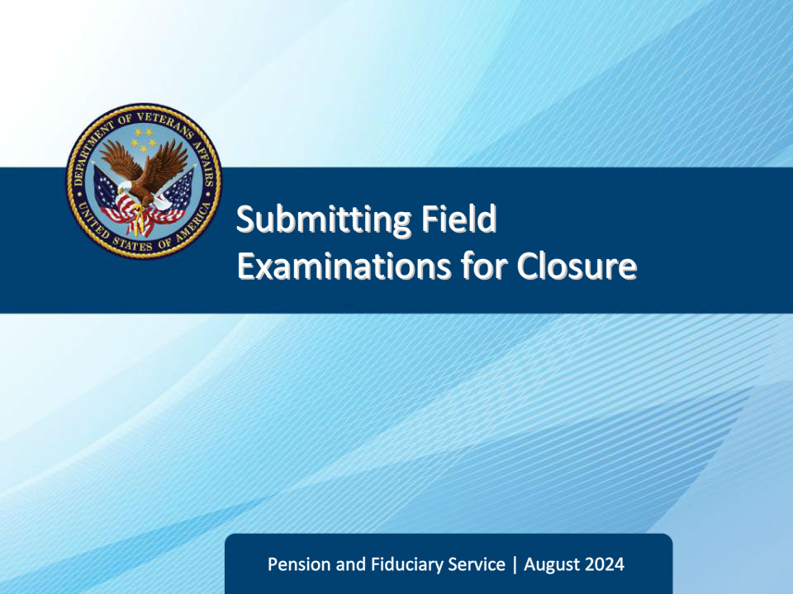
Slide notes

Course Description:

This lesson teaches the required elements of submitting a field examination for closure.

Slide 2 - Objectives
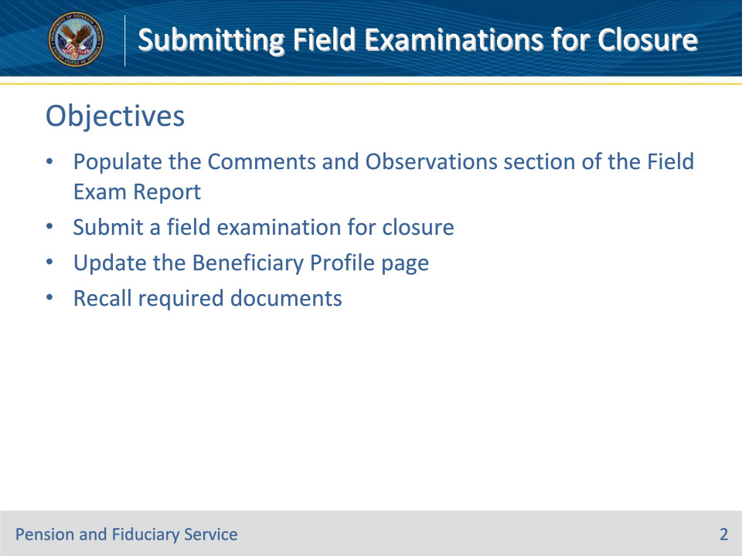
Slide notes

Instructor Notes:

By the end of this lesson, given the training and references, the learner will be able to do the following:

• Populate the Comments and Observations section of the Field Exam Report

• Submit a field examination for closure

• Update the Beneficiary Profile page

• Recall required documents

Slide 3 - References
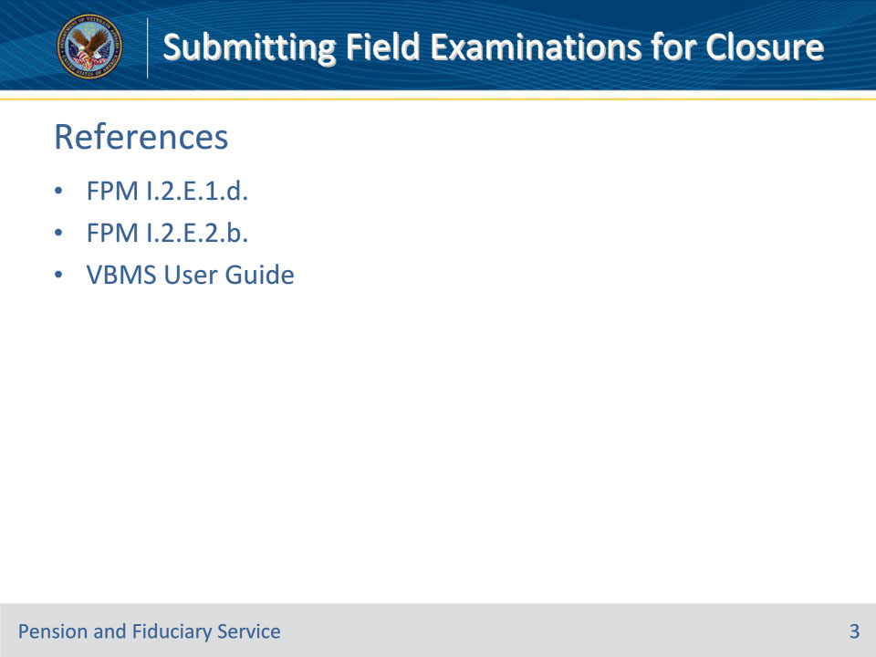
Slide notes

Instructor Notes:

The following are relevant references for this training:

• FPM I.2.E.1.d. How to Prepare Field Examination Documentation

• FPM I.2.E.2.b. Reviewing and Sending Notification Letters

• VBMS User Guide

Slide 4 - Comments and Observations
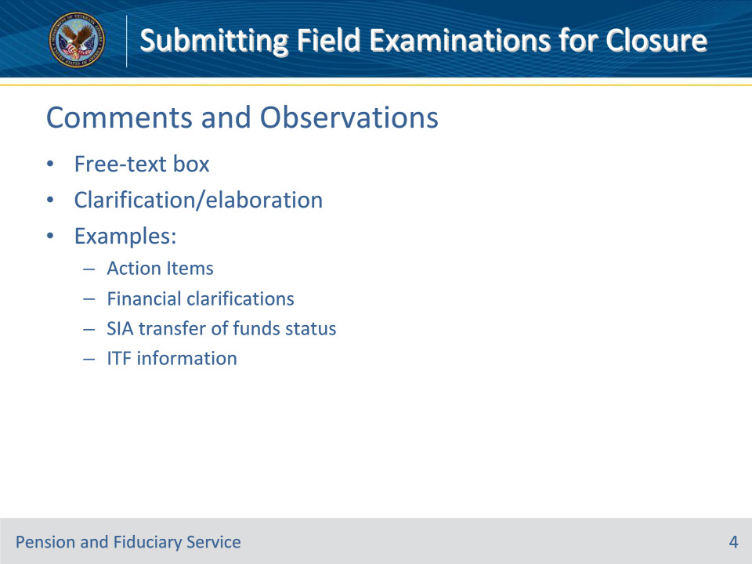
Slide notes

Policy Reference(s): VBMS User Guide

Instructor Notes:

• The Comments and Observation block on the Field Exam report is for the FE to put any information that did not fit in a box or section elsewhere in the report or provide additional explanation.

• Some possible examples may be:

• Action items for the FSR to be aware of

• Clarifications regarding a unique situation with the beneficiary’s finances

• On a SIA, FE documenting the status of the funds transfer from the previous fiduciary to the incoming fiduciary

• Intent to File (ITF) information (See next slide)

Slide 5 - Finalizing the Field Exam Report
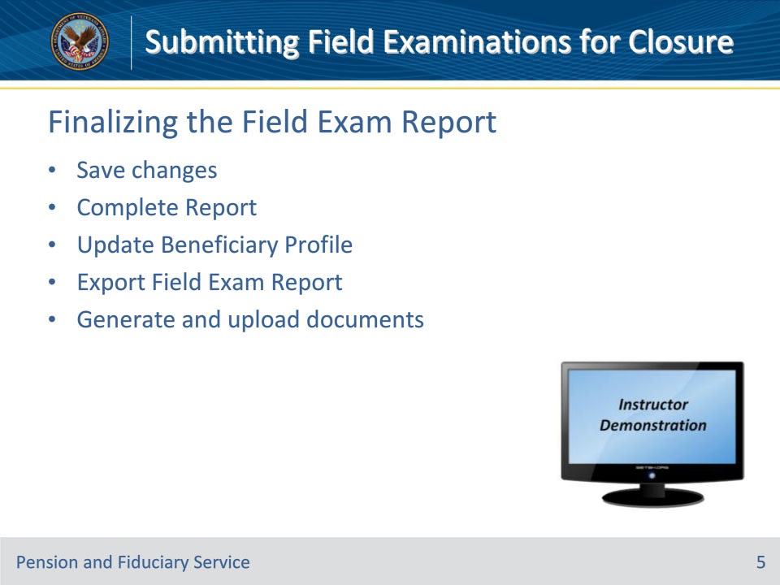
Slide notes

Policy Reference(s): VBMS User Guide

Instructor Notes:

Some steps to finalize the field exam report and the EP590:

• Save changes—Press the “Save Changes” button

• Complete report—Press the “Complete Report” button. Pressing this button should open the “Update Beneficiary” box.

• Update Beneficiary—Use the shortcut “Update Beneficiary” block to easily update block in the Beneficiary Profile screen.

• Export—Press the “Export” button to generate a copy of the report.

• Generate and upload required documents to the eFolder

Instructor Actions: Open VBMS, share your screen and demo the information just discussed.

Slide 6 - Update Beneficiary Profile (#1)
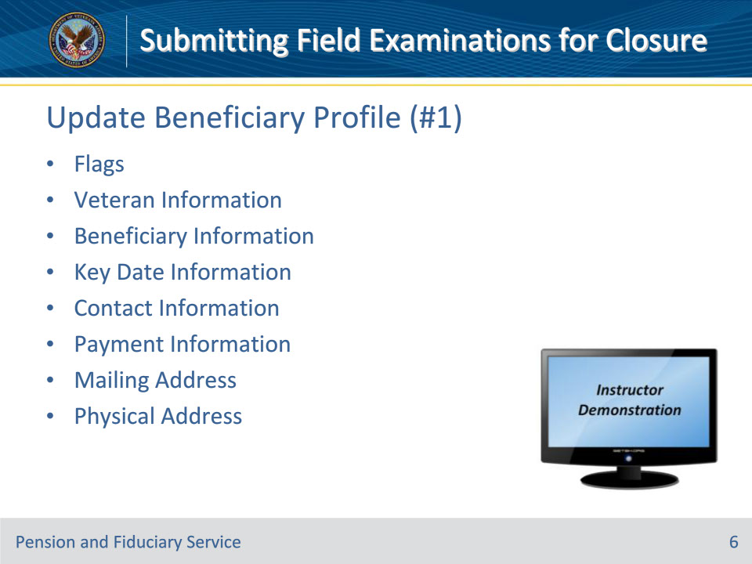
Slide notes

Policy Reference(s): VBMS User Guide

Instructor Notes:

• Flags—Check the relevant boxes for the beneficiary. Additional fields are shown if you select Hostile or Dual Supervision boxes.

• Veteran Information—Displays information regarding the Veteran.

• Beneficiary Information—Displays information regarding the beneficiary.

• Key Date Information—Shows key dates for the beneficiary. Date of Birth, Date of death and Date of Incompetency.

• Contact Information—Shows contact information for the beneficiary. Some fields may be read-only for some users.

• Payment Information—This information should match SHARE.

• Mailing Address—Mailing address for the bene.

• Physical Address—Important blocks include whether the address is a Facility, a VA Contract Nursing Home, and the type of the facility.

Instructor Actions: Open VBMS, share your screen and demo the information just discussed.

Slide 7 - Update Beneficiary Profile (#2)
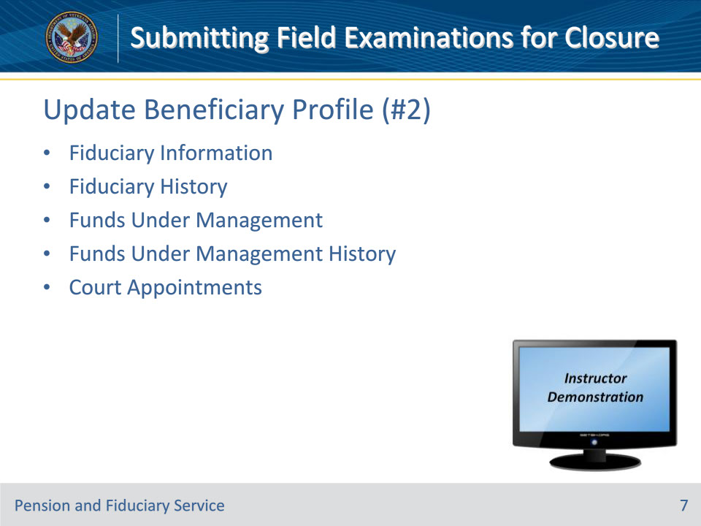
Slide notes

Policy Reference(s): VBMS User Guide

Instructor Notes:

• Fiduciary Information—Verify that this information is correct.

• Fiduciary History—Update as needed.

• Funds Under Management—When an IA or SIA is conducted, the relevant FUM blocks must be updated.

• Funds Under Management History—Update as needed.

• Court Appointments—Press the “Add Court Appointment” and fill in the relevant information, if applicable.

Instructor Actions: Open VBMS, share your screen and demo the information just discussed.

Slide 8 - Update Beneficiary Profile (#3)
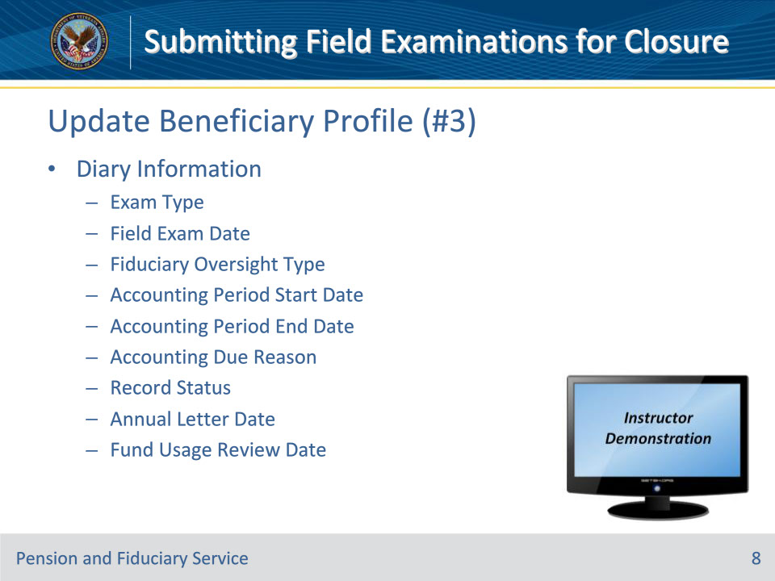
Slide notes

Policy Reference(s): VBMS User Guide

Instructor Notes:

Diary Information—Ensure most current guidance is followed for Exam Type, Field Exam Date, Fiduciary Oversight Type, Accounting Period Start Date, Accounting Period End Date, Accounting Due Reason, Annual Letter Date and Fund Usage Review Date.

• NOTE: Do NOT fill in the Record Closed Date or the Record Status blocks.

• Exam Types/Field Exam Date—Select appropriate beneficiary oversight method and dates

• Fiduciary Oversight Type--Select appropriate fiduciary oversight method

• Accounting Period Start Date and Accounting Period End Date

• Only input a start and end date when an accounting is required; no accounting dates entered here when fiduciary is doing a Fund Usage Review

• Accounting Due Reason—Select most appropriate accounting reason for requiring an accounting

• Record Status—Use only if appropriate

• Pending Final Action

• Pending Review and Action

• Pending Review with VSC/PWC

• Annual Letter Date

• ALWAYS schedule an annual written contact

• One year from the date the Field Exam EP is completed

• Fund Usage Review Date

• Only input a fund usage review date when a Fund Usage Review is required

Instructor Actions: Open VBMS, share your screen and demo the information just discussed.

Slide 9 - Update Beneficiary Profile (#4)
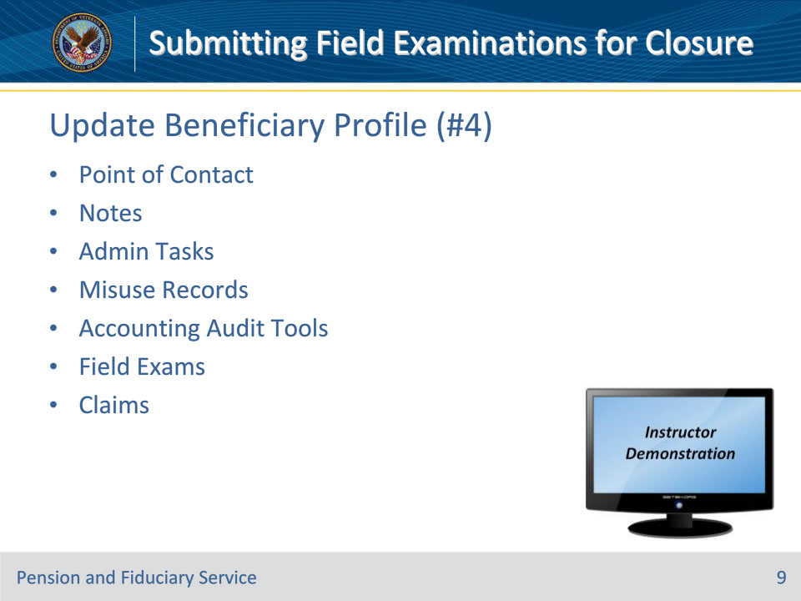
Slide notes

Policy Reference(s): VBMS User Guide

Instructor Notes:

• Point of Contact—This is contact information for someone, other than the fiduciary, who might be able to reach the beneficiary.

• Notes—For any notes associated with the beneficiary. These may be or may not be specific to your recently completed field exam. To add a new note, select Add Note. Then from the Add Note dialog, enter the note information and select OK.

• Admin Tasks—This section lists admin tasks associated with the beneficiary. Create a new task by selecting Create Admin Task.

• Misuse Records—List of misuse records for the beneficiary, including the associated fiduciary and the date of allegation. To open a misuse record, press the View Record button.

• Accounting Audit Tools—List of accounting audit tools associated with the beneficiary.

• Field Exams—Lists field exam reports associated with the beneficiary.

• Claims—Lists claims associated with the beneficiary.

Instructor Actions: Open VBMS, share your screen and demo the information just discussed.

Slide 10 - Required Documents
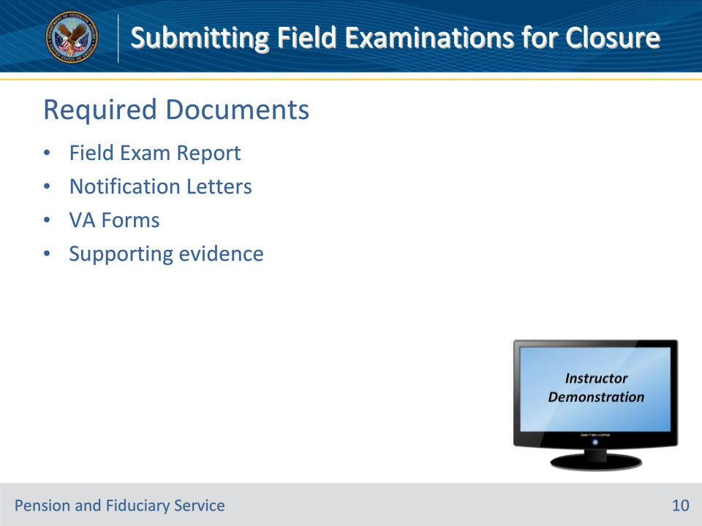
Slide notes

Policy Reference(s): FPM I.2.E.1.d., FPM I.2.E.2.b.

Instructor Notes:

The type of field exam conducted, and the evidence obtained will determine what all the required documents are. A list of some common reports, documents and VA Forms are listed below. This list is not all-inclusive, and not all reports, documents and forms will be required in every case.

IA/SIA/EIA

• Field Exam Report (from VBMS-Fid)

• VA Form 21P-4703

• VA Form 21P-555

• Credit Report

• Criminal Background Inquiry

• IA Beneficiary Notification Letter

• Beneficiary Fee Notice Letter

• Beneficiary Bond Notification Letter

• Fiduciary Commission Notification Letter

• Bond Request Letter

• Certified Court Accounting Due Letter

• IA Fiduciary Notification Letter

• SIA Letter to the previous fiduciary

Scheduled Follow-up

• Field Exam Report (from VBMS-Fid)

• VA Form 21P-4718a

• FB Fiduciary Notification Letter

Telephone Follow-Up

• VA Form 21-3537b

Unscheduled/Fund Usage or Non-Fiduciary Program Field Exam

• VA Form 21-3537b

Instructor Actions: Open VBMS, share your screen and demo the information just discussed.

Slide 11 - Questions?
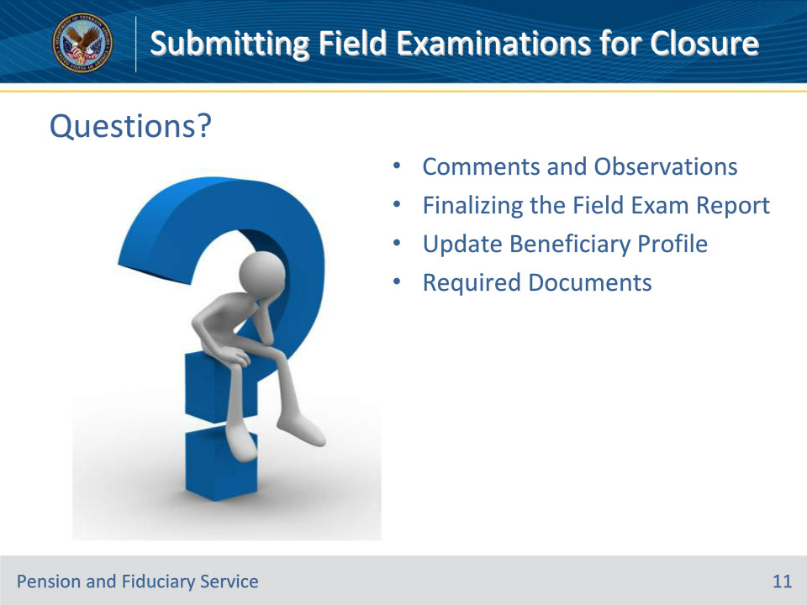
Slide notes

Instructor Notes:

(Recall) These are our learning objectives as stated from the beginning of the training:

• Populate the Comments and Observations section of the Field Exam Report

• Submit a field examination for closure

• Update the Beneficiary Profile page

• Recall required documents

(Recap) We discussed each of these learning objectives through the topics on each of the slides:

• Comments and Observations

• Finalizing the Field Exam Report

• Update Beneficiary Profile

• Required Documents

Are there any additional questions?

Questions should be filtered through your QRT team. They will submit your questions to the Field Inquiry Tool (FIT) on your behalf.

Slide 12 - TMS Survey/Assessment
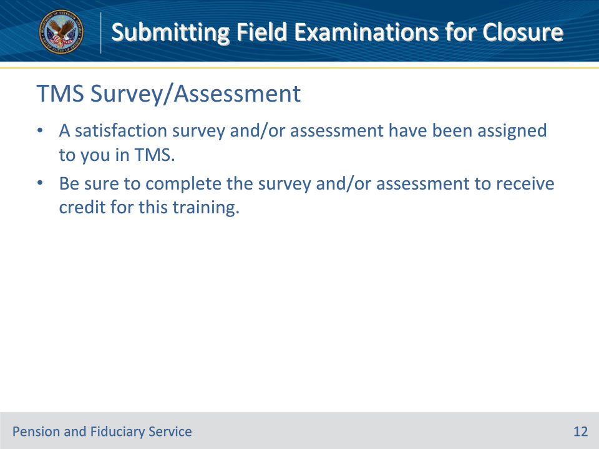
Slide notes

Instructor Notes

A satisfaction survey and/or assessment have been assigned to you in TMS.

Be sure to complete the survey and/or assessment to receive credit for this training.

