Slide 1 - Pre-Field Examination Review
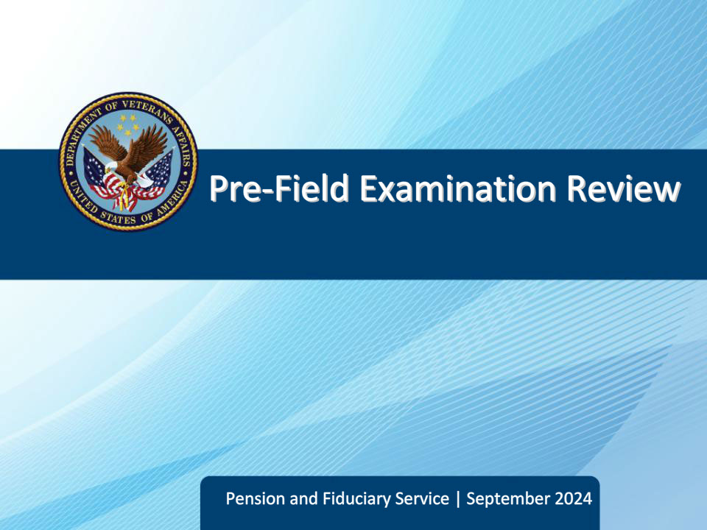
Slide notes

Course Description:

The purpose of this lesson is to provide an overview of how to review a field examination end product to confirm validity and how to review Department of Veteran Affairs (VA) computer systems for information prior to conducting a field examination.

Slide 2 - Objectives
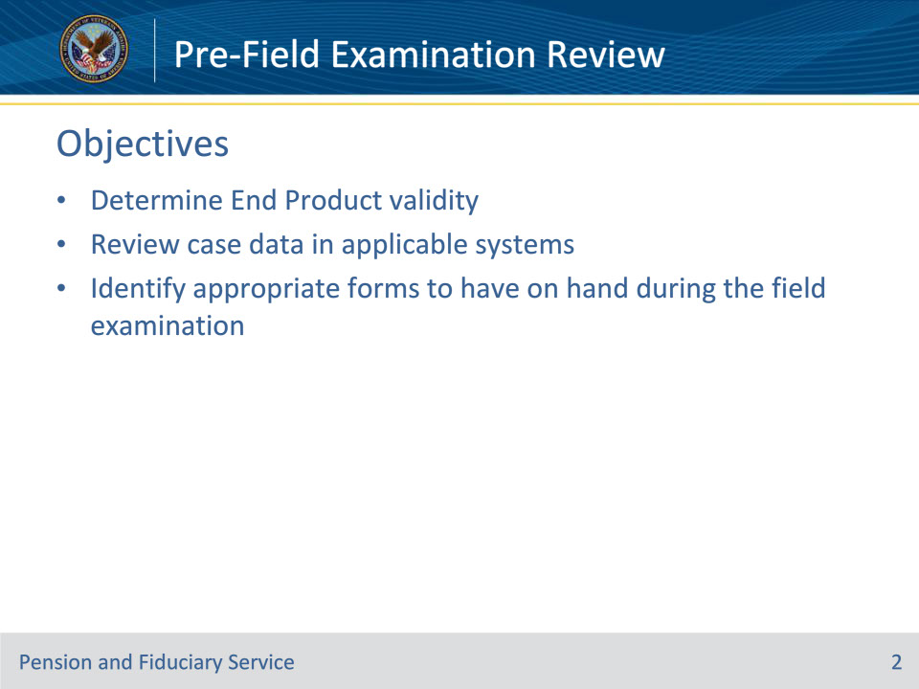
Slide notes

Instructor Notes:

By the end of this lesson, given the training and corresponding references, the learner will be able to do the following:

• Determine End Product validity

• Review case data in applicable systems

• Identify appropriate forms to have on hand during the field examination

Slide 3 - References
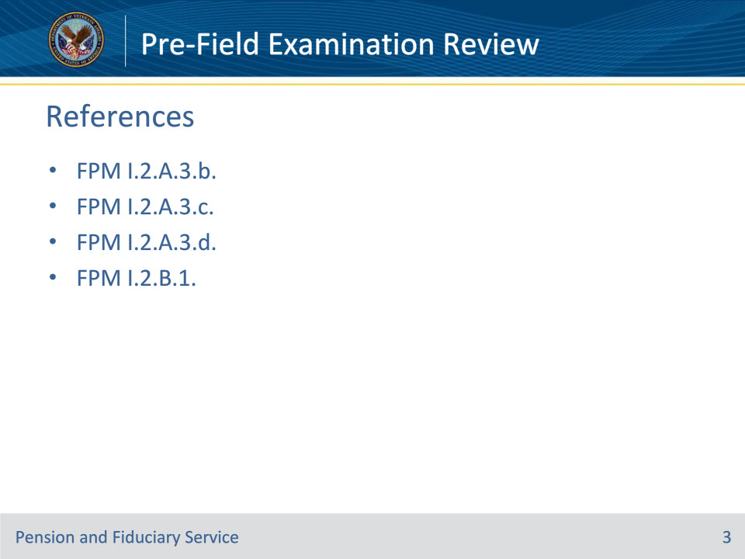
Slide notes

These are the relevant references pertaining to this training:

• FPM I.2.A.3.b. Content Requirements for Requests

• FPM I.2.A.3.c. Review of Fiduciary Program Field Examination Requests

• FPM I.2.A.3.d. FHM Review of Non-Fiduciary Program Field Examination Requests

• FPM I.2.B.1. Reviewing Beneficiary Information Prior to the Field Examination

Slide 4 - Review of Field Examination Requests
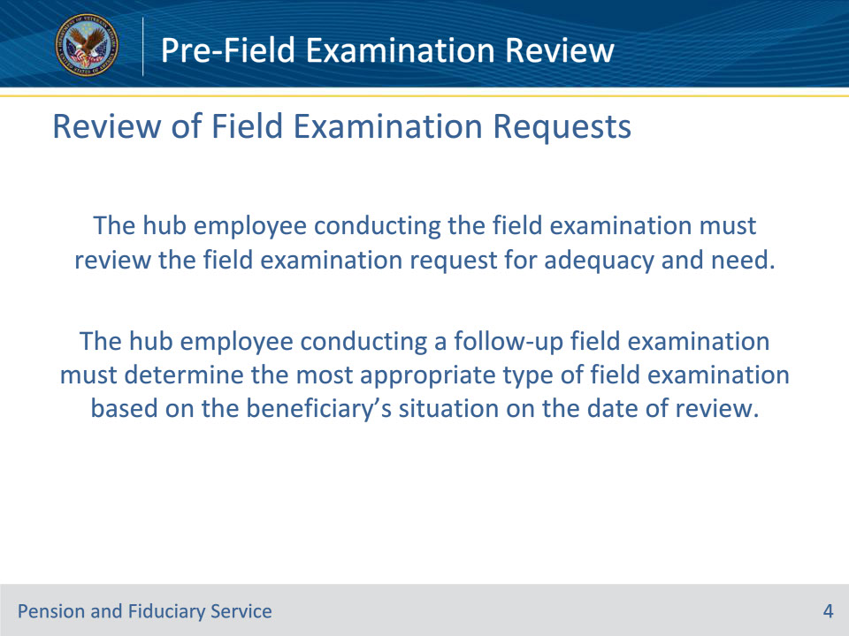
Slide notes

Policy Reference(s): FPM I.2.A.3.c.

Instructor Notes:

The hub employee conducting the field examination must review the field examination request for adequacy and need. Additionally, the hub employee conducting a follow-up field examination must determine the most appropriate type of field examination based on the beneficiary’s situation on the date of review.

Slide 5 - Review of Field Examination Requests
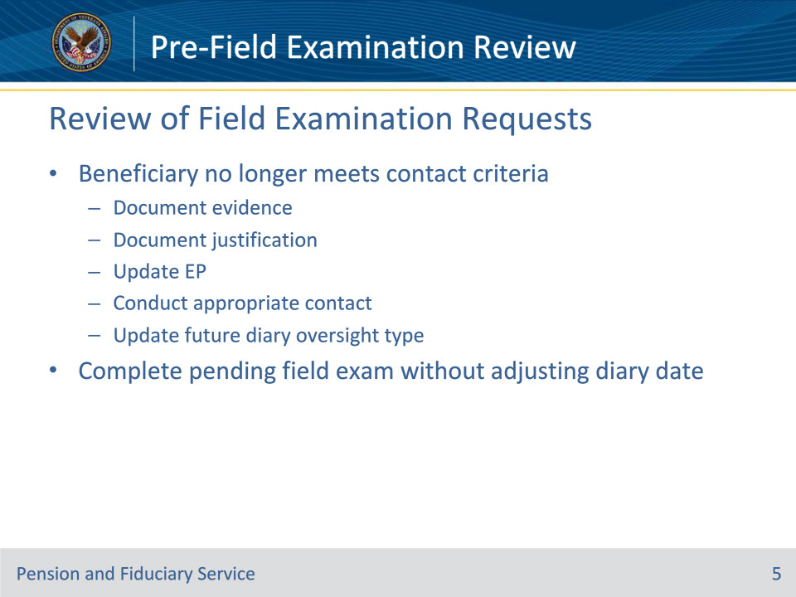
Slide notes

Policy Reference(s): FPM I.2.A.3.c.

Instructor Notes:

If the hub employee conducting the field examination determines that there is evidence in the eFolder prior to the interview or during contact with the beneficiary that the beneficiary no longer meets the criteria for the current beneficiary follow-up contact type, the individual conducting the field examination must

• document the

• evidence, and

• specific justification for the follow-up field examination, to include that the oversight of the beneficiary requires a different follow-up field examination type because the beneficiary no longer meets the criteria

• update the EP to reflect the follow-up oversight that is consistent with the beneficiary’s situation

• conduct the appropriate contact, and

• establish the appropriate future follow-up diary type based on the beneficiary’s current situation.

Hubs must complete the pending field examination using the most appropriate oversight type without adjusting the diary date.

The following slides will describe the content requirements for various types of field examination requests prior to the field examination interview.

Slide 6 - Initial Appointments
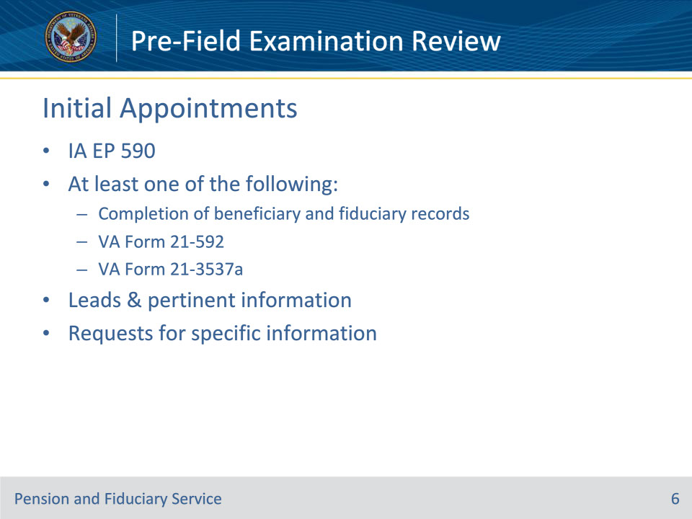
Slide notes

Policy Reference(s): FPM I.2.A.3.b.

Instructor Notes:

IA requests must include establishment of the IA EP 590 in VBMS and at least one of the following available sources for review in the appropriate system of record:

• completion of all appropriate fields on the

• beneficiary record, and

• fiduciary record

• VA Form 21-592, or

• VA Form 21-3537a, Field Examination Request, for appointment of a temporary fiduciary.

Requests will include all available leads and pertinent information, including requests for specific information.

Slide 7 - Successor IAs
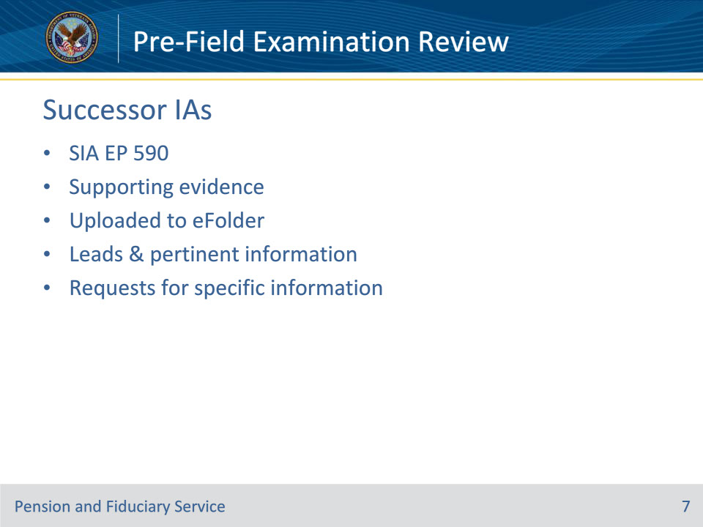
Slide notes

Policy Reference(s): FPM I.2.A.3.b.

Instructor Notes:

SIA field examination requests must include the following and be available for review in the appropriate system of record:

• establishment of an SIA EP 590 in VBMS

• evidence supporting the reason for the SIA uploaded to the electronic claims folder (eFolder), and

• all available leads and pertinent information, including requests for specific information.

Example: If the SIA is being requested due to the fiduciary’s inability to complete an accounting, the fiduciary’s written statement or a VA Form 27-0820, if verbally received, must be uploaded to the eFolder.

Slide 8 - Fund Usage and Unscheduled Follow-up
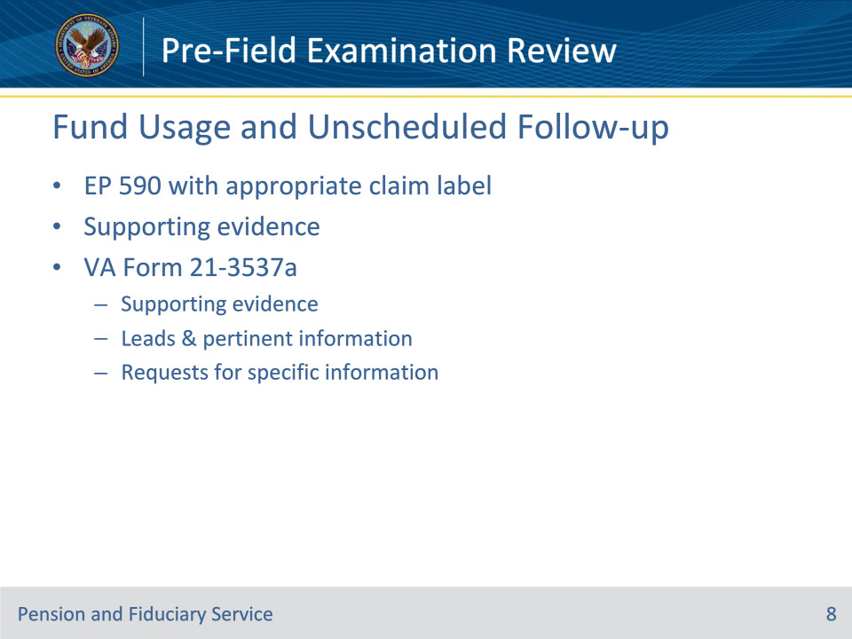
Slide notes

Policy Reference(s): FPM I.2.A.3.b.

Instructor Notes:

Unscheduled follow-up field examination requests must include the following and be available for review in the appropriate system of record:

• establishment of an EP 590 with the appropriate claim label

• evidence supporting the unscheduled field examination, and

• a completed VA Form 21-3537a uploaded to the eFolder containing

• evidence supporting the reason for the fund usage or unscheduled follow-up, and

• all available leads and pertinent information, including requests for specific information.

Slide 9 - Non-Fiduciary Program Field Exams
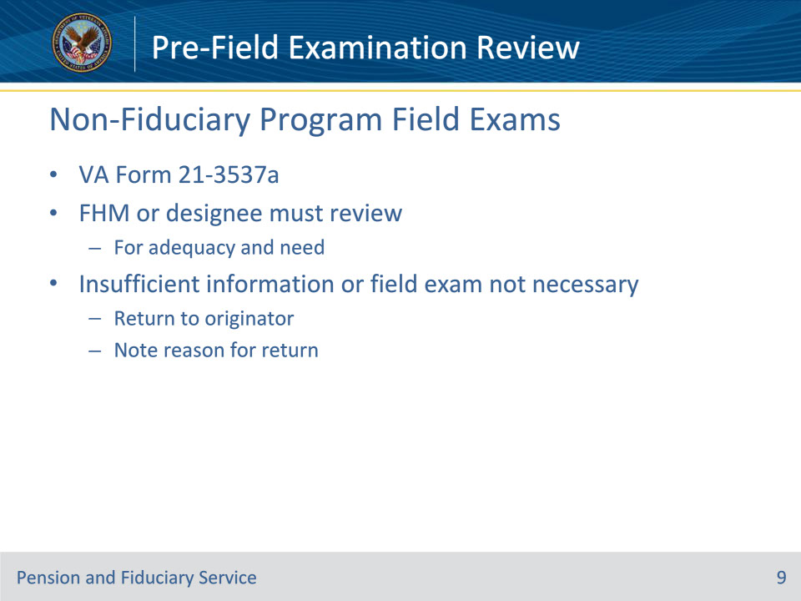
Slide notes

Policy Reference(s): FPM I.2.A.3.b.; d.

Instructor Notes:

Non-fiduciary program requests must also include a completed VA Form 21-3537a made available for review in the appropriate system of record.

The Fiduciary Hub Manager (FHM) or designee must review non-fiduciary program requests for adequacy and need. The hub must return requests containing insufficient information or seeking information that can be obtained without a field examination to the originator noting the reason for return.

Slide 10 - Pre-Exam Review
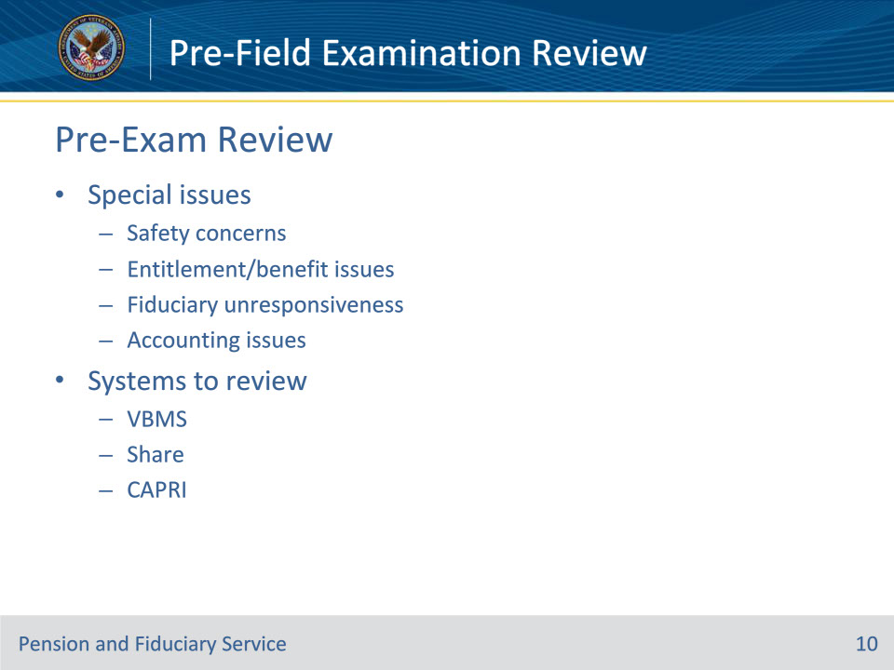
Slide notes

Policy Reference(s): FPM I.2.B.1.a.

Instructor Notes:

Prior to conducting the field examination, the Field Examiner (FE) must review beneficiary information to become familiar with the beneficiary’s situation and identify any issues that may require special attention. These include but are not limited to

• safety concerns

• entitlement/benefit issues

• fiduciary unresponsiveness, and

• accounting issues.

Some available systems to review are:

• VBMS

• Share

• CAPRI

Specific information regarding these systems and the potential documentation that can be found in each are discussed in the following slides.

Slide 11 - Case Data in VBMS
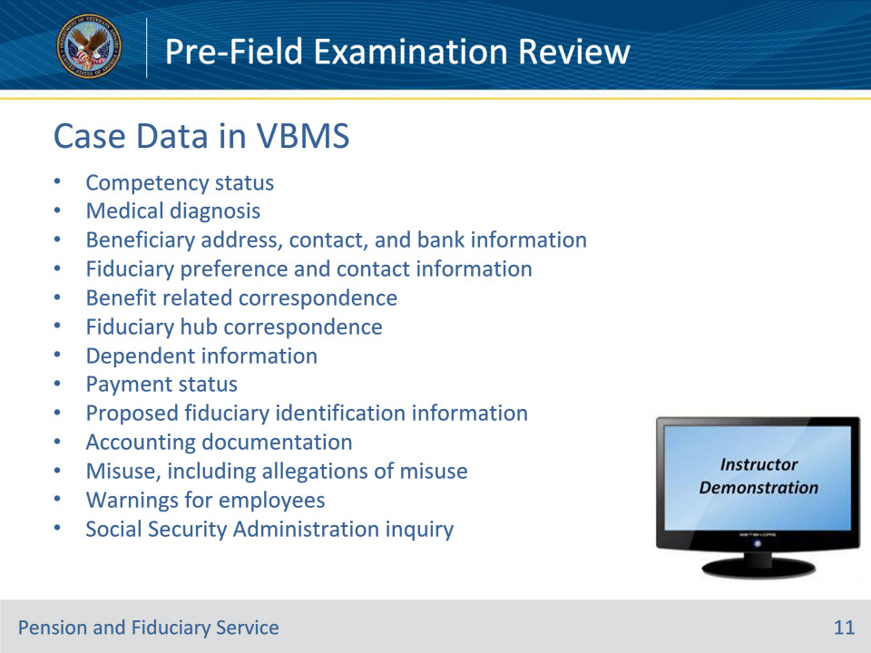
Slide notes

Policy Reference(s): FPM I.2.B.1.a.

Instructor Notes:

If the system is VBMS, then potentially available documentation to assist in identifying issues includes:

• competency status

• medical diagnosis

• beneficiary address, contact, and bank information

• fiduciary preference and contact information

• benefit related correspondence

• fiduciary hub correspondence

• dependent information

• payment status

• proposed fiduciary identification information

• accounting documentation

• misuse, including allegations of misuse

• warnings for employees, and/or

• Social Security Administration inquiry

These are only potential documentation options and not an exhaustive list.

Instructor Demonstration: Demonstrate how to locate this information in VBMS.

Slide 12 - Case Data in Share
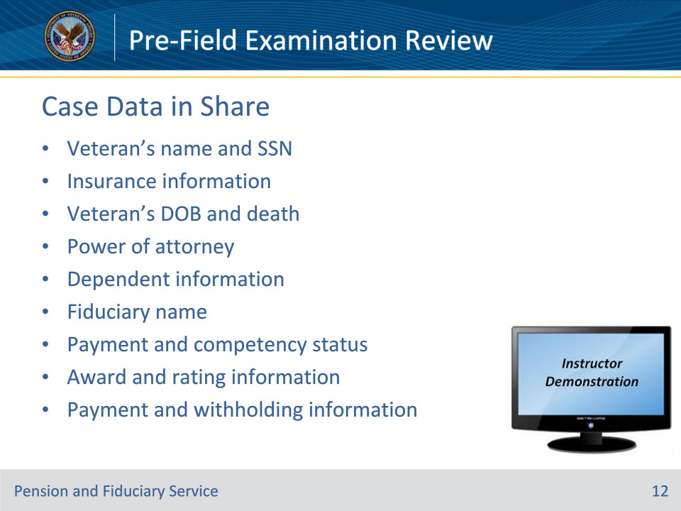
Slide notes

Policy Reference(s): FPM I.2.B.1.a.

Instructor Notes:

If the system is Share, then potentially available documentation to assist in identifying issues includes:

• Veteran’s name and Social Security number

• insurance information

• Veteran’s date of birth and date of death

• power of attorney

• number of dependents and dependency status

• dependent information

• fiduciary name

• payment status and competency status

• award information and rating information, and/or

• payment information and withholding information

These are only potential documentation options and not an exhaustive list.

Demonstration Notes: Demonstrate how to locate this information in Share.

Slide 13 - Case Data in CAPRI
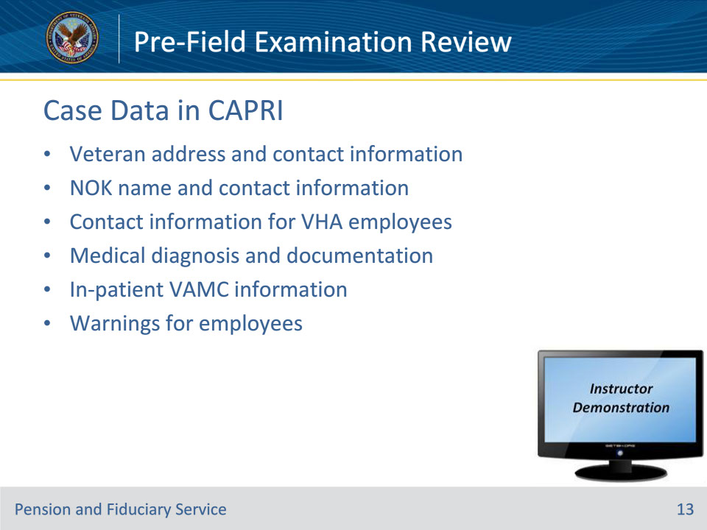
Slide notes

Policy Reference(s): FPM I.2.B.1.a.

Instructor Notes:

If the system is CAPRI, then potentially available documentation to assist in identifying issues includes:

• Veteran’s address and contact information

• next-of-kin name and contact information

• contact information for Department of Veterans Affairs (VA) Veterans Health Administration employees

• medical diagnosis and documentation

• in-patient VA medical center information, and/or

• warnings for employees

These are only potential documentation options and not an exhaustive list.

Demonstration Notes: Demonstrate how to locate this information in CAPRI.

Slide 14 - Criminal Background Inquiry
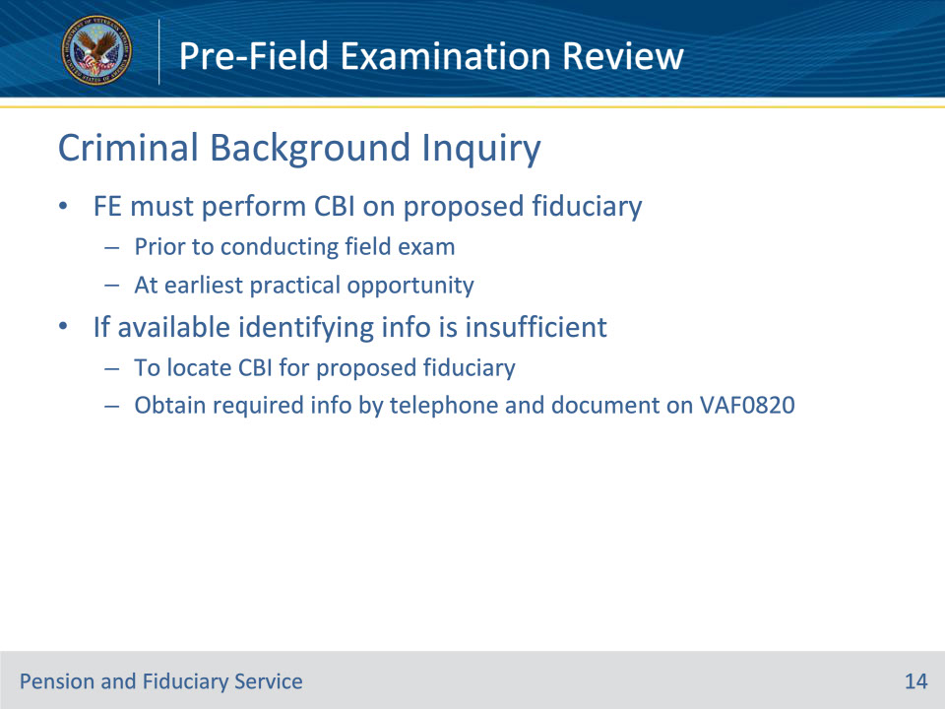
Slide notes

Policy Reference(s): FPM I.2.B.1.a.

Instructor Notes:

Prior to conducting the field examination, the FE must perform the criminal background inquiry (CBI) on the proposed fiduciary. Obtaining the CBI at the earliest practical opportunity prevents further investigation of a person that will not be appointed based on the results of the inquiry. If the available identifying information is insufficient to locate the CBI for the proposed fiduciary, obtain the required information by telephone and document on a VA Form 27-0820, Report of General Information.

Once sufficient information on the proposed fiduciary is identified, follow procedures to obtain the CBI prior to conducting the interview.

Slide 15 - Safety Concerns
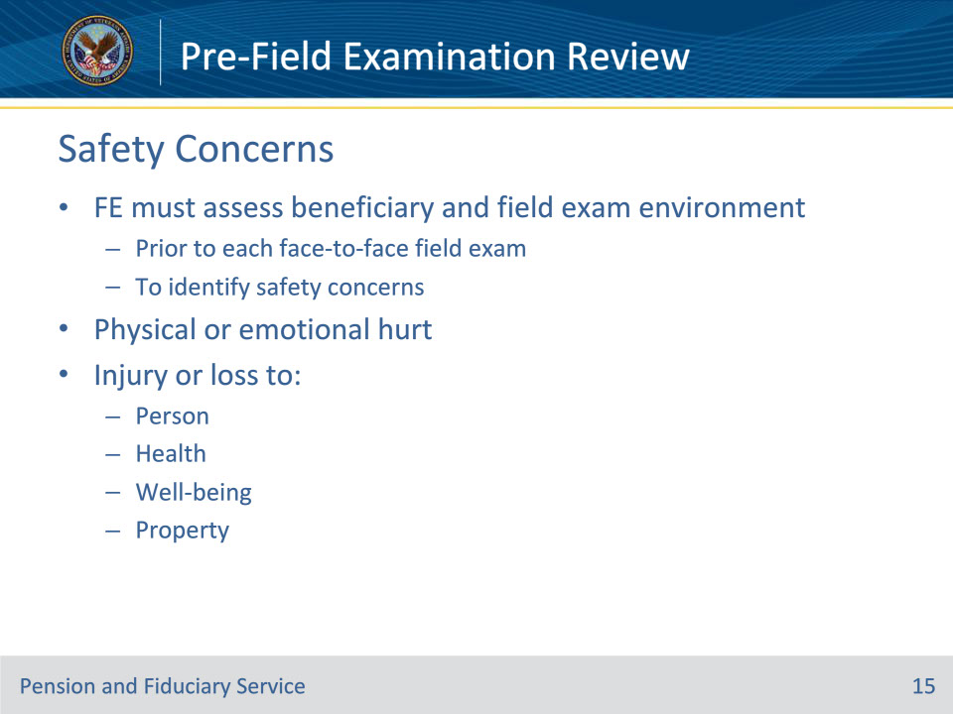
Slide notes

Policy Reference(s): FPM I.2.B.1.b.

Instructor Notes:

Employee safety is a primary concern. Prior to each face-to-face field examination, the FE must assess the beneficiary and field examination environment to identify safety concerns. Safety concerns are conditions that make the FE feel or believe that they may encounter physical or emotional hurt, injury or loss to their person, health, well-being, or property while traveling to, conducting, or leaving a field examination.

The FE must review the beneficiary information to identify safety concerns. The FE must also assess potential safety concerns that may impact travel or the appropriateness of in-person contact.

Further information on this topic can be found in the Field Examination Safety training module.

Slide 16 - Entitlement & Benefit Issues
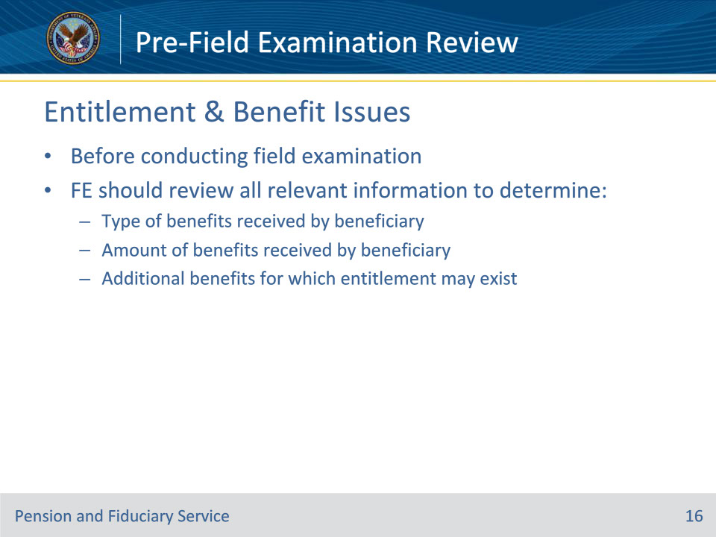
Slide notes

Policy Reference(s): FPM I.2.B.1.c.

Instructor Notes:Before conducting the field examination, the FE should review all relevant information to determine

• the type of benefits received by the beneficiary to include the amount, and

• any additional benefits for which the beneficiary may be entitled.

Slide 17 - Accounting & Fund Usage Issues
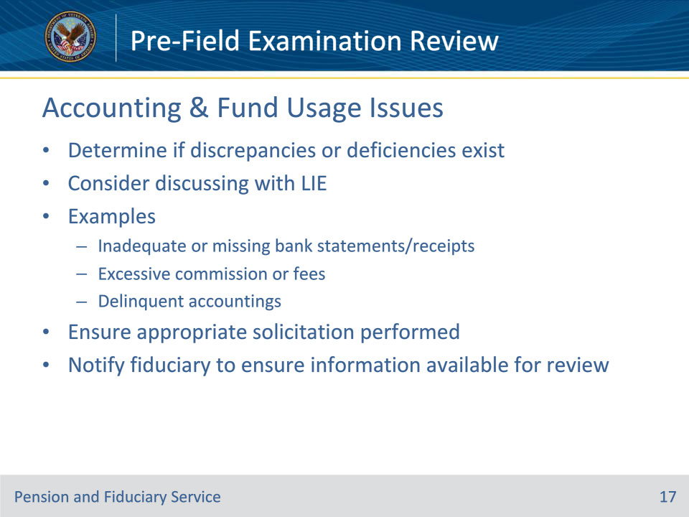
Slide notes

Policy Reference(s): FPM I.2.B.1.d.

Instructor Notes:Prior to conducting the field examination, the FE must review all relevant information to determine if accounting or fund usage discrepancies or deficiencies exist that must be addressed during the field examination. The FE may find it helpful to discuss accounting and/or fund usage issues with a Legal Instrument Examiner (LIE) for assistance and/or clarification on the problems.

Examples of issues include, but are not limited to, a report of

• inadequate or missing bank statements and/or receipts

• excessive commission or fees, and/or

• delinquent accountings.

Ensure the hub solicited the accounting or fund usage report appropriately, to include verifying

• the notification was mailed to the appropriate address, and /or

• telephonic contact to the fiduciary was attempted.

Notifying the fiduciary during the preparation of the field examination might be beneficial to ensure all the appropriate information is available to review or collect.

Slide 18 - Unresponsiveness
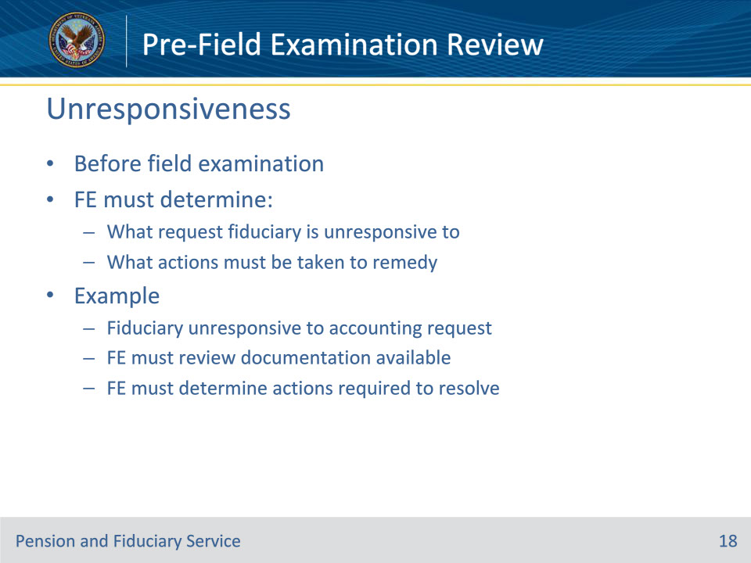
Slide notes

Policy Reference(s): FPM I.2.B.1.e.

Instructor Notes:

The FE must determine before the field examination what request the fiduciary is unresponsive to and what actions must be taken to remedy the problem.

For example, the fiduciary is unresponsive to VA’s request for an annual accounting. The FE must review the documentation available to determine actions required prior to the field examination to resolve the issue.

Slide 19 - Further Preparation
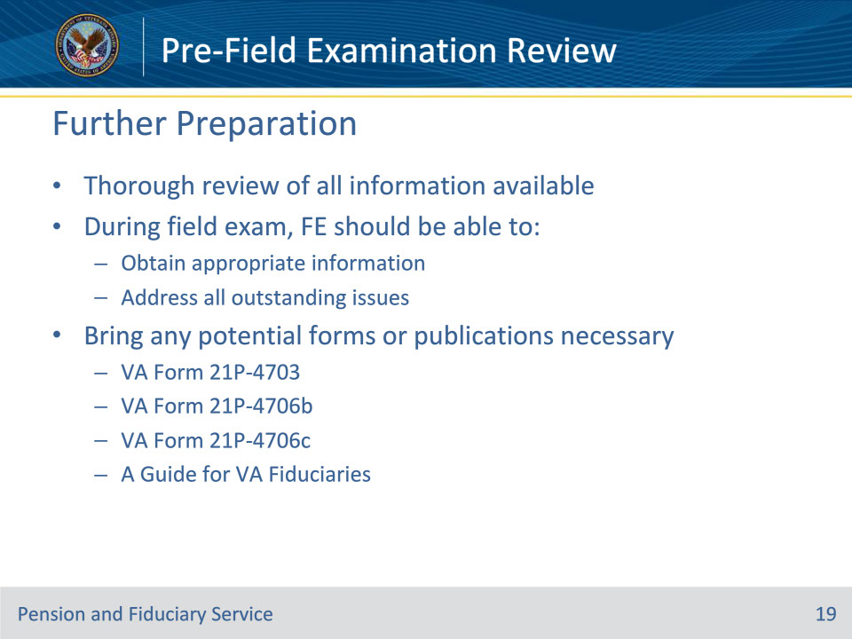
Slide notes

Policy Reference(s): FPM I.2.B.1.f.

Instructor Notes:

Based on a thorough review of the information available, the FE should be able to obtain the appropriate information and address all outstanding issues during the field examination. To address all outstanding issues, the field examination may be conducted in-person, telephonically, or virtually depending on the specific requirements for the type of field examination being conducted.

The preparation also includes bringing any potential forms or publications that may be necessary to address all outstanding issues, such as:

• VA Form 21P-4703, Fiduciary Agreement

• VA Form 21P-4706b, VA Fiduciary’s Account

• VA Form 21P-4706c, Court Appointed Fiduciary’s Account, and/or

• A Guide for VA Fiduciaries.

Slide 20 - Questions?
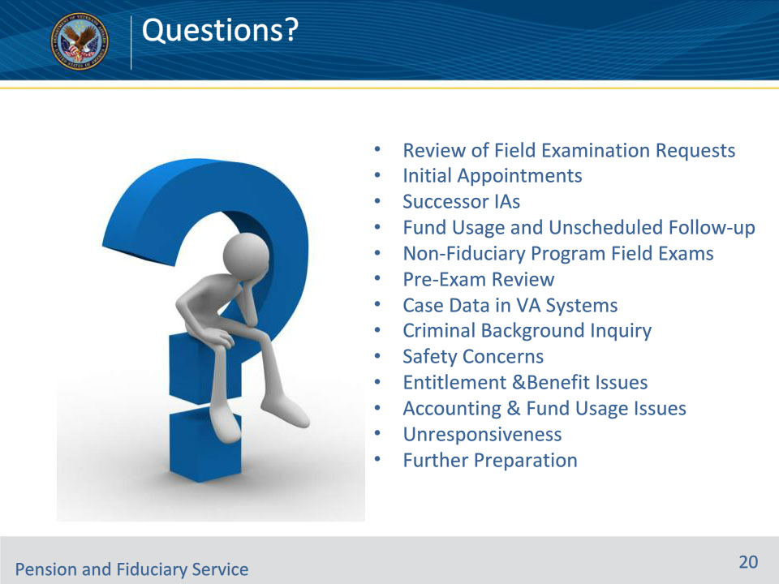
Slide notes

Instructor Notes:

(Recall) These are our learning objectives as stated from the beginning of the training:

• Determine end product validity

• Review case data in applicable systems

• Identify appropriate forms to have on hand during the field examination

(Recap) We discussed each of these learning objectives through the following topics in each slide today:

• Review of Field Examination Requests

• Initial Appointments

• Successor IAs

• Fund Usage and Unscheduled Follow-up

• Non-Fiduciary Program Field Exams

• Pre-Exam Review

• Case Data in VA Systems

• Criminal Background Inquiry

• Safety Concerns

• Entitlement &Benefit Issues

• Accounting & Fund Usage Issues

• Unresponsiveness

• Further Preparation

Are there any additional questions?

Questions should be filtered through your QRT team. They will submit your questions to the Field Inquiry Tool (FIT) on your behalf.

Slide 21 - TMS Survey/Assessment
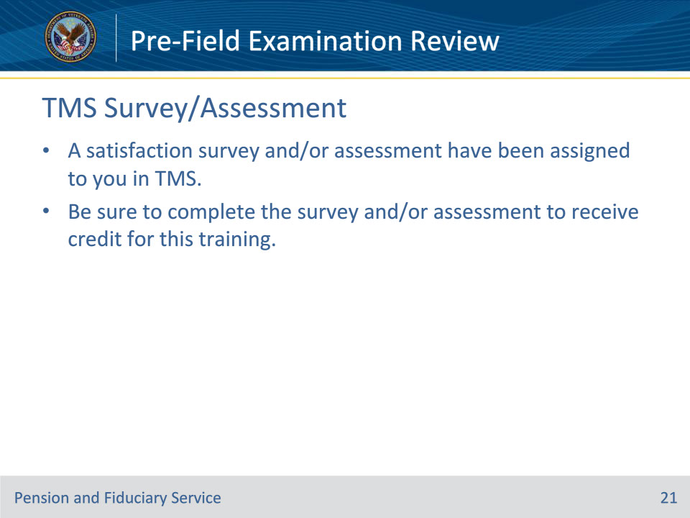
Slide notes

Instructor Notes:

A satisfaction survey and/or assessment have been assigned to you in TMS.

Be sure to complete the survey and/or assessment to receive credit for this training.

