Slide 1 - Overview of Compensation and Pension Record Interchange (CAPRI)
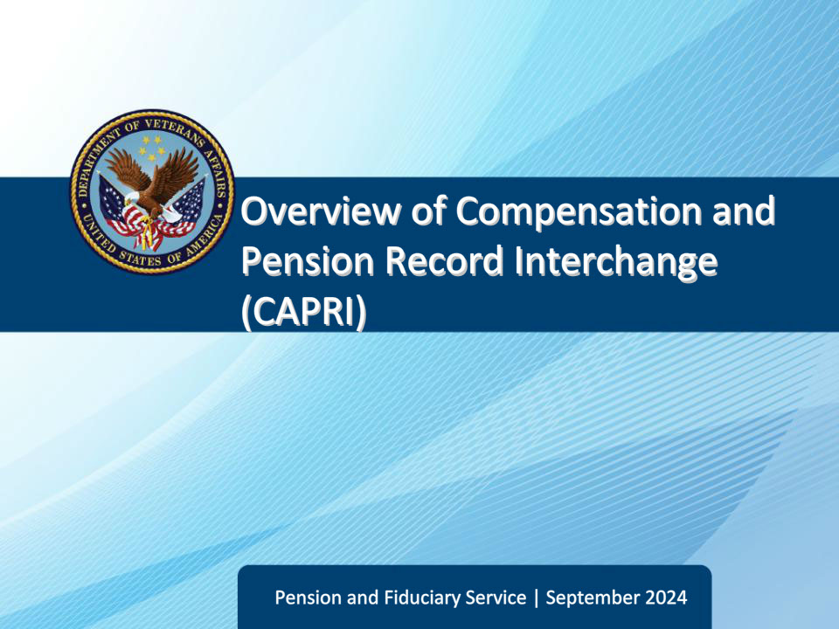
Slide notes

The purpose of this lesson is to provide learners with an overview of the Veterans Health Administration (VHA) application, Compensation and Pension Record Interchange (CAPRI), and provide examples of how to utilize CAPRI during field examination preparation.

Slide 2 - Objectives
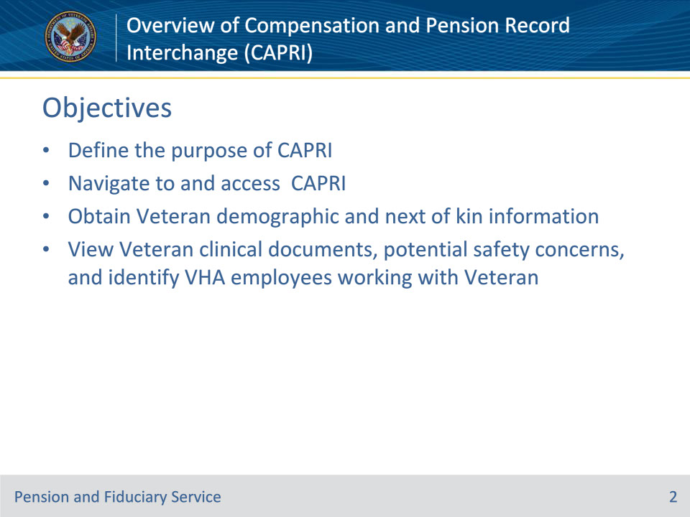
Slide notes

Instructor Notes:

By the end of this lesson, given the training and corresponding references, the learner will be able to do the following:

• Define the purpose of CAPRI

• Navigate to and access CAPRI

• Search Veteran folder to obtain Veteran contact and next of kin information

• Search Veteran folder to view Veteran clinical documents, potential safety concerns, and identify VHA employees working with the Veteran

Slide 3 - References
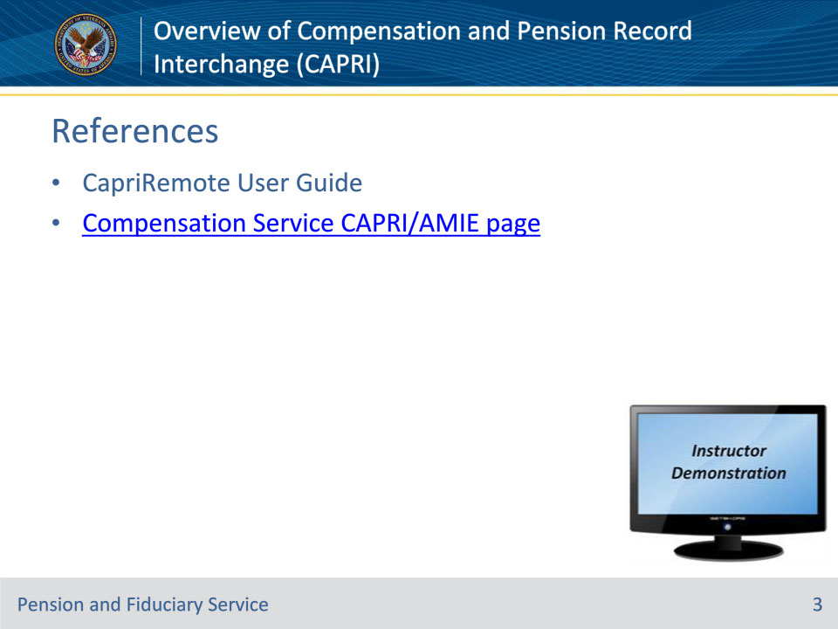
Slide notes

Instructor Notes:

There are two references for this lesson:

• CapriRemote User Guide and

• Compensation Service CAPRI/AMIE webpage.

Demonstration:

Minimize PowerPoint and demonstrate how to access:

• The CapriRemote User Guide—The CapriRemote User Guide can be accessed from the Compensation Service CAPRI/AMIE page: Compensation Service CAPRI/AMIE page: https://vbaw.vba.va.gov/bl/21/DEMO/capri.htm

• Compensation Service CAPRI/AMIE page: Compensation Service CAPRI/AMIE page: https://vbaw.vba.va.gov/bl/21/DEMO/capri.htm

Slide 4 - Purpose
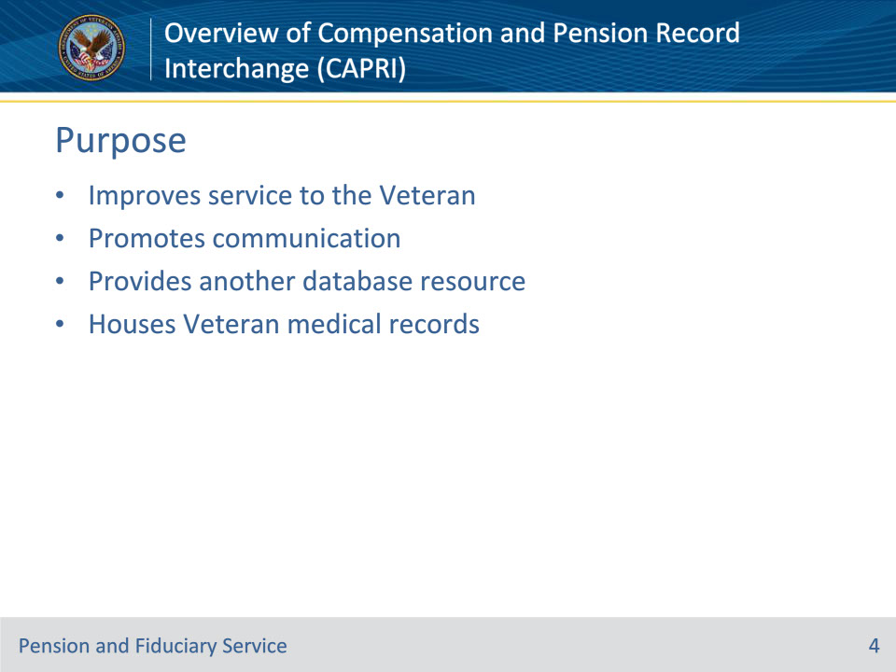
Slide notes

Policy Reference(s): N/A

Instructor Notes:

CAPRI is an information technology initiative to improve service to disabled Veterans by promoting efficient communication between Veterans Health Administration (VHA) and Veterans Benefits Administration (VBA). It is an automated information system that provides authorized users read-only access to Veterans’ medical records created and maintained by VHA facilities.

CAPRI is a resource available to fiduciary hub employees and provides access to:

• View Veteran address and phone number on record with VHA

• View Veteran next of kin on record with VHA

• View Veteran clinical documents and hospitalization records

• Obtain contact information for VHA employees pertaining to a Veteran

• View Veteran date of death

NOTE: CAPRI houses information for Veterans only, and fiduciary hub employees cannot modify CAPRI records.

Slide 5 - Access CAPRI
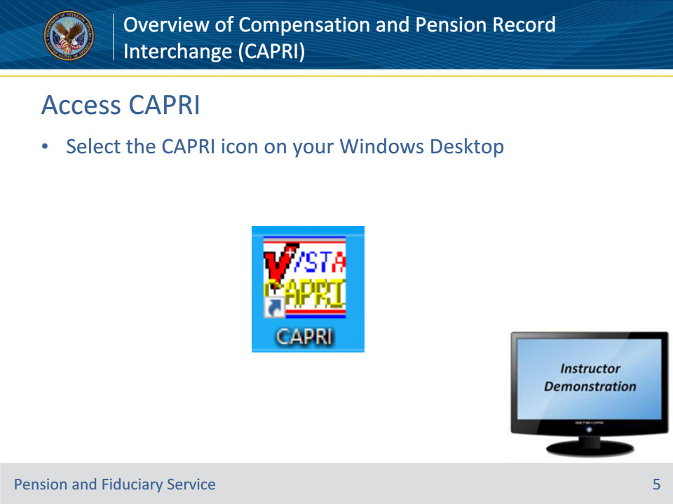
Slide notes

Policy Reference(s): N/A

Instructor Notes:

You must be granted access to CAPRI. After obtaining application access, open the CAPRI application by going to your Windows Desktop and select the CAPRI icon.

The CAPRI news flash screen will populate. Click “close” to open the CAPRI log-in screen.

The CAPRI log-in screen requires entry of an individual Access Code and Verify Code. After entering a personal Access Code, press the Tab key to go to the next field to enter the Verify Code. Press enter or click OK.

Note 1: The first time the user logs into a VISTA application, only the Access Code should be entered. CAPRI will prompt the user to create a Verify Code. CAPRI Access Code and Verify Code are unique to the system and individual user. CAPRI Verify Codes are valid for 30 days; users MUST sign into the system every 30 days to refrain from being locked out.

Note 2: Once the user has logged in the first time, the user may set up CAPRI so the program is able to login using PIV card. Those procedures are listed on the CAPRI webpage discussed earlier--Compensation Service CAPRI/AMIE page: Compensation Service CAPRI/AMIE page: https://vbaw.vba.va.gov/bl/21/DEMO/capri.htm

Demonstration:

Minimize PowerPoint and demonstrate how to navigate to and log-in to CAPRI.

Slide 6 - Search Veteran Folder
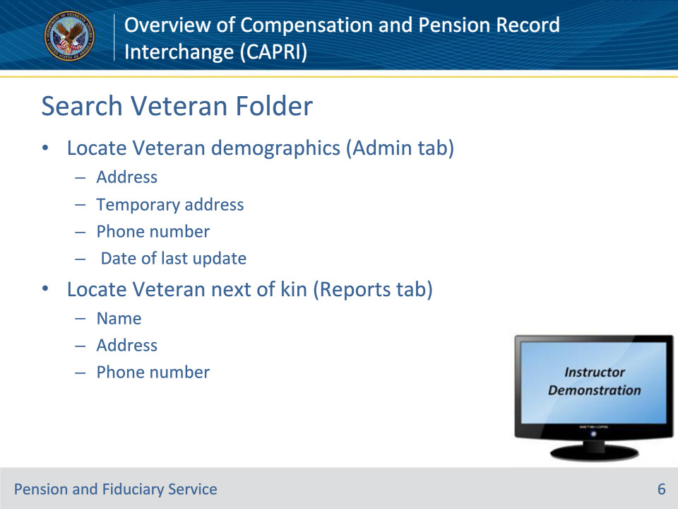
Slide notes

Policy Reference(s): N/A

Instructor Notes:

It is possible that a Veteran does not understand that Veterans Health Administration (VHA) and Veterans Benefits Admiration (VBA) are different entities of the Department of Veterans Affairs (VA). If the Veteran does not understand the entities within VA, he/she may not realize that all VA computer systems do not talk to each other. It is imperative that fiduciary hub employees attempt to explain the mission differences of VHA and VBA when the opportunity arises. VHA focuses on the medical care of Veterans while VBA focuses on the benefits a Veteran is entitled to. Fiduciary hub employees should also explain to the Veteran that updating contact information or next of kin information with VHA does not automatically update VBA systems and the best way to confirm correct system updates is to notify VHA and VBA independently.

CAPRI demographic records may assist fiduciary hub employees in locating a Veteran by providing the employee with a different contact phone number, a different address or contact information for Veteran next of kin. If this information differs from VBA records, fiduciary hub employees should utilize these pieces of information to exhaust all avenues when searching for a Veteran.

Selection of the Admin tab allows users to view:

• permanent and temporary addresses VHA records show for a specific Veteran

• Veteran’s contact information

• a Veteran’s past and future appointments, and

• dates of a Veteran’s inpatient admissions.

Selection of the Reports tab allows users to:

• inquire about a specific Veteran’s

• Next of kin contact information

• Demographics

• eligibility for treatment, and

• inpatient admissions

• determine whether a Veteran has been treated at another VHA facility

• review registration and profile data, and

• obtain surgery reports.

Demonstration:

• Using a pre-screened file, minimize PowerPoint and demonstrate how to search a Veteran folder for the Admin tab. Explain that the tab displays the current and temporary address for a Veteran, phone number, and date of last update.

• Demonstrate how to search a Veteran folder for the Reports tab. Explain that the tab displays the sub-category of Patient Inquiry automatically, and that next of kin information (name, address, and phone number), if on record with VHA, is found at the bottom of the Patient Inquiry screen.

Slide 7 - Search Veteran Folder Continued
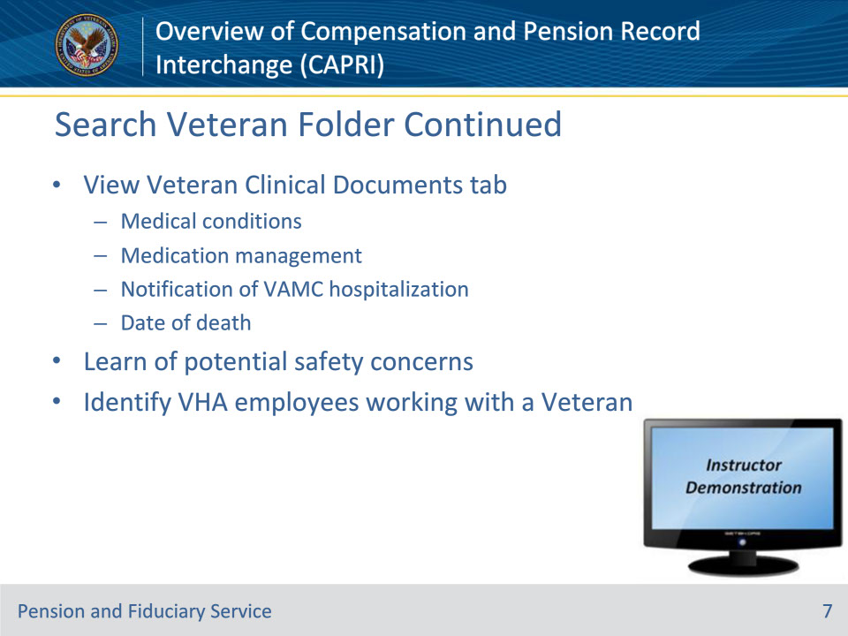
Slide notes

Policy Reference(s): N/A

Instructor Notes:

Veteran clinical documents may provide fiduciary hub employees insight on the Veteran’s medical conditions, the Veteran’s medication management (or lack thereof), and deliver notification of hospitalization in a VA Medical Center (VAMC).

Selection of the Clinical Documents tab allows users to search and view a Veteran’s clinical documents. Clinical documents are organized by category and accessible from the following tabs, which appear at the bottom of the screen:

• NOTES (progress notes)

• DISCHARGE SUMMARIES

• CONSULTS

• VITALS

• MEDS

• LABS

• IMAGING (X-rays, magnetic resonance imaging (MRI), computer axial tomography (CT))

• DIET

• NUTRITIONAL ASSESSMENT

• ORDER SUMMARY

• PROCEDURES (Holter monitor, echocardiogram, stress test, etc.), and

• PROBLEM LIST.

If the Veteran is hostile with Veteran Health Administration (VHA) employees, the clinical notes will document the hostility. Clinical documents may assist a fiduciary hub employee to identify potential safety concerns and allow the field examiner (FE) to take appropriate action before conducting the field examination.

Clinical documents may also help connect Veterans Benefits Administration employees with VHA employees who are working with the same Veteran. The suggestion of fostering good working relationships with VHA employees can not be stressed enough. Those relationships may prove to ease some of the fiduciary hub employee burden and open the lines of communication between entities.

CAPRI will also notify a user of a Veteran’s death in a pop-up window upon access to the applicable Veteran record. The date of death may also be found in the Reports tab.

Demonstration:

• Using a pre-screened file, minimize PowerPoint and demonstrate how to search a Veteran folder for the Clinical Documents tab. Show some of the clinical documents and discuss how the information contained in the documents are useful to fiduciary hub employees – the employees may see documentation relating to medical conditions, medication management, VAMC hospitalization records, and the Veteran’s date of death.

• Demonstrate how to search a Veteran folder for the Reports tab. Demonstrate and explain that this tab displays the sub-category of Patient Inquiry automatically, and that Veteran expiration information (date of death, source of notification, time and date of update, and last edited by), is found in the middle of the Patient Inquiry screen.

• Discuss that clinical documents may also contain documentation relating to the Veteran’s demeanor and if traveling VHA employees visit the Veteran alone or with another employee present. Stress that this information is extremely helpful to FEs as they prepare and schedule field examinations.

• Demonstrate identifying a VHA employee working with the same Veteran as the FE by puling up a social work note and showing the writer’s name. The name can be used to search for email, phone, or IM contact. Give example of how collaborating with a social worker could positively impact a Veteran beneficiary.

• Example: FE is unable to contact or locate a Veteran to conduct an IA field examination, but the clinical records show the Veteran is due at the VAMC for a Social Work appointment tomorrow. Contacting the social worker and explaining the situation may yield the social worker granting the FE permission to attend the meeting, the social worker having the Veteran return the FEs call during the scheduled social work appointment, or the social worker updating the Veteran’s contact information in CAPRI and notifying the FE of the Veteran’s updated contact information.

Slide 8 - Questions?
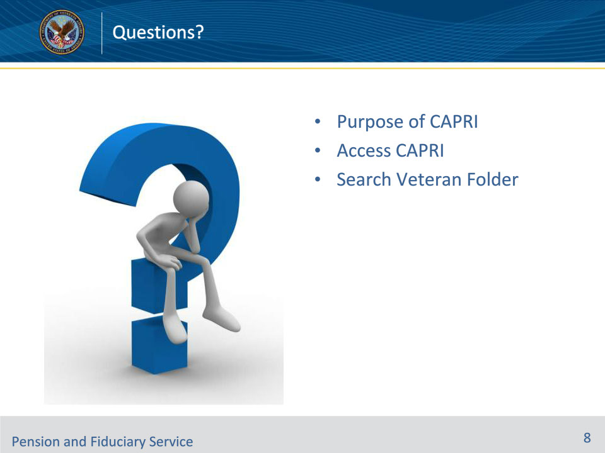
Slide notes

Instructor Notes:

(Recall) These are our learning objectives as stated from the beginning of training:

• Define the purpose of CAPRI

• Navigate to and access CAPRI

• Search Veteran folder to obtain Veteran contact and next of kin information

• Search Veteran folder to view Veteran clinical documents, potential safety concerns, and identify VHA employees working with the Veteran

(Recap) We discussed each of these learning objectives through the following topics in each slide today:

• Purpose

• Access CAPRI

• Search Veteran Folder

Are there any other questions?

Questions should be filtered through your QRT team. They will submit your questions to the Field Inquiry Tool (FIT) on your behalf.

Slide 9 - TMS Survey/Assessment
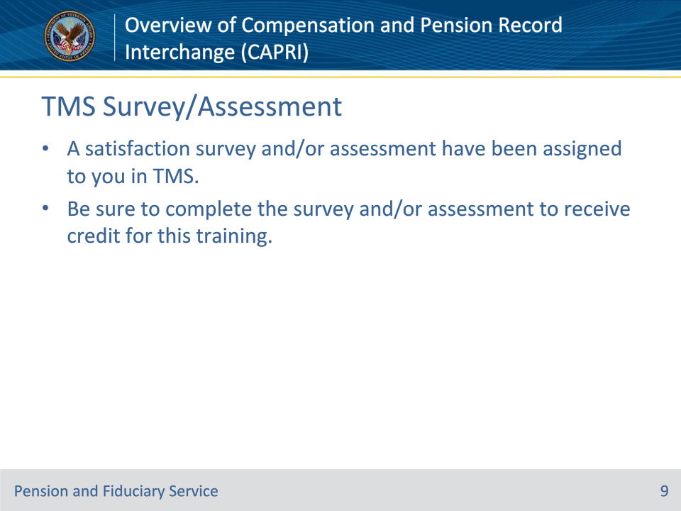
Slide notes

Instructor Notes:

A satisfaction survey and/or assessment have been assigned to you in TMS.

Be sure to complete the survey and/or assessment to receive credit for this training.

