Slide 1 - Field Examinations
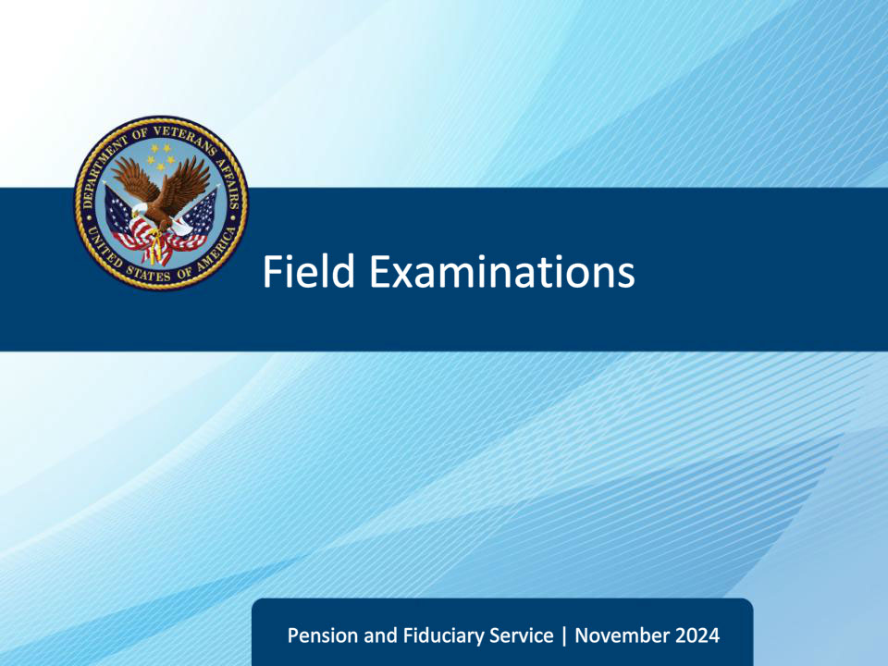
Slide notes

Instructor Notes:

This lesson teaches learners the purpose and reasons for conducting field examinations, the major elements of field examinations, the different types of field examinations, and assists the learner to identify mandatory field examination supporting documents, forms, and notification letters.

Slide 2 - Objectives
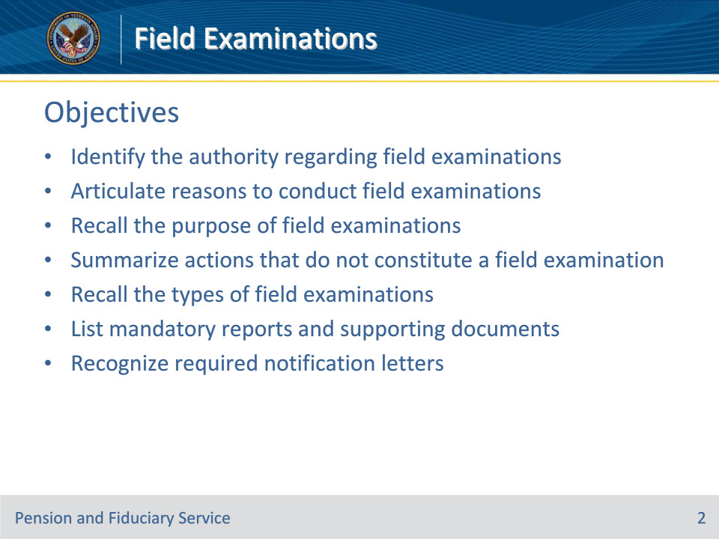
Slide notes

Instructor Notes:

By the end of this lesson, given the training and corresponding references, the learner will be able to do the following:

• Identify the authority regarding field examinations

• Articulate reasons to conduct field examinations

• Recall the purpose of field examinations

• Summarize actions that do not constitute a field examination

• Recall the types of field examinations

• List mandatory reports and supporting documents

• Recognize required notification letters

Slide 3 - References
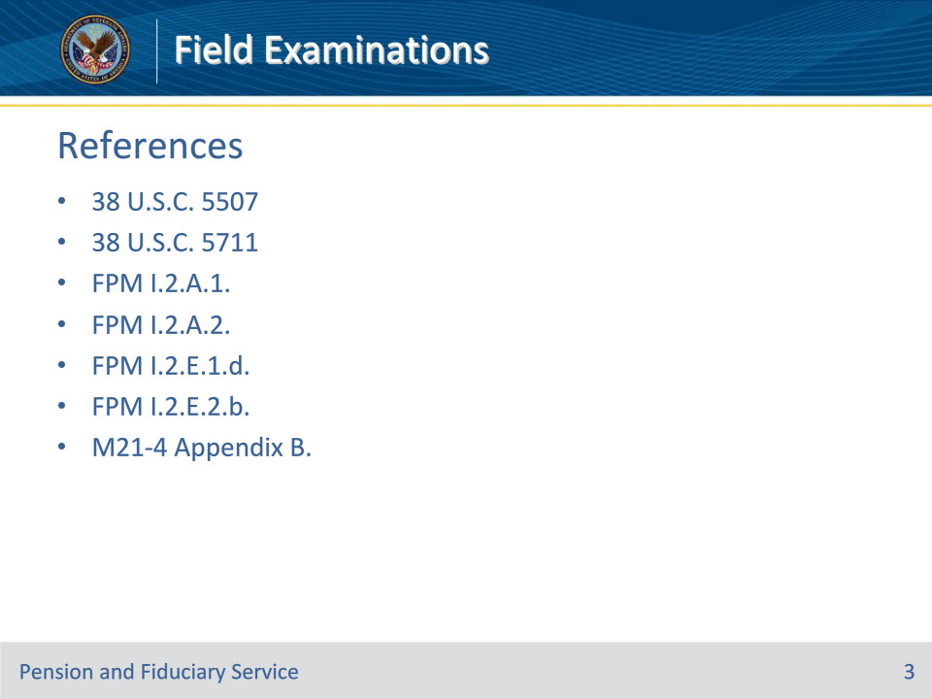
Slide notes

Instructor Notes:

These are the relevant references for todays’ training:

• 38 U.S.C. 5507 - Inquiry, investigations, and qualification of fiduciaries

• 38 U.S.C. 5711 - Authority to issue subpoenas

• FPM I.2.A.1. Authority and Purpose of Field Examinations

• FPM I.2.A.2. Field Examination Types

• FPM I.2.E.1.d. How to Prepare Field Examination Documentation

• FPM I.2.E.2.b. Required Notification Letters

• M21-4 Appendix B. End Product (EP) Codes

Slide 4 - Authority
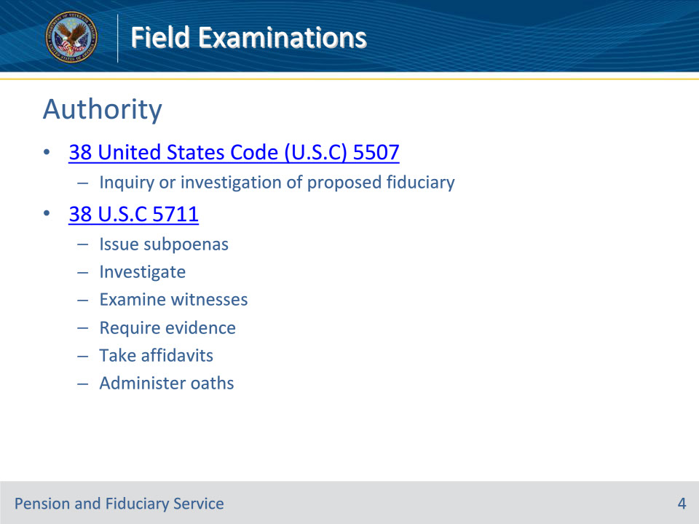
Slide notes

Policy Reference(s): FPM I.2.A.1.a.; 38 U.S.C. 5507; 38 U.S.C. 5711

Instructor Notes:

38 U.S.C. 5507 requires the Department of Veterans Affairs (VA) to conduct an inquiry or investigation regarding the fitness of a person to serve as fiduciary for a beneficiary.

38 U.S.C. 5711 authorizes VA to conduct investigations and examine witnesses upon any matter within the jurisdiction of VA, issue subpoenas, require the production of books, papers, documents, and other evidence; and take affidavits and administer oaths and affirmations.

Slide 5 - Reasons
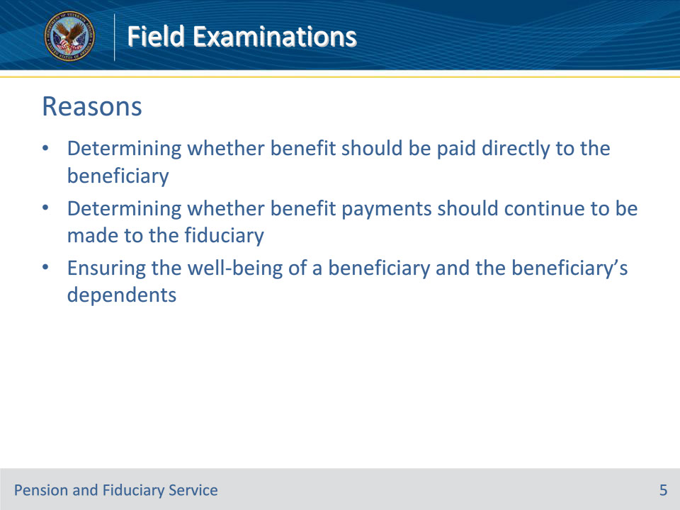
Slide notes

Policy Reference(s): FPM I.2.A.1.b.

Instructor Notes:

In accordance with 38 U.S.C. 5502, VA makes benefit payments directly to adult beneficiaries unless VA determines payment to a duly recognized fiduciary is in the best interest of the beneficiary. When the payment method is anything other than direct and unsupervised, the fiduciary hub (hub) must conduct periodic field examinations or other approved means of supervision to continually assess the beneficiary’s status and integrity of services provided by the fiduciary.

The reasons for conducting a field examination include

• determining whether benefits should be paid directly to the beneficiary or continue to be made to the fiduciary, and

• ensuring the well-being of a beneficiary and the beneficiary’s dependents.

Slide 6 - Purpose
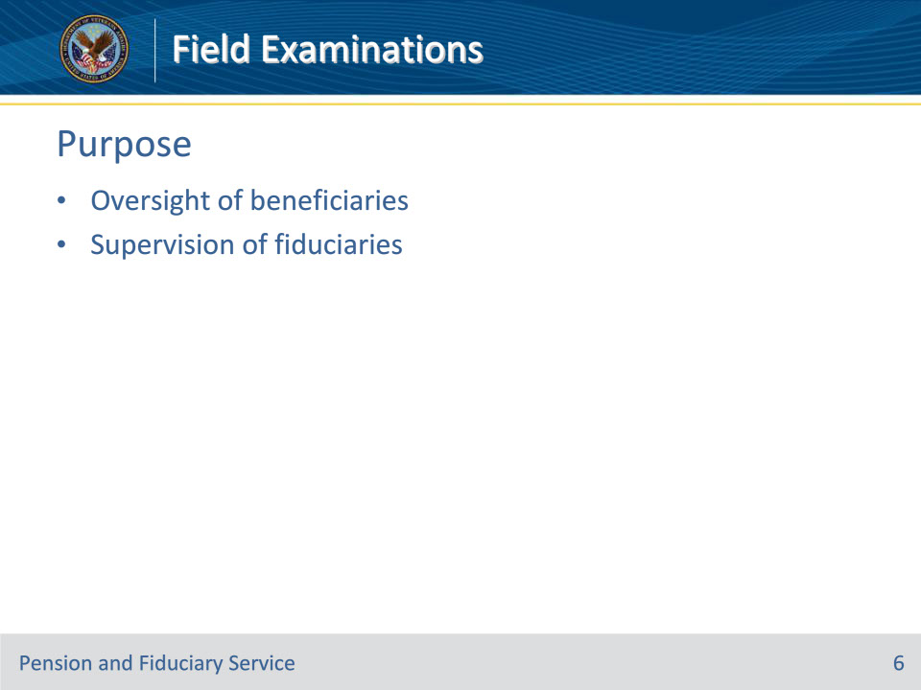
Slide notes

Policy Reference(s): FPM I.2.A.1.c.

Instructor Notes:

With respect to fiduciary appointments, VA will conduct field examinations for the purpose of performing oversight of beneficiaries in the fiduciary program and supervision of fiduciaries appointed to manage their VA benefits.

Slide 7 - Not a Field Exam
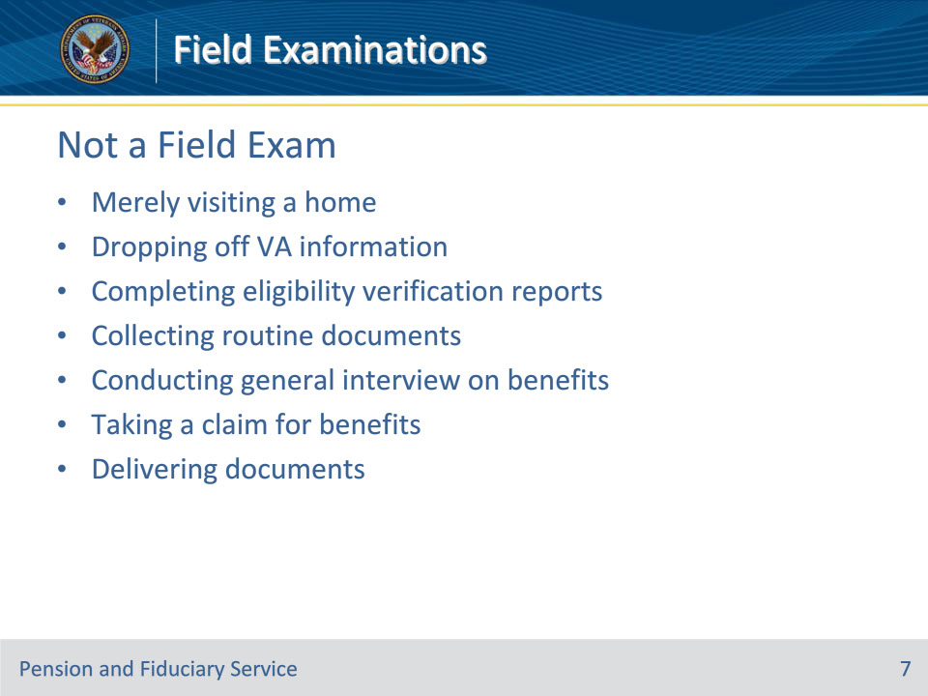
Slide notes

Policy Reference(s): FPM I.2.A.1.d.

Instructor Notes:

To be considered a field examination, it is essential that the elements of inquiry, search, or investigation are present.

The following actions do not constitute Fiduciary Program field examinations of any type and do not fulfill VA’s responsibility to perform oversight:

• merely visiting a home

• dropping off VA information

• completing eligibility verification reports

• collecting routine documents

• conducting an away-from-office general interview on benefits

• taking a claim for benefits, or

• delivering letters, subpoenas, or similar documents without gathering and documenting facts, or developing evidence.

Slide 8 - Responsibility
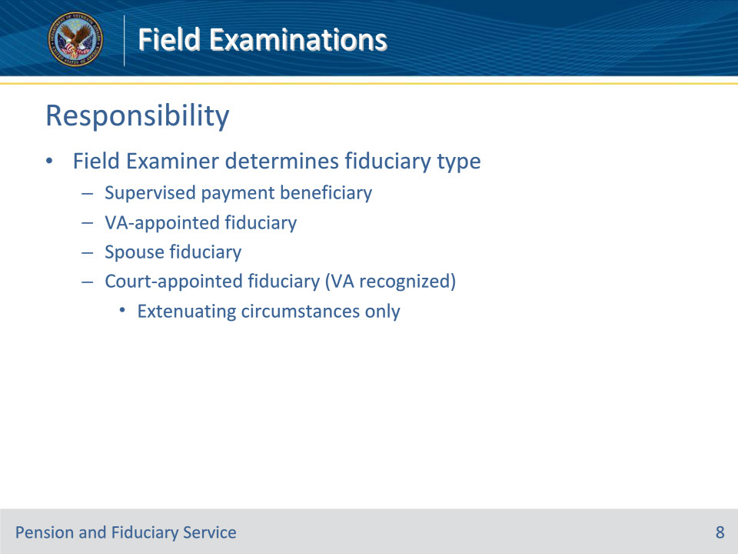
Slide notes

Policy Reference(s): FPM I.2.A.1.e.

Instructor Notes:

If the beneficiary is rated unable to manage their funds, or is under a court appointed guardianship, the Field Examiner (FE) is responsible for determining the type of fiduciary relationship that will best serve the needs of the beneficiary. Benefit payments may be made

• directly to a supervised direct payment beneficiary

• to a VA-appointed fiduciary

• to a spouse fiduciary, or

• in extenuating circumstances only, to a court-appointed fiduciary (VA recognized).

Slide 9 - Initial Appointment Field Exams
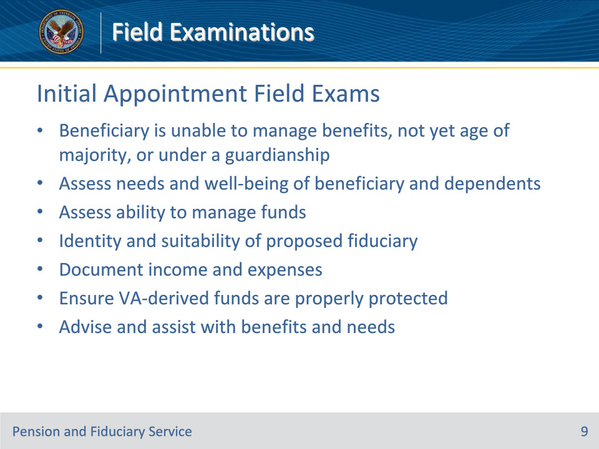
Slide notes

Policy Reference(s): FPM I.2.A.2.a.

Instructor Notes:

An initial appointment (IA) field examination involves the need for and, when necessary, the qualification and appointment of a fiduciary to receive VA benefits or insurance payments. The appointment is made on behalf of a beneficiary who is determined to be unable to manage their benefits, has not reached age of majority, or is under a court-appointed general law or plenary guardianship or Uniform Veterans Guardianship Act guardianship.

IA field examinations are completed to

• assess the

• needs and well-being of the beneficiary and their dependents

• ability of an adult beneficiary to manage funds, and

• suitability of the proposed fiduciary

• identify a proposed fiduciary

• document income and expenditures for the beneficiary

• ensure VA funds are properly protected, if required, and

• provide advice and assistance with benefits and needs.

Slide 10 - Types of IA Field Exams
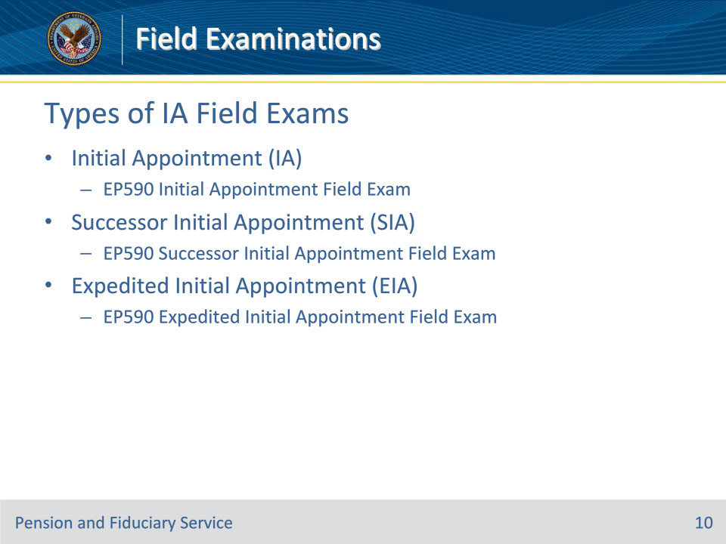
Slide notes

Policy Reference(s): FPM I.2.A.2.b.; M21-4 Appendix B

Instructor Notes:

There are three types of IA field examinations: IA, successor IA and Expedited IA

Initial Appointment (IA)--A face-to-face interview or telephone interview, when applicable, and investigation activity conducted by designated hub or other qualified VA personnel for the purpose of qualifying and appointing a fiduciary for an individual who is not currently under hub supervision.

• EP590IAFE – Initial Appointment Field Exam is the associated End Product for this work product.

Successor IA (SIA): A face-to-face inquiry or telephone interview, when applicable, and investigation activity conducted by designated hub or other qualified VA personnel for the purpose of qualifying and appointing a replacement fiduciary for the beneficiary.

• EP590SIAFE – Successor Initial Appointment Field Exam is the associated End Product for this work product.

Expedited IA (EIA): A telephone interview and investigation activity conducted by designated hub or other qualified VA personnel for the purpose of expediting the qualification and appointment of a fiduciary. Only certain situations qualify for EIA field exams based on criteria outlined in the FPM.

• EP590EIAFE – Expedited Initial Appointment Field Exam is the associated End Product for this work product.

Slide 11 - Follow-up Field Exams
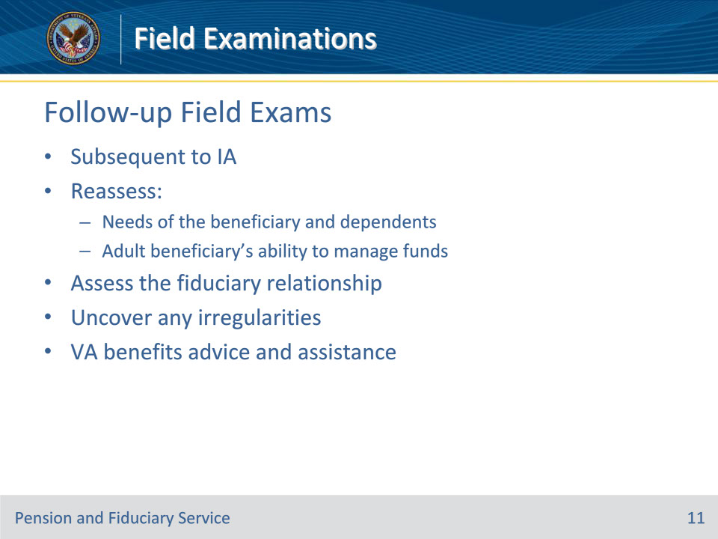
Slide notes

Policy Reference(s): FPM I.2.A.2.d.

Instructor Notes:

Follow-up field examinations are performed subsequent to an IA field examination. These examinations may include the need to

• reassess the

• needs of the beneficiary and dependents, and

• adult beneficiary’s ability to manage funds

• assess the fiduciary relationship

• uncover any irregularities, and

• provide advice and assistance in relation to VA or other benefits based on the beneficiary’s needs.

A follow-up field examination that results in a change of fiduciary is considered an SIA field examination. The VBMS EP must be changed to reflect the appropriate examination type.

Slide 12 - Types of Follow-up Field Exams
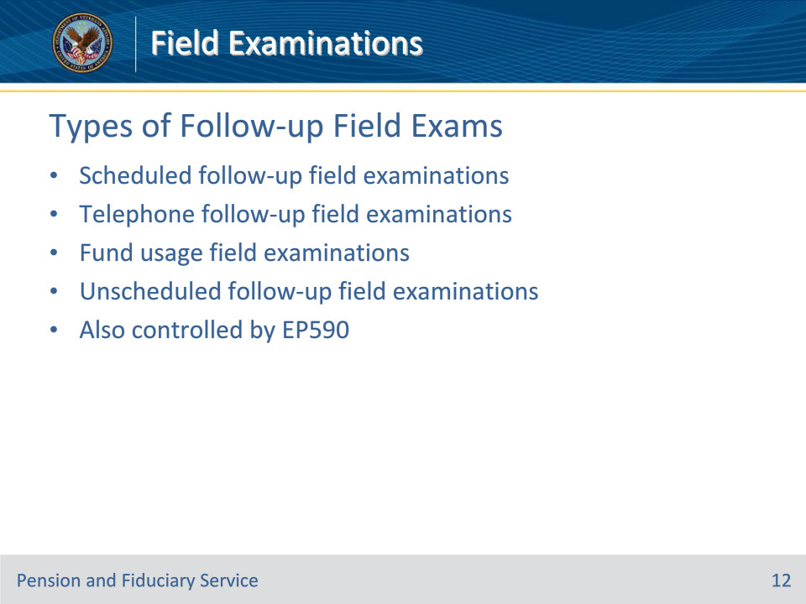
Slide notes

Policy Reference(s): FPM I.2.A.2.e.

Instructor Notes:

The four types of follow-up field examinations are listed below.

Scheduled follow-up field examinations: The inquiry and monitoring activity conducted for the purpose of protecting the beneficiary and their VA benefits through face-to-face contact with the beneficiary.

Telephone follow-up field examinations: The inquiry and monitoring activity conducted for the purpose of monitoring the beneficiary and their VA benefits through telephone contact with the beneficiary.

Fund usage field examinations: The specific inquiry into the fiduciary’s use of the beneficiary’s funds for the purpose of reviewing an issue affecting the fiduciary’s management of VA benefits, which was identified or reported to the hub and determining if the fiduciary’s appointment should continue. Appropriate reasons for fund usage field examination requests could include, but are not limited to

• accounting assistance issues, or

• fund usage review documentation issues.

Unscheduled follow-up field examinations: The inquiry conducted for the purpose of reviewing a specific issue affecting the beneficiary’s well-being, which was identified by or reported to the hub. Appropriate reasons for unscheduled follow-up field examination requests could include, but are not limited to

• adverse conditions, or

• well-being check.

Similar to IA field exams, these follow-up field exams are also controlled by EP590s with claim labels matching the type of exam.

Slide 13 - Follow-up Field Exam Stages
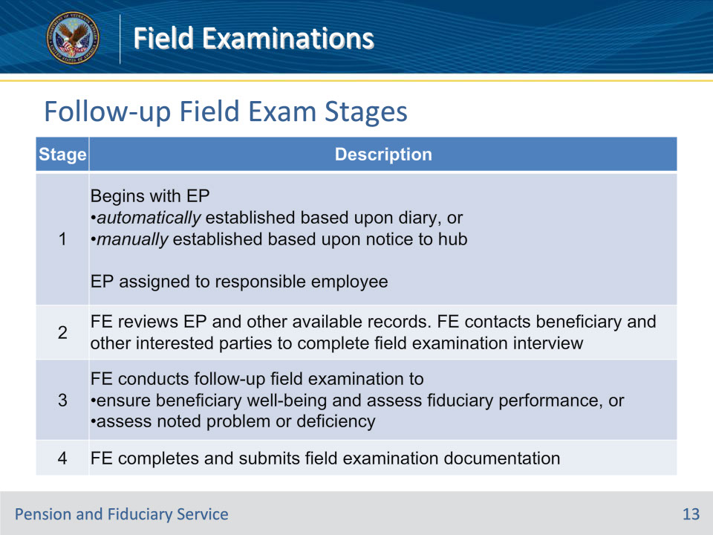
Slide notes

Policy Reference(s): FPM I.2.A.2.f.

Instructor Notes:

This table describes the stages of the follow-up field examination process.

Slide 14 - Non-Fiduciary Program Field Exams
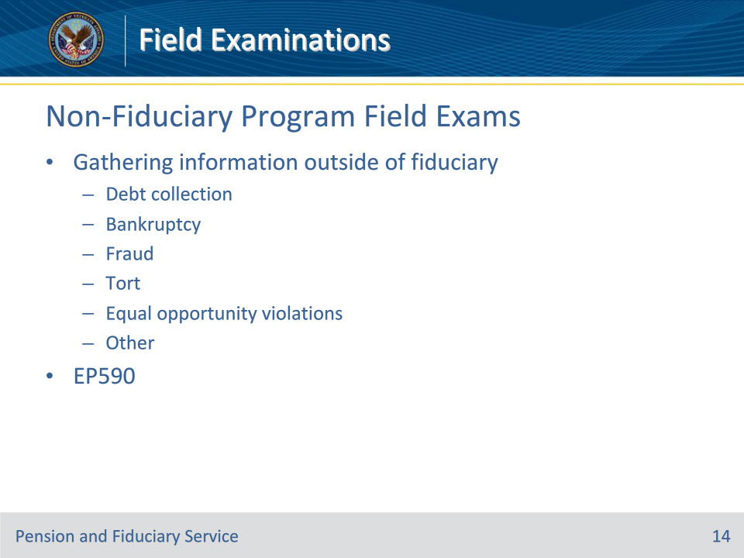
Slide notes

Policy Reference(s): FPM I.2.A.2.g.

Instructor Notes:

A non-fiduciary program field examination is a field examination that does not involve fiduciary program issues. This type of exam is conducted to investigate or develop evidence to enable the requesting VA business line to resolve outstanding issue(s).

Non-fiduciary program field examinations are grouped into the following areas of investigation:

• debt collection

• bankruptcy

• fraud

• tort

• equal opportunity violations

• other

The “other” category includes requests for facts or documentation involving claims for benefits such as compensation or pension.

• As with IAs and follow ups, non-program exams are also controlled by EP590

Evaluating the information being requested, the hub employee conducting the non-fiduciary program field examination must determine the most appropriate method to conduct the examination. For example, if the hub is being asked to assist with obtaining information relating to a bankruptcy, the hub employee must determine if the information may be obtained through telephone contact and through review of available records. If the hub employee finds the information can be obtained without face-to-face contact, an in-person meeting should not occur.

Slide 15 - Field Exam Reports
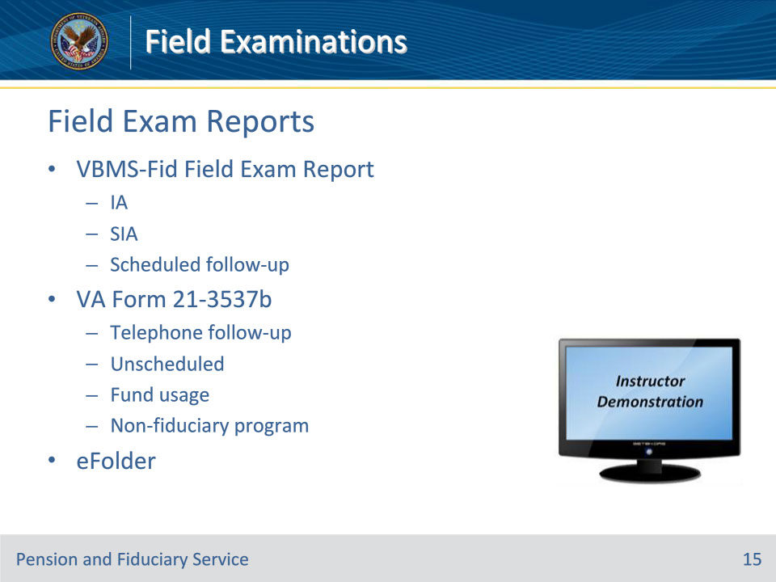
Slide notes

Policy Reference(s): FPM I.2.E.1.d.

Instructor Notes:

VBMS-Fid Field Exam Report

Information gathered in an IA, SIA, or scheduled follow-up field examination may be documented and stored in the VBMS-Fid Field Exam Report – the official system of record.

VA Form 21-3537b

The other place a field examination may be documented is on VA Form 21-3537b, Report of Field Examination. This document is used in cases where a VA Form 21-3537a, Field Examination Request, was used, or when a VBMS-Fid Field Exam report is not appropriate. Typically, telephone follow-up field exams, unscheduled field exams, fund usage field exams, and non-fiduciary program field exams.

Hub personnel must enter the information gathered during the field examination process in the appropriate system or on the appropriate form. Hub personnel must also generate the applicable field examination report and upload the report and required form(s) to the electronic claims folder (eFolder).

Demonstration:

• Navigate to VBMS-Fid and walk the field examiner through how to document a field examination report in VBMS-Fid and how to generate the resulting field examination report. Also show the field examiner what a VA Form 21-3537a and 3537b look like.

Slide 16 - Supporting Documentation
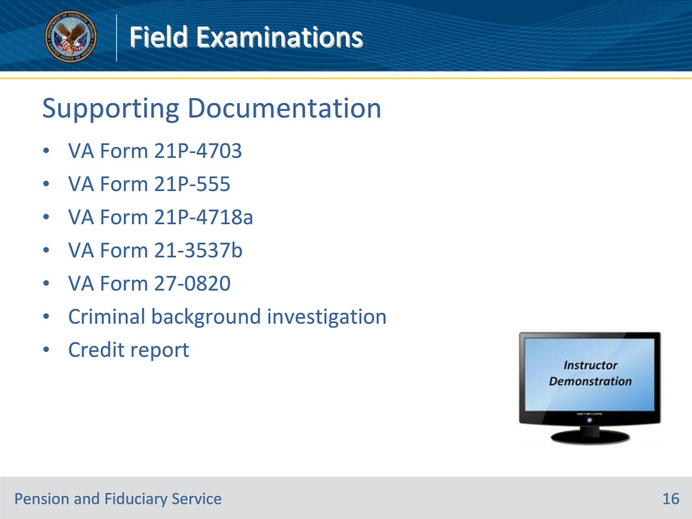
Slide notes

Policy Reference(s): FPM I.2.E.1.d.

Instructor Notes:

VA Form 21P-4703, Fiduciary Agreement

During the initial appointment or successor initial appointment field examination, the field examiner must provide the proposed fiduciary with the qualification requirements as well as the responsibilities the fiduciary will have to the beneficiary and to the Department of Veterans Affairs. The discussion on qualification requirements and responsibilities may be centered around the completion of VA Form 21P-4703, Fiduciary Agreement. Each proposed fiduciary must sign the VA Form 21P-4703, Fiduciary Agreement. A signed VA Form 21P-4703, Fiduciary Agreement, must be of record in the beneficiary’s eFolder. This form is not required when the beneficiary is approved for supervised direct pay (SDP).

VA Form 21P-555, Certificate of Legal Capacity to Receive and Disburse Benefits and Fee Authorization

This form is required to certify all fiduciary appointment types to include SDP and temporary fiduciary appointments.

VA Form 21P-4718a, Certificate of Balance on Deposit and Authorization to Disclose Financial Records,

This form may be used to certify the balance of a financial account.

VA Form 21-3537b, Report of Field Examination

This form is used to document Telephone follow up field exams Unscheduled Field exams, Fund usage field exams, or Non-fiduciary program field exams.

VA Form 27-0820, Report of General Information.

This form is used to document phone calls with stakeholders. This form is used by FEs, LIEs and FSRs.

Criminal Background Check and Credit Report

The qualification requirements differ based on the type of fiduciary appointment. If the fiduciary appointment type requires a criminal background check and/or a credit report, the document(s) must be of record in the beneficiary’s eFolder.

Demonstration: Show the field examiner the 4703 and the 555.

Slide 17 - Notification Letters
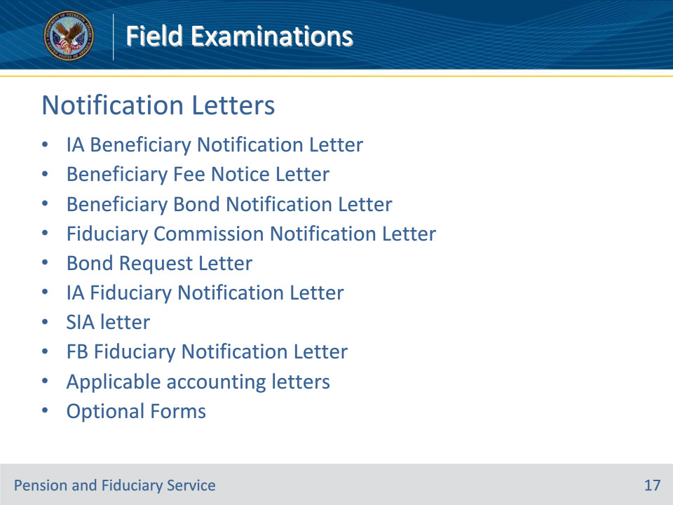
Slide notes

Policy Reference(s): FPM I.2.E.2.b.

Instructor Notes:

The required notification letters for various field exams are:

• IA Beneficiary Notification Letter

• Beneficiary Fee Notice Letter

• Beneficiary Bond Notification Letter

• Fiduciary Commission Notification Letter

• Bond Request Letter

• IA Fiduciary Notification Letter

• SIA letter

• FB Fiduciary Notification Letter

• Applicable accounting letters

• Optional Forms (VA Form 21P-4718a and a Standard Form (SF) 1199A, Direct Deposit Sign-Up Form.)

Slide 18 - Questions?
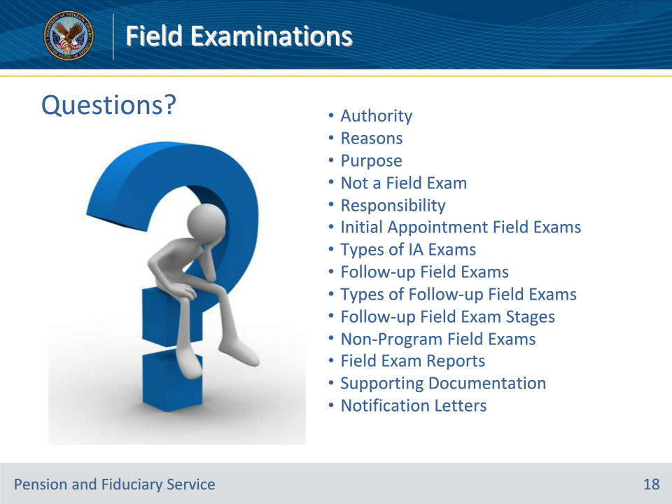
Slide notes

Instructor Notes:

(Recall) These are our learning objectives as stated at the beginning of the training:

• Identify the authority regarding field examinations

• Articulate reasons to conduct field examinations

• Recall the purpose of field examinations

• Summarize actions that do not constitute a field examination

• Recall the types of field examinations

• List mandatory reports and supporting documents

• Recognize required notification letters

(Recap) We discussed each of these learning objectives through the following topics in each slide today:

• Authority

• Reasons

• Purpose

• Not a Field Exam

• Responsibility

• Initial Appointment Field Exams

• Types of IA Exams

• Follow-up Field Exams

• Types of Follow-up Field Exams

• Follow-up Field Exam Stages

• Non-Program Field Exams

• Field Exam Reports

• Supporting Documentation

• Notification Letters

Are there any additional questions?

Questions should be filtered through your QRT team. They will submit your questions to the Field Inquiry Tool (FIT) on your behalf.

Slide 19 - TMS Survey/Assessment
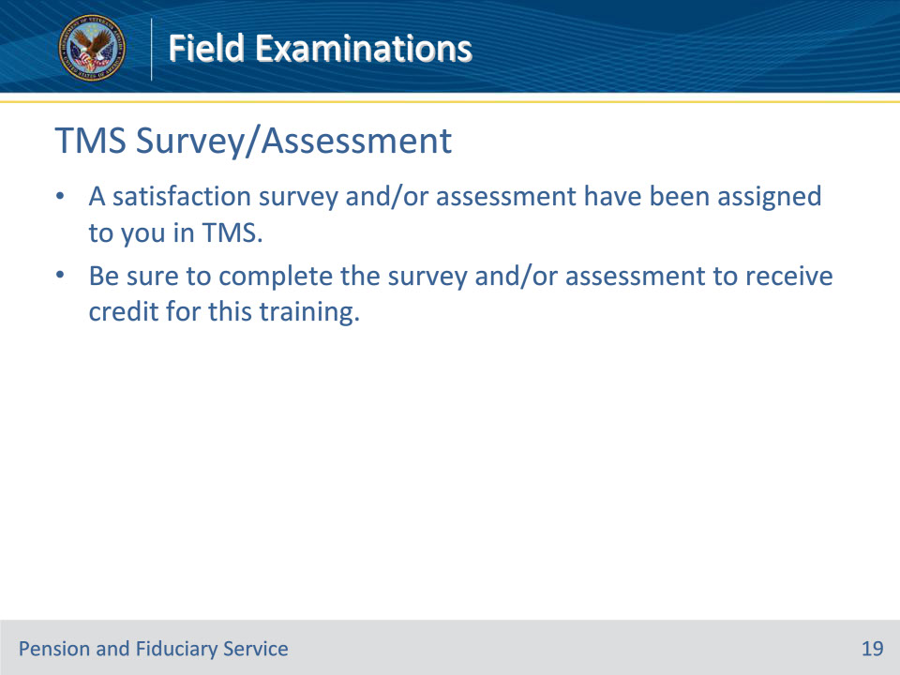
Slide notes

Instructor Notes

A satisfaction survey and/or assessment have been assigned to you in TMS.

Be sure to complete the survey and/or assessment to receive credit for this training.

