Slide 1 - Fiduciary Program References
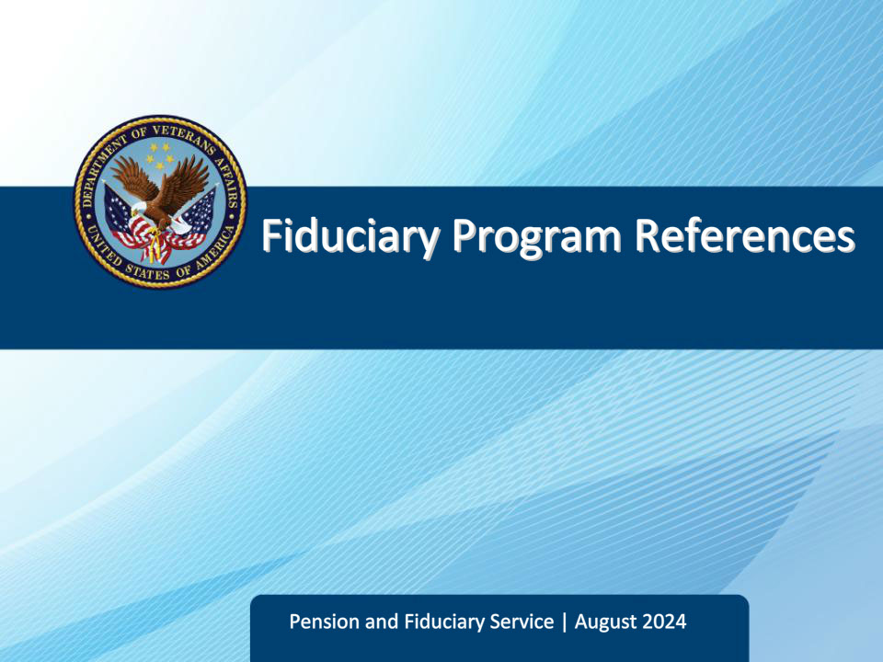
Slide notes

Course Description:

This course introduces trainees to fiduciary program references including United States Code, Code of Federal Regulations, and Fiduciary Program Manual It also teaches how to use other important tools such as FPM Changes document, VA and VBA internet, intranet, and forms websites. By the end of this course, learners will be able to discuss the importance of using references, explain the purpose and precedence of laws and regulations, identify fiduciary references, and properly cite a reference.

Slide 2 - Objectives
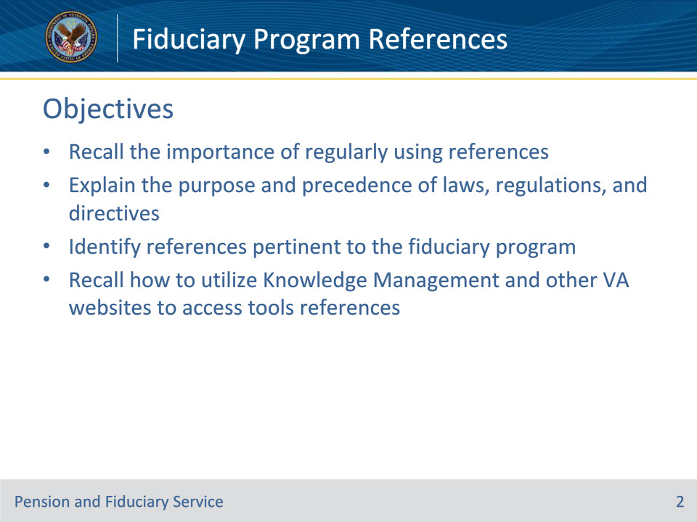
Slide notes

Instructor Notes:

By the end of this lesson, given the training and the corresponding references, the learner will be able to do the following:

• Recall the importance of regularly using references

• Explain the purpose and precedence of laws, regulations, and directives

• Identify references pertinent to the fiduciary program

• Recall how to utilize Knowledge Management and other VA websites to access tools references

Slide 3 - References
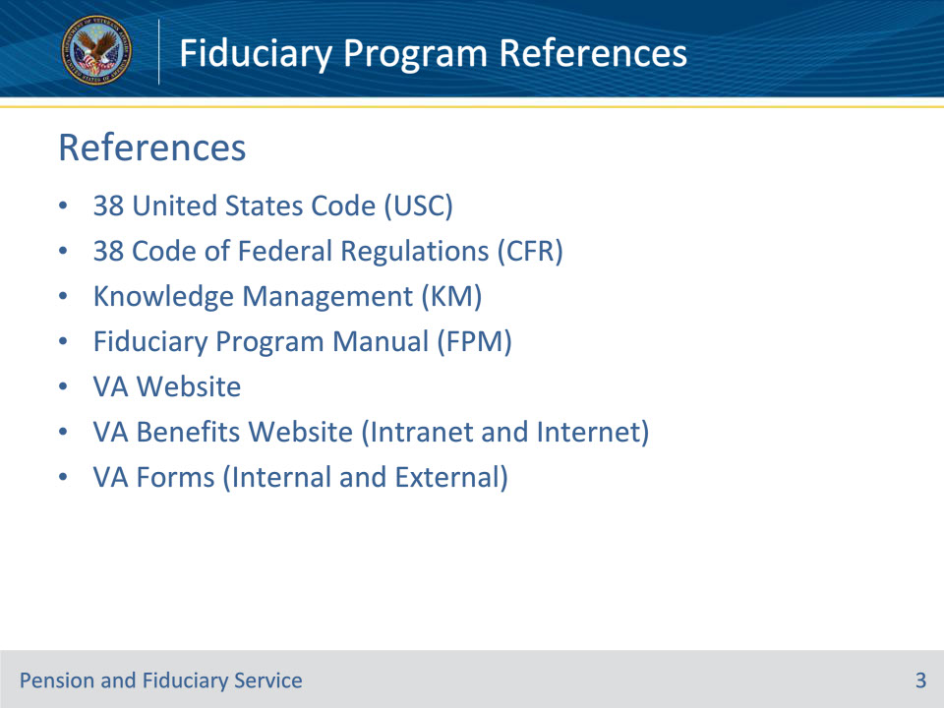
Slide notes

Instructor Notes:

The following are relevant references for this course:

• 38 United States Code (USC)

• 38 Code of Federal Regulations (CFR)

• Knowledge Management (KM)

• Fiduciary Program Manual (FPM)

• VA Website

• VA Benefits Website (Intranet and Internet)

• VA Forms (Internal and External)

Slide 4 - Importance of References
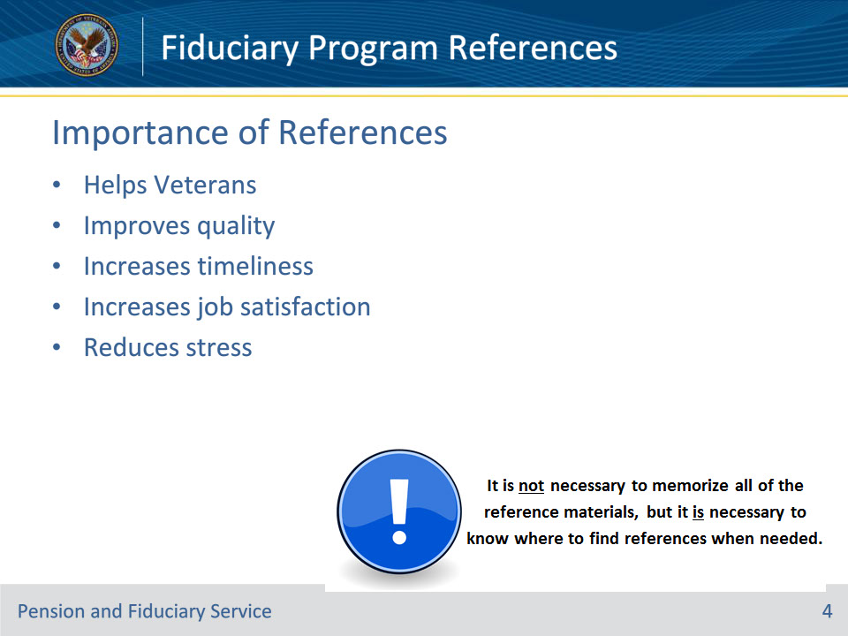
Slide notes

Policy Reference: n/a

Instructor Notes:

Explain that understanding, properly applying, and continually using references will help perform the job better in the following ways:

Helps Veterans – VA’s primary mission is to serve Veteran’s and it is impossible to accomplish this without understanding the appropriate references as they relate to benefits, entitlements and service (VA, state, or local). Only helps if we have an understanding of reference.

Improves quality – Quality is improved when we meet and exceed the standards and measures that have been promulgated. Only helps when references are applied.

Increases timeliness – Based on the amount of time that it takes to meet a specific goal. Only comes with proficiency with program references. Practice does not make perfect, perfect practice makes perfect.

Increases job satisfaction – We are better able to enjoy the job that we do if we are able to unequivocally substantiate the actions that we take in the performance of our duties. (Builds confidence.)

Reduces stress – Stress comes from lack of confidence in outcomes. (Example: Our bills only stress us when we are uncertain of whether we will be able to pay them. Our children stress us when we are uncertain of what decisions they will make in life.)

Slide 5 - The Big Picture
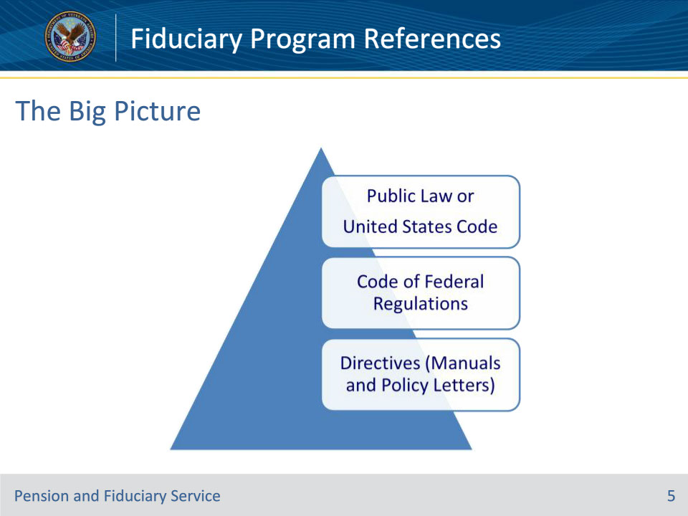
Slide notes

Policy Reference: n/a

Instructor Notes:

References are listed on this slide from top to bottom in order of precedence – Public Law and United States Code always take precedence over everything else. They are also listed in in an order that is written from broad to specific interpretation.

• Public Law (PL) and United States Code (USC) – Broadly-written in nature. USC codifies PLs to keep Agency-specific laws cohesive. Usually written by those in the law profession.

• Regulations- are the VA’s interpretation of PLs and how the laws apply to VA practices.

• Manuals- are written by VA and provide procedures and more specific guidelines on how to meet regulations.

• Policy Letters- also written by VA (usually by a specific business line) and provides interim procedural guidance on a specific topic.

Slide 6 - Public Law
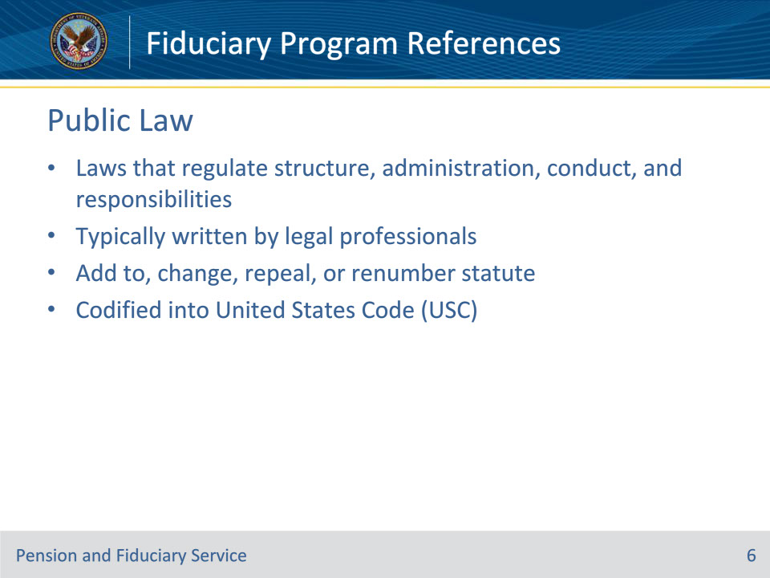
Slide notes

Policy Reference: n/a

Instructor Notes:

Public Law are the laws that regulate the structure and administration of the government, the conduct of the government in its relations with its citizens, the responsibilities of government employees and the relationships with foreign governments. **In other words, they establish what we should look like and how we are to interact with others as an agency and as representatives of an agency. Public law/U.S. Code are usually written by those in the law profession.

Public Law may:

• Add a section (statute) in the statutory code

• Change language in a section (statute)

• Repeal a section (statute) of the statutory code

• Re-number a section (statute)

• Do all the above

Ultimately, Public Laws are codified into the United States Code to:

• Place all laws on the same topic together

• Eliminate all repealed or expired statutes

• Unite amendments with the original statute

Slide 7 - United States Code
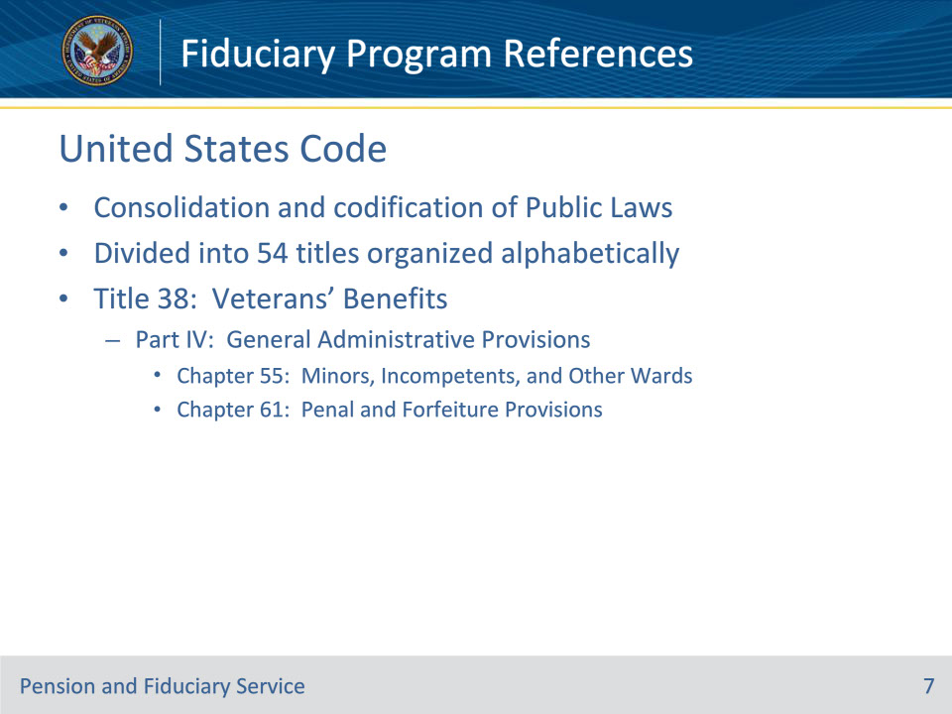
Slide notes

Policy Reference: 38 USC

Instructor Notes:

The United States Code (U.S.C.) is a consolidation and codification by subject matter of the general and permanent laws of the United States. Basically, it is the ‘book’ containing all the Public Laws.

The U.S.C. prepared by the Office of the Law Revision Counsel of the United States House of Representatives. It is divided into 54 titles that are organized alphabetically.

38 U.S.C., Chapters 55 and 61 contain the laws which govern the VA and the Fiduciary Program.

Slide 8 - Code of Federal Regulations
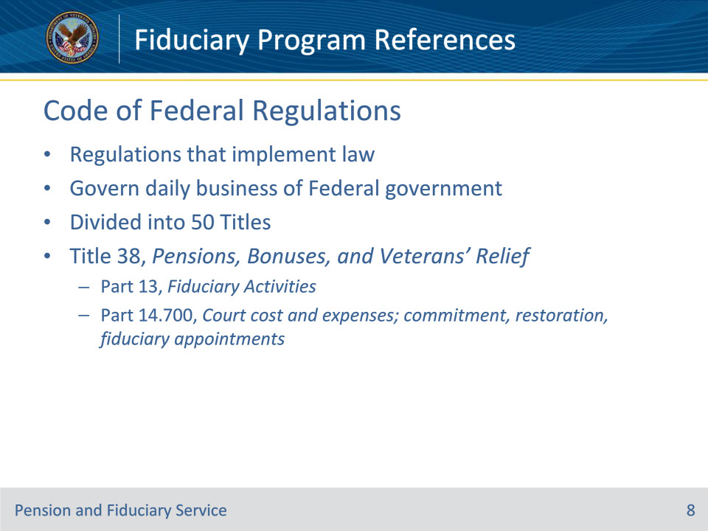
Slide notes

Policy Reference: 38 CFR

Instructor Notes:

In 1935, Congress created the Federal Register, which is a daily publication of the rules and federal documents produced by the Executive Branch of the federal government and by the agencies. It contains the federal regulations which implement the law.

The C.F.R. is divided into 50 Titles that represent broad areas subject to Federal regulation.

38 C.F.R. Parts 13 and 14.700 govern the Fiduciary Program.

Slide 9 - Citing the CFR
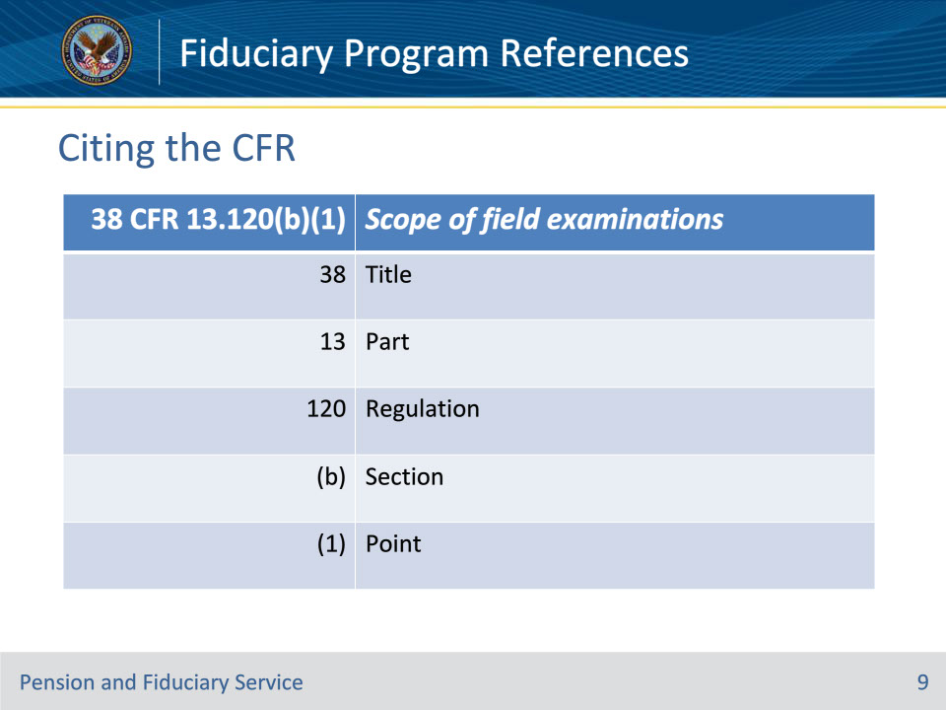
Slide notes

Policy Reference: 38 CFR

Instructor Notes:

To cite a 38 C.F.R. reference, you must indicate the:

• Part

• Regulation

• Section

• Point

An example of a C.F.R. citation is 38 C.F.R. 13.120(b)(1), and it is interpreted as follows:

• 13=Part

• 120=Regulation

• (b)=Section

• (1)=Point

Slide 10 - Internal Directives
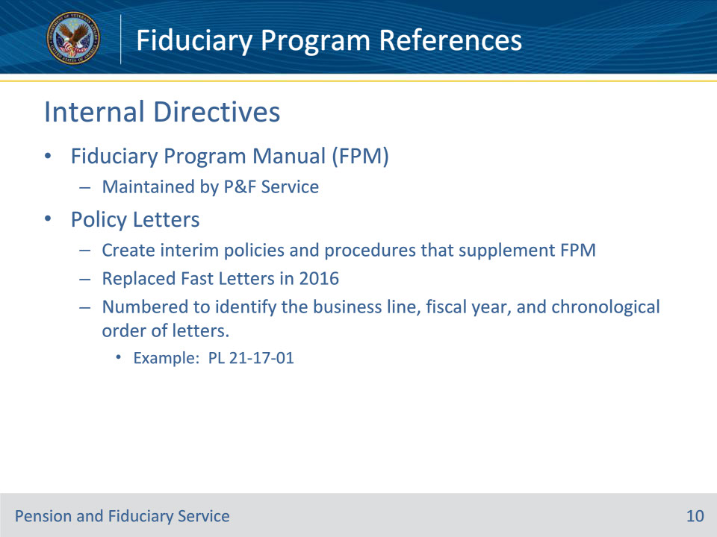
Slide notes

Policy Reference: Fiduciary Knowledge Management (KM) Site

Instructor Notes:

Fiduciary Program Manual (FPM) The Fiduciary Program Manual (FPM) is the primary reference source for fiduciary hub personnel. This manual is written and maintained by Pension and Fiduciary Service. The FPM is a “living document” which is regularly reviewed and updated to ensure legal compliance and improve/modernize fiduciary hub processes.

Policy Letters are designed to create interim policies and procedures to address uncommon circumstances identified by Pension & Fiduciary Service. Policy Letters supplement the FPM by providing pertinent information, updates, and announcements to Fiduciary hub employees. They replaced Fast Letters in 2016. They are numbered to identify it as P&F Service guidance, the fiscal year that it was created and the chronological number; for example, Policy Letter 21-17-01 indicates:

• 21= P&F Service

• 17= Fiscal Year

• 01= Chronological Number

Slide 11 - Citing the FPM
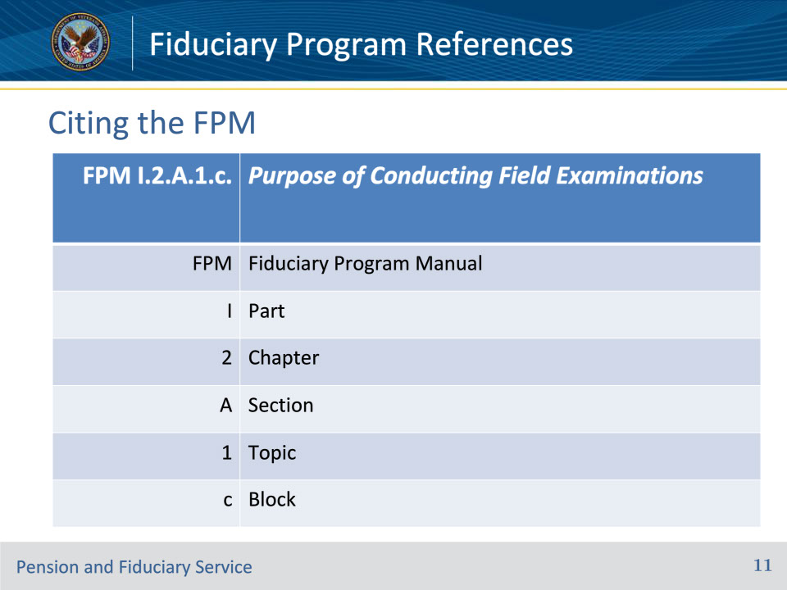
Slide notes

Policy Reference: Fiduciary Program Manual

Instructor Notes:

Explain the hierarchy of the Fiduciary Program Manual and how to properly cite a reference.

Slide 12 - Fiduciary Reference Tools
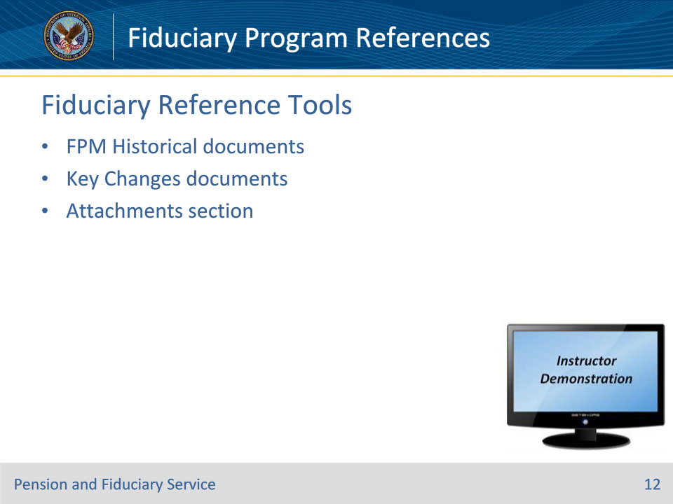
Slide notes

Policy Reference: Fiduciary KM Site

Instructor Notes:

Instructor Demonstration: Minimize the PowerPoint and demonstrate to students how to find each one of these documents and explain their function. Reminder—They are hyperlinked at the bottom of each page of the current FPM.

FPM Historical and Key Changes documents: Whenever changes are made to the FPM, P&F Service keeps a list of the key changes as well as any historical versions of that Chapter, Section and Topic so that users can always see what has been edited, removed, and/or added. These documents are listed at the very bottom of a Topic under “Attachments.” For example, navigate to FPM II.1.C. , scroll down to the bottom of the page, and see that there are documents under “Attachments.”

1. Demonstrate the most recent Key Changes document

2. Demonstrate the most recent Historical FPM document

Slide 13 - Knowledge Management
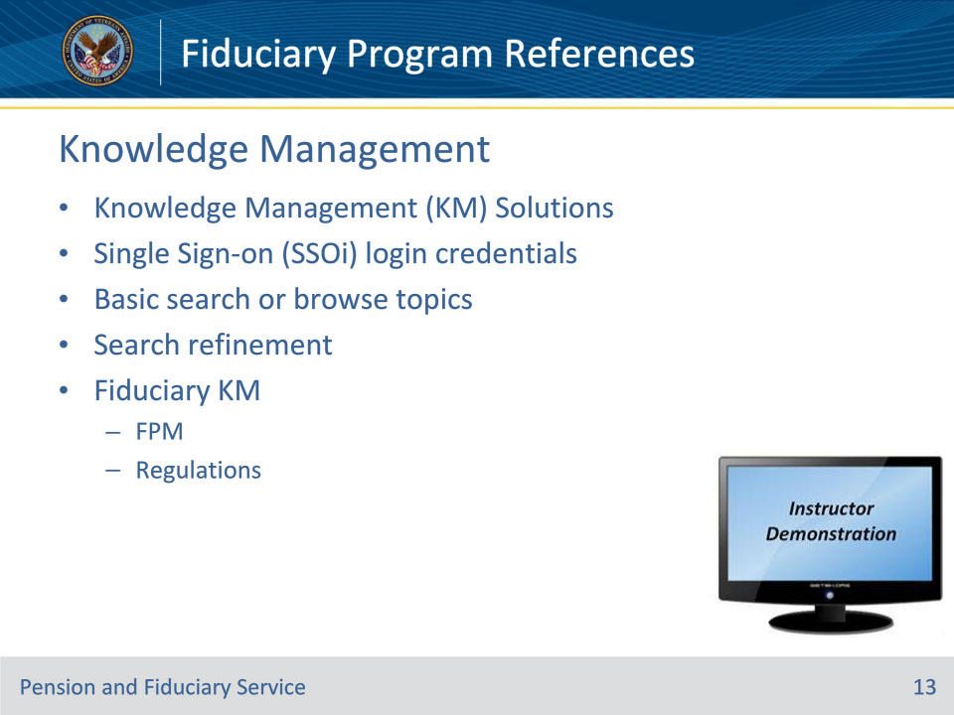
Slide notes

Policy Reference: Fiduciary KM Site

Instructor Notes:

Knowledge Management (KM) Solution was created to provide a single, accessible location for various reference tools needed by VA personnel to perform their daily responsibilities.

Fiduciary KM: https://vaww.fiduciary.km.va.gov/

Instructor Demonstration: Minimize the PowerPoint and show students each element listed on this slide by demonstrating and speaking to it directly from the fiduciary KM site. You have already discussed FPM, USC, and CFR – also show students how to access each of those within the fiduciary KM.

Home Page

Once logged into KM Solution, you will be directed to the homepage. The homepage provides several options for searching.

Breaking News

The subjects under the “Breaking News” heading include announcement articles regarding KM utilization and some policy information of particular importance. Breaking News articles are organized in date order with the most recently updated articles at the top of the list. Breaking News does not contain all new or updated articles in KM Solution.

Most Popular

The subjects under the “Most Popular” heading include articles KM users most commonly access. The Most Popular widget is available at the right of the page throughout KM.

As you browse, the Most Popular widget displays articles based on what Topic you are viewing. Click the “More>” link under most popular to find more articles. The Most Popular widget provides you easy access to the most popular articles for each Topic.

Recently Added and Recently Changed Articles

“Recently Added” articles contain information new to KM Solution.

“Recently Changed” articles displayed on the homepage are articles that were already available in KM Solution but have recently been updated. These articles are available on the homepage for up to five days after the article has been updated. These headings are only available if there is recent content available.

Basic Search

The basic search is the preferred and most common method of searching information in KM. A basic search is performed by typing what you are looking for in the “Search Knowledge Base” area and clicking “Go!” or the enter key.

There are features built into KM designed to improve the results and speed of your basic search: 1) type ahead /auto complete, and 2) “Did you mean”

1) Type Ahead/Auto Complete

Like a search engine, KM provides common search topics based on what you are typing in the search box. These suggestions appear as you type. Example: show options provided when typing homeless.

2) Did You Mean?

KM will correct common misspellings. This feature is displayed whenever you mistype or misspell what you are searching.

Example: If you accidentally typed “authorixatoin” (without the quotes) in the search box and hit the enter key or Go!, you will receive a “Did you mean:” option for the word “authorization.” Selecting this word will route you to the search you intended.

“Browse Topics” Fly Out Search

Another search functionality within KM is the “Browse Topics” Fly Out Search. When articles are created, they are entered into topics. This search allows you to search by topics and subtopics.

• From the homepage hover over the “Browse Topics” graphic to launch.

• Hover over desired topics to display subtopics, as necessary. An arrow to the right of the topic is an indicator of additional subtopics within that topic.

• Click the topic you want to search.

Not all articles related to a topic may be available for view when utilizing the “Browse Topics” Fly Out Search. Additional Basic search methods may be necessary to find the desired article.

Search Refinement

There are three available search refinement tools that can be used with a search:

• Boolean Search

• Search by Topic Configuration, and

• Multi-Faceted Search Refinement by Category

Boolean Search

Put quotes around “your search phrase” to only receive output with your exact search phrase.

Placing quotes around your search term tells the search engine only to provide output that includes your search term/phrase

KM presents the article with the first instance of the searched phrase highlighted and at the top of the screen

*Important* - this only works for articles not attachments

Search by Topic Configuration

In a basic search, you may choose to use this refinement tool when accessing information with many topics and articles. Two options for topic refinement are available:

• Choose a sub-folder, or

• type a refinement search term

Example: type “fiduciary” (without quotes) into the search field and demonstrate the various options

Multi-Faceted Search Refinement by Category

When searching a topic with several related articles, you may refine your search by using this tool which appears to the left of the screen in cases where an abundance of articles correlate to the search topic. Topics can be refined by content type, special benefit group, target audience, or process stage.

Slide 14 - Other KM References
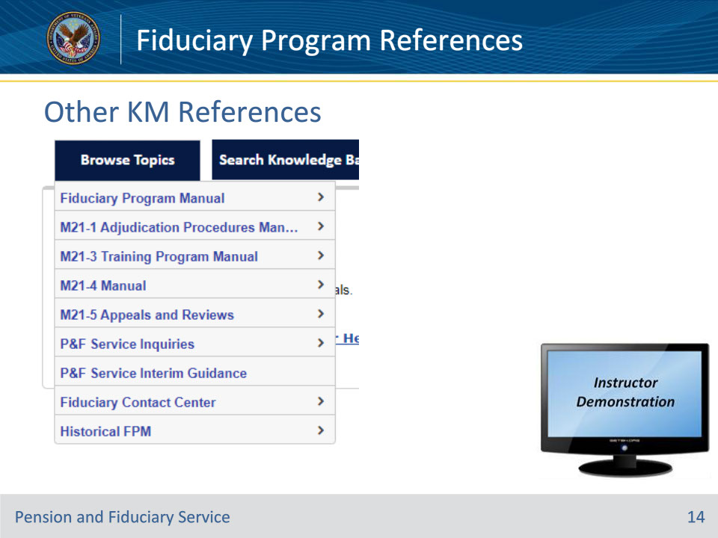
Slide notes

Policy Reference: KM Site

Instructor Notes:

Instructor Demonstration: Share with the students all the “Browse Topics” references available in the KM drop down.

• M21-1 Adjudication Procedures Manual

• M21-3 Training Program Manual

• M21-4 Manual

• M21-5 Appeals and Reviews

• P&F Service Inquiries

• P&F Service Interim Guidance

• Fiduciary Contact Center

• Historical FPM

Slide 15 - M21-1 Adjudication Procedures Manual
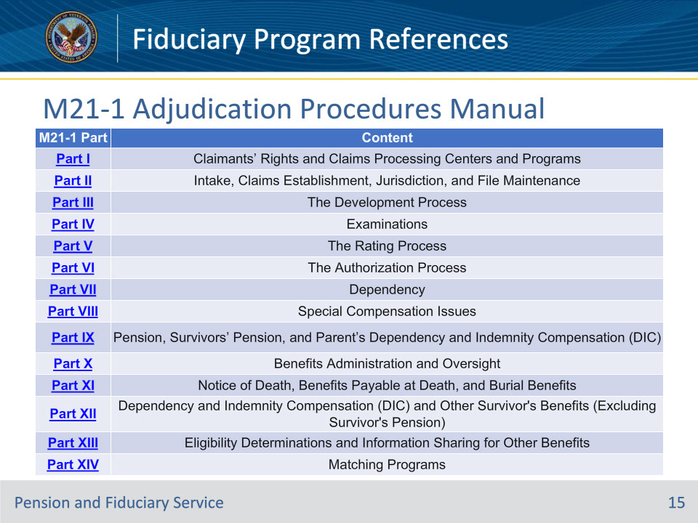
Slide notes

Policy Reference: M21-1 Adjudication Procedures Manual Prologue

Instructor Notes:

The M21-1, Adjudication Procedures Manual (M21-1), serves as a general guide for processing and adjudicating claims for compensation, pension, and related benefits for Veterans and their dependents. It is based on the statutes and regulations set forth in Title 38 of the United States Code (U.S.C.) and Title 38 of the Code of Federal Regulations (CFR), the legal authority governing Department of Veterans Affairs benefits. Therefore, relevant statutes and regulations in 38 U.S.C. and 38 CFR take precedence over procedural guidance in the M21-1. The regulations are overarching legal provisions for general consumption, while M21-1 procedures are written with a view toward enabling Veterans Benefits Administration (VBA) employees to properly adjudicate claims. As such, the CFR and M21-1 routinely use different terminology based on their intended audiences, with the M21-1 using more contextually informative terms rather than the general, nondescript nouns like “person” that are frequently used in the regulations.

The purpose of the M21-1 is to summarize or restate in plain language the applicable law, clarify any ambiguities, and provide a picture of the adjudication process that is reasonably complete and easy to understand and apply. Therefore, the M21-1 generally links to regulations and only occasionally reproduces regulatory passages for context on the concept being discussed.

The M21-1 is a guide for processing claims. It is

• not a decision-making tool, and

• not intended to

• direct workload priorities

• determine workload assignments, or

• determine personnel assigned to complete tasks or achieve performance goals.

Note: For more information on workload priorities and assignments, refer to the established performance standards and priorities of the Office of Field Operations.

While the M21-1 will incorporate and reference certain claims-related technical processes and business management tools, it is not intended to substitute the applicable user guides, such as National Work Queue Playbook or Veterans Benefits Management System user references.

Slide 16 - M21-3 Training Program Manual
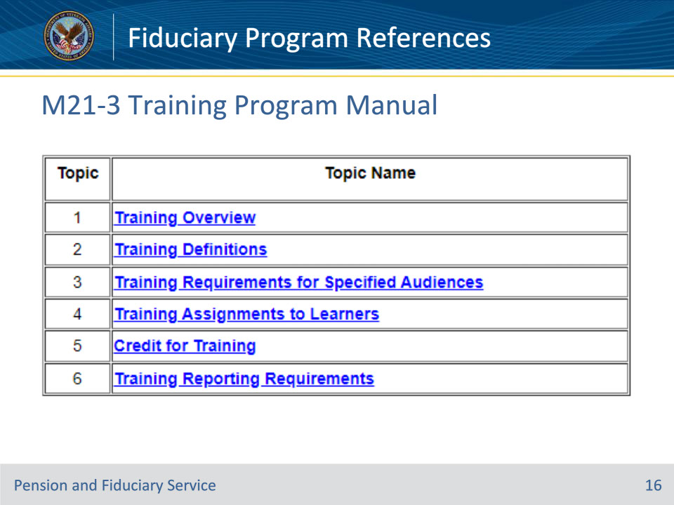
Slide notes

Policy Reference: M21-3 Part 3

Instructor Notes:

Per 5 CFR 410.201, Pension and Fiduciary (P&F) Service is responsible for creating training programs that support an agency workforce capable of achieving agency mission and performance goals, and facilitating continuous improvement of employee and organizational performance.

The Fiduciary National Training Curriculum (FNTC) consists of required annual training for Legal Administrative Specialists (LASs), Legal Instrument Examiners (LIEs), Field Examiners (FEs), Fiduciary Accounting Representatives (FARs), Fiduciary Service Representatives (FSRs), and Quality Review and Training (QRT) personnel, who are all herein referred to as employees. It guides training managers (TMs) in ensuring all employees receive quality training according to P&F Service guidelines. Assigned casework should continually reinforce skills as taught during training.

Slide 17 - M21-4 Manual
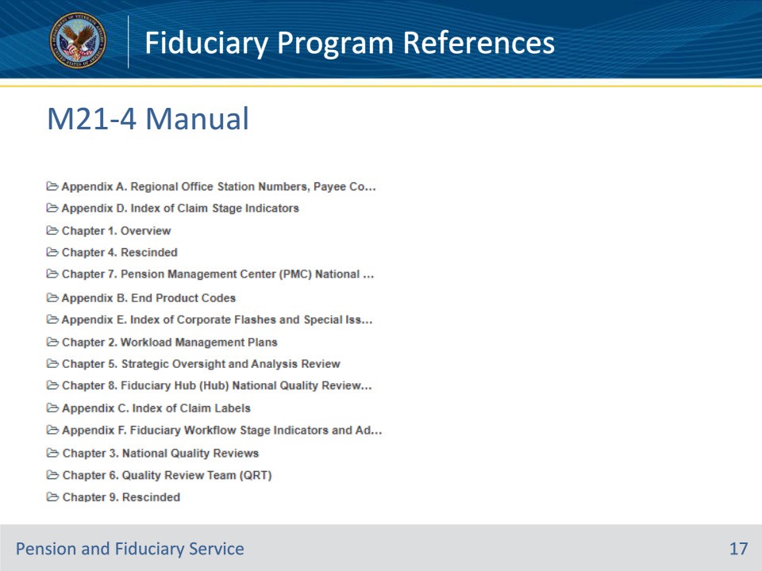
Slide notes

Policy Reference: M21-4

Instructor Notes:

The purpose of this manual is to prescribe and discuss workload and staffing controls applicable to Compensation, Pension, and Fiduciary activities in the Regional Office (RO). This manual also describes tools and strategies available to field managers to assist in assessing the level of service afforded to claimants.

Slide 18 - M21-5 Appeals and Reviews
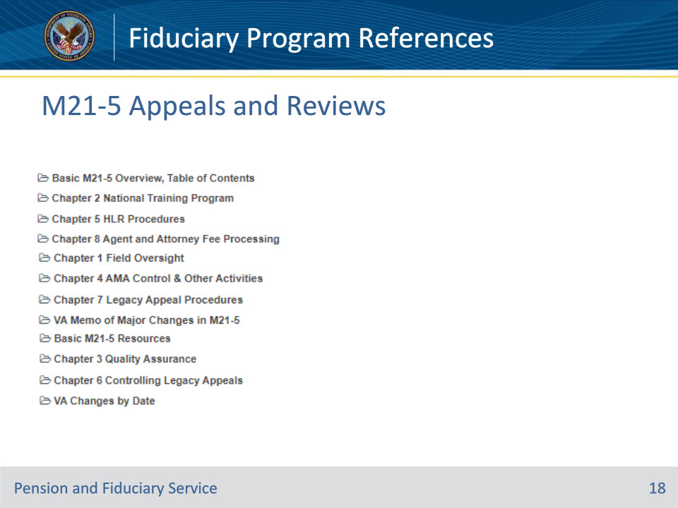
Slide notes

Policy Reference: M21-5 Appeals and Reviews, Overview

Instructor Notes:

The M21-5, Appeals and Reviews, serves as a general guide for processing legacy appeals for compensation and higher-level reviews (HLRs) under the Appeals Modernization Act (AMA). This manual also discusses the responsibilities of the decision review operations centers (DROCs), their oversight by the Office of Administrative Review (OAR) and both local and national training and quality assurance programs. Additionally, the M21-5 serves as a guide for processing agent and attorney fees.

This manual and its adjudication procedures are based on the statutes and regulations found in title 38 of the United States Code (U.S.C.) and title 38 of the Code of Federal Regulations (CFR), the legal authority governing Department of Veterans Affairs benefits. Therefore, relevant statues and regulations in 38 U.S.C. and 38 CFR take precedence over procedural guidance in the M21-5. The regulations are overarching legal provisions for general consumption, while M21-5 procedures are written so adjudicators within Veterans Benefits Administration (VBA) can properly, fairly, and accurately decide claims. As such, the CFR and M21-5 routinely use different terminology based on their intended audiences, with the M21-5 using more contextually informative terms rather than the general, nondescript nouns like “person” that are frequently used in the regulations.

The purpose of the M21-5 is to summarize or restate in plain language the applicable law, clarify any ambiguities, and provide a picture of the adjudication process that is reasonably complete and easy to understand and apply. Therefore, the M21-5 generally links to regulations and only occasionally reproduces regulatory passages for context of the covered concept.

The M21-5 is a guide for processing claims. It is

• not a decision-making tool, and

• not intended to

• direct workload priorities

• determine workload assignments, or

• determine personnel assigned to complete tasks or achieve performance goals.

Note: For more information on workload priorities and assignments, refer to the established performance standards and priorities of the OAR Operations staff, as well as Chapter 1, Field Oversight.

While the M21-5 incorporates and references certain claims-related technical processes and business management tools, it is not intended to substitute the applicable user guides, such as National Work Queue Playbook, or the user references to Caseflow or the Veterans Benefits Management System (VBMS).

Slide 19 - P&F Service Inquiries
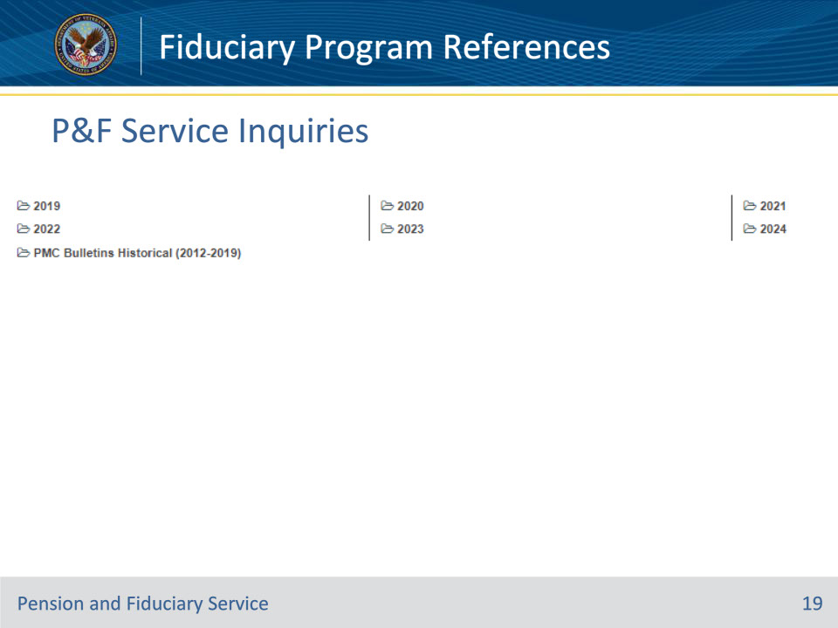
Slide notes

Policy Reference: P&F Service Inquiries

Instructor Notes:

This section contains the Pension & Fiduciary (P&F) Service inquiry response highlights relating to policy and procedures.

Slide 20 - P&F Service Interim Guidance
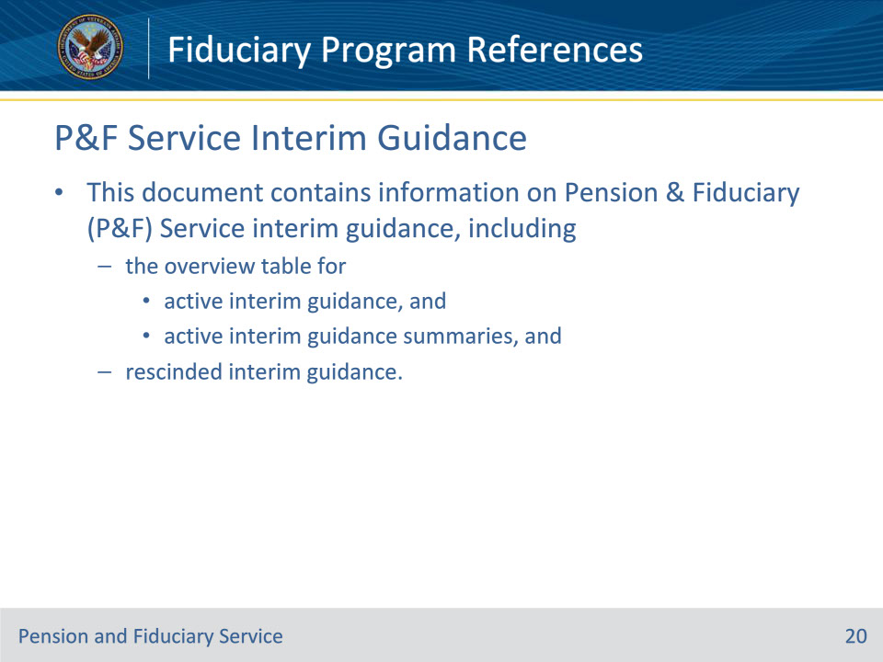
Slide notes

Policy Reference: P&F Service Interim Guidance

Instructor Notes:

This document contains information on Pension & Fiduciary (P&F) Service interim guidance, including

• the overview table for

• active interim guidance, and

• active interim guidance summaries, and

• rescinded interim guidance.

Slide 21 - Fiduciary Contact Center
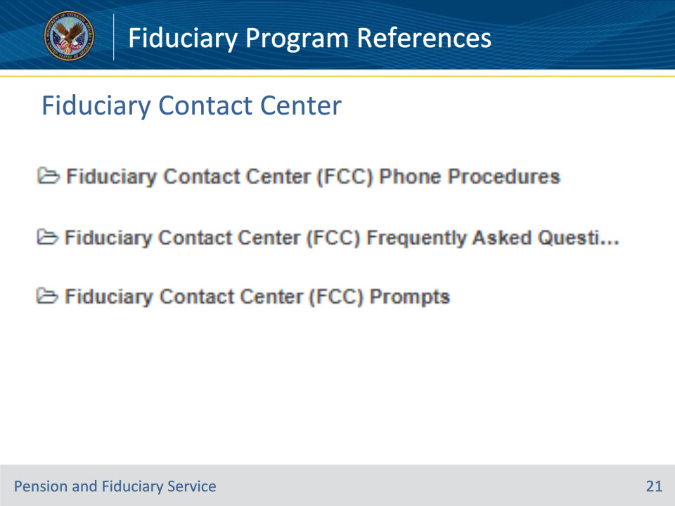
Slide notes

Policy Reference: Fiduciary Contact Center

Instructor Notes:

This is the manual that dictates policy and procedure for the fiduciary contact center (FCC).

Slide 22 - Other VBA Websites
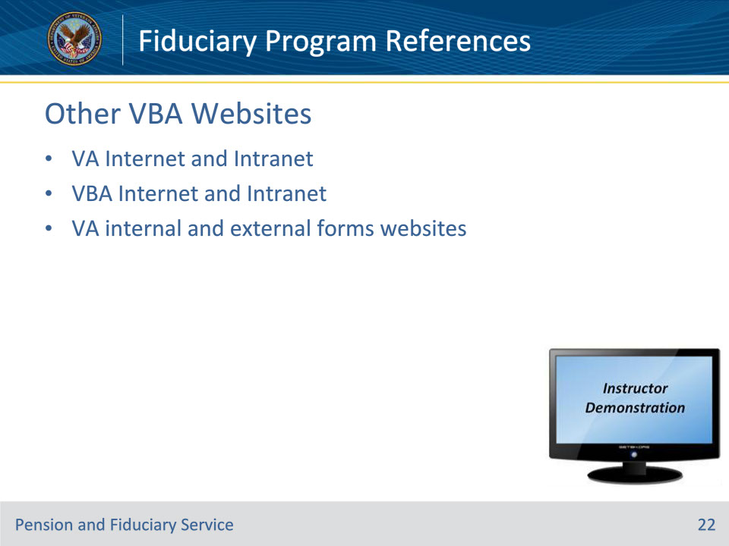
Slide notes

Policy Reference: n/a

Instructor Notes:

VA Internet (www.va.gov): VA makes a wealth of information available to the public via VA’s Internet website. As a platform of information to the public, VA’s website serves as a worthy resource for those who communicate with the public. VA personnel may refer to information housed within VA’s website, and refer inquirers to this site for additional information.

VA Intranet (http://vaww.va.gov): The Department of Veterans Affairs houses a wealth of knowledge within the VA Intranet website. This information is specifically designated for VA employees to have a better understanding of the various aspects and benefits of the organization.

VA Forms: Benefits information and application instructions are located on most VA forms. These websites will contain the most updated version of each form. Some forms may not be externally available for print by the public because they are internal forms for VA employees – such as the VA Form 21P-4716a, Beneficiary Field Examination Report. In such cases the internal forms site will yield these forms.

• External, available to Veterans http://www.va.gov/vaforms/

• Internal, available to VA employees http://vaww.va.gov/vaforms/

Slide 23 - Questions?
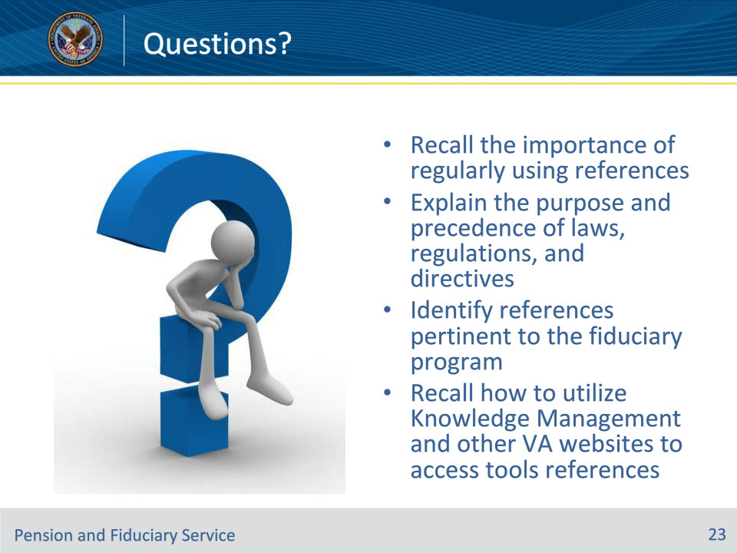
Slide notes

Instructor Notes:

(Recall): These are our learning objectives as stated in the beginning of the training:

• Recall the importance of regularly using references

• Explain the purpose and precedence of laws, regulations, and directives

• Identify references pertinent to the fiduciary program

• Recall how to utilize Knowledge Management and other VA websites to access tools references

(Recap): We discussed each of these learning objectives through the following topics in each slide today:

• Importance of References

• The Big Picture

• Public Law

• United States Code

• Code of Federal Regulations

• Citing the CFR

• Internal Directives

• Citing the FPM

• Fiduciary Reference Tools

• Knowledge Management

• Other VBA Websites

Are there any additional questions?

Questions should be filtered through your QRT team. They will submit your questions to the Field Inquiry Tool (FIT) on your behalf.

Slide 24 - TMS Survey/Assessment
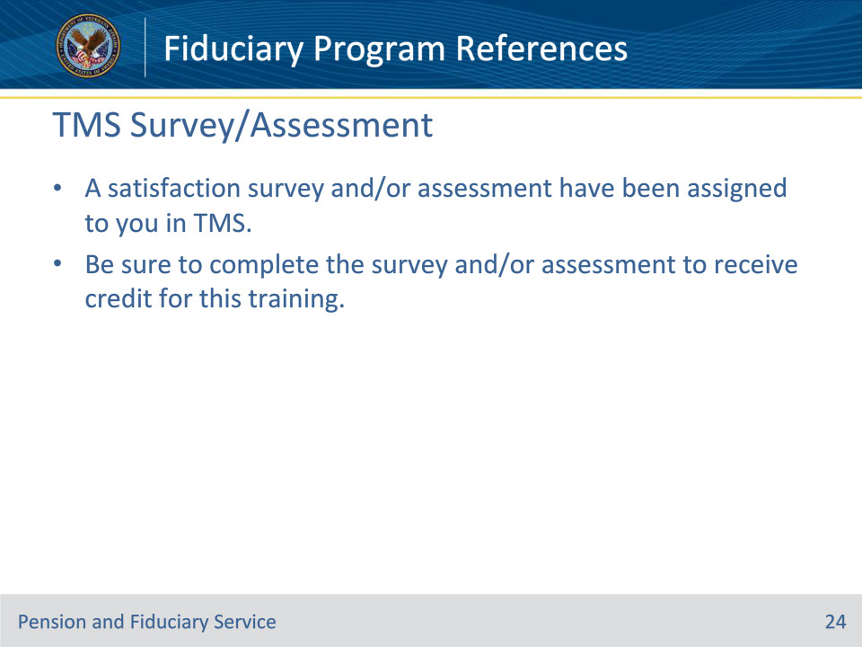
Slide notes

Instructor Notes:

A satisfaction survey and/or assessment have been assigned to you in TMS.

Be sure to complete the survey and/or assessment to receive credit for this training.

