Slide 1 - VBMS-Fiduciary Tasks
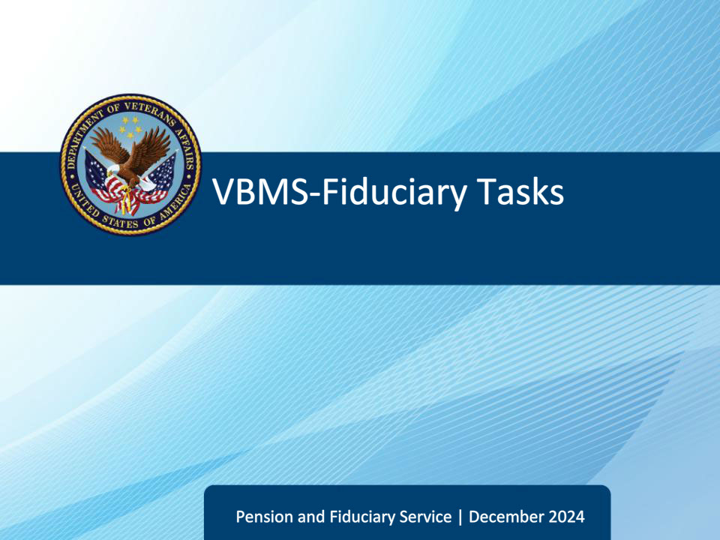
Slide notes

Course Description:

This training teaches learners how to create and complete a task in VBMS-Fiduciary to track completion of various fiduciary program activities.

Slide 2 - Objectives
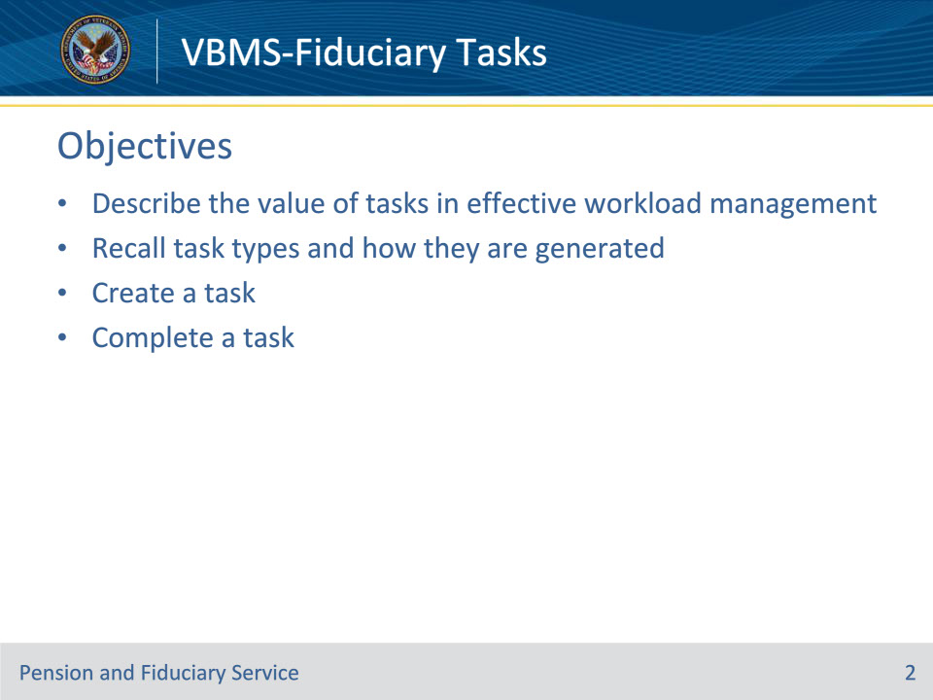
Slide notes

Instructor Notes:

By the end of this course, given access to VBMS-Fid and appropriate manual references and guides, the learner will be able to:

• Describe the value of tasks in effective workload management

• Recall task types and how they are generated

• Create a task

• Complete a task

Slide 3 - References
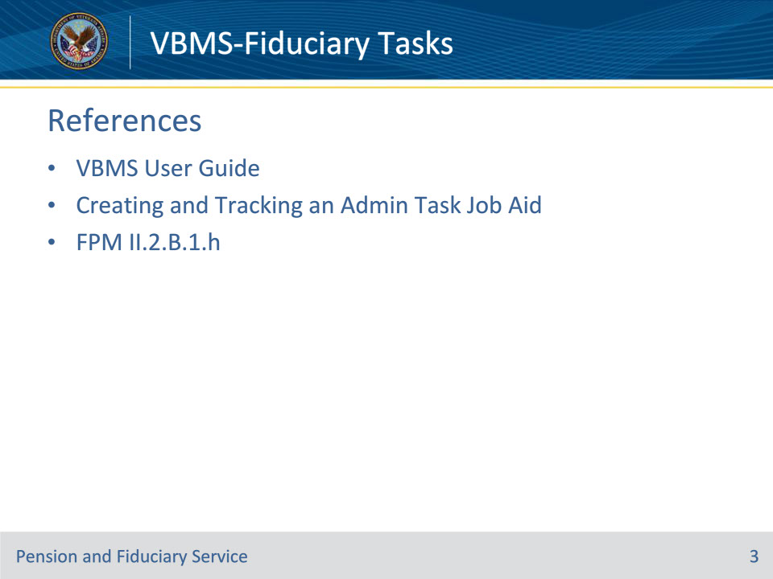
Slide notes

Instructor Notes:

These are the relevant references for todays’ training:

• VBMS User Guide, Chapter 8

• https://www.vbms.vba.va.gov/vbmsp2/resources_p4/webhelp/assets/docs/vbms_user_guide.pdf

• Creating and Tracking an Admin Task Job Aid

• FPM II.2.B.1.h. Adjustment of Corporate Surety Bond Amount

Slide 4 - Workload Management
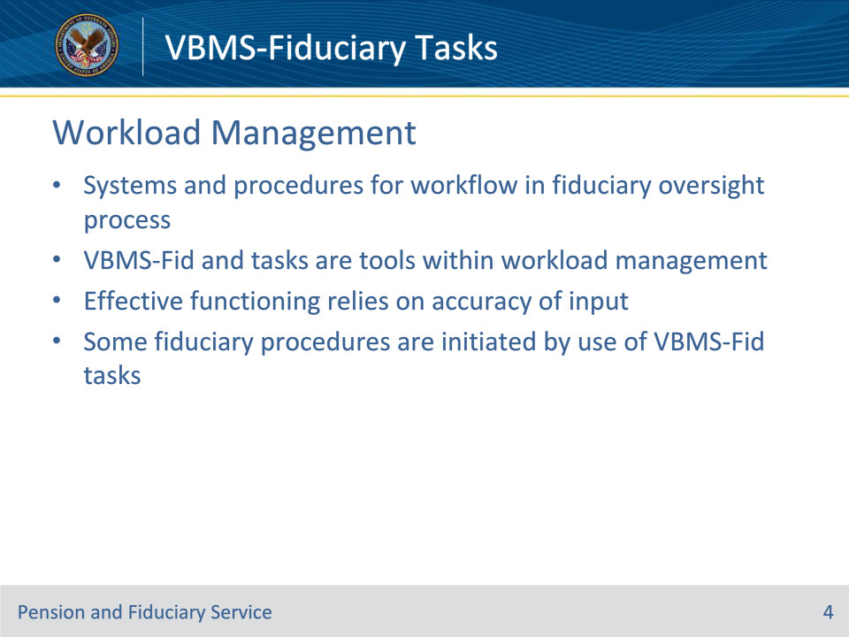
Slide notes

Policy Reference: VBMS User Guide

Instructor Notes:

Workload Management is a coordinated system, or operational procedure, used to control how workflow moves through the fiduciary oversight processes. Fiduciary hub managerial oversight will ensure the operational procedure is efficient and works effectively to control the movement of work.

Available electronic system tools and available reports are used to assist in workload management to ensure work is completed correctly and timely. The effective functioning of these tools relies on the accuracy of input by fiduciary program personnel.

Many procedures for maintaining accurate fiduciary records and proper processing of fiduciary work are initiated through the use of VBMS-Fid tasks.

**VBMS-Fid tasks are powerful workload management tools, and it is essential to maintain accuracy in their input and timeliness of oversight.

Slide 5 - Tasks
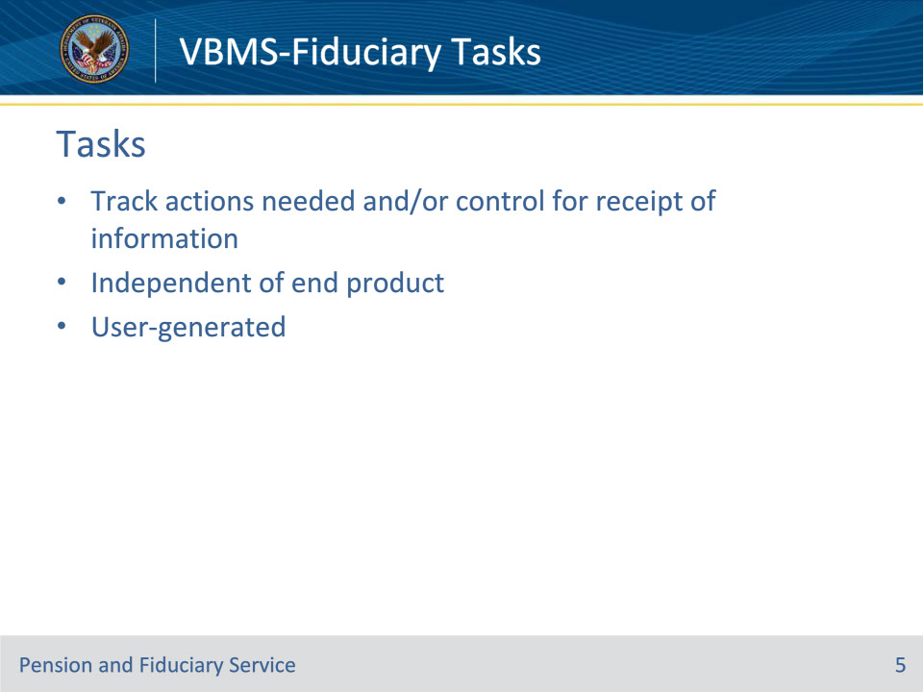
Slide notes

Policy Reference: VBMS User Guide; FPM II.2.B.1.h.

Instructor Notes:

Tasks are created in VBMS-Fid to track the actions required on a record outside of a pending end product. For example, The hub must create a SURETY BOND task with a 30-day due date to track requests for surety bond adjustments.

Tasks are user-generated - To track an activity outside of an end product’s automated workflow, VBMS-Fid users must manually create a task in VBMS-Fid.

Slide 6 - Create a Task
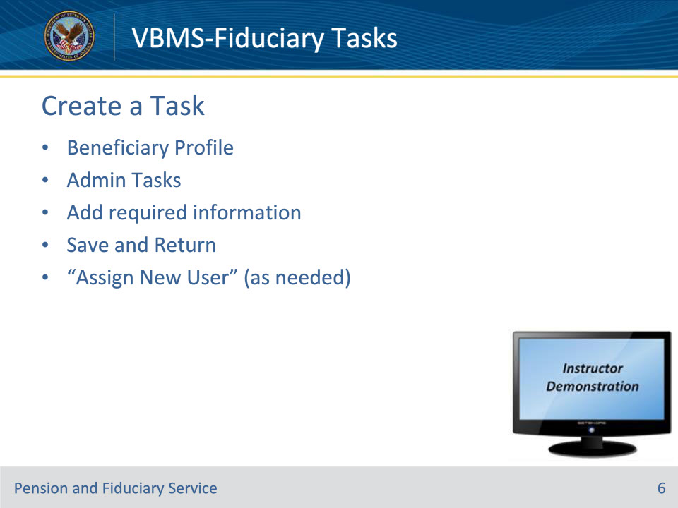
Slide notes

Policy Reference: VBMS User Guide

Instructor Notes:

Now let’s go over how to create a user-generated task.

1. From the Admin Tasks section of a beneficiary profile or fiduciary profile, select Create Admin Task.

2. From the Admin Task page, populate the required fields for the task.

3. Your Fiduciary Hub will be shown as the Station of Jurisdiction at first, and the task will be assigned to you and your team.

4. Select Save to create the task and continue editing or select Save and Return to create the task and return to create the task and return to the previous page.

5. The task is added to the admin task work queues for the selected Station of Jurisdiction. After the task is created, you can edit the Status field.

6. To reassign the task, users with permission can select Assign New User and choose a different Fiduciary Hub and/or user. Manually created tasks can only be reassigned by the user who created the task.

Instructor Demonstration: Navigate to the VBMS User Guide and demonstrate to students how to create a task.

Slide 7 - Complete a Task
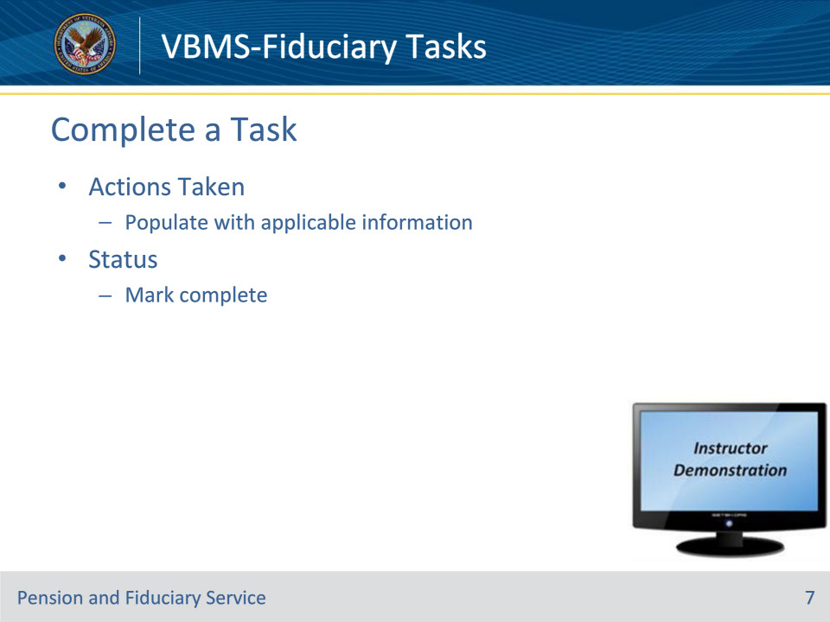
Slide notes

Policy Reference: VBMS User Guide

Instructor Notes:

In order to complete an Admin Task, in the “Action Taken” block, the user must fill in the actions taken to complete the task.

Finally, the user should “Complete” from the “Status” drop down menu.

Instructor Demonstration: Navigate to a beneficiary’s record in VBMS-Fid and show how to complete a task.

Slide 8 - Questions?
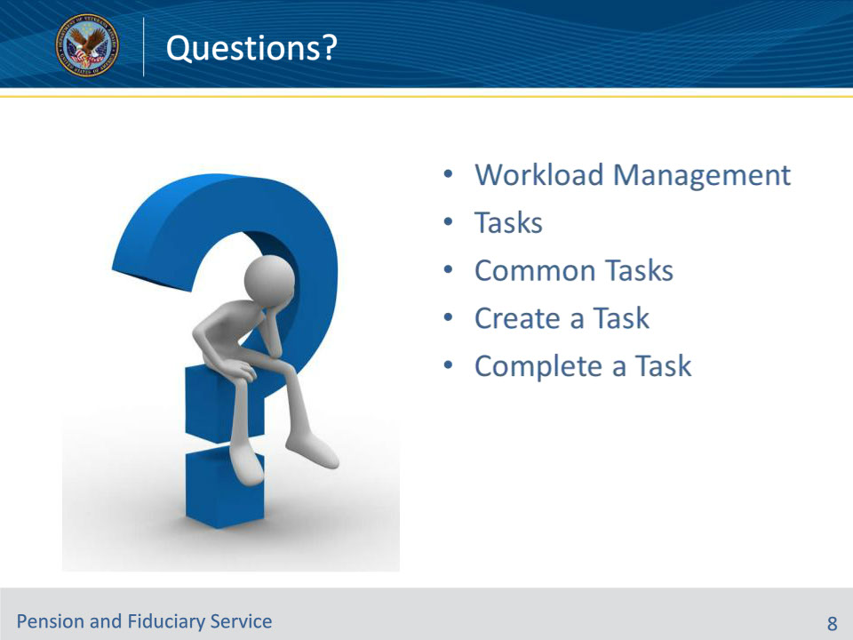
Slide notes

Instructor Notes:

(Recall) These are our learning objectives as stated in the beginning of the training:

• Describe the value of tasks in effective workload management

• Recall task types and how they are generated

• Create a task

• Complete a task

(Recap) We discussed each of these learning objectives through the following topics in each slide today:

• Workload Management

• Tasks

• Create a Task

• Complete a Task

Are there any additional questions?

Questions should be filtered through your QRT team. They will submit your questions to the Field Inquiry Tool (FIT) on your behalf.

Slide 9 - TMS Survey/Assessment
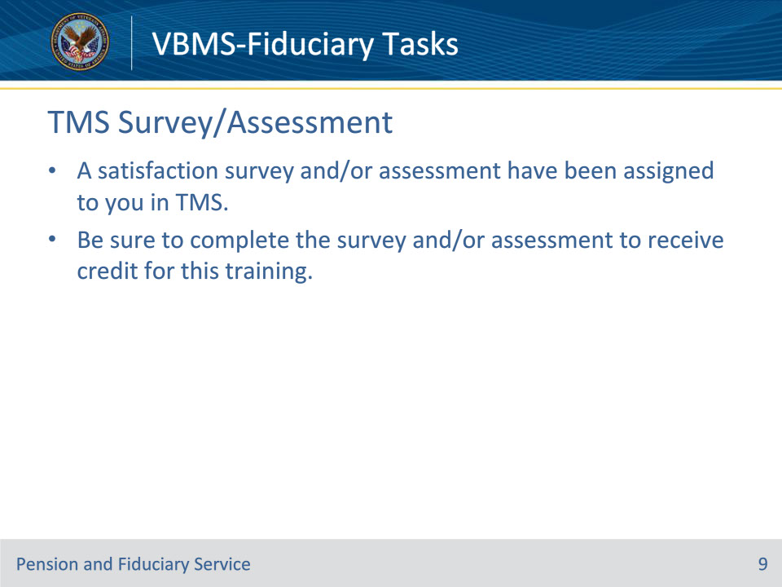
Slide notes

Instructor Notes:

A satisfaction survey and/or assessment have been assigned to you in TMS.

Be sure to complete the survey and/or assessment to receive credit for this training.

