Slide 1 - Creating and Assigning End Products in VBMS-Fid
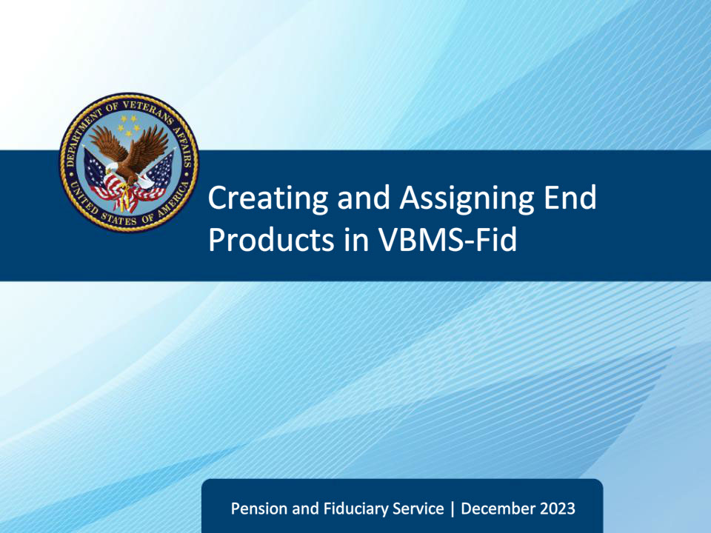
Slide notes

This course teaches fiduciary personnel how to create and assign end products to aid in accurate workload management in VBMS-Fiduciary.

Slide 2 - References
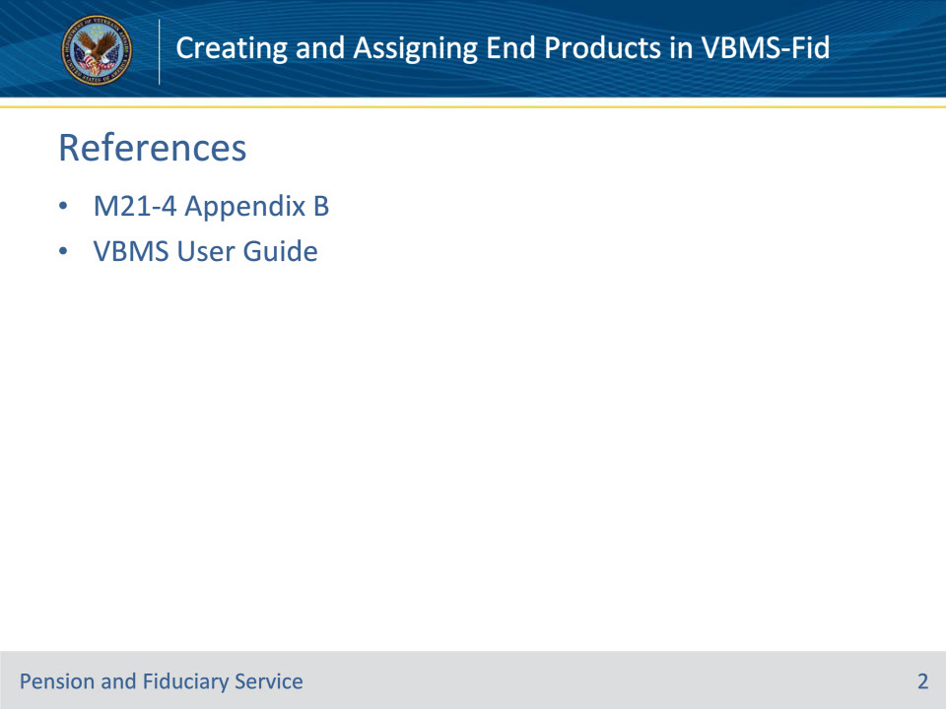
Slide notes

Instructor Notes:

These are the relevant references for this training:

• M21-4 Appendix B, End Product (EP) Codes

• VBMS User Guide

Slide 3 - Objectives
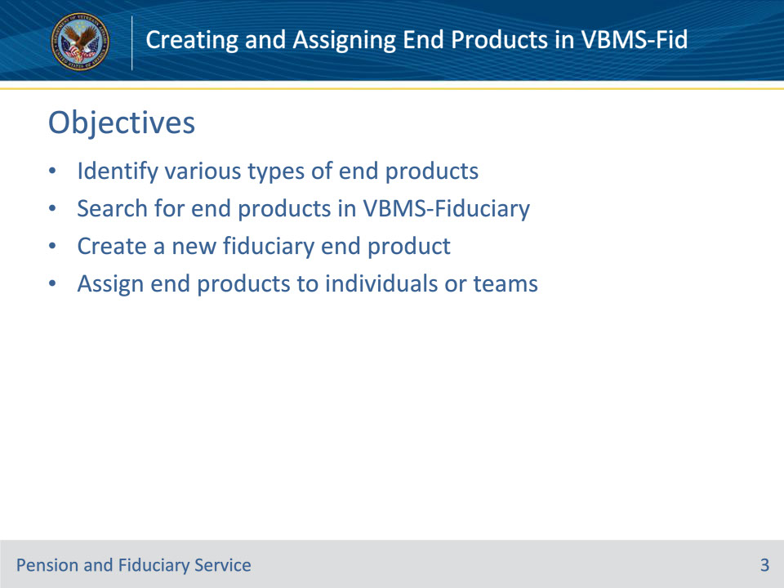
Slide notes

Instructor Notes:

Using the appropriate manual and regulatory references and handouts, learners will be able to do the following:

• Identify various types of end products

• Search for end products in VBMS-Fiduciary

• Create a new fiduciary end product

• Assign end products to individuals or teams

Slide 4 - End Products
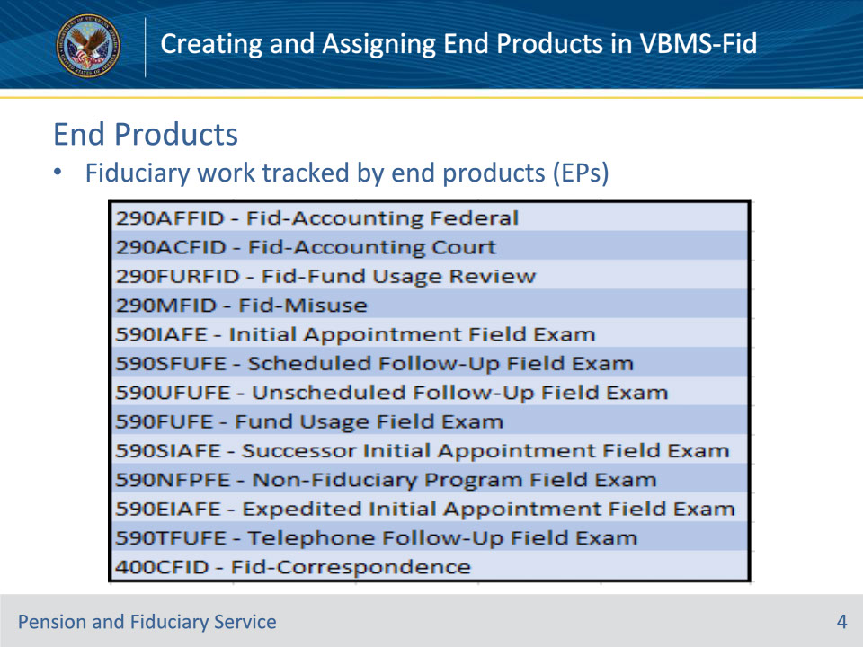
Slide notes

References: VBMS User Guide, M21-4 Appendix B

Instructor Notes:

• Fiduciary work is tracked by 2 main EP codes—290 and 590. Within each of those main EP codes, there are sub-categories for each type of work needed.

• Reminder: EPs are used to control lots of various work products by other VBA Business Lines also.

Slide 5 - Search End Products
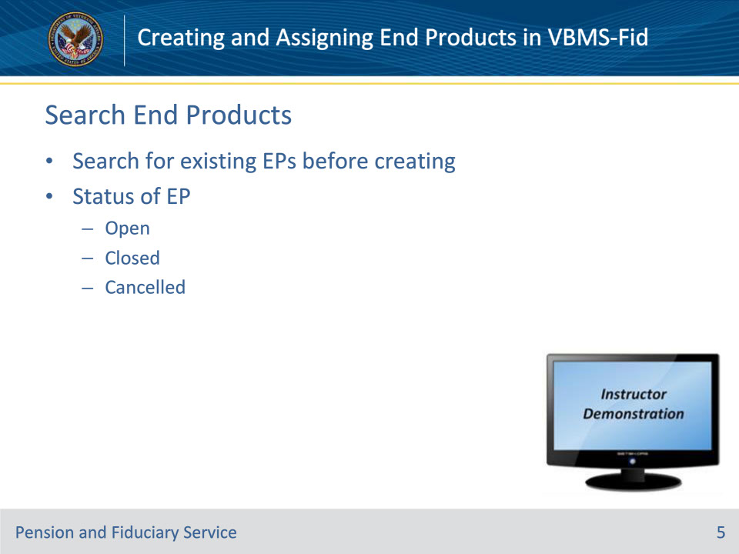
Slide notes

References: VBMS User Guide

Instructor Notes:

It is important to search for and review all EPs prior to creating a new EP to ensure the same EP does not already exist in the system.

Easiest for all users:

1. Go to the Beneficiary Profile page

2. Click on the Claims tab on the left side of the screen

3. View all active claims associated with that Beneficiary.

Note: User may check the “Include Inactive” block to see previously closed EPs.

The status of the EP can be found in the Claim Status column.

• Open: The EP is available for processing

• Closed: The EP was processed through the final stage or a defined work-flow and VBMS-Fid closed the EP.

• Cancelled: The EP item was unnecessary and removed it from inventory

Instructor Actions: Open VBMS, share your screen and demo activities described above.

Slide 6 - Create End Products
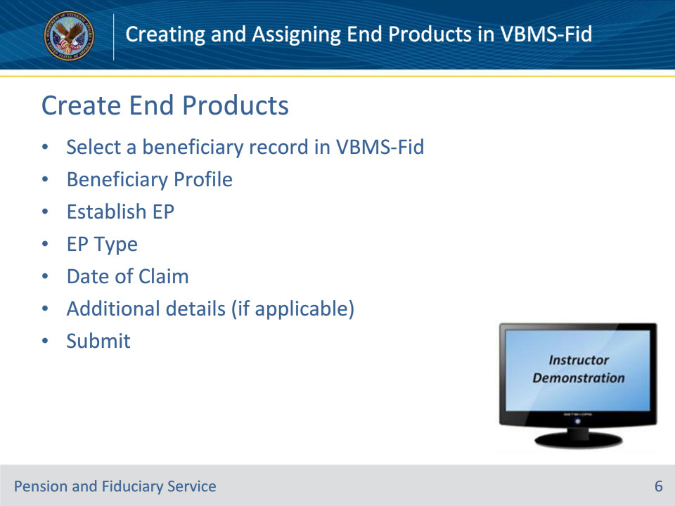
Slide notes

References: VBMS User Guide

Instructor Notes:

These are the general steps for creating any EP in VBMS-Fiduciary

1. Navigate to the Beneficiary Profile page.

2. From the Beneficiary Information tab (on left side of screen) of the beneficiary profile, select Establish EP

3. From the Establish EP dialog, select an EP Type.

4. Enter the Date of Claim. Other required fields may vary based on the EP type.

5. Select Submit. A success message is shown indicating the Claim ID of the new EP.

Instructor Actions: Open VBMS, share your screen and demo activities described above.

Slide 7 - Assign End Products
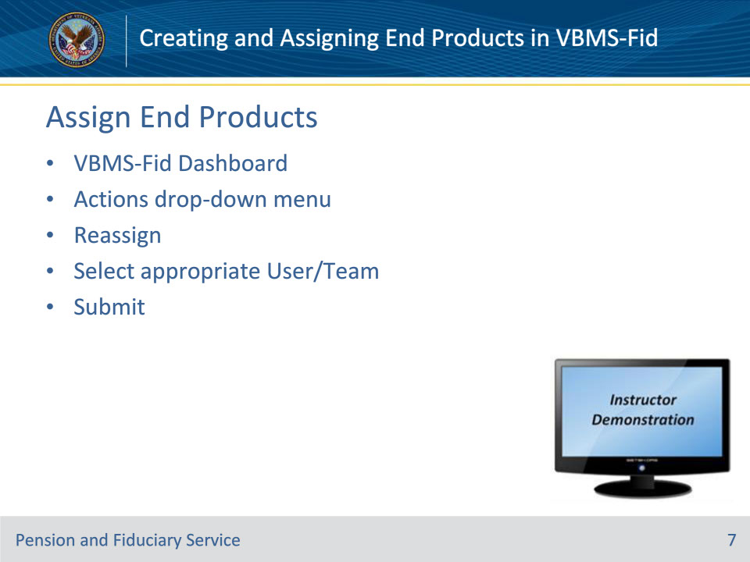
Slide notes

References: VBMS User Guide

Instructor Notes:

1. From the main VBMS-Fid dashboard, user can place check mark in the radial block(s) on all rows that are to be reassigned.

2. Select Reassign from the Actions drop-down menu.

3. In the pop-up window, the User should select the appropriate user and/or team the EP will now be assigned to.

4. Press Submit

Instructor Actions: Open VBMS, share your screen and demo activities described above.

Slide 8 - Questions?
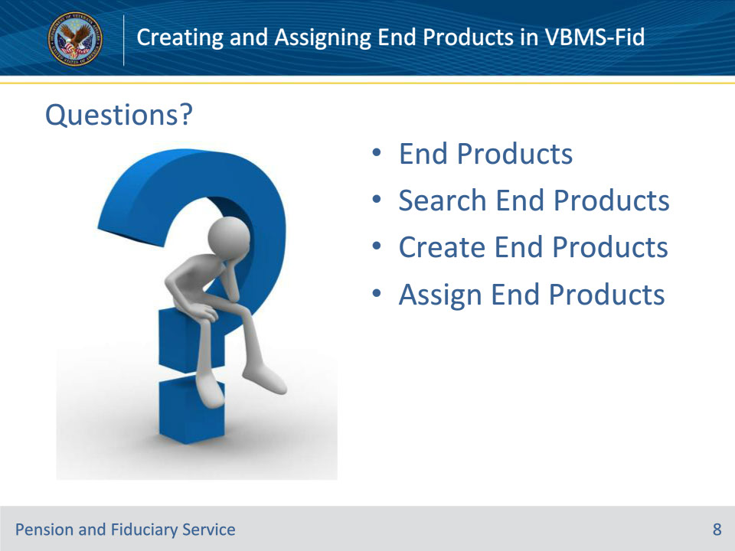
Slide notes

(Recall) These are our learning objectives as stated from the beginning of the training:

• Identify various types of end products

• Search for end products in VBMS-Fid

• Create a new fiduciary end product

• Assign end products to individuals or teams

(Recap) We discussed each of these learning objectives through the following topics in each slide today:

• End Products

• Search End Products

• Create End Products

• Assign End Products

Are there any additional questions?

Slide 9 - TMS Satisfaction Survey
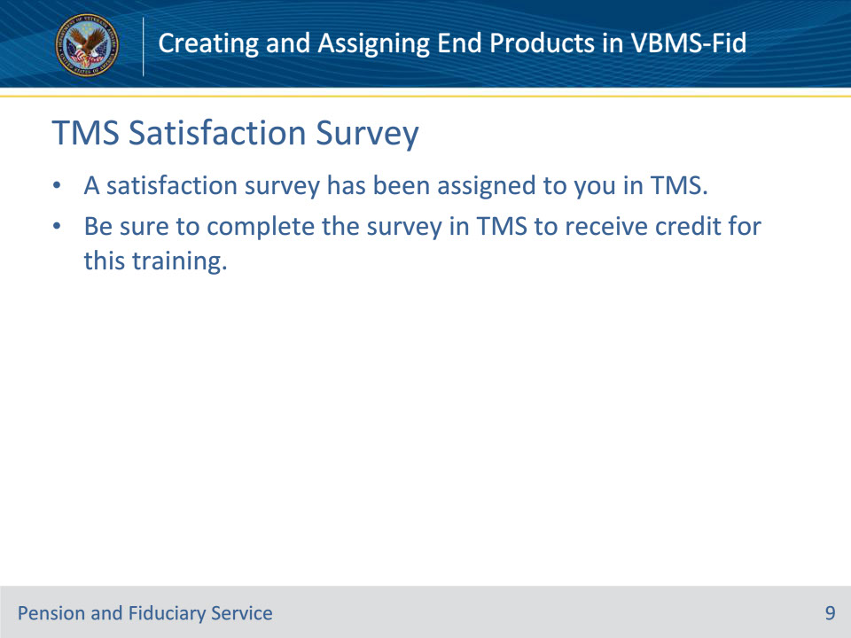
Slide notes

Explain to students that a satisfaction survey has been assigned to them in TMS. This survey provides them with an opportunity to help improve the training. The survey must be completed in order to receive training hours. All feedback is welcome!

