Slide 1 - Establishing and Verifying VBMS-Fid Records
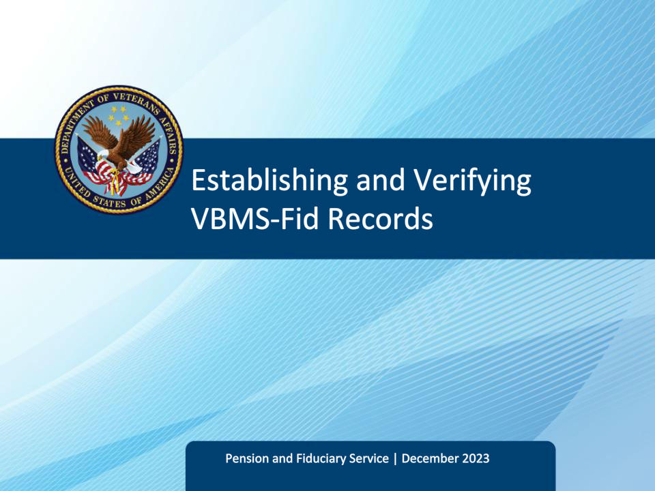
Slide notes

Course Description:

This course teaches fiduciary personnel how to access and create Veteran, Beneficiary and Fiduciary records. Additionally, it teaches fiduciary personnel how to verify correct data within a VBMS-Fid beneficiary and fiduciary record.

Slide 2 - Objectives
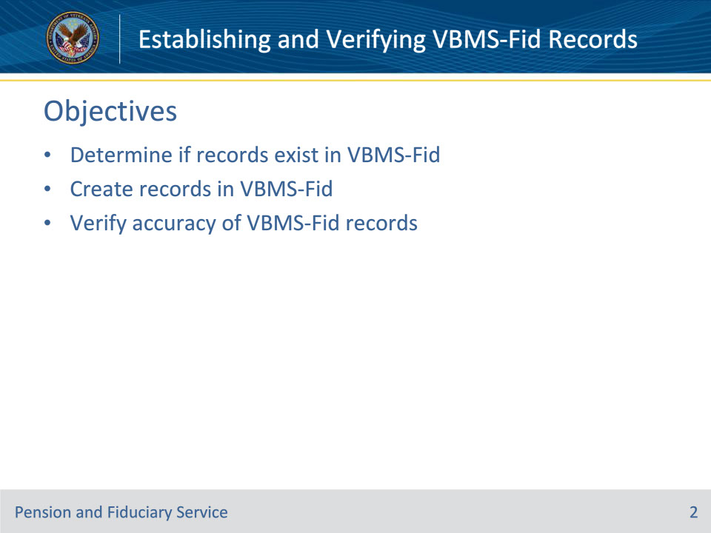
Slide notes

Instructor Notes:

By the end of this course, given the training and corresponding references, learners will be able to do the following:

• Determine if records exist in VBMS-Fid

• Create records in VBMS-Fid

• Verify accuracy of VBMS-Fid records

Slide 3 - References
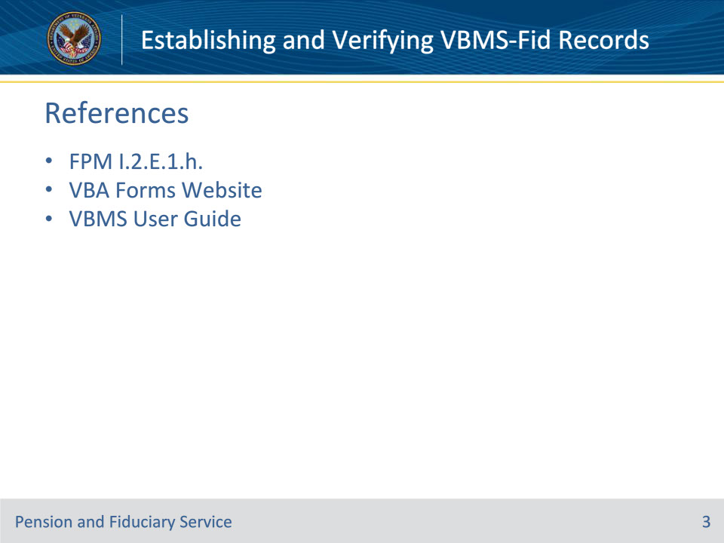
Slide notes

Instructor Notes:

These references discuss the various requirements for creating and accurately maintaining Veteran, beneficiary, and fiduciary records:

• FPM I.2.E.1.h, Updating the Beneficiary’s and Fiduciary’s Profiles

• VBA Forms Website--https://vaww.va.gov/vaforms/

• VBMS User Guide--https://www.uat.vbms.aide.oit.va.gov/vbmsp2/resources_p4/webhelp/core_webhelp/guides_for_download/vbms_user_guide.pdf

Slide 4 - Veteran - Beneficiary Record
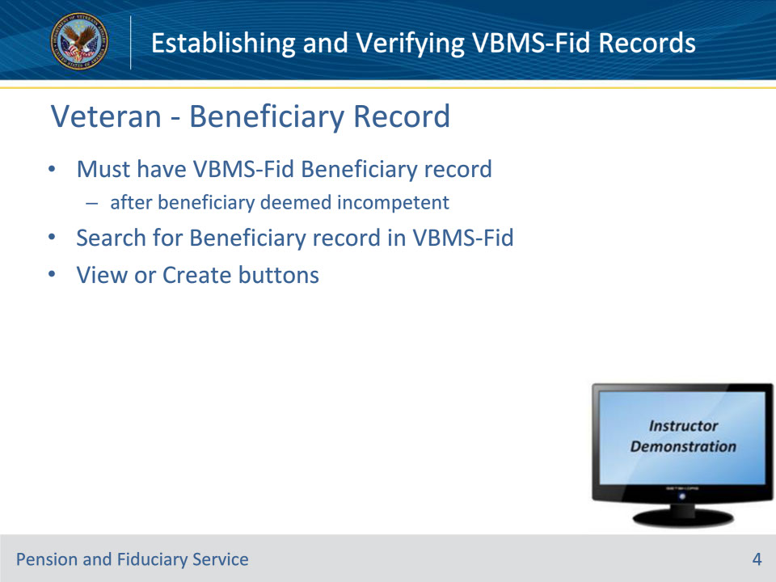
Slide notes

References: VBMS User Guide, VA Forms webpage

Instructor Notes:

A VBMS-Fid record for the beneficiary is needed to control aspects within the Fiduciary Program.

After the EP590 Due Process is closed, a Beneficiary Record within VBMS-Fid should be automatically established. However, there may be times when the Beneficiary Record must be manually created. Two examples are receipt of a VA Form 21-592, Request for Initial Appointment Information, or when the Fid Hub receives Court papers showing a non-Veteran is unable to manage his/her funds.

(VBMS User Guide) To create a beneficiary profile for an existing person profile, you must first search the records to see if the person already has a VBMS-Fid Beneficiary Record.

(VBMS User Guide) Search for a Beneficiary Record

• From the VBMS-Fid Beneficiaries Tab (on the left side of the screen), search by entering a first and last name, SSN, or a File Number.

• From the search results screen, the user can select View to view an existing profile. If the search returns a person without a beneficiary record, the user can select Create to create a new beneficiary profile.

• Note: In the unlikely scenario there is no person or Veteran record shown in the search results, the Veteran’s profile must be added through VBMS before creating a VBMS-Fid beneficiary profile. Not all VBMS users have the electronic permissions to add a Veteran profile to VBMS. To see if the user has the add Veteran record permissions, the user should search for the Veteran using the Advanced Search function. Once the negative result screen is seen, the user will be able to select the Add New Veteran button and enter the required information.

• When creating a beneficiary profile, a minimal set of information, including the beneficiary type and a physical address with ZIP Code, must be entered before you can save the profile.

Instructor Actions: Open VBMS, share your screen and demo the information just discussed.

Slide 5 - Fiduciary Record
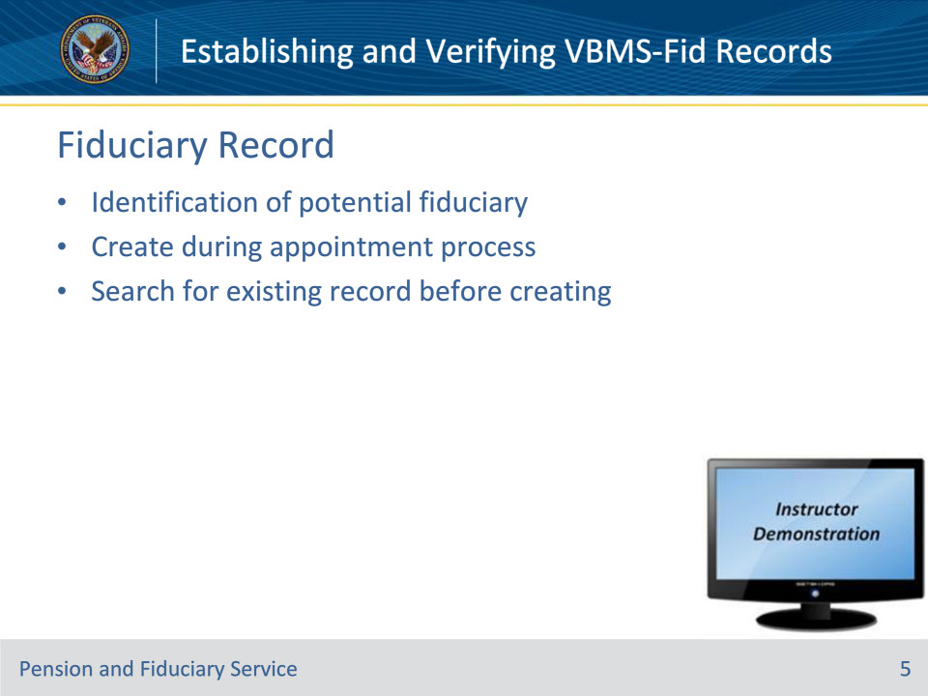
Slide notes

References: VBMS User Guide

Instructor Notes:

A VBMS-Fid Fiduciary record is required to control various aspects of the Fiduciary Program. A Fiduciary Record can be created anytime in the fiduciary appointment process.

Just like the Beneficiary record (discussed on previous slide), before creating a Fiduciary record, it is important to ensure that a record does not already exist. A record should already exist if the fiduciary has been appointed for another beneficiary.(VBMS User Guide) To create a fiduciary profile for a person or entity, the user must first search the records to see if the fiduciary already has a VBMS-Fid Fiduciary Record.

(VBMS User Guide) Search for a Fiduciary Record

• From the VBMS-Fid Fiduciaries Tab (on the left side of the screen), search by selecting the Person or Organization button and then filling in the required information.

• From the search results screen, the user can select View Profile to view an existing profile. If the search returns a person without a fiduciary record, the user can select Create Fiduciary to create a new fiduciary profile.

• When creating a fiduciary profile, a minimal set of information must be entered before you can save the profile.

Instructor Actions: Open VBMS, share your screen and demo the information just discussed.

Slide 6 - Record Accuracy
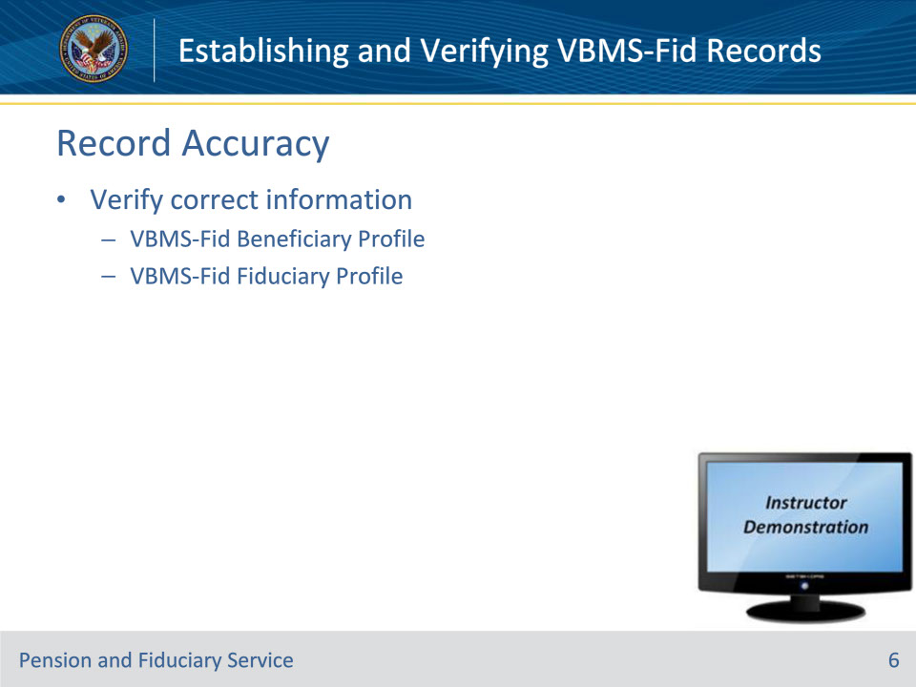
Slide notes

References: FPM I.2.E.1.h, VBMS User Guide, VA Forms webpage

Instructor Notes:

(I.2.E.1.h) At all stages of the field examination, hub personnel must ensure all appropriate fields in the beneficiary’s and fiduciary’s profiles are updated to reflect the most current information.

During the creation of the beneficiary record, the main fields of interest to the employee are those populated from the corporate record. However, some data fields can be verified manually using resources such as SHARE, VBMS core (eFolder documents), among others.

Fiduciary Record information can also be verified from existing documentation of record, usually in VBMS core (eFolder) and/or LCM.

Instructor Actions: Open VBMS, share your screen and demo the information just discussed.

Slide 7 - Questions?
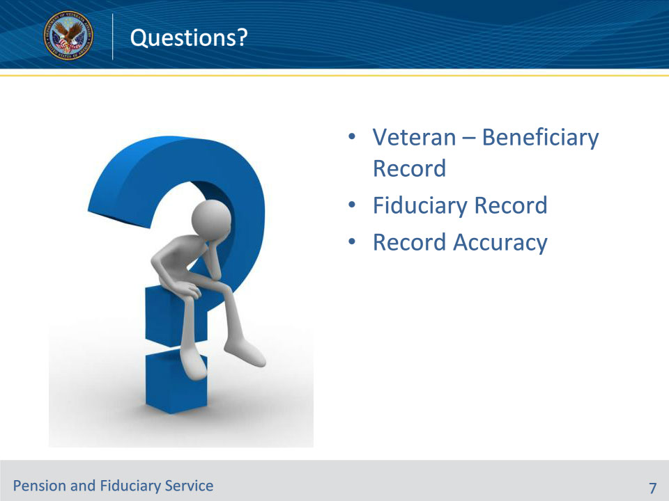
Slide notes

Instructor Notes:

(Recall) These are our learning objectives as stated from the beginning of the training:

• Determine if records exist in VBMS-Fid

• Create records in VBMS-Fid

• Verify accuracy of VBMS-Fid records

(Recap) We discussed each of these learning objectives through the topics on each of the slides:

• Veteran – Beneficiary Record

• Fiduciary Record

• Record Accuracy

Slide 8 - TMS Survey
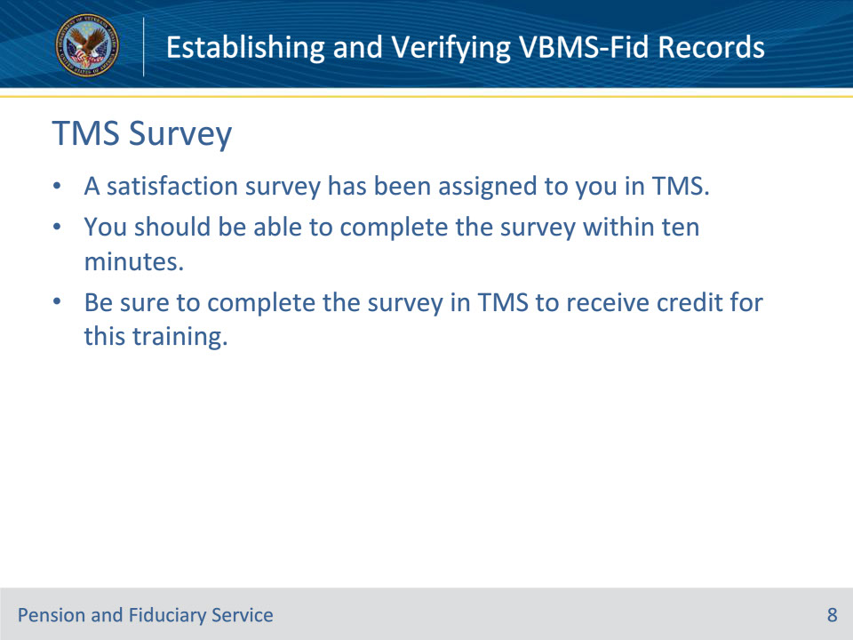
Slide notes

Instructor Notes:

A satisfaction survey has been assigned to you in TMS. You should be able to complete the survey within ten minutes. Completing the survey will allow you to receive credit for this training.

