Slide 1 - Accounting Disposition (User App)
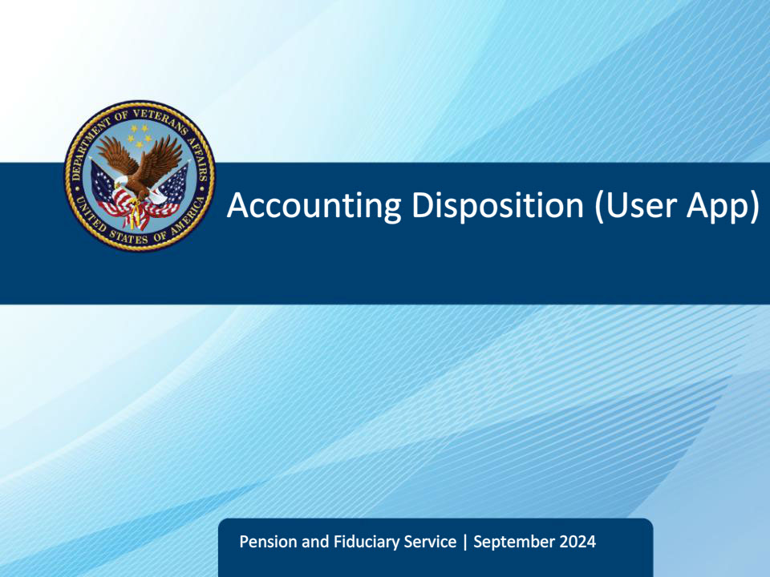
Slide notes

Course Description:

This course teaches fiduciary personnel the required actions they must conduct after making an accounting decision such as drafting correspondence, updating accounting end products, and managing associated tasks.

Slide 2 - Objectives
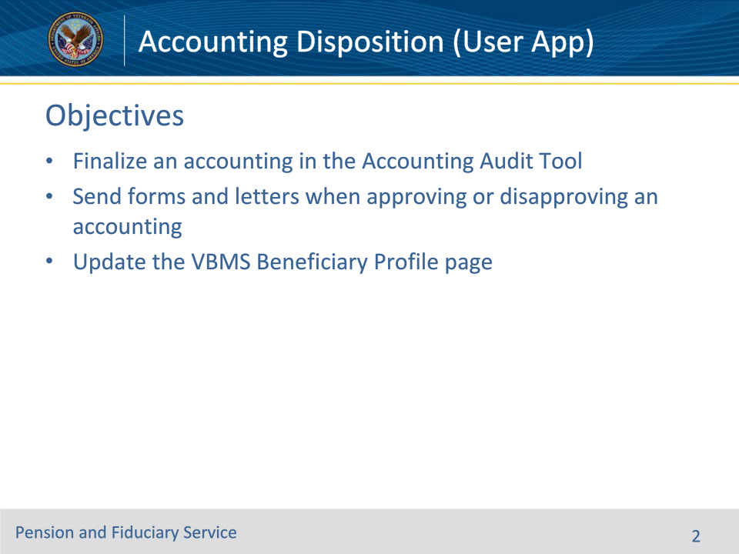
Slide notes

Instructor Notes:

At the end of this lesson, given the training and corresponding references, the learner will be able to:

• Finalize an accounting in the Accounting Audit Tool

• Send forms and letters when approving or disapproving an accounting

• Update the VBMS Beneficiary Profile page

Slide 3 - References
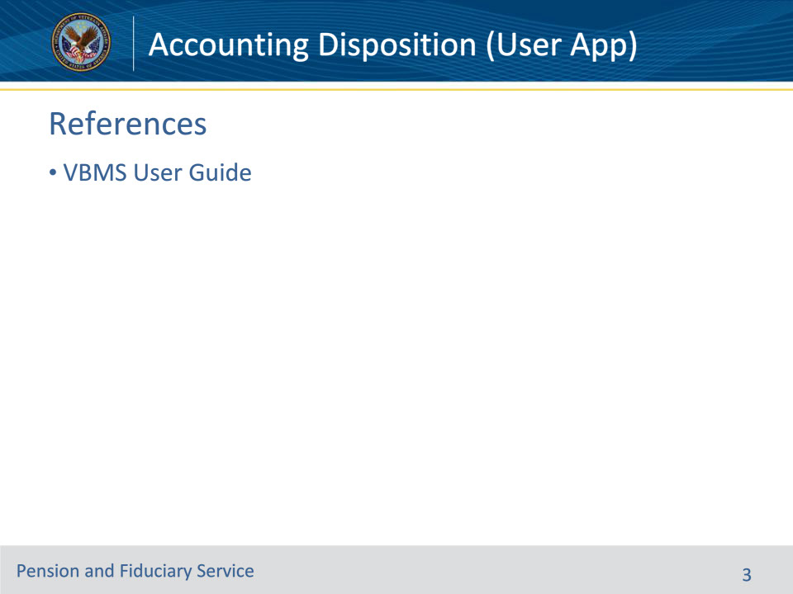
Slide notes

Instructor Notes:

These are the relevant references for this training:

• VBMS User Guide-- https://www.vbms.vba.va.gov/vbmsp2/resources_p4/webhelp/core_webhelp/guides_for_download/vbms_user_guide.pdf

Slide 4 - Disapproval-No Submission
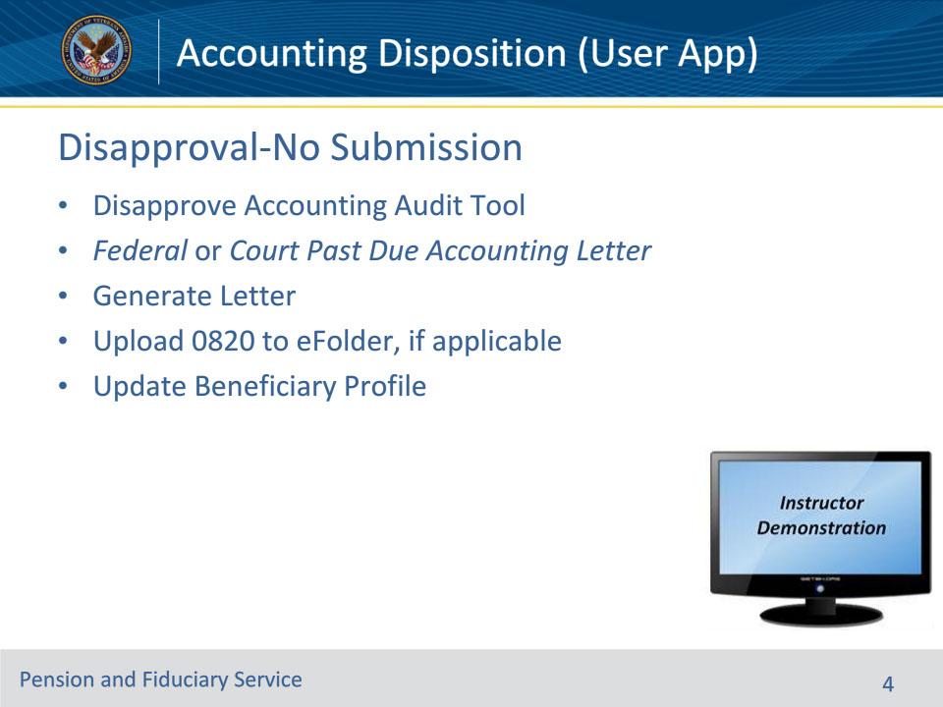
Slide notes

Policy Reference(s): VBMS User Guide

Instructor Notes:

• When the fiduciary did not submit any accounting information:

• LIE should now select “No” in the drop-down question for Accounting Approved in the AAT Audit Approval section. The LIE should fill in the Disapproval Date and the Disapproval Reason blocks.

• LIE should press the Disapprove Accounting button.

• LIE may use the Update Beneficiary pop-up to assist in updating the Beneficiary Profile page (as described in later slides.)

• The LIE should then return to the EP Overview page

• Select Federal or Court Past Due Accounting Letter from the Choose a Letter drop-down menu under the Correspondence section.

• Fill in the required Accounting Due Date block.

• Generate Letter to preview the Federal or Court Past Due Accounting Letter.

• Once the LIE has confirmed the accuracy of the letter, the LIE should press the Generate Letter within the pop-up Send Letter screen. This will automatically upload the letter to the Beneficiary’s eFolder. The LIE must ensure the letter gets mailed using current procedures.

• Remember to upload any VA Form 27-0820s, Report of General Information, created during the accounting process.

Beneficiary Profile Page

• Update the Beneficiary Profile Record (see later slides)

Instructor Actions: Open VBMS, share your screen and show the students example(s) of how to disapprove the accounting and generate the applicable letters.

Slide 5 - Disapproval-Incomplete Accounting
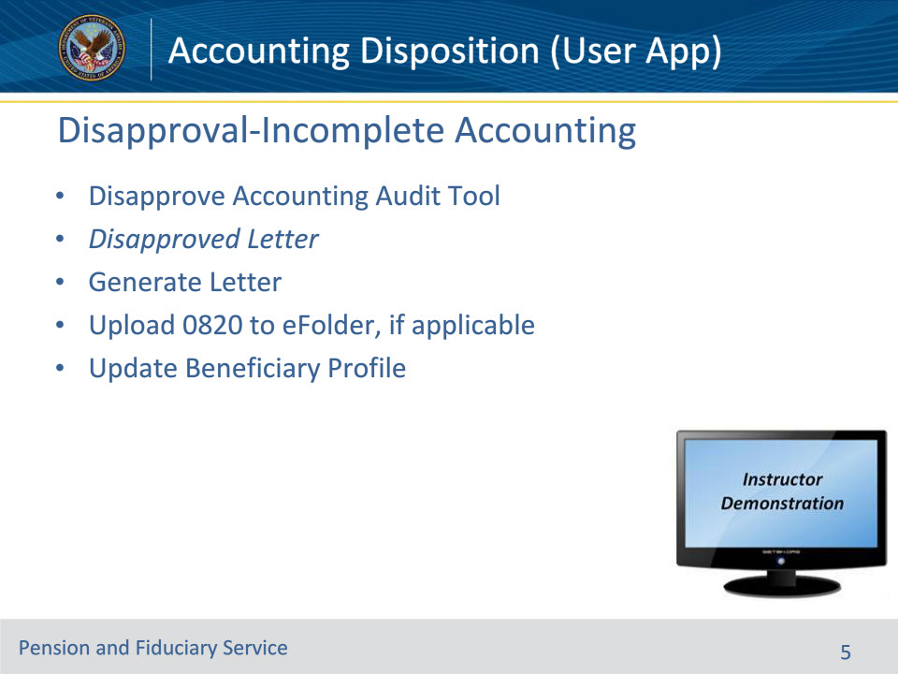
Slide notes

Policy Reference(s): VBMS User Guide

Instructor Notes:

• When the fiduciary submitted information and the accounting is not able to be approved, in the AAT,

• LIE should now select “No” in the drop-down question for Accounting Approved in the AAT Audit Approval section. The LIE should fill in the Disapproval Date and the Disapproval Reason blocks.

• LIE should press the Disapprove Accounting button.

• LIE may use the Update Beneficiary pop-up to assist in updating the Beneficiary Profile page (as described in later slides.)

• The LIE should then return to the EP Overview page

• Select Disapproved Letter from the Choose a Letter drop-down menu under the Correspondence section.

• Fill in the required Suspense Date block.

• Use the Add Account button, Add Check button, Add Purchase button or Free Text box, as appropriate, to describe why the accounting is being disapproved.

• Generate Letter to preview the Disapproved Letter.

• Once the LIE has confirmed the accuracy of the letter, the LIE should press the Generate Letter within the pop-up Send Letter screen. This will automatically upload the letter to the Beneficiary’s eFolder. The LIE must ensure the letter gets mailed using current procedures.

• Remember to upload any VA Form 27-0820s, Report of General Information, created during the accounting process.

Beneficiary Profile Page

• Update the Beneficiary Profile Record (see later slides)

Instructor Actions: Open VBMS, share your screen and show the students example(s) of how to disapprove the accounting and generate the applicable letters.

Slide 6 - Accounting Approval
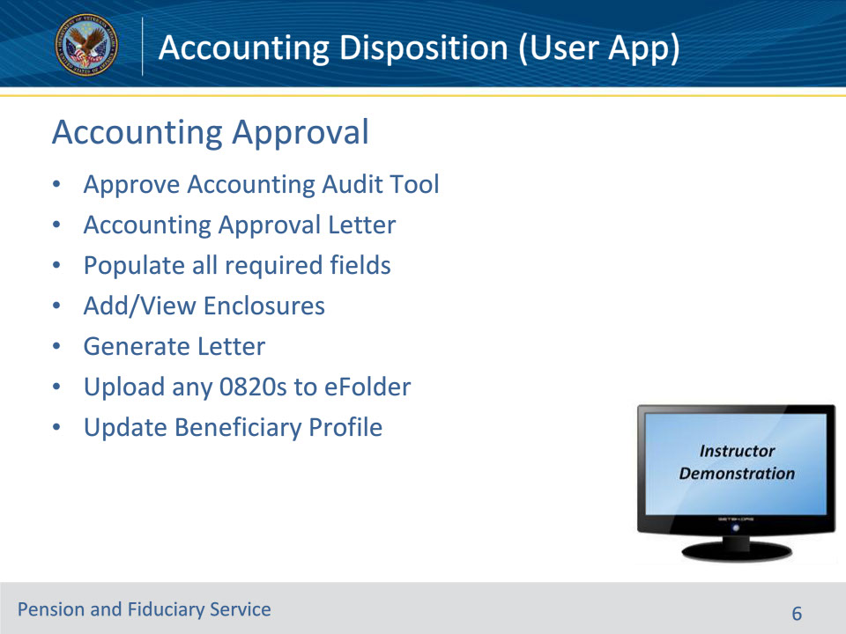
Slide notes

Policy Reference(s): VBMS User Guide

Instructor Notes:

If the accounting is approvable then the LIE should approve the AAT.

EP Overview Page

• Once the LIE has approved the Accounting in the AAT, return to the EP Overview Page.

• Under Correspondence drop-down menu, select the correct approved accounting letter.

• Fill in the required pop-up blocks

• CY Ending Balance

• Next Accounting Period Start

• Next Accounting Period End

• Additional Information

• The Additional Information block is designed for the LIE to describe anything to the fiduciary that has not been explained. For example, this is where the LIE can explain that there were discrepancies on the accounting form that the LIE was able to reconcile with bank statements in order to approve.

• Selecting the Add/View Enclosures block allows the LIE to add an enclosure to the Accounting Approval Letter (like the approved VA Form 21P-4706b or 4706c.)

• The LIE should then select Generate Letter to preview the Accounting Approval Letter. Once the LIE has confirmed the accuracy of the letter, the LIE should press the Generate Letter within the pop-up Send Letter screen. This will automatically upload the letter to the Beneficiary’s eFolder. The LIE must ensure the letter gets mailed using current procedures.

• Remember to upload any VA Form 27-0820s, Report of General Information, created during the accounting process.

Beneficiary Profile Page

• Update the Beneficiary Profile Record (see later slides)

Ensure the EP is cleared after finishing the update of the Accounting Audit Tool, beneficiary profile, and notification letter.

Instructor Actions: Open VBMS, share your screen and show the students how to finalize approving an accounting and generate an accounting approval letter

Slide 7 - Additional Letters
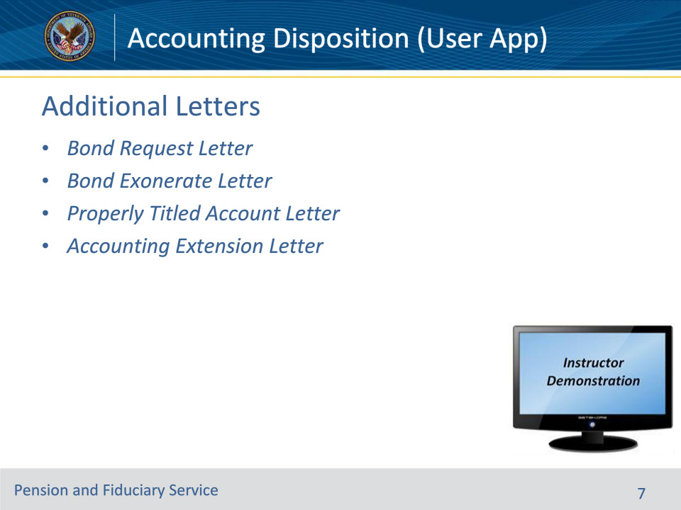
Slide notes

Policy Reference(s): VBMS User Guide

Instructor Notes:

If any additional letters are required to be sent in conjunction with the accounting approval or disapproval letters, LIE must take action to ensure the letter(s) are generated and mailed. Some letters may include:

• Bond Request Letter

• Bond Exonerate Letter

• Properly Titled Account Letter

• Accounting Extension Letter

To generate these letter(s),

• The LIE should go to the EP Overview page

• Select the desired letter from the Choose a Letter drop-down menu under the Correspondence section.

• Fill in any required blocks.

• Press the Generate Letter to preview the letter.

• Once the LIE has confirmed the accuracy of the letter, the LIE should press the Generate Letter within the pop-up Send Letter screen. This will automatically upload the letter to the Beneficiary’s eFolder. The LIE must ensure the letter gets mailed using current procedures.

Instructor Actions: Open VBMS, share your screen and show the students how to generate additional letters.

Slide 8 - Update Beneficiary Profile (#1)
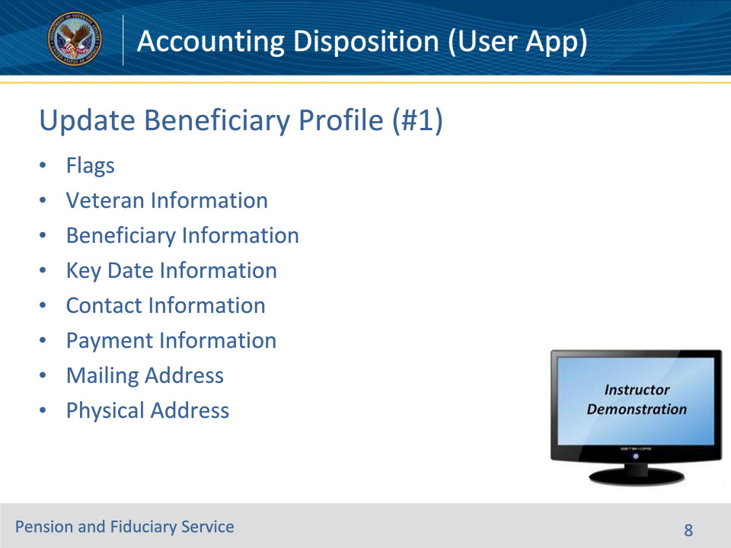
Slide notes

Policy Reference(s): VBMS User Guide

Instructor Notes:

• Flags—Check the relevant boxes for the beneficiary. Additional fields are shown if you select Hostile or Dual Supervision boxes.

• Veteran Information—Displays information regarding the Veteran.

• Beneficiary Information—Displays information regarding the beneficiary.

• Key Date Information—Shows key dates for the beneficiary. Date of Birth, Date of death and Date of Incompetency.

• Contact Information—Shows contact information for the beneficiary. Some fields may be read-only for some users.

• Payment Information—This information should match SHARE.

• Mailing Address—Mailing address for the bene.

• Physical Address—Important blocks include whether the address is a Facility, a VA Contract Nursing Home, and the type of the facility.

Instructor Actions: Open VBMS, share your screen and demo the information just discussed.

Slide 9 - Update Beneficiary Profile (#2)
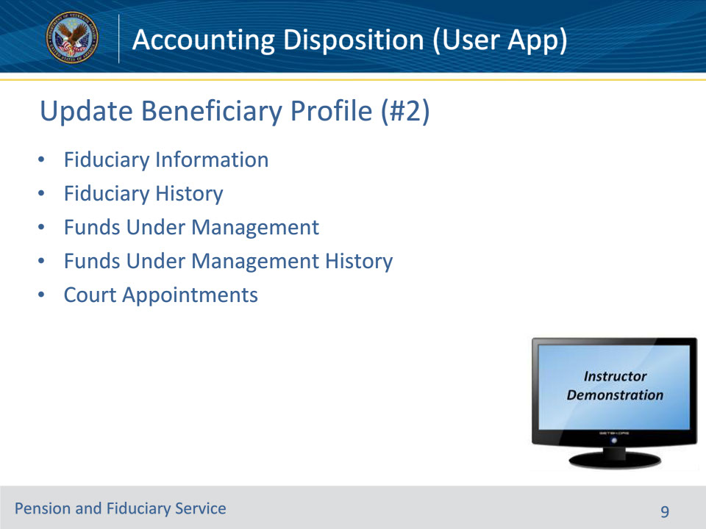
Slide notes

Policy Reference(s): VBMS User Guide

Instructor Notes:

• Fiduciary Information—This information should all be correct.

• Fiduciary History—Update as needed.

• Funds Under Management—Update as needed.

• Funds Under Management History—Update as needed.

• Court Appointments—Press the “Add Court Appointment” and fill in the relevant information, if applicable.

Instructor Actions: Open VBMS, share your screen and demo the information just discussed.

Slide 10 - Update Beneficiary Profile (#3)
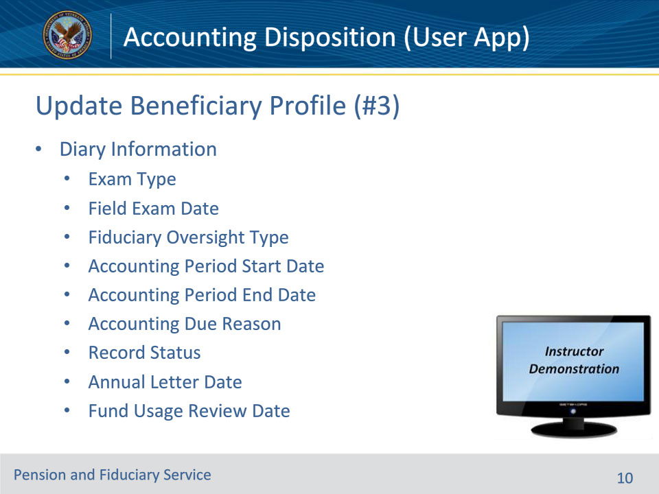
Slide notes

Policy Reference(s): VBMS User Guide

Instructor Notes:

Since some of these fields belong to beneficiary oversight, not all of these blocks will need to be adjusted by the LIE.

Diary Information—Ensure most current guidance is followed for Exam Type, Field Exam Date, Fiduciary Oversight Type, Accounting Period Start Date, Accounting Period End Date, Accounting Due Reason, Annual Letter Date and Fund Usage Review Date.

• NOTE: Do NOT fill in the Record Closed Date or the Record Status blocks.

• Exam Types/Field Exam Date

• Annual Written Contact Only

• Telephone Contact

• Scheduled Follow Up

• Fiduciary Oversight Type--Select appropriate fiduciary oversight method

• Accounting Court or Accounting Federal

• Fund Usage Review

• Accounting Period Start Date and Accounting Period End Date

• Only input a start and end date when an accounting is required; no accounting dates entered here when fiduciary is doing a Fund Usage Review

• Accounting Due Reason—Select most appropriate accounting reason for requiring an accounting

• Record Status—Use only if appropriate (which will be rarely during a field exam.)

• Pending Final Action

• Pending Review and Action

• Pending Review with VSC/PWC

• Annual Letter Date

• ALWAYS schedule an annual written contact

• One year from the date the last Field Exam EP is completed

• Fund Usage Review Date

• Only input a fund usage review date when a Fund Usage Review is required

Instructor Actions: Open VBMS, share your screen and demo the information just discussed.

Slide 11 - Update Beneficiary Profile (#4)
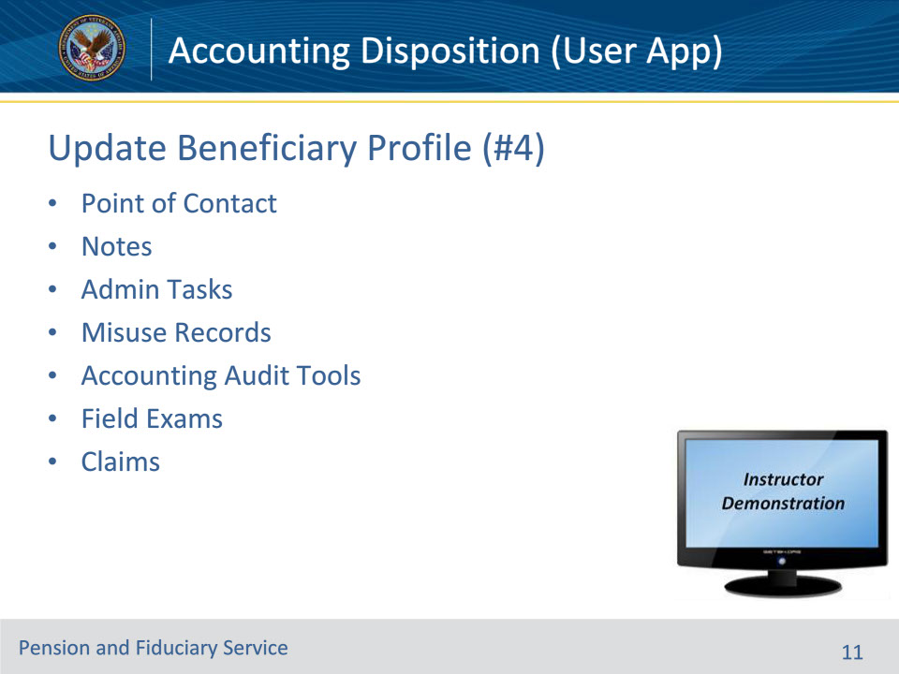
Slide notes

Policy Reference(s): VBMS User Guide

Instructor Notes:

• Point of Contact—This is contact information for someone, other than the fiduciary, who might be able to reach the beneficiary.

• Notes—For any notes associated with the beneficiary. These may be or may not be specific to your recently completed accounting. To add a new note, select Add Note. Then from the Add Note dialog, enter the note information and select OK.

• Admin Tasks—This section lists admin tasks associated with the beneficiary. Create a new task by selecting Create Admin Task.

• Misuse Records—List of misuse records for the beneficiary, including the associated fiduciary and the date of allegation. To open a misuse record, press the View Record button.

• Accounting Audit Tools—List of accounting audit tools associated with the beneficiary.

• Field Exams—Lists field exam reports associated with the beneficiary.

• Claims—Lists claims associated with the beneficiary.

Instructor Actions: Open VBMS, share your screen and demo the information just discussed.

Slide 12 - Questions?
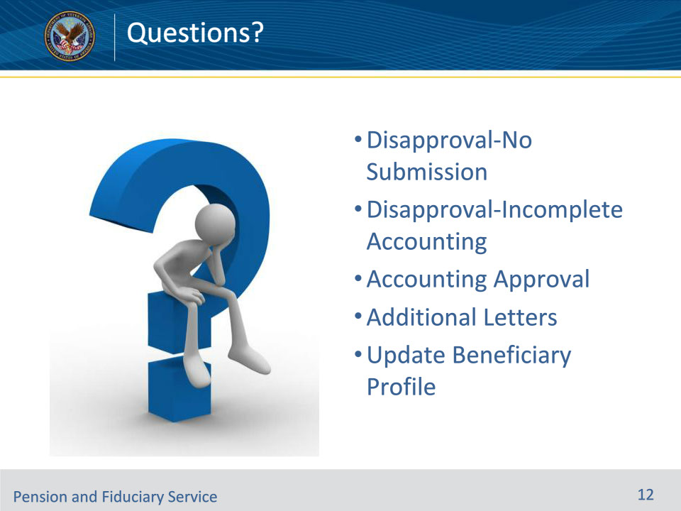
Slide notes

Instructor Notes:

(Recall) These are our learning objectives as stated from the beginning of the training:

• Understand how to finalize an accounting in the Accounting Audit Tool.

• Describe how to send forms and letters when approving or disapproving an accounting.

• Understand how to update the VBMS-Fid Beneficiary Profile page.

(Recap) We discussed each of these learning objectives through the following topics in each slide today:

• Disapproval-No Submission

• Disapproval-Incomplete Accounting

• Accounting Approval

• Additional Letters

• Update Beneficiary Profile

Are there any additional questions?

Questions should be filtered through your QRT team. They will submit your questions to the Field Inquiry Tool (FIT) on your behalf.

Slide 13 - TMS Survey/Assessment
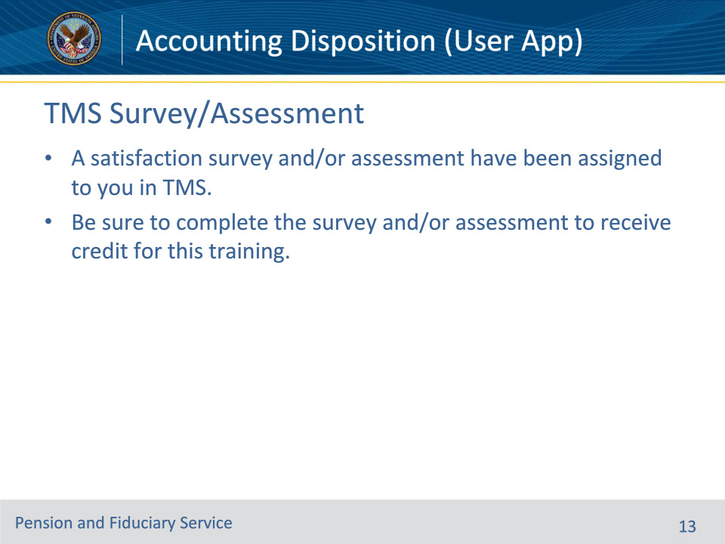
Slide notes

Instructor Notes:

A satisfaction survey and/or assessment have been assigned to you in TMS.

Be sure to complete the survey and/or assessment to receive credit for this training.

