Slide 1 - Accounting Audit (User App)
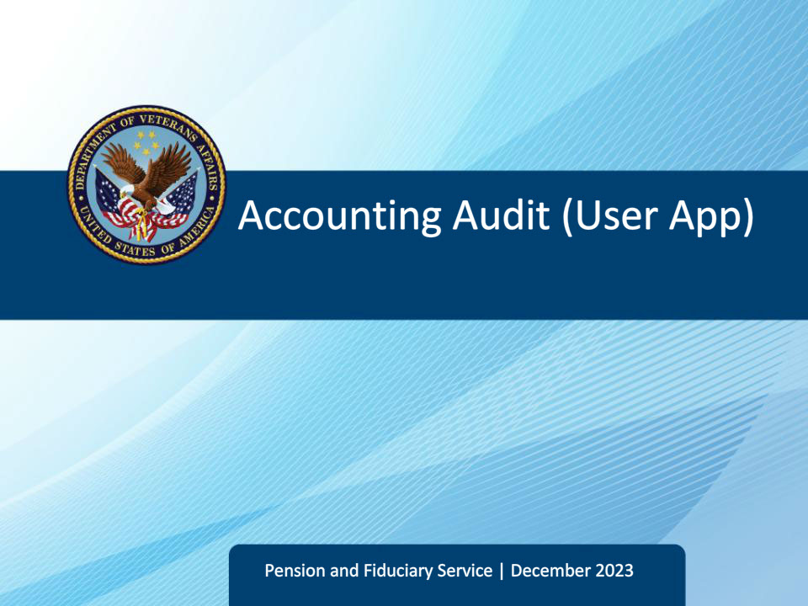
Slide notes

Course Description:

This course teaches fiduciary personnel the accounting audit process using the eFolder, VBMS-Fid Accounting Audit Tool (AAT), Share, and accounting casework.

Slide 2 - Objectives
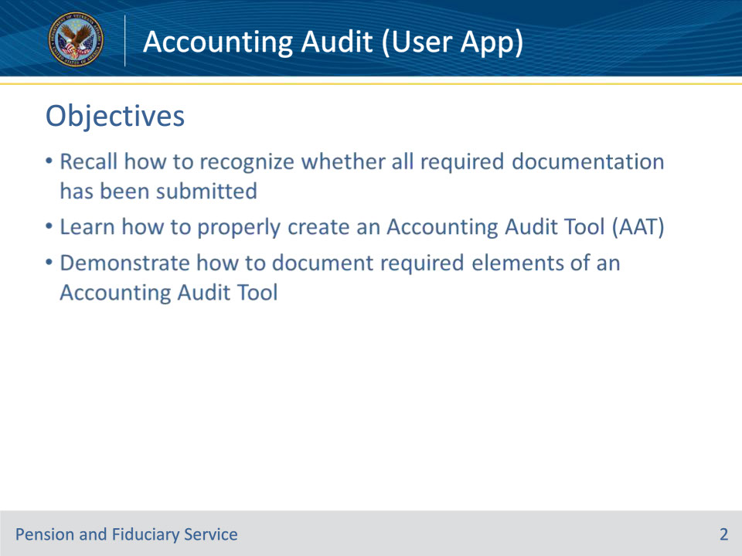
Slide notes

Instructor Notes:

At the end of this lesson, given the training and corresponding references, the learner will be able to:

• Recall how to recognize whether all required documentation has been submitted

• Learn how to properly create an Accounting Audit Tool (AAT)

• Demonstrate how to document required elements of an Accounting Audit Tool

Slide 3 - References
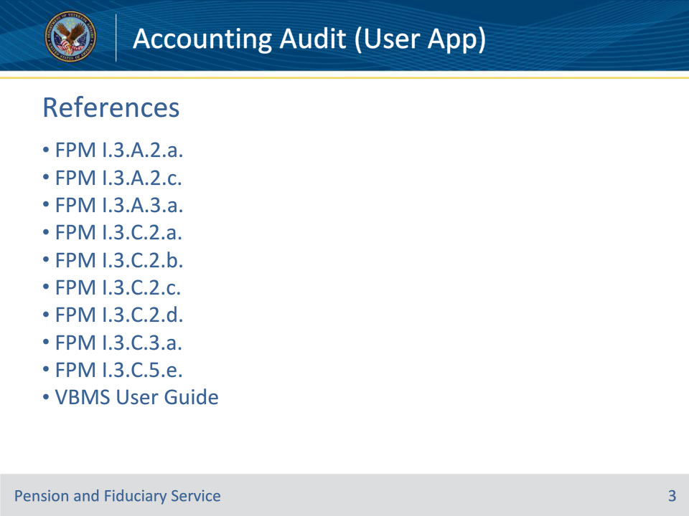
Slide notes

Instructor Notes:

These are our references for today’s training:

• FPM I.3.A.2.a. VA-Appointed Fiduciaries

• FPM I.3.A.2.c. Exceptions to the Accounting Requirements for VA-Appointed Fiduciaries

• FPM I.3.A.3.a. Elements of a Complete Accounting

• FPM I.3.C.2.a. Review of Proper VA Accounting Form

• FPM I.3.C.2.b. Confirming Receipt of Financial Statements

• FPM I.3.C.2.c. Documenting Accounting Period Start and Ending Dates

• FPM I.3.C.2.d. Review of Documents

• FPM I.3.C.3.a. Verifying the Starting Balance

• FPM I.3.C.5.e. Verifying Existing Corporate Surety Bonds, Blanket Bonds, Liability Insurance, or Withdrawal Agreements

• VBMS User Guide--https://www.uat.vbms.aide.oit.va.gov/vbmsp2/resources_p4/webhelp/core_webhelp/guides_for_download/vbms_user_guide.pdf

Slide 4 - Preliminary Review
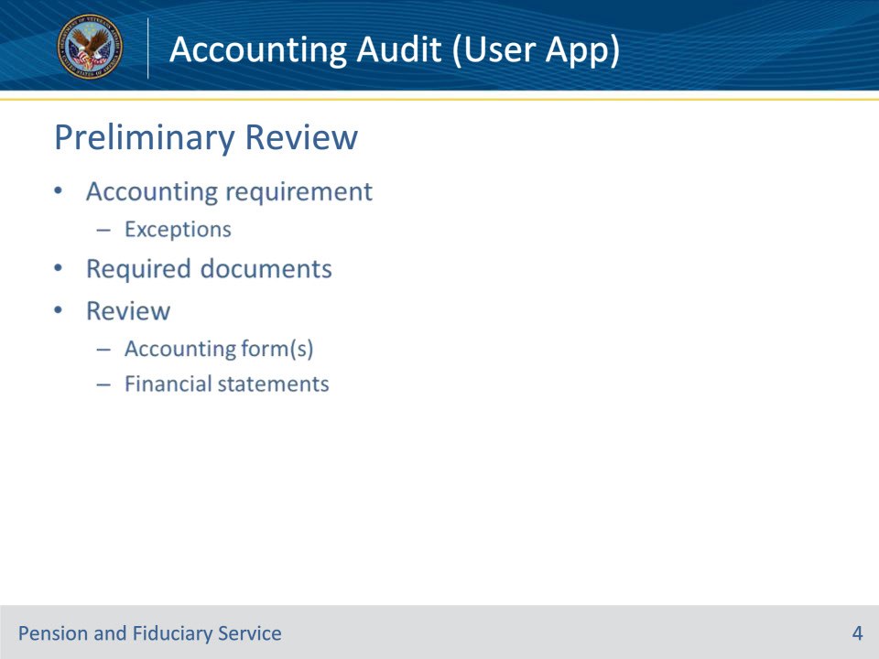
Slide notes

Policy Reference(s): FPM I.3.A.2.a., FPM I.3.A.2.c., FPM I.3.A.3.a., FPM I.3.C.2.a.-d.

Instructor Notes:

Recall there is some preliminary work to be done before actually auditing the accounting.

Determine if an accounting is actually required:

(I.3.A.2.a)

• The amount of VA FUM for the beneficiary exceeds $10,000.

• The fiduciary deducts a VA-authorized fee from the beneficiary’s account.

• The beneficiary receives VA benefits at a rate equal to or exceeding the amount paid for a 100 percent disability rating.

• Upon the death of a beneficiary who dies without a valid will and without heirs, whose VA FUM must be returned to VA through escheat.

• The fiduciary is appointed as a temporary fiduciary.

• Minor beneficiary receives a one-time insurance payment, and the funds will be immediately consumed.

But there are exceptions to requiring an accounting:

(I.3.A.2.c)

If the situation involves a chief officer of a non-VA facility receiving benefits for a beneficiary institutionalized in the facility, then an accounting does not apply to a fiduciary where:

• the beneficiary’s monthly care, maintenance, and personal use expenses equal or exceed the amount of the beneficiary’s monthly VA benefit, and

• the amount of VA benefit funds under management (FUM) by the fiduciary does not exceed $10,000.

• This includes beneficiaries paid at a rate equal to or exceeding the amount paid for a 100 percent disability rating.

• Note: This decision is at the discretion of the Fiduciary Hub Manager. However, temporary fiduciaries are required to account.

• If the situation involves a spouse, recognized as a dependent by VA and designated as a spouse fiduciary, then an accounting does not apply.

• If the situation involves a chief officer of a Federal institution, then an accounting does not apply if the officer is receiving VA benefits in a fiduciary capacity.

• If the situation involves fiduciaries and beneficiaries who permanently reside, and the fiduciary was appointed outside the United States, or in the Commonwealth of Puerto Rico, or the Republic of the Philippines, then an accounting does not apply.

Reminder: The Fiduciary Hub Manager may require an accounting at any time to determine the financial well-being of the beneficiary.

Making sure we have all the elements of a complete accounting:

(I.3.A.3.a)

An accounting report submission by a fiduciary is considered complete and ready for audit if all the conditions below are met:

• the VA Form 21P-4706b, VA Fiduciary’s Account, VA Form 21P-4706c, Court Appointed Fiduciary’s Account, or an accounting submitted via FAST contains the

• name of the beneficiary

• VA file number associated with the beneficiary

• expenses, and

• income, and

• the fiduciary

• completes the background information, and

• provides financial statements detailing account transactions during the entire accounting period.

Review of Proper VA Accounting Form:

(I.3.C.2.a)

• Review the accounting report submission from the fiduciary before initiating the accounting audit to confirm that the VA Form 21P-4706b, or VA Form 21P-4706c, Court Appointed Fiduciary’s Account, is minimally complete

• All accounting documentation received via mail or within FAST must be uploaded to the eFolder and reviewed.

Confirming Receipt of Financial Statements:

(I.3.C.2.b)

• After identifying the accounting period start and end dates, the LIE must confirm that the required financial statements are of record for the entire accounting period.

• The fiduciary must submit financial statements for the entire accounting period for all financial accounts containing funds under management (FUM). The financial statements must contain the beginning and ending balances, generally identified by a month or year, for the entire accounting period under review. Financial statements must show all transactions to include income, expenses, fees, and transfers for the entire accounting period.

(I.3.C.2.c-.d)

During the accounting audit, examine all accounting report documents closely for inconsistencies in type face, print quality, website addresses, or color. The LIE must question any documents that show signs of alteration.

• The LIE is responsible for reviewing

• all bank statements

• VA Form 21P-4706b, or VA Form 21P-4706c

• the eFolder

• documents within FAST

• previous accountings, and

• the VBMS Beneficiary Profile page.

• The LIE must identify the accounting period start and end date and populate the dates in the VBMS Accounting Audit Tool.

Slide 5 - Create Accounting Audit Tool
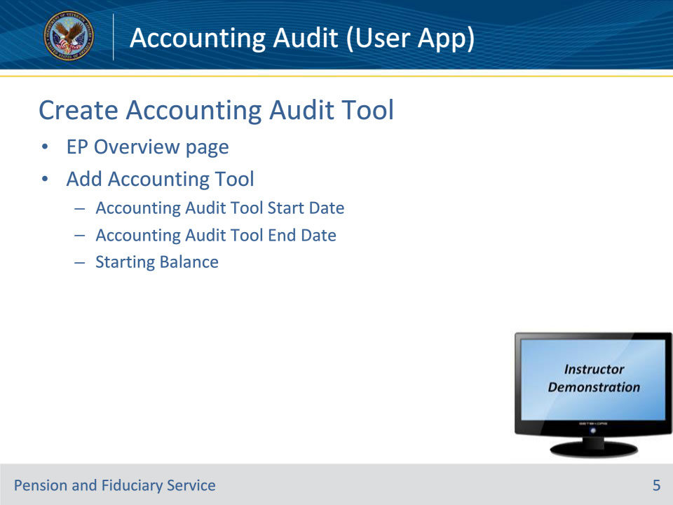
Slide notes

Policy Reference(s): FPM I.3.C.3.a, VBMS User Guide

Instructor Notes:

• Navigate to the EP Overview Page for the Beneficiary.

• Click the Add Accounting Tool button

• Enter the requested information in the sub-window:

• Accounting Audit Tool Start Date

• Accounting Audit Tool End Date

• Starting Balance

• Recall I.3.C.3.a has an in-depth discussion of the starting balance

• First accounting following an IA—Starting Balance $0

• First accounting following a SIA—Starting Balance $0

• Subsequent accounting—Starting balance of this accounting is the ending balance as indicated in the previously approved accounting

• New accounting requirement established after the IA or SIA due to the discovery of VA FUM exceeding $10,000 or a determination under 38 CFR 13.280(a)(4)—Starting balance is the verified VA FUM amount documented on the field examination or in the eFolder on the date of the field examination, fund usage review, or other routine oversight.

• New accounting requirement established after the IA or SIA due to an increase in the Veterans compensation payment to the 100% rate—Starting balance is the verified VA FUM amount documented on the field examination or in the eFolder on the date of the field examination, fund usage review, or other routine oversight, if known. If the VA FUM amount is unknown, the appropriate starting balance is $0.

• One way to open the newly created AAT is to click on the 6-digit number to the right of the row titled Accounting Audit Tool on the EP Overview page.

Instructor Actions: Open VBMS, share your screen and demo the information just discussed.

Slide 6 - General Information
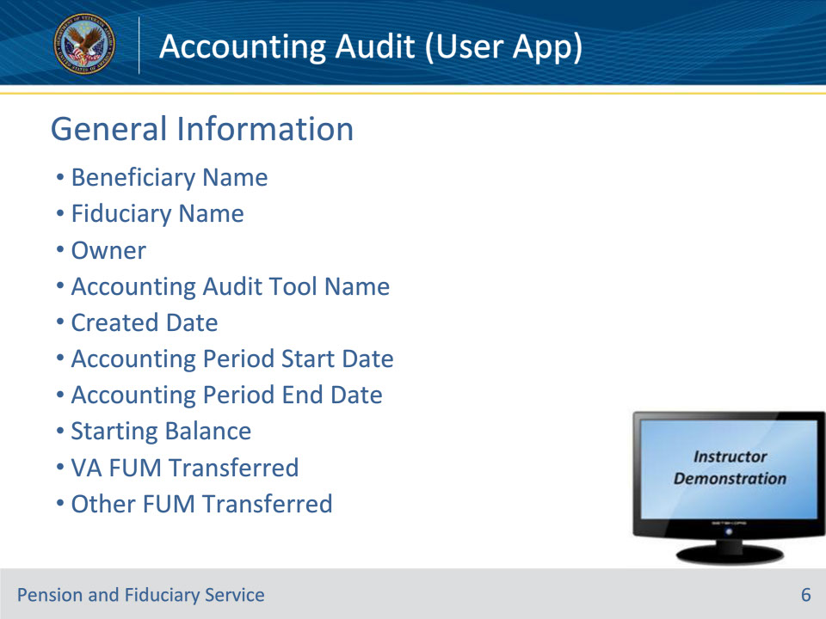
Slide notes

Policy Reference(s): VBMS User Guide

Instructor Notes:

On the General Information Tab, confirm the pre-filled blocks:

• Beneficiary Name

• Fiduciary Name

• Owner

• Accounting Audit Tool Name

• Created Date

• Accounting Period Start Date

• Accounting Period End Date

• These three blocks may be manually edited in the AAT:

• Starting Balance

• VA FUM Transferred (If the fiduciary is a successor)

• Other FUM Transferred (If the fiduciary is a successor)

Instructor Actions: Open VBMS, share your screen and demo the information just discussed.

Slide 7 - Incomes
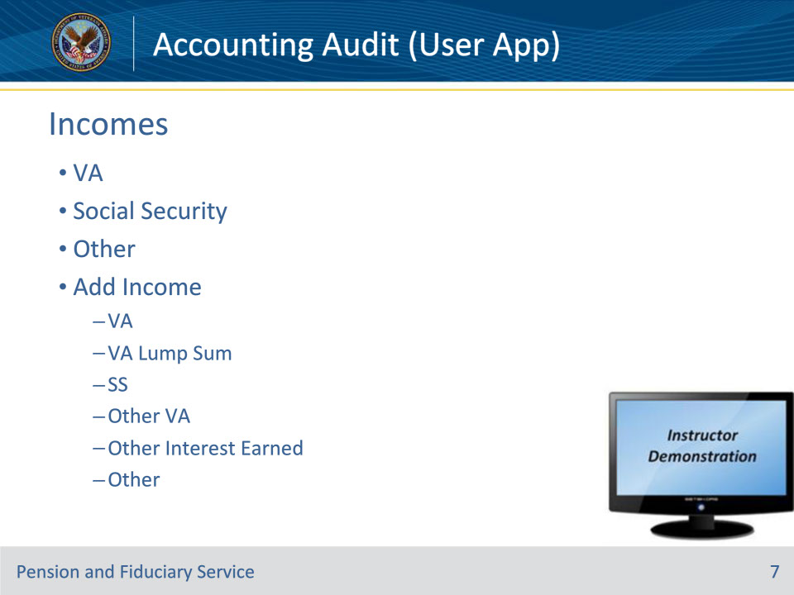
Slide notes

Policy Reference(s): VBMS User Guide

Instructor Notes:

Enter the beneficiary’s sources of income for the accounting period.

• There are two pre-built rows for VA income and two pre-built rows for Social Security incomes. There is also a pre-built row for an Other category.

• Note: This matches the order of the 21-4706b

• To add another row of income, the LIE should press the Add Income button.

• With the Add Income button, there is a drop-down menu. LIE should choose the best matching Income Type.

• VA

• VA Lump Sum

• SS

• Other VA

• Other Interest Earned

• Other

• NOTE: Some of the rows from the Add Income button do not have a Months block. This allows the LIE to add non-fixed amount incomes easier.

• LIE may press the Delete button to remove any Add Income row.

• To edit the income of any row, press the Edit button on the right-hand side of the screen.

• In the sub-window, fill in the required blocks (which will vary based on the Income Type).

• The five blocks at the bottom of the Income section should display the totals of the various categories entered in the Income rows.

• Total VA This Period

• Total Social Security This Period

• Total Other Income This Period

• Total Income This Period

• Total Income + Starting Balance

Instructor Actions: Open VBMS, share your screen and demo the information just discussed.

Slide 8 - Expenses
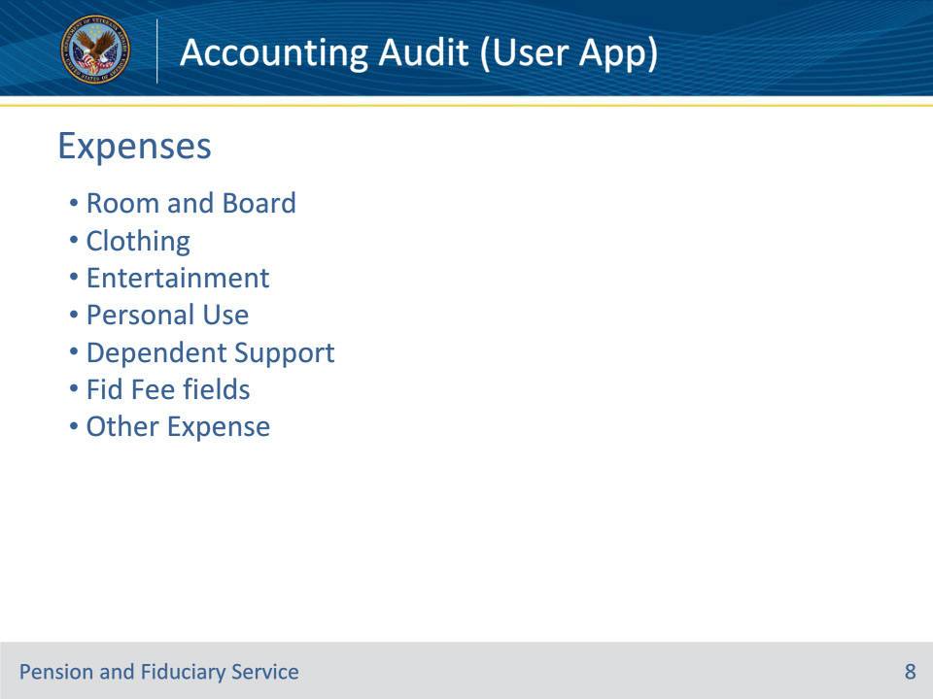
Slide notes

Policy Reference(s): VBMS User Guide

Instructor Notes:

Enter the beneficiary’s expenses for the accounting period.

• There are several pre-labeled expenses with amounts and months. Fill in the blocks with the corresponding amounts and months. Leave the blocks blank that are $0.

• Room and Board Amount / Months

• Clothing Amount

• Entertainment Amount

• Personal Use Amount / Months

• Dependent Support Amount / Months

• Fid Fee Percent (drop down menu)

• Fid Fee Authorized (computes automatically)

• Fid Fee Taken

• Fid Fee Difference (becomes yellow and displays difference if Fid Fee Taken is greater than Fid Fee Authorized; Additionally, a required free-text box appears if the Fiduciary Fee Taken is greater than Fid Fee Authorized)

• Other Expense Name / Amount

• Note: These pre-labeled expenses match the order of the 21-4706b.

• Press the Add Expense button to add another row of expenses.

• A User-added row may be deleted by pressing the trash-can button to the right of the respective row.

• Total Other Expense This Period and Total Expense This Period are at the bottom of the section and show the respective totals.

Instructor Actions: Open VBMS, share your screen and demo the information just discussed.

Slide 9 - Assets
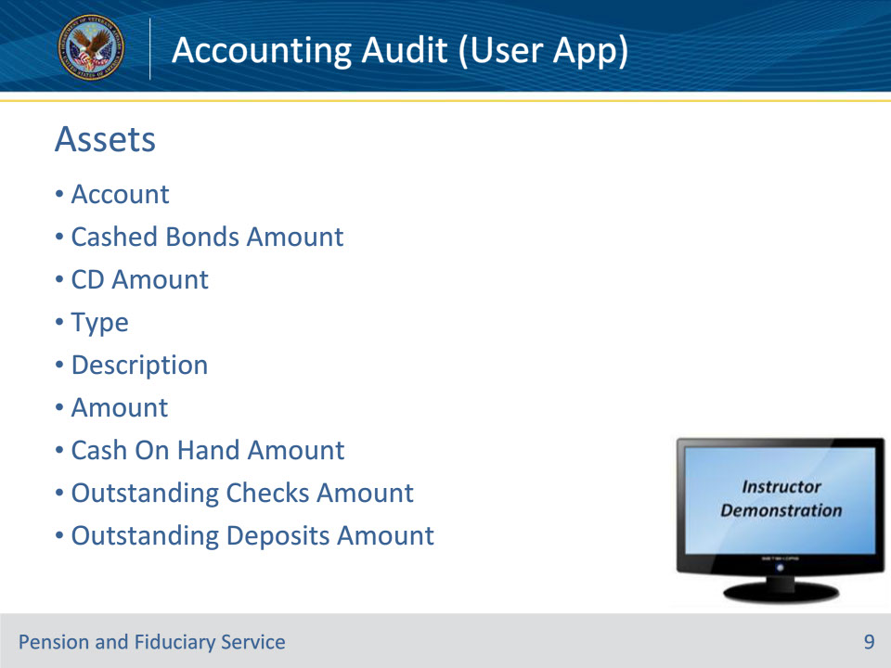
Slide notes

Policy Reference(s): VBMS User Guide

Instructor Notes:

Enter the beneficiary’s assets for the accounting period.

• Three Account rows, once Cashed Bonds Amount, and two CD Amount rows are shown and can not be deleted.

• To add another asset row, press the Add Asset button.

• Complete the required information for the asset the beneficiary owns.

• Type (from the drop-down menu)

• Description (free-text block to describe the asset)

• Amount (fill in the value of the asset)

Three blocks can be manually filled in:

• Cash On Hand Amount

• Outstanding Checks Amount

• Outstanding Deposits Amount

• Total Assets at End of Accounting Period block automatically computes the value of all entered assets

Instructor Actions: Open VBMS, share your screen and demo the information just discussed.

Slide 10 - FUM Summary
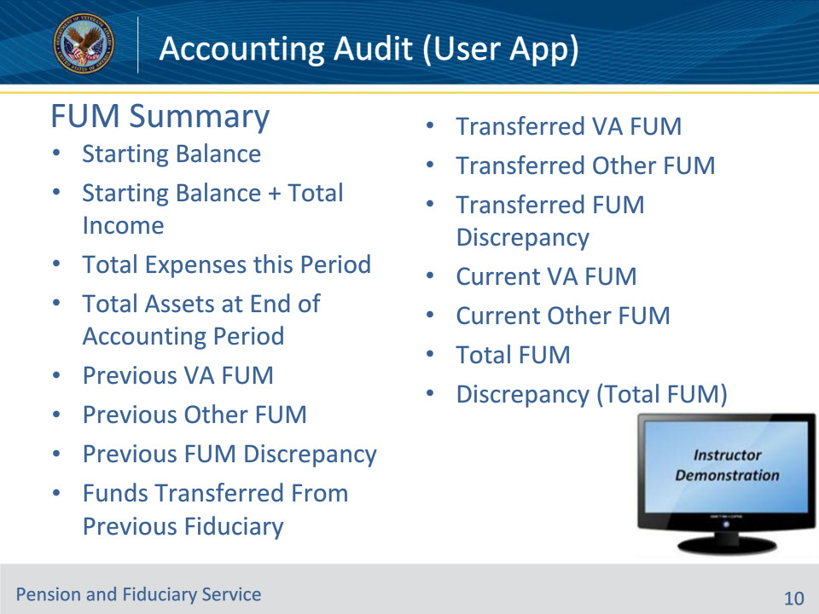
Slide notes

Policy Reference(s): VBMS User Guide

Instructor Notes:

The FUM Summary section summarizes the amounts entered into the AAT thus far. The only blocks to be adjusted directly in this section are the Previous VA FUM and Previous Other FUM blocks. Since all other blocks are computations of other entries, they must be adjusted using other blocks elsewhere in the AAT.

• Starting Balance

• Starting Balance + Total Income

• Total Expenses this Period

• Total Assets at End of Accounting Period

• Previous VA FUM

• Previous Other FUM

• Previous FUM Discrepancy

• Funds Transferred From Previous Fiduciary

• Transferred VA FUM

• Transferred Other FUM

• Transferred FUM Discrepancy

• Current VA FUM

• Current Other FUM

• Total FUM

• Discrepancy (Total FUM)

Instructor Actions: Open VBMS, share your screen and demo the information just discussed.

Slide 11 - Bonds
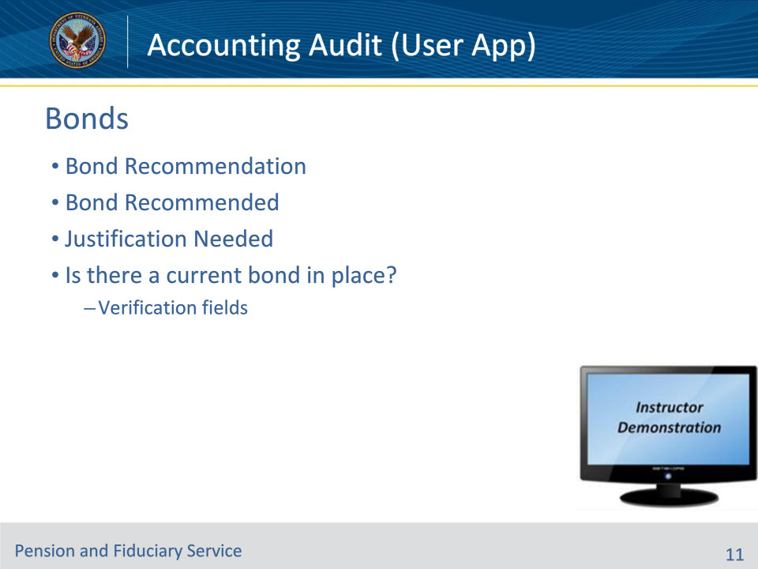
Slide notes

Policy Reference(s): FPM I.3.C.5.e, VBMS User Guide

Instructor Notes:

The Bonds section is for Surety Bond information.

• Bond Recommendation (VBMS recommendation to LIE whether a Surety Bond is needed or not.)

• Bond Recommended (Drop-down menu with Yes or No)

• Yes (Opens a Justification Needed free-text block for the LIE to explain why the bond is needed.)

• No

• Is there a current bond in place? (Drop-down menu with Yes or No)

• No

• Yes (Blocks for surety bond details appear; Remember—The LIE may be required to verify the surety bond.)

• Protection Amount Verified Date

• Protection Type

• Bond Company

• Bond Number

• Bond Phone

• Bond Agent

• Bond Active as of Date

• Recommended Amount

• Current Protection Amount

• Bond Payable To

• Premium Amount

• Renewal Date

• Justification Needed

(I.3.C.5.e) Important Reminder: The hub must contact the bonding company to verify the corporate surety bond information for all new and existing surety bonds. The hub must update all fields of the BOND section of the Accounting Audit Tool with any information received from the bond or insurance company. If information is not known, input UNK.

Instructor Actions: Open VBMS, share your screen and demo the information just discussed.

Slide 12 - Approval
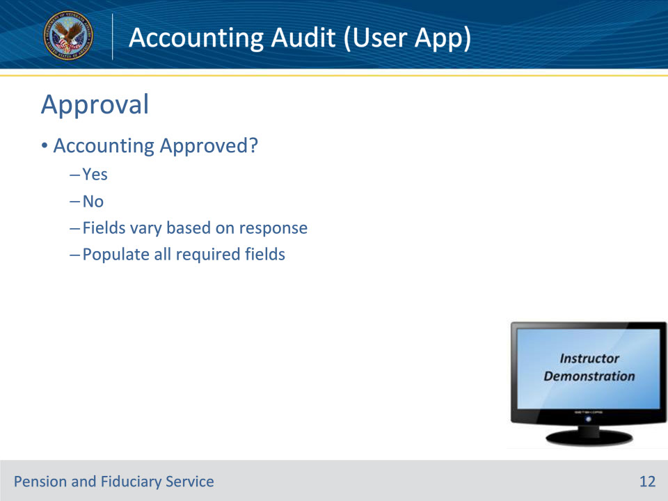
Slide notes

Policy Reference(s): VBMS User Guide

Instructor Notes:

The Audit Approval section is where the LIE must decide whether to approve or disapprove the accounting. Different blocks appear based on what the LIE chooses.

• Accounting Approved? (Drop-down menu with Yes or No)

• Yes

• Accounting Diary

• Approval Date

• Next Accounting Period Start Date

• Next Accounting Period End Date

• Fiduciary Oversight Type (drop-down menu for future required oversight types)

• Accounting Court

• Accounting Federal

• Fund Usage Review

• Accounting Due Reason (drop-down menu justifying the future accounting)

• Estate greater than or equal to $10,000

• Fee Authorized

• Veteran in receipt of 100% s/c rate

• Other

• If other, please explain (free-text box to explain why the future accounting is required)

• No

• Accounting Diary

• Disapproval Date

• Disapproval Reason

Instructor Actions: Open VBMS, share your screen and demo the information just discussed.

Slide 13 - Notes
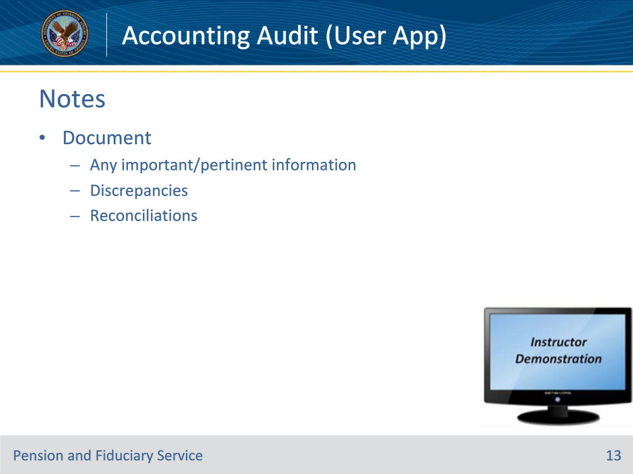
Slide notes

Policy Reference(s): VBMS User Guide

Instructor Notes:

Any discrepancies identified in the accounting, as well as any discrepancies that are reconciled (justified and accepted for that particular audit), must be documented in detail within the Notes section.

Some discrepancies can be reconciled during the accounting audit, but if the fiduciary must do something before the accounting can be approved, it is a contingency that must be corrected prior to approving the accounting.

Instructor Actions: Open VBMS, share your screen and demo the notes section and the information just discussed

Slide 14 - Questions?
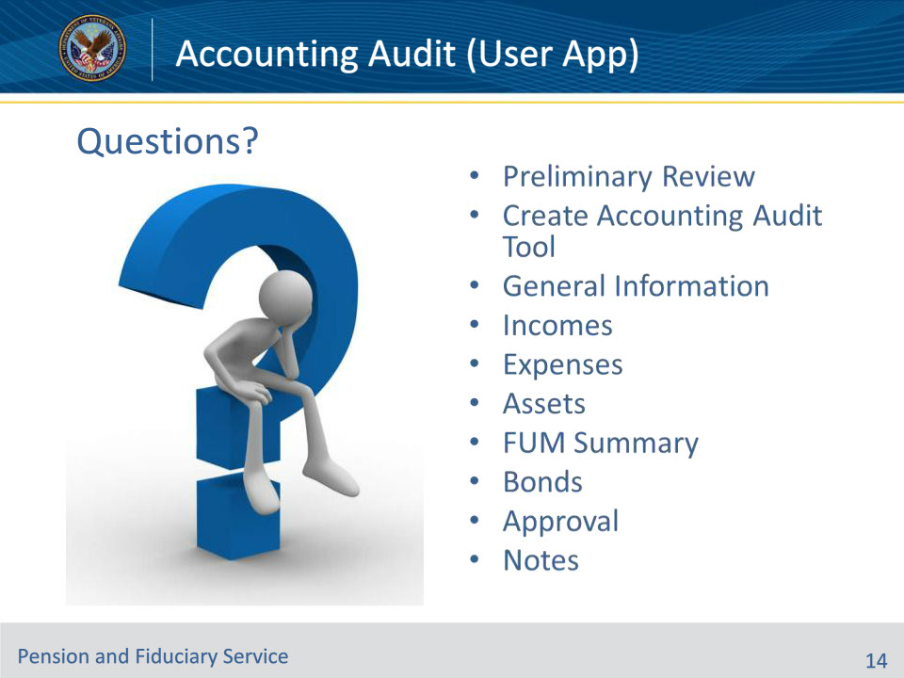
Slide notes

Instructor Notes:

(Recall) These are our learning objectives as stated from the beginning of the training:

• Recall how to recognize whether all required documentation has been submitted

• Learn how to properly create an Accounting Audit Tool (AAT)

• Demonstrate how to document required elements of an Accounting Audit Tool

(Recap) We discussed each of these learning objectives through the following topics in each slide today:

• Preliminary Review

• Create Accounting Audit Tool

• General Information

• Incomes

• Expenses

• Assets

• FUM Summary

• Bonds

• Approval

• Notes

Are there any additional questions?

Slide 15 - TMS Survey
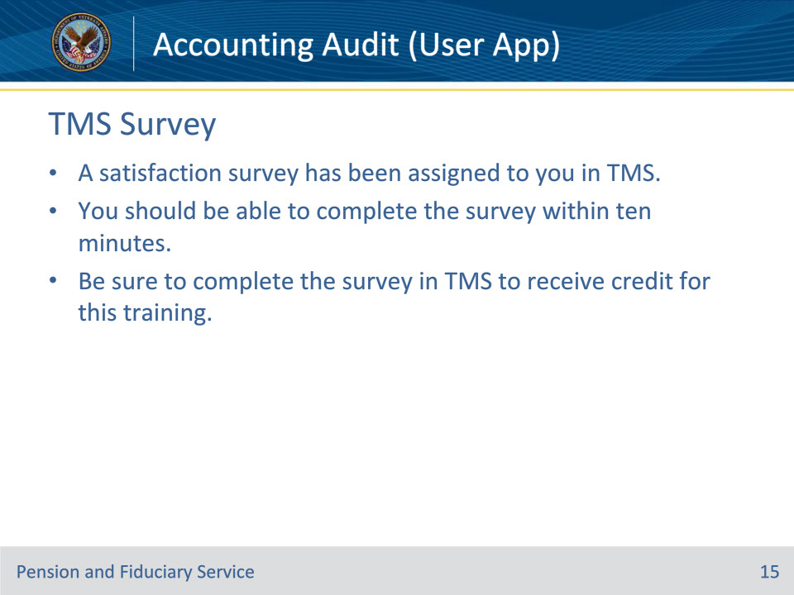
Slide notes

Instructor Notes:

A satisfaction survey has been assigned to you in TMS. You should be able to complete the survey within ten minutes. Completing the survey will allow you to receive credit for this training.

