Slide 1 - Fiduciary Authorization Activities
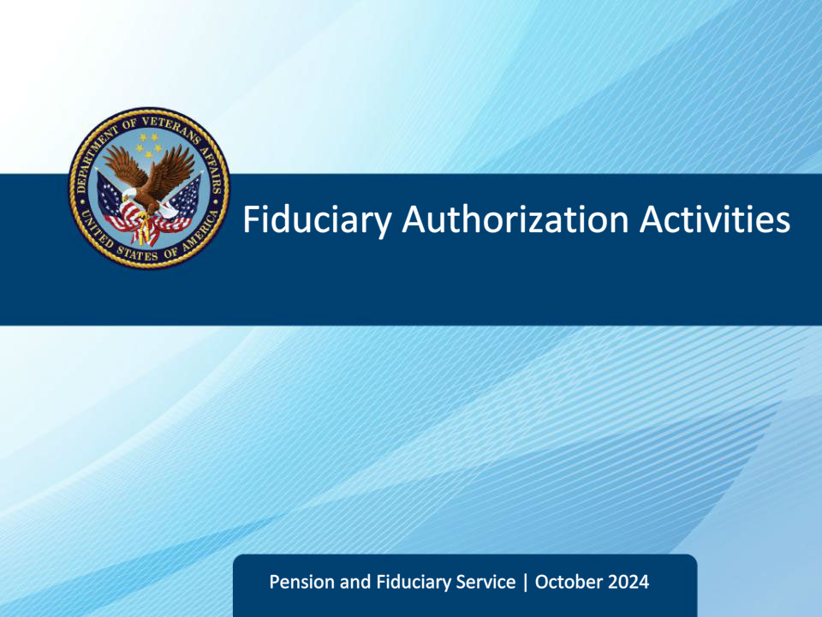
Slide notes

Course Description:

This lesson provides the learner with the purpose and overview of fiduciary promulgation teams, activities, and responsibilities.

Slide 2 - Objectives
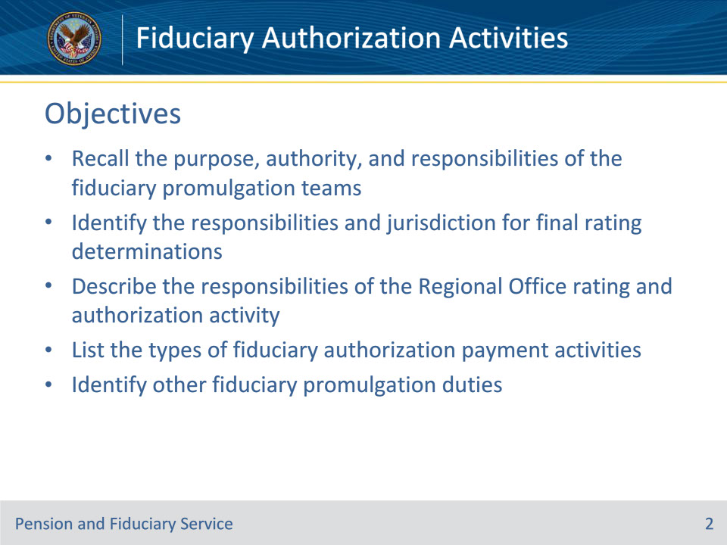
Slide notes

Instructor Notes:

At the end of this lesson, given the training and various references, learners will be able to:

• Recall the purpose, authority, and responsibilities of the fiduciary promulgation teams

• Identify the responsibilities and jurisdiction for final rating determinations

• Describe the responsibilities of the Regional Office rating and authorization activity

• List the types of fiduciary authorization payment activities

• Identify other fiduciary promulgation duties

Slide 3 - References
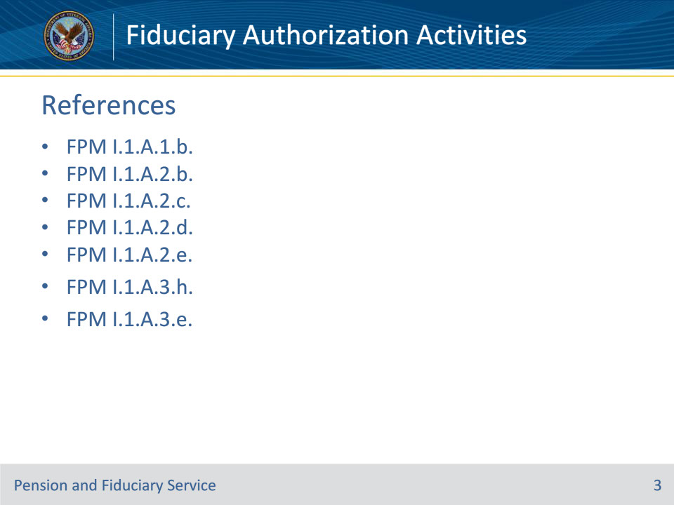
Slide notes

Instructor Notes:

These are the references relevant to today’s training:

• FPM I.1.A.1.b.

• FPM I.1.A.2.b.

• FPM I.1.A.2.c.

• FPM I.1.A.2.d.

• FPM I.1.A.2.e.

• FPM I.1.A.3.h.

• FPM I.1.A.3.e.

Slide 4 - Fiduciary Promulgation Teams
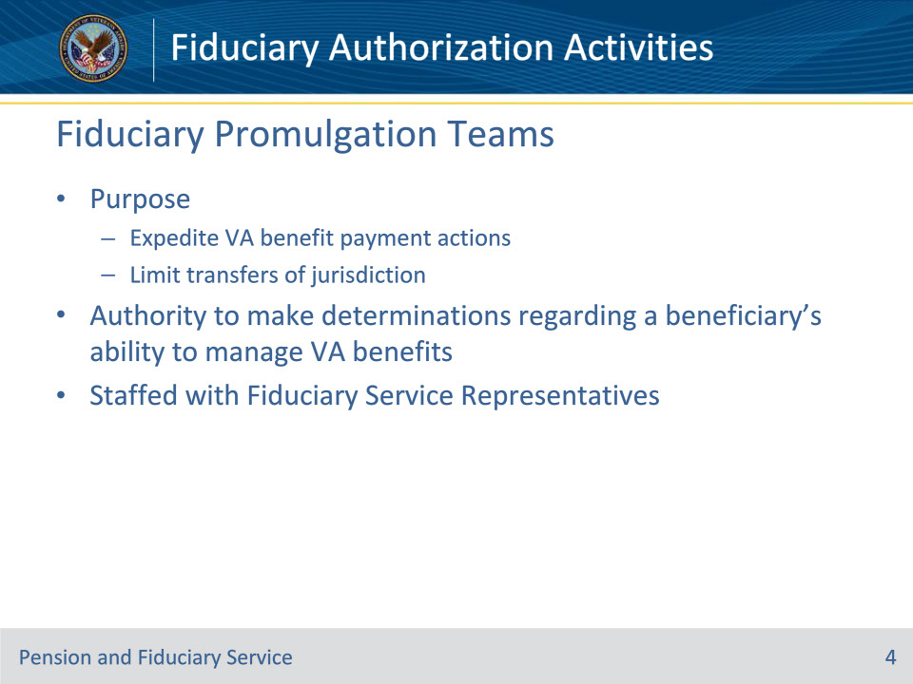
Slide notes

Policy Reference(s): FPM I.1.A.1.b.; I.1.A.3.e.

Instructor Notes:

The purpose of fiduciary promulgation teams is to expedite VA benefit payment actions to beneficiaries by limiting the transfers of jurisdiction between the regional office and the fiduciary hub when VA has evidence that a beneficiary is unable to manage their VA benefits.

38 CFR 3.353 authorizes VA, in part, to make determinations regarding a beneficiary’s ability to manage VA benefits after receipt and review of medical evidence that is clear, convincing, and leaves no doubt as to the beneficiary’s ability.

The Fiduciary Promulgation team is staffed mainly with Fiduciary Service Representatives – FSRs.

Slide 5 - Promulgation Responsibilities
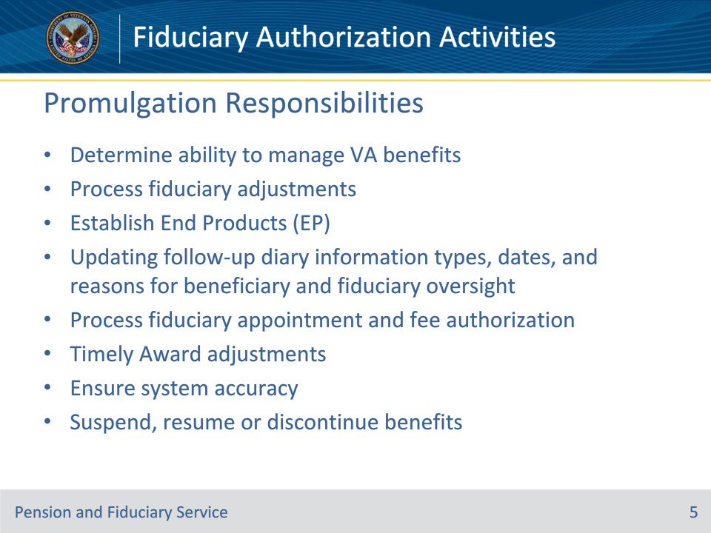
Slide notes

Policy Reference(s): FPM I.1.A.1.b.

Instructor Notes:

Fiduciary promulgation activity is responsible for completing all final determinations that a beneficiary cannot manage their VA benefits for which the due process period expired on or after August 1, 2014, unless an exception applies.

Fiduciary promulgation activity is also responsible for

• processing fiduciary adjustments for all cases requiring a fiduciary appointment

• ensuring the appropriate end product (EP) is established

• updating the follow-up diary information types, dates, and reasons for beneficiary and fiduciary oversight

• processing the appointment of the fiduciary and fee authorization

• completing all award adjustments that are ready for decision at the time the field examination work item is being completed

• ensuring the accuracy of system information, and

• ensuring fiduciary adjustments are completed within the established timeframe.

Fiduciary promulgation activity has authority to suspend, resume, or discontinue benefit payments when action is identified because of a finding by the hub of jurisdiction.

Slide 6 - Definitions
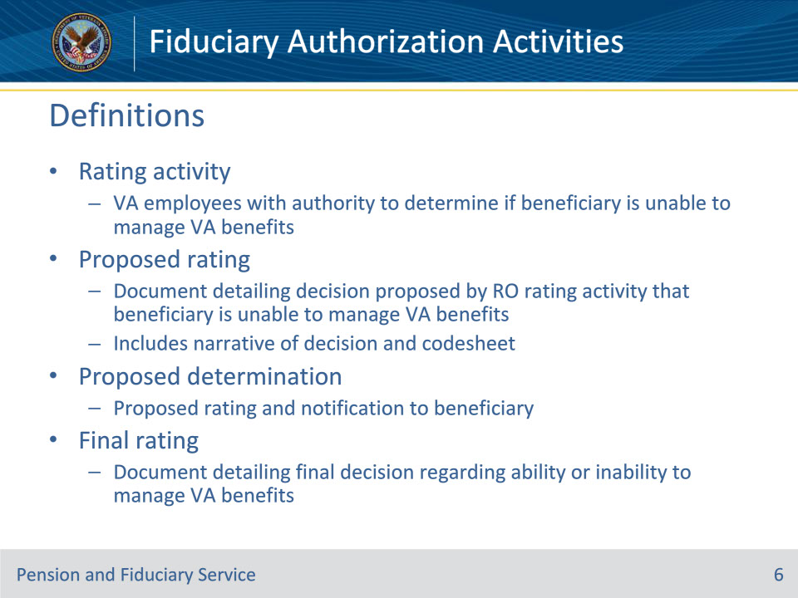
Slide notes

Policy Reference(s): FPM I.1.A.3.e.

Instructor Notes:

• Rating activity refers to the VA employees who have authority under 38 CFR 3.353 to determine whether a beneficiary is unable to manage VA benefits.

• Proposed rating refers to the document detailing the decision proposed by the RO rating activity that the beneficiary is unable to manage VA benefits and includes the narrative of the decision and the codesheet.

• Proposed determination refers to the proposed rating and the notification to the beneficiary regarding the decision proposed by the RO rating activity that the beneficiary is unable to manage VA benefits.

• Final rating refers to the document detailing the final decision regarding the ability or inability to manage VA benefits.

Slide 7 - Regional Office Authority
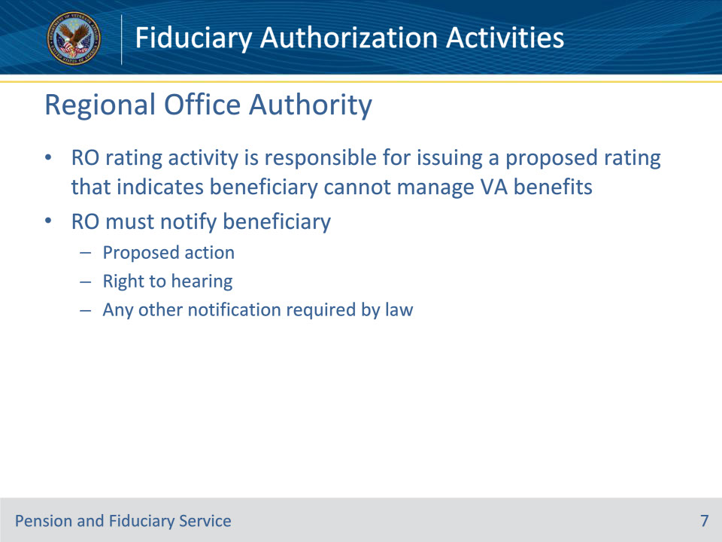
Slide notes

Policy Reference(s): FPM I.1.A.3.e.

Instructor Notes:

The RO rating activity is responsible for issuing a proposed rating and proposed determination that indicates the beneficiary cannot manage VA benefits. At the time of the proposed determination, the RO must notify the beneficiary of the proposed action, the right to a hearing as provided in 38 CFR 3.103, and any other notification required by law.

Slide 8 - Fiduciary Hub Authority
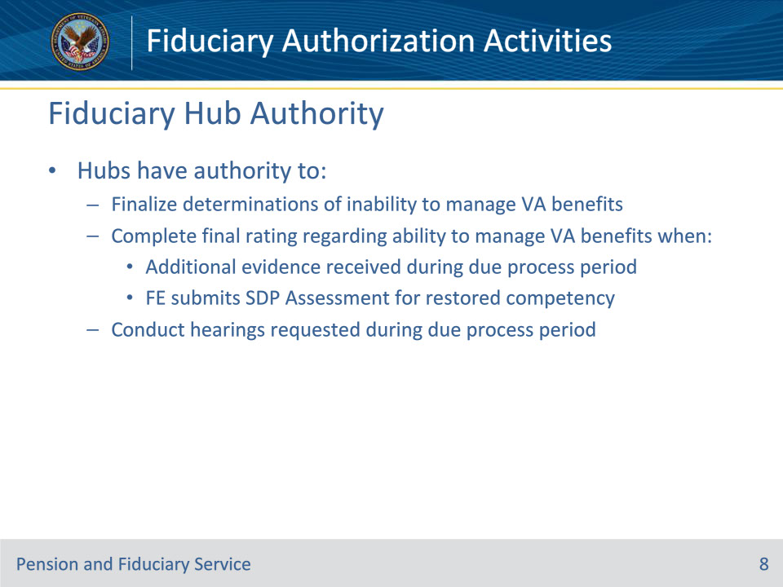
Slide notes

Policy Reference(s): FPM I.1.A.3.e.

Instructor Notes:

Hubs have the authority to finalize determinations of inability to manage VA benefits. Additionally, hubs have expanded the authority for FSRs, who received qualified training, to

• complete a final rating regarding a beneficiary’s ability to manage VA benefits when

• additional evidence is received during the due process period (unless one of the exceptions in FPM, Part I, 1.A.2.b applies), or

• the FE submits a Supervised Direct Pay Assessment for restored competency, and

• conduct hearings that are requested during the due process period.

Slide 9 - Jurisdiction
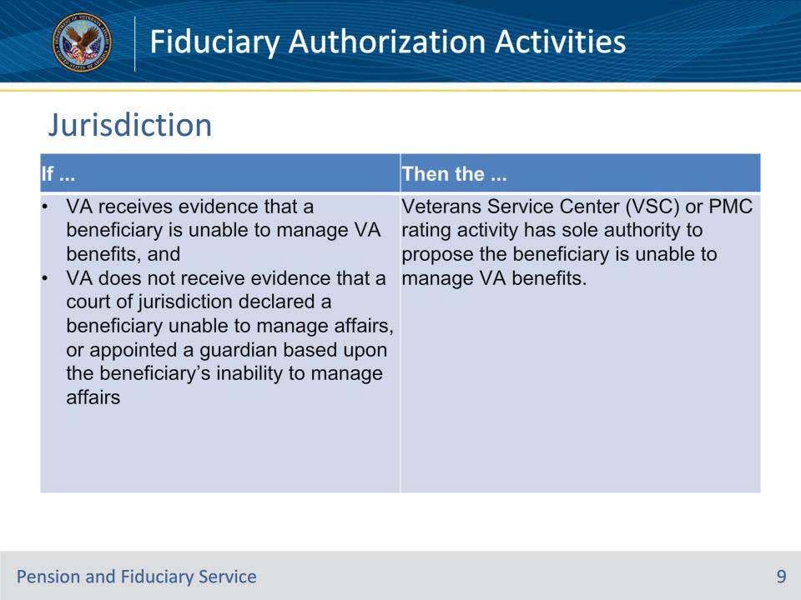
Slide notes

Policy Reference(s): FPM I.1.A.2.c.

Instructor Notes:

Use this table to identify the jurisdiction of the determination of a beneficiary’s inability to manage VA benefits based on the evidence of record and actions completed.

Note: When the hub receives evidence that a child beneficiary is permanently incapable of self-support and may be incompetent, process the information as described in M21-1, Part X, Subpart ii, 6.D.2.h.

Slide 10 - Jurisdiction
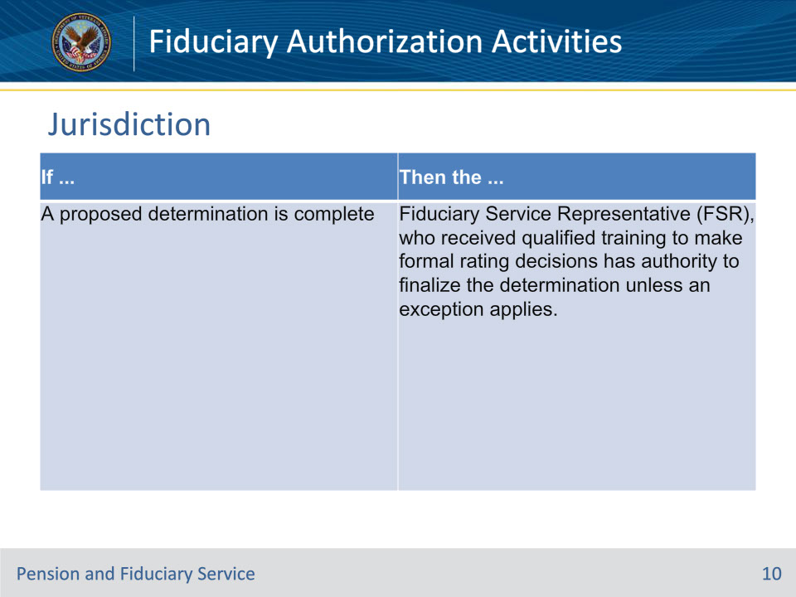
Slide notes

Policy Reference(s): FPM I.1.A.2.c.

Instructor Notes:

Use this table to identify the jurisdiction of the determination of a beneficiary’s inability to manage VA benefits based on the evidence of record and actions completed.

Slide 11 - Jurisdiction
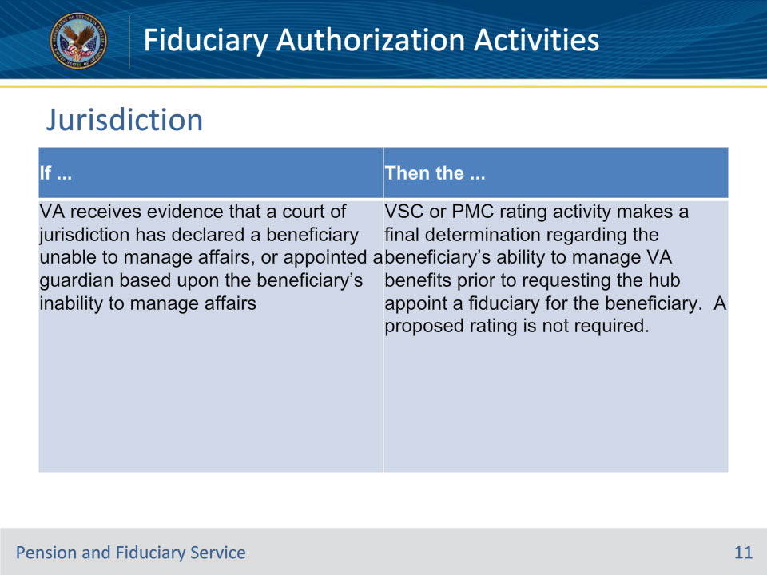
Slide notes

Policy Reference(s): FPM I.1.A.2.c.

Instructor Notes:

Use this table to identify the jurisdiction of the determination of a beneficiary’s inability to manage VA benefits based on the evidence of record and actions completed.

Slide 12 - Jurisdiction
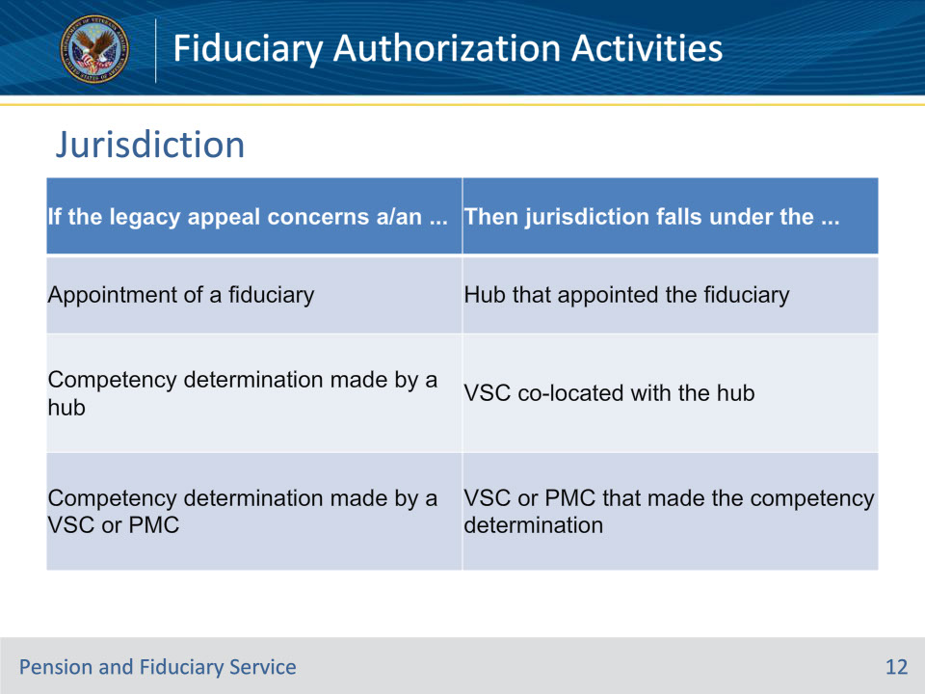
Slide notes

Policy Reference(s): FPM I.1.A.2.d.

Instructor Notes:

Use this table to determine the jurisdiction of legacy appeals of final determinations.

Slide 13 - Jurisdiction
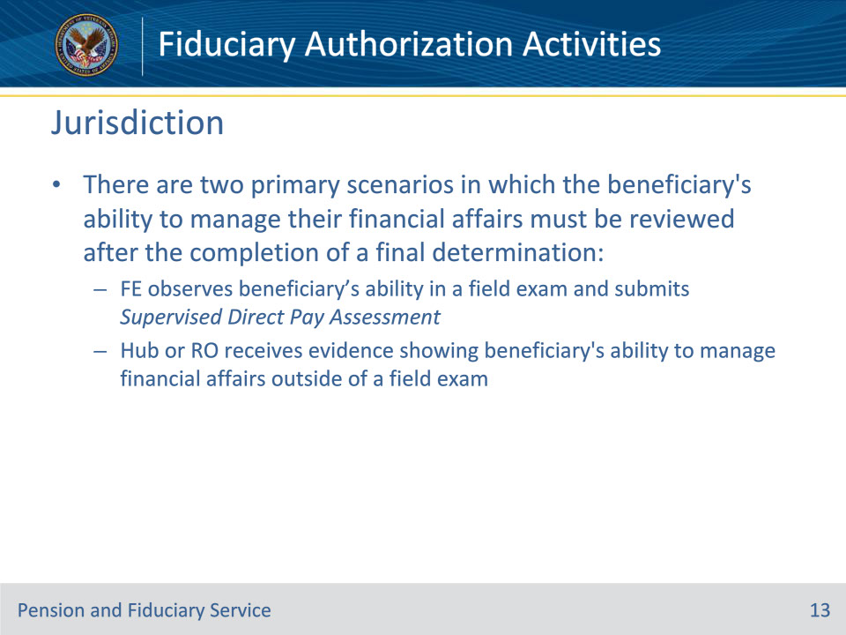
Slide notes

Policy Reference(s): FPM I.1.A.2.e.

Instructor Notes:

There are two primary scenarios in which the beneficiary’s ability to manage their financial affairs must be reviewed after the completion of a final determination:

• an FE observes the beneficiary’s ability in a field examination and submits a Supervised Direct Pay Assessment, or

• the hub or RO receives evidence showing the beneficiary’s ability to manage financial affairs, and the evidence was received outside of a field examination.

Slide 14 - Jurisdiction
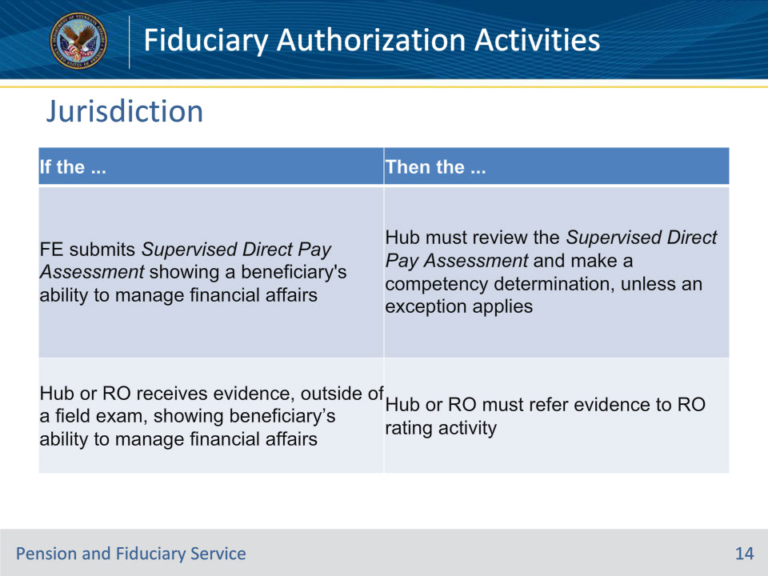
Slide notes

Policy Reference(s): FPM I.1.A.2.e.

Instructor Notes:

Use this table to determine the appropriate jurisdiction and actions to take upon receipt of additional evidence of a beneficiary’s ability to manage financial affairs received after a final determination.

Slide 15 - Exceptions
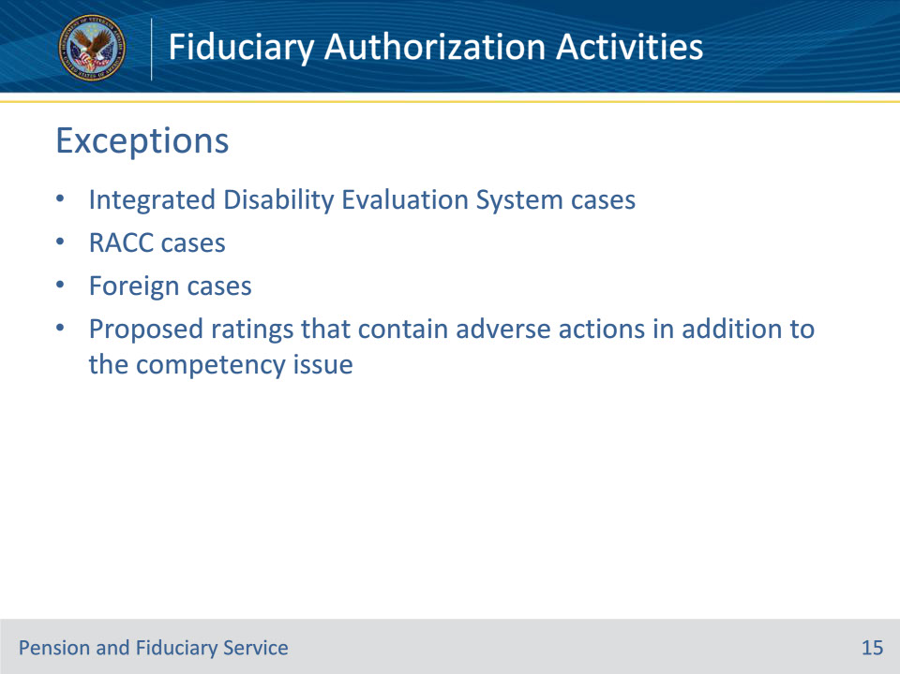
Slide notes

Policy Reference(s): FPM I.1.A.2.b.

Instructor Notes:

The following cases are excluded from the fiduciary promulgation team processing due to their unique processing requirements:

• Integrated Disability Evaluation System cases

• RACC cases

• foreign cases, and

• proposed ratings that contain adverse actions in addition to the competency issue.

Slide 16 - Suspend, Resume, Discontinue
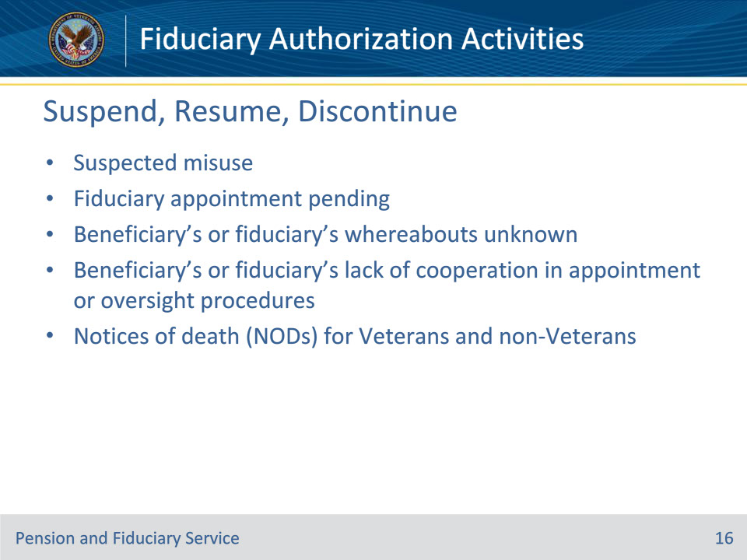
Slide notes

Policy Reference(s): FPM I.1.A.1.b.

Instructor Notes:

Fiduciary promulgation activity has authority to suspend, resume, or discontinue benefit payments when action is identified because of a finding by the hub of jurisdiction. Fiduciary promulgation activity will take applicable payment actions in situations involving

• suspected misuse

• fiduciary appointment pending

• beneficiary’s or fiduciary’s whereabouts unknown

• beneficiary’s or fiduciary’s lack of cooperation in appointment or oversight procedures, or

• notices of death (NODs) for Veterans and non-Veterans.

Slide 17 - Surety Bonds
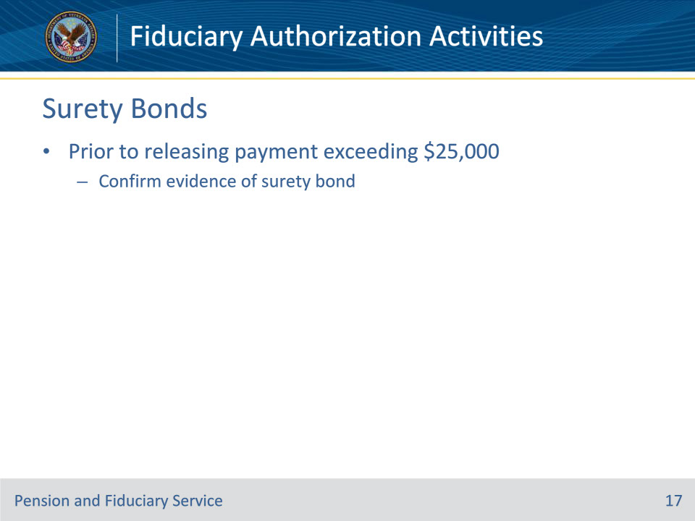
Slide notes

Policy Reference(s): FPM I.1.A.3.h.

Instructor Notes:

38 CFR 13.230(b) requires that prior to the release of any retroactive, one-time, or other pending lump sum VA benefit payment exceeding $25,000, the hub must confirm that VA has evidence of a surety bond payable to the Secretary of VA or the court of jurisdiction if a court ordered surety bond already exists.

Per 38 CFR 13.230(c), a surety bond is not required when the withheld retroactive payment exceeds $25,000 and the fiduciary meets one of the exceptions outlined in FPM, Part II, 2.B.1.d.

Slide 18 - Questions?
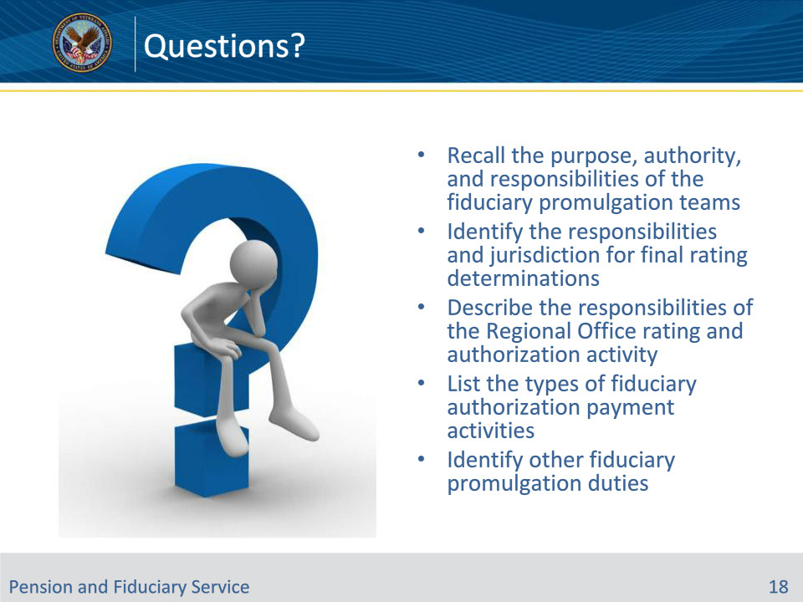
Slide notes

Instructor Notes:

(Recall) These are the learning objectives as stated from the beginning of the training:

• Recall the purpose, authority, and responsibilities of the fiduciary promulgation teams

• Identify the responsibilities and jurisdiction for final rating determinations

• Describe the responsibilities of the Regional Office rating and authorization activity

• List the types of fiduciary authorization payment activities

• Identify other fiduciary promulgation duties

Are there any additional questions?

Questions should be filtered through your QRT team. They will submit your questions to the Field Inquiry Tool (FIT) on your behalf.

Slide 19 - TMS Survey/Assessment
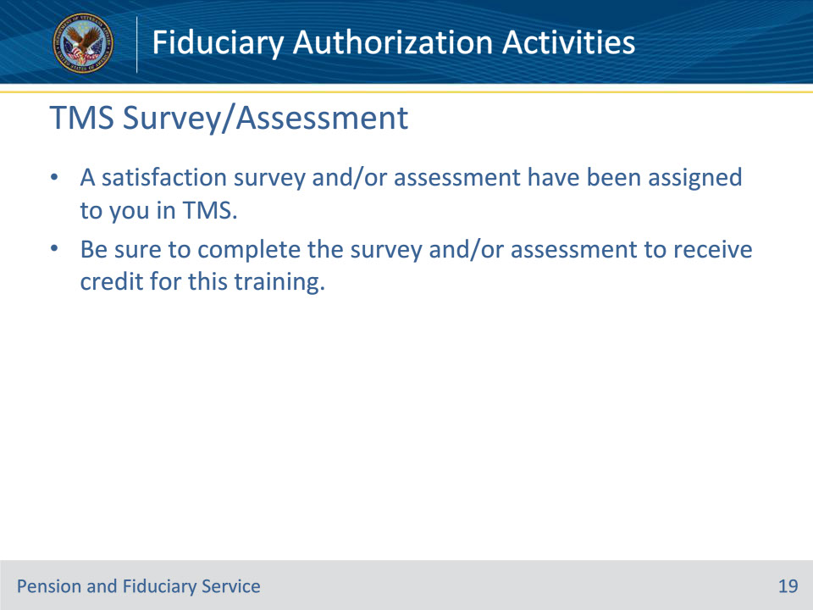
Slide notes

Instructor Notes

A satisfaction survey and/or assessment have been assigned to you in TMS.

Be sure to complete the survey and/or assessment to receive credit for this training.

