Slide 1 - Overview of Veterans Benefits Management System (VBMS)
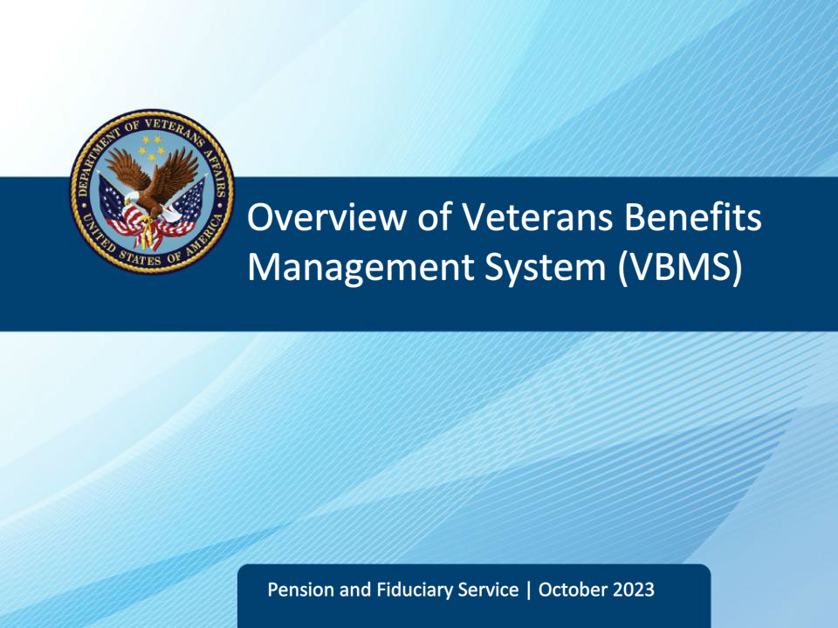
Slide notes

Instructor Notes:

The purpose of this lesson is to provide fiduciary program personnel with the steps necessary to access and navigate the Veterans Benefits Management System (VBMS), search for a beneficiary, and manage documents in the VBMS eFolder.

Slide 2 - Objectives
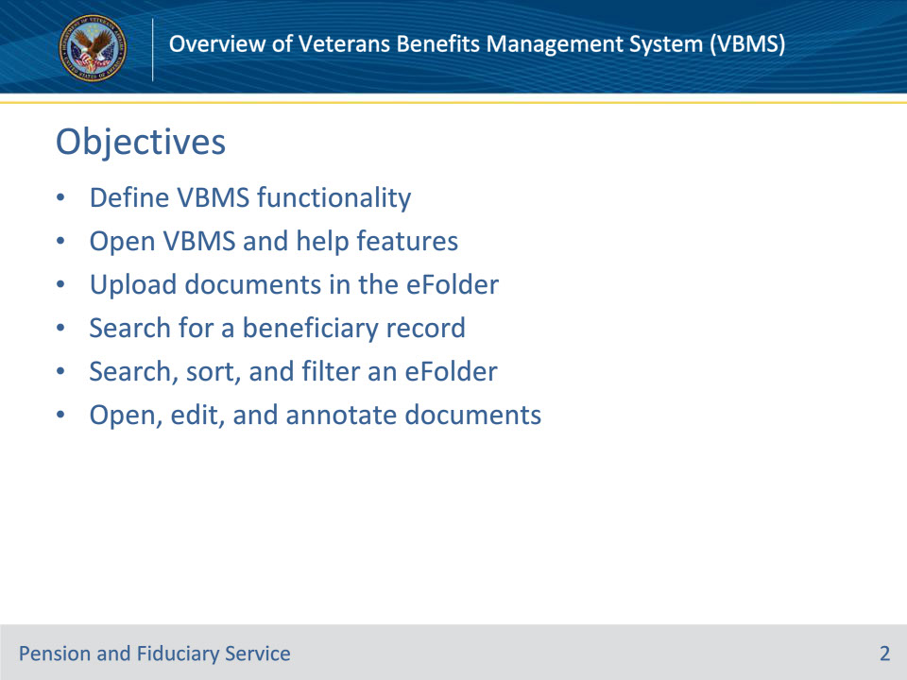
Slide notes

Instructor Notes:

By the end of this lesson, given the training and the corresponding references, the learner will be able to do the following:

• Define Veterans Benefits Management System (VBMS) functionality

• Open VBMS and help features

• Upload documents in the eFolder

• Search for a beneficiary record

• Search, sort and filter an eFolder

• Open, edit, and annotate documents in the eFolder

Slide 3 - References
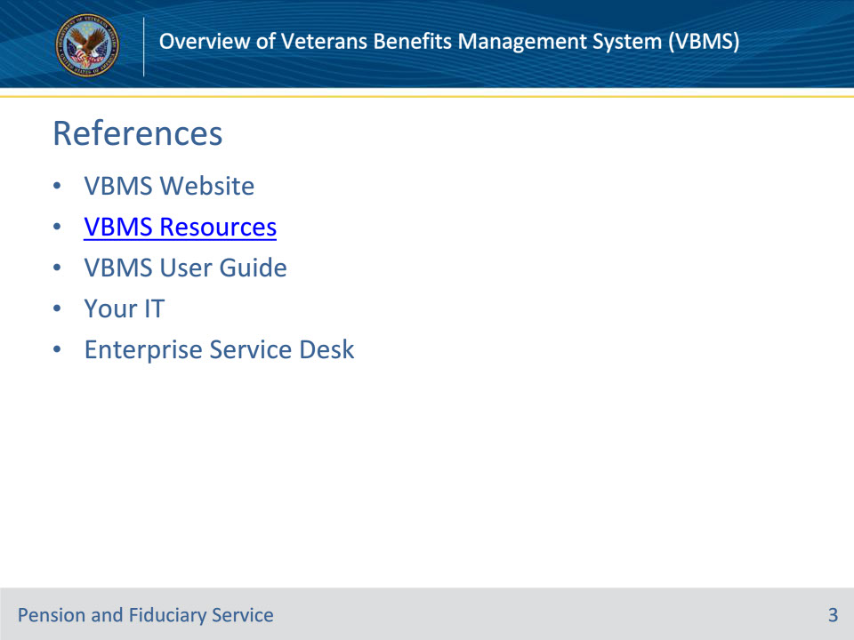
Slide notes

Instructor Notes:

The following are relevant references to working in Veterans Benefits Management System (VBMS):

• VBMS website

• The website can be accessed from VBAPPS or directly from the website itself

• VBMS Resources page

• You may use the VBMS Resources page as a reference to answer questions regarding the use of the application. This website contains Fact Sheets, FAQs, Job Aids, Toolkits, Job Instruction Sheets and more.

• VBMS User Guide

• The User Guide contains how-to as well as version update information.

• yourIT

• Application on your desktop that allows you to enter an IT help ticket

• Enterprise Service Desk

• IT help ticket phone line

Slide 4 - VBMS Functionality
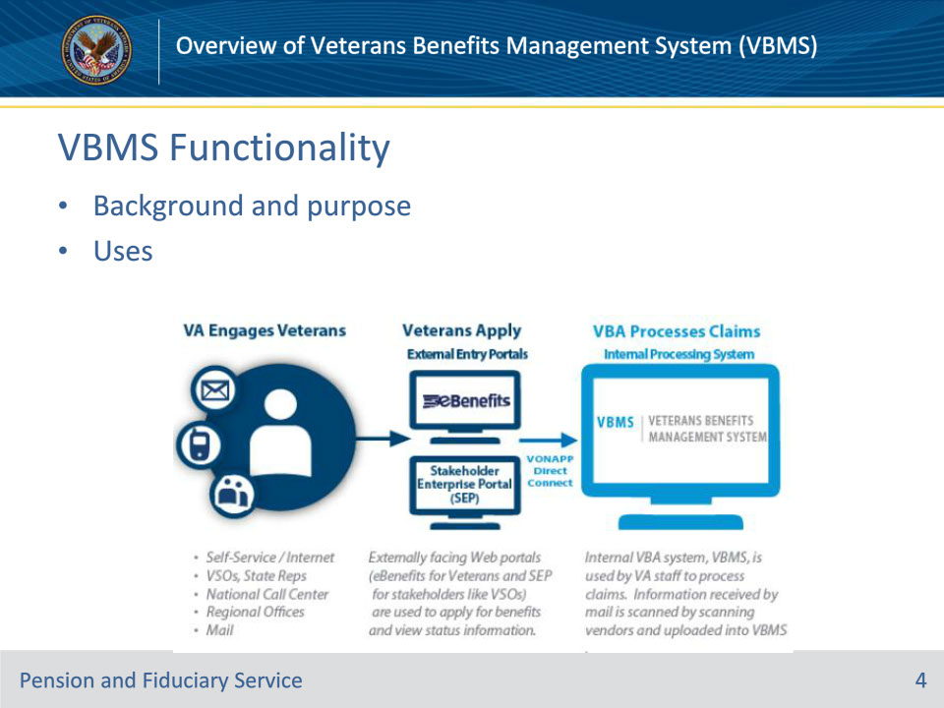
Slide notes

Learning Objective: Define VBMS functionality

Policy Reference(s): N/A

FPG Articles: N/A

Instructor Notes:

Background and Purpose

Veterans Benefits Management System (VBMS), was one of several major transformation efforts designed to enable 21st century, customer-centric benefits delivery to Veterans and beneficiaries. It was designed to transition the Veterans Benefits Administration from a paper-intensive claims process to an electronic environment. The Generation 1 rollouts were released in January 2013.

VBMS is a web-based, electronic claims processing solution that was developed to reduce a claims backlog by providing the ability to establish claims, view and store electronic documents in an electronic folder (eFolder), track evidence requested from beneficiaries, complete rating decisions, promulgate award decisions, provided end-users with web-accessible rules-based tools and calculators, and more. This ensures consistency in rating decisions and improves the overall quality and timeliness of rating decisions.

Uses

In short, VBMS is used to manage claims and beneficiary documents, rate claims and process awards. VBMS provides the technology capabilities needed to process a claim from start to finish and serve as the internal system that complements Veteran-facing application such as eBenefits and the Stakeholder Enterprise Portal (SEP).

Slide 5 - Open VBMS
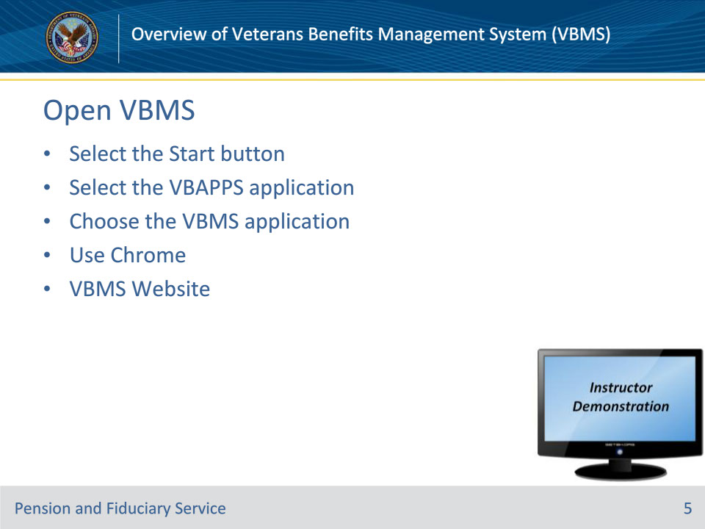
Slide notes

Learning Objective: Open VBMS, cache, and help features

Policy Reference(s): N/A

FPG Articles: N/A

Instructor Notes:

You must be granted access to Veterans Benefits Management System (VBMS), so discuss with your supervisor if you do not have access.

Personal Identity Verification (PIV) Login

Most users will use their PIV card to login to all Veteran Benefit Administration systems. Use of a PIV card to login to VBMS only requires the user to enter their station number and PIV card PIN number.

PIV Exemption Login

You may need to obtain a PIV exemption at some point. If that is the case, you will need to manually enter your user password to login to VBMS. If you forget your password, use the yourIT application on your desktop or contact the Enterprise Service Desk to establish a help ticket.

If you don’t log into VBMS for an extended period of time, your access will be denied and you must request access again by contacting your supervisor.

VBAPPS

Begin the VBMS application by going to the Start button in the bottom left corner of the Windows taskbar. 1. Select the Start button2. Select the VBAPPS application3. Choose the VBMS application

4. The VA Single Sign-On screen will be present.

• PIV Login: Select the “Sign In with VA PIV Card” button and enter your PIN when prompted. Enter Station ID and press the login button. This will take you to the VBMS home screen.

5. After logging in, you will arrive at the VBMS main search screen.

6. If no actions are performed, the system will eventually time out and you will be logged out.

Important

Make sure you are using Chrome as your browser for VBMS. It reduces the number of technical issues that can occur.

Website

You can also bookmark the VBMS website in your browser and return to it that way or create a shortcut on your desktop or start menu.

Demonstration

Minimize PowerPoint and demonstrate how to

• login to VBMS by using VBAPPS

• Demonstrate how to bookmark the website in Chrome and create shortcuts to it

Slide 6 - Help Features
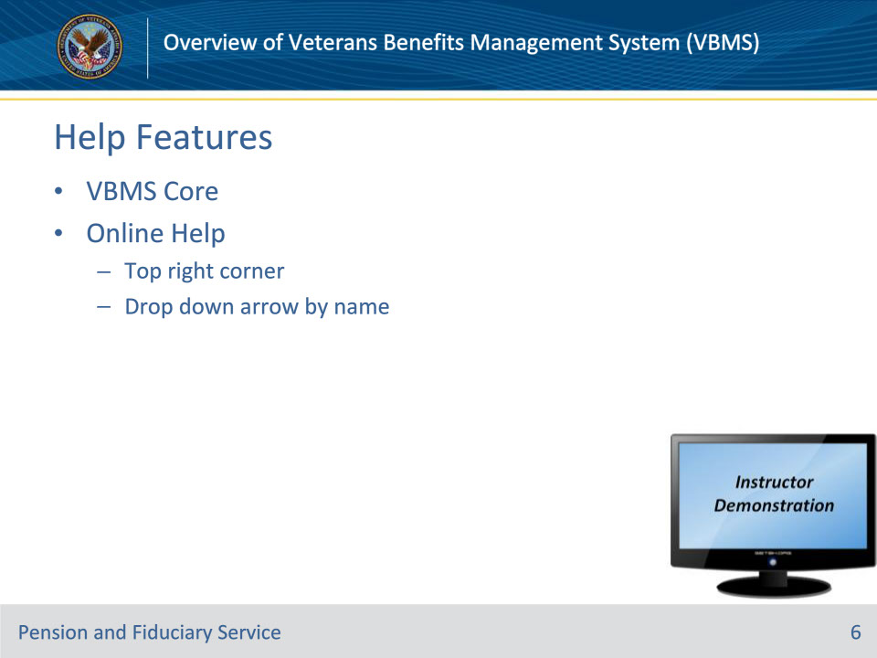
Slide notes

Learning Objective: Open VBMS, cache, and help features

Policy Reference(s): N/A

FPG Articles: N/A

Instructor Notes:

Announcement Banner

Upon signing into Veterans Benefits Management System (VBMS), you enter VBMS Core.

Help

The Online Help feature is accessed by clicking on the drop-down arrow next to your name in the top right corner of the screen. From there, select the Help option. The VBMS Online Help System screen displays in a new screen. Select the appropriate links on the Help screen to open the desired topic.

You can access the online help system anytime. When a you are unsure how to perform an operation in VBMS, you should always consult Online Help first before calling a local VBMS superuser or establishing a help ticket through yourIT or the Enterprise Service Desk .

Demonstration

Minimize PowerPoint and demonstrate :

• The main screen upon logging in to VBMS,

• how to use the Online Help feature.

Slide 7 - Upload Documents
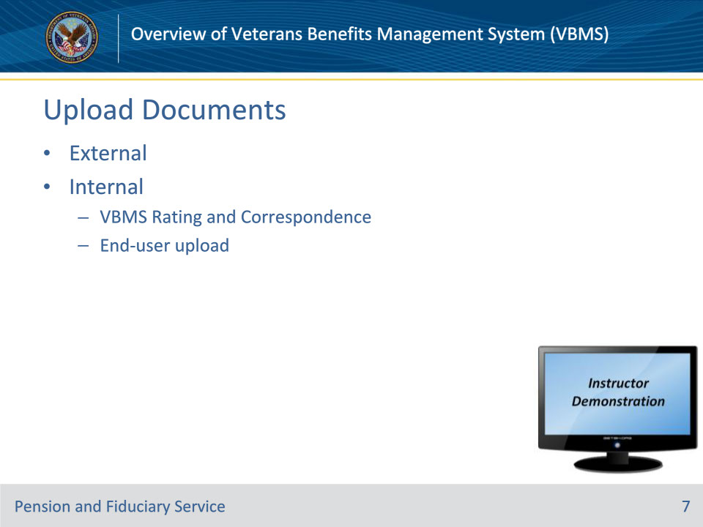
Slide notes

Learning Objective: Upload documents in the VBMS eFolder

Policy Reference(s): N/A

FPG Articles: N/A

Instructor Notes:

External Sources

Documents are uploaded in the Veterans Benefits Management System (VBMS) eFolder from multiple external sources:

• National Archives and Records Administration (NARA) - Locates and scans Official Military Personnel Files (OMPFs) and service treatment records (STRs) housed in their facilities.

• Records Management Center (RMC) - Scans any STRs for live VBMS claims.

• Contract Scanning Vendors - Regional Offices (ROs) and the RMC ship claim materials to the vendors who scan documents and upload images into the VBMS eFolder.

• Stakeholder Enterprise Portal (SEP) - The SEP is a single, secure entry portal that provides VA partner organizations and external stakeholders the ability to submit documents in support of a Veteran’s claim.

Internal Sources

Documents are also uploaded in the eFolder internally as follows:

• VBMS Rating & Correspondence Engines - Rating Decisions and development and notification letters generated in VBMS are automatically uploaded into the Veteran’s eFolder.

• End-User Uploads - VBMS system functionality allows users with the proper credentials to upload documents directly into the VBMS eFolder. Users can upload documents by choosing “Upload Document” from the Actions drop-down menu within a beneficiary record.

Demonstration

Minimize PowerPoint and show users how to navigate to the Actions drop-down menu within a beneficiary record and select ‘Upload Documents’

Slide 8 - Search Options
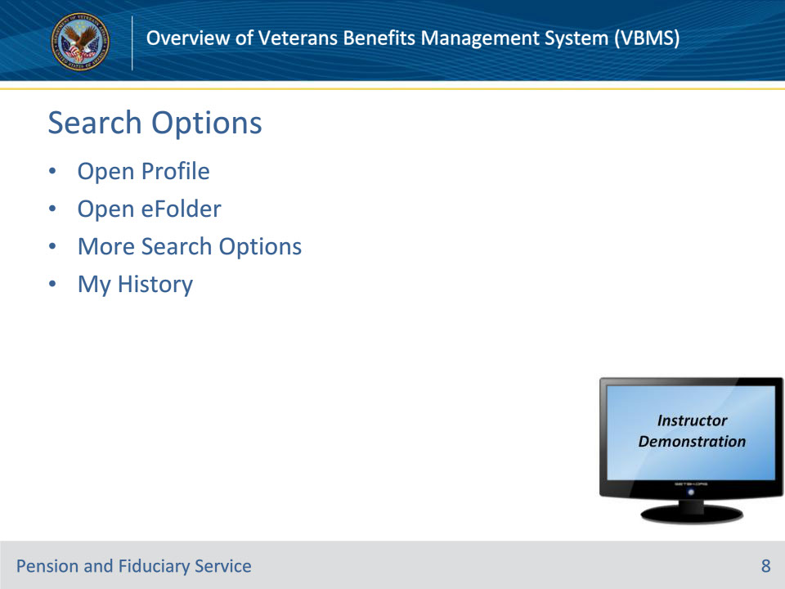
Slide notes

Learning Objective: Search for a beneficiary record

Policy Reference(s): N/A

FPG Articles: N/A

Instructor Notes:

Now that you know how new documents are uploaded to Veterans Benefits Management System (VBMS), let’s discuss how to find a Veteran or beneficiary record to view documents specific to that record. You can search for records by doing a Profile search, eFolder search, utilizing more search options, and by easily navigating to records in your recent search history.

Profile search

• Select the search drop down, enter your file number or SSN and select Open Profile

eFolder search

• Allows a user to navigate directly to a specific beneficiary’s eFolder to view documents. Select the search dropdown, enter the VA File number or Social Security number associated with the record you want to find and select Open eFolder.

More search options:

• Allows you to perform five different types of searches – Global, Veteran, Person, Claim and Document.

• The most efficient way to search for a particular beneficiary is to input their VA file or Social Security number, if available. If a user searches by a common name, the search results may generate multiple beneficiaries.

• Valid search criteria are required. Acceptable criteria include:

• VA file numbers,

• first and last name separated by a space,

• last name then first separated by a comma,

• Social Security numbers in the form of xxx-xx-xxxx or xxxxxxxxx

• Note: Utilizing a Social Security number is the most efficient way to search for a specific record.

My History

• Users can also view a history of searches for current and previous login sessions. Utilizing this feature allows the user to see previous searches made within VBMS.

• To review My History:

1. Select “My History” at the top-right hand corner of the screen next to the user’s name, or

2. Select the magnifying glass icon to the left of the search field (without any text or file numbers in the search bar).

Demonstration

Minimize PowerPoint and demonstrate how to search for a record by:

• Opening the Profile

• Opening the eFolder

• Utilizing More Search Options

• Utilizing My History

Slide 9 - Search and Filter Documents
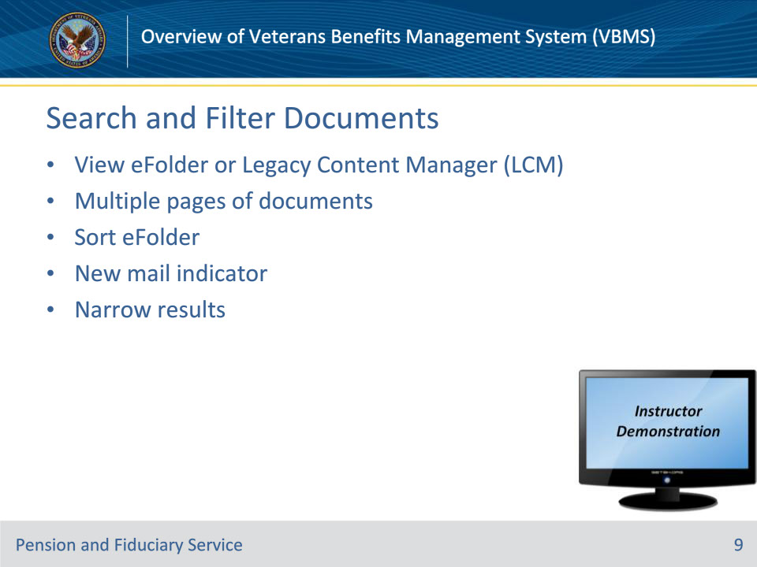
Slide notes

Learning Objective: Search, sort, and filter an eFolder

Policy Reference(s): N/A

FPG Articles: N/A

Instructor Notes:

eFolder or Legacy Content Manager (LCM)

• Once a specific eFolder is opened, you are on the main eFolder / documents screen. There are two types of documents to view:

1. eFolder documents: these are documents stored within Veterans Benefits Management System (VBMS), or

2. Legacy Content Manager (LCM) documents: these are documents stored for the beneficiary within the LCM system. Note: Users will be able to see both restricted and non-restricted documents listed under the Document Type column. If you click a link to a restricted document, a Notification screen appears informing you that this document type is restricted. Restricted documents can only be accessed via the LCM system.

Multiple Pages of Documents

• The documents screen is set, by default, to show 10 items per page. To advance to additional pages, users can click on the navigation at the bottom right-hand of the screen which offers options to skip directly to a page, go to first/previous/next/last, or select the page number (i.e. 1, 2…). Users can also change the preference to show 25, 50, or 100 items per page by selecting the quantity desired from the drop-down menu at the bottom left-hand side of the screen.

Sorting eFolder

• Users can customize their view in several ways by sorting the documents in the eFolder. To do so, select any of the column headers to sort in ascending or descending order. You can also filter multiple columns at once by selecting Shift on your keyboard as you select each column header.

• Customized options can be saved as a preference so the saved view is available at every login. For example:

• Receipt Date: Users can sort the eFolder document receipt date.

• Document Type: A user may wish to view all similar documents at once. To do so, select Document Type column and this will group the document types together by name, such as rating decisions and award documents.

• Show/Hide Columns: Users may utilize the Show/Hide Columns feature to organize the columns they want to view and what columns aren’t necessary to view. Once you select optional columns, these columns appear on the Documents screen.

• To save document preferences select Save Preferences button. These preferences will then appear each time you log into VBMS.

New Mail Indicator

• New documents uploaded into an eFolder that are pending Claim Processor review will display the New Mail Indicator; it alerts you to newly scanned documents in the eFolder. This indicator is an icon of an envelope with a star, indicating that there is a new and unread document.

• If there is a check mark next to it instead of the envelope, this means the document was viewed by the user currently logged in. The new mail indicator is available to RO employees, some external employees, and VSOs.

Filter eFolder (narrow results)

• Users can also narrow document search results within the eFolder by utilizing the Narrow Results options in the left-hand pane of the screen. Common options to narrow the results are by date range, or by keyword. This panel uses dynamic filtering; as you make selections or enter filter data, the Documents screen displays filtered results automatically. As options are selected, the work queue will reorganize to only display work items that match the specified filter criteria.

• If desired, you can save the filter criteria for quick access in the future.

Demonstration

Minimize PowerPoint and go into the documents screen of a specific eFolder and demonstrate how to:

• select the eFolder or LCM,

• change the number of items per page, and

• to sort, filter, and save views.

Slide 10 - Viewing Documents
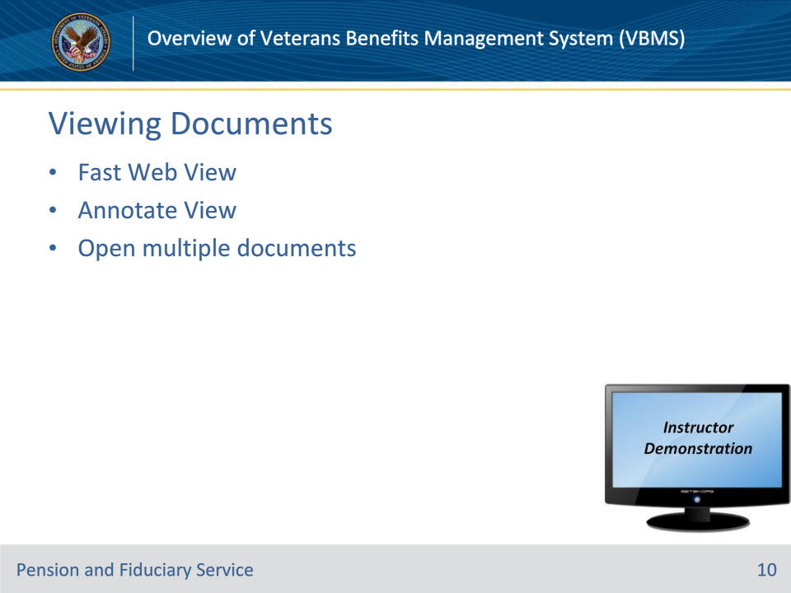
Slide notes

Learning Objective: Open, edit, and annotate documents in the eFolder

Policy Reference(s): N/A

FPG Articles: N/A

Instructor Notes:

Now that we’re familiar with the interface of the eFolder, let’s explore opening and viewing the eFolder’s documents. Users can view documents with either the Fast Web View or the Annotate View.

Fast Web View

• This is the fastest and most efficient way to open a read-only version of a document in the eFolder. Users can open a document by clicking on the hyperlink/name of the document under the Document Type column. Once opened, users can immediately begin to review the document. When the document is open, users can view the document by scrolling down, or select the thumbnail view and see all the pages on the left side panel.

Annotate View

• This view allows the user to open a document with annotations included (to be discussed in a future slide).

• Select the pencil and paper icon next to the document name hyperlink to open the Annotated version.

Open Multiple Documents

• You may open multiple documents at a time by selecting the check boxes in the far-left corner and selecting open read only from the Actions drop-down on the right side of the screen.

Demonstration

Minimize PowerPoint and navigate to a specific eFolder and demonstrate how to:

• open documents in fast web view and

• annotate view

• open multiple documents

Slide 11 - Document Properties
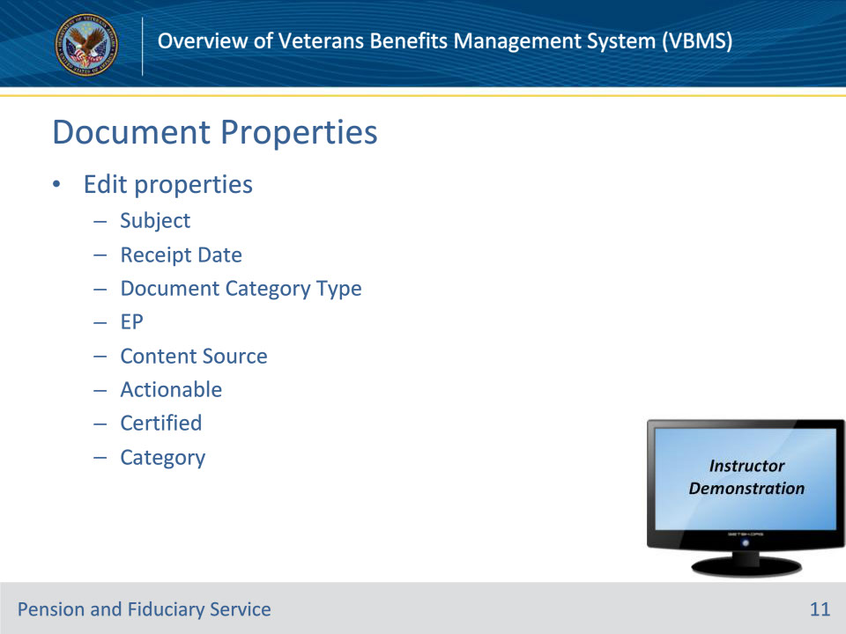
Slide notes

Learning Objective: Open, edit, and annotate documents in the eFolder

Policy Reference(s): N/A

FPG Articles: N/A

Instructor Notes:

Edit Properties

• There may be situations where the document properties that have been loaded into the eFolder are incorrect. For example, the receipt date may be incorrect.

• You may edit the document properties within the document or by navigating through the document properties screen.

Demonstration

Minimize PowerPoint and demonstration how to change document properties by:

1. Opening a document

2. Clicking the Document Properties button. The Editable Properties section appears on the left side of the screen.

3. You can edit document properties for Subject, Receipt Date, Document Category - Type, EP, Content Source, Actionable, Certified, and Category

4. Clicking Save to save your changes to the document properties.

NOTE: If using a live document, be careful to just TELL students to hit save, do not actually change document properties.

Slide 12 - Annotations
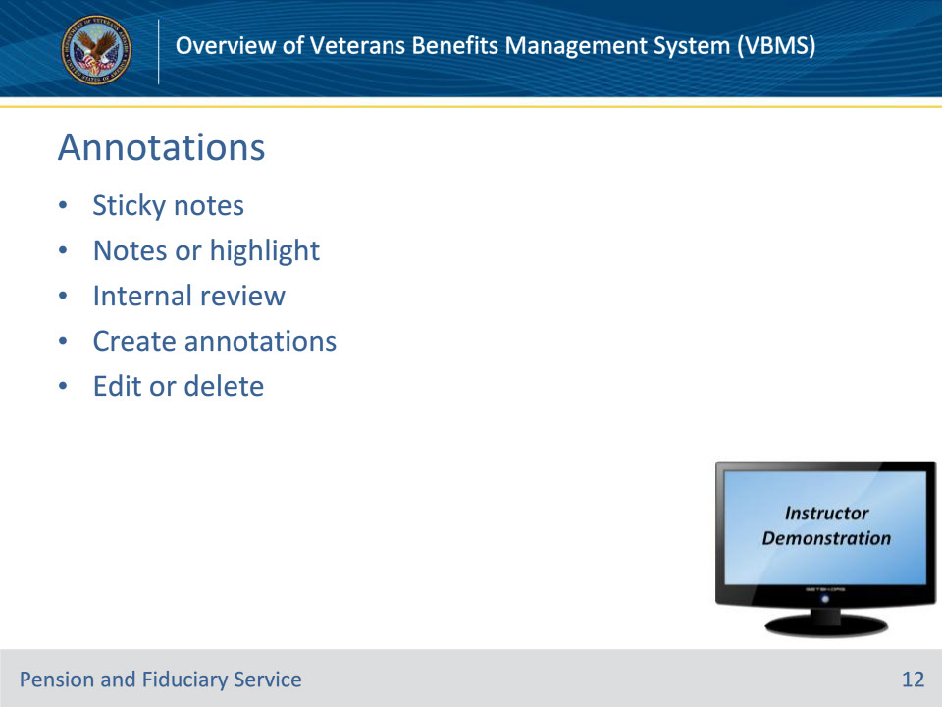
Slide notes

Learning Objective: Open, edit, and annotate documents in the eFolder

Policy Reference(s): N/A

FPG Articles: N/A

Instructor Notes:

Annotations

• Annotations are comparable to post-it or sticky notes used to mark certain documents within the claims folder. Users may use the annotation feature to make notes or highlight specific items on a document. The annotation allows users to leave notes within a document, which can be reviewed internally.

To add an annotation:

1. Open a document in the annotate view

2. Select the area of the document that you wish to annotate

3. Select one of the various options on the left side of the screen to create an annotation

4. When the create annotation prompt box appears, populate the necessary fields

5. Select Save

Annotated documents in the eFolder will display the text “Annotated” next to the document type. To view, edit and delete an annotation:

6. Select the option on the left side of the screen for View Annotation List (3 horizontal lines icon)

7. Select the annotation from the list which you wish to view, edit, or delete

8. To edit the annotation, select the pencil icon on the upper right of the box. To delete the annotation, select the X icon on the upper right of the box.

Demonstration

Minimize the PowerPoint and demonstrate how to:

• Create annotations

• View annotations

Slide 13 - Notes
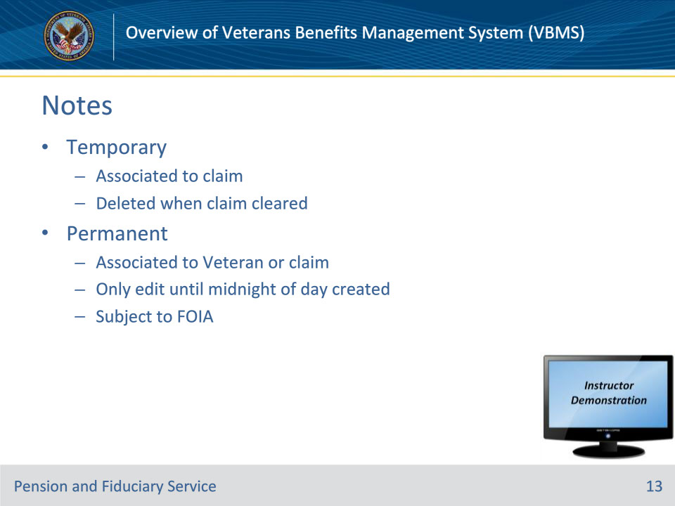
Slide notes

Learning Objective: Open, edit, and annotate documents in the eFolder

Policy Reference(s): N/A

FPG Articles: N/A

Instructor Notes:

Notes

• You may input temporary and permanent notes into Veterans Benefits Management System (VBMS). Notes are helpful to inform others of conditions specific to a case/beneficiary. They can also be used to provide information as directed by VA procedures.

Temporary

• Temporary notes can only be associated to a claim and will be automatically deleted when the claim is closed or completed. Only the user who added the note, the user assigned to the work item, and supervisors can view temporary notes; only the user who added the note or a supervisor can edit or delete it.

Permanent

• Permanent notes can be associated with either a Veteran or a claim. If you create a permanent note, you can edit it until midnight of the day you created it. After that time, permanent notes become part of the Veteran file and are subject to the Freedom of Information Act (FOIA).

• Many actions taken on claims will automatically generate a permanent note.

Demonstration

Minimize PowerPoint and navigate to the add note icon, available from Veteran file menu bar, which provides the option to add either a permanent or temporary note. Click the add note icon. The Add Note dialog opens.

Slide 14 - Questions?
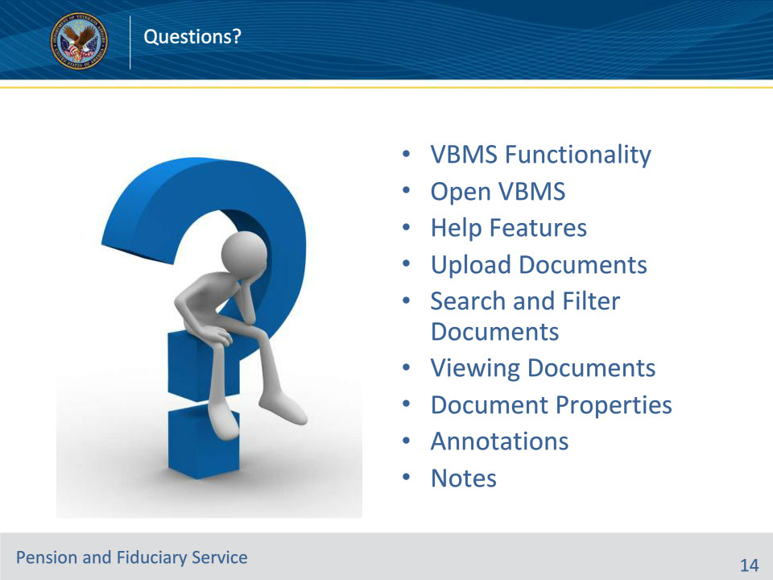
Slide notes

Instructor Notes:

(Recall) These are our learning objectives as stated from the beginning of training:

• Define Veterans Benefits Management System (VBMS) functionality

• Open VBMS, cache, and help features

• Upload documents in the eFolder

• Search for a beneficiary record

• Search, sort and filter an eFolder

• Open, edit, and annotate documents in the eFolder

(Recap) We discussed each of these learning objectives through the following topics in each slide today:

• VBMS Functionality

• Open VBMS

• Help Features

• Upload Documents

• Search and Filter Documents

• Viewing Documents

• Document Properties

• Annotations

• Notes

What questions to you have for me today?

Slide 15 - TMS Satisfaction Survey
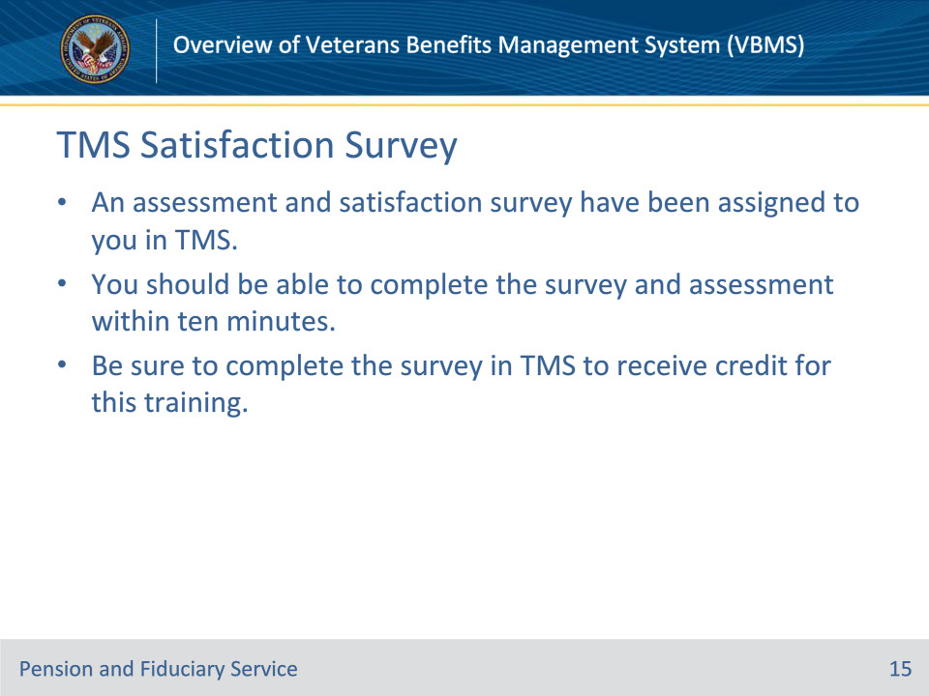
Slide notes

Instructor Notes:

An assessment and satisfaction survey have been assigned to you in TMS. You should be able to complete both within ten minutes. Completing both will allow you to receive credit for this training

