Slide 1 - Overview of Share
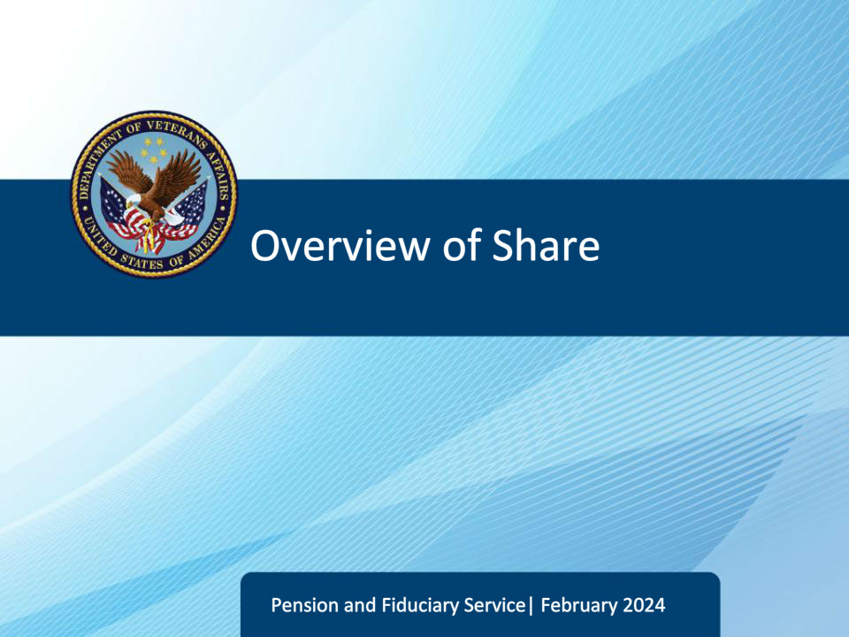
Slide notes

Course Description:

The purpose of this lesson is to provide you with an overview of the Veterans Benefits Administration (VBA) Application, Share.At the conclusion of this lesson, you will be able to access Share to locate and review beneficiary records to accurately complete your job tasks. This is an introductory lesson to Share and additional hands-on practice will occur throughout training. During this lesson you will receive a PowerPoint presentation and live demonstration.

Slide 2 - Objectives
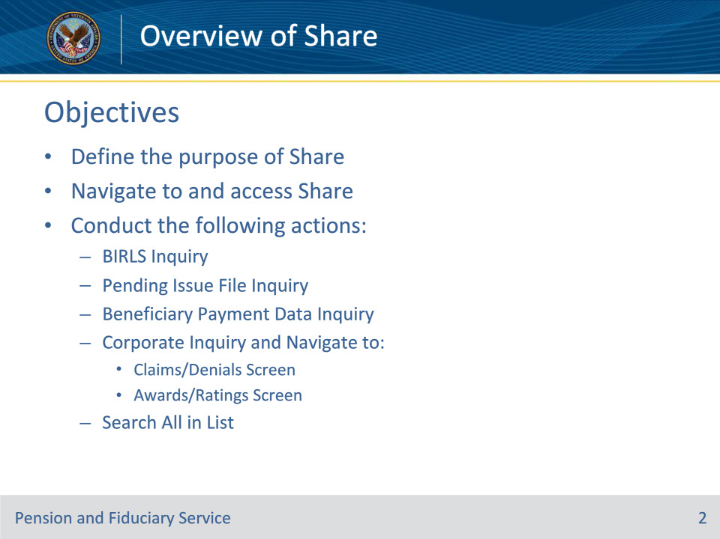
Slide notes

Instructor Notes:

By the end of this lesson, learners will be able to:

• Define the purpose of Share

• Navigate to and access Share

Learners will also be able to conduct the following actions:

• BIRLS Inquiry

• Pending Issue File Inquiry

• Beneficiary Payment Data Inquiry

• Corporate Inquiry and Navigate to:

Claims/Denials Screen

Awards/Ratings Screen

• Search All in List

Slide 3 - Reference
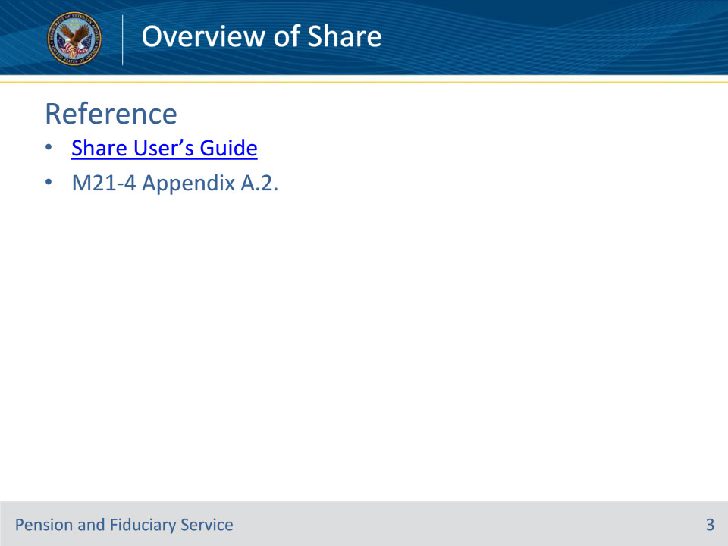
Slide notes

Instructor Notes:

These are the relevant references for this training.

Slide 4 - Purpose of Share
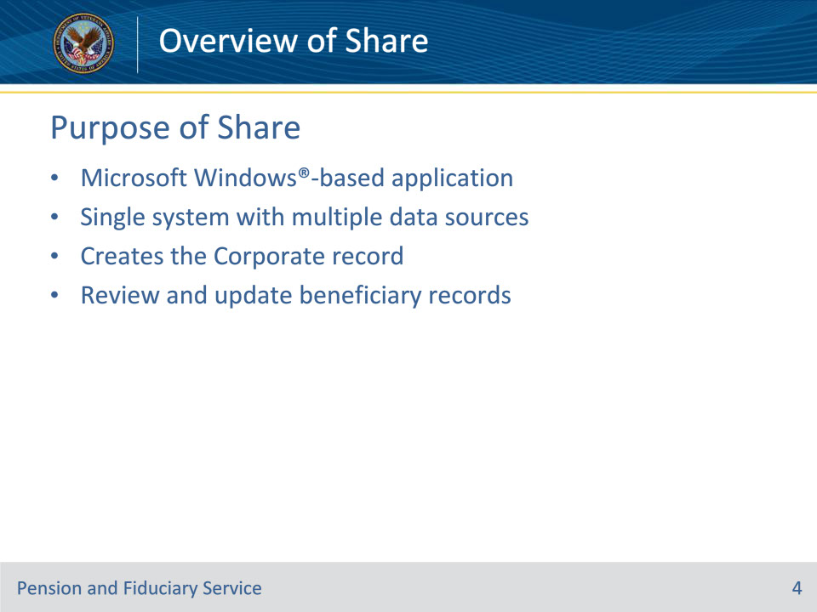
Slide notes

Instructor Notes:

Share is a Microsoft Windows®-based application which is utilized by VA employees to create and maintain beneficiary records to support case management.

It is a single system that interfaces with other VBA systems and databases to retrieve data and create a ‘Corporate’ environment.

Beneficiary records can be reviewed and updated through various commands in Share.

Today’s lesson focuses on providing an overview of identifying information in Share using its read-only screens. A separate lesson provides instruction on how to use the update functions of the application.

Slide 5 - Payee Codes
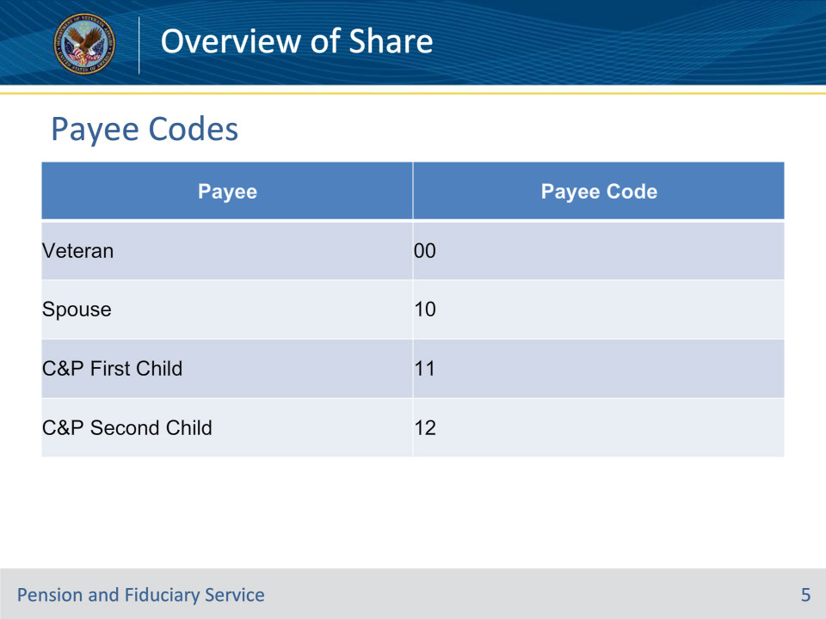
Slide notes

Reference(s): M21-4 Appendix A.2.

Instructor Notes:

This slide shows some of the most common payee codes. Payee codes indicate the type of beneficiary record you are accessing.

Slide 6 - Accessing Share
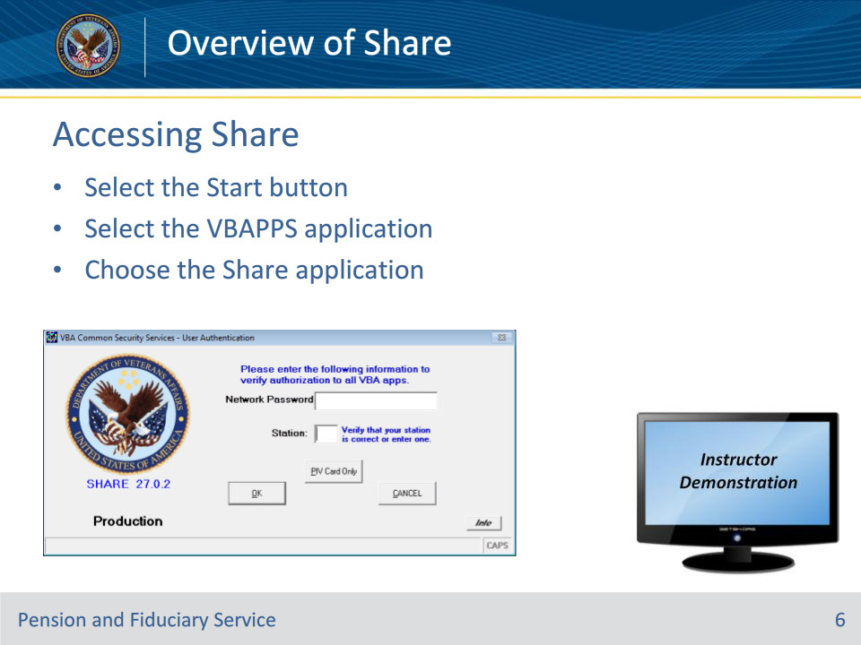
Slide notes

Instructor Notes:

You must be granted access to Share. Begin the Share application by selecting the icon, or by going to the Start button in the bottom left corner of the Windows taskbar. 1.Select the Start button2.Select the VBAPPS application3.Choose the Share applicationThe Common Security Service (CSS) screen will be present. Enter a CSS password and press the Enter button or select the OK button. You may also choose to select the “PIV Card Only” button and enter your PIV credentials to login. In order to login, the station field must have the correct station number.If you forget your password, you can contact the National Service Help Desk.After logging in, you will arrive at the Share ready screen.Note to Instructor: Share keyboard shortcuts are located in the Share Online Help Guide - “Using Keyboard Shortcuts” http://css.vba.va.gov/SHARE/ (hyperlink this website within the notes)Demonstration Notes: Login to Share to Demonstrate the information discussed.

Slide 7 - Share Ready Screen
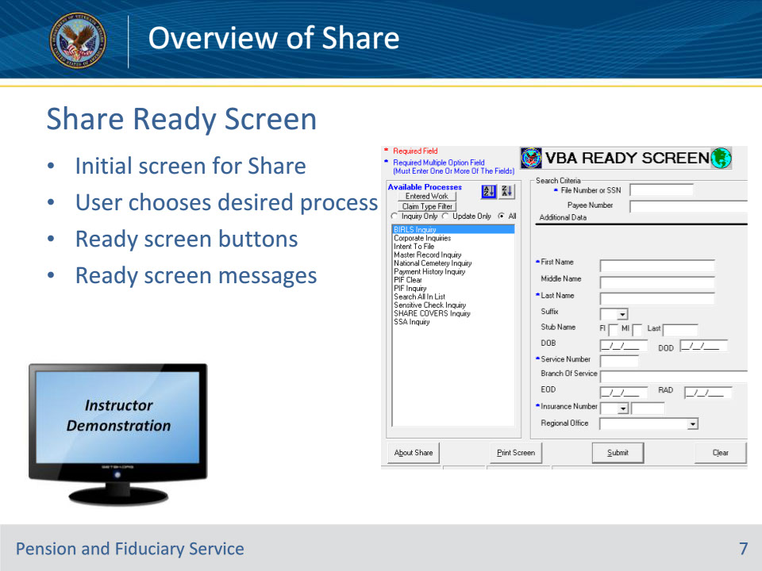
Slide notes

Instructor Notes:

After logging in, you will arrive at the Share ready screen.The menu screen on the left pane, listed under ‘Available Processes’, allows the User to choose the desired Share command or process. The Ready Screen buttons are at the bottom; most used are ‘Submit’, ‘Clear’, and ‘Exit.’

Ready screen messages will display when there is a system or application problem, or the user entered an invalid command. The error messages are displayed in a message box and the user must respond to the message before proceeding. Demonstration Notes: Open Share to identify the information discussed.

Slide 8 - Conduct BIRLS Inquiry
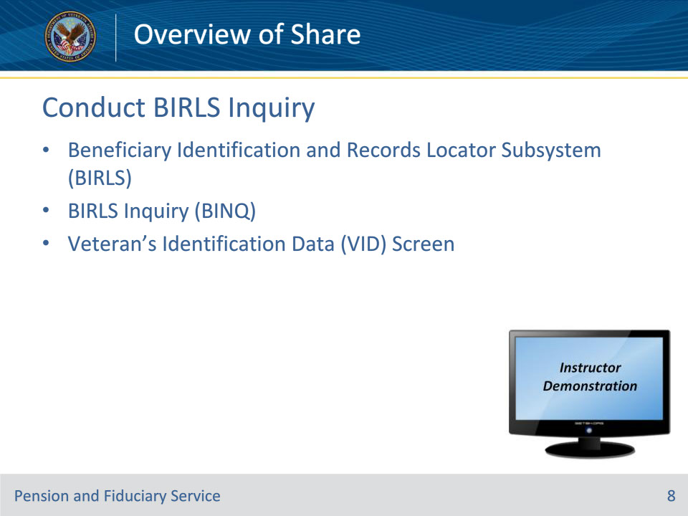
Slide notes

Instructor Notes:

What is BIRLS?

The Beneficiary Identification and Records Locator Subsystem (BIRLS) contains a record for each Veteran or beneficiary for whom one of the following types of files has been established: Pension or Compensation Claim, Counseling, Education & Rehabilitation, Chapter 30, Dependents Educational Assistance, Insurance, Loan Guarantee, Notice of Death, Fiduciary/Guardianship Record, CH31 Rehabilitation Folder, and Service Medical Record.

BIRLS Inquiry

A BIRLS Inquiry, or BINQ, allows an inquiry of a Veteran or beneficiary BIRLS record to review the data associated with a record. When BIRLS Inquiry process is selected from the Ready Screen, all the fields are protected from user entry. To conduct a BINQ:

1. Select BIRLS Inquiry from the Available Processes list on the Ready Screen.2. Under Search Criteria, enter the File Number or SSN, -OR Under Additional Data; enter the First Name, Last Name, Service Number, or

Insurance Number of the veteran.3. Select the Submit button.4. The Veteran Identification screen will be displayed.

VID Screen

The Veteran’s Identification Data, or VID, Screen, displays Veteran identification information including birth and death dates, periods of service, Claim folder location, etc.

The user may also view additional screens by tabbing through the Name, Insurance, Inactive Comp & Pen, Folder Location, or Miscellaneous Information tabs.

Demonstration Notes: Demonstrate how to conduct a BINQ, show the various information on the VID screen, and show the additional tabs and corresponding information on them.

Slide 9 - Pending Issues
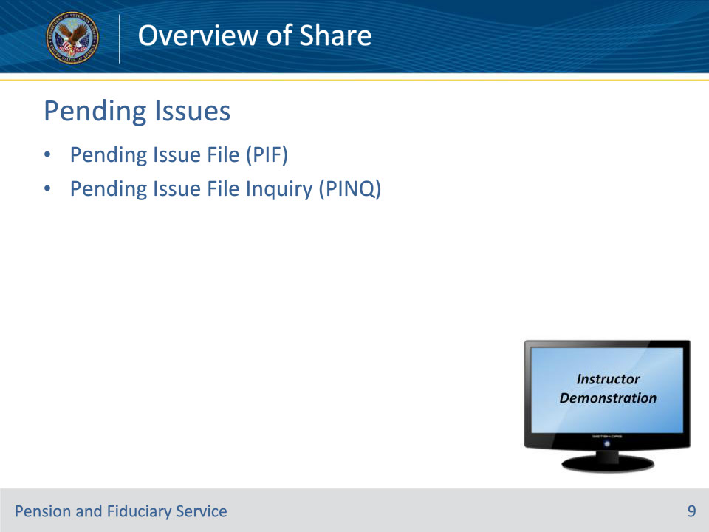
Slide notes

Instructor Notes:

Pending Issue File (PIF)

The Claims Establishment process enables the user to set up a pending issue to hold the claim data entered. This data is stored in the Pending Issue File (PIF). The PIF is a working file that contains data for a pending claim and maintains control until an award or disallowance is processed. This process also provides for automatic work measurement and controls. Authorization of the completed action clears the pending issue out of the PIF and automatically generates end product credit.

Pending Issue File Inquiry (PINQ)

A Pending Issue File Inquiry, or PINQ, allows an inquiry of any issues (claims) that may be pending for a beneficiary.

1. Select PIF Inquiry from the Available Processes list on the Ready Screen.

2. Under Search Criteria, enter the File Number or SSN Social Security Number. The remaining fields are optional.

3. Select the Submit button.

4. If only one record is located, the Claim Status (P01) screen is displayed.

5. If more than one record is located, the Payee Selection screen is displayed. The user may select a record by double-clicking on the correct entry or highlighting the entry and selecting the Inquiry button.

6. If no record is located, a message is displayed on the Ready Screen.

Demonstration Notes: Demonstrate how to conduct a PINQ. Note - Ensure you use a file with a PIF.

Slide 10 - Payment Data
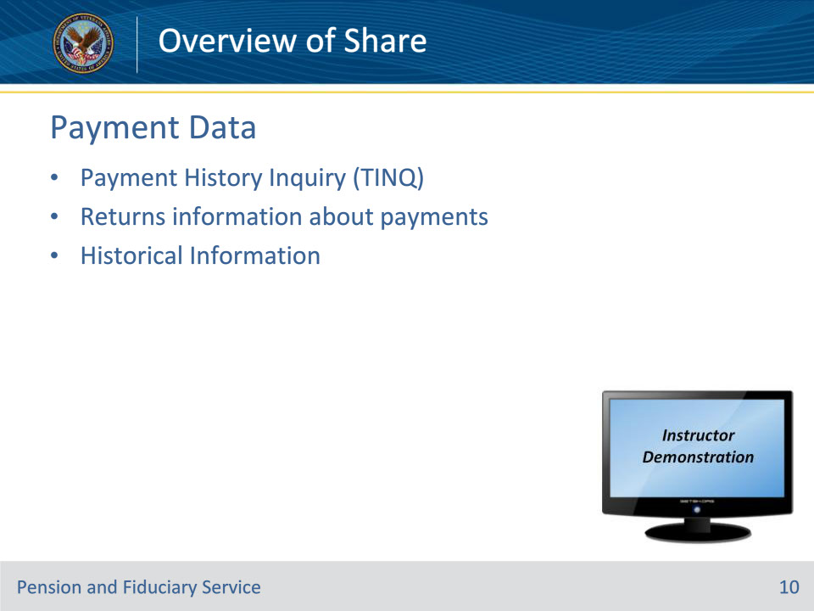
Slide notes

Instructor Notes:

The Payment History Inquiry, or TINQ, screen displays the payment history for a beneficiary. The history contains the type of payment, amount, date, routing codes, addresses, and returned payment data.

A maximum of 18 payments may be displayed under Payment Data, and a maximum of 6 payments under the Returned Payment Data. Historical Payment information exceeding these maximum number of payments may be stored in the “Historical Payment Information” screen, and/or in station Microfiche.

Available payment histories include the following:

• Compensation and Pension

• Spina Bifida Chapter 18

• Montgomery GI Bill Chapter 30

• Veterans Education Assistance Chapter 32

• Vocational Rehabilitation Chapter 31

• Chapter 34

• Dependents Education Assistance Chapter 35

• Montgomery GI Bill Chapter 1606 (Reservists)

• 901

• 903

Demonstration Notes: Demonstrate how to conduct a TINQ and view Historical Payment Information.

Slide 11 - Corporate Inquiry
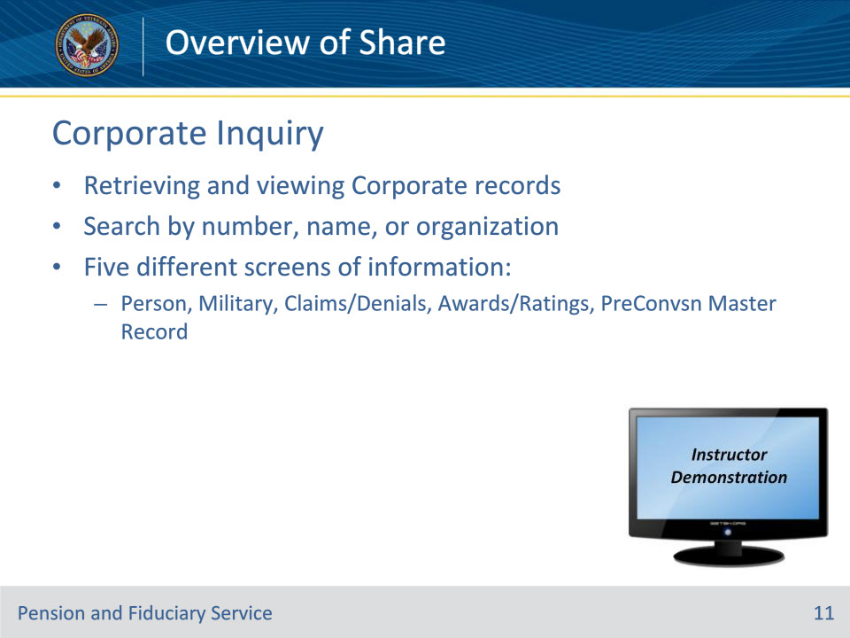
Slide notes

Instructor Notes:

What is Corporate Inquiry?

The Corporate Inquiries, or CINQ, command allows authorized users to access three search methods for retrieving and viewing Corporate database records:

1. Number Search - User enters file number, SSN Social Security Number, or Corporate Participant ID

2. Person Search - User enters name

3. Organization Search - User enters organization name and selects from list of organization types

Accessing Corporate Inquiry1.Select Corporate Inquiry from the Available Processes list on the Ready Screen.2. Three tabs will be displayed: Number Search, Person Search and Organization Search.3. Select the appropriate tab and enter the required information.4. Select the Submit button.

Note: If more than one entry is located, highlight the appropriate entry and select the Submit button.

5. The Corporate Inquiry screen, pertaining to the search criteria, will be displayed. The default screen with be the Person tab on the Person button. The fields are view-only.

The Corporate Inquiry displays five (5) different screens with their own subsets of information: Person, Military, Claims/Denials, Awards/Ratings, and the PreConversion Master Record which shows you the BDN Master Record as it appeared prior to the VETSNET conversion.

I will demonstrate the information found on each screen, however, the next slides and learning objective are dedicated to two of those screens – Claims/Denials and Awards/Ratings.

Demonstration Notes: Demonstrate how to conduct a Corporate Inquiry and show the information found on the Person and Military screens only.

Slide 12 - Claims and Denials
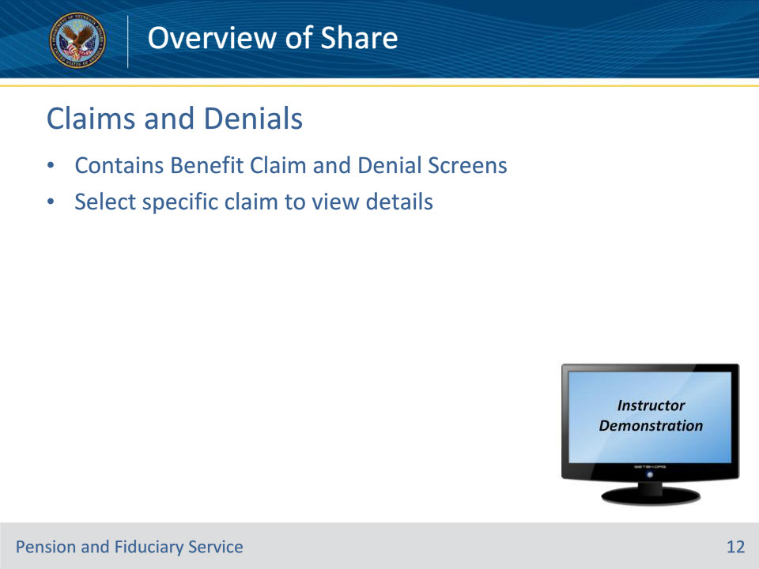
Slide notes

Instructor Notes:

The Benefit Claim Information screen on the Corporate Inquiry displays information from the Corporate database about the benefit claim for a Veteran. The screen shows a historical list of all claims and issues established for a beneficiary and their corresponding information such as claim type, end product code, date of claim, claims status, and date of final action.

The following claim statuses may be available:

• CLR – Cleared

• CAN – Cancelled

• PEND – Pending

• RDC – Ready for Decision

*To see additional information about a Claim, click on a specific claim to view details.

The Denials screen on the Corporate Inquiry displays information from the Corporate database about compensation denials regarding the beneficiary’s claim.

Demonstration Notes: Demonstrate how to navigate to the Claims and Denials screen, and how to click on a specific claim to view the details about a claim. *Once in a specific claim, ensure you click into the “Current Claim Level Suspense” grid to show them how to see the different actions taken on a claim, by whom, and the date the actions were taken.

Slide 13 - Awards and Ratings
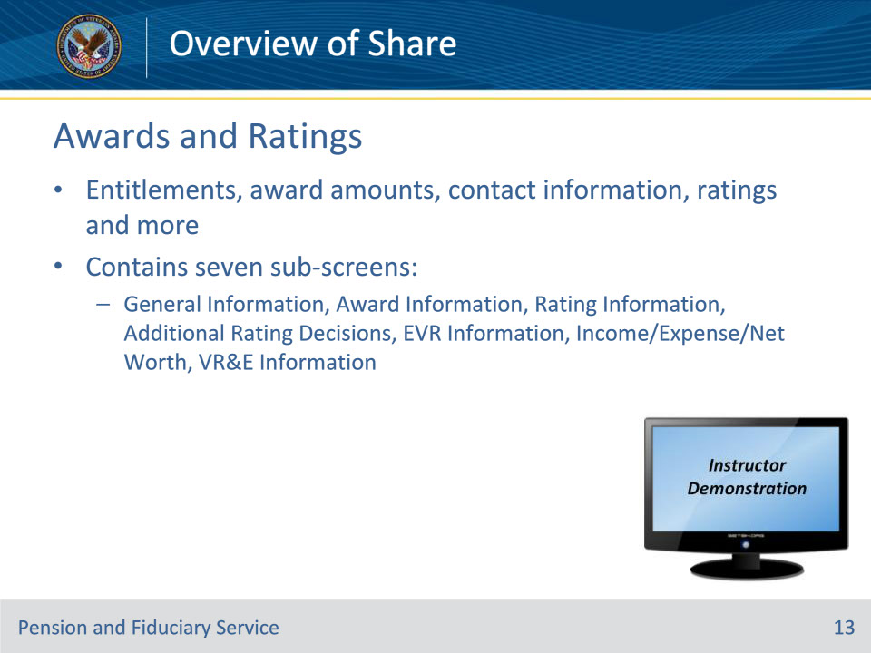
Slide notes

Instructor Notes:

The Award and Ratings screen within the Corporate Inquiry displays information about a beneficiary’s entitlements, award amounts, contact information, and much more. There are seven (7) screens of information within Awards and Ratings as follows:

1. General Information: displays information from the Corporate database about the beneficiary, payee, diaries, payment addresses, pay status, appointed Power of Attorney, address information and more. **Note that this screen also displays the fiduciary category and competency decision.

2. Award Information: displays information about award amounts, effective dates, withholdings, and entitlements. **Note that this screen also displays if the beneficiary has any overpayments, withholdings from benefits, monies in proceeds, etc.

3. Rating Information: displays information about a beneficiary’s disabilities. It displays various diagnostic codes, the evaluation, special provisions, and combat status of the Veteran.

4. Additional Rating Decisions: displays four additional tabs for rating decisions: Other Decisions, SMC Decisions, Family Member Rating Decisions, and Death Decisions. **Note that this is the screen in which competency determinations are documented.

5. EVR Information: displays information about Eligibility Verification Reports. This used to be an annual required report for beneficiary’s in receipt of non-service-connected pension. However, annual EVRs are no longer required as income is verified through up-front processing now on receipt of applications for benefits.

6. Income/Expenses/Net Worth: displays information about the beneficiary’s income, expenses, and net worth that are being counted when determining the amount of non-service-connected pension, or death pension, that a beneficiary is entitled to. **Note that clicking on a specific award line/effective date under the ‘Summary’ grid in this screen reveals the income and expenses that are being counted to determine the rate of pension.

7. VR&E Information: displays information about the beneficiary’s entitlement to Vocational Rehabilitation and Education, if any.

Demonstration Notes: Demonstrate the Awards and Ratings screen, and the seven (7) sub-screens, for a specific beneficiary. Be sure to show the special **Notes as listed, above. Specifically, highlight the areas that are critical to fiduciary employees such as, but not all inclusive:

• Pay Status, Competency Decision, Fiduciary Category, Power of Attorney, and Address (listing the payee) on the General Information Screen

• Receivables, Deductions, and the Award Entitlement grid in the Award Information Screen

• The Competency Determination ratings in the Additional Ratings screen

• The Income/Expenses/Net Worth screen to verify information that is obtained in a field examination

Slide 14 - Search All in List
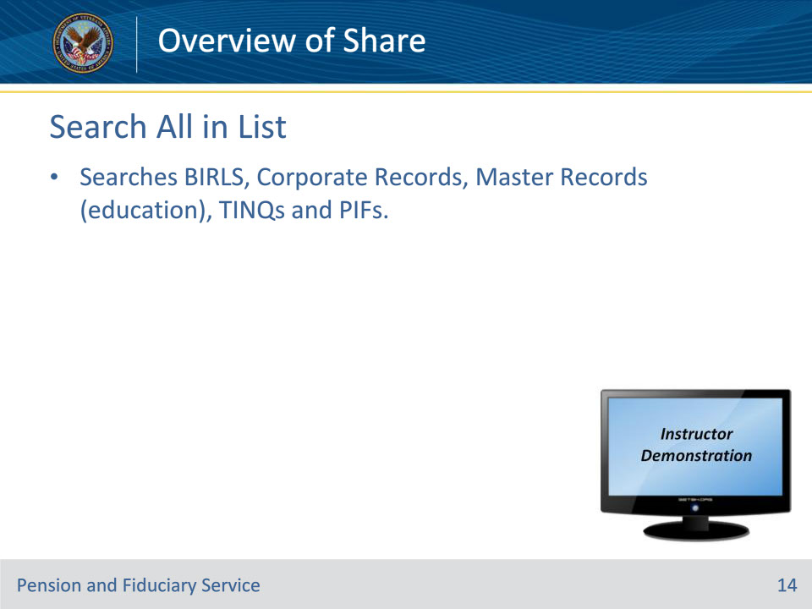
Slide notes

Instructor Notes:

Now that you know about some of the various read-only screens, we will cover the Search All in List (SAIL) process.

This process is a combination of BIRLS records, Corporate Records, Master Record (education), BIRLS Payment History Inquiries (TINQ), and Pending Issue Files (PIFs). Share will search and display all payee types from BIRLS and BDN Master Records.

To conduct a SAIL:

1. Select Search All In List from the Available Processes list on the Ready Screen.

2. Under Search Criteria, enter the File Number or SSN Social Security Number.

3. Select the Submit button.

Note: If a user is attempting to access a record with a higher sensitivity level, Share will prevent the record from being accessed and an error message will be displayed.

4. If a record exists, the Ready Screen will display ‘Additional Data’ including the locations. Records found from each inquiry is displayed separately.

Note: If there is more than one record for an inquiry, a plus (+) sign will be located to the left of the result. Selecting the plus sign will display all records available under the heading.

Veteran’s Identification Data

Corporate Inquiry

Pending Issue File

Demonstration Notes: Demonstrate how to complete a SAIL.

Slide 15 - Questions?
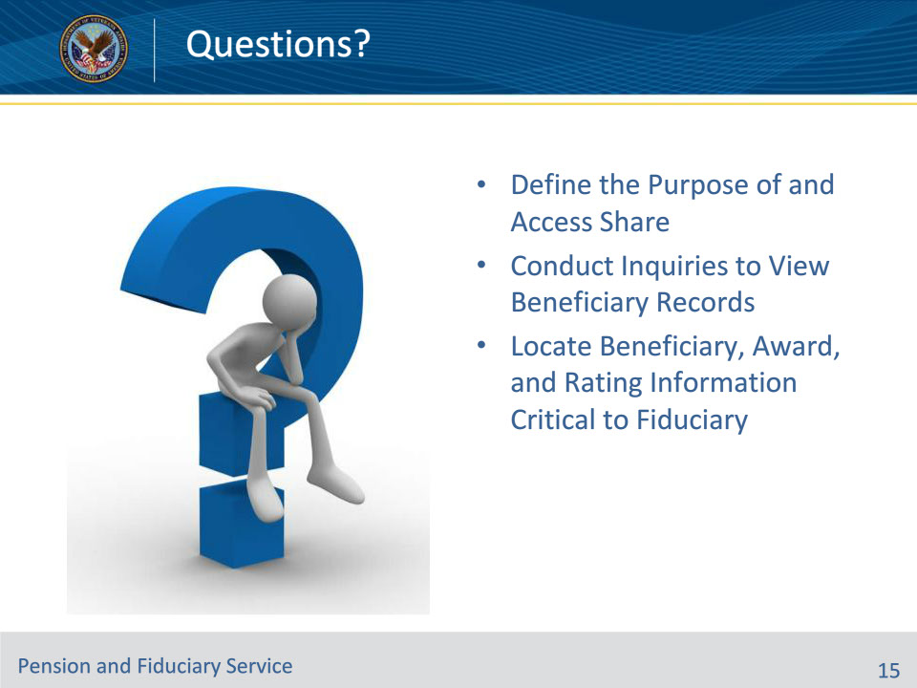
Slide notes

Instructor Notes:

Today you have learned about the system, Share, which is used to create and maintain beneficiary records to support VA case management. It is a single system that interfaces with other VBA systems and databased to retrieve data and create a ‘Corporate’ environment.

You learned about the various inquiries you can conduct to retrieve and view different aspects of beneficiary records such as:

• BIRLS – the record of each Veteran/beneficiary that a VA file has been created for

• Pending Issue Files – a working file that contains data for a pending claim and maintains control until an award or disallowance is processed.

• Payment History Data – a historical list of payments and returned payments paid to a beneficiary.

• Corporate Inquiry – an inquiry of corporate records which returns information in the following five different sub-screens: Person, Military, Claims/Denials, Awards/Ratings, and the PreConversion Master Record.

From the Corporate Inquiry, we dove deeper into two of the sub-screens:

• Claims/Denials – this screen shows a historical list of all claims and issues established for a beneficiary and their corresponding information such as claim type, end product code, date of claim, claims status, and date of final action.

• Awards/Ratings – displays information about a beneficiary’s entitlements, award status, award amount, contact information, elected Power of Attorney, rating and competency determinations, income, expenses, and net worth, fiduciary category, overpayments and deductions (if any) and more.

• Are there any questions?

Slide 16 - TMS Satisfaction Survey
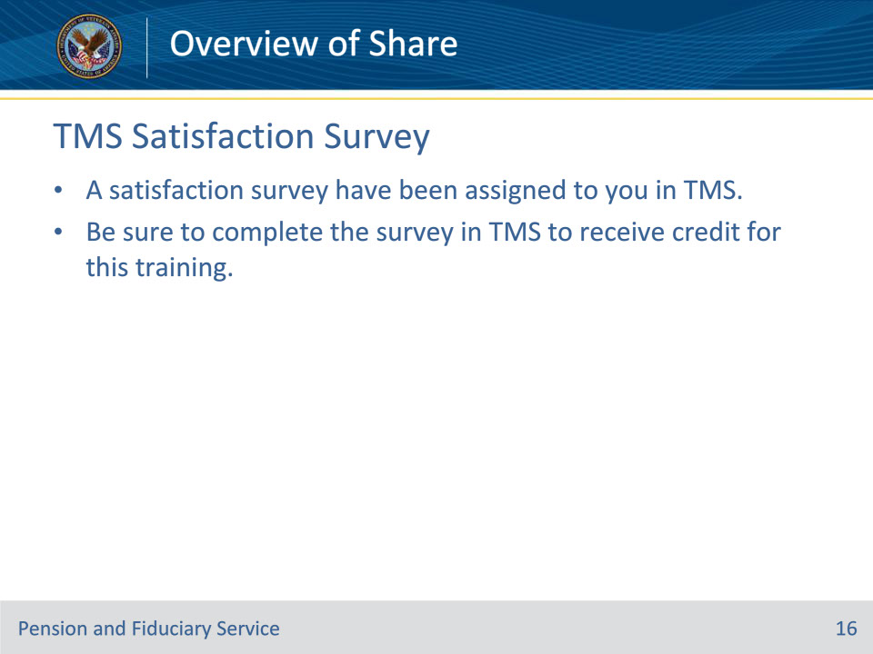
Slide notes

Instructor Notes:

Explain to students that a satisfaction survey has been assigned to them in TMS. This survey provides them with an opportunity to help improve the training. The survey must be completed in order to receive training hours. All feedback is welcome!

