Education Service
My Education Benefits (MEB) Applicant View (1990e)
Lesson Plan
August 2023
Version 1.0

Lesson Overview
Topic | Description
Time Estimate: | 1 hour (60 minutes)
Purpose of the Lesson: | The purpose of the lesson is to assist the Veteran Claims Examiner (VCE) with understanding the process of a Transfer of Entitlement (TOE) application in MEB from applicant entry to VCE processing. This training will count toward the National Training Curriculum.
Prerequisite Training Requirements: | ‘My Education Benefits (MEB)- Applicant View (1990)’ (VA 4646073).
Target Audience: | Veteran Claims Examiners, Education Call Center
Lesson References: | - DGI 3.1 Need to Knows  - DGI 3.1.5 Need to Knows  - DGI 4.0 Need to Knows
Lesson Objectives: | - Recreate the steps to apply for the TOE benefit in MEB  - Deduce the effect of applicant responses in MEB to DGI  - Correlate the applicant’s responses to what is seen by a VCE in DGI.
What You Need: | - Computer/Laptop  - Speaker/Headset  - Lesson Plan/Script
Post Training Requirements: | A survey has been assigned to you in Talent Management System (TMS).  You should be able to complete the survey within one half hour.  Be sure to complete the survey in TMS to receive credit for this training.

Instructor Notes
The purpose of the lesson is to assist the VCE with understanding the process of a TOE application in MEB from applicant entry to VCE processing. The Instructor Activities are a verbatim script of the recording to be used for in-person training.
Slide 1 - Welcome

Script

Welcome to My Education Benefits - Transfer of Entitlement (TOE) Applicant View.

Select “Begin”

Slide 2 - Today's Training
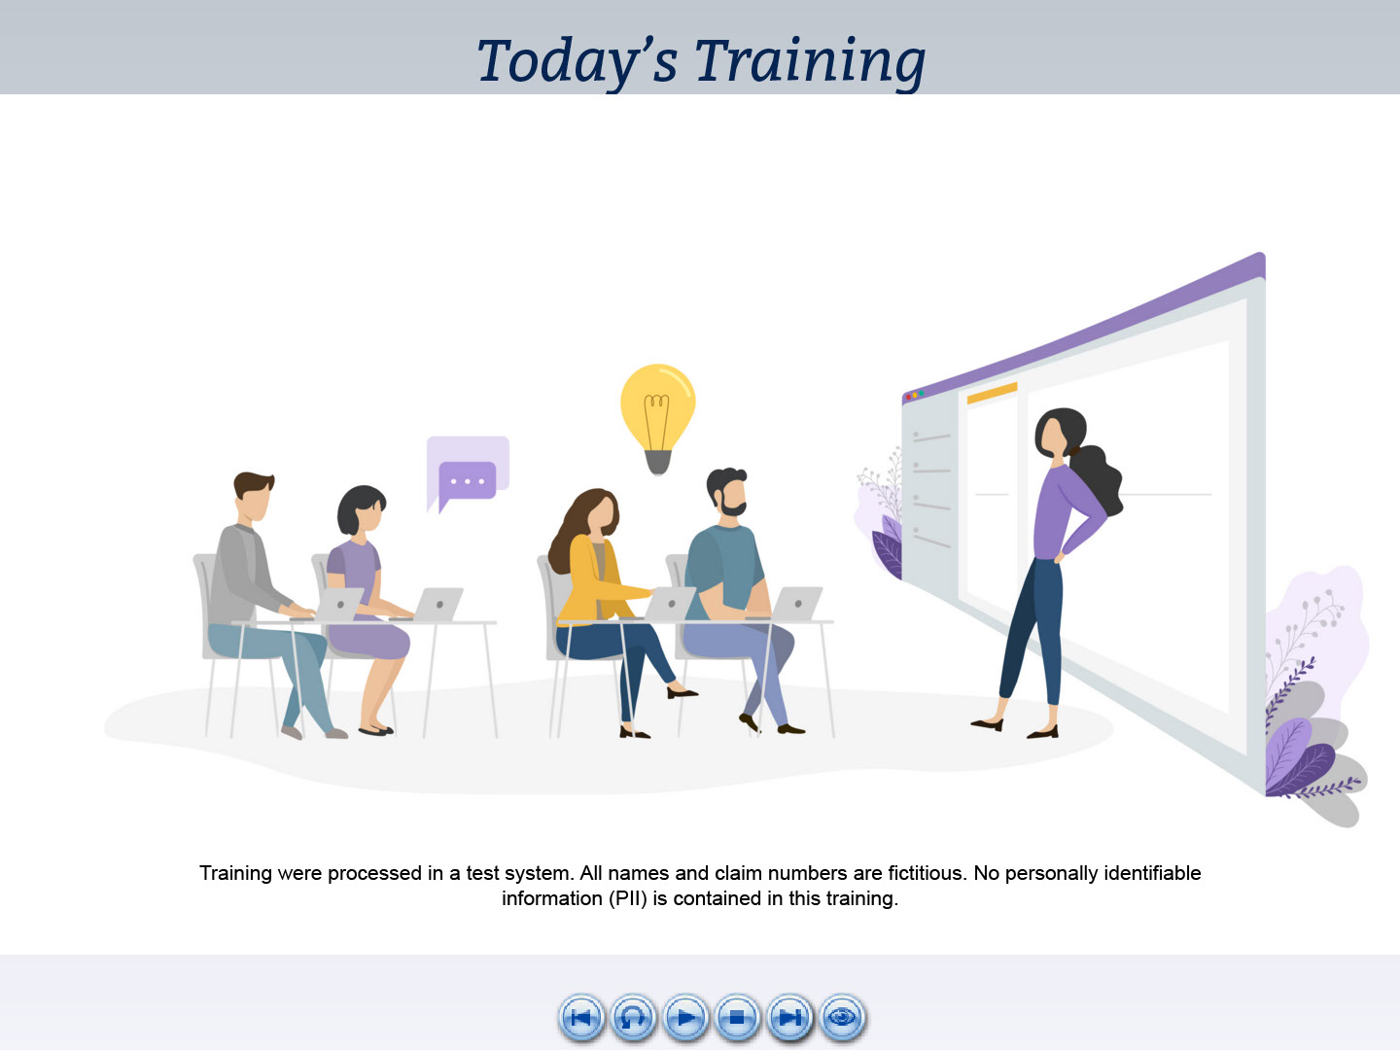
Script

Today’s training is intended to show what My Education Benefits or MEB looks like from the view of a person applying for Transferred Education benefits.

Please note, the examples you will see during this training were processed in a test environment.

All information you see is fictitious and does not represent actual beneficiaries.

Slide 3 - Navigation Controls
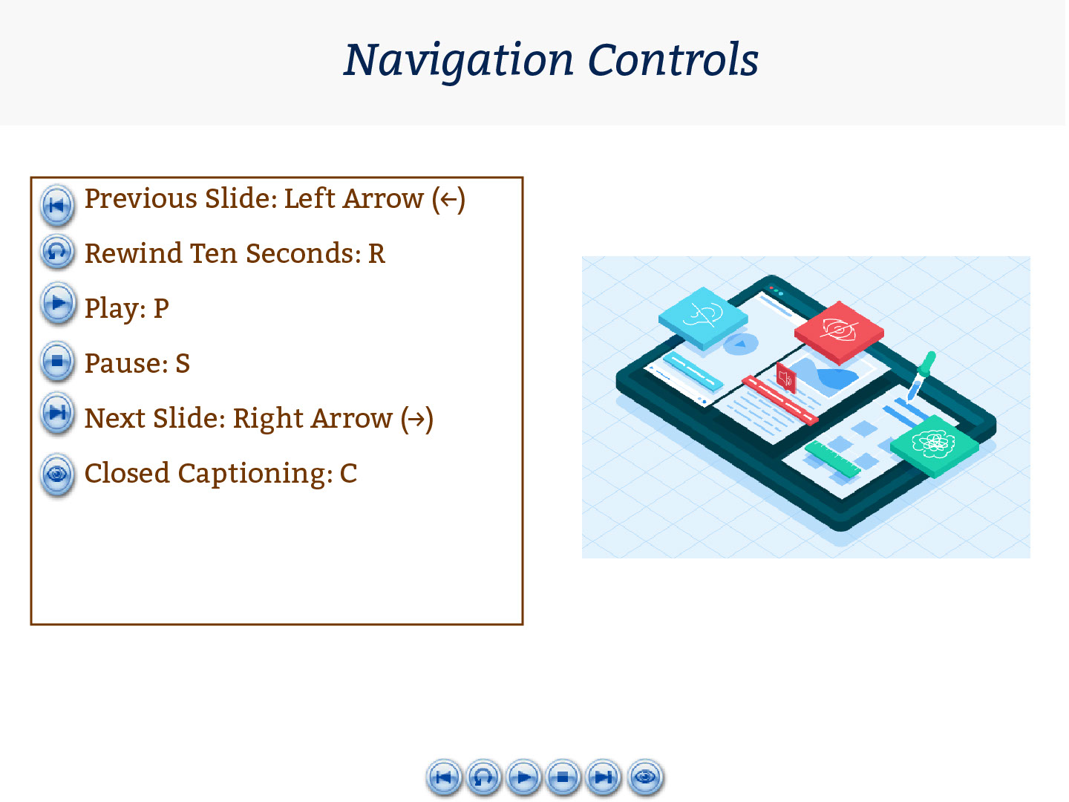
Script

You can use the navigation buttons at the bottom of the screen to move forward and backward throughout this module.

Also, you may use the keyboard shortcuts listed on-screen.

Slide 4 - Objectives
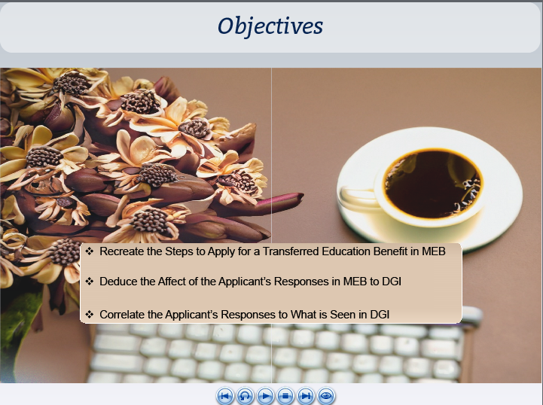
Script

At the conclusion of this lesson, you should be able to recreate the steps to apply for a transferred education benefit in MEB and deduce how the response options available to the beneficiary correlate to what is seen by a VCE in DGI.

Slide 5 - Glossary
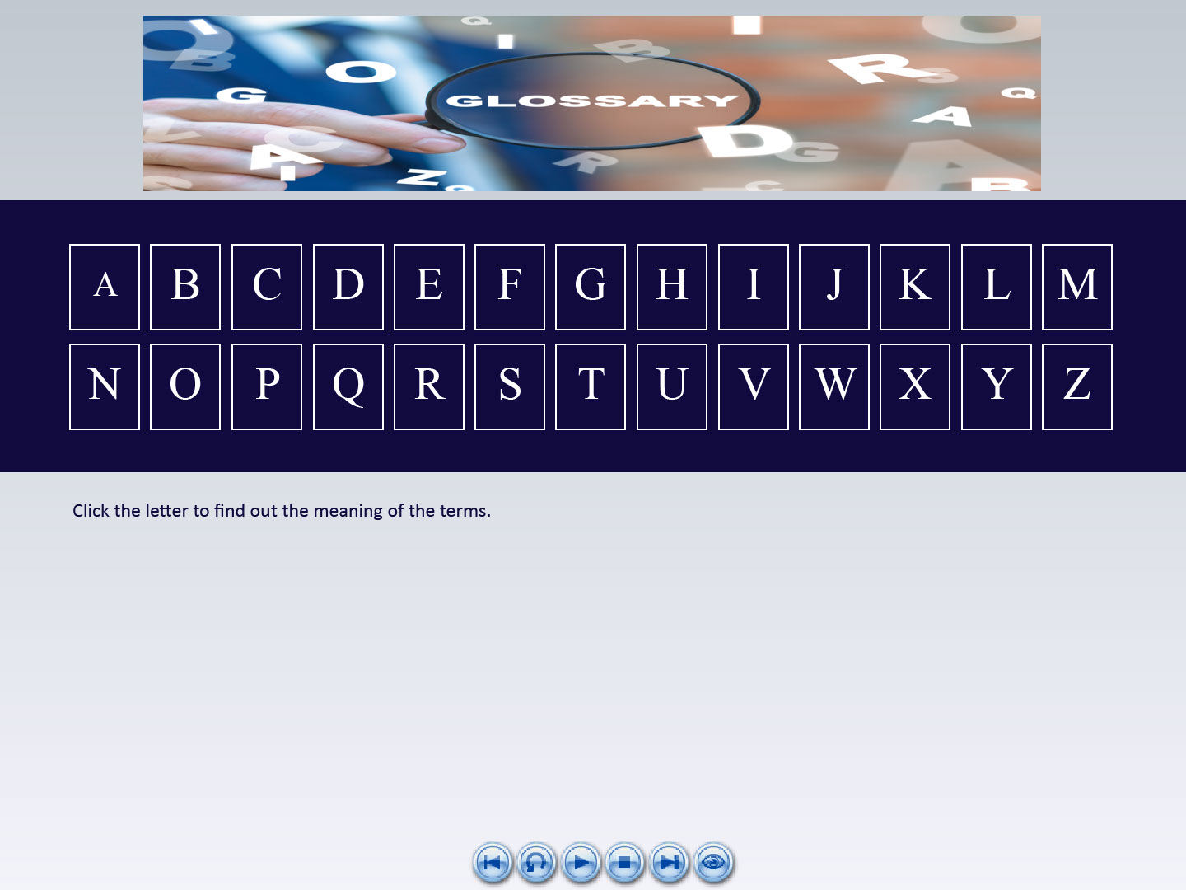
Script

A glossary for terms, acronyms and abbreviations used throughout this training has been provided for reference.

Slide 6 - Demo Intro

Script

Let’s jump right into our demonstration of a person applying for TOE benefits using MEB.

Since the MEB Applicant View training was a prerequisite for this training, some of these steps will seem familiar.

As we view the interactions, I will share what this means to the VCE.

Slide 7 - How do I apply?
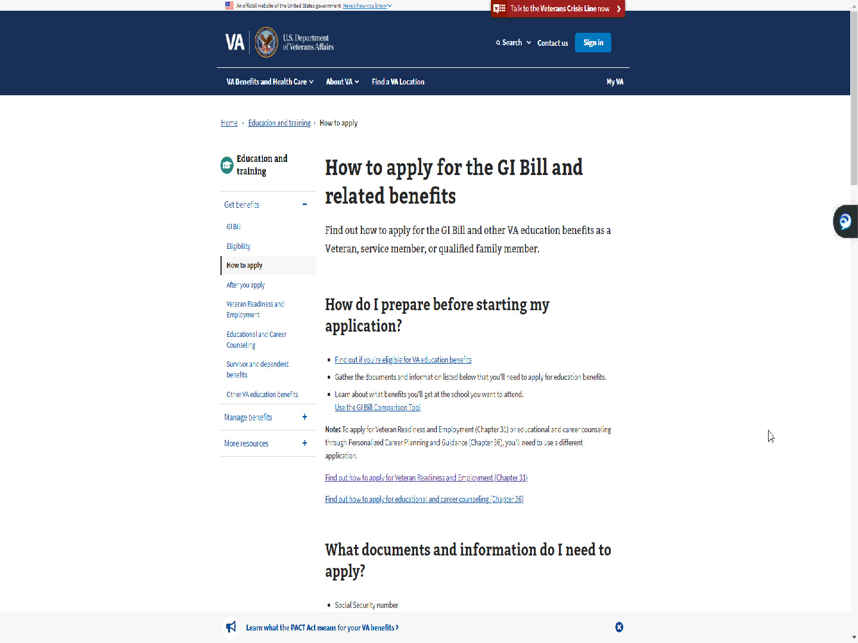
Script

As shown in the MEB Applicant View training, the applicants will begin on the education page in VA.gov and select “How to apply”.

Slide 8 - Find your education benefits form
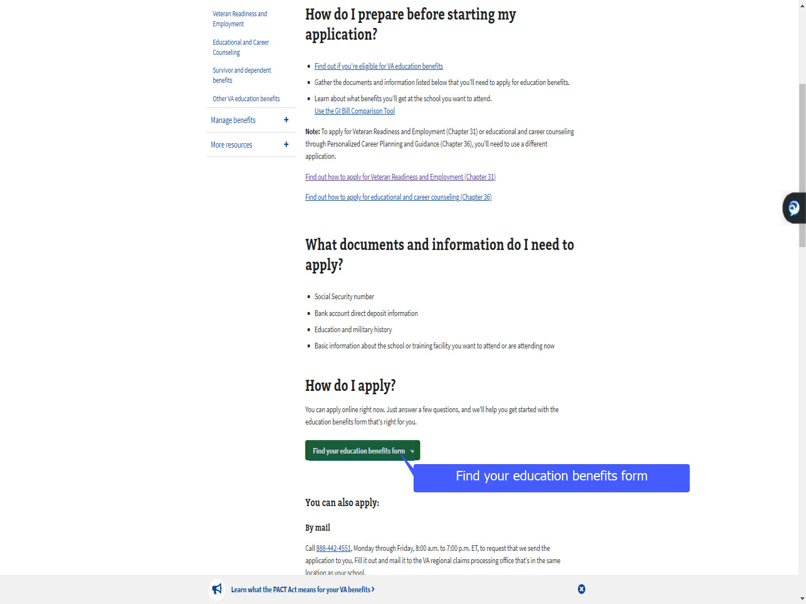
Script

They will select “Find your education benefits form.”

Slide 9 - Slide 9
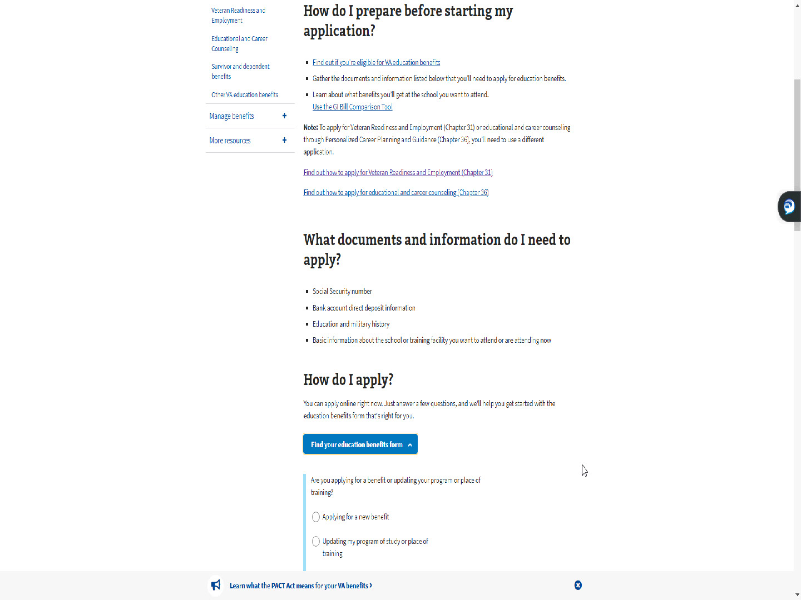
Script

Slide 10 - Applying for a new benefit
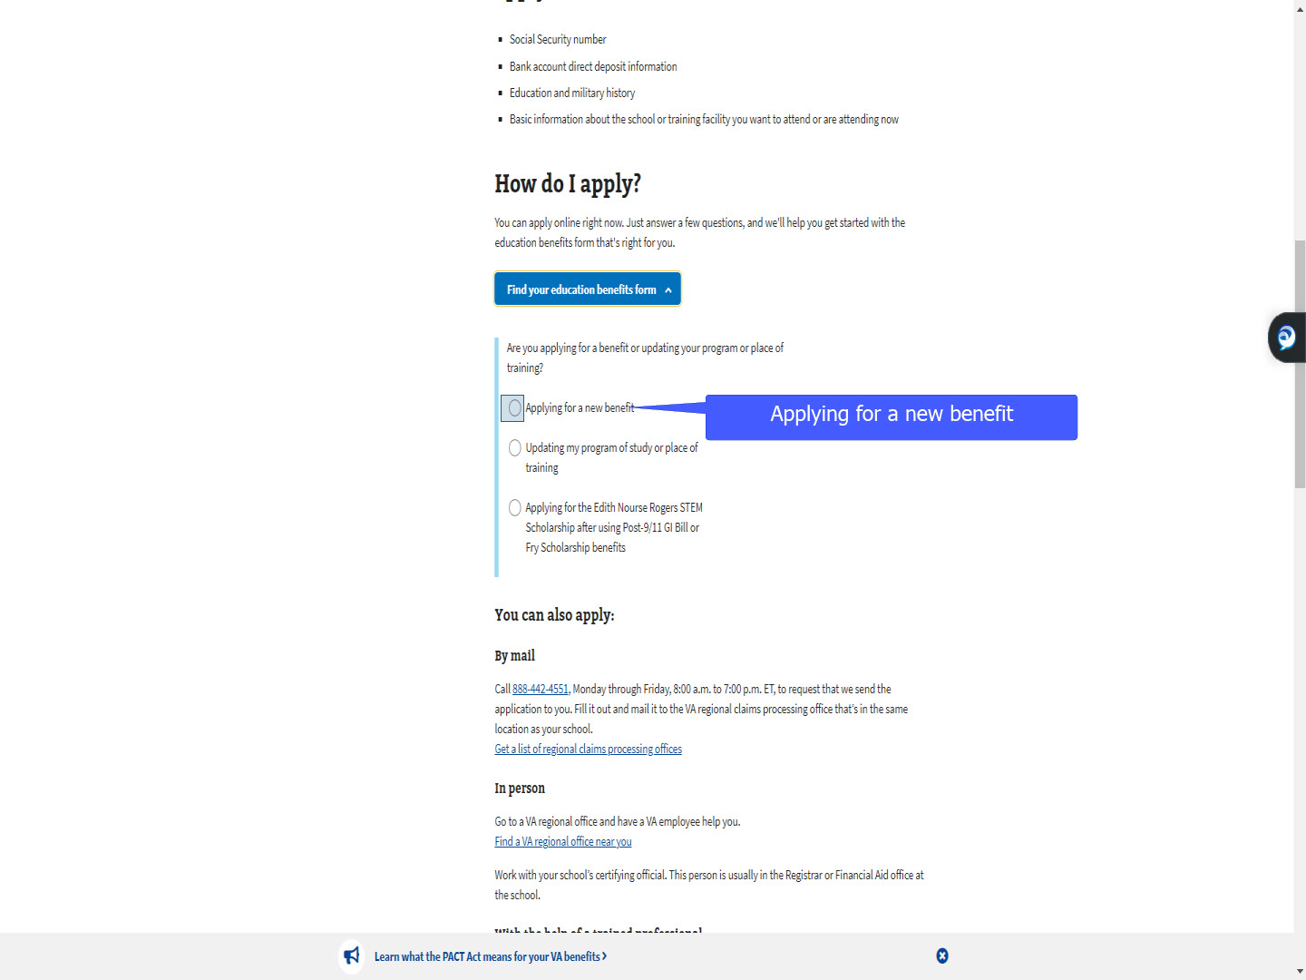
Script

then select “Applying for a new benefit”.

Slide 11 - Slide 11
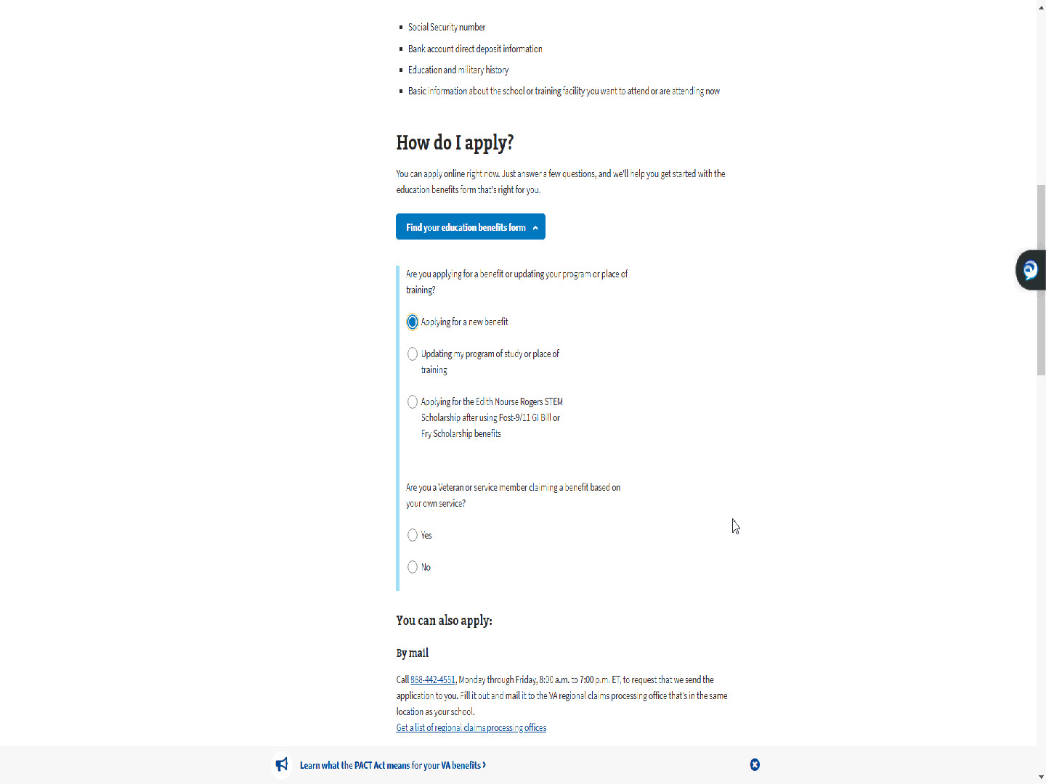
Script

Slide 12 - Using own service
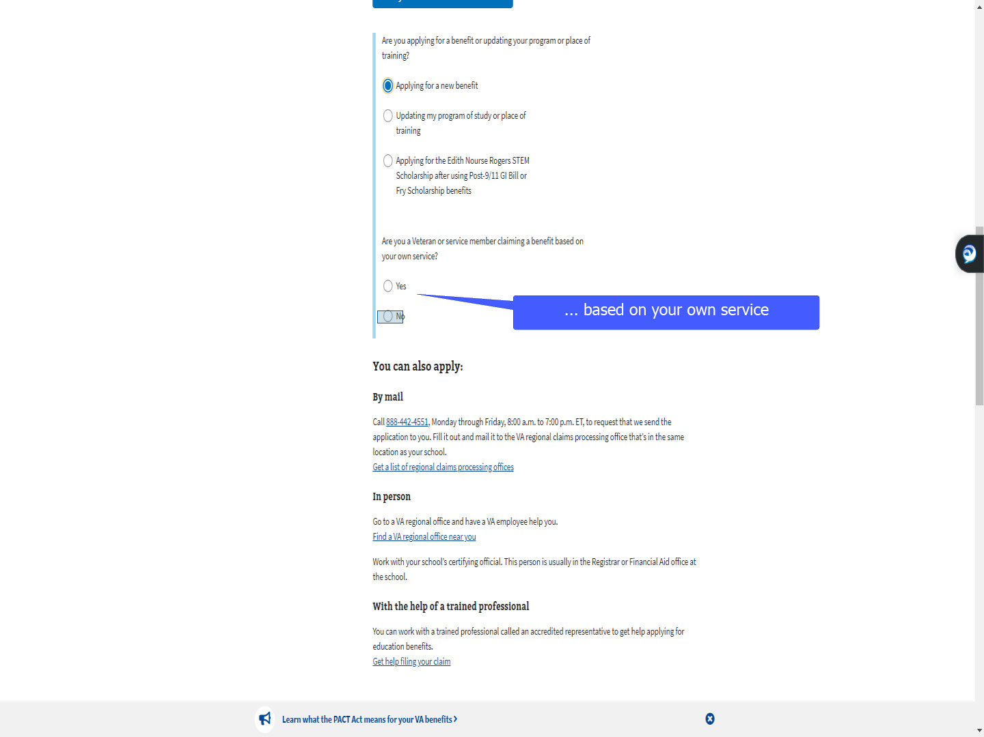
Script

The difference for a TOE applicant is they will select “No” to answer the question “Are you a Veteran or service member claiming a benefit based on your own service?”

Slide 13 - Slide 13
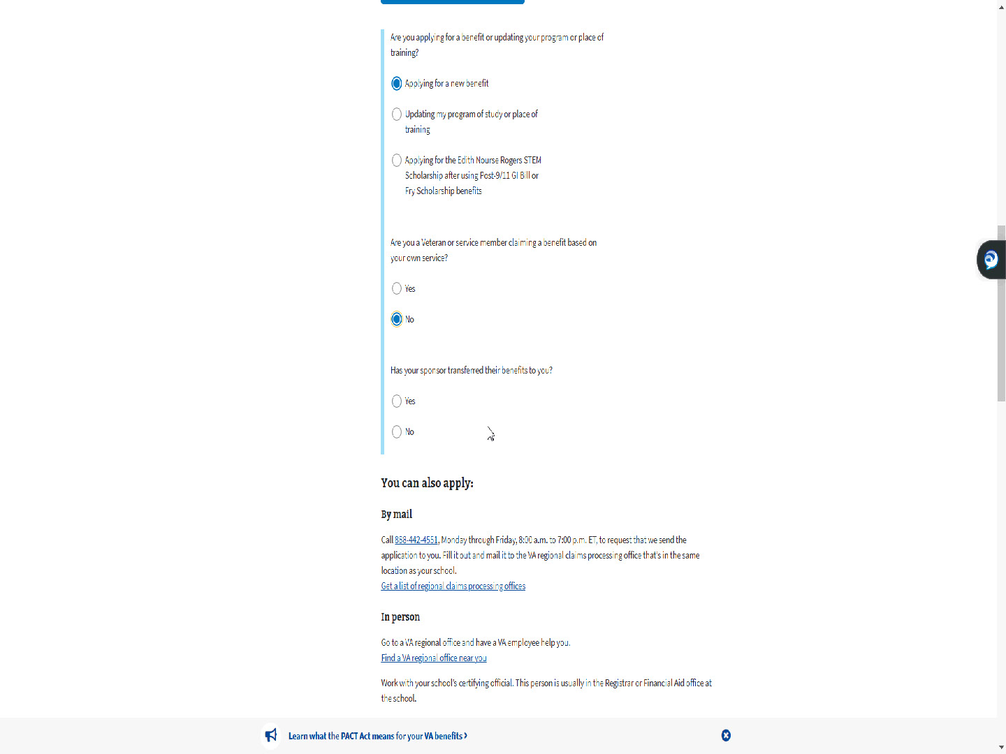
Script

Slide 14 - Has your sponsor transferred their benefits to you
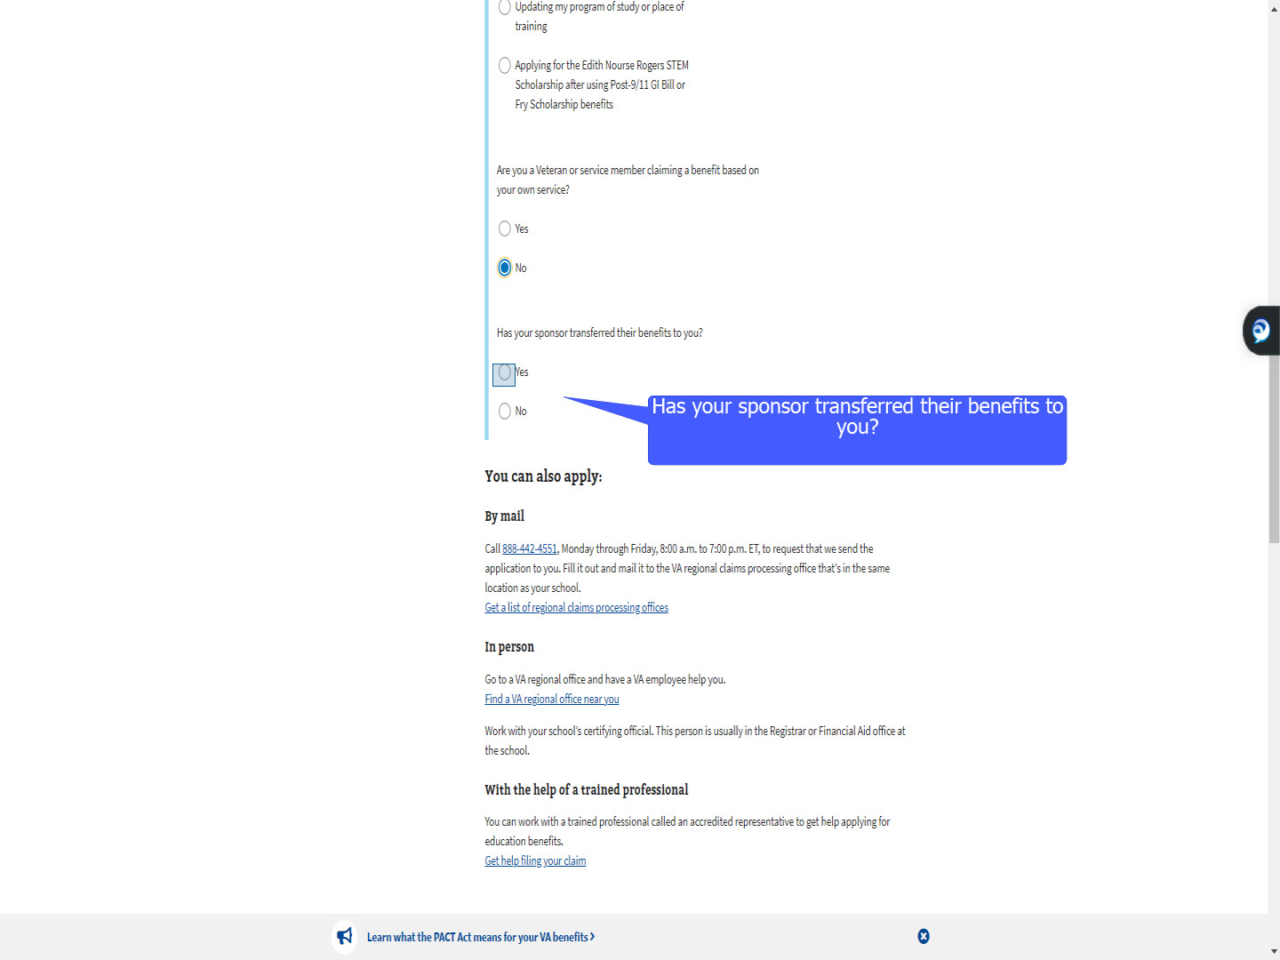
Script

As a result of selecting “No” MEB prompts the question “Has your sponsor transferred their benefits to you?”

Slide 15 - No transferred benefits
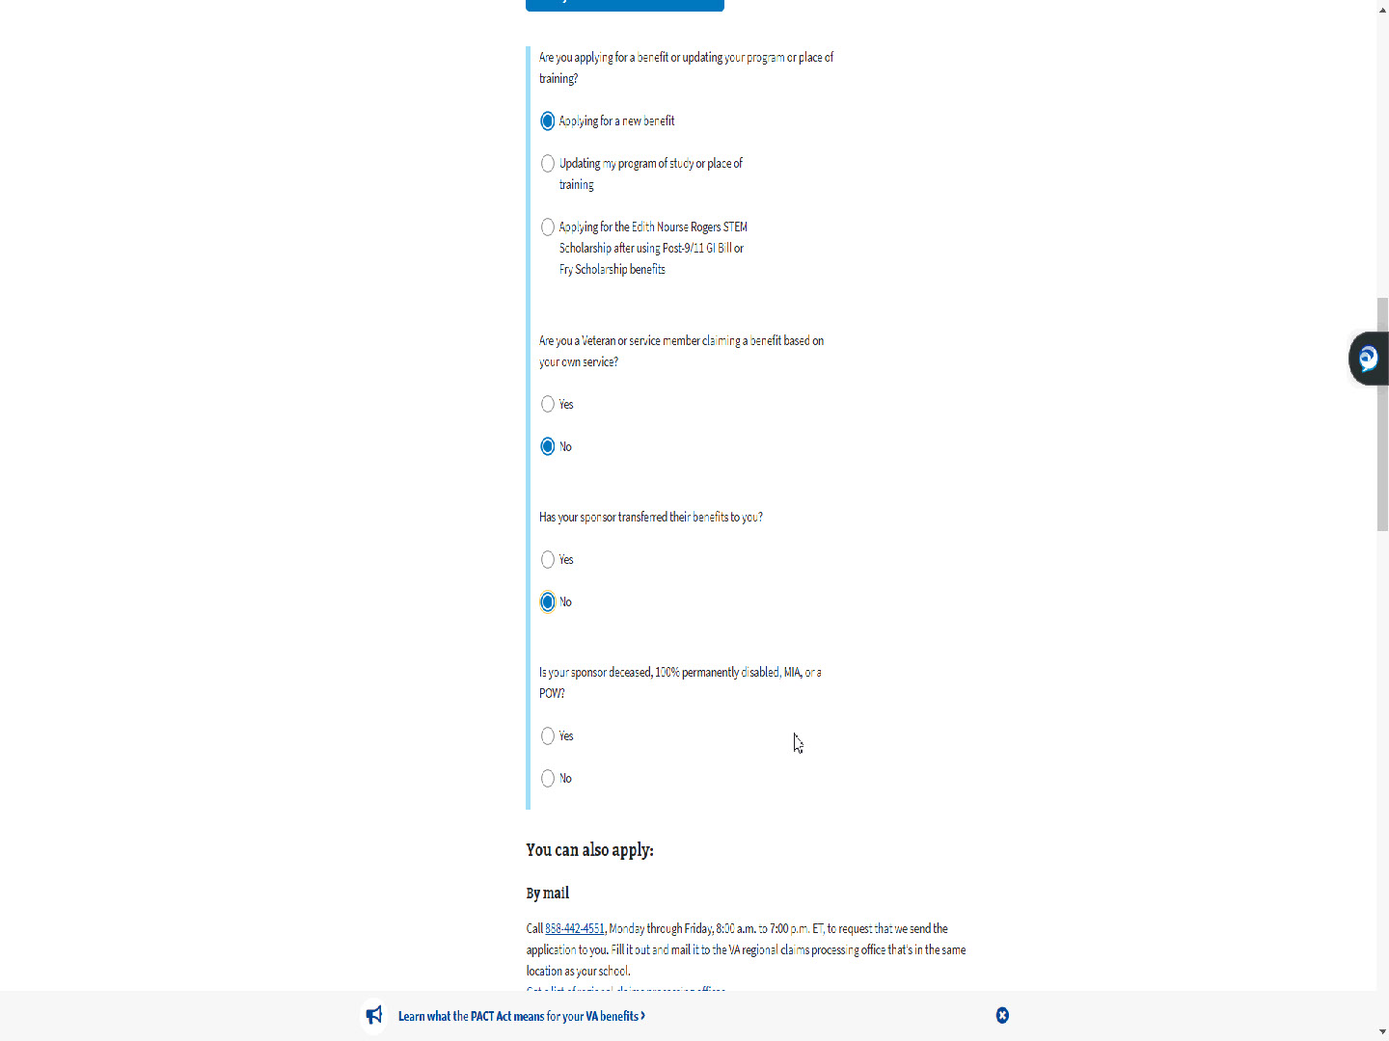
Script

If the applicant selects “No”, MEB asks if the sponsor is deceased, 100% permanently disabled, MIA or a POW.

If the applicant responds “Yes”, they are routed outside of MEB to apply for Fry or CH35.

Slide 16 - No sponsor disability
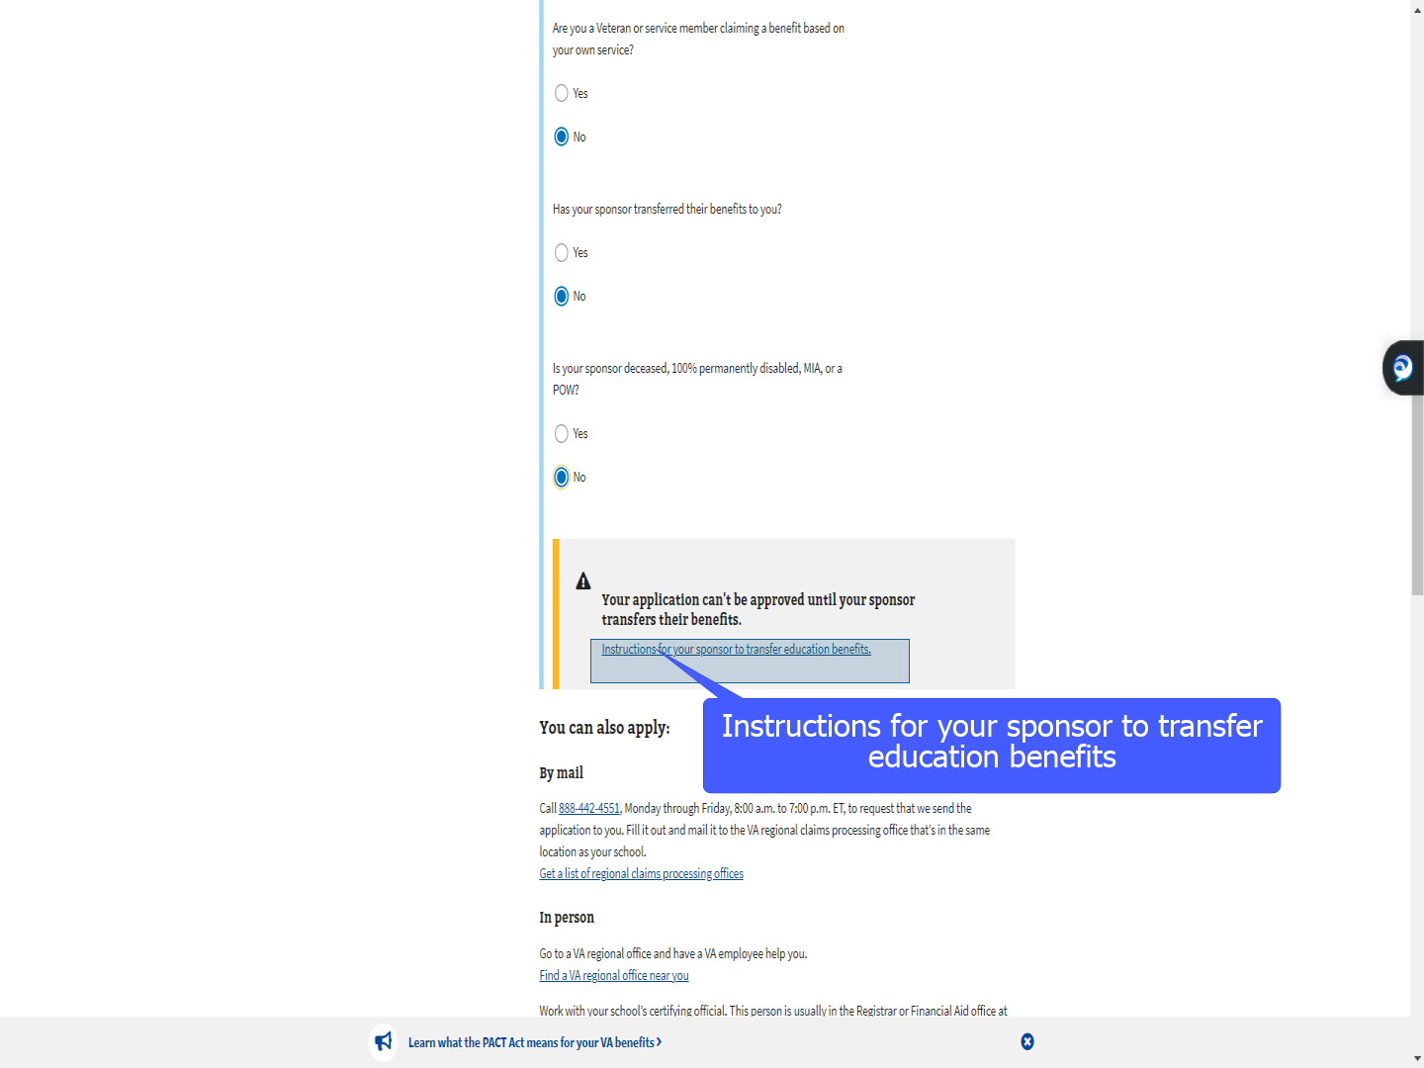
Script

If the applicant selects “No”, a window pops up stating “Your application can’t be approved until your sponsor transfers their benefits”.

A link is provided with instructions for the sponsor.
It will open a new window.

Slide 17 - How to Transfer and Use Benefits
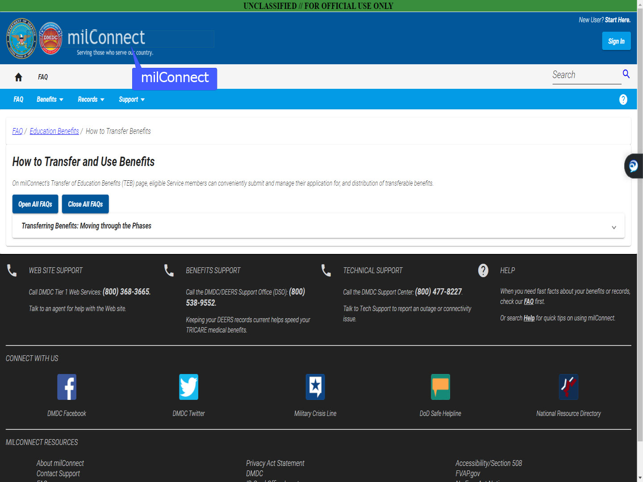
Script

The applicant is taken to milConnect. There they are provided information on “How to Transfer and Use Benefits”.

Slide 18 - Apply Now
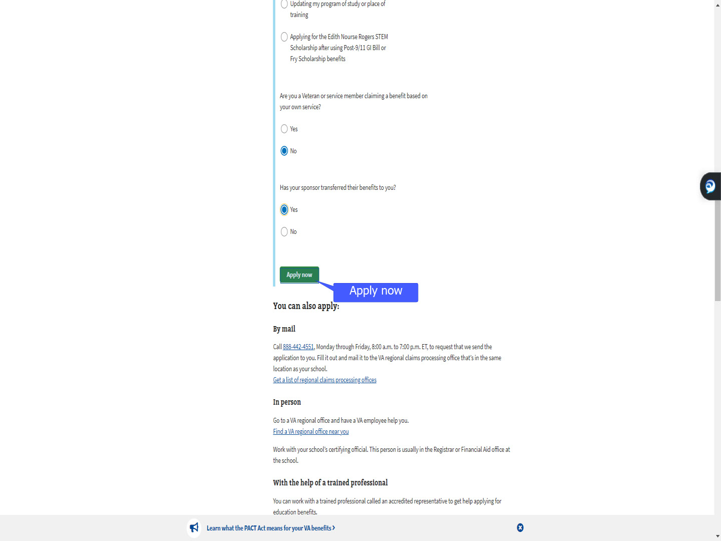
Script

For today’s demonstration, we will select “Yes”, to acknowledge benefits have been transferred, then select “Apply now”.

Slide 19 - Slide 19
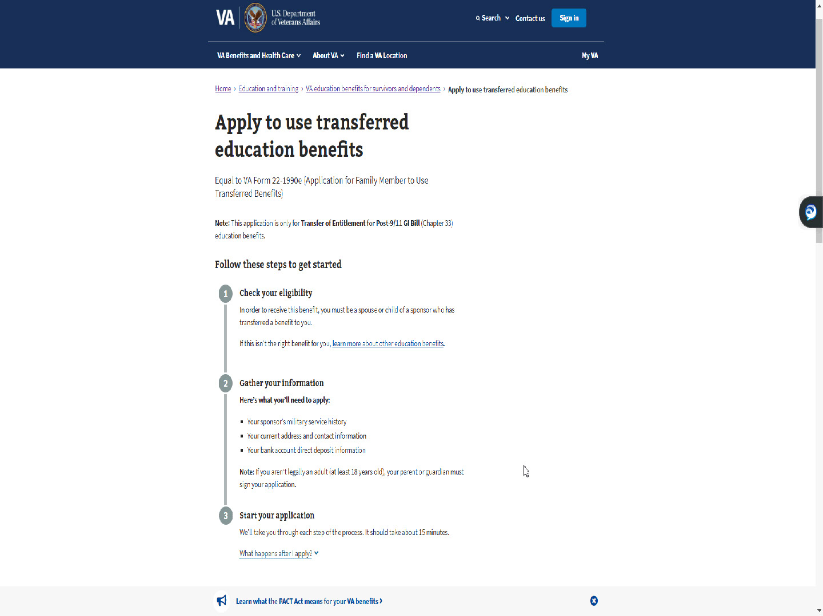
Script

As with the Chapter 33 “Self” application in MEB, information is provided to assist with applying

Slide 20 - What happens after I apply?
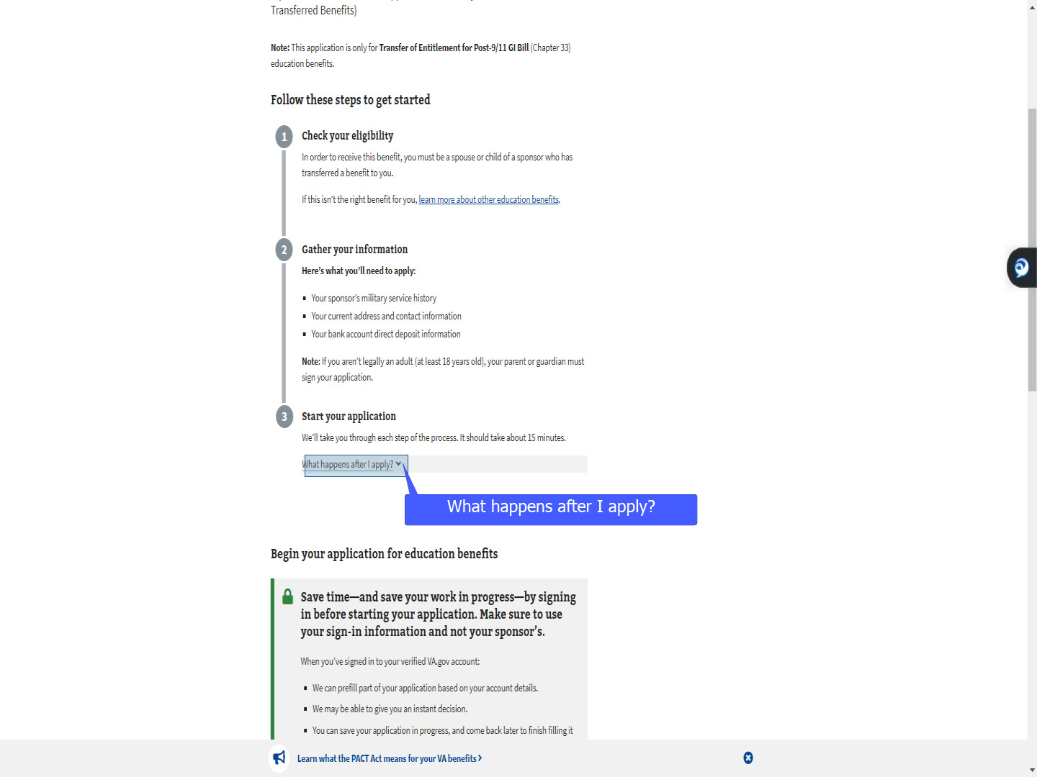
Script

Slide 21 - Slide 21
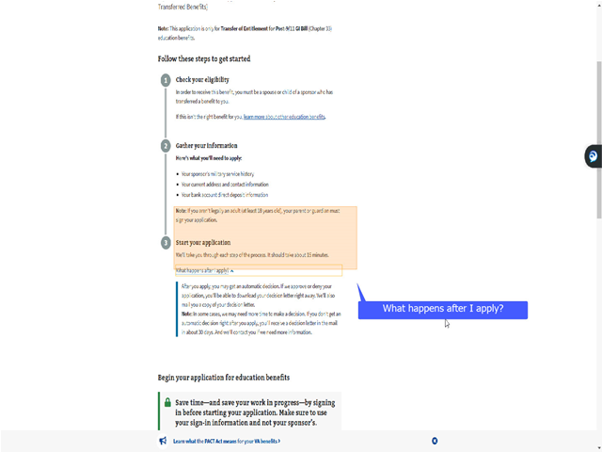
Script

and provide a snippet of what happens after.

Slide 22 - Slide 22
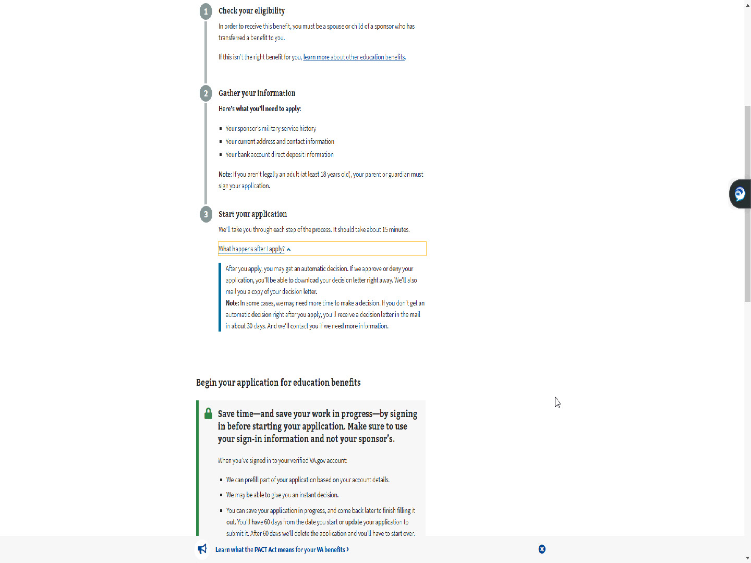
Script

The applicant will scroll down

Slide 23 - Sign in to start your application
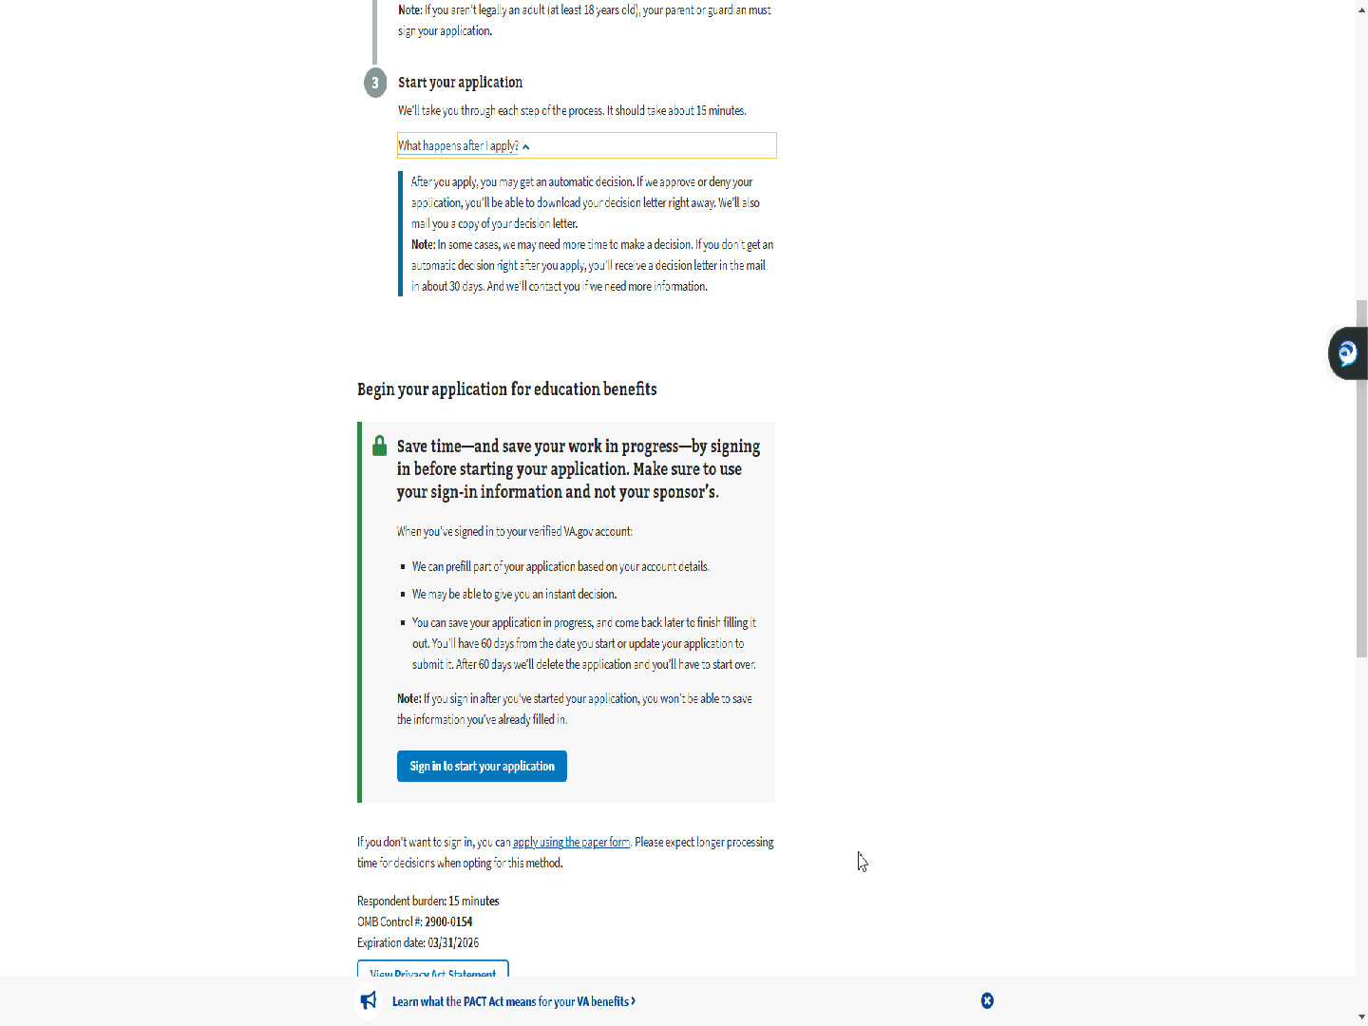
Script

and select “Sign in to start your application”.

Slide 24 - Slide 24
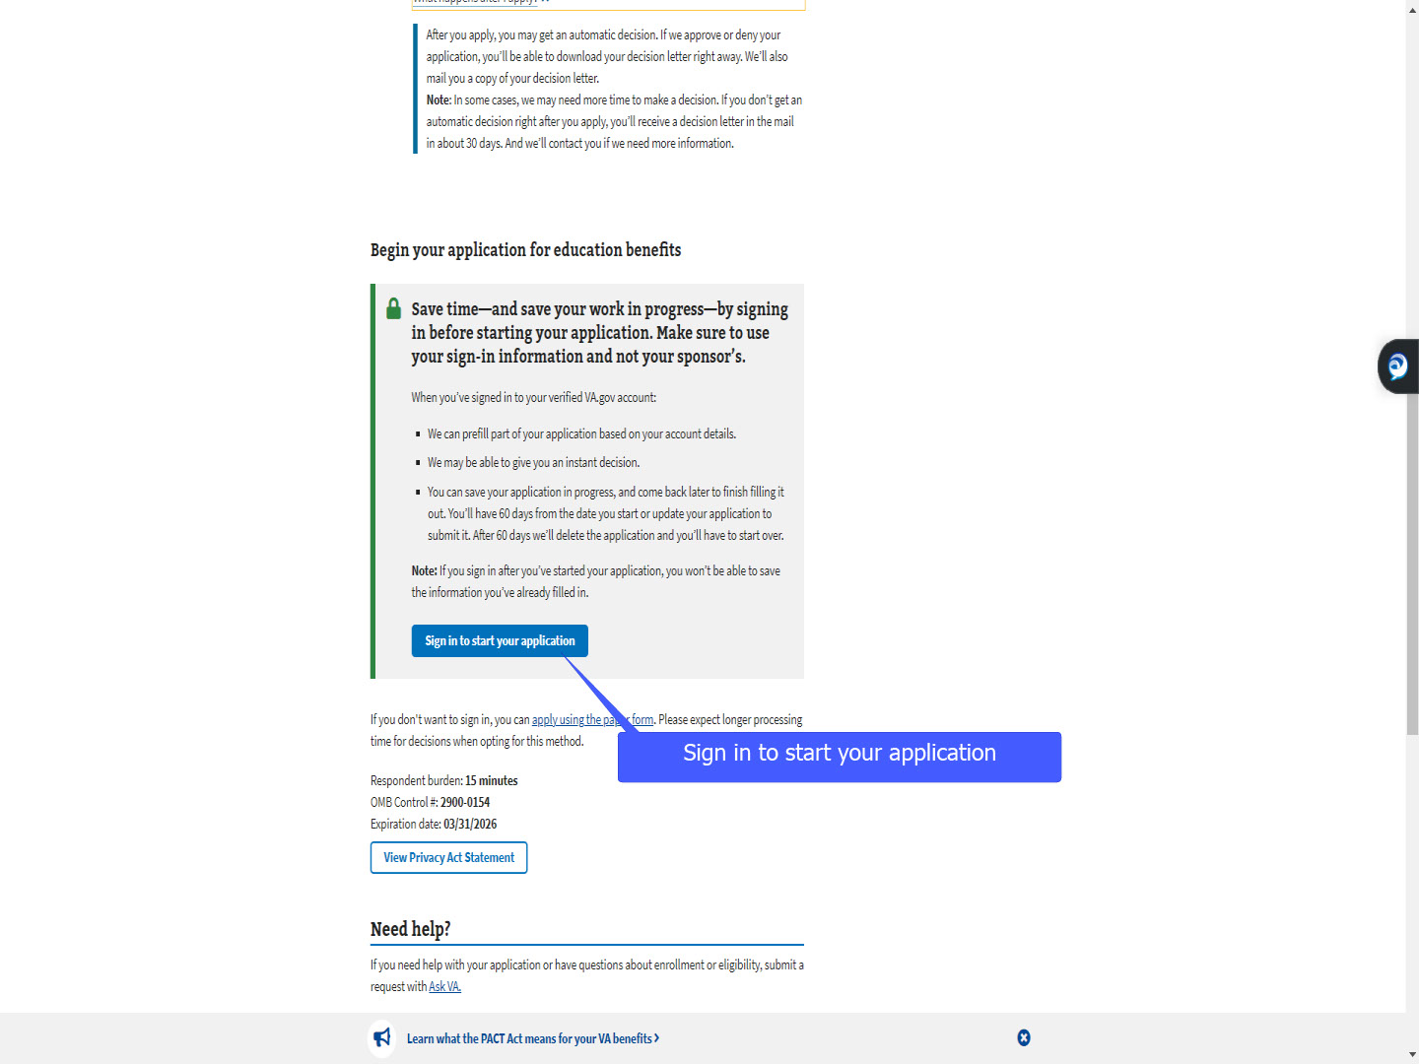
Script

Slide 25 - Apply using the paper form
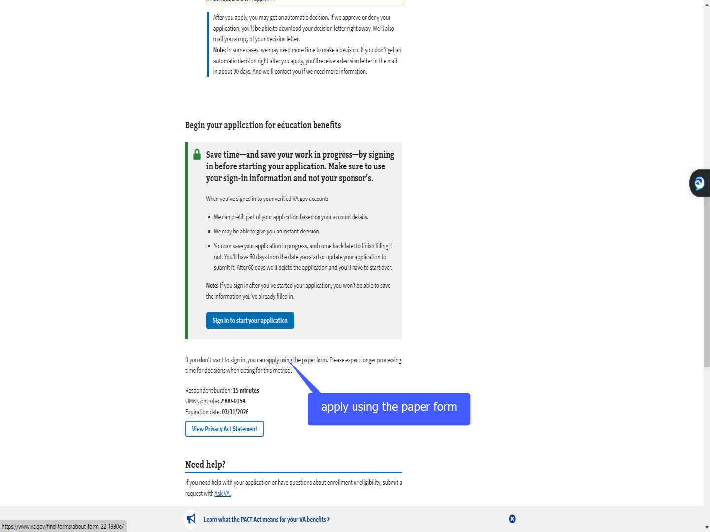
Script

If the applicant does not want to sign in, a link is provided to apply using the paper form.

Slide 26 - ID.me
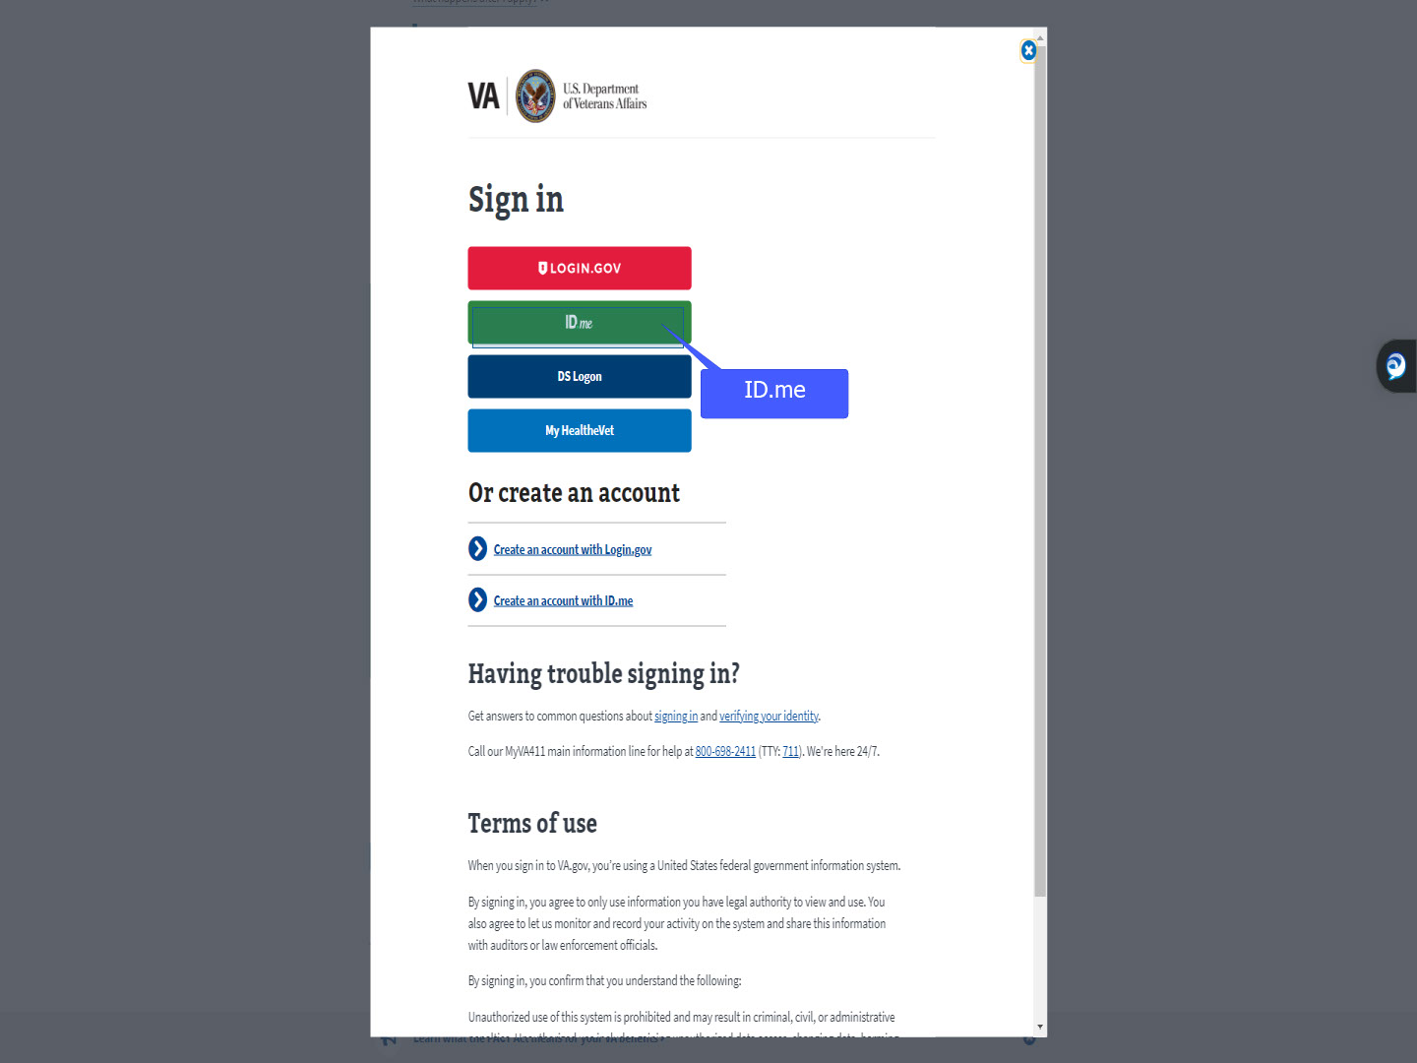
Script

As with all online applications, the applicant will need to authenticate their identity.

For today’s training, we will use ID.me.

Slide 27 - Slide 27
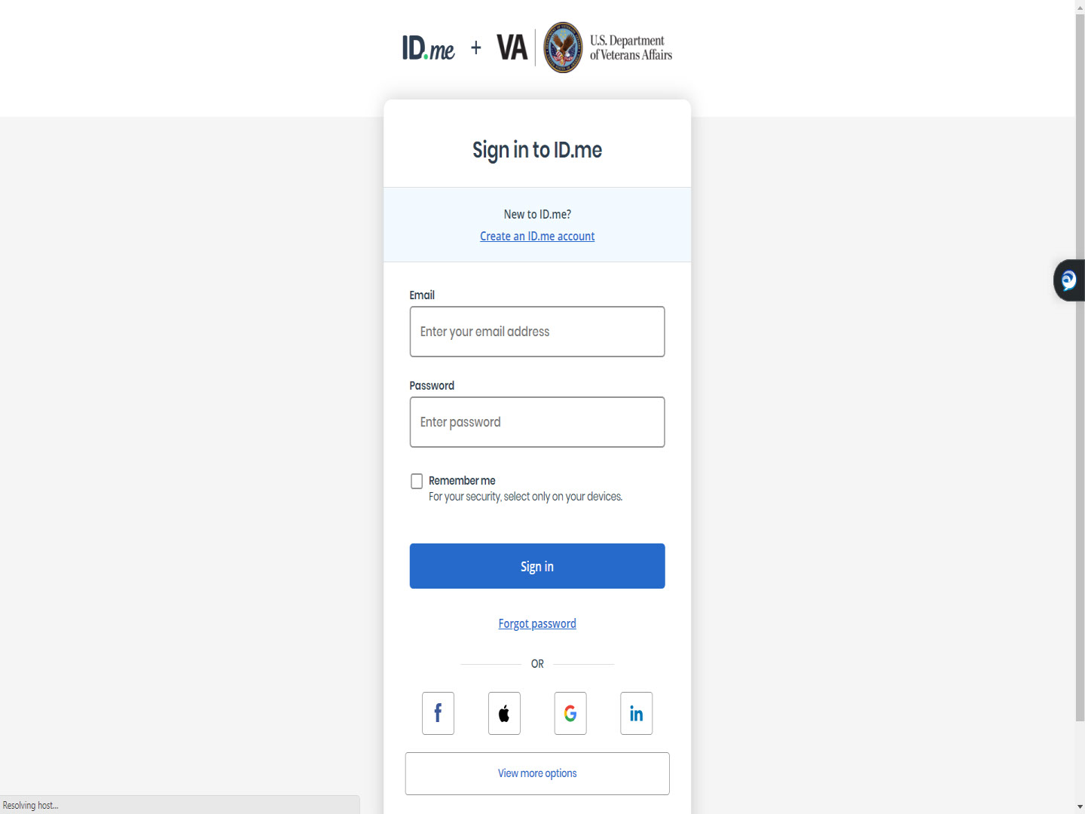
Script

Slide 28 - Sign In- ID.me
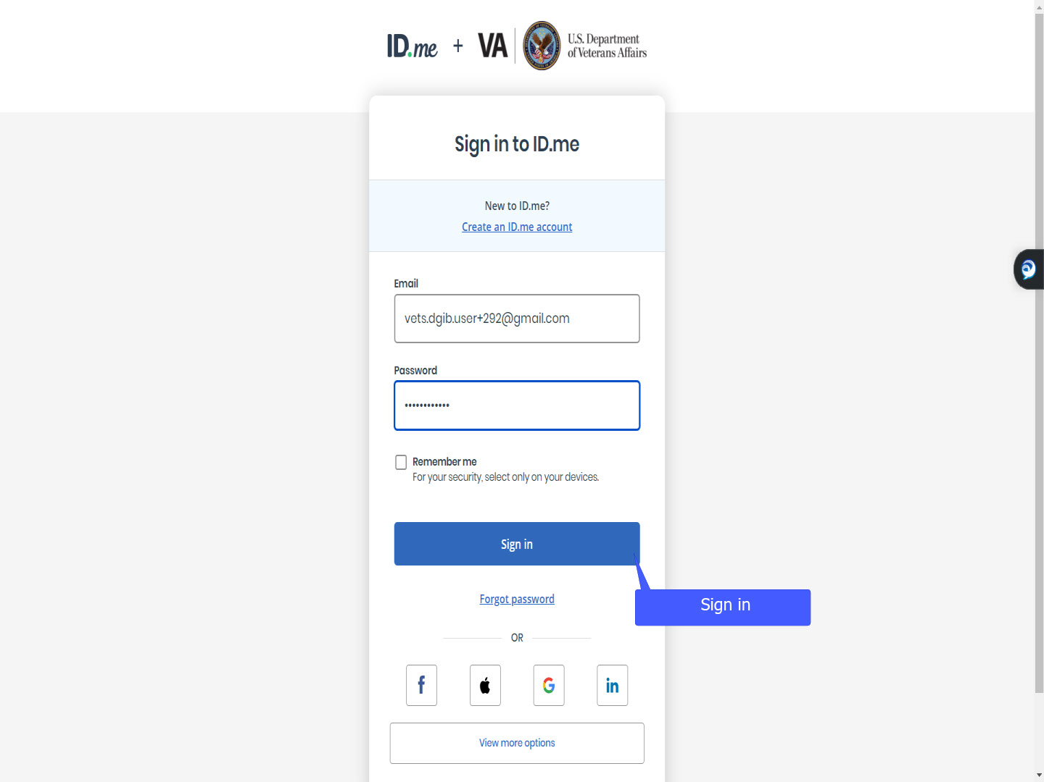
Script

Slide 29 - ID.me verification
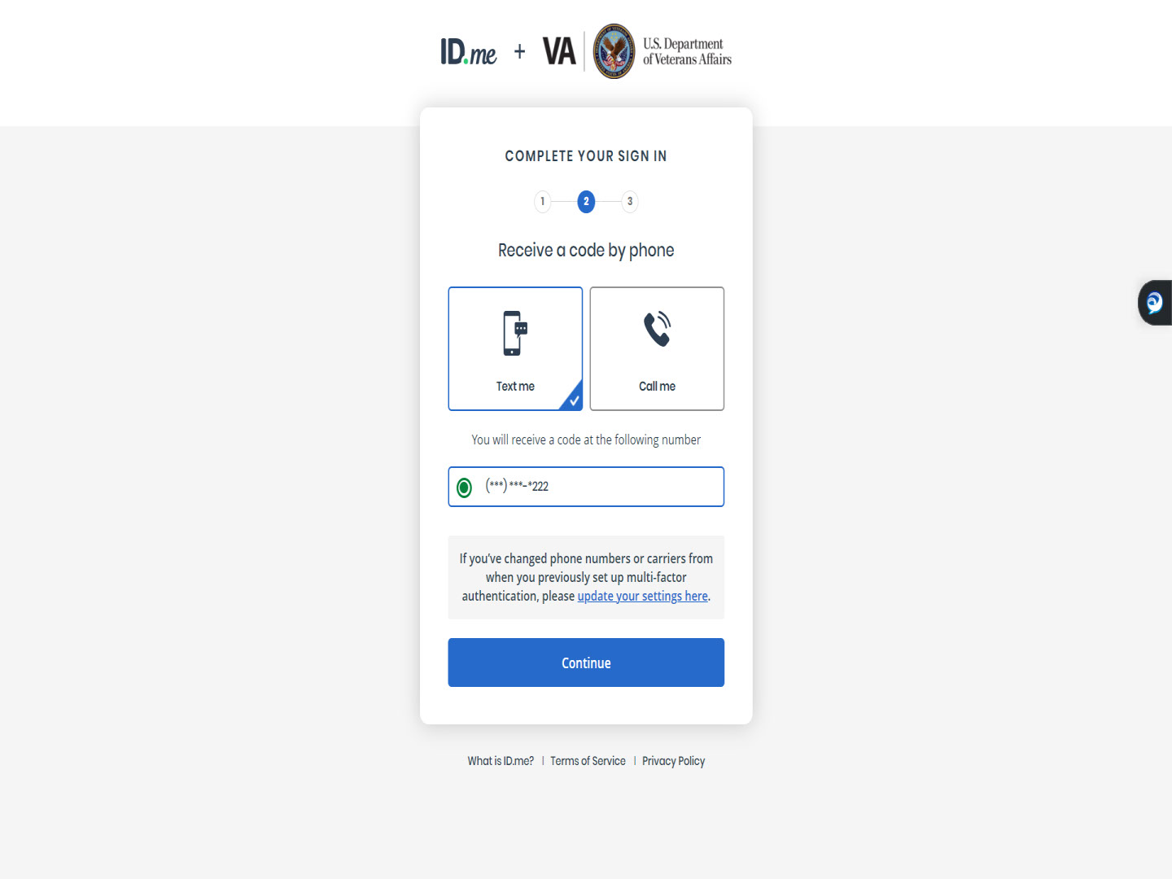
Script

Slide 30 - 6-digit code
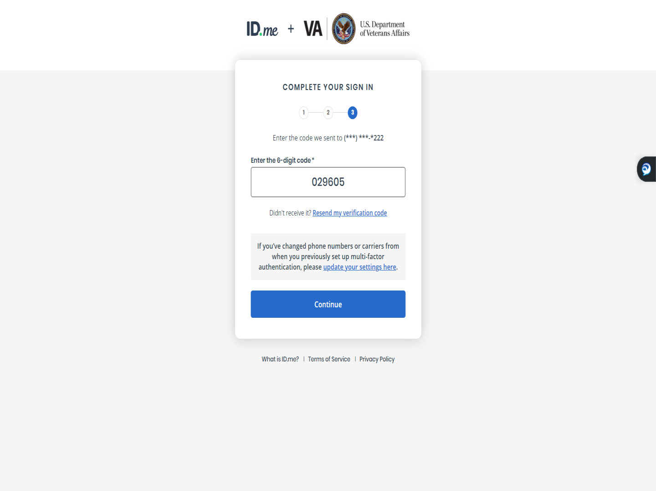
Script

Slide 31 - Slide 31
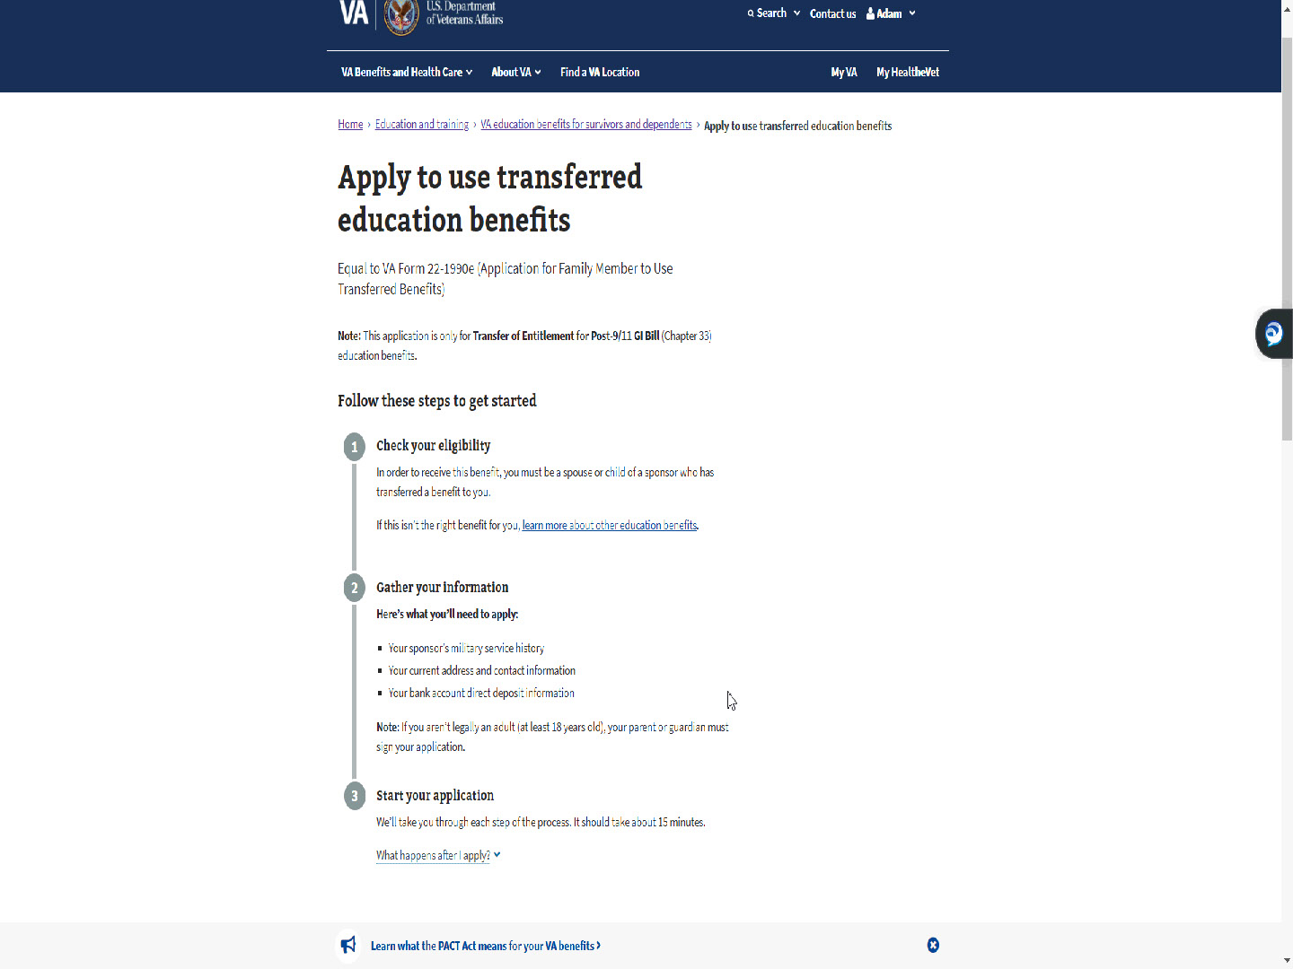
Script

Slide 32 - Slide 32
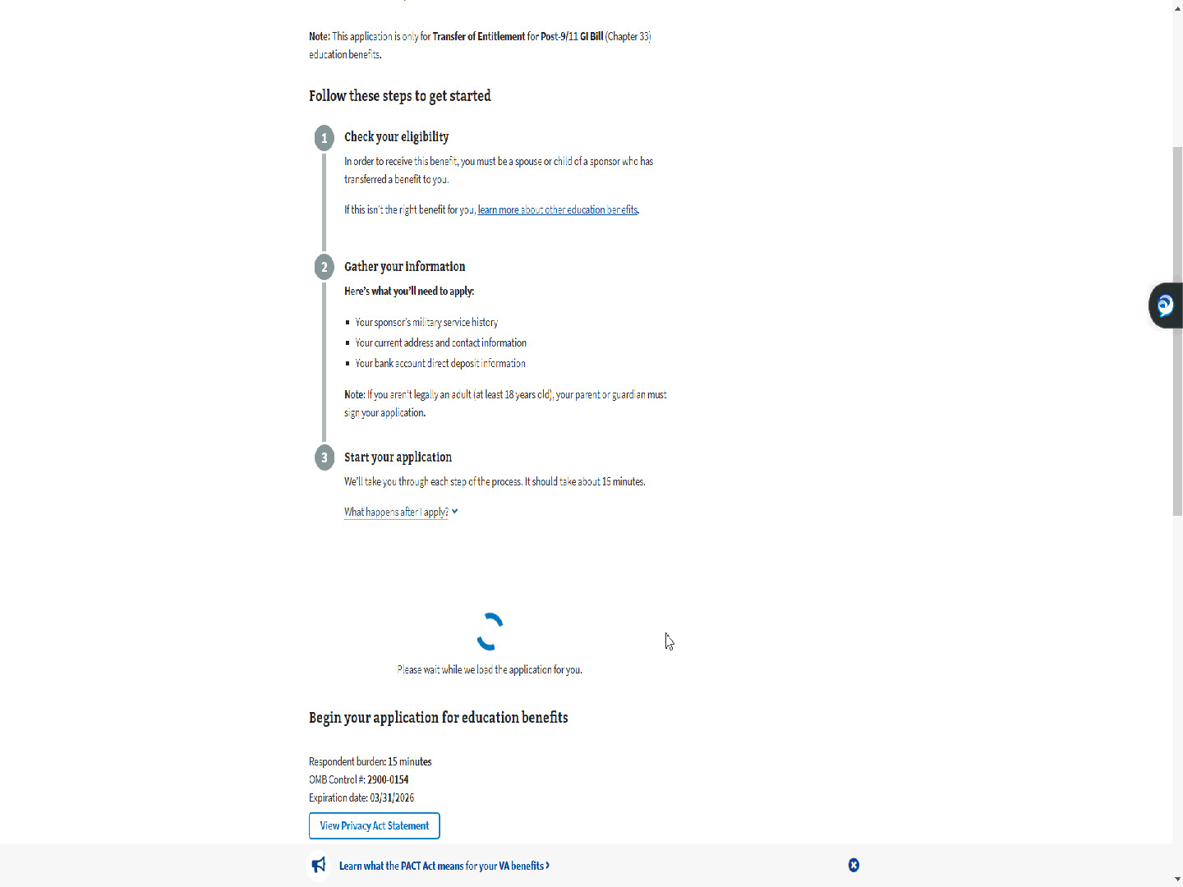
Script

Now the applicant is verified, and the application process will begin.

Slide 33 - Step 1: Your information
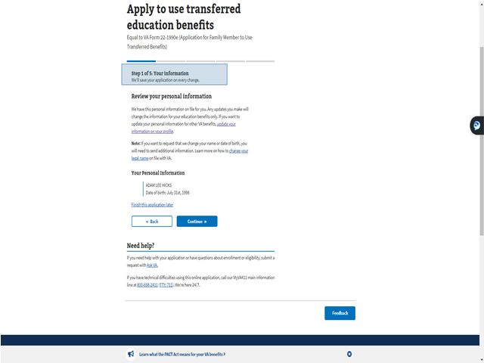
Script

Similar to the MEB Self applicant, Step 1 is Your information.

Slide 34 - Update your VA profile
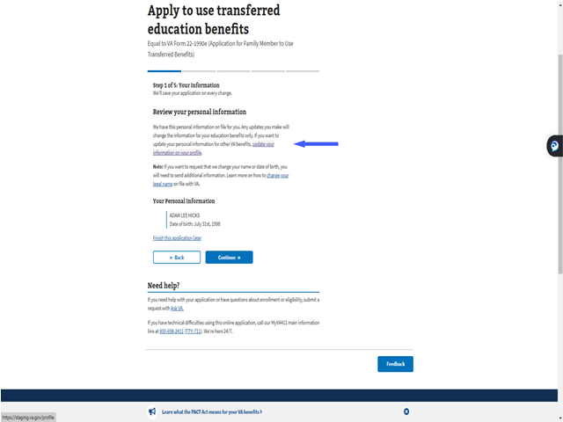
Script

Links are available to assist the applicant if the information is incorrect.

They are “update your information on your profile”, which updates the VA profile for all benefits,

Slide 35 - Change your legal name
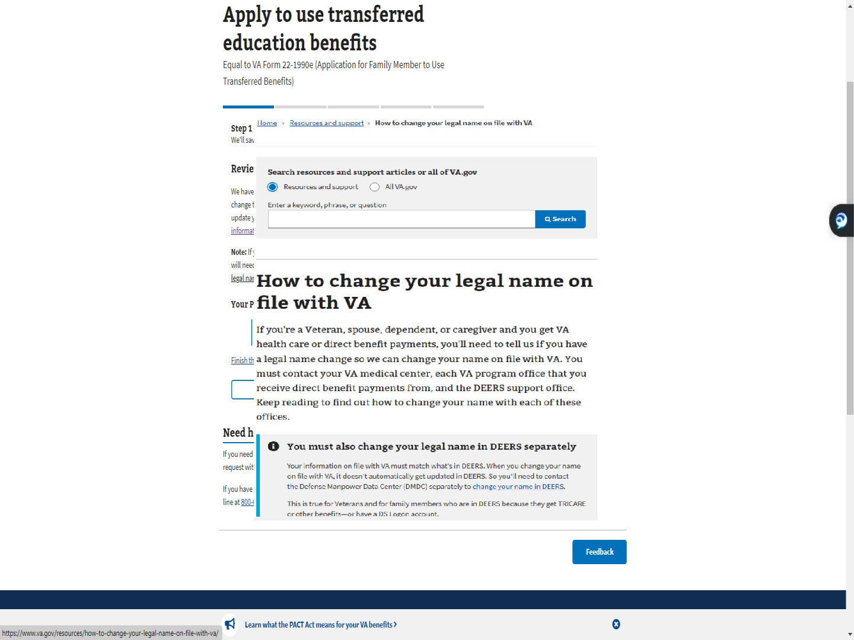
Script

and “Change your legal name”, which opens a separate resource window.

Slide 36 - Continue
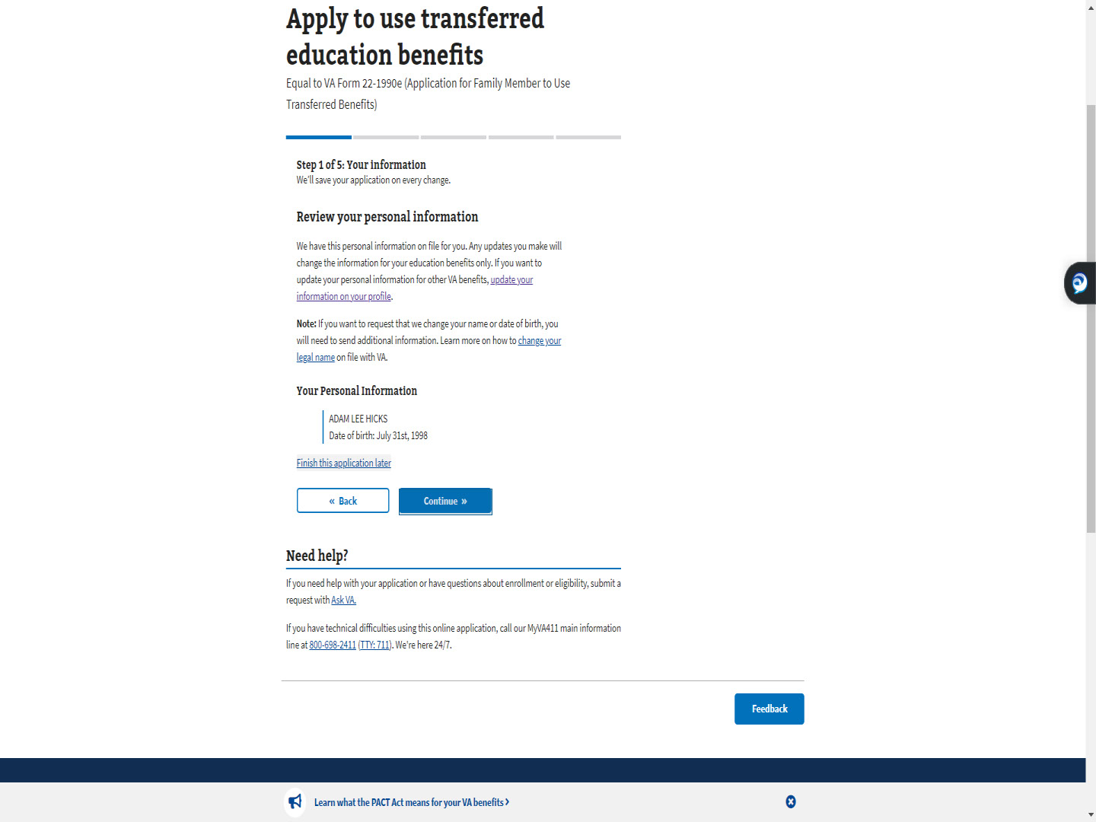
Script

For this demo, we will accept what is shown and select “Continue”.

Slide 37 - Knowledge Checks

Slide notes

Let’s do a few knowledge checks to making sure you’re tracking so far.

Slide 38 - Multiple Choice
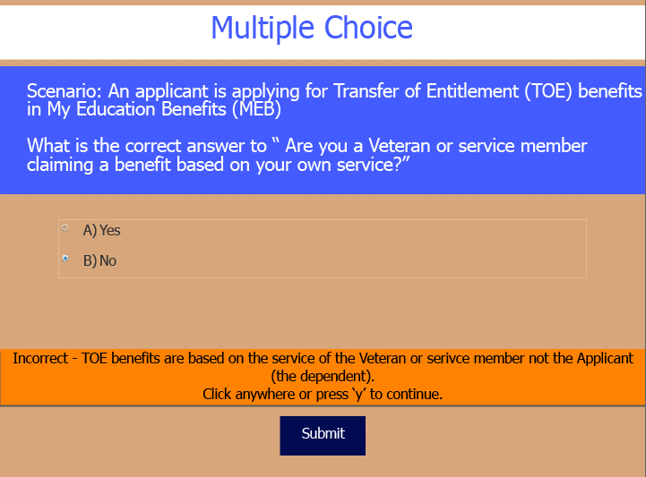
Slide notes

First, a multiple choice.
If a person is applying for TOE in MEB, should the applicant respond “Yes” or “No” to the question “Are you a Veteran or service member claiming a benefit based on your own service”?

Slide 39 - True or False
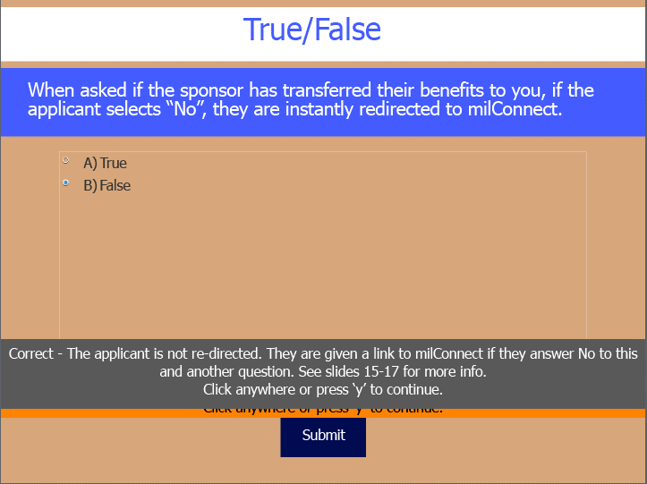
Slide notes

Next, True or False.
When asked the question “Has the sponsor transferred their benefits to you”,
if they select “No”, they are instantly redirected to the milConnect website.

Slide 40 - Multiple Choice
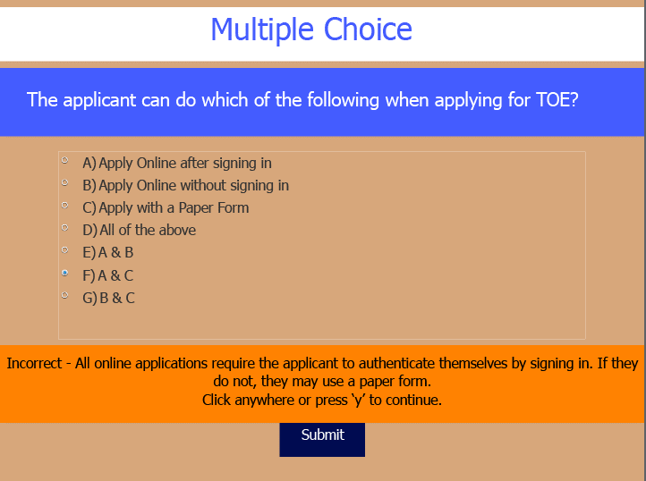
Slide notes

Last question.
Which of the following are ways one can apply for TOE?

Slide 41 - Back to the Demo

Slide notes

The PAWS is over.
Now back to the demo.

Slide 42 - Step 2: Sponsor information
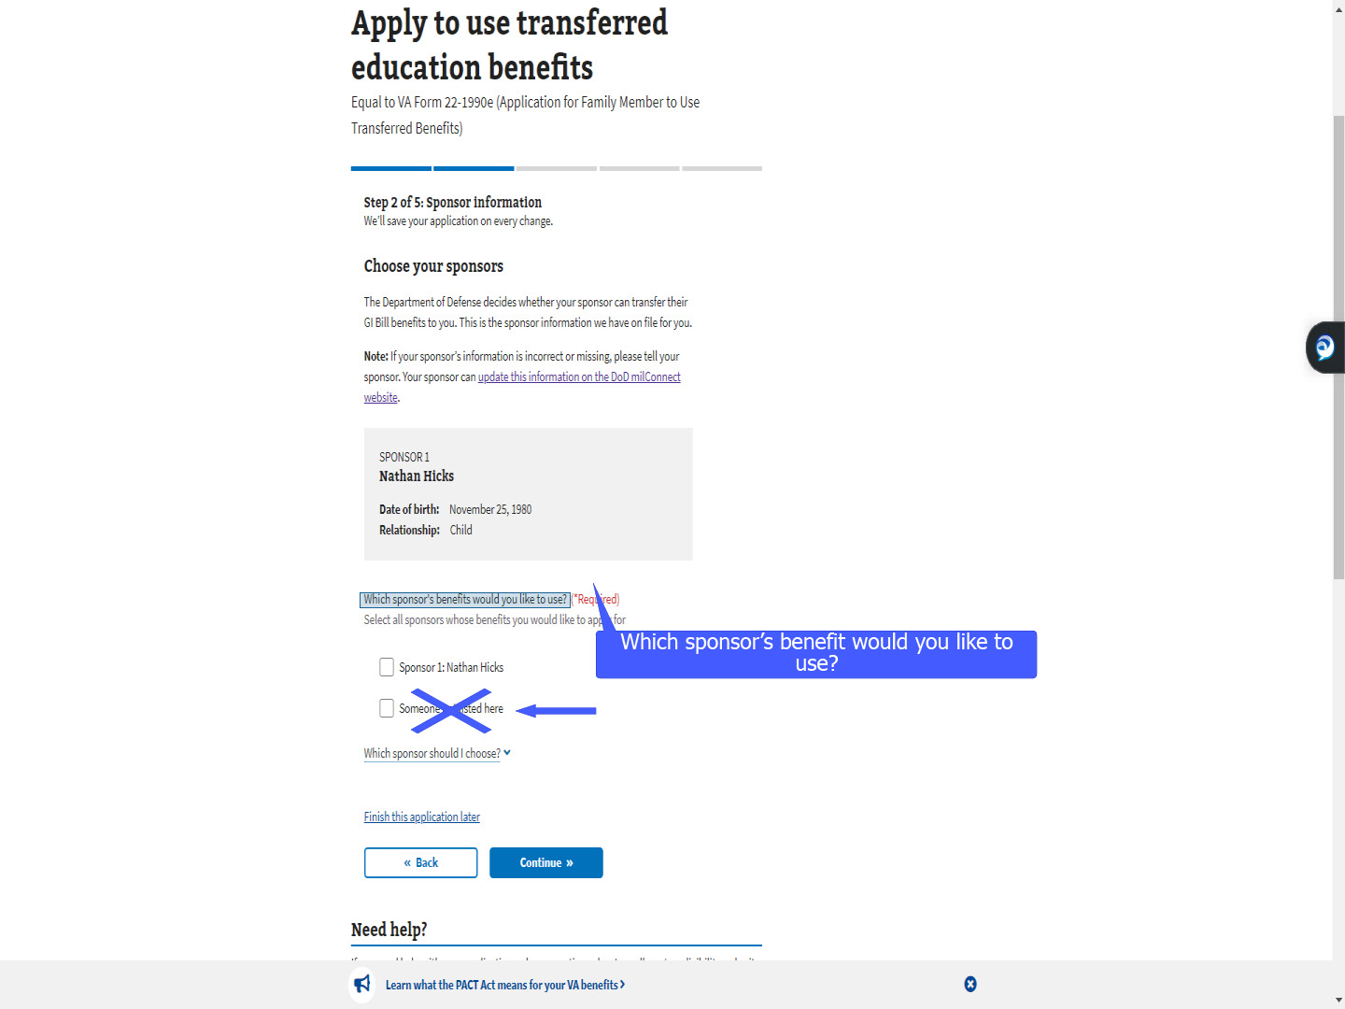
Script

“Step 2 of 5: Sponsor information” is next in the TOE MEB application. The applicant will select which sponsor’s benefit they would like to use.

Currently, the application gives the choice to select “Sponsor not listed”.

This will be removed in a future release.

Slide 43 - Which sponsor should I choose
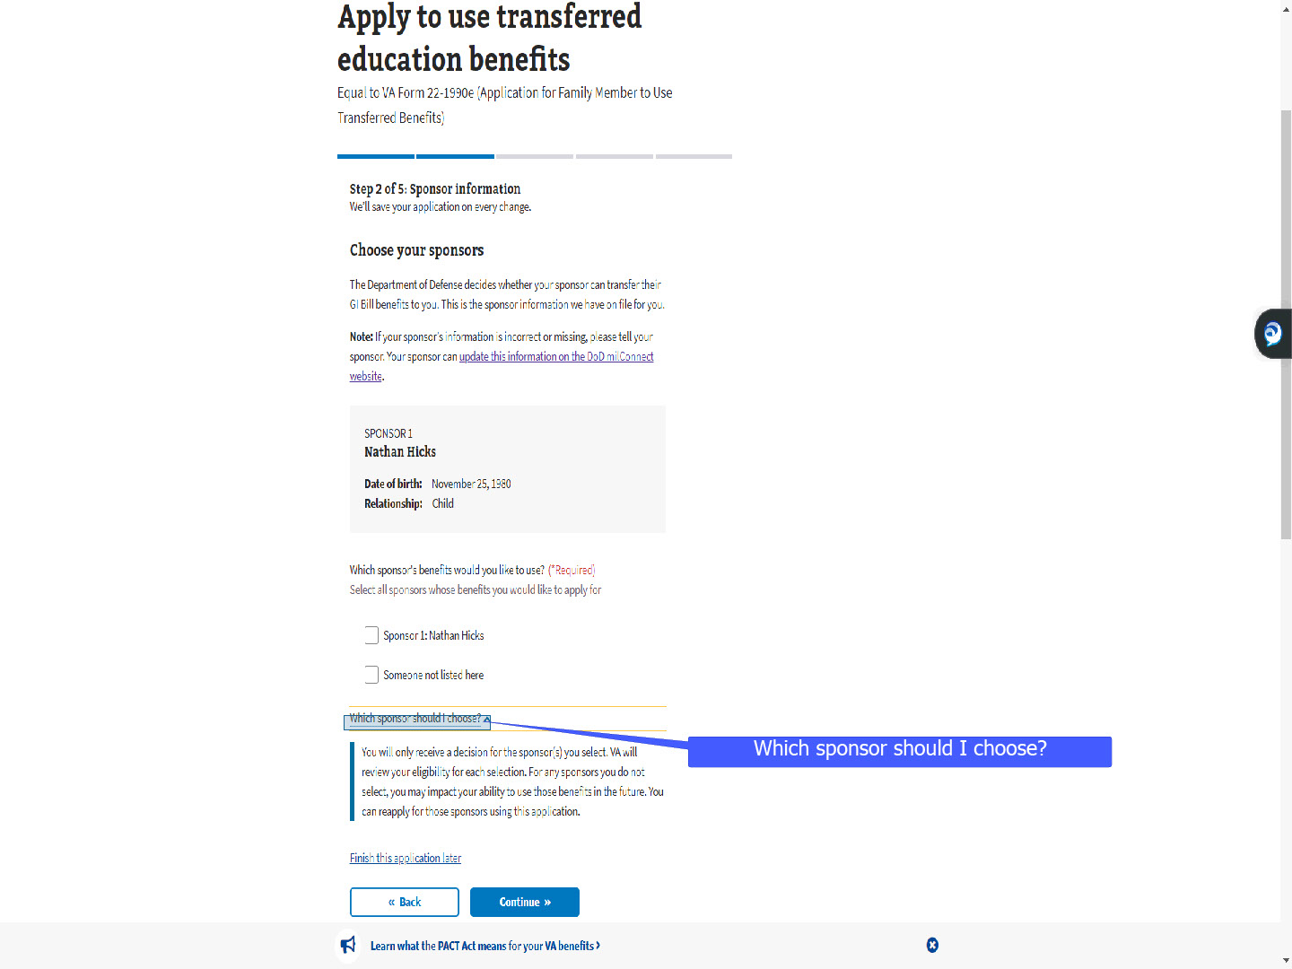
Script

As we saw in the previous demonstration, MEB has dropdowns with additional information.

For TOE, it offers help on which sponsor the dependent should choose.

Slide 44 - Multiple Sponsors
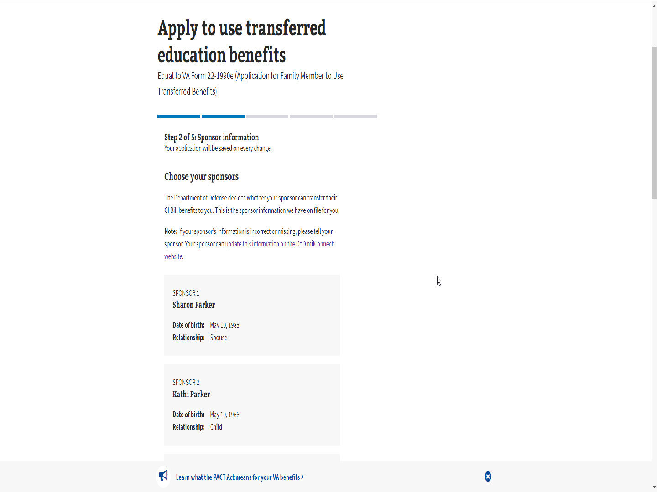
Script

For some dependents, there may be multiple sponsors.

Slide 45 - Select all sponsors whose benefits you would like to apply for
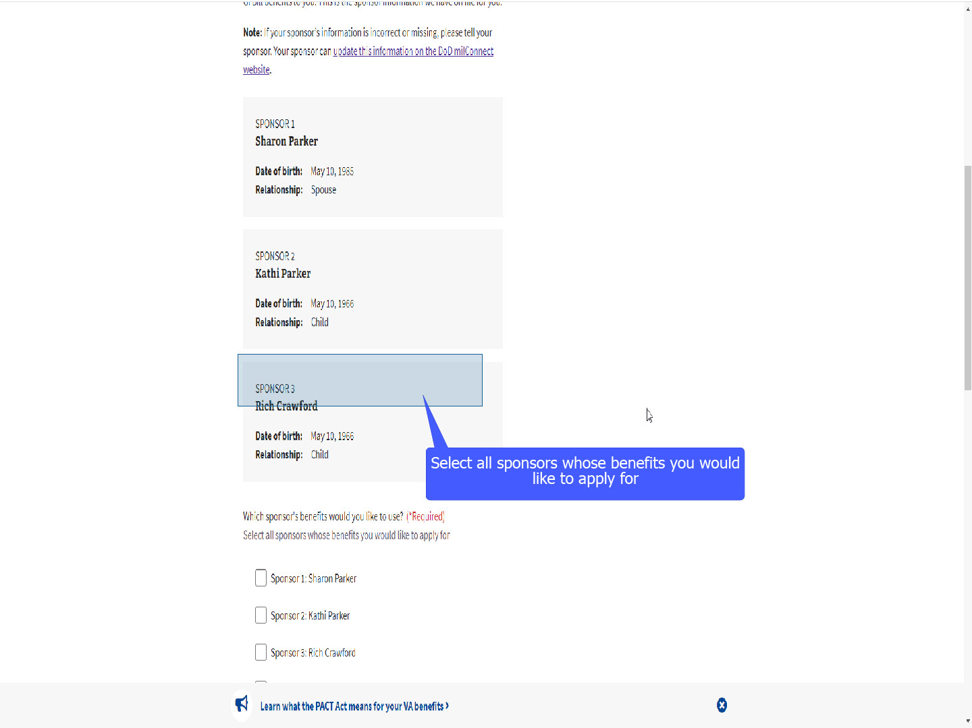
Script

The applicant will select ALL the sponsor’s whose benefit they would like to apply to use.

Slide 46 - Select multiple sponsors
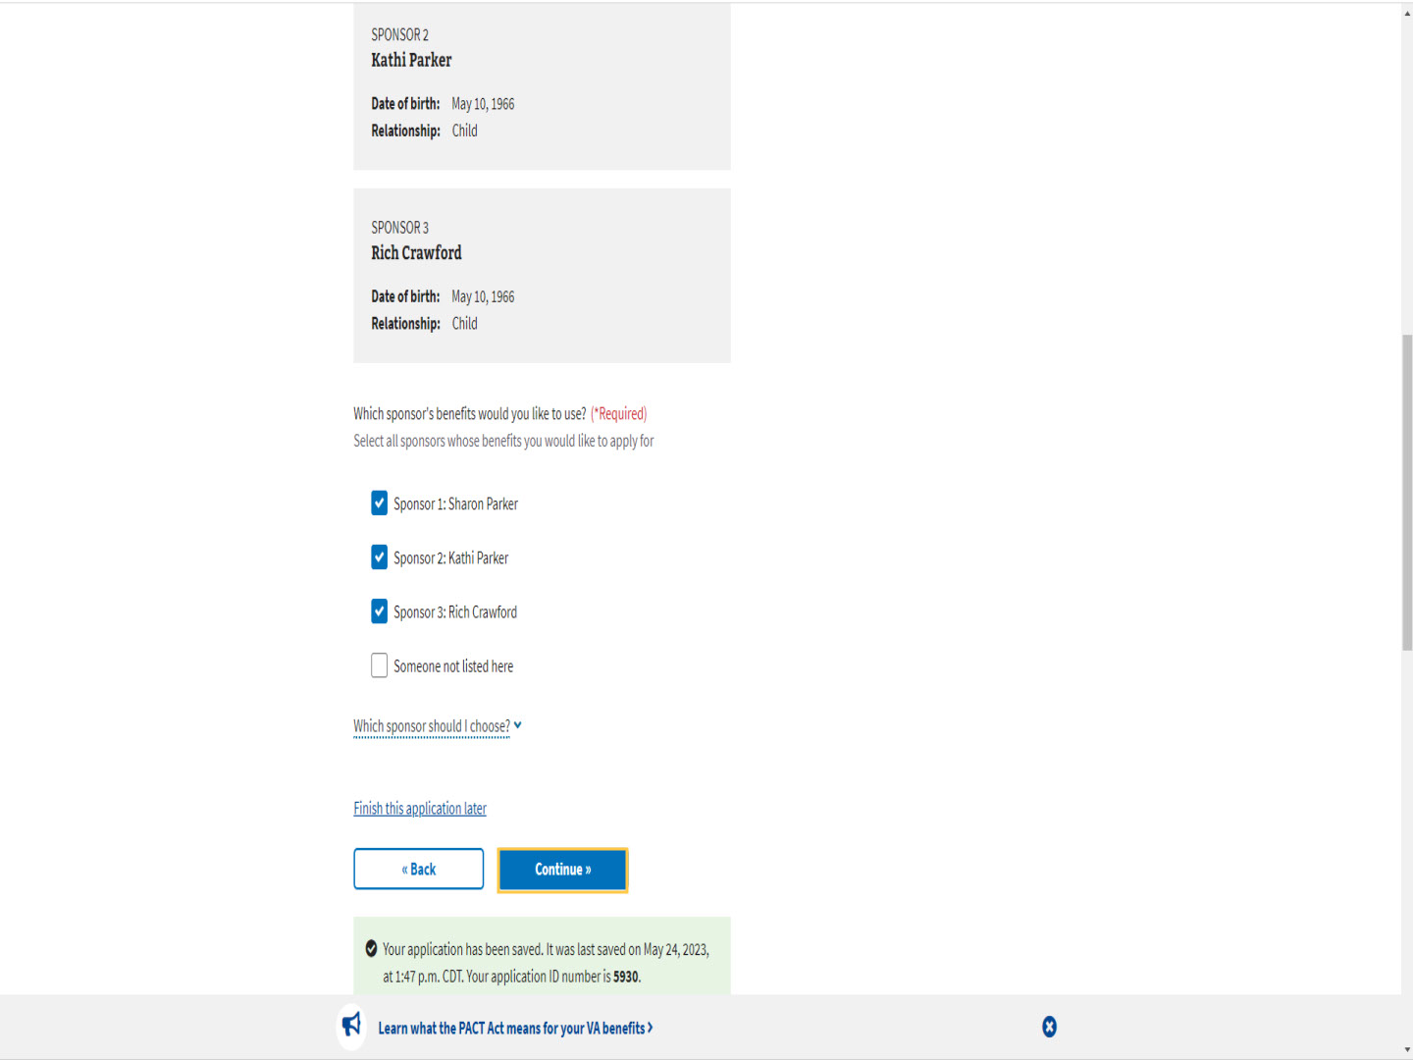
Script

If they select multiple sponsors and select continue,

Slide 47 - Which sponsor should I use first?
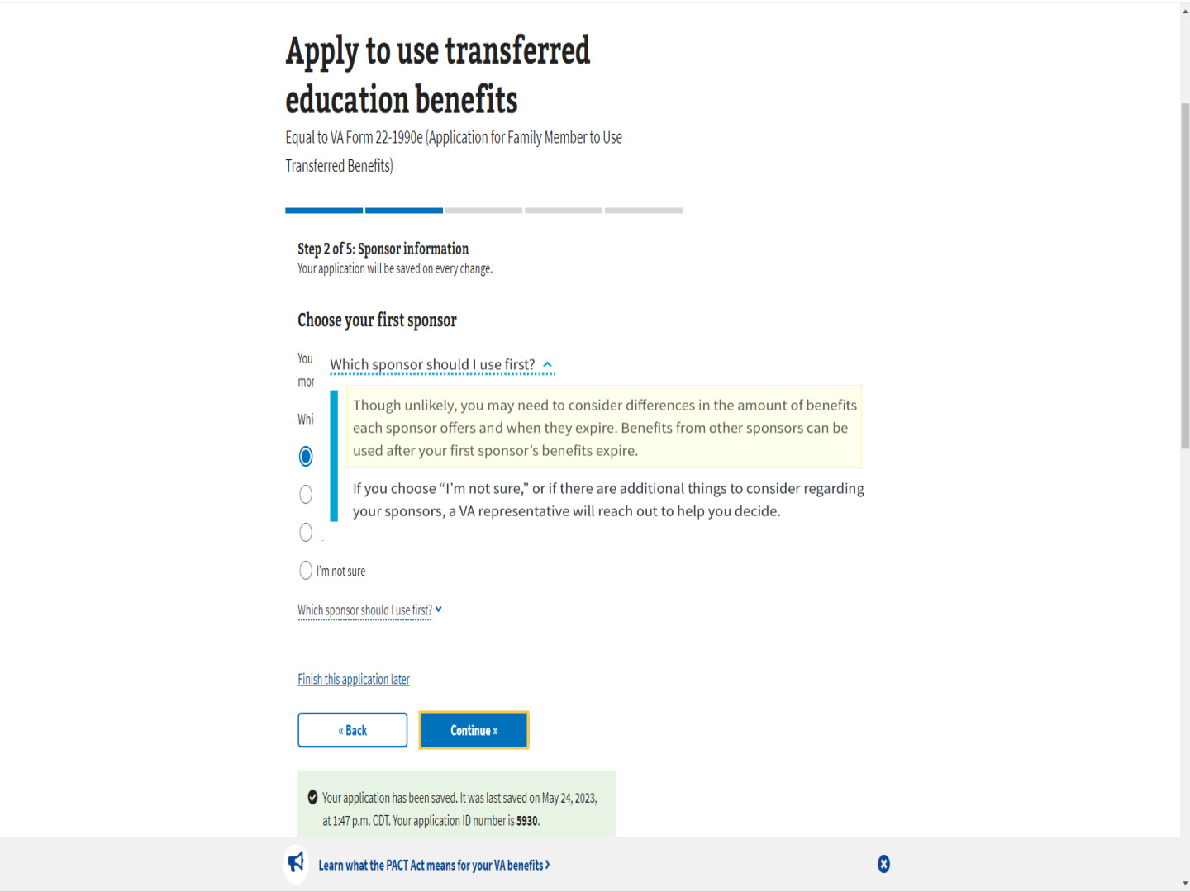
Script

MEB offers a dropdown, “Which sponsor should I use first?”

The pop-up states “Though unlikely, you may need to consider differences in the amount of benefits each sponsor offers and when they expire. Benefits from other sponsors can be used after your first sponsor’s benefits expire.

Slide 48 - Which sponsor should I use first cont.
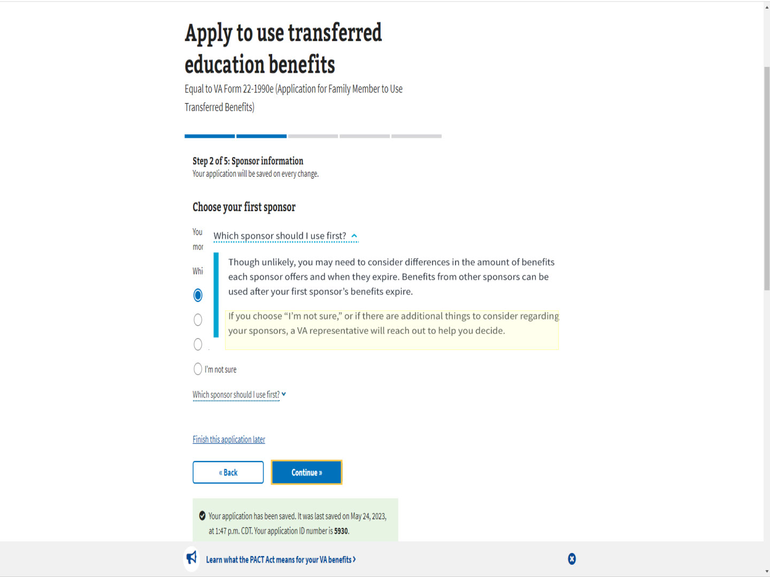
Script

If you choose “I’m not sure”, or if there are additional things to consider regarding your sponsors, a VA representative will reach out to help you decide. “

Slide 49 - One Sponsor
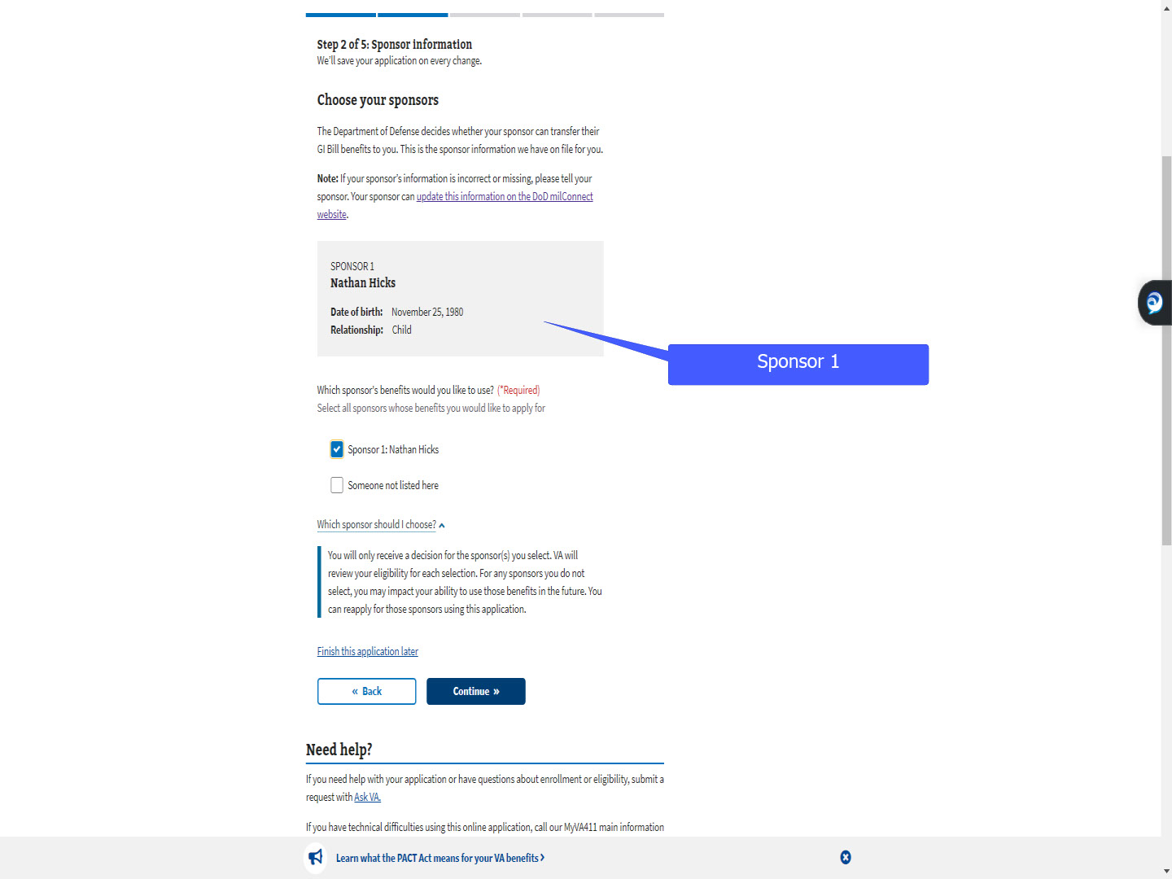
Script

For today’s demonstration, we will use an applicant with only one sponsor.

Slide 50 - Verify your high school education
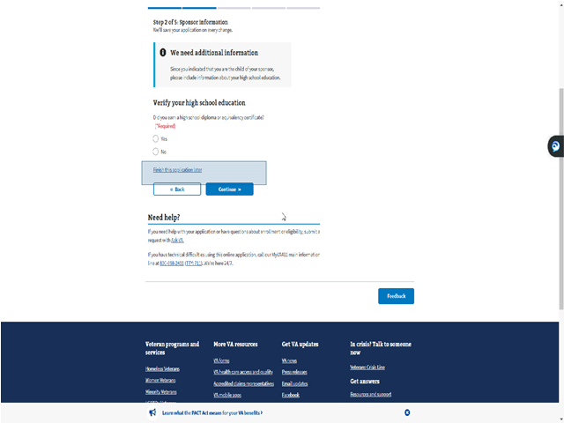
Script

The next step under “Sponsor information” is verifying their high school education if they are a child of the sponsor.

Slide 51 - Slide 51
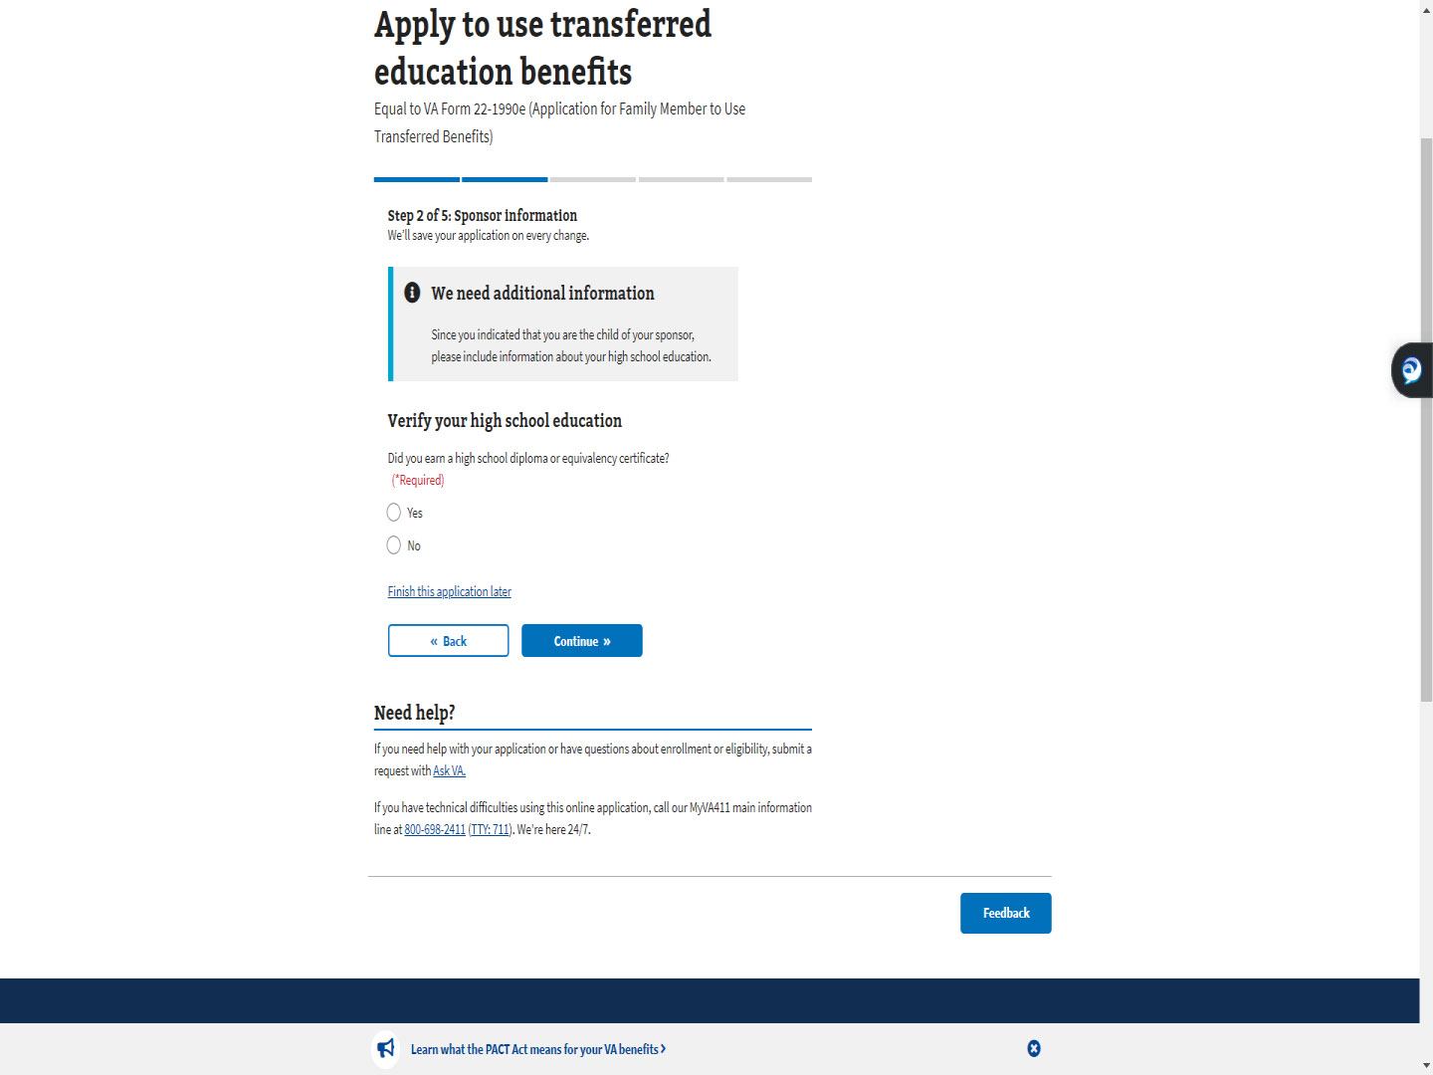
Script

The child would select “Yes” or “No’ as to whether they earned a high school diploma or GED.

Slide 52 - Slide 52
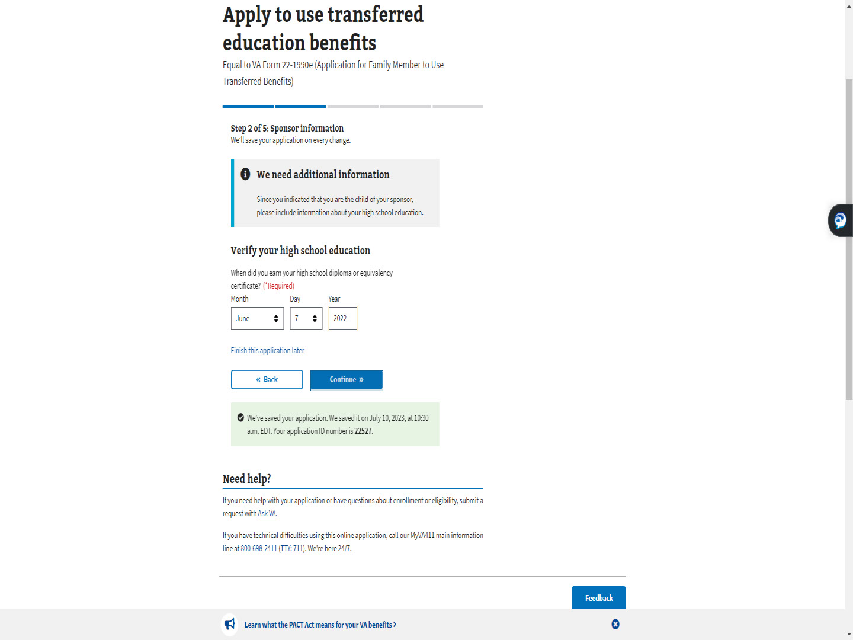
Script

If they selected “Yes”, MEB will ask for the date.

If they are a dependent spouse, education is not addressed.

Slide 53- Step 3: Contact information
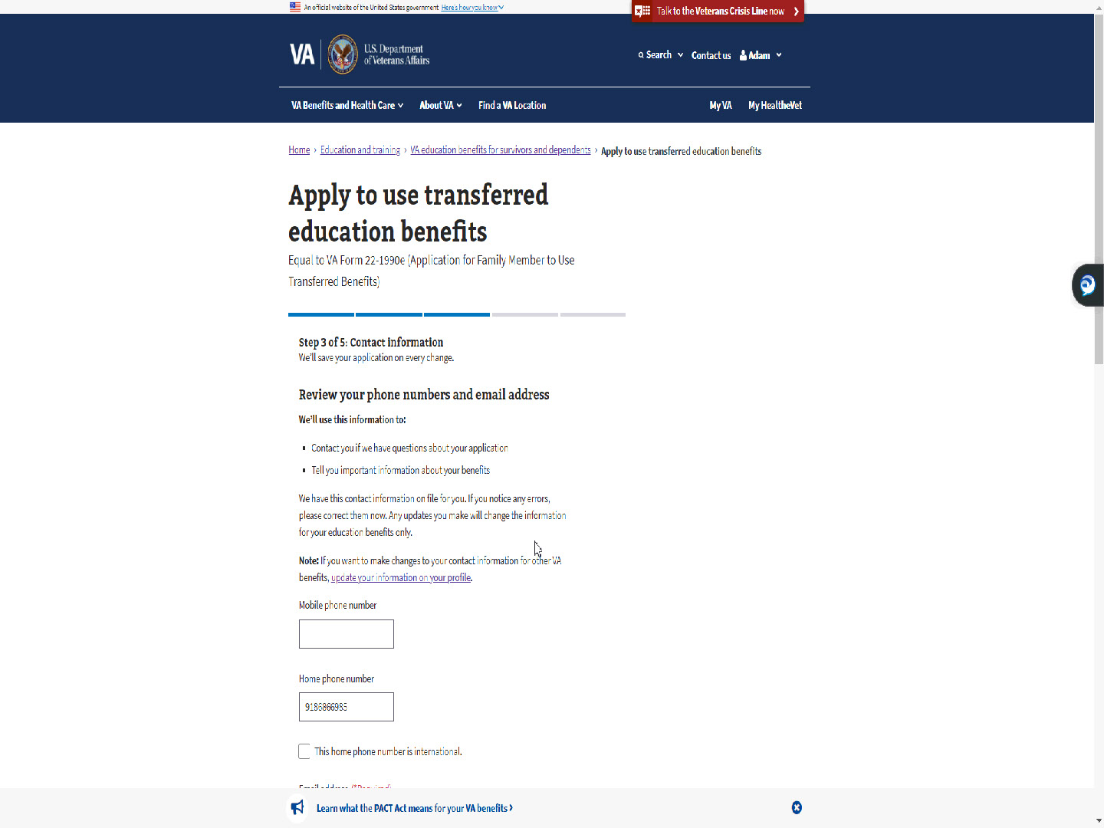
Script

Step 3 of 5 is Contact Information. The phone numbers and email address are pre-populated.

The TOE applicant can update this information in MEB for their Education benefits.

Slide 54 - Slide 54
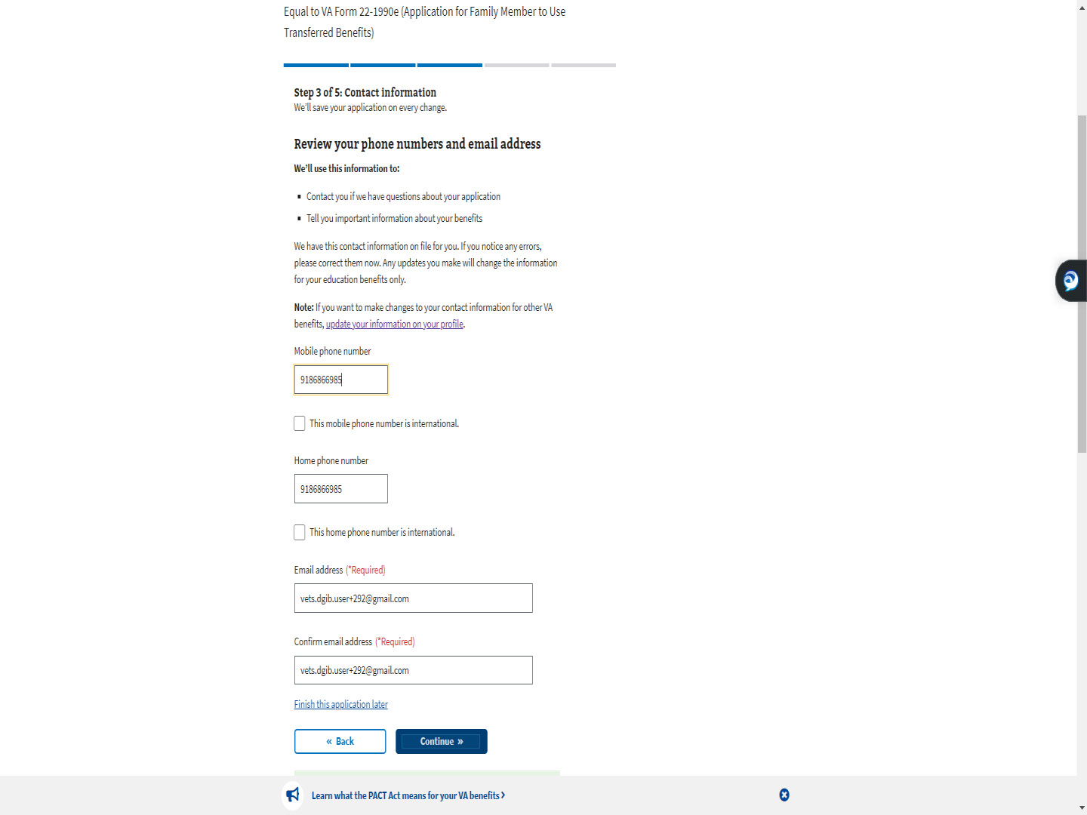
Script

Slide 55 - VA profile vs MEB
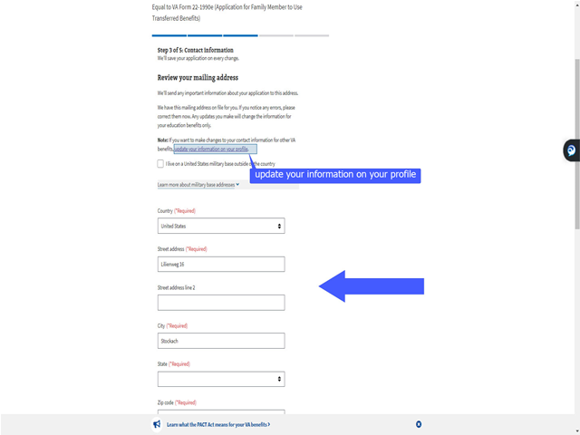
Script

While reviewing their mailing address, all “*Required” fields must be filled.

Updating the fields in MEB does not update the address for other VA benefits.

If the applicant wants to update for all VA benefits, to include compensation and pension, they will need to click the link “update your information on your profile”.

Slide 56 - Slide 56
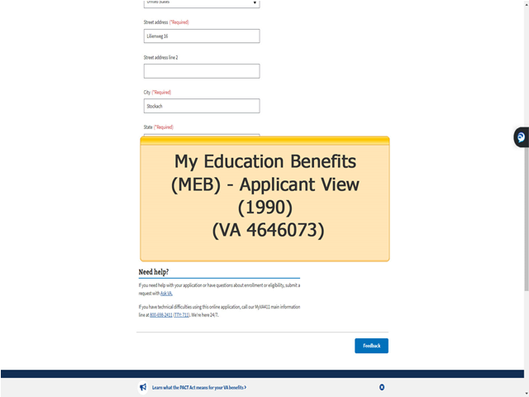
Script

The MEB Applicant View (1990) training covers the differences in the profiles and provides more detailed information on the contact information section of MEB.

Slide 57 - Contact method for follow-up
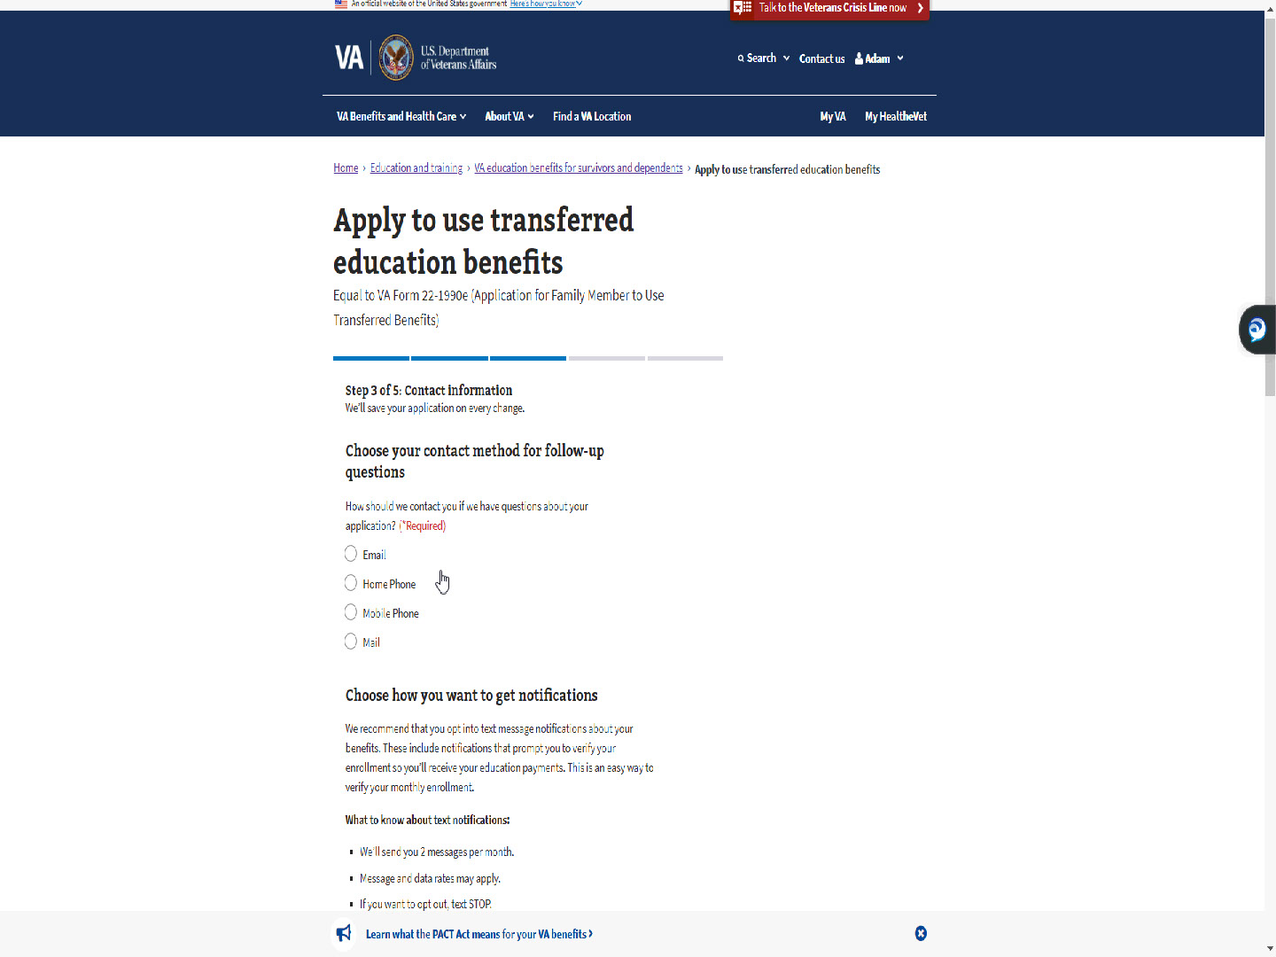
Script

The TOE applicant will need to choose a method of contact for follow-up questions and notifications.

Slide 58 - Slide 58
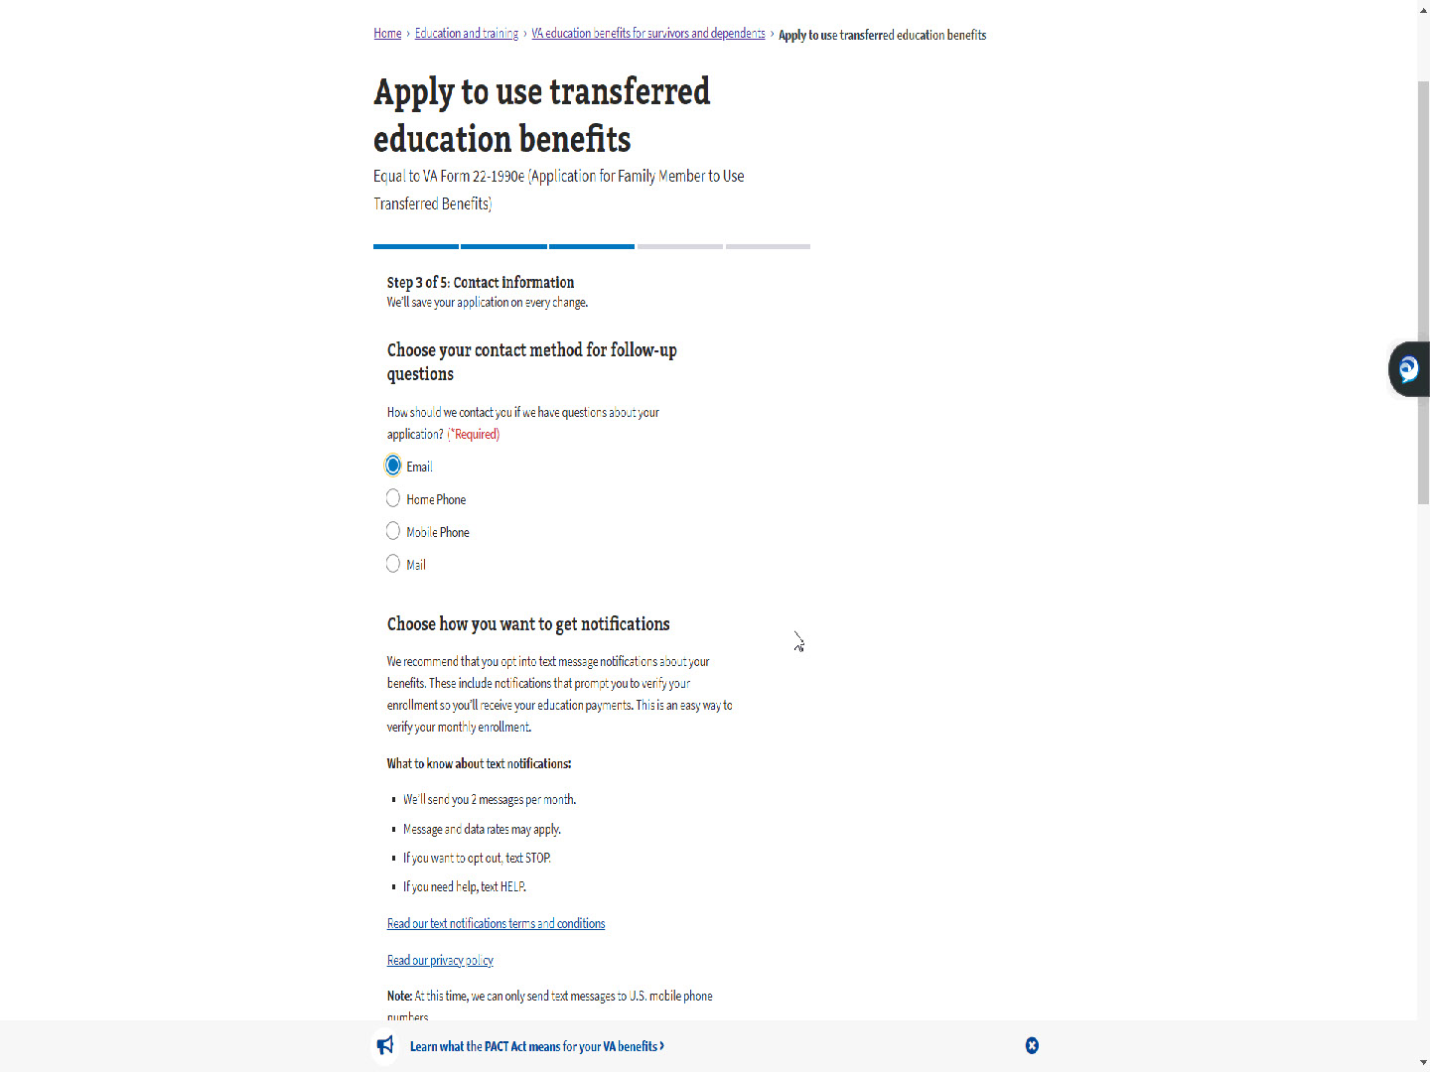
Script

Slide 59 - Choose how you want to get notifications
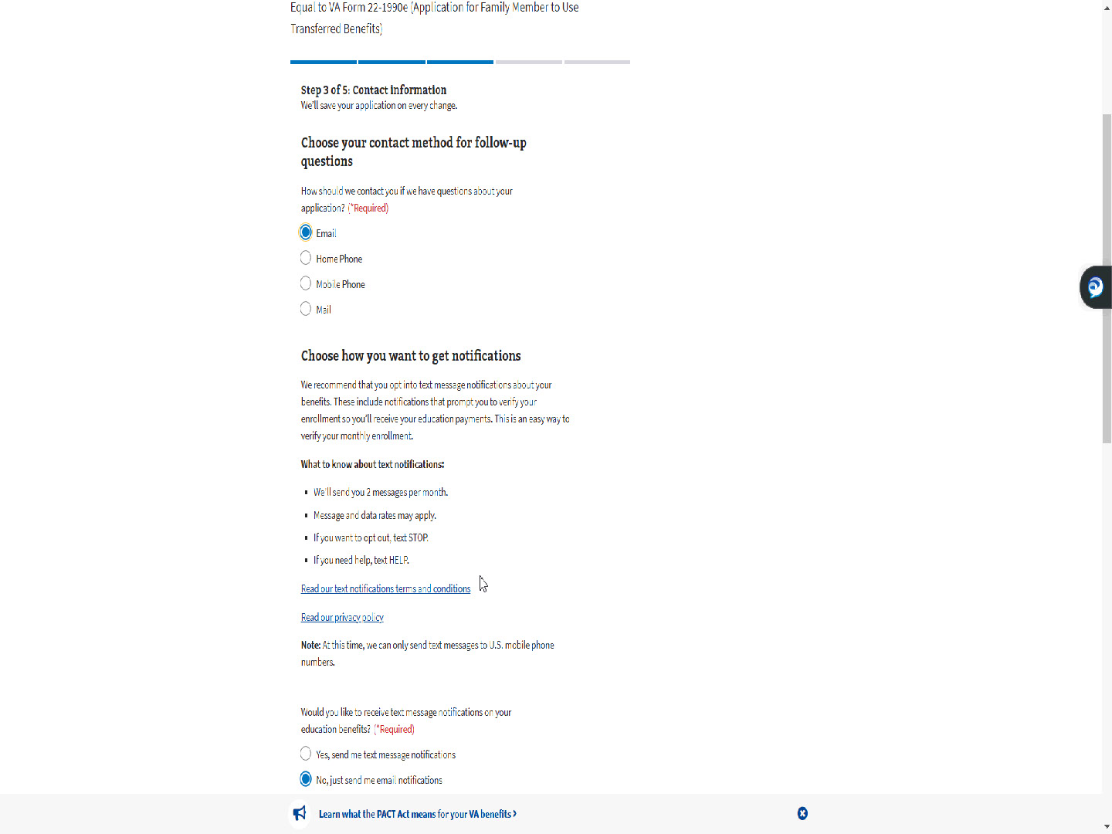
Script

Similar to the Self MEB application, the follow-up question defaults to “Email”.

Slide 60 - Default- No
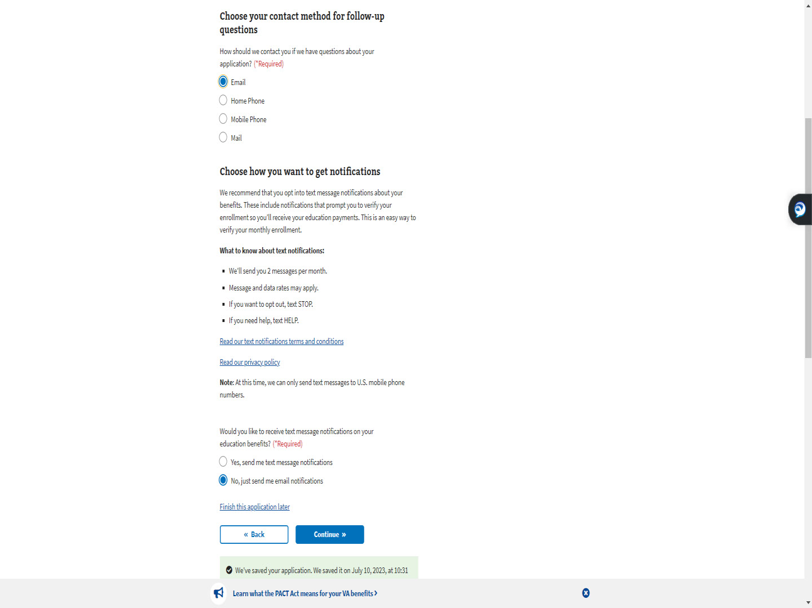
Script

Unlike the Self MEB application, text messaging defaults to “No”.

Slide 61 - Slide 61
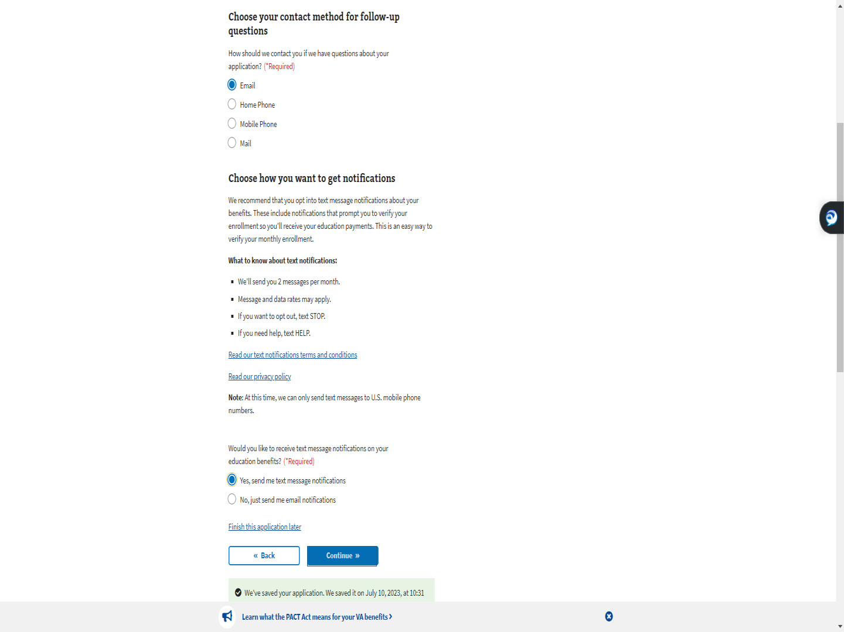
Script

Slide 62 - Step 4: Direct deposit
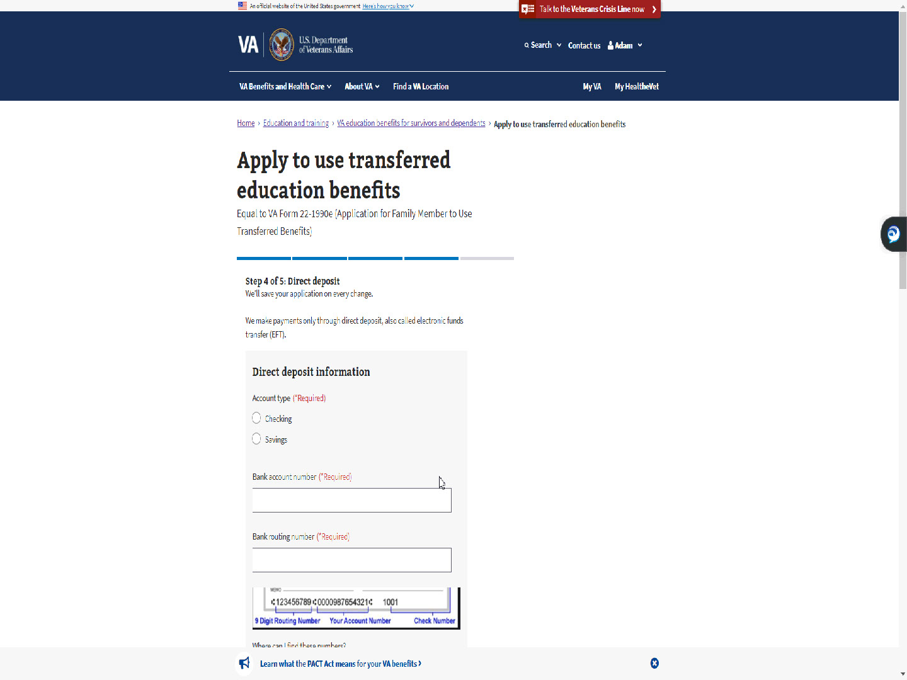
Script

The next step is Step 4: Direct deposit.

Slide 63 - Slide 63
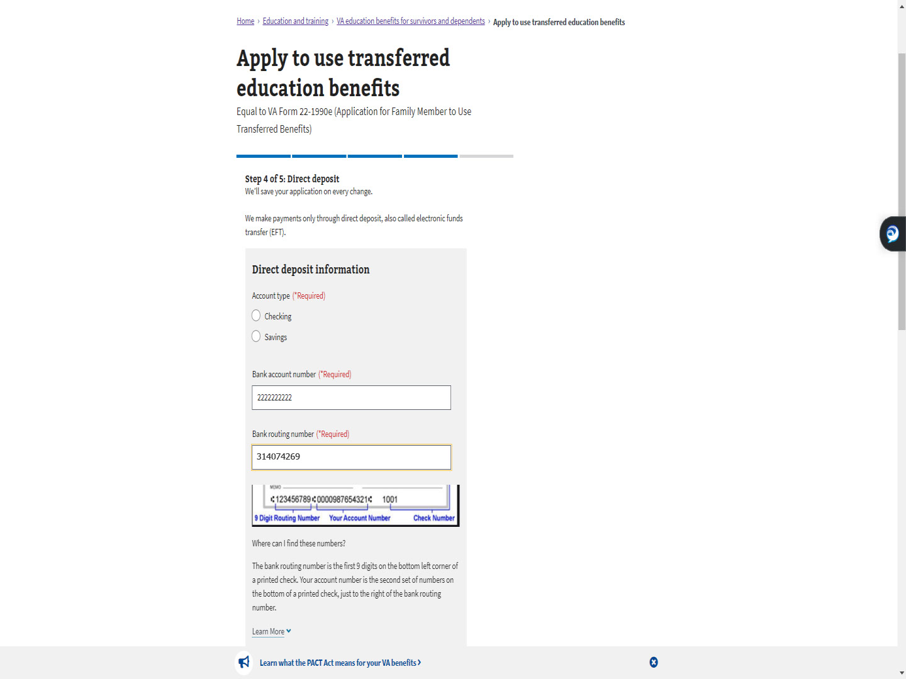
Script

The applicant will enter their direct deposit information.

Slide 64 - Slide 64
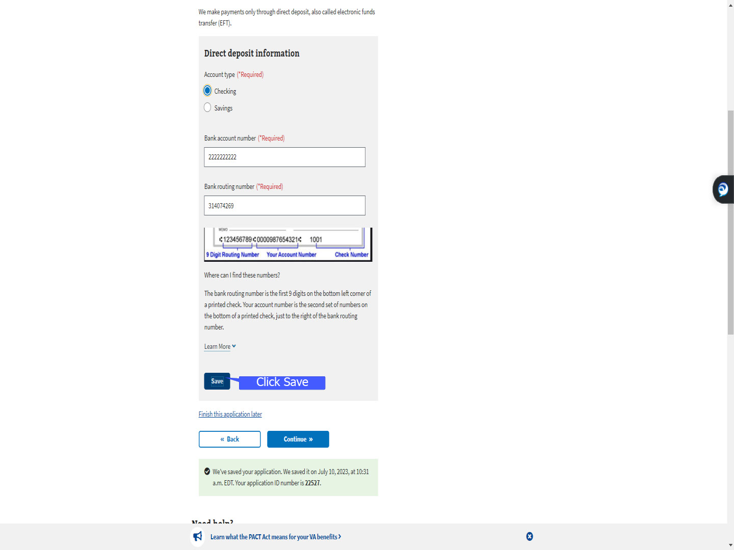
Script

An update to MEB, now asks them to select “Save”.

Slide 65 - Slide 65
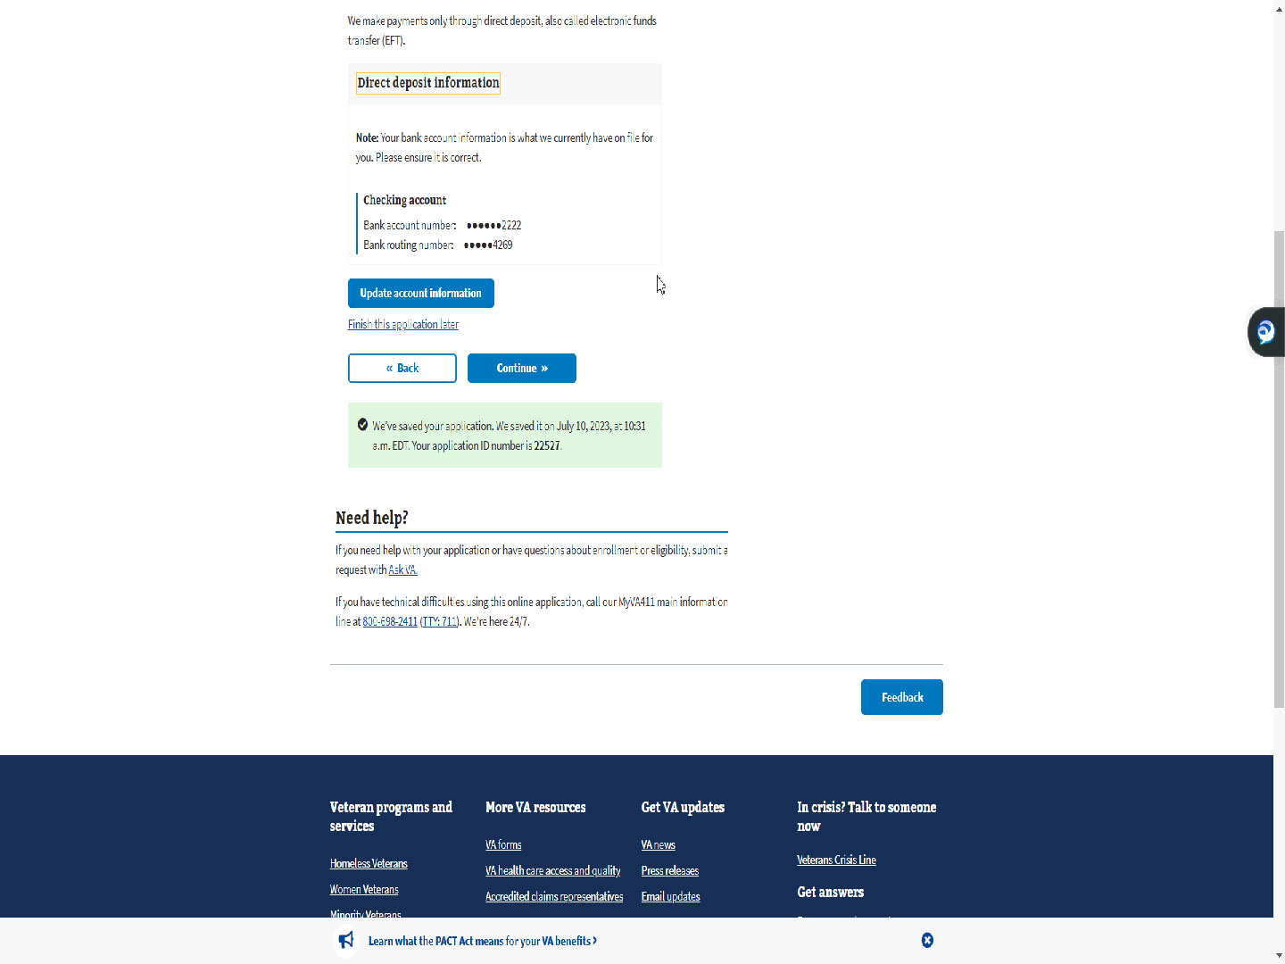
Script

They are shown their direct deposit information one more time and given the opportunity to “Update account information” before advancing.

Slide 66 - Slide 66
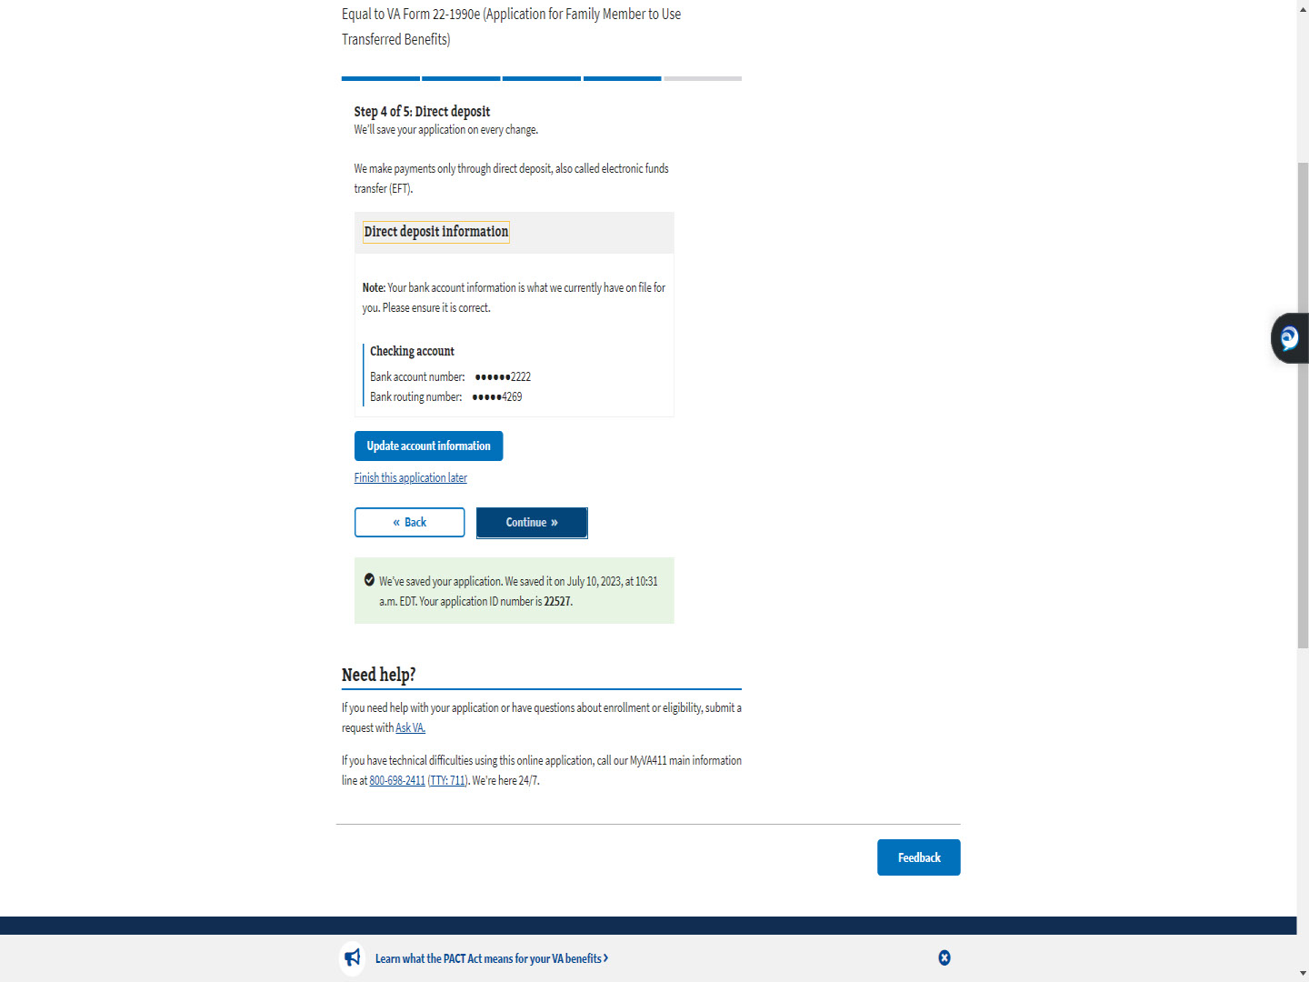
Script

Slide 67 - Step 5: Review application
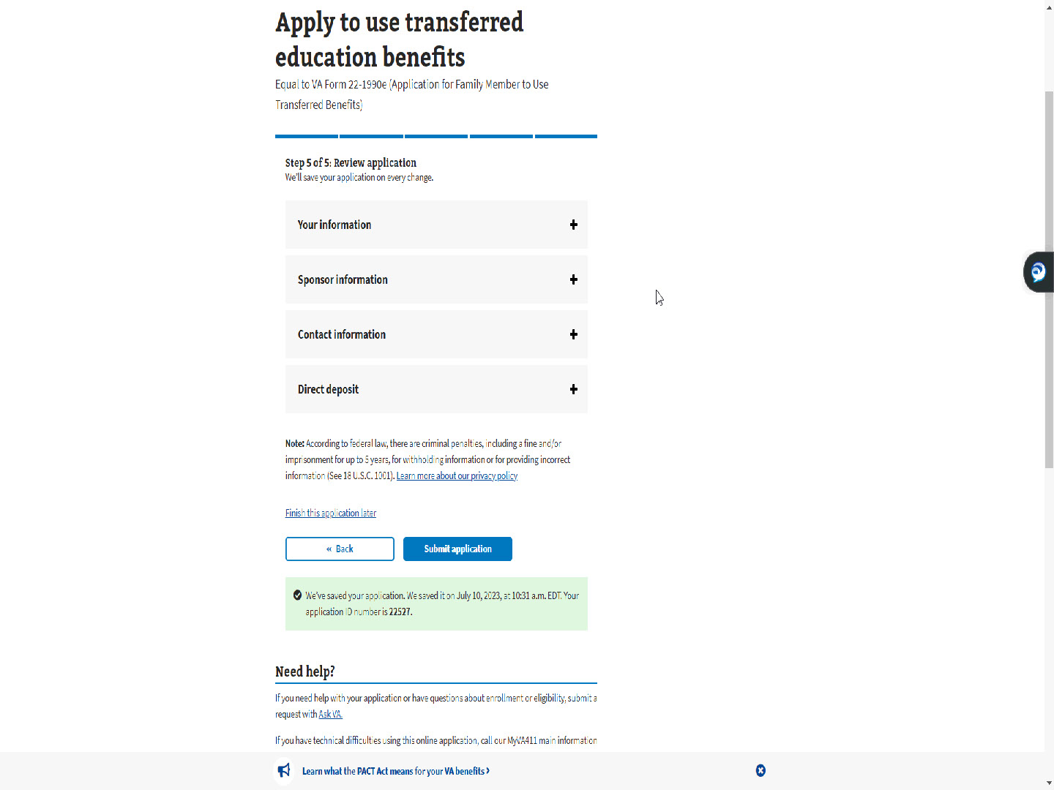
Script

The final step is Step 5 of 5: Review application.

Slide 68 - Plus sign
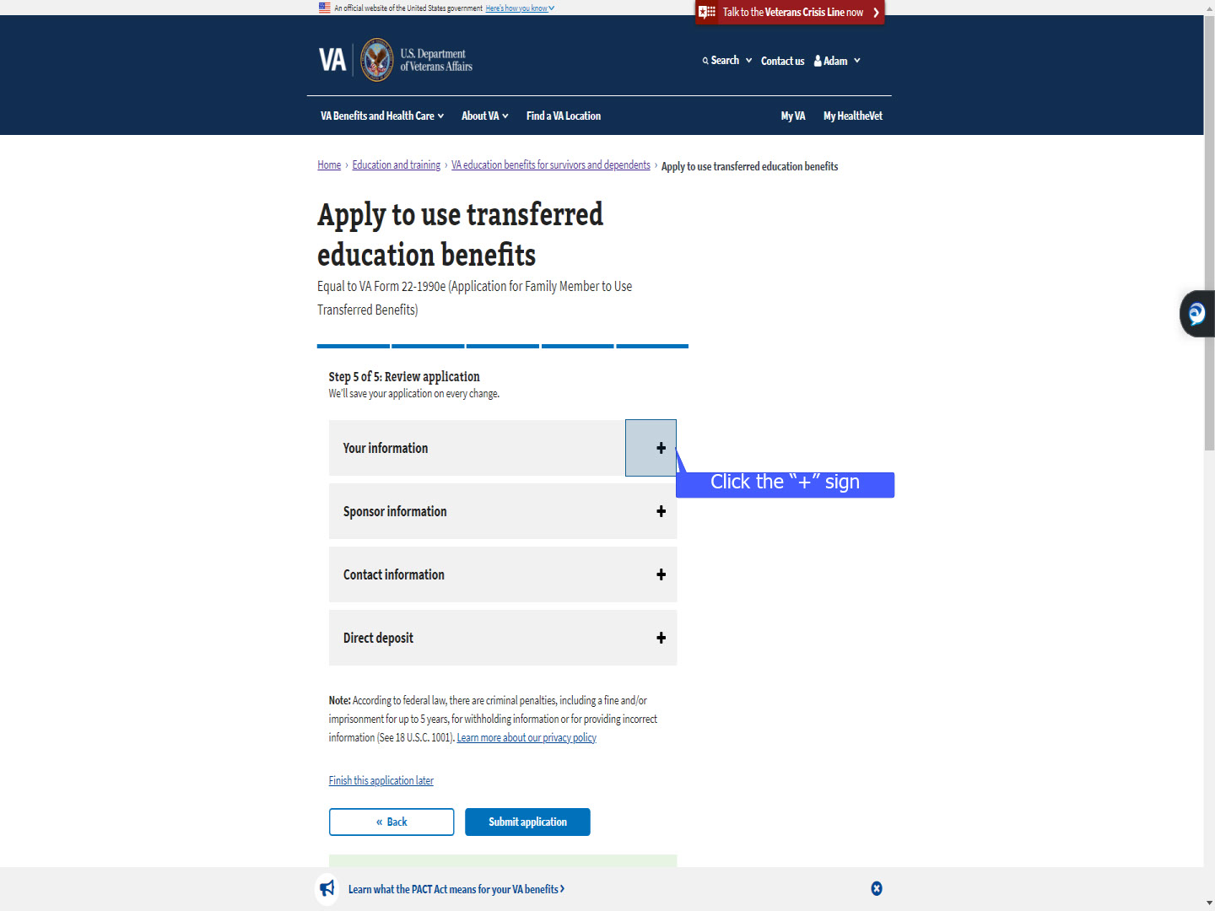
Script

Selecting the “+” sign allows the applicant to review the information they have entered, per section, throughout the application process.

Slide 69 - Your information
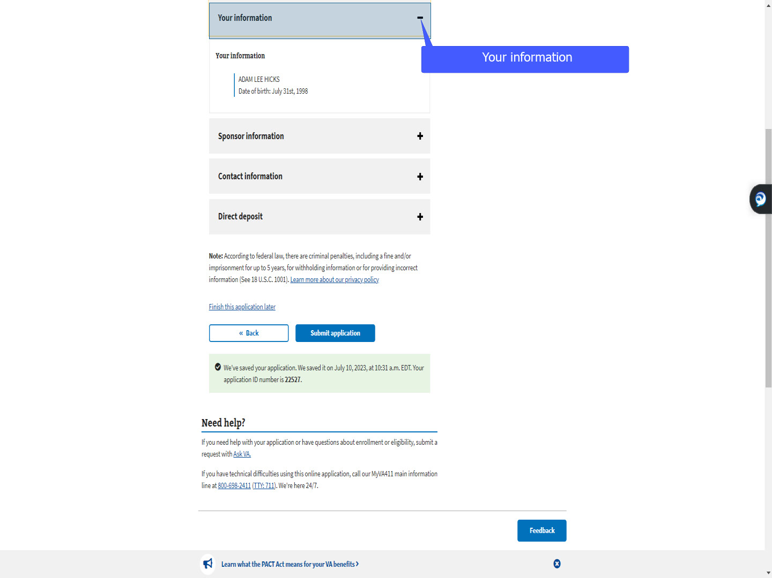
Script

“Your information”

Slide 70 - Sponsor information
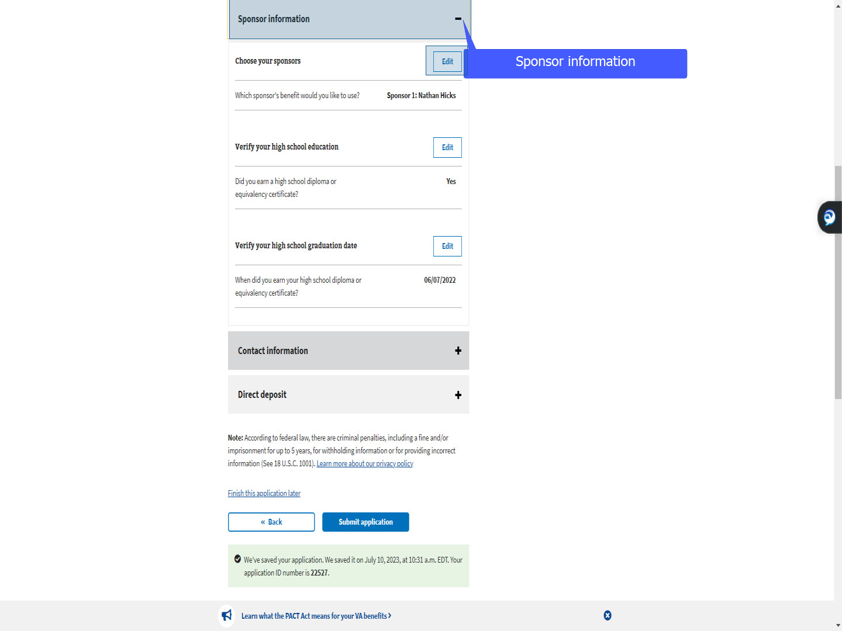
Script

“Sponsor information”.

Note: The “Edit” button is introduced in this section. The applicant can select “Edit” and amend any information previously entered.

Slide 71 - Contact information
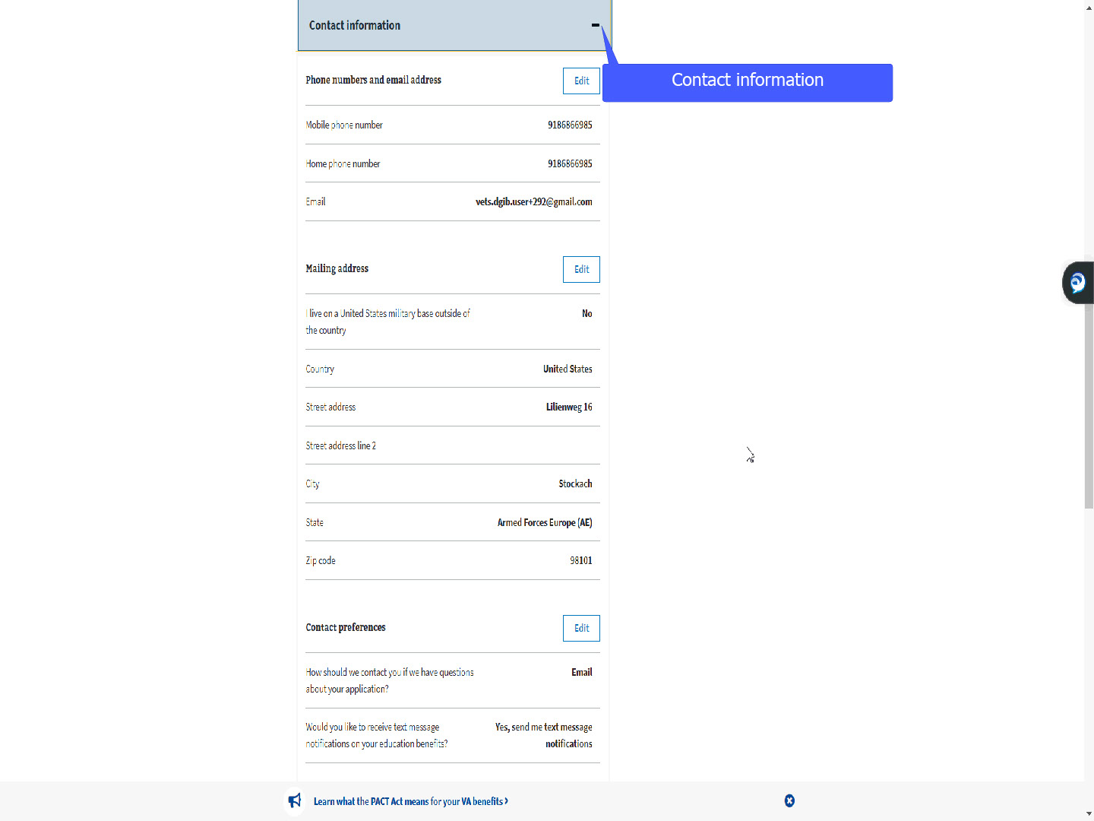
Script

“Contact information”

Slide 72 - Direct deposit
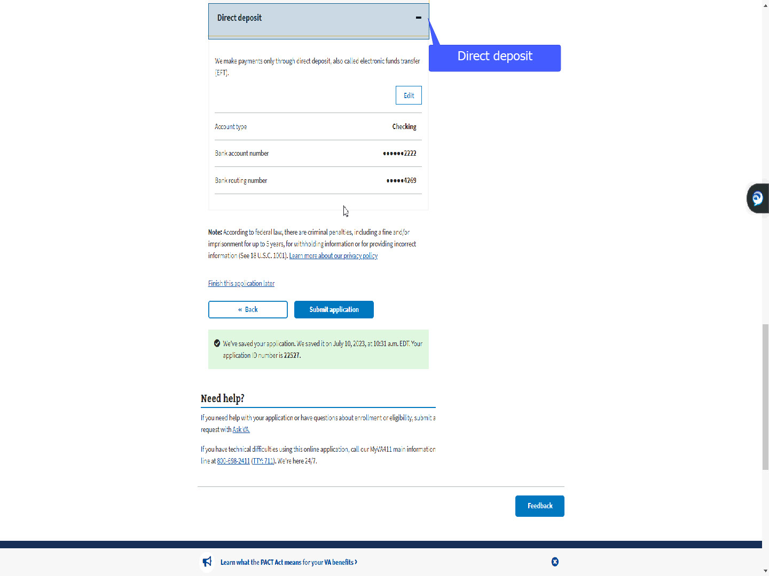
Script

and “Direct Deposit”.

Slide 73 - Submit application
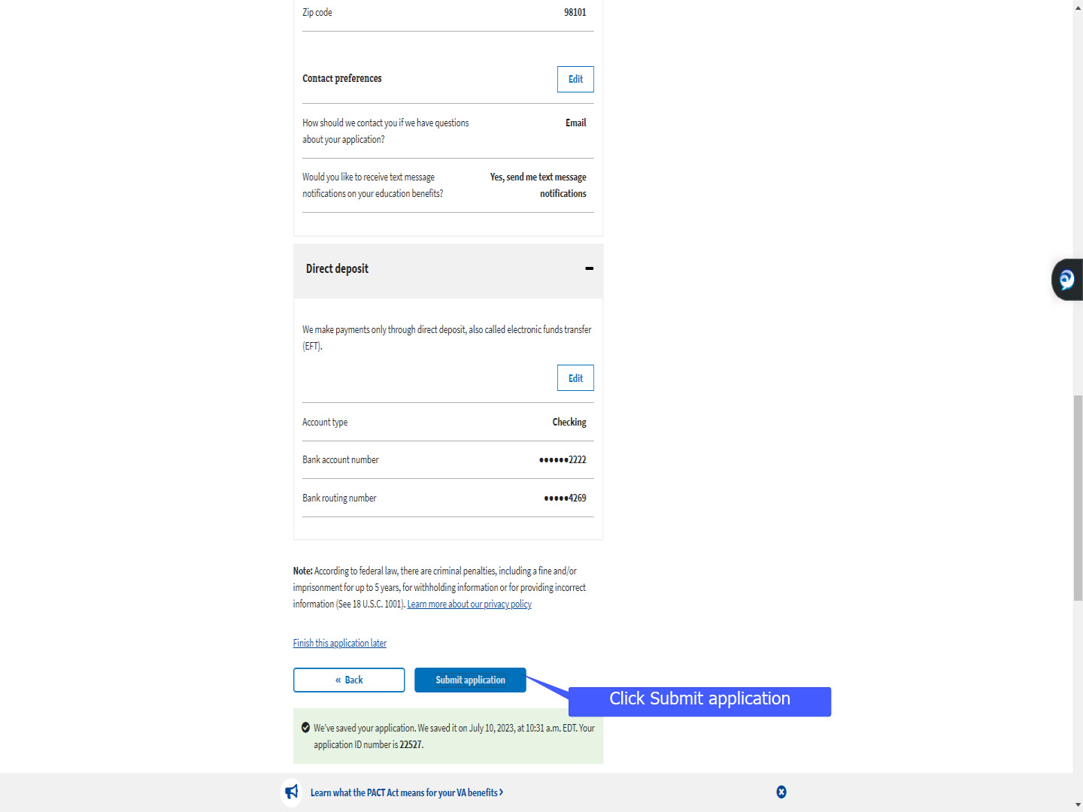
Script

Once all has been reviewed, the TOE applicant will “Submit” their application.

Slide 74 - TOE offramped
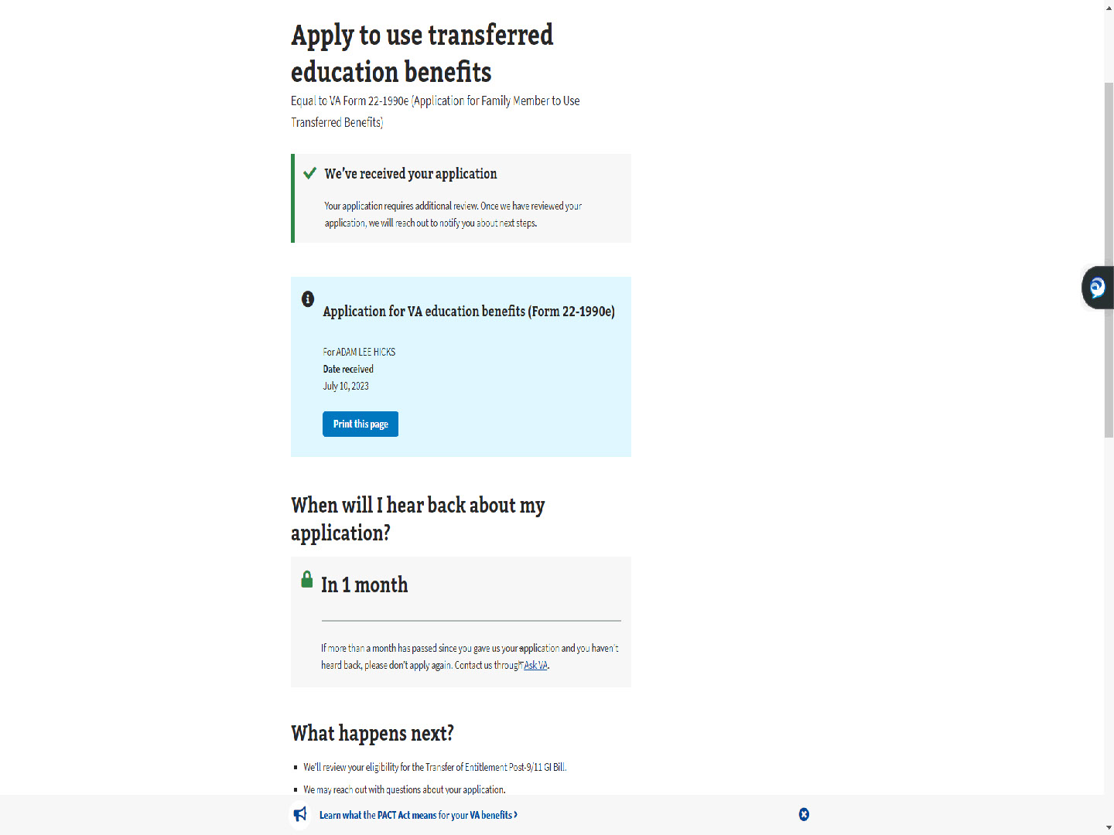
Script

As of this training, ALL TOE applications are off ramped for VCE intervention.

Slide 75 - Print this page
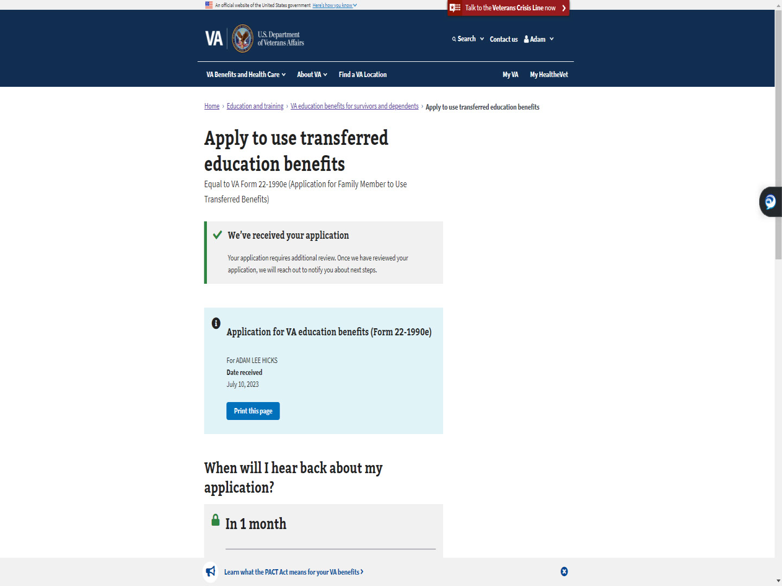
Script

The applicant can print this page for their reference.

Slide 76 - Next Steps
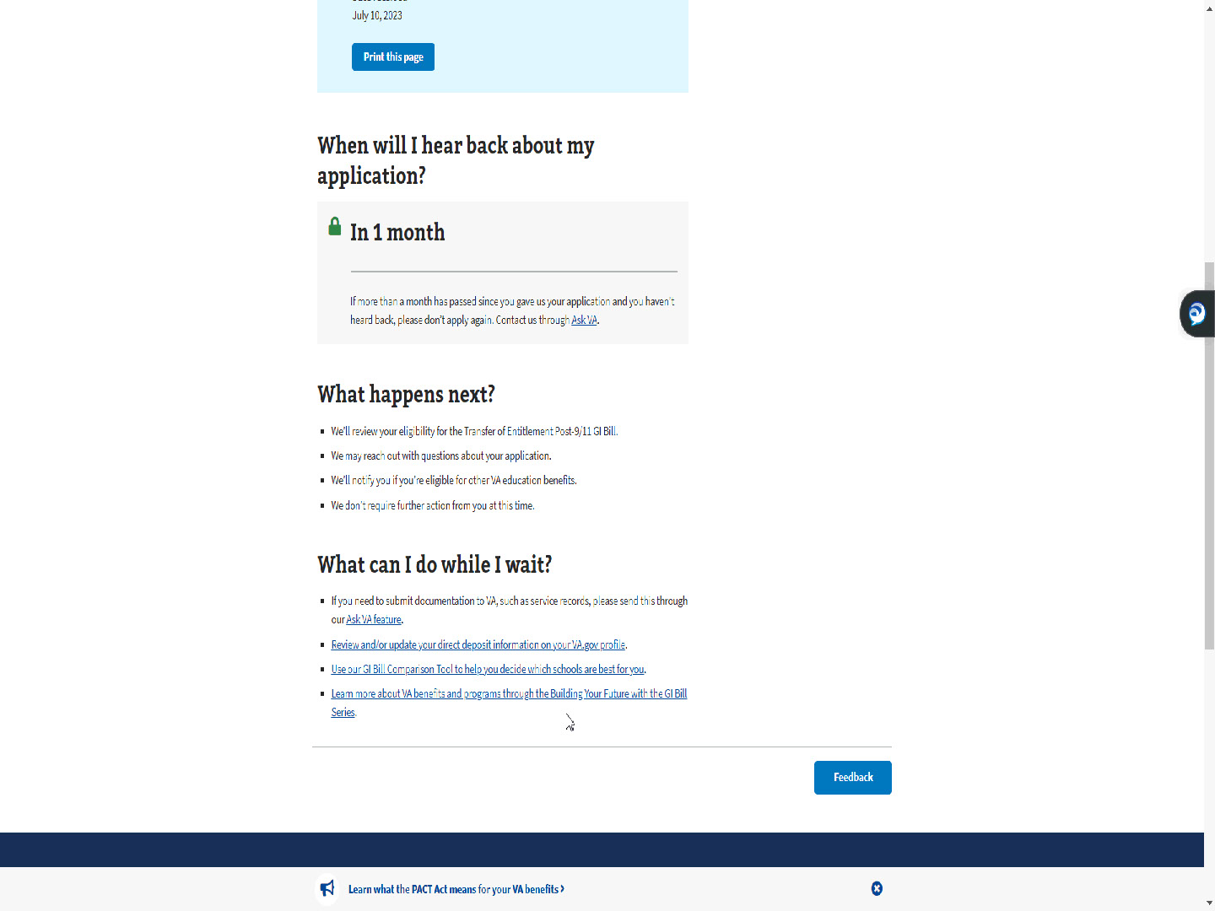
Script

MEB offers a 1-month timeline for a response, explains what happens next, and tells the applicant what they can do while they wait.

Slide 77 - The End

Script

This completes the application process in MEB for a dependent requesting Transfer of Entitlement (TOE) benefits under the Post-9/11 GI Bill.

I hope this demonstration provides insight on why you see, what you see in DGI or on the application in TIMS.

Slide 78 - TMS
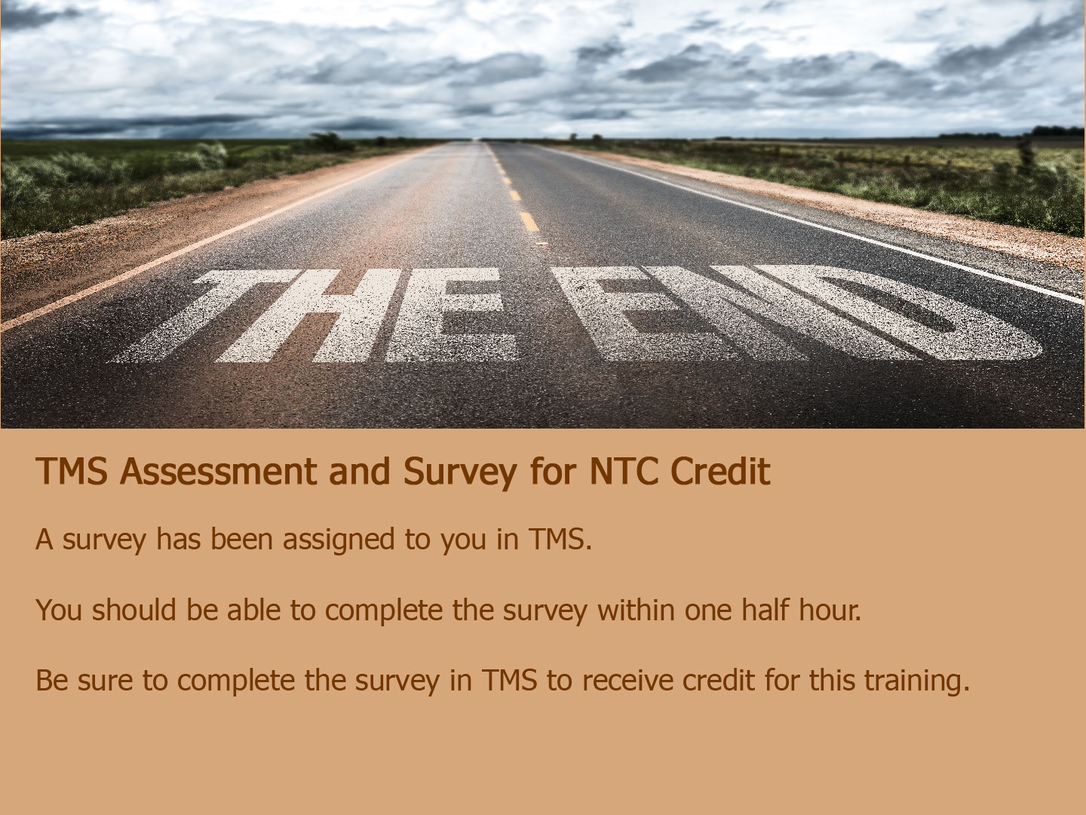
Script

The survey has been assigned to you in TMS.

You should be able to complete the survey within one half hour.

Be sure to complete the survey in TMS to receive credit for this training.

Slide 79 - Thank You

Script

Thank you for your time and attention, and Thank You to Angela Phalen, the creator of the beautiful handmade ’wrap’ 😊.
This concludes the presentation.
You may exit by clicking anywhere on your screen, hitting enter, or the right arrow on your keyboard.
Enjoy the rest of your day!

