Education Service
My Education Benefits (MEB) Applicant View (1990)
Lesson Plan
July 2023
Version 1.0

Lesson Overview
Topic | Description
Time Estimate: | 1 hour (60 minutes)
Purpose of the Lesson: | The purpose of the lesson is to assist the Veteran Claims Examiner (VCE) with understanding the process of an application in MEB from applicant entry to VCE processing. This training will count toward the National Training Curriculum.
Prerequisite Training Requirements: | None
Target Audience: | Veteran Claims Examiners, Education Call Center
Lesson References: | - DGI 3.1 Need to Knows  - DGI 3.1.5 Need to Knows  - DGI 4.0 Need to Knows
Lesson Objectives: | - Recreate the steps to apply for an education benefit in MEB  - Deduce the effect of applicant responses in MEB to DGI  - Correlate the applicant’s responses to what is seen by a VCE in DGI.
What You Need: | - Computer/Laptop  - Speaker/Headset  - Lesson Plan/Script
Post Training Requirements: | A survey has been assigned to you in Talent Management System (TMS).  You should be able to complete the survey within one half hour.  Be sure to complete the survey in TMS to receive credit for this training.

Instructor Notes
The purpose of the lesson is to assist the VCE with understanding the process of an application in MEB from applicant entry to VCE processing. The Instructor Activities are a verbatim script of the recording to be used for in-person training
Captivate Slides | Instructor Activities
 | DISPLAY slide  Welcome to My Education Benefits-Applicant View. Select “Begin”.
 | DISPLAY slide  Today’s training is intended to show what My Education Benefits (MEB) looks like from the Applicant’s view.  Please note, the examples you will see during this training were processed in a test system. All names and claim numbers you see are fictitious and do not belong to actual beneficiaries. No personally identifiable information (PII) is contained in this training.
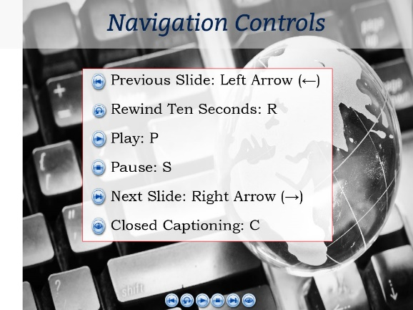 | DISPLAY slide  You can use the navigation buttons at the bottom of the screen to move forward and backward throughout this module.  Also, you may use the keyboard shortcuts shown on-screen.
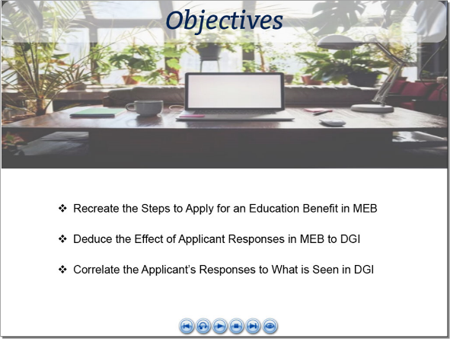 | DISPLAY slide  At the conclusion of this lesson, you should be able to recreate the steps to apply for an education benefit in MEB and deduce how the response options available to the beneficiary correlate to what is seen by a VCE in DGI.
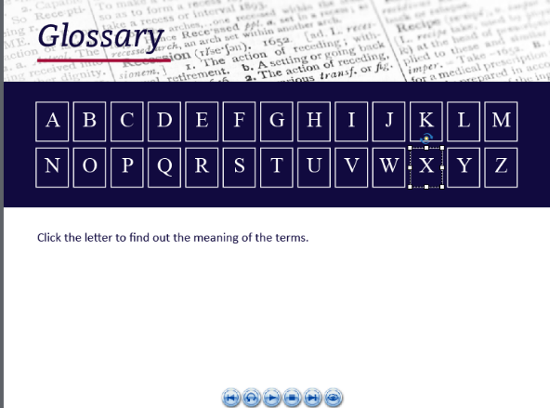 | DISPLAY slide  A glossary for terms, acronyms and abbreviations used throughout this training has been provided for reference.
DEMO Video   | DISPLAY slide  We will begin with a demonstration of a person applying for Education benefits using MEB. As we view the interactions, I will share what this means to the VCE.  (Begin Demo)
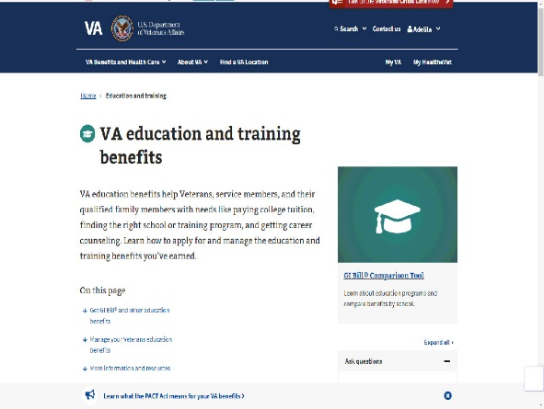 | DISPLAY slide 7-9.  To start, the applicant will begin by accessing the Education section of VA.gov, select “How to Apply” then advance to How To Apply For The GI Bill And Related Benefits | Veterans Affairs (va.gov).
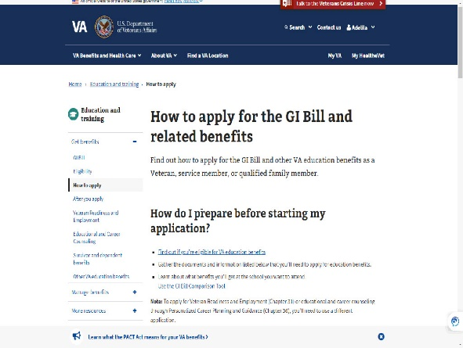 | DISPLAY slides 9-11.  The MEB application provides some background information on how to prepare for the application and what documents the applicant will need.
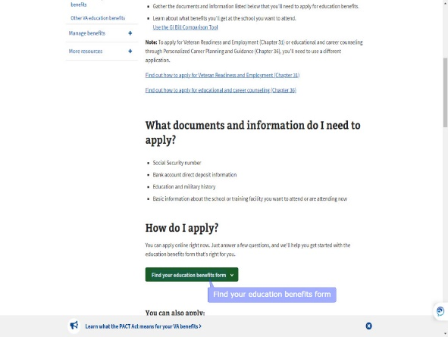 | DISPLAY slides 12-13  Under “How do I apply?”, the applicant will select “Find your education benefits form” which will prompt a new window displaying:  - Applying for a new benefit  - Updating my program of study or place of training, or  - Applying for the Edith Nourse Rogers STEM Scholarship after using Post-9/11 GI Bill or Fry Scholarship benefits
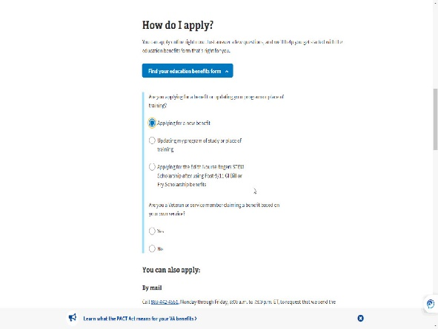 | DISPLAY slide 14  Selecting “Updating my program of study or place of training” takes the applicant along the “Legacy” application path of a VA Form 22-1995/5495.  Choosing STEM or FRY, follows a path similar to what you will see for chapter 33 with different prompts.  For today’s training, we will select Applying for a new benefit.
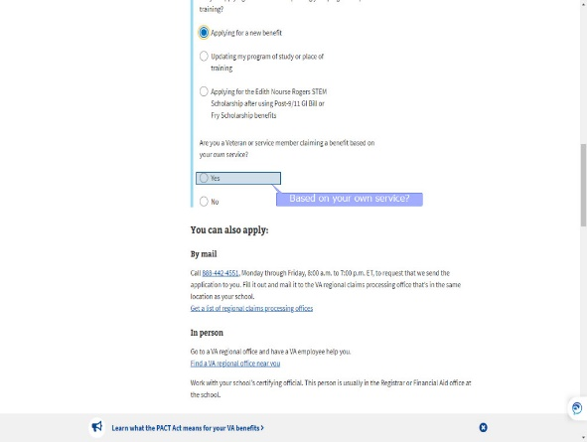 | DISPLAY slides 15-16  Once “Applying for a new benefit” has been selected, the applicant is asked to answer Yes or No to:  Are you a Veteran or service member claiming a benefit based on your own service?
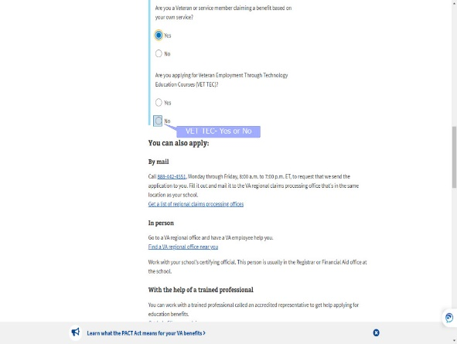 | DISPLAY slides 17-20  An applicant requesting Transfer of Entitlement (TOE) would select “No.  For today’s training we will select: “Yes” and follow the path of a VA Form 22-1990.  The subsequent prompts narrow down which benefit the applicant is requesting.  Because we selected “Yes”, the prompts ask the applicant to choose between VET TEC and Post-9/11 GI Bill.  For today’s training, we’ll select “Post-9/11 GI Bill”.  Once all prompts have been answered, the applicant chooses “Apply now”.
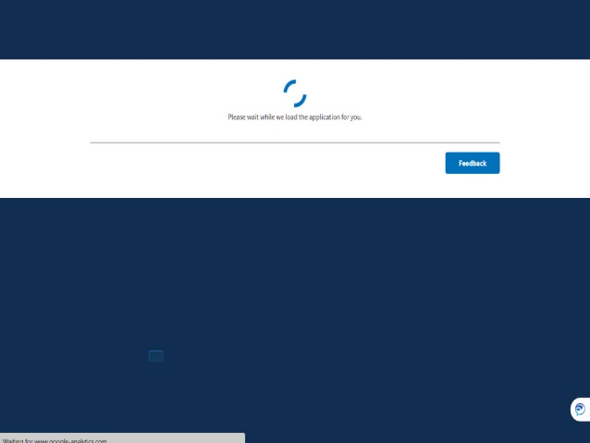 | DISPLAY slide 21
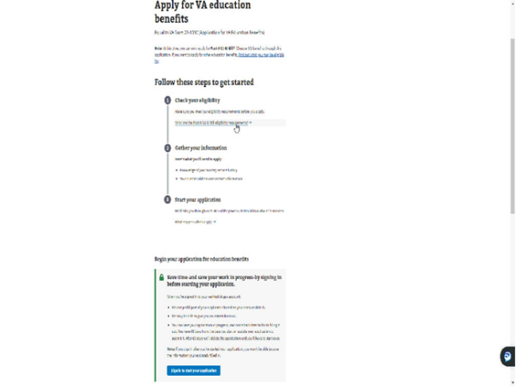 | DISPLAY slide 22  We are now on the “Apply for VA education benefits” page. Applicants must sign in to access the MEB application.
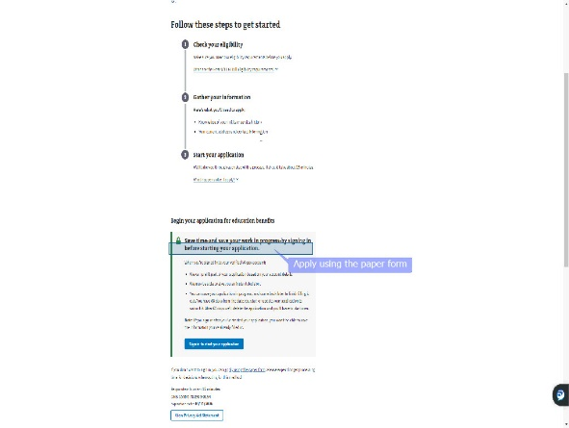 | DISPLAY slide 23  If the applicant does not wish to sign in, a link is provided to “Apply using the paper form”.
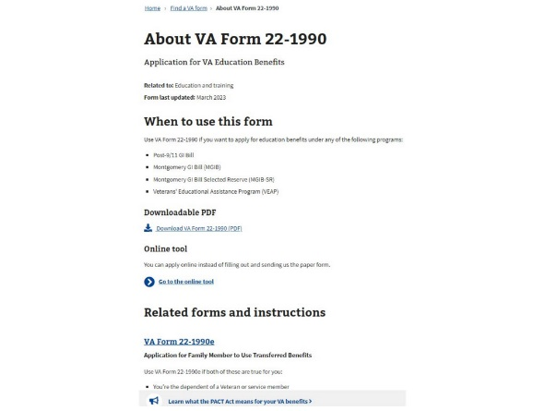 | DISPLAY slide 24  If the applicant clicks the link, they will be directed to Find a VA form and the VA Form 22-1990.  If they change their mind, there is a link to return to the Online tool.
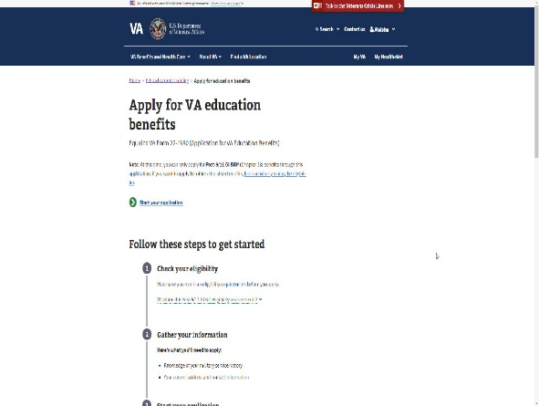 | DISPLAY slide 25
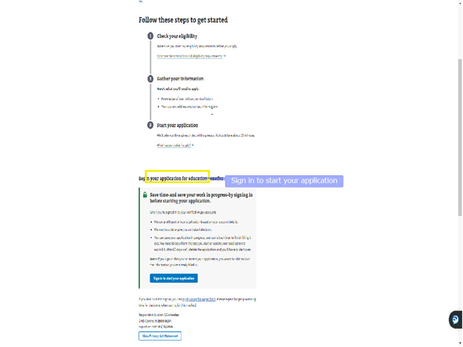 | DISPLAY slide 26  Signing in allows the applicant to authenticate themselves and use the My Education Benefits (MEB) application because as you recall, we selected to request Post-9/11 GI Bill benefits.
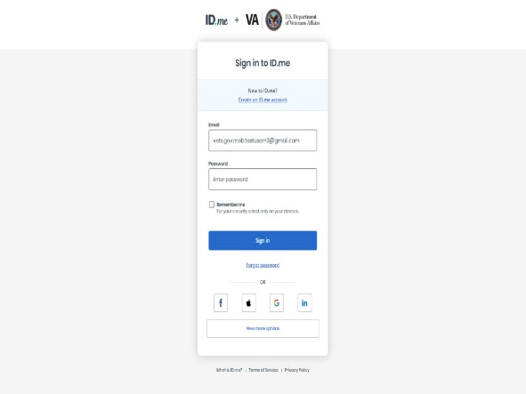 | DISPLAY slide 27  The applicant is given the option to login through Login.gov, ID.me, DS Logon, My HealtheVet, or create a new account.
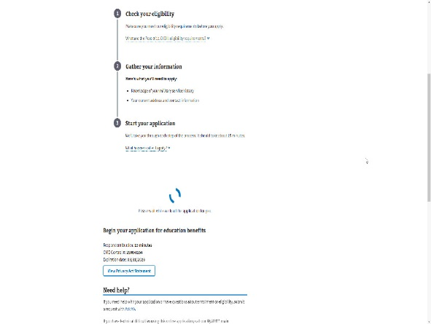 | DISPLAY slide 28  For this demonstration, we will use ID.me which requires a verification sent to the applicant.
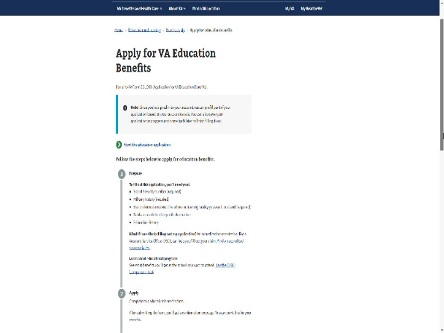 | DISPLAY slide 29  Once the applicant has been verified, they will be instructed to “Start your education application”.
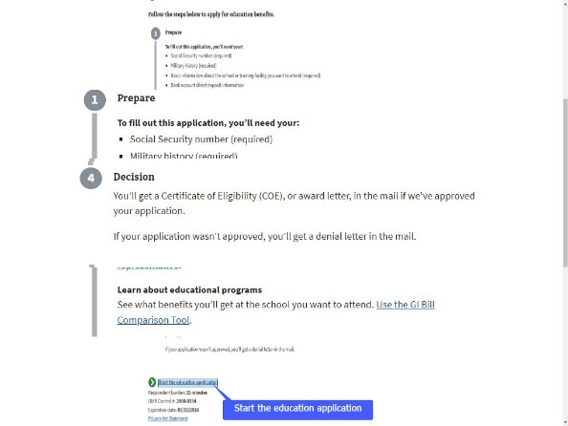 | DISPLAY slide 30  The “Start your Education Application” page provides information similar to the “How do I prepare” page earlier,  with links to an accredited representative and the GI Bill Comparison tool.  The page also provides a few words on Applying, VA review, and the Decision.  Let’s start the education application.
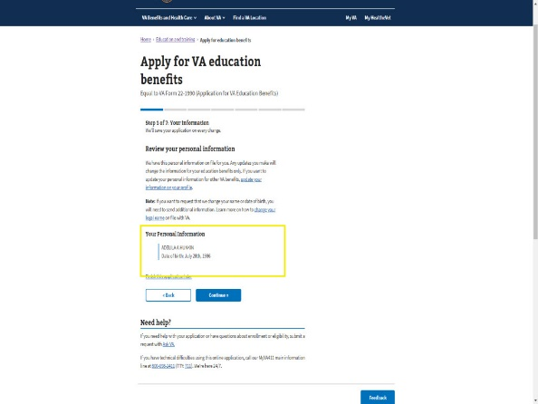 | DISPLAY slide 31  The first step of this 7-step process is for the applicant to enter their personal information. Because they signed in, this information is prefilled.
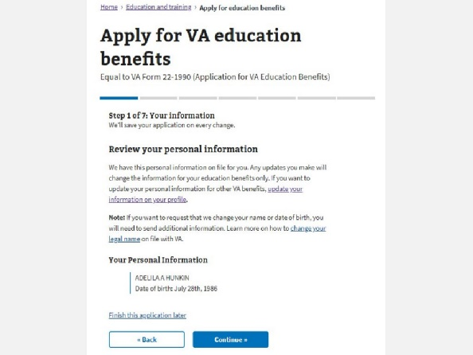 | DISPLAY slide 32
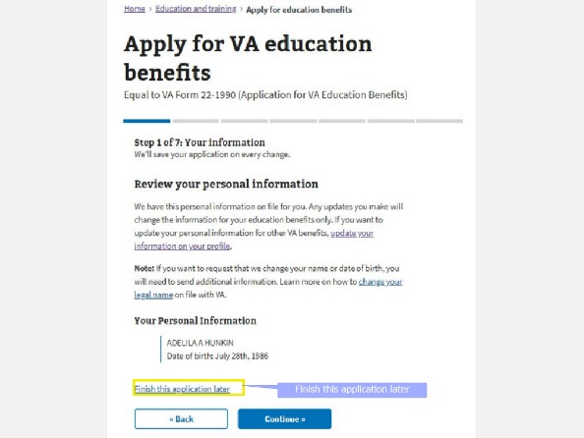 | DISPLAY slide 33  A link provided on each page hereafter offers the option to “Finish this application later” because their information is stored as a result of signing in.
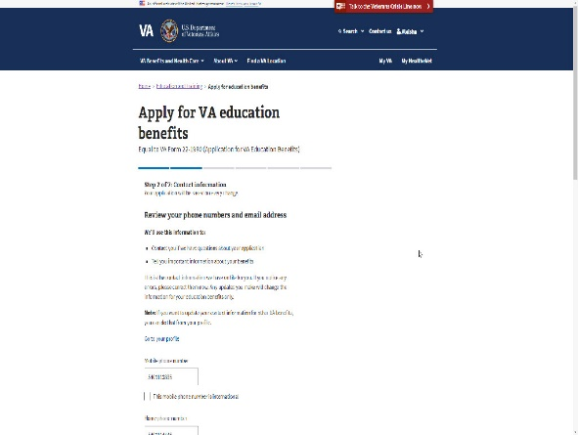 | DISPLAY slides 34  Step 2 is where the applicant will view their contact information. Here, their phone number(s) and email address are pre-populated.
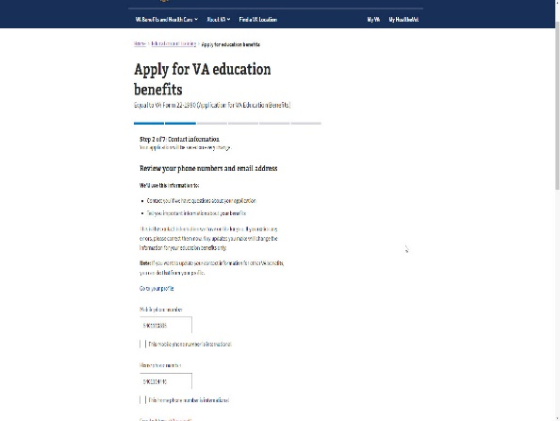 | DISPLAY slide 35  If the applicant needs to update this information, they can do so in the application. This update will only impact Education benefits.
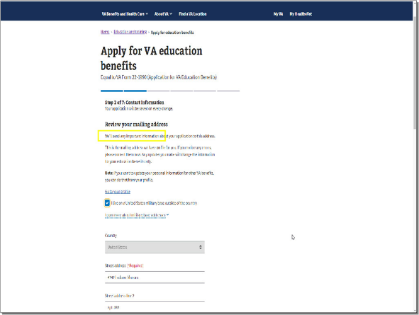 | DISPLAY slide 36  However, if the applicant wants to update their information for other VA benefits, to include Education, they can access their VA profile by selecting “Go to your profile”. Any updates made outside of the MEB application in the Profile,
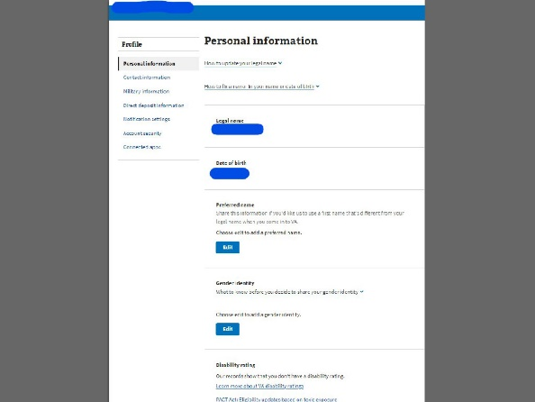 | DISPLAY slide 37  will impact and update all VA benefits they are currently using to include Disability compensation, Pension benefits and VR&E (Veteran Readiness and Employment) to name a few.
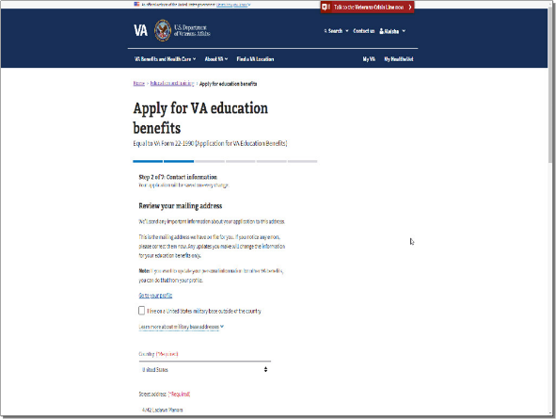 | DISPLAY slide 38  Next the applicant is asked to review their mailing address.
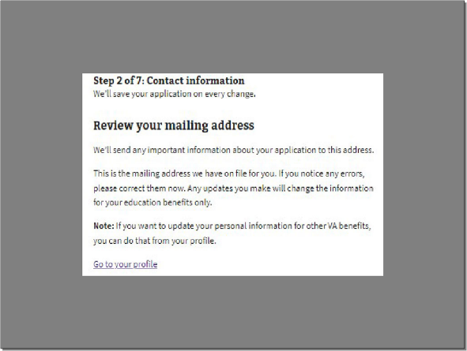 | DISPLAY slide 39  There is a warning message which reiterates what I just said about updating your VA profile versus education benefits only.
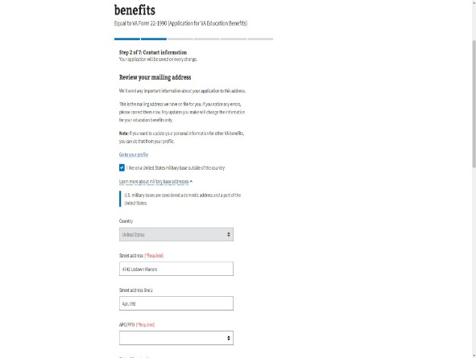 | DISPLAY slides 40-41  There is a box available to be checked if the applicant lives on a United States military base outside of the country and provides a link for more information on base addresses.
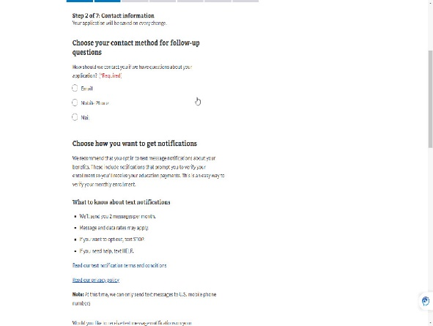 | DISPLAY slide 42  During step 2, the application has two (2) different questions asking how the applicant wants to be contacted:  - If VA has questions about their application or to share important information about their benefits.  - To verify their enrollment.
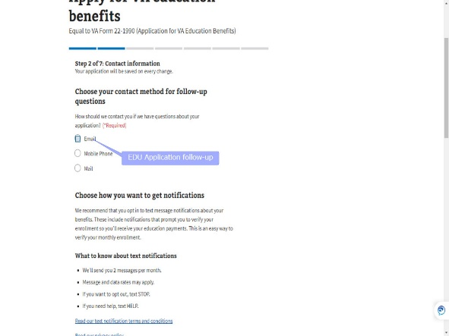 | DISPLAY slide 43  The options for application follow-up are Email, Mobile Phone or Mail.
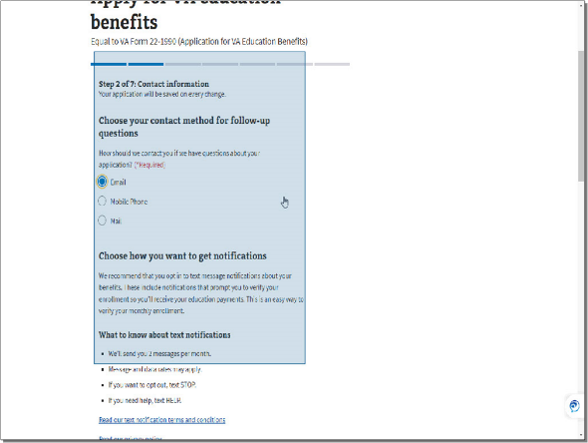 | DISPLAY slide 44  Next the application suggests the applicant opt into text messaging and provides information on “What to know about text notifications.
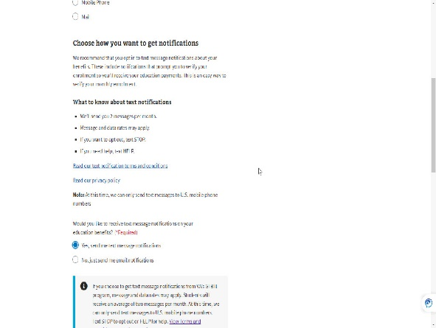 | DISPLAY slide 45  The Enrollment Verification option, defaults to “Yes, send me text message notifications”.  If the applicant did not include a mobile number a message will appear.  The applicant has the option to select “No, just send me email notifications”. They must select one of the two options.
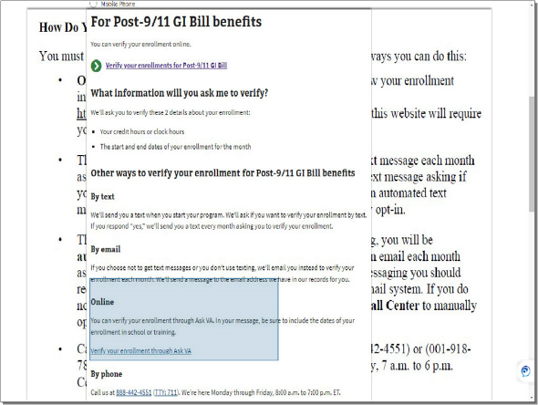 | DISPLAY slide 46  As we know, Online Enrollment Verification is now an option through MEB. Information on this option is available on VA.Gov and included in the AWD3 Letter when an enrollment exists. As of this training, it is not an option during the application process.  For those applicants who opt-in for text messaging, an informational pop-up will appear with a few disclaimers and links.
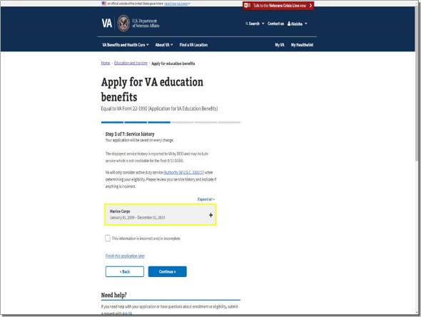 | DISPLAY slide 47  Step 3 is Service History. The applicant will see a snapshot of their service based on the information provided from DOD to VA.
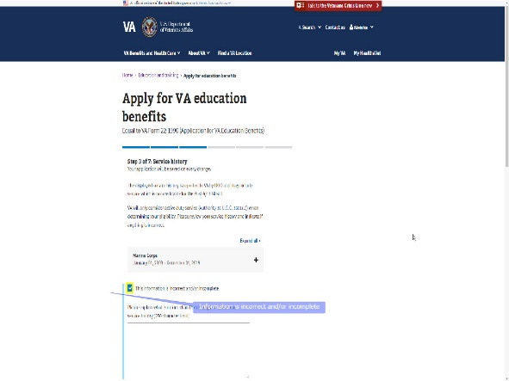 | DISPLAY slide 48  If the applicant disagrees with what is displayed, they can check the box titled “This information is incorrect and/or incomplete”.
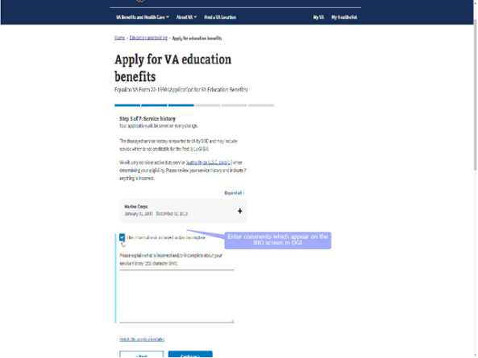 | DISPLAY slide 49  If this box is checked, a comment entry box will open. The information provided within this comment entry box will appear on the BIO screen in DGI once the application is submitted.
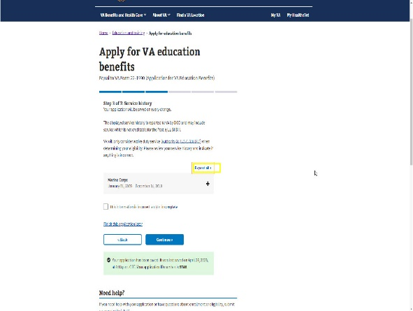 | DISPLAY slide 50  If the applicant has multiple service periods, they can click the “+” sign next to “Expand All” to view all their displayed service history.
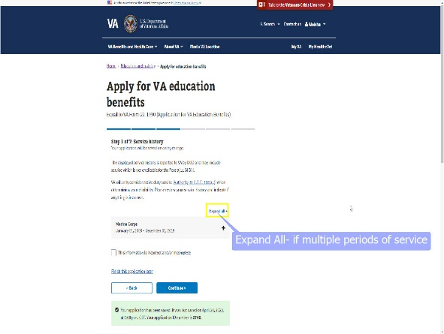 | DISPLAY slide 51  Once “Expand all” or the “+” sign next to the single period of service is selected, the applicant can view the displayed Branch of Service, Service Period, Character of Service, Separation Reason and Training Period.
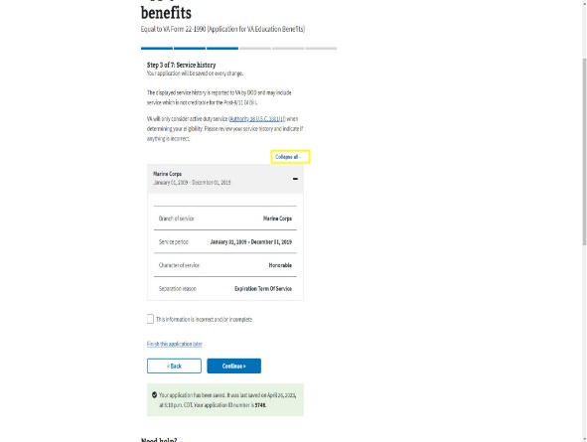 | DISPLAY slide 52-53  To close the service periods, they will select “Collapse all” or the “-“sign.
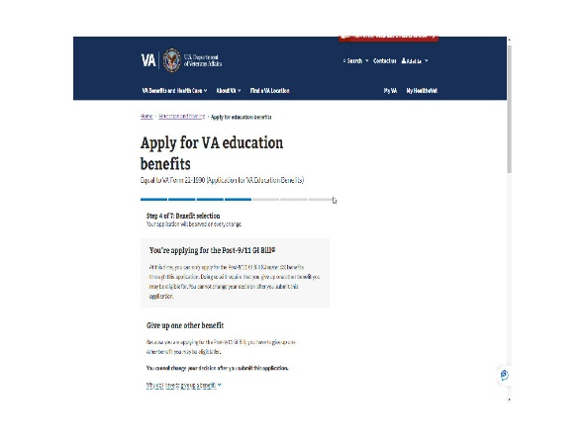 | DISPLAY slide 54  Next up is Step 4: Benefit Selection. Remember Post-9/11 GI Bill was selected when the application was started.  Transfer of Benefits, STEM and VET TEC were other options at the beginning of the application based on the answers to the introductory questions.
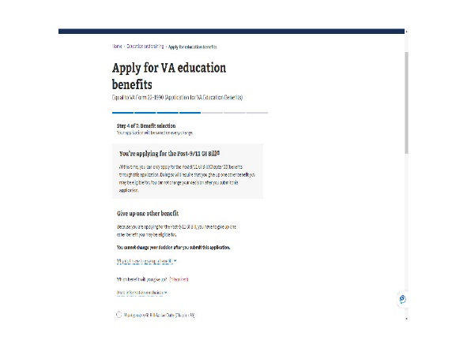 | DISPLAY slide 55  Because chapter 33 was selected, the application mentions giving up one other benefit.  It informs the applicant they cannot change their relinquishment after the application is submitted.
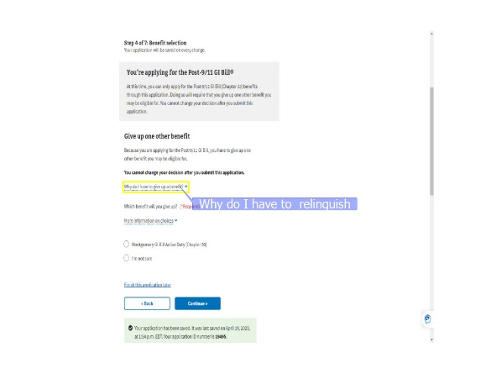 | DISPLAY slides 56-57  In addition, if there is any confusion about why they must relinquish, information is available by selecting a dropdown next to “Why do I have to give up a benefit?”.
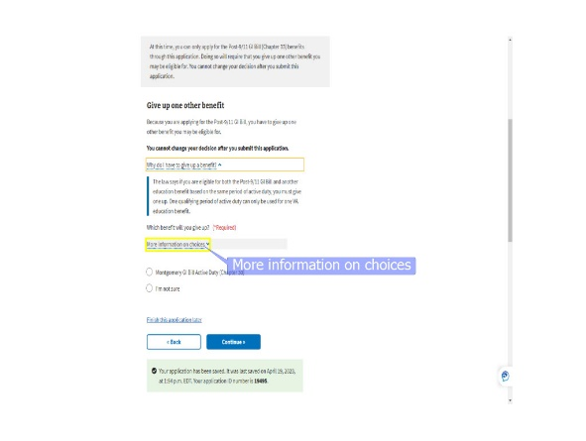 | DISPLAY slide 58  To provide even more clarity on the relinquishment process, the application has a “More information on your choices” dropdown. Dependent upon the benefits available for relinquishment, the applicant may see:  ‘Our records show you may be eligible for the Montgomery GI Bill Active Duty (Chapter 30). If you give up this benefit, we’ll pay you for any eligible kickers associated with it’ or ‘Our records show you may be eligible for both Montgomery GI Bill Active Duty (Chapter 30) and Montgomery GI Bill Selected Reserve (Chapter 1606). If you give up one of these benefits, we’ll pay you for any eligible kickers associated with it.
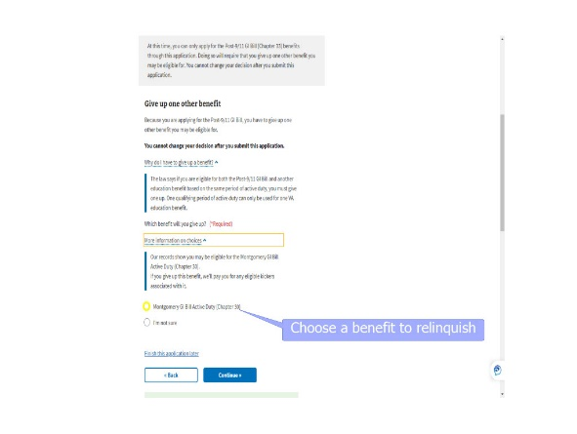 | DISPLAY slide 59  The applicant can select “I’m not Sure” and the application will be off ramped for VCE intervention.  The applicant can select one of the benefit options listed.
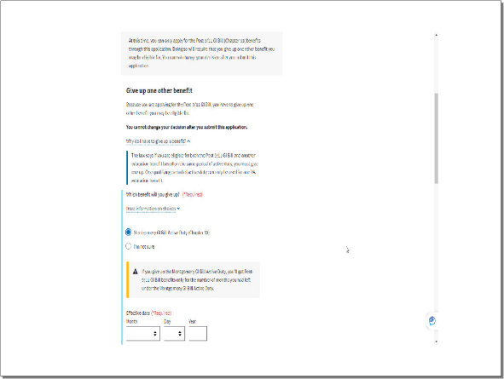 | DISPLAY slide 60  and a pop-up will appear for a selection of a relinquishment effective date.
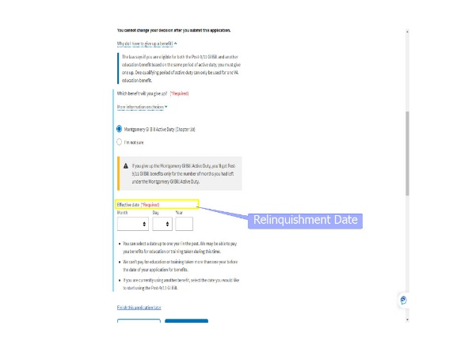 | DISPLAY slides 61-67  During the effective date selection process, more information is given to assist the applicant with selecting the best date for them.  Below the “Effective date (*Required) dropdowns, there are bullets explaining the rules for relinquishment:  - You can select a date up to one year in the past. We may be able to pay you benefits for education or training taken during this time.  - We can’t pay for education or training taken more than one year before the date of your application for benefits.  - If you are currently using another benefit, select the date you would like to start using the Post-9/11 GI Bill.
 | DISPLAY slide 68  Now let’s take a quick break and make sure you’re retaining some of the information shared so far.
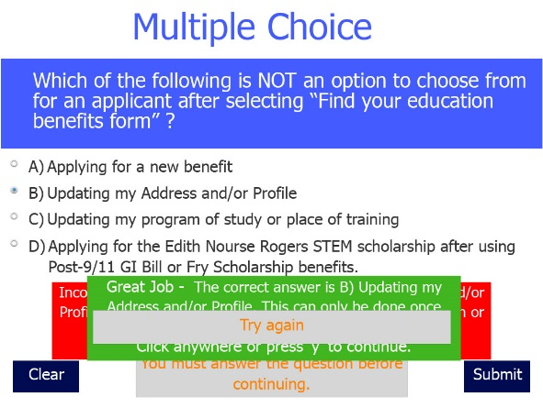 | DISPLAY slide 69  Let’s begin with a multiple choice question.  Which of the following is NOT an option to choose from for an applicant after selecting “Find your education benefits form”?
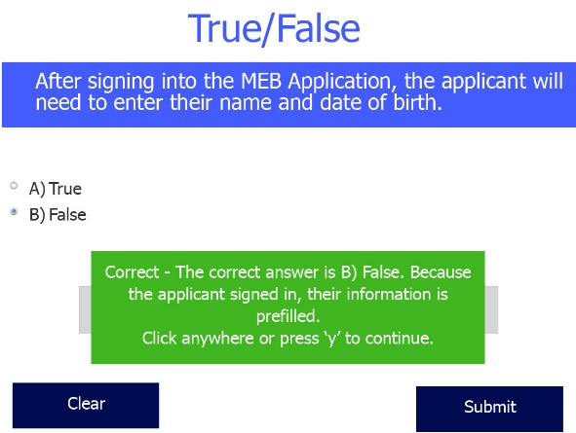 | DISPLAY slide 70  True or False: After signing into the MEB Application, the applicant will need to enter their name and date of birth.
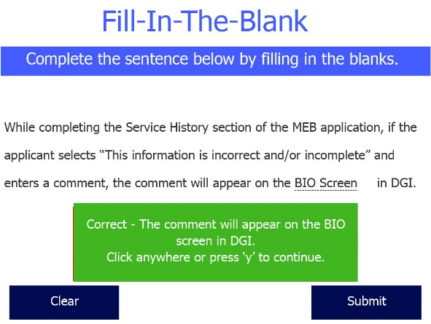 | DISPLAY slide 71  Fill-In-The-Blank: While completing the Service History section of the MEB application, if the applicant selects “This information is incorrect and/or incomplete” and enters a comment, the comment will appear on the “blank” in DGI.
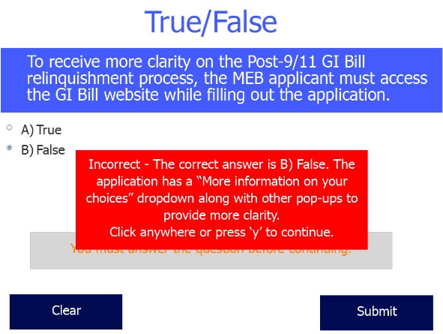 | DISPLAY slide 72  The last question is a “True or False”. To receive more clarity on the Post-9/11 GI Bill relinquishment process, the MEB applicant must access the GI Bill website while filling out the application.
 | DISPLAY slide 73
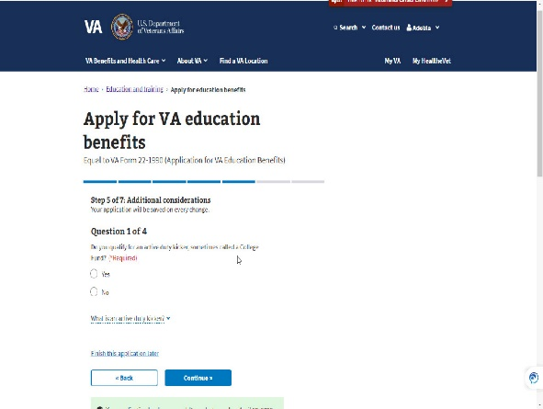 | DISPLAY slide 74  Moving on to Step 5: Additional Considerations. This step includes questions about Kicker, Commissioning, ROTC, and Loan Repayment.  As information sharing between DOD and VA continues to evolve, the best practice for a VCE is to review the sections -Excluded Obligated Periods of Service and Military Service Academy Period in VIS- when processing supplemental claims.
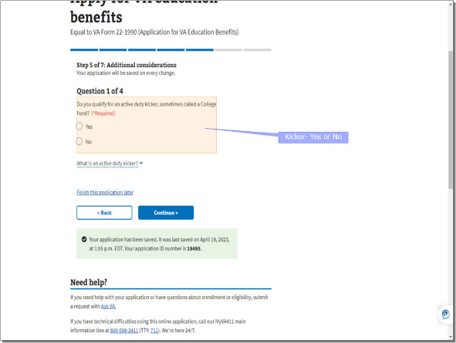 | DISPLAY slide 75  Question 1 asks the applicant if they qualify for an active-duty kicker.
DISPLAY slide 76
It also provides information on “What is an active-duty kicker” to better enable the applicant to answer Yes or No.

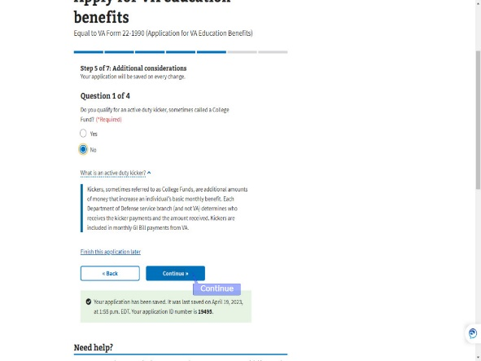 | DISPLAY slide 77-78  If the applicant answers “Yes” or VADIR identifies a kicker, a Stop Automation Flag will be displayed in DGI with a note to “Please review claimant’s eligibility for a Chapter 30 or 1606 kicker”.
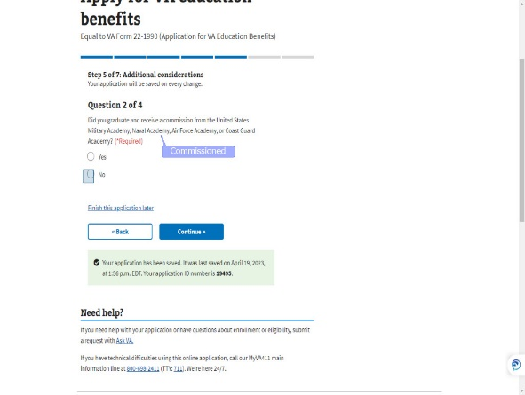 | DISPLAY slides 79-80  The next question is about commissioning from the US Military, Naval, Air Force or Coast Guard Academy. As we know, there may be some periods of exclusion based upon their answer.
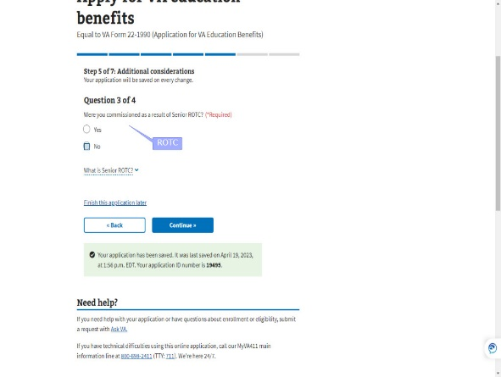 | DISPLAY slide 81  The third question asks if they were commissioned as a result of ROTC (Reserve Officer Training Corps).
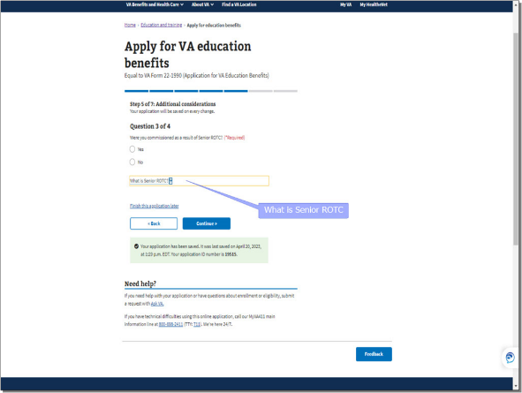 | DISPLAY slides 82-84  As with the previous questions, the applicant can select a dropdown for more information on “What is Senior ROTC”.
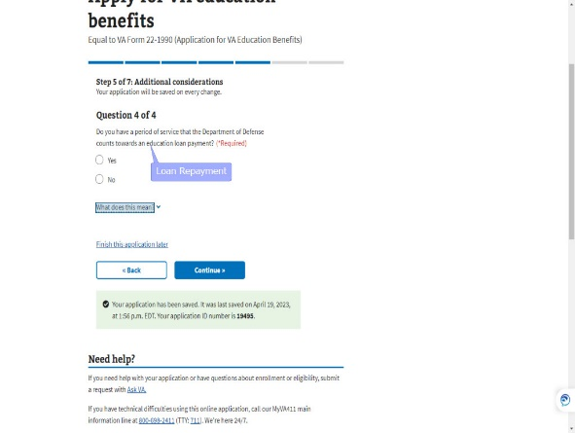 | DISPLAY slide 85  The final question under “Additional Considerations” references Education Loan Repayment
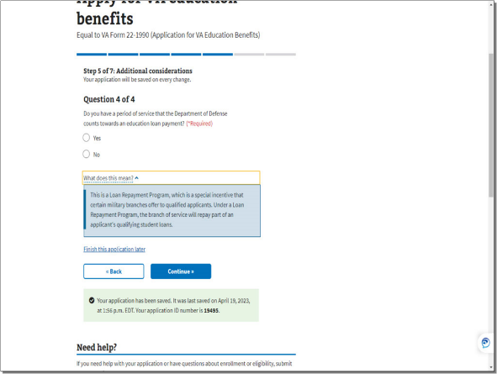 | DISPLAY slides 86-87  and explains what loan repayment means.
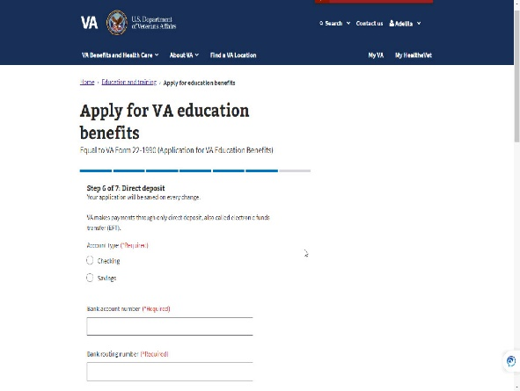 | DISPLAY slides 88  The application is almost complete. Only two more steps to go.
 | DISPLAY slide 88  Step 6 is entering Direct Deposit information which is required.  This should not be an issue for the applicant as even services like Venmo and Cashapp offer account and routing numbers for Direct Deposit.  If the applicant is unable to provide direct deposit information, they will not be able to advance in the MEB application. The applicant would need to apply by submitting a paper application.  All online education benefit applications require authentication and direct deposit.
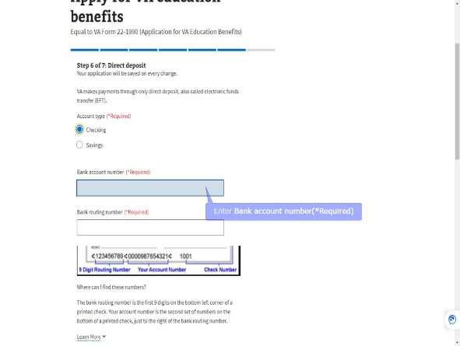 | DISPLAY slides 90-91  They will enter their account type, bank account,
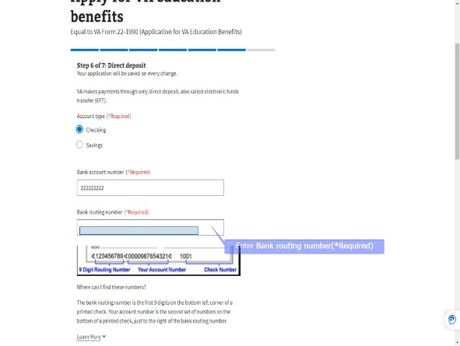 | DISPLAY slides 92-95  and routing number, then click “Continue”.
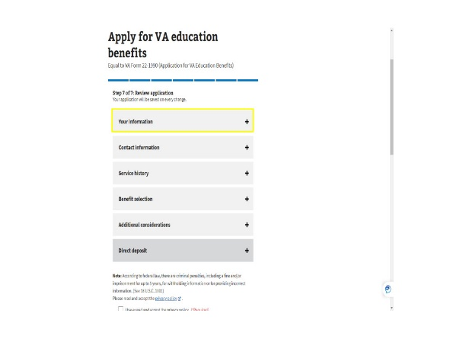 | DISPLAY slide 96  Step 7: “Review application” is the final step before submitting the application.  The applicant is given a screenshot of all they have answered in steps 1-6. Clicking the “+”
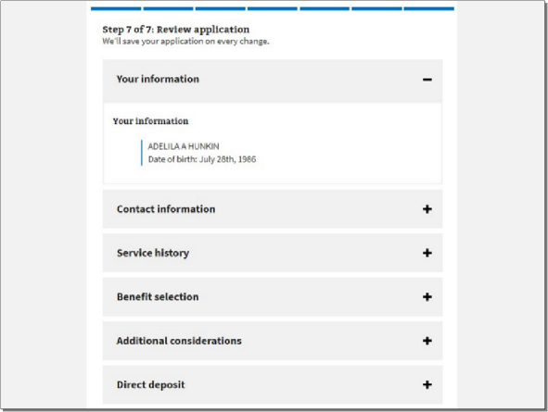 | DISPLAY slide 97  “+” allows each section to expand.
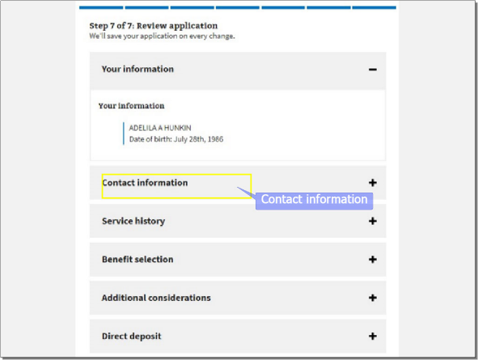 | DISPLAY slides 98- 99  The applicant can review “Your information” as just shown, “Contact information” as seen here,
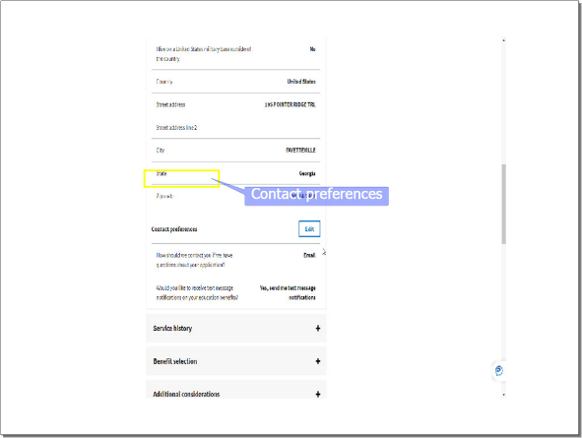 | DISPLAY slide 100  “Contact preferences”
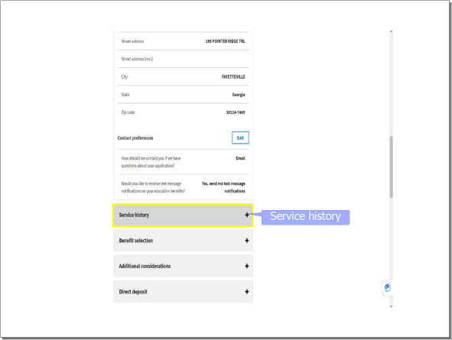 | DISPLAY slides 101-102  “Service history”
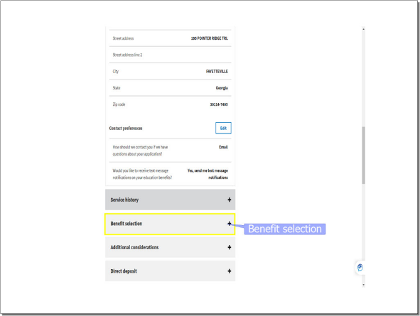 | DISPLAY slide 103  “Benefit selection”
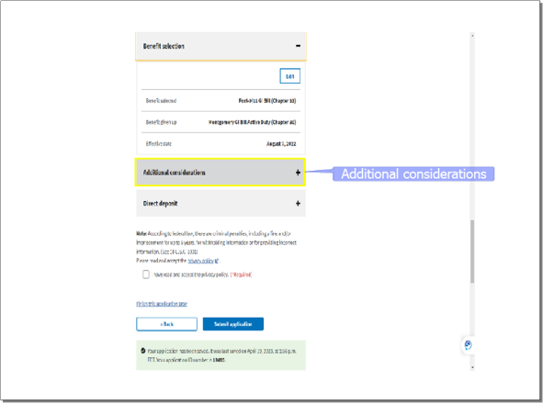 | DISPLAY slides 104-105  “Additional Considerations”
DISPLAY slide 106-107
And “Direct Deposit”.
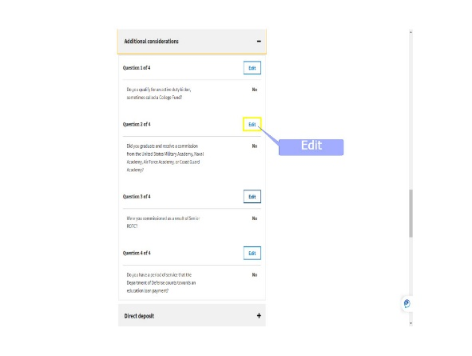 | DISPLAY slide 108  While reviewing what has been entered and/or selected during the application process, the applicant can select the “Edit” button and adjust their choice.
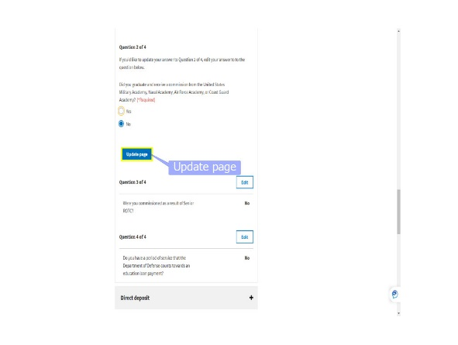 | DISPLAY slide 109  Once the edit has been completed, they will select “Update page” to save the change.
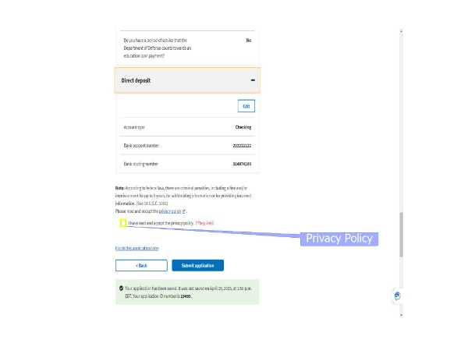 | DISPLAY slides 110-111  Prior to submitting the application, the Privacy Policy must be read, accepted and the checkbox checked. The Privacy Policy will open in a separate window for viewing.
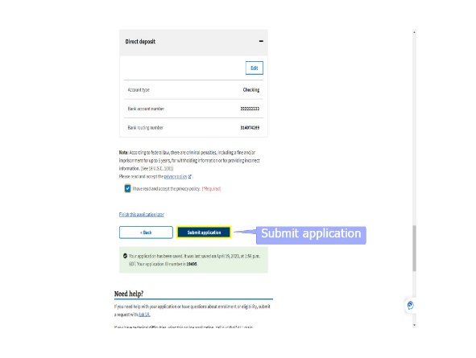 | DISPLAY slide 112  Finally, the applicant will “Submit application”. It may take a few minutes for the application to process.
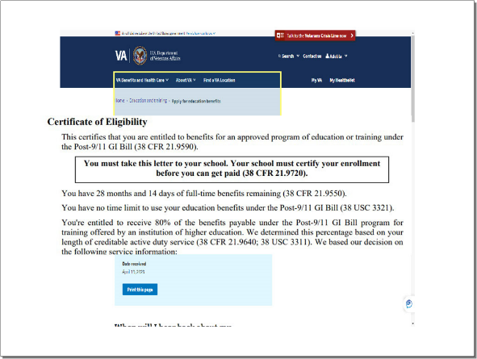 | DISPLAY slide 113  If an immediate decision can be given, the applicant will receive a Certificate of Eligibility (COE) or Denial letter.  In our example, the application was sent to the RPO for further processing.
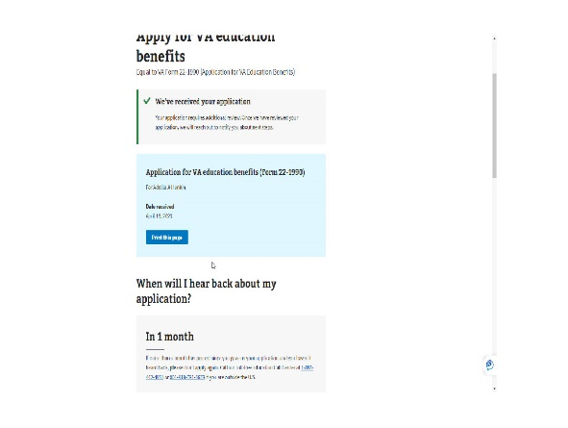 | DISPLAY slide 114  The applicant can print the page for their records and are informed they should hear back from us within 1 month.  They are instructed "If more than a month has passed since you gave us your application and you haven’t heard back, please don’t apply again. Call our toll-free Education Call Center at...” and it provides the number.
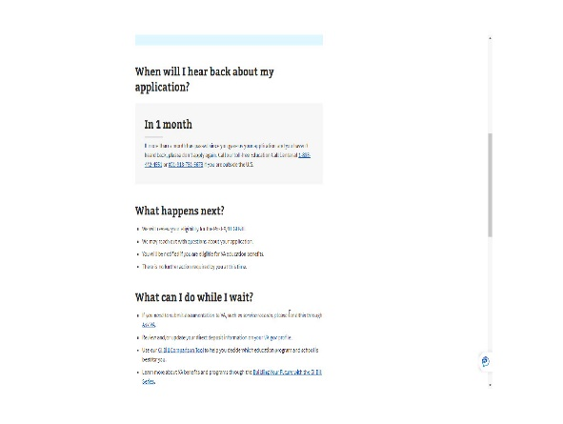 | DISPLAY slide 115  Lastly, the applicant is provided information on “What happens next’ and ‘What can I do while I wait”.
 | DISPLAY slide 116  This completes the application process in MEB for a Veteran requesting the Post-9/11 GI Bill.  I hope this demonstration provides insight on why you see, what you see in DGI or on the application in TIMS.
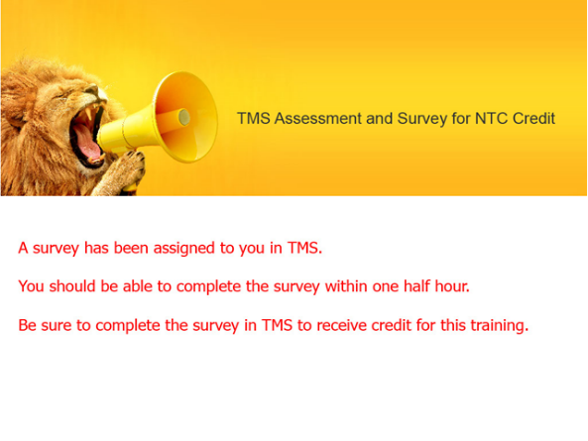 | DISPLAY slide 117  The survey has been assigned to you in TMS.  You should be able to complete the survey within one half hour.  Be sure to complete the survey in TMS to receive credit for this training.
 | DISPLAY slide 118  Thank you for your time and attention. This concludes the presentation.  You may exit by clicking the balloons on your screen, hitting enter, or the right arrow on your keyboard.  Enjoy the rest of your day!

