

Understanding Entitlement Display Functionality
in DGI
Lesson Plan

December 2022 – FY 2023

Display Functionality in DGI (1 hour)

Lesson Overview
Purpose of the Lesson: | This lesson is part of the Supplemental Tips, Advice, and Refresher (STAR) Training series from the National Training Team -Processing. This lesson will assist processors in understanding how and why the Used Entitlement and the Remaining Entitlement in DGI are not adding up to the Original Entitlement for dependents receiving Transfer of Entitlement benefits.
Prerequisite Training Requirements: | N/A
Target Audience: | Veterans Claims Examiners, Senior Veterans Claims Examiners, Lead Veterans Claims Examiners, and EQTS.
Lesson References: | N/A
Lesson Objectives: | At the end of this lesson, students will be able to:  - Comprehend how entitlement is displayed in DGI and why it displays this way.  - Process claims affected by this display functionality.

Instructor Notes
This lesson explores the importance of understanding how and why DGI rounds entitlement in the background. Students will learn to understand how to process claims affected by this issue and clarify how it is a fundamental issue and not a system error. The lesson presents the what, why, how and importance of understanding how to process claims with this issue. Two examples will be provided to assist with understanding how DGI works in the background vs. what the student will see. Students will complete an assessment and survey in TMS at the end of the lesson. Six questions comprise the assessment.

PowerPoint Slides | Instructor Activities
 | DISPLAY slide  - “NTT-P Logo”  The National Training Team Processing Presents…
 | DISPLAY slide  2 Understanding Entitlement Display Functionality in DGI  Welcome to today’s Supplemental Tips, Advice and Refresher training, or STAR Training. Today’s topic is Understanding Entitlement Display Functionality in DGI. Please note, this is how the display functionality will work across all VBA systems such as BDN. For training purposes, we will only be focusing on DGI.
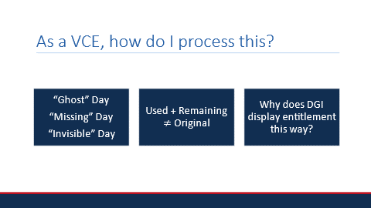 | DISPLAY slide  3 Have you ever heard the term “Ghost Days” used by your RPO Trainer before? If you haven’t, at some point you may have come across a claim with entitlement which didn’t seem to add up quite right. Still not sure what I’m talking about? Let’s talk about it…
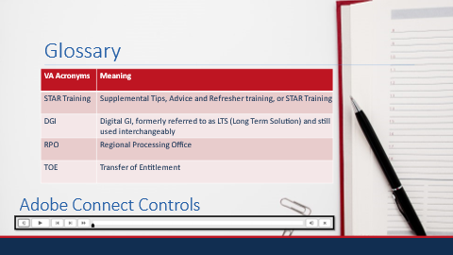 | DISPLAY slide  4 Before we discuss today’s topic, let’s go over a couple of housekeeping matters…  If at anytime you need a break or want to relisten to a section of this video, feel free to use the Adobe Connect Controls found at the bottom of your screen. This video is not only a refresher training for the most seasoned of VCEs, but a great guide for beginners and those levels in between -when you just need some reassurance.  And for reference, here is a list of acronyms used throughout. There are a lot of calculation breakdowns throughout the course of this training, so please press pause if you would like to review or sit back and relax and enjoy today’s presentation.
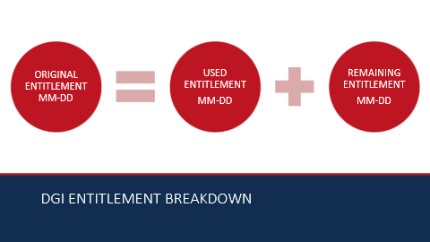 | DISPLAY slide  5 So where were we? Ah yes, Entitlement Display Functionality in DGI. Typically, what you see in DGI is the original, used, and remaining entitlement displayed in two-digit month and two-digit day format. The used entitlement plus the remaining entitlement should add up to the original entitlement…
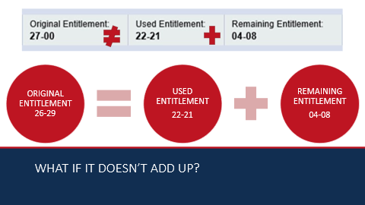 | DISPLAY slide  6 …but what happens when the entitlement doesn’t add up, like in this scenario?  Used Entitlement and Remaining Entitlement in DGI do not always add up to the Original Entitlement. In fact, DGI is programmed to display entitlement this way. For today’s example, the beneficiary’s Original Entitlement awarded is 27 months. DGI is displaying the beneficiary’s Used Entitlement as 22 months and 21 days and the Remaining Entitlement as 4 months and 8 days. When we add the Used and Remaining Entitlement amounts together, manually, we get 26 months and 29 days, not 27 months. We are missing 1 days’ worth of entitlement in our actual total of original entitlement. Let’s take a deeper dive and take a look into the reason why it doesn’t add up and figure out what happened to that 1 day of entitlement that we are missing.
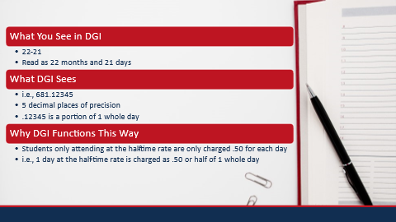 | DISPLAY slide  7 Behind the scenes, DGI calculates used entitlement in days and fractional days with up to five decimal places of precision. Fractional days are the result of beneficiaries attending school at less than full-time. For example, when someone attends at the half-time rate, their entitlement is only charged .50 for each day they attend. Subsequently, the number of days is then converted to the two-digit month, two-digit day format for display purposes and during this process, some precision is lost.
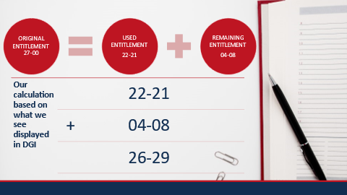 | DISPLAY slide  8 For this scenario, the Used Entitlement value states 22 months and 21 days used, while the Remaining Entitlement value states 4 months and 8 days remaining. As we have already discussed, when we calculate this manually, based off what we see displayed in DGI, we get 26 months and 29 days, not 27 months as the original entitlement displays.
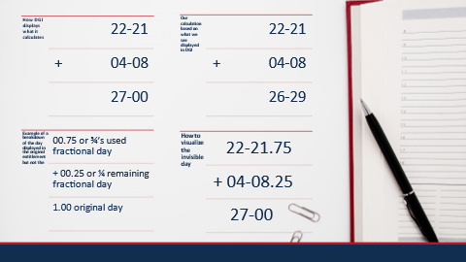 | DISPLAY slide  9 Let’s take it from the top. We see 22 months and 21 days of used entitlement and 4 months and 8 days of remaining entitlement, but the original is 27 months and 0 days. When we add up the used and remaining entitlement with the amounts, we see displayed in DGI, we get 26 months and 29 days total which is 1 day off from the 27 months and 0 days of original entitlement displayed.  To make the 1 missing original day tangible, we will be dividing it up into fractional portions. In our scenario, the beneficiary has used .75 or ¾’s of 1 day of entitlement and has .25 or ¼ of 1 day remaining. With the fractional days visible, we can see where the 1 day missing is to bring our 26 months and 29 days to 27 months and 0 days of original entitlement.
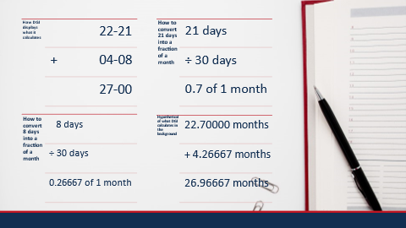 | DISPLAY slide  10 Technically, since DGI only rounds to 5 decimal places of precision, the 1 day missing is most likely broken down into something more like what you see on the screen in the bottom right calculation box, with some precision lost. Please note, these numbers displayed are not the actual decimal calculations. We cannot see what DGI is calculating in the background, but what we can do is better understand how it works and why it displays data the way it does. Now you have a better understanding of how DGI calculates entitlement, and you are aware the missing day is not actually missing but instead is not reflected by the used and remaining entitlement displayed in DGI.
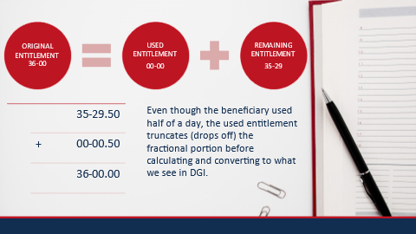 | DISPLAY slide  11 So, here is where it gets a little tricky…  To facilitate conversion of entitlement into the two-digit month two-digit day format, the fractional portion of the used entitlement is truncated before conversion. This means that the fractional portion, of the used entitlement, is dropped off before being converted to the two-digit month two-digit day format.  For example, a beneficiary has 36 months of original entitlement. The beneficiary uses .5 or half a day of entitlement. What DGI displays is 36 months and 0 days of original entitlement and 0 months and 0 days of used entitlement. The fractional portion, .5 of 1 day used is truncated, dropped off before being converted to the two-digit month two-digit day format. The remaining entitlement is calculated using the fractional portion and then truncated before being displayed in DGI. So, in this scenario, DGI calculates the used entitlement to be 0 months and 0 days used because the .5 days used is truncated to 0 immediately before being converted to display. To calculate remaining entitlement, DGI subtracts the .5 days used from the 36 months of original entitlement and gets 35 months and 29.5 days of remaining entitlement. The .5, half day is truncated, dropped off after the calculation but before being converted to the two-digit month two-digit day format. Resulting in 35 months and 29 remaining days being displayed.
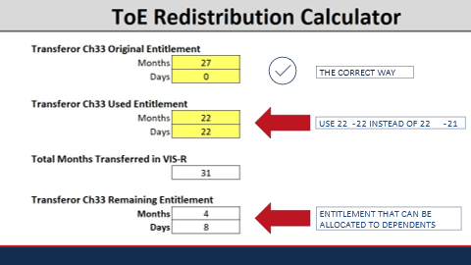 | DISPLAY slide  12 Back to our original scenario… For Transfer of Entitlement purposes, in this case, we want to use the Remaining Entitlement value of 4 months and 8 days. Therefore, used entitlement would be 22 months and 22 days.
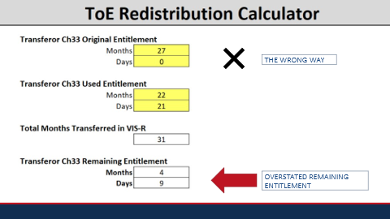 | DISPLAY slide  13 If we use 4 months and 9 days of remaining entitlement, we run the risk of overstating the remaining entitlement which can result in overpayments.  But how did I determine to use 4 months and 8 days of remaining entitlement and why is it important that I didn’t round it up?
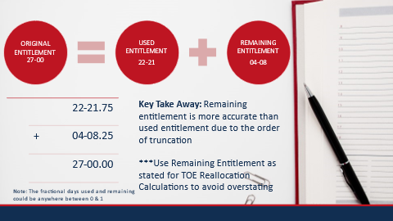 | DISPLAY slide  14 Because of when DGI truncates the entitlement, with the remaining entitlement being truncated after being calculated for conversion and the used entitlement being truncated before being calculated for conversion, the remaining entitlement is more accurate.  As a user, we do not know the exact amount of entitlement usage, including the fractional portion, due to how entitlement is displayed in DGI, two-digit month, two-digit day format. In our scenario, we are using for this training, we can’t see the franctional portion for the displayed amount of 4 months and 8 days. The .25 of 1 day used to explain the calculations going on behind the scenes in DGI, is not displayed and in reality it might be something more like .275 or .333, any fractional portion of one day is possible. Regardless, we don’t need to know what DGI has calculated in the background. The take away is that since remaining entitlement is more accurate, we should use the remaining entitlement as stated, when using the reallocation excel worksheet. If we use 4 months and 9 days, to try to make up for the invisible day split up between the used and remaining, then we are overstating the remaining entitlement.  By using 4 months and 8 days of remaining entitlement, to determine what to enter for your used entitlement, in the reallocation worksheet, we are preventing the overstatement of benefits, which is crucial because extension of entitlement is not permitted in all Transfer of Entitlement cases.
 | DISPLAY slide  15 With the information from this training, you should be able to recognize and comprehend how and why DGI displays entitlement the way it does and be able to process claims affected by the display functionality.
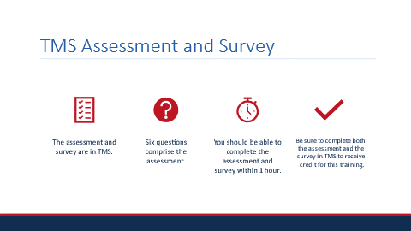 | DISPLAY slide  16 An assessment and survey have been assigned to you in TMS. The questions are based on the information you learned today. You should be able to complete the assessment and survey within 1 hour. Be sure to complete both the assessment and the survey in TMS to receive credit for this training.
 | DISPLAY slide  17 Until next time!

